 | Midocean Journal for Research and Studies  https://  e-ISSN: | 

Deep Learning Framework for Galaxy Morphology Classification and Analysis
Ahmad Yousef Alkahlout¹, Mohammed Taleb Ragash Mohammed¹, Mohamed Eassa¹
¹College of Informatics - Midocean University, 98123, Moroni, Comoros
253000753@st.midocean.edu.km, 252000097@st.midocean.edu.km

Abstract:
Classification of galaxy morphology is important for studying the formation and evolution of galaxies. With the rapid growth of imaging datasets from surveys such as SDSS and DECaLS, manual classification has become increasingly challenging in large-scale studies. This study presents a confidence-aware deep learning framework that combines hard-label morphological classification with continuous prediction of Galaxy Zoo vote fractions. The framework was evaluated across different model families, including convolutional neural networks, transfer-learning models, transformer-based models, and YOLO classifiers. Galaxy10 DECaLS was used for ten-class morphological classification, while the Galaxy Zoo Challenge dataset was used for continuous prediction of 37 vote-fraction outputs. Accuracy, Recall, and Macro F1-score were used to evaluate the hard-label tasks, whereas RMSE and MAE were used for continuous prediction. Model reliability was examined through robustness testing, confidence analysis, Grad-CAM, and saliency maps. The ConvNeXtV2 transfer-learning model achieved a test accuracy of 91.58% on the ten-class classification task, while the YOLO11x model achieved 99.17% accuracy on the high-confidence Smooth-versus-Featured classification task. For the 37-output Galaxy Zoo prediction task, the selected model achieved an RMSE of 0.0749. These results demonstrate that the proposed framework supports accurate, interpretable, and confidence-aware galaxy morphology analysis.
Keywords: galaxy morphology; deep learning; Galaxy Zoo; Galaxy10 DECaLS; confidence-aware classification.

1. Introduction
Classification of galactic morphology is a fundamental subject in modern astronomy, as visible structures provide significant insight into the formation and evolution of galaxies. New achievements in astronomical imaging allow the use of such morphological features as shape, luminosity, spiral structure, and central bulge to understand better the physical properties of the galaxies. Therefore, classification of galaxy morphology is a field which attracts active research interest (Walmsley et al., 2022).
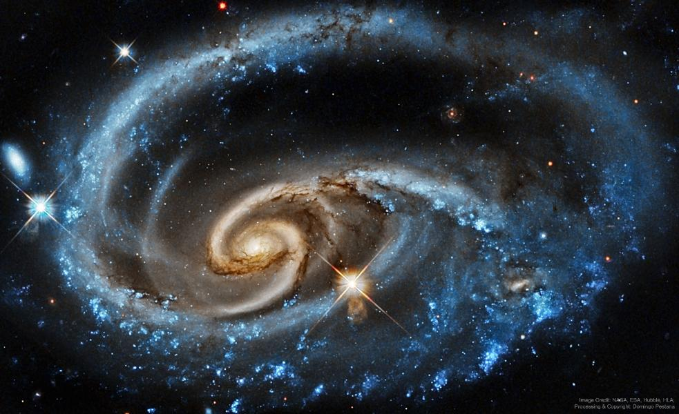
Figure ‎1. An example of galaxy morphology diversity in the context of automated galaxy classification. Source: NASA/Hubble.

As seen in Figure 1, galaxies show considerable diversity in their morphological structures. Some galaxies have well-visible morphological features, while some other galaxies have complicated shape and blurred boundaries between different morphological types. In the past, galaxies were classified manually. While there were some benefits in manual classification, due to the increased amount of galaxies in large sky surveys (SDSS and DECaLS), manual methods become impractical (Walmsley et al., 2022).
Furthermore, in addition to accuracy, interpretability is an important factor to consider as the models should depend on the scientific morphological features of the image and not the irrelevant areas (Bhambra et al., 2022). Robustness across survey conditions is also an important criterion for the creation of reliable galaxy morphology classification models (Ye et al., 2025). Moreover, uncertainty estimates can help identify ambiguous predictions and improve reliability of the results (Chen et al., 2025).
In this research, galaxy morphology classification using deep learning will be analyzed in terms of accuracy, robustness, uncertainty, and interpretability. The chosen datasets include Galaxy10 DECaLS which gives samples with hard-label classification and Galaxy Zoo Challenge which gives continuous targets in the form of vote-fractions. While the previous works covered various aspects of galaxy morphology classification (e.g., semi-supervised learning under scarcity of labels (Luo et al., 2025)), this research includes modern classification algorithms, image pre-processing, robustness testing, uncertainty analysis, and visual explanation. The purpose of this research is not only to achieve high classification accuracy but also create reliable models whose decisions can be examined through visual explanation methods.

1.1. Problem Statement
Deep learning advances the field of galaxy morphology classification; however, neither accuracy nor F1-score provide information about which morphological features (spirals, bars, disk, bulge) are used by the classifier and whether its decisions are made by noise or artifact on the image (Bhambra et al., 2022). The performance of the models might be affected by changing survey conditions and thus making robustness an important factor for developing dependable astronomical models (Ye et al., 2025).

A hard label may be too simple to describe galaxies with ambiguous or transitional morphology. Vote-fractions from Galaxy Zoo represent the level of agreement of classifiers, thus providing more complete picture (Walmsley et al., 2022). The above-described problems motivate the need to create a unified framework that would take into account accurate classification, confidence-based prediction, robustness test, uncertainty analysis, and visual explanation. It will be done in this research by using Galaxy10 DECaLS for hard-label classification and Galaxy Zoo Challenge dataset for continuous vote-fraction prediction.

1.2. Main Contribution
The main contribution of this research is the development of the confidence-aware framework for galaxy morphology classification which combines hard-label classification and continuous prediction of Galaxy Zoo vote-fractions. Several deep learning models, such as baseline convolutional neural network, transfer-learning models, transformer and YOLO classifiers will be tested in a uniform experimental environment. Apart from classification accuracy, robustness under image perturbations and confidence score analysis will be used to identify reliable predictions. Explainable AI techniques like Grad-CAM and saliency maps will be used to ensure that the model pays attention to relevant parts of images.

2. Previous Studies
The following section describes briefly background information and previous work related to the topic of galaxy morphology classification using deep learning approaches.

Walmsley et al. (2022) investigated the morphological classification of galaxies on a larger scale using machine learning techniques on current astronomical datasets. The use of the Galaxy Zoo DECaLS dataset allowed the researchers to utilize morphological classifications provided by many citizen scientists. The authors developed a deep learning model called Zoobot, which integrates convolutional neural network and probability approaches to estimate the entire distribution of answers provided by volunteers for about 300,000 galaxies. The model provided good agreement with human classification efforts and demonstrated good prediction accuracy, even regarding complicated morphological patterns. The main advantage of the investigation under analysis is the creation of one of the biggest morphological catalogs created using deep learning techniques. However, the use of volunteer-generated answers can be considered the main disadvantage of the methodology employed in this research.

The significance of this line of investigation to the current research is that it views galaxy morphology as a probabilistic problem in terms of distributions rather than just a hard-labeling issue. The reason why this perspective is important is that the current study begins with a controlled hard-labeling issue through the Galaxy10 DECaLS dataset but also involves the bigger Galaxy Zoo vote fraction problem as well. In this regard, previous work done on Galaxy Zoo provides a useful foundation for expanding galaxy classifications beyond one label.

Bhambra et al. (2022) conducted research on the explainability of deep learning models which were used in the classification of galaxies based on their morphology. In this research, different explainable artificial intelligence approaches such as Grad-CAM and saliency maps were used to illustrate image areas that contributed towards the prediction made by deep learning models. Through galaxy images obtained from large sky surveys such as Galaxy Zoo and DECaLS, it was shown that deep neural networks were able to recognize different morphological structures within galaxies such as spiral arms, galactic core structures, and even asymmetry. This research illustrates that using explainability techniques, it is possible to learn more about the internal functioning of deep learning models.

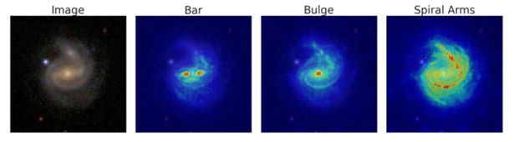
Figure 2. Example of a saliency map highlighting discriminative regions in galaxy morphology classification. Source: Adapted from Bhambra et al. (2022).

As shown in Figure 2, saliency maps highlight the regions of the galaxy image that contribute most strongly to the model's prediction. In many cases, the visualization confirms that the neural network focuses on key morphological structures such as spiral arms, bars, or the central bulge. This provides an additional layer of reliability by allowing astronomers to verify whether the classification decision is based on meaningful physical features. In this study, a similar explainability approach will be used to evaluate whether the proposed deep learning framework focuses on relevant morphological structures when classifying galaxy images.

Luo et al. (2025) believed problems related to galaxy morphological classification in situations when there are not many labeled samples available a frequent situation in the field of astrophysics. They developed an innovative semi-supervised deep learning algorithm that uses convolutional neural network and GAN models. In this case, the experiments were conducted using the Galaxy10 DECaLS dataset, and the classification accuracy obtained was around 84%. One positive point about this study is the reduced need for big fully labeled samples due to the simultaneous application of both labeled and unlabeled data. Such an innovation will be particularly beneficial in astronomy due to the time consumption involved in the process of labeling. On the other hand, one drawback of such an algorithm is its instability.

Yao et al. (2024) present a galaxy image augmentation system that combines few-shot learning techniques with generative adversarial networks to address the problem of insufficient numbers of labeled images of galaxies. Yao et al. (2024) use the Galaxy10 DECaLS dataset and test the FSL-GAN system on three classification models – AlexNet, VGG, and ResNet. According to the findings, the biggest increase in quality is achieved when the number of images in the generated dataset varies between 0.5 and 1.0 of the initial dataset. Applying the FSL-GAN technique to the ResNet model produces F1-scores equal to 89.54% for the class of In-between Round Smooth Galaxies and 63.18% for Unbarred Loose Spiral Galaxies. One of the strong points of the paper is the consideration of the effect of different augmentation techniques on various galaxy classes and classification models. Still, there is no one-size-fits-all augmentation technique that works well for all morphological classes of galaxies.

Le et al. (2025) carried out a comparative study of several deep learning models for galaxy morphology classification. The researchers employed the Galaxy10 DECaLS dataset to test customized CNN algorithms against the transfer learning algorithm models like ResNet and EfficientNet. It is demonstrated that the EfficientNet model produced an accuracy score of about 87%, which is considered among the best-performing models tested in the paper. The main advantage of this study lies in the fact that it presents a comparative analysis between several architectures under identical experimental conditions. In addition, experimental research was limited to utilization of just one dataset, implying its potential applicability to other astronomical survey data.

Fernando et al. (2024) conducted research on galaxy morphology classification with a deep convolutional neural network based on the VGG19 architecture. As the data source, the authors used Galaxy10 DECaLS dataset that contains 17,736 images that are divided into ten morphological classes. Transfer learning is conducted via using VGG19 architecture as the feature extraction backbone, along with fully connected layers, image preprocessing, and data augmentation. The performance of the suggested approach was measured via accuracy (97.97%), Macro Precision (89.84%), Macro Recall (89.69%), Macro F1-score (89.68%), and AUC (0.98). One of the main advantages of the conducted research is that it proves the effectiveness of transfer learning in the case of ten-class galaxy morphology classification. However, there are some disadvantages of the research related to the class imbalance in Galaxy10 DECaLS and computational complexity of VGG19.

Parker et al. (2024) present AstroCLIP, a cross-modal foundation model developed for analysis of galaxy images and optical spectroscopy. The researchers used imaging data obtained by the DESI Legacy Imaging Survey and spectral data collected by the Dark Energy Spectroscopic Instrument, using Galaxy Zoo DECaLS classifications for evaluation of morphology classification. The model is based on self-supervised transformer encoders and employs contrastive learning for alignment of image and spectral representations in a common latent space. Within the problem of morphology classification, AstroCLIP managed to demonstrate an average accuracy of around 77% in answering ten questions from Galaxy Zoo regarding morphology with the best result being 97% in disk-edge-on case. One of the main advantages of the model is its transferability to various astronomical tasks requiring only minor supervision. On the other hand, the approach requires large pretraining and significant computational power, and its results are rather poor in the case of complex questions requiring multiple classes.

Cao et al. (2024) came up with a combination approach to deep learning where the researcher merged CNNs with elements from transformers to classify the morphology of galaxies. For this research, Cao used galaxy images from the Galaxy Zoo database. Specifically, CvT architecture was used because the model integrates local feature detection in CNNs and global feature detection in transformer architectures. The achieved accuracy was around 98%, thus making it one of the most effective models among those that have been reviewed in this analysis. One strength of this research paper is that it uses both architectural designs, hence can detect patterns in galaxies using a wide range of approaches. However, the improvement made in the model makes it complex, thus requiring more computational resources.

Mao et al. (2025) The DenseNet-SE4 model was developed for improving the discrimination of morphologies of visually similar galaxies. The authors created a dataset containing eight classes of galaxies taken from the Galaxy10 DECaLS and GZD-5 datasets. This new architecture is an expansion of the DenseNet-121 model based on the use of dynamic multiscale convolution, learnable grouped convolution, and squeeze-and-excitation attention layers to extract more features. This architecture showed 88.96% accuracy, 89.00% precision, 89.44% recall, and 89.21% F1-score. The main advantage of this research is that the model can distinguish small differences between morphologically similar classes of galaxies and show good results at different redshifts. However, the number of classes used in the dataset, eight, differs from the original number of classes, ten, in the Galaxy10 DECaLS dataset.

Chen et al. (2025) propose a semi-supervised learning algorithm for classification of galaxies using diversity and uncertainty-based learning strategies. Chen et al. (2025) test their proposed framework on the Galaxy10 DECaLS and Galaxy Zoo 2 benchmarks using a few labeled examples in combination with many unlabeled examples. They vary their training procedure depending on the level of confidence in the pseudo-labels and include uncertainty in their approach to avoid confirmation bias due to high-confidence predictions. On the Galaxy10 DECaLS benchmark, their algorithm achieves 76.8% accuracy with only 2,000 labeled examples, whereas the supervised baseline yields 70.8% accuracy on the same few labeled data condition. An important contribution of this study is the improved utilization of unlabeled examples and consideration of uncertainty in predictions. However, the results presented in this paper were obtained through a limited-label setting experiment and cannot be compared directly with the fully supervised evaluation results obtained on the whole labeled Galaxy10 DECaLS benchmark.

The comparison of the selected studies is presented in Table 1.

Table ‎‎1. Comparison of related studies in galaxy morphology classification
Author | Year | Technique Used | Accuracy | Dataset | Comparison with This Research
Walmsley et al. | 2022 | Bayesian Deep Learning (Zoobot) | Not explicitly reported | Galaxy Zoo / DECaLS | Reference for uncertainty-aware galaxy classification
Bhambra et al. | 2022 | Grad-CAM & Saliency Mapping | Not focus of study | Galaxy Zoo / DECaLS | Reference study for explainable AI evaluation
Luo et al. | 2025 | Semi-supervised Learning (GAN-based) | ~84% | Galaxy10 DECaLS | Semi-supervised learning reference under limited labels
Yao et al. | 2024 | FSL-GAN Data Augmentation | F1-score up to 89.54% | Galaxy10 DECaLS | Data augmentation reference for limited and imbalanced galaxy classes
Le et al. | 2025 | EfficientNetB5 Transfer Learning | ~87% | Galaxy10 DECaLS | Transfer learning architecture benchmark
Fernando et al. | 2024 | VGG19 Transfer Learning | 97.97% | Galaxy10 DECaLS | Transfer-learning benchmark for ten-class galaxy morphology classification
Parker et al. | 2024 | Self-supervised Vision Transformer / AstroCLIP | 44%–97% across morphology questions | Galaxy Zoo DECaLS | Recent transformer-based reference for self-supervised and confidence-aware morphology analysis
Cao et al. | 2024 | Convolutional Vision Transformer (CvT) | ~98% | Galaxy Zoo CANDELS | Hybrid CNN–Transformer performance benchmark
Mao et al. | 2025 | DenseNet-SE4 with multiscale convolution and attention | 88.96% | Galaxy10 DECaLS and GZD-5 | Attention-enhanced CNN reference for visually similar morphology classification and robustness analysis
Chen et al. | 2025 | Semi-supervised learning with uncertainty estimation | 76.8% with 2,000 labeled samples | Galaxy10 DECaLS | Uncertainty-aware semi-supervised reference under limited labels

Although recent studies have reported promising results, several important challenges remain. Many existing models achieve good accuracy, but they do not always provide enough information about how stable their predictions are when image conditions change, and heavy dependence on massive, perfectly labeled datasets remains a challenge for future large-scale surveys. Crucially, a distinct gap persists in current literature where classification accuracy, uncertainty, robustness, and interpretability are treated as entirely separate paths of research. Furthermore, a clear methodological divide remains between rigid hard-label classification and the richer representation of vote fractions. The framework proposed in this study directly bridges the gap between class label classification and a more general confidence-based approach, combining these critical dimensions into a single setting.

3. Methodology
The methodology is offered as a rigorous end-to-end engineering pipeline designed to solve specific problems inherent to hard-label classification and continuous morphology estimation. The architecture performs a structural analysis following a step-by-step process starting from data ingestion, specialized multi-branch preprocessing pipelines, and various deep backbone feature extractors before reaching continuous multi-output prediction. As shown in figure 3?

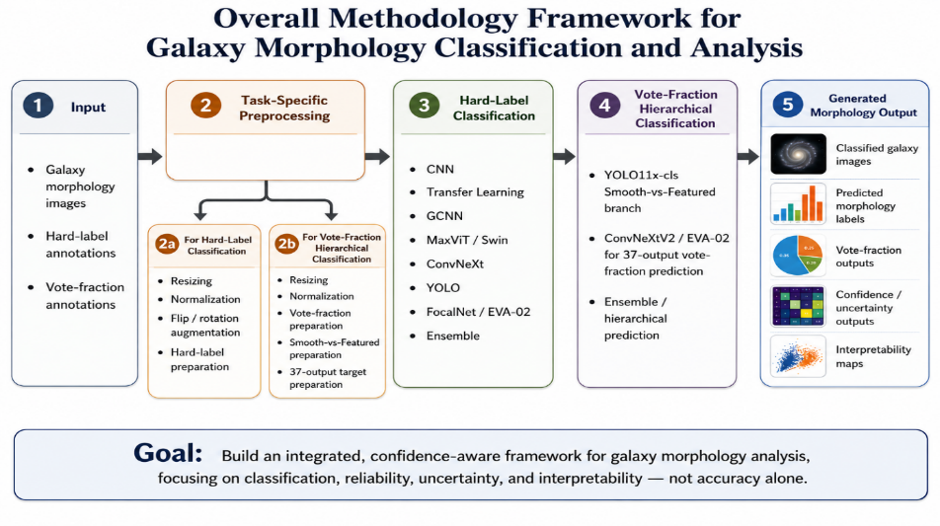
Figure ‎3. Overall proposed galaxy morphology methodology framework.

3.1. Input (Datasets)
To test the pipeline's capability across different classification approaches, two major datasets were utilized:
- Galaxy10 DECaLS Dataset: It offers the basis for the multi-class hard-label branch, containing discretized morphological classes across thousands of labeled images.

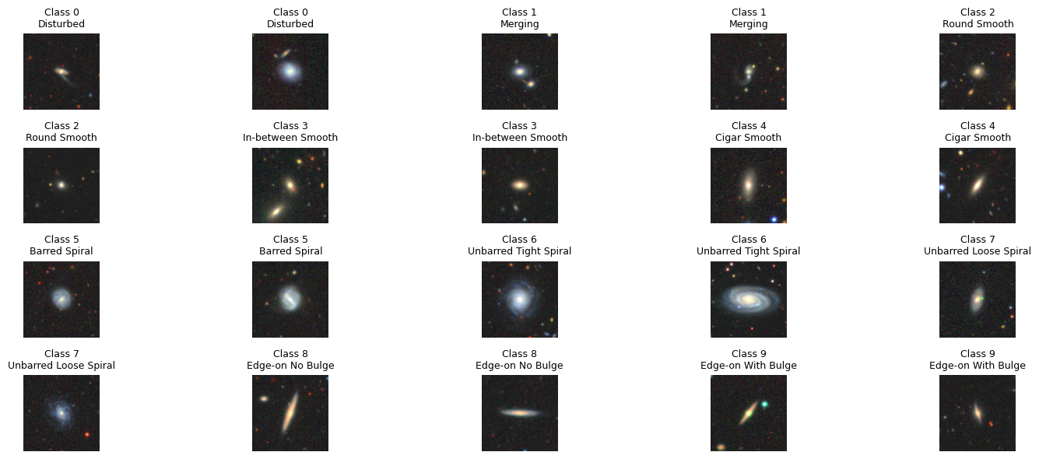
Figure ‎4. Sample galaxy images from the Galaxy10 DECaLS dataset used for hard-label morphology classification.

- Galaxy Zoo Challenge Dataset: To enable continuous, confidence-aware hierarchical prediction, it was used because of its ability to preserve original, uncompressed volunteer vote fraction targets.

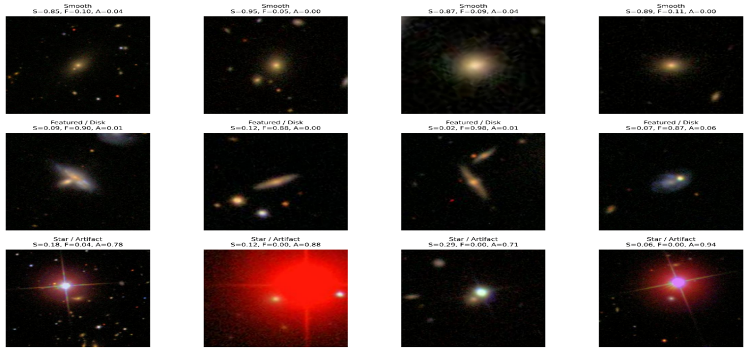
Figure ‎5. Sample Galaxy Zoo Challenge images with first-gate vote-fraction annotations used for hierarchical morphology classification.

3.2. Preprocessing
Since the pipeline works with both discrete classes and continuous target distributions, the preprocessing phase is deliberately separated into two parallel paths.

3.2.1. Hard-Label Preprocessing Pathway
Galaxy10 DECaLS images classified within this branch go through multi-scale spatial resizing. These images are processed with different dimensions of 64×64, 128×128, 160×160, 224×224, and 256×256 pixels to study how preserving spatial information affects feature extraction in comparison with computing costs. Channel-wise normalization according to ImageNet standard was applied to all pre-trained deep learning backbones with the following formula:

$x_{\text{norm}}=\frac{x-μ}{σ}$ (1)

where μ = [0.485, 0.456, 0.406] and σ = [0.229, 0.224, 0.225]. In order to ensure orientation invariance during training while preventing information leakage, random rotations and reflections were applied to the training subset only.

3.2.2. Continuous Vote-Fraction Pathway
For the purpose of continuous prediction, the targets were preserved as a full multi-output regression vector with the whole 37-dimensional Galaxy Zoo morphology decision tree:

$y∈{[0,1]}^{37},y=[y_{1},y_{2},y_{3},…,y_{37}]$ (2)

Alongside, a high-confidence binary classification branch focused on distinguishing Smooth and Featured systems was created based on isolated images when the first-gate user vote fraction is equal to or exceeds a certain confidence threshold τ:

$label= \left\{\begin{aligned} Smooth, "if Class1.1" >= τ \\ Featured, "if Class1.2" >= τ\end{aligned}\right.$ (3)

Images meeting the above-mentioned condition were resized to a higher 448×448 pixels resolution required for training of the dedicated YOLO11x-cls architecture.

3.3. Experimental Control and Data Partitioning
To avoid any data leakage and keep validation choices and interpretability metrics clean, a strict data partitioning protocol was applied. The fully labeled Galaxy10 DECaLS dataset was separated into completely independent training, validation, and testing subsets. The numbers of images, their ratio, and roles for each subset are specified in Table 2:

Table ‎2. Galaxy10 DECaLS split used in the main classification experiments.
Subset | Images | Approx. ratio | Role
Training | 12,415 | 70% | Parameter learning
Validation | 2,660 | 15% | Model selection and refinement decisions
Testing | 2,661 | 15% | Held-out final evaluation
Total | 17,736 | 100% | Full labeled Galaxy10 DECaLS dataset

Unlabeled imagery, such as Kaggle test data, is not included in the local training and hyperparameters tuning process at all but only used for post-deadline external validation.

3.4. Classification Models
Several distinct architectural families of deep learning models were being used in the pipeline to compare local feature extraction with global context modeling. The baseline layer blocks, dimensional transformations, and mathematical attributes implemented in these models are briefly summarized below (Walmsley et al., 2022).

Table ‎3. Galaxy Zoo Challenge labeled split and official unlabeled test set role.
Galaxy Zoo subset | Images | Approx. ratio | Role
Training | 43,104 | 70% | Parameter learning for 37-output prediction
Validation | 9,237 | 15% | Model selection and ensemble design
Internal testing | 9,237 | 15% | Held-out internal evaluation
Labeled total | 61,578 | 100% | Images with vote-fraction annotations
Official Kaggle test | 79,975 | Not part of labeled split | Unlabeled images used only for final submission prediction

3.4.1 Deep Learning CNN Baseline
Traditional convolutional neural networks represented the basic baseline, passing images through the chain of convolutional and pooling blocks to automatically detect localized structural patterns (e.g., spiral arms or galactic cores) through spatial filtering:

$F(i, j, k) = ∑_{m} ∑_{n} ∑_{c} X(i + m, j + n, c) W(m, n, c, k) + b_{k}$ (4)
Mention Equation and figures??
3.4.2 Group Convolutional Networks (GCNN D16): To explicitly take the geometric nature of astronomical data into account, an orientation-aware extension is applied. This architecture embeds rotation and reflection symmetries directly into weight layers, ensuring the geometric consistency in D16 dihedral group configuration:

$[f * ψ](g) = ∑_{x ∈ Z²} f(x)ψ(g^{-1}x)$ (5)
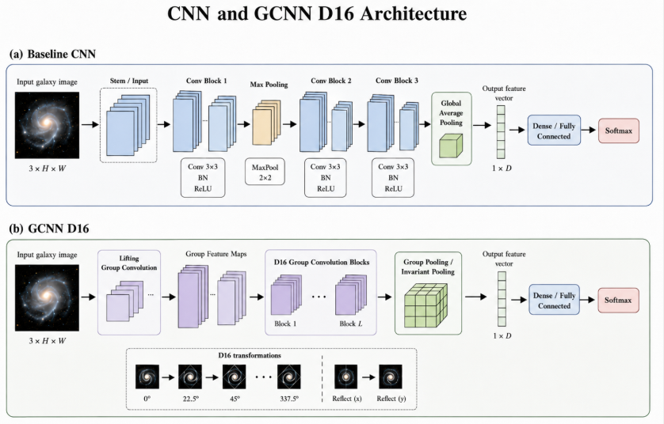
Figure ‎6. CNN family architecture used for local galaxy morphology feature extraction.

3.4.3 Transfer Learning Backbones: Advanced pre-trained models like ResNet, EfficientNet, and ConvNeXtV2 were utilized to transfer complex visual features trained on large natural images to astronomical pixel domain.

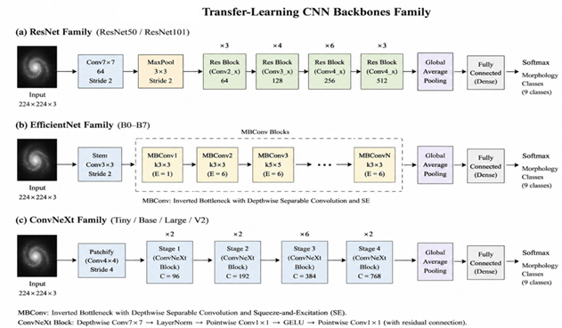
Figure ‎7. Transfer-learning CNN backbone family adapted for galaxy morphology classification
3.4.4 Vision Transformers and Hybrid Models: Attention mechanism blocks were added through ViT and Convolutional Vision Transformers (CvT) to handle dependencies across larger spatial layout, including outer tidal tails and low surface brightness features.

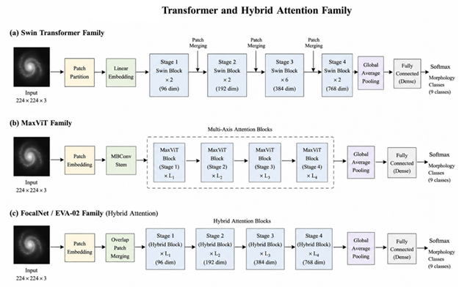
Figure 8. Transformers and hybrid attention architecture family used for broader spatial morphology reasoning.
3.4.5 YOLO Classification Family: For fast structural screening, a highly efficient classifier uses optimized backbone representation and routes it through a linear softmax top layer for quick image-level routing.

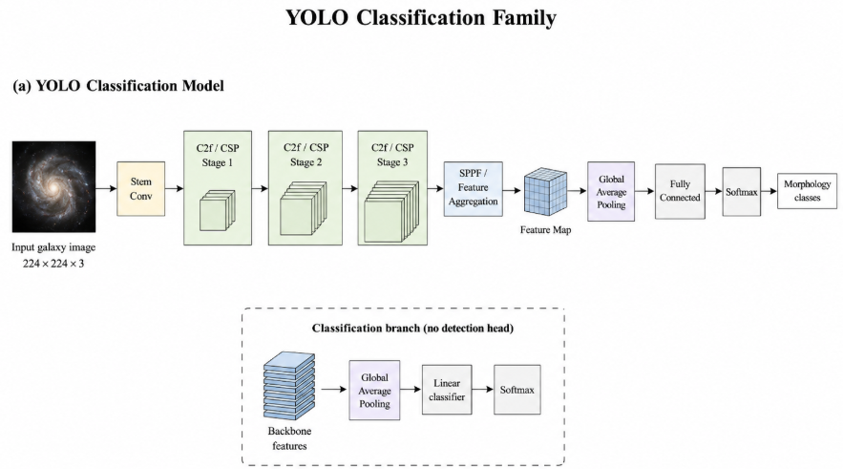
Figure 9. YOLO classification architecture family used as an efficient image-level morphology classifier

3.4.6 Ensemble and Hierarchical Strategy: To minimize model variance, a weighted ensemble approach was applied, aggregating predictions from different architecture families into one optimized output vector:

${\overset{^}{y}}_{j}=\sum_{m=1}^{M}{w_{m}{\overset{^}{y}}_{j,m},}\text{ where }\sum_{m=1}^{M}{w_{m}=1}$ (6)

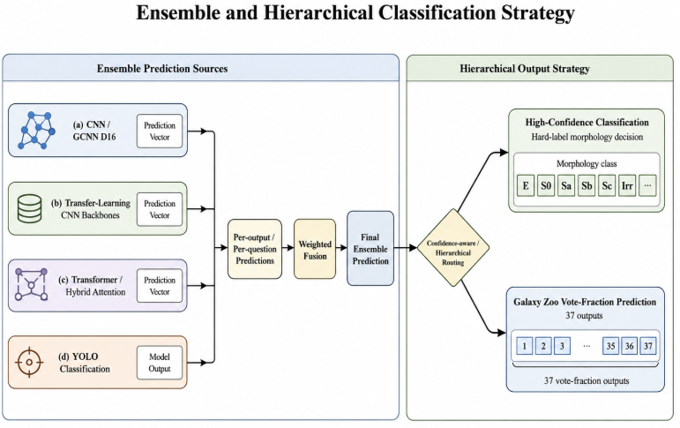
Figure ‎10. Ensemble and hierarchical prediction strategy connecting model families with 37-output Galaxy Zoo morphology prediction.

3.5. Training and Evaluation Protocol
Training process and evaluation metrics are adjusted according to learning goals of each particular branch:
Hard-label multi-class classification tasks were optimized with categorical cross-entropy loss function:
$I_{\text{CE}}=-\sum_{c=1}^{C}{y_{c}log({\overset{^}{y}}_{c})}$ (7)

Accuracy, Precision, Recall, and Macro F1-score were used as evaluation metrics.
For the continuous 37-dimensional vote-fraction tracking, the problem was considered as a multi-output regression problem, optimized with regression loss and evaluated with RMSE and MAE to accurately reflect the model's uncertainty.
Finally, the whole pipeline incorporates Explainable AI (XAI) procedures to visualize that the model focuses on true astronomical features with Grad-CAM and saliency map techniques.

4. Results and Discussion
This section provides the empirical verification of the proposed galaxy morphology framework. The performance assessment covers the aspects of discrete hard-label classification, high-confidence binary routing, continuous multi-output vote-fraction estimation, and the extensive reliability evaluation including robustness, calibration, and visual explanations.

4.1. Preprocessing Results
In order to ensure the data consistency required for the operational paths outlined in Section 3, the data ingestion pipeline was validated with regard to both hard-label and continuous targets. The output data and stratification settings are provided in Table 4.

Table ‎‎4. Preprocessing outputs used in the framework.
Data component | Label type | Preprocessing result
Galaxy10 DECaLS | Hard labels | Official ten-class classification and reduced diagnostic analysis
Galaxy Zoo Challenge | 37 vote fractions | Continuous hierarchical prediction and first-gate analysis
Smooth vs Featured subset | High-confidence binary labels | 7905 training, 1694 validation, 1694 held-out test samples

Some examples of source images and the corresponding normalized spatial representations in both pipelines are depicted in Figure 11.
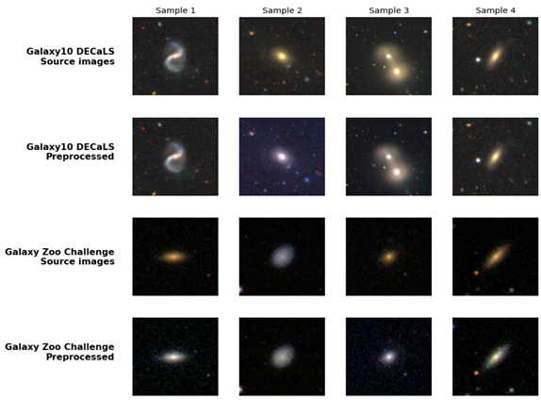
Figure ‎11. Representative source and preprocessed galaxy images from the Galaxy10 DECaLS and Galaxy Zoo datasets

4.2. Hard-Label Classification Results Across Model Families
Multi-class hard-label classification performance was assessed systematically for the principal families of models presented in the methodological part. Comparative experimental results on the 10-class Galaxy10 DECaLS dataset are provided in Table 5.
Table ‎5. Hard-label classification performance across the evaluated model families.
Model family | Representative experiment | Task setting | Accuracy / Recall / F1-score | Evaluation status | Interpretation
CNN / GCNN family | Baseline CNN and GCNN D16 | Galaxy10 full 10-class | Validation accuracy = 0.886466; Macro Recall = 0.876281; Macro F1 = 0.878177 | Validation evidence | Provides the baseline and symmetry-aware reference for hard-label galaxy morphology classification.
Transfer-learning CNN family | ConvNeXtV2 transfer-learning CNN model | Galaxy10 full 10-class | Test accuracy = 0.915821; Macro Recall = 0.908692; Macro F1 = 0.907277 | Held-out test evidence | Provided the highest full ten-class test performance in this comparison and was used for the detailed per-class and confusion-matrix analysis.
Transformer / hybrid attention family | Swin Large 384 attention model | Galaxy10 full 10-class | Validation accuracy = 0.884962; Macro Recall = 0.861231; Macro F1 = 0.862763 | Validation evidence | Shows the contribution of attention-based representations in the full ten-class hard-label classification setting.
YOLO11 classification family | YOLO11x-cls and YOLO11 ensemble classifiers | Galaxy10 full 10-class | Validation Top-1 = 0.893233; weak-class recall mean = 0.753126; Macro F1 = 0.878678 | Validation evidence | Confirms that YOLO11 was evaluated as an independent hard-label classification family on the full ten-class Galaxy10 task.
Ensemble and fusion strategy | YOLO11 + FocalNet reduced-class fusion | Reduced 7-class validation-clean diagnostic | Accuracy = 0.980296; Macro Recall = 0.971904; Macro F1 = 0.970908 | Validation-only diagnostic evidence | Shows that model-family diversity improved the reduced-class diagnostic result, while this evidence remains separate from the original full ten-class task.

Table 5 presents the representative experiments selected from each model family examined in this study. The Baseline CNN and GCNN D16 experiment achieved a validation accuracy of 0.886466, a Macro Recall of 0.876281, and a Macro F1-score of 0.878177. Among the models evaluated on the full ten-class held-out test set, the ConvNeXtV2 transfer-learning CNN model achieved the best performance, with an accuracy of 0.915821, a Macro Recall of 0.908692, and a Macro F1-score of 0.907277. The Swin Large 384 attention model achieved a validation accuracy of 0.884962, a Macro Recall of 0.861231, and a Macro F1-score of 0.862763. For the YOLO11 classification family, the YOLO11x-cls and YOLO11 ensemble classifiers achieved a validation Top-1 accuracy of 0.893233, a weak-class mean recall of 0.753126, and a Macro F1-score of 0.878678. The YOLO11 and FocalNet reduced-class fusion achieved an accuracy of 0.980296, a Macro Recall of 0.971904, and a Macro F1-score of 0.970908 on the reduced seven-class validation setting. It is important to note that this final result belongs to a reduced-class diagnostic experiment and should not be directly compared with the results obtained on the full ten-class task.
Due to better test metrics on the 10-class task, the ConvNeXtV2 transfer-learning CNN model was chosen for detailed per-class analysis and uncertainty profiling.

4.2.1. Detailed Analysis of the ConvNeXtV2 Transfer-Learning CNN Model
The classification report of the ConvNeXtV2 architecture on the test dataset is presented below in Table 6.

Table ‎6. Per-class classification report for the ConvNeXtV2 transfer-learning CNN model on the Galaxy10 DECaLS ten-class test set.
Class | Precision | Recall | F1-score | Support
Class 0 | 0.759 | 0.778 | 0.768 | 162
Class 1 | 0.967 | 0.942 | 0.954 | 278
Class 2 | 0.989 | 0.945 | 0.966 | 397
Class 3 | 0.986 | 0.961 | 0.973 | 304
Class 4 | 0.830 | 0.880 | 0.854 | 50
Class 5 | 0.976 | 0.915 | 0.945 | 307
Class 6 | 0.808 | 0.887 | 0.846 | 275
Class 7 | 0.811 | 0.860 | 0.835 | 394
Class 8 | 0.971 | 0.958 | 0.965 | 213
Class 9 | 0.971 | 0.961 | 0.966 | 281
Accuracy | — | — | 0.916 | 2661
Macro Avg | 0.907 | 0.909 | 0.907 | 2661
Weighted Avg | 0.920 | 0.916 | 0.917 | 2661

The test confusion matrix (Figure 12) demonstrates primarily diagonal structure. Errors are mainly localized in visually ambiguous classes: tight and loose unbarred spirals (Class 6 and Class 7) and disturbed galaxies (Class 0). Some examples of correctly and incorrectly classified images are provided in Figure 13.

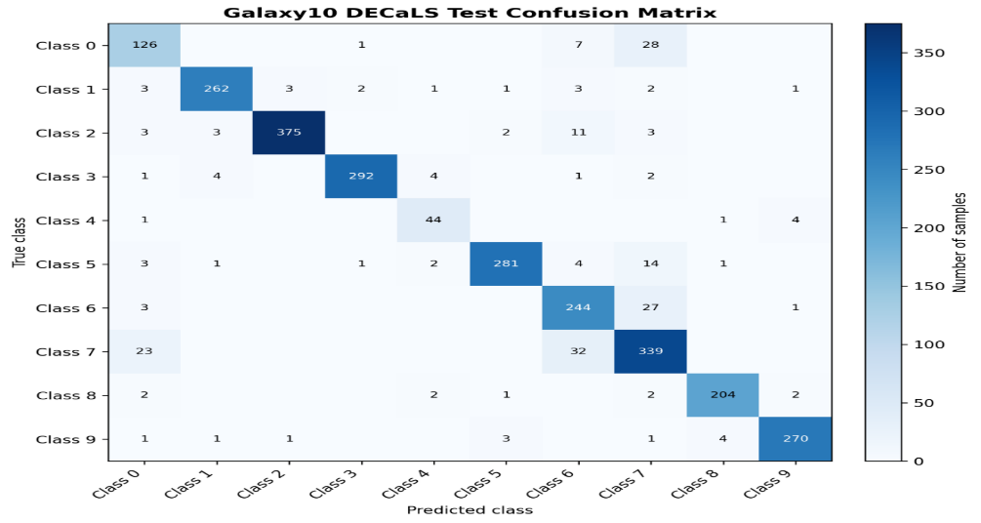
Figure ‎12. Galaxy10 DECaLS ten-class confusion matrix on the held-out test set.
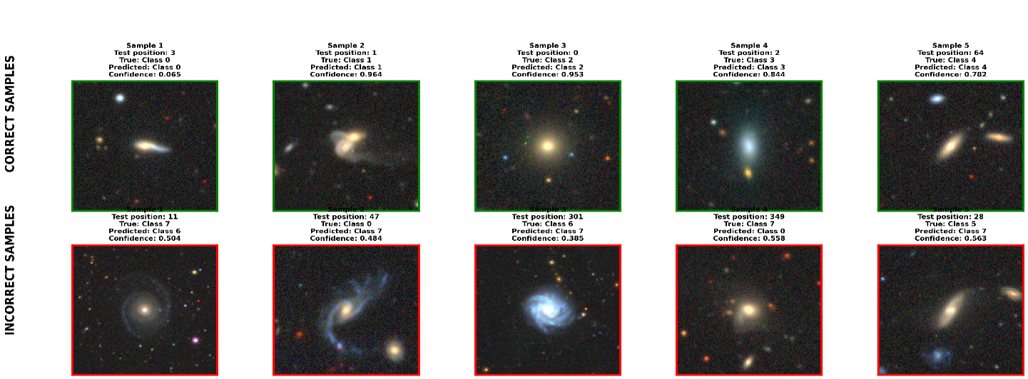
Figure 13. Representative correct and incorrect Galaxy10 DECaLS predictions from the ConvNeXtV2 transfer-learning CNN model.
In order to check if the model isolates physically significant galactic features and not just the background noise, the Grad-CAM maps were constructed as in Figure 14. The heatmaps demonstrate strong focus on scientifically relevant structures like central bulges, disks, and asymmetries.

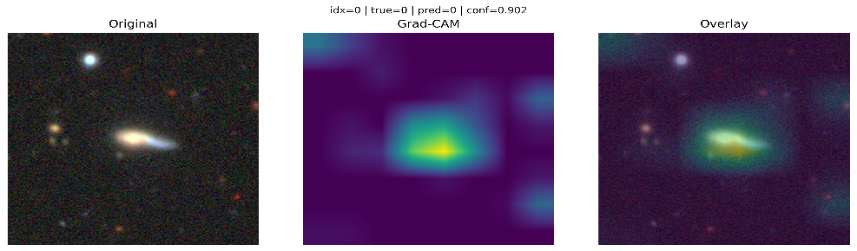
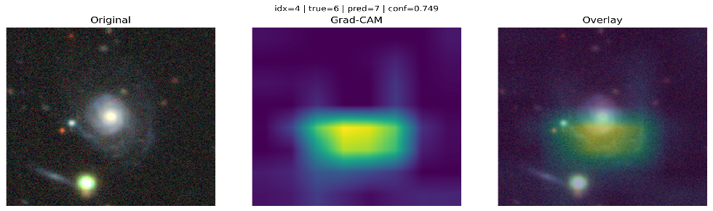
Figure 14. Grad-CAM visual explanations for selected Galaxy10 DECaLS predictions from the ConvNeXtV2 transfer-learning CNN model.
Robustness profiling under the controlled image perturbations (Figure 15) reveals that while the model is robust to moderate changes, the performance deteriorates significantly with extreme noise and blur types.

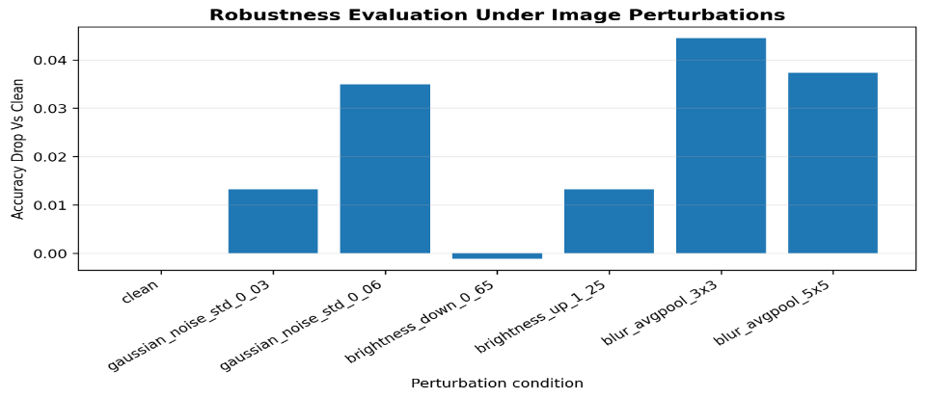
Figure 15. Robustness evaluation under controlled image perturbations.
The uncertainty distribution (Figure 16) shows that incorrect predictions correspond to more spread and lower confidence profiles than correct ones, which validates the self-awareness of the framework.
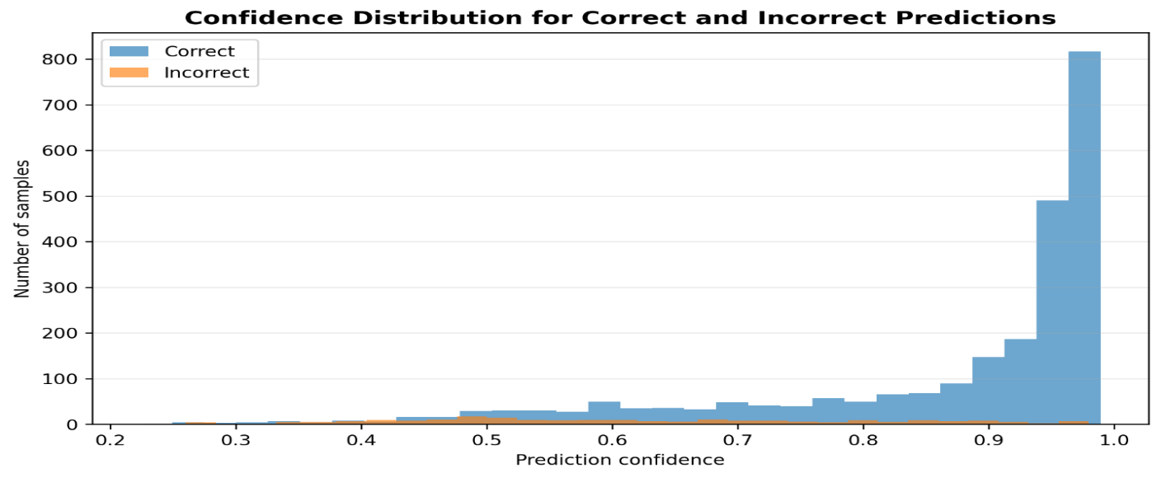
Figure ‎16. Uncertainty distribution for correct and incorrect Galaxy10 DECaLS predictions.

4.3. High-Confidence Smooth vs Featured Classification
The morphology routing gateway was tested through the high-confidence Smooth vs Featured binary classification path using the YOLO11x architecture. The training and evaluation datasets were filtered with a high vote fraction threshold (τ ≥ 0.90) in order to include only unambiguous targets (Figure 17).

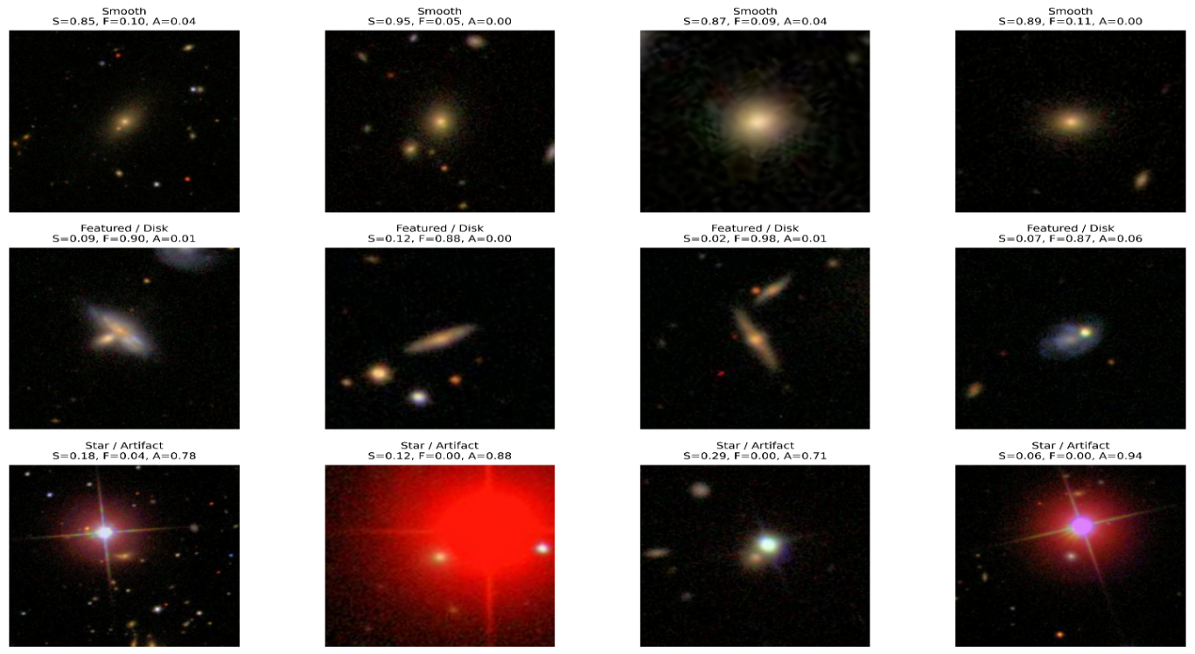
Figure ‎17. Galaxy Zoo first-gate vote-fraction examples used to construct the high-confidence Smooth vs Featured binary classification task.
The performance on the test dataset is summarized in Table 7 and demonstrates the accuracy 99.1736% and the macro F1-score 0.988126.

Table ‎7. Per-class classification report for the YOLO11x high-confidence Smooth vs Featured classifier on the held-out test set.
Class | Precision | Recall | F1-score | Support
Featured | 0.9962 | 0.9932 | 0.9947 | 1316
Smooth | 0.9764 | 0.9868 | 0.9816 | 378
Accuracy | — | — | 0.9917 | 1694
Macro avg | 0.9863 | 0.9900 | 0.9881 | 1694
Weighted avg | 0.9918 | 0.9917 | 0.9918 | 1694

As seen from the binary confusion matrix (Figure 18), the errors are evenly distributed: 9 Featured galaxies were classified as Smooth and 5 Smooth ones as Featured. The qualitative error analysis (Figure 19) confirms that errors appear only in faint galaxies with low contrast.
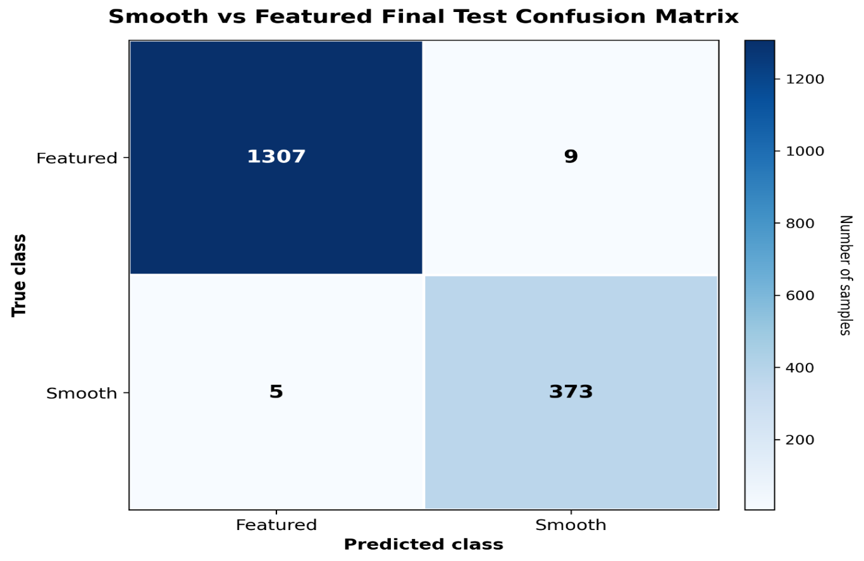
Figure 18. Official held-out test confusion matrix for the high-confidence Smooth vs Featured binary classification stage.
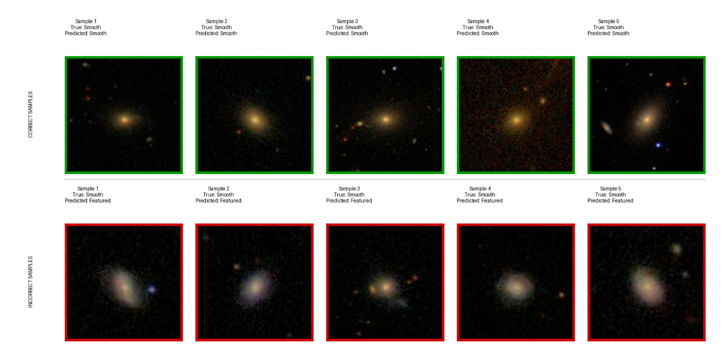
Figure ‎19. Representative correct and incorrect predictions from the high-confidence Smooth vs Featured classification stage.
Selective confidence filtering (Figure 20) reveals that the constraint τ > 0.975 increases the routing accuracy to 100.0000% while leaving only 95.8087% of data covered. The robustness test (Figure 21) demonstrates robust performance (≥99%) for standard perturbations, while for the high Gaussian noise the accuracy drops a bit.

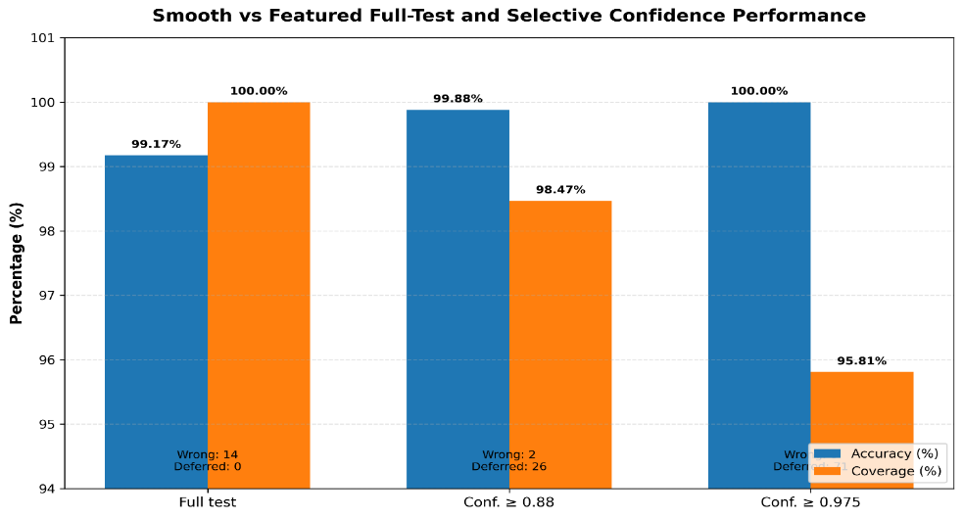
Figure ‎20. Full-test and selective-confidence performance of the Smooth vs Featured classification stage.
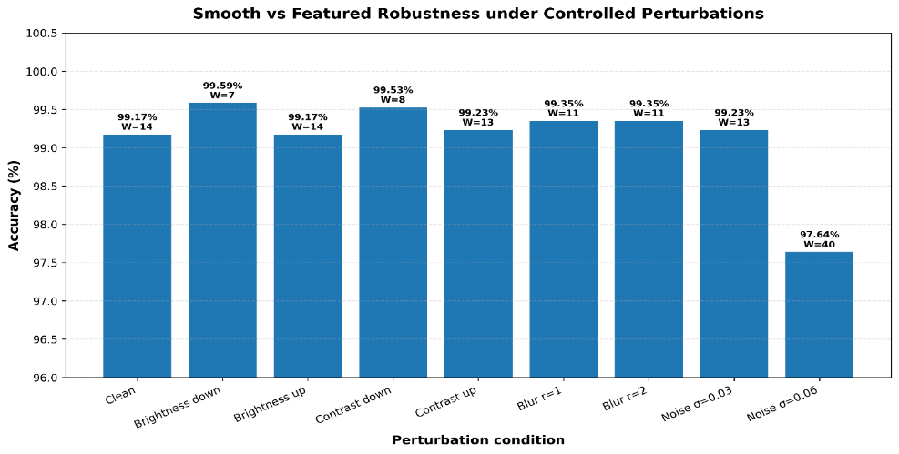
Figure ‎21. Robustness of the Smooth vs Featured classifier under controlled image perturbations.

4.4. Galaxy Zoo Vote-Fraction Prediction Results
To assess the morphological uncertainty beyond hard boundaries, the continuous multi-output branch was validated with the help of the ConvNeXtV2 Large architecture that predicts all 37 continuous vote fractions simultaneously. Quantitative performance results are provided in Table 8.
Table ‎8. Official Galaxy Zoo 37-output vote-fraction prediction results on the held-out test set.
Architecture | Output type | Evaluation set | RMSE | MAE | First-gate accuracy
ConvNeXtV2 Large | 37 continuous vote fractions | Held-out test | 0.074912 | 0.042315 | 0.887626

Per-output error mapping (Figure 22) indicates that error distribution depends on the complexity of the underlying questions tree, with primary features being predicted with smaller RMSE value than deeper geometric ones.
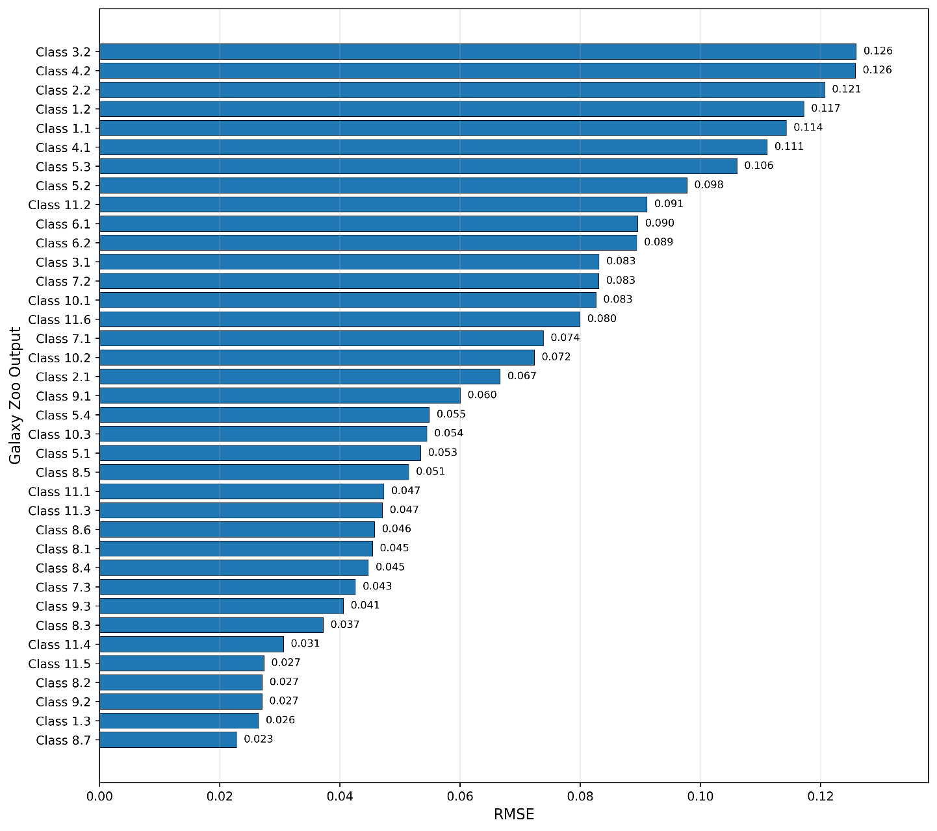
Figure ‎22. Per-output RMSE values for the Galaxy Zoo 37-output vote-fraction prediction task.
The first gate diagnostic filtering reveals the dominant class matching accuracy 88.7626% (Figure 23), confirming that the regression vectors preserve the structural relevance. Examples of lowest-error and highest-error targets are provided in Figure 24.
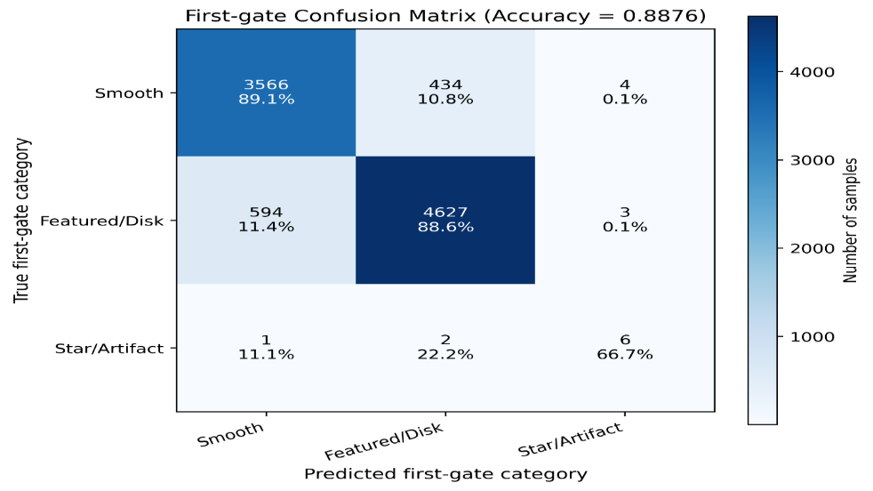
Figure ‎23. First-gate prediction analysis for the Galaxy Zoo 37-output vote-fraction model.
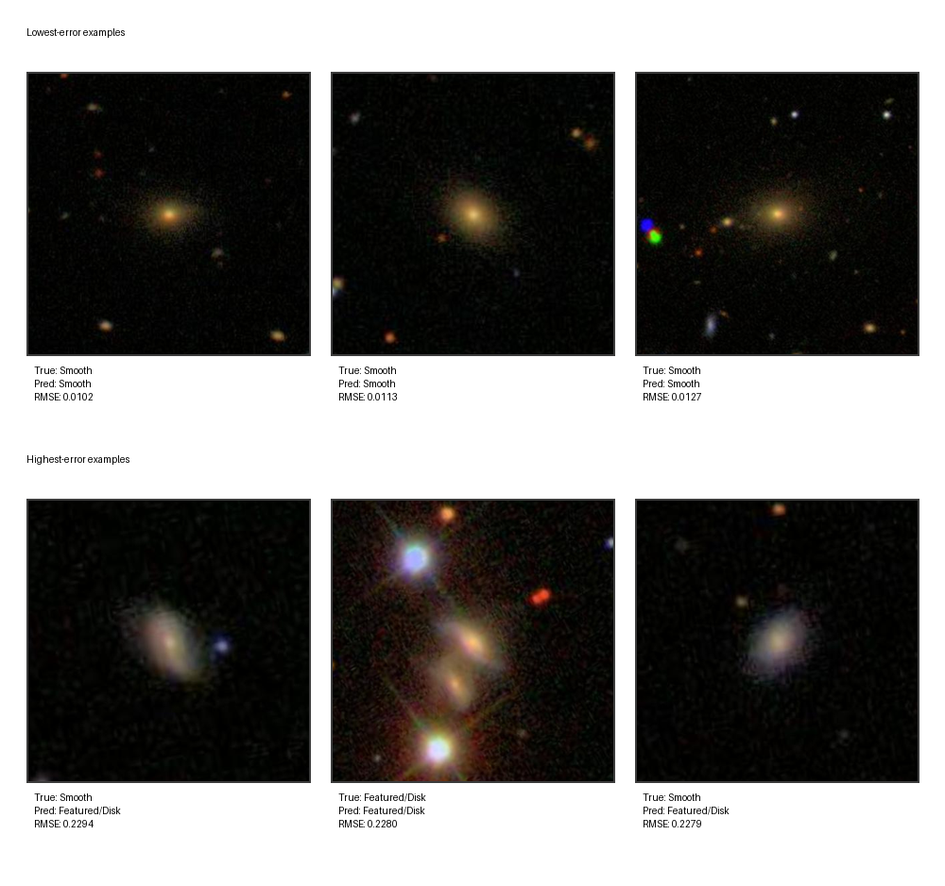
Figure 24. Representative lowest-error and highest-error Galaxy Zoo vote-fraction prediction examples.

4.5. Reliability-Oriented Evaluation
Reliability evidence collected during the robustness testing, selective-confidence analysis, confidence/error diagnostics, and visual explanations with saliency maps is enumerated in Table 9.

Table ‎9. Quantitative reliability evidence supporting the proposed galaxy morphology framework.
Reliability component | Experiment / evidence source | Quantitative evidence | Interpretation
Robustness under perturbations | Galaxy Zoo 37-output vote-fraction prediction | Clean RMSE = 0.074912; Gaussian noise RMSE = 0.095387 | Gaussian noise produced the clearest degradation, showing that strong image noise affects continuous vote-fraction prediction.
First-gate stability | Galaxy Zoo 37-output vote-fraction prediction | Clean first-gate agreement = 0.887626; Gaussian noise agreement = 0.797770 | The first-gate morphology decision remained meaningful, but decreased under stronger noise.
Selective confidence | Smooth vs Featured classification | Full-test accuracy = 99.1736%; at threshold 0.88: accepted accuracy = 99.8801% with 98.4652% coverage; at threshold 0.975: accepted accuracy = 100.0000% with 95.8087% coverage | Higher confidence thresholds improved accepted-prediction reliability while reducing coverage.
Confidence and error behaviour | Galaxy Zoo 37-output prediction diagnostics | Mean confidence: correct = 0.750, incorrect = 0.578; mean sample RMSE: correct = 0.065, incorrect = 0.096 | Incorrect predictions were associated with lower confidence and higher sample-level error.
Visual explanation evidence | Saliency-based explanation examples | Saliency maps visually concentrated around galaxy regions in selected lowest-error and highest-error examples | The visual evidence supports that the model attention was generally located on relevant galaxy structures.

Corresponding visual evidence for robustness of the pipeline (Figure 25), confidence/error diagnostics (Figure 26), and saliency maps (Figure 27) confirms that feature extraction of the model remains tightly related to physically relevant structures.
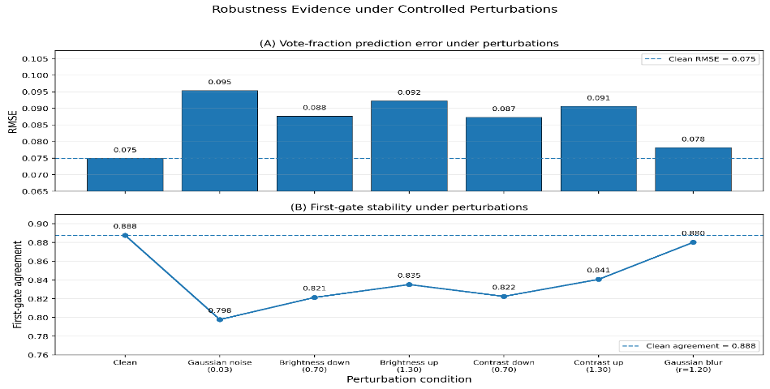
Figure ‎25. Framework-level robustness evidence under controlled image perturbations.
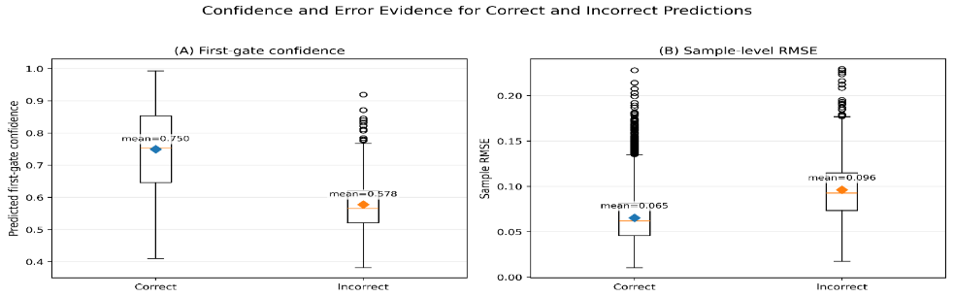
Figure ‎26. Confidence and error evidence for correct and incorrect galaxy morphology predictions.
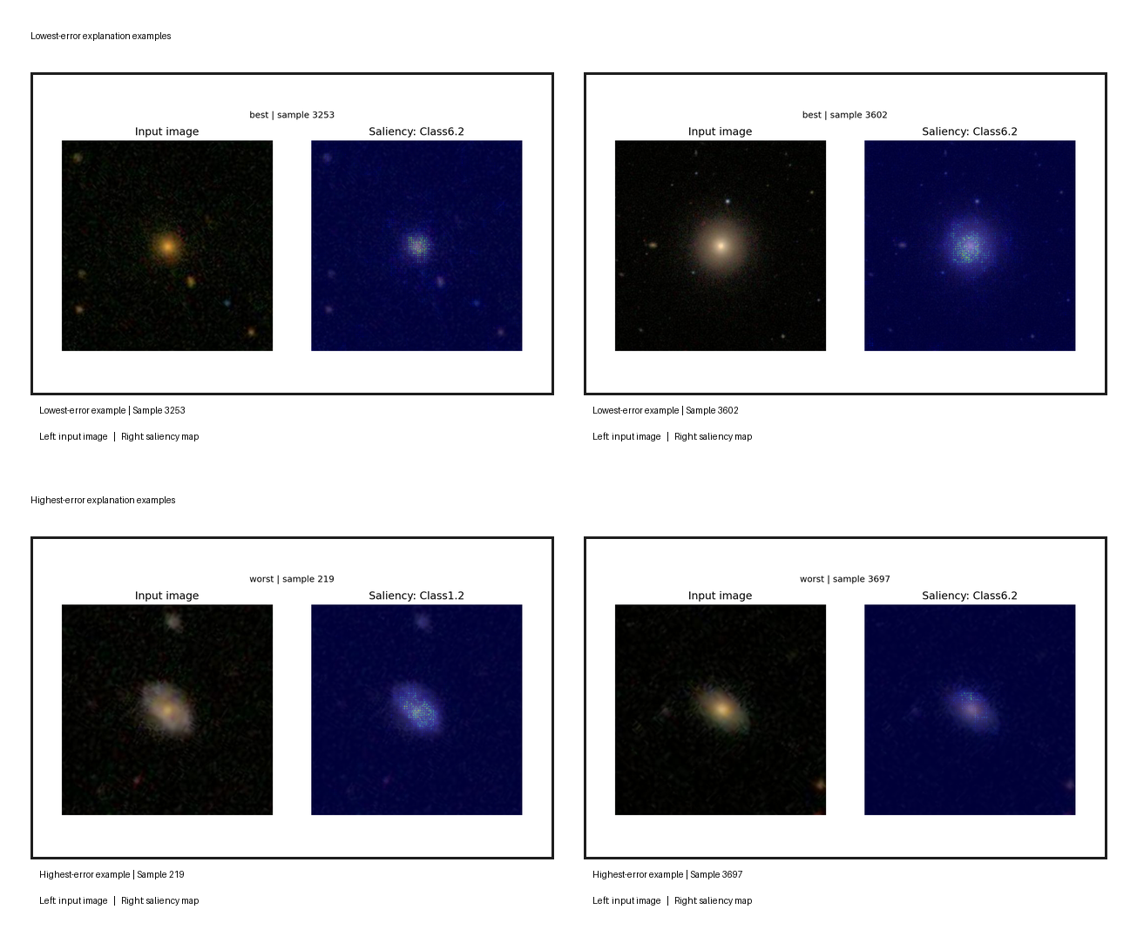
Figure ‎27. Saliency-based visual explanation evidence for selected lowest-error and highest-error Galaxy Zoo predictions.

4.6. Discussion
This sub-section highlights the key results from Section 4 and positions the proposed architecture in the existing literature on galaxy morphology classification. As there were two directions for evaluations, the comparative analysis is divided into two parts: Galaxy10 DECaLS hard-label classification and Galaxy Zoo vote-fraction evidence.

Table ‎10. Comparison with Galaxy10 DECaLS hard-label classification studies.
Study / Evidence | Dataset / Task | Method / Model Family | Reported Result | Position Relative to This Framework
Luo et al. (2025) | Galaxy10 DECaLS classification | Semi-supervised GAN-based learning | ~84% accuracy | Relevant Galaxy10 reference under limited-label learning.
Yao et al. (2024) | Galaxy10 DECaLS classification | FSL-GAN data augmentation | F1-score up to 89.54% | Augmentation-based reference for limited and imbalanced galaxy classes.
Mao et al. (2025) | Galaxy10 DECaLS and GZD-5 classification | DenseNet-SE4 with attention | 88.96% accuracy | Attention-enhanced comparison for visually similar galaxy classes.
Chen et al. (2025) | Galaxy10 DECaLS classification | Semi-supervised learning with uncertainty estimation | 76.8% accuracy with 2,000 labeled samples | Uncertainty-aware reference under limited-label learning.
Proposed Metedology | Galaxy10 DECaLS ten-class classification | ConvNeXtV2 transfer-learning CNN model | 91.58% accuracy; macro F1 = 0.9073 | Integrates competitive accuracy with robustness profiling and explainable AI.

Continuous vote-fraction estimation and routing performance are compared with the historical and contemporary benchmarks of surveys in Table 11.

Table ‎11. Comparison with Galaxy Zoo and Kaggle benchmark evidence.
Study / Evidence | Dataset / Task | Method / Evaluation Type | Reported Result | Position Relative to This Framework
Dieleman et al. (2015) | Galaxy Zoo morphology classification | Rotation-invariant CNN | ~91% accuracy | Provides an early CNN-based Galaxy Zoo morphology classification benchmark.
Walmsley et al. (2022) | Galaxy Zoo / DECaLS morphology responses | Probabilistic deep learning / Zoobot | Vote-fraction response prediction | Provides an important reference for treating galaxy morphology as response distributions rather than only hard labels.
Pearson et al. (2026) | Galaxy Zoo high-confidence morphology questions | Zoobot-based active learning and volunteer-label evaluation | Very high Smooth or Featured performance on high-confidence volunteer labels | Provides a directly related comparison point for the high-confidence Smooth vs Featured routing stage.
Ye et al. (2025) | Galaxy Zoo morphology questions under cross-survey shift | Unsupervised domain adaptation for Galaxy Zoo morphology prediction | Smooth or Featured reported with strong performance under domain-adaptation evaluation | Supports the importance of robustness and dataset-shift evaluation for first-level morphology prediction.
Original Galaxy Zoo Challenge winning solution (Dieleman, 2014) | Galaxy Zoo Challenge 37-output vote-fraction prediction | Kaggle private leaderboard benchmark | Private RMSE = 0.07492 | Provides the original Kaggle benchmark reference for Galaxy Zoo vote-fraction prediction.
This study: Smooth vs Featured stage | Galaxy Zoo high-confidence binary morphology routing | YOLO11x classification family | 99.1736% accuracy; macro F1 = 0.9881 | Shows strong first-level morphology routing using high-confidence vote-fraction labels.
This study: Galaxy Zoo vote-fraction task | Galaxy Zoo 37-output vote-fraction prediction | ConvNeXtV2 Large held-out test evaluation | RMSE = 0.074912; MAE = 0.042315 | Extends the framework beyond single-label classification toward continuous morphology estimation.
This study: Kaggle post-deadline evidence | Galaxy Zoo Challenge 37-output vote-fraction prediction | External Kaggle scoring evidence | Public RMSE = 0.07433; Private RMSE = 0.07440 | Provides supporting external benchmark evidence and is not treated as a final leaderboard claim.
Note: Lower values of RMSE mean better performance.

As seen from the comparative analysis, while the standalone models might be optimized for some specific metrics, the proposed framework manages to bridge hard labeling and continuous uncertainty-aware estimation. It provides the calibrated uncertainty intervals along with visual explanations, thus ensuring a solid basis for the automated morphology pipelines.

5. Conclusion
This paper proposed and assessed a confidence-aware deep learning framework for the purposes of galaxy morphology classification and analysis based on the Galaxy10 DECaLS and Galaxy Zoo dataset. Various model families were studied, including convolutional neural networks, CNN backbone of the transfer-learning models, transformers, and YOLO object detectors. The proposed framework consisted of three types of tasks: ten-class hard-label classification, high-confidence Smooth-versus-Featured routing, and prediction of 37 Galaxy Zoo vote-fractions. ConvNeXtV2 model performed with a held-out test accuracy of 91.58% and a Macro F1-score of 0.9073 on the ten-class task, while YOLO11x performed with an accuracy of 99.17% and a Macro F1-score of 0.9881 on the high-confidence binary task. As for the 37-outputs prediction, ConvNeXtV2 Large performed with an RMSE of 0.074912 and MAE of 0.042315. Additionally, the post-deadline submission on Kaggle offered extra external benchmarking evidence with the Public and Private RMSE scores of 0.07433 and 0.07440, respectively, compared to the original Galaxy Zoo Challenge winner Private RMSE score of 0.07492; however, the held-out test results were the primary ones. Along with confidence analysis, controlled robustness testing, Grad-CAM and saliency map visual explanation techniques, this work proves that the research goals have been fulfilled and the main research question was answered within the experimental scope of this study.

Nonetheless, the results of this work must be considered within the context of the used datasets and evaluation conditions. Some classes of the Galaxy10 dataset are visually similar or ambiguous, and the performed perturbations do not cover all imaging conditions or survey differences that might appear in future astronomical observations. Moreover, the visual explanation techniques provide additional evidence but not complete proof of the model reasoning. Therefore, further work on this topic might include expanding the evaluation of the framework on more astronomy surveys, developing the confidence calibration and uncertainty estimation via probabilistic and/or Bayesian approaches, performing the robustness testing under survey and observation shift conditions, and adding the evaluation of the visual explanations quantitatively. Also, the framework can be further extended to build an AI-assisted decision support system for the initial morphology classification and explanation.

References

Bhambra, P., Joachimi, B., and Lahav, O. (2022). “Explaining deep learning of galaxy morphology with saliency mapping”. Monthly Notices of the Royal Astronomical Society 511(4), pp. 5032–5041. https://doi.org/10.1093/mnras/stac368

Cao, J., Xu, T., Deng, Y., Deng, L., Yang, M., Liu, Z., & Zhou, W. (2024). “Galaxy morphology classification based on Convolutional Vision Transformer (CvT)”. Astronomy & Astrophysics 683, A42. https://doi.org/10.1051/0004-6361/202348544

Chen, Z., Xu, Z., & Chen, W. (2025). “Semi-supervised learning for galaxy morphology classification based on diversity enhancement and uncertainty estimation”. Research in Astronomy and Astrophysics, 25(10), 104005. https://doi.org/10.1088/1674-4527/adf712

Dieleman, S. (2014). “My solution for the Galaxy Zoo challenge”. Sander Dieleman Blog. https://sander.ai/2014/04/05/galaxy-zoo.html

Dieleman, S., Willett, K. W., and Dambre, J. (2015). “Rotation-invariant convolutional neural networks for galaxy morphology prediction”. Monthly Notices of the Royal Astronomical Society 450(2), pp. 1441–1459. https://doi.org/10.1093/mnras/stv632

Fernando, T., Rathnayake, S., & Dissanayaka, K. (2024). “Galaxy Morphology Classification Based on VGG19 Deep Convolutional Neural Network”. 2024 6th International Conference on Advancements in Computing (ICAC), pp. 229–234. https://doi.org/10.1109/ICAC64487.2024.10851157

Le, T., Ibrahim, N., Nguyen, T., et al. (2025). “Enhanced Comparative Analysis of Pretrained and Custom Deep Convolutional Neural Networks for Galaxy Morphology Classification”. Engineering Proceedings 89(1), Article 36. https://doi.org/10.3390/engproc2025089036

Luo, Z., Chen, J., Chen, Z., Zhang, S., Fu, L., Xiao, H., & Shu, C. (2025). “Galaxy Morphology Classification via Deep Semi-supervised Learning with Limited Labeled Data”. The Astrophysical Journal Supplement Series 279(1), Article 17. https://doi.org/10.3847/1538-4365/addb4c
Mao, Y., Tu, L., Xu, Z., Jiang, Y., & Zheng, M. (2025). “Galaxy morphology classification based on DenseNet-SE4 algorithm”. Research in Astronomy and Astrophysics, 25(8), 085009. https://doi.org/10.1088/1674-4527/ade22c

Parker, L., Lanusse, F., Golkar, S., et al. (2024). “AstroCLIP: a cross-modal foundation model for galaxies”. Monthly Notices of the Royal Astronomical Society 531(4), pp. 4990–5011. https://doi.org/10.1093/mnras/stae1450

Pearson, J., Dickinson, H., Serjeant, S., Walmsley, M., Fortson, L., Kruk, S., Masters, K. L., Simmons, B. D., Smethurst, R. J., Lintott, C., et al. (2026). “Galaxy Zoo: Cosmic Dawn–morphological classifications for over 41,000 galaxies in the Euclid Deep Field North from the Hawaii Two-0 Cosmic Dawn survey”. Monthly Notices of the Royal Astronomical Society 546(3), Article staf2250. https://doi.org/10.1093/mnras/staf2250

Walmsley, M., Lintott, C., Galloway, M., et al. (2022). “Galaxy Zoo DECaLS: Detailed visual morphology measurements from volunteers and deep learning for 314,000 galaxies”. Monthly Notices of the Royal Astronomical Society 509(3), pp. 3966–3988. https://doi.org/10.1093/mnras/stab2093

Yao, Y., Zhang, J., Du, P., & Dong, S. (2024). “A Galaxy Image Augmentation Method Based on Few-shot Learning and generative adversarial networks”. Research in Astronomy and Astrophysics 24(3), Article 035015. https://doi.org/10.1088/1674-4527/ad2128

Ye, R., Shen, S., de Souza, R. S., Xu, Q., Chen, M., Chen, Z., Ishida, E. E. O., Krone-Martins, A., and Durgesh, R. (2025). “From Galaxy Zoo DECaLS to BASS/MzLS: detailed galaxy morphology classification with unsupervised domain adaption”. Monthly Notices of the Royal Astronomical Society 537(2), pp. 640–649. https://doi.org/10.1093/mnras/staf025

14 references???

