

The Relationship Between social Media Use And Depression Among Young Adults

Prepared By
Name: Talal Kamal ID No.: 221001382
Submitted in fulfilment of the requirements for the degree Master of Science in Artificial Intelligence
At
College of Informatics
Midocean University
UAE
Supervisor Name: Dr. Mustafa Sharif,
College of Informatics, Midocean University, Comoros

Acknowledgements

I would like to sincerely express my gratitude to my advisor Dr. Mustafa Sharif, and support throughout this project

Abstract

332 Million of people worldwide affected by depression and the majority the cases are the young adults and they are especially vulnerable and the young adults are the heaviest users of social media and the language and behaviour on the platforms can contribute on early detection for the signals
This thesis reviews the existing NLP and ML approaches to the matter of detecting across the platforms covering the classification needed (SVM, Naïve Bayes), deep learning models (CNN, LSTM) Existing approaches face three persistent limitations: unreliable labelling from self-report and keyword methods, poor generalisability across platforms, and a trade-off between model accuracy and explainability.

List of Abbreviations

- BERT: Bidirectional Encoder Representations from Transformers
- CES-D: Center for Epidemiologic Studies Depression Scale
- CNN: Convolutional Neural Network
- ERDE: Early Risk Detection Error
- LSTM: Long Short-Term Memory
- ML: Machine Learning
- NLP: Natural Language Processing
- RSDD: Reddit Self-reported Depression Diagnosis
- SVM: Support Vector Machine
- WHO: World Health OrganizationGrad-CAM: Gradient-weighted Class Activation Mapping

List of figures

2.1 Global depression and suicide statistics
2.2 Global average daily social media usage
2.3 TikTok global user growth and engagement
2.4 Social comparison theory framework
2.5 Passive versus active social media use
2.6 NLP processing pipeline for text classification
2.7 CNN and LSTM architectures for text classification
2.8 Depression detection framework pipeline

Chapter 1: Introduction

Social media are online platforms that allow people to share what they want to share or tell people whether it is sharing information personal or general information or the entertainment content and also communicate with others these platforms provide various types of content and communication and the most popular platforms Instagram, snapchat, TikTok, Facebook and X.

social media has become important to many people because millions of people use social media every day for all sorts of reasons communication, business , ideas , news , entertainment, staying connected with friends and family, as a result it became part of peoples routine in daily basis the social media has Taken a significant part of everyday life and it has become an important part to each individual for both young people and adults and there are a lot of kinds of usage to social media weather it’s just wasting time in scrolling or reading and social media offers both benefits and risks in this situation and it became very important and it can help a lot to people to connect with others and to enjoy time.

However excessive or unhealthy social media use can lead to an emotional distress and may contribute to depressive symptoms these effects can have a significant psychological impact on individuals weather it is comparing yourself toothers which leads to lower self-esteem or cyberbullying or the emotional numbness that comes after doomscrolling excessive use may also reduce productivity and interfere with daily activities and leads to bad phycological affects.

the reason why researchers are interested in this issue is because these platforms are in a rapid growth in a large scale and their impact on how people communicate and live and it have both benefits or risks mainly on the mental health and state health this is considered to be an important issue for that depression can affect the person not only on an emotional level it can affect their academic performance relationships and quality of life.

Depression may affect an individual relationship, academic, quality of life, and in sever cases daily functioning so understanding this matter can help providing individuals and professionals develop a way to use them in a healthier way for a daily routine.

this research will discuss what are the relationship between the social media use and how it is related with an impact to their users this research will identify weather social media is excessive for higher levels of depression and identify the factors that contribute in this relationship and this research will help student, parents, mental health professionals , for a better understanding of the affect of social media and how to be caution in the matter.

  - problem Definition

The use of social media have increased dramatically over the last decade it became a daily routine a part of everyday life and the time that is spent on social media is significant time based on most people such as Instagram, TikTok, Snapchat, x, etc. and it is still growing more and more researchers have become concerned about the effects that it can leads to mental state and it is easy to access for all ages it does not mean that social media are bad but not being caution can lead to mental health problems
Although social media can actually help in many ways as an art or music insight and knowledge and there are a lot of advantages but the excessive use may negatively affect the users mental health and state it is considered a problem when there are many of the users suffer from anxiety, stress, loneliness, depressive, after spending much time screen not getting anything done or productive about there own life because millions use social media every day even a small effect can have a large impact on society
Researchers believe several online actions take a role in the matter of increasing the risk of depression and these actions include comparing yourself to others seeking validations from the people you like or follow you unrealistic goals or beauty too much scrolling (doomscrolling) fear of missing out (FOMO) that includes trends in the way of speaking and memes and there is the impact of influencers weather it is the way they think or dress or believe it can impact there followers too and it can have a great impact of the individual personality and belief system and the cyber bullying and Fake lifestyle , misleads about information’s
Although there are a lot of studies around the relationship between social media and its relevance to depression and mental health and state there are still more questions to the matter require further investigation and a lot to of reports and finding and examinations to cover and understand more to determine the main factors of influencing the mental health and state
This research aims to address the link between the social media and mental health to young adults mainly and identifying what contributes in the mental health and providing much better understanding on how social media can be a factor on the mental health and how it can help building a healthier habits

  - Research objective

This research conducted due to how social media became an essential part of everyday life specially among the young adults as for the numbers of users are in a continuous increase it is important to hot it is impacting the mental health and how they might contribute in depression
To measure the time spent on the social media and the usage patterns and online behaviours is associated with the higher level of depression among users
And to identify the activities and behaviours that cause the contribute to depression including self-comparison, cyberbullying, fear of missing out , doomscrolling, seeking validations
And to provide recommendations that provide for a healthier habits and usage of the social media platforms and spread awareness of the matter and guiding people to better usage to them and more safely

  - thesis contributions

the value of the research is in investigating in worldwide issue affecting young adults today

the relationship between social media use and depression

a better understanding of the matter well help individuals recognise and aware of the unhealthy habits and behaviour

it will benefit students, parents, teachers, and doctors in the mental health profession, influencers

This study may help and encourage the excessive users on a healthier paths and parents to be cautious and influencers on how to be aware of their impact on the people it can help from each part how to be responsible

Chapter 2: Introduction

This chapter will provide the background on the social media and depression concept it will cover the link between the two and its effects on the mental health and review previous studies that investigated the relationship studies and cases in the relationship between them and what does require more investigation in the matter

2.2 Background

2.2.1 Depression among the young adults

Depression also known as (depressive disorder) it as a common mental disorder it involves depressed mood and loss of simple pleasures or interest in any kind of activates whether simple activates or important ones for a long period of time and because this state consist within the person it have symptoms like: sleep disturbance, fatigue, concentration difficulty and it is estimated that it affects roughly 332 million people making it a worldwide issue

Why the young adults? Young adults represent the population of the most users in the social media platforms and most of the global incident ages are in the ages of 15-39-years-old, and suicide ranks are the fourth leading factor of death among these ages and behind why the young adult’s vulnerability for the social media effects this period of time the development and the transitions starting with education works the whole identity formation and critically young adults are the highest rates of usage for social media

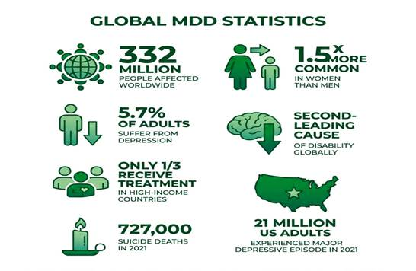

2.2.2 Social media use pattern

The scale of how the use of social media became among the young adults aged 18-24 years the screen time with an average of 141 minutes a day and the global average for users are roughly 2 hours 21 minutes across all users

Platforms choice among the users have shifted very notable in the recent years toward TikTok has been set as the most used platform overall
Beyond the raw usage of time and efforts in the social media a behavioural patterns started to link with this usage nearly 70% of people check their feeds within
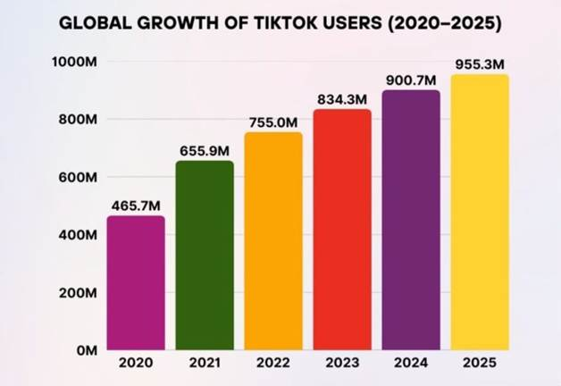

minutes of waking up one of the reports show that 15% of the adults between 23-38 years old identified as addicted to social media with over 40% reported they have sleep disruption related to their time screen and checking this behaviour risk a factor for the depressions symptoms

2.2.3 Theoretical mechanisms linking

One established works explaining this relationship on the comparison theory was established by Festinger on (1954) which explains that the individuals evaluate and make worth of himself by comparing their own self to others, and on social media the user mostly exposed to people to idles actors, the wealthy, the beautiful, so they are idealize these things give them something could be hard to obtain or even feel as a failure and this exposure to this outstanding competition it has been shown to negatively impact the self-esteem while positively leading to depression

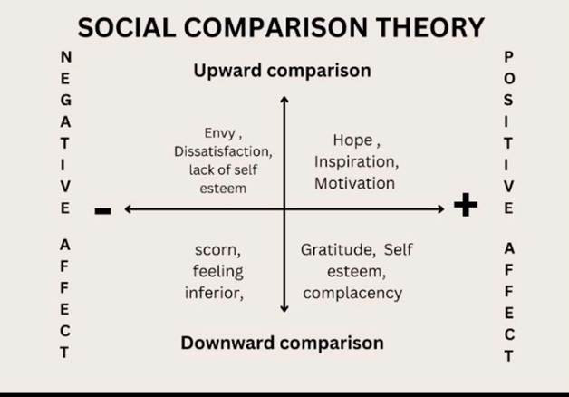

there are passive and active exposures the measurement to this is not depending as scrolling reading and watching without engaging which is the heavily negative on their usage time screen whether heavy or not the passive one defined on since it maximizes exposures to others as for the active one have in some studies shows that it is associated with more social support and better outcomes

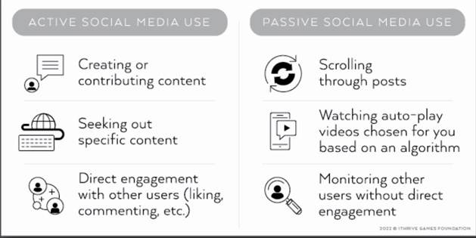

2.2.4 NLP/ML approaches to depression detectors

Knowing that depression manifest in different languages and different word of choice to each individual and the Natural language processing (NLP) turn the text to a computer language that can work with Machine learning (ML) to find the pattern in those numbers to that correlate to an outcome to this case Weather depressed or not and the detector will read negative emotions terms to classify a fit for a large scale as for the early studies works relied primely on machine learning classifiers as SVM, Naïve Bayes, Random Forest, Logistic Regression trained on hand-engineered

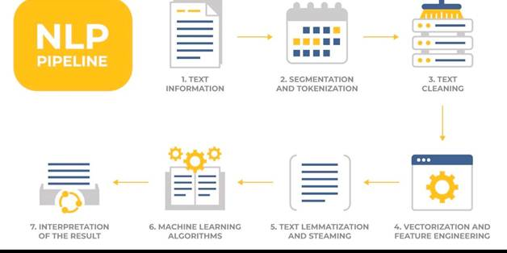

Later studies toward Convolutional Neural Network (CNN) and Long Short-Term Memory (LTSMs) CNN originally it was made for images but it can read texts it gets a group of words (3-5) and learns recognise meaningful patterns for a full sentence, LTSMs tracks the meaning of the words in sentences by remembering earlier texts and contents

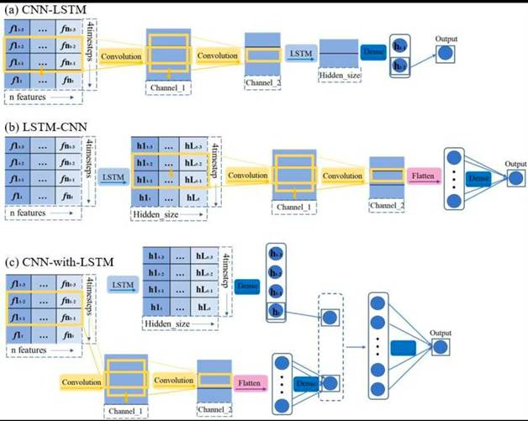

2.2.5 Detection Framework Pipeline

Depression detection systems tend to follow end-to-end pipeline data is collected from the social media platform based on keywords or self-disclosure to identify the most likely depressed or depressed users and the system gives a score on how likely the user is affected through classifications using either traditional ML or deep learning models

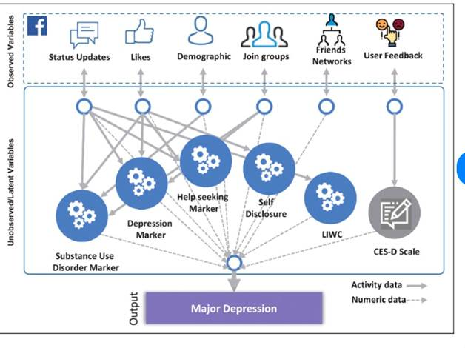
The key to this decision making across the framework on how ground-truth labels are obtained. Some relies on the expressions of the users if a user stated that he was diagnosed with depression while others different terms and weaker sad each approach involves a trade-off of between label reliability and dataset scale with self-report and keyword-based methods enabling larger datasets
For finale stage of the framework pipeline, it gives a binary statement on the cases whether depressed or not depressed and for the advanced frameworks a risk score that flags a user account

2.2.6 Datasets Resources

The choices of the platforms that were used for the datasets have been contributing in the research over the years which are Twitter(X), Reddit, Shared task/benchmark

Twitter (X): have been a common source in early works and study cases since 2013 using the users self-reports collecting one year of tweeting for each participant and on later works on 2018 Orabi et al built on twitter(X) based collections relying on keywords and self-reports to identify and filter the depressed ones

Reddit: have a significant impact on the study cases and researches due to its mental health communities and their long-posts which remained one of the most favoured since it is one of the largest and most Widley
Benchmarks in the area

2.2.7 The Limitations & Challenges of This Approach

Despite the progress the researchers have come through one of the biggest challenges it is reliabilities of the methods: self-report diagnosis and keywords-based

Related works

- De Choudhury et al 2013: Investigated if social media can be used to identify behavioural association with depression and the researchers have collected data from hundreds of users who have been clinically diagnosed with depression as a major factor in assisting the process of the research and several social engagements, emotional expressions, language patterns, characteristics, mentions of medications, afterwards a statistical model comes to classify to estimate the risk of depression based on these behaviours and keywords
And the study found the relationship between social media and its relevance to the users cases on the activates on social media associate and indicates with depression

2. Coppersmith 2014: Investigated if twitter (X) data if they can provide signals and indicators in the mental health state the study examined several conditions and cases including Bipolar disorder, post-traumatic stress disorder (PTSD), seasonal affective disorder (SAD) the researchers compared in different languages for the indivisibles associated with different mental health state and identified the linguistic in the information’s that could provide for useful information and the study showed that social media language can measure signs to the mental health state although the relied on the publicly availability of information

3. Tsugawa Investigated the pattern on twitter (X) in Japan users the researchers collected the activity history through web-based questionnaire on the centre of epidemiologic studies depression scale (CES-D) and used support vector machine (SVM) to estimate the user mental health and the studies showed an accuracy of 69% user

4. Losada & Crestani 2016— Participated on the lack of the public dataset availability that could contribute in the studies regarding the relationship between social media and depression so the researchers developed interaction texts from social media the resulting to a collection of 892 users and 137 users who have self-reported on there depression and 755 in the control groups.

5. Reece & Danforth 2017 — tried photos instead of words. Instagram, Invistgated if Instagram photos could contain measurable indicators for depression the research had 166 participants within them are diagnosed with depression already 71 resulting 43,950 photos and the method shows contribution in the research although it mostly relies on Instagram.

6. Shen 2017 — combined text, images, and behaviour together. Investigated the possibility of combining multiple social media platforms for improving the detection of the mental health and used six groups of depression related on twitter (X) and it has shown that this method contributed and improved on the existing methods with a rate of 3-10%

7. Yates 2017 — Built a dataset can study and detect depression from social media using Convolutional Neural Network (CNN) on reddit with a result of 9000 users who had publicly disclosed a depression and the method a large scale of dataset on social media . Problem: only captures open people.

8. Trotzek 2018 — investigated the detection of depression from social media using neural-network methods. Reddit, used the eRisk dataset and combined CNN with word embeddings and additional information about users. The method achieved strong results compared with other approaches and showed that combining text representation with additional features can improve depression detection. Problem: the method was mainly evaluated on one benchmark dataset.

9. Sadeque 2018 — investigated how early depression can be detected from social media. Reddit, used LSTM to analyse users’ posts over time and introduced a latency metric to measure how quickly depression can be detected. The study showed a trade-off between detection speed and accuracy. Problem: detecting depression earlier can reduce the available information and affect accuracy..

10. Orabi 2018 — investigated different word-embedding methods for depression detection. Twitter, tested CNN and RNN models to analyse the text of users’ posts. CNN showed better performance than the tested RNN approach. The study shows that deep-learning models can identify useful language patterns related to depression. Problem: the results were mainly based on the specific dataset used..

11. Guntuku 2017— reviewed previous research about detecting depression and mental illness through social media. Studied multiple platforms and summarized different indicators such as language, online activity and social-network patterns. The review showed that users with depression can be distinguished through differences in their language and online behaviour. Problem: it was a review and did not introduce a new experimental model.

12. Tadesse 2019 — investigated the detection of depression-related posts on Reddit. Used linguistic features and machine-learning methods including LSTM and word-based features to identify depression-related content. The combined features showed better performance than using individual approaches, with the best reported result around 80% accuracy. Problem: the method focuses on detecting depression-related posts rather than directly identifying depression in individuals.

13. Kerasiotis 2024 — investigated the use of transformer models for detecting depression from social-media posts. Used DistilBERT together with metadata and linguistic features and a neural-network classifier. The proposed approach achieved a weighted F1-score of about 84%, improving from 72.59% after data augmentation. The study shows the benefit of combining transformer-based language representations with additional features. Problem: transformer models can be difficult to interpret and require suitable training data.

14. Pirina & Çöltekin 2018 — investigated the reliability of datasets used for depression detection. Reddit, compared different datasets and control groups using machine-learning methods including SVM. The study showed that the way control groups are selected can significantly affect the results of depression-detection models. Problem: high results may depend partly on how the dataset is constructed and may not represent other platforms

15. Losada, Crestani & Parapar 2017/2018 — developed the eRisk shared-task framework for early detection of depression from social-media writings. Reddit, different research teams used the same benchmark to compare their depression-detection methods and identify depression as early as possible. The framework provided a standard way to compare different approaches and helped develop research in early depression detection. Problem: the benchmark mainly relies on Reddit, so the results may not represent users from other social-media platforms.

# |  | Study | Platform |  | Method | Key results | Limitation
1 | De Choudhury 2013 |  | Twitter (X) | SVM |  | 70% Accuracy |  | Small sample
2 | Coppersmith  2014 |  | Twitter (X) | Linguistic analysis |  | Clear language differences |  | Unverified self-reports
3 | Tsugawa 2015 |  | Twitter (X) in Japan | Logistic regression |  | 69% Accuracy |  | Single language/culture
4 | Losada & Crestani 2016 |  | Reddit | Benchmark creation |  | eRisk dataset introduced |  | Reddit only
5 | Reece & Danforth 2017 |  | Instagram | ML on image features |  | Beat unaided GP rate |  | 166 users only
6 | Shen 2017 |  | Twitter (X) | Multimodal dict. learning |  | Beat single-modality models |  | Needs multiple data types
7 | Yates 2017 |  | Reddit | CNN |  | RSDD benchmark, 9k users |  | Self-disclosure bias
8 | Trotzek 2018 |  | Reddit | CNN + metadata ensemble |  | SOTA early detection |  | Benchmark-specific tuning
9 | Sadeque 2018 |  | Reddit | LSTM + latency metric |  | Speed/accuracy trade-off |  | Metric still debated
10 | Orabi 2018 |  | Twitter (X) | CNN/RNN + embeddings |  | CNN performed best |  | Dataset-specific
11 | . Guntuku 2017 |  | Multiple platforms | integrative review |  | Synthesised known markers |  | No new experiment
12 | Tadesse 2019 |  | Reddit | LSTM + feature models |  | Combined beat single models |  | Post-level, not user-level
13 | Kerasiotis 2024 |  | Social media posts | DistilBERT + auxiliary |  | Beat traditional ML |  | Black box, low explainability
14 | . Pirina & Çöltekin 2018 |  | Reddit | SVM + n-grams |  | Depends on control data |  | Possible dataset artefacts
15 | . Losada, Crestani & Parapar 2017/2018 |  | Reddit | Annual shared task |  | Standardised comparison |  | Reddit-only framing

References

[Coppersmith, Glen, et al., 2014]
Coppersmith, Glen, Mark Dredze, and Craig Harman. "Quantifying mental
health signals in Twitter". Proceedings of the Workshop on Computational
Linguistics and Clinical Psychology, 51-60, 2014.
https://aclanthology.org/W14-3207/

[De Choudhury, Munmun, et al., 2013]
De Choudhury, Munmun, Michael Gamon, Scott Counts, and Eric Horvitz.
"Predicting depression via social media". Proceedings of the 7th
International AAAI Conference on Weblogs and Social Media, 128-137, 2013.
https://ojs.aaai.org/index.php/ICWSM/article/view/14432

[Kerasiotis, Marios, et al., 2024]
Kerasiotis, Marios, Loukas Ilias, and Dimitris Askounis. "Depression
detection in social media posts using transformer-based models and
auxiliary features". arXiv preprint arXiv:2409.20048, 2024.
https://arxiv.org/abs/2409.20048

[Losada, David E., and Fabio Crestani, 2016]
Losada, David E., and Fabio Crestani. "A test collection for research on
depression and language use". CLEF 2016, 28-39, 2016.

[Orabi, Ahmed Husseini, et al., 2018]
Orabi, Ahmed Husseini, Prasadith Buddhitha, Mahmoud Husseini Orabi, and
Diana Inkpen. "Deep learning for depression detection of Twitter users".
Proceedings of the Fifth Workshop on Computational Linguistics and
Clinical Psychology, 88-97, 2018.
https://aclanthology.org/W18-0609/

[Reece, Andrew G., and Christopher M. Danforth, 2017]
Reece, Andrew G., and Christopher M. Danforth. "Instagram photos reveal
predictive markers of depression". EPJ Data Science 6(1), 15, 2017.
https://epjdatascience.springeropen.com/articles/10.1140/epjds/s13688-017-0110-z

[Sadeque, Farig, et al., 2018]
Sadeque, Farig, Dongfang Xu, and Steven Bethard. "Measuring the latency
of depression detection in social media". WSDM 2018, 495-503, 2018.

[Trotzek, Marcel, et al., 2018]
Trotzek, Marcel, Sven Koitka, and Christoph M. Friedrich. "Utilizing
neural networks and linguistic metadata for early detection of depression
indications in text sequences". IEEE Transactions on Knowledge and Data
Engineering, 2018. https://arxiv.org/abs/1804.07000

[Tsugawa, Sho, et al., 2015]
Tsugawa, Sho, Yusuke Kikuchi, Fumio Kishino, Kosuke Nakajima, Yuichi Itoh,
and Hiroyuki Ohsaki. "Recognizing depression from Twitter activity".
CHI 2015, 3187-3196, 2015.

[World Health Organization, 2023]
World Health Organization. "Depressive disorder (depression)".
WHO Fact Sheets, 2023.
https://www.who.int/news-room/fact-sheets/detail/depression

[Yates, Andrew, et al., 2017]
Yates, Andrew, Arman Cohan, and Nazli Goharian. "Depression and self-harm
risk assessment in online forums". EMNLP 2017, 2968-2978, 2017.
https://aclanthology.org/D17-1322/

