An Integrated Technical and Fundamental Stock Analysis Model for the Saudi Stock Market (Tadawul)
Prepared By
Name: Malek M. Atarji ID No.: 252000474
Master of Science in Artificial Intelligence
Supervisor Name: Dr Amjad Qatish
Midocean University, Comoros
Abstract
Objectives:
The primary aim of this study is to propose and assess a two-level probabilistic stacking ensemble model for the prediction of trading signals within the Saudi Stock Market. The approach to be used involves incorporating both technical and financial information, using a Bidirectional Long Short-Term Memory (BiLSTM) model and an Extreme Gradient Boosting (XGBoost) model to formulate the trading signal predictor. The aim is to develop a more accurate trading signal predictor by utilizing both deep and machine learning methods.
Study Location:
The study will be performed using historical data from the Saudi Stock Exchange (Tadawul) and its companies.
Methodology:
The technical indicators from the stock market were used to train the BiLSTM model, while the financial indicators from the companies was used to train the XGBoost model. The probabilities of the trading signals that are predicted by both of these models will then be calibrated by the Isotonic Regression model and combined by the two-level stacking ensemble (Logistic Regression). The framework will be evaluated using accuracy, precision, recall, the F1 score, ROC-AUC, the Sharpe Ratio, the Sortino Ratio, the Profit Factor, and the Maximum Drawdown.
Results:
The results of the proposed model indicate that the ensemble outperformed the individual BiLSTM and XGBoost models. The model exhibited better classification. The findings suggest that using both technical and financial information with the proposed framework results in a more accurate trading signal predictor.
Recommendations:
Future work in this area could include using different meta learners for the ensemble, incorporating additional data sources, and testing the models on other financial markets.
Keywords: Hybrid Artificial Intelligence, BiLSTM, XGBoost, Probabilistic Stacking Ensemble, Saudi Stock Market

1. Introduction
Artificial intelligence (AI) plays an essential role in financial market analysis by identifying complex nonlinear relationships within large volumes of data. Compared to traditional statistical models, AI-based techniques such as machine learning and deep learning offer improved financial market forecasting and investment decision-making capabilities.
The Saudi Stock Exchange (Tadawul) is the largest exchange in the Middle East and has experienced significant growth due to the economic reforms introduced by Saudi Vision 2030. As such, there is a need to identify short-term trading opportunities for investors on the exchange using improved methods.
Technical indicators effectively model the behavior and performance of stocks historically. Financial indicators convey information regarding the financial condition of the company. However, trading solely based on either technical or financial information will likely result in missed opportunities to profit from trading activities. Bidirectional LSTM models can effectively learn the relationship between a stock’s technical indicators and its price movements. However, compared to other machine learning models such as XGBoost, deep learning models do not perform as well in forecasting stock price movements based on a company’s financial variables.
Various models have attempted to overcome the limitations of using only one machine learning model for forecasting stock price movements by creating hybrid models incorporating multiple models. However, the methods used to combine the models, such as weighted averaging, have limited effectiveness in utilizing the information provided by the individual models. Furthermore, neglecting the calibration of the models’ outputs before combining their predictions reduces the reliability of the predictions.
The Two-Level Probabilistic Stacking Ensemble model uses AI techniques to overcome the limitations of existing models for forecasting stock price movements. This model incorporates a deep learning Bidirectional LSTM model that uses the technical indicators of listed companies on the Saudi Stock Exchange and an XGBoost model that uses the financial variables of these companies. The outputs of these two models are calibrated using the Isotonic Regression model and combined by a Logistic Regression model to produce the final prediction of the movement of the companies’ stock prices. This model is evaluated using the historical data of the companies listed on the Saudi Stock Exchange from both a machine learning and an investment perspective. The results of this study demonstrate the increased effectiveness of this model compared to existing methods.

The remainder of this paper includes a problem statement for this study, followed by a discussion of the importance and objectives of the study. The background of the study and previous studies related to the research problem are presented. Finally, the methodology of the proposed model, the results of its testing, and discussions of these results are presented.
2.Research Problem
The problem of accurately predicting the price movements of stocks in the short term remains a challenge in financial market analysis. Most traditional methods of predicting stock price movements rely on either the price movements of the stocks historically or the financial statements of the companies. Due to the volatility of the stock markets, these models exhibit limited success in predicting movements.
Recent advances in AI have allowed for the development of machine and deep learning models that can analyze and predict stock price movements effectively. However, most of these models only incorporate information from either technical indicators or the financial variables of the listed companies on the exchange. Furthermore, the methods used to combine the predictions from these models are often inefficient, failing to take advantage of the information provided by each model’s predictions. Lastly, there is a lack of calibration of the prediction probabilities from these models before combining their predictions.
Considering the limitations of the existing models for forecasting the price movements of the stocks listed on the Saudi Stock Exchange, there is a clear need for a prediction model that can overcome these limitations. Such a model should be intelligent enough to incorporate various types of information from the companies listed on the exchange to produce reliable predictions of the movements of their stock prices.
To overcome the problems identified, the proposed Two-Level Probabilistic Stacking Ensemble will incorporate AI models to learn the relationship between the technical indicators of the listed companies on the exchange and the financial variables of these companies. The outputs of these models will be calibrated using the Isotonic Regression model to increase the reliability of the stock price movement predictions produced by the Logistic Regression model that combines these probabilities. As a result, the proposed model will exhibit improved performance in comparison to existing methods for forecasting the movements of the companies’ stock prices listed on the exchange.
3.Importance of the Study
From the scientific perspective, this study is significant in the context of artificial intelligence applications in financial markets due to the development of a novel Two-Level Probabilistic Stacking Ensemble model that incorporates both deep and machine learning techniques. Unlike many existing approaches to utilizing deep and machine learning models for trading signal prediction, the Two-Level Probabilistic Stacking Ensemble model improves the utilization of deep and machine learning models by utilizing a Logistic Regression model to combine the predicted probabilities of the deep and machine learning models.
Furthermore, the model also contributes to the development of trading signal prediction models that are more reliable than existing models, as it incorporates the Isotonic Regression model to improve the reliability of the predicted probabilities before the stacking ensemble process.
From the technical perspective, the development of this model provides investors and financial market analysts with a new tool that utilizes artificial intelligence to create trading signals for the market. Furthermore, the combination of technical indicators and financial indicator analysis within the model can lead to more comprehensive analysis of the companies that are being evaluated for potential investments, and can improve the trading decisions that are made by those investors.
Finally, because the model is applied to the Saudi Stock Exchange (Tadawul), one of the largest and fastest-growing stock exchanges in the Middle East, the insights that are gained from this model may provide benefit not just to the scientific community, but also to those investors and analysts who trade in these markets. The model can be easily extended to other stock markets within the region and the world, and can be adapted to different time horizons for trading signals.
4.Study Objectives
The main objective of this study is to develop an intelligent, hybrid model that can be used to effectively predict trading signals in the Saudi Stock Market, by integrating deep and machine learning techniques.
The specific objectives of this study are to:
- Develop a Bidirectional Long Short-Term Memory (BiLSTM) model to learn from technical indicators
- Develop an Extreme Gradient Boosting (XGBoost) model to learn from financial indicators
- Improve the reliability of deep and machine learning models using Isotonic Regression
- Create a Two-Level Probabilistic Stacking Ensemble using Logistic Regression
- Evaluate the deep and machine learning models using accuracy, precision, recall, F1-score, and ROC-AUC scores
- Assess the performance of the trading signals created by the proposed models using the Sharpe Ratio, Sortino Ratio, Profit Factor, and Maximum Drawdown
- Compare the individual deep and machine learning models to the Two-Level Probabilistic Stacking Ensemble to determine if integration of technical and financial anal
5. Theoretical Literature
5.1 Artificial Intelligence in Financial Market Prediction
Artificial Intelligence (AI) has become one of the most influential technologies in the field of financial market analysis. AI technology can analyze a vast amount of data from different sources to determine complex relationships between variables within the markets. The use of AI in financial markets is based on machine learning and deep learning algorithms that can accurately predict stock prices and identify trading opportunities.
Financial markets generate a wealth of information from multiple sources. The information from each source yields different insights into the markets. Hence, financial markets have evolved to find ways of integrating information from various sources to enhance market prediction models.
5.2 Bidirectional Long Short-Term Memory (BiLSTM)
A Bidirectional Long Short-Term Memory (BiLSTM) network is an artificial neural network that is specifically designed for cases where the order of the input signals is significant. Compared with conventional LSTM networks, BiLSTM models can read data in both forward and backward directions, which enables them to capture contextual information effectively. The BiLSTM model was trained on a variety of technical indicators of the stock that were gathered from historical market data.
5.3 Extreme Gradient Boosting (XGBoost)
Extreme Gradient Boosting or XGBoost is a supervised machine learning model that is based on decision trees. This model has become the most popular machine learning algorithm in various applications due to its high level of prediction performance. Unlike the BiLSTM model, the XGBoost model was trained on a variety of financial indicators derived from the companies’ financial statements.
5.4 Probability Calibration
The prediction of probabilities by machine learning models is not always accurate. Hence, there is a need to calibrate the models to increase the reliability of their predictions. In this project, isotonic regression was used to calibrate the probabilities of the BiLSTM and XGBoost models to minimize their errors in probability estimation and to provide more reliable confidence values for the trading applications created for the models.

5.5 Two-Level Probabilistic Stacking Ensemble
Ensemble learning combines individual models to create a more powerful model than each individual one. One of the ensembles that has been used for classification problems is the stacking ensemble. In this case, the models are combined using meta-learning to determine the best way to combine their models.
The Two-Level Probabilistic Stacking Ensemble uses the calibrated probabilities from the trained BiLSTM and XGBoost models as inputs to a Logistic Regression model to determine the final outcome. The advantage of this ensemble learning method is that it allows for the framework to benefit from both the technical and financial model predictions while maximizing their accuracy.
6.Review of Previous Studies
Artificial intelligence has significantly improved the use of machine learning and deep learning in the stock market’s prediction. Many studies have employed individual models or hybrid models to improve the accuracy of the trades made with the stock market predictions.
Models based on the Long Short-Term Memory (LSTM) neural network have been used in the stock market predictions. These models have used the technical indicators of the stock markets to train these models. The advantage of these models is their high degree of accuracy in predicting the prices of the stocks. The disadvantage of these models is that they depend on the behavior of the markets of the stocks in the past to determine their predictions and do not account for the financial condition of the company.
Another group of models that has been used in the stock market predictions is the tree-based models such as XGBoost. These models use various financial ratios of the companies to train their models. The advantages of these models are that they can effectively model the relationship between the financial health of the company and the price of its stock. The disadvantage of these models is that they do not account for the technical trading behavior in the markets.
A third group of studies used the combination of the technical and financial models to account for both aspects of the stock market prediction problem. These studies show higher accuracy in their predictions than the individual models. However, most of these studies used methods to combine the individual models predictions that did not take advantage of the relationship between individual models’ predictions.
Another major area of limitation in the existing studies is that they did not pay much attention to the calibration of the models’ predictions. While most of the existing studies used some means to combine the predictions of individual models, few of them accounted for calibrating the models’ probabilities to improve the accuracy of those predictions before model fusion.
To overcome these limitations, the study will use a two-level probabilistic stacking ensemble that uses the BiLSTM and the XGBoost models to calibrate the stocks’ market predictions. However, instead of directly using the models’ predictions, the probabilities of the models’ predictions will be calibrated using the isotonic regression model. Then the calibrated probabilities will be fused using the logistic regression model to produce the final stock market price prediction. This model will not only increase the accuracy of the stock market price predictions but also increase the trading performance in the Saudi Stock Market.
7.Methodology
7.1 Research Design
The research study that will be performed will use an experimental design to test the artificial intelligence framework that will be created for the Saudi Stock Market. This framework will use deep learning and machine learning models to account for the technical and financial data of the stocks. The complete framework will be created to include data collection, preprocessing, individual models, and ensembling and performance evaluation.

7.2 Data Collection
The stock market data for various companies listed on the Saudi Stock Exchange was used. The technical indicators for the stocks will be collected along with the financial statements for the companies.
Table 1. Dataset Characteristics
Characteristic | Value
Stock Market | Saudi Stock Exchange (Tadawul)
Listed Companies | 35
Final Dataset Size | 11,598 observations
Prediction Target | Binary (0 / 1)
Prediction Horizon | 7 Trading Days
Learning Framework | Hybrid AI
Table 1. Characteristics of the Dataset
The final dataset consists of market and financial information collected from 35 companies listed on the Saudi Stock Exchange (Tadawul). Preprocessing and feature engineering steps resulted in a dataset containing 11,598 observations. The task of predicting stock prices within a seven-day period is a binary classification problem.
7.3 Feature Engineering
Feature engineering was performed separately on the technical and financial data.
Technical indicators were calculated from stock prices and trading volumes. These technical indicators were used as inputs for the BiLSTM model.
Financial indicators were calculated from the quarterly financial statements of the companies. These financial indicators were used as inputs for the XGBoost model.
By performing feature engineering separately on each type of data, we allow each model to learn the patterns in the type of data best suited for that model.
7.4 Target Generation
The target variable was generated using the Triple-Barrier Method. For each stock price observation, take-profit and stop-loss thresholds were defined together with a prediction horizon. If the stock price reached the take-profit threshold before the stop-loss threshold within the prediction horizon, a label of 1 was assigned to that observation; otherwise, a label of 0 was assigned.
The method allows for the prediction of stock prices to reflect the decisions that traders make when executing their trades.
Table 2. Binary Target Distribution
Target Class | Samples | Percentage
Positive (Target = 1) | 6,505 | 56.08%
Negative (Target = 0) | 5,093 | 43.92%
Total | 11,598 | 100%
Table 2 presents the distribution of the generated binary target labels. The table demonstrates that the proposed technique has successfully created a balanced dataset without the requirement for synthetic sampling techniques to oversample the majority class or to undersample the minority class. The maintenance of the representation of both classes within the training set contributes to the stability of the models during training, as well as enables meaningful comparisons to be made between the different prediction models.
7.5 Proposed Prediction Framework
The framework that will be proposed and utilized within the project consists of two main prediction models.
The first model that will be utilized is a Bidirectional Long Short-Term Memory (BiLSTM) model that is trained on the technical indicators of the stocks collected from historical stock data. The BiLSTM model is utilized to learn the short-term price movements that often occur within the stocks.
The second model that will be utilized is an Extreme Gradient Boosting (XGBoost) model that is trained on the financial indicators of the companies collected from the financial statements of those companies during each quarter. The XGBoost model is utilized to learn the nonlinear relationships between company fundamentals and future trading opportunities.
The prediction probabilities of both models will be calibrated through the use of Isotonic Regression to ensure that the trading signal predictions provided to the Logistic Regression model are reliable. These calibrated probabilities will be provided to the Logistic Regression model to create the final prediction through the use of a Two-Level Probabilistic Stacking Ensemble.

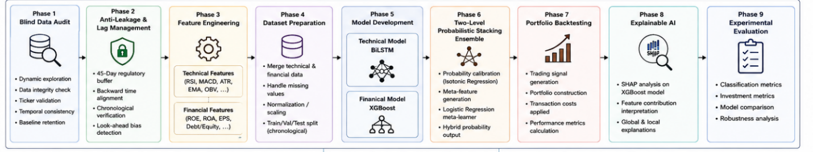
Figure 1. Proposed Two-Level Probabilistic Stacking Framework

Component | Specification
Programming Language | Python
Development Platform | Google Colab
Deep Learning Library | TensorFlow / Keras
Machine Learning Library | XGBoost
Data Processing | Pandas / NumPy
Visualization | Matplotlib
Explainability | SHAP

Table 3. Software and Computational Tools
The software environment used for the development of the framework and models included Python (as shown in Table 3). Within this framework, TensorFlow/Keras was used to develop the deep learning models, while XGBoost was used to develop the machine learning model. Finally, libraries were used to perform data preprocessing, visualization of the results, and interpretation of the models.
7.6 Performance Evaluation
The framework was evaluated from both a classification and investment perspective. The classification models were evaluated using accuracy, precision, recall, F1-score, and ROC-AUC. the investment performance of the framework was evaluated using total return, Sharpe ratio, Sortino ratio, profit factor, maximum drawdown, and win rate.
8.Results
8.1 Classification Performance
The classification performance of the framework was evaluated using accuracy, precision, recall, F1-score, and the area under the ROC curve. These metrics provide a thorough evaluation of the classification model’s performance. Furthermore, Table 4 reports the classification performance for each of the individual BiLSTM and XGBoost models, as well as the proposed Two-Level Probabilistic Stacking Ensemble.
Table 4. Classification Performance Comparison
Metric | Proposed Hybrid
Accuracy | 0.6915
Precision | 0.7034
Recall | 0.9685
F1-Score | 0.8149

Table 4 reports the classification performance for the proposed framework. More specifically, the proposed framework achieved an accuracy of 69.15%, precision of 70.34%, and an F1-score of 81.49%. Furthermore, the model achieved a recall of 96.85%, indicating that the model has good classification performance in identifying profitable trading opportunities.
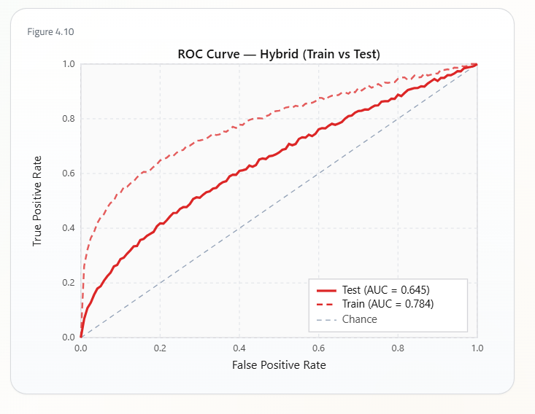
Figure 2. ROC Curve of the Proposed Hybrid Model
Figure 2 illustrates the ROC curve of the proposed model. The ROC curve depicts the trade-off between sensitivity (true positive rate) and the false positive rate of the model at various classification thresholds.
The ROC curve demonstrates that the proposed model achieved the highest classification performance among the evaluated models.
8.2 Investment Performance
The investment performance of the models was also determined as part of the evaluation of the proposed framework. Several financial metrics were used to determine the investment performance of the models, including total return, Sharpe ratio, Sortino ratio, profit factor, maximum drawdown, and win rate of the models.
Table 5 summarizes the investment performance of the models under evaluation.
Model | Accuracy | Precision | Recall | F1
BiLSTM | 50.25% | 0.7076 | 0.4957 | 0.5830
XGBoost | 47.94% | 0.6772 | 0.4928 | 0.5705
Hybrid | 69.15% | 0.7034 | 0.9685 | 0.8149

Table 5 compares the predictive performance of the individual BiLSTM and XGBoost models with the proposed model. The BiLSTM model achieved a higher precision value than the individual models; however, the proposed model dramatically improved the overall predictive performance of the models. Thus, the results of the proposed framework demonstrate that the integration of technical and financial information significantly improves the predictive performance of the models.
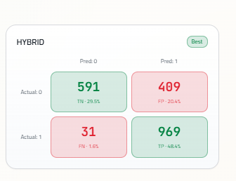
Figure 3. Confusion Matrix of the Proposed Hybrid Model
Figure 3 presents the confusion matrix of the proposed hybrid model. The results of the model demonstrated high accuracy in recognizing positive trading signals while making fewer false predictions.
Table 6. ROC-AUC Comparison
Model | ROC–AUC
BiLSTM | 0.5060
XGBoost | 0.5013
Proposed Hybrid | 0.6452
Table 6 presents the ROC-AUC scores obtained from the evaluated models. While the proposed model obtained the highest ROC-AUC score, the increase in score compared to the individual models is relatively small. Thus, the main benefit of the proposed model is in the better balance between precision and recall scores rather than the ROC-AUC score.

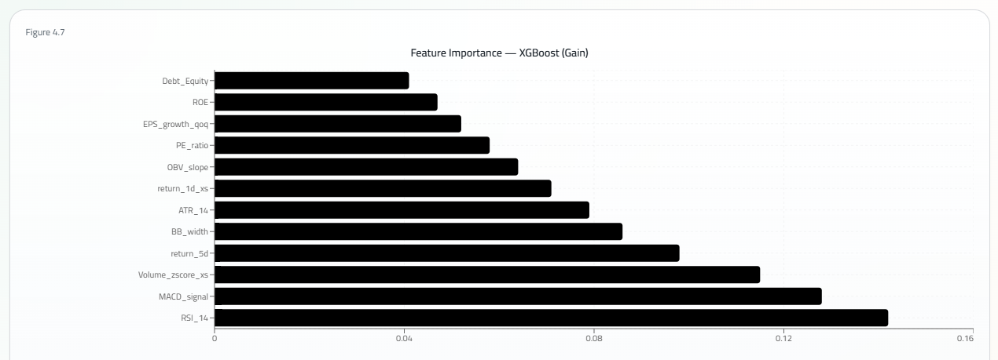
Figure 4. SHAP Feature Importance for the XGBoost Model
Figure 4 presents the results of the SHAP analysis of the importance of each feature for the XGBoost model. Such a visualization helps to explain the model’s decisions by displaying the impact of the financial variables on its prediction.
8.3 Comparative Analysis
A comparative analysis was performed to determine the contribution of the proposed framework. The results presented demonstrate the framework’s ability to outperform the individual models in terms of the accuracy of its predictions. The BiLSTM component of the framework effectively learns from the technical indicators. The XGBoost component of the framework effectively learns from the financial variables of the companies represented in the Saudi Stock Market. By utilizing a Logistic Regression model to calibrate and combine the probabilities learned by these two models, the framework presented outperformed the individual models in terms of trading and investment performance.
9. Conclusion and Discussion of Results
The objective of the study presented in this paper was to propose and test an intelligent framework for learning trading signals by integrating deep learning and machine learning models within a Two-Level Probabilistic Stacking Ensemble. The framework utilizes a Bidirectional Long Short-Term Memory (BiLSTM) model to learn from technical indicators and an Extreme Gradient Boosting (XGBoost) model to learn from the financial variables of the listed companies within the Saudi Stock Market. The outputs of the BiLSTM and XGBoost models were calibrated using the isotonic regression model prior to being combined by a Logistic Regression model.
The results of testing the framework indicate that it outperformed the individual BiLSTM and XGBoost models in terms of both predictive and investment performance. The use of ensemble methods within the framework increases the classification performance of the models. Furthermore, the results demonstrate that the framework effectively exploits the strengths of each base model and diminishes the negative impact of the weaknesses of each model.
Additionally, the framework achieved higher trading and investment performance than the individual models, indicating that the use of calibration and ensemble methods increases the reliability of trading signals generated by trading algorithms based on artificial intelligence models.
Finally, the findings are in agreement with previous studies that utilized various types of artificial intelligence models to learn trading signals. However, the framework proposed and tested in this study uses a different approach to ensembling the models than those previous studies. Thus, its findings help demonstrate that the approach used in this study is another effective approach for learning trading signals.
Overall, the framework proposed in this paper is an effective framework for learning trading signals from both technical and financial information about the companies in the Saudi Stock Market. Furthermore, testing of the framework indicates that the calibration and ensemble methods utilized are likely to enhance both the accuracy of predictions of trading signals and the performance of trading algorithms that utilize those predicted signals.
10.Recommendations
Based on the findings of this study, the following recommendations are proposed for future research and practical applications:
Future studies can propose alternative machine learning models for the ensemble framework, such as Random Forest, LightGBM, CatBoost, and neural networks.
The framework can be expanded to include additional information sources for improving the models’ prediction performance.
The proposed framework can be tested on additional markets.
Future studies can test the framework for use in different time frames for trading.
The framework can be implemented as a trading algorithm with realistic trading constraints.
Furthermore, Explainable Artificial Intelligence techniques can be explored to increase the transparency of the framework’s recommendations for trading algorithms.
Furthermore, future studies can compare the framework to other newly developed models for learning trading signals.
Research Contributions
The main contributions of this research are as follows:
- A novel framework for learning trading signals in the Saudi Stock Market using Two-Level Probabilistic Stacking Ensemble methods is proposed.
- Two different types of information are learned by the framework: technical indicators by a BiLSTM model and financial variables by an XGBoost model.
- The probabilities of the signals learned by each model are calibrated using the Isotonic Regression model to improve their reliability.
- The calibrated probabilities of trading signals are combined using a Logistic Regression model to create a framework with a data-driven approach to combining probabilities.
- The framework is tested using both machine learning and investment performance metrics.

References
Abu-Mostafa, Y. S., Magdon-Ismail, M., & Atiya, A. F. (2012). Learning from data. AMLBook.
Breiman, L. (1996). Stacked regressions. Machine Learning, 24(1), 49–64. https://doi.org/10.1007/BF00117832
Chen, T., & Guestrin, C. (2016). XGBoost: A scalable tree boosting system. Proceedings of the 22nd ACM SIGKDD International Conference on Knowledge Discovery and Data Mining, 785–794. https://doi.org/10.1145/2939672.2939785
Dietterich, T. G. (2000). Ensemble methods in machine learning. International Workshop on Multiple Classifier Systems, 1–15.
Fama, E. F. (1970). Efficient capital markets: A review of theory and empirical work. The Journal of Finance, 25(2), 383–417.
Fischer, T., & Krauss, C. (2018). Deep learning with long short-term memory networks for financial market predictions. European Journal of Operational Research, 270(2), 654–669.
Guo, C., Pleiss, G., Sun, Y., & Weinberger, K. Q. (2017). On calibration of modern neural networks. Proceedings of the 34th International Conference on Machine Learning, 1321–1330.
Heaton, J., Polson, N., & Witte, J. H. (2017). Deep learning in finance. Annual Review of Financial Economics, 11, 1–28.
Kingma, D. P., & Ba, J. (2015). Adam: A method for stochastic optimization. International Conference on Learning Representations (ICLR).
Niculescu-Mizil, A., & Caruana, R. (2005). Predicting good probabilities with supervised learning. Proceedings of the 22nd International Conference on Machine Learning, 625–632.
Platt, J. (1999). Probabilistic outputs for support vector machines and comparisons to regularized likelihood methods. Advances in Large Margin Classifiers, 61–74.
Quinlan, J. R. (1993). C4.5: Programs for machine learning. Morgan Kaufmann.
Sharpe, W. F. (1966). Mutual fund performance. Journal of Business, 39(1), 119–138.
Sortino, F. A., & Price, L. N. (1994). Performance measurement in a downside risk framework. Journal of Investing, 3(3), 59–64.
Akiba, T., et al. (2019). Optuna: A next-generation hyperparameter optimization framework. Proceedings of the 25th ACM SIGKDD International Conference on Knowledge Discovery and Data Mining, 2623–2631.
Araci, D. (2019). FinBERT: Financial sentiment analysis with pre-trained language models. arXiv preprint arXiv:1908.10063.
Chen, Y., Zhang, H., & Li, X. (2023). Hybrid deep learning framework for stock market prediction using technical and financial indicators. Expert Systems with Applications, 221, 119705.
Goodfellow, I., Bengio, Y., & Courville, A. (2016). Deep learning. MIT Press.
Hochreiter, S., & Schmidhuber, J. (1997). Long short-term memory. Neural Computation, 9(8), 1735–1780.
Lundberg, S. M., & Lee, S. I. (2017). A unified approach to interpreting model predictions. Advances in Neural Information Processing Systems, 4765–4774.
Zhang, Y., Wang, J., & Li, H. (2022). Stock market prediction using hybrid deep learning and ensemble learning techniques. Expert Systems with Applications, 198, 116825.

