
Midocean University
College of Management
Department of Project Management

The Impact of Emotional Intelligence on Project team members in Riyadh City Projects

Prepared by:
Engr Haitham Berhan
Academic Number: 253002768

Supervised by:
Dr. Alfaisal Hasan

Year:2026

Copyright: -

Copyright is held by Midocean University. All materials and content contained in this research are the property of the University and may not be used, republished, or distributed without prior permission from Midocean University.

Engr Haitham Berhan
Master of Project Management
Candidate College of Management,
Midocean University

Abstract:
Emotional intelligence (EI) has emerged as a critical factor influencing individual and team performance in project-based environments. This study examines the impact of emotional intelligence on project team members working on projects in Riyadh City, with a focus on understanding how emotional competencies contribute to communication, collaboration, conflict resolution, leadership effectiveness, and overall project success. As Riyadh continues to experience rapid urban development under Saudi Vision 2030, project teams are required to operate in increasingly complex and multicultural environments, making emotional intelligence an essential competency for effective teamwork. Using a quantitative research approach, data are collected from employees working in Construction fields through a structured questionnaire and analyzed using appropriate statistical techniques to examine the relationship between emotional intelligence and team performance indicators.
The study investigates key dimensions of emotional intelligence, including self-awareness, self-regulation, motivation, empathy, and social skills, and evaluates their influence on project team effectiveness. The findings are expected to demonstrate that higher levels of emotional intelligence positively affect team collaboration, employee engagement, decision-making, and project outcomes while reducing workplace conflicts and improving organizational performance. The study contributes to the growing body of knowledge on project management by providing empirical evidence from the context of Riyadh City projects and offers practical recommendations for organizations to integrate emotional intelligence into recruitment, leadership development, and project management practices to enhance project success.

Keywords: Emotional Intelligence, Project Management, Project Team Members, Team Performance, Riyadh City, Saudi Vision 2030, Leadership, Organizational Performance.

Acknowledgments: -
I extend my sincere thanks to everyone who contributed to the completion of this research. First and foremost, I give thanks to Allah alone. I also thank my family and friends for their encouragement and understanding during the challenging stages of this academic journey; your belief in my abilities has been a constant source of motivation.
I would also like to express my gratitude to Midocean University for providing the academic environment and necessary support to complete this research; the resources and facilities provided by the university were instrumental in achieving this milestone. Furthermore, I express my deep appreciation to my supervisor Dr. Alfaisal Hasan, for his invaluable guidance, insightful feedback, and unwavering support throughout the research process; their expertise was instrumental in shaping the direction and quality of this study.
I am also grateful for the assistance and cooperation of the responders who responded to the questionnaire and the research sample; their openness in sharing information and expertise has enriched the depth of my research.
I also extend my thanks to the academic community and the authors whose work laid the foundation for this research; their contributions were indispensable in shaping the theoretical framework and methodology.

Engr Haitham Berhan
Master of Project Management
Candidate College of Management,
Midocean University

Table of Contents: -

Cover Letter ………………………………………………………………….1
Copyright …………………………………………………………………….2
Abstract.……………………………………………………………………....3
Acknowledgments ………………………………………………….………..4
Table of Contents………………………………………………………….….5
Chapter 1 ……………………………………………………………………..7
Introduction……………………………………………………………….….8
Problem Statement …………………………………………………….…….9
Study Questions …...…………………………………………………………9
Study Purpose……………………......…………………………………..….10
Importance of Study …………………………...…………………………..10
Research Hypotheses ….……………………………………...…………….11
Theoretical Model ………………….……………………………………….11
Scope of Research ………………………………...……………..………….12
Chapter Conclusion ……………………..…………………………...…….12
Chapter 2 ………………………………………………………………...….13
Introduction…………………………………………………………...…….14
Theoretical Framework ……………………………………...…………….14
Summary of Past studies ………………..……………...………………….15
Benefits from previous study …………………………………………...….19
What distinguishes this study from previous studies……………………..19
Chapter Conclusion …………..……………………………………...…….20
Chapter 3 ………………………… …………………………………..…….21
Introduction………………………………………………………...……….22
Research Methodology ………………..…………………...……………….22
Research community ……………………………………………………….22
Research Sample ……………………………………………………..…….22
Search tool …………………………………………………………………..24
Steps for preparing the research instrument……………………………...24
Chapter 4 ………………………………………………..……………..…....26
Data Analysis ……………..…………………………………………..…….27
Results……………………………………………………………………….47
Recommendation…………………………………………………...……….48
References …………………………………………………………….…….49
English References ……………………………………………………...….49
Arabic References ……………………..………………………………..….50
Appendix…………………………..…………………………..…………….51
Request Letter for Arbitration ………….….……………..……………….52
Letter for Questionnaire……..…………...…………………………...……55
Acknowledgment ……………………………………………………..…….56
Abstract in Arabic ……………………………………………….…...…….57
Cover letter in Arabic ………………………………………..…………….58

CHAPTER 1
INTRODUCTION

INTRODUCTION:

Since early days, Construction sector is one of the sectors which plays a big role in civilization the country. At the same time, it’s one of the sectors where the time & quality plays an important role in implementing projects, therefore the project managers & team members perform their tasks under big pressure, this pressure creates conflicts, misunderstanding & unhealthy environments.
As we see these days in Riyadh City, Saudi Arabia fast & and highly collaborative work environment, technical knowledge and professional expertise alone are no longer sufficient to ensure team success. Organizations increasingly recognize that emotional intelligence is a critical factor that influences how individuals communicate, collaborate, and perform within teams. Emotional intelligence refers to the ability to recognize, understand, manage, and regulate one's own emotions while also recognizing and responding appropriately to the emotions of others. These abilities enable individuals to build positive relationships, make sound decisions under pressure, and effectively navigate interpersonal challenges.
The impact of emotional intelligence on team members extends beyond individual performance. Teams composed of emotionally intelligent members are more likely to experience higher levels of trust, cooperation, and mutual respect. Such teams communicate openly, handle disagreements constructively, and adapt more effectively to changing situations. Emotional intelligence also encourages empathy, active listening, and emotional support, creating an inclusive environment where members feel valued and motivated to contribute their ideas. As a result, emotionally intelligent teams often demonstrate greater creativity, stronger problem-solving abilities, and improved decision-making.

Problem Statement:

As we experience these days in Riyadh city, highly populated city, growing markets, and diversity in team co-workers. This concludes that people come from different cultures and different languages as consequences of this many organizations continue to experience low productivity, poor communication, interpersonal conflicts, and reduced employee engagement due to insufficient emotional intelligence among team members and leaders. When individuals struggle to recognize, understand, and manage their own emotions—or respond effectively to the emotions of others—it can weaken teamwork, trust, and overall organizational performance. Despite growing recognition of EI as an important workplace competency, there is still a need to better understand how emotional intelligence influences team members' collaboration, job satisfaction, motivation, and effectiveness. Therefore, this study seeks to examine the impact of emotional intelligence on team members specifically in Construction sector and determine how it contributes to improved teamwork and organizational success.

Study Questions:

Main Study Question:
- How does emotional intelligence impact on project team members?

Sub-Main Questions:
- How does emotional intelligence impact on project team member’s productivity?
- How does emotional intelligence impact on project team member’s integrity?
- “How does emotional intelligence impacts on project team member’s communication?”

Study Purposes:

The purpose of this study is to examine the impact of emotional intelligence on team members at construction sectors performance, communication, collaboration, and overall effectiveness within a team. The study aims to determine how emotional intelligence influences interpersonal relationships, conflict resolution, job satisfaction, and teamwork in Construction Company in Riyadh city.
This study also aims to determine whether emotional intelligence contributes to increased team engagement, job satisfaction, and commitment among team members. By exploring the relationship between emotional intelligence and team dynamics, the research intends to identify the ways in which emotionally intelligent behaviors support cooperation, reduce interpersonal conflict, and improve collective problem-solving.

Importance of Study:
In Construction sector, studying the importance of the impact of emotional intelligence on team members is important because it helps explain how emotions influence teamwork, communication, and performance.
It improves communication among team members and allows them to express their ideas clearly and at the same time listen actively
In Construction sector is not easy building trust among members due to diversity in positions labors, Engineers, high management.
Which will be held to reduce conflicts among team members.

Research Hypotheses:

Main Research Hypothesis:
There is a statistically significant relationship between emotional intelligence and team members.

Sub-Main Research Hypothesis:

There is a statistically significant relationship between emotional intelligence and team member’s productivity.
There is a statistically significant relationship between emotional intelligence and team member’s integrity.
There is a statistically significant relationship between emotional intelligence and team member’s communication.
There is a statistically significant relationship between emotional intelligence and Stakeholders of the project.

Theoretical Model:

Independent Variable:
Emotion Intelligence

Dependent Variable:
- Team Member’s Outcomes
- Performance
- Collaboration
- Trust
- Commitment

Scope of Research:

Location of the research: This research was conducted in Riyadh City, Saudi Arabia on Construction Projects

Who conducted the research: This research was conducted on random people in Riyadh city projects
Time of the research: This research was conducted May-July 2026

Chapter Conclusion:

In this chapter, we provided an overview of the research, mentioning the general concept of the chosen topic and the reasons for its selection. It defines the research problem and presents the questions the study seeks to answer. Furthermore, it clarifies the significance of the research and its objectives, as well as the hypotheses it aims to substantiate.

CHAPTER 2
LITERATURE REVIEW

Introduction:
In this chapter, we address the theoretical framework of the research by reviewing studies concerning the impact of emotion intelligence in relation to the team member’s performance, communication, trust as well as the necessity of drawing upon this existing literature and how the current study differs from previous ones.

Theoretical Framework:
In this chapter, we will address the study variables: Emotion intelligence and project performance.
We will examine the key concepts associated with each and their impact on the success of construction projects in the Riyadh region.
We will begin by defining the concept of emotion intelligence, then move on to define project performance across multiple productivity, communication, trust & commitment.

- Usage of EI: This technique is used to improve the relationship between team members, increase productivity & performance.
- Reason for using EI: As there is diversity among team members in Riyadh City, conflicts & misunderstanding occur continuously in construction sectors especially in highly populated cities like Riyadh,
- Work Performance after using EI: Their findings showed that team members’ emotional intelligence was positively associated with trust among team members, which improved overall team performance.

Summary of Past studies

In this section, we will address previous studies and what distinguishes the current study from them.

- Daniel Goleman's Emotional Intelligence Theory:
Emotional intelligence is the ability to recognize, understand, manage, and use emotions effectively in oneself and others. According to Goleman, emotional intelligence consists of five key components:
- Self-awareness – Recognizing one's own emotions and their effects.
- Self-regulation – Managing emotions appropriately in different situations.
- Motivation – Maintaining a positive attitude and working toward goals.
- Empathy – Understanding and sharing the feelings of others.
- Social skills – Building positive relationships and communicating effectively.
In a team setting, members with high emotional intelligence are more likely to communicate openly, resolve conflicts constructively, collaborate effectively, and support one another. These behaviors contribute to greater team cohesion, trust, job satisfaction, and overall team performance.

- John D. Mayer and Peter Salovey's Ability Model of Emotional Intelligence:

This framework views EI as a set of abilities involved:
- Perceiving emotions,
- Using emotions to facilitate thinking,
- Understanding emotions, and
- Managing emotions.
These abilities help team members make better decisions, adapt to challenges, and maintain productive interpersonal relationships.

Conceptual Relationship:
Independent Variable:
Emotional Intelligence
- Self-awareness
- Self-regulation
- Motivation
- Empathy
- Social skills
Dependent Variable (DV):
Team Member Outcomes
- Team collaboration
- Communication effectiveness
- Conflict resolution
- Job satisfaction
- Team performance
The theoretical framework proposes that emotional intelligence positively influences team members by improving interpersonal relationships, communication, collaboration, and conflict management. As emotional intelligence increases, team members are expected to work more effectively together, leading to improved individual and team outcomes. This framework provides the theoretical basis for examining how emotional intelligence contributes to team success in organizational settings.

- Feyerherm and Rice examined the relationship between team emotional intelligence, leadership emotional intelligence, and team performance among customer service teams. The study found that certain emotional intelligence abilities, especially understanding and managing emotions, were positively related to aspects of team performance such as customer service quality. The researchers concluded that emotional intelligence plays an important role in improving team effectiveness.

- Chang, Sy, and Choi investigated the influence of team emotional intelligence on team performance using data from 91 teams. Their findings showed that team members’ emotional intelligence was positively associated with trust among team members, which improved overall team performance. The study suggested that emotionally intelligent members contribute to stronger relationships and better team outcomes.

- Rezvani and colleagues examined the relationship between team emotional intelligence, trust, conflict, and team performance among project teams. The results showed that emotional intelligence positively influenced team performance by increasing trust and reducing conflicts within teams. The study highlighted emotional intelligence as an important factor for successful teamwork.

- This study explored how emotional intelligence contributes to team performance by examining different ways of measuring team-level emotional intelligence. The findings indicated that emotional intelligence is linked with improved team performance and that the emotional abilities of team members influence how effectively teams work together.

- Jordan et al. investigated the relationship between emotional intelligence and team effectiveness. The study examined how emotionally intelligent teams develop better communication, cooperation, and problem-solving abilities. The findings indicated that teams with higher emotional intelligence were more capable of managing stress and adapting to difficult situations, resulting in improved team performance.

- Druskat and Wolff explored the concept of group emotional intelligence and its influence on team effectiveness. The study proposed that emotionally intelligent teams develop shared norms that encourage trust, understanding, cooperation, and constructive conflict management. The researchers concluded that emotional intelligence improves team functioning by strengthening relationships among members.

- Prati et al. studied emotional intelligence, leadership effectiveness, and team outcomes. The findings showed that emotional intelligence contributes to better teamwork by improving communication, reducing interpersonal problems, and increasing team cohesion. The study emphasized that emotionally intelligent members are more effective in collaborative environments.

- Ayoko and colleagues examined how emotional intelligence influences team conflict management and communication. The study found that emotionally intelligent team members were better able to recognize emotional reactions, manage disagreements, and maintain positive relationships within teams.

- Chang et al. examined the effect of team emotional intelligence on team performance among 91 teams. The study found that emotional intelligence among team members increased trust within teams, which positively influenced team performance. The authors concluded that both members’ and leaders’ emotional intelligence contribute to effective teamwork.

- Mahon conducted a qualitative study involving IT teams to examine the relationship between team emotional intelligence and teamwork performance. The study found that effective teams demonstrated stronger trust, communication, conflict resolution skills, and the ability to adapt to changing situations.

- Miao et al. conducted a meta-analysis examining the relationship between emotional intelligence and workplace outcomes. The study found that emotional intelligence was positively related to job performance, teamwork behaviors, and interpersonal effectiveness, showing that emotionally intelligent employees contribute positively to organizational teams.

Benefits from previous study:
- By reviewing previous studies, the researcher was able to identify research gaps and formulate the research problem
- Leveraging the theoretical frameworks of previous studies to design the current study
- Determining the research methodology and selecting the optimal methods and tools for data collection and analysis
- Highlighting the theoretical and practical significance of the research topic.
- Determining the method for calculating the appropriate research sample size.

What distinguishes this study from previous studies:
This study focuses specifically on the Riyadh region of Saudi Arabia, lending it significant local value regarding the region's unique challenges and opportunities. It coincides with the major changes and rapid developments the Kingdom is witnessing under Vision 2030, thereby enhancing the importance of its findings and recommendations. Furthermore, the study examines the impact of emotion intelligence on a wide range of project performance dimensions—such as commitment, trust, productivity offering a comprehensive perspective that addresses these factors collectively, an approach not previously covered in existing literature. Thus, the study is distinguished by its specific geographic focus, the breadth of the dimensions analyzed, and its alignment with the Kingdom's major developments, all of which reinforce its scientific and practical value.

Chapter Conclusion:

In this chapter addresses the theoretical framework of the research by reviewing the study variables. It explains the concept of emotion intelligence and team project performance—specifically commitment, trust, productivity, and stakeholder satisfaction. Additionally, it reviews previous studies and highlights what distinguishes the current study from them.

CHAPTER 3
RESEARCH METHODOLOGY

Introduction:
This chapter outlines the research methodology and procedures, including the definition of the methodology, the study population and sample, and the data collection instruments—covering their development and the verification of their validity and reliability—as well as the statistical tools and processes to be used for data analysis, as follows:
Research Methodology:
The descriptive-analytical method was adopted due to its suitability for the nature of the study. Data was collected from a sample of construction projects employees in the Riyadh region using a questionnaire specifically designed for this purpose. The questionnaire included questions aimed at gathering information on the impact of Emotion Intelligence on team within the context of construction projects in the Riyadh region.
Following data collection, the data were analyzed using appropriate statistical methods to determine the relationships between the research variables.

Research community:
The study population consisted of engineers working on construction projects in the Riyadh region of the Kingdom of Saudi Arabia.

Research sample:
A random sample was selected from the research population—engineers working on construction projects in the Riyadh region of Saudi Arabia. The questionnaire was converted into an electronic form using Google Drive, and the link was distributed to the target sample via social media applications. A total of 00 questionnaires were collected; following review and verification, 00 were deemed valid for analysis.

The distribution of the sample according to demographic characteristics was as shown below:

The table above shows that most of the sample (82%) are male and 18% are female, Additionally, 56% of the sample falls within the 31–35 age group, and 91% hold a bachelor's degree. Furthermore, 35% of the sample possess more than five years of experience, which enhances the reliability of the results. Regarding employment, 47% of the sample work for contractors, while 79% work in Riyadh Region.

Search tool:

To collect data and achieve the research objectives, the questionnaire was chosen as the primary tool due to its ease of application, low cost, accuracy of results, and diversity of data. The questionnaire underwent pilot testing on a small sample of participants before widespread distribution to ensure its effectiveness and the reliability of the results. After data collection, it was analyzed and the results extracted using SPSS software. (Al-Zoubi, 2023)

Steps for preparing the research instrument:

Step 1:
The researcher defined the main objective of the research, which is to identify the impact of Emotion Intelligence on team performance, specifically focusing on construction projects in the Riyadh region of Saudi Arabia.

Step 2:
Defining the measurement areas for the research instrument:
The measurement areas for the research instrument consisted of two parts:
- Demographic characteristics: (gender, age, educational level, years of experience, employer, client type)
- Questions about the impact of Emotion Intelligence on team members on projects
Step 3:
Drafting the research instrument items in their initial form after defining the questionnaire domains.
Step 4:
Scaling responses for the main dimensions: Responses to the statements within the dimensions were scaled using a five point scale (Strongly Agree – Agree – Neutral – Disagree – Strongly Disagree), with scores of 5, 4, 3, 2, and 1 assigned respectively.

Step 5:
Drafting the research instrument instructions. The questionnaire instructions were drafted to inform the sample members of the study instrument's purpose, ensuring that the statements were clear and appropriate for the respondents' level, presenting study variable details in a simplified manner, and emphasizing the privacy and confidentiality of the information provided.
Step 6:
Finalizing the questionnaire and administering it to the target sample. This involved converting the questionnaire into an electronic form via Google Drive and subsequently sending the link to the target sample members through social media applications.

CHAPTER 4
DATA ANALYSIS, RESULTS AND RECOMMENDATIONS

Introduction:
This chapter presents the findings derived from the intelligence analysis conducted using the study's data, addressing the research questions and examining the research hypotheses. It also outlines several results that inform the formulation of recommendations and proposals.

Data Analysis:
In this section of the research, a description of the variables under study is presented as follows:

A- Who were our respondents?
In this section, we will know who our respondents were and how does the Analysis effects our study.

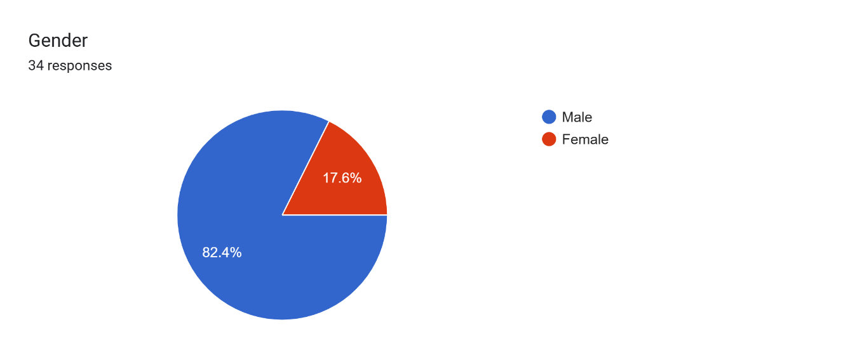
The Gender of the Respondents were as follows:
- Male – 82.4%
- Female - 17.6%

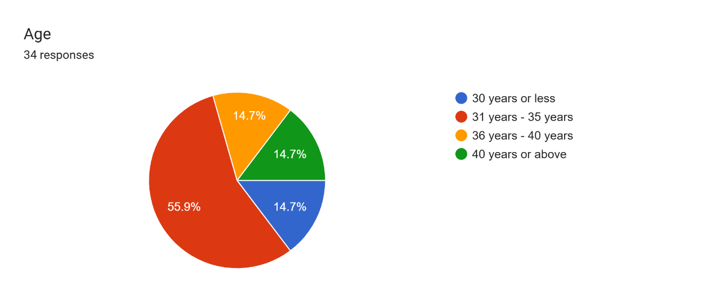
The ages of the Respondents were as follows:
- 30 years or less - 14.7%
- 31 years – 35 years - 55.9%
- 36 years – 40 years - 14.7%
- 40 years or above - 14.7%

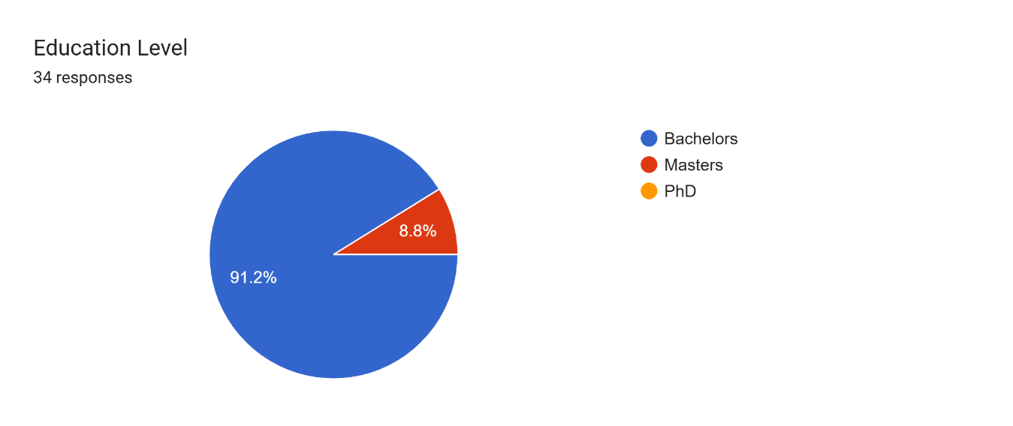

The Educational level of the Respondents was as follows:
- Bachelor’s degree – 91.2%
- Master’s degree – 8.8%
- PhD - 0%

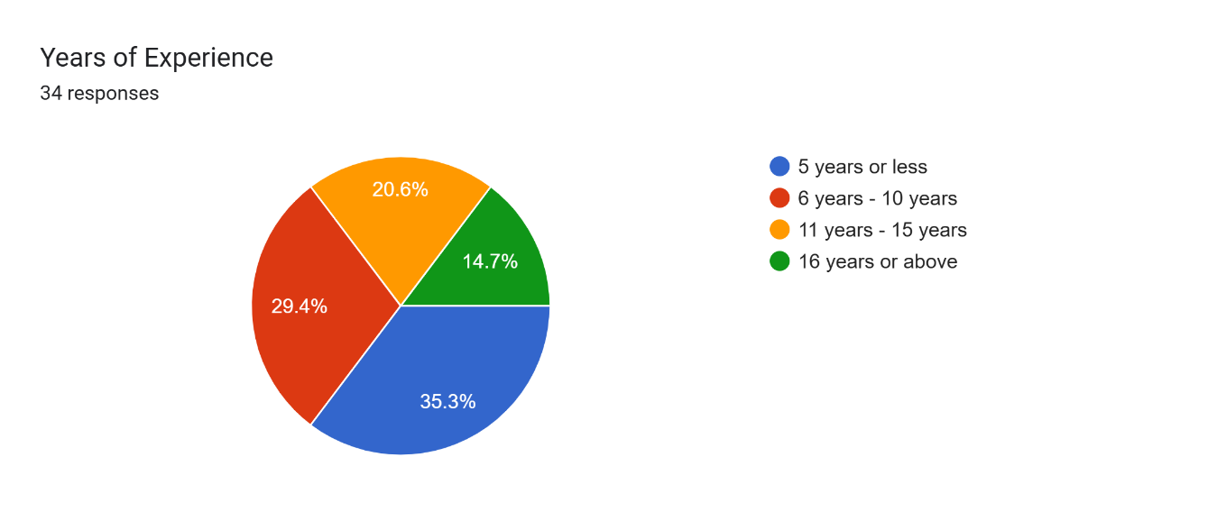
The years of Experience of the Respondents were as follows:
- 5 years or less – 35.3%
- 6 years – 10 years – 29.4%
- 11 years – 15 years – 20.6%
- 16 years or above – 14.7%

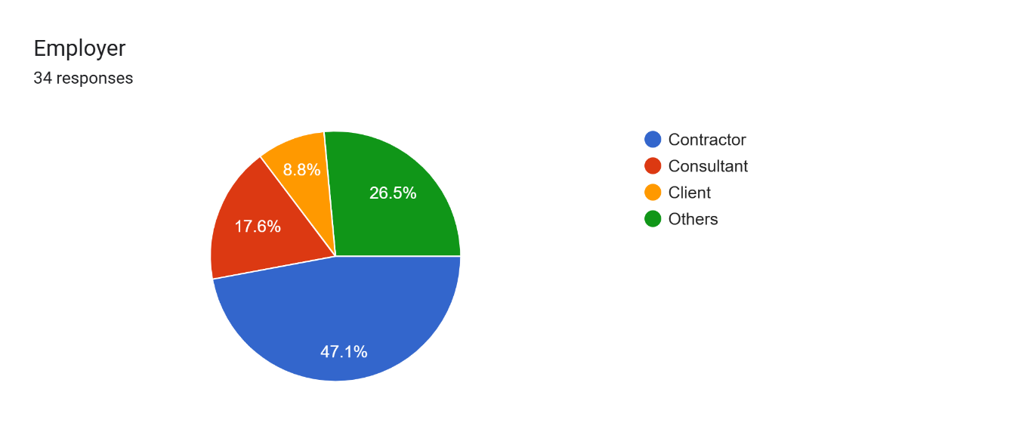
The Employment of the Respondents was as follows:
- Contractor – 47.1%
- Consultant – 17.6%
- Client – 8.8%
- Others – 25.5%

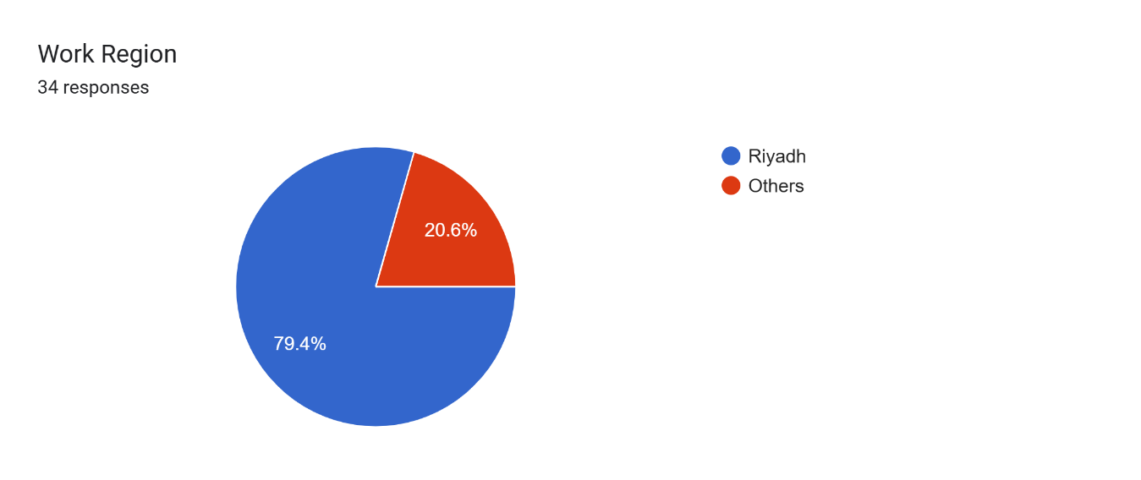
The Work Region of the Respondents was as follows:
- Riyadh – 79.4%
- Others – 20.6%

B- Respondents responses: -

In this section, we will here the responses of our respondents and how does the Analysis effects our study.

Note: The rate of the statements was on a scale of 1 to 5, where 1 represents “Strongly Disagree” and 5 represents “Strongly Agree”

- 35.3% of the respondent agrees that the Term Emotion Intelligence was familiar with them, which is considered “Satisfactory”
The means that Emotion Intelligence is not used in certain projects, which reflects that conflicts and misunderstandings have high chances to occur.
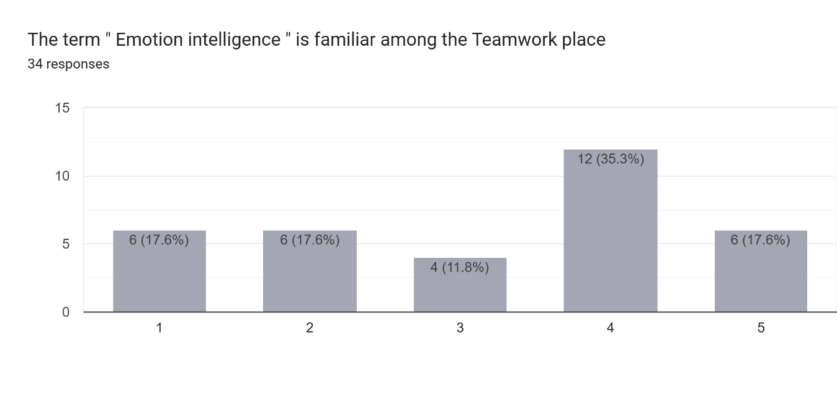

- 50% of respondents strongly agree that Emotional intelligence enhances communication among construction team members, it is considered as “average “

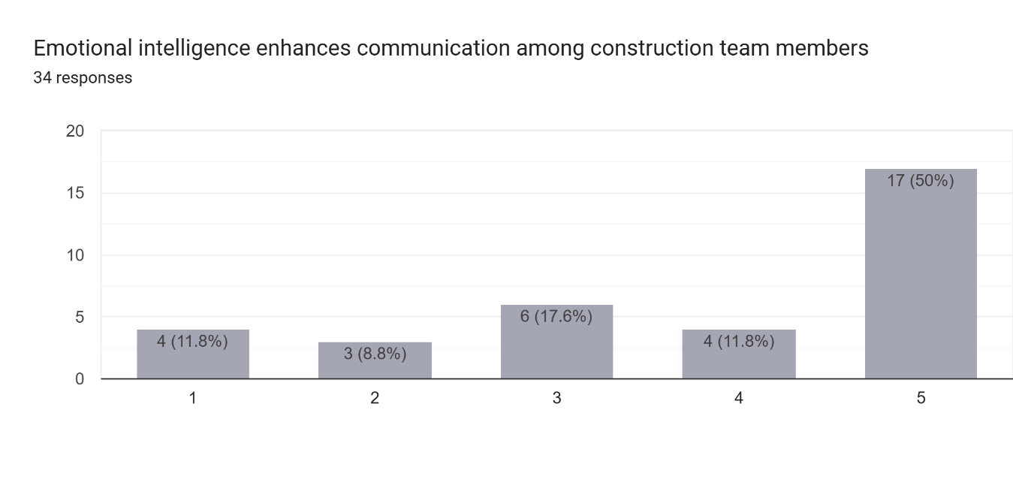
- 47.1% of the respondents strongly agree that Emotional intelligence enhances communication among High level Management, it is considered as “below average “
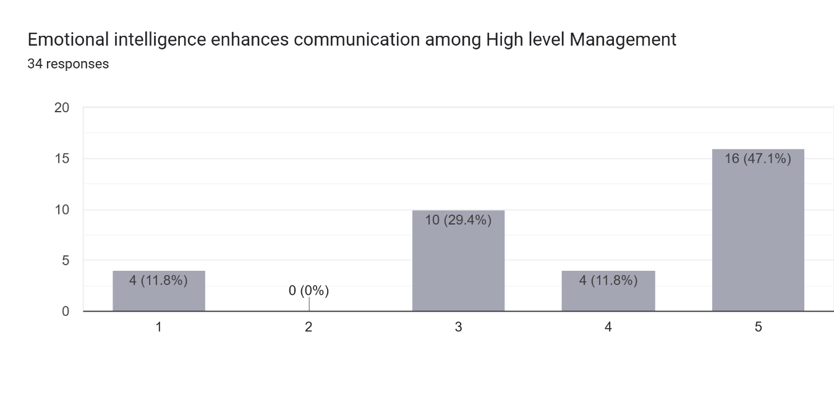

- 61.8% of the respondents strongly agree that Project managers with high emotional intelligence improve team morale, which concludes the high impact of Emotion Intelligence on the team members at the project sites. It is considered as “Good”.
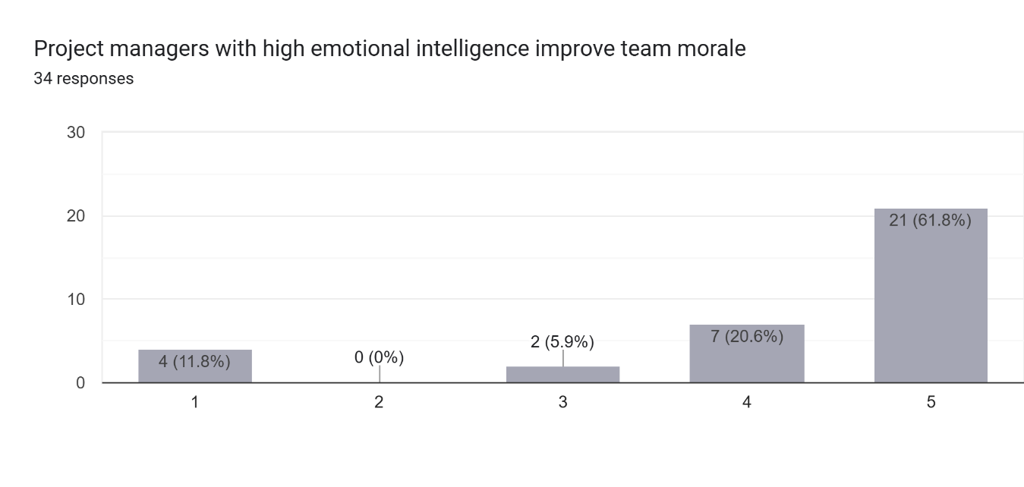
- 58.8% of the respondents strongly agree that Emotional intelligence helps reduce workplace conflicts on construction sites, it is considered as “Above average”

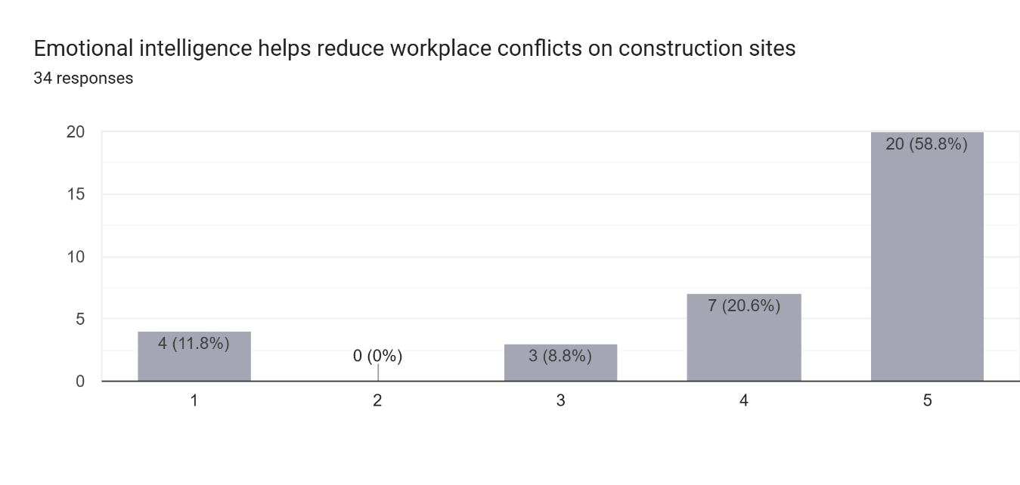

- 58.8% of the respondents strongly agree that emotionally intelligent leadership contributes to better project outcomes, it is considered as “above average “

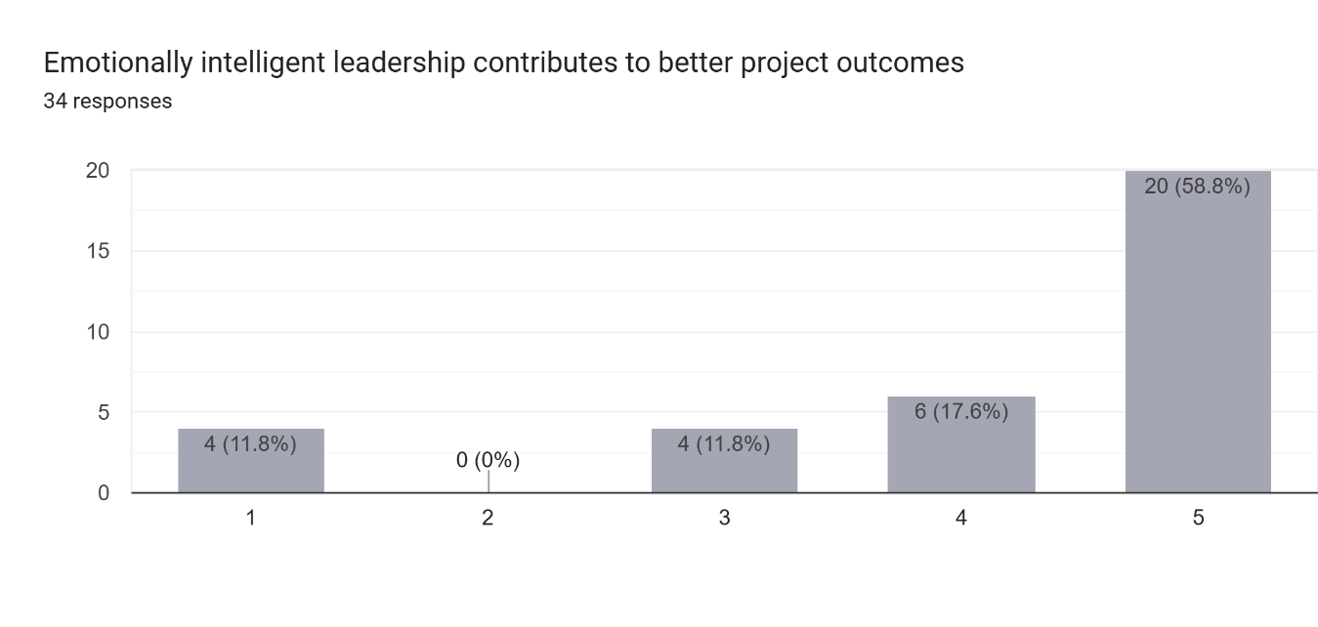

- 52.9% of the respondents strongly agree that team members with higher emotional intelligence adapt better to project changes, it is considered as “average “

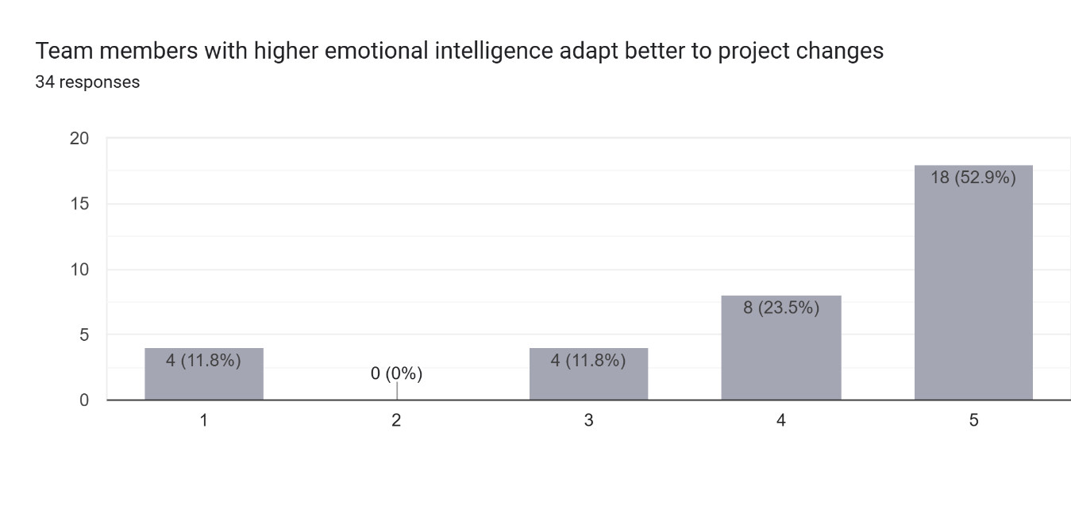

- 41.2% of the respondents strongly agree that Emotional intelligence positively influences safety compliance in construction projects, it is considered as “below average”

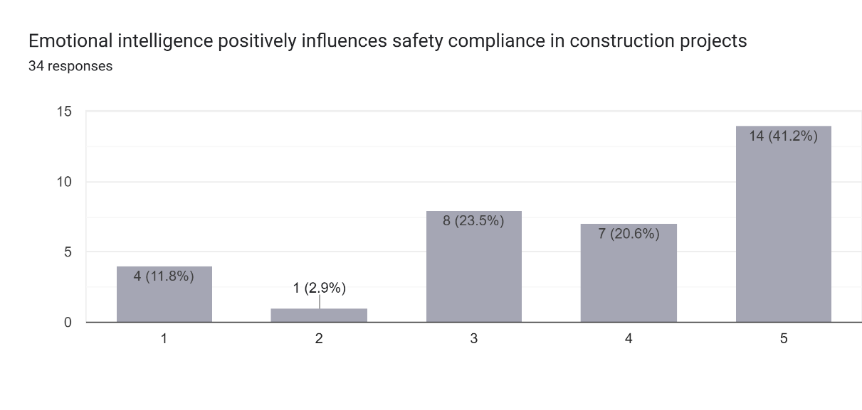
- 47.1% of the respondents strongly agree that Emotional intelligence increases trust among construction team members. It is considered as “below average”

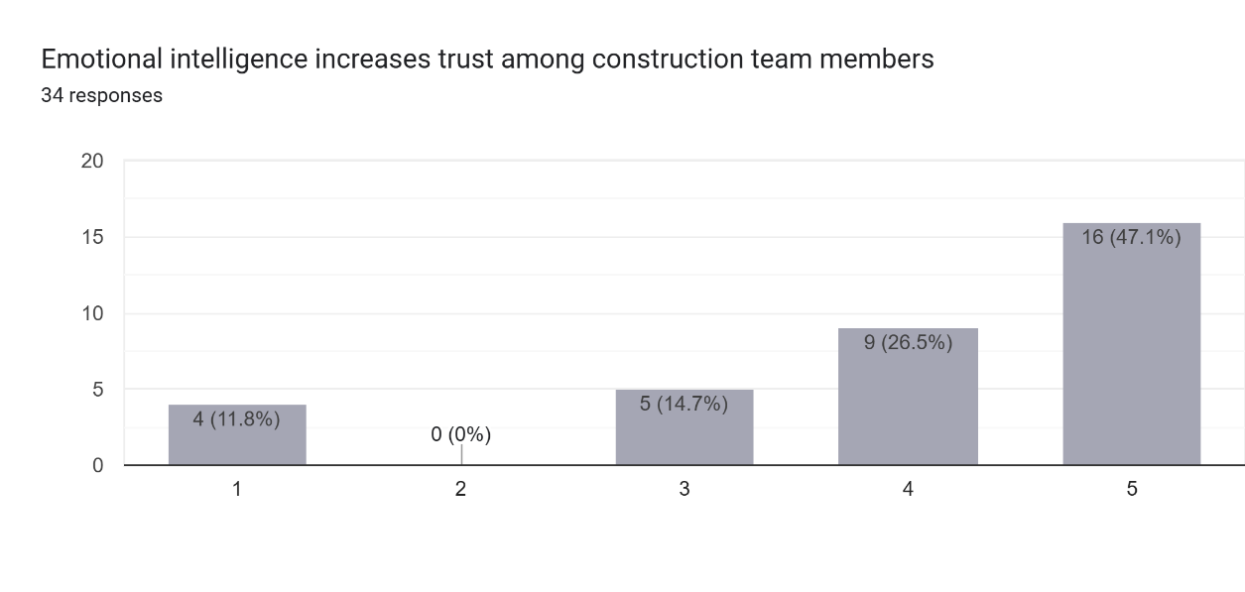

- 58.8% of the respondents strongly agree that team members with high emotional intelligence communicate more effectively under pressure, it is considered as “above average “
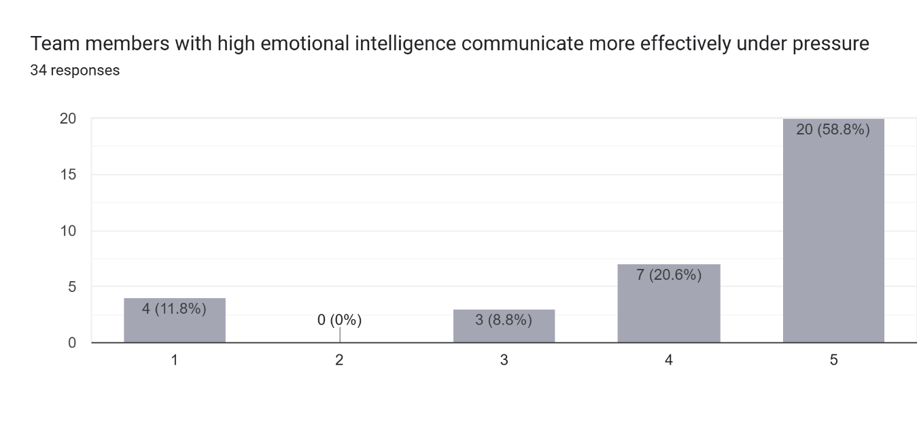
- 55.9% of the respondents strongly agree that Emotional intelligence reduces misunderstandings on construction projects, it is considered as “above average “

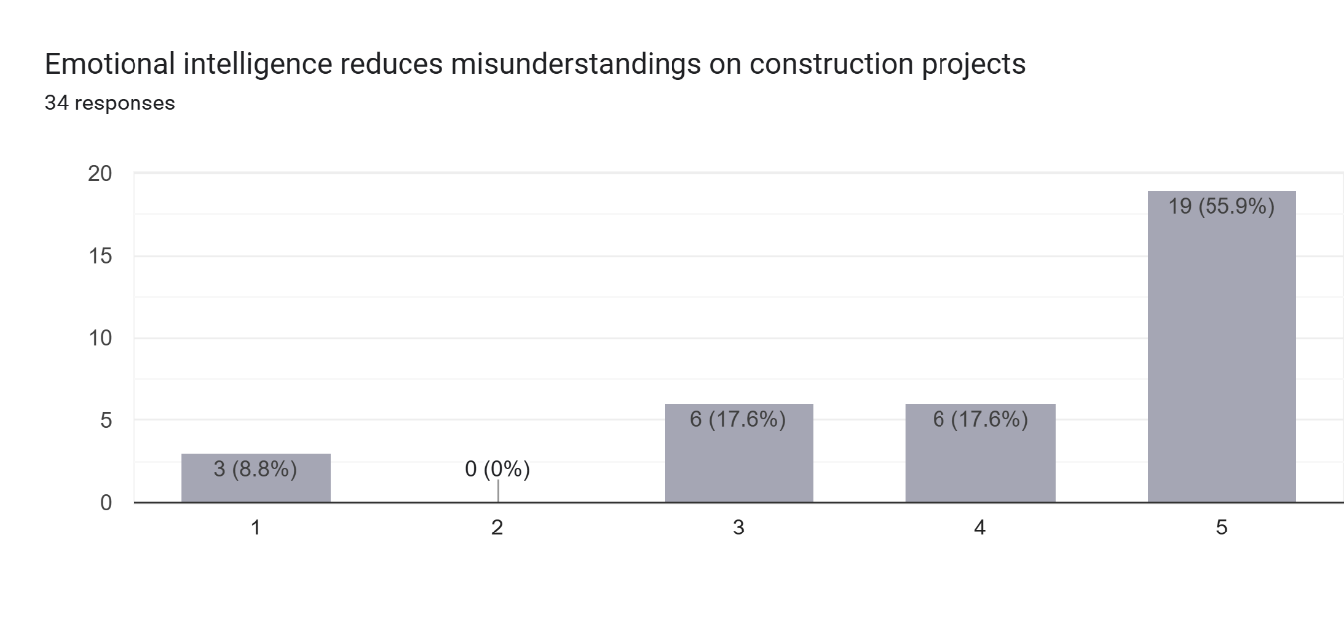

- 52.9% of the respondents strongly agree that the open communication is encouraged by emotionally intelligent leaders, it is considered as “ above average”
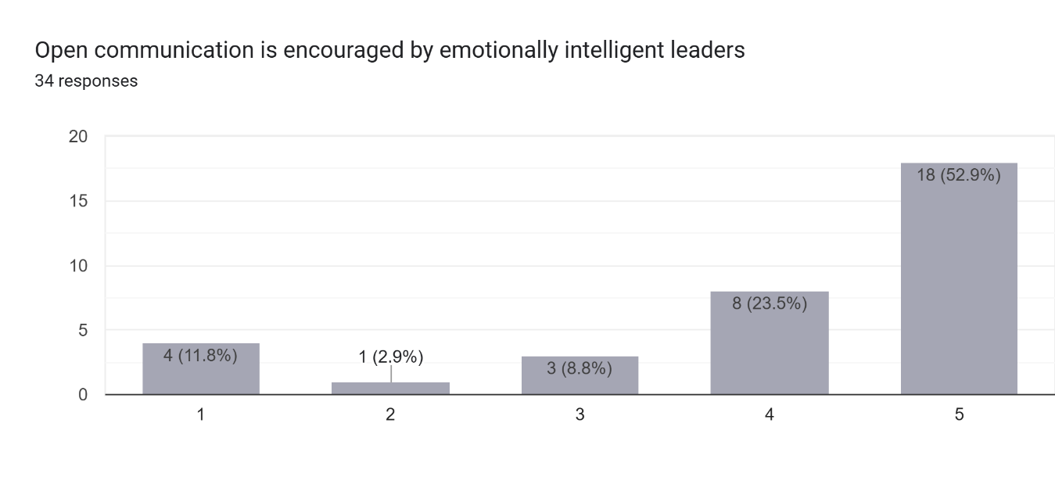

- 47.1% of the respondent strongly agree that emotionally intelligent employees are more willing to support their colleagues, it is considered as “below average “
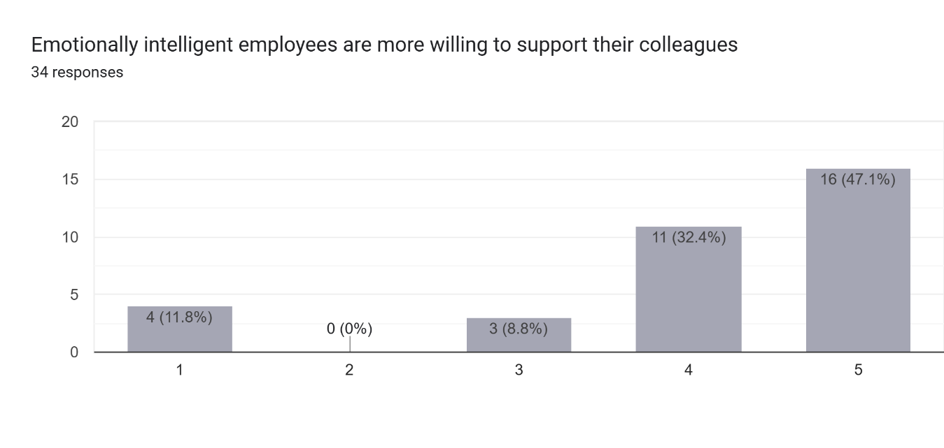

- 47.1% of the respondents strongly agree the Emotional intelligence improves cooperation between contractors, consultants, and clients, it is considered as “ below average”
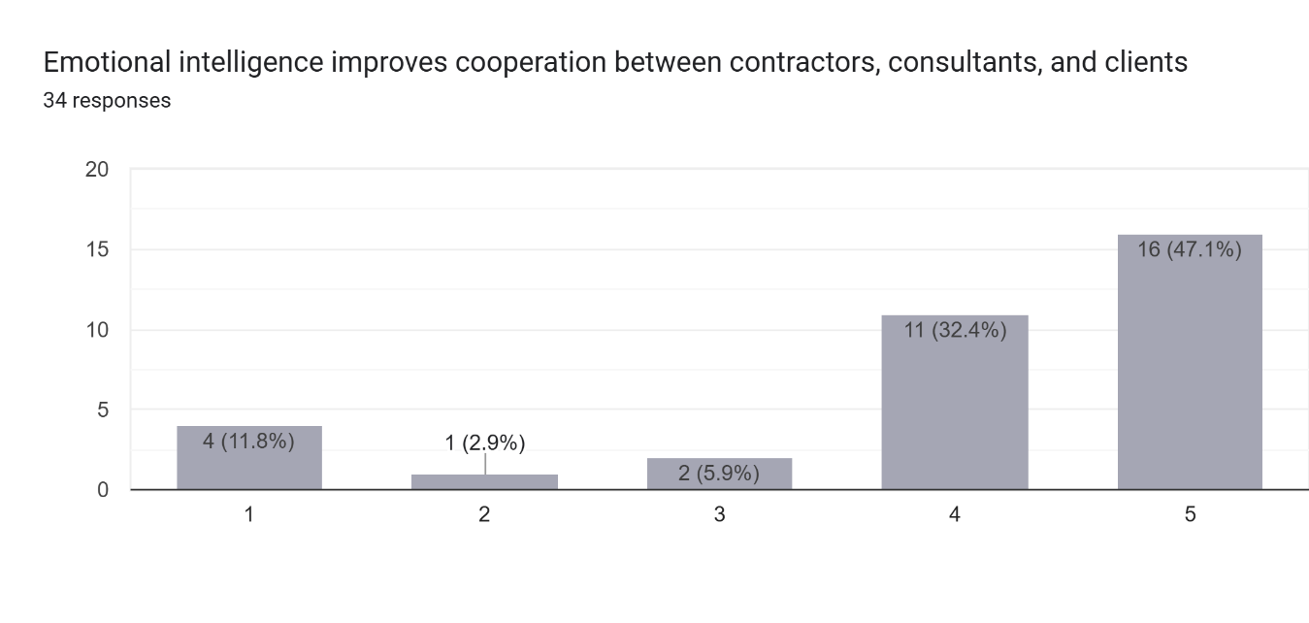
- 50% of the respondents strongly agree that Emotional intelligence helps resolve workplace conflicts effectively, it is considered as “average”

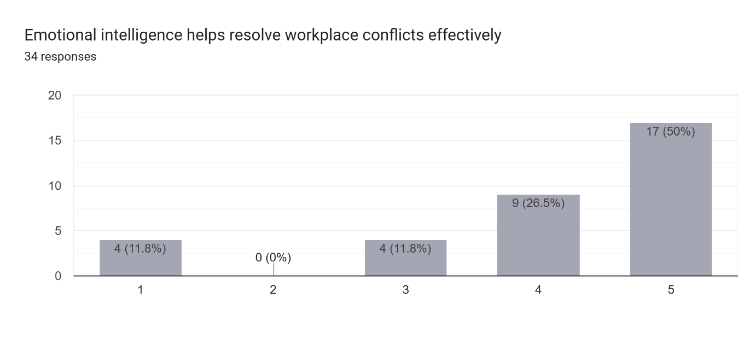

- 41.2% of the respondents strongly agree that Emotional intelligence contributes to timely completion of construction tasks, it is considered as “below average”

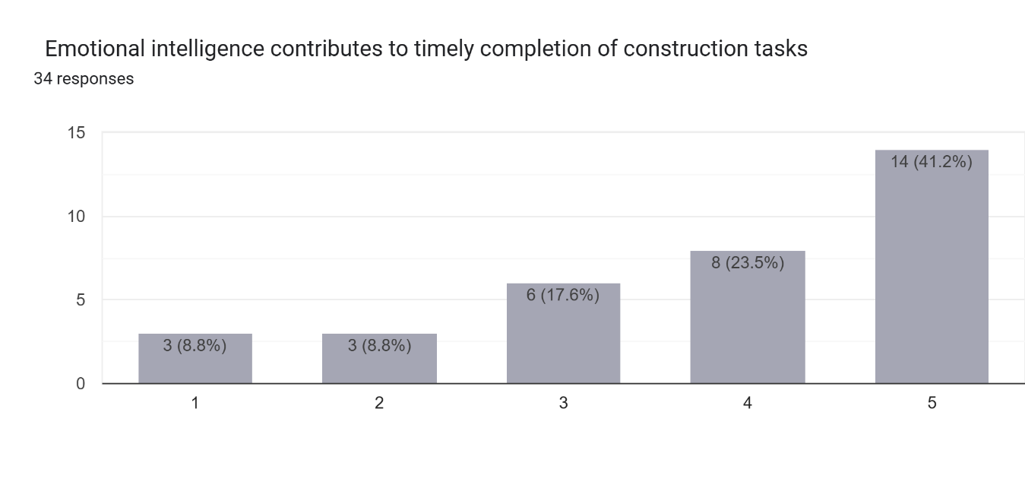

- 44.1% of the respondents strongly agree that Emotional intelligence increases employee productivity, it is considered as “below average “

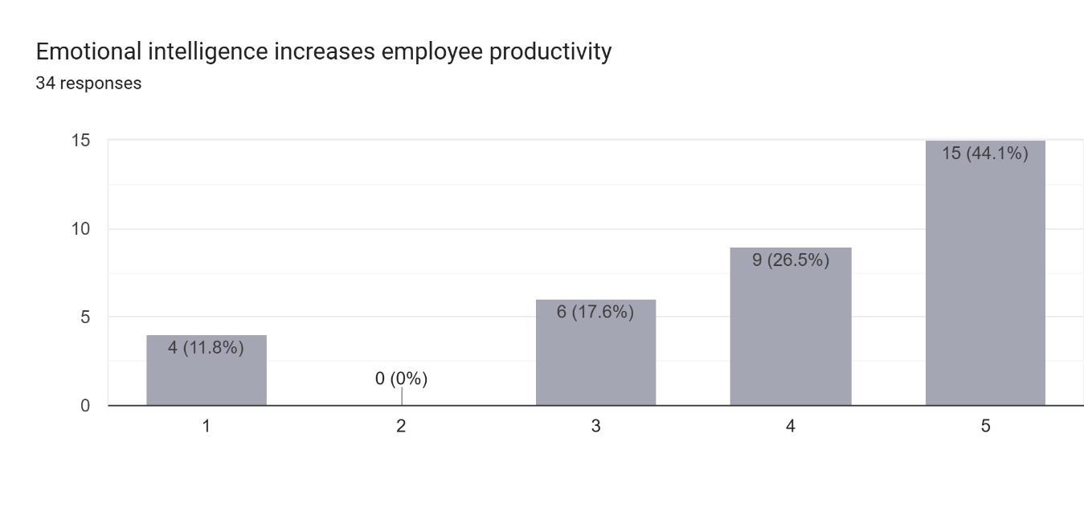

- 47.1% of the respondents strongly agree that Emotional intelligence helps construction workers cope with workplace stress, it is considered as “below average “

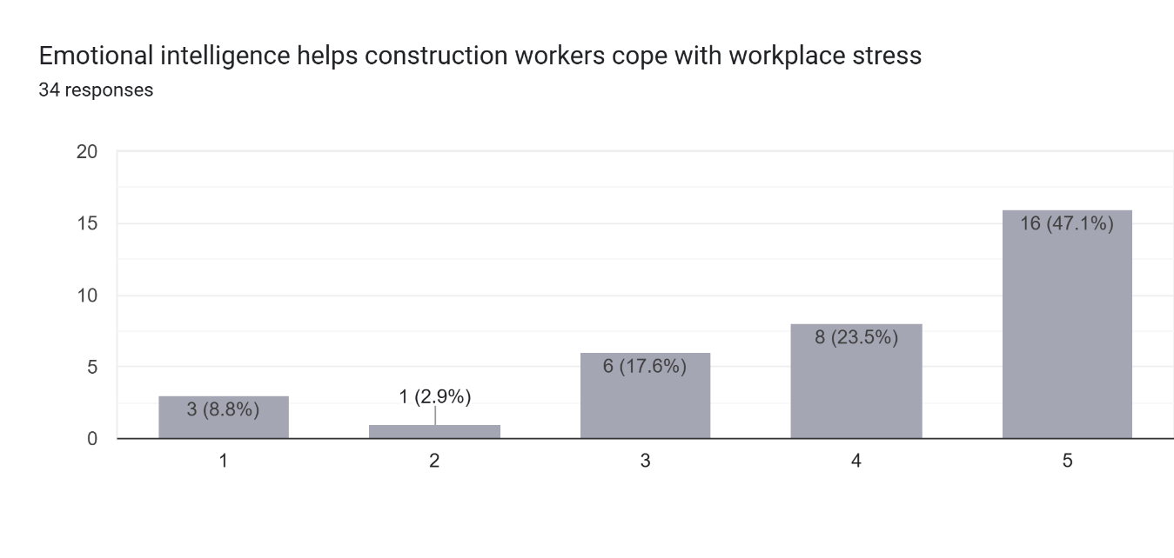
- 35.3% of the respondent strongly agree that emotionally intelligent employees remain calm during project challenges, it is considered as “Satisfactory”

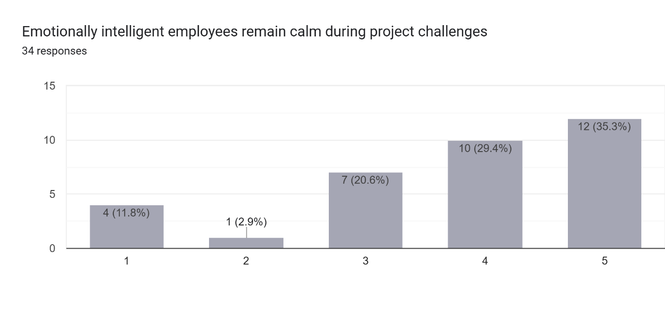

- 38.2% of the respondent strongly agree that Emotional intelligence reduces the negative effects of work pressure, it is considered as “Satisfactory”

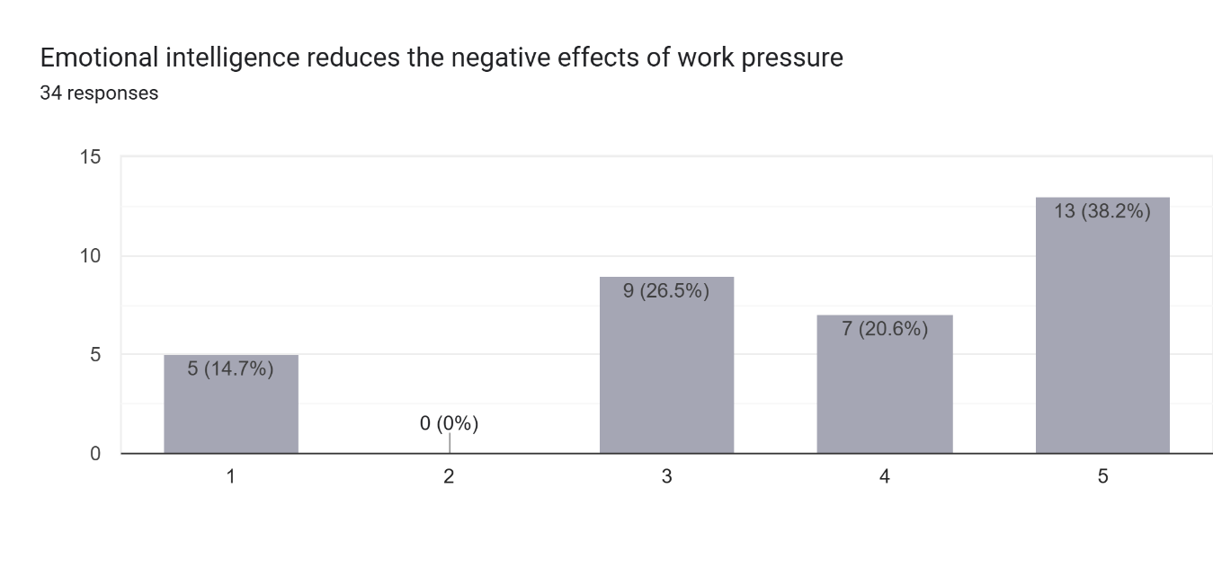
- 44.1% of the respondent strongly agree that Emotional intelligence helps team members maintain a positive attitude during project delays, it is considered as “below average”
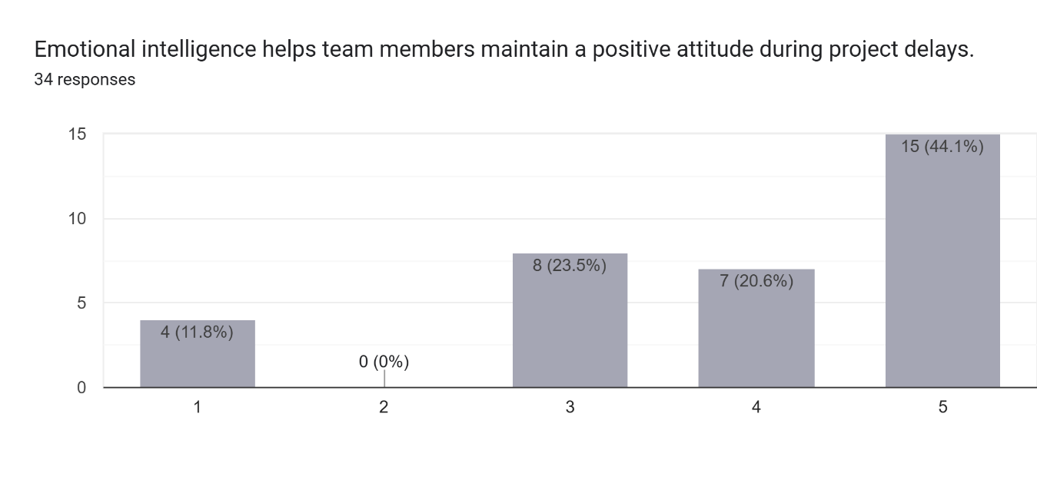

- 38.2% of the respondent strongly agree that Emotional intelligence contributes to the successful completion of construction projects, it is considered as “below average”

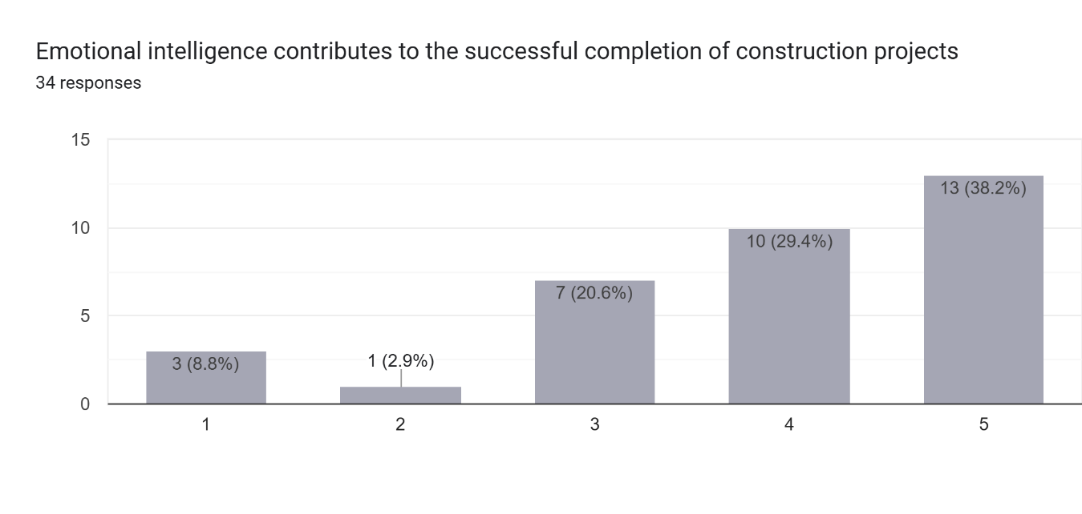

- 41.2% of the respondent strongly agree that Projects led by emotionally intelligent managers are more likely to achieve their objectives, it is considered as “below average”
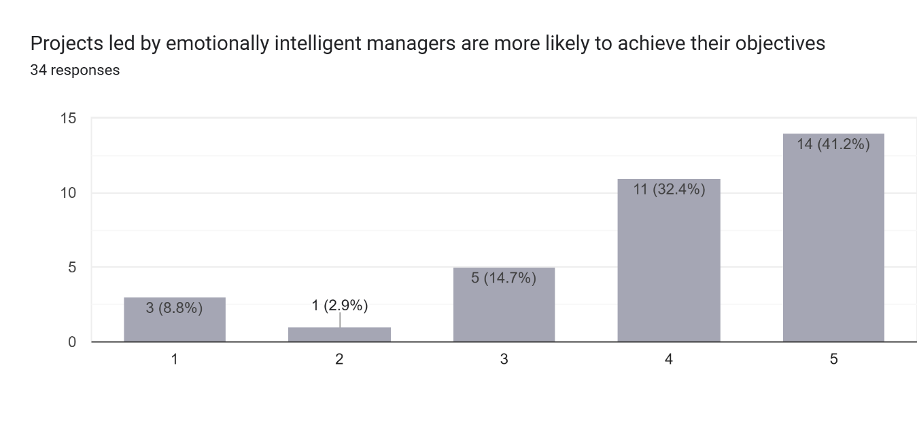\

- 44.1 % of the respondent strongly agree that Emotional intelligence improves the overall performance of construction project teams, it is considered as “below average “
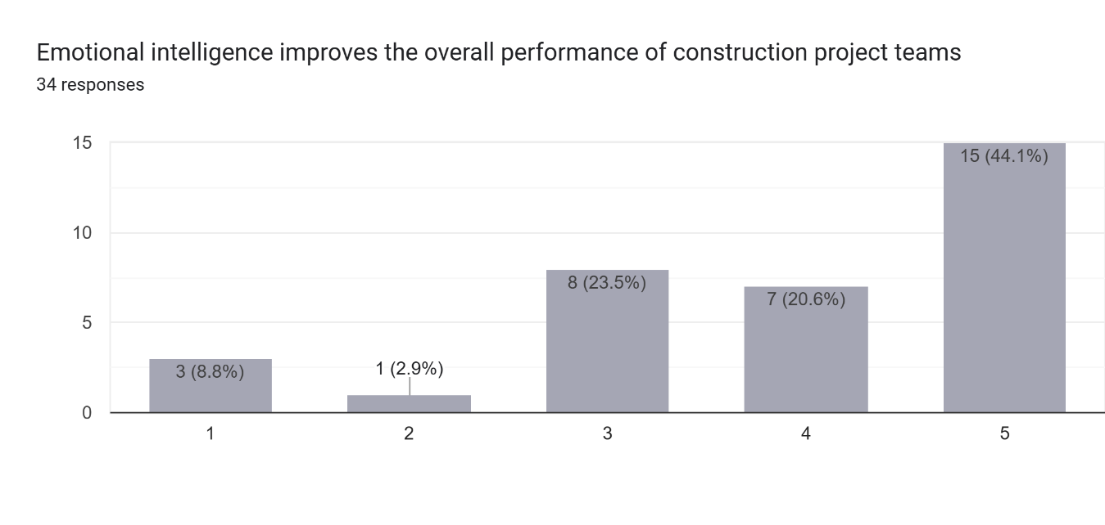

- 35.3% of the respondent strongly agree that Emotional intelligence enhances client satisfaction with project outcomes, it is considered as “Satisfactory”

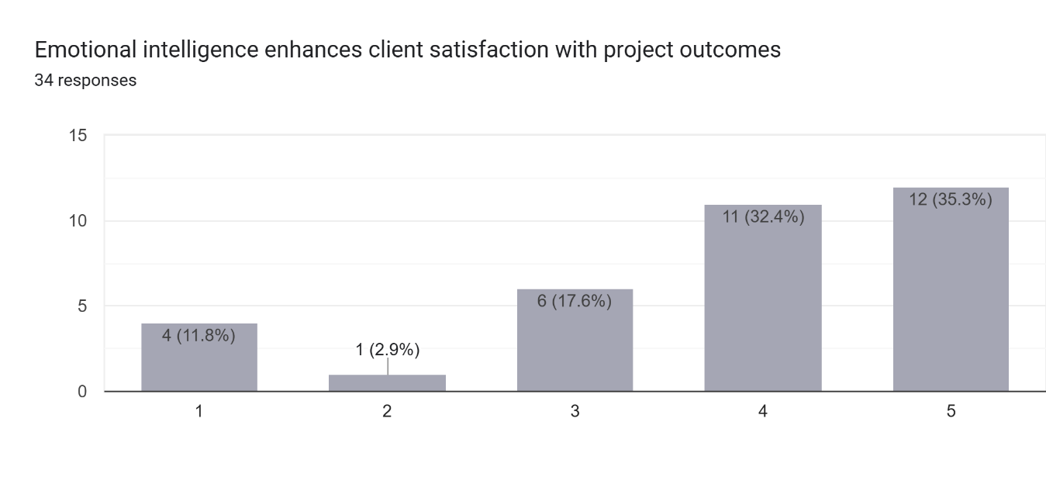

- 41.2% of the respondent strongly agree that Emotional intelligence improves coordination between project stakeholders, it is considered as “below average”
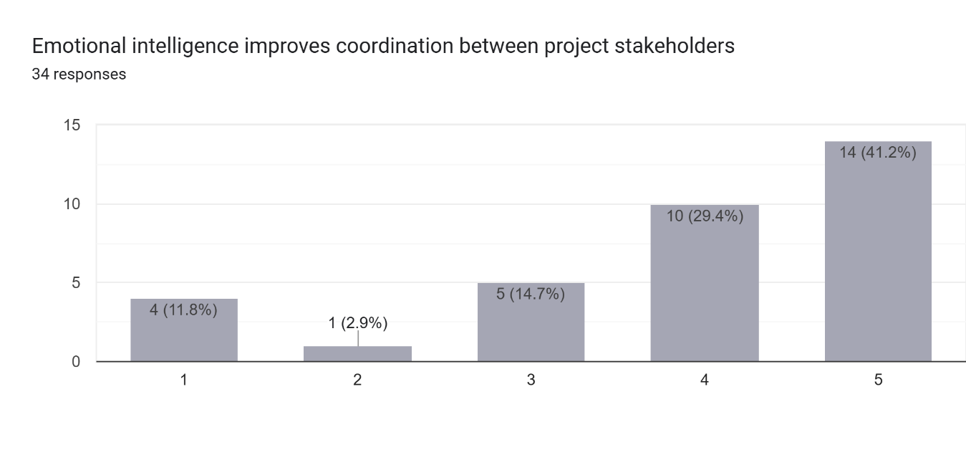

- 38.2% of the respondent agrees that Emotional intelligence strengthens decision-making within project teams, it is considered as “Satisfactory”

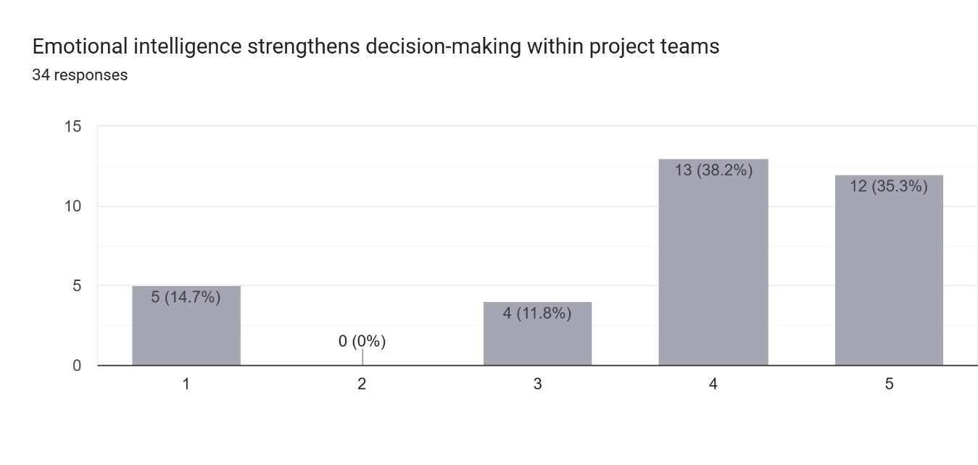

- 47.1% of the respondent strongly agree that the Organizations should provide emotional intelligence training for construction professionals, it is considered as “below average”

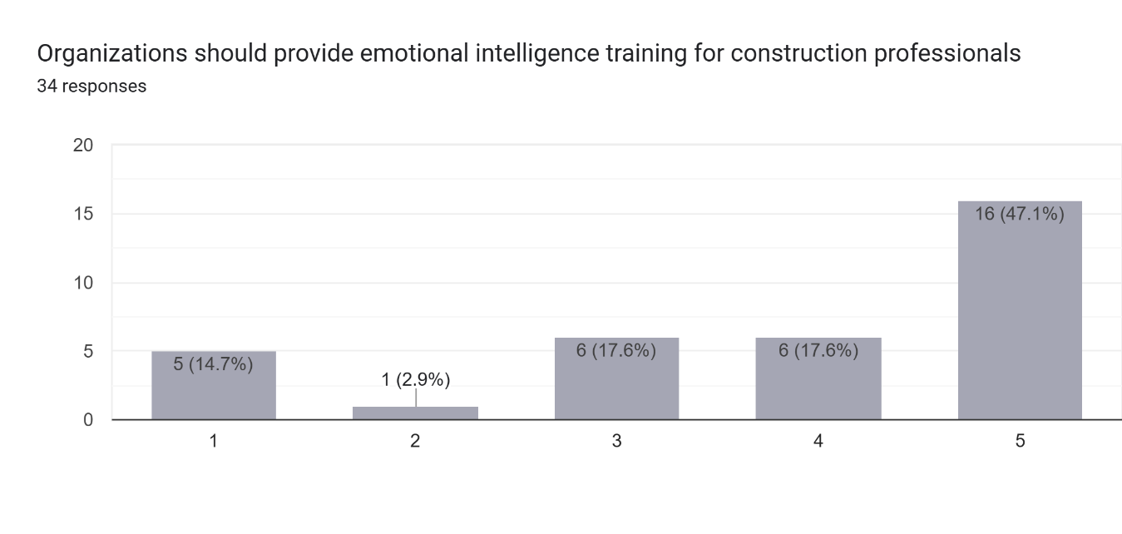

- 47.1% of the respondents strongly agree that Emotional intelligence is as important as technical skills in construction project management, it is considered as “below average”

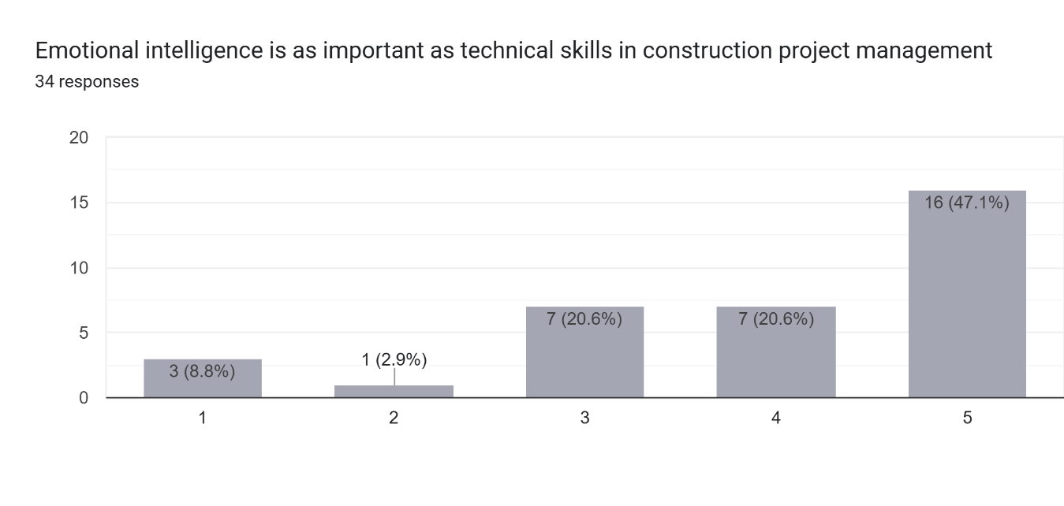

- 47.1% of the respondent strongly agree that Emotional intelligence provides a competitive advantage in construction project delivery, it is considered as “below average”

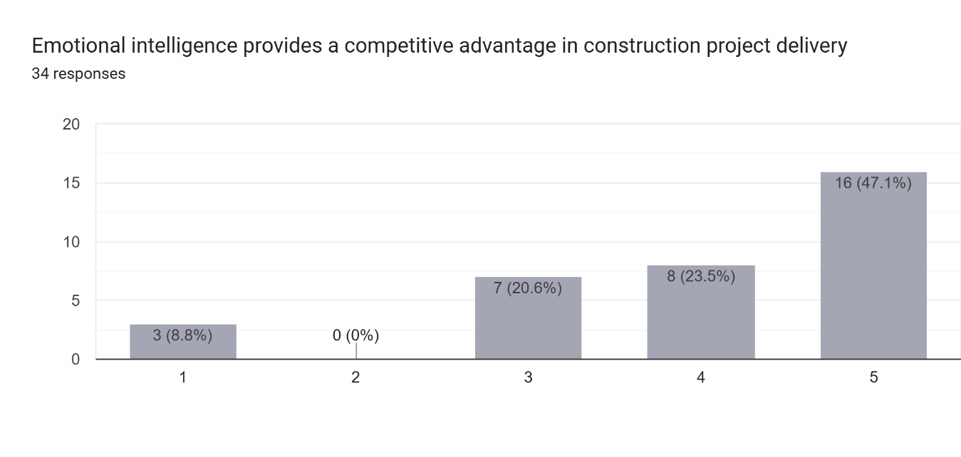

RESULTS:

Recommendations: -

- Conduct a study on the impact of Emotion Intelligence on project performance.
- Identify research gaps in the current study and conduct an in-depth study addressing them.

References: -

English References:-

- Ayoko, Callan, and Härtel (2008) ) (Ayoko, O. B., Callan, V. J., & Härtel, C. E. J. (2008). The influence of team emotional intelligence climate on conflict and team members’ reactions to conflict. Small Group Research, 39(2), 121–149.
- Chang, J. W., Sy, T., & Choi, J. N. (2012). Team emotional intelligence and performance: Interactive dynamics between leaders and members. Small Group Research, 43(1), 75–104. https://doi.org/10.1177/1046496411415692
- Druskat and Wolff (2001) Druskat, V. U., & Wolff, S. B. (2001). Building the emotional intelligence of groups. Harvard Business Review, 79(3), 80–90.
- Goleman, D. (1995). Emotional intelligence: Why it can matter more than IQ. Bantam Books.
- Jordan, Ashkanasy, Härtel, and Hooper (2002) ) Jordan, P. J., Ashkanasy, N. M., Härtel, C. E. J., & Hooper, G. S. (2002). Workgroup emotional intelligence: Scale development and relationship to team process effectiveness and goal focus. Human Resource Management Review, 12(2), 195–214.
- Mahon (2008) ) Mahon, E. (2008). Emotional Intelligence, Shared Vision, and Teamwork Performance: A Qualitative Study. Case Western Reserve University.
- Managing Complexity in Global Organizations
Feyerherm, A. E., & Rice, C. L. (Eds.). (2002). Managing complexity in global organizations. Praeger.
- Mayer, J. D., & Salovey, P. (1997). What is emotional intelligence? In P. Salovey & D. J. Sluyter (Eds.), Emotional development and emotional intelligence: Educational implications (pp. 3–31). Basic Books.
- Miao, Humphrey, and Qian (2017) ) Miao, C., Humphrey, R. H., & Qian, S. (2017). A meta-analysis of emotional intelligence and workplace outcomes. Journal of Organizational Behavior, 38(3), 392–417.
- Prati, Douglas, Ferris, Ammeter, and Buckley (2003) ) Prati, L. M., Douglas, C., Ferris, G. R., Ammeter, A. P., & Buckley, M. R. (2003). Emotional intelligence, leadership effectiveness, and team outcomes. The International Journal of Organizational Analysis, 11(1), 21–40.

Arabic References:

- M. A. Majeed, S. Ramayah, A. Mustamil, & A. Nazri. (2019). Emotional intelligence and organizational performance: A systematic review. Journal of Critical Reviews, 6(6), 82–88.
- Rezvani, H., Taheri, M., Tabaei, M., Kazemzadeh, Y., & Sharifi, M. (2018). Experimental investigation of interfacial properties in the EOR mechanisms by the novel synthesized Fe₃O₄@Chitosan nanocomposites. Colloids and Surfaces A: Physicochemical and Engineering Aspects, 544, 15–27. https://doi.org/10.1016/j.colsurfa.2018.02.012

APPENDIXES

Subject: Request for Arbitration of Research Questionnaire

Dear Dr. ........................................................................., I hope this email finds you well. I am writing to inform you that I am a student at Midocean University - College of Management, specializing in a master’s degree in project management. I am currently conducting research titled " The Impact of Emotional intelligence on project team members in Riyadh city projects " as part of my master's program requirements in Project Management. I am reaching out to request your expertise in reviewing and validating the survey designed for my research.
Attached is a copy of the survey, and I kindly ask you to review it and provide your insights and suggestions regarding the accuracy and appropriateness of the statements in measuring the study's objectives.
Additionally, I would appreciate any recommendations for modifications, whether it be rephrasing, removing, or adding new statements. Thank you very much for your time and effort.
I look forward to receiving your valuable feedback.

Sincerely,
Engr Haitham Berhan
Master of Project Management
Candidate College of Management,
Midocean University

موضوع : طلب تحكيم استبيان بحثي

الدكتور.............................................. المحترم،

السلام عليكم ورحمة هللا وبركاته،
أتمنى أن تكونوا بخير وبأفضل حال

أود إبالغكم بأنني طالب في جامعة ميدأوشن - كلية الإدارة - تخصص ماجستير في إدارة المشاريع، على بحث بعنوان " تأثير الذكاء العاطفي على كوادر فريق المشروع في مشاريع مدينة الرياض"

وذلك كجزء من متطلبات درجة الماجستير في إدارة المشاريع. أتوجه إليكم بهذا الطلب لأستفيد من خبراتكم القيمة في تحكيم الاستبيان الخاص ببحثي. أرفق لكم نسخة من الاستبيان ، وأرجو منكم التكرم بمراجعتها وإبداء مالحظاتكم واقتراحاتكم حول مدى دقة وملاءمة العبارات المطروحة لقياس الأهداف المرجوة من الدراسة. كما أرجو منكم اقتراح أي تعديلات ترونها بإعادة صياغة العباارت، أو حذفها، أو إضافة عبارات جديدة.
أشكركم جزيل الشكر على وقتكم وجهودكم، وأتطلع إلى تلقي ملاحظاتكم القيمة

مع خالص التقدير واالحترام،

م هيثم برهان
طالب ماجستير إدارة المشاريع
كلية الإدارة
جامعة ميدأوشن

الاستبيان
بسم الله الرحمن الرحيم

السيد/ ............................................................................ المحترم،
السلام عليكم ورحمة الله وبركاته، أود إبالغكم بأنني طالب في جامعة ميدأوشن - كلية الإدارة تخصص ماجستير في إدارة المشاريع، وأعمل حاليا على بحث باسم الموضوع " تأثير الذكاء العاطفي على كوادر فريق المشروع في مشاريع مدينة الرياض""، كجزء من متطلبات درجة الماجستير في إدارة المشاريع. و نظراً لاهمية ارئكم القيمة، أرجو منكم التفضل بالإجابة على هذا الاستبيان.

شاكر لكم حسن تعاونكم،

م هيثم برهان
طالب ماجستير إدارة المشاريع
كلية الإدارة
جامعة ميدأوشن

المشرف
د. الفيصل حسن
كلية الإدارة
جامعة ميدأوشن

Questionnaire
Dear Mr. / Ms. ....................................................................,
I would like to inform you that I am a student at Midocean University – College of Management, specializing in a master’s degree in project management. I am currently conducting research titled " The Impact of Emotional intelligence on project team members in Riyadh city projects " as part of the requirements for the master's program in Project Management. Given the importance of your opinions, I kindly request you complete this survey. I assure you that your responses will be highly valued and treated with utmost confidentiality, used solely for the purpose of academic research. Therefore, I hope your answers will reflect reality as closely as possible to contribute to achieving accurate results. Thank you for your cooperation.

Sincerely,

Haitham Berhan
Master of Project Management
College of Management
Midocean University

Supervisor
Dr. Alfaisal Hasan
College of Management,
Midocean University

Acknowledgment
I would like to express my sincere gratitude and appreciation to all participants of this survey for your valuable time and efforts. Your active participation and insightful feedback have significantly contributed to the success of this study. I greatly value your cooperation and support, and I assure you that your responses will be treated with the utmost confidentiality and used solely for academic research purposes.

Haitham Berhan
Master of Project Management
College of Management
Midocean University

شكر وتقدير
أتوجه بخالص الشكر والتقدير لجميع المشاركين في هذا االاستبيان على وقتكم وجهودكم القيمة.
إن مشاركتكم الفعالة وملاحظاتكم الهامة ساهمت بشكل كبير في إنجاح هذه الدراسة. اقدر تعاونكم ودعمكم وأوكد لكم ان إجابتكم ستعامل بسرية تامة ولن تستخدم الا لأغراض البحث.

م هيثم برهان
طالب ماجستير إدارة المشاريع
كلية الإدارة
جامعة ميدأوشن

الملخص

برز الذكاء العاطفي كعامل جوهري يؤثر في أداء الأفراد والفرق في بيئات العمل القائمة على المشاريع. وتتناول هذه الدراسة أثر الذكاء العاطفي على أعضاء فرق العمل في المشاريع بمدينة الرياض، مع التركيز على فهم كيفية مساهمة الكفاءات العاطفية في تعزيز التواصل والتعاون وحل النزاعات وفعالية القيادة وتحقيق النجاح الشامل للمشروع. وفي ظل استمرار وتيرة التنمية العمرانية المتسارعة التي تشهدها الرياض ضمن إطار "رؤية المملكة 2030"، يتعين على فرق المشاريع العمل في بيئات تتسم بتزايد التعقيد وتعدد الثقافات؛ مما يجعل من الذكاء العاطفي كفاءةً أساسيةً لضمان فعالية العمل الجماعي. وتعتمد الدراسة منهجية بحثية كمية، حيث يتم جمع البيانات من العاملين في قطاع الإنشاءات عبر استبانة مقننة، وتحليلها باستخدام الأساليب الإحصائية الملائمة لبحث العلاقة بين الذكاء العاطفي ومؤشرات أداء فرق العمل.
تبحث هذه الدراسة في الأبعاد الرئيسية للذكاء العاطفي - بما في ذلك الوعي الذاتي، والتنظيم الذاتي، والدافعية، والتعاطف، والمهارات الاجتماعية - وتُقيِّم تأثيرها على فعالية فرق العمل في المشاريع. ومن المتوقع أن تُظهر النتائج أن المستويات المرتفعة من الذكاء العاطفي تؤثر إيجاباً على التعاون بين أعضاء الفريق، ومستوى اندماج الموظفين، وعمليات اتخاذ القرار، ونتائج المشاريع، فضلاً عن دورها في الحد من الصراعات في بيئة العمل وتحسين الأداء المؤسسي. وتُسهم الدراسة في إثراء المعرفة المتنامية في مجال إدارة المشاريع من خلال تقديم أدلة تجريبية مستمدة من سياق المشاريع في مدينة الرياض، كما تقدم توصيات عملية للمؤسسات لدمج الذكاء العاطفي في عمليات التوظيف، وتطوير القيادة، وممارسات إدارة المشاريع، وذلك بهدف تعزيز فرص نجاح المشاريع.

الكلمات المفتاحية: الذكاء العاطفي، إدارة المشاريع، أعضاء فريق المشروع، أداء الفريق، مدينة الرياض، رؤية السعودية 2030، القيادة، الأداء التنظيمي.


جامعة ميدأوشن
كلية الإدارة
ماجستير إدارة المشاريع

تأثير الذكاء العاطفي على كوادر فريق المشروع في مشاريع مدينة الرياض

إعداد الطالب:
م / هيثم عبدالواسع برهان
الرقم األكاديمي/ 253002768

إشراف:
الدكتور الفيصل حسن

العام الدراسي:
2026

