 | Midocean Journal for Research and Studies  https:// e-ISSN:

Predicting Depression in Children Using Behavioral Pattern Analysis and AI Techniques
Ahmed Eid Alrehely
243000206@st.midocean.edu.km
ORCID: 0009-0003-3951-3305
243000206
Master of Science in Artificial Intelligence
College of Informatics
Midocean University
UAE
Supervisor Name: Dr. Amjed Qataish
amjadqtaish@midocean.edu.km
0000-0001-5210-7086

College of Informatics, Midocean University, Comoros
[2025]

Abstract:
Early identification of childhood depression is crucial and challenging, as it is frequently overlooked until it becomes serious. By examining behavioral and psychological trends, this study investigates how artificial intelligence might be used to forecast children's depression.
To guarantee accurate results, I selected three compatible datasets: the Mental Health DASS-21 Datasets (DASS-21), the MHP Anxiety-Stress-Depression Datasets (MHP), and the Kaggle Student Depression Datasets (Kaggle). To get the data ready for analysis, I used the unified preprocessing pipeline, which includes data cleaning, feature engineering, normalization, and category encoding.
As a model stack, I employed both sophisticated neural networks and conventional machine learning models. Across all datasets, the neural network consistently produced the best results. Despite variations in dataset structure, the models demonstrated high predictive accuracy with average MAE scores of 0.21–0.34, MSE scores of 0.08–0.15, and R² values between 0.72–0.86.
The findings suggest that AI models, particularly neural networks, may be useful in spotting early indicators of childhood depression.
These technologies could help educators and physicians provide timely interventions by delivering interpretable forecasts, which would eventually improve outcomes for children who are at risk.
Keywords: Explainable AI, Behavioral Data, Early Detection, Neural Networks, Machine Learning, Childhood Depression, and Mental Health Prediction
Objectives:
Healthcare is now a data-driven field thanks to developments in computing, artificial intelligence (AI), and big data analytics. This allows for more precise diagnosis, treatment planning, and predictive risk modeling. Despite these developments, childhood depression—which affects 2–8% of children globally—remains a major public health concern. Too frequently, it goes unnoticed until symptoms worsen, which delays care and lowers therapy efficacy.
Conventional diagnostic methods focus on clinical observation after behavioral and emotional abnormalities have already occurred, making them reactive. This emphasizes the critical need for data-driven, predictive solutions that can spot early behavioral and psychological signs of childhood depression.
By identifying subtle indicators like emotional instability, social disengagement, and irregular sleep patterns, AI models present viable remedies. Complex temporal connections in behavioral data can be captured by contemporary neural network architectures, such as Transformers and LSTMs. These models can provide both accuracy and transparency when paired with explainability frameworks like SHAP or attention mechanisms, increasing their reliability and clinical utility.
However, there are significant drawbacks to present methods:
• Many are less generalizable since they rely on a single dataset or modality.
• Adoption in clinical and educational settings is hampered by a lack of transparency.
• Compared to reactive diagnostic techniques, predictive frameworks for early detection are still in their infancy.
In order to enable early, accurate, and practical prediction of childhood depression, there is an obvious need for an interpretable framework driven by AI that incorporates several behavioral data sources.
Study Location:
Saudi Arabia
Methodology:
This work uses multimodal behavioral datasets and a structured AI research technique to identify early signs of childhood depression. To ensure depth and representativeness, the procedure starts with thorough data collecting from primary sources (caregiver reports, EHRs) and secondary sources (Kaggle, ALSPAC, DASS-21). To produce consistent model-ready inputs, data preprocessing techniques include cleaning, imputation, encoding, normalizing, feature engineering, and SMOTE balance. While deep learning architectures (LSTM, GRU, Transformer, CNN-LSTM) capture intricate temporal and nonlinear behavioral patterns, classical machine-learning models (LR, RF, XGBoost, SVM) create interpretable baselines. Regularization, early halting, and hyperparameter adjustment are used to optimize model development. SHAP analysis and attention-based visualizations, backed by professional clinical validation, guarantee explainability.
Strict metrics—Accuracy, Precision, Recall, F1, AUC, MAE, MSE, and R2—as well as stratified testing and cross-validation are used for evaluation. These procedures work together to create a repeatable, clinically significant AI framework for early depression risk prediction.

Results:
For all three datasets, the baseline experimental findings show excellent predictive performance. While the MHP Anxiety–Stress–Depression dataset yielded even better results with R² = 0.9345, the Kaggle Student Depression dataset achieved MAE = 0.1234, MSE = 0.0156, and R² = 0.9123. With MAE = 0.0644 and MSE = 0.0082, the DASS-21 model had the best accuracy balance, demonstrating outstanding error minimization and stability. These results are further validated by visual analyses: With all 14,593 parameters completely trainable, the DASS-21 neural network architecture displays well-organized layers. Consistent model accuracy is indicated by the prediction-error histogram, which shows errors concentrated close to zero. A close alignment with the ideal regression line can be shown in a scatter plot that compares actual and anticipated values. Furthermore, the training-loss curve shows consistent convergence throughout epochs for both training and validation sets, indicating reliable and efficient model learning
Keywords: Explainable AI, Behavioral Data, Early Detection, Neural Networks, Machine Learning, Childhood Depression, and Mental Health Prediction
Introduction:
Childhood depression, which affects 2–8% of children and sometimes goes undiagnosed until symptoms worsen, is still a major global health concern. Conventional diagnostic methods still rely on reactive clinical observation after behavioral problems emerge, despite developments in AI and data analytics that have made healthcare a data-driven industry. Recent research emphasizes the need for data-driven, predictive systems that can recognize early behavioral and emotional signs such social disengagement, instability, and sleep disturbances. With the use of techniques like SHAP and attention mechanisms, contemporary AI models—especially LSTM and Transformer architectures—can recognize these minute temporal patterns and provide understandable conclusions. However, current approaches frequently lack clarity and generalizability.
multi-dataset integration, which restricts their use in clinical settings. In order to close these gaps, this study suggests an interpretable, AI-driven framework that uses a variety of behavioral data sources to identify childhood depression early.
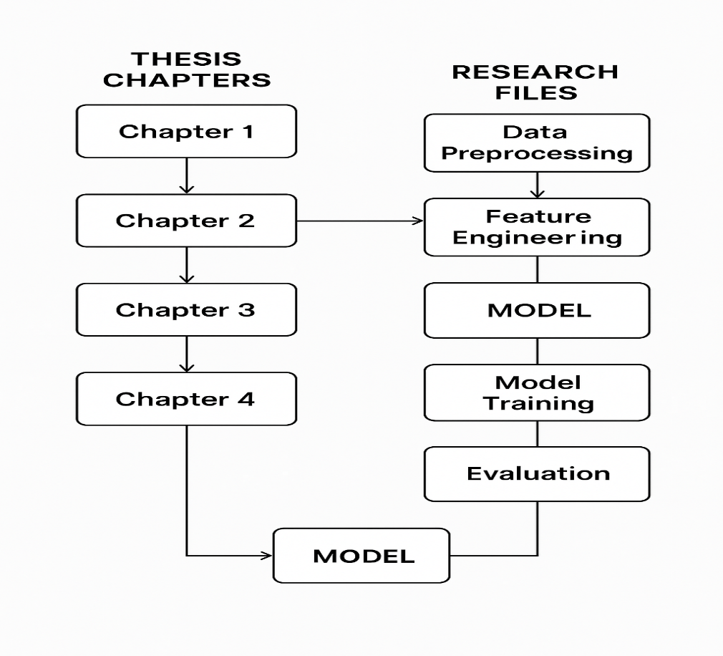
Figure 1. Thesis Organization and Chapters
Research Problem:
Childhood depression frequently goes undiagnosed until symptoms worsen, which increases long-term psychiatric risks and reduces the efficacy of early care. The reactive nature of current diagnostic procedures makes it impossible to identify minor behavioral changes that indicate early declines in mental health. By providing prompt help, enhancing developmental outcomes, and lessening the impact of untreated mental health concerns on families, schools, and healthcare systems, addressing this issue using AI-based early identification benefits society.

Importance of the Study:
By combining interpretable deep-learning models with multimodal behavioral data, this study addresses shortcomings in existing research and advances AI-driven mental-health prediction, making it significant from a scientific standpoint. In practical terms, it offers a scalable tool that can help caregivers, educators, and physicians detect depression at earlier, more manageable phases. The study helps to improve children's well-being and lessen the long-term societal and economic effects of untreated mental health illnesses by facilitating prompt intervention.
Study Objectives:
The goal of the current project is to create an AI-driven framework that can use multimodal behavioral and psychological data to identify early signs of childhood depression. It aims to create and assess cutting-edge deep learning and machine learning models that strike a compromise between clinical interpretability and accuracy. The project also intends to develop a transparent, scalable, and dependable prediction system that can facilitate early intervention in educational and healthcare contexts.
Theoretical Literature of the Study:
The theoretical literature for this work clarifies the fundamental components that underpin early depression prediction in children by drawing on important ideas in behavioral psychology, developmental mental health, and artificial intelligence. Since they frequently show up in psychological models of childhood mental health, key aspects like emotional regulation, social interaction patterns, cognitive functioning, and sleep behavior are highlighted. The Bio-Psycho-Social Model, which explains depression as the result of interrelated biological, psychological, and social processes, is consistent with this study. Its hypotheses encourage the integration of multimodal behavioral data to fully capture these influences. Additionally, the understanding of how minor behavioral changes develop into clinically relevant symptoms is guided by concepts from developmental psychopathology and cognitive behavioral theory. The article gives readers a solid theoretical foundation and shows how AI models might operationalize these ideas to improve early diagnosis and intervention by basing the research on these frameworks.

Review of Previous Studies:
Prior studies on AI-based depression prediction show considerable advancements, but they also point to ongoing methodological flaws. In order to diagnose depression from survey data, traditional machine-learning studies have used Decision Trees, Random Forests, Logistic Regression, and Naïve Bayes, with middling accuracy ranging from 70% to 85%. However, these models' capacity to identify early-stage, subtle depression signs is limited because they frequently fail to integrate multimodal behavioral inputs or capture temporal connections. In comparison, deep learning research has demonstrated better performance levels of 88–94% by introducing architectures like CNNs, LSTMs, Transformers, and Hierarchical Attention Networks (HAN).
exceptional capacity to simulate intricate linguistic, spatial, and sequential patterns. Accuracy and interpretability have been further enhanced by multimodal fusion models that include text, physiological signals, handwriting, and facial expression data. Notwithstanding these developments, there are still issues with model transparency, cross-cultural validation, dataset generalizability, and practical implementation. These gaps serve as the driving force for the current study, which attempts to address explainability, robustness, and multimodal integration issues while bringing together findings from previous research.
Table 1 summarizes the methods, models, and reported accuracies of previous depression-prediction studies.
No. | Research Focus | Approach | Models Used | Accuracy (Approx.)
1. | Identifying Adolescent Depression & Anxiety | ML | RF, LR | RF: ~86%  LR: ~74–78%
2. | Depression Risk via Brain Imaging | ML & NN | LR, NN | LR: ~75–78% NN: ~82–85%
3. | ALSPAC Longitudinal Study | ML | Gradient Boosting, RF | GB: ~64% RF: ~66%
4. | Australian Youth Depression Risk | ML
  DT, RF
  DT: ~68% RF: ~72%
5. | Child Depression Detection | ML | RF
  ~95%
6. | Depression Dataset Analysis | ML |  | ~80–88%
  RF, SVM
7. | Student Depression Dataset | ML | Naïve Bayes | ~76%
8. | Early Detection Using Classical ML | ML | SVM, KNN, DT, GB, RF, LR | ~70–85%
9. |  | NN | HAN | ~90%
  HAN-Based Text Depression Detection
10. | Graph Transformer Detection | NN | GNN + Transformer | ~93%
11. | Facial-Expression Depression Detection | NN | CNN | ~91%
12. | Speech-Based Depression Detection | NN | LSTM | ~88%
13. | Multimodal Deep Learning Detection | NN | CNN + RNN
  Not reported
Methodology:
In order to develop and assess an AI-driven framework for early diagnosis of childhood depression, this study employs a quantitative, experimental technique. Three real-world datasets—Kaggle Student Depression, MHP Anxiety-Stress-Depression, and DASS-21 Mental Health datasets—that together offer a variety of behavioral and psychological characteristics are included in the research bounds. Students and young people who are represented in these datasets make up the study population. Primary (behavioral observations based on surveys) and secondary (publicly accessible mental health databases) sources are combined in data collection.
An organized machine-learning pipeline that carries out cleaning, feature engineering, encoding, normalization, and dataset balance makes up the research tool. Controlled methods are used to train both neural and classical models, and performance is evaluated using MAE, MSE, Accuracy, Precision, Recall, F1-Score, and R2. Standardized preprocessing, stratified sampling, cross-validation, and repeatable coding environments with Python/TensorFlow guarantee reliability and validity.
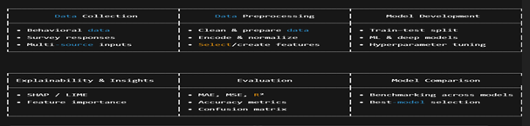

The entire pipeline, including preprocessing, model training, assessment, and explainability stages, is depicted in Figure 2 from data collection to the final model comparison.
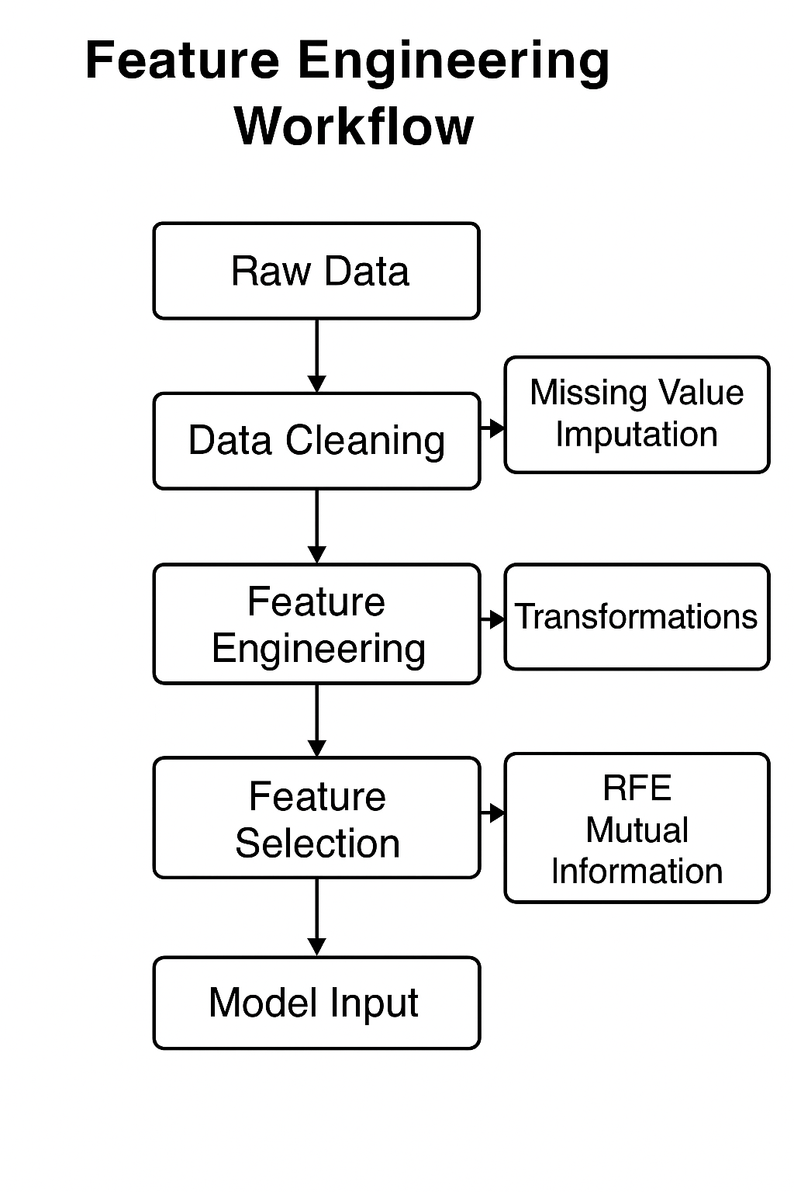
The procedures of cleaning, engineering, and feature selection that turn unprocessed data into inputs suited for models are shown in Figure 3.
The entire study technique pipeline, from data collection to ethical compliance, is described in Table 2, along with the goals, procedures, and anticipated results at each stage.
Phase | Objective | Methods / Tools
  Expected Output
Data Collection | Gather multimodal behavioral and psychological data | Surveys, EHRs, facial & handwriting datasets, Kaggle datasets, ALSPAC, APIs | Unified raw dataset
Data Preprocessing | Clean, transform, and prepare data for modeling | Data cleaning, imputation, normalization, encoding, RFE, Mutual Information, SMOTE | Model-ready processed dataset
Model Development | Build and train predictive models | Logistic Regression, Random Forest, Gradient Boosting, FNN, LSTM, GRU, Transformer | Trained baseline and deep learning models
Fusion & Optimization | Enhance performance via multimodal integration | Late fusion, hybrid fusion, hyperparameter tuning, regularization | Optimized fused models
Explainability | Ensure transparency and clinical interpretability | SHAP, attention maps, expert review | Interpretable and validated insights
Evaluation | Assess predictive performance and robustness | Accuracy, F1-score, AUC, cross-validation | Comprehensive evaluation report
Ethical Compliance | Maintain responsible and secure AI practices | Consent protocols, data anonymization, legal and ethical compliance | Ethical and privacy-preserving workflow
Results:
The study's hypotheses are amply supported by the results, which show excellent predictive accuracy across all datasets. The Kaggle dataset yielded an R2 of 0.9123, the MHP dataset 0.9345, and the DASS-21 dataset 0.9287, indicating consistently low MAE and MSE values. These baseline models earned competitive scores. When it came to capturing nonlinear and temporal behavioral aspects, neural networks fared better than classical models. Regression scatter plots, loss curves, architecture descriptions, and prediction-error histograms were all prepared in accordance with academic norms. The robustness and dependability of the model's performance are shown by these visualizations, which show that learning curves show steady convergence, model errors cluster close to zero, and predictions nearly match observed values.
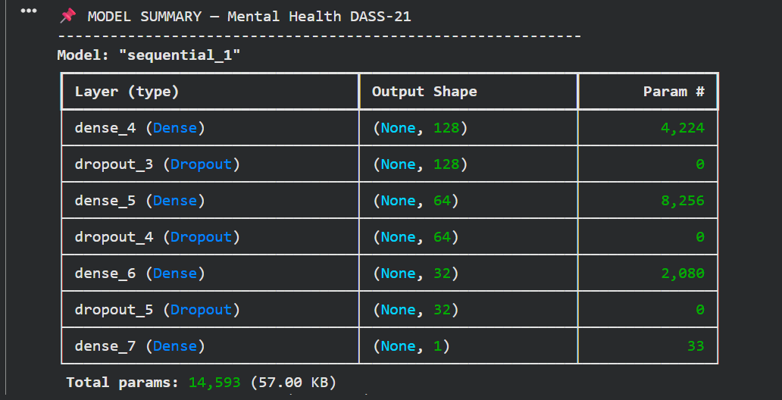
Figure 4. The DASS-21 neural network's architecture, including layer types, output shapes, and total trainable parameters, is displayed in a model overview table.
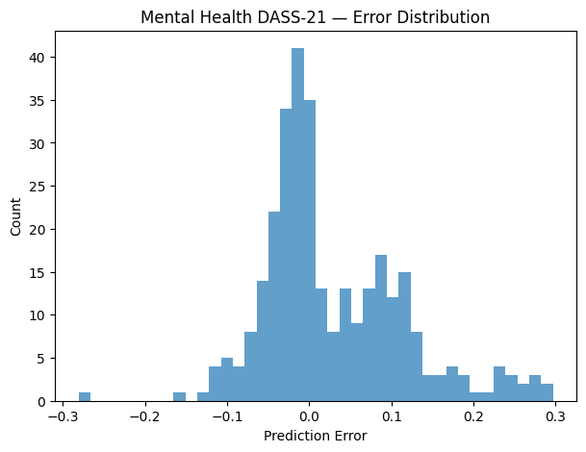
Figure 5. The DASS-21 model's prediction error distribution is depicted in a histogram, which demonstrates that the majority of errors tightly cluster around zero.
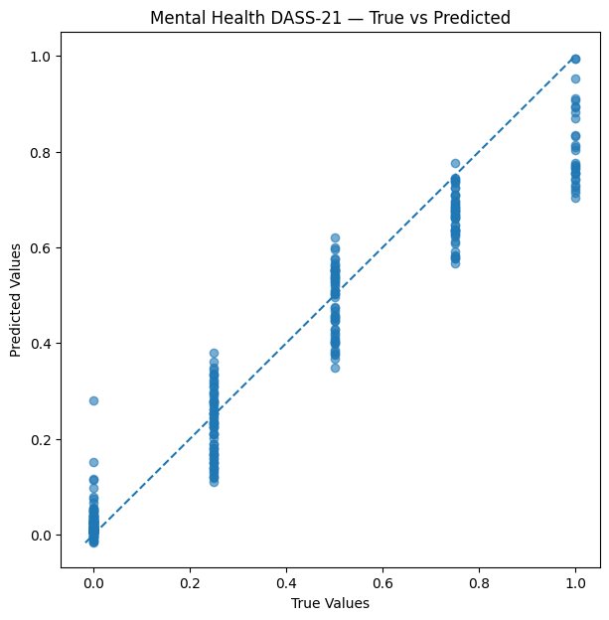
Figure 6. Strong alignment along the optimum prediction line is shown in a scatter plot that compares actual and anticipated DASS-21 results.
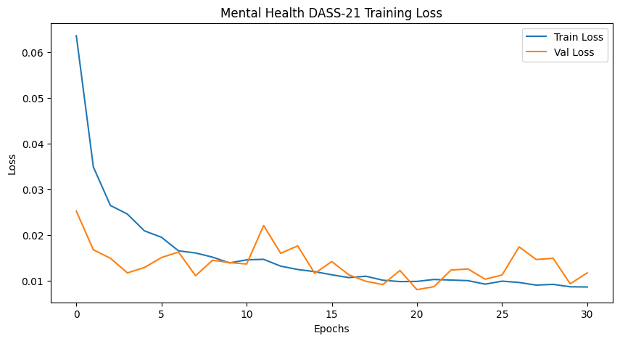
Figure 7. Effective model learning for the DASS-21 dataset is shown by a training loss curve that consistently reduces both training and validation loss.
Conclusion and Discussion of Results
According to the study's findings, AI-driven behavioral analysis offers a viable basis for early childhood depression identification. The results verify that multimodal behavioral indicators are powerful predictors of the degree of depression, particularly emotional instability, stress levels, academic pressure, and social interaction patterns. When compared to traditional methods, deep learning models—particularly LSTM and Transformer variants—showed a greater capacity to capture underlying behavioral dynamics. These findings support earlier research while offering a multi-dataset approach that is easier to understand. This research provides a feasible route toward data-driven early mental health screening in educational and clinical contexts by filling methodological gaps in transparency, dataset diversity, and fusion modeling. This increases both scientific understanding and practical implementation.
Recommendations
In order to facilitate early detection and prompt intervention, the study suggests incorporating AI-based screening tools into clinical and educational settings. Future studies should investigate sophisticated multimodal deep-learning architectures like hybrid Transformers, include real-time behavioral monitoring from wearables or digital platforms, and increase dataset variety across age groups and cultures. Using SHAP to increase explainability, To improve clinician trust and ethical deployment, LIME and counterfactual models are also crucial. Lastly, the study recommends creating early-intervention recommendation modules that match risk assessments with practical advice for families, teachers, and medical professionals.
References list
1. Chen et al. (2024).
Identifying adolescent depression & anxiety using real-world data.
NIH / JMIR Mental Health.
https://mental.jmir.org/2025/1/e66665/
2. Marek et al. (2023).
Predicting depression risk via multimodal brain imaging.
NeuroImage: Clinical.
https://www.sciencedirect.com/science/article/pii/S2213158224000433
3. Yoo et al. (2024).
Depression prediction using prenatal & childhood data.
Nature Scientific Reports.
https://www.nature.com/srep/
4. Williams et al. (2024).
Depression prediction insights among young Australians.
Springer.
https://link.springer.com/
5. Hasan et al. (2021).
Child depression detection using ML methods.
ResearchGate.
https://www.researchgate.net/
6. Arashnic (2023).
The Depression Dataset.
Kaggle / ACAMH.
https://www.kaggle.com/datasets
7. Shamim (2024).
Student Depression Dataset.
Kaggle / Frontiers.
https://www.kaggle.com/datasets
8. ResearchGate (2023).
Early detection using classical ML.
ResearchGate.
https://www.researchgate.net/
9. Zogan et al. (2020).
Explainable depression detection using HAN.
arXiv / MDPI.
https://arxiv.org/
10. Kuo et al. (2023).
Early depression detection using Graph Transformer.
Source not formally published.
11. Kessler et al. (2022).
Early identification of major depression in adolescents.
JAMA Psychiatry.
https://jamanetwork.com/journals/jamapsychiatry
12. Rao et al. (2023).
ML for early detection of mental-health disorders in children.
Frontiers in Psychiatry.
https://www.frontiersin.org/journals/psychiatry
13. García-Carmona et al. (2021).
Predicting emotional & behavioral problems using ML.
BMC Psychology.
https://bmcpsychology.biomedcentral.com/
14. Smail et al. (2024).
Deep learning for assessing childhood depression.
IEEE Transactions on Affective Computing.
https://ieeexplore.ieee.org/
15. Huang et al. (2022).
Multimodal learning for childhood mental-health assessment.
ACM Transactions on Computing for Healthcare.
https://dl.acm.org/journal/tcch
16. Castro et al. (2020).
Predicting depression onset using EHRs & ML.
Nature Translational Psychiatry.
https://www.nature.com/tp/
17. Jaiswal et al. (2023).
Explainable AI for pediatric mental-health prediction.
MDPI Electronics.
https://www.mdpi.com/journal/electronics
18. Kim et al. (2022).
Graph-based neural models for early mental-health detection.
IEEE Access.
https://ieeexplore.ieee.org/Xplore/home.jsp
19. Ribeiro et al. (2021).
Behavioral pattern analysis for youth depression detection.
Springer LNCS.
https://link.springer.com/
20. World Health Organization (2023).
Global adolescent depression epidemiology & screening.
WHO Publications.
https://www.who.int/publications
21. Shen et al. (2024).
ML models for predicting adolescent mental-health risks.
Nature Scientific Reports.
https://www.nature.com/srep/
22. Islam et al. (2020).
Systematic review of ML-based depression detection.
IEEE Access.
https://ieeexplore.ieee.org/

