
Midocean University
College of Management
Department of Business Administration

Evaluating the Relationship between Master Plan Updates and Project Alignment with Community Needs in Yanbu

By:
Ghalia Adel Hanafi - 242001246

Supervised By:
Dr. Faisal Abdul Hamid Dr. Fayez Jarad

Academic Year
2024/2025



Dedication
To the light of my life and my greatest support, to my beloved mother and father,
Who have always been a guiding light on my path and the foundation of every success, with their prayers, patience, and unwavering support.
To my dear grandmother, may God protect her,
Who instilled in my heart kindness and wisdom, and has been a true example of patience and faith. Her prayers have accompanied me every step of the way.
To my beloved aunt,
Who never hesitated to give her love and support, always being a warm embrace and a sincere encourager.
To the delight of my eyes, my precious sons,
Yasser and Ahmed, you are the light that brightens my life. With you, every achievement becomes complete. You are my greatest motivation to pursue success.
To my esteemed teachers,
Who generously shared their knowledge and wisdom, and guided me with care and dedication. I dedicate this work as a token of gratitude and appreciation for their role in my journey.
To my colleagues and friends,
Who stood by my side and offered support and encouragement. This work is a humble expression of my thanks for all they have given me.
And finally,
To everyone who contributed to my success, and supported me with a word, an act, or a prayer throughout this journey —
I ask Allah to make this achievement a blessed step toward a bright future and the fulfillment of even greater ambitions.

Copyright Notice

I acknowledge and declare that all copyrights for this MBA study and research belong to Mid-Ocean University.

Abstract
This study focuses on master plan revisions and project alignment with community needs for Yanbu, a fast-growing city in Saudi Arabia. The study answers concern on project delay and mismatches among completed projects and evolving community needs, influencing Yanbu's Vision 2030 goals. The purpose here was to determine whether master plan updates adequately incorporate emerging community needs. Cross-sectional, qualitative data through interviews with Royal Commission of Yanbu residents (n = 265) were conducted. The data collection entailed a structured questionnaire assessing perceptions on five domains: Master Plan Updates, Project Alignment, Community Engagement, Implementation Effectiveness, and Barriers. Descriptive statistics, correlation, and regression analyses with SPSS were employed for data analysis. The findings revealed a predominantly male, middle-aged, long-term resident sample. Environmental sustainability ranked high among master plan revisions, but communication and participation from communities were moderately effective. Project alignment was generally positive, particularly towards quality-of-life improvements. Effectiveness at implementation level was moderate, with a high priority placed on governmental support but with problems with project timeliness. Barriers included gaps in feedback and process improvement requirement.
Correlation analyses identified strong, positive correlations between master plan updates, project alignment, engagement, and implementation. Regression analyses also identified that community perception of master plan updates consistently predicted community engagement and effectiveness of implementation, with communication playing a crucial role. Project alignment itself was not a predictor. The research concludes that effective communication for master plan updates is crucial.
Keywords: Yanbu Master Plan, Urban Development, Community Needs, Project Alignment, Community Engagement, Infrastructure Development.

الملخص
تركز هذه الدراسة على تحسين المخطط الرئيسي ومواءمة المشروع مع احتياجات المجتمع في ينبع، وهي مدينة سريعة النمو في المملكة العربية السعودية. تجيب الدراسة على المخاوف بشأن تأخير المشروع وعدم التوافق بين المشاريع المكتملة واحتياجات المجتمع المتطورة، مما يؤثر على أهداف رؤية ينبع 2030. كان الغرض من ذلك هو تحديد ما إذا كانت تحديثات المخطط الرئيسي تدمج بشكل كافٍ احتياجات المجتمع الناشئة. تم إجراء بيانات نوعية مقطعية من خلال مقابلات مع سكان الهيئة الملكية لينبع (ن = 265). تضمن جمع البيانات استبيانًا منظمًا لتقييم التصورات في خمس مجالات: تحديثات المخطط الرئيسي، ومواءمة المشروع، والمشاركة المجتمعية، وفعالية التنفيذ، والعوائق. تم استخدام الإحصاءات الوصفية وتحليل الارتباط والانحدار باستخدام برنامج SPSS لتحليل البيانات. كشفت النتائج عن عينة غالبيتها من الذكور في منتصف العمر ومقيمين طويلي الأمد. احتلت الاستدامة البيئية مرتبة عالية بين تحسين المخطط الرئيسي، ولكن التواصل والمشاركة من المجتمعات كانا فعالين بشكل معتدل. كان مواءمة المشروع إيجابية بشكل عام، وخاصة فيما يتعلق بتحسينات جودة الحياة. كانت الفعالية على مستوى التنفيذ متوسطة، مع إعطاء أولوية عالية للدعم الحكومي، ولكن مع وجود مشاكل في توقيت المشروع. وشملت العوائق فجوات في التغذية الراجعة ومتطلبات تحسين العمليات.
أظهرت تحليلات الارتباط ارتباطات قوية وإيجابية بين تحديثات الخطة الرئيسية، ومواءمة المشروع، والمشاركة، والتنفيذ. كما أظهرت تحليلات الانحدار أن إدراك المجتمع لتحديثات الخطة الرئيسية تنبأ باستمرار بمشاركة المجتمع وفعالية التنفيذ، مع لعب التواصل دورًا حاسمًا. لم يكن توافق المشروع بحد ذاته مؤشرًا. وخلص البحث إلى أن التواصل الفعال لتحديثات الخطة الرئيسية أمر بالغ الأهمية.
الكلمات المفتاحية: الخطة الرئيسية لينبع، التنمية الحضرية، احتياجات المجتمع، مواءمة المشروع، المشاركة المجتمعية، تطوير البنية التحتية.

Acknowledgement
First, I would like to extend my sincerest gratitude to the esteemed members of the jury and evaluators for their time, careful feedback, and constructive criticism. Their experience and input have been instrumental in helping mold and enhance the quality of this work. I am also particularly grateful for my academic advisors and professors, whose counsel and motivation have been a constant source of inspiration for me throughout this process. Their experience and mentorship have played a great part in shaping my research and broadening my understanding on the subject. In addition, I also appreciate my fellow students and colleagues for their thought-provoking discussions, motivational words, and sharing with each other, which have played a great role in enhancing my academic experience. Special appreciation is given to family and friends for their ongoing support, tolerance, and encouragement. Their faith in me has been a source of strength and motivation throughout this challenging but rewarding experience.
I would also like to extend my sincerest appreciation and thanks to all those people who contributed towards making this research a successful one. Furthermore, I appreciate all those people who donated resources, ideas, or assistance in whatever form, helping me overcome challenges and achieve my research objectives. This thesis is a culmination of collective work, and I am genuinely indebted to all those individuals who have helped me bring it to fruition.

Table of Contents
Copyright Notice II
Abstract III
الملخص IV
Acknowledgement V
Table of Contents VI
List of tables VIII
Chapter 1: Introduction 1
1.1 Introduction 2
1.2 Problem Statement 2
1.3 Study purposes 3
1.4 Study Importance 4
1.5 Study Questions 5
1.6 Research Hypotheses 5
1.7 Theoretical model 5
Chapter 2: Literature Review 7
2.1 Introduction 8
2.2 Study Variable 8
2.2.1 Dependent Variables 8
2.2. Independent Variables 8
2.3 Summary of Past Studies 9
2.3.1 Master Planning and Urban Development 9
2.3.2 Community Engagement in Master Planning 9
2.3.3 Benefits and Challenges of Master Plan Updates 10
2.3.4 Urban Development in Yanbu 11
2.3.5 Theoretical Framework 11
Chapter 3: Study Methodology 13
3.1 Introduction 14
3.2 Study Approach 14
3.3. Research Design 14
3.4 Population of the study 15
3.5 Sample Characteristic 15
3.6 Sample Size Determination 15
3.7 Data Collection: 16
3.8 Measurement of the Study Tool: 16
3.9 Design of the Study Instrument 17
3.10 Research Limits 18
3.11 Scale Validity 18
3.11.1 Virtual Honesty 18
3.11.2 Construct Validity 19
3.11.3 Overall Scale 22
3.12 Stability of the Scale 23
3.13 Normal Distribution Test 24
3.14 Statistical Tests 26
Chapter 4: Analysis and Study Results 27
4.1 Introduction 28
4.2 Respondent Demographics 28
4.3 Characterization of Study Variables 29
4.3.1 Section I: Master Plan Updates 29
4.3.2 Section II: Project Alignment with Community Needs 31
4.3.3 Section III: Community Engagement in Planning 32
4.3.4 Section IV: Effectiveness of Master Plan Implementation 34
4.3.5 Section V: Barriers to Project and Master Plan Alignment 35
4.4 Study the relationship between the dependent variable and the independent variable 36
4.5 Effect of the Independent Variable on the Dependent Variable 38
4.5.1 First Hypothesis 38
4.5.2 Second Hypothesis 39
5. Chapter Five: Discussion of Results and Recommendations 41
5.1 Introduction 42
5.2 Results 42
5.2.1 Demographic Characteristics: The Context of the Respondents 42
5.2.2 Descriptive Statistics of Study Variables: Unpacking Perceptions 43
5.2.3 Community Engagement in Planning 44
5.2.4 Effectiveness of Master Plan Implementation 44
5.2.5 Barriers to Project and Master Plan Alignment 45
5.2.6 Relationships Between Variables (Correlation Analysis): The Interconnected Web 45
5.2.7 Impact of Independent Variables on Dependent Variables (Regression Analysis): Predictive Power 46
5.3 Recommendations 47
5.4 Conclusion 48
References 49
Appendices 53
Appendix I: The Questionnaire 53
Appendix II: The Responses 60

List of tables
Table 1: Item-Total Correlations for Independent Variable Sections 19
Table 2: Item-Total Correlations for Dependent Variable Sections 21
Table 3: Correlations Between Section Scores and Total Scale Score 22
Table 4: Cronbach's Alpha Coefficients for Scale Sections 24
Table 5: Normality Test Results for Part Two of the Scale 25
Table 6: Demographic Profile of Respondents 28
Table 7: Descriptive Statistics for Master Plan Updates Items 29
Table 8: Descriptive Statistics for Project Alignment with Community Needs Items 31
Table 9: Descriptive Statistics for Community Engagement Items 32
Table 10: Descriptive Statistics for Effectiveness of Master Plan Implementation 34
Table 11: Descriptive Statistics for Barriers to Project and Master Plan Alignment Items 35
Table 12: Pearson Correlation Coefficients Between Study Variables 37
Table 13: Regression Results: Predicting Community Engagement in Planning 38
Table 14: Regression Results: Predicting Effectiveness of Master Plan Implementation 39

Chapter 1: Introduction

1.1 Introduction
The population of people in urban areas across the world is rapidly increasing. Belaïd, Amine, and Massie (2023) stated that the global population is about 8 billion. 55% of this population lives in urban areas. This population is projected to increase to 68% by 2050 (Alshuwaikhat, Aina, and Binsaedan, 2022). The increased population presents challenges like socioeconomic inequalities, increased energy usage, environmental degradation, and natural disasters (Alshuwaikhat, Aina, and Binsaedan, 2022; Belaïd, Amine, and Massie, 2023). These problems promote climate changes and can be addressed through smart cities. For smart cities to achieve sustainability, well-being, transparency, and competitiveness they must apply modern technologies, policies, and community needs during construction (Belaïd, Amine, and Massie, 2023). In Saudi Arabia, smart cities are important because they promote economic diversification, showcase the capabilities of Middle East and North Africa (MENA) to the world, and support population growth (Belaïd, Amine, and Massie, 2023). A smart city was first introduced in Yanbu, Saudi Arabia. Over the years, Yanbu has been highly relying on oil. It is the third-largest oil refinery center globally. To reduce its overreliance on oil, the NEOM initiative was introduced. It is a smart city project that focuses on trade, knowledge, and innovation. The initiative was introduced for economic diversification, to serve both work and residential services, promote sustainability, and merging various communities (Al-Sayed et al., 2022; Belaïd, Amine, and Massie, 2023).
The NEOM project is expected to be completed by 2025. The ability to deliver a quality project within the set budget and on time is attributed to an effective master plan. Nallathiga (2016) defined a master plan as a future plan of urban development that clearly explains the use of the allocated land, regulations on the land development, and the civic infrastructure provided. Additionally, the plans are proposals that provide guidance on how to access various facilities and services for every process in urban development. For a master plan to be effective and efficient, the needs of the community must be included. However, the needs of the community, Yanbu development, and the operation of businesses keep changing with time. Therefore, the master plan needs of the updated regularly to accommodate the changing needs of the community. Failure to which, the new project or developments will not meet the expectations of the community. This paper evaluates the relationship between master plan updates and project alignment with community needs in Yanbu by identifying the problems and providing recommendations or solutions to the problems for continued urban development.

1.2 Problem Statement
Just like the rest of the world, the population of Saudi Arabia is growing rapidly. The rapid population growth is forcing the country to expand its cities quickly. The population growth, poor planning frameworks, and weak institutions in the city that cannot control the increased population are leading to lopsided and sprawling development. The increased population in the cities of the country has resulted in increased consumption of natural resources and energy, traffic congestion, insufficient transportation means, and lack of awareness on these serious issues (Alshuwaikhat, Aina, and Binsaedan, 2022). These issues have led to increased emission of toxic gases to the environment, water pollution, and high energy consumption. In other words, they promote environmental degradation and climate change. Another problem is that Yanbu highly relies on oil. It is the third-largest oil center globally (Belaïd, Amine, and Massie, 2023). However, with the fluctuating oil prices in modern times, the economy of Yanbu and Saudi Arabia has been negatively affected. In this case, the reduction in oil prices reduces the economic development of the region and the country as a whole. Additionally, oil production is one of the biggest environmental degradation causes. It promotes the emission of toxic substances of the environment, thus increasing pollution. As stated earlier, environmental pollution promotes climatic changes. Therefore, the NEOM or smart city project was introduced to address the increased population issue together with the challenges it presents.
Despite the implementation of a project that will help resolve increased population related issues, Yanbu still experiences the delay problem when it comes to projects. Yanbu experiences delays when it comes to approving master plans and completing projects. Taking too long to complete projects means that the needs of the community, urban priorities, and business environment may have changed by the time the project is completed. The needs documented on the original master plan will not satisfy the community, the resources will be wasted, and the project will fail in achieving its sustainable development goal. Furthermore, project delays may result in cost overruns. Moreover, limited research related to the topic, evaluating the relationship between master plan updates and project alignment with community needs in Yanbu, exist. This study will fill the gap and provide valuable insights for future researchers, business people, policymakers, and other stakeholders.

1.3 Study purposes
This study aims at evaluating the relationship between master plan updates and project alignment with community needs in Yanbu. To be more specific, the study will investigate whether the master plan updates in Yanbu consider the changing needs of the community to improve development outcomes. This study will use surveys to gather information from local residents, business owners, urban planners, architects, and government officials to provide valuable insights about updating master plans and how they impact urban sustainability. The study will also provide recommendations on how to improve master planning and promote community-centric urban development.

1.4 Study Importance
As discussed, the population of Saudi Arabia is rapidly growing. The growth presents problems like socioeconomic inequalities, increased energy usage, environmental degradation, and natural disasters (Belaïd, Amine, and Massie, 2023). It is no different in Yanbu, a region that highly relies on oil production. These problems are addressed through the development of smart cities. However, such projects experience delay issues. The delays are a problem because the applied master plans may have not accommodated the changing needs of the community. The evaluation of the relationship between master plan updates and project alignment with community needs in Yanbu will provide important information about these challenges and solutions to the issues. This will help address the delay issues and promote master plan updates to meet the expectations of the community. As a result, the project resources will be effectively and efficiently used for the satisfaction of the community and urban development. Additionally, this study will help in the achievement of vision 2030. As stated earlier, Yanbu highly relies on oil production. It is the third-largest oil center in the world. However, the fluctuation in oil prices is negatively affecting the economic growth and development of Saudi Arabia. In 2016, the government of Saudi Arabia introduced vision 2030 with the aim of promoting economic diversification, reducing unemployment, and reducing over dependence on oil. In other words, these strategies will promote the growth of the economy. The development of a smart city in Yanbu will lead to the achievement of vision 2030 since it promotes economic diversification and creates employment opportunities in the community and Saudi Arabia as a whole. This will help address the socioeconomic inequality because it will merge different communities.
This study is also important because it will provide valuable insights to policymakers, business people, urban planners, architects, and the community. For policymakers, the identification of challenges and solutions will enable them to come up with effective policies to help promote urban development and infrastructure. When it comes to urban planners and architects, the study will clearly highlight the role of all stakeholders and the required resources for the completion of projects on time and the inclusion of community needs in master plans. This will lead to the delivery of quality projects within the set budget and on time. As a result, the needs and expectations of the community will be achieved and urban development promoted. The success of the smart city project will not only create employment opportunities for the locals or community but also attract investors to the region, thus promoting economic development. Finally, the study will highlight the importance of regularly updating master plans and aligning the project with the needs of the community. Regular updates of master plans and the alignment of projects with community needs result in the delivery of projects that satisfy the needs of customers. Additionally, they promote the effective and efficient utilization of resources, thus reducing wastage and the on-time delivery of projects. Therefore, the study will promote urban development.

1.5 Study Questions
- What is the relationship between master plan updates and project alignment with community needs in Yanbu?
- How does master plan updates address the current community needs through urban development projects?
- What is the impact of urban projects on the daily lives and the wellbeing of the Yanbu people?
- Do urban projects adhere to the set policies and regulations?
- What is the influence of urban development plans on operations of businesses and the economy?
- What recommendations do you suggest to make master plans in Yanbu more achievable and adaptable?

1.6 Research Hypotheses
H1: Master plan updates improve the alignment of projects with community needs in Yanbu.
H2: Master plan updates have a positive relationship with community engagement during the planning process.
H3: The successful adoption of master plan updates is attributed to effective and efficient resource allocation, institutional capacity, and government support through favorable policies and regulations.
H4: The inconsistencies and differences between master plan updates and community needs is as a result of gaps in feedback acquisition and stakeholder participation.

1.7 Theoretical model
This study will adopt the participatory planning theory. This theory focuses on the significance of involving policy maker, community members, and other stakeholders in the process of planning. This will promote the alignment of projects with community needs, leading to community satisfaction. The theory proves that participation results in effective and responsive urban plans. Another theoretical framework applied in this study is the adaptive planning model. This theory examines how master plans change with community needs. In this case, community needs are determined by the environment, social, and economic factors. The master plans need to be flexible so that they can be updated regularly for the accommodation of the new opportunities and issues. These two theoretical frameworks will help in the evaluation of how master plan updates in Yanbu include community needs and adapts to the current and emerging urban development trends.

Chapter 2: Literature Review

2.1 Introduction
In modern times, the community expects businesses to address issues related to poverty, inequality, and environmental degradation. The leader of organizations have realized that for these issues to be addressed they do not only need to satisfy the needs of shareholders but all stakeholders (Kapla and McMillan, 2020). Alshuwaikhat, Aina, and Binsaedan (2022) and Belaïd, Amine, and Massie (2023) suggested that these societal issues are brought about by the raid population growth. They went further to recommend the development of smart cities as a solution to these issues. For the successful development of smart cities or urban development, an effective master plan must be developed. The master plan must be updated regularly to meet the needs of the community for their satisfaction. However, some researchers argue that regularly updating master plans presents issues like the inability to involve or engage the community, the challenge of implementing policies and regulations adequately, and governance issues. In this chapter, existing studies related to the relationship between master plan updates and project alignment with community needs in Yanbu will be reviewed. It will also identify the independent and dependent variables and the theoretical frameworks applied in the study.

2.2 Study Variable

2.2.1 Dependent Variables
- Community satisfaction: Regular master plan updates promote community satisfaction. As discussed, the needs of the community keep changing with time. Therefore, updating master plans regularly will promote community satisfaction since their needs will be put into consideration, leading to the delivery of quality projects on time and within the set budget.
- Implementation efficiency: Updating master plans regularly promotes the effective and efficient utilization of resources and actionable plan. This reduces wastage and cost overruns, thus promoting customer satisfaction.
- Project development: Regularly updating master plan ensures that the project aligns with the goals and objectives of the community. In modern times, most people are embracing sustainable practices. The ability to deliver quality and sustainable projects promotes community satisfaction.

2.2. Independent Variables
- Master plan updates: Master plans need to be updated regularly to meet the changing needs of the community.
- Technological integration: For master plans to be updated effectively and efficiently, modern technologies must be adopted. In this case, technologies such as artificial intelligence (AI) and data analytics promote the acquisition of real-time data about the needs of the community, which keep changing with time. Understanding the needs of the community leads to development of effective master plans that will promote community satisfaction and economic and urban development.

2.3 Summary of Past Studies

2.3.1 Master Planning and Urban Development
Nallathiga (2016) defined a master plan as a future plan of urban development that clearly explains the use of the allocated land, regulations on the land development, and the civic infrastructure provided. The author went further to suggest that master planning involves developing proposals that guide stakeholders on how to access facilities and services in urban development. Aina et al. (2019) discussed the concept of urban planning by exploring how top-down approaches promote sustainable development in Saudi Arabia. The study shows that in recent times, Saudi Arabia has experienced an impressive transformation when it comes to urban governance. The transformation is attributed to the reduction of oil prices, which negatively affected the economic growth of the country. The issue of unsustainable development has been addressed by decentralizing urban planning and effective policies implemented. The study concluded that it is important to integrate administrative and legislative procedures into the strategic environmental assessment (SEA) for effective and efficient urban governance. These sentiments were supported by Bolívar, Munoz, and Munoz, (2023) who argued that urban or smart city issues cannot only be addressed by technological factors but also environmental, social, and governance factors. The study found that some researchers argued against relying on technological factors due to the challenges they present, data privacy issues. The study promotes the application of top-down approach in the formulation of effective planning strategies. This approach encourages the collaboration of technological, social, economic, governance, and environmental factors in urban development planning. This means that in planning for urban development, different stakeholders must be involved or engaged for formulation and implementation of an effective master plan. As some researchers argued against the reliance on technology, Belaïd, Amine, and Massie (2023) supported the integration of technology into smart cities. The authors highlighted that technologies such as AI and data analytics are important because they help in the acquisition of real-time data from the stakeholders, especially the community. The application of the collected data in planning or updating master plans is important because it will promote the effective and efficient utilization of resources and delivery of quality products that satisfy the community.

2.3.2 Community Engagement in Master Planning
Community engagement or participation is important in master planning. Deep (2023) suggested that urban planning promotes inclusive and sustainable development. It involves gathering information from different members of the community to understand their needs. Community involvement in urban initiatives involves the inclusion of community members in decision making. It also ignites the sense of belongingness among community members, resulting in improved preservation and urban area management. In the end, sustainability in urban development will be achieved. Additionally, community involved leads to the achievement of better outcomes and an improve quality of life. The importance of involving different stakeholders from different communities in decision making helps in addressing their needs and ensuring equitable and inclusive development. The notion that public participation brings about equality and inclusivity was supported by Hofer, Wicki, and Kaufmann (2024). The authors suggested that public participation from different communities will help identify gaps and differences in society, leading to the development of areas that were previously neglected in South Africa. In South Africa, public participation is conducted at ward or municipality levels so that people fom different communities and socioeconomic backgrounds can be accessed. Additionally, Echendu (2023) discussed public participation in planning in Nigeria. The author suggested that urban planning is meant to benefit the people. Therefore, it is important to involve them in decision making process. The involvement of the public in urban planning promotes satisfaction and makes them have the feeling of belongingness and ownership. In other words, involving the public in urban planning promotes effectiveness and compliance. The author went further to suggest that the stakeholders to involve in public participation can be accessed through advocacy and the adoption of digital technology. When it comes to advocacy, the government must be involved. The application of technology to promote participation was supported by Belaïd, Amine, and Massie (2023). Technologies enable the acquisition of real-time data. The use of technology is important because it enables urban planners to access or acquire information from many people from different socioeconomic backgrounds.

2.3.3 Benefits and Challenges of Master Plan Updates
As discussed, master plan updates promote community satisfaction. In this case, the needs of the community keep changing with time. Therefore, it is important to update master plan to accommodate the new changes for delivery of quality projects that will meet the expectations of the community. Community satisfaction promotes the attraction of investors, thus creating employment opportunities for the people of the country. The increased employment opportunities promote the growth and development of the economy. Despite the benefits presented by master plan updates, it also comes with challenges and barriers. Echendu (2023) suggested that discussed the importance of public participation in urban planning in Nigeria. The author highlighted that the implementation of urban development has its challenges. These challenges are connected to government and people weaknesses. When it comes to the government, the study found that weak capacity, interference and dominance of political parties, lack of resources, the inability to involve or engage the community and other stakeholders in the planning process, and no political will. The obstacles connected to people include frustration and lack of trust in the government, language barrier, lack of awareness about the urban planning processes, and dynamics of local power. These sentiments were supported by Khatibi et al. (2021) who discussed public awareness, engagement, and knowledge in climate change. The authors clearly highlighted the barriers that hinder public participation when it comes to climate change. The barriers in this study include bias, no motivation, power redistribution resistance, paternalism, inequality, and distrust.
Kitur (2019) explored the barriers of adopting urban plans in Kenya. Urban planning in Kenya is unpredictable and the objectives of the plan are rarely achieved. Failure to achieve the objectives of the plan is attributed to inadequate resources, land issues, inadequate human resources, and inadequate enforcement. The study went further by identifying institutional and governance issues and the inability to understand the value for orderly development and planning. Njeru (2024) further explored the implementation plan issues in Kenya. The study suggested policy issues like lack of effective public engagement or participation, inadequate connection with budgeting tools, and internal inconsistencies. The agency-related problems include lack of institutions that are mandated by the law to implement plans and insufficient resources, technological, human, and financial. The environmental issues include incomplete land registry and land disputes.

2.3.4 Urban Development in Yanbu
Before 1970s, Yanbu was a settlement scheme (Mortada, 2018). However, in modern times, it is known as an industrial location. This is attributed to the discovery of oil in the region. However, with the reduction of oil prices and population growth, the region is diversifying its economy by investing in urban development, smart cities. In other words, the region is promoting residential development and industrial expansion. This will create employment opportunities and improve the economy of Saudi Arabia. Yanbu is strategically located, making it the best location for the NEOM project. The NEOM project focuses on trade, knowledge, and innovation. The initiative was introduced for economic diversification, to serve both work and residential services, promote sustainability, and merging various communities (Al-Sayed et al., 2022; Belaïd, Amine, and Massie, 2023).

2.3.5 Theoretical Framework
The first theoretical framework applied in this research is participatory planning theory. According to Sebunya and Gichuki (2024), participatory planning theory involves active engagement of marginalized communities, stakeholders, and local communities in decision-making in matters of development and governance. The framework suggests that people to be affected by a situation should have a voice in terms of decision-making. The framework stresses and calls for the engagement of the government, citizens, and other stakeholders for making decisions together. Participatory planning is crucial since it assists in developing and creating accountable, responsive, and transparent governance systems for the needs of the people. This framework does not support a top-down approach to decision-making. The involvement of the community affects programs and policy development, which have direct impacts on people's lives. The other theoretical framework applied in this research is adaptive planning model. Rauws and De Roo (2016) suggested that adaptive planning model focuses on creating favorable conditions that give the city capacity for responding effectively to changes in the community. In this case, the master plans must be adaptive so that they can be regularly adjusted for accommodating emerging opportunities and challenges.

Chapter 3: Study Methodology

3.1 Introduction
Chapter 3 Methodological Procedures outlines research design, methodology, and analysis strategies employed for investigation into master plan updates and urban development outcomes for Yanbu, Saudi Arabia. The chapter outlines the systematic process employed for data collection and analysis, ensuring validity and rigor for findings emerging from the research. It particularly outlines population and sample selection, instrument development and validation (a structured questionnaire), data collection, and statistical analysis strategies employed for answering research questions and hypotheses. The ethical considerations employed during the research process are also outlined, including compliance with responsible and unbiased data collection and interpretation. The methodologies employed are designed for ensuring that research is accurate, reliable, and relevant.

3.2 Study Approach
The research will adopt a descriptive-analytical approach, which, according to Adawi et al. (2020), aims at explaining attributes of a population or phenomenon and exploring relationships among different variables. The approach is well-suited for understanding in detail the state of affairs regarding master plan revisions and project alignment with community requirements at Yanbu, identifying patterns, and establishing potential correlations.
This research will apply qualitative research strategies for a better understanding of participants' views and experience. Qualitative research, as defined by Bhatti et al. (2023), is a research strategy that studies and understands people's or communities' meaning attached to human or social concerns. Qualitative research allows for rich, descriptive data collection through strategies such as interviews, providing a detailed understanding of the complexity of the research issue.

3.3. Research Design
This study will take a cross-sectional design, with the onion approach as a guiding framework. The onion approach, used universally for business and management studies, involves peeling away layers of the research process in a step-by-step manner to arrive at core research questions and methods. For this cross-sectional study, data will be collected at a single point in time to provide a snapshot of how master plan updates correlate with project alignment with community needs. With qualitative research and the administration of interviews, this design allows for sampling a cross-section of stakeholders in Yanbu for their attitudes and experience regarding the subject area for this research. Interviews will allow the researchers to gain insight into community members, planners, and developers' various perspectives, providing a balanced picture of the alignment of planning initiatives and community needs at a specific point in time.

3.4 Population of the study
Study population refers to the entire group of people, events, or objects that are of interest in research (Sekaran & Bougie, 2016). The population for this research includes all stakeholders involved in, or affected by, master plan updates and development projects within Yanbu. The population for the Yanbu metro area numbered around 365,000 as of 2024, based on recent data (Macrotrends, 2024). The population includes a diverse group of residents, local enterprises, and workers for major industries and the Yanbu Royal Commission, whom urban planning influences directly or indirectly. To create a holistic view, this study will attempt to gather information from a representative sample from this diverse population, with special emphasis on key informants from within society, planning authorities, and development agencies.

3.5 Sample Characteristic
Sample population consists of inhabitants within Royal Commission's Yanbu, a population that is diverse with regard to gender, age, and duration of residency. The sample is representative of Royal Commission's adult population, providing a cross-section perspective on projects and urban development. Sample characteristics facilitate analysis on how demographic segments perceive alignment of projects and master plan revisions with their needs.

3.6 Sample Size Determination
The study sample refers to a subset of the population selected for observation in order to make inferences about the nature of the total population (Gravetter & Forzano, 2018). The required sample size for this study was calculated using the Krejci-Morgan equation (Krejcie & Morgan, 1970):
S = X² * N * P * (1-P) / (d² * (N-1) + X² * P * (1-P))
Where:
- S = Required sample size
- X² = Chi-square value at one degree of freedom and a significance level of 0.05 (3.841)
- N = Total population size (365,000 for the year 2024)
- P = Population proportion (assumed to be 0.50)
- d² = Permissible error rate (0.05)² = 0.0025
Applying the equation:
S = 3.841 * 365,000 * 0.5 * (1-0.5) / (0.05² * (365,000 - 1) + 3.841 * 0.5 * (1-0.5))
S = 3.841 * 365,000 * 0.25 / (0.0025 * 364,999 + 3.841 * 0.25)
S = 350491.25 / (912.4975 + 0.96025)
S = 350491.25 / 913.45775
S ≈ 383.697
Rounding up, the calculated sample size was 384. The sample was intended to be collected using a simple random sampling technique. However, only 265 valid questionnaires were collected. This discrepancy could be attributed to several factors, including non-response from some of the selected individuals, incomplete or unusable responses, and potential limitations in the accessibility of all members of the randomly selected sample within the given timeframe and resources.

3.7 Data Collection:
Data collection involved both primary and secondary data:
- Primary Data: Collected directly from respondents through the questionnaire distributed via Google Forms.
- Secondary Data: The study title suggests that existing documents like the Yanbu Master Plan itself, previous reports, and potentially community feedback archives might have been used as secondary data sources. Although not explicit,

3.8 Measurement of the Study Tool:
- Contact and Distribution: Respondents were contacted and sent a link to the questionnaire via Google Forms.
- Questionnaire Structure: The questionnaire included components related to the study's objectives, with dimensions for each component measured using multiple items (questions).
- Validity and Reliability Testing:
  - Validity: The questionnaire's validity was tested using a small pilot study. This helps ensure that the questions are measuring what they are intended to measure (e.g., are the questions about "community engagement" actually capturing aspects of community engagement?).
  - Reliability: While not explicitly stated, a pilot study also helps assess reliability (consistency of measurement). If respondents in the pilot study answer similar questions in a similar way, it suggests good reliability.
- Statistical Analysis:
  - Software: SPSS (Statistical Package for the Social Sciences) was used for data analysis.
  - Methods: The specific statistical methods aren't listed in full detail, but based on the context and Likert scale data, we can confidently assume the following were used:
    - Descriptive Statistics: Frequencies, percentages, means, and standard deviations were likely calculated to summarize the data for each question and demographic group.
    - Inferential Statistics: Depending on the specific research questions, the researchers might have used:
- Likert Scale: A 5-point Likert scale was used (Strongly Agree = 5, Agree = 4, Neutral = 3, Disagree = 2, Strongly Disagree = 1).
- Calculating Arithmetic Means and Interpretation:
  - Arithmetic Mean: For each statement, the mean response was calculated by summing the weighted responses (multiplying each response value by the number of times it was selected) and dividing by the total number of responses to that statement.
  - Relative Blindness (Percentage): The obtained score was divided by the maximum possible score (5) and multiplied by 100 to get a percentage. This provides a standardized way to compare responses across different questions.
  - Category Length and Range: The range of the Likert scale (1 to 5) was divided into three categories:
    - Low: 1 to < 2.33
    - Medium: 2.34 to < 3.67
    - High: 3.68 to 5
This categorization allows for a simplified interpretation of the results. For example, a mean score of 4.2 on a particular statement would be considered "High" agreement.

3.9 Design of the Study Instrument
Instrument design, questionnaire, involved a systematic approach for acquiring relevant information from participants regarding their experience and perception with respect to master plan updates and project alignment with community requirements for the Royal Commission of Yanbu City. The questionnaire had two sections. Part 1 involved acquiring general demographic information from the respondent, including gender, age group, and years resident at Royal Commission of Yanbu City. Such information aids understanding sample characteristics and perhaps identifying differences in response based on these demographic attributes. Part 2, which comprised the core data collection, involved a list of statements divided into five main areas: Master Plan Updates, Project Alignment with Community Needs, Community Participation in Planning, Effectiveness of Master Plan Implementation, and Barriers for Project and Master Plan Alignment. Each statement within these areas was designed for eliciting agreement on a five-point Likert scale ranging from 'Strongly Disagree' (1) through 'Strongly Agree' (5). Use of tables helped with clarity and ease of response for participants. Questionnaire design relied on a review of relevant literature on urban planning, community participation, and project management for ensuring that the questions captured main aspects of research topic. Wordings used remained clear and simple for avoiding ambiguity and ensuring ease for participants in understanding and responding to each item. Questionnaire organization, including section division and clear instruction, helped with ensuring quality and comprehensiveness of data gathered.

3.10 Research Limits
- Thematic Limits: This study will focus on the intersection of urban planning, specifically master plan updates, and community needs assessment in the context of project development and implementation. It will examine how the processes of updating the master plan account for and address the needs and priorities of the local community.
- Spatial Limits: The geographical scope of this study is confined to the city of Yanbu, located within the borders of Saudi Arabia.
- Human Limits: The study's target population will primarily include individuals and groups directly involved in urban planning and development in Yanbu, such as officials from the Yanbu Royal Commission, community leaders, representatives from local businesses, and residents of Yanbu.
- Temporal Limits: The study will focus on master plan updates and development projects that have occurred or are in progress up to the present date (March 20, 2025).

3.11 Scale Validity

3.11.1 Virtual Honesty
Face validity, a fundamental aspect of measurement in research, refers to the extent to which a test or questionnaire appears to measure what it is intended to measure, based on a superficial examination (Holden, 2010). In this study, face validity was established through a two-stage process. Initially, the questionnaire items were carefully reviewed for clarity, relevance, and appropriateness to the context of Yanbu's master plan and urban development projects. Subsequently, the questionnaire was presented to the academic supervisor, acting as an expert arbitrator, for further scrutiny. Their feedback was incorporated to refine the instrument, ensuring that the items were understandable and relevant to the target population and research objectives. This process confirmed that, on the surface, the questionnaire appeared to effectively capture the constructs under investigation.

3.11.2 Construct Validity
Construct validity is a core aspect of assessing a research instrument's overall validity. It refers to how well a theoretical construct is represented by a research instrument intended to measure it (Cronbach & Meehl, 1955). Construct validity can be ascertained through a correlation among items on a scale. Pearson's correlation coefficient is commonly employed for this, as it estimates linear association among two continuous variables. Strong, positive correlations among items on a section meant to measure a shared construct suggest convergent validity, which means that the items are indeed measuring a shared concept.
Part I: The Independent Variable
To assess the construct validity of the independent variable sections, "Master Plan Updates" and "Project Alignment with Community Needs," Pearson's correlation coefficient was employed. This analysis examined the relationships between each individual item within a section and the total score for that section. Strong positive correlations indicate that the items are cohesively measuring the same underlying construct.
Table 1: Item-Total Correlations for Independent Variable Sections
Sections | Correlations
Master Plan Updates
The master plan updates are clearly communicated to the people of the royal commission of Yanbu. | 0.549**
The master plan updates are regularly shared with the public. | 0.539**
The master plan updates consider the evolving needs of the community. | 0.607**
I find the master plan updates to be clear and transparent. | 0.604**
The updates to the master plan effectively adapt to changing urban priorities. | 0.600**
Environmental sustainability is a key priority in the royal commission of Yanbu’s master plan updates. | 0.539**
Project Alignment with Community Needs
The infrastructure projects align with the evolving needs of Yanbu’s RC residents. | 0.348**
The completed projects enhance the quality of life in Yanbu RC. | 0.420**
Projects developed from the master plan updates meet community expectations. | 0.290**
I am satisfied with the community services and facilities provided through new projects. | 0.448**
The projects have had a positive impact on my daily life. | 0.649**
The master plan updates support Yanbu’s RC economic growth. | 0.637**
Master plan updates enhance job opportunities for local residents | 0.300**
The item-total correlations for the "Master Plan Updates" section ranged from 0.539 to 0.607, while the correlations for the "Project Alignment with Community Needs" section ranged from 0.290 to 0.649. All correlations were statistically significant at the p < 0.01 level (indicated by the double asterisks), with the exception of one item ("Projects developed from the master plan updates meet community expectations") which showed a weaker, though still positive, correlation. The predominantly strong and significant positive correlations suggest good internal consistency and support the construct validity of these sections, indicating that the items within each section are measuring a common underlying concept.
Part II: Dependent Variable
The construct validity of the dependent variable sections, encompassing "Community Engagement in Planning," "Effectiveness of Master Plan Implementation," and "Barriers to Project and Master Plan Alignment," was evaluated using Pearson's correlation coefficient. This analysis determined the strength and direction of the linear relationship between each item and its corresponding section's total score.
Table 2: Item-Total Correlations for Dependent Variable Sections
Sections | Correlations
Community Engagement in Planning
The community is provided with opportunities to participate in the planning process. | 0.646**
There are effective channels for gathering community feedback on master plan updates. | 0.662**
I believe my input (or the community’s input) is considered in urban planning. | 0.632**
The master planning process incorporates a diverse range of community voices. | 0.581**
I am satisfied with the extent of community engagement in master planning. | 0.628**
Effectiveness of Master Plan Implementation
Urban projects are completed on time in accordance with the master plan. | 0.533**
Master plan updates are implemented efficiently with minimal delays. | 0.503**
Resources are effectively allocated to ensure project completion. | 0.664**
Government support play crucial role in the success of master plans. | 0.574**
The institutions involved have the necessary capacity to manage urban development. | 0.132*
Barriers to Project and Master Plan Alignment
There are noticeable gaps in the collection of community feedback during planning. | 0.605**
Discrepancies between project outcomes and community needs are evident. | 0.563**
The lack of stakeholder participation negatively impacts project success. | 0.472**
Policy and regulatory challenges hinder the effective implementation of project. | 0.642**
The urban development process needs improvement to better align with community needs. | 0.427**
Analysis of the item-total correlations revealed that for "Community Engagement in Planning," correlations ranged from 0.581 to 0.662. For "Effectiveness of Master Plan Implementation," correlations ranged from 0.132 to 0.664. Finally, for "Barriers to Project and Master Plan Alignment," correlations ranged from 0.427 to 0.642. All correlations were significant at the p < 0.01 level, except for one item in the "Effectiveness" section ("The institutions involved have the necessary capacity to manage urban development") which showed weaker positive correlation (0.132) significant only by p<0.05. These largely strong positive correlations, significant at the p < 0.01 level, provide evidence of good internal consistency and support the construct validity of the dependent variable sections, indicating that the items are effectively measuring their intended constructs.

3.11.3 Overall Scale
To assess the overall construct validity of the entire scale, Pearson's correlation coefficient was used to examine the relationships between the total scores of each major section (both independent and dependent variables) and the total score of the complete scale. This provides an indication of how well each section contributes to the overall measurement of the interconnected constructs.
Table 3: Correlations Between Section Scores and Total Scale Score
All scale | Correlations
Master Plan Updates | 0.847**
Project Alignment with Community Needs | 0.696**
Part one | 0.883**
Community Engagement in Planning | 0.682**
Effectiveness of Master Plan Implementation | 0.575**
Barriers to Project and Master Plan Alignment | 0.633**
Part two | 0.862**
The correlations between the section scores and the total scale score were all strong and positive. "Master Plan Updates" correlated at 0.847, "Project Alignment with Community Needs" at 0.696, "Part One" (combined independent variables) at 0.883, "Community Engagement in Planning" at 0.682, "Effectiveness of Master Plan Implementation" at 0.575, "Barriers to Project and Master Plan Alignment" at 0.633, and "Part Two" (combined dependent variables) at 0.862. All correlations were statistically significant at the p < 0.01 level (indicated by the double asterisks), providing strong evidence for the overall construct validity of the scale. These high correlations suggest that each section contributes meaningfully to the overall measurement.

3.12 Stability of the Scale
Scale reliability, specifically internal consistency, refers to the extent to which the items within a scale measure the same underlying construct consistently (DeVellis, 2017). A widely used measure of internal consistency is Cronbach's alpha, which estimates the average correlation among all items in a scale. Higher values of Cronbach's alpha (generally above 0.70) indicate greater internal consistency, suggesting that the items are reliably measuring the same construct.

Table 4: Cronbach's Alpha Coefficients for Scale Sections
All dimensions & sections | Cronbach's Alpha | N of Items
Master Plan Updates | 0.929 | 6
Project Alignment with Community Needs | 0.882 | 7
Part one | 0.948 | 13
Community Engagement in Planning | 0.952 | 5
Effectiveness of Master Plan Implementation | 0.809 | 5
Barriers to Project and Master Plan Alignment | 0.795 | 5
Part two | 0.864 | 15
All scale | 0.947 | 28
Cronbach's alpha was calculated for each section and for the overall scale. "Master Plan Updates" had an alpha of 0.929 (6 items), "Project Alignment with Community Needs" had an alpha of 0.882 (7 items), and "Part One" (combined) had an alpha of 0.948 (13 items). For the dependent variable sections, "Community Engagement in Planning" had an alpha of 0.952 (5 items), "Effectiveness of Master Plan Implementation" had an alpha of 0.809 (5 items), and "Barriers to Project and Master Plan Alignment" had an alpha of 0.795 (5 items). "Part Two" (combined dependent variables) had an alpha of 0.864 (15 items). The overall scale demonstrated excellent internal consistency with a Cronbach's alpha of 0.947 (28 items). All alpha values exceed the generally accepted threshold of 0.70, indicating high internal consistency reliability for each section and the overall scale.

3.13 Normal Distribution Test
Many statistical tests assume that the data being analyzed are normally distributed. The normal distribution, also known as the Gaussian distribution, is a bell-shaped curve that is symmetrical around the mean. To assess whether the data in this study meet the assumption of normality, both the Kolmogorov-Smirnov and Shapiro-Wilk tests were employed. These tests compare the observed data distribution to a theoretical normal distribution. A non-significant result (p > 0.05) suggests that the data do not significantly deviate from normality.
Table 5: Normality Test Results for Part Two of the Scale
 | Mean | Std. Deviation | Kolmogorov-Smirnovª |  |  | Shapiro-Wilk
 | Mean | Std. Deviation | Statistic | df | Sig. | Statistic | df | Sig.
Part two | 3.4644 | 0.61438 | 0.138 | 30 | 0.148 | 0.929 | 30 | 0.047
The normal distribution was checked by Kolmogorov-Smirnova test and Shapiro-Wilk test. The results showed that the significance level for part two was (0.148) according to the Kolmogorov-Smirnova test, and it was (0.047) according to the Shapiro-Wilk test, also the mean of part two (3.4644) and standard deviation (0.61438), which means that the distribution did not follow a normal distribution. It is shown in Figure 3.1.
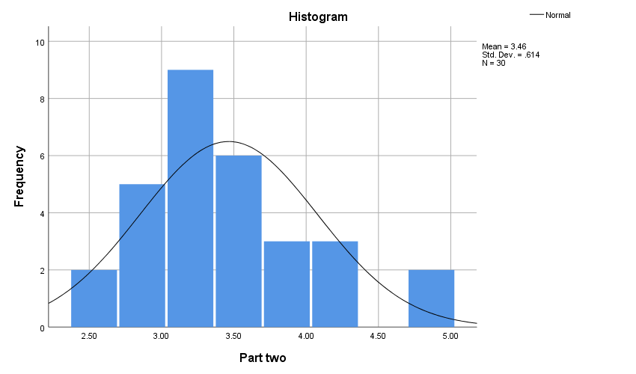

3.14 Statistical Tests
Data analysis was conducted using SPSS version 25. A range of statistical techniques were employed, including descriptive statistics (means, standard deviations), correlation analysis (Pearson's correlation coefficient), reliability analysis (Cronbach's alpha), and normality tests (Kolmogorov-Smirnov and Shapiro-Wilk). These tests were selected to address the research questions and hypotheses, providing a comprehensive assessment of the relationships between master plan updates, project alignment, community engagement, implementation effectiveness, and barriers. Specifically, correlation analyses were used to assess construct validity, while Cronbach's alpha was used to evaluate scale reliability. Normality tests were conducted to determine the appropriateness of parametric statistical procedures.

Chapter 4: Analysis and Study Results

4.1 Introduction
A comprehensive analysis of the data collected was undertaken to examine the relationships between master plan updates, project alignment with community needs, community engagement, implementation effectiveness, and barriers to alignment in Yanbu, Saudi Arabia. The results are presented in the following sequence: demographic characteristics of the respondents, descriptive statistics for the study variables and their constituent items, and finally, an examination of the main and sub-hypotheses using correlation and regression analyses. All analyses were conducted using SPSS version 25, and findings are presented in the passive voice.

4.2 Respondent Demographics
The demographic characteristics of the sample provide context for understanding the respondents' perspectives and experiences. The sample consisted of residents of the Royal Commission of Yanbu city.
Table 6: Demographic Profile of Respondents
Variables | Items | Frequency | Percent
Gender | Male | 24 | 80.0
Gender | Female | 6 | 20.0
Age Group | 18-29 | 2 | 6.7
Age Group | 30-39 | 7 | 23.3
Age Group | 40-49 | 15 | 50.0
Age Group | 50 and above | 6 | 20.0
Years of Residence in Royal commission of Yanbu city | Less than 1 year | 2 | 6.7
Years of Residence in Royal commission of Yanbu city | 1-5 years | 10 | 33.3
Years of Residence in Royal commission of Yanbu city | More than 10 years | 18 | 60.0
Total |  | 30 | 100.0
The sample (N=30) was predominantly male, with 80.0% (n=24) identifying as male and 20.0% (n=6) as female. In terms of age distribution, the largest group (50.0%, n=15) fell within the 40-49 age range, followed by 30-39 (23.3%, n=7), 50 and above (20.0%, n=6), and 18-29 (6.7%, n=2). Regarding residency duration, the majority (60.0%, n=18) had lived in Yanbu for more than 10 years, 33.3% (n=10) for 1-5 years, and 6.7% (n=2) for less than 1 year. The overall sample size was 30, resulting in a total response rate of 100%.

4.3 Characterization of Study Variables
To characterize the study variables, descriptive statistics, including means, standard deviations, relative significance, degree of agreement, and rank order, were calculated for each item and dimension. These statistics provide an overview of the respondents' perceptions and attitudes towards the various aspects of master plan updates and urban development in Yanbu.

4.3.1 Section I: Master Plan Updates
This section presents the descriptive statistics for the items related to "Master Plan Updates," examining respondents' perceptions of communication, clarity, and responsiveness to community needs.
Table 7: Descriptive Statistics for Master Plan Updates Items
No. | Items & Section | Mean | Std. Deviation | Relative significance | Degree | Rank
1 | The master plan updates are clearly communicated to the people of the royal commission of Yanbu. | 2.73 | 1.41 | 54.7% | Intermediate | 5
2 | The master plan updates are regularly shared with the public. | 2.57 | 1.28 | 51.3% | Intermediate | 6
3 | The master plan updates consider the evolving needs of the community. | 3.37 | 1.22 | 67.3% | Intermediate | 3
4 | I find the master plan updates to be clear and transparent. | 3.13 | 1.31 | 62.7% | Intermediate | 4
5 | The updates to the master plan effectively adapt to changing urban priorities. | 3.63 | 0.89 | 72.7% | High | 2
6 | Environmental sustainability is a key priority in the royal commission of Yanbu’s master plan updates. | 3.90 | 0.96 | 78.0% | High | 1
A | Master Plan Updates | 3.22 | 1.02 | 64.4% | Intermediate
The "Master Plan Updates" dimension yielded an overall mean of 3.22, a standard deviation of 1.02, and a relative significance of 64.4%, indicating an intermediate level of agreement. Within this dimension, "Environmental sustainability is a key priority in the royal commission of Yanbu's master plan updates" received the highest mean score (3.90) and was ranked first, with a high degree of agreement (78.0%). Conversely, "The master plan updates are regularly shared with the public" had the lowest mean score (2.57) and was ranked last, with an intermediate degree of agreement (51.3%). Individual item means ranged from 2.73 ("The master plan updates are clearly communicated to the people of the royal commission of Yanbu.") to 3.90, reflecting varying levels of agreement across the different aspects of master plan updates.

4.3.2 Section II: Project Alignment with Community Needs
This section presents the descriptive statistics for items related to "Project Alignment with Community Needs," assessing the extent to which urban development projects are perceived to meet the needs and expectations of the community.
Table 8: Descriptive Statistics for Project Alignment with Community Needs Items
No. | Items & Section | Mean | Std. Deviation | Relative significance | Degree | Rank
1 | The infrastructure projects align with the evolving needs of Yanbu’s RC residents. | 3.93 | 0.98 | 78.7% | High | 3
2 | The completed projects enhance the quality of life in Yanbu RC. | 4.03 | 0.89 | 80.7% | High | 1
3 | Projects developed from the master plan updates meet community expectations. | 3.77 | 0.73 | 75.3% | High | 7
4 | I am satisfied with the community services and facilities provided through new projects. | 3.90 | 1.03 | 78.0% | High | 4
5 | The projects have had a positive impact on my daily life. | 4.03 | 0.93 | 80.7% | High | 1
6 | The master plan updates support Yanbu’s RC economic growth. | 3.80 | 0.96 | 76.0% | High | 6
7 | Master plan updates enhance job opportunities for local residents | 3.87 | 1.04 | 77.3% | High | 5
B | Project Alignment with Community Needs | 3.90 | 0.72 | 78.1% | High
 | Part one | 3.56 | 0.85 | 71.3%
The "Project Alignment with Community Needs" dimension exhibited an overall mean of 3.90, a standard deviation of 0.72, and a relative significance of 78.1%, indicating a high level of agreement. The items "The completed projects enhance the quality of life in Yanbu RC" and "The projects have had a positive impact on my daily life" tied for the highest mean score (4.03), both ranked first, with high degrees of agreement (80.7%). The lowest mean score was observed for "Projects developed from the master plan updates meet community expectations" (3.77), ranked seventh, although still with a high degree of agreement (75.3%). The combined first part had a mean of 3.56. Individual item means ranged, reflecting a generally positive perception of project alignment with community needs.

4.3.3 Section III: Community Engagement in Planning
This section presents the descriptive statistics for the items related to "Community Engagement in Planning," examining respondents' perceptions of opportunities of participation, inclusion, and satisfaction.
Table 9: Descriptive Statistics for Community Engagement Items
No. | Items & Section | Mean | Std. Deviation | Relative significance | Degree | Rank
1 | The community is provided with opportunities to participate in the planning process. | 2.80 | 1.37 | 56.0% | Intermediate | 3
2 | There are effective channels for gathering community feedback on master plan updates. | 2.77 | 1.33 | 55.3% | Intermediate | 5
3 | I believe my input (or the community’s input) is considered in urban planning. | 3.17 | 1.37 | 63.3% | Intermediate | 1
4 | The master planning process incorporates a diverse range of community voices. | 3.03 | 1.27 | 60.7% | Intermediate | 2
5 | I am satisfied with the extent of community engagement in master planning. | 2.80 | 1.30 | 56.0% | Intermediate | 3
A | Community Engagement in Planning | 2.91 | 1.22 | 58.3% | Intermediate
The "Community Engagement in Planning" had an overall mean of 2.91, a standard deviation of 1.22, and a relative significance of 58.3%, indicating an intermediate level of agreement. Within this dimension, "I believe my input (or the community’s input) is considered in urban planning" had the highest mean score (3.17) and was ranked first, with an intermediate degree of agreement (63.3%). Conversely, "There are effective channels for gathering community feedback on master plan updates" had the lowest mean score (2.77) and was ranked fifth, with an intermediate degree of agreement (55.3%).

4.3.4 Section IV: Effectiveness of Master Plan Implementation
This section presents the descriptive statistics for the items related to "Effectiveness of Master Plan Implementation," examining perceptions of projects' timeline, efficiency, resources, support, and institutions.
Table 10: Descriptive Statistics for Effectiveness of Master Plan Implementation
No. | Items & Section | Mean | Std. Deviation | Relative significance | Degree | Rank
1 | Urban projects are completed on time in accordance with the master plan. | 2.70 | 1.29 | 54.0% | Intermediate | 5
2 | Master plan updates are implemented efficiently with minimal delays. | 3.00 | 1.11 | 60.0% | Intermediate | 4
3 | Resources are effectively allocated to ensure project completion. | 3.43 | 0.90 | 68.7% | Intermediate | 3
4 | Government support play crucial role in the success of master plans. | 4.50 | 0.57 | 90.0% | High | 1
5 | The institutions involved have the necessary capacity to manage urban development. | 3.97 | 0.67 | 79.3% | High | 2
B | Effectiveness of Master Plan Implementation | 3.52 | 0.71 | 70.4% | Intermediate
The "Effectiveness of Master Plan Implementation" had an overall mean of 3.52, a standard deviation of 0.71, and a relative significance of 70.4%, indicating an intermediate level of agreement. Within this dimension, "Government support play crucial role in the success of master plans." had the highest mean score (4.5) and was ranked first, with a high degree of agreement (90.0%). Conversely, "Urban projects are completed on time in accordance with the master plan." had the lowest mean score (2.70) and was ranked fifth, with an intermediate degree of agreement (54.0%).

4.3.5 Section V: Barriers to Project and Master Plan Alignment
This section presents the descriptive statistics for the items related to "Barriers to Project and Master Plan Alignment," examining perceptions of community feedback, projects' outcomes, participation, policies, and urban development.
Table 11: Descriptive Statistics for Barriers to Project and Master Plan Alignment Items
No. | Items & Section | Mean | Std. Deviation | Relative significance | Degree | Rank
1 | There are noticeable gaps in the collection of community feedback during planning. | 3.90 | 0.80 | 78.0% | High | 3
2 | Discrepancies between project outcomes and community needs are evident. | 3.53 | 0.82 | 70.7% | Intermediate | 5
3 | The lack of stakeholder participation negatively impacts project success. | 4.27 | 0.74 | 85.3% | High | 2
4 | Policy and regulatory challenges hinder the effective implementation of project. | 3.73 | 0.91 | 74.7% | High | 4
5 | The urban development process needs improvement to better align with community needs. | 4.37 | 0.67 | 87.3% | High | 1
C | Part two | 3.46 | 0.61 | 69.3% | Intermediate
 | All scale | 3.51 | 0.69 | 70.3% | Intermediate
The "Barriers to Project and Master Plan Alignment" dimension yielded an overall mean of 3.46, a standard deviation of 0.61, and a relative significance of 69.3%, indicating an intermediate level of agreement. Within this dimension, "The urban development process needs improvement to better align with community needs." had the highest mean score (4.37) and was ranked first, with a high degree of agreement (87.3%). Conversely, "Discrepancies between project outcomes and community needs are evident." had the lowest mean score (3.53) and was ranked fifth, with an intermediate degree of agreement (70.7%). The combined second part had a mean of 3.46. The All-Scale mean was 3.51 with SD of 0.69 and relative significance of 70.3%.

4.4 Study the relationship between the dependent variable and the independent variable
Pearson correlation analysis was conducted to investigate the relationships between the independent and dependent variables.

Table 12: Pearson Correlation Coefficients Between Study Variables
Dimensions of variables | Master Plan Updates | Project Alignment with Community Needs | Community Engagement in Planning | Effectiveness of Master Plan Implementation | Barriers to Project and Master Plan Alignment
Master Plan Updates | 1 | 0.886** | 0.894** | 0.787** | -0.196
Project Alignment with Community Needs | 0.886** | 1 | 0.769** | 0.647** | -0.345
Community Engagement in Planning | 0.894** | 0.769** | 1 | 0.773** | -0.172
Effectiveness of Master Plan Implementation | 0.787** | 0.647** | 0.773** | 1 | 0.006
Barriers to Project and Master Plan Alignment | -0.196 | -0.345 | -0.172 | 0.006 | 1
The correlation analysis revealed significant positive relationships among most of the study variables. "Master Plan Updates" showed strong positive correlations with "Project Alignment with Community Needs" (r = 0.886, p < 0.01), "Community Engagement in Planning" (r = 0.894, p < 0.01), and "Effectiveness of Master Plan Implementation" (r = 0.787, p < 0.01). However, it had a non-significant negative correlation with "Barriers to Project and Master Plan Alignment" (r = -0.196, p > 0.05). Similar patterns were observed for other variable pairings, with most showing statistically significant positive correlations. Notably, "Barriers to Project and Master Plan Alignment" consistently showed weak, non-significant negative correlations with the other variables. These results suggest a generally positive interplay between master plan updates, project alignment, community engagement, and implementation effectiveness, while barriers tend to be inversely related to these positive factors.

4.5 Effect of the Independent Variable on the Dependent Variable
To assess the influence of the independent variables ("Master Plan Updates" and "Project Alignment with Community Needs") on the dependent variables ("Community Engagement in Planning" and "Effectiveness of Master Plan Implementation"), multiple regression analyses were conducted. These analyses help determine the unique contribution of each independent variable while controlling for the effects of others.

4.5.1 First Hypothesis
Hypothesis Statement: Master plan updates improve the alignment of projects with community needs in Yanbu. This should actually be stated There is a significant positive effect of Master Plan Updates on Community Engagement in Planning, controlling for Project Alignment with Community Needs. The following table presents the results of the multiple regression analysis examining the effect of "Master Plan Updates" and "Project Alignment with Community Needs" on "Community Engagement in Planning."
Table 13: Regression Results: Predicting Community Engagement in Planning
Dimensions | Unstandardized Coefficients |  | Standardized Coefficients | t | p.value
Dimensions | B | Std. Error | Beta | t | p.value
(Constant) | -0.149 | 0.683 |  | -0.218 | 0.829
Master Plan Updates | 1.180 | 0.219 | 0.994 | 5.383 | 0.000
Project Alignment with Community Needs | -0.189 | 0.312 | -0.112 | -0.608 | 0.548
Dependent Variable: Community Engagement in Planning | F= 54.880 | p.value= 0.000 | Df= 2/27 | R= 0.896 | R²= 0.803
The regression model predicting "Community Engagement in Planning" was statistically significant (F(2, 27) = 54.880, p < 0.001), with an R-squared value of 0.803, indicating that 80.3% of the variance in "Community Engagement in Planning" is explained by the model. "Master Plan Updates" had a significant positive effect (β = 0.994, t = 5.383, p < 0.001), suggesting that more positive perceptions of master plan updates are associated with higher levels of perceived community engagement. However, "Project Alignment with Community Needs" did not have a statistically significant effect (β = -0.112, t = -0.608, p = 0.548). The constant was not statistically significant.

4.5.2 Second Hypothesis
- Hypothesis Statement: There is a significant positive effect of Master Plan Updates on Effectiveness of Master Plan Implementation, controlling for Project Alignment with Community Needs.
The following table presents the results of the multiple regression analysis examining the effect of "Master Plan Updates" and "Project Alignment with Community Needs" on "Effectiveness of Master Plan Implementation."
Table 14: Regression Results: Predicting Effectiveness of Master Plan Implementation
Dimensions | Unstandardized Coefficients |  | Standardized Coefficients | t | Sig.
Dimensions | B | Std. Error | Beta | t | Sig.
(Constant) | 2.196 | 0.547 |  | 4.015 | 0.000
Master Plan Updates | 0.694 | 0.176 | 0.996 | 3.952 | 0.001
Project Alignment with Community Needs | -0.233 | 0.250 | -0.236 | -0.935 | 0.358
Dependent Variable: Effectiveness of Master Plan Implementation | F= 23.169 | p.value= 0.000 | Df= 2/27 | R= 0.795 | R²= 0.632
The regression model predicting "Effectiveness of Master Plan Implementation" was statistically significant (F(2, 27) = 23.169, p < 0.001), with an R-squared value of 0.632, indicating that 63.2% of the variance in "Effectiveness of Master Plan Implementation" is explained by the model. "Master Plan Updates" demonstrated a significant positive effect (β = 0.996, t = 3.952, p = 0.001), suggesting that more positive perceptions of master plan updates are associated with higher perceived effectiveness of implementation. "Project Alignment with Community Needs" did not show a statistically significant effect (β = -0.236, t = -0.935, p = 0.358). The constant was significant at p = 0.000.

5. Chapter Five: Discussion of Results and Recommendations

5.1 Introduction
This chapter synthesizes the findings presented in Chapter 4, providing a comprehensive discussion and interpretation of the results. The primary objective is to move beyond the statistical data and explore the meaning and implications of the relationships uncovered between master plan updates, project alignment with community needs, community engagement, implementation effectiveness, and barriers to alignment in the context of Yanbu, Saudi Arabia. The chapter begins with a detailed discussion of each key finding, drawing connections to existing literature and the specific context of Yanbu. Subsequently, based on this thorough analysis, practical and actionable recommendations are proposed to enhance the master planning process, improve project outcomes, and foster greater community satisfaction. These recommendations are targeted towards policymakers, urban planners, project managers, and community stakeholders in Yanbu, aiming to provide a roadmap for more effective and inclusive urban development. The chapter concludes by offering the limitations, further studies, and final conclusion.

5.2 Results

5.2.1 Demographic Characteristics: The Context of the Respondents
The findings are interpreted against respondent demographics. The sample had a predominantly male population, with a much greater number of male participants than female participants. The gender split is a crucial consideration, as this may introduce a bias into captured opinion. The findings may predominantly reflect male experience and opinion on urban development in Yanbu, perhaps overlooking specific women's needs and concerns. Future studies will need to try for a better gender split if they are to have a better-rounded understanding. The age structure revealed that a majority of the respondents belonged to the middle age ranges (30-49 years). This suggests that the research captured predominantly views from individuals presumably well-established within their professional and family lives, and who have presumably lived through a significant stretch of Yanbu's urban development. While useful, this also means that views from young adults (18-29 years) were not as well-represented, perhaps missing out on views from a group with perhaps differing priorities and expectations for urban development, particularly with technology, innovation, and forward-thinking development.
The length of residency in Yanbu was biased towards long-term residents, with a majority living there for over a decade. This indicates that the findings are dominated by those with a detailed understanding of the history and development of the city. They have witnessed changes over time and are likely to provide well-informed opinions on whether master plan updates and project delivery have been well managed. However, the lack of representation among recently settled residents (less than 5 years) restricts the contribution of those with new ideas and comparisons with other urban areas from being represented in the findings.

5.2.2 Descriptive Statistics of Study Variables: Unpacking Perceptions
The descriptive statistics provided a valuable overview of the respondents' general attitudes and perceptions regarding each aspect of the study. These findings are discussed in detail below for each section.
A. Master Plan Updates
In total, there was a generally positive perception of master plan updates, with the sense that there is potential for improvement but generally a sense that there is appreciation for what has been accomplished here. The most positively received point, with highest level of agreement, was that there is emphasis on environmental sustainability through master plan updates. It is a reflection of a high degree of appreciation for a focus on environmental concerns on the part of the Royal Commission, a reflection on a global trend toward increased awareness and prioritization of sustainability in urban development. It is part of a broader trend toward inclusion of green initiatives and sustainable practices within urban development around the globe. The least agreement, however, was regarding clear and frequent communication with the community on master plan updates. It is a reflection on a lack of communication on the part of the Royal Commission with residents of Yanbu, where perhaps well-intentioned, a master plan may well point out important issues, but where a lack of effective communication undermines its impact and reduces awareness and participation among people. It points toward a need for increased proactive and open communication, through a variety of mediums, reaching a greater number of individuals. These can include routine public forums, websites, social media, and summaries readily available on plan updates.
The other parameters, such as the responsiveness of the master plan updates to emerging community needs and the clarity of the master plan updates, recorded moderate levels of agreement. This would suggest that while the plans are not perceived as being totally unclear or unresponsive, there is still a lot of scope to make them more accessible and adaptable to be able to respond to evolving circumstances. This can be done by making the language used in the plans simpler, including visual aids and summaries, and by having mechanisms for ongoing feedback and revision of the plans in accordance with community inputs.
B. Project Alignment with Community Needs
There was a generally very positive perception of project alignment with community needs, with residents overall perceiving that projects carried out for urban development in Yanbu are meeting their needs and improving their quality of life. This is a very encouraging finding, suggesting that, in spite of some communication issues, the master planning process is ultimately leading to projects that are beneficial to the community. The strongest agreement was for items about the positive effect of projects on daily life and quality of life improvement. It would indicate that projects are not merely realizing abstract planning goals, but actually improving residents' lived experience. It could have been due to improvements in infrastructure, open spaces, services, or otherwise, which directly affect residents' daily lives and general well-being.
While still positive, the lowest level of agreement for this section was for community expectations being fully met with projects that were the outcome of master plan updates. That indicates a slight gap between what is anticipated by the community and what is delivered. That can be the outcome of several factors, including unrealistic expectations at the beginning, communication breakdowns during the planning process, or unforeseen problems during project implementation. Additional research is needed to identify the precise reasons for this gap and address them for upcoming projects.

5.2.3 Community Engagement in Planning
There was a moderate perception on community participation in the planning process, which points towards a strong area for improvement. While residents do not reject efforts entirely, there's a clear perception that engagement can be better and representative. The highest agreement level for this section dealt with a perception that community input is given consideration at urban planning. It means residents feel that their opinions are being heard, at least to a certain extent, which is a strong foundation for improvement. However, this perception is moderated with low agreement levels on a number of other aspects of engagement. The least agreement level dealt with effective means for receiving feedback from communities. It is a serious finding, as if residents do not feel effective means for giving their feedback, their potential for shaping the planning process is highly limited, even if their feedback is conceptually given consideration. It points towards a need for a greater and accessible range of feedback options, including online surveys, town hall meetings, focus group discussions, and community representatives. The moderate agreement level on diverse community voices being represented indicates that certain sections of society might feel excluded from the planning process. It might be due to factors such as a lack of familiarity with a foreign language, accessibility, or a lack of awareness about engagement opportunities. Measures should be taken for ensuring all sections of society, including women, youth, and minorities, have equal opportunities for participation and contribution of their opinions.

5.2.4 Effectiveness of Master Plan Implementation
Overall, there was a moderately positive perception regarding the effectiveness of master plan implementation. This indicates that there are perceived successes but also areas that require improvement for drives into tangible outcomes efficiently and effectively. The highest agreement level was for the crucial role played by government support for master plan success. This captures the importance attached to effective leadership, clear policy, and adequate provision of resources by the government for effective implementation. It shows that residents value the crucial role played by the government in leading urban development and ensuring that projects are completed successfully. The residents also positively agreed on effective institution capacity for managing urban development for the city. However, there was low agreement on urban projects being completed on time. This captures that project delays are a great issue for residents, which can interfere with their daily lives and affect overall urban development success. It may result from a variety of factors including red tapism, lack of resources, unforeseen challenges, or inefficient project management. It is crucial that these factors are dealt with for increased efficiency in implementation. The moderate agreement regarding effective implementation of master plan updates and effective utilization of resources indicates there is some potential for improvement regarding these factors. It may involve minimizing administrative barriers, improving project management practices, and ensuring that resources are distributed in a manner that maximizes impact.

5.2.5 Barriers to Project and Master Plan Alignment
Overall, there was a moderately positive perception regarding the effectiveness of master plan implementation. This indicates that there are perceived successes but also areas that require improvement for drives into tangible outcomes efficiently and effectively. The highest agreement level was for the crucial role played by government support for master plan success. This captures the importance attached to effective leadership, clear policy, and adequate provision of resources by the government for effective implementation. It shows that residents value the crucial role played by the government in leading urban development and ensuring that projects are completed successfully. The residents also positively agreed on effective institution capacity for managing urban development for the city. However, there was low agreement on urban projects being completed on time. This captures that project delays are a great issue for residents, which can interfere with their daily lives and affect overall urban development success. It may result from a variety of factors including red tapism, lack of resources, unforeseen challenges, or inefficient project management. It is crucial that these factors are dealt with for increased efficiency in implementation. The moderate agreement regarding effective implementation of master plan updates and effective utilization of resources indicates there is some potential for improvement regarding these factors. It may involve minimizing administrative barriers, improving project management practices, and ensuring that resources are distributed in a manner that maximizes impact.

5.2.6 Relationships Between Variables (Correlation Analysis): The Interconnected Web
Correlation analysis revealed a high and positive correlation among most variables employed in this research except for "Barriers to Project and Master Plan Alignment," which had a generally negative correlation with all other factors. The high positive correlations among "Master Plan Updates," "Project Alignment with Community Needs," "Community Engagement in Planning," and "Effectiveness of Master Plan Implementation" suggest that these factors reinforce one another. That is, changes for the better on one dimension are likely to correlate with changes for the better on the others. For example, clear and transparent master plan updates are likely to translate into better project alignment with community needs, which can, in turn, enhance community engagement and enhance implementation effectiveness.
This connectivity highlights that there is a requirement for a comprehensive approach towards urban development. It is not enough to focus on one area, for instance, modernizing the master plan, but a collective effort on all areas is a prerequisite for best outcomes. It requires effective coordination and communication among all those departments and stakeholders involved in the planning and implementation process. The hypothesized and reasonable negative relationship among "Barriers to Project and Master Plan Alignment" and all other variables is that as barriers increase, effectiveness in planning and implementation will decrease, as well as project alignment with community needs. It also highlights that barriers have to be identified and dealt with proactively so that they do not hinder the urban development process.

5.2.7 Impact of Independent Variables on Dependent Variables (Regression Analysis): Predictive Power
The regression analyses provided further insights into the specific relationships between the independent and dependent variables.
A. Predicting Community Engagement in Planning
The initial model revealed that "Master Plan Updates" positively affected "Community Engagement in Planning," but not "Project Alignment with Community Needs." It would therefore seem that how the master plan is communicated and updated is a stronger influence on community engagement than whether projects are actually well-aligned with needs (at least as a predictor of perceived engagement). One might have expected project alignment to have been a stronger predictor, but this emphasizes the importance given to communication and transparency as a basis for building trust and a sense of participation. Even if projects are well-aligned with needs, if communities do not know why the updates have been made and how their input has been addressed, they will feel disconnected. It supports, therefore, a proactive and open communications strategy for master plan updates. It is not enough merely to update the plan; updates have also to be explained, justified, and communicated effectively to communities if a sense of ownership and engagement is to be realized.
B. Predicting Effectiveness of Master Plan Implementation
The second model also showed a pattern, with "Master Plan Updates" having a statistically significant, positive influence on "Effectiveness of Master Plan Implementation," but not with "Project Alignment with Needs." It would thus seem that clarity, transparency, and responsiveness of master plan updates are more important for effective implementation than perceived alignment with needs. Once again, this finding highlights not only the importance of what goes into master plan updates, but also how they are created. An effectively communicated, dynamic master plan can provide a clear plan for implementation, even if projects are not best matched with needs. Conversely, even if projects are best matched with needs, a poorly communicated, static master plan can hinder effective implementation.
This accommodates a continuous improvement cycle for master plan updating, with constant stakeholder feedback and a reaction to changing circumstances. The master plan can't be a fixed plan, but a living guideline for directing urban development over an extended period.

5.3 Recommendations
Based on the comprehensive analysis of the results, the following recommendations are proposed to enhance the master planning process, improve project outcomes, and foster greater community satisfaction in Yanbu:
- Implement a Comprehensive and Transparent Communication Strategy: Develop a proactive communication plan that utilizes diverse channels (public forums, online portals, social media, simplified summaries) to regularly inform the public about master plan updates, project progress, and the rationale behind decisions. A dedicated communication team should manage this effort.
- Strengthen Inclusive Community Engagement: Create varied and accessible feedback mechanisms (surveys, town halls, focus groups, advisory boards) that specifically target underrepresented groups (women, youth, minorities, new residents) and provide clear feedback on how community input is used. Establish a formal process for public comment on draft plans.
- Enhance Project Management and Implementation Efficiency: Streamline administrative processes, reduce bureaucratic delays, provide project management training, establish clear performance indicators for monitoring, and foster strong collaboration between all involved departments and agencies.
- Proactively Address Barriers to Project-Plan Alignment: Conduct regular community needs assessments, review and update policies/regulations that hinder implementation, and ensure stakeholder participation throughout the entire project lifecycle (planning, design, implementation, evaluation).
- Foster a Culture of Continuous Improvement and Learning: Treat the master plan as a dynamic document, regularly reviewing and updating it based on community feedback, changing circumstances, and performance data.
- Build Capacity for Community Participation: Empower local organizations and community members with the resources and training needed to effectively participate in the planning process and advocate for their needs.
- Promote Innovation in Urban development: Encourage, document and analyze the use of new approaches for urban development such as smart city and sustainable designs.

5.4 Conclusion
This study has contributed valuable insight into the complex dynamics among master plan revisions, project alignment, community engagement, implementation effectiveness, and alignment barriers within Yanbu, Saudi Arabia. The study highlights not only the importance given to a holistic approach towards urban development, but also to how master plans are developed, communicated, and implemented. With the implementation of measures outlined above, Yanbu can transition towards a more inclusive, responsive, and sustainable urban future that meets the needs and dreams of its people. The extent of interdependencies among different components of the urban development process underscores the importance of a concerted and collective approach, where all stakeholders participate within a cycle of implementation, assessment, and improvement.

References

Adawi, T., Yousif, L., & Mousa, M. (2020). Scientific Research Methods for Social Sciences and Humanities. Dar Al-Hamid for Publishing and Distribution.
Aina, Y. A., Wafer, A., Ahmed, F., & Alshuwaikhat, H. M. (2019). Top-down sustainable urban development? Urban governance transformation in Saudi Arabia. Cities, 90, 272-281.
Al-Sayed, A., Al-Shammari, F., Alshutayri, A., Aljojo, N., Aldhahri, E., & Abouola, O. (2022). The smart city-line in Saudi Arabia: issue and challenges. Postmodern Openings, 13(1 Sup1), 15-37.
Alshuwaikhat, H. M., Aina, Y. A., & Binsaedan, L. (2022). Analysis of the implementation of urban computing in smart cities: A framework for the transformation of Saudi cities. Heliyon, 8(10).
Belaïd, F., Amine, R., & Massie, C. (2023). Smart cities initiatives and perspectives in the MENA region and Saudi Arabia. In Smart cities: Social and environmental challenges and opportunities for local authorities (pp. 295-313). Cham: Springer International Publishing.
Bhatti, A., Abbas, M., Roshni, & Bilal, M. (2023). Qualitative Research: Definition, Types, Methods and Examples. International Journal of Education and Social Science Research, 6(1), 1-12.
Bolívar, M. P. R., Munoz, L. A., & Munoz, C. A. (2023). Identifying patterns in smart initiatives' planning in smart cities. An empirical analysis in Spanish smart cities. Technological Forecasting and Social Change, 196, 122781.
Cronbach, L. J., & Meehl, P. E. (1955). Construct validity in psychological tests. Psychological Bulletin, 52(4), 281–302.
Deep, G. (2023). Evaluating the impact of community engagement in urban planning on sustainable development. World Journal of Advanced Research and Reviews, 20(3), 1633-1638.
DeVellis, R. F. (2017). Scale development: Theory and applications (4th ed.). Sage Publications.
Echendu, A. J. (2023). Urban planners’ perspectives of public participation in planning in Nigeria. SN Social Sciences, 3(2), 33.
Gravetter, F. J., & Forzano, L. A. B. (2018). Research methods for the behavioral sciences (6th ed.). Cengage Learning.
Hofer, K., Wicki, M., & Kaufmann, D. (2024). Public support for participation in local development. World Development, 178, 106569.
Holden, R. R. (2010). Face validity. In I. B. Weiner & W. E. Craighead (Eds.), The Corsini encyclopedia of psychology (4th ed., Vol. 2, pp. 637-638). John Wiley & Sons.
Kaplan, R. S., & McMillan, D. (2020). Updating the balanced scorecard for triple bottom line strategies. Harvard Business School Accounting & Management Unit Working Paper, (21-028).
Khatibi, F. S., Dedekorkut-Howes, A., Howes, M., & Torabi, E. (2021). Can public awareness, knowledge and engagement improve climate change adaptation policies?. Discover Sustainability, 2, 1-24.
Kitur, R. C. (2019). Barriers to implementing urban plans in Kenya (Doctoral dissertation, Walden University).
Krejcie, R. W., & Morgan, D. W. (1970). Determining sample size for research activities. Educational and Psychological Measurement, 30(3), 607-610.
Macrotrends. (2024). Yanbu al-Bahr, Saudi Arabia Metro Area Population 1950-2025. Retrieved from Yanbu al-Bahr, Saudi Arabia Metro Area Population 1950-2025 - Macrotrends
Mortada, H. (2018). Yanbu, Saudi Arabia: A Traditional City in Transition. Journal of Civil Engineering and Architecture, 12(10), 706-715.
Nallathiga, R. (2016). Assessing the role of master plans in city development: reform measures and approaches.
Njeru, S. (2024). Implementation of Urban Development Plans in Kenya: Gaps and Needs of Implementing the Nairobi Integrated Urban Master Plan (Niuplan) (Doctoral dissertation, University of Nairobi).
Rauws, W., & De Roo, G. (2016). Adaptive planning: Generating conditions for urban adaptability. Lessons from Dutch organic development strategies. Environment and Planning B: Planning and Design, 43(6), 1052-1074.
Sebunya, J., & Gichuki, A. (2024). The Impact of Participatory Planning on Sustainable Development: A Literature Review. Journal of Strategic Management, 4(4), 1-9.
Sekaran, U., & Bougie, R. (2016). Research methods for business: A skill building approach. John Wiley & Sons.

Appendices

Appendix I: The Questionnaire
الإخوة والأخوات
السلام عليكم ورحمة الله وبركاته
يسرني دعوتكم للمشاركة في دراسة عن تقييم العلاقة بين تحديثات المخطط الرئيسي ومواءمة المشاريع مع احتياجات المجتمع في الهيئة الملكية بينبع الصناعية حيث تهدف الدراسة إلى فهم و تقييم العلاقة بين تحديثات المخطط الرئيسي لمدينة ينبع الصناعية ومواءمة المشاريع القائمة والمستقبلية بها واتصالها بالاحتياج المجتمعي .
‎تساهم هذه الدراسة في تطوير مدينة ينبع الصناعية ورفع جودة الحياة لقاطنيها، حتى تصبح المدينة أكثر ازدهارا ووعيًا بالعمارة الحضرية الخاصة بها. حيث تأتي هذه الدراسة ضمن متطلبات أطروحة درجة الماجستير الثانيه الخاصة بي ضمن برنامج إدارة الأعمال (MBA) بجامعة ميد أوشن. وتعد آراؤكم أعزائي وتصوراتكم ذات قيمة كبيرة، حيث ستساهم في تعزيز فهم تأثير مشاريع التنمية الحضرية على المجتمع وتوجيه عمليات التخطيط المستقبلية.
تستغرق المشاركة من ( ٨ ) إلى ( ١٠ ) دقائق فقط .. آمل منكم استقطاع جزء من وقتكم الثمين للمشاركة في الدراسة من خلال الإجابة على أسئلة الاستبيان ذلك من خلال الرابط التالي:
‏https://forms.gle/vbyqKhA383AxdhzHA
كما آمل منكم التفضل بإرسال وتوزيع رابط الاستبيان لجميع معارفكم من قاطني وسكان ينبع الصناعية.
شاكرة لكم وقتكم وتعاونكم …
م/ غالية عادل حنفي
إدارة التخطيط العمراني

Dear Participant,
Thank you for taking the time to participate in this survey. This questionnaire is part of a study aimed to assessing the relationship between master plan updates and project alignment with community needs in the royal commission of Yanbu city . Your insights and opinions are valuable and will contribute to a deeper understanding on how urban development projects impact the community and influence future planning processes.
The questionnaire is divided into two parts:
- Part 1: Collects general demographic information.
- Part 2: Gathers your perspective on master plan updates, project alignment with community needs, community engagement, and other related aspects.
All responses will remain strictly confidential and will be used solely for academic purposes. Your honest feedback is highly valued greatly appreciated.
Thank you for your participation!

Part 1: Demographic Data
- Gender:
  - ☐ Male
  - ☐ Female
- Age Group:
  - ☐ 18-29
  - ☐ 30-39
  - ☐ 40-49
  - ☐ 50 and above
- Years of Residence in Royal commission of Yanbu city:
  - ☐ Less than 1 year
  - ☐ 1-5 years
  - ☐ 6-10 years
  - ☐ More than 10 years
Part 2:
Instructions: Please indicate your level of agreement with the following statements using the scale below:
- 1: Strongly Disagree
- 2: Disagree
- 3: Neutral
- 4: Agree
- 5: Strongly Agree

Section 1: Master Plan Updates
# | Statement | 1 | 2 | 3 | 4 | 5
1 | The master plan updates are clearly communicated to the people of the royal commission of Yanbu. | ☐ | ☐ | ☐ | ☐ | ☐
2 | The master plan updates are regularly shared with the public. | ☐ | ☐ | ☐ | ☐ | ☐
3 | The master plan updates consider the evolving needs of the community. | ☐ | ☐ | ☐ | ☐ | ☐
4 | I find the master plan updates to be clear and transparent. | ☐ | ☐ | ☐ | ☐ | ☐
5 | The updates to the master plan effectively adapt to changing urban priorities. | ☐ | ☐ | ☐ | ☐ | ☐
6 | Environmental sustainability is a key priority in the royal commission of Yanbu’s master plan updates. | ☐ | ☐ | ☐ | ☐ | ☐

Section 2: Project Alignment with Community Needs
# | Statement | 1 | 2 | 3 | 4 | 5
6 | The infrastructure projects align with the evolving needs of Yanbu’s RC residents. | ☐ | ☐ | ☐ | ☐ | ☐
7 | The completed projects enhance the quality of life in Yanbu RC. | ☐ | ☐ | ☐ | ☐ | ☐
8 | Projects developed from the master plan updates meet community expectations. | ☐ | ☐ | ☐ | ☐ | ☐
9 | I am satisfied with the community services and facilities provided through new projects. | ☐ | ☐ | ☐ | ☐ | ☐
10 | The projects have had a positive impact on my daily life. | ☐ | ☐ | ☐ | ☐ | ☐
11 | The master plan updates support Yanbu’s RC economic growth. | ☐ | ☐ | ☐ | ☐ | ☐
12 | Master plan updates enhance job opportunities for local residents | ☐ | ☐ | ☐ | ☐ | ☐

Section 3: Community Engagement in Planning

# | Statement | 1 | 2 | 3 | 4 | 5
11 | The community is provided with opportunities to participate in the planning process. | ☐ | ☐ | ☐ | ☐ | ☐
12 | There are effective channels for gathering community feedback on master plan updates. | ☐ | ☐ | ☐ | ☐ | ☐
13 | I believe my input (or the community’s input) is considered in urban planning. | ☐ | ☐ | ☐ | ☐ | ☐
14 | The master planning process incorporates a diverse range of community voices. | ☐ | ☐ | ☐ | ☐ | ☐
15 | I am satisfied with the extent of community engagement in master planning. | ☐ | ☐ | ☐ | ☐ | ☐

Section 4: Effectiveness of Master Plan Implementation

# | Statement | 1 | 2 | 3 | 4 | 5
16 | Urban projects are completed on time in accordance with the master plan. | ☐ | ☐ | ☐ | ☐ | ☐
17 | Master plan updates are implemented efficiently with minimal delays. | ☐ | ☐ | ☐ | ☐ | ☐
18 | Resources are effectively allocated to ensure project completion. | ☐ | ☐ | ☐ | ☐ | ☐
19 | Government support play crucial role in the success of master plans. | ☐ | ☐ | ☐ | ☐ | ☐
20 | The institutions involved have the necessary capacity to manage urban development. | ☐ | ☐ | ☐ | ☐ | ☐

Section 5: Barriers to Project and Master Plan Alignment

# | Statement | 1 | 2 | 3 | 4 | 5
21 | There are noticeable gaps in the collection of community feedback during planning. | ☐ | ☐ | ☐ | ☐ | ☐
22 | Discrepancies between project outcomes and community needs are evident. | ☐ | ☐ | ☐ | ☐ | ☐
23 | The lack of stakeholder participation negatively impacts project success. | ☐ | ☐ | ☐ | ☐ | ☐
24 | Policy and regulatory challenges hinder the effective implementation of project. | ☐ | ☐ | ☐ | ☐ | ☐
25 | The urban development process needs improvement to better align with community needs. | ☐ | ☐ | ☐ | ☐ | ☐

Appendix II: The Responses
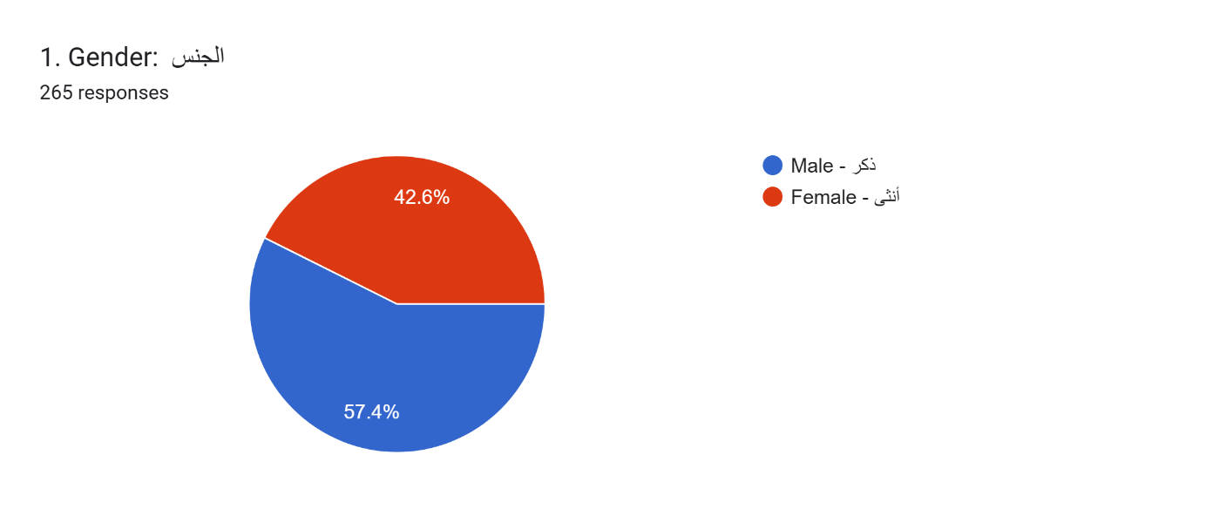

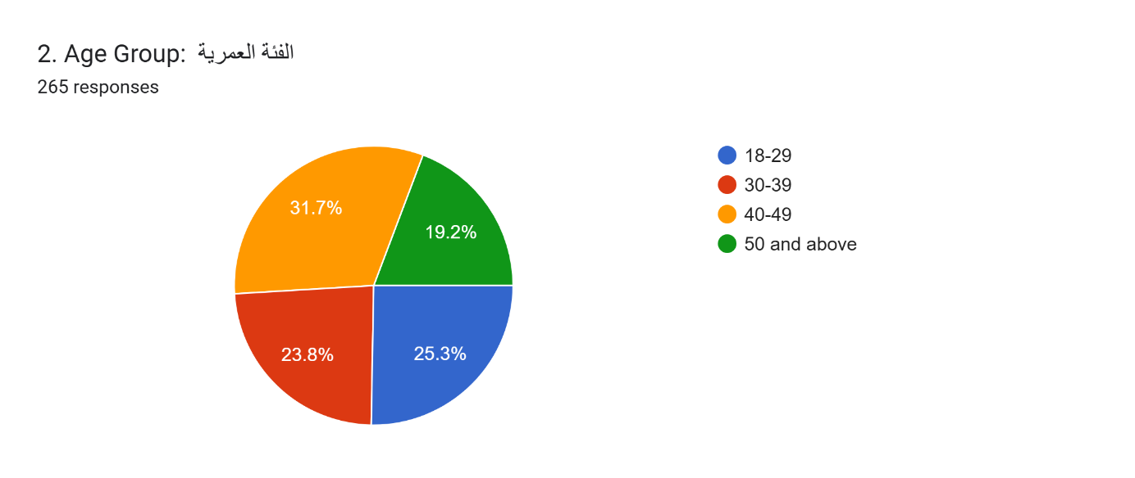

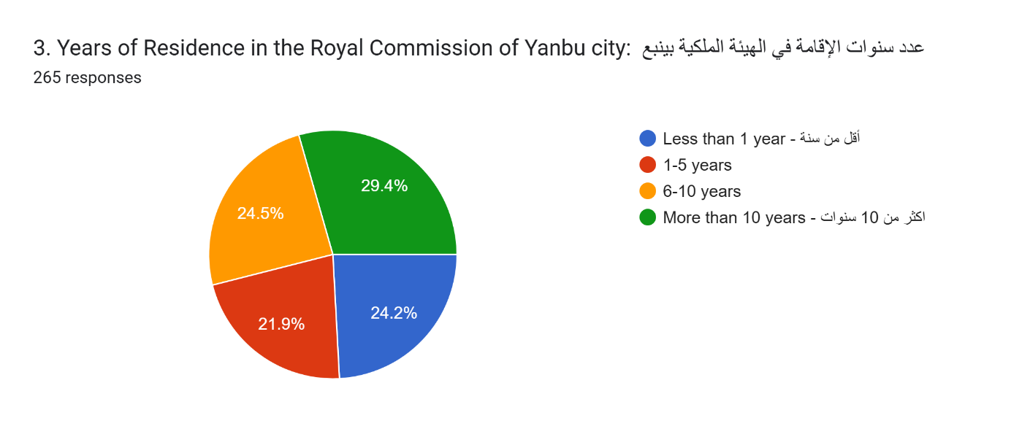
Section 1: Master Plan Updates - القسم الأول: تحديثات المخطط الرئيسي
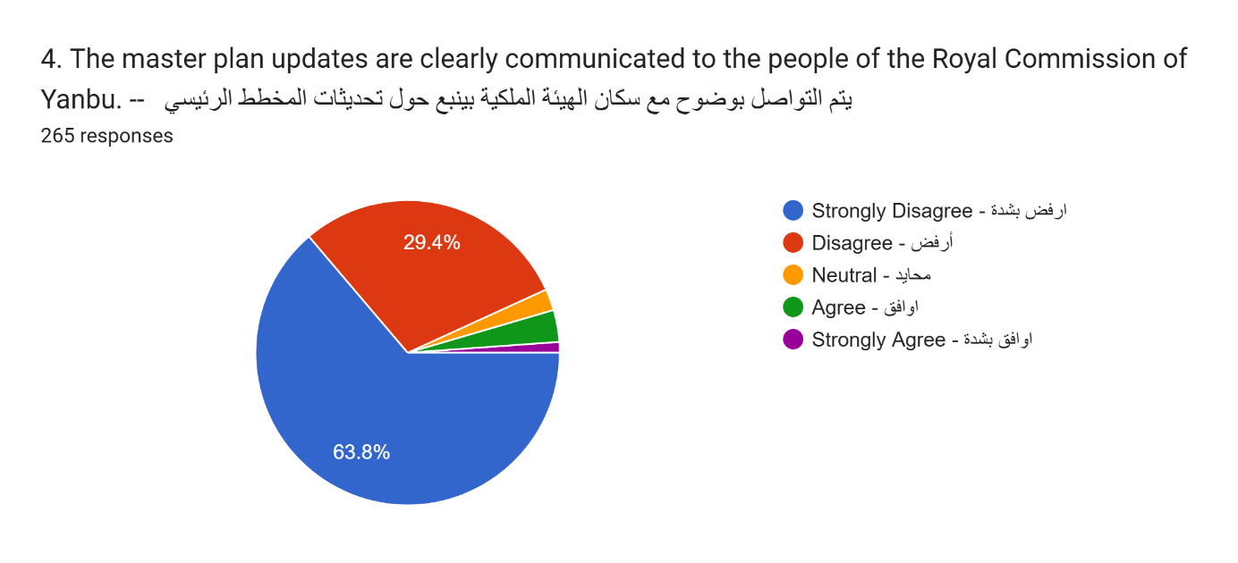

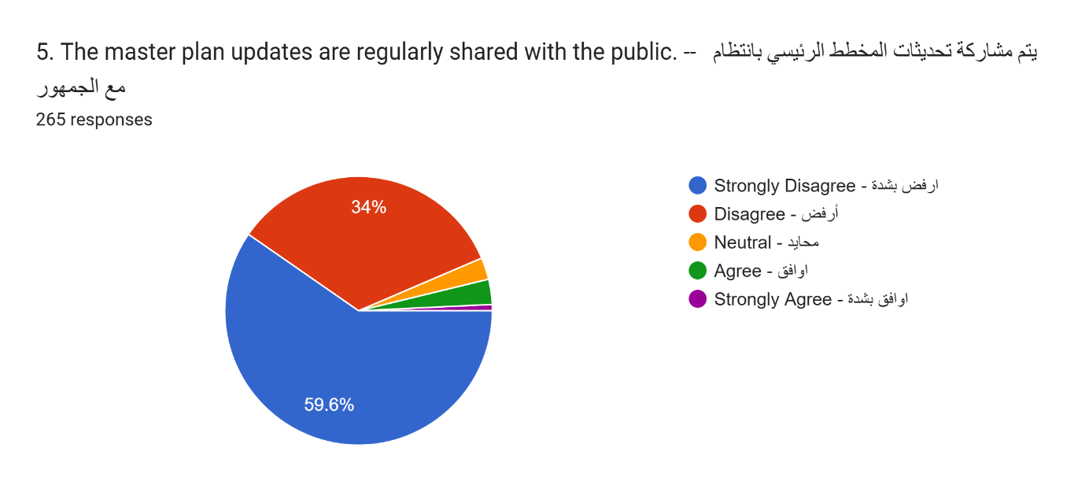
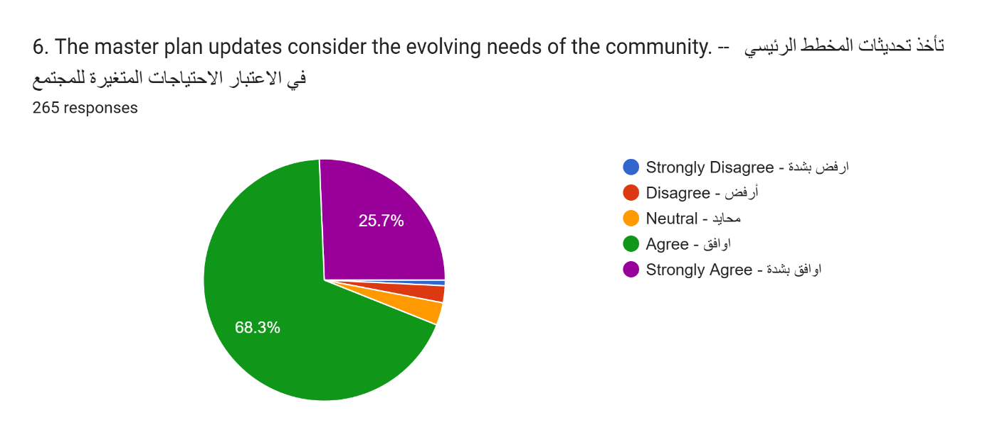
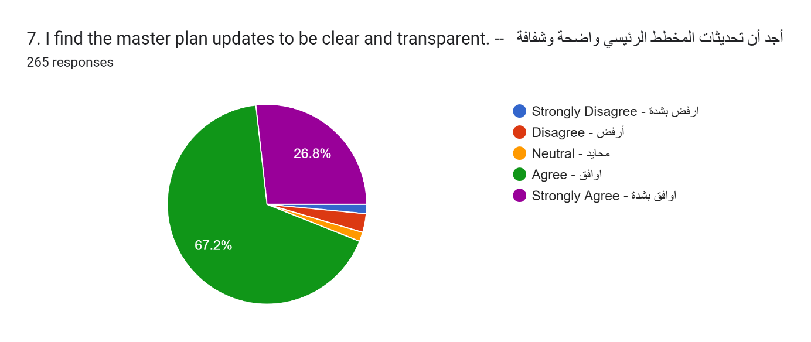

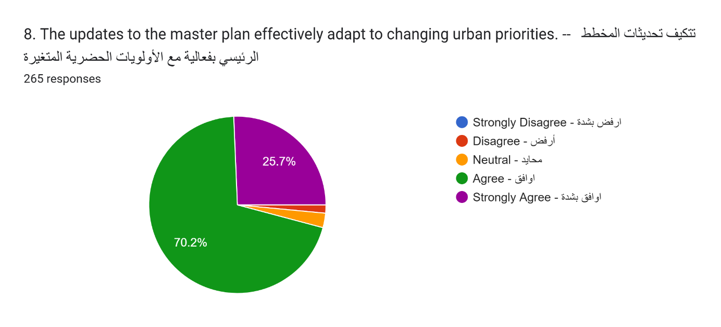

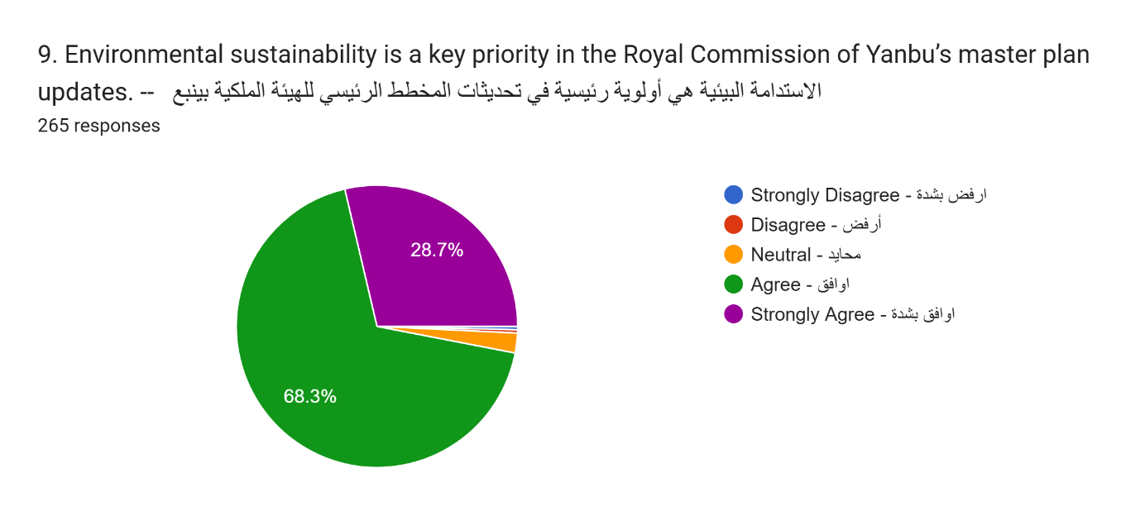
Section 2: Project Alignment with Community Needs القسم الثاني: توافق المشاريع مع احتياجات المجتمع
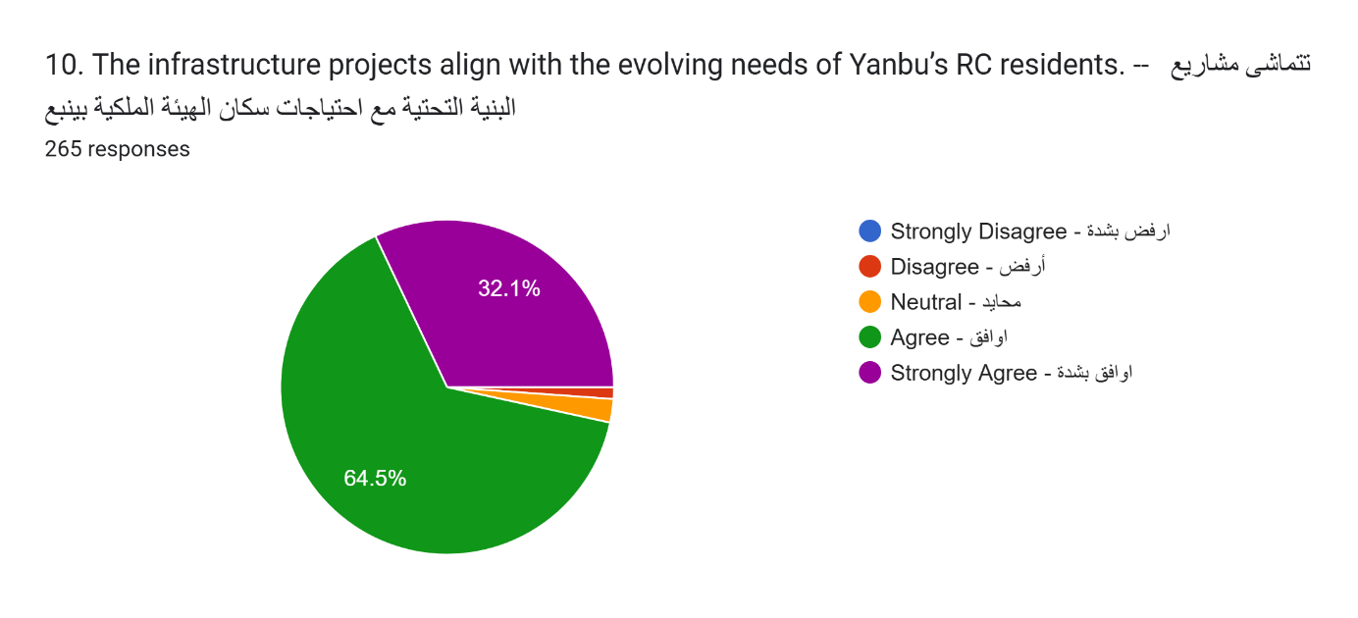
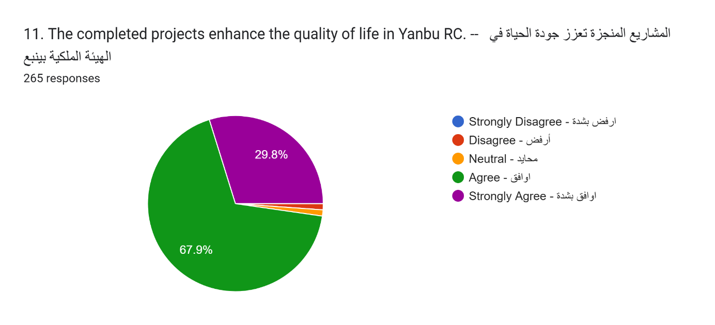
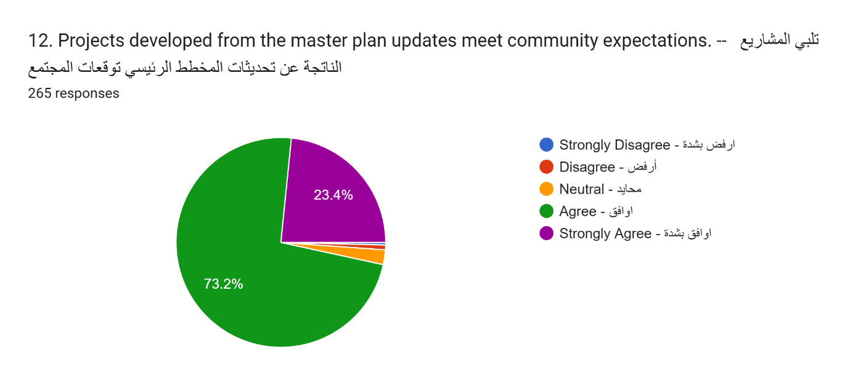
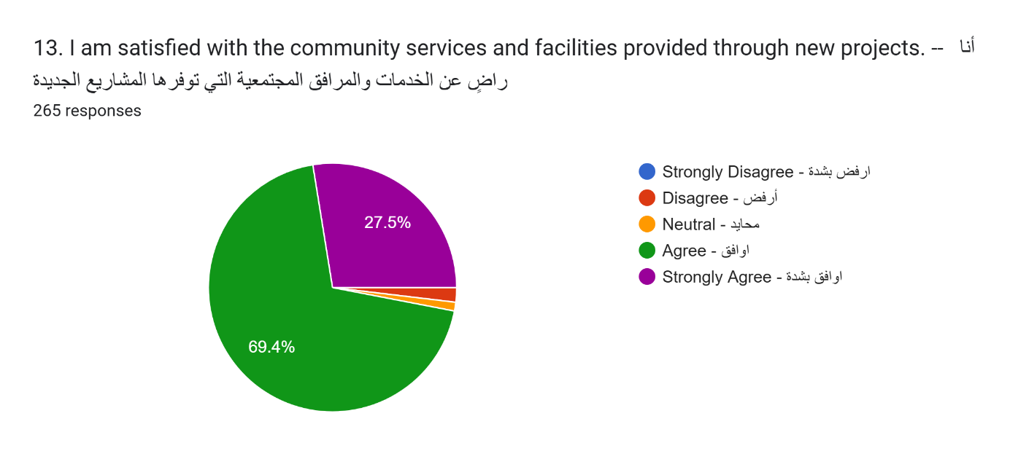
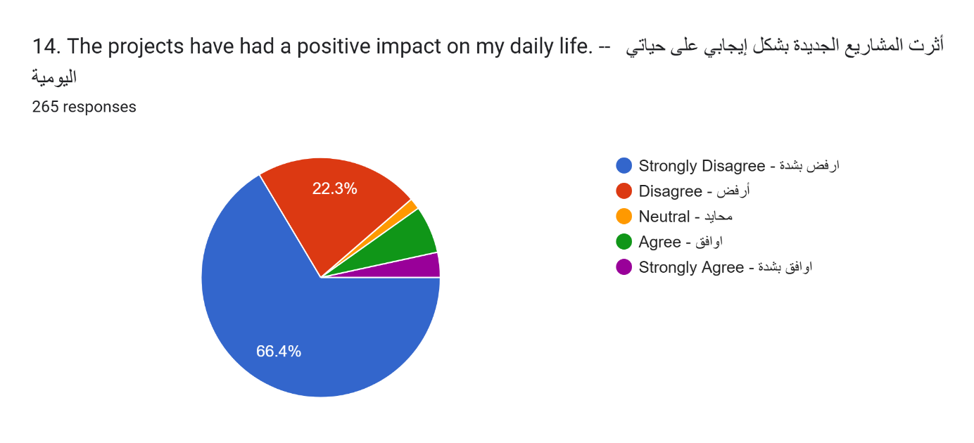
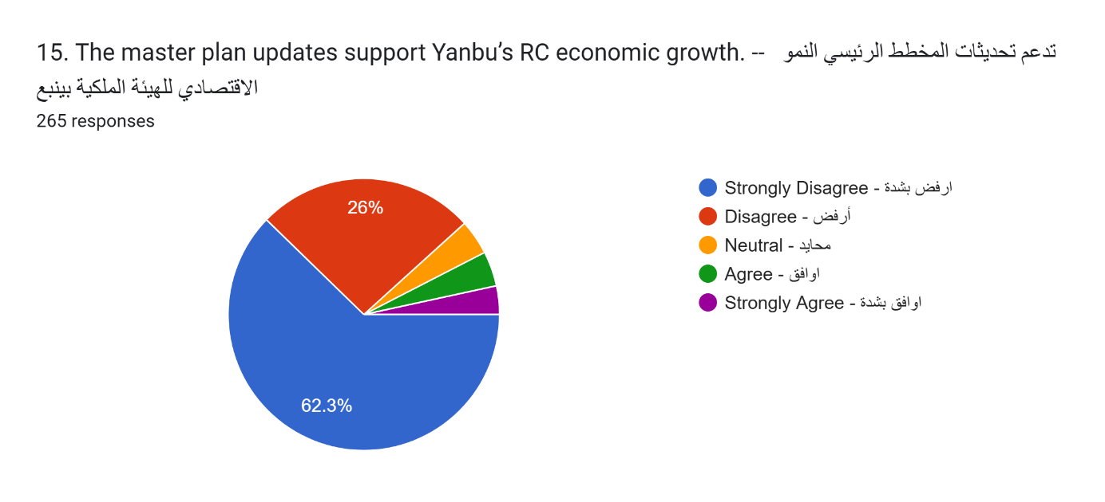

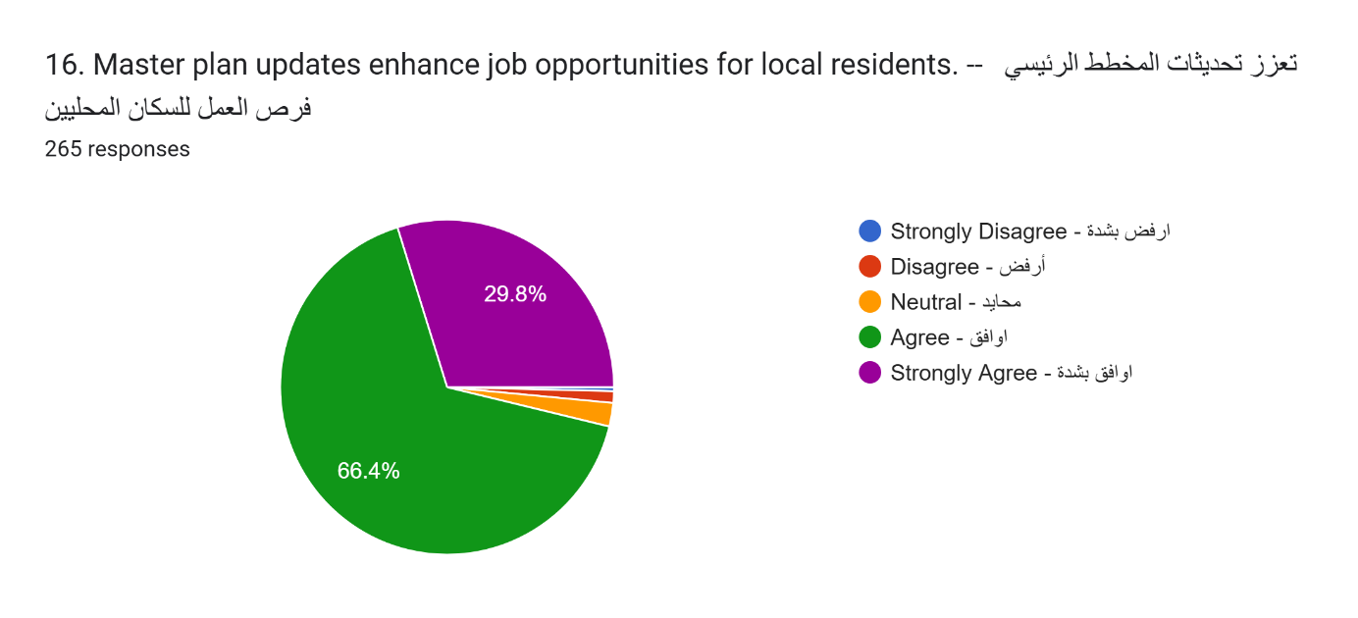

Section 3: Community Engagement in Planning القسم الثالث: مشاركة المجتمع في التخطيط
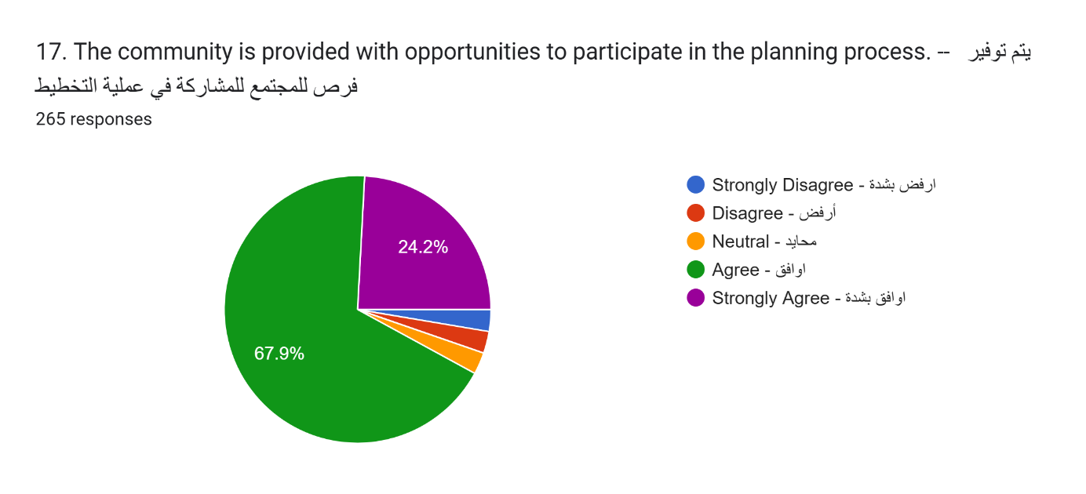
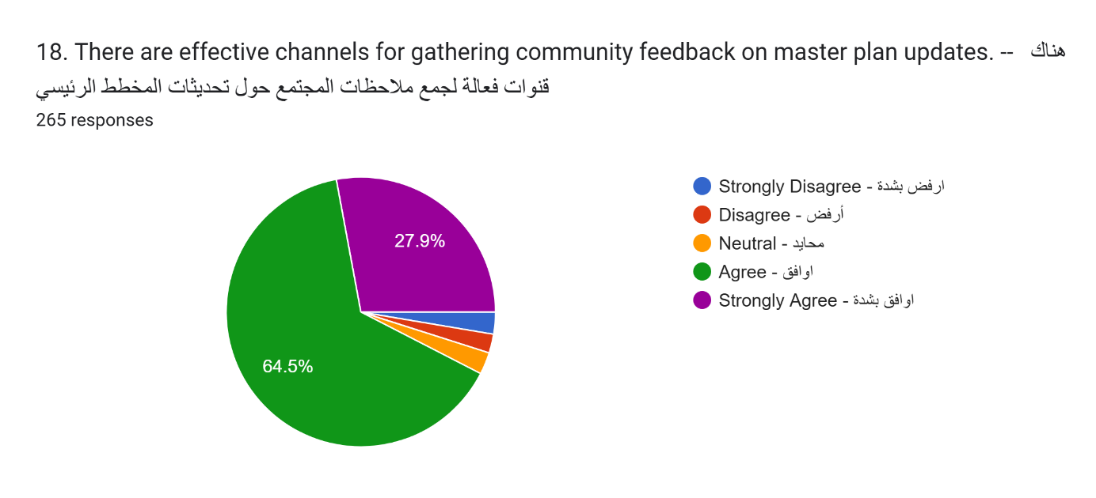
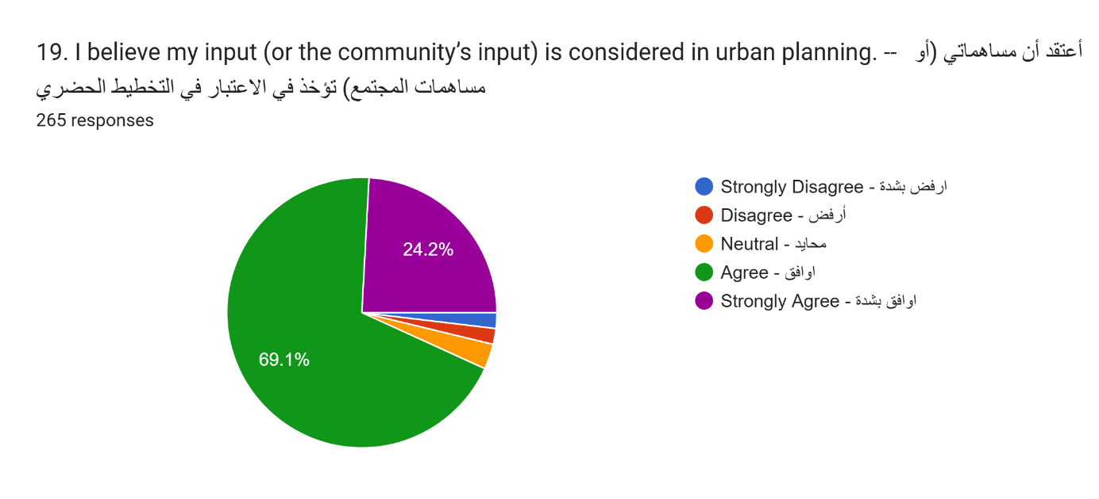
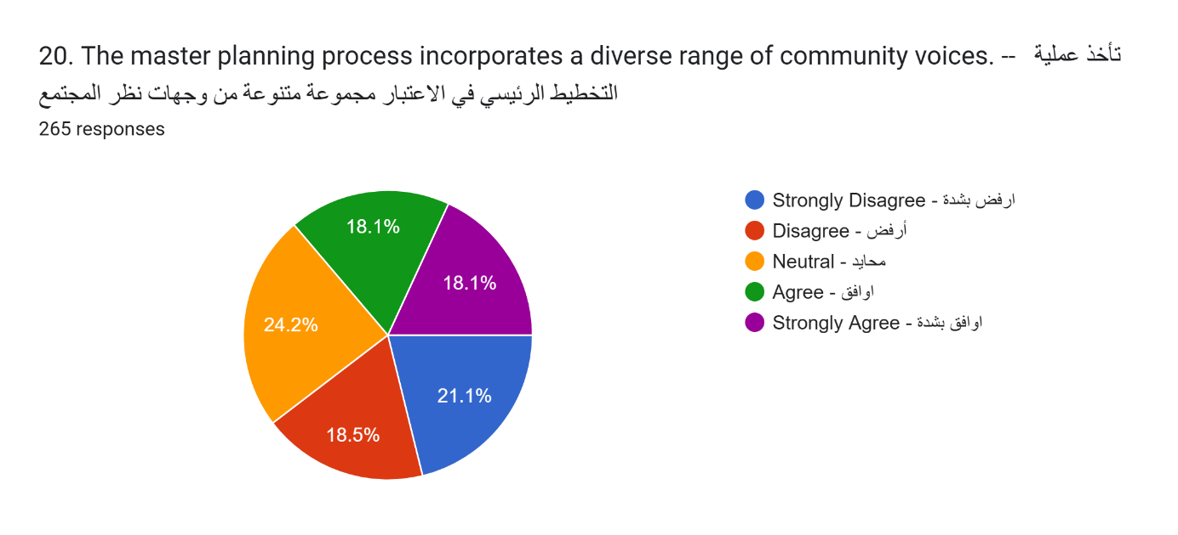
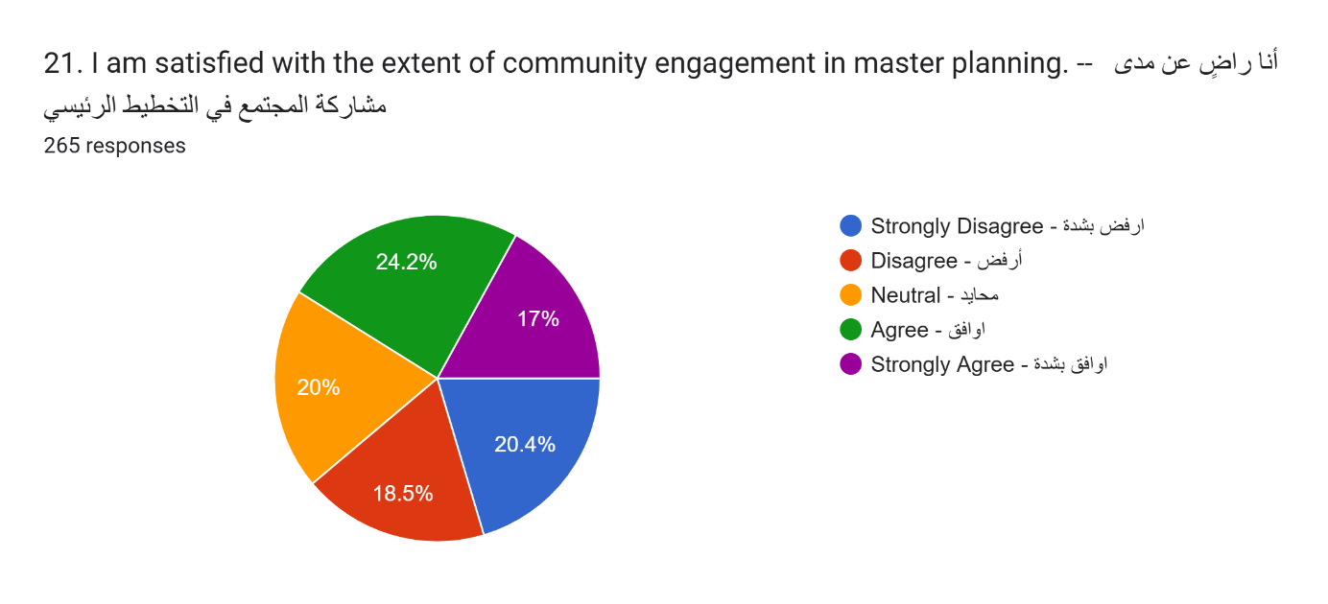

Section 4: Effectiveness of Master Plan Implementation القسم الرابع: فعالية تنفيذ المخطط الرئيسي
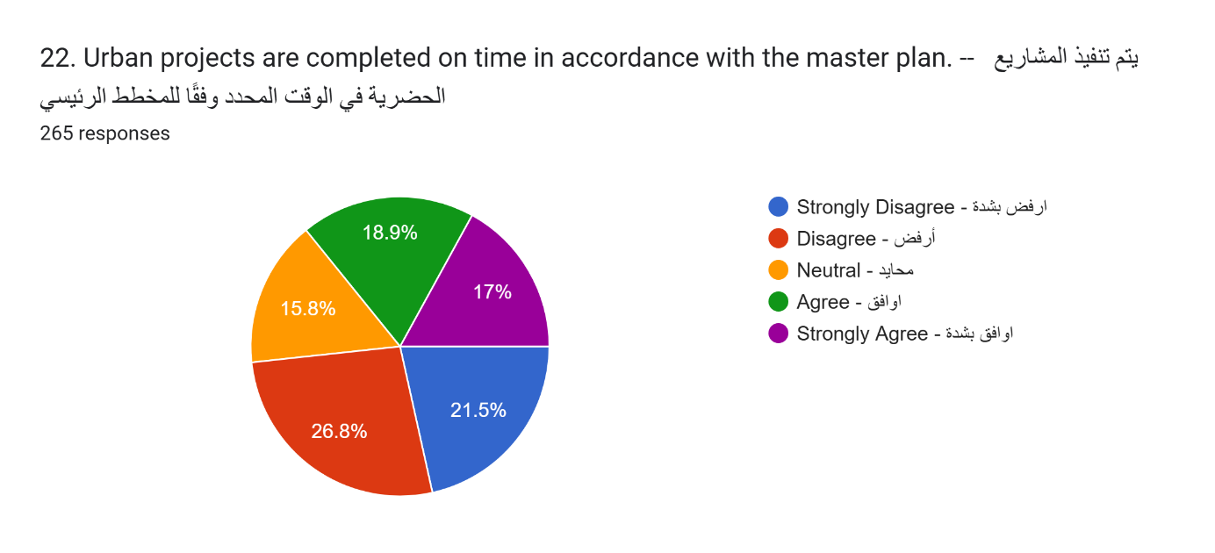
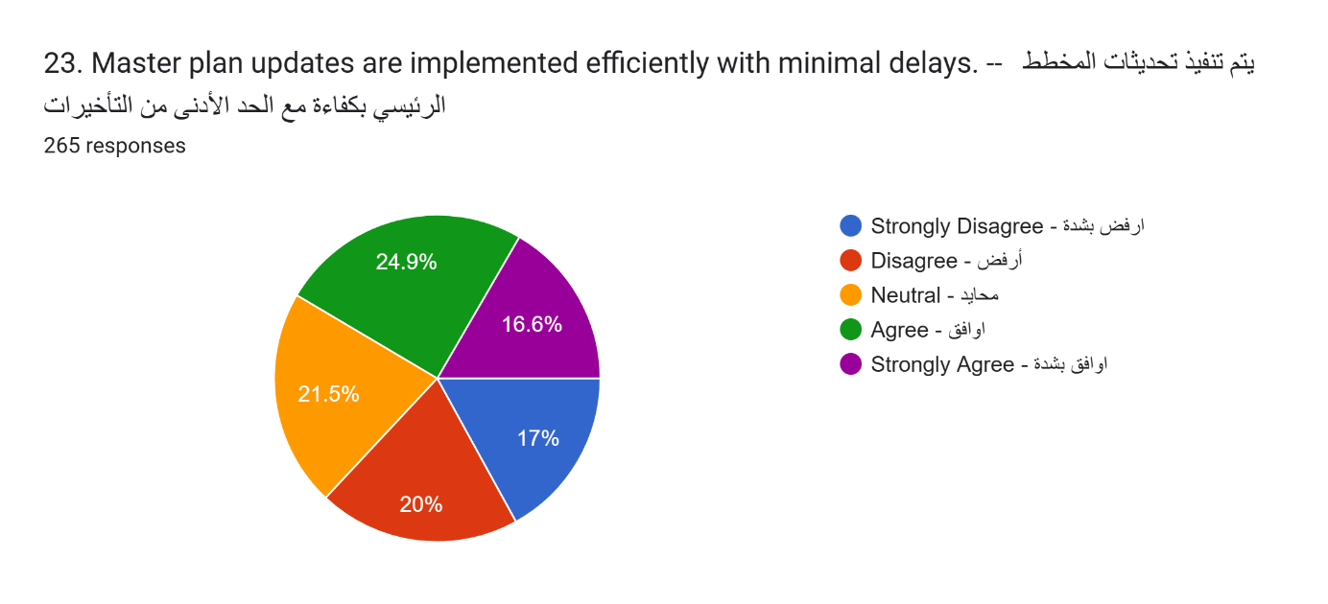
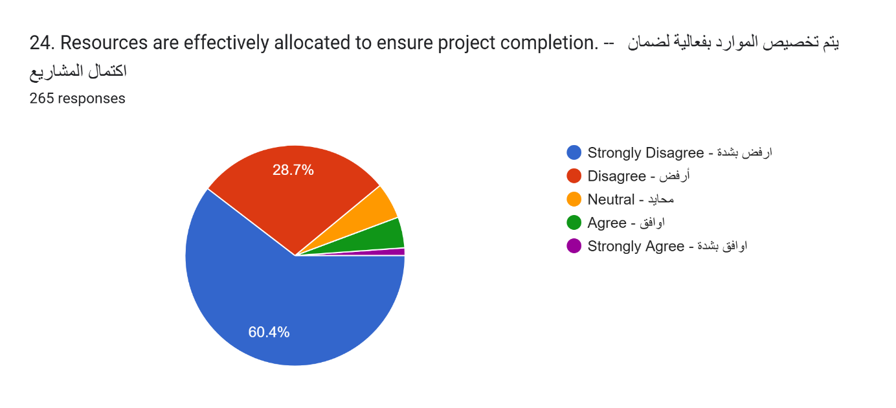
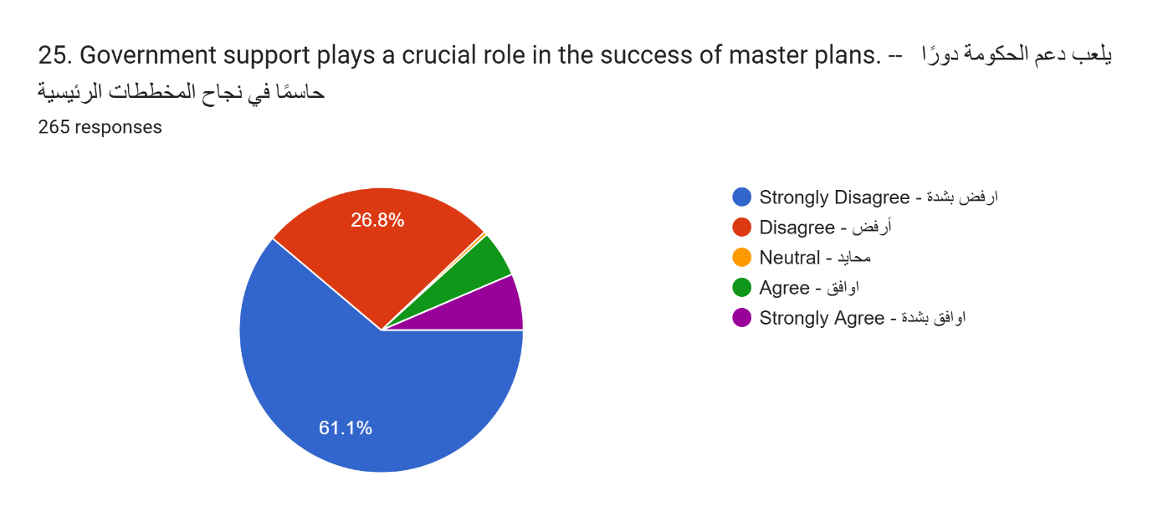
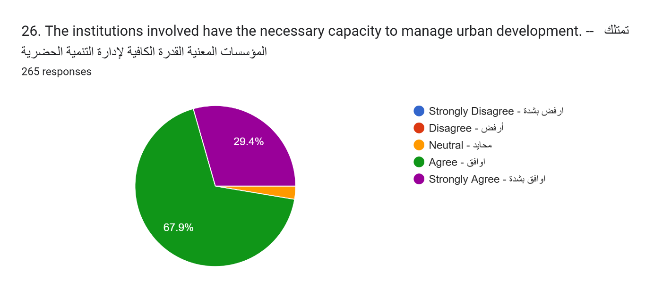
Section 5: Barriers to Project and Master Plan Alignment القسم الخامس: العوائق أمام توافق المشروع مع المخطط الرئيسي
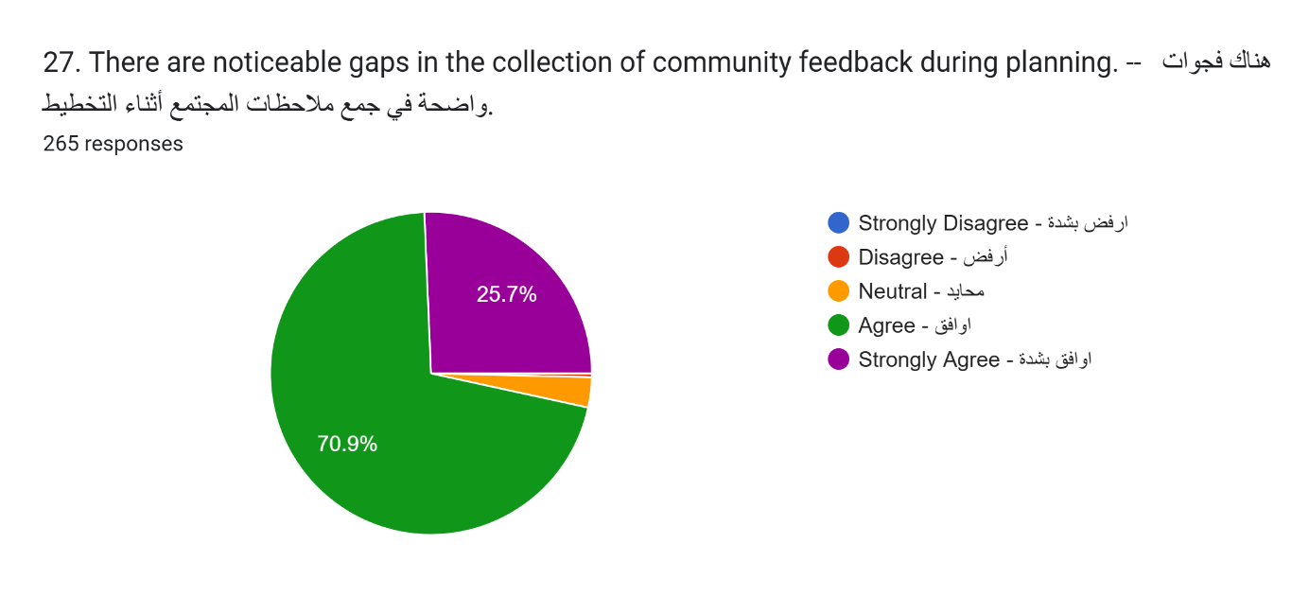
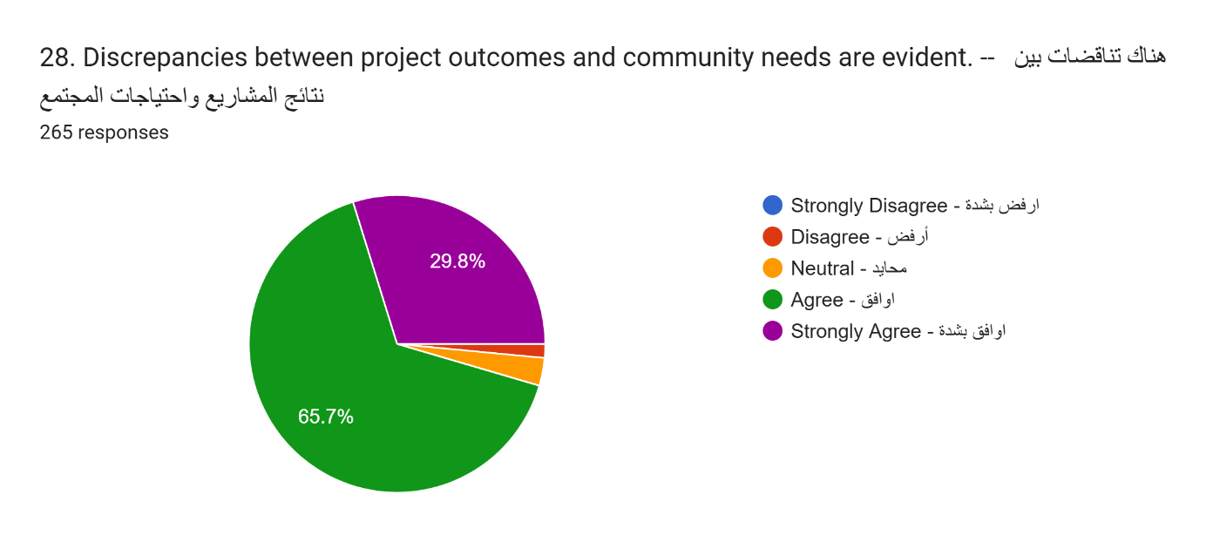
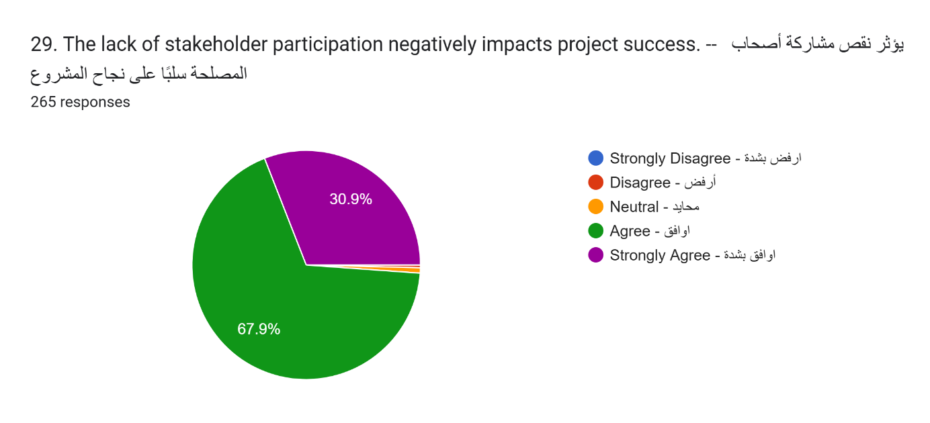
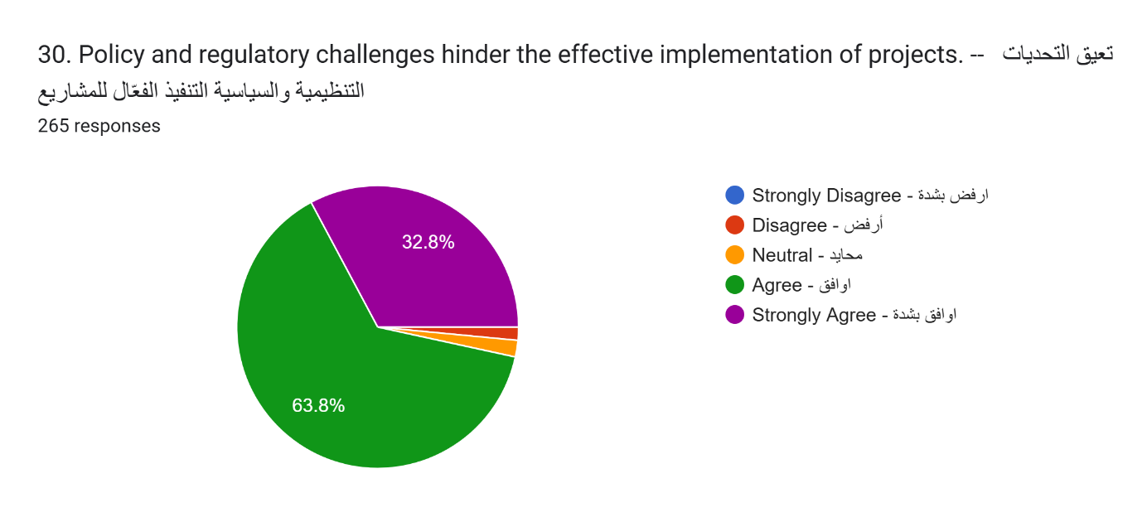
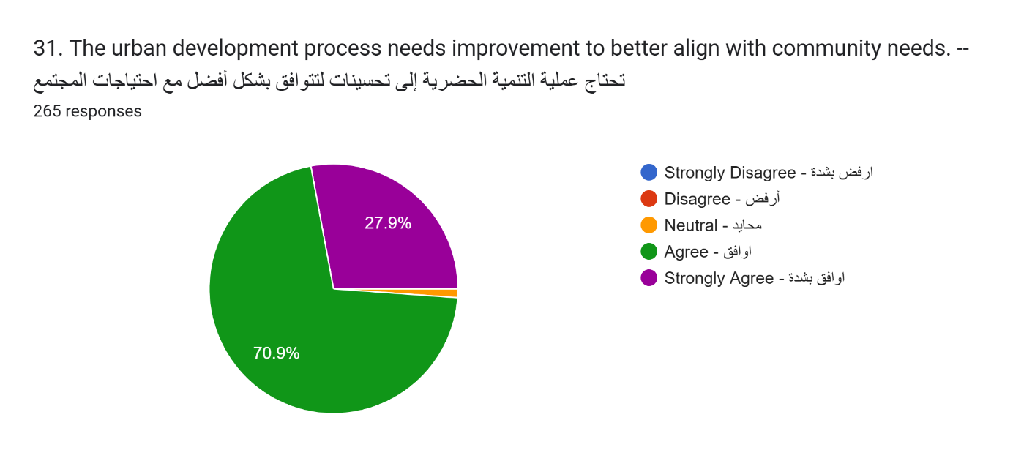

جامعة ميدأوشن
كلية الإدارة
قسم إدارة الأعمال

تقييم العلاقة بين تحديثات الخطة الرئيسية ومواءمة المشروع مع احتياجات المجتمع في ينبع

اسم الطالبة:
غالية عادل حنفي

تحت اشراف:
د. الفيصل عبدالحميد د.فايز جراد

العام الأكاديمي
2024/2025

