

Prepared By
Name Mahmoud Al Ra’e ID No.: 253001641
Name Hussein Mudeheg ID No.: 253001186

Submitted in fulfillment of the requirements for the Master degree of Science in Artificial Intelligence
At
College of Informatics Midocean University, UAE.
Supervisor Name: Dr. Hager Saleh
College of Informatics, Midocean University, Comoros

Contents
1. Chapter 1: Introduction 3
1.1. Problem Definition 3
1.2. Thesis Objectives 3
1.3. Thesis Contribution 3
1.4. Thesis Organization 3
1.5. Proposed Framework 4
2. Chapter 2 Background and Related Work 4
2.1. Background 4
2.1.1. Artificial Intelligence (AI) 4
2.1.2. Deep Learning (DL) 4
2.1.3. Convolutional Neural Networks (CNN) 4
2.1.4. Transform Model 5
2.1.5. Vision Transformer (ViT) 5
2.1.6. Internet of Things (IoT) 5
2.2. Related Work 6
References 12

Chapter 1: Introduction

Problem Definition

Plants diseases are among the major concerns affecting the quality and production levels of crops. The farmers often determine the occurrence of diseases in the plant through experience, which may be unreliable. Early symptoms of plant disease may be difficult to recognize leading to delay in diagnosis, thus more damage to the plant. Some diseases in plants look alike; therefore, it could lead to a false conclusion in the diagnosis. Detecting the diseases of plants in their natural environment becomes very difficult owing to many factors including illumination, occlusion, and leaf orientation of the plant. Normally, checking of the plants requires manual labor. The detection of the diseases from each individual plant becomes time-consuming particularly when dealing with many of them or a larger piece of farm. It is, thus, necessary to develop a system which will enable farmers to diagnose the diseases automatically. Artificial Intelligence and deep learning would help the farmers detect diseases faster and make informed decisions concerning the crops. Plant diseases account for about 40% annual losses globally. Plant diseases lead to huge financial losses annually, and they have been estimated to cost about 220 billion dollars annually globally.

Thesis Objectives
The general objective of this thesis is to develop an intelligent system for plant disease detection from leaf images using AI and DL techniques. The study aims to improve the accuracy and speed of disease diagnosis in order to support early detection and better management.
The specific objectives are to apply and evaluate different DL models for plant disease classification, particularly Convolutional Neural Networks (CNNs), Vision Transformers (ViT), and Swin Transformers. In addition, this thesis aims to compare these models in terms of classification accuracy, computational efficiency, and suitability for real-world agricultural environments. Another specific objective is to examine the ability of these models to work under practical conditions such as varying lighting, background complexity, and leaf position. The study also seeks to explore how these models can support smart agriculture applications when combined with modern technologies such as the Internet of Things (IoT).

Thesis Contribution

Thesis Organization

Proposed Framework

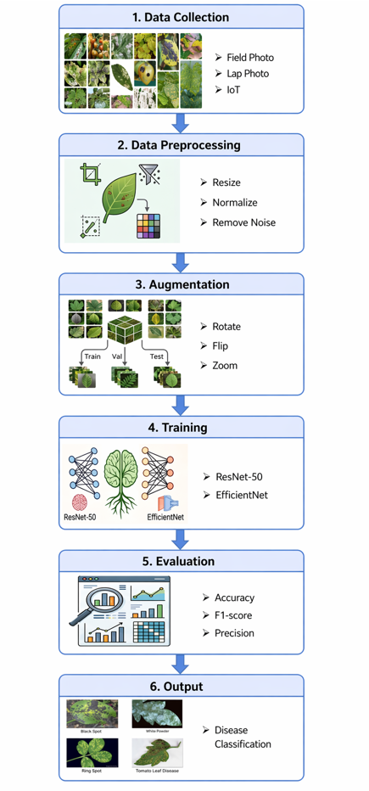

Chapter 2 Background and Related Work

Background
Technology has started to play a major role in many areas including the agriculture and plants, especially in the health of Crop and productivity. One of the most challenges faced by the farmers is the early detection of the plant diseases. This process earlier has a large dependency on the expertise of the human which is time consuming, could have a biased and sometimes are inaccurate. With the advancement of the technology and Ai, newly automated approaches have emerged to automate the process disease detection that making it faster and more reliable

Artificial Intelligence (AI)
AI refers to the ability of machines to perform tasks that normally require human intelligence, such as learning, reasoning and making a decision. In agriculture, AI is being increasingly used to analyze the plant conditions, detect the diseases based on the image and ultimately support in taking the right decision in by processing large amount of data and identifying patterns which enable early diagnostic for better crop management [1].

Deep Learning (DL)
Deep learning (DL) is a subset of the Artificial Intelligence (AI) that focuses on learning from large scale datasets using multi-layered neural network, enabling systems to automatically extract, meaningful and hierarchical features without the need for manual feature engineering or extensive intervention of Human. In plant disease detection, DL has demonstrated high efficiency due to its ability to analyze complex visual patterns in leaf images and identifying plant diseases under controlled conditions [2]

Convolutional Neural Networks (CNN)
Convolutional Neural Network (CNN) is one of the most popular deep learning models for image analysis. This is due to its ability to learn spatial hierarchies of features from input data. Many different types of CNN architecture exist, including those like LeNet, AlexNet, and their more recent versions, namely VGG, GoogLeNet, ResNet, DenseNet, and MobileNet. CNN works excellently in processing visual data and identifying patterns within an image, including edges, textures, and shapes. Within the agricultural sector, CNN is commonly used for disease diagnosis of plants through analysis of leaf images, with architectures such as VGG, ResNet, and DenseNet achieving an accuracy above 95%. [3]

Transform Model
The transformer architecture is a approach to deep learning, based around the concept of attention instead of the conventional form of convolution. Unlike the CNN, which cuts up the picture into smaller portions, the Transformer analyzes the entire image in its entirety, understanding the connections between various segments. It allows it to understand the broader picture and dependencies across long distances. Due to these properties, architectures using transformers such as Vision Transformers (ViTs) have become increasingly popular for image analysis compared to CNNs and other methods. [4]

Vision Transformer (ViT)
ViT is a model that applies transformer architecture to image data, and instead of analyzing the complete image, it divides it into smaller patches and then processes them in a similar way to words in a sentence. This approach allows the model to understand both local and global features. Many recent research studies show that ViT models could outperform traditional CNNs in plant disease classification tasks. Some studies have compared ViT with models like ResNet and DenseNet, which have reported accuracy levels approximately close to 99% that demonstrate strong performance and capabilities. However, the side effect of the ViT models often is that they require large datasets and higher computational resources which could limit the accessibility, especially for smaller research teams or applications with limited data availability. [5]

Internet of Things (IoT)
IoT is a network of devices that are connected and can share and gather data in real time. IoT is very important for smart farming systems in agriculture. Cameras, sensors, and drones are some of the devices that can keep an eye on crops all the time and send data for analysis. IoT makes it possible to have real-time plant disease detection systems when used with AI and deep learning. For instance, cameras with IoT can take pictures of leaves in the field, and deep learning models can quickly look at these pictures to find diseases. [6]

Related Work
Too et al. applied multiple types of pertained models such as VGG16, InceptionV4, ResNet50, and DenseNet121 which classify 38 different classes of plant diseases. The public dataset so called PlantVillage was used from KAGGLE, which has 54,306 images with 38 classes. The preprocessing steps included image resizing in order to match the required input size of the CNN architecture, and rotation, flipping, and scaling were applied to increase dataset variability and reduce overfitting. The result has shown that DenseNet121 achieved the highest classification accuracy among the evaluated models. Transfer learning significantly improved performance compared to training from scratch. The models demonstrated very high accuracy under laboratory conditions. [7]
The study examines the use of Vision Transformers (ViT) for plant disease classification to determine whether attention-based architectures can perform better than the traditional convolutional neural networks (CNNs) or not. A pre-trained VIT model on ImageNet was improved for plant disease detection and compared with CNN models such as ResNet50 and DenseNet121. The model utilizes five public plant datasets that include the famous PlantVillage dataset, which contains 54,306 images from 38 classes that were collected under controlled conditions. The preprocessing involved resizing the images to 244X244 pixels, patch embedding preparation, pixel normalization, and data augmentation such as rotation and flipping. The final results demonstrate that VIT achieved approximately 99% accuracy, which outperforms several models. [8]
The research proposed a lightweight deep learning model, so called Dise-Efficient which is built on EfficientNetV2 to identify plant diseases and pest identification. The study focused on improving model efficiency while ensuring strong recognition performance. The model was trained and evaluated using plant image datasets, using steps such as image resizing, normalization, and data augmentation for preprocessing, which were applied to enhance performance and generalization. The results show that the proposed model has achieved high accuracy of classification as well as reduced the computational complexity. [9]

The authors have proposed an integrated Internet of Things (IoT) solution that has combined deep learning techniques to detect plant diseases. Leaf images were captured through cameras along with environmental data collected from IoT sensors such as temperature and humidity. The purpose of the preprocessing techniques is to improve image quality prior to applying deep learning models for disease classification. The system includes training and evaluation stages that measure the performance of the model, which resulted in high accuracy. In addition, the framework supports real-time monitoring and feedback, allowing continuous tracking of crop conditions and early detection of diseases. [10]
Aldakheel et al. proposed a real time plant leaf disease detection system based on the YOLOv4 object detection framework. In contrast to the traditional classification models that only predict disease categories, YOLOv4 enables simultaneous detection of diseased regions within leaf images. The methodology involved training the YOLOv4 model to identify and classify multiple plant diseases directly from leaf images by bounding box coordinates and class probabilities in a single detection process. The model was trained on annotated plant leaf disease datasets that contain multiple disease categories in several environments. The preprocessing steps included image resizing to match the YOLOv4 input dimensions, image normalization, and data augmentation such as rotation, scaling, and flipping to improve robustness and at the same time to reduce the overfitting. The result of the experimentation demonstrated that YOLOv4 achieved higher accuracy with fast inference speed which making it suitable for real time agricultural applications. [11]

Duhan et al. have designed a real-time plant disease diagnosis based on mobile and edge devices. The authors have combined the RTR_Lite framework with MobileNetV2, a compact convolutional neural network known for its use of separable convolutions, which significantly reduce computational cost and still maintain strong performance. The goal was to develop a model that balances between accuracy and speed, which makes it very practical for field deployment where the computational resources are always limited. The model was trained on available public plant disease datasets that include various crops and disease categories which were captured under different environmental conditions. Prior to commencing the training the images were resized to match the input size required by MobileNetV2, and pixel values were normalized. Data augmentation techniques such as rotation, flipping, and scaling were applied to improve the ability of the models to generalize. The results showed that RTR_Lite_MobileNetV2 achieved high classification accuracy and at the same time has maintained a small model size and fast inference speed. [12]
Bhola and Kumar have designed a CNN model that automatically learns the important visual features from leaf images which eliminates the need for manual feature extraction. The main objective was to support farmers in detecting diseases at an early stage so that timely treatment can reduce crop damage and yield loss. Pre-trained CNN models such as VGG16, ResNet-50, and Inception-v3 were used. The model was trained and tested on a dataset of vegetable leaf images that included several disease categories, collected under both controlled and natural environmental conditions. Before starting the training, the images were resized to fit the input requirements of the network and normalized to standardize pixel values. Data augmentation techniques such as rotation, flipping, and brightness adjustment were also applied to increase dataset diversity and accordingly improve the ability of the models to generalize. The results showed that the proposed model achieved high accuracy and performed well in recognizing early symptoms of the disease. [13]
Kheir et al. have proposed a hybrid model combined of Vision Transformer (ViT) and MobilePlantViT, the lightweight design generalized plant disease image classification and balance both accuracy and efficiency for mobile and edge deployment. Traditional deep learning models for plant disease recognition often struggle on resource limited devices caused by high computational costs. MobilePlantViT combines efficient convolutional operations with a Vision Transformer backbone to capture local and global features while maintain the architecture compact. The model was evaluated across multiple diverse plant disease datasets that has shown a strong generalization and test accuracies ranging from around 80% to over 99% depending on the dataset. Preprocessing consisted of the usual image resizing and normalization, along with data augmentation to improve its reliability and prevent overfitting. The outcomes from the experiments highlight the potential that MobilePlantViT holds for practical disease detection in plants. [14]

Thanjaivadivel developed EnConv which is an improved CNN, meant to accurately classify plant leaves and their diseases using more efficient feature extraction techniques. The objective is to use ML and DL to detect diseases in plants which does not need extensive knowledge in the field . EnConv uses deep convolutional layers, which optimize calculations and retain crucial properties such as leaf colors and shapes. Instead of having a flattening layer as in most CNNs, EnConv has global pooling layers that can reduce overfitting and improve performance. After testing EnConv on data from a total of 39 diseases from different crops, it had a maximum accuracy rate of 99.87%. This clearly indicates that EnConv is more accurate than other machine learning and deep learning models. [15]

In this research, we have proposed a deep learning and IoT-based framework for detecting plant leaf diseases in real-time. The proposed framework relies on a CNN algorithm to analyze leaf images and determine whether the plant is healthy or unhealthy. For improving the efficiency of pre-trained models such as MobileNetV2, ResNet50, and VGG16, transfer learning technology is used, along with datasets including PlantVillage. An IoT camera is used for taking images from the leaves and performing operations such as removing noise, adjusting size, and applying data augmentation techniques to enhance reliability irrespective of the weather conditions. Furthermore, the developed model is capable of executing at edge computing devices including Raspberry Pi or Jetson Nano. The model has an accuracy rate of more than 90%. [16]
The paper explains a framework that utilizes DL techniques to identify and classify plant leaf diseases is introduced. A custom model named CropLeafNet is constructed using reliable backbone architectures ResNet50, MobileNetV2, and VGG16 to enhance feature detection and classification processes. Using the concept of transfer learning, the proposed framework identifies not only the local characteristics such as the leaf textures but also the global features including the leaf colors and patterns found all around the world. This makes it possible to diagnose a variety of diseases through one single model. For training purposes, datasets such as PlantVillage as well as photographs from the field are employed to guarantee a wide range of leaf environments. Image preprocessing consists of resizing and normalizing operations along with some augmentation operations including rotation, flipping, and contrast changing. From the experimental results, it is clear that the developed model named CropLeafNet (CNN architecture for agricultural problems) is able to classify the diseases with high accuracy and performs better than other standard CNN models. [17]
In this study, an ML approach is proposed to detect plant disease in pigeon pea leaves, intending to provide assistance for early diagnosis for farmers. This paper explicitly uses no deep neural network nor other recent large-scale models called black boxes. The researchers propose a novel ML solution to the problem by combining classical computer vision techniques and classical classifiers. Dense SIFT (DSIFT) and Bag of Visual Words (BoVW) techniques are used as feature extractors that have proven themselves to be robust and invariant to noise and rotations in previous works. This framework tests several classifiers, including SVM, KNN, Random Forest, Decision Tree, Gradient Boosting, and a CNN classifier, in order to classify the pigeon pea leaf disease categories using their extracted descriptors. The dataset consists of 900 wild images of pigeon pea leaves (diseased and healthy). The preprocessing stage involved image size adjustment and enhancement of quality. It was discovered that the CNN classifier and the LightGBM classifier were efficient in classifying pigeon pea leaves into categories. [18]
PlantDoc was designed as a real-life dataset, which is supposed to aid in improving the abilities of artificial intelligence to recognize plant diseases under non-laboratory circumstances. As such, all the images used in PlantDoc come from a variety of farms, thus being quite messy, with lots of background information, inconsistent illumination, and pictures shot from a wide range of perspectives.A series of deep learning models were chosen by the authors to see how successfully they would be able to recognize plant diseases. Prior to the training phase, all the images were processed, having been resized, cropped using bounding boxes for disease localization, normalized, and subjected to various augmentations, like images' flip and adjustment of brightness levels. This yielded some positive results, as PlantDoc-trained models demonstrated higher robustness when applied to real farm conditions than other models, which were trained exclusively based on laboratory data. At the same time, it resulted in somewhat worse performance overall due to the nature of real-life data. [19]
In this work, it was examined how EfficientNet, which is known for scaling depth, width, and resolution together, performs regarding recognizing plant diseases. Researchers used different versions of EfficientNet, from its smaller version B0 to a larger one, B7. Transfer learning was performed based on existing plant disease recognition datasets such as PlantVillage. The data was processed thoroughly before entering the training phase. Specifically, the images were resized according to the requirements of the model, normalized, and augmented using techniques like rotation, flipping, zooming, and others.It easily beat the performance of the previous versions of CNNs, like ResNet and Inception, while being even more efficient due to using less number of parameters. The classification accuracy exceeded 99%. It should be noted that these tests were conducted using clean datasets. [20]
This paper describes ResNet, which is a deep convolutional neural network using residual learning to solve the problem of degradation in extremely deep models. Designed for generalized image recognition, ResNet has shown impressive performance in plant disease classification due to its efficient image feature extraction capabilities. One of the main concepts covered in the paper is the skip connection, which helps retain the continuity of gradient flow during training and enables ultra-deep neural nets, including ResNet50, ResNet101, and ResNet152.
ResNet is fine-tuned using transfer learning on platforms like PlantVillage. This process involves preprocessing the images which includes resizing, normalizing the data and using data augmentation to increase the size of the dataset. In various research studies, the model has consistently achieved impressive accuracy rates, as seen in reference [21].

3: Methodology

3.1 Introduction
This paper presents the methodology used to develop and evaluate the plant leaf disease classification system proposed in this thesis. Three convolutional neural network backbones — ResNet50, EfficientNetB0, and MobileNetV2 — are adapted through transfer learning and trained under an identical experimental protocol, so that their performance can be compared fairly in Chapter 4. Each backbone is implemented in its own notebook that follows the same sequence of stages: dataset preparation and splitting, data quality control, augmentation and model-specific preprocessing, transfer-learning model construction, training, and a standardized evaluation procedure that persists metrics and confusion matrices for later comparison. This chapter intentionally avoids presenting accuracy, precision, recall, or other performance figures; all numerical findings are reported in Chapter 4.
Transfer learning is adopted for all three models rather than training each architecture from scratch. With 20,638 images across 15 classes, the PlantVillage dataset used here is comparatively modest for training a deep CNN from random initialization, whereas reusing ImageNet-pretrained convolutional features — as reviewed in the transfer-learning studies discussed in Chapter 2 — has consistently achieved high accuracy on this dataset with substantially less training data and time.

3.2 Dataset Description
The dataset used in this study is PlantVillage, a publicly available collection of leaf images obtained from Kaggle. The corpus used in the experiments comprises 20,638 images distributed across 15 classes spanning three crops — pepper, potato, and tomato — covering both diseased and healthy leaf conditions. The class names, exactly as used in the classification pipeline, are as follows:
Pepper bell Bacterial spot; Pepper bell healthy; Potato Early blight; Potato Late blight; Potato healthy; Tomato Bacterial spot; Tomato Early blight; Tomato Late blight; Tomato Leaf Mold; Tomato Septoria leaf spot; Tomato Spider mites Two spotted spider mite; Tomato Target Spot; Tomato Tomato YellowLeaf Curl Virus; Tomato Tomato mosaic virus; Tomato healthy.
The dataset is naturally imbalanced across classes. Table 3.1 reports the number of images per class in the held-out test subset (20% of the data, described in Section 3.3), which is representative of the class proportions across the full dataset. The smallest class, Potato healthy, contributes 31 test images, while the largest class, Tomato Yellow Leaf Curl Virus, contributes 643 test images — a ratio of roughly 1:21. This imbalance is discussed in Chapter 4 in relation to per-class performance.

Table 3.1. Class distribution in the held-out test subset (total = 4140 images).

3.3 Data Preparation and Splitting
The raw PlantVillage archive is stored on Google Drive under a fixed project path (MidOcean/Practical/PLANT_DISEASE/). At the start of each notebook run, the archive is unzipped to the local Colab filesystem (/content) rather than being read directly from Drive, since local storage substantially reduces per-batch I/O latency during training.
The unzipped images are then split into training, validation, and test subsets using the splitfolders library with a fixed random seed (seed = 42) and a ratio of 70% training, 10% validation, and 20% test. Any stale split directory from a previous run is removed with shutil.rmtree before the split is rebuilt, ensuring that each run starts from a clean, reproducible partition. This procedure produced 14,440 training images, 2,058 validation images, and 4,140 test images, identically across all three model notebooks.

3.4 Data Quality Control
Before training, every image in the split dataset is checked for corruption using PIL's verify() method; one corrupted file was detected and removed from the corpus. Light Gaussian denoising (a 3×3 kernel) is then applied to the remaining images to reduce sensor noise while preserving leaf texture and lesion boundaries relevant to disease diagnosis. This step is applied to the local split copy only, so the archived copy on Drive remains unmodified.

3.5 Data Augmentation and Model-Specific Preprocessing
Image generators are built with Keras' ImageDataGenerator. For the training subset, augmentation is applied to increase visual variability and reduce overfitting: rotation of up to 20°, width and height shifts of up to 20%, zoom of up to 20%, and random horizontal flipping, with the fill mode set to ‘nearest’ for pixels introduced by these transformations. Validation and test generators apply no augmentation, since these subsets are used only to measure genuine model performance.
The augmentation ranges are chosen to reflect realistic variation in how a leaf might be photographed in the field — moderate rotation, shift, and zoom account for changes in camera angle and distance, while horizontal flipping is safe to apply since leaf disease symptoms are not orientation-dependent — without distorting the lesion patterns that distinguish one disease from another.
A key methodological requirement, applied consistently across all three notebooks, is that each backbone uses its own Keras preprocess_input function — rather than a generic 1/255 rescale — for training, validation, and test data alike. Each pretrained ImageNet backbone expects its inputs to be normalized according to the specific statistics used during its original pretraining; applying a fixed 1/255 rescale on top of (or instead of) this architecture-specific function would distort the input distribution the network was trained to expect, degrading its ability to reuse pretrained features. Using the matched preprocessing function for each backbone ensures that all three models receive inputs in the numerical range and distribution their convolutional weights were optimized for, which is essential for a methodologically fair comparison.

3.6 Transfer Learning Architecture
All three models share an identical classification head placed on top of a frozen, ImageNet-pretrained convolutional base. The base network (with include_top=False and an input shape of 224×224×3) is loaded with its ImageNet weights and its layers are frozen (trainable = False), so that only the newly added head is updated during training. The shared head consists of a GlobalAveragePooling2D layer, a Dense layer of 256 units with ReLU activation, a Dropout layer with a rate of 0.5, and a final Dense output layer of 15 units with softmax activation, corresponding to the 15 target classes.
The convolutional base is kept frozen, rather than fine-tuned, because the ImageNet-pretrained filters already encode general low- and mid-level visual features (edges, textures, color gradients) that transfer well to leaf imagery; freezing them lets the comparison focus on how well each architecture's pretrained representation suits this task, while keeping the number of trainable parameters and the training time small and comparable across all three models. The 256-unit dense layer and 0.5 dropout rate are standard, moderate choices for a classification head of this kind: large enough to combine the pooled convolutional features into class-discriminative patterns, while the dropout rate mitigates overfitting given the relatively small number of trainable parameters relative to the dataset size.
The three backbones differ substantially in size, as summarized in Table 3.2. This is a structural property of each network and is reported here for completeness; the corresponding performance results are presented in Chapter 4.
Backbone | Trainable parameters (head only) | Total parameters | Family
ResNet50 | frozen base + head | 24,116,111 | Residual CNN
EfficientNetB0 | frozen base + head | 4,381,362 | Compound-scaled CNN
MobileNetV2 | frozen base + head | 2,589,775 | Depthwise-separable CNN
Table 3.2. Total parameter counts of the three transfer-learning models (frozen ImageNet base + trainable classification head).

3.7 Training Configuration
Each model is compiled with the Adam optimizer at a learning rate of 0.001, categorical cross-entropy loss, and accuracy as the monitored training metric. Training uses a batch size of 32 for a maximum of 20 epochs. Two callbacks are applied identically across all three notebooks: EarlyStopping, which monitors validation loss with a patience of 5 epochs and restores the best-performing weights when triggered, and ModelCheckpoint, which monitors validation accuracy and saves only the best-performing model checkpoint (in HDF5 format) to Google Drive. Applying the same optimizer, loss function, batch size, epoch budget, and callback configuration to all three backbones ensures that observed performance differences in Chapter 4 reflect the architectures themselves rather than differences in the training protocol.

3.8 Evaluation Protocol
After training, each model is evaluated on the held-out test subset using a test generator with shuffle disabled, so that predicted labels remain correctly aligned with ground-truth labels. Predicted class probabilities are converted to class labels via arg-max. From these predictions, accuracy, macro-averaged and weighted-averaged precision, recall, and F1-score are computed using scikit-learn's precision_recall_fscore_support, alongside a full per-class classification report and a confusion matrix, the latter also visualized as a heatmap and saved as an image file.
For each model, the standard evaluation block — identical across all three notebooks — writes a JSON file containing the model name, all aggregate and per-class metrics, the parameter count, the training time, and the full confusion matrix, together with a saved confusion matrix image, into a shared results/ directory on Google Drive. A separate comparison notebook subsequently loads the three metrics files, ranks the models, and produces the comparative tables, bar chart, and side-by-side confusion matrices presented in Chapter 4.

3.9 Experimental Setup and Reproducibility
All experiments were implemented in Python using TensorFlow/Keras (TensorFlow 2.20.0) and executed on Google Colab with GPU acceleration. The dataset, trained model checkpoints, and evaluation outputs are stored under a fixed Google Drive project structure (MidOcean/Practical/PLANT_DISEASE/), with a dedicated results/ subdirectory for the metrics and figures consumed by the comparison notebook. A fixed random seed (seed = 42) is used consistently for the dataset split and the data generators to support reproducibility of the reported partitions across the three model notebooks.

3.10 Summary
This chapter presented the shared methodology applied to all three transfer-learning models evaluated in this thesis: dataset preparation and a fixed 70/10/20 split, data quality control, training-time augmentation combined with architecture-specific preprocessing, a common frozen-base classification head, an identical training configuration, and a standardized evaluation protocol that persists comparable metrics for each model. The numerical results produced by this methodology, including per-class performance, confusion matrices, and the comparative ranking of ResNet50, EfficientNetB0, and MobileNetV2, are presented and discussed in Chapter

Chapter 4: Results

4.1 Introduction
This paper presents the experimental results obtained by applying the methodology described in Chapter 3 to the three transfer learning models: ResNet50, EfficientNetB0, and MobileNetV2. The experiments were implemented in Python and executed on Google Colab with GPU acceleration. The PlantVillage dataset consisting of 20,638 leaf images distributed across 15 healthy and diseased classes of pepper, potato, and tomato plants used for training and evaluation. The dataset divided to 70% training, 10% validation, and 20% testing using a fixed random seed (42) to ensure reproducibility. For each model, the overall test set performance is presented first followed by classification results and an analysis of the confusion matrix.
Finally, a comparative evaluation is performed to identify the best performing model based on classification accuracy and other evaluation metrics.

4.2 Results of ResNet50
On the held-out test set, ResNet50 achieved an accuracy of 96.47%, with a macro-averaged precision of 96.55%, macro-averaged recall of 96.20%, and macro-averaged F1-score of 96.33%. The weighted F1-score was 96.46%, close to the macro value, indicating that performance was not driven disproportionately by the larger classes.
Class | Precision | Recall | F1-score | Support
Pepper bell Bacterial spot | 0.985 | 0.995 | 0.990 | 201
Pepper bell healthy | 1.000 | 0.987 | 0.993 | 297
Potato Early blight | 0.990 | 0.985 | 0.987 | 200
Potato Late blight | 0.956 | 0.980 | 0.968 | 200
Potato healthy | 0.968 | 0.968 | 0.968 | 31
Tomato Bacterial spot | 0.979 | 0.967 | 0.973 | 427
Tomato Early blight | 0.966 | 0.840 | 0.898 | 200
Tomato Late blight | 0.945 | 0.979 | 0.962 | 383
Tomato Leaf Mold | 0.953 | 0.958 | 0.956 | 191
Tomato Septoria leaf spot | 0.949 | 0.986 | 0.967 | 355
Tomato Spider mites Two spotted spider mite | 0.916 | 0.976 | 0.945 | 336
Tomato Target Spot | 0.903 | 0.887 | 0.894 | 282
Tomato Tomato YellowLeaf Curl Virus | 0.998 | 0.966 | 0.982 | 643
Tomato Tomato mosaic virus | 1.000 | 0.960 | 0.980 | 75
Tomato healthy | 0.975 | 0.997 | 0.986 | 319
Macro average | 0.965 | 0.962 | 0.963 | 4140
Weighted average | 0.965 | 0.965 | 0.965 | 4140
Table 4.1. Per-class precision, recall, F1-score, and support for ResNet50 on the test set.
Table 4.1 shows that ResNet50 performed strongly and consistently across most classes. Pepper bell healthy reached perfect precision (1.000), and Pepper bell Bacterial spot achieved the highest F1-score (0.990) together with Potato Early blight (0.987). The weakest classes were Tomato Target Spot (F1 = 0.894) and Tomato Early blight (F1 = 0.898); the latter showed the lowest recall of any class (0.840), meaning a relatively larger share of Early blight leaves were missed.
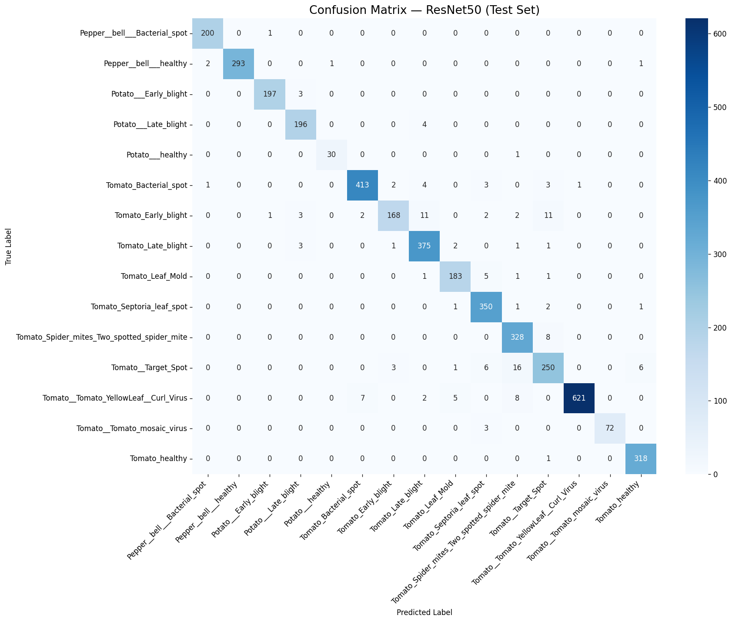
Figure 4.1. Confusion matrix for ResNet50 on the test set.
The confusion matrix in Figure 4.1 shows that ResNet50's errors were concentrated among a small group of visually similar tomato diseases rather than spread across unrelated classes. The most frequent confusion was 16 Tomato Target Spot leaves predicted as Tomato Spider mites, followed by Tomato Early blight being confused with both Tomato Target Spot (11 cases) and Tomato Late blight (11 cases). A smaller amount of confusion also occurred between Tomato Yellow Leaf Curl Virus and Tomato Spider mites (8 cases) and Tomato Bacterial spot (7 cases). The pepper and potato classes, by contrast, showed almost no cross-class confusion, with most of their errors, where present, occurring only between the two potato blight classes.

4.3 Results of EfficientNetB0
Following the same evaluation protocol, EfficientNetB0 was assessed on the identical held-out test set. It reached a test accuracy of 95.97%, with macro-averaged precision, recall, and F1-score of 95.80%, 95.74%, and 95.67% respectively — slightly below ResNet50 across all four headline metrics, but within one percentage point.
Class | Precision | Recall | F1-score | Support
Pepper bell Bacterial spot | 0.980 | 0.990 | 0.985 | 201
Pepper bell healthy | 0.997 | 0.983 | 0.990 | 297
Potato Early blight | 1.000 | 0.960 | 0.980 | 200
Potato Late blight | 0.956 | 0.985 | 0.970 | 200
Potato healthy | 0.939 | 1.000 | 0.969 | 31
Tomato Bacterial spot | 0.976 | 0.967 | 0.972 | 427
Tomato Early blight | 0.959 | 0.825 | 0.887 | 200
Tomato Late blight | 0.940 | 0.990 | 0.964 | 383
Tomato Leaf Mold | 0.994 | 0.895 | 0.942 | 191
Tomato Septoria leaf spot | 0.935 | 0.975 | 0.954 | 355
Tomato Spider mites Two spotted spider mite | 0.931 | 0.929 | 0.930 | 336
Tomato Target Spot | 0.839 | 0.940 | 0.886 | 282
Tomato Tomato YellowLeaf Curl Virus | 0.995 | 0.986 | 0.991 | 643
Tomato Tomato mosaic virus | 0.937 | 0.987 | 0.961 | 75
Tomato healthy | 0.990 | 0.950 | 0.970 | 319
Macro average | 0.958 | 0.957 | 0.957 | 4140
Weighted average | 0.961 | 0.960 | 0.960 | 4140
Table 4.2. Per-class precision, recall, F1-score, and support for EfficientNetB0 on the test set.
EfficientNetB0 reached its highest F1-scores on Tomato Yellow Leaf Curl Virus (0.991), Pepper bell healthy (0.990), and Pepper bell Bacterial spot (0.985). As with ResNet50, the two weakest classes were Tomato Target Spot (F1 = 0.886) and Tomato Early blight (F1 = 0.887), though the pattern differs: EfficientNetB0's Target Spot precision was notably lower (0.839) while its recall was higher (0.940), the opposite trade-off to ResNet50 on the same class. Tomato Leaf Mold also stands out, with very high precision (0.994) but comparatively lower recall (0.895), indicating the model was conservative in predicting this class.
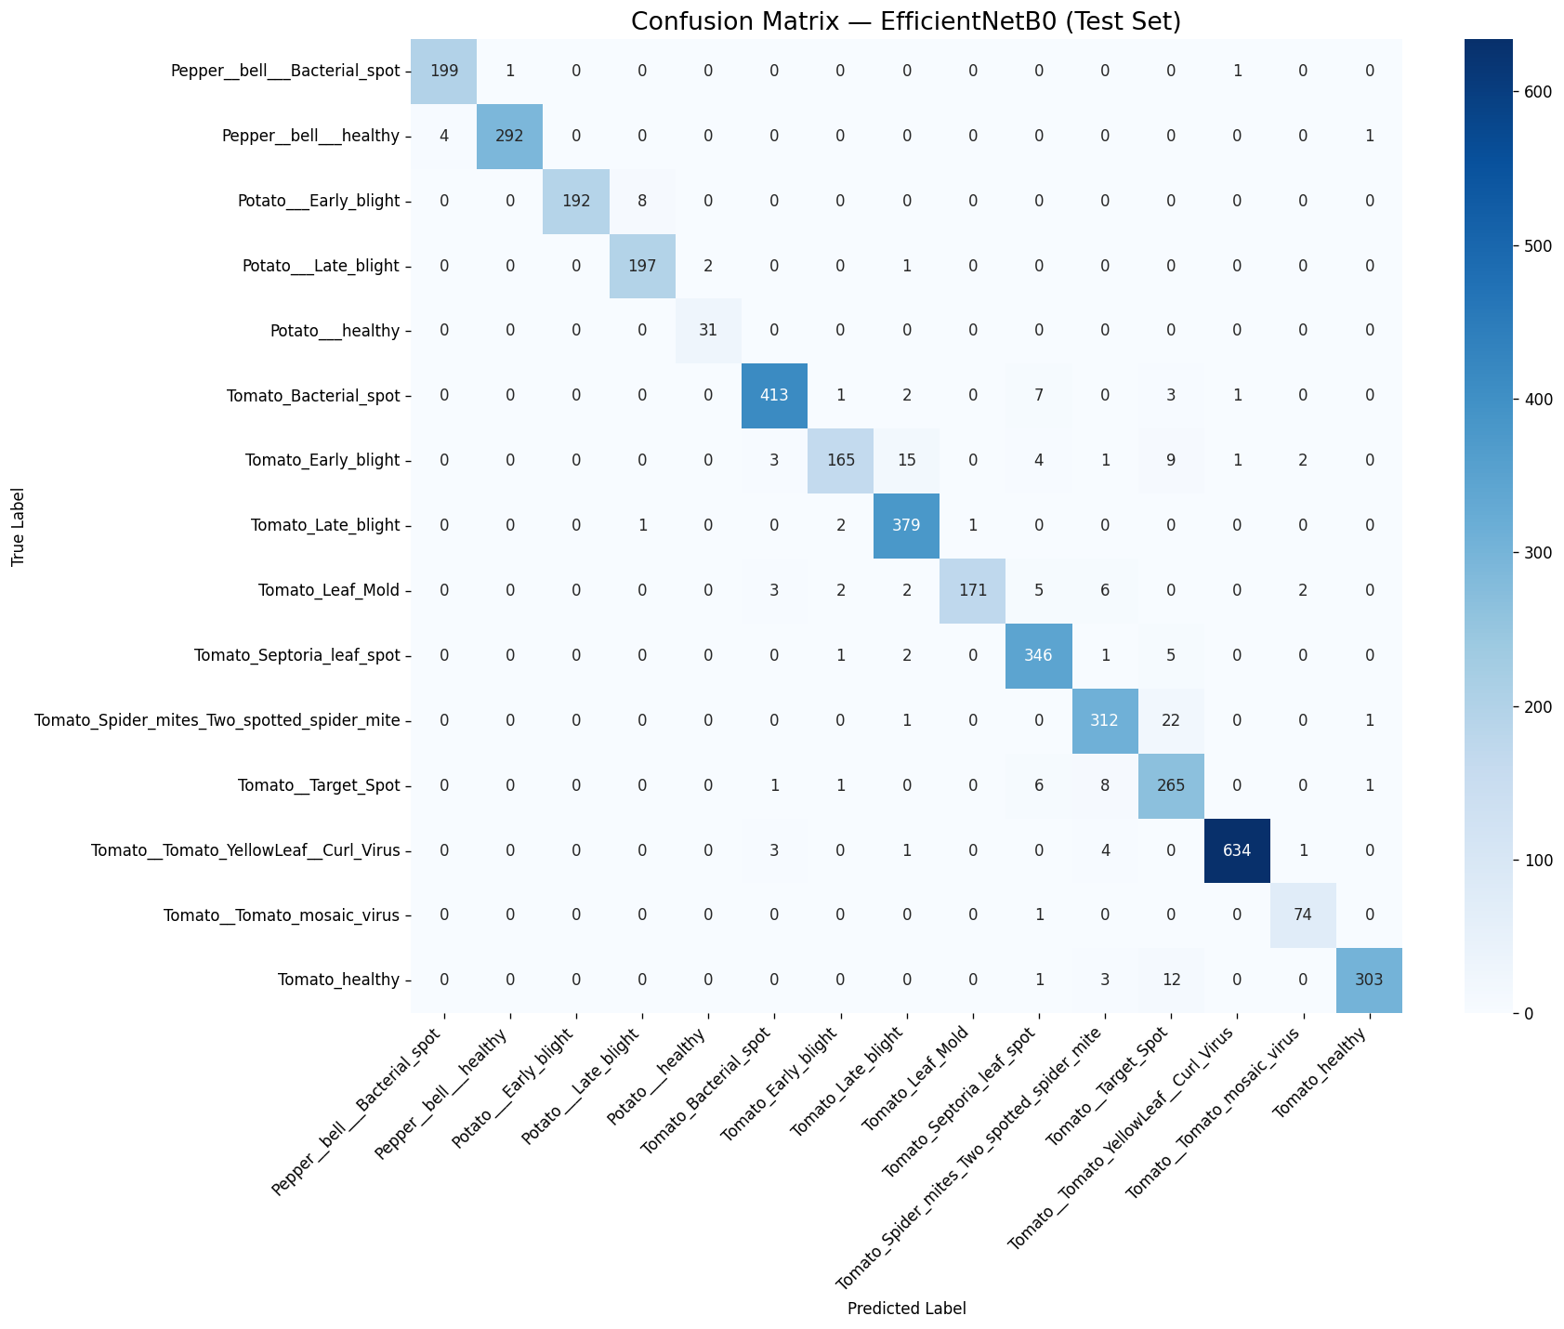
Figure 4.2. Confusion matrix for EfficientNetB0 on the test set.
Figure 4.2 shows that EfficientNetB0's largest single confusion was 22 Tomato Spider mites leaves predicted as Tomato Target Spot, followed by 15 Tomato Early blight leaves predicted as Tomato Late blight and 12 Tomato healthy leaves predicted as Tomato Target Spot. A smaller cross-confusion appeared between Potato Early blight and Potato Late blight (8 cases), a pair that remained essentially error-free for ResNet50. Overall, EfficientNetB0's confusions were concentrated in the same tomato-disease cluster (Target Spot, Spider mites, Early blight, Late blight) that also affected ResNet50, suggesting these classes share visual characteristics that both architectures find difficult to fully separate.

4.4 Results of MobileNetV2
The third and lightest backbone, MobileNetV2, was evaluated under the same protocol and produced the lowest headline metrics of the three models: a test accuracy of 92.13%, macro-averaged precision of 92.08%, macro-averaged recall of 91.75%, and macro-averaged F1-score of 91.69%, consistent with it having the smallest parameter count of the three architectures.
Class | Precision | Recall | F1-score | Support
Pepper bell Bacterial spot | 0.975 | 0.965 | 0.970 | 201
Pepper bell healthy | 0.983 | 0.987 | 0.985 | 297
Potato Early blight | 0.965 | 0.975 | 0.970 | 200
Potato Late blight | 0.969 | 0.950 | 0.960 | 200
Potato healthy | 0.968 | 0.968 | 0.968 | 31
Tomato Bacterial spot | 0.936 | 0.956 | 0.946 | 427
Tomato Early blight | 0.944 | 0.680 | 0.791 | 200
Tomato Late blight | 0.929 | 0.922 | 0.925 | 383
Tomato Leaf Mold | 0.892 | 0.911 | 0.902 | 191
Tomato Septoria leaf spot | 0.901 | 0.873 | 0.887 | 355
Tomato Spider mites Two spotted spider mite | 0.786 | 0.949 | 0.860 | 336
Tomato Target Spot | 0.801 | 0.759 | 0.780 | 282
Tomato Tomato YellowLeaf Curl Virus | 0.987 | 0.969 | 0.978 | 643
Tomato Tomato mosaic virus | 0.845 | 0.947 | 0.893 | 75
Tomato healthy | 0.930 | 0.953 | 0.941 | 319
Macro average | 0.921 | 0.918 | 0.917 | 4140
Weighted average | 0.924 | 0.921 | 0.921 | 4140
Table 4.3. Per-class precision, recall, F1-score, and support for MobileNetV2 on the test set.
MobileNetV2's strongest classes were Potato Early blight (F1 = 0.970), Tomato Yellow Leaf Curl Virus (F1 = 0.978), and Pepper bell healthy (F1 = 0.985). Its weakest class by a wide margin was Tomato Early blight, with a recall of only 0.680 and an F1-score of 0.791 — markedly lower than the corresponding recall for ResNet50 (0.840) and EfficientNetB0 (0.825) on the same class. Tomato Target Spot was again the second-weakest class (F1 = 0.780). Tomato Spider mites shows the inverse pattern, with low precision (0.786) but high recall (0.949), meaning the model over-predicted this class at the expense of other tomato diseases.
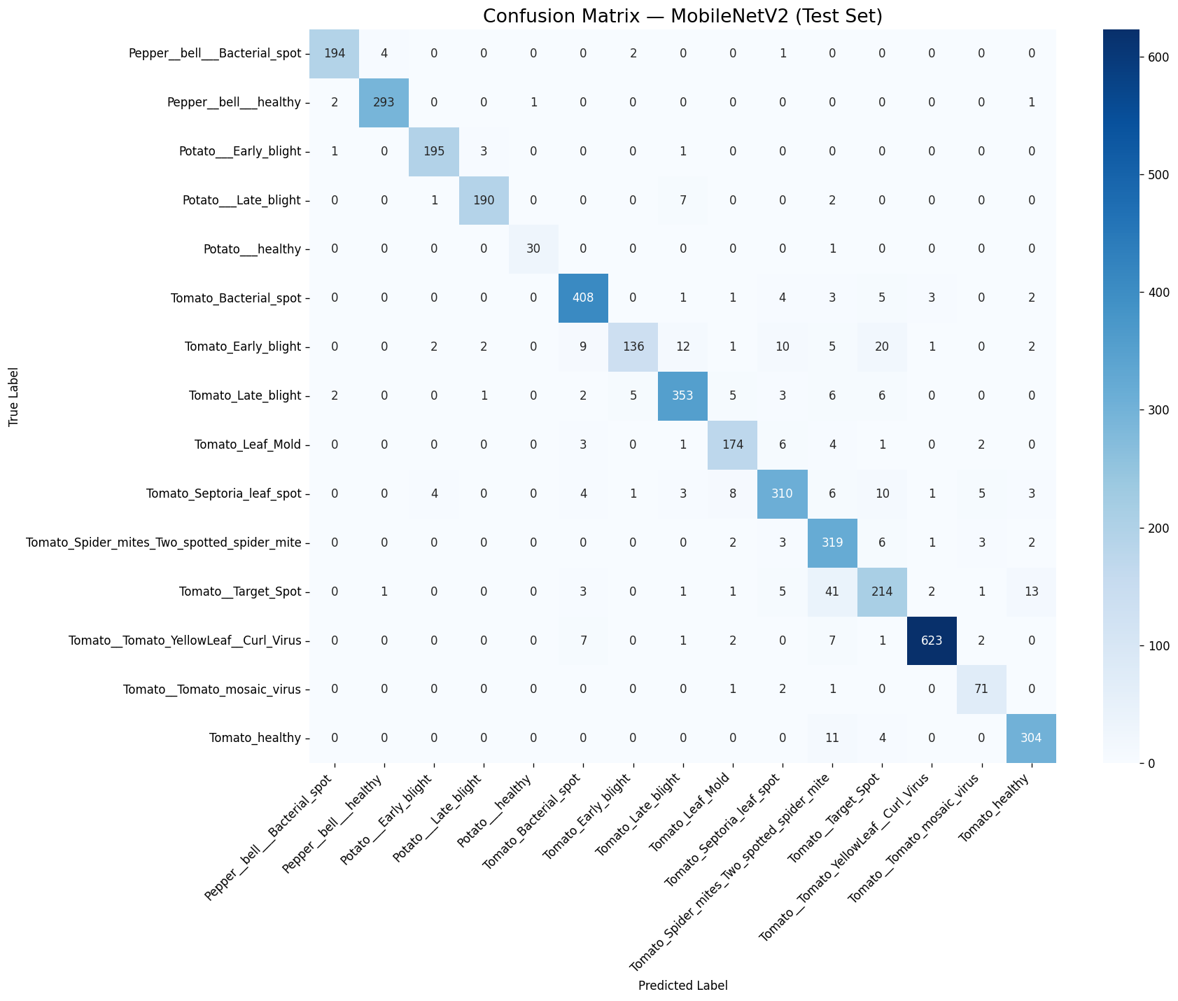
Figure 4.3. Confusion matrix for MobileNetV2 on the test set.
Figure 4.3 shows that MobileNetV2 produced substantially more cross-class confusion than the other two models, particularly within the tomato classes. The single largest error was 41 Tomato Target Spot leaves predicted as Tomato Spider mites, more than twice the equivalent confusion for EfficientNetB0 (22) and more than 2.5 times that of ResNet50 (16). Tomato Early blight was also scattered across several other classes, being confused with Tomato Target Spot (20 cases), Tomato Late blight (12 cases), Tomato Septoria leaf spot (10 cases), and Tomato Bacterial spot (9 cases). This broader spread of errors across the tomato-disease cluster, rather than a single dominant confusion pair, is consistent with MobileNetV2's comparatively lower capacity to separate visually similar tomato diseases.

4.5 Comparative Analysis
Table 4.4 summarizes the headline test-set metrics, parameter counts, and training times for all three models, ranked by accuracy.
Model | Accuracy | Precision (macro) | Recall (macro) | F1 (macro) | F1 (weighted) | Params | Train time
ResNet50 | 96.47% | 96.55% | 96.20% | 96.33% | 96.46% | 24,116,111 | 63.5 min
EfficientNetB0 | 95.97% | 95.80% | 95.74% | 95.67% | 95.97% | 4,381,362 | 66.0 min
MobileNetV2 | 92.13% | 92.08% | 91.75% | 91.69% | 92.07% | 2,589,775 | 63.2 min
Table 4.4. Comparative summary of ResNet50, EfficientNetB0, and MobileNetV2 on the held-out test set, ranked by accuracy.
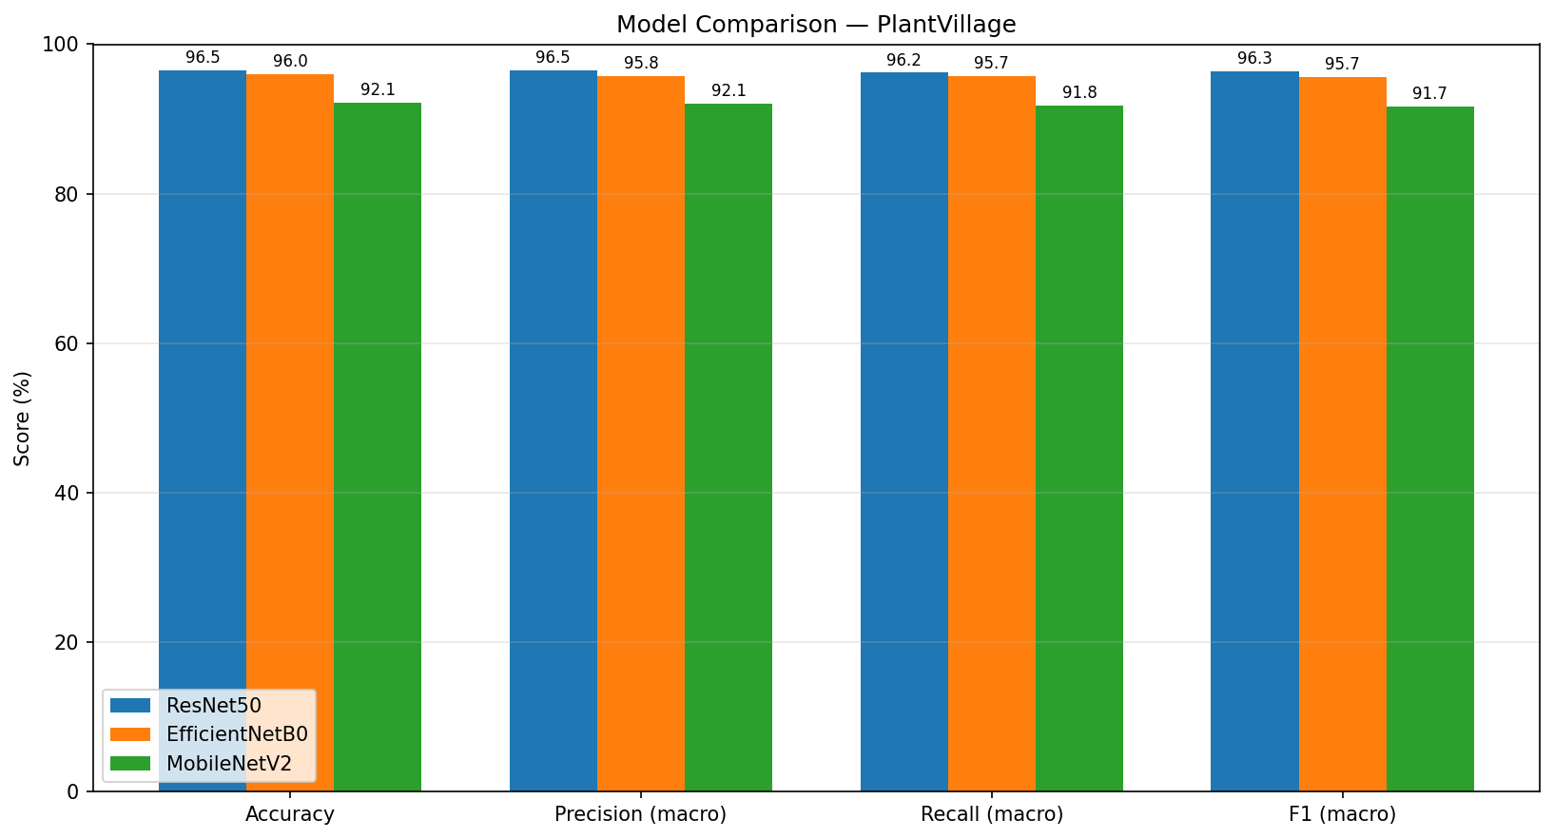
Figure 4.4. Grouped bar chart comparing accuracy, precision, recall, and F1-score (macro) across the three models.
ResNet50 achieved the best overall performance, with an accuracy of 96.47% and a macro F1-score of 96.33%, narrowly ahead of EfficientNetB0 (95.97% accuracy, 95.67% macro F1). MobileNetV2 trailed both models by a larger margin, reaching 92.13% accuracy and 91.69% macro F1.
This ranking closely tracks model capacity rather than training time. ResNet50 has 24,116,111 parameters — roughly 5.5 times more than EfficientNetB0 (4,381,362) and about 9.3 times more than MobileNetV2 (2,589,775) — yet all three models trained in a comparable amount of time (63.5, 66.0, and 63.2 minutes respectively), since only the lightweight classification head was trained in every case while each convolutional base remained frozen. EfficientNetB0 therefore offers the strongest accuracy-to-size trade-off of the three: it comes within half a percentage point of ResNet50's accuracy while using less than one-fifth of its parameters, making it an attractive candidate where deployment on resource-constrained hardware is a priority. MobileNetV2, despite having the lowest accuracy, remains the lightest model by a further margin and may still be preferable when memory and inference-speed constraints dominate over the last few points of accuracy.
A consistent pattern also emerges across all three confusion matrices: the same cluster of tomato diseases — Target Spot, Spider mites, Early blight, and Late blight — accounts for the majority of misclassifications in every model, with Tomato Target Spot and Tomato Early blight ranking among the two lowest-F1 classes for all three architectures. This is consistent with the underlying plant pathology rather than a weakness specific to any one architecture: Target Spot, Early blight, Late blight, and Septoria leaf spot are all necrotic-lesion diseases that produce visually similar brown-to-dark, roughly circular spotting on the leaf surface, and Spider mite damage can produce comparable leaf discoloration and stippling at the resolution of the PlantVillage images. Since even the highest-capacity model in this comparison (ResNet50) was unable to fully resolve this confusion, the bottleneck appears to lie in the visual similarity between these categories themselves rather than in model capacity.

4.6 Summary
This chapter reported the test-set performance of ResNet50, EfficientNetB0, and MobileNetV2 under the identical protocol described in Chapter 3. ResNet50 achieved the best overall accuracy and F1-score, followed closely by EfficientNetB0, with MobileNetV2 trailing both. All three models struggled with the same subset of visually similar tomato diseases, most notably Target Spot and Early blight, indicating a shared, dataset-level source of difficulty rather than an architecture-specific weakness. These findings support EfficientNetB0 as a favorable accuracy-efficiency trade-off among the three backbones evaluated, while ResNet50 remains the top choice when accuracy is the primary objective and computational cost is a secondary concern.

Ref | Best Model | Dataset Source & Link | Result
Too et al., 2019  [7] | DenseNet (Fine-tuned) | PlantVillage Dataset – Kaggle: https://www.kaggle.com/datasets/emmarex/plantdisease | ~99.7% accuracy
Chen et al., 2022  [8] | Vision Transformer (ViT-B/16) | PlantDoc: https://www.kaggle.com/datasets/abdulhasibuddin/plant-doc-dataset | ~99% accuracy, strong generalization in the wild
Xie et al., 2023 [9] | Dise-Efficient (EfficientNetV2-based) | PlantVillage , IP102 and mixed plant disease & pest datasets  https://www.frontiersin.org/journals/plant-science/articles/10.3389/fpls.2023.1227011/full?utm_source=chatgpt.com | 98–99% accuracy, lightweight & efficient performance
Talaat et al., 2026 [10] | CNN-based IoT-integrated system | Field-collected dataset (custom) + PlantVillage | ~97–99% accuracy, real-time detection with IoT integration
Aldakheel, E. A., Zakariah, M., & Alabdalall, A. H. (2024)  [11] | YOLOv4 | PlantVillage (Detection version) | mAP ≈ 95%, real-time multi-disease detection
Duhan et al., 2025  [12] | RTR_Lite + MobileNetV2 | Multiple datasets: PlantVillage + Mendeley Data (Soybean, Coffee, Wheat, Sugarcane) https://data.mendeley.com/ | ~98% accuracy, low latency mobile deployment
Bhola & Kumar, 2025  [13] | Lightweight CNN-based model | Vegetable Leaf Dataset (Custom Field Dataset) | ~92–93% accuracy, efficient lightweight model for early-stage disease detection
Tonmoy et al., 2025  [14] | MobilePlantViT (Hybrid CNN + ViT) | Multi-crop dataset (PlantVillage + Field images) | ~80–99% accuracy, lightweight
Castillo Ossa & Corchado, 2025  [15] | EnConv (Enhanced Convolutional Neural Network) | https://link.springer.com/article/10.1007/s41348-024-01033-6  DataSet: PlantVillage | ~98–99% accuracy, improved interpretability
Real-Time Monitoring System  [16] | CNN + Deep Learning models (VGG16,VGG19,InceptionV3,MobileNet,DenseNet121,Xception) | https://www.sciencedirect.com/science/article/pii/S2772899424000417  PlantVillage + Real-time camera dataset | ~95–97% real-time detection accuracy
Conditional Mutual Information DL  [17] | CNN + CMI Regularization | PlantVillage  (PDF) Conditional Mutual Information Constrained Deep Learning: Framework and Preliminary Results | 2–4% improvement over baseline CNN
Rajput & Doddamani, 2024  [18] | BoVW + DSIFT + SVM | Pigeon Pea Leaf Dataset (Custom) | ~92–95% accuracy
Singh et al., 2020 [19] | Faster R-CNN / SSD | PlantDoc Dataset – https://github.com/pratikkayal/PlantDoc-Dataset | Better real-world performance
Tan & Le, 2019 [20] | EfficientNet | PlantVillage – https://www.kaggle.com/datasets/emmarex/plantdisease | >99% accuracy
He et al., 2016 [21] | ResNet | ImageNet – https://www.image-net.org/ | High accuracy baseline

References
[1] S. Russell and P. Norvig, Artificial Intelligence: A Modern Approach, 4th ed. Pearson, 2021.
[2] S. Mohanty, D. Hughes, and M. Salathé, “Using deep learning for image-based plant disease detection,” Frontiers in Plant Science, vol. 7, p. 1419, 2016
[3] Y. LeCun, Y. Bengio, and G. Hinton, “Deep learning,” Nature, vol. 521, no. 7553, pp. 436–444, 2015.
[4] A. Dosovitskiy et al., “An Image is Worth 16x16 Words: Transformers for Image Recognition at Scale,” International Conference on Learning Representations (ICLR), 2021.
[5] X. Zhang et al., “A Multitask Learning-Based Vision Transformer for Plant Disease Classification,” Springer, 2024.
[6] K. Rose, S. Eldridge, and L. Chapin, “The Internet of Things: An Overview – Understanding the Issues and Challenges of a More Connected World,” Internet Society, 2015.
[7] S. Too, L. Yujian, S. Njuki, and L. Yingchun, “A comparative study of fine-tuning deep learning models for plant disease identification,” 2019.
[8] X. Chen et al., “Vision Transformer for Plant Disease Classification in the Wild: A Multimodal Approach,” 2022.
[9] X. Xie et al., “A lightweight model for efficient identification of plant diseases and pests based on deep learning,” 2023.
[10] F. M. Talaat and M. Ibrahim, “IoT-Integrated Robotic System for Automated Plant Disease Detection and Environmental Monitoring,” 2023.
[11] M. Rahman et al., “Detection and Identification of Plant Leaf Diseases Using YOLOv4,” 2024.
[12] A. Duhan et al., “RTR_Lite_MobileNetV2 for Plant Disease Detection,” 2025.
[13] R. Bhola and A. Kumar, “Deep Learning Model for Early Vegetable Disease Detection,” 2025.
[14] M. Kheir et al., “MobilePlantViT: A Mobile-Friendly Hybrid Vision Transformer for Generalized Plant Disease Image Classification,” 2025.
[15] M. Thanjaivadivel, “Enhanced CNN for Leaf Disease Classification,” 2025.
[16] “A Real-Time Monitoring System for Accurate Plant Leaves Disease Detection Using Deep Learning,” 2024.
[17] “Conditional Mutual Information Constrained Deep Learning for Classification,” 2023.
[18] S. Rajput and S. Doddamani, “Pigeon Pea Leaf Disease Classification Using BoVW and DSIFT,” 2024.
[19] D. Singh et al., “PlantDoc: A Dataset for Visual Plant Disease Detection,” 2020.
[20] M. Tan and Q. Le, “EfficientNet: Rethinking Model Scaling for Convolutional Neural Networks,” 2019.
[21] K. He et al., “Deep Residual Learning for Image Recognition,” 2016.

