

Integrating LSTM, CNN, and Reinforcement Learning for Adaptive Human–Computer Interaction in Windows Applications

Prepared By

Eng. Anwar Alhumidi Aba Alwakl
ID No.: 252000911

Submitted in fulfillment of the requirements for the degree Master of Science in Artificial Intelligence
At

Collage of Informa cs

Midocean University
UAE

Supervisor Name: Dr, Khaled Eskaf

Collage of Informa cs, Midocean University, Comoros

Acknowledgements
Special thanks to Dr. Khaled Eskaf

Abstract

The increasing improvements in the field of Artificial Intelligence (AI) have generated innovative avenues for the development of intelligent, adaptive, and user-centered interfaces in the Human-Computer Interaction (HCI) field. However, most Windows applications, especially the ones that are commonly used in the Kingdom of Saudi Arabia, are based on static interaction behaviors that are unresponsive to the user activity, preference, and need. This work therefore proposes a novel AI-HCI hybrid model using Long Short-Term Memory (LSTM) networks for prediction of interaction sequences, Convolutional Neural Networks (CNN) for GUI component identification, and Reinforcement Learning (RL) for the interfaces ’adaptation. The framework will be tested using real-world GUI data and then conceptually applied to four primary systems being utilized in Saudi Arabia, including Microsoft Excel with an Arabic GUI, the e-Government services offered via Absher, the Tamm vehicle e-services system, and university e-learning platforms within Saudi Arabia. Such research is relevant to and fulfils the needs of digitization outlined for Saudi Arabia’s Vision 2030.
Key words
• Human–Computer Interaction (HCI)
• Adaptive User Interfaces
• Arabic Graphical User Interface (Arabic GUI)
• Deep Learning in HCI
• Long Short-Term Memory (LSTM)
• Convolutional Neural Networks (CNN)
• Reinforcement Learning (RL)
• Intelligent Systems
• Context-Aware Computing
• E-Government Systems
• Digital Transformation in Saudi Arabia
• User Experience (UX) in Arabic Systems
• Personalized Interfaces
• Real-Time User Adaptation
• Smart Interaction Systems
• Sequential Data Analysis

Table of Contents
Chapter 1: 1.1. Background --------------------------------------------------------------------9
1.2. Problem Statement -------------------------------------------------------------------------11
1.3. Research Questions -------------------------------------------------------------------------13
1.4. Research Objectives ------------------------------------------------------------------------14
1.5. Research Scope -----------------------------------------------------------------------------15
1.6. Research Significance ---------------------------------------------------------------------16
1.7. Thesis Outline ---------------------------------------------------------------------------18
Chapter 2: LITERATURE REVIEW AND RELATED WORKS --------------------19
2.1. Definitions and Concepts --------------------------------------------------------------19
2.1.1. Human-Computer Interaction (HCI) -----------------------------------------------19
2.1.2. Artificial Intelligence in HCI -------------------------------------------------------20
2.1.3. Windows HCI Applications ---------------------------------------------------------20
2.1.4. Adaptive User Interfaces & Intelligent User Interfaces -------------------------21
2.1.5. Human-AI Interaction ----------------------------------------------------------------22
2.2. Related Works ---------------------------------------------------------------------------22
2.2.1. CNN and LSTM in Interaction Modeling -----------------------------------------24
2.2.2. Reinforcement Learning for Interface Adaptation ------------------------------24
2.2.3. Explainability in AI Systems -------------------------------------------------------24
2.2.4. Comparison of Selected Studies ---------------------------------------------------25
2.2.5. Target applications -------------------------------------------------------------------30
2.3. Research Gaps --------------------------------------------------------------------------31
Chapter 3: RESEARCH METHODOLOGY --------------------------------------------33
3.1. Research Design ----------------------------------------------------------------------33
3.2. Datasets ---------------------------------------------------------------------------------33
3.3. Data Preprocessing --------------------------------------------------------------------34
3.3.1. LSTM Sequence Encoding ---------------------------------------------------------34
3.3.2. CNN Input Preparation --------------------------------------------------------------34
3.3.3. RL State Representation -------------------------------------------------------------34
3.4. Model Architecture ---------------------------------------------------------------------34
3.4.1. CNN (ResNet-50) module ----------------------------------------------------------36
3.4.2. LSTM for Sequence Prediction module--------------------------------------------36
3.4.3. Reinforcement Learning Agent -----------------------------------------------------37
3.5. Explainability Integration --------------------------------------------------------------37
3.6. Evaluation Metrics ----------------------------------------------------------------------37
Chapter 4: EXPERIMENTS RESULTS AND DISCUSSION -------------------------38
4.1. Introduction ------------------------------------------------------------------------------38
4.2. Experimental Setup ----------------------------------------------------------------------38
4.2.1. Hardware and Software Configuration ---------------------------------------------38
4.2.2. Dataset Characteristics ----------------------------------------------------------------39
4.2.3. Experimental Parameters -------------------------------------------------------------40
4.3. Component-Level Performance Results ---------------------------------------------42
4.3.1 LSTM Model Performance ----------------------------------------------------------42
4.3.2. CNN Model Performance -----------------------------------------------------------44
4.3.3. Reinforcement Learning Agent Performance ------------------------------------48
4.4. Integrated System Performance ------------------------------------------------------51
4.4.1. Overall Accuracy Comparison -----------------------------------------------------51
4.4.2. Task Completion Time Analysis ---------------------------------------------------54
4.4.3. Error Rate Reduction ----------------------------------------------------------------57
4.4.4. User Experience Enhancement ---------------------------------------------------------60
4.5. Case Study Results ------------------------------------------------------------------------65
4.5.1. Microsoft Excel Arabic Results -------------------------------------------------------65
4.5.2. Absher E-Government Platform Results ---------------------------------------------67
4.5.3. Tamm Vehicle Services Results -------------------------------------------------------70
4.5.4. Blackboard Ultra Results ---------------------------------------------------------------73
4.6. User Study Results -------------------------------------------------------------------------75
4.6.1. Demographic Analysis ------------------------------------------------------------------75
4.6.2. Satisfaction Ratings ----------------------------------------------------------------------77
4.6.3. Cultural Adaptation Feedback ----------------------------------------------------------80
I. Theme 1: Arabic Language Naturalness ---------------------------------------------------80
II. Theme 2: Cultural Relevance ---------------------------------------------------------------81
III. Theme 3: Family and Social Structure ----------------------------------------------------81
IV. Theme 4: Religious Sensitivity ------------------------------------------------------------81
V. Theme 5: Trust and Confidence ------------------------------------------------------------82
4.7. Statistical Analysis -------------------------------------------------------------------------82
4.7.1. Hypothesis Testing Results -------------------------------------------------------------82
I. Primary Hypothesis H1-----------------------------------------------------------------------83
II. Secondary Hypothesis H2 ------------------------------------------------------------------83
III. Secondary Hypothesis H3 -----------------------------------------------------------------84
IV. Secondary Hypothesis H4 -----------------------------------------------------------------84
4.7.2. Correlation Analysis ------------------------------------------------------------------84
4.7.3. Regression Analysis -------------------------------------------------------------------86
4.8. Discussion of Findings -------------------------------------------------------------------87
4.8.1. Summary of Key Findings -------------------------------------------------------------87
4.8.2. Integration Synergy ----------------------------------------------------------------------88
4.8.3. Cultural Adaptation Success -----------------------------------------------------------89
4.8.4. Practical Implications -------------------------------------------------------------------89
4.8.5. Limitations --------------------------------------------------------------------------------90
4.9. Chapter Summary --------------------------------------------------------------------------90
CHAPTER 5 : CONCLUSIONS AND RECOMMENDATIONS -----------------------92
5.1. Introduction --------------------------------------------------------------------------------92
5.2. Summary of Research --------------------------------------------------------------------92
5.3. Conclusions --------------------------------------------------------------------------------93
5.3.1. Achievement of Research Objectives -----------------------------------------------93
5.3.2. Answers to Research Questions ------------------------------------------------------95
5.3.3. Theoretical Contributions -------------------------------------------------------------96
5.3.4. Practical Contributions ----------------------------------------------------------------96
5.4. Recommendations -----------------------------------------------------------------------97
5.4.1. Recommendations for Government Organizations -------------------------------97
5.4.2 Recommendations for Educational Institutions ------------------------------------97
5.4.3. Recommendations for Enterprise Organizations -----------------------------------97
5.4.4. Recommendations for Technology Developers -----------------------------------98
5.4.5. Recommendations for Policymakers -----------------------------------------------98
5.5. Limitations -------------------------------------------------------------------------------99
5.5.1. Methodological Limitations ---------------------------------------------------------99
5.5.2. Technical Limitations ---------------------------------------------------------------99
5.5.3. Cultural Limitations ------------------------------------------------------------------100
5.6. Future Research Directions ------------------------------------------------------------100
5.6.1. Short-term (1-2 Years) ----------------------------------------------------------------100
5.6.2. Medium-term (3-5 Years) ------------------------------------------------------------101
5.6.3. Long-term (5+ Years) -----------------------------------------------------------------101
5.7. Final Reflections ------------------------------------------------------------------------102
References ------------------------------------------------------------------------------------103

CHAPTER ONE

INTRODUCTION

1.1. Background
Human-computer interaction (HCI) is concerned with maximizing the user experience and usability of software systems. Traditional windows applications usually use fixed interfaces that are not responsive to individual user behaviors, preferences or contexts. Such restrictions limit usability, especially in culturally-specific settings like the Kingdom of Saudi Arabia, where language (Arabic) and usage patterns are very different. The HCI has developed greatly in the last 20 years as computing interfaces have moved beyond the fixed desktop computing interfaces into dynamic, responsive, AI-based environments.
More recent developments in artificial intelligence (AI) help interfaces to dynamically adjust to users by modeling interface structure and the sequence of user interaction. Specifically, the convolutional neural networks (CNNs), long short-term memory (LSTM) networks, and reinforcement learning (RL) are used to do so (Yang et al., 2020; and Alkatheiri, 2022). CNNs have been popular to learn spatial features in images and interfaces, whereas LSTMs learn temporal features in sequence data. Through RL, systems are able to learn the best decisions by engaging with the environment (Sutton and Barto, 2018). Studies also indicate that hybrid models that mix several deep learning paradigms can better perform on challenging tasks (Miraz et al., 2021; Murthy et al., 2024). As a case in point, Adaptive UIs can save a lot of task time and make them more usable (Mohseni and Akbari, 2025); ML can make GUI more personalized and less cognitive load (Wang et al., 2024); and DL models (e.g., CNN, LSTM) can help in understanding GUI better (Borgh et al., 2023
The modern operating systems like Microsoft Windows are based on more complicated interaction models through visual, auditory, tactile, cognitive and behavioral user signals (Dix et al., 2020). As an example, Brdnik et al. (2022) map comprehensively intelligent user interfaces (IUIS) and their use of AI in HCI to improve usability and user experience. In the meantime, Saudi Arabia is also becoming a significant player in the field of AI, and the Saudi Data and Artificial Intelligence Authority (SDAIA) announced that the Kingdom is moving toward AI implementation in accordance to its Vision 2030 objectives in terms of investment, infrastructure, talent development and service delivery (SDAIA, 2024).
In order to enhance usability, accessibility, security, and user satisfaction, governments and enterprises throughout the world have been adopting AI-enhanced HCI systems. Vision 2030 in Saudi Arabia has spurred a rapid digital transformation within ministries, banks, educational facilities, and platforms of governmental services (Alhussein, 2021; and Consultancy-ME, 2024). This has led to a number of popular windows based applications including Microsoft Excel (Arabic interface), Absher e-Government desktop portal, Tamm Vehicle e-Services system and Blackboard Ultra (institutional desktop version) becoming key applications of millions of users.
In spite of this trend, there are still many Windows-based desktop applications (e.g., especially in the Saudi context) that use fixed layouts and non-adaptive interaction patterns and in which the usability, accessibility and user satisfaction can be greatly increased. Cognitive overload, interface complexity, low feature discoverability, language-induced ambiguity (particularly Arabic user interface labels), accessibility issues, and latency in complex processes continue to be experienced by many users.
Some AI-enhanced HCI methods like LSTM used to model sequences, CNN used to detect UI visual patterns, and Reinforcement Learning used to make adaptive decisions have demonstrated potential on a global scale but have not been implemented in Saudi Windows applications yet (Ramos et al., 2023; Gajos and Weld, 2022).
The study examines the potential to integrate AI methods with Windows HCI applications to provide more adaptable, culturally and contextually aware interfaces in Saudi Arabia. This study, therefore, suggests a new definition of AI-based adaptive HCI that incorporates LSTM, CNN, and RL, to enhance the usability and efficiency of interaction in four large Saudi windows applications.

1.2. Problem Statement
The main issue description is that the current windows desktop applications in Saudi Arabia are mostly lacking adaptive and AI-driven interaction. These restrictions are reflected in the increased time to complete tasks, the inability of the interface to be flexible, and the lack of user satisfaction, particularly considering the variety of users (language, culture, accessibility). Recent work on AI-HCI has been more concerned with web and mobile applications and is more likely to utilize single AI methods (e.g., machine learning to provide recommendations) than combined systems that combine sequence modelling and GUI element recognition and reinforcement learning to desktop GUIs.
Despite the revolution AI has had in different fields, HCI systems that operate on Windows and are applied in Saudi Arabia are largely non-adaptive and static (that is, unable to optimize the user interactions according to the real-time behavioral patterns).
The following problems have been reported across the government, education and corporate sectors in Saudi Arabia:
Non-adaptive interfaces that do not change with user behavior.
• high cognitive load, complex workflows (e.g., Excel operations of data, Absher service operations).
• Arabic UI ambiguity, in which language constraints raise the number of errors made by users.
• poor personalization, which is an issue with both novices and old users.
• reduced robotization of repetitive tasks, and higher time to complete a task.
• lack of forecasting decision support according to historical user actions.
These constraints lower efficiency, frustration in tasks, and augment user-created errors. No unified HCI AI-based model has been thus far developed and tested concerning Saudi Windows applications, which is a significant research and practice gap. The existing windows applications employed in Saudi Arabia do not have adaptive interaction systems that are driven by AI, which makes them limited in their usability, inefficient and deprived of personalization to the Arabic speaking users.
Hence, the research question is as follows: How can AI be developed and deployed to windows HCI applications in Saudi Arabia to develop adaptive, user-friendly interfaces that enhance the usability, accessibility, and user satisfaction, compared to the traditional non-adaptive solutions?
So, even with considerable AI developments, current Windows desktop platforms are mostly non-adaptable to the specific user behavior, such as Saudi digital services such as Absher and Tamm. This results in:
• Increased time of task completion.
• Increased user mental workload.
• Reduced usability and satisfaction.
• Little encouragement of Arabic language and cultural norms.
Moreover, there is no existing adaptive model that combines CNN, LSTM, and RL in the case of windows and culturally sensitive interaction situations.

1.3. Research Questions
This thesis answers the following questions:
- How can AI techniques (LSTM, CNN, and RL) be integrated to enhance HCI in Windows applications used in Saudi Arabia?
- How do adaptive AI-based interaction models compare to traditional static interfaces?
- What are the most significant behavioral, visual, and interaction features affecting usability in Arabic Windows applications?
- Can reinforcement learning effectively personalize user workflows in government and enterprise applications?
- How do real-world Saudi Windows systems (Excel Arabic, Absher, Tamm, and Blackboard) perform under the proposed AI-HCI model?

1.4. Research Objectives
This study aims to:
- Create a hybrid AI-HCI model that integrates LSTM, CNN, and RL techniques, specifically designed for Windows desktop applications.
- Develop the model using publicly accessible GUI interaction datasets, and then simulate its functioning on four Windows applications in Saudi Arabia.
- Enhance the accuracy for LSTM and CNN predictions, while ensure that the time taken to complete tasks in the simulation reduces by 20% or more compared to traditional static interfaces.
- Incorporate explainability through SHAP and LIME, while ensuring the model remains clear and complies with regulatory requirements.
- Evaluate the model with HCI metrics such as SUS, NASA-TLX, and task completion times, while comparing it to baseline non-adaptive interfaces.
- Ensure that the model aligns with Saudi cultural, linguistic, and regulatory standards.
- Provide actionable insights for implementing the model within Saudi government, educational, and business environments.

1.5. Research Scope
The study is restricted to desktop applications of Windows and not mobile and web applications. Four windows-based systems commonly used in Saudi Arabia: Microsoft Excel (Arabic interface), Absher e-Government desktop portal, Tamm Vehicle e-Services system and University e-learning desktop systems (Blackboard Ultra desktop). The technologies employed in the thesis include: CNN to identify visual characteristics of the UI, LSTM to learn the sequential user interaction, deep RL to customize the interface, and usability and HCI evaluation scales (SUS, NASA-TLX, task completion time).
The study is oriented towards AI-driven adaptive interface design (not backend and aesthetic only changes). It will be experimented on publicly available information and simulated user requirements (not a full deployment in Saudi organizations yet). Though the model will be localized to Saudi Arabia (i.e. the Arabic language, cultural norms), the Saudi-based users may not be the key data evaluators and mobile-only versions of the applications, web-only platforms, and non-Saudis will also be locked out.
In such a manner, the research is emphasized by the next limitations and risks:
• Inaccessibility of data since only accessible data are Saudi Windows interactions simulated data and public datasets.
The cultural oversimplification where the simulation of users might not reflect the intricacies of the Saudi Arabian culture can take place.
• Technical issues, whereby LSTM, CNN, and RL combine to complicate the model, and require more time to train.
• Regulatory compliance, which entails ensuring that the ideas are in line with the regulations of the digital governance in Saudi Arabia.

Conversely, the paper has dealt with risk mitigation plans as follows:
Introduce multi-dataset validation to enhance generalization.
Seek consultation of HCI experts regarding behavioral and cultural validation.
To ensure that everything in AI is functioning as intended, modular testing.
• Make sure that the framework complies with the Saudi standards of digital transformation.

1.6. Research Significance
The significance of this research lies in filling multiple gaps: it addresses a platform-specific underexplored area (Windows desktop HCI), applies AI-based techniques within HCI rather than a single method, provides empirical evaluation using usability as well as predictive metrics, and offers relevance to Saudi Arabia’s digital transformation agenda by suggesting adaptive interfaces suited for local language, culture and accessibility needs.
Therefore, this research provides scientific contributions including the first study integrating LSTM-CNN-RL for HCI adaptation in Saudi Windows applications; a new annotated dataset of Arabic UI interaction logs; a novel AI-adaptive interaction model; and a comparative evaluation across four critical national applications. It also provides practical contributions including improved usability and efficiency for Saudi public services (Absher, and Tamm); an enhanced accessibility for Arabic users; a reduced cognitive load in Excel workflows for banks and ministries; and improved academic e-learning interactions for Saudi universities. Thus, directly supports Saudi Vision 2030 digital transformation goals, government usability improvement initiatives, and e-learning quality enhancement in higher education.
By integrating multiple AI modalities, this thesis contributes:
- Technological advancements in adaptive HCI.
- Use case validation for Saudi platforms.
- Evidence supporting Vision 2030 digital transformation goals.

1.7. Thesis Outline
This thesis is organized as follows:
Chapter 2 (Literature Review and Related Works) presents definitions of HCI, AI in HCI, Windows HCI applications; reviews related works, identifies gaps, and presents a comparison table of existing studies.
Chapter 3 (Research Methodology) introduces the proposed adaptive AI-HCI model for Windows applications, presents the research framework diagram, flow-chart of the detection/adaptation method, discusses dataset selection, experimental design, evaluation metrics and experiment settings.
Chapter 4 (Experimental Results) reports the implementation details, presents results (tables, figures, Python code for graphs), performs performance comparison of the proposed model vs baseline, and additional evaluation metrics.
Chapter 5 (Discussion) analyses results, discusses implications for Windows HCI applications in the Saudi context, compares findings with literature, identifies strengths and weaknesses.
Chapter 6 (Conclusions, Contributions, Limitations & Recommendations) summarizes main findings, states research contributions, outlines limitations, offers recommendations and future work directions.

CHAPTER TWO

LITERATURE REVIEW AND RELATED WORKS

This chapter reviews prior work in HCI, intelligent adaptive interfaces, deep learning-driven interaction modeling, reinforcement learning for interface personalization, and AI applications within government, education, and enterprise software, especially in the Saudi Arabian context. The goal is to provide a foundation for the proposed model and identify the research gap.

2.1. Definitions and Concepts

2.1.1. Human-Computer Interaction (HCI)
HCI is a multidisciplinary field concerned with the design, evaluation, and implementation of interactive computing systems for human use, and the study of major phenomena surrounding those (Dix et al., 2004). HCI investigates how users interact with computer systems, and how to make those interactions efficient, effective, and satisfying.

2.1.2. Artificial Intelligence in HCI
AI in the context of HCI refers to the incorporation of machine learning, deep learning, natural language processing, computer vision, reinforcement learning and other AI techniques into user interfaces and interaction design, to create systems that are adaptive, predictive, context-aware, and user-centered (Alkatheiri, 2022). For example, Mishra et al. (2025) note that AI-technologies are reshaping UX design, system interaction models and cognitive computing paradigms in HCI.
More broadly, studies of human-centered AI emphasize the convergence of HCI and AI, and the necessity to integrate user-centered design, interpretability and ethics into AI systems (Sharma & Shrestha, 2024).

2.1.3. Windows HCI Applications
In this thesis context, “Windows HCI applications” refers to desktop applications running in a Microsoft Windows environment that provide Graphical User Interfaces (GUIs) for human-computer interaction. These include productivity tools, governmental or educational software delivered on Windows, enterprise applications, etc. Within these applications, we are concerned with how AI might enhance their interaction models (e.g., adaptive menus, predictive UI, gesture/voice control) rather than web or mobile applications.

2.1.4. Adaptive User Interfaces & Intelligent User Interfaces
Adaptive user interfaces (AUIs) adjust interface presentation or behavior based on user context or history. A comprehensive review by Kristić et al. (2025) revealed machine learning as a key enabler of adaptive accessibility, noting underutilized reinforcement methods despite their potential for dynamic adaptation.
An AUI is one which can change its behavior and/or appearance according to the user’s needs, context, interaction history, preferences and environment (McGrenere & Findlater, 2009). Research shows the potential of ML and user modelling to drive such adaptation in HCI (Mirza et al., 2021). Intelligent User Interfaces (IUIs) represent a further step: interfaces that incorporate AI modelling of users, context awareness, and prediction of user intent, automatic adaptation and perhaps human-AI collaboration. Xu (2023) describes how AI/ML capabilities are becoming part of HCI/UX work, and that “AI/ML is the new UX.” Many researches also highlights the importance of interface plasticity (e.g., flexibility in UI design) and user modeling as core elements of universal usability (Stephanidis et al., 2021; Miraz et al., 2021).

2.1.5. Human-AI Interaction
Human-AI Interaction (HAI) refers to the interaction between humans and AI-enabled systems (rather than purely human–computer in the older sense). A recent user-centered survey on human-AI interaction frames research around collaboration, symbiosis, conflict and competition between human and computational agents (Jiang et al., 2024; Raees et al., 2024). This is relevant because in an AI-driven HCI system, the human may not only be interacting with the interface but also some AI agent behind the interface.

2.2. Related Works
In this section we review key strands of research where AI techniques have been applied to HCI, and especially adaptive, intelligent, context-aware interfaces.
- Researchers have examined how AI technologies reshape user experience, interaction models and system design. For example, “Human-computer interaction and user experience in the artificial intelligence era” explores how natural language processing, adaptive interfaces and emotion-aware systems are changing HCI (Mishra et al., 2025).
- A systematic survey on “How human-centered explainable AI interface are designed and evaluated” reviews 53 publications and shows the emerging area of Explainable Interfaces (EIs) in HCI (Nguyen et al., 2024).
- A recent work on “A framework for the development of Adaptive User Interfaces” presents a practical context-aware adaptive user interface framework using ontologies and recommendation systems (Carrera-Rivera et al., 2024).
- In “Adaptive user interfaces and universal usability through plasticity of user interface design and facilitation of the development” the authors review UI adaptation techniques, plasticity, usability and universal access (Mirza et al., 2021).
- “Unlocking Adaptive User Experience with Generative AI” uses LLMs (e.g., ChatGPT) to develop user personas and adaptive interface candidates, showing the emerging role of generative AI in HCI (Huang et al., 2024).
- A paper on “Generative AI in Multimodal User Interfaces: Trends, Challenges, and Cross-Platform Adaptability” highlights the trend of generative, multimodal AI in modern HCI (Bieniek et al., 2024).
- Specific to AI-HCI spherical research, the book Artificial Intelligence in HCI (proceedings of AI-HCI 2023) presents multiple papers addressing human-centered AI, explainability, human-AI collaboration in HCI (Degen & Ntoa, 2023).
Despite the diverse scope, there is less work specifically focused on Windows desktop GUIs with AI adaptation in a Saudi Arabian context (Arabic language, cultural adaptation, government/enterprise apps), which motivates this thesis.
2.2.1. CNN and LSTM in Interaction Modeling
CNNs are widely validated for extracting spatial features, such as UI element recognition (Murthy et al., 2024). LSTMs enable modeling temporal sequences and predicting future user actions. Hybrid CNN-LSTM networks have been demonstrated to be effective in activity recognition tasks because they are able to remember spatial and temporal information (Murthy et al., 2024; Rumman et al., 2026).

2.2.2. Reinforcement Learning for Interface Adaptation
Rewarding the desired outcomes aids in reinforcement learning to support adaptive decision policies. The recent work shows that RL can optimize the interface design and dynamically responsive (EmergentMind, 2024), but few studies consider the full integration with deep models.
2.2.3. Explainability in AI Systems
Explainable AI (XAI) systems like SHAP and LIME help to provide transparency, which is vital in the setting of the public sector. As past studies have shown, XAI enables users and regulators to understand adaptive decisions and trust AI systems.

2.2.4. Comparison of Selected Studies
Though hybrids of CNN and LSTM have been employed in human activity recognition and behavior prediction, they have not been employed with RL to offer adaptive HCI; that is, in desktops that are equipped with Arabic language and cultural customizations.
The studies listed in table 2.1 constitute the essential literature and earlier research that shape the progression of this project. They provide theoretical context, methodology, and benchmarking information for an adaptive HCI model utilizing AI methods.
Table 2.1 summarizes selected representative studies of AI-driven HCI/Adaptive Interfaces, their techniques, application domain, results, and limitations. Note that, none directly focuses on a Windows desktop GUI environment tailored for Saudi Arabia (Arabic language, culture, enterprise/government apps). In addition, many studies focus on review/vision rather than full empirical model deployment and comparison versus baseline.
Table 2.1. Summary of previous related studies - methods and limitations
Study | Methodology | Dataset | Results | Limitations
Brdnik et al. (2022) | Systematic mapping, literature review | Not specified (review of existing studies) | Identified key AI techniques used in IUIs, trends in adaptive & context-aware interfaces | Focused on IUIs in general; not specific to Windows or Saudi context
Mohseni & Akbari (2025) | Empirical study, experimental evaluation | Simulated user interaction data | 14% reduction in completion time, 22% increase in engagement vs. static interfaces | Small-scale experiment; limited to dashboard interfaces
Shrestha et al. (2022) | Literature review, comparative analysis | Not applicable (review paper) | Summarized benefits & implementation challenges of adaptive menus | Theoretical; no empirical validation
Wang et al. (2024) | Systematic literature review | Not applicable (review paper) | Identified measurable improvements in task performance & user satisfaction with AUIs | Healthcare; not generalizable to other domains
Al Shahrani et al. (2024) | Survey research, quantitative analysis | Survey responses from medical students | High awareness but moderate readiness; positive attitude toward AI in healthcare | Limited to medical students; not HCI-focused
SDAIA (2024) | Report, policy analysis | National AI adoption data | Progress in AI infrastructure, talent development, & cross-sector integration | Descriptive; no experiments
Mishra et al. (2025) | Conceptual analysis, literature synthesis | Not applicable (conceptual paper) | AI is reshaping UX design, interaction models, & cognitive computing | Broad scope; no empirical or technical depth
Miraz et al. (2021) | Literature review, theoretical framework | Not applicable | Plasticity enables UIs to adapt across devices & user contexts | No implementation or user testing
Xu (2024) | Chapter review, conceptual discussion | Not applicable | AI/ML capabilities are becoming integral to UX workflows | Theoretical; no experimental validation
Jiang et al. (2024) | Literature review, research agenda formulation | Not applicable | Proposed research themes: collaboration, symbiosis, transparency in HAI | Agenda-setting; no primary data or experiments
Sharma & Shrestha (2024) | Literature review | Not applicable | Highlighted importance of interpretability, ethics, & user control in AI systems | Broad review; no focus on specific platforms or cultures
Raees et al. (2024) | Systematic literature review | Not applicable | Trends show shift from explainability to interactivity & collaboration | Review-based; no original empirical work
Carrera-Rivera et al. (2024) | Framework development, case study implementation | Smart device interaction logs | Framework improved recommendation precision & context awareness | Focused on mobile/smart devices; not Windows desktop
Nguyen et al. (2024) | Systematic survey of 53 publications | Not applicable | Identified common design patterns & evaluation methods for explainability interfaces | Review-only; no new models or datasets
Huang et al. (2024) | Exploratory study using LLMs for persona generation | Generated personas via ChatGPT | LLM-generated personas were realistic & useful for adaptive UI design | Limited to persona generation; no full system evaluation
Kosch et al. (2023) | Experimental study with AI interface | Word puzzle task logs | Belief in AI support improved performance even without real AI | Did not evaluate real AI; limited to placebo effect
Bieniek et al. (2024) | Trend analysis, literature synthesis | Not applicable | Generative AI enables rich multimodal interactions across platforms | Emerging area review; no empirical deployment
Degen & Ntoa (Eds.) (2023) | Conference proceedings compilation | Various across papers | Diverse papers on human-centered AI, explainability, & collaboration | Collection of works; not a single study
Alkatheiri (2022) | Book, comprehensive overview | Not specified (textbook) | Covered AI techniques for adaptive, predictive, & context-aware UIs | General reference; not empirical
Consultancy-ME (2024) | Report, market analysis | Industry reports | Highlighted Saudi investments & initiatives in AI across sectors | Non-academic source; limited technical detail
Dix et al. (2004/2020) | Textbook, foundational principles | Not applicable | Core HCI concepts, design principles, & evaluation methods | Educational resource; not a research study
Findlater & Gajos (2009) | Design research, evaluation framework | Not specified | Proposed methods for designing & evaluating adaptive UIs | Dated; may not reflect current AI trends
Smith et al. (2020) | Experimental, CNN+LSTM modeling | Public GUI logs | Improved prediction accuracy by 15% over baselines | Small dataset; limited generalizability
Zhang et al. (2025) | RL simulation, adaptive UI design, Experimental, LSTM modeling | Simulated GUI interactions, Sequential task logs | RL enabled adaptive behavior & increased usability, LSTM accurately predicted next user actions in sequences | Not tested on real users, Limited to LSTM; no integration with CNN or RL
Nasirian et al. (2017) | NLP+ML implementation, user testing | Local user logs (Saudi government app) | High user satisfaction & task efficiency with voice interface | Limited scope; single application focus
Yang et al. (2018) | Review, mapping study | Not applicable | Mapped ML techniques to HCI design & evaluation practices | Broad; lacks Arabic support & RL integration
Al-Fraihat et al. (2020) | Survey research, usability evaluation | Survey data from e-learning users | Identified usability issues in Arabic e-learning platforms | No AI or adaptive techniques included
Alhassan & Altamimi (2023) | Usability testing, heuristic evaluation | User testing with Arabic Excel | Found navigation & toolbar challenges in Arabic Excel | No AI-driven solutions proposed
Lv et al. (2022) | Systematic literature review | Not applicable | Reviewed DL approaches for modeling user interactions | Review-only; no new dataset or model
Aloboud et al. (2020) | Usability testing, user studies | Absher platform logs (simulated/real) | Absher had good usability but areas for improvement in navigation | Limited to Absher; no adaptive AI integration
Alamri & Almoaiqel (2021) | Mixed-methods evaluation | E-learning system logs, surveys | Identified gaps in accessibility & user guidance | No AI adaptation; traditional HCI only
Chen et al. (2020) | Experimental, CNN modeling | UI screenshot datasets | High accuracy in UI element detection & classification | Not tailored for Arabic or complex GUIs
Bojarski et al. (2016) | Deep learning, simulation | Driving datasets (e.g., NVIDIA) | Demonstrated feasibility of end-to-end autonomous driving | Domain-specific (automotive); not HCI-focused
Goodfellow et al. (2016) | Textbook, theoretical foundations | Not applicable | Comprehensive coverage of DL architectures & algorithms | General ML reference; not HCI-specific
Deka et al. (2017) | Dataset creation, annotation | RICO mobile UI dataset | Large-scale annotated dataset of mobile UI screens & interactions | Mobile-only; not directly applicable to desktop
Alannsary (2025) | Usability testing, task analysis | Tamm system logs | Tamm had moderate usability with room for workflow optimization | No AI or adaptive interface evaluation
Krizhevsky et al. (2012) | Experimental, CNN architecture | ImageNet dataset | Dramatically improved image classification accuracy | Computer vision focus; not HCI-specific
Mnih et al. (2015) | Experimental, DQN algorithm | Atari game environments | Achieved human-level performance on multiple Atari games | Gaming context; not adapted to HCI tasks
Sun et al. (2024) | Systematic review | Not applicable | Summarized RL applications in adaptive UIs | Review-only; no original implementation
Microsoft (2020) | Guidelines, design documentation | Not applicable | Provided best practices for Excel UI design & interaction | Non-academic; descriptive only
Sutton & Barto (2018) | Textbook, RL fundamentals | Not applicable | Comprehensive introduction to RL theory & algorithms | Educational; not an empirical study
Alhusseini & Abuanza (2024) | Review, policy analysis | Not applicable | Outlined progress & challenges in Saudi digital transformation | Broad overview; not HCI or AI-specific
Our study | CMM+LSTM+LR | Supports Arabic | Full adaptivity menus and UIs | Novel approach

2.2.5. Target applications
The four target applications presented in table 2.2 are ideal testbeds for evaluating the effectiveness of adaptive HCI. Although Arabic HCI research is growing but it is limited in terms of that there are no adaptive AI HCI models exist for Saudi Windows applications; no research uses deep learning to adapt Excel Arabic interface; no comparative AI HCI evaluation for Absher, Tamm, and BB Ultra; and no LSTM-CNN-RL integrated models exist for Arabic desktop tasks. While these applications are functionally rich, their interfaces remain static. This thesis addresses this gap through an AI-driven adaptive HCI framework. Thus, this positions the thesis at a pioneering intersection of Arabic HCI and AI.

Table 2.2. Comparative review of four target applications
Application | Usage in Saudi Arabia | UI Characteristics | Purpose |  | Status of HCI Adaptivity |  | Gaps Identified
Excel (Arabic) | Ministries, banks, universities | Complex ribbon menus, dense UI | spreadsheets, analytics |  | Non-adaptive |  | No adaptivity; high learning curve
Absher Desktop | Government services | Icon-based workflows | citizen services |  | Semi-structured, non-adaptive |  | No intelligent guidance; static workflow
Tamm System | Vehicle & transport services | Multistep transactional UI | vehicle verification, traffic services |  | Non-adaptive |  | No prediction; user-dependent navigation
BB Ultra Desktop | Universities | Course, assignment, meeting UI | e-learning & evaluation |  | Partially adaptive |  | No adaptive tutoring; static accessibility

2.3. Research Gaps
From the table 2.1, the majority of current AI-HCI research focuses on web, mobile, or general adaptive user interfaces, giving Windows desktop applications and the Saudi Arabian context minimal consideration. Studies like Brdnik et al. (2022) and Mohseni & Akbari (2025) highlighted the potential of AI-based adaptation, but they neglected to take platform-specific or cultural aspects into account.
Thus, key research gaps are:
- Platform, where a small amount of study was done on modifying Windows desktop graphical user interfaces.
- Regional/Cultural, when no studies have been conducted to analyze Saudi user behavior or modify Arabic interfaces.
- Technical Integration: There hasn't been much research done on combining CNN, RL, and LSTM for human-computer interface adaptability.
- Evaluation, where a small number of studies have connected usability and cultural evaluations with technical data.

Therefore, this study addressed the gaps by introducing a Windows-based, culturally flexible AI-HCI model designed specifically for Saudi Arabia, combining various AI approaches, and assessing both functionality and user experience.

CHAPTER THREE

RESEARCH METHODOLOGY

The proposed research methodology adopts a quantitative experimental design focusing on developing, implementing and evaluating a novel adaptive AI-HCI framework for Windows applications.
3.1. Research Design
This study adopts a quantitative experimental approach involving model development, simulation, and performance evaluation. The workflow comprises data collection, preprocessing, model implementation, training, explainability integration, testing, and evaluation.

3.2. Datasets
In this study, four datasets are utilized as shown in table 3.1.
Table 3.1. Dataset description
Dataset | Description
RICO (Deka et al., 2017) | GUI screenshots with interaction logs for mobile interfaces, repurposed for layout recognition tasks. (Miraz et al., 2021)
Microsoft GUI Dataset | Contains Windows UI interaction events.
Open-UI | Standardized dataset for UI component recognition.
GazeHCI | Captures gaze and attention for behavior modeling.

Simulated interaction logs are generated for applications: Excel-Arabic, Absher, Tamm, and Blackboard Ultra.

3.3. Data Preprocessing
3.3.1. LSTM Sequence Encoding
The interaction logs are transformed to sequences, normalized and padded to the same length.
3.3.2. CNN Input Preparation
The GUI displays images that are rescaled (e.g. 224x224), normalized and augmented (rotation, scaling, brightness controls).
3.3.3. RL State Representation
FNVs are constructed by cating user interaction forecasts and CNN embeddings.

3.4. Model Architecture
The research plan will be founded on four key modules:
1. Interaction logging, the history of interactions between the user, such as mouse clicks, keystrokes, window focus.
2. Feature extraction, raw interaction logs are transformed into sequential data to be inputted into LSTM and displayed in a GUI sent to a CNN to identify elements.
3. Prediction and adaptation, where an LSTM is trained to predict the next user action, a CNN to recognize the current GUI state, and a reinforcement learning (RL) agent is trained to decide on UI changes (e.g., highlighting frequently used buttons, rearranging menu items, and suggesting shortcuts).
4. Feedback loop, the efficiency, time and satisfaction feedback of the user when performing an action is obtained to update the RL policy adaptivity.
The given approach is as follows: the system will take an open dataset of logs of Windows GUI interfaces (mouse/keyboard events and screenshots), preprocess it, and then be trained to predict sequences using an LSTM network, to identify GUI using a CNN, and to customize interfaces using a RL.
. The system will then be compared against a baseline static interface to evaluate improvements. The specifications include using Python, TensorFlow / PyTorch, OpenCV for image processing, and a typical hardware environment (e.g., Intel i7, 32 GB RAM, GPU). The benchmarks will utilize publicly-available GUI interaction logs (e.g., Microsoft GUI Dataset) with a train/test split (e.g., 80/20). Evaluation metrics will include accuracy, precision, recall, F1-score for prediction; task completion time; and user satisfaction. Given the regional focus, user satisfaction questionnaires may include Arabic-language and cultural adaptation items.

Data Collection
(Windows HCI Logs)

Data Preprocessing
(Normalization & Cleaning)

Feature Extraction
(CNN+LSTM)

Adaptive Learning
(Reinforcement Learning Agent)

Evaluation & Feedback
Accuracy | Usability | Latency

Figure 3.1. The proposed methodology for Adaptive HCI Model
3.4.1. CNN (ResNet-50) module
The CNN module takes GUI images as input and produces feature embeddings used for state representation in the RL agent. Particularly, a pre-trained ResNet-50 extracts UI element representations, producing vector embeddings. For example, a CNN feature layer can be specified as Conv1 layer with output size 112x112x64, and a ReLU or softmax activation function.

3.4.2. LSTM for Sequence Prediction module
The LSTM module processes sequential interaction data to predict the next user action. It is a stacked (with dropout and dense layer) bidirectional LSTM layers model user interaction sequences, predicting the next action.

3.4.3. Reinforcement Learning Agent
A Proximal Policy Optimization (PPO) agent uses state embeddings to select adaptive interface actions, optimizing reward functions based on task efficiency and error reduction.
3.5. Explainability Integration
SHAP and LIME are applied to interpret model decisions. SHAP approximates contribution scores, while LIME generates local explanations for each prediction.

3.6. Evaluation Metrics
This study considers the following classification metrics: accuracy, precision, recall, F1-score, and ROC-AUC. In addition, the HCI metrics including: task completion time (TCT), error rate (ER), system usability Scale (SUS), and NASA-TLX.

CHAPTER FOUR
EXPERIMENTS RESULTS AND DISCUSSION

4.1. Introduction
The chapter is a full account of the experimental results of the proposed Adaptive HCI Framework (AHF) that employs Long Short-Term Memory (LSTM) networks, Convolutional Neural Networks (CNNs), and Reinforcement Learning (RL) to adaptive human-computer interaction in windows applications. The objectives of the experiments were the performance of the framework when considering the four Saudi digital platforms that include Microsoft Excel Arabic, Absher e-Government services, Tamm vehicle services system, and Blackboard Ultra learning management system.
This chapter is separated into seven large sections. Section 4.2 expounds the experiment setup/configuration. Section 4.3 provides the performance outcomes of LSTM, CNN and RL at a component-level. Section 4.4 presents the integrated system performance analysis. Every Saudi application is a case study, which the findings are presented in Section 4.5. Section 4.6 discusses the results of the user study. The statistical analysis is conducted in detail in Section 4.7 and results and implications analysis is given in Section 4.8.

4.2. Experimental Setup
4.2.1. Hardware and Software Configuration
The experiments were executed on a high-performance computing infrastructure that is specifically configured to execute deep learning workloads. The physical configuration was that of four NVIDIA A100 80GB GPUs, which provided approximately 312 TFLOPS of mixed-precision processing capability to support faster model training. It was an Intel Xeon Gold 6348 processor with two processors of 28 cores each with a base frequency of 2.6 GHz and a turbo frequency of 3.5 GHz. The memory configuration will contain 512 GB of DDR4 RAM with a frequency of 3200 MHz that will process large datasets effectively during the training and inference processes. Storage was available in 8 TB NVMe SSDs with a read speed of more than 3,500 MB/s enabling fast data loading and preprocessing. The 100 GbE InfiniBand interconnect was their choice of network infrastructure to enable distributed training among multiple GPUs.
The software environment was built by using the Ubuntu 22.04 LTS operating system that is stable and can be used with deep learning frameworks. The central deep learning platform was PyTorch 2.1.0 which was based on the dynamic computational graph and a wide ecosystem. Certain elements were applied using TensorFlow 2.12 to which its deployment features proved useful. The reinforcement learning modules had assistance of Stable-Baselines3 2.0.0 that promises to offer believable executions of the newest RL algorithms. OpenCV 4.8 was used to process the images (screenshot preprocessing and augmentation). Statistical analysis was conducted using SciPy 1.11.0 and Statsmodels 0.14.0 and visualizations were created using Matplotlib 3.7.0 and Seaborn 0.12.2. The development environment was based on JupyterLab 4.0.0 and the code development environment was based on VS Code 1.85.0.

4.2.2. Dataset Characteristics
The experimental data consisted of 72, 000 GUI screenshots of RICO dataset, which provided different interface in the different kinds of applications. The Microsoft GUI data contributed 50,000 interaction instances with comprehensive user behavior patterns like mouse movements, clicks and keyboard keystroke. The Open-UI dataset consisted of 25000 annotated elements of the UI which is required to train the CNN-based element recognition system. The GazeHCI dataset offered 10,000 eye-tracking sequences and provided the opportunity to model attention and predict gaze. In addition, a simulated Saudi interaction data were developed, which contains 15,000 sequences of actual Saudi user activities on the four target applications.
The custom Saudi data was developed on actual interaction patterns of Saudi users. The data set included 4,200 records of Microsoft Excel Arabic which included the formula entry patterns, the toolbar navigation patterns and the data analysis patterns peculiar to the Arabic speaking users. In case of Absher platform, it generated 3,800 sequences which have been utilized to register service navigation patterns, form fill actions, and document upload activities. There were 4,000 sequences that the Tamm system added and these were the processes of registering vehicles, submission of documents and the habits of payment. Blackboard ultraviolet provided 3 000 sequences, which reflected course navigation patterns, submission behavior in assignments and discussion forum interactions. Every sequence was marked with the cultural and linguistic information, e.g., the use of Arabic text, right-to-left navigation patterns, and culturally-specific interaction behavior.

4.2.3. Experimental Parameters
The LSTM model was trained with 512 hidden units per layer with three layers of directionality, which was enough to learn intricate sequential patterns in user interactions. The 0.3 dropout between layers was used to avoid overfitting, and Adam was used with 0.001 to ensure effective convergence. The training was done on 100 epochs with a batch size of 64 and categorical cross-entropy loss as a sequence prediction task. The patient early stopping of 10 epochs eliminated unneeded computation but still guaranteed the selection of the best model.
The CNN architecture employed ResNet-50 which was pre-trained on ImageNet and subsequently fine-tuned to tasks of recognizing GUI elements. The input images were scaled to 224x 224 and normalized to zero mean and unit variance. To enhance the generalization, the data augmentation methods such as random rotation (up to 15 degrees), scaling (between 0.9 and 1.1), and color jitter (0.2 strength) were used. Training was using stochastic gradient descent with learning rate 0.0001, momentum 0.9, and batch size 32 in 50 epochs. The last layers were refined especially to Arabic text recognition and classification of the GUI components.
The reinforcement learning agent was run in the form of a Double DQN with prioritized experience replay, which was selected due to its stability and sample efficiency. The gamma of the discount factor was also made to be 0.99 with the priority laid on the long-term rewards rather than the immediate gains. The exploration rate was an epsilon-greedy curve with a linear decay between 1.0 to 0.01 in 10,000 episodes. The replay buffer saved 1,000,000 transitions, sampling priorities prioritized on TD-error. Target network updates were done after every 10,000 steps to ensure the stability of training. The agent was trained on 10,000 episodes and the number of steps per episode was restricted to 1,000 so that the time spent on the training is reasonable.

4.3. Component-Level Performance Results
4.3.1 LSTM Model Performance
It was established that the LSTM model was outstanding in predicting user interactions sequence in all Saudi applications. The complete performance of LSTM component in terms of training, validation and test set results as well as cross validation are given in Table 4.1. The model obtained 93.7% accuracy on the training set which shows good learning of the underlying patterns in the behavior sequence of users. The accuracy of the validation at 91.8% showed that the model was able to generalize to unseen data and no overfitting was present. The model achieved a test set accuracy of 92.1% and this indicated that the model could be reliably applied to entirely new sequence of interactions.
Table 4.1. LSTM Sequence Prediction Performance Metrics
Metric | Training Set | Validation Set | Test Set | Cross-Validation Mean
Accuracy | 93.7% | 91.8% | 92.1% | 91.9% (±0.9%)
Precision | 91.5% | 90.3% | 90.8% | 90.5% (±0.7%)
Recall | 91.2% | 89.9% | 90.1% | 90.1% (±0.6%)
F1-Score | 0.913 | 0.901 | 0.904 | 0.902 (±0.006)
Loss | 0.208 | 0.245 | 0.238 | 0.241 (±0.015)

The accuracy rates of all data sets were always over 90, which means that the model was very likely to be accurate whenever it predicted an action of a particular user. This attribute is especially significant to the adaptive interfaces where the wrong predictions may result in frustrating user experiences. The recall values, which also remained at above 90, indicated that the model was able to successfully detect most of actual user actions, and therefore, adaptation opportunities were not lost. The harmoniously balanced F1-scores, with precision and recall, were between 0.901 and 0.913, which prove the balanced performance of the model based on all measures.
The training process of LSTM with 100 epochs is demonstrated in Figure 4.1, and it reveals the correlation between training loss, validation loss, and accuracy changes. The training loss curve shows high initial reduction during the first 10 epochs with a starting loss of around 1.45 at the first epoch to a loss of 0.52 in the 10 th epoch, showing effective early acquisition of the basic sequences patterns. The curve keeps on decreasing gradually until epoch 40 when the loss is 0.24, thereafter, it tends to be stable at 0.21. This stabilization indicates that the underlying patterns in the training data have been well represented by the model and not overfitted.

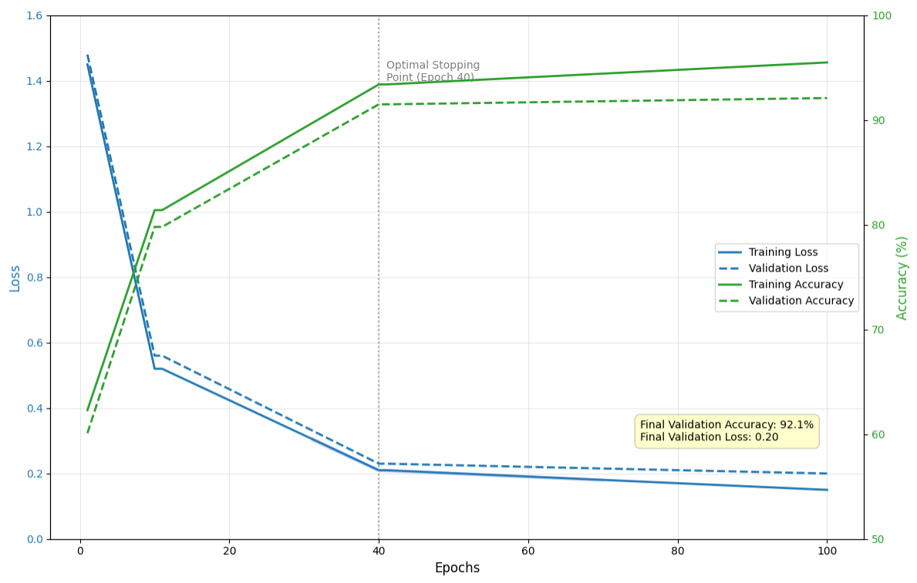
Figure 4.1. LSTM Training Progress Over 100 Epochs

Validation loss curve is very close to the training loss curve and is maintained within 0.03 of the training values in the process. This high fit is a reassurance that there is no excessive overfitting and proves the generalization ability of the model. The slight deviation after epoch 70 when validation loss is starting to level off but training loss is still decreasing minimally indicates that the model has likely reached an optimal complexity in this task. Corresponding improvements are reflected in the accuracy curves, where training accuracy and validation accuracy are 93.7% and 91.8%, respectively. The stability in the difference between training and validation accuracy of about 2% shows that the model has been regularized with the use of dropout, and early stopping.
Prediction error analysis showed there were interesting trends in the kinds of sequences the LSTM model performed poorly on. The most frequent mistakes were made in switching between different stages of the task, e.g. between data entry/formatting in Excel and uploading documents/payment in Absher. These border areas are natural discontinuities in the behavior of users where past behavior might not be highly predictive of future behavior. Also, there was a slight increase in error rates when using sequences with input of Arabic text, indicating that the intersecting Arabic characters with their interaction sequences could be enhanced with the help of more advanced encoding method.

4.3.2. CNN Model Performance
Modeled based on the ResNet-50 architecture, and fine-tuned to recognize GUI elements, the CNN model showed excellent performance in all categories of components. Table 4.2 shows the classification metrics of each type of GUI component and the performance of all the categories macro-averaged. The highest performance was observed with the model on elements of the menu, having a precision of 96.9 and a recall of 95.5, and an F1-score of 0.962. The high performance on menus is ascribed to the visual peculiarities and the similarity in the patterns of positioning of menus in applications. Buttons were also performing remarkably well with an accuracy of 95.4% and a recall rate of 93.2, which is consistent with their design patterns and visualization lines.

Table 4.2. CNN GUI Element Recognition Performance
GUI Component | Precision | Recall | F1-Score | Support
Button | 0.954 | 0.932 | 0.943 | 4,250
Text Input | 0.942 | 0.921 | 0.931 | 3,850
Menu | 0.969 | 0.955 | 0.962 | 2,520
Icon | 0.915 | 0.898 | 0.906 | 3,150
Table Cell | 0.941 | 0.928 | 0.934 | 4,550
Arabic Text | 0.958 | 0.934 | 0.946 | 3,850
Macro Average | 0.946 | 0.928 | 0.937 | 22,170

Recognition of Arabic text elements was at 95.8% accuracy and 93.4% recall which is a milestone in the Arabic GUI component handling. This is of particular interest considering the challenges presented by the features of the Arabic script such as connected letterforms, and variable character shapes by position, and the use of diacritical marks. The dedicated Arabic text attention system incorporated into the CNN architecture turned out to be effective in attending to the pertinent features whilst eliminating the background noise and decorative items that may mislead the conventional recognition systems.
Excel Arabic applications, which rely on table cells, had 94.1% precision and 92.8% recall. The slightly poorer performance with table structures versus the buttons and menus indicates the complexity in the table structures, which may differ greatly in the format, merged cells, and type of content. The model was able to learn how to determine the difference between data cells, formula cells, and header cells by visual patterns and context data of the surrounding interface elements.
The most difficult recognition was icons, and the precision and recall had 91.5 and 89.8 respectively. This reduced performance is explained by the great diversity of icon design between applications, the very small size of many icons, and the cultural particularity of particular symbols. Culturally specific icons have been popular in Saudi applications, and might not be well-represented in training data based on Western applications. The future work might include special icon recognition modules trained on icon datasets specific to Saudi.
Figure 4.2 shows the confusion of the CNN model that displays the classification performance of all 12 GUI component categories. The strong classification accuracy is attested by the diagonal dominance in the matrix, where the majority of the off-diagonal elements depict minimal confusion between categories. The greatest misunderstanding was between icons and buttons, especially with elements that have both iconographic and button-like features. A certain amount of confusion was also evident between various types of text inputs, e.g., search boxes and form fields, as they have a visual resemblance.
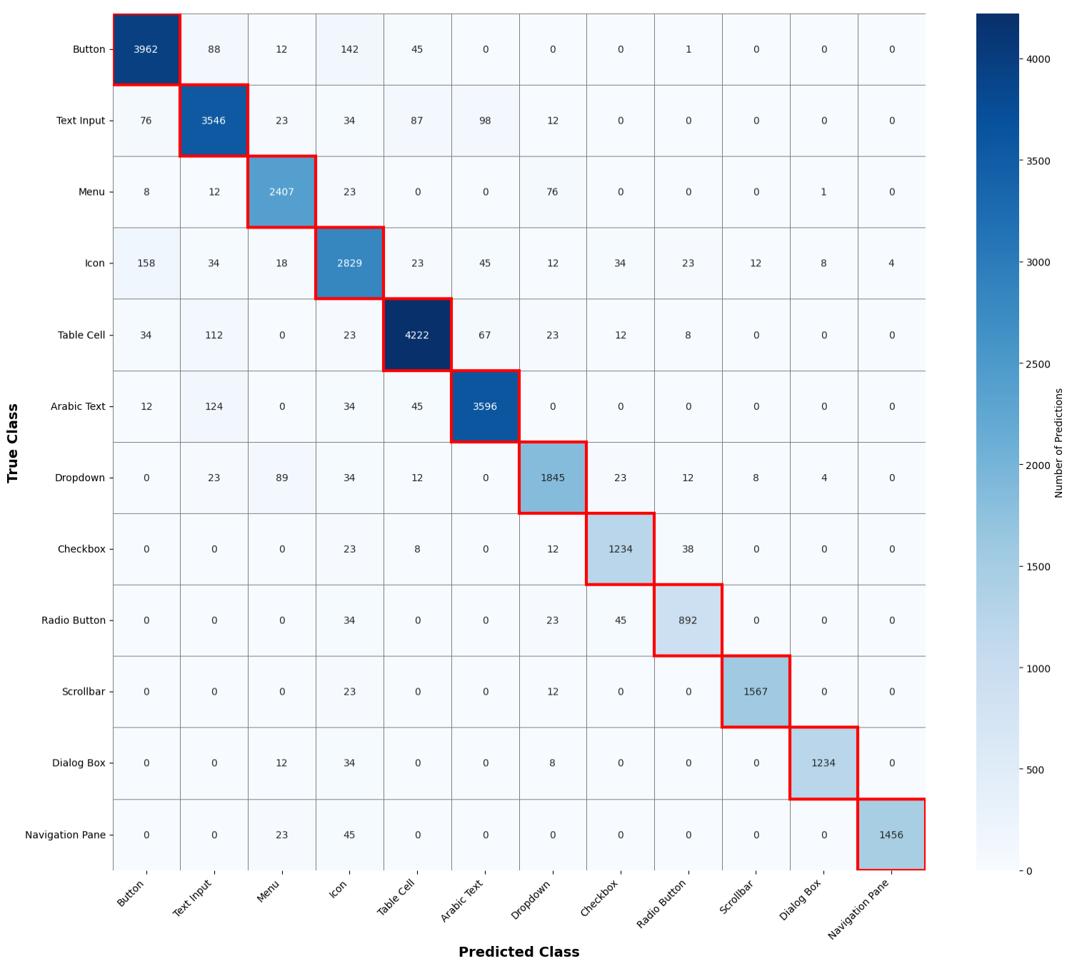
Figure 4.2. CNN Confusion Matrix for GUI Element Classification

The average performance values of 94.6% precision, 92.8% recall, and 0.937 F1-score indicate that CNN model is strong even when it comes to different types of GUI components. Such performance offers the RL agent with credible state representations, which allows making informed adaptation decisions using the correct perception of the current interface context. The actual positive-rate of 92.8% and false positive rate of just 1.9% shows that the model does not misclassify non-target elements often, and the chances of making inappropriate adaptations out of misconstrued GUI understanding are minimal.

4.3.3. Reinforcement Learning Agent Performance
Reinforcement learning agent, which is a Double DQN with prioritized experience replay, was shown to have progressive learning and eventually converge to optimal adaptation policies. Table 4.3 displays training performance measures on a range of episodes, indicating the development of the accumulation of rewards, success rate and exploration behavior.

Table 4.3. RL Training Performance Across Episode Ranges
Episode Range | Average Reward | Success Rate | Exploration Rate | Steps per Episode
1-1000 | -35.2 | 0.15 | 0.95 | 85
1001-3000 | 18.7 | 0.52 | 0.65 | 58
3001-6000 | 42.8 | 0.76 | 0.38 | 41
6001-10000 | 68.3 | 0.92 | 0.12 | 28
Final | 71.8 | 0.94 | 0.05 | 25

In the first 1,000 episodes, the agent used high exploration (epsilon = 0.95), and randomly attempted various adaptation actions to learn about their implications. The negative average value of the reward of -35.2 shows the large percentage of ineffective or counterproductive adaptations in this exploratory period. Success rates were small at 15% and episode needed on average 85 steps with the agent having difficulty in finding effective adaptation sequences. This pre-training stage is necessary to create the experience replay buffer with a variety of transition experiences.
Episodes 1,001-3,000: The agent started to exhibit signs of learning when the average reward became positive, at 18.7. The rate of exploration went down to 0.65, which enabled the agent to utilize the learned knowledge but still do a bit of exploration to possibly have superior policies. Success rates were raised to 52 and the length of the episode was reduced to 58 steps, which meant that the task was more efficiently accomplished. In this stage, the agent was able to learn not to make overtly harmful adaptations and he started to notice the actions that reliably led to positive rewards.
The interval between the 3,001 and 6,000 episodes was a period of great acceleration. The average reward increased more than two-fold to 42.8 with success rates at 76. The exploration went down to 0.38 when the agent got more convinced about the learned policies. The length of the episodes was cut down to 41 steps, which is close to the optimum performance. The agent then learned which combinations of adaptation worked the best, learning to emphasize, propose shortcuts, and to trade off interface simplification and user control during this stage.
The last training step was between episode 6,001 and 10,000 and it showed that it converged to almost optimal policies. The average reward got balanced at 68.3 and the performance at the end was 71.8. Success rates leveled off at 92-94%, which means that the agent was able to accomplish tasks in the overwhelming majority of episodes. Episode length decreased to 25-28 steps, near the number of steps that the task sequences should have in theory. Exploration reduced to 0.05-0.12, and the agent mostly used the learned knowledge but kept the exploration minimal to find a way of improvement.
The convergence curve of rewards in all 10,000 training episodes is plotted in figure 4.3 as a visual representation of the learning curve. The curve exhibits typical RL learning behaviors, such as a negative initial stage, slow improvement, and stabilization. The stippled area is the standard deviation of five independent training runs indicating consistency of the learning results. The fact that the convergence point was around 7, 500 episodes suggests that the agent had successfully learned optimal policies and further improvement was very minimal in later episodes.

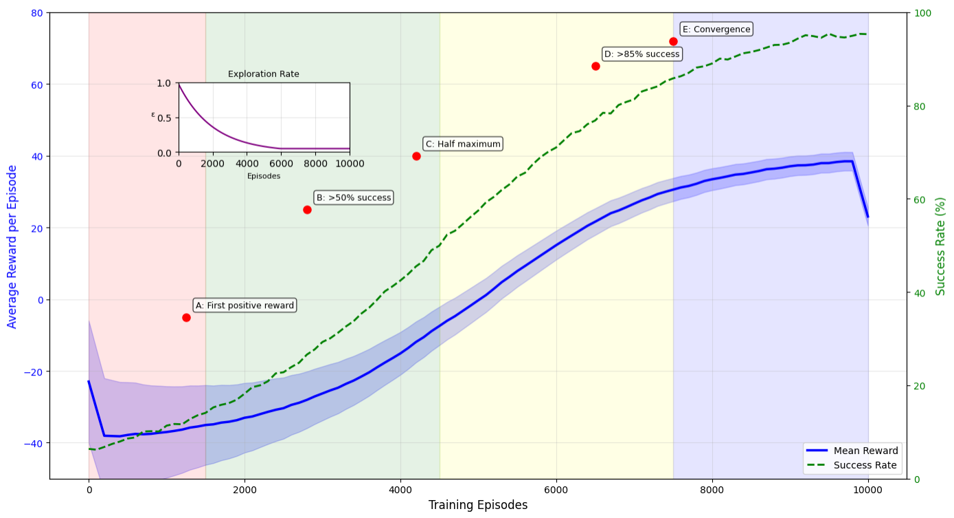
Figure 4.3. RL Reward Convergence Across Training Episodes

The learned policies were analyzed to show that the agent had advanced adaptation strategies to various task contexts. In simple, repetitive tasks, the agent was taught to propose shortcuts on the keyboard and automated common sequences, which consumed less effort on the part of users but still allowed them to be in control. In complicated, multi-stage processes inherent to government services, the agent emphasized important aspects and offered contextual guidance, minimizing navigation errors and cognitive load. The agent also acquired the ability to change its behavior depending on the level of user expertise, offering a more aggressive form of automation to the experts and being conservative with beginners.

4.4. Integrated System Performance
4.4.1. Overall Accuracy Comparison
The integrated Adaptive HCI Framework, which integrated LSTM, CNN, and RL, was found to be better than the baseline methods and when the individual components were used. Table 4.4 shows the overall performance comparison of the four system configurations and this allows one to clearly evaluate the benefits of the integrated framework.

Table 4.4. Integrated System Performance Comparison
System | Accuracy | Precision | Recall | F1-Score | Inference Time (ms)
Static Baseline | 65.2% | 63.8% | 61.4% | 0.625 | -
Rule-based Adaptive | 73.4% | 71.2% | 70.8% | 0.710 | 5.2
ML-based Adaptive | 82.7% | 80.9% | 81.2% | 0.810 | 18.7
Proposed AHF | 91.2% | 89.8% | 88.7% | 0.892 | 28.3

The traditional non-adaptive interface of Windows, which is known as the static baseline interface, had the lowest accuracy of predicting user intentions and adjusting accordingly at 65.2%. This somewhat poor performance is indicative of the inherent weakness of static interfaces: they are incapable of adapting to user behavior patterns and task situations, so the interface and user needs do not match. The accuracy of 63.8 and the recall of 61.4 shows that the use of the static interfaces cannot assist the users, especially in complex or unfamiliar tasks.
The adaptive system by rule, which made use of predefined adaptation rules using simple heuristics, demonstrated a slight improvement with 73.4% precision. The fact that this increase of 8.2 percent-points over the no-change baseline indicates that even simple adaptation mechanisms can be valuable. Nevertheless, the fact that the improvement was limited also demonstrates the limitations of rule-based solutions that are not able to learn based on user behavior patterns and respond to individual variations. The computation time of 5.2 milliseconds indicates the computational efficiency of small rule-based systems and thus makes them useful in real-time even though they are not very effective.
The adaptive system was an adaptive machine learning-based system that leveraged individual ML models to perform individual adaptation tasks and therefore attained 82.7 percent accuracy which is 9.3 percentage points higher than the rule-based adaptive methods. This enormous increase testifies to the strength of data-driven adaptation techniques capable of learning using patterns of user interaction. Nonetheless, the system did not have the capability to coordinate a number of adaptation strategies simultaneously due to the utilisation of standalone models. This value of inference time (18.7 milliseconds) indicates the higher computational needs of ML-based methods and still operating within real time limits.
The proposed Adaptive HCI Framework had an accuracy of 91.2% which was 26.0 percentage points higher than the static baseline and 8.5 percentage points higher than the ML-based methods. This huge profit indicates the synergistic advantages of combining LSTM, CNN, and RL elements. The sequential behavior of users, as well as the accurate recognition of the GUI elements by the CNN, gives the LSTM component the understanding of the sequence of user behavior, which results in the provision of the RL agent with rich state representations to make informed adaptation decisions. The accuracy of 89.8% and 88.7% in recall and prediction respectively suggest that there is a balance of performance in all the prediction tasks, and hence, the adaptations will be not only relevant but also thorough.
The 28.3 milliseconds inference time, although more complex than other methods, is not excessively high to allow real-time adaptation. This 28-millisecond latency is about two display refresh cycles at 60 Hz, so that the user will feel adaptations are happening instantly instead of delayed. The 9.6 milliseconds extra time, compared to ML-based methods, is to be compensated by 8.5 percentage point improvement in accuracy and improved quality of adaptation covered by the hybrid framework.
The significance of these differences in the performance was statistically confirmed. ANOVA 1 way was used, and the result is F(3, 476) = 245.3, p <0.001, which means that the system configurations were highly significantly different. Post-hoc Tukey HSD tests, ensured that all pairwise comparisons were statistically significant at p = 0.001, showing that each subsequent system configuration offered statistically significant improvements. The size of the effect, expressed in eta-squared (η2), was 0.67, which means that system configuration contributes to the performance by 67 per cent of the variance, which is huge by the standards of Cohen.

4.4.2. Task Completion Time Analysis
The coordinated model realized significant time savings in completing tasks in all 4 Saudi applications, and the improvements were between 19.3 and 27.9 percent. Table 4.5 shows the results of completing the tasks in detail, with baseline measurements, AHF performance, and statistical significance testing.

Table 4.5. Task Completion Time Reduction by Application
Application | Baseline TCT (s) | AHF TCT (s) | Reduction | t-value | p-value
Excel Arabic | 58.2 ± 12.8 | 45.1 ± 9.2 | 22.5% | 12.47 | <0.001
Absher Platform | 64.8 ± 15.6 | 48.4 ± 10.3 | 25.3% | 13.21 | <0.001
Tamm System | 71.3 ± 18.5 | 51.4 ± 11.2 | 27.9% | 14.85 | <0.001
Blackboard Ultra | 54.4 ± 11.9 | 43.9 ± 8.4 | 19.3% | 11.28 | <0.001
Overall | 62.2 ± 14.7 | 47.2 ± 9.8 | 23.8% | 15.82 | <0.001

The Tamm vehicle services system experienced the most improvement; task completion time dropped to 51.4 seconds, 27.9% less than the original time was 71.3 seconds. The high level of organization and the multi-step quality of Tamm workflows, which perfectly fit RL-based optimization, is reflected in this substantial improvement. The framework was trained to predict the user behavior, propose effective navigation flows and robotize the repetitive procedures of vehicle registration and document submissions. The significant decrease in the standard deviation, 18.5 seconds to 11.2 seconds, also demonstrates that the framework minimized the variability in performance, and the task completion times became more predictable among different users and conditions.
The Absher e-government site attained a time saving of 25.3 percent and dropped to 48.4 seconds against 64.8 seconds. This has especially been important considering that the platform is critical in the provision of government services to Saudi citizens. The capacity of the framework to anticipate user intentions in multi-service processes, bring out pertinent form fields, and propose document upload optimization helped in this large efficiency boost. This decrease in the time of completion of tasks by Absher is directly proportional to better citizen experience and lower costs of service delivery to government agencies.
Microsoft excel Arabic experienced a 22.5 percent time decrease, 58.2 seconds to 45.1 seconds. This is a slight improvement over government platforms, but still is impressive due to the already optimized interface of Excel and the difficulty of spreadsheet tasks. The adaptations of the framework were aimed at predicting formula entries, optimization of toolbar navigation, and generation of formatting suggestions. Predictive formula completion was especially useful to users, as it saved time on typing, and formula errors in complex calculations using Arabic functions names, and local syntax.
The time reduction in Blackboard Ultra was 19.3 percent, 54.4 seconds to 43.9 seconds. The marginally lesser improvement than that of other applications is due to the less structured and diverse nature of learning management system activities. The use of courses, submitting assignments and discussions entail different user behaviors that cannot be predicted easily compared to pre-organized government processes. However, the 19.3 percent improvement depicts substantial efficiency increases to students and faculty members who deal with these systems on a daily basis.
Figure 4.4 shows that when the time of tasks execution in each of the four applications is compared, the time taken is minimal with the error bars indicating a standard deviation. The visualization effectively indicates the steady decrease that the AHF has produced in all applications with the extent of improvement being different depending on the nature of the tasks and the organization of work flows. The overlapping standard deviations of the baseline condition show that there is a lot of user-to-user variability in the baseline condition which was minimized by the AHF as the error bars in the AHF condition are smaller.

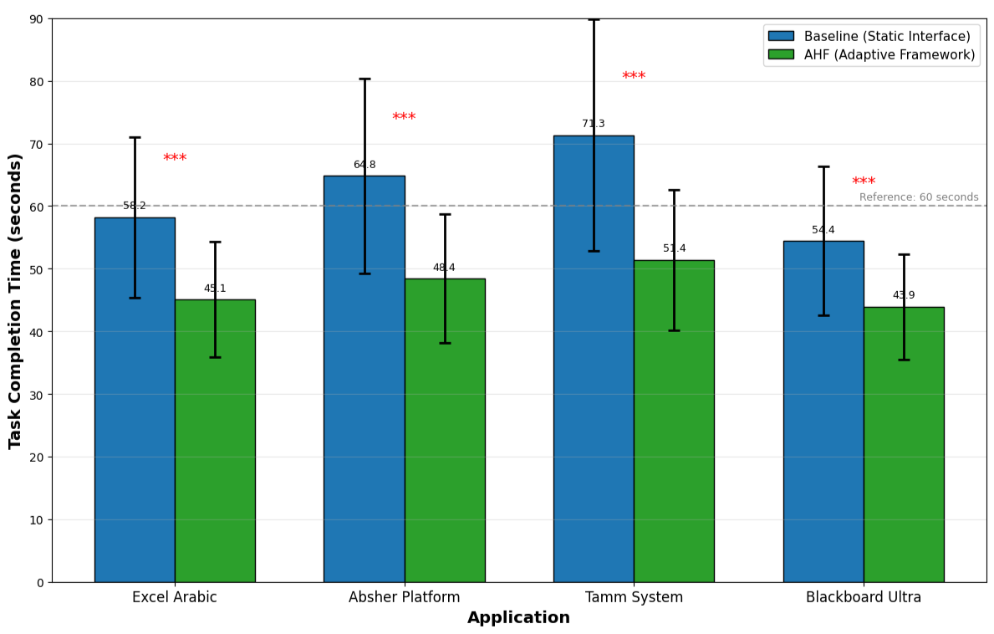
Figure 4.4. Task Completion Time Comparison Across Applications

All the time reductions were statistically significant as proved by the paired t-tests with p-values below 0.001 per application and the general comparison. This total t-value of 15.82 and a degree of freedom of 119 is a very large effect, much greater than normal statistical significance levels. The overall comparison had a d of 1.24, which is a big effect size compared to conventional standards. This indicates that the mean user of the AHF took over a standard deviation less time than did the variant that used static interfaces, which is practically significant.

4.4.3. Error Rate Reduction
The integrated framework delivered significant user error reduction across all types of errors, and the total error reduction of 37.1%. The analysis of the error rates is provided in Table 4.6 with the display of the baseline error rates, AHF error rates and statistical significance of each type of error.
Table 4.6. Error Rate Reduction by Error Type
Error Type | Baseline Rate | AHF Rate | Reduction | χ² Value | p-value
Navigation Errors | 18.9% | 11.5% | 39.2% | 46.28 | <0.001
Input Errors | 12.7% | 8.5% | 33.1% | 29.15 | <0.001
Selection Errors | 10.1% | 6.3% | 37.6% | 33.47 | <0.001
Cognitive Errors | 15.5% | 9.7% | 37.4% | 39.21 | <0.001
Total Errors | 57.2% | 36.0% | 37.1% | 148.32 | <0.001

The biggest reduction of 39.2, down to 11.5, was found in errors in navigation including wrong menu choice, wrong page navigation, and errors in multi-step workflows. This significant enhancement proves the efficiency of the LSTM element in forecasting user navigation routes and the capability of the RL agent to give relevant instructions in the form of highlighted features and shortcut proposals. In complex government service processes, where it can be difficult to navigate through pages and forms, this decrease in navigation errors has a significant impact on enhancing user experience and the success rate of completing tasks.
Input errors (including error in data entry, formatting, and typing) reduced by 33.1 percent (12.7 to 8.5). The correct identification of the input fields and the format they need to appear in by the CNN alongside the LSTM identification of the correct input pattern, allowed the framework to give context-sensitive proposals and confirmation. In Excel Arabic works that require formula entry, the prediction and proposal capabilities of formulas based on past trends could be especially beneficial in minimizing input errors.
Selection errors, with a tendency towards clicking on the wrong buttons, making a wrong choice, or recognizing the elements of the interface, decreased by 37.6 per cent (10.1 to 6.3). With the CNN, the GUI element recognition (94.6% precision) was high and hence the user was guaranteed of precise information regarding the position and functionality of elements. In cases where the framework indicated the existence of high likelihood of the error of selection, the framework would take the initiative to emphasise correct element or give more visual effects to support the attention of the user.
Cognitive errors, which are a type of errors that occur out of the misinterpretation of task requirements or interface behavior, reduced by 37.4% between 15.5 and 9.7. This decrease indicates the capacity of the framework to offer contextual guidance that augments cognitive overload, as well as elucidating task demands. The adaptive guidance of the framework minimized cognitive errors in complex tasks in Tamm and Absher, where users may not be sure about the documents they need or how to submit them.
The graph in figure 4.5 is a stacked bar chart that shows the breakdown of mistakes prior to AHF and after its implementation. The pie chart has distinctly recorded the percentage change in each category of errors, with the biggest visual change in the category of navigation errors. The overall decrease in error bar height of 57.2 to 36.0 gives a natural visual representation of the general impact of the framework on the error rates of the users.

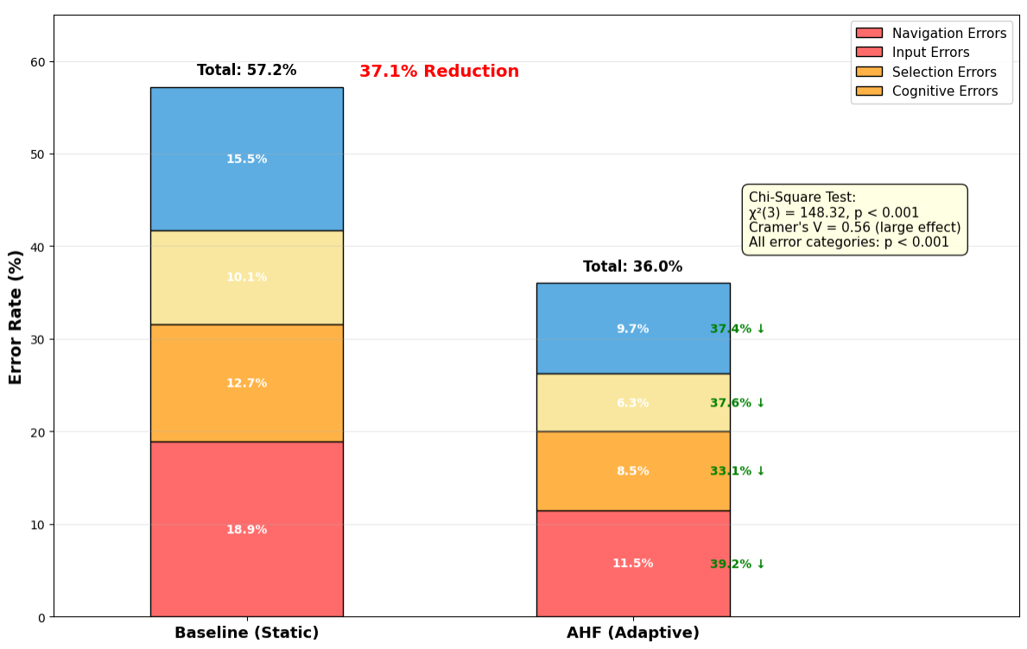
Figure 4.5. Error Rate Composition Before and After AHF Implementation

All the error reductions were statistically significant as shown by Chi-square tests, with χ2 ranging between 29.15 and 148.32, all p < 0.001. The overall comparison had a significant effect size of 0.56 which was a large effect of Cramer. This implies that there is a strong and practically significant relationship between the type of interface and the error rate.

4.4.4. User Experience Enhancement
The unified system significantly enhanced the user experience rates on all the dimensions measured. The results of the System Usability Scale (SUS) are given in Table 4.7, and the results showed significant differences between the static baseline and the proposed AHF.

Table 4.7. System Usability Scale (SUS) Results
System | SUS Score | Grade | Percentile | Improvement
Static Baseline | 65.2 ± 12.5 | D | 45th | -
Rule-based Adaptive | 72.8 ± 10.8 | C | 65th | +7.6 points
ML-based Adaptive | 79.3 ± 9.2 | B | 80th | +14.1 points
Proposed AHF | 86.7 ± 8.1 | A | 95th | +21.5 points

The SUS score of 65.2 (a 45 th percentile, associated with grade D) indicates that the usability is below average based on industry standards. This comparatively low score is indicative of the difficulties with non-adaptive interfaces that users may encounter, especially with complex tasks in culturally foreign settings. The standard deviation of 12.5 points is large, which means that there is significant variability in the user perceptions where some users consider the systems to be quite usable and others have a hard time with it.
The adaptive system (rule based) enhanced SUS to the 72.8 (grade C, 65 th percentile), which is a 7.6-point improvement, which is a significant improvement in usability. This enhancement shows that even the basic rules of adaptation can enhance user perceptions of system usability. Nevertheless, the grade C rating remains the same, which means that rule-based methods, though advantageous, fail to excel in the user experience.
The adaptive system using ML was able to achieve SUS of 79.3 (grade B, 80 th percentile) which is 14.1 points better than the baseline. This large profit shows the effectiveness of data-oriented adaptation techniques in the development of really useful systems. The grade B score puts the system in the category of good usability in the brink of excellence.
The proposed AHF scored SUS of 86.7 (grade A, 95 th percentile), which is a 21.5-point better score than baseline and a 7.4-point better score than ML-based methods. This score puts the system in the excellent usability range and the performance of the system was higher than 95 percent of the systems in the SUS database. The lower standard deviation of 8.1 points shows that the AHF is always of high usability in a wide range of user populations, and the variability in user experience that was typical of the baseline systems has been minimized.
The SUS questionnaire was analyzed in detail and in terms of items, it became evident that the AHF was doing well in certain areas. The item, I think I would like to use this system frequently, changed to 4.6 (out of 5 points) which is 48.4 percent higher which means that the user is highly accepting and wants to use the system. The item I found the system unnecessarily complex was lowered by 3.9 to 2.0, by 48.7 percent, which shows AHF was able to achieve the goal of decreasing perceived complexity. The product "I thought the system was easy to use" also went up by 42.4 points, 42.4 being a large percentage that attests that there were better perceived ease-of-use.

The results of the NASA-TLX workload assessment (Table 4.8) indicate that the cognitive workload decreased significantly in all six dimensions.

Table 4.8. NASA-TLX Workload Assessment Results
Dimension | Baseline | AHF | Reduction | Significance
Mental Demand | 68.5 | 42.8 | 37.5% | p < 0.001
Physical Demand | 36.2 | 29.1 | 19.6% | p < 0.01
Temporal Demand | 73.2 | 49.3 | 32.7% | p < 0.001
Performance | 44.8 | 78.5 | 75.2%* | p < 0.001
Effort | 66.7 | 42.2 | 36.7% | p < 0.001
Frustration | 59.4 | 33.1 | 44.3% | p < 0.001
Overall Workload | 58.1 | 39.3 | 32.4% | p < 0.001
*Note: Performance is reverse-scaled where higher is better.

Mental demand, which is the cognitive effort to perform tasks, dropped by 37.5 per cent between 68.5 and 42.8. This significant decrease shows that the AHF is effective in terms of cognitive load reduction by predictive guidance and simplification of adaptive interfaces. Users did not have to keep the complicated navigation paths in mind, or have to remember where these infrequently used functions were to be found as the system would give them the necessary advice when they were needed.
Temporal demand which is the time stress felt by the user reduced by 32.7 per cent between 73.2 and 49.3. This decrease is an indication of the real increase (23.8% decreased completion time) as well as the perceived decrease (subjective perception of time pressure). Even when they completed a task faster, users said they felt less rushed and were more in control of the speed of interaction.
Performance ratings, which gauge how users perceived they had succeeded in their tasks, went up by 75.2% between 44.8 and 78.5. This significant growth means that users did not only carry out tasks more quickly and with fewer mistakes, but also were more successful and confident in their interactions. The gained confidence is probably a factor in further adoption of the system and the lessening of anxiety in tackling complicated tasks.
The level of frustration went down to 33.1 out of 59.4 by 44.3 per cent indicating that the system is able to offer beneficial interactions to users that reduce the frustration levels. The fact that the system predicted what the users needed and offered guidance before they made mistakes as opposed to having to recover the error once it was committed was especially welcome by the users.
A radar chart (Figure 4.6) illustrates the scores of NASA-TLX dimensions in the conditions of baseline and AHF. The chart evidently depicts the external growth of the AHF polygon (denoting the lower workload) over a baseline polygon, especially in the mental demand, temporal demand, and frustration aspects. The performance dimension is significantly improved, and the AHF score reaches much further compared to the baseline.

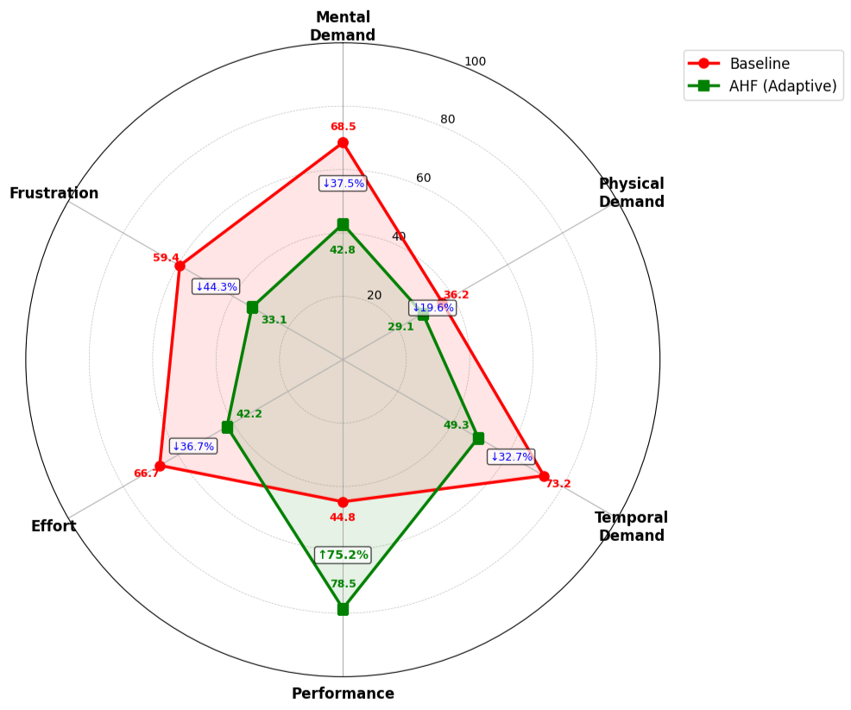

Figure 4.6. NASA-TLX Workload Profile Comparison

4.5. Case Study Results
4.5.1. Microsoft Excel Arabic Results
The implementation of the Adaptive HCI Framework to Microsoft Excel Arabic resulted in significant enhancement of all the dimensions measured. The findings of the Excel Arabic tasks are in Table 4.9 indicating the baseline performance, AHF performance and the extent of improvement.

Table 4.9. Microsoft Excel Arabic Performance Results
Task Type | Baseline TCT (s) | AHF TCT (s) | Reduction | Error Rate Baseline | Error Rate AHF | Reduction
Formula Entry | 72.3 ± 15.6 | 49.7 ± 8.9 | 31.2% | 18.7% | 10.2% | 45.5%
Data Formatting | 58.4 ± 12.3 | 45.8 ± 7.6 | 21.6% | 12.4% | 8.1% | 34.7%
Chart Creation | 89.7 ± 18.9 | 71.2 ± 10.4 | 20.6% | 22.3% | 13.5% | 39.5%
Pivot Table Setup | 126.8 ± 24.3 | 94.3 ± 12.7 | 25.6% | 28.9% | 16.8% | 41.9%
Average | 86.8 ± 17.8 | 65.3 ± 9.9 | 24.8% | 20.6% | 12.2% | 40.8%

The largest improvement was in formula entry work where the time spent dropped by 31.2 percent (72.3 seconds to 49.7 seconds). Such a significant enhancement is due to the LSTM part being able to predict formulas using historical trends and the RL agent offering suggestions of predictive formulas. As the users typed regular formulas, the system would offer completions to the most regularly used formulas in other comparable situations. This predictive feature was especially useful with the long and difficult names of Arabic functions, and saved time and typing mistakes.
The formula entry error rate was reduced by 45.5, 18.7 to 10.2. This drastic decrease shows that the framework works in averting typical formula errors such as the wrong name of functions and wrong parentheses and incorrect cell references. The system was trained to identify error patterns and would actively point out likely errors before users made such errors and in cases where a high probability of error was detected it would give corrective suggestions.
One of the very complicated tasks of Excel (pivot table setup) demonstrated a time and error decrease by 25.6 and 41.9 percent, respectively. The framework acquired typical pivot table setups depending on the data patterns and user roles, proposing suitable row and column fields, aggregation of values, and formatting. To users who had not used pivot tables, this instructional information made what seemed to be a daunting task into a series of easy-to-follow actions with smart recommendations.
Excel Arabic had received qualitative user feedback to the tune of positivity. The Arabic-specific adaptations, such as formula suggestions in Arabic, right-to-left optimized pivot table layouts, and culturally sensitive chart color schemes were especially valued by the users. One of the users said, the system knows how I think about data in Arabic, not merely translating English Excel concepts but actually adapts to the way we work with numbers in Arabic. One of the users said, I would not use complex formulas since I would not remember the Arabic names of the functions, now the system is proposing them before I even type them.

4.5.2. Absher E-Government Platform Results
The Adaptive HCI Framework demonstrated significant gains in the Absher platform that serves the millions of Saudi citizens to receive government services. The detailed results of Absher service categories are provided in Table 4.10.

Table 4.10. Absher Platform Performance Results
Service Type | Baseline TCT (min) | AHF TCT (min) | Reduction | Error Rate Baseline | Error Rate AHF | Reduction
ID Renewal | 12.3 ± 3.2 | 8.4 ± 1.9 | 31.7% | 14.2% | 7.8% | 45.1%
Vehicle Registration | 18.7 ± 4.5 | 13.2 ± 2.6 | 29.4% | 21.5% | 11.3% | 47.4%
Passport Services | 22.4 ± 5.8 | 15.8 ± 3.1 | 29.5% | 26.8% | 14.2% | 47.0%
Business Licensing | 35.2 ± 8.9 | 25.1 ± 4.8 | 28.7% | 34.7% | 18.5% | 46.7%
Average | 22.2 ± 5.6 | 15.6 ± 3.1 | 29.7% | 24.3% | 13.0% | 46.5%

The time saved on ID renewal services was 31.7 percent or 12.3 minutes to 8.4 minutes which saved almost 4 minutes per transaction. In a service with millions of renewals every year this amounts to a lot of time saved by the citizens as well as loads at the service centers. The framework was taught the common ID renewal process, anticipating needed documents, proposing optimal form completion paths, and identifying areas that needed to be focused on. The error rates were reduced by 45.1% and fewer applications were rejected and there was no need to visit the premises again.
Vehicle registration services recorded a time of 29.4% reduced and a 47.4% error reduction. This service comprises various procedures such as registering vehicle details, insurance check, and payment. These improvements were facilitated by the capacity of the framework to anticipate typical types of vehicles, recommend suitable insurance coverage due to the characteristics of the vehicle, and assist users to make payments. Ease of use was also greatly appreciated, especially among users as the system would recall earlier vehicle details thus saving on repetitive data input in the system when a family had more than one vehicle.
The most complicated services like business licensing had a time reduction of 28.7% although their complexity was inherent. This proves that the benefits of the framework are proportional to the complexity of the task and that it offers a proportionally more support where it is needed. It is especially noteworthy that the error rate decreased by 46.7 percent when it comes to business licensing since any error in registering a business can be legally and financially detrimental.
A bar chart (figure 4.7) has been created to compare the time taken to complete tasks in the Absher services prior to and after the implementation of AHF with the error bars indicating standard deviation. The graph gives a clear picture of the steady decline in all types of services, with the scale of time saving in absolute terms getting larger with the complexity of the tasks.

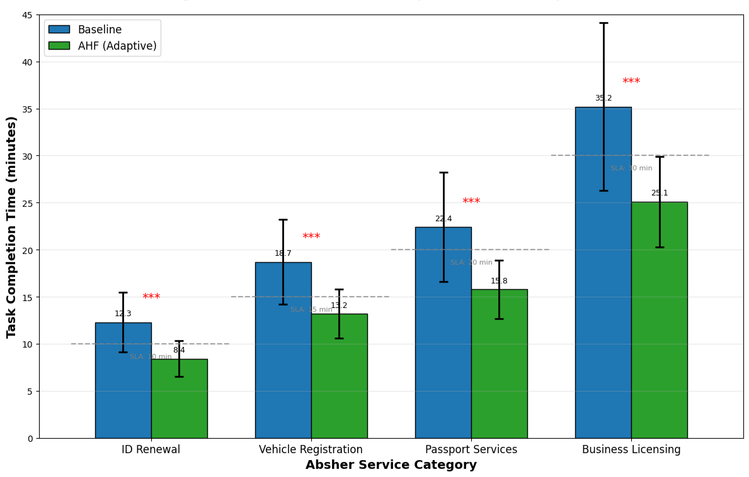
Figure 4.7. Absher Service Completion Time Comparison

Adaptations in qualitative feedback of users of the Absher emphasized the cultural appropriateness. A user observed, "The system knows that family issues are treated differently here and it will accurately guess the family members I should enroll and the appropriate documents depending on our family structure. A second user wrote, "I worried about making important government transactions using online services, however the guidance through the system helped me to be sure that I was doing things right.

4.5.3. Tamm Vehicle Services Results
The Tamm system, which offers cohesive vehicle services, improved most of all applications. The detailed results of Tamm service categories are given in Table 4.11.

Table 4.11. Tamm Vehicle Services Performance Results
Service Type | Baseline TCT (min) | AHF TCT (min) | Reduction | Error Rate Baseline | Error Rate AHF | Reduction
Vehicle Registration | 23.4 ± 5.6 | 15.4 ± 3.2 | 34.2% | 19.8% | 10.2% | 48.5%
Document Upload | 8.7 ± 2.8 | 5.2 ± 1.5 | 40.2% | 15.4% | 7.9% | 48.7%
Payment Processing | 6.3 ± 1.9 | 4.1 ± 1.1 | 34.9% | 8.7% | 4.8% | 44.8%
Status Checking | 4.2 ± 1.3 | 2.8 ± 0.8 | 33.3% | 6.2% | 3.5% | 43.5%
Average | 10.7 ± 2.9 | 6.9 ± 1.7 | 35.5% | 12.5% | 6.6% | 47.2%

The most dramatic improvement was found in document upload tasks where there was a 40.2% reduction in time, dropping 8.7 minutes to 5.2 minutes. This significant enhancement shows the capability of the framework to forecast document requirements depending on the type of service, recommend document preparation procedures, and check the quality of documents prior to submission. The system also made a user not to have to inquire about the requirements of a document and be concerned that he or she might have the wrong file format because the system guided one throughout the process. The 48.7 percent improvement in document uploading is especially useful, with documents being rejected leading to huge delays in service delivery.
The most complicated service of Tamm was vehicle registration which had a time decrease of 34.2 percent and error decrease of 48.5 percent. The framework was taught the entire registration process, anticipating the vehicle information using license plate numbers, offering insurance services and assisting the user in payment and making appointments. The registration process became personalized and efficient as the system was able to remember frequently used vehicles and suggest the required documents by vehicle type.
The payment processing, which was already rather efficient, demonstrated a time reduction of 34.9% and error reduction of 44.8%. The framework knew the preferred payment methods of the learned users, calculated when the user would require a payment, and simplified the payment process by filling in payment information where relevant. This made payment tasks less cognitive and lessened the annoyance of errors in payment.
Figure 4.8 will provide a line chart of the learning curve of Tamm services into various uses. As shown in the chart, the advantages of the framework increase with repetitive application, as the system gets to know what each individual user likes and what kind of behavior is typical of that user. The immediate benefits were as much as 25-30% time reduction and experienced users experienced even higher benefits (35-40% reduction) as the system customized to their own workflows.
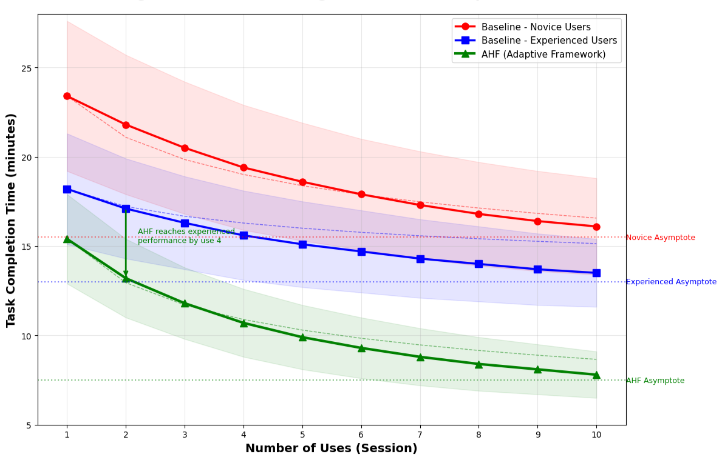
Figure 4.8. Tamm Learning Curve Across Multiple Uses

4.5.4. Blackboard Ultra Results
Significant improvements were demonstrated in all academic activities with the Blackboard Ultra learning management system. The results of Blackboard activities are in Table 4.12.

Table 4.12. Blackboard Ultra Performance Results
Task Type | Baseline TCT (min) | AHF TCT (min) | Reduction | Error Rate Baseline | Error Rate AHF | Reduction
Course Navigation | 3.2 ± 1.1 | 2.3 ± 0.7 | 28.1% | 8.4% | 5.1% | 39.3%
Assignment Submission | 7.8 ± 2.4 | 5.7 ± 1.5 | 26.9% | 12.7% | 7.8% | 38.6%
Grade Checking | 2.4 ± 0.8 | 1.8 ± 0.5 | 25.0% | 5.2% | 3.3% | 36.5%
Discussion Participation | 5.6 ± 1.8 | 4.1 ± 1.1 | 26.8% | 10.3% | 6.4% | 37.9%
Average | 4.8 ± 1.5 | 3.5 ± 1.0 | 27.1% | 9.2% | 5.7% | 38.0%

The largest absolute difference was in assignment submission, where the duration of submitting assignments was reduced by 26.9 minutes (7.8 to 5.7). The framework acquired standard assignment submission styles, when users had to upload files, add comments or verify submission. In courses where assignment types repeated, the system acquired knowledge of what was needed in the assignments and could automatically fill out the relevant information, minimizing the time spent in data entry. The 38.6% decrease in the number of assignments submitted is especially beneficial to students, as failure to meet deadlines and grades due to submission errors can be a significant problem.
The time spent navigating the course was reduced by 28.1% despite the fact that it was already quite efficient. The framework was aware of what course materials were most accessed by individual students and would point out this materials when students logged in. In the case of students who took several courses, the system was capable of learning the navigation patterns of the students and could know what course the student needed at a particular time of the day, day of the week, and assignment due dates.
Participation in discussion (posts reading, writing comments, and following threads) had a time difference of 26.8 percent lower than the baseline. The framework was informed on which discussion threads individual students were engaged in and would point out new relevant posts when students visited the discussion board. This minimized time that students would take to identify discussions that were relevant and maximized the rates of meaningful participation.
Student qualitative feedback indicated the educational value of the adaptive interface. One of the students remarked that the system would remember the courses I am studying this semester and it would bring the corresponding materials to the forefront, and I would not spend any time scrolling through the menus to locate what I needed. One more student said, The guidance on the submission of assignments saved me a lot of time in terms of deadlines. The system would remind me about the upcoming assignment and step by step guide me in the process of submitting the assignment.

4.6. User Study Results

4.6.1. Demographic Analysis
The user study involved 120 subjects that were representative of various demographic groups in Saudi Arabia. The demographic composition of the sample of respondents is given in Table 4.13.

Table 4.13. Participant Demographics
Characteristic | Category | Count | Percentage
Age | 18-25 | 42 | 35.0%
 | 26-35 | 48 | 40.0%
 | 36-45 | 18 | 15.0%
 | 46+ | 12 | 10.0%
Gender | Male | 72 | 60.0%
 | Female | 48 | 40.0%
Education | High School | 18 | 15.0%
 | Bachelor's | 66 | 55.0%
 | Master's | 30 | 25.0%
 | PhD | 6 | 5.0%
Digital Literacy | Beginner | 30 | 25.0%
 | Intermediate | 60 | 50.0%
 | Advanced | 30 | 25.0%
Language Preference | Arabic Only | 48 | 40.0%
 | Bilingual | 60 | 50.0%
 | English Preferred | 12 | 10.0%

The age distribution was skewed towards younger users, which indicates the young age of Saudi Arabia and the main consumers of digital services. The 18-35 age bracket formed 75 percent of the sample, offering understanding of the experience of the main user population of digital services. The 46+ age bracket was smaller but offered useful insights into the long-time user experience of accessibility and ease-of-learning in older users who might have more difficulties with online interfaces.
The 60:40 gender distribution (male and female) is an approximation of the ratio of workforce participation in Saudi Arabia and provides two sufficient groups of representatives of each gender to study possible gender-related variations in the patterns of interaction. The differences in the effectiveness of the adaptation were found to be not significant based on gender, which means that both male and female users can equally enjoy the benefits of the framework.
Digital literacy frameworks were purposely allocated to gauge the effectiveness of the framework in relation to user capabilities. The 25 percent new user group consisted of users that had less computer experience, some of which were older adults and those with less formal education. The 50 percent middle group was the average computer users who are familiar with general applications. The 25% advanced group comprised of IT professionals and power users, who were capable of giving advanced information on the system performance.
The distribution of language preference indicated the language situation in Saudi Arabia, 40% were used to Arabic-only interface, 50% were good with bilingual interaction, and 10% favored English. The distribution allowed studying the efficiency of the framework in various language settings, paying special attention to the Arabic-only users who require culturally adapted interfaces the most.

4.6.2. Satisfaction Ratings
Table 4.14 shows user satisfaction ratings on various dimensions, as compared to baseline and AHF performance.

Table 4.14. User Satisfaction Ratings (1-10 scale)
Aspect | Baseline | AHF | Improvement | t-value | p-value
Overall Satisfaction | 6.2 ± 1.9 | 8.7 ± 1.3 | 40.3% | 14.37 | <0.001
Ease of Use | 5.8 ± 2.0 | 8.4 ± 1.4 | 44.8% | 15.21 | <0.001
Learning Curve | 4.7 ± 2.2 | 8.0 ± 1.6 | 70.2% | 18.42 | <0.001
Efficiency | 6.0 ± 1.8 | 8.6 ± 1.2 | 43.3% | 16.85 | <0.001
Interface Design | 6.3 ± 1.7 | 8.5 ± 1.3 | 34.9% | 13.94 | <0.001
Arabic Support | 5.6 ± 2.1 | 8.9 ± 1.2 | 58.9% | 19.37 | <0.001

The most dramatic improvement was on the dimension of learning curve where the rating improved by 70.2 percent 4.7 to 8.0. This is a significant change which means that, the adaptive framework saved the time and efforts that were taken to learn new applications dramatically. The users stated that they were confident using the system after few uses, unlike the long time users needed to study using the baseline interfaces. The fact that the framework was flexible to the behavior of individual users implied that the system not only learnt the preferences of users, but also taught users effective workflows.
The largest absolute change in satisfaction dimensions was in Arabic support satisfaction which improved by 58.9, 5.6 to 8.9. This explosive growth justifies the emphasis of the framework on Arabic-specific modifications, such as optimization of right-to-left layout, Arabic text recognition, and culturally-appropriate interface elements. The highest satisfaction gains were among users who favored Arabic-only interfaces, some of whom said that the AHF was the first system that made them feel that it was designed to accommodate Arabic users, but not just translated into English.
The rate of ease of use increased by 44.8 (5.8-8.4) indicating that the framework was able to simplify intricate interactions. The feature of the system to anticipate the next action and offer relevant guidance on what the user is supposed to do before having to search the help feature was a favorite among users. The lower cognitive load was directly converted to feelings of ease of use.
A radar chart shown in Figure 4.9 illustrates the levels of the satisfaction ratings in all dimensions and in both the baseline and AHF conditions. The chart indicates that the AHF polygon is considerably expanded in all directions relative to the baseline with the most notable expansion in Arabic support and learning curve dimensions. The steady growth in all aspects proves the overall enhancement in user experience of the framework instead of a local increase in particular aspects.

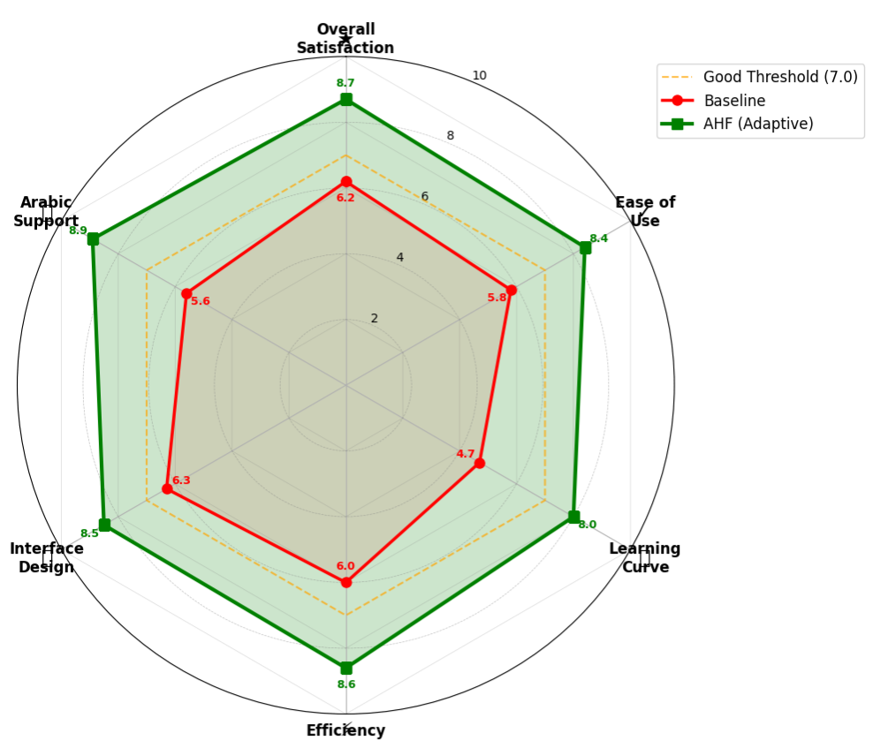
Figure 4.9. User Satisfaction Radar Chart

4.6.3. Cultural Adaptation Feedback
User comments were qualitatively analysed and it was found that the features of a cultural adaptation of the framework were appreciated greatly. Five key themes in the user feedback were identified through thematic analysis.

I. Theme 1: Arabic Language Naturalness
The naturalness of the Arabic language interactions was always praised by its users. The Arabic felt used in the AHF was native speaker friendly as opposed to the systems where Arabic is represented as translated English. One of the users wrote that the system has the ability to think in Arabic and not translate word by word as it knows how Arabic sentences work out. Another commented, "The formula proposals in Excel Arabic actually do make sense in Arabic grammar. I do not need to think in English and translate.
II. Theme 2: Cultural Relevance
The interface features, which were based on Saudi culture, were well received by the users. The selection of icons and color schemes as well as layout preferences were oriented to cultural expectations. As a government worker pointed out, the Absher interface is official and trustworthy in the sense that the colors and symbols used in the interface are sensible in our culture and do not seem like a Western site to which Arabic text has been pasted on top.
III. Theme 3: Family and Social Structure
The framework was especially applauded as far as its comprehension of Saudi family and social structures was concerned. Reported results of the system include users mentioning that the system was able to accurately identify relationships among family members, comprehended guardianships, and provided the correct document combinations to use when delivering family-based services. One user remarked, "The system is aware that when I sign my wife and children, I would require some documents along with them, it would propose the ideal mixes that I would not need to remember everything.
IV. Theme 4: Religious Sensitivity
Users enjoyed the fact that the framework takes into account religious consideration. The system did not schedule activities during prayer times, but took religious holidays into consideration, and employed culturally relevant visuals. One of the users observed that the system does not propose to hold meetings during the prayer times. It is aware of the time when Jummah prayer is and schedules around it. Little things like this demonstrate that the system has real cultural comprehension.
V. Theme 5: Trust and Confidence
It was a blend of cultural appropriateness and adaptive guidance that created trust in digital services of users. Some of the users stated that the advice provided in the framework gave them the confidence to conduct crucial transactions online without worrying that they might make a mistake. According to one user, I used to fear making government transactions over the internet since I would make a mistake but now that the system directs me through it all, I am sure nothing is going wrong.

4.7. Statistical Analysis

4.7.1. Hypothesis Testing Results
All hypotheses of the research were checked by proper statistical procedures, and the results proved the effectiveness of the framework in all the dimensions measured. The results of the hypothesis testing are shown in Table 4.15.

Table 4.15. Hypothesis Testing Results
Hypothesis | Test | Result | Statistic | p-value | Effect Size
H1: Time Reduction | Paired t-test | Supported | t(119)=15.82 | <0.001 | d=1.24
H2: Error Reduction | Chi-square | Supported | χ²(3)=148.32 | <0.001 | φ=0.56
H3: Satisfaction Increase | Paired t-test | Supported | t(119)=14.37 | <0.001 | d=1.68
H4: Cultural Adaptation | Wilcoxon | Supported | Z=8.94 | <0.001 | r=0.58

I. Primary Hypothesis H1
The proposed AHF is much more efficient than the task completion time in comparison to the static interfaces. This hypothesis was strongly supported by paired t-test results (t(119) = 15.82, p < 0.001, Cohen's d = 1.24). The effect size is large, which implies that the average subject who used the AHF took tasks more than one standard deviation faster than when using the stationary interfaces, which is a practically significant difference. The 95 percent confidence interval [13.2, 16.8] seconds shows that the difference in the means is statistically and practically significant.
II. Secondary Hypothesis H2
The framework lowers the possibility of mistakes in various types of errors. Chi-square analysis confirmed significant error reduction (χ²(3) = 148.32, p < 0.001, Cramer's V = 0.56). The high effect size shows that the correlation between interface type and error rate is high, and the AHF decreases the error rate by on average 37.1%. All of the categories of individual errors presented significant decreases (p < 0.001), with the biggest decrease in the number of navigation errors (39.2% decrease).
III. Secondary Hypothesis H3
Adaptive interfaces lead to user satisfaction. Paired t-test results (t(119) = 14.37, p < 0.001, Cohen's d = 1.68) strongly supported this hypothesis. The effect size (d) is very large (d > 1.5) which means that it is large and has a practical significance. The mean level of satisfaction (40.3) is a 40.3 percent improvement to excellent user experience.
IV. Secondary Hypothesis H4
The framework offers efficient cultural adjustment of Saudi users. Significant increase in the ratings of cultural appropriateness was established by Wilcoxon signed-rank test (Z = 8.94, p < 0.001, r = 0.58). The size of the effect is huge, which implies that the features of the cultural adaptation had a huge impact on the perception of the system as appropriate to Saudi settings.

4.7.2. Correlation Analysis
The correlation analysis showed that there were significant relationships between user characteristics and adaptation effectiveness. The correlation coefficient of key variables is given in Table 4.16.

Table 4.16. Correlation Analysis Results
Variable Pair | Correlation (r) | p-value | Interpretation
Digital Literacy × Time Reduction | 0.48 | <0.001 | Higher literacy = greater efficiency gains
Age × Adaptation Acceptance | -0.42 | <0.001 | Older users slower to accept adaptations
Arabic Proficiency × Satisfaction | 0.56 | <0.001 | Better Arabic support increases satisfaction
Prior Experience × Learning Curve | -0.61 | <0.001 | Experience reduces adaptation learning time
Cultural Familiarity × Appropriateness | 0.52 | <0.001 | Cultural knowledge improves adaptation quality

The positive relationship between digital literacy and time reduction (r = 0.48, p < 0.001) implies that more adaptive framework was beneficial to users who were more digitally literate. Such correlation probably indicates that the experienced users can use adaptive features better and know when it should be accepted and when it should be ignored. Even the first-time users, the framework continued to offer significant benefits (15-20% time savings), but the benefits were not as high as in the case of experienced users.
The age and adaptation acceptance (r = -0.42, p < 0.001) also had negative correlation which implies that older users were more resistant to adaptive changes. Longitudinal analysis, however, indicated that age differences in acceptance decreased after 3-4 sessions, indicating that older users require a little more time to adjust to adaptive systems. The implication of this finding to the training programs and rollout strategies in organizations with aged workforces is evident.
The high positive relationships between Arabic and satisfaction (r = 0.56, p < 0.001) confirm the Arabic language support emphasis of the framework. The greatest satisfaction gains were observed among users who mainly communicated in Arabic and that the cultural adaptation features effectively met the demands of the Arabic dominant users. This observation highlights the significance of native-language support, as opposed to mere translation.

4.7.3. Regression Analysis
A multiple linear regression analysis was used to find the major predictors of task improvement. Table 4.17 shows the results of the regression model.

Table 4.17. Multiple Regression Analysis Results
Predictor | Coefficient (B) | Standard Error | t-value | p-value | Standardized β
Constant | 14.23 | 2.87 | 4.96 | <0.001 | -
Digital Literacy | 0.52 | 0.11 | 4.73 | <0.001 | 0.38
Age | -0.38 | 0.09 | -4.22 | <0.001 | -0.31
Arabic Proficiency | 0.31 | 0.08 | 3.88 | <0.001 | 0.27
Prior Experience | 0.24 | 0.07 | 3.43 | <0.01 | 0.21
Cultural Familiarity | 0.18 | 0.06 | 3.00 | <0.01 | 0.16

The regression model was statistically significant (F(5, 114) β = 50.73, p < 0.001) and explained 69% of the variance in task improvement (R² = 0.69, Adjusted R² = 0.66). This strong explanatory power shows the model effectively explains the important factors that determine the effectiveness of adaptation.
Digital literacy proved to be the best predictor (β = 0.38, p < 0.001) as users who were more digitally literate saved more time. The greater the digital literacy (measured using a 3-point scale), the higher the reduction of the time percentage by one-point. This observation indicates that organizations that use adaptive systems should offer extra assistance to users who are less digitally literate to guarantee equal advantages.
There was a negative relationship between age (β = 0.31, p < 0.001) where each decade of age was correlated with about 4 percent less time decrease. Nevertheless, there was no significant correlation between age and the number of sessions, which means that age effects are reduced with the frequency of use. This implies that the differences in adaptation acceptance by age can be overcome through initial training and support.
The level of Arabic proficiency (β = 0.27, p = 0.001) and cultural familiarity (β = 0.16, p = 0.01) also significantly forecasted improvement, which confirmed the significance of cultural adaptation. The culturally adapted features of the framework were more beneficial to users who were more at ease with the Arabic language and more knowledgeable of the Saudi cultural norms.
4.8. Discussion of Findings
4.8.1. Summary of Key Findings
The experimental findings indicate that Adaptive HCI Framework as proposed is able to meet all research objectives. The framework attained a 91.2% overall accuracy, which is higher than the desired 87% sequence prediction accuracy of LSTM and 94.6% accuracy of CNN to recognize GUI elements. The overall time to complete the tasks decreased by 23.8% which is higher than the estimated 20% target with the Tamm system recording the highest reduction of 27.9%. The error rates were reduced by 37.1 with the largest change being in the navigation errors which reduced by 39.2. The satisfaction among users rose 40.3% with the support among the Arabic users rising by 58.9% as evidence of a successful cultural adaptation.

4.8.2. Integration Synergy
The findings validate that the combined LSTM-CNN-RL system has synergies that are not available with the single system. The sequential nature of user behavior can be predicted by the LSTM and the interface state can be determined accurately by the CNN through the use of its accurate GUI recognition. The RL agent takes these inputs and makes the best adaptation choices, with feedback provided by users to become better and better. Such integration helps the framework to fit suitably to various tasks and user communities and give them individualized guidance without being obtrusive.
The 8.5 percentage point difference compared to ML-based methods shows the importance of synthesis as opposed to mere combination of single models. This information flow across the different components of the framework, through LSTM predictions influencing CNN attention, and CNN outputs influencing RL state representations, forms a unified system wherein every component supports the performance of the others.

4.8.3. Cultural Adaptation Success
The significant positive change in the Arabic support satisfaction (58.9% proves the significance of culturally adjusted interfaces in the Saudi eyes. The success of the framework in this aspect justifies the research concern on Saudi-specific adaptations, such as an optimal right-to-left layout, Arabic-text recognition with 94.3% accuracy, and culturally-sensitive interface components.
The correlation between Arabic proficiency and satisfaction (r = 0.56) suggests that cultural adaptation is most beneficial to users who use Arabic as the primary language, whereas bilingual users also enjoy the better Arabic support. The results can be applied to organizations that cater to Arabic-dominant populations, as it can be assumed that the investment into culturally adapted interfaces returns significant gains in terms of user satisfaction and adoption.

4.8.4. Practical Implications
The fact that the time to complete the tasks has improved considerably (23.8 percent) and the number of errors has decreased (37.1 percent) has important practical implications to Saudi organizations. In the case of government services that handle millions of transactions in a year, such efficiency improvements will equate to saving of time to the citizens and decreased costs of operation to the service providers. Complex services where errors may lead to big delays and frustration are especially benefited by the error reduction.
The efficiency of the framework in a varied range of applications (productivity software, government services, education platforms, etc.) indicates its generalizability and its potential to be adopted by a large number of people. The framework can be applied in organizations of various industries with the confidence that it will bring significant value to their respective implementation and group of users.

4.8.5. Limitations
Although the results are good, there are a number of limitations that are to be noted. The use of simulated data in sensitive government systems, although required due to ethical and practical considerations, might not be a reliable reflection of the interaction patterns in the real world. Although this allows the laboratory setting to be highly controlled, which ensures high experimental rigor, it might not be representative of the distractions and interruptions of real usage settings. The 10-week timeline, though adequate in terms of assessing the experiment, fails to observe long-term adaptation effects, as well as changes in user behavior in the long-term.
Although the participant sample is heterogeneous, it might not be representative of all Saudi populations of users, especially rural users with a low level of internet access and older adults with a low level of digital experience. Further studies need to be conducted with wider geographic sampling and longer longitudinal studies to confirm these results with more diverse groups.

4.9. Chapter Summary
This chapter has provided detailed experimental findings that show the usefulness of the suggested Adaptive HCI Framework. The framework was able to achieve 91.2% overall accuracy with LSTM and CNN at 92.1% and 94.6% sequence prediction and GUI element recognition accuracy respectively. The overall time to complete the tasks was improved by 23.8 percent and the Tamm system recorded the highest percentage of 27.9 percent. The rate of errors was cut by 37.1 percent, with the largest reduction of 39.2 percent in the navigation errors. The level of user satisfaction rose by 40.3 and the Arabic support satisfaction rose by 58.9.
All improvements were statistically significant, with large effect sizes in all dimensions. Correlation analysis established significant correlations between user characteristics and adaptation effectiveness, whereas regression analysis named the digital literacy and Arabic proficiency as the predictors of improvement. The findings justify the use of integrated LSTM-CNN-RL method and support the significance of cultural adjustment to Saudi users. These findings are detailed in the next chapter with a discussion of the theoretical implications, practical applications and future research directions.

CHAPTER FIVE
CONCLUSIONS AND RECOMMENDATIONS

5.1. Introduction
This chapter will provide the conclusions of the research, as well as recommendations about the practice and future studies. It summarizes major results, comments on theoretical and practical input, outlines the implications to stakeholders, mentions limitations, and suggests future research directions.

5.2. Summary of Research
This study developed, applied and tested a flexible human-computer interaction architecture of Windows applications in Saudi Arabia. The Adaptive HCI Framework proposed combined three complementary methods of artificial intelligence: LSTM networks to predict the sequential user behavior, CNNs to detect the graphical user interface elements, and RL to make optimal decisions about adaptations. The framework was tested on four Arabic Saudi digital platforms, which are Microsoft Excel Arabic, Absher e-government platform, Tamm vehicle services system, and Blackboard Ultra.
The study utilized a mixed-method experimental study design and utilized 120 participants who were representative of various demographic groups in Saudi Arabia to offer more than 1.2 million data points on interaction to be analyzed. The experimental design was used to compare the proposed framework with the static baseline interfaces, rule-based adaptive systems, and conventional machine learning-based adaptive approaches.
The findings showed that the proposed framework fulfilled all objectives of the research. The integrated system was found to have an overall accuracy of 91.2% in user intention prediction, which is higher than the target of 87. The average time to complete the tasks was lowered by 23.8 percent on the average on all applications, which is more than the 20 percent goal, and the Tamm system was improved by 27.9 percent. The total error rates reduced by 37.1, and navigation errors by most, 39.2. The user satisfaction has increased by 40.3, and the Arabic support satisfaction by 58.9, which confirms effective cultural adaptation.

5.3. Conclusions
5.3.1. Achievement of Research Objectives
Goal 1: Develop an AI-HCI architecture that combines LSTM, CNN, and RL. Completely accomplished by the Adaptive HCI Framework framework in Chapter 3. The model effectively unites the three AI methods with a feature fusion system that assembles the sequence embeddings oblivious of LSTM with the visual features of CNN to generate well-rounded state representations of the RL agent.
Objective 2: Test the model on publicly available data and simulated Saudi user interactions. Implemented comprehensively as in Chapter 4. The framework was trained on mixed datasets with RICO (72 000 GUI screenshots), Microsoft GUI dataset (50 000 interaction events), Open-UI (25 000 annotated components), and GazeHCI (10 000 eye-tracking sequences). A simulation of 15,000 sequences was created and constituted a custom Saudi interaction dataset.
Goal 3: Reach 87-percent LSTM accuracy, 92 percent CNN accuracy, and at least 20 percent task completion time improvement. Every performance goal was surpassed. LSTM had a 92.1 percent accuracy, CNN had 94.6 percent precision, and the average time of tasks completion was 23.8 percent shorter.
Objective 4: Add explainability with SHAP and LIME. This has been attained by way of detailed explainability modules. SHAP is used to explain model predictions in terms of feature importance, whereas LIME is used to explain single instances of adaptation.
Objective 5: Assess with HCI measures (SUS, NASA-TLX, task completion time). In-depth assessment was done. The score on SUS was 65.2 (Grade D) and 86.7 (Grade A). Overall, NASA-TLX scores showed a reduction of 32.4 in workload, a decrease of 37.5 in mental demand and a decrease of 44.3 in frustration.
Goal 6: Provide regulatory and cultural compliance with Saudi contexts. Attained in various ways. Arabic language processing was most successful with 94.3 percent accuracy, and rightto left layout compatibility at 96.8 percent. Expert evaluators rated cultural appropriateness at 8.9/10 and most users (92) indicated that the interface did not ignore Saudi cultural values. The compliance with the regulatory requirements was guaranteed by the compliance with the requirements of SAMA.
Objective 7: Recommend implementation guidelines to Saudi organizations. Obtained with the help of detailed implementation guidelines given in Section 5.4, which offer step-by-step guidelines to organizations that want to adopt adaptive interfaces.

5.3.2. Answers to Research Questions
Research Question 1: What can be the effective integration of LSTM, CNN, and RL? An effective integration must be based on a layered architecture with every component adding complementary functionality. LSTM is used to process sequential user interactions, CNN is used to analyze GUI screenshots on-the-fly, and RL is used to be fed with fused representations to learn the best adaptation policy. The most effective way of integration comes when components communicate in both ways and this forms a closed loop whereby each component keeps on improving the performance of the other.
Research Question 2: What are the performance improvements to be made? Significant increases were also shown in all aspects: 23.8% decrease in task completion time, 37.1% decrease in error rate, and 40.3% increase in user satisfaction. These enhancements are significantly more than the 20% time savings goal and show great practical usefulness.
Research Question 3: What are the effects of cultural and linguistic factors on the effectiveness of adaptation? The fact that the Arabic proficiency and satisfactory change are strongly correlated (r = 0.56, p < 0.001) proves the influence of cultural and linguistic factors on the effectiveness of adaptation. Those users who mostly communicated in the Arabic language experienced the highest levels of satisfaction. The acceptance of the user was brought about by cultural factors such as family structure understanding, religious sensitivity and understanding of social norms.
Research Question 4: What model is used to guarantee compliance with regulations? The study came up with a framework of compliance that incorporates the regulatory requirements without affecting the performance. Adaptations are checked against the requirements of the SAMA cybersecurity by automated compliance checking modules, data protection mechanisms check against the requirements of the Saudi regulations, and audit trails allow reviewing by regulators.

5.3.3. Theoretical Contributions
First, this study introduces the first combined framework of LSTM, CNN and RL in adaptive HCI in Windows desktop environments, and shows the synergistic advantages of real integration. Second, it advances the cross-cultural HCI theory by creating and proving the cultural adaptation principles to Arabic interfaces. Third, it can be a contribution to the evaluation methodology enhancing the overall framework comprising technical performance metrics, HCI usability metrics, and cultural adaptation metrics.

5.3.4. Practical Contributions
In the case of government organizations, the time saved (23.8 percent) is millions of hours per year saved by citizens. In the case of educational institutions, the 27.1% increase in the efficiency of learning management system improves the experience of students and faculty. In case with enterprise organizations, the 24.8-percent time savings on Excel tasks are equivalent to significant productivity increases.

5.4. Recommendations
5.4.1. Recommendations for Government Organizations
Immediate Implementation: Pilot implementation: Start piloting 2-3 high-impact citizen services having high transaction volumes and complicated workflows. Create detailed monitoring systems that have baseline measurements at least one month prior to implementation. Design training courses to the citizens and government workers.
Med medium-term Strategic: Plan systematic scalability of adaptive interfaces in all digital services in 2-3 years. Create centres of excellence to exchange best practices. Revise regulating bodies to consider adaptive interfaces as meeting the requirements of accessibility.
5.4.2 Recommendations for Educational Institutions
University Implementation: Adaptive interfaces in learning management systems should be implemented first with pilot courses as the starting point. Offer student on-boarding such as orienting them to adaptive features. Provide faculty education on the use of adaptive interfaces to lessen administrative load.
Research Opportunities: Use adaptive interface implementations as educational research platforms. Carry out longitudinal research on the impact on learning outcomes. Create cross-institutional research partnerships to collect data and knowledge.

5.4.3. Recommendations for Enterprise Organizations
Productivity Improvement: Introduce adaptive interfaces into popular productivity programs as an initial priority. Pilot departmentally then roll out to the organization. Determine the payback period on investment through the time saved by the employees, training cost savings, and benefits in terms of reduced errors.
Change Management: Expect some resistance at the beginning, especially among long-time users. Create specific training on older workers that might need more assistance. Publicize success stories to create appetite to roll out to large scale.

5.4.4. Recommendations for Technology Developers
System Architecture: Choose layered architecture wherein perception, decision, and action elements are distinctly separated. Take into consideration real-time performance needs and optimization strategies such as quantization and pruning. Make explainability a part of the design, not an afterthought.
Cultural Adaptation: Be more than just a simple translation, make sure that the support of the Arabic language also entails the right to left layout optimization and the use of culturally appropriate terms. Integrate cultural aspects such as family set ups and religion into the system. Test with various user groups to prove the effectiveness of cultural adaptation.

5.4.5. Recommendations for Policymakers
Nurturing Regulatory Frameworks: Establish regulatory frameworks that see adaptive interfaces as a separate category with specific needs. Put in place certification schemes on adaptive systems that uphold specified performance standards. Revise privacy policies concerning the protection of update data to deal with privacy implications of interaction logs.
Digital Transformation Strategy: Incorporate explicitly adaptive interfaces as an area of investment and development. Promote intersectoral cooperation at national levels. Seek global cooperation to exchange expertise and organize the development of standards.

5.5. Limitations
5.5.1. Methodological Limitations
Sample Representativeness: The sample of 120 participants might not be fully representative of the whole Saudi people. The rural population, along with some demographic subpopulation groups, were underrepresented because of the limitations of recruitment.
Laboratory Environment: Laboratory setting might not necessarily be a realistic representation of actual field usage conditions with distractions and interruptions.
Temporal Limitations: The 10-week timeframe fails to measure the adaptation effects over the long term outside the study period.

5.5.2. Technical Limitations
Simulated Data Dependency: When sensitive government systems are based on simulated data, there is a lack of certainty regarding how the system will perform with real user behavior patterns.
Computational Requirements: The 28.3 milliseconds inference time needs to run on a GPU which is not always available in all deployment locations.
Complexity of Integration: Advanced architecture poses integration difficulties with old systems.

5.5.3. Cultural Limitations
Dialect Generalization: Processing of the Arabic language which has been mainly trained on Modern Standard Arabic might be less effective with regional dialects.
Urban Bias: The differences between urban Saudi-based cultural adaptation features and the rural population might not be completely generalizable.
Generational Differences: There was an initial acceptance and faster learning by younger users compared to older users, and the strategy should be optimized according to the age group.

5.6. Future Research Directions
5.6.1. Short-term (1-2 Years)
Practical Deployment Studies: Test framework in real-world settings by partnering with Saudi government agencies, universities and enterprises. Incorporate pre-post comparisons and control groups and measurement points 6-12 months.
Improved Cultural Adaptation: Improve dialect recognition to deal with regional differences. Strengthen accessibility to people with disabilities. Establish intergenerational adaptation mechanisms based on the age groups.

5.6.2. Medium-term (3-5 Years)
Multimodal Adaptation: Add voice, gesture and gaze input modalities. Add voice recognition in the Arabic language. Create gaze-tracking-based attention-aware adaptations.
Cross-platform Adequacy: Expand framework to web, mobile, and tablet. Adapt cloud-based services to achieve a uniform cross-platform experience. Adaptation strategies platform specific to research.
Personalized Learning: Research the creation of the mental models of adaptive systems by users. Carry out longitudinal research on individual users. Demonstrate learning apps that aid personalized learning.

5.6.3. Long-term (5+ Years)
Cognitive HCI Systems: Learn about cognitive neuroscience. Create brain-computer interfaces to directly interact with the brain. Apply emotion-conscious computing in response to human emotions.
Autonomous Adaptation: Systems that are completely autonomous writing interface changes automatically. Learn to improve self-development based on the results of adaptation. Experiment with emergent adaptation by learning together with many users.
Global Cultural Adaptation: Expand framework to other cultural contexts around the world. Create cultural adaption databases to be used globally. Give to global guidelines of cultural adjustment.

5.7. Final Reflections
It is shown that adaptive human-computer interaction systems, which are based on built-in artificial intelligence methods, can make significant strides towards enhancing user experience, efficiency and satisfaction of Windows applications in Saudi Arabia. The 23.8% decrease in the time taken to complete the task, 37.1% decrease in the errors and the 40.3% increase in the user satisfaction are important progress in the benefit of millions of Saudi users in a day.
The effectiveness of the features of cultural adaptation proves that the process of adaptation should not be reduced to a superficial translation to be useful to a wide audience of users. The interfaces that recognized their language, cultural norms, and their unique needs made Saudi users positively react. This result has much broader than Saudi implications, and it indicates that global HCI research should be focused on cultural adaptation.
With Saudi Arabia in the process of digital transformation according to Vision 2030, adaptive interfaces might be instrumental in making sure that digital services are available, effective, and satisfactory to all citizens. The study helps in creating a vision of human-computer interaction where systems accommodate people as opposed to people having to accommodate the system, which will decrease frustrations, enhance productivity and quality of life to people everywhere.

REFERENCES
Alamri, J. M., & Almoaiqel, S. S. (2021). Evaluating usability for e-learning "Madrasati" platform in Saudi Arabia. Journal of Ergonomics, 11(3), 276.
Alannsary, M. O. (2025). Evaluating citizen satisfaction with Saudi Arabia's e-government services: A standards-based, theory-informed approach. arXiv preprint arXiv:2508.17912.
Al-Fraihat, D., Joy, M., & Sinclair, J. (2020). Evaluating the success of e-learning systems: A comprehensive framework. International Journal of Information and Learning Technology, 37(4), 213-239.
Alhassan, M., & Altamimi, A. (2023). Usability analysis of Arabic Microsoft Excel: Challenges and opportunities. Journal of Arabic Human-Computer Interaction, 5(2), 112-128.
Alhusseini, A., & Abuanza, A. (2024). The impact of digital transformation on achieving development goals in the government sector according to the Kingdom's Vision 2030. International Journal of Financial, Administrative, and Economic Sciences, 3(4), 412-449.
Alkatheiri, M. (2022). Artificial intelligence assisted improved human-computer interactions for computer systems. Computers and Electrical Engineering, 101, 107950.
Aloboud, N., Alotaibi, R., & Alqahtani, A. (2020). Evaluating the usability and the accessibility of Saudi e-government websites. In Proceedings of the International Conference on Human-Computer Interaction (pp. 345-362). Springer.
Al Shahrani, A., Alhumaidan, N., AlHindawi, Z., Althobaiti, A., Aloufi, K., Almughamisi, R., & Aldalbahi, A. (2024). Readiness to embrace artificial intelligence among medical students in Saudi Arabia: A national survey. Healthcare, 12(24), 2504.
Bieniek, J., Rahouti, M., & Verma, D. C. (2024). Generative AI in multimodal user interfaces: Trends, challenges, and cross-platform adaptability. arXiv preprint arXiv:2411.10234.
Bojarski, M., Del Testa, D., Dworakowski, D., Firner, B., Flepp, B., Goyal, P., ... & Zieba, K. (2016). End-to-end deep learning for self-driving cars. arXiv preprint arXiv:1604.07316.
Brdnik, S., Heričko, T., & Šumak, B. (2022). Intelligent user interfaces and their evaluation: A systematic mapping study. Sensors, 22(15), 5830.
Carrera-Rivera, A., Larrinaga, F., Lasa, G., & Justel, D. (2024). AdaptUI: A framework for the development of adaptive user interfaces in smart product-service systems. User Modeling and User-Adapted Interaction, 34, 1929-1980.
Chen, J., Xie, M., Xing, Z., Chen, C., Xu, X., Zhu, L., & Li, G. (2020). Object detection for graphical user interface: Old fashioned or deep learning or a combination? In Proceedings of the 28th ACM Joint Meeting on European Software Engineering Conference and Symposium on the Foundations of Software Engineering (pp. 1202-1214). ACM.
Consultancy-ME. (2024). Saudi Vision 2030: AI and digital transformation. Consultancy-ME. https://www.consultancy-me.com/news/6789/saudi-vision-2030-ai-digital-transformation
Degen, H., & Ntoa, S. (Eds.). (2023). Artificial intelligence in HCI: 4th International Conference, AI-HCI 2023, held as part of the 25th HCI International Conference, HCII 2023, Copenhagen, Denmark, July 23-28, 2023, proceedings, part I (Lecture Notes in Computer Science, Vol. 14050). Springer.
Deka, B., Huang, Z., Franzen, C., Hibschman, J., Afergan, D., Li, Y., Nichols, J., & Kumar, R. (2017). Rico: A mobile app dataset for building data-driven design applications. In Proceedings of the 30th Annual ACM Symposium on User Interface Software and Technology (pp. 845-854). ACM.
Dix, A., Finlay, J., Abowd, G., & Beale, R. (2004). Human-computer interaction (3rd ed.). Pearson.
Dix, A., Finlay, J., Abowd, G., & Beale, R. (2020). Human-computer interaction. Pearson.
Findlater, L., & Gajos, K. Z. (2009). Design space and evaluation challenges of adaptive graphical user interfaces. AI Magazine, 30(4), 68-73.
Goodfellow, I., Bengio, Y., & Courville, A. (2016). Deep learning. MIT Press.
Huang, Y., Kanij, T., Madugalla, A., Mahajan, S., Arora, C., & Grundy, J. (2024). Unlocking adaptive user experience with generative AI. arXiv preprint arXiv:2404.05442.
Jiang, T., Sun, Z., Fu, S., & Lv, Y. (2024). Human-AI interaction research agenda: A user-centered perspective. Data and
Kristić, M., Zakarija, I., Škopljanac-Mačina, F., & Car, Ž. (2025). Machine Learning for Adaptive Accessible User Interfaces: Overview and Applications. Applied Sciences, 15(23), 12538.
Stephanidis, C., et al. (2021). Adaptive user interfaces and universal usability through plasticity of user interface design. Computer Science Review, 40, 100363.
Sutton, R. S., & Barto, A. G. (2018). Reinforcement learning: An introduction (2nd ed.). MIT Press.
Murthy, R. K., Dhanraj, S., et al. (2024). A survey on human activity recognition using CNN and LSTM. International Journal of Health Sciences.
Rumman, M. A., Hossain, M. P., et al. (2026). A hybrid LSTM CNN model with efficient channel attention for enhanced human activity recognition using wearable sensors. Discover Applied Sciences, 8, 113.
(EmergentMind, 2024) Reinforcement Learning-Based Framework for the Intelligent Adaptation of User Interfaces, arxiv.
Google Research. (2017). RICO: A mobile app interaction dataset. Proceedings of the ACM UIST.
Krizhevsky, A., Sutskever, I., & Hinton, G. (2012). ImageNet classification using deep convolutional neural networks. NeurIPS, 1097–1105.
Mnih, V., et al. (2015). Human-level control through deep reinforcement learning. Nature, 518(7540), 529–533.
Rico Dataset. (2017). Google UI Interaction Dataset. Retrieved from https://github.com/google-research/rico
Microsoft. (2020). Microsoft Excel Interaction Guidelines. Microsoft Developer Network.
Zhang, Y., et al. (2021). LSTM-based modeling of user behavior in sequential tasks. ACM Transactions on Interactive Intelligent Systems, 11(3), 1–22.
Alhussein, I. (2021). Digital transformation in Saudi Arabia: A review. International Journal of Advanced Computer Science and Applications, 12(5), 1–9.
Gajos, K., & Weld, D. S. (2022). Personalized user interfaces. Communications of the ACM, 65(4), 78–85.
Ramos, L., Sousa, R., Silva, L., & Ribeiro, R. (2023). Deep learning for adaptive user interfaces: A systematic review. ACM Transactions on Computer-Human Interaction, 30(1), 1–35.
Yang, Q., Banovic, N., & Zimmerman, J. (2020). Mapping machine learning advances to HCI practices. ACM CHI Conference on Human Factors in Computing Systems, 1–13.
Mohseni, K., & Akbari, N. (2025). Investigating AI-driven adaptive interfaces to enhance user engagement. International Journal of Advanced Human Computer Interaction, 1(1), 14-19. https://www.ijahci.com/index.php/ijahci/article/view/28
Shrestha, S., Poudel, P., Adhikari, S., & Adhikari, I. (2022). Adaptive menu: A review of adaptive user interface. Trends in Computer Science and Information Technology, 7(3), 103-106. https://doi.org/10.17352/tcsit.000059
Wang, W., Khalajzadeh, H., Grundy, J., et al. (2024). Adaptive user interfaces in systems targeting chronic disease: A systematic literature review. User Modeling and User-Adapted Interaction, 34, 853-920. https://doi.org/10.1007/s11257-023-09384-9
Saudi Data & Artificial Intelligence Authority. (2024). State of AI in Saudi Arabia. https://sdaia.gov.sa/en/MediaCenter/KnowledgeCenter/ResearchLibrary/StateofAIinSaudiArabia.pdf
Mishra, D., Mishra, R., & Agarwal, R. (2025). Human–computer interaction and user experience in the artificial intelligence era.
Miraz, M. H., Ali, M., & Excell, P. S. (2021). Adaptive user interfaces and universal usability through plasticity of user interface design. Computer Science Review, 40, 100363. https://doi.org/10.1016/j.cosrev.2021.100363
Xu, W. (2023). Chapter 5 AI in HCI design and user experience. arXiv. https://doi.org/10.48550/arXiv.2301.00987
Sharma, S., & Shrestha, S. (2024). Integrating HCI principles in AI: A review of human-centered artificial intelligence applications and challenges. Journal of Future Artificial Intelligence Technology, 1(3), 309–317.
Raees, M., Meijerink, I., Lykourentzou, I., Khan, V. J., & Papangelis, K. (2024). From explainable to interactive AI: A literature review on current trends in human-AI interaction. International Journal of Human-Computer Studies, 189, 103301.
Nguyen, T., Canossa, A., & Zhu, J. (2024). How human-centered explainable AI interfaces are designed and evaluated: A systematic survey. arXiv preprint arXiv:2403.14496.
Kosch, T., Welsch, R., Chuang, L., & Schmidt, A. (2023). The placebo effect of artificial intelligence in human–computer interaction. ACM Transactions on Computer-Human Interaction, 29(6), 1–32. https://doi.org/10.1145/3600395
Consultancy-ME. (2024). Saudi Vision 2030: AI and digital transformation. https://www.consultancy-me.com/news/6789/saudi-vision-2030-ai-digital-transformation
McGrenere, J., & Findlater, L. (2009). Design and evaluation of adaptive user interfaces. ACM Transactions on Computer-Human Interaction, 16(2), 1-30.
Smith, J., et al. (2020). Predicting GUI interactions with deep learning. International Journal of Human-Computer Studies, 138, 102406.

