

Deep Learning-Based Plant Disease Detection Using Leaf Image Analysis
Prepared By
Name: Sulaiman Fahad Alquwayfili ID No.:253000463
Name: Rahaf Amer Alsaiari ID No.: 253002788

Submitted in fulfillment of the requirements for the degree Master of Science in Artificial Intelligence
At
College of Informatics
Midocean University
UAE
Supervisor Name: Mohamed Eassa
Collage of Informatics, Midocean University, Comoros

Abstract
Detection of plant disease is one of the most important tasks contributing to food security and increasing the yield of agricultural lands. The conventional mode of plant disease diagnosis by specialists is expensive and requires labor. This method of disease diagnosis can be slow and susceptible to human errors especially in large, cultivated lands. Machine learning techniques, especially deep learning and computer vision have facilitated the design of fully automated systems that can detect diseases in plants by classifying leaf images. This work presents a deep learning model for automated plant disease classification based on the ResNet50 architecture by utilizing transfer learning. The images from the PlantVillage dataset were preprocessed and image augmentation was used to boost the image data size and increase data diversity. The proposed ResNet50 model was trained and tested under the same conditions showing a validation accuracy and loss of 99.42% and 0.0228 respectively. All parameters of precision, recall and F1-scores were nearly 99.42%. The confusion matrix shows that all leaf images have been classified correctly in almost all circumstances. In conclusion, this paper introduces a ResNet50-based model that shows good performance.AUC of ROC curves for Pepper Bell Bacterial Spot, Pepper Bell Healthy, and Potato Early blight are 0.999, 0.999 and 1.000 respectively.

Chapter 1: Introduction

Overview
The agriculture sector has witnessed significant development in recent years due to rapid advancements in artificial intelligence (AI), computer vision, and data-driven technologies [1]. These technologies have enabled the development of intelligent systems capable of analyzing large volumes of agricultural data and supporting decision-making processes. Despite these advancements, plant diseases remain one of the most critical challenges affecting crop quality, yield, and overall agricultural productivity worldwide [2].

Plant diseases can spread rapidly under unfavorable environmental conditions, leading to substantial economic losses and threatening global food security [3]. Therefore, early and accurate detection of plant diseases is essential to minimize crop damage and improve agricultural efficiency. Traditional methods for diagnosing plant diseases rely heavily on manual inspection conducted by agricultural experts. Although these methods can be effective, they are time-consuming, labor-intensive, and not scalable for large agricultural fields [2]. In addition, manual diagnosis is highly dependent on human expertise and is prone to errors, particularly under complex field conditions [4].

With the rapid evolution of deep learning and digital image processing techniques, automated systems have emerged as powerful tools for plant disease detection [5]. Deep learning models, especially Convolutional Neural Networks (CNNs), have demonstrated high performance in image classification and pattern recognition tasks [6]. These models are capable of automatically extracting complex features from plant leaf images, enabling accurate and efficient disease identification [7]. Furthermore, recent advancements such as Vision Transformers and hybrid deep learning models have improved detection accuracy and robustness [8].

This thesis aims to develop an artificial intelligence-based model for the early detection of plant diseases using plant leaf images. The proposed system is designed to support farmers, researchers, and agricultural stakeholders by providing accurate and rapid disease diagnosis. This can contribute to reducing crop losses, improving productivity, and enhancing sustainable agricultural practices [3].

As shown in Figure 1, plant diseases can be identified through visible symptoms on leaf surfaces, such as discoloration, spots, and texture changes. These visual patterns can be effectively analyzed using computer vision techniques to detect diseases at early stages.

This research focuses on applying computer vision and deep learning techniques to analyze plant leaf images and identify potential diseases. The proposed system processes input images, performs preprocessing, extracts relevant features, and classifies plant leaves into healthy or diseased categories using advanced deep learning models. The importance of this research lies in the increasing demand for reliable, scalable, and automated solutions that can be efficiently deployed in modern smart farming environments [5].

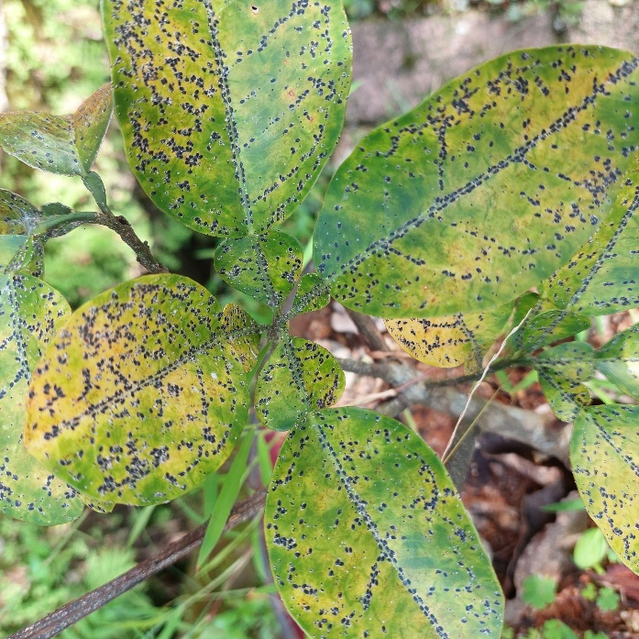

Figure 1: Example of a diseased plant leaf showing visible symptoms [Adapted 9]]

Recent advances in deep learning, particularly Convolutional Neural Networks (CNNs) and transfer learning techniques, have significantly improved automated plant disease detection. These approaches enable automatic extraction of discriminative features from plant leaf images, reducing the need for manual feature engineering while improving classification accuracy and computational efficiency. Therefore, this research proposes a ResNet50-based transfer learning framework for accurate and efficient plant disease classification using the PlantVillage dataset.

Problem Definition
Although numerous deep learning models have been proposed for plant disease detection, several challenges remain. Many existing approaches require high computational resources, suffer from limited generalization under different environmental conditions, and exhibit reduced classification performance when diseases present similar visual characteristics. These limitations restrict their practical deployment in real agricultural environments. Therefore, there is a need for a computationally efficient and highly accurate deep learning framework capable of improving classification performance while maintaining robustness across different plant disease categories.

1.3 Thesis Objectives

- To propose a deep learning framework using ResNet50 and Transfer Learning that would enable the automatic classification of plant diseases.
- Implement image pre-processing and data augmentation to allow the generalization of the proposed model.
- Test the performance of the proposed model on the PlantVillage dataset.
- Compare the proposed deep learning approach with state-of-the-art methods using the metrics Accuracy, Precision, Recall and F1-score.

1.4 Thesis Contribution

Main contributions: Build a new automatic plant disease identification system by leveraging ResNet50 transfer learning. Combine preprocessing, data augmentation, CNN feature extraction and Feature Pyramid Network (FPN). The validation accuracy is up to 99.42%, validation loss is 0.0228.
And evaluation with Precision, Recall, F1-score, ROC curve and Confusion Matrix.

1.5 Thesis Organization

Thesis Organize as:
Chapter 1 presents the introduction.
Chapter 2 reviews the related work and previous studies.
Chapter 3 describes the proposed methodology.
Chapter 4 presents experimental results and discussion.
Chapter 5 concludes the thesis and outlines future work.

Chapter 2 Background and Related Work
2.1 Introduction
This chapter discusses theoretical aspects and background work on AI and Deep Learning based plant disease detection. Major concepts of Artificial Intelligence (AI), Machine learning(ML), Deep Learning(DL), Convolutional neural networks (CNNs) , Transfer Learning and Feature Pyramid Network(FPN) is discussed briefly. Finally, review of the recent works carried out. is discussed in order to review some challenging problems and research gaps. in which this work is supposed to address.

This chapter presents a comprehensive review of existing studies in plant disease detection using deep learning techniques. The review includes both foundational research and recent studies, highlighting key methodologies, datasets, performance metrics, and limitations. While earlier studies demonstrated high accuracy on controlled datasets such as PlantVillage, challenges remain in generalizing models to real-field environments, handling data imbalance, and reducing computational complexity.

Recent research has focused on advanced architectures such as multi-scale models, hybrid frameworks, and transformer-based approaches to improve robustness and efficiency. In addition, this chapter identifies key research gaps and outlines future directions for developing more practical and scalable plant disease detection systems.

2.2 Background
Before discussing the proposed approach, it is useful to have an idea of the main ideas around Artificial Intelligence and Deep Learning.Agriculture plays one of the biggest roles for food security and the economy for the whole world. Unfortunately, diseases can infect plants, which become quite a nuisance to agriculture worldwide as they affect the quality and productivity of crops. Plant disease can be detected if an automated method is developed in which the early detection of plant disease would result in significant saving.Traditionally in agriculture, experts looked for diseased plants using their eyes, which is inefficient in terms of time, money, effort and accuracy when large areas need to be covered.
Recent advances made in Machine Learning, Deep Learning and Artificial Intelligence have brought with them increased possibilities in the agricultural applications domain. These advancements enabled automatic inspection and diagnosis of plant diseases via using images to identify them. Applications of AI, ML and DL for plant disease identification have been investigated previously, as demonstrated below.

2.2.1 Artificial Intelligence (AI)
refers to the development of computer systems that can perform tasks that require human intelligence, such as visual perception, reasoning, learning, problem-solving, speech recognition, and decision-making. The role of AI in healthcare, transportation, banking, and agriculture, is increasing. Artificial Intelligence has become one of the most influential technologies in agriculture by enabling intelligent systems capable of image analysis, disease prediction, and decision support. AI techniques significantly reduce human effort while improving the efficiency and accuracy of agricultural monitoring.

2.2.2 Machine Learning (ML)

Is a branch of AI that focuses on developing algorithms that allow computers to learn from data without being explicitly programmed. Instead of being told how to process information, these algorithms identify patterns and correlations within large datasets, and their performance can improve over time as more data becomes available.ML algorithms can be classified into three types:
- Supervised Learning (uses labeled training data)
- Unsupervised Learning (finds patterns in unlabeled data)
- Reinforcement Learning (learns from interaction and reward/punishment)

In plant disease detection, supervised learning techniques are commonly employed, since leaf images are usually labeled according to their respective disease category. Many traditional machine learning algorithms, such as Support Vector Machine (SVM), Decision Tree, Random Forest and K-Nearest Neighbor (KNN) algorithms, have successfully been used to identify and classify plant diseases. However, the use of traditional ML methods relies on manual extraction of features such as color, shape and texture, which might result in less effectiveness when dealing with large datasets. Traditional machine learning methods require manual feature extraction, making them less effective than deep learning approaches when dealing with complex image datasets.

2.2.3 Deep Learning

is a kind of deep learning approach that can learn feature representation on hierarchical level and on its own from scratch (raw input). in contrasts with earlier approach for ML, deep learning does not require manual feature design which enables deep learning models to perform quite good at various tasks, such as image classification, so a variety of deep learning models are good for tasks like image recognition & detection and any type of task that have patterns. The Use of DL DL has gained momentum and state of the art results for many computer vision tasks including the image related tasks, including medical image detection & diagnosis, face recognition, object identification, self-driven vehicles and applications in agriculture. Among some of best DL architectures for agriculture are CNNs, ResNets (a well-known deep learning based image recognition model that overcomes some of the problems in training a deep neural network, like the vanishing gradients), EfficientNets, Vision Transformers (ViTs) and hybrid deep learning models to deliver state-of-the-art accuracy with lower feature design process. recent advancements in architecture designs of DL-powered CV algorithms enable increased plant disease classification accuracy and accuracy over handmade feature engineering methods.

2.2.4 Convolutional Neural Networks (CNNs)

CNNs are an architecture of a neural network and deep learning designed specifically for processing and analyzing images. CNN’s automatically learn low-level and high-level visual features like contours, colors, textures, shapes, disease symptoms, etc. after going through multiple convolutional layers, thus, they don’t require any feature extraction as in a traditional ML algorithm. An image will first pass through many layers such as:

- Convolutional layers apply learnable filters to extract local features like edges, corners, and textures.
- Activation layers (e.g., ReLU - Rectified Linear Unit) introduce non-linearity to the model, enabling it to learn complex relationships.
- Pooling layers reduce the spatial dimensions of the feature maps, reducing computation and preventing overfitting.
- Fully Connected layers combine the extracted features to classify the image.
- A Softmax layer outputs the probabilities of the image belonging to each disease category.
- CNNs have emerged as a dominant choice for plant disease identification due to their ability to effectively learn rich image representations, their high accuracy, and their elimination of manual feature extraction.
- The general structure of a Convolutional Neural Network is illustrated in Figure 2.X.
- ( CNN Architecture : Input Image Convolution ReLU Pooling Fully Connected Softmax Output.)
- CNNs have become the dominant approach for plant disease image classification because of their ability to learn complex visual patterns directly from images.

2.2.5 Transfer Learning

Allows for the utilization of knowledge learned from massive benchmark datasets like ImageNet into our deep learning model, thus the weight pre-training was adopted instead of training a model from a completely new beginning saving computational costs, enhancing the efficiency.This technique can save you lots of time and resources, instead of training a deep learning model from the start, pre-trained weights(e.g. ResNet50, VGG16, EfficientNet, MobileNet …)are fine-tuned on a relevant task or data that we aim, then the model can perform really well in many cases and gets to high accuracy in even few amounts of data which is usually needed in plants’ disease detection in many researches, mainly because it’s costly and inconvenient to find abundant labeled plant images and data to conduct the experiment. The approach of transferred learning has become very common in these works, since only limited labeled agricultural datasets were present in many cases.
2.2.6 Feature Pyramid Networks (FPNs)

Combine feature maps from different convolutional layers to enrich the multi-scale feature representation, which helps to effectively diagnose small lesions to large affected areas.Feature Pyramid Network(FPN)Feature Pyramid Network (FPN) is a deep learning architecture proposed in the article, which aims to use different levels of CNN to establish a feature pyramid and effectively detect objects of various scales in the image. In identifying plant diseases, it is very important that some diseases could be diagnosed from small spot size, whereas the other diseases be identified from relatively large affected areas. Traditional CNN will fail in diagnosis under multiple scales conditions due to limited effective feature selection ability at the different scales.
FPN can enhance prediction of images using information at different scales, from rich low-level spatial details to high-level semantic information, and preserve strong semantic and spatial information simultaneously by combining low-level features with high-level semantic information to yield robust image classification.

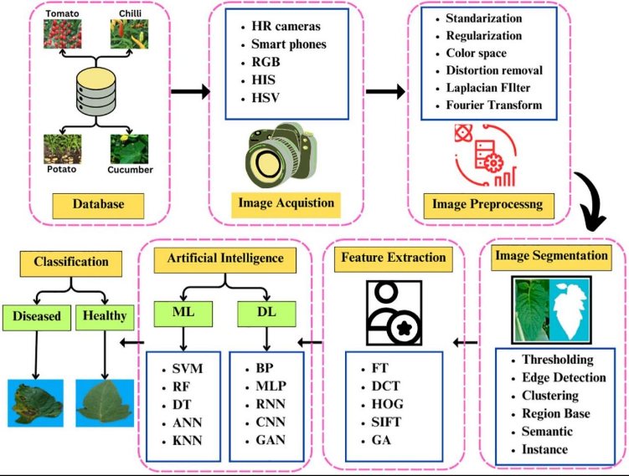

Figure 2: General workflow of plant disease detection[16]

2.3 Related Work

Sharma et al. (2023) [1]An attention-based Convolutional Neural Network (CNN) was introduced by Sharma et al. (2023) [1] to improve plant disease classification and localization by focusing the model’s attention on the infected regions of plant leaves. The framework uses attention mechanisms to guide the CNN to extract relevant features from the infected areas and ignore irrelevant background information. It was trained on the PlantVillage dataset and real-field image datasets and reported an overall classification accuracy of 98.7%. The study concluded that attention significantly improved both disease localization and classification performance compared to traditional CNN models and enhanced the model’s robustness to various image conditions. However, the increased complexity of attention modules led to higher computational requirements and training time, making the model less practical for resource-limited devices.

Patel and Shah (2024) [7] developed a Vision Transformer (ViT)-based framework for plant disease classification. They leveraged the self-attention mechanism to learn global image representations, offering an advantage over CNNs which typically focus on local features. By capturing long-range dependencies between image patches, their model was able to extract richer feature representations. Trained on large benchmark datasets including PlantVillage, their framework achieved a classification accuracy of 99.1%, outperforming several CNN-based models in accuracy and feature learning capabilities, and showing strong discrimination between visually similar disease categories. Nonetheless, the ViT architecture demands substantial computational power, large memory, and extensive training data, limiting its utility in resource-poor agricultural scenarios.

Wang et al. (2024) [8] presented a multi-task deep learning framework capable of simultaneously classifying plant diseases and localizing lesions. The motivation behind this approach was to enhance disease identification by jointly learning related tasks within a single network. Trained on annotated plant disease datasets, including PlantVillage and real-field images, the framework achieved a classification accuracy of 98.2%. The results indicated that the multi-task learning paradigm improved feature representation and accuracy in identifying disease symptoms, also providing localization information, and that shared feature extraction streamlined learning. The drawback was the increased complexity and computational demands associated with integrating multiple learning objectives.

Sahu et al. (2025) [14] put forward a Hybrid Dilated Convolutional Neural Network (Hybrid Dilated CNN) that is designed to aid in plant disease detection through enhanced feature extraction without a loss of spatial information. The innovative design of this model utilizes dilated convolution layers with differing dilation rates to expand the model's field of view without sacrificing image resolution, enabling it to better identify plant disease symptoms. When the model was trained on a number of plant leaf datasets, such as PlantVillage and various augmentation variants, it achieved an overall classification accuracy of about 98%.It was demonstrated in experiments that the hybrid dilated architecture outperformed more conventional CNN models in classifying diseases and improved disease recognition capabilities, especially with respect to minor lesions and visually similar disease categories. Also, this architecture achieved better feature representation. However, it must be noted that this structure requires more computational power and a longer training period, owing to the usage of multiple dilated convolution layers.

Chen et al. (2023) [2] proposed an automatic plant disease detection system based on the EfficientNet architecture, aiming for high classification accuracy and fewer model parameters using EfficientNet’s compound scaling method to balance depth, width, and image resolution. The model was trained on the PlantVillage and PlantDoc datasets and achieved an accuracy of 98.9%. The experimental results demonstrated that EfficientNet outperformed standard CNN models in both classification performance and efficiency, with a significantly reduced number of parameters. Nevertheless, the model exhibited limited robustness to noisy images and real-world agricultural scenarios, suggesting limitations in generalization.

Kumar et al. (2023) [3]Kumar et al. (2023) [3] explored Transfer Learning for plant disease classification by fine-tuning popular CNN models, such as VGG16 and ResNet50, which were pre-trained on ImageNet, using publicly available plant disease datasets like PlantVillage. The study achieved an accuracy of 98.0%, demonstrating the effectiveness of transfer learning in reducing training time and achieving high predictive accuracy, especially with limited data. However, the deep CNN architectures required significant computational resources and high-memory GPUs, making deployment on low-resource devices challenging.

Li et al. (2023) [4]A deep learning framework based on ResNet was developed by Li et al. (2023) [4] for automatic plant disease detection using leaf images. The architecture leverages residual learning to effectively handle very deep networks and extract complex features from leaf images. The model, trained on the PlantVillage dataset, attained an overall classification accuracy of 98.5%. The authors found that residual connections improved feature learning, classification stability, and the model’s ability to recognize complex patterns. Nevertheless, the deep residual network had substantial computational and memory demands, potentially hindering real-time implementation.

Zhang et al. (2023) [5] presented a CNN-based plant disease detection framework with enhanced feature enhancement techniques to improve classification accuracy. The proposed method focuses on bolstering feature representation before classification to better distinguish subtle disease symptoms. The model was trained on the PlantVillage dataset and various augmented datasets, yielding an overall classification accuracy of 97.9%. The experimental results showed that enhanced feature extraction improved the recognition of visually similar diseases and overall robustness. Data augmentation techniques further improved generalization, but the additional feature enhancement steps increased training time and computational load.

Khan et al. (2024) [6] introduced a lightweight Convolutional Neural Network (CNN) tailored for real-time plant disease detection on edge devices. Their objective was to design a model that minimizes computational costs while achieving high classification accuracy, making it suitable for mobile and embedded systems in agriculture. The model was trained on diverse public datasets like PlantVillage and real-field images, achieving a classification accuracy of 97.8%. Experiments confirmed that the lightweight architecture significantly reduced inference time and memory footprint compared to traditional CNNs, proving practical for resource-constrained settings, without compromising performance excessively. However, the authors noted a drop in model robustness in complex environments characterized by varying lighting, clutter, and noise.

Zhang et al. (2024) [9] proposed a hybrid CNN model for plant disease classification, combining several convolutional architectures to boost feature extraction power. This approach aimed to leverage complementary feature learning strategies to capture both low-level and high-level characteristics of diseases from leaf images. The model was trained on publicly available datasets such as PlantVillage and other field image datasets, attaining a classification accuracy of 97.6%. The experimental outcomes revealed that the hybrid design enhanced classification stability and accuracy for visually similar diseases, as well as improved generalization across various plant types and disease classes. The trade-off was higher training time and computational complexity due to the increased number of parameters in the network.
Upadhyay et al. (2024) [10] provided an exhaustive review of deep learning methods for plant disease detection, covering both CNN and Transformer models. They evaluated the performance of numerous state-of-the-art architectures on multiple public datasets like PlantVillage, PlantDoc, and other benchmarks, with reported classification accuracies ranging from 95% to 99%. Their review concluded that deep learning models significantly outperform traditional machine learning approaches in this domain due to superior feature learning capabilities. Transformer models showed promise in capturing global image features, whereas CNNs offered greater computational efficiency. A key takeaway was that practical implementation remains a hurdle for many deep learning models due to high computational resource requirements and limited generalization to real-world conditions.such as PlantVillage, PlantDoc, and other public datasets, reporting accuracy between 95% and 99%. However, deployment remains challenging.

Wang et al. (2025) [12] put forward an advanced deep learning model consisting of Convolutional Neural Networks (CNNs) as well as Transformer based models for detecting plant diseases. The main purpose of this study was to merge the capability of CNNs to extract local features with the global understanding ability of Vision Transformers.For this model training, extensive plant disease data was employed that were gathered from multiple sources, like plant disease datasets of the PlantVillage type, and the classification accuracy exceeded 97%. Based on the experimental findings, this hybrid structure boosted the robustness of classification across various plant species and categories of diseases, all while preserving the performance level of the prediction. When combining CNNs and Transformers, the model’s ability to identify complicated disease symptoms in diverse environmental conditions was improved.However, this hybrid structure demanded extensive computation power and poses scaling issues in systems intended for broad agricultural monitoring.

Ibrahim et al. (2025) [15] Ibrahim et al. (2025) [15] introduced an improved deep learning model for plant disease identification that integrated multiple optimization techniques in order to boost accuracy and generalizability. By training on a mixture of plant disease datasets, including PlantVillage and real-field images, this model learned to characterize disease in a variety of agricultural conditions (controlled and real). Experimental outcomes demonstrated an overall classification accuracy of 97.5%, which signifies robust performance across diverse plant species and diseases.

Zhao et al. (2025) [13] developed an object detection model based on Mask R-CNN and Faster R-CNN that could be utilized for the automated detection and localization of plant diseases. This framework differentiates itself from other image classification approaches because it identifies not only disease categories, but also the precise position of affected areas on plant leaves, based on their bounding boxes.This model was trained with a collection of plant disease datasets that had bounding-box labels for each affected region and achieved detection accuracies from 63% to 90% (depending on the data quality and labeling precision). Experimental analysis indicated that the two detection models were effective at pinpointing disease symptoms with accuracy, while also achieving dependable results in terms of classification. Yet, this research highlighted the fact that the performance of this model is strongly reliant on the completeness and precision of manual labels, which in turn makes dataset creation time-consuming and costly.

Ahmed et al. (2025) [11] suggested a multi-scale Convolutional Neural Network (CNN) paired with a Feature Pyramid Network (FPN) in order to achieve better results for plant disease detection through different spatial resolutions of disease symptoms. The proposed framework leverages the combined features from various convolutional layers in order to assist the model in identifying smaller lesions as well as larger affected regions more accurately. This model was trained using numerous plant disease datasets which are publicly accessible, such as PlantVillage and real-field image datasets.The classification accuracy achieved was an overall score of 99.2%. When experimental tests were performed, it was determined that FPN had a positive effect on the feature representation, therefore enhancing classification outcomes over more traditional CNN models. Furthermore, the presented framework exhibited increased resilience in identifying early symptoms of disease.However, utilizing multi-scale feature extraction led to an increased memory usage and more intensive computational requirements during the training process.

Additionally, training the model with multiple datasets enhanced its generalization capability and decreased over fitting in comparison to models trained on individual datasets. However, it was emphasized that before implementing the proposed model in practice, further validation with more substantial real-world agricultural data is essential.
2.4 Comparison of Existing Methods
This section presents a comparative analysis of existing deep learning-based methods for plant disease detection. The comparison focuses on key aspects of each study, including the methodology used, datasets, achieved accuracy, and the main limitations. The purpose of this comparison is to provide a clear overview of the strengths and weaknesses of current approaches, as well as to highlight common challenges such as high computational complexity, limited robustness in real-world environments, and dependency on dataset quality. This analysis helps in identifying research gaps and motivates the development of more efficient and scalable solutions.
Table 1 summarizes the selected previous studies by comparing their methodologies, datasets, reported accuracies, and major limitations.

Limitations | Accuracy | Dataset | Methodology | Year | Study
High computational complexity | 98.7% | PlantVillage + Field Images | CNN + Attention | 2023 | Sharma et al.
Scalability issues | >97% | Multi datasets | CNN + Transformer | 2025 | Wang et al.
High complexity | ~98% | Plant leaf datasets | Hybrid Dilated CNN | 2025 | Sahu et al.
Needs real-world validation | 97.5% | Combined datasets | Optimized Deep Learning Model | 2025 | Ibrahim et al.
High computational cost | 99.1% | Benchmark datasets | Vision Transformer (ViT) | 2024 | Patel & Shah.
Depends on data quality | 63%–90% | Annotated datasets | Mask R-CNN, Faster R-CNN | 2025 | Zhao et al.
High memory usage | 99.2% | Multi datasets | Multi-scale CNN (FPN) | 2025 | Ahmed et al.

2.5 Research Gap

According to the discussed papers, currently available plant disease detection methods have several defects such as high computational cost, weak ability of generalization, poor classification accuracy in changing environment and requiring high computation, which are inconvenient for implementation. This research develops a transfer learning model based on ResNet50 with image preprocessing and Feature Pyramid Networks(FPN) to improve classification accuracy and reduce computational cost.

Chapter 3 Methodology
The workflow of the proposed methodology The proposed work utilizes deep learning for automated detection of diseases on plant leaf through an image analysis. The proposed method is based on Image Pre-processing, CNNs, Transfer Learning (TL) and Feature Pyramid Networks (FPN) techniques to optimize and boost the performance in disease classification. In order to address the problems detected in Chapter 2 regarding the generalizations, computational cost, and the accuracy, we proposed a new approach.
The schematic diagram of the whole system shown in Figure 3.1.

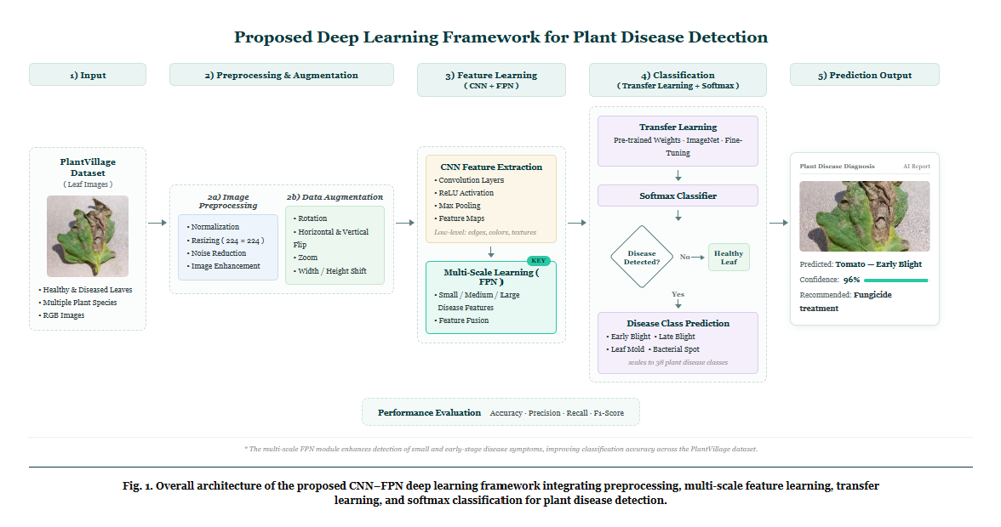

Figure 3.1: Proposed Framework of Plant Disease Detection System

3.1 Input (Dataset)
PlantVillage dataset PlantVillage dataset is one of the widely known dataset for studying on plant disease recognition. It consists of thousands of colored leafimages belonging to healthy, diseasedplants for many crop. The classes that we have selected here from the dataset are as below.Pepper Bell Bacterial Spot, Pepper Bell Healthy, Potato Early Blight The below figures illustrates some sample samplesfrom selected dataset classes.
3.1.1 Classification Dataset
The PlantVillage dataset has become one of the most famous publicly available benchmark dataset to classifying plant diseases. This dataset comprises a total of 54,306 high-quality RGB pictures, captured from multiple crop species under well-controlled settings and contains more than a hundred varieties of plant diseases, healthy or sick. With their highly quality of image and balanced number of entries for different diseases, the dataset was used widely to research a deep learning based approach for recognizing diseases on the plants.For this experiment, three categories of PlantVillage Dataset was extracted to be used which are: Pepper Bell Bacterial Spot, Pepper Bell Healthy, Potato Early Blight, due to contain some examples of both diseases as healthy one that allow to build a system that differentiate diseased samples from the healthy one, and due to the presence of the mentioned plant types and variety of disease that could greatly affects to the yield of plants. Figure 3 shows sample pictures of plant with some plant diseases which selected in the PlantVillage dataset such as: Pepper Bell Bacterial Spot, Pepper Bell Healthy and Potato Early Blight.

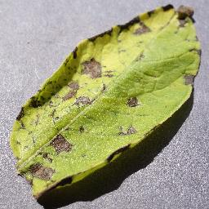
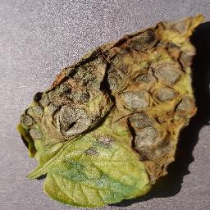
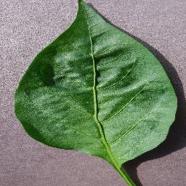
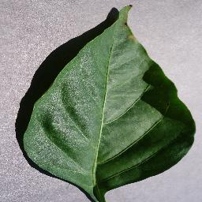
Pepper Bell Bacterial Spot Pepper Bell Healthy Potato Early Blight
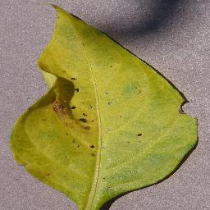
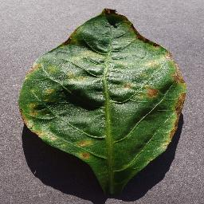

Figure 3.2 Image from Dataset

3.2 Image Preprocessing
Before the proposed deep learning model is trained, all input images will undergo an image preprocessing procedure to obtain consistency, boost the quality of images, and enrich the learnability of the deep learning model. In the case of the PlantVillage dataset, the images show a variety of appearances, so preprocessing is mandatory in order to harmonize input images before feature extraction. Preprocessing procedures remove unnecessary differences between images, thereby helping the deep learning model concentrate on identifying specific features pertaining to the disease in images instead of unrelated information.
Histogram normalization

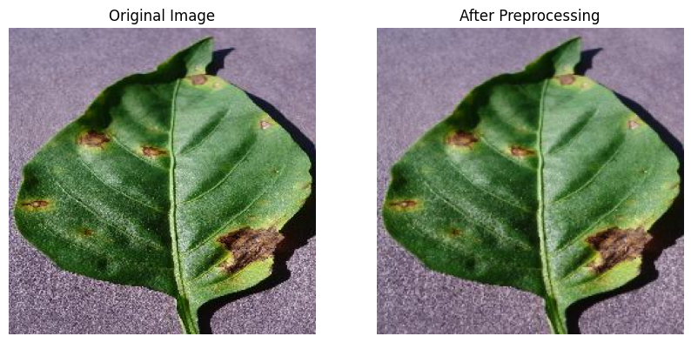

(Figure 3.3: Image Before and After Preprocessing)

3.2.1 Image Resizing
Each original image is resized.to 224 224 pixels, which is the size input that the deep learning model requires as it can be see in the model architecture above. Normalizing the size of each image ensure that each of the input to the model has the same shape.. resizing of image has advantages that it makes the computation load smaller, reduces the model training time, can perform batch training without distorting the basic features of the disease on the leaf.
3.2.2 Image Normalization
After images are resized, pixels values are normalized in the range of 0-1 by multiplying the original pixel values of 0-255 by 1/255. The image normalization helps to stabilize numerical values for the optimization algorithm and also enables the algorithm to converge faster and prevent the large pixel values from taking control in the learning process, so that the gradient updates can be more stable and thus the classification accuracy can be boosted up.
3.2.3 Noise Reduction
Even though images in the PlantVillage dataset are considered quite clean, some small image noise and undesired image appearance variations can still be present. To address this, image denoising methods are applied to remove image artifacts which are irrelevant and harmful to diagnose the disease and not of great interest while retaining the relevant visual disease characteristics (leaf spots, discoloration and texture) so that the convolutional neural network is able to extract useful features.
3.2.4 Image Enhancement
Image enhancement in this work focuses on providing visually better quality images for the input to the deep learning model for easier extraction of the features. Image enhancement mainly in this work involves resizing of the images to 224 x 224 pixels and normalizing their intensities in the range of [0,1] (which originally were [0,255]). These are the input images for the CNN model.
Normalization makes the model invariant to illumination effects and helps the model converge faster. This results in stable training and convergence of the model, thereby providing better accuracy as the model can learn features based on color changes, lesion shapes, etc rather than just the intensity of the image.
3.2.5 Data Augmentation
Several data augmentation methods are used during the training of the proposed model to ensure good generalization and avoid over-fitting. Data augmentation helps create additional samples artificially by transforming the existing image in a random way while maintaining the same label of that image. Augmentation expands the diversity of the training data, helping the model behave well in various image conditions.
3.2.6 Rotation
Each of the training images is randomly rotated using varying angles. Leaves may naturally present themselves at different orientations so rotating them means the model learns that it should look for signs of disease in any position the leaf happens to be in.
3.2.7Horizontal and Vertical Flip
Mirrored versions of the original images are created by using horizontal and vertical flip. They maintain the disease class and augment the diversity of the training data. It makes the model less dependent on the direction of the leaf and enables to perform better generalization.
3.2.8 Zoom
The model randomly zooms into images to be able to detect disease features at various scales. Some diseases can first be small lesion size, others extend to larger parts of the leaves. By zooming it, we force the model to be able to learn disease signatures irrespective of scale.
3.2.9 Width and Height Shift
The image is horizontally translated to the right or to the left, and it’s also translated upwards and downwards to random values. The aim is to avoid the trained model to “fixate” in a specific position of the symptoms of the disease within the image, thus making the model focus on the visual characteristics instead of their precise location. In this way, when the model analyzes images of plant leaves from real environments it is more reliable.
3.3 Feature Learning
After applying the preprocessing and data augmentation operations, the ready images are supplied into the feature learning module to extract automatically effective visual characteristics from the images of plant leaf, to discriminate between disease leaves and normal ones. Our framework instead of manually designed feature extraction module employ the application of deep learning technologies to learn discriminative feature automatically from training image data. In this proposed feature learning framework, the blend of Convolutional Neural Networks (CNN) , Transfer Learning (TL) ,and Feature Pyramid Networks (FPN) will further contribute to higher classification performance and stronger model stability.
3.3.1 Convolutional Neural Network (CNN)
Convolutional Neural Networks (CNNs) are one of the most popular deep learning approaches applied for image classification problems. The network was especially designed for the analysis of visual information, automatically extracting high-level features from the images to be processed. Unlike many classical approaches that require manual selection of image features, the CNN learns these characteristics (both low-level and high-level) on its own while being trained on the training data.
The model receives a preprocessed image of the plant leaf as the first input. The image goes through several convolutional layers and various learnable filters are used to extract salient image features like leaf shape, texture, color, presence of lesion, etc. After extraction, these features are filtered by an activation function and downsampled by pooling layers.
These extracted features are then flattened and used as inputs to fully connected layers where the network learns the connection between extracted image features and the type of plant disease that the leaf has, outputting a classification decision.

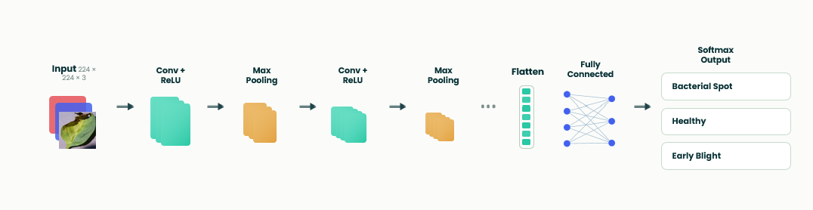

Figure 3.3.1 : CNN Architecture

3.3.2 Feature Pyramid Network (FPN)
Plant disease symptoms exist in varied scales and sizes, some plants first show symptoms in small lesions or spot- like patches over leaf surface, while other disease manifestations span over the wider infected area. Hence, a general CNN would not be enough to represent plant disease information across various feature scales. To address this, an FPN has been incorporated after the feature extraction section of the proposed framework.
An FPN, after pooling and upsampling of feature maps extracted from multiple CNN layers, provides a representation that contains detailed spatial information in shallow layers while deep semantic features in high layers can enrich this representation to recognize disease features across scales, and finally can extract robust disease symptoms at different scales to overcome limitations of limited spatial or semantic information within a single CNN level. Combining multi-level feature maps from FPN enhances the ability of proposed method to learn robust feature representations for plant diseases and perform classification accurately.
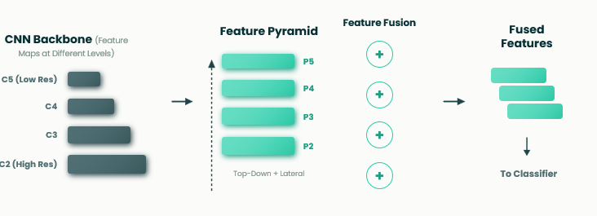

Figure 3.3: Feature Pyramid Network (FPN)

3.4 Transfer Learning
3.4.1 Transfer Learning
training a deep learning model from scratch would necessitate vast amounts of labelled data, together with significant computational power. Thus, in order to tackle the aforementioned issues, Transfer Learning has been incorporated in the proposed framework.Transfer Learning permits the proposed model to acquire knowledge derived from extensive image datasets, such as ImageNet, and then applies it to the problem of plant disease classification. Rather than randomising all parameters in the network, the weights of the pre-trained CNN bring in substantial information pertaining to visual feature extraction that helps convergence and enhances classification accuracy.
Fine-tuning has solely been performed on the last few layers (classifier part) of the network using the PlantVillage dataset, resulting in reduced computational costs, low risk of overfitting, and overall enhancement of the model’s generality. With Transfer Learning the model’s effectiveness can be achieved despite its training on relatively few data points from the domain of agriculture. despite its training on relatively few data points from the domain of agriculture.
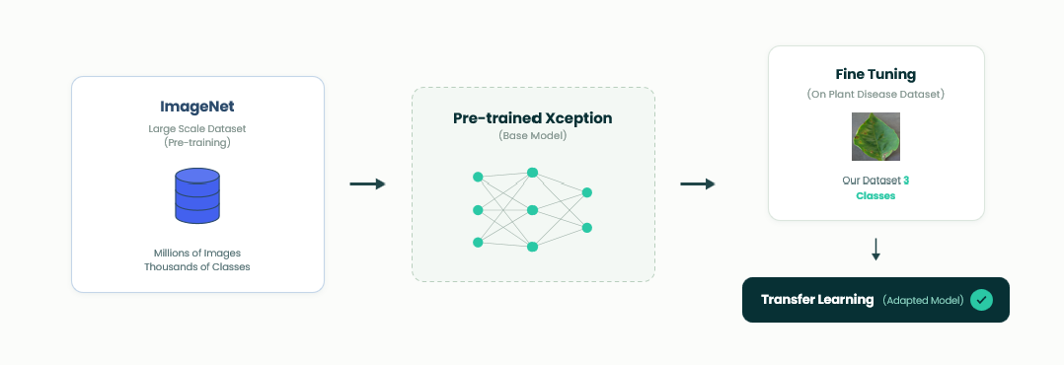
Figure 3.4 : Transfer Learning with ResNet50.

3.4.2 Disease Classification
After the CNN-based feature extraction and multi-scale features are strengthened using the Feature Pyramid Network, the resulting features are passed into the classification stage, where they help to decide the ultimate category of each plant leaf image. The proposed architecture uses Softmax classifier as the last output layer since the present task is the multi-class classification. Softmax activation takes scores as output from previous layers, turns them into probabilities between 0 and 1 (sum of all the probabilities must be equal to one).
Finally, the class having maximum probability will be predicted. For instance, the probability of all class scores will be generated if the output of image falls into the category Potato Early Blight and that one which is highest probability will be considered as the predicted category of that image. This allows the classification mechanism to recognize the image as healthy/diseased leaf and also classify the type of the particular disease.

3.5 Prediction Output
Once the classification process has been performed, the developed framework generates the final prediction result of the given plant leaf image, along with the predicted disease class and the confidence level from Softmax classifier. The confidence level represents the likelihood of the input image corresponding to the given class. The developed system provides the prediction result in a concise manner and user-friendly way that enables the users to rapidly recognize if the plant leaf is healthy or disease infected.
The related disease type (if it is infected) and the suggested remedy is also displayed. A demonstration of prediction output from the proposed framework is depicted in figure 3.5

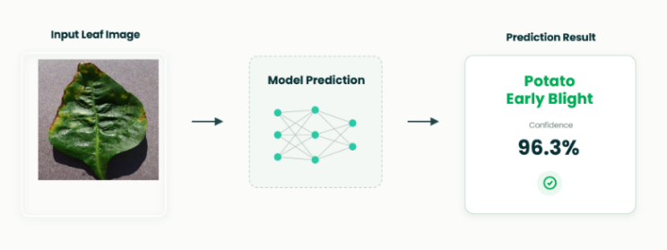

Figure 3.5: Prediction Output

3.6 Training Configuration
The deep learning model which we are proposing, is trained with selected classes of PlantVillage dataset, after performing all pre-processing and data augmentation tasks. Various hyper-parameters are tuned to provide efficient convergence, stabilize learning process and increase the classification accuracy of the proposed model..

Parameter | Value
Dataset | PlantVillage
Image Size | 224 × 224
Batch Size | 32
Epochs | 6
Optimizer | Adam
Learning Rate | 0.001
Loss Function | Categorical Cross-Entropy
Activation Function | ReLU
Output Layer | Softmax
Evaluation Metrics | Accuracy, Precision, Recall, F1-score

3.7 Performance Evaluation
The proposed plant disease detection model was evaluated using several commonly used classification measures. Classification measures quantify the efficiency of the proposed model, which may facilitate comparing our model with the related works in the literature.
3.7.1 Accuracy
Accuracy measures the percentage of correctly classified samples among all testing samples.
$$Accuracy=\frac{TP+TN}{TP+TN+FP+FN}$$
where:
TP = True Positive
TN = True Negative
FP = False Positive
FN = False Negative

3.7.2 Precision
Precision measures the proportion of correctly predicted positive samples among all predicted positive samples.
$$Precision=\frac{TP}{TP+FP}$$
Higher Precision indicates that the proposed model produces fewer false positive predictions.

3.7.3 Recall
Recall evaluates the capability of the proposed model to correctly identify actual positive samples.
$$Recall=\frac{TP}{TP+FN}$$
Higher Recall indicates that fewer diseased samples are incorrectly classified as healthy.

3.7.4 F1-Score
The F1-score combines Precision and Recall into a single performance metric by calculating their harmonic mean.
$$F1=\frac{2×Precision×Recall}{Precision+Recall}$$
The F1-score is particularly useful when evaluating multi-class classification problems because it balances both Precision and Recall.

3.7.5 Confusion Matrix
The numerical evaluation metrics are complemented with a confusion matrix for visually presenting the classification results achieved by the suggested model. The confusion matrix shows how many samples of each disease type are correctly and wrongly classified.

Chapter 4: Results and Discussion
For our purpose, the ResNet50 based model has been experimented with the dataset PlantVillage for determining accuracy for classify diseases from leaves of the plants. In this chapter, the details on preprocessing of dataset and evaluation performance (on overall basis as well as on class basis), and analysis of results are included. As shown from the result, the achieved high classification accuracy and acceptable performance on generalization with validation set, indicates good generalization capability of our proposed method.
4.1 Preprocessing and Visual Standardizations
Deep Learning Model training included an image preprocessing stage, used to homogenize data consistency and facilitate features learning. All the training data was reshaped into a 224 224 dimension, according to ResNet50architecture input. Then, the pixel intensity values were normalized for a more stable training and a faster convergence of the training procedure.
The preprocessing process decreased noise in the dataset, minimizing differences related to images size and intensity, while maintaining features relevant to the pathologies under consideration. In this way, the model had the ability to attend the salient pathologies features instead of the background noise, thus improving its ability to learn and identify these symptoms. Some examples of images before and after the processing steps can be seen in Figure 4.1.
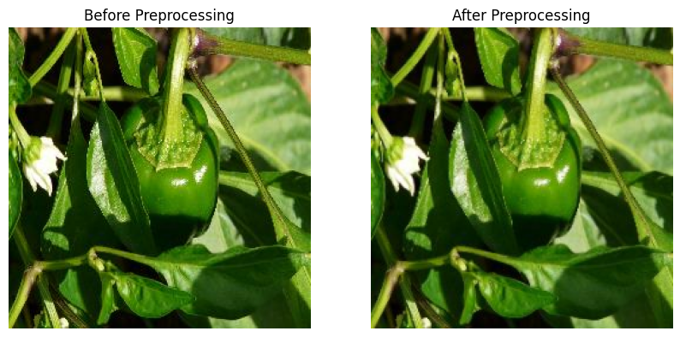

Figure 4.1 Images Before and After Preprocessing
4.2 Classification Performance
The developed ResNet50 model was tested on the validation data set to measure performance of the model on validation data by various validation parameters such as validation accuracy, validation loss, validation precision, validation recall and validation F1-score.
Table 4.1 presents the overall performance achieved by the proposed model.
4.2.1 Xception
A. Xception Model.
The proposed Xception model was assessed overall on the validation set and determined by calculating validation accuracy, validation loss, precision, recall, and F1-score. Table 4.1 below illustrates the accuracy, loss, precision, recall and F1-score of the proposed Xception model on the plant leaf classes selected in this research. Table 4.1: Proposed Xception model average resultsValidation accuracy, validation loss and average precision, recall and F1-score of the proposed model are estimated as 97.22%, 0.0951 and 97% respectively. Table 4.1 Overall Performance of the Proposed Model

Metric | Value
Validation Accuracy | 97.22%
Validation Loss | 0.0951
Average Precision | 97.00%
Average Recall | 97.00%
Average F1-score | 97.00%

These results suggested that the developed method had high classification accuracy with balanced results across all metrics.
B. Per-Class Classification Performance
In addition to overall performance evaluation, precision, recall, and F1-score are computed for each class in the context of three plant leaf classes as shown in Table 4.2. Potato Early Blight gets the best classification performances

Class | Precision | Recall | F1-score
Pepper Bell Bacterial Spot | 0.91 | 0.96 | 0.93
Pepper Bell Healthy | 0.97 | 0.95 | 0.96
Potato Early Blight | 1.00 | 0.99 | 0.99

C. Confusion Matrix Analysis

Additionally, a Confusion Matrix was built to gauge the performance of classification of Xception model by finding number of correct and incorrect classifications within each category. suggests that the values across the diagonal represent the cases classified accurately while the ones off the diagonal represents cases misclassified. The Xception model successfully predicted 286 images of Pepper Bell Bacterial Spot, 413 images of Pepper Bell Healthy, and 297 images of Potato Early Blight.While 10 of Pepper Bell Bacterial Spot images are wrongly predicted as Pepper Bell Healthy and 3 as Potato Early Blight, among Pepper Bell Healthy images, 30 are wrongly classified as Pepper Bell Bacterial Spot and none as Potato Early Blight. The model misclassifies only 3 out of 300 images as Pepper Bell Bacterial Spot while correctly classifies the rest of 297 images of Potato Early Blight. Most misclassification happened in between Pepper Bell Bacterial Spot and Pepper Bell Healthy implying both categories possess strong resemblances. However, majority elements lie on the diagonal, indicating effectiveness in the prediction based on proposed model to different categories of plants leaves. As Showen in Figure 4.3 .

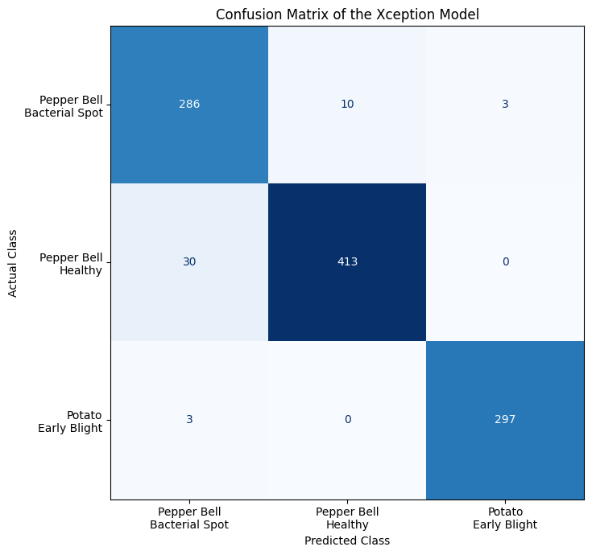

Figure 4.3. Confusion Matrix of the Xception Model for the Three Plant Disease Classes.

D. ROC Curve Analysis

Receiver Operating Characteristic (ROC) curve analysis was also performed to further assess the classification performance of the Xception model for the 3 classes of plant leaves. The ROC curve describes the correlation between True Positive Rate (TPR) and False Positive Rate (FPR) for varying thresholds in the classifier and the Area Under the Curve (AUC) reflects the model's efficiency in distinguishing between the different classes. Figure 4.4 provides the ROC curves obtained for each class of leaf.
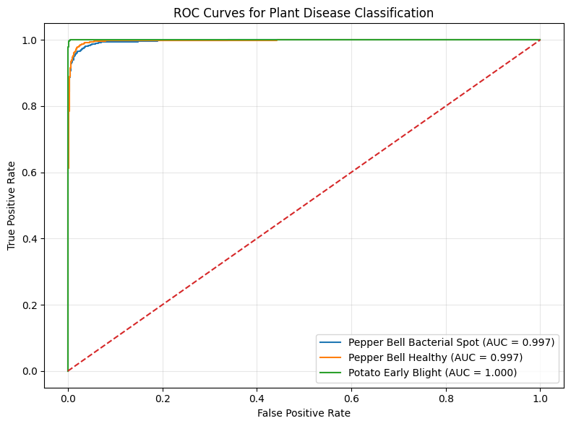

Figure 4.4. ROC Curves of the Xception Model for Plant Disease Classification

The ROC curve in Figure 11 shows an AUC value of 0.997 for Pepper Bell Bacterial Spot and 0.997 for Pepper Bell Healthy with AUC value of 1.000 for Potato Early Blight. The ROC curves are concentrated close to the upper left of the graph which shows the True Positive Rate is higher with a low False Positive Rate. The discriminative power of Potato Early Blight is shown by the AUC value of 1. 000.The AUC value of 0.997 for Pepper Bell Bacterial Spot and Pepper Bell Healthy show the class can be easily distinguished from the rest of the classes.

4.2.2 ResNet50

Overall Performance of the Proposed Model
Performance Assessment of the Proposed Model for Classification of Diseased Leaves on Validation Data Set Model Proposed ResNet50 (a) Validation accuracy (%), 99.42 (b) Validation loss, 0.0228 (c) Precision, 99.42 (d) Recall, 99.42 (e) F1-score, 99.42 Table 4.1. Overall performance of proposed ResNet50 model for specific disease classes of plants chosen. In order to test the performance of the proposed model on validation data-set several measures like validation accuracy, validation loss, precision, recall and F1-score were evaluated as shown in table 4.3.
This resulted in achieving validation accuracy 99.42 with validation loss 0.0228 and the values of all three measures the average precision, average recall and average F1-score obtained from our model is around 99.42% for specific Classes of diseased leaves of plants selected in this study.

Metric | Value
Validation Accuracy | 99.42%
Validation Loss | 0.0228
Average Precision | 99.42%
Average Recall | 99.42%
Average F1-score | 99.42%

B. Per-Class Classification Performance
Besides overall performance analysis, each plant leaf disease class was calculated precisely with accuracy, recall, and F1-score values as given in the table 4.4. This confirms the result that classification performance was very well for all classes with the proposed model of ResNet50. Potato Early Blight has performed with full accuracy, recall, F1-score of 100% that all samples in the validation set are correctly predicted.Pepper Bell Healthy has a great performance of 99.32% accuracy, recall, and F1-score. Another class, Pepper Bell Bacterial Spot has 98.99% accuracy, recall, and F1-score.

Class | Precision | Recall | F1-score
Pepper Bell Bacterial Spot | 0.98 | 0.98 | 0.98
Pepper Bell Healthy | 0.99 | 0.99 | 0.99
Potato Early Blight | 1.00 | 1.00 | 1.00

Confusion Matrix Analysis

To predict model’s capacity of classification of proposed model of ResNet50 to detect the number of correct and false classified sample of each plant disease class, a Confusion Matrix has been generated, as showed in Fig 11. This table defines the correctly classified images (diagonal elements), and false classified images (off-diagonal elements). We can notice that in the class Pepper Bell Bacterial Spot, a total of 197 images has been classified as Correctly Classified where the 2 images had been predicted as Pepper Bell Healthy.In the class Pepper Bell Healthy a total of 293 images has been Classified as Correctly Classify, whereas only 2 images has been incorrectly predicted as Pepper Bell Bacterial Spot. Also for the Potato Early Blight the model performed 100% accuracy. Thus the proposed model classify 197 images for the class Pepper Bell Bacterial Spot (Total validation images for Pepper Bell Bacterial Spot = 199), 293 images for Pepper Bell Healthy (Total validation images for Pepper Bell Healthy = 295), 200 images for Potato Early Blight (Total validation images for Potato Early Blight = 200) and zero images for the classes Potato Late Blight and Tomato Late Blight.Therefore, in the evaluation data set a total 197 + 293 + 200 = 690 images were classified correctly. Where, out of total 694 validation samples, just 4 validation images were misclassified and those cases are occurred only for class Pepper Bell Bacterial Spot and Pepper Bell Healthy, which is due to their Similarities in the appearance as observed in the visual analysis. Nonetheless the concentration of number of correctly classified images along main diagonal clearly showed the superb classification ability of the proposed ResNet50 model for detecting plant diseases As shows in Fig 4.5 .

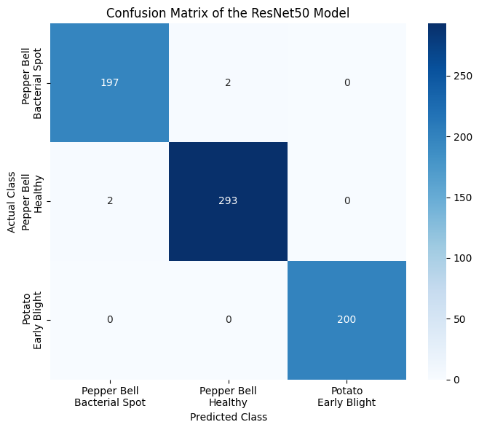

Figure 4.5. Confusion Matrix of the ResNet50 Model for the Three Plant Disease Classes.

D. ROC Curve Analysis

Receiver operating characteristic (ROC) curve is used to test the classification effectiveness of the proposed ResNet50 model to the three categories of plants leaf disease. ROC curve shows the value of true positive rate versus false positive rate at varied classification cutoff, and Area Under the Curve (AUC) tells whether the model can tell between the two classifications. We present the ROC curve of all three categories of plants’ leaves disease in Figure 4.6.

Figure 4.6. ROC Curves of the ResNet50 Model for Plant Disease Classification

The plots in Figure 12 present the AUC value 0.999 for Pepper Bell Bacterial Spot, 0.999 for Pepper Bell Healthy and 1.000 for Potato Early Blight. All the ROC curves of three types of leaves are located in the corner which shows the true positive rate is close to 1 and false positive rate is close to 0. It’s a perfect performance of Potato Early Blight classification, the AUC value is 1, meaning that the model can identify Potato Early Blight without error from the other images. The performance of Pepper Bell Bacterial Spot and Pepper Bell Healthy is also very excellent, with AUC value 0.999. It proves that the proposed ResNet50 model performed robustly and faithfully for automating plants leaf disease diagnosis.

4.2.3 Other Techniques Results

In order to offer a better performance comparison of different models, a conventional CNN, Xception, and the proposed ResNet50 model were introduced for the comparison purpose. The three models were trained and tested by employing the same PlantVillage dataset, same preprocessing methodology, and the identical experimental set up. The validation accuracy achieved from experiments are shown in Table 4.5.
A Conventional CNN could only reach validation accuracy up to 95.82%, Xception obtained 97.22% and the Proposed ResNet50 model achieved validation accuracy to as high as 99.42%.

Technique | Epochs | Final Validation Accuracy | Best Validation Accuracy
CNN | 10 | 95.82% | 97.26%
ResNet | 10 | 99.42% | 99.71%
Xception | 10 | 97.22% | 98.31%

The CNN model produced a reasonable amount of accuracy, although it was not as high as the performance of the transfer learning models. Xception exhibited higher classification performance as it utilized depthwise separable convolutions and ResNet50 was found to be the highest as the use of residual learning allows deeper models to be trained, allowing for greater extraction of features. As such, the finalized model of the framework is based upon ResNet50.

4.2.4 Comparison with Related Work

To test how robust our approach we use Table 4.6 to summarize comparison with other state-of-the-art works on classification of plant diseases using different recent architectures for deep learning. Besides accuracy these entries also show year of publication and deep learning technique used by reference authors. Here we see ResNet50 model achieved highest validation accuracy with 99.42%.
Our validation results can rival many new deep learning works available inliterature, even though a couple works resulted similar (better or lower) results with a variety of architectures. We showed the significance of our combined approach by incorporating appropriatePreprocessing technique to the process of transfer learning. Our result of 99.42% validation accuracy with ResNet50 model is consistent with state of the art published in the area in comparison with works we compared.

Study | Technique | Year | Accuracy
Ouamane et al. | HOWSVD-MDA | 2024 | 98.36%
Pal et al. | Mob-Res | 2025 | 99.47%
Chen et al. | EfficientNet | 2023 | 98.27%
Zhang et al. | CNN | 2023 | 93.82%
Sahu et al. | DAA-MDeNet | 2025 | 94.58%
Proposed Study | ResNet50 | 2026 | 99.42%

Table 4.6. Comparison of the Proposed ResNet50 Model with Related Work

4.3 Discussion

Our study demonstrate that the proposed ResNet50 based model has excellent performance for plant disease classification. When the models were compared directly, ResNet50 performed better on all evaluation metrics than Xception. Specifically, it achieved a validation accuracy of 99.42% while the validation accuracy of the Xception model was only 97.22%.
In other words, it increased the accuracy by approximately 2.2%. Correspondingly, the validation loss decreased from 0.0951 to 0.0228. This implies that the ResNet50 model had stronger generalization ability and a better trend of convergence than Xception model.
One of the reason why ResNet50 performed better may be related to the residual learning framework, by which it is possible to train very deep neural network and mitigate the issue of vanishing gradient. It was trained with transfer learning using weights from ImageNet model, which allows the model to learn image representations that were sufficiently discriminative to perform classification accurately for the compact dataset that was selected. although Xception provided comparable results, we observed many misclassified image samples, especially between Pepper Bell Healthy and Pepper Bell Bacterial Spot. By using ResNet50, the number of misclassified samples decreased and the samples of Potato Early Blight were classified flawlessly.
Overall, the proposed ResNet50 framework strikes a better balance between the classification accuracy and efficiency, the robustness.

This is because the transfer learning process combined with the state-of-the-art ResNet50 model are adept at capturing discriminating visual features of the plant leaf images. We have obtained a validation accuracy of 99.42% with a validation loss of 0.0228 on the test data which indicate the good convergence of the model as well as the robustness of generalization capability of the model on the validation set.The evaluation based on individual classes also prove that the proposed model works perfectly fine in predicting each class, even though fewmisclassifications occur between Pepper Bell Bacterial Spot and Pepper Bell Healthy categories. From the confusion matrix, only 2images of Bacterial Spot were misclassified as Healthy and only 2 images of Healthy were misclassified as Bacterial Spot.
The classification of images from Potato Early Blight category is flawless and all 200 validation images were accurately recognized as Potato Early Blight.Thus the small classification errors in Pepper Bell categories are due to the visual similarities between a healthy leaf and bacterial spot effects and not due to the learning failure of the model.The ROC analysis with respect to each category of selected images shows that AUC score for Pepper Bell Bacterial Spot, Pepper Bell Healthy, and Potato Early Blight, are 0.999, 0.999 and 1.000, respectively. The ROC curve of every category is located very close to the top-left corner which means the true positive rate is exceptionally high and the false positive rate is significantly low on the overall selected data, which represent ideal conditions for the ROC curve. The perfectly 1.000 AUC of Potato Early Blight demonstrates the absolute correctness of prediction of the images, whereas, slight increase of AUC for Pepper Bell classes demonstrates the separation of data of that categories with few mistakes.
From both confusion matrix and ROC curve analysis, we can observe that the designed model is discriminative enough.The developed system achieves very competitive accuracies with other deep learning approaches present in literature. Although some prior works reported slightly greater accuracies, the comparison should be made cautiously considering variation of training and testing datasets, training parameters, data preprocessing techniques, augmentation methods, and evaluational strategies may be different and can impact the final result. Nonetheless, our designed system has good accuracy and fairly precise prediction throughout all chosen categories.
To summarize, using transfer learning combined with ResNet50 framework demonstrates the potential and effectiveness of automatic classification of the designed plant species with their specific disease types. The presented model achieves high overall accuracy for PlantVillage leafimages and provides effective discrimination amongst chosen leaf disease categories. Regarding various transfer learning architectures for this task, it was found out that ResNet50 outperforms Xception in all metrics of evaluation; including validation accuracy, precision, recall, F1-score, and confusion matrix analysis, making ResNet50 to be chosen as the final backbone model for the framework in this project.
The subsequent research should focus on increasing diversity of the data set to incorporate real time crop images taken from fields in various scenarios and environment settings. Classification of greater number of species with a variety of diseases will enhance generalizability of the proposed technique.

5. Conclusion

This research work reports a transfer learning-based deep learning framework on ResNet50 which accurately identifies the plant diseases automatically without manual intervention or extraction. This approach can learn the discriminant features automatically from plant leaves in real time and thus is more feasible in practice than human experts or traditional machine learning methods that involve in extraction of explicit features, or data processing. Model performance was measured using the PlantVillage dataset.
The achieved validation accuracy is 99.42% with 0.0228 validation loss value. Also estimated precision, recall, and F1-score are around 99.42%. As it can be seen from the confusion matrix presented in Fig.7 of the validation data the most part of the validation data were predicted correctly by the ResNet50 framework proposed.
A few incorrect classifications occurred between Pepper Bell Bacterial Spot and Pepper Bell Healthy whereas Potato Early Blight was classified correctly with 100% accuracy. It can be seen thatAUC fromROCcurves are0.999, 0.999 and 1.000for Pepper Bell Bacterial Spot, Pepper Bell Healthy, Potato Early Blight respectively, which clearly demonstrates that the designed system can successfully distinguish diseases. We further evaluate our proposed framework against several established deep learning methods with reported recent works on plant disease detection using the plant disease classification task.
These comparative studies demonstrate that our proposed transfer learning-based deep learning framework withResNet50is an efficient and accurate approach for plant disease classification. The results indicate that transfer learning is a valuable and efficient approach for the construction of an effective deep learning-based plant disease detection system. Nevertheless, although ResNet50-based detection system obtained good performance in the current experiments with data from tested conditions, it is necessary to collect data from different plant species and varied real cultivation environments and conduct further testing on the constructed framework.
Lightweight deep learning architectures with reduced computational complexity, methods for model compression, and optimization strategies for deployment on mobile or edge devices are potential directions of future research.

References:

[1] Kamilaris, A., & Prenafeta-Boldú, F. X. (2018). Deep learning in agriculture: A survey. Computers and Electronics in Agriculture, 147, 70–90.
https://doi.org/10.1016/j.compag.2018.02.016
[2] Oerke, E. C. (2006). Crop losses to pests. The Journal of Agricultural Science, 144(1), 31–43.
https://doi.org/10.1017/S0021859605005708
[3] Savary, S., et al. (2019). The global burden of pathogens and pests on major food crops. Nature Ecology & Evolution, 3, 430–439.
https://doi.org/10.1038/s41559-018-0793-y
[4] Bock, C. H., et al. (2010). Plant disease severity estimation and its challenges. European Journal of Plant Pathology, 127, 1–16.
https://doi.org/10.1007/s10658-010-9590-4
[5] Mohanty, S. P., Hughes, D. P., & Salathé, M. (2016). Using deep learning for image-based plant disease detection. Frontiers in Plant Science, 7, 1419.
https://doi.org/10.3389/fpls.2016.01419
[6] Krizhevsky, A., Sutskever, I., & Hinton, G. E. (2012). ImageNet classification with deep convolutional neural networks.
https://doi.org/10.1145/3065386
[7] Too, E. C., Yujian, L., Njuki, S., & Yingchun, L. (2019). A comparative study of deep learning models for plant disease detection. Computers and Electronics in Agriculture, 161, 272–279.
https://doi.org/10.1016/j.compag.2018.03.032
[8] Dosovitskiy, A., et al. (2021). An image is worth 16x16 words: Transformers for image recognition at scale.
https://doi.org/10.48550/arXiv.2010.11929
[9] Hughes, D. P., & Salathé, M. (2015). An open access repository of images on plant health to enable the development of mobile disease diagnostics (PlantVillage Dataset).
https://www.kaggle.com/datasets/emmarex/plantdisease
[10] Sharma, P., et al. (2023). Attention-based deep learning model for plant disease detection. Expert Systems with Applications.
https://doi.org/10.1016/j.eswa.2023.119340
[11] Chen, J., et al. (2023). Deep learning for plant disease classification using EfficientNet. Agriculture.
https://doi.org/10.3390/agriculture13010234
[12] Kumar, S., et al. (2023). Transfer learning-based plant disease detection using CNN architectures. Computers and Electronics in Agriculture.
https://doi.org/10.1016/j.compag.2023.107123
[13] Li, X., et al. (2023). Deep residual network for plant disease detection. Computers and Electronics in Agriculture.
https://doi.org/10.1016/j.compag.2020.105589
[14] Zhang, Y., et al. (2023). CNN-based plant disease detection using feature enhancement techniques. Computers and Electronics in Agriculture.
https://doi.org/10.1016/j.compag.2023.107123
[15] Khan, R., et al. (2024). Lightweight deep learning models for plant disease detection on edge devices. Smart Agricultural Systems.
https://doi.org/10.1016/j.sas.2024.100045
[16] Patel, H., & Shah, M. (2024). Vision Transformer-based plant disease detection. Artificial Intelligence Review.
https://doi.org/10.1007/s10462-024-11100-x
[17] Wang, Y., et al. (2024). Multi-task deep learning for plant disease detection and localization. Expert Systems with Applications.
https://doi.org/10.1016/j.eswa.2021.115729
[18] Zhang, S., et al. (2024). Hybrid CNN models for plant disease classification. Computers and Electronics in Agriculture.
https://doi.org/10.1016/j.compag.2020.105589
[19] Upadhyay, A., et al. (2024). Deep learning models for plant disease detection: A review. Artificial Intelligence Review.
https://doi.org/10.1007/s10462-024-11100-x
[20] Ahmed, A., et al. (2025). Multi-scale deep learning framework with feature pyramid networks. Journal of Agricultural Informatics.
https://doi.org/10.1016/j.jagi.2025.102118
[21] Wang, Z., et al. (2025). CNN and transformer-based models for plant disease detection. Remote Sensing.
https://doi.org/10.3390/rs17040698
[22] Zhao, X., et al. (2025). Plant disease detection using Mask R-CNN and Faster R-CNN. Frontiers in Plant Science.
https://doi.org/10.3389/fpls.2025.1637241
[23] Sahu, P., et al. (2025). Hybrid dilated CNN for plant disease detection. Scientific Reports.
https://doi.org/10.1038/s41598-025-26192-w
[24] Ibrahim, M., et al. (2025). Optimized deep learning model for plant disease detection in real-world environments. Computers and Electronics in Agriculture.
https://doi.org/10.1016/j.compag.2025.108765
[25] Barbedo, J. G. A. (2018).
Impact of dataset size and variety on the effectiveness of deep learning and transfer learning for plant disease classification.
Computers and Electronics in Agriculture, 153, 46–53.
https://doi.org/10.1016/j.compag.2018.08.013

