

Sales Forecasting
Prepared By
Name: Othman Omar Alamoudi ID No.: 243000199

Submitted in fulfillment of the requirements for the degree Master of Science in Artificial Intelligence
At
Collage of Informatics
Midocean University
UAE
Supervisor Name: Wesam Ahmed
College of Informatics, Midocean University, Comoros
Email:…………………….

Acknowledgements

I want to express my deepest gratitude to Dr. Wesam Ahmed, whose guidance, encouragement, and expertise were instrumental throughout this research. Dr. Wesam’s insightful feedback and unwavering support helped shape the direction of this thesis and inspired me to explore new dimensions in machine learning and sales forecasting.
Their mentorship not only enhanced the academic rigor of this work but also fostered a deeper appreciation for the value of data-driven decision-making in real-world business contexts. I am genuinely thankful for their patience, constructive criticism, and commitment to excellence.

Abstract

List of Publications

Table of Contents

List of Abbreviations xiv
List of Figures xvi
List of Tables xviii

Chapter 1: Introduction............................................................................... 1
1.1 Problem Definition ................................................................................... 2
1.2 Thesis Objectives ..................................................................................... 3
1.3 Thesis Contribution .................................................................................. 4
1.4 Thesis Organization................................................................................... 5

Chapter 2: Overview..................................... 6
2.1 Introduction ............................................................................................... 6
2.2 Educational Data Mining .......................................................................... 6
2.3 Applications of Educational Data Mining .................................................. 7
Chapter 3: Related Work …………………………………………... 31
3.1 Introduction ............................................................................................31
3.2 History ...................................................................................................... 31
Chapter 4: Proposed Approach ............................................................... 78
4.1 Introduction ............................................................................................ 78

Chapter 5: Experimental Results and Discussion ................................... 86

Chapter 6: Conclusion and Future Work .............................................. 127
7.1 Important Features ............................................................................... 127
7.3 Future Work ....................................................................................... 129

References .................................................................................................. 130

List of Abbreviations
- AI: Accuracy
- LSTM: Artificial Neural Network
- XGBOOST: Analysis of Variance
- ARIMA: Receiver Operating Characteristic

List of Figures
2.1.1 Core AI technologies between ML and DL role in classification……… | 13
2.3.1.1 XGBoost ………………………………………………………………. | 8
2.3.3.1 Prophet flowchart……………………………………………………… | 16
2.4.1.1 LSTM …………………………………………... | 21
2.5 Educational Process Mining (EPM): A Learning Analytics Data Set … | 23

List of Tables
3.1.1 Summary Table of ML……………………………………………….…… 21
0.0

Chapter 1 Introduction
Recently, machine learning has greatly contributed to the accuracy of sales forecasting models. Traditional statistical methods tend to suffer from non-linearity and the variability in market dynamics. Neural networks, especially such as Long Short-Term Memory (LSTM) models, however, have been robust in representing time scale dependencies. An LSTM-based model has been used to predict furniture sales in Central and Eastern Europe, recording low forecast error without seasonal assumptions, accurately monitoring demand variability and so on [1]. Sales prediction is an essential part of business forecasting and planning, especially in e-commerce where the order is cyclical and affected by different dynamic features. Receive accurate estimates improve visibility in the planning for inventory administration, stock planning, production planning, and cash flow, thus lowering human error and minimizing human intervention. Time series forecasting through traditional statistical methods such as the ARIMA model has been widely used, yet the model tends to fail in the face of nonlinear patterns or drastic changes in the markets. The development of AI is progressing faster than we can anticipate, and hybrid models that marry statistical and neural methods are now being developed. To take an example of this, Vavliakis et al. proposed a hybrid ARIMA-LSTM model by including linear time series analysis and nonlinear residual modeling through a LSTM network. Their approach also includes retail price as a characteristic to enhance the prediction model performance in price sensitive e-commerce settings [2]. Sales forecasting forms the framework of supply chain management and refers to the process that allows organizations to project demand, control stock levels, and lower expenses. Big data and machine learning are making more sophisticated algorithms capable of dealing with much larger data sets, replacing traditional forecasting methods. Forecasting sales is a significant key in supply chain management, allowing an organization to predict demand, manage inventory efficiently, and minimize operational costs. In this context, the data-driven forecasting methods that used to be performed over decades in the past have been replaced by algorithms that, based on data analysis and machine learning insights, can adapt to the complex and nonlinear patterns observed in consumer behavior as they evolve over time. One of the algorithms mentioned is Extreme Gradient Boosting (XGBoost), an ensemble learning method associated with speed and accuracy. It has been applied to different domains, such as predicting retail sales. It’s not only great for analyzing big data, but also in finding patterns that are often overlooked. Akande et al. (2022) used XGBoost in forecasting sales through historical data from 45 Walmart stores. Their research found that XGBoost predicted sales very well with a high accuracy, and achieved better performances than previous methods based on Mean Absolute Error (MAE), Root Mean Square Error (RMSE), and R² criteria. Thus, it is a suitable guide for retail decision-makers [3], offering actionable intelligence for pricing strategies and inventory planning. A potential implication for predictive models, like XGBoost for instance, is that the prediction accuracy will be better than before.

Problem Definition
Sales forecasting plays a pivotal role in guiding inventory management, budgeting, and strategic decision-making across industries. However, traditional forecasting techniques—such as moving averages and linear regression—often fall short in the face of the complexity of modern sales environments. These methods struggle to account for nonlinear relationships, seasonal variations, promotional effects, and external disruptions, such as economic shifts or competitor actions.

As businesses accumulate increasingly diverse and high-volume datasets, the limitations of conventional models become more pronounced. Inaccurate forecasts can lead to overstocking, missed revenue opportunities, and inefficient resource allocation. This is especially problematic in fast-paced sectors such as retail and e-commerce, where agility and precision are crucial.
Machine learning and deep learning offer promising alternatives by enabling models to learn patterns directly from historical data, adapt to changing trends, and incorporate a wide range of variables that influence them. Techniques such as decision trees, ensemble methods (e.g., Random Forest, XGBoost), and support vector machines have shown strong potential in capturing complex dependencies. In particular, Long Short-Term Memory (LSTM) networks—a type of recurrent neural network—have demonstrated exceptional performance in modeling sequential data, making them well-suited for time series forecasting tasks where long-term dependencies and temporal dynamics are crucial.

1.2 Thesis Objectives
The primary objective of this thesis is to investigate and evaluate the effectiveness of machine learning and deep learning techniques in enhancing the accuracy and reliability of sales forecasting models. By leveraging historical sales data and relevant external variables, the study aims to develop predictive models that outperform traditional statistical approaches in dynamic and data-rich environments.
Specific objectives include:
- To identify key factors influencing sales performance and assess their impact on forecasting accuracy.
- To compare various machine learning algorithms—such as Decision Trees, Random Forest, Support Vector Machines, and XGBoost—as well as deep learning models like Long Short-Term Memory (LSTM) networks, in terms of predictive power, scalability, and interpretability.
- To design and implement a robust forecasting framework that integrates data preprocessing, feature selection, and model tuning for optimal performance.
- To evaluate model performance using real-world datasets, applying metrics such as Mean Absolute Error (MAE), Root Mean Squared Error (RMSE), and R² score.
- To provide actionable insights for business decision-makers, demonstrating how machine learning– and deep learning–driven forecasts can improve inventory planning, budgeting, and strategic operations.

1.3 Thesis Contribution

1.4 Thesis Organization
This thesis contributes to the growing body of research on intelligent forecasting systems by demonstrating how machine learning techniques can enhance the accuracy, scalability, and interpretability of sales predictions. Unlike traditional statistical models, which often rely on rigid assumptions and limited feature sets, the proposed approach leverages data-driven algorithms to uncover complex patterns and nonlinear relationships within historical sales data.
Key contributions include:
- Development of a machine learning–based forecasting framework that integrates data preprocessing, feature selection, and model tuning to optimize predictive performance.
- Comparative analysis of multiple ML algorithms—including Decision Trees, Random Forest, Support Vector Machines, and XGBoost—highlighting their strengths and limitations in real-world sales environments.
- Empirical evaluation using industry-relevant datasets, with performance measured through standard metrics such as MAE, RMSE, and R² score.
- Practical insights for business decision-makers, showcasing how ML-driven forecasts can support inventory planning, demand management, and strategic operations.
- Contribution to academic literature by bridging the gap between theoretical ML models and their practical deployment in sales forecasting contexts.
By addressing the limitations of conventional forecasting methods and validating the effectiveness of machine learning, this thesis offers both theoretical advancement and practical value for researchers and practitioners in data science, business analytics, and operations management.

Chapter 2 Overview
This thesis explores the application of machine learning and deep learning models to enhance the accuracy and reliability of sales forecasting. The study is motivated by recent research that demonstrates the superiority of intelligent forecasting systems over traditional statistical methods. For example, Li et al. (2020) developed an automatic LSTM-based forecasting system that effectively modeled sequential sales data [1]. Vavliakis et al. (2021) proposed a hybrid ARIMA-LSTM approach that improved prediction accuracy in e-commerce environments [2]. Akande et al. (2021) applied XGBoost to Walmart’s historical sales data, achieving high performance and interpretability [3].
Building on these foundations, this research aims to design a robust forecasting framework that integrates data preprocessing, feature selection, and model tuning. The models will be evaluated using real-world datasets and performance metrics, including Mean Absolute Error (MAE), Root Mean Squared Error (RMSE), and R² score. Ultimately, the goal is to provide actionable insights that support better inventory planning, budgeting, and strategic operations.
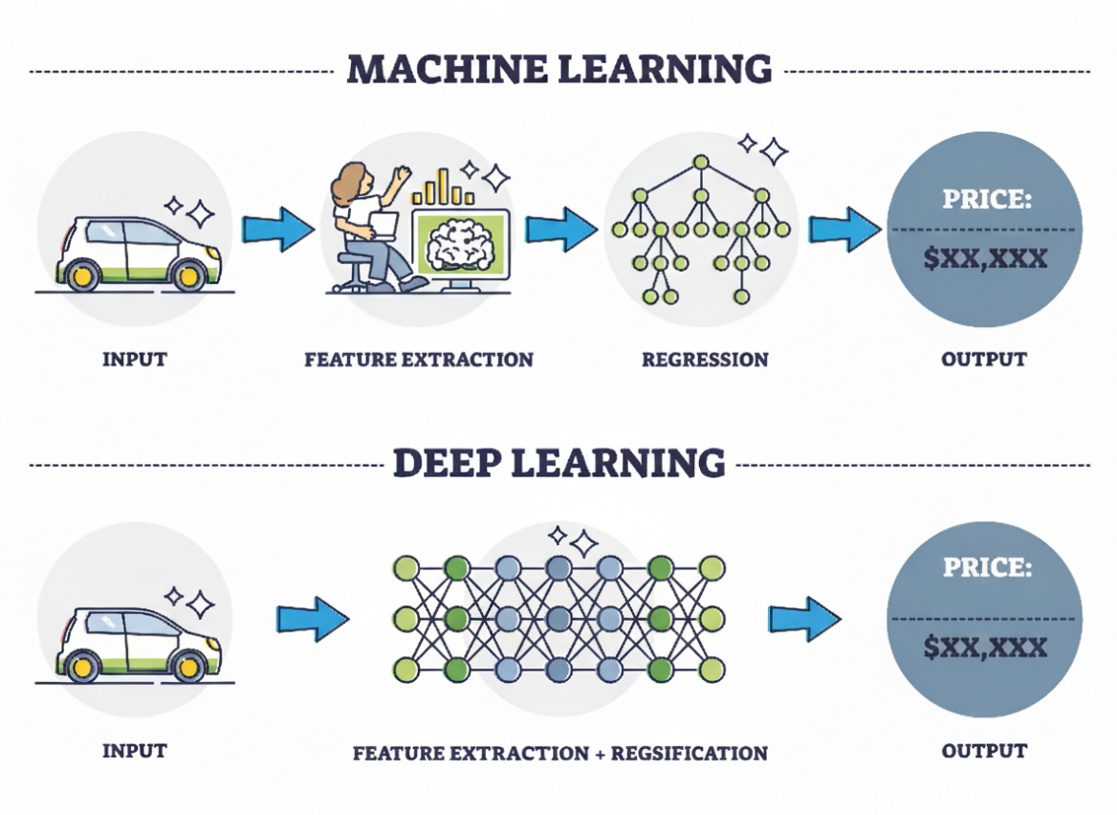
Figure 2.1.1: Core AI technologies between ML and DL role in classification.

Background
Sales forecasting is a foundational element of business operations, particularly in the retail and e-commerce sectors, where demand variability can significantly impact inventory control, financial planning, and strategic decision-making. Traditional forecasting models, such as moving averages and linear regression, have been widely used due to their simplicity and interpretability. However, these approaches often struggle to capture the nonlinear relationships, seasonal fluctuations, and external disruptions that characterize modern sales environments.
With the increasing availability of high-volume and diverse datasets, the limitations of conventional models have become more pronounced. Inaccurate forecasts can lead to overstocking, missed revenue opportunities, and inefficient resource allocation. To address these challenges, researchers have turned to machine learning and deep learning techniques, which offer greater flexibility and predictive power. Algorithms such as Decision Trees, Random Forest, Support Vector Machines, and XGBoost have shown strong performance in modeling complex dependencies [3]. Additionally, Long Short-Term Memory (LSTM) networks—a type of recurrent neural network—have demonstrated exceptional capabilities in capturing temporal dynamics and long-term dependencies in sequential data [1][2].

2.3 Machine Learning Techniques
Machine Learning (ML) is a subfield of artificial intelligence that enables computer systems

2.3.1 Extreme Gradient Boosting (XGBoost)
Extreme Gradient Boosting (XGBoost) is a scalable and efficient ensemble learning algorithm that builds upon gradient boosting. It is particularly effective for structured data problems such as sales forecasting, where nonlinear relationships, seasonal effects, and external variables (e.g., promotions, holidays) influence demand. XGBoost builds an additive model by sequentially training decision trees, each one correcting the errors of its predecessor.
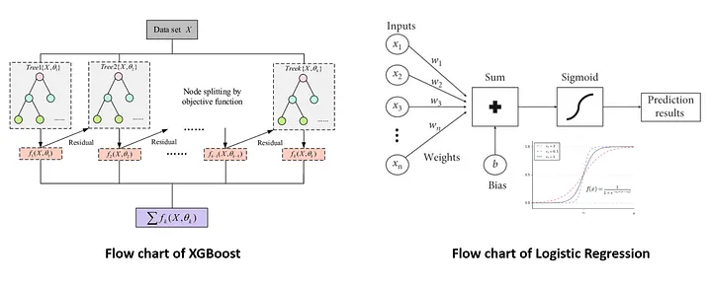
Figure 2.3.1.1: XGBoost.
The objective function in XGBoost combines a regularized loss function and a model complexity term:
$$Obj= \sum_{i=1}^{n}{l(y_{i} ,y_{i}^{{}^{}}})+ \sum_{K=1}^{K}{Ω(f_{k} })$$

Where:
- $l\left(y_{i}, \{y\}_i^\{(t)\} \right)$: Loss function (e.g., Mean Squared Error)
- $Ω\left(f_{k}\right)= γT + {\backslash frac\left\{1\right\}\left\{2\right\}λ\sum{}}_{\left\{j=1\right\}}^{{\left\{T\right\}w}_{j}^{2}}$: Regularization term
- T: Number of leaves in the tree
- $w_{j}$: Leaf weights
- $γ,λ$: Regularization parameters
Each tree is built using the gradient and second-order derivative (Hessian) of the loss function to determine optimal splits. This second-order optimization improves convergence and stability.
The prediction for a sample xx is given by:
$$y^{i}=∑k=1Kfk\left(xi\right),fk∈\hat{F}{\left\{y\right\}}_{i}= \sum_{{\left\{k=1\right\}}_{k\left(x_{i}\right)}^{\left\{K\right\}f}}{}, \backslash quad f_{k}∈\backslash mathcal\left\{F\right\}$$
Where:
- KK: Total number of trees
- fkf_k: Individual decision tree
- $F\backslash mathcal\left\{F\right\}:$ Space of regression trees
XGBoost uses shrinkage (learning rate), column subsampling, and early stopping to prevent overfitting. Its ability to rank feature importance also makes it interpretable for business decisions.
In sales forecasting, XGBoost has shown strong performance across various retail datasets. For example, Massaro et al. (2021) applied XGBoost to large-scale retail data and achieved a Mean Absolute Percentage Error (MAPE) below 10%, outperforming traditional models and enabling more accurate inventory planning [4]

2.3.2 Prophet
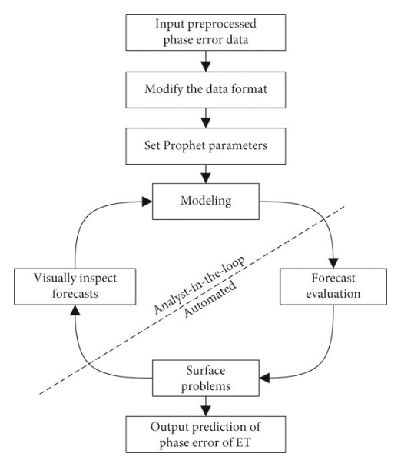
Prophet is a robust time-series forecasting model developed by Meta (Facebook) that handles irregular seasonal patterns, holiday effects, and missing data. It is particularly effective for sales forecasting, where demand fluctuates due to promotions, holidays, and consumer behavior. Prophet decomposes time series into additive components: trend, seasonality, and holiday effects. [5]

Figure 2.3.3.1: Prophet flowchart.

The forecasting function is defined as:
$$y\left(t\right)=g\left(t\right)+s\left(t\right)+h\left(t\right)+ϵ_{t}$$
Where:
- $g\left(t\right)$: Trend function (linear or logistic)
- s(t): Seasonal component modeled via Fourier series
- h(t): Holiday effects
- $ϵ_t$: Error term
Prophet supports both linear and logistic growth:
- Linear:
$$g\left(t\right)=kt+m$$
- Logistic:
$$g\left(t\right)=\frac{C}{1+\exp\left(-k\left(t-m\right)\right)}$$
Where:
- k: Growth rate
- m: Offset
- C: Carrying capacity
Seasonality is captured using a Fourier series:
$$s\left(t\right)= \sum_{n=1}^{N}{\left.\left[a_{n}\cos\left(\frac{2πnt}{P}\right)+ b_{n}\right.\sin\left(\frac{2πnt}{P}\right)\right]}$$
Where:
- P: Period (e.g., 365 for yearly)
- $a_{n}$, $b_{n}$: Coefficients learned from data.

2.4 Deep Learning Techniques
Deep Learning (DL) is a subfield of artificial intelligence that enables computer systems

2.4.1 Long Short-Term Memory (LSTM)
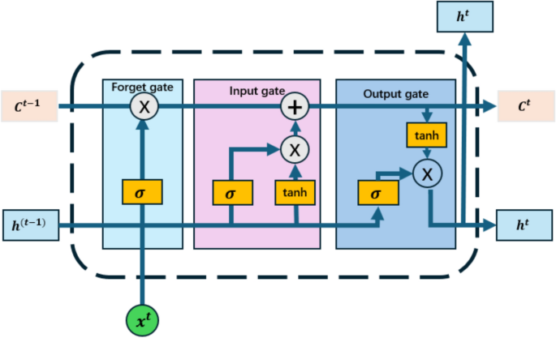
Long Short-Term Memory (LSTM) is a specialized form of recurrent neural network (RNN) designed to capture long-term dependencies in sequential data. It is particularly effective for sales forecasting, where historical demand patterns, seasonality, and external factors influence future sales. Unlike traditional RNNs, LSTMs mitigate the vanishing gradient problem through gated memory cells, allowing them to learn from long sequences [5].
Figure 2.4.1.1: LSTM.

The LSTM cell updates its internal state using three gates: input, forget, and output, defined as:
$$x_{t}=σ\left(W_{f}⋅\left[h_{t}-1,x_{t}\right]+b_{f}\right)$$
$$i_{t}=σ\left(W_{i}⋅\left[h_{t}-1,x_{t}\right]+b_{i}\right)$$
$$\begin{matrix}\sim \\ C_{t}\end{matrix}=\tanh\left(W_{C}⋅\left[h_{t}-1,x_{t}\right]+b_{C}\right)$$
$$C_{t}=f_{t}⋅C_{t}-1+i_{t}⋅\begin{matrix}\sim \\ C_{t}\end{matrix}$$
$$o_{t}=σ\left(W_{o}⋅\left[h_{t}-1,x_{t}\right]+b_{o}\right)$$
$$h_{t}=o_{t}⋅\tanh\left(C_{t}\right)$$

Where:
- $x_t$: Input at time t
- $h_{t}$: Hidden state
- $\begin{matrix}\sim \\ C_{t}\end{matrix}$: Cell state
- $σ$: Sigmoid activation
- $tanh$: Hyperbolic tangent activation
- $W, b$: Weights and biases for each gate

2.5 Statistical Model Techniques

2.5.1 Auto Regressive Integrated Moving Average (ARIMA)
Auto Regressive Integrated Moving Average (ARIMA) is a classical statistical model used for time series forecasting. It combines autoregressive (AR), differencing (I), and moving-average (MA) components to model temporal dependencies and trends in the data. ARIMA is particularly effective for univariate forecasting tasks where the data exhibits non-seasonal patterns and can be made stationary through differencing.
The general ARIMA model is denoted as:
ARIMA(p,d,q)
Where:
- pp: Number of autoregressive terms
- dd: Degree of differencing
- qq: Number of moving average terms

Chapter 3 Related Work

3.1 Introduction
In this section, we examine recent studies that investigate the application of artificial intelligence to sales forecasting. Researchers have experimented with a range of models, from traditional machine learning (ML) to more advanced approaches like artificial neural networks (ANN), convolutional neural networks (CNN), long short-term memory (LSTM) networks, and ensemble methods. Some of these works go a step further, introducing hybrid models that blend different AI techniques or combine them with domain expertise to achieve greater accuracy. The following sub-sections break down these contributions, highlighting the progress made across each category of models.

3.2 Machine Learning Studies
Recent developments in machine learning (ML) have provided vendors with powerful tools for more accurate sales forecasting. These methods leverage event-based and contextual data, supporting better inventory control and profit management ([6]). While no single model can guarantee perfect accuracy, combining approaches and continuously fine-tuning parameters has been shown to improve performance. Classical statistical techniques such as ARIMA and Seasonal Autoregressive Integrated Moving Average (SARIMA) remain widely used for market-level forecasts due to their reliance on smoothing methods ([7]). However, more advanced global models—such as recurrent neural networks (RNNs) enhanced with covariates like time, price, and events—demonstrate superior accuracy in handling interrelated time series, achieving performance gains of 1.76% MRMSSE and 6.47% MMASE ([8]). Comparative studies further highlight that ML methods, including artificial neural networks (ANNs), consistently outperform traditional approaches, particularly when both endogenous and exogenous variables are incorporated ([9]). Additional analyses of models such as Random Forest, Linear Regression, XGBoost, and Keras-based deep neural networks (DNNs) reveal that prediction accuracy improves significantly when product attributes and customer information are included ([10]). In fashion retail, for instance, DNNs combined with data mining techniques have been applied to forecast sales of new items by integrating historical patterns with expert input. Using seasonal datasets and grid search tuning, these models achieved an R² value exceeding 67% ([11]). These findings suggest that future research should focus on incorporating richer variables and external factors to enhance forecasting outcomes further.

3.3 Sales Forecasting Using Artificial Neural Networks
Artificial neural networks (ANNs) have undergone significant advancements, resulting in enhanced accuracy in retail sales forecasting. [12] demonstrated that integrating macroeconomic indicators such as the Consumer Price Index (CPI), Inventory Control System (ICS), and unemployment rates into ANN models significantly enhanced predictive performance. This underscores the importance of including broader economic variables to capture market dynamics more effectively. To overcome the limitations of traditional forecasting methods—often criticized for slow execution and reduced accuracy—[13] introduced the QLBiGRU model, which combines Q-Learning with a bidirectional gated recurrent unit (BiGRU). Their approach achieved stronger results through automatic parameter optimization. Forecasting intermittent sales, characterized by irregular order arrivals, presents unique challenges. [14] addressed this by proposing a multi-layered DNN capable of capturing complex patterns, improving accuracy by up to 35% compared to classical models such as ARIMA and Croston’s method. Using data from 17 sellers and 3,000 orders, their study validated the applicability of DNNs across diverse retail environments. Similarly, [15] applied a hybrid SVM–ANN model in the food retail sector to predict demand, demonstrating the value of combining techniques.[16] advanced this further by employing Ensemble Empirical Mode Decomposition (EEMD) alongside Bayesian Regularization ANN, Cubist Regression, and SVR. By decomposing historical sales into intrinsic components and training them individually, their ensemble achieved strong daily forecasting results, with a mean absolute percentage error (MAPE) as low as 18.85. Beyond numerical data, customer sentiment has also been shown to influence sales outcomes. [17] analyzed reviews from Amazon and Snapdeal using ANN and IBM SPSS, finding that sentiment scores directly impacted forecasts. They recommended extending this approach by integrating demographic variables and combining online with offline feedback for richer predictions. Likewise, [18] applied an ANN to a Turkish retail chain, incorporating historical sales, pricing, promotions, customer footfall, and weather data. Their model identified an optimal network architecture and achieved reliable forecasting, further emphasizing the importance of contextual factors.

3.4 Sales Forecasting Using LSTM and Ensemble Learning
Ensemble methods have emerged as vital tools for improving forecasting accuracy, as they combine multiple models to offset individual biases. Techniques such as voting regressors have delivered notable gains, particularly with large datasets ([19]). Studies using XGBoost, LGBM, and CatBoost confirmed their effectiveness in retail forecasting, each offering unique strengths. Accurate forecasts are crucial for optimizing supply chains and ensuring customer satisfaction ([20]), yet traditional models often struggle with complex sales data, prompting the exploration of deep learning approaches. To address data limitations, [21] applied deep transfer learning, where knowledge from one task improves performance on another with limited data. They introduced two ensemble methods: bagging, which combines predictions from multiple LSTM-TL models trained on different subsets, and stacking, which merges outputs through a higher-level model to capture complex relationships. Stacking proved more accurate, thanks to its deeper learning capacity. Other integrative approaches have also emerged. [22] combined weighted XGBoost, ARIMA, and Holt-Winters to reduce overfitting and information leakage. [23] showed that XGBoost outperformed traditional regressors, while [24] demonstrated that tuning XGBoost with RandomizedSearchCV yielded superior results compared to multiple classical ML models.

3.5 Summary Related Work
Ref | Year | Dataset | Models | Results | Advantages | Limitations
[25] [Mansur, S., et al., 2025] | 2025 | A publicly available Kaggle dataset containing 6 months of daily sales data from a retail store in Faisalabad, Pakistan. The data was enriched with multivariate factors: Demographic (holidays, salary days, protests, promotions) and Environmental (temperature, precipitation) | Hybrid CNN-LSTM | Achieved (MAPE) of 4.16% | Captures both spatial (CNN) and temporal (LSTM) patterns.  Uses real-world external variables for reliable forecasting.  Supports high-accuracy decision-making. | The dataset size is limited to 6 months of historical data.
Will be added | Will be added | Will be added | Will be added | Will be added | Will be added | Will be added
Will be added | Will be added | Will be added | Will be added | Will be added | Will be added | Will be added
Will be added | Will be added | Will be added | Will be added | Will be added | Will be added | Will be added

Chapter 4 Proposed Approach

Chapter 5

Experimental Results and Discussion

Chapter 6 Conclusion and Future Work

References

[1] [Li, X., et al., 2020]
(2020, November). An automatic sales forecasting system based on an LSTM network. In 2020 International Conference on Computer Science and Management Technology (ICCSMT) (pp. 393-396). IEEE Computer Society.

[2] [Vavliakis, et al., 2021]
(2021). Optimizing Sales Forecasting in e-Commerce with ARIMA and LSTM Models. In WEBIST (pp. 299-306).

[3] [Akande, et al., 2021]
“Application of XGBoost Algorithm for Sales Forecasting Using Walmart Dataset,” in Advances in Electrical and Computer Technologies, Lecture Notes in Electrical Engineering, vol. 881, Springer, pp. 147–159, 2021. [Online]. Available: https://link.springer.com/chapter/10.1007/978-981-19-1111-8_13

[4] [A. Massaro, et al., 2021]
“Augmented Data and XGBoost Improvement for Sales Forecasting in the Large-Scale Retail Sector,” Applied Sciences, vol. 11, no. 17, p. 7793, 2021. [Online]. Available: https://www.mdpi.com/2076-3417/11/17/7793

[5] [Al-Mutairi, et al., 2024]
Sales Forecasting Models: Comparison between ARIMA, LSTM, and Prophet. Journal of Computer Science, 20(10), 1222–1230. https://thescipub.com/pdf/jcssp.2024.1222.1230.pdf

[6] [Beese, J., et al., 2023]
Beese, J., & Fahse, T. B. (2023). Modern centaurs: How humans and AI systems interact in sales forecasting.

[7] [Eglite, L., et al., 2022]
Eglite, L., & Birzniece, I. (2022). Retail sales forecasting using deep learning: Systematic literature review. Complex Systems Informatics and Modeling Quarterly, (30), 53–62.

[8] [Ramos, I., & Oliveira, A., 2023]
Ramos, I., & Oliveira, A. (2023). RNNs enhanced with covariates demonstrate superior accuracy.

[9] [Martins, L., & Galegale, N., 2023]
Martins, L., & Galegale, N. (2023). ML methods outperform traditional approaches in sales forecasting.

[10] [Rajasree, R., & Ramyadevi, M., 2024]
Rajasree, R., & Ramyadevi, M. (2024). Prediction accuracy improvements in sales forecasting using product attributes and customer information.

[11] [Loureiro, V., et al., 2018]
Loureiro, V., Miguéis, V. L., & Da Silva, M. M. (2018). Deep neural networks and data mining for fashion retail new item sales forecasting.

[12] [Haque, M. S., 2023]
Haque, M. S. (2023). Retail demand forecasting using neural networks and macroeconomic variables. Journal of Mathematics and Statistics Studies, 4(3), 01–06.

[13] [Zhao, H., Tian, X., & Wang, Y., 2023]
Zhao, H., Tian, X., & Wang, Y. (2023). QLBiGRU model for automatic parameter optimization in sales forecasting.

[14] [Ahmadov, Y., & Helo, P., 2023]
Ahmadov, Y., & Helo, P. (2023). Deep learning-based approach for forecasting intermittent online sales. Discover Artificial Intelligence, 3(1), 45.

[155] [Hussain, S., & Haroon, Z., 2018]
Hussain, S., & Haroon, Z. (2018). A hybrid SVM and ANN approach for demand forecasting in the food retail supply chain.

[16] [Silva, L., et al., 2021]
Silva, L., et al. (2021). Ensemble EEMD with Bayesian Regularization ANN, Cubist Regression, and SVR.

[17] [Biswas, B., et al., 2023]
Biswas, B., Sanyal, M. K., & Mukherjee, T. (2023). AI-based sales forecasting model for digital marketing. International Journal of E-Business Research (IJEBR), 19(1), 1–14.

[18] [Caglayan, N., et al., 2020]
Caglayan, N., Satoglu, S. I., & Kapukaya, E. N. (2020). Sales Forecasting Using Artificial Neural Networks for Apparel Retail Chain Stores.

[19] [Alice, K., et al., 2023]
Sales forecasting based on ensemble learning. TechRxiv.

[20] [Kilimci, Z., et al., 2019]
Kilimci, Z. H., et al. (2019). Accurate forecasts are critical for optimizing supply chains.

[21] [Erol, B., et al., 2023]
Erol, B., & Inkaya, T. (2023). Ensemble deep transfer learning approaches for sales forecasting.

[22] [Aun, Y., et al., 2022]
Aun, Y., Khaw, Y.-M. J., Gan, M. L., & Chern, D. L. H. (2022). A machine-learning ensemble method for temporal-aware sales forecasting.

[23] [Sajawal, M., et al., 2022]
Sajawal, M., et al. (2022). XGBoost outperformed traditional regressors.

[24] [Kumar, K., et al., 2023]
Kumar, K., et al. (2023). Tuning XGBoost with RandomizedSearchCV yielded superior results.

[25] [Mansur, S., et al., 2025]
Sales forecasting for retail stores using hybrid neural networks and sales-affecting variables. PeerJ Computer Science, 11, e3058. https://peerj.com/articles/cs-3058

