CHAPTER 3: Proposed Methodology
3.1 Introduction
The chapter that follows will present the complete methodology that will be used for the implementation of the artificial intelligence framework that is to be proposed within this dissertation. The framework will include the steps that will be performed to develop the artificial intelligence models for the prediction of financial markets for the Saudi Stock Exchange (Tadawul).
Unlike conventional financial prediction pipelines that focus primarily on model training, the proposed methodology integrates chronological data engineering, anti-leakage validation, probability calibration, two-level probabilistic stacking, portfolio backtesting, and explainability into a unified end-to-end framework.
The methodology that will be developed for the artificial intelligence framework for the Saudi Stock Exchange will include nine different phases for the development and evaluation of artificial intelligence models for the market’s predictions. To improve methodological transparency and reproducibility, the proposed framework is organized into nine sequential phases. Each phase addresses a specific component of the overall artificial intelligence pipeline, beginning with raw data validation and chronological data engineering, progressing through feature engineering and model development, and concluding with explainability and comprehensive experimental evaluation. This modular organization facilitates systematic implementation while ensuring that each stage can be independently verified and reproduced.
The nine phases are as follows:
- Blind Data Audit
- Anti-Leakage and Lag Management
- Feature Engineering
- Dataset Preparation
- Model Development
- Two-Level Probabilistic Stacking Ensemble
- Portfolio Backtesting
- Explainable Artificial Intelligence
- Experimental Evaluation
The following sections describe each phase in detail.
Figure 3.1 represents the architecture for the proposed framework for artificial intelligence models for prediction of the Saudi Stock Exchange.
Figure 3.1 Overall Methodology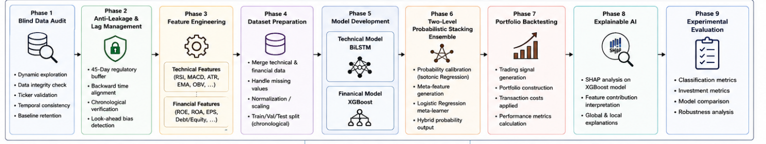

3.2 Phase 1 - Blind Data Audit
The first phase of the methodology consists of performing a blind data audit of the collected datasets prior to performing any preprocessing steps. Before financial information can be utilized by machine learning algorithms, it is necessary to ensure its integrity. Such a process can reveal issues with the data that may impact its use in modeling, such as missing values, duplicated data, invalid formats, and issues related to the companies represented by the data.
The goal of this audit is to establish a reliable data baseline prior to the application of any preprocessing steps to that data.
Furthermore, it is essential that this audit is performed prior to any data cleaning procedures. Performing the audit on raw data will reveal any issues with the data prior to any attempts to alter that data.
The blind data audit will consist of five steps:
· Dynamic dataset exploration
· Data integrity assessment
· Company identifier validation
· Temporal consistency verification
· Baseline data retention assessment
3.2.1 Dynamic Dataset Exploration
The first validation step examines the structural characteristics of both datasets. Each of the datasets was collected from different sources. Daily market data was collected from the financial website Yahoo Finance. Financial statement data was collected separately, and is integrated into the main dataset according to the chronological order of the financial statements. The complete dataset was then validated prior to preprocessing.
The market data contained 47,110 daily market observations and nine different variables associated with each market observation. The financial data contained 237 financial statement records, each containing 237 different financial variables. Each of these variables was examined prior to performing any additional analysis on the data.
The market data contained mostly numerical variables related to market and trading activity. The financial data contained numerous financial variables related to financial statements of the analyzed companies.
The dynamic exploration of the data helped to establish the characteristics of each of the datasets, and to confirm that they are suitable for the preprocessing steps that will be applied to those datasets.
Table 3.1 Data Sources Used in This Research
Data Source | Data Type | Update Frequency | Purpose in the Proposed Framework
Yahoo Finance | Daily OHLCV market data (Open, High, Low, Close, Volume) | Daily | Used to construct technical indicators, historical price sequences, and BiLSTM input features.
Quarterly Financial Statements | Balance Sheet, Income Statement, and Cash Flow Statement | Quarterly | Used to engineer financial variables, calculate TTM features, and generate XGBoost input features.
Saudi Exchange (Tadawul) | Company listings and market information | Static / Periodically Updated | Used to validate listed companies, verify ticker symbols, and define the study universe.
Capital Market Authority (CMA) | Regulatory reporting requirements and market regulations | Regulatory Updates | Used to define the 45-day reporting buffer and support the anti-leakage strategy.

3.2.2 Data Integrity Assessment
Following the completion of the structural assessment of the two main datasets, an extensive audit was performed to determine the completeness of the data as well as to identify any abnormal values represented by numbers within the data.
The integrity of the data was assessed for the presence of:
· Missing values
· Infinite values within the numerical variables
· Completeness of each variable within the dataset
· Completeness of the entire dataset
As a result of this assessment, no abnormal infinite values were identified within the financial variables. Furthermore, statistics regarding the number of missing values for each feature within the dataset were calculated.
Rather than removing any examples from the dataset that had missing values for these features, the assessment of the integrity of the data allowed for the determination of the quality of the financial information available for each company during the timeframe represented by the dataset.
The integrity assessment was conducted before any preprocessing operations to ensure that the reported statistics accurately reflected the original characteristics of the collected datasets.

3.2.3 Ticker Validation
In order to ensure that the data from each of the companies represented within the market and financial datasets were consistent, each of the company identifiers were validated against a whitelist of those companies.
Each of the company identifiers that were discovered within the datasets were compared against the list of the companies that were to be included within the study.
The validation performed ensured that the company datasets included:
· All expected companies
· All identifiers for each company that were missing from the datasets
· No companies that were identified outside of those within the whitelist
· That each company used the same ticker symbols over time within their financial markets
In addition to validating all of the companies against the whitelist, any instances of duplicates within each of the datasets were also examined to ensure that their inclusion would not impact the creation of the features for the machine learning models.
This process of automatic validation of all company identifiers ensures that each company within the market and financial datasets maintain their company identifier throughout the complete engineering process.

3.2.4 Temporal Validation
As the financial information that is used in the construction of the models is both daily market information as well as quarterly financial information for those companies, it was essential to ensure that the temporal data for each dataset was validated.
All dates from both datasets were standardized prior to integration into a unified dataset.
Temporal validation of the two datasets ensured that each of the datasets was validated for:
· Invalid timestamps
· Time period represented by market data
· Time period represented by financial data
· Duplicates within the quarterly financial reports
The market data was standardized and included time periods between January 3rd, 2021 and June 7th, 2026. Furthermore, the financial information covered the time period between September 30th, 2024 and March 31st, 2026.
The shorter financial reporting period reflects the availability of complete and chronologically validated quarterly financial statements after applying the regulatory reporting buffer and data quality filtering.
This validation of the timestamps within each of the datasets created the chronological foundation for the anti-leakage process.

3.2.5 Baseline Data Retention
Prior to any filtering of the datasets, it was essential to determine the initial Data Retention Rate (DRR) for the complete engineering process.
By recording the initial size of the dataset prior to any filtering processes, it becomes possible to determine the impact of each stage within the engineering process upon the availability of data for training the models.
As a result of this baseline data retention rate, it is possible to filter the data at each stage of the engineering process while maintaining visibility into the data retention rates after each phase. This is in contrast to conventional machine learning engineering processes, wherein data is typically removed from the dataset at each phase.

3.3 Phase 2 - Anti-Leakage and Temporal Alignment
One of the most crucial aspects of the creation of the machine learning models is to ensure that the models are trained using only information that would have been available during the formation of the investment decisions. Conventional machine learning datasets typically do not contain time-varying information, and do not incorporate the various information sources that can be combined to create financial datasets with information from different temporal frequencies. Thus, maintaining the chronological integrity of the created datasets is an essential requirement for the development of reliable machine learning models for the determination of investment returns.
The Anti-Leakage and Temporal Alignment stage of the engineering process ensures that each of the daily market observations are synchronized with the financial statements of each company, while eliminating the possibility of incorporating information from future financial reports within the training data for the models. Future financial reports for each company are not published simultaneously with the end of each reporting quarter; each company must take additional time to prepare and publish their financial reports. Thus, any merging of financial information with market data should incorporate a time delay between the end of each financial quarter and the publication of those reports.
This phase of the engineering process ensures that the entire engineering process is constructed in a manner that is chronologically-integrative and realistic regarding the conditions under which investment decisions are to be made.

3.3.1 Financial Reporting Delay
Financial reports for each company are not published immediately after the end of each reporting quarter. Each company must prepare and publish its financial reports during this time to disclose its financial information to its investors.
If the financial reports are merged with market data using the end of each quarter as the time stamp, the machine learning models will have access to financial information that would not have been available during the investment period. This information leakage will artificially enhance the performance of the models.
To eliminate this potential problem, a 45-day buffer period is established between the end of each reporting quarter for companies and the availability of their financial reports. This 45-day time period allows for each company’s preparation and publication of its financial reports. For example, if a company's financial quarter ends on March 31, the corresponding financial statements are assumed to become available approximately 45 days later (e.g., May 15). Consequently, all trading days between April 1 and May 14 continue to use the most recently available financial report from the previous quarter. This prevents the prediction models from accessing financial information that would not yet have been publicly available to investors. This process is illustrated in Figure 3.2.
Figure 3.2 Financial Reporting Timeline

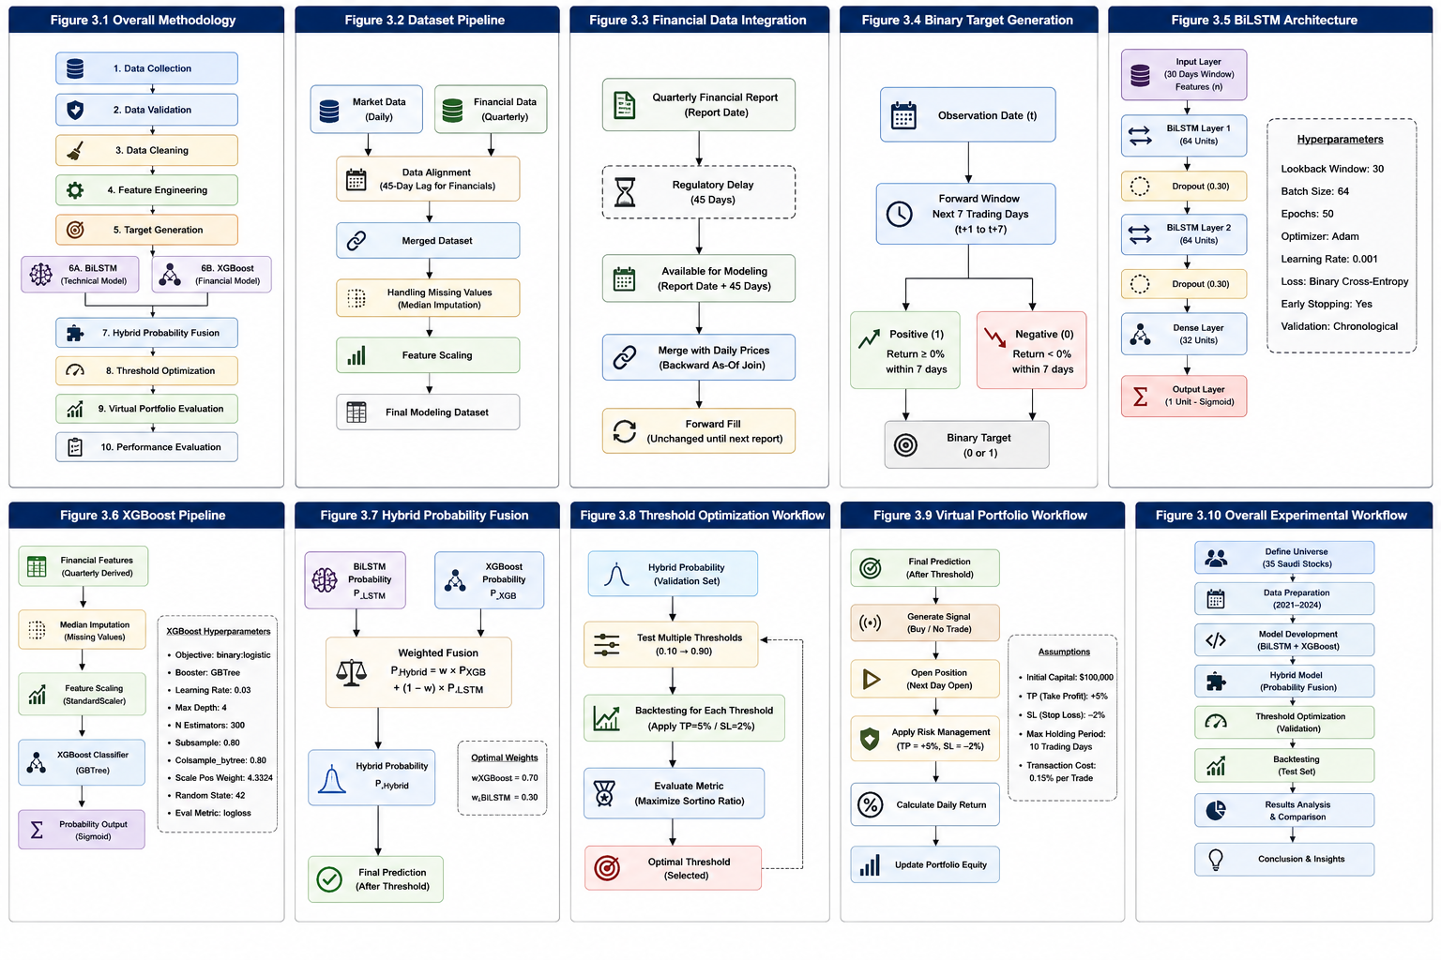
3.3.2 Time-Aware Financial Integration
Following adjustment of the financial reporting dates to incorporate the regulatory reporting buffer, the financial statements were synchronized with daily market observations according to their chronological order.
Whereas financial information is typically published according to calendar quarters, the information for each trading day was associated with the most recent financial statement that had become available to the company for publication.
This process guarantees that the prediction models are provided with information that is accessible to investors on each trading day.
Unlike conventional database joins operations, which typically ignore the time delays for financial report publication, the integration of financial and market information in this approach utilizes a time-aware join strategy that ensures that financial information always precedes market observation of the same company’s shares.
3.3.3 Chronological Verification
Following synchronization of the financial and market information, an independent process was performed to verify the chronological integrity of the integrated information.
This verification process automatically inspected each row of the integrated database to determine whether the following conditions were satisfied:
· Financial report availability always preceded trading date;
· No future financial reports were associated with historical market observations;
· Information regarding the company remained consistent throughout the database;
· There were no instances of duplicated financial information for the same company.
This verification process ensured that the resulting database had zero instances of Look-Ahead Bias. This process is one of the main safeguards that is implemented in the methodology for ensuring chronological integrity of the information included in the database.
3.3.4 Data Filtering and Retention Analysis
Following chronological alignment and verification, additional filters were applied to the database to remove any rows of market observations that were not associated with complete financial statements.
Whereas conventional database joins simply remove observations that do not meet the criteria without further analysis, the filtering of the database according to data completeness in this algorithm also includes the monitoring of a statistic known as the Data Retention Rate (DRR).
The goal of implementing a metric to measure Data Retention Rate has two main components:
First, it allows for the measurement of the amount of information that is preserved within the database after each stage of the prediction model development process.
Second, it allows for transparency in the presentation of the impact of data filtering on the dataset that is utilized to train the machine learning models.
The results of this data filtering process indicated that the size of the database was reduced from 13,665 market observations to 11,762 observations after application of the chronological filters and financial information verification. Thus, the Data Retention Rate of the database after this stage was determined to be approximately 86.07%.
By monitoring the DRR throughout the engineering of this database, the repeatability of the engineering process can be ensured, as can the ability of future researchers to evaluate the effectiveness of each preprocessing stage.
Table 3.2 Data Retention During Phase 2
Processing Stage | Remaining Records | DRR (%)
Initial Integrated Dataset | 13,665 | 100.00
After Quality Filtering | 11,762 | 86.07

3.3.5 Value of Anti-Leakage Control
The prevention of temporal information leakage is one of the most valuable concepts relating to the methodology of financial AI.
While the model will exhibit high quality in its predictions when evaluated on data that contains future financial information, the model will perform dismally in real investing scenarios due to the inability of such learned behaviours to be reproduced in live investing scenarios.
Thus, the Anti-Leakage strategy is not simply a pre-processing step to be applied to the data, but an essential methodological component of the proposed prediction methodology.
The proposed Anti-Leakage strategy will ensure that all testing and experimentation with the model reflects realistic investing scenarios, rather than results that are artificially created by the inclusion of future market information.
Figure 3.3 Anti-Leakage Validation Pipeline
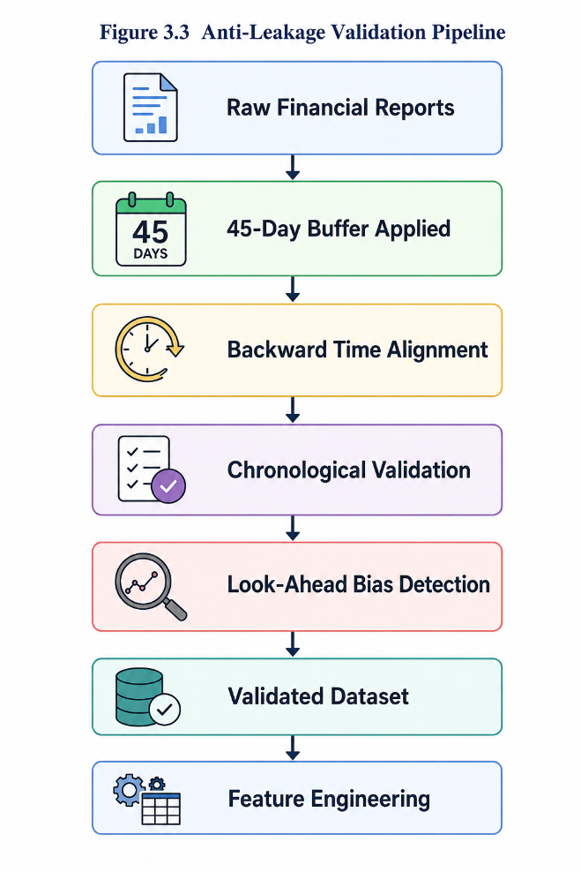

3.4 Phase 3 - Feature Engineering
Feature engineering is one of the most influential steps within the proposed artificial intelligence framework. Prediction algorithms determine the methods through which AI “learns,” but the feature engineer determines the features that will be presented to the AI for that learning to occur. Thus, the features of the artificial intelligence models have a major influence upon the predictive power of those models.
The aim of the feature engineering step is to transform the observations from the financial markets into a series of numerical features that can be fed into the AI systems. Rather than utilizing either the market prices or the company financial values as the features to be fed into the AI models, each of these AI models will generate a large number of different features that describe the various aspects of financial market and company behavior over time.
The feature engineering framework was constructed in a way that includes three main components: technical features, financial feature engineering, and feature engineering validation. Each of these components contains information that is utilized by the artificial intelligence framework to provide the predictions that it is known for.
Figure 3.4 shows the overall feature engineering workflow used in this research.
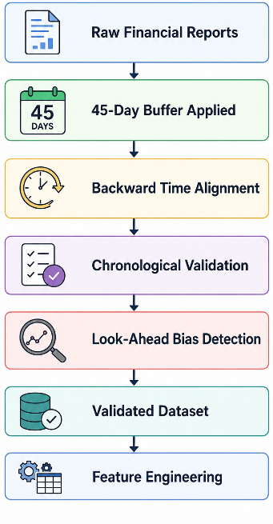

3.4.1 Technical Feature Engineering
The financial observations included in the dataset exhibit a relatively weak representation of stock behaviour when examined on its own. While the features of stocks in the dataset (such as features related to the opening, closing, highest, and lowest price of the stock, or the trading volume of the stock) contain information regarding the behaviour of those stocks, they have limited power in predicting the price of those stocks—unless they are engineered.
In line with the aforementioned discussion, a variety of technical features were created.
These technical features were grouped according to their functionality within the prediction model for the stock’s price.
The groups of created features included:
· Trend indicators.
· Momentum indicators.
· Volatility indicators.
· Volume-based indicators.
· Price relationship indicators.
By creating these different groups of technical indicators, the artificial intelligence models will gain an understanding of the market in relation to a variety of different aspects of stock behaviour. Furthermore, it will ensure that the models do not become overly reliant upon any specific technical indicator in particular.
It should be noted that these indicators are not to be utilized by any human traders; instead, the indicators are to be provided to the artificial intelligence for analysis.
Table 3.3 Technical Feature Categories
Feature Category | Information Represented
Trend | Direction of market movement
Momentum | Strength and speed of price movement
Volatility | Market uncertainty and price dispersion
Volume | Trading activity and liquidity
Price Relationship | Relative position of current price
3.4.2 Financial Feature Engineering
While technical indicators provided valuable information regarding the behaviour of the market as a whole, financial variables allowed for the description of the internal condition of the listed companies.
The financial statements were transformed into financial features that described the companies’ profitability, liquidity, operational efficiency, leverage, valuation, and growth.
All financial variables were normalized and represented as standardized financial indicators to allow for the comparison of companies of different sizes.
Furthermore, Trailing Twelve Months (TTM) calculations were performed on most financial variables to smooth out the representation of the companies’ performance and to allow for the reduction of the influence of seasonal fluctuations on those variables.
Category | Example Features | Purpose
Profitability | ROE, ROA, Net Profit Margin | Measure corporate profitability
Valuation | P/E Ratio, P/B Ratio | Assess market valuation
Leverage | Debt-to-Equity Ratio | Measure financial risk
Growth | Revenue Growth, EPS Growth | Measure business expansion
Cash Flow | Free Cash Flow Margin | Assess cash generation capability

The incorporation of TTM calculations allows the machine learning models to use smoothed and more stable information regarding the financial variables of the listed companies.
Figure 3.5 Financial Feature Engineering
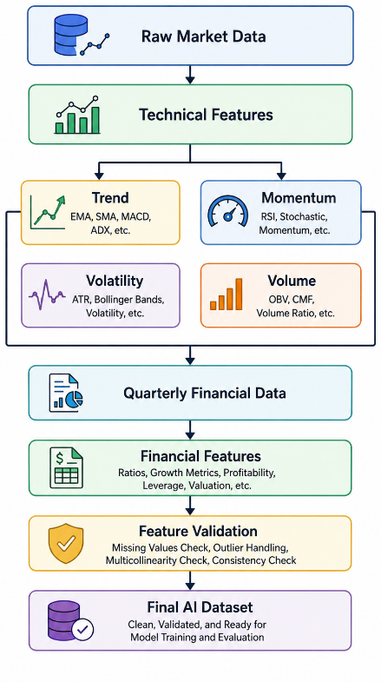
3.4.3 Feature Coverage Validation
Creating a large number of financial features ensures that the models will have a variety of potential input variables; however, it does not ensure that each of those features will contain high-quality data.
An analysis of the coverage of each of the created features was performed to ensure that each model would have high data completeness.
An analysis of the percentage of available observations for each of the created features allowed for the identification of any financial variables that were not complete before the creation of the prediction models.
As a result, it was found that most of the technical indicators were complete; the majority of the observations for RSI, MACD, Bollinger Bands, and ADX were above 90%. Furthermore, as a result of the engineering and integration of the TTM calculations, the financial features also had high data completeness and availability.
Thus, each of the created prediction models will use high-quality and complete data.
Table 33 Example Feature Coverage
Feature Group | Average Coverage | Status
Trend Indicators | 95% | Accepted
Momentum Indicators | 94% | Accepted
Volatility Indicators | 93% | Accepted
Volume Indicators | 96% | Accepted
Financial Variables | 98% | Accepted

3.4.4 Feature Selection Strategy
Rather than creating prediction models with the intention of using as many of the created features as possible, the feature selection was guided by four main principles:
1. Each of the selected features should represent some measure of financial or market behaviour.
2. No feature should include information from the future of the market or company financial variables (chronological validity).
3. The technical and financial features should represent different forms of market and financial information.
4. Financial features with insufficient coverage or those with unstable behaviour were eliminated from the models.
3.4.5 Phase Output
The output of this phase was the creation of a feature matrix that included the technical and financial variables that would be utilized in the creation of the artificial intelligence models.
The creation of the artificial intelligence models was performed after this phase and after the validation of all features.
The inclusion of these steps before the creation of the prediction models increases the quality and the credibility of the models, as well as ensures that they can be reproduced in the future in the same area of financial artificial intelligence research.
The resulting feature matrix constitutes the final input representation for the proposed hybrid framework, where sequential technical features are supplied to the BiLSTM model and structured financial variables are supplied to the XGBoost model in the subsequent model development phase.
3.5 Phase 4 - Dataset Construction and Binary Target Engineering
The development of the supervised machine learning models critically depends on the availability of a well-structured and accurately labelled training dataset. While the previous phases of the research described the steps that were necessary to ensure the quality of the available data, the objective of the present phase is to actually construct the machine learning dataset that will be used to train the artificial intelligence models.
As with the available financial datasets, the data that was engineered for this research included features that described the companies’ behaviour and financial variables. Furthermore, the goal of creating such a dataset was to allow for the engineering of data that could be used to perform short-term stock market predictions. Thus, the dataset that was engineered for this research is used by the BiLSTM and the XGBoost models to train the models to recognize the features of markets that will lead to specific market movements.

Figure 3.6 Dataset Construction Workflow

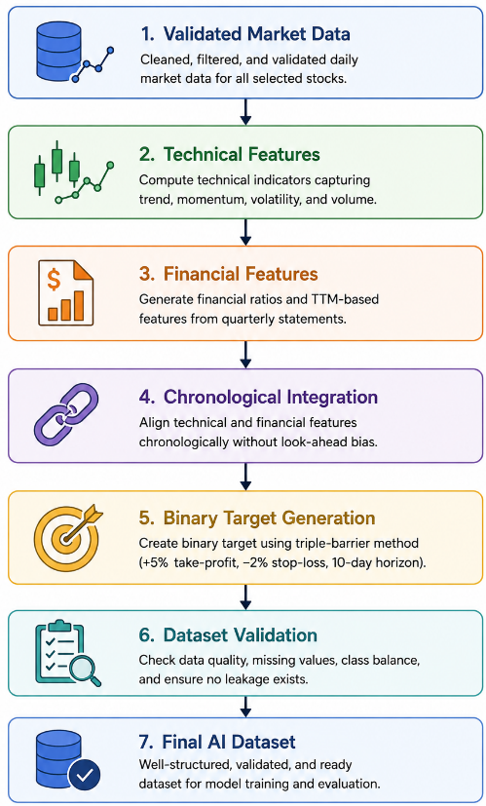
3.5.1 Construction of the Master Dataset
After the process of feature engineering, the collected variables were combined into a single master dataset that would be used for supervised machine learning. Each observation in the dataset represented each trading day’s market information, but with financial information associated with that market day that had become publicly available through time.
Each observation in the master dataset contained information regarding:
trading date
company
daily market information
engineered technical features
financial variables
binary prediction target
This master dataset enables the artificial intelligence framework to learn how to accurately predict stock market movement while avoiding the need for additional preprocessing of the data.
3.5.2 Binary Target Engineering
The artificial intelligence models that are to be developed will be utilized to perform a task that is essentially a classification problem. Rather than attempting to determine the price of a stock in the future, the goal of the models will be to recognize whether or not there is a positive investment opportunity within a defined period for that stock.
3.5.3 Prediction Horizon
For each stock market observation within the database, the following period that will be evaluated is a seven-day trading period. Thus, each data point will be associated with the subsequent seven trading days for that stock to determine if there was a positive investment condition during that time period.
By utilizing a period of seven trading days, there are a variety of advantages to this time period. First, it ensures that the stock market prediction becomes a supervised learning problem. Second, it guarantees that each data point is evaluated during the same time period. Finally, it provides a balance between examining the stock market for short-term movements in the stock prices while providing sufficient time for those prices to even change.
This time period will be utilized to define the artificial intelligence models’ learning objectives while avoiding the introduction of any portfolio management rules.
3.5.4 Distribution of Binary Targets
The binary target data has been generated and analyzed to determine the distribution of each type of target within the master dataset.
In total, there were 11,598 labeled data points after the application of all of the target generation rules.
Within the dataset:
6,505 stocks had a target value of “1”
5,093 stocks had a target value of “0”
These targets are relatively even compared to other financial data prediction problems. Furthermore, within the stock market, it is typically true that positive investment opportunities exist for only a small fraction of the total labeled data points. Thus, the fact that there are an adequate number of each target class within the data indicates that there is an even distribution of opportunities for positive investments within the defined seven-day trading period.
Table 3.5 summarizes the distribution of the binary target values.
Table 3.5 Binary Target Distribution
Target Class | Number of Samples
Target = 1 | 6,505
Target = 0 | 5,093
Total | 11,598
3.5.5 Interpretation of Target Distribution
The target distribution indicates that there are sufficient observations of both the positive and negative targets. Furthermore, the use of a seven-day trading period as the prediction horizon ensures that the artificial intelligence models will be able to learn about short-term investment opportunities while providing enough samples of each target class for the models to recognize the differences between each type of target.
3.5.6 Validation of the Dataset
The final data set created through this process was validated prior to the development of the artificial intelligence models. The validation process ensured that the master dataset contained all of the features and data points that were necessary to create a supervised learning algorithm, including:
chronological ordering of the stocks
binary target data
correctly identified companies
correct integration of technical and financial features
no duplicate data points
absence of look-ahead bias
Following the validation process, the dataset was confirmed as suitable for development of the artificial intelligence models.
3.5.7 Output of Phase 4
The output of this phase of the artificial intelligence framework is a complete and validated machine learning dataset that contains chronological data points of market activity, technical market features, financial features, and labels created through the binary target generation process.
It is important to note that this data was created for the sole use of training and testing the artificial intelligence models. The stop-loss and take-profit levels, such as the +5% take-profit or -2% stop-loss strategy for the stocks, are not generated during this process. These rules will be created during phase five, when the artificial intelligence models are to be tested within the context of a trading portfolio.
Thus, the targets are utilized to define the objectives of the artificial intelligence models, while the stop-loss and take-profit rules will define the strategy for evaluating the performance of those artificial intelligence models.
3.6 Development of the Individual Prediction Models
The machine learning dataset that was created and validated during phase four will be utilized during the development of the individual artificial intelligence models that are to be developed for the portfolio management system. Because there are two different types of data that relate to the stocks, it was decided that each AI model will be trained with the type of data that best relates to that model. Thus, two separate models will be trained and developed: one that learns from the technical market data for those stocks, and another that learns from the financial data for those stocks.
The reason that the technical and financial markets contain different types of information is due to the fact that the technical indicators form a series of observations of the market over time, while the financial data is a series of attributes for each company that is published in the company’s financial reports.
Furthermore, it is likely that no single algorithm will be able to learn the features and aspects of both types of data equally well. Thus, the development of these two separate models will allow for each artificial intelligence algorithm to maximize its potential to recognize opportunities for positive investments in the stocks within the portfolio.
For this reason, two separate models will be developed during this phase:
A Bidirectional Long Short-Term Memory (BiLSTM) model that is trained with the technical market data.
An eXtreme Gradient Boosting (XGBoost) model that is trained with the financial data.
Figure 3.9 depicts the development of these individual AI models.
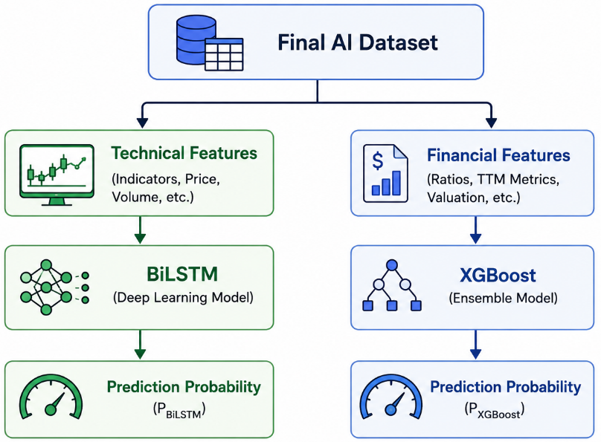
3.6.2 Sequential Data Preparation
In addition to conventional approaches to data preparation, additional preprocessing is required to prepare the financial data for use with deep learning approaches.
Each group of consecutive daily observations was grouped into a rolling temporal window of a specific size. This enables the BiLSTM model to learn from the relationship among each of the consecutive market observations, rather than analyzing each trading day independently.
The structure of these temporal data groupings ensures that the temporal relationship is maintained throughout the complete dataset, and ensures that no future market observations are incorporated into any of those sequences.

3.6.3 BiLSTM Training Strategy
The chronological training dataset was used to train the BiLSTM model. The data was divided into training, validation, and testing subsets according to their chronological order within the training dataset. As such, no future market observations were used during the training phase of the BiLSTM model. Furthermore, the model was trained according to the validation data to minimize overfitting of the training data, and to maximize the generalization of the BiLSTM model to the observations in the testing data. Consequently, early stopping techniques were utilized during training to ensure that the model was generalized well to the training data, yet still performed well on the validation data.
3.6.4 Output of the BiLSTM Model
Rather than directly converting the output of the BiLSTM model into a trading signal, the probability that the market observation belongs to the positive class of trading signals is calculated. This probability is not directly used to make a trading decision, but is sent to the probability fusion stage of the hybrid model, along with the trading signal probabilities calculated by the XGBoost model. Utilizing the probabilities rather than the binary trading signals maximizes the potential for finding an appropriate optimization strategy for the BiLSTM and XGBoost model during the training phase.
3.6.5 BiLSTM Model Configuration and Training Strategy
As with other machine learning models, the deep learning approach of BiLSTM models also has various parameters that must be configured prior to training. The BiLSTM model was developed with specific configurations that ensure that it gains the maximum predictive capability while minimizing the potential for overfitting of the training data.
Each of the parameters of the model were configured according to the characteristics of the financial data that was used to train the model.
3.6.5.1 Sequential Observation Window
As with other deep learning models, the BiLSTM model requires the input of various sequential observations. The technical analysis data was converted into rolling sequences using a specific lookback window size. Each example of the training data included multiple consecutive trading sessions. Thus, the model was able to recognize relationships among the various technical indicators that were measured during each of those sessions, and to use those relationships to inform the prediction of future market behavior. Furthermore, a specific size of the lookback window was chosen for the model; various factors informed the choice of that size. The structure of the sequences of daily market observations that were created for training data is displayed in Table 3.6.
Table 3.6 BiLSTM Input Configuration
Parameter | Value
Lookback Window | 30
Input Features | X_lstm
Input Shape | (Samples × Timesteps × Features)
Prediction Output | Binary Probability (Sigmoid Output)
3.6.5.2 Network Architecture
The proposed BiLSTM model consists of the following network architecture: multiple Bidirectional LSTM layers and dropout layers, followed by an output layer with a Sigmoid activation function.
The Bidirectional LSTM layer is used to capture the long-term dependencies between market observations from the previously engineered technical indicators. Furthermore, multiple such layers allow the model to sequentially learn and refine the dependencies between these observations prior to making the final prediction.
Dropout layers are incorporated into the network between the Bidirectional LSTM layers to regularize the model and reduce overfitting. By randomly deactivating a certain proportion of neurons within the network during training, the model learns to rely less upon any specific weights within the network to perform well, which improves its generalization ability on market conditions it has not yet seen.
The output layer of the BiLSTM network contains a single neuron with the Sigmoid activation function to determine the probability that a given set of technical indicators belongs to the positive class within the classification problem.
Figure 3.11 illustrates the architecture of the BiLSTM network.
Figure 3.11 BiLSTM Architecture
3.6.5.3 Training Strategy
The training data for the BiLSTM model consisted of the training dataset created during the preprocessing phases of the project.
The training data was divided chronologically into training, validation, and testing data subsets.
By partitioning the training data in this way, the model is trained in a way that more accurately reflects real-world market conditions.
The model’s performance on the validation data was used to monitor the training process. Using this validation data, it was possible to automatically adjust the training process to avoid overfitting to the training data alone.

3.6.5.4 Early Stopping Strategy
Deep neural networks such as the BiLSTM network are often vulnerable to overfitting to the training data.
To mitigate this issue, an early stopping strategy was incorporated into the training strategy. The training process is automatically terminated if the model’s performance on the validation data does not improve over a pre-defined number of training epochs.
By including this strategy, the model is less likely to overfit the training data while training the network. Furthermore, this strategy allows for the automatic selection of the best model to utilize rather than having it selected manually after training is complete.

3.6.5.5 Model Optimization
In the training of the BiLSTM model, the Adam optimization algorithm was utilized.
The Adam optimization algorithm is a gradient-based optimization algorithm that automatically adapts the learning rate within the network according to the performance of the model. Thus, the algorithm is often used to train deep neural networks, especially on large datasets, such as financial time-series data.
For the BiLSTM model, the objective function to minimize was the binary cross-entropy error function. As the goal of the model is to determine the probability of the observation belonging to each of the two classes, the binary cross-entropy function was the most appropriate loss function to minimize in this case.
Table 3.7 BiLSTM Configuration
Hyperparameter | Configuration
Lookback Window | 30
Number of Technical Features | 9
Batch Size | 64
Maximum Epochs | 50
Optimizer | Adam
Learning Rate | 0.001
Loss Function | Binary Cross-Entropy
Output Activation | Sigmoid
Early Stopping | Enabled
Validation Strategy | Chronological Validation Set
Gradient Clipping | clipnorm = 1.0
Dropout | 0.30
LSTM Units | 64
Recurrent Dropout | 0.20
L2 Regularization | 0.01
3.6.5.6 Training Monitoring
Throughout the training of the BiLSTM model, the loss of both the training and validation data was continuously monitored.
By recording both training and validation loss after each epoch, it is possible to create a visual representation of the training process of the network. Furthermore, such a visual representation can aid in the determination of the best BiLSTM model to utilize.
3.6.5.7 Output of the BiLSTM Training Phase
The output of the BiLSTM model after the training phase is the probability of the technical indicator observation belonging to the positive class for investments. As these probabilities contain richer information than the classification of these observations as positive or negative classes, these outputs are the input that is fed into the Stacking Ensemble stage.
3.6.6 Development of the XGBoost Model
In contrast to the BiLSTM model, a different machine learning model had to be utilized to analyze the information contained within the financial statements of the listed companies. The financial information within these tables does not have a temporal component to it, unlike the technical indicators. As such, the model that will be utilized within the second component of the framework is eXtreme Gradient Boosting (XGBoost) - a machine learning algorithm that is well-suited to analyzing tabular data.
The XGBoost model will take the financial features created during Phase 3 as its inputs, as these are the only variables that will be fed into this second component of the framework.
3.6.6.1 Financial Feature Representation
The inputs to the XGBoost model will be the financial variables extracted from the listed companies’ financial statements and transformed during the feature engineering stage.
These financial variables represent a variety of different aspects of the financial statements and the companies that published them.
Unlike the technical indicator features, these financial variables have no temporal component to their features. Furthermore, before the development of the XGBoost model, all of the financial observations had already been pre-processed to ensure that they satisfied the conditions required to be used by the BiLSTM model.
Figure 3.13 Financial Learning Pipeline
3.6.6.2 Gradient Boosting Strategy
The XGBoost model is based on the gradient boosting strategy, which trains multiple decision trees to iteratively improve the prediction performance of the previous decision trees.
Instead of relying on a single decision tree to learn and make predictions, the algorithm trains additional decision trees whose predictions are used to compensate for the errors of the previous decision trees.
This strategy allows the model to effectively learn nonlinear relationships between the financial variables and accurately predict the target variable while maintaining good computational efficiency.
The objective of the XGBoost model is to estimate the probability of a financial observation belonging to the positive trading class.
3.6.6.3 Model Configuration
The XGBoost model configuration was chosen to provide a good balance between the model’s prediction performance and its generalization ability.
The model adopts a relatively simple configuration to reduce the risk of overfitting while maintaining the model’s ability to learn complex nonlinear relationships between the financial variables.
The main parameters that can be configured within XGBoost include the boosting strategy, tree depth, learning rate, sampling strategy, and the regularization controls. The final configuration of the model’s hyperparameters is presented in Table 3.8.
Table 3.8 XGBoost Hyperparameter Configuration
Hyperparameter | Value | Purpose
Objective | binary:logistic | Binary probability estimation
Learning Rate (η) | 0.03 | Controls update step size
Max Depth | 4 | Controls tree complexity
Number of Trees | 300 | Number of boosting iterations
3.6.6.4 Training Procedure
The XGBoost model determines the weights to be applied to each of the financial features using the feature matrix obtained from the previous stage of model training.
The training, validation, and testing datasets were chronologically separated to ensure that there were no trading session signals from future trading sessions included in either the training or testing datasets.
The model was trained on the training and validation datasets using cross-validation to determine the best performing model, with the testing dataset being used solely to test the model after the training phase.
By chronologically training the model, the model’s performance is representative of its capability to accurately forecast the stock market’s future trading signals.
3.6.6.5 Feature Learning Characteristics
The XGBoost model learns the features in a manner similar to decision trees; it partitions the feature space into different regions according to which region contains the majority of observations with a particular value of the target variable.
This approach allows the model to find complex nonlinear relationships between the financial variables.
Furthermore, as the model is based on decision trees, it is inherently somewhat explainable; the contribution of each financial variable to the learning of the model can be analyzed in the explainable AI stage of this project.
3.6.6.6 Output of the XGBoost Model
The output of the XGBoost model is the probability that a financial observation belongs to the positive trading class.
This probability is not directly used in making trading decisions; instead, it is preserved as an output for use in the fusion of probabilities with the probabilities generated by the BiLSTM model.
By preserving the probabilities from both models, the trading signals can be generated based on the information content of both the technical and financial variables of the company in question.
3.6.7 Comparative Characteristics of the Individual Models
After the development of the two individual models, it is useful to review their different roles within the trading system that is proposed for this project.
Both models solve the same problem of identifying whether a company will experience a positive trading class; however, they use different representations of that financial information.
The BiLSTM model learns the temporal patterns in the sequence of technical indicators for a company, while the XGBoost model learns the nonlinear relationships between financial variables.
These different specializations of the two models will allow them to contribute to the Stacking Ensemble stage of this project.
Table 3.9 presents a comparison between the two individual models within the system.
Characteristic | BiLSTM | XGBoost
Input Data | Sequential Technical Features | Structured Financial Features
Data Representation | Time-Series Sequences | Tabular Financial Variables
Learning Mechanism | Bidirectional Recurrent Neural Network | Gradient Boosted Decision Trees
Output | Probability | Probability
Primary Strength | Temporal Pattern Learning | Structured Financial Modeling
Role in Framework | Technical Prediction | Financial Prediction

3.7 Phase 6 - Two-Level Probabilistic Fusion (Stacking Ensemble)
Following the independent development of the BiLSTM and XGBoost models, a two-level probabilistic stacking ensemble was implemented to combine their complementary predictive capabilities. Instead of directly averaging the outputs of the individual models, the proposed framework first calibrates the probability estimates of each base learner using isotonic regression. The calibrated probabilities are subsequently provided to a Logistic Regression meta-learner, which produces the final prediction by learning the optimal combination of both models. This architecture improves probability reliability while allowing the fusion process to adapt automatically to different market conditions.
Table 3.10 Two-Level Probabilistic Stacking Workflow
Stage | Input | Output | Purpose
Probability Calibration | Raw probabilities from BiLSTM and XGBoost | Calibrated probabilities | Improve probability reliability
Meta-Feature Construction | Calibrated probabilities | Meta-feature vector | Capture complementary information
Logistic Regression Meta-Learner | Meta-feature vector | Final probability | Learn optimal combination
Threshold Optimization | Final probability | Final trading signal | Convert probabilities into Buy / No Buy decisions

3.7.1 Rationale for Probability Fusion
Ensemble learning can be implemented at different stages of the prediction process. The framework proposed uses probability-level fusion since the calibrated probabilities contain more predictive information than the binary predictions from the models.
Instead of using weights for the individual models’ predictions, a Logistic Regression model is used to automatically determine the weights that best suit the two models using the validation data.
The predicted probabilities from the BiLSTM and XGBoost models are calibrated using Isotonic Regression prior to fusing the predictions. Probability calibration ensures that the predicted probabilities contain more reliable information for the trading outcomes.
Figure 3.14 Two-Level Probabilistic Fusion (Stacking Ensemble)
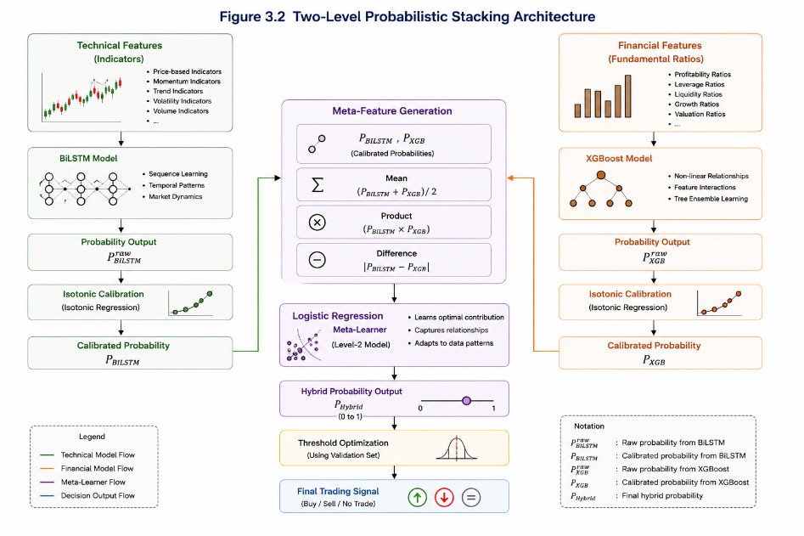

3.7.2 Probability Integration Strategy
Rather than directly using the probabilities of the BiLSTM and XGBoost models, each of these probabilities is transformed into a set of features. These features include the calibrated probabilities, the mean of the two probabilities, the product of the two probabilities, and the difference between the two probabilities. Each of these features is provided to a Logistic Regression model, which learns a final probability value from these features.
3.7.3 Meta-Learner Training Strategy
The Logistic Regression model is trained using only the validation data after the BiLSTM and XGBoost models are trained. Using only the validation data to train the Logistic Regression model ensures that the model is not “leaking” information from the independent test set, and that the results of the model are an unbiased estimate of its performance. Regularization and class weighting are used during training to encourage generalization of the model. The Logistic Regression model employed L2 regularization with a regularization parameter of C = 1.0 and class_weight = balanced to encourage generalization of the model under class imbalance.
Table 3.11 Meta-Features Used by the Stacking Ensemble
Meta Feature | Description
BiLSTM Probability | Calibrated probability produced by the BiLSTM model
XGBoost Probability | Calibrated probability produced by the XGBoost model
Product | Interaction between both probabilities
Mean | Average confidence of both models
Absolute Difference | Degree of disagreement between both models

3.7.4 Learned Meta-Feature Contributions
After training, the Logistic Regression model automatically calculated the contribution of each of the engineered meta-features. These coefficients are not the result of manually specifying weights for each of the base models, but were learned from the validation dataset itself. Thus, the model’s final prediction is based upon the statistical relationships between these two base models.
Meta Feature | Coefficient | Relative Contribution
BiLSTM Probability | 2.2128 | 29.6%
XGBoost Probability | 1.1296 | 15.1%
Product | 1.8043 | 24.1%
Mean | 1.6712 | 22.3%
Absolute Difference | -0.6662 | 8.9%

3.7.5 Hybrid Probability Output
The output of the model is the single probability generated by the trained Logistic Regression model. This probability indicates the likelihood of the portfolio outcome based on both technical and financial model outcomes. Utilizing probabilities rather than direct classification of the portfolio outcome allows the probability to be used by the portfolio evaluation model to make decisions regarding the portfolio.
3.7.6 Advantages of the Proposed Stacking Strategy
The proposed strategy includes several advantages.
First, each of the prediction models includes the type of information that is best for that model’s architecture.
Second, the fusion of the probabilities preserves the model’s prediction of the target variable.
Third, automatic learning of model contributions by the meta-learner.
Fourth, the model is easily extensible by adding additional prediction models to the learning phase.
Finally, the strategy separates the learning phase from the investment decision phase, allowing the two processes to be optimized independently of one another.
Table 3.12 Advantages of Probability Fusion
Design Component | Methodological Benefit
Independent Learning | Specialized feature learning
Probability Calibration | Improves probability reliability
Meta-Learner Fusion | Automatically learns optimal model contributions
Engineered Meta-Features | Captures interactions between models
Modular Architecture | Easily extensible
Separate Decision Stage | Independent portfolio optimization
3.7.6 Decision Threshold Optimization
The final trading decision was made by applying a decision threshold to the calibrated probability derived from the stacking ensemble. A threshold value grid search (from 0.00 to 1.00 in increments of 0.01) was performed on the validation set to find the most suitable threshold. F1-score and Youden's J statistic were tested as criteria for optimization. As both values converged around 0.50, the conventional 0.50 threshold was selected for all subsequent experiments to mitigate nonsensical threshold optimization.
As anticipated, a lower threshold shifted the balance in favor of recall at the expense of precision, while higher thresholds generated fewer but more trustworthy trade predictions. The 0.50 threshold offered the most advantageous compromise between both considerations and was therefore chosen for the final modeling and evaluation.
3.7.7 Output of Phase 6
The stacking ensemble provides a calibrated probability value for each observation. However, the probability alone does not provide a trading decision. The probability value is compared against a decision threshold defined through validation. Probabilities that meet or exceed the threshold represent a trading opportunity, whereas lower probabilities represent no opportunity to trade. This delineation maintains the independence of model learning and trade decisions while preventing leakage from the training dataset to the test dataset.
3.8 Phase 7 - Portfolio Evaluation Framework
Although the framework was trained as a classification model, its purpose is to allow investors to make investment decisions based upon the model’s predictions. Thus, evaluation of the classification models using traditional classification model metrics only provides a limited evaluation of the utility of the model. Accordingly, a portfolio evaluation framework is proposed to enable the model predictions to be evaluated in relation to its potential to enable investors to make investment decisions.
Unlike the other phases of the framework, the portfolio evaluation framework does not influence the training of the prediction models. Instead, the portfolio evaluation stage enables the evaluation of the potential of the model’s predictions to enable investors to make investment decisions.
Figure 3.16 Portfolio Evaluation Framework
3.8.1 From Prediction to Trading Decision
The trading model will generate a trading decision for every observation in the market data.
The trading decision will be made by comparing the value of the prediction of the model’s probability to a threshold. If the probability value meets the threshold, then an investment decision will be made with that stock; otherwise, the stock will be ignored by the model.
Thus, the trading model’s prediction and investment decisions are independent of one another. Furthermore, the threshold for investment decisions is applied after the trading model makes its predictions, ensuring that the learning phase of the model is independent of the trading decisions of the investor.
3.8.2 Virtual Portfolio
The trading signals generated by the trading model were evaluated using a virtual portfolio.
The virtual portfolio was constructed to evaluate the trading signals generated by the trading model.
The virtual portfolio executed every trade signal generated by the trading model and tracked the performance of each trade.
3.8.3 Trading Rules
Each trade signal was executed according to a set of rules for the virtual portfolio.
The rules were established independently of the trading model and its training.
The trading rules included the following components:
Rules for making trading entries according to the trading model’s signals
A holding period for each trade
A take-profit level for each trade
A stop-loss level for each trade
An evaluation of each executed trade
These trading rules are only employed during the portfolio evaluation stage. Thus, they are independent of the training of the trading model.

Table 3.13 Portfolio Evaluation Rules
Component | Description
Signal Source | Hybrid AI Model
Portfolio Type | Virtual Portfolio
Decision Rule | Probability Threshold
Exit Strategy | Fixed Portfolio Rules
Performance Assessment | Portfolio-Level Metrics
3.8.4 Portfolio Performance Recording
Every trade executed by the portfolio was recorded during the evaluation of its performance.
The portfolio engine automatically recorded measures including:
- The entry date for the trade.
- The exit date for the trade.
- The entry price for the trade.
- The exit price for the trade.
- The length of time that the trade was active.
- The return of the individual trade.
- The evolution of the equity of the portfolio.
By recording the complete trading history of the portfolio’s trades, it becomes possible to perform a detailed analysis of the performance of the portfolio and to ensure that the evaluation of its performance is completely reproducible.
3.8.5 Performance Measurement Strategy
As with many other forms of machine learning evaluation, the evaluation of the profitability of investments also considers the risk associated with those investments.
A variety of different performance measures were considered for evaluating the profitability of the investments, including measures of profitability, consistency in trading, and risk measures.
Each of these different performance measures allows for a more complete evaluation of the capabilities of the proposed investment framework.
The results of these measures are presented and analyzed in Chapter Four of this thesis.
3.8.6 Separation Between Learning and Evaluation
One of the main characteristics of the proposed framework is the separation that exists between the learning of the models and the evaluation of the trading portfolio.
When the learning algorithms are trained to classify the market movements as either positive or negative returns, those algorithms do not consider any factors related to the trading portfolio.
Thus, after the algorithms have learned of the probability that the markets movements will be positive or negative returns, it is only at this point that trading decisions are executed within the portfolio.
This method of separating the learning algorithms from the trading portfolio helps to ensure the objectivity of each of these processes.
Figure 3.17 illustrates this separation between the learning and evaluation of the trading portfolio.

3.9 Chapter Summary
The engineering methodology to be used for the development of the proposed framework for artificial intelligence trading systems was presented in this chapter.
The methodology included first auditing the data to be used to ensure its integrity, followed by integrating the technical and financial features into a machine learning dataset. The algorithm was used to create a target for each instance of the created dataset. Two different prediction models were created for the system, each with a different set of features. Finally, a portfolio evaluation framework was created to evaluate the profitability of the predictions made by the artificial intelligence trading framework. Furthermore, the method for creating the artificial intelligence trading framework ensured the separation between the learning of the models and the evaluation of the trading portfolio.
The following chapter presents the results of the experiments that were performed for the proposed framework.

