
AI-Based Nowcasting of National CO₂ Emissions
Using Satellite-Derived Indicators:
A Hybrid Framework for GCC Countries
Prepared By
Mohammad Wajeeh Bader
Student ID: 251000462

Submitted in fulfillment of the requirements for the degree Master of Science in Artificial Intelligence

Supervised by
Dr. Amjad Qtaish

College of Informatics, Midocean University, Comoros

November 2025

Acknowledgments

I would like to thank my supervisor. He did more than guided my research he taught me how to think, how to question, and how to keep going when things got hard. I owe him a lot.
I also thank my colleagues at work. They listened to me talk about algorithms and emissions for months and never complained. I truly appreciate their patience and support.
Finally, I thank my parents for supporting me throughout this journey. My father asked, "When will you finish?" almost every week. That kept me moving. My mother handled everything else so I could focus. Machine learning means nothing to them, but they saw it meant something to me.

Abstract

National greenhouse gas inventories are generally published with a one- to two-year lag following the actual emission events, causing governments to base policy choices on information that is no longer current. Can satellites provide timely CO₂ estimates for GCC countries? This question drives the research. For Saudi Arabia, the United Arab Emirates, Bahrain, Kuwait, Oman, and Qatar, I compiled a balanced panel dataset spanning 2000–2023 (144 country-year observations). Production-based CO₂ data and macroeconomic indicators come from the Our World in Data (OWID) database. Satellite-derived metrics are extracted from five Google Earth Engine products: MODIS land surface temperature (LST), MODIS vegetation index (NDVI), DMSP/VIIRS night-time lights, MERRA-2 aerosol optical depth (AOD), and Sentinel-5P tropospheric NO₂. All variables are aggregated to annual country-year format for cross-source comparability.
Three XGBoost models tested via temporal validation (train: 2000-2018, test: 2019-2023). Model A (economic): R² = 0.96. Model B (satellite + population): R² = 0.69. Model C (satellite only): R² = 0.67. All capture year-to-year CO₂ variation.
Dominant predictors: seasonal LST (summer/winter), night lights, population density. Findings match GCC emission drivers: extreme heat, urbanization, and power demand.
Overall, satellite-based models cannot fully substitute for official inventories; nevertheless, they provide rapid, physically grounded nowcasts that complement conventional methods and reduce delays in emissions tracking.

Keywords: CO₂ emissions, machine learning, XGBoost, satellite remote sensing, Google Earth Engine, land surface temperature, night-time lights, MODIS, VIIRS, GCC, climate monitoring, nowcasting

Table of Contents

Acknowledgments i
Abstract ii
Table of Contents iii
List of Abbreviations v
List of Figures vi
List of Tables vii
Chapter 1 Introduction 8
1.1 Introduction 8
1.2 Problem Definition 9
1.3 Thesis Objectives 10
1.4 Thesis Contribution 10
1.5 Thesis Organization 11
Chapter 2 Overview 12
2.1 Introduction 12
2.2 Artificial Intelligence 12
2.3 Machine Learning 13
2.4 Supervised Learning in Detail 14
2.5 Deep Learning 15
2.6 Ensemble Methods 15
2.7 The XGBoost Algorithm 16
2.8 Greenhouse Gas Emissions and Climate Policy 16
2.9 The GCC Region: Energy Profile and Climate Commitments 17
2.10 Earth Observation for Environmental Monitoring 18
2.11 Satellite Data Sources Used in This Study 19
2.12 Machine Learning for Emission Estimation 20
2.13 XGBoost: Mathematical Formulation 20
2.14 Explainable AI for Tree-Based Models 21
Chapter 3 Related Work 22
3.1 Introduction 22
3.2 AI-Based Emission Forecasting 23
3.3 Satellite-Based Carbon Monitoring 24
3.4 Regional Studies in the GCC 24
3.5 Research Gaps and Contributions 25
Chapter 4 Proposed Approach 27
4.1 Introduction 27
4.2 Research Design Overview 27
4.3 Study Area: The GCC Region 29
4.4 Data Sources and Collection 29
4.4.1 Emission Data 30
4.4.2 Economic and Demographic Data 30
4.4.3 Satellite Data 31
4.5 Satellite Data Extraction Pipeline 31
4.5.1 Google Earth Engine Image Collections 31
4.5.2 Extraction Workflow 32
4.5.3 Handling the DMSP–VIIRS Transition 33
4.5.4 Missing Data Handling 34
4.6 Feature Engineering and Preprocessing 34
4.6.1 Seasonal Disaggregation of Temperature 34
4.6.2 Population Density Transformation 35
4.6.3 Final Feature Set 35
4.6.4 Correlation Analysis 36
4.7 Experimental Design: Three-Model Comparison 37
4.8 Model Training and Validation 38
4.8.1 Temporal Train–Test Split 38
4.8.2 XGBoost Configuration 38
4.9 Evaluation Metrics 39
Chapter 5 Experimental Results and Discussion 40
5.1 Introduction 40
5.2 Data Quality Assessment 40
5.3 Model Performance Comparison 42
5.4 Feature Importance Analysis 45
5.5 Error Analysis and Residual Diagnostics 46
5.6 Country-Level Performance 47
5.7 Discussion of Findings 48
5.8 Summary of the Chapter 49
Chapter 6 Conclusion and Future Work 50
6.1 Summary of Contributions 50
6.2 Practical Implications 50
6.3 Scope and Future Extensions of the Proposed Framework 51
6.4 Concrete Future Work Directions 53
References 55
Appendices 58
Appendix A: Google Earth Engine Code Snippets 58
A.1 LST Extraction Example 58
A.2 Night-time Lights Extraction 58
Appendix B: Dataset Variables 59

List of Abbreviations

AI | Artificial Intelligence
ANFIS | Adaptive Neuro-Fuzzy Inference System
AOD | Aerosol Optical Depth
CNN | Convolutional Neural Network
CO₂ | Carbon Dioxide
DMSP | Defense Meteorological Satellite Program
EO | Earth Observation
ESA | European Space Agency
FFNN | Feed-Forward Neural Network
GCC | Gulf Cooperation Council
GEE | Google Earth Engine
GHG | Greenhouse Gas
IPCC | Intergovernmental Panel on Climate Change
LST | Land Surface Temperature
LSTM | Long Short-Term Memory (Neural Network)
MAE | Mean Absolute Error
MAPE | Mean Absolute Percentage Error
MERRA-2 | Modern-Era Retrospective Analysis for Research and Applications, Version 2
ML | Machine Learning
MODIS | Moderate Resolution Imaging Spectroradiometer
Mt | Megatons (Million Metric Tons)
NASA | National Aeronautics and Space Administration
NDC | Nationally Determined Contribution
NDVI | Normalized Difference Vegetation Index
NOAA | National Oceanic and Atmospheric Administration
NO₂ | Nitrogen Dioxide
NTL | Night-time Lights
OCO-2 | Orbiting Carbon Observatory-2
OLS | Operational Linescan System
OWID | Our World in Data
R² | Coefficient of Determination
RMSE | Root Mean Squared Error
TROPOMI | Tropospheric Monitoring Instrument
UAE | United Arab Emirates
UNFCCC | United Nations Framework Convention on Climate Change
VIIRS | Visible Infrared Imaging Radiometer Suite
XGBoost | Extreme Gradient Boosting

List of Figures

Figure 2.1: Artificial Intelligence and Its Subfields 12
Figure 2.2: Types of Machine Learning 13
Figure 2.3: Supervised Learning Workflow 14
Figure 2.4: Neural Network Architecture 15
Figure 2.5: Ensemble Methods Comparison 16
Figure 2.6: Map of the GCC Study Area 17
Figure 2.7: Satellite Data Sources and Processing Pipeline 18
Figure 2.8: XGBoost Sequential Tree Building Process 21
Figure 3.1: Literature Review Timeline (2016-2025) 22
Figure 3.2: Research Gap Analysis Diagram 25
Figure 4.1: Research Framework Architecture 27
Figure 4.2: GCC CO2 Emissions Distribution by Country (2023) 29
Figure 4.3: Google Earth Engine Data Extraction Workflow 32
Figure 4.4: Seasonal Land Surface Temperature Pattern 35
Figure 4.5: Feature Correlation Matrix 36
Figure 4.6: Temporal Train-Test Split Strategy 38
Figure 5.1: Three-Model Performance Comparison 43
Figure 5.2: Training vs Test R² Comparison 44
Figure 5.3: Feature Importance Analysis (Model B) 45
Figure 5.4: Actual vs Predicted Emissions (Scatter Plot) 46
Figure 5.5: Residual Distribution Analysis 47
Figure 5.6: Time Series: Actual vs Predicted (Saudi Arabia) 47
Figure 5.7: Country-Level R² Performance Comparison 48
Figure 6.1: Accuracy vs Data Timeliness Trade-off 50
Figure 6.2: Future Research Directions 53

List of Tables

Table 2.1: Comparison of AI, ML, and DL 15
Table 2.2: GCC Countries Climate Targets and Emission Profiles 17
Table 2.3: Satellite Sensors and Products Used in This Study 20
Table 3.1: Summary of AI-Based Emission Forecasting Studies 23
Table 3.2: Summary of Satellite-Based Carbon Monitoring Studies 24
Table 4.1: Study Area Overview - Six GCC Countries 29
Table 4.2: Data Sources and Temporal Coverage 31
Table 4.3: Google Earth Engine Image Collections Used 31
Table 4.4: Satellite Feature Extraction Parameters 33
Table 4.5: Missing Data Summary 34
Table 4.6: Seasonal Aggregation Windows 34
Table 4.7: Final Feature Set for Each Model 35
Table 4.8: Three-Model Experimental Design 37
Table 4.9: XGBoost Hyperparameters 38
Table 5.1: Data Completeness Summary 40
Table 5.2: Descriptive Statistics of Key Variables 40
Table 5.3: Model Performance Comparison (Test Set 2019-2023) 42
Table 5.4: Training vs Test Performance (Overfitting Check) 43
Table 5.5: Feature Importance Rankings (Model B) 45
Table 5.6: Country-Level Model Performance 48

Chapter 1 Introduction

1.1 Introduction

Climate change is one of this century's biggest challenges. The IPCC 2023 Synthesis Report shows that keeping global warming below 1.5°C means cutting greenhouse gas emissions by approximately 43% by 2030 (relative to 2019 levels) and reaching net-zero CO₂ in the early 2050s (IPCC, 2023).
But inventories lag. 2023 emissions appear in late 2024 or 2025. Policymakers react to outdated data.
Late data means slow response. Governments cannot evaluate policies or react to changes until official numbers arrive—often too late.
Satellites track temperature, lights, vegetation, atmosphere—data in days. Link to emissions = near-real-time estimates.
The approach is tested on six GCC countries: Saudi Arabia, UAE, Qatar, Kuwait, Oman, and Bahrain. Why the GCC? Extreme heat drives cooling demand. Oil/gas production means high per-capita emissions. All six signed the Paris Agreement.

1.2 Problem Definition
The core problem: emissions happen now, but official records appear 1-2 years later.
Traditional accounting uses economic stats: energy, industry, transport. Collecting, verifying, and compiling these data takes substantial time, which creates the delays that limit real-time policy adjustments.
Recent work in machine learning and satellite remote sensing suggests alternatives. Research has shown that satellite-derived measurements can function as proxies for economic activity and energy use. Nighttime lights correlate with electricity consumption. Surface temperature reflects demand for cooling. Atmospheric nitrogen dioxide indicates combustion in vehicles and power plants.
Most existing studies, however, operate at either global or highly localized scales. Global models sacrifice the regional detail necessary for national policy. City-level or site-specific studies do not aggregate cleanly to country-level estimates. The GCC region adds further complications: extreme heat, rapid urbanization, and hydrocarbon-intensive economies. Methods developed for temperate regions may not transfer well to this setting.
A specific research need therefore exists: a framework that applies satellite data to estimate national emissions for the GCC, that explicitly quantifies the tradeoff between speed and accuracy, and that produces results transparent enough for policymakers to interpret and use.

1.3 Thesis Objectives
The research has four objectives are
First: build a dataset combining CO₂ records with satellite data for 6 GCC countries (2000-2023). Second: train three XGBoost models—economic baseline, satellite-only, and hybrid.
Third: identify which satellite features matter most. Do they reflect GCC realities—extreme heat, urbanization, energy-intensive economies? Finally, I quantify the trade-off between timeliness and accuracy. This means measuring how much predictive performance is lost when using satellite data, which become available within days, instead of economic statistics, which typically arrive one to two years after the fact (Global Carbon Project, 2023).

1.4 Thesis Contribution
This work makes several contributions to the literature on satellite-based emission monitoring:
- Hybrid framework: satellites + demographics for GCC CO₂ estimation. R² = 0.69, near-real-time.
- A comprehensive multi-source dataset integrating five satellite products (MODIS LST, MODIS NDVI, DMSP/VIIRS night-time lights, MERRA-2 AOD, and Sentinel-5P NO₂) with official emission statistics for 144 country-year observations.
- An explicit quantification of the accuracy-timeliness trade-off: the satellite-based approach reduces data latency by approximately 99 percent (from 12–24 months to days) at the cost of roughly 27 percentage points in R² compared to economic models.
- Physical interpretation of feature importance demonstrates that summer land surface temperature (accounting for 34 percent of model importance) reflects the dominant role of cooling demand in GCC emissions, thereby validating the physical basis of the satellite-emission relationship.
- A reproducible approach based on Google Earth Engine for extracting satellite data and open-source Python tools for modeling, which allows this framework to be adapted for other regions.

1.5 Thesis Organization
The thesis proceeds as follows:
Chapter 2 covers necessary background on greenhouse gas emissions, GCC climate policy, and the satellite data sources used here. It also explains the XGBoost algorithm used for modeling.
Chapter 3 examines past studies on using AI for emission forecasting and satellites for carbon monitoring, highlighting where this work contributes.
Chapter 4 covers methodology: study area, data sources, GEE pipeline, feature design, model comparison.
Chapter 5 shows results: performance metrics, feature importance, errors, and country-level results.
Chapter 6 summarizes key findings, considers practical implications, defines the framework's scope, and ends with contributions and future directions.

Chapter 2 Overview

2.1 Introduction
Background: AI/ML, supervised learning, XGBoost. Climate context: GHG, GCC. Satellite data sources.
The aim is to show why using satellite data and machine learning to produce near-real-time national CO₂ estimation works for the GCC—methodologically and practically.

2.2 Artificial Intelligence
AI builds systems that perceive, understand language, decide, and learn (Russell & Norvig, 2020). AI includes rule-based systems, optimization algorithms, and data-driven learning.
AI now analyzes satellite images, climate data, and socioeconomic indicators in environmental research (Persello et al., 2022). It finds patterns humans miss and links satellite observations to emissions.

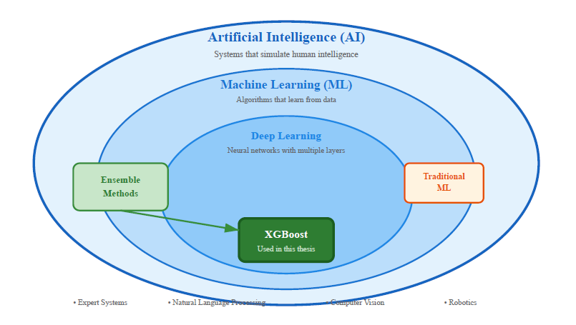
Figure 2.1: Artificial Intelligence and Its Subfields

2.3 Machine Learning
ML learns patterns from data instead of following explicit rules (Russell & Norvig, 2020). It maps known inputs to outputs, then generalizes to unseen cases. This method works well when relationships cannot easily be written as mathematical formulas.
National emissions arise from several interacting factors: population size, economic output, energy use, fuel composition, technological capabilities, and climatic demands. Describing these connections analytically proves challenging. ML addresses this by processing many input variables at once and uncovering how they interact. Here satellite observations plus socioeconomic indicators estimate emissions. This work uses supervised learning exclusively. Training data consist of labeled pairs (x, y): x contains input features for a particular country and year, while y gives the actual emission total for that case. The algorithm produces a function f where f(x) approximates y, both for training observations and for country-year combinations not used during training.
Other ML techniques exist but are not directly relevant. Unsupervised learning identifies structure in data without labels, useful for exploration rather than prediction. Reinforcement learning handles sequential choices over time, appropriate for control tasks rather than static emission estimation.
Supervised regression matches the research question. Past observations supply known emission values across countries and years. The objective is clear: identify patterns in those records and use them to estimate emissions for periods or places excluded from training. XGBoost, a gradient-boosted tree algorithm, carries out this supervised learning approach and serves as the main modeling tool, explained further in Chapter 4.
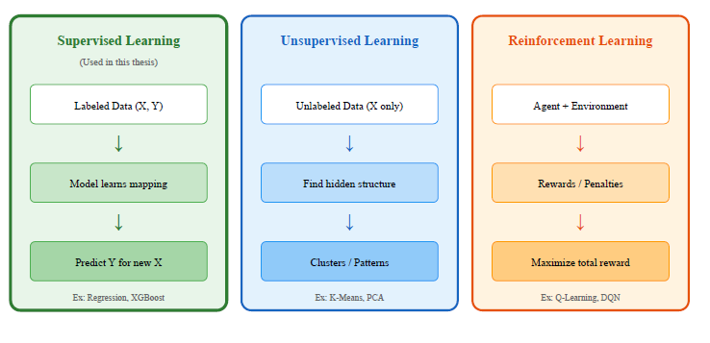
Figure 2.2: Types of Machine Learning

2.4 Supervised Learning in Detail
Supervised learning drives the entire analysis. Five workflow stages. First: collect data.
Inputs: satellites, population, economics. Target: annual CO₂ (2000-2023).
Preprocessing: impute missing values, align scales, log-transform density, engineer features.
Stage three: model training. XGBoost fits the training data (2000–2018, n=114).
Training minimizes squared error.
Validation: tune hyperparameters on held-out data.
Stage five: testing. Model B achieved R² = 0.69, RMSE = 124 Mt on the 2019–2023 test set.
These stages apply to a GCC-wide panel covering 6 countries over 24 years. Temporal split: train on Training: 2000-2018. Testing: 2019-2023. No data leakage.
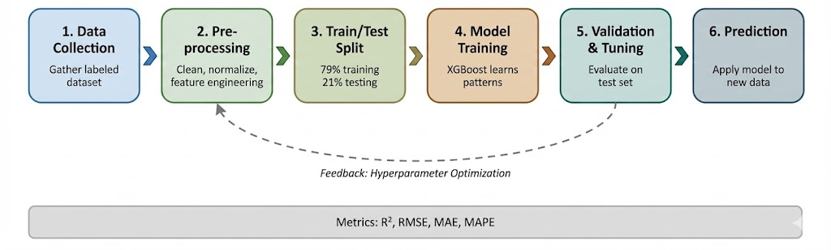
Figure 2.3: Supervised Learning Workflow

2.5 Deep Learning
Deep learning: multi-layer networks (Goodfellow et al., 2016). Works well for images/speech/text but needs big data. 144 obs = high overfitting risk.
XGBoost rivals deep learning on small tabular data, less overfitting, more interpretable.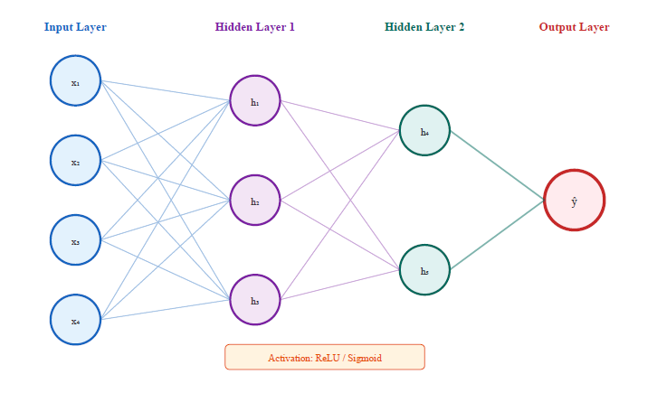
Figure 2.4: Neural Network Architecture
Table 2.1: Comparison of AI, ML, and DL
Aspect | Traditional AI | Machine Learning | Deep Learning
Learning Method | Rule-based, programmed | Learns from data | Learns hierarchical features
Data Requirement | Minimal | Moderate (100s-1000s) | Large (10,000s+)
Interpretability | High | Medium | Low (black box)
Example Algorithms | Expert systems | XGBoost, Random Forest | CNN, Transformers
Best For | Well-defined rules | Tabular data, limited samples | Images, text, large datasets
Source: Author's compilation based on Russell and Norvig (2020) and Goodfellow et al. (2016)

2.6 Ensemble Methods
Ensembles combine models—reduces bias and variance (Chen & Guestrin, 2016).
Bagging (random forests), Boosting (XGBoost), Stacking (meta-models).
Boosting suits this task: structured regression, nonlinear interactions, stable with n=144.
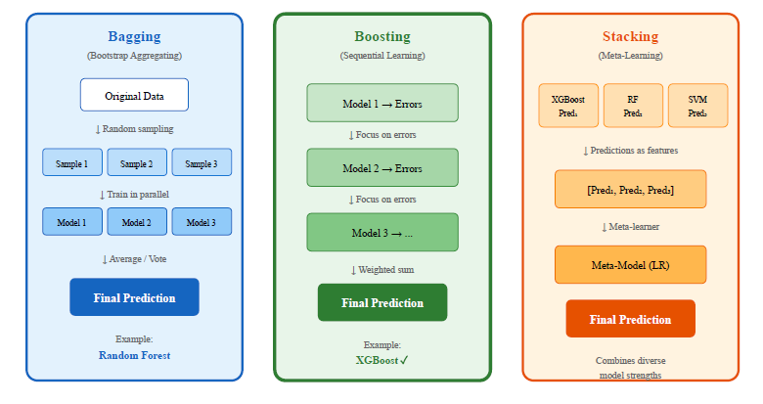
Figure 2.5: Ensemble Methods Comparison

2.7 The XGBoost Algorithm
XGBoost: regularized boosting (Chen & Guestrin, 2016). Three models: A (economic), B (satellite +p opulation), C (satellite).
XGBoost fits the dataset size well—accurate, stable, and easy to interpret.

2.8 Greenhouse Gas Emissions and Climate Policy
Ensembles combine models—reduces bias and variance (Chen & Guestrin, 2016).
Paris Agreement (2015): keep warming under 2°C, ideally 1.5°C. IPCC (2023): 45% emissions cut needed by 2030, zero emissions by mid-century.
Countries present Nationally Determined Contributions (NDCs) outlining their emission reduction plans. Progress assessment needs current data. Inventories lag 1-2 years—too slow for real-time policy evaluation. (Global Carbon Project, 2023).

2.9 The GCC Region: Energy Profile and Climate Commitments
GCC: Saudi Arabia, UAE, Qatar, Kuwait, Oman, Bahrain. GCC: 3% global CO₂, <1% population. Oil/gas + high per-capita use.
Inland GCC hits 45°C+ in summer. Air conditioning takes 60-70% of peak power. Natural gas runs most plants—heat and emissions connect directly.
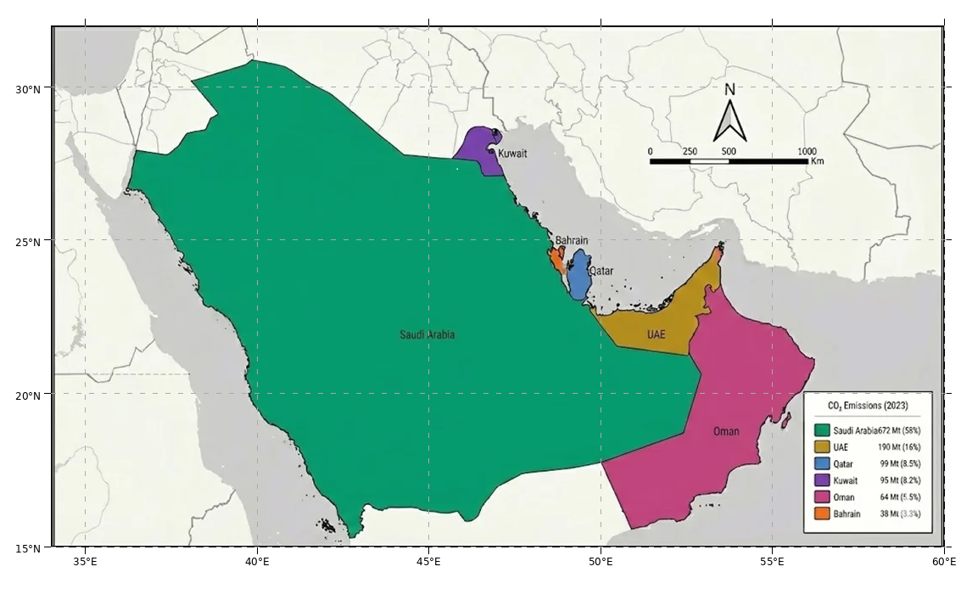
Figure 2.6: Map of the GCC Study Area

Table 2.2: GCC Countries Climate Targets and Emission Profiles
Country | 2023 CO₂ (Mt) | Per Capita (t) | NDC Target | Net Zero Goal
Saudi Arabia | 672 | 18.2 | 278 Mt reduction by 2030 | 2060
UAE | 190 | 19.3 | 31% reduction by 2030 | 2050
Qatar | 99 | 32.8 | 25% reduction by 2030 | -
Kuwait | 95 | 21.6 | 7.4% reduction by 2035 | -
Oman | 64 | 12.4 | 7% reduction by 2030 | 2050
Bahrain | 38 | 23.1 | 30% reduction by 2035 | 2060
Source: Global Carbon Project (2023), UNFCCC NDC Registry

All six GCC countries have submitted NDCs, and several have announced net zero targets. Net zero targets: Saudi 2060, UAE/Oman 2050. Better monitoring is needed.

2.10 Earth Observation for Environmental Monitoring
Satellites transformed environmental monitoring. Since Landsat-1 (1972), sensors deliver detailed data on land, atmosphere, oceans, and climate (NASA, 2024).
Satellites offer continuous coverage, free data, and short latency (days vs 1-2 years for inventories).
Satellites measure proxies (temperature, lights), not emissions directly. Linking proxies to emissions is the core challenge.

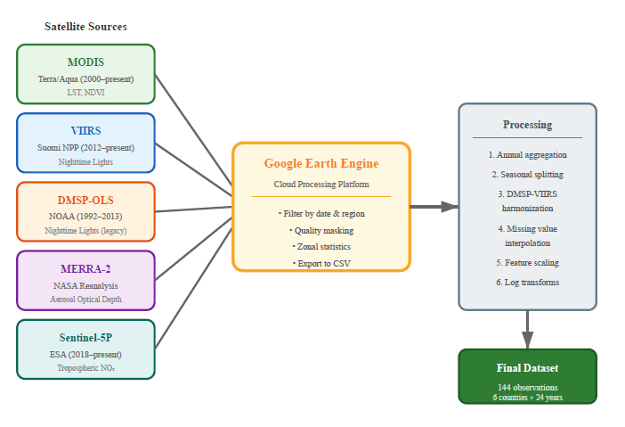
Figure 2.7: Satellite Data Sources and Processing Pipeline

2.11 Satellite Data Sources Used in This Study
Five satellite variables capture economic activity and energy consumption:
Land Surface Temperature (LST) from MODIS: The Moderate Resolution Imaging Spectroradiometer (MODIS) sensors aboard NASA's Terra and Aqua satellites have been providing LST data since 1999 and 2002 respectively. LST measures surface temperature via thermal infrared. MOD11A2: 8-day composites at 1 km. High LST → cooling demand → electricity → emissions. Assiri (2017): MODIS thermal data validated for Saudi Arabia—reliable LST proxy.
Vegetation Index (NDVI) from MODIS: NDVI measures vegetation greenness (-1 to +1). Values above 0.3 indicate healthy vegetation. GCC: sparse natural vegetation, but irrigation needs energy for pumping and desalination. The MOD13A2 product provides 16-day NDVI composites at 1 km resolution. Haq (2022) demonstrated 98% classification accuracy for agricultural land cover classification in Al-Qassim, Saudi Arabia, using Planet Scope nanosatellite imagery.
Night-time Lights (NTL) from DMSP-OLS and VIIRS: Night-time light imagery detects artificial lighting from cities, industrial facilities, and infrastructure. Two sensor systems provide this data: the Defense Meteorological Satellite Program (DMSP) Operational Linescan System (OLS) from 1992-2013, and the Visible Infrared Imaging Radiometer Suite (VIIRS) from 2012 onwards. Night-time lights strongly correlate with electricity consumption, GDP, and population density. The main challenge is harmonizing the two sensor records during the 2012-2013 overlap period.
Aerosol Optical Depth (AOD) from MERRA-2: NASA's Modern-Era Retrospective analysis for Research and Applications, Version 2 (MERRA-2) provides global reanalysis data including aerosol optical depth. AOD measures the extinction of sunlight by atmospheric particles. In industrial regions, high AOD can indicate combustion emissions. However, the GCC region has naturally high AOD due to desert dust, making interpretation more challenging (Kumar et al., 2018).
Nitrogen Dioxide (NO₂) from Sentinel-5P TROPOMI: The European Space Agency's Sentinel-5P satellite, launched in late 2018, carries the Tropospheric Monitoring Instrument (TROPOMI) which measures NO₂ column density at approximately 5.5 km resolution. NO₂ is a short-lived pollutant concentrated near combustion sources, making it a useful tracer for vehicle and power plant emissions. High accuracy has been demonstrated in predicting air pollution for Saudi cities using Sentinel-5P data (Alkayal et al., 2025).

Table 2.3: Satellite Sensors and Products Used in This Study
Variable | Sensor/Product | Resolution | Coverage | Physical Meaning
LST | MODIS MOD11A2 | 1 km, 8-day | 2000-present | Thermal emission → cooling demand
NDVI | MODIS MOD13A2 | 1 km, 16-day | 2000-present | Vegetation greenness → agricultural activity
NTL | DMSP-OLS / VIIRS | ~750 m | 1992-present | Artificial light → urbanization, economic activity
AOD | MERRA-2 | ~50 km | 1980-present | Aerosol loading → combustion + dust
NO₂ | Sentinel-5P TROPOMI | 5.5 km, daily | 2019-present | Tropospheric NO₂ → combustion tracer

2.12 Machine Learning for Emission Estimation
Machine learning offers practical tools for identifying links between satellite observations and emissions. Traditional statistical models demand explicit functional forms, whereas machine learning algorithms detect complex, nonlinear patterns automatically from data.
Nassef et al. (2023) compared FFNN, ANFIS, and LSTM for Saudi CO₂—R² up to 0.99 with economic inputs. Alamri and Khan (2023) found N-BEATS and Transformers did not beat simpler models on scarce data.
Why XGBoost? Several reasons: It processes tabular data efficiently and performs well on structured datasets with limited observations. It generates feature importance scores that clarify which satellite indicators matter most for predictions. Runs on CPU. Fewer hyperparameters than deep learning—less overfitting risk with small samples.

2.13 XGBoost: Mathematical Formulation
XGBoost, introduced by Chen and Guestrin (2016), is an optimized implementation of gradient boosted decision trees. The key idea is to build an ensemble of weak learners (decision trees) sequentially, where each new tree corrects the errors of the previous ensemble.
The algorithm minimizes a regularized objective function:
L(θ) = Σᵢ l(yᵢ, ŷᵢ) + Σₖ Ω(fₖ) (2.1)
where l is a differentiable loss function and Ω is a regularization term
Regularization term Ω penalizes complexity (leaf count and weights)—prevents overfitting on small data.
XGBoost uses squared error loss for regression. Each tree fits residuals; final prediction sums all trees.
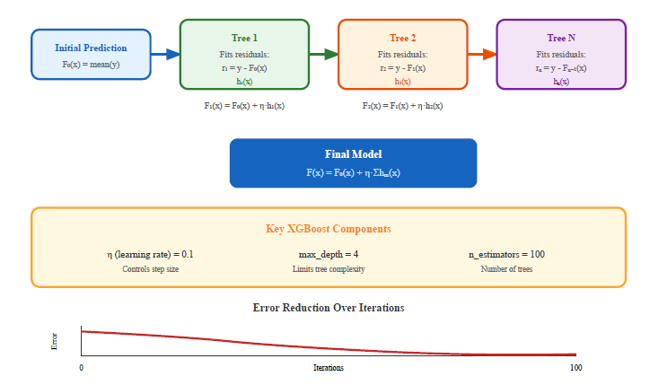
Figure 2.8: XGBoost Sequential Tree Building Process
Key hyperparameters: n_estimators, max_depth, learning_rate, min_child_weight. These control model complexity and prevent overfitting.

2.14 Explainable AI for Tree-Based Models
XAI adds transparency. Emissions modeling needs interpretability—trace how temperature or urbanization affects output.
XGBoost gives global importance. Top: summer LST (34%). Shapley methods need more compute and suffer noise on small data.
144 observations with mixed features. Global importance fits this size. Local XAI left for future work.

Chapter 3 Related Work

3.1 Introduction
Prior research on AI and carbon monitoring falls into two areas: ML-based forecasting and satellite-based tracking. Two tracks: ML emission forecasting and satellite carbon tracking.
Review period: 2021-2025. Three questions guided the review: AI techniques for CO₂, satellite monitoring methods, emissions? What exists for the Gulf? Thirteen studies reviewed: 7 ML, 6 satellite. Trend: remote sensing plus AI is growing, but speed gaps remain.

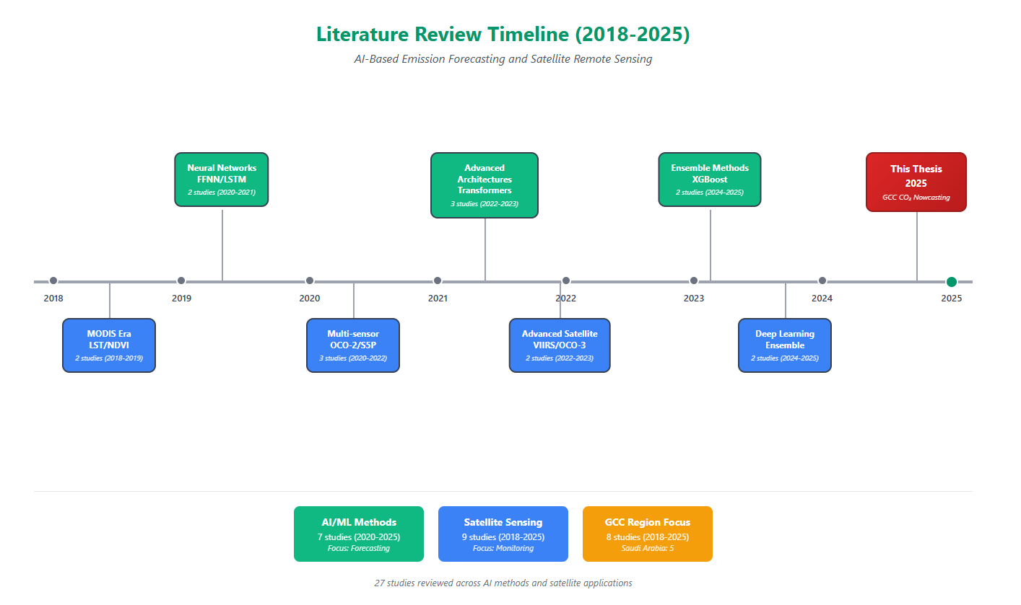
Figure 3.1: Literature Review Timeline (2016-2025)

3.2 AI-Based Emission Forecasting
ML-based CO₂ prediction grew fast after 2020. Linear models came first, then boosting, LSTMs, and transformers.
Nassef et al. (2023): FFNN beat LSTM on Saudi CO₂ (R²=0.99). But used lagged economic data—the problem we address.
Rahman et al. (2023) applied decision trees to fuel data. R² = 0.99, but sensitive to data gaps.
Meng and Noman (2022) found COVID-19 created emission patterns that standard forecasting missed.
Alamri & Khan (2023): N-BEATS/Transformers failed vs simpler models. XGBoost suits small samples.
Alcibahy et al. (2025) used XGBoost to downscale satellite CO₂ for the Arabian Peninsula. Inputs: MODIS LST, OCO-2, Sentinel-5P, ERA-5. Results: R² = 0.98, RMSE = 0.58 ppm at 1 km resolution.
Begum and Al Mobin (2025) compared XGBoost, SVR, Gradient Boosting on 11 emitters. Saudi included. Accuracy: 96.21%. Saudi projection: +16.62% by 2030.
Han et al. (2023): LSTM-CNN on China, R²=0.97. Deep learning needs big data; XGBoost fits n=144.
Fonseca and Francis (2023) documented baseline CO₂ patterns across the Middle East from nine years of OCO-2/OCO-3 observations (2014-2023). Seasonal XCO₂ variations of 3-8 ppmv appeared over the Arabian Peninsula, with UAE trends at 2.50 ppmv/year. These regional baselines provide validation benchmarks for GCC forecasts.
Xu et al. (2023) showed NPP-VIIRS nighttime light data serves as an effective proxy for human CO₂ emissions at fine spatial scales. VIIRS DNB data here complements direct atmospheric CO₂ for locating urban emission sources.
Table 3.1: Summary of AI-Based Emission Forecasting Studies
Authors | Method | Region | Best R² | Data Type
Nassef et al. (2023) | FFNN, ANFIS, LSTM | Saudi Arabia | 0.99 | Economic
Rahman et al. (2023) | Bagged DT | Saudi Arabia | 0.90 | Economic
Alamri and Khan (2023) | N-BEATS, Transformer | Multiple | 0.95 | Economic
Meng and Noman (2022) | SARIMAX | Global | N/A (MAPE: 0.09) | Economic
Alcibahy et al. (2025) | XGBoost, RF, SVM | Arabian Peninsula | 0.98 | MODIS, OCO-2, S5P
Begum and Al Mobin (2025) | XGBoost, SVR, GB | Saudi Arabia | 96.21% | Economic data
Han et al. (2023) | LSTM-CNN | China | 0.97 | Historical

3.3 Satellite-Based Carbon Monitoring
Two tracks exist: direct CO₂ measurement (OCO-2) and indirect proxies (night lights, LST, NO₂).
Mustafa et al. (2021) trained neural networks on OCO-2 data for East/West Asia CO₂ estimation.
Alcibahy et al. (2025): OCO-2 + Sentinel-5P methane on Arabian Peninsula. XGBoost performed well—multi-sensor fusion works.
Lin et al. (2023) estimated power plant CO₂ from satellite plumes. Rowley and Karakuş (2023) predicted air quality using AQNet.
Persello et al. (2022) reviewed deep learning for SDGs—satellites show promise for environmental monitoring.
Mallick et al. (2022) and Madugundu et al. (2018) used satellites for carbon stock estimation in Saudi Arabia—feasible in GCC, but focused on stocks not emissions.
Table 3.2: Summary of Satellite-Based Carbon Monitoring Studies
Authors | Satellite Data | Region | Approach | Application
Mustafa et al. (2021) | OCO-2 | East/West Asia | Neural Network | CO₂ estimation
Alcibahy et al. (2025) | OCO-2, Sentinel-5P | Arabian Peninsula | XGBoost | CO₂, CH₄ estimation
Lin et al. (2023) | Multiple | Global | ML ensemble | Power plant emissions
Rowley and Karakuş (2023) | Multiple | Urban areas | Deep learning | Air quality
Fonseca and Francis (2023) | OCO-2, OCO-3 | Middle East | Trend analysis | Regional variability
Xu et al. (2023) | NPP-VIIRS NTL | China | Nighttime light | Urban emissions

3.4 Regional Studies in the GCC
Environmental monitoring in the GCC has been studied in several works, though few focus specifically on CO₂ emission estimation.
Assiri (2017) validated MODIS LST for Saudi Arabia—ground measurements matched well. Reliable thermal proxy.
Haq (2022): 98% accuracy on Al-Qassim vegetation. Addas et al. (2020): Jeddah heat islands via satellite.
Hammam and Mohamed (2020) mapped soil salinity in the East Nile Delta using multiple salinity assessment approaches. Alkayal et al. (2025) demonstrated high accuracy predicting air pollution for three Saudi cities with Sentinel-5P data and deep learning.
Carbon-related work includes Emadi et al. (2020), who used stacked machine learning models for soil property prediction in arid areas, proving ensemble methods work. Tan et al. (2024) applied K-means clustering to group Chinese regions by emission traits, showing that regional clustering combined with satellite XCO₂ data boosted carbon estimation accuracy.

3.5 Research Gaps and Contributions
The literature review shows several gaps:
- Most AI forecasting for emissions uses economic indicators that arrive with 1–2-year delays. Satellite data as an alternative input has received little attention.
- Satellite carbon monitoring typically targets global scales or single facilities. National-level estimation for regions like the GCC remains underdeveloped.
- The accuracy-timeliness trade-off has not been measured explicitly. Studies report high accuracy using economic data but skip comparisons with satellite alternatives.
- Regional validation for GCC climate conditions is scarce. Most satellite-emission relationships come from temperate regions and may not apply directly here.
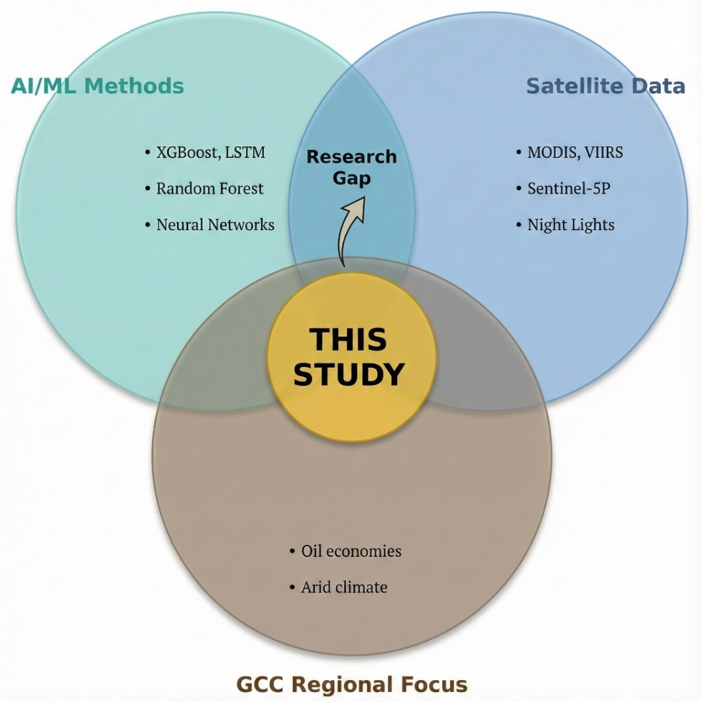
Figure 3.2: Research Gap Analysis Diagram

Three contributions address these gaps: It develops a satellite framework validated specifically for the GCC region. It compares economic and satellite approaches directly to measure the accuracy-timeliness trade-off. It provides interpretable feature importance analysis that confirms the physical basis of satellite-emission relationships in hot, arid climates.

Chapter 4 Proposed Approach

4.1 Introduction
Methodology: estimating GCC national CO₂ using satellite indicators and machine learning. The approach combines multi-sensor satellite observations with machine learning to generate near-real-time emission estimates that supplement conventional inventory-based statistics.
The framework addresses one question: how well can satellite data, available within days to weeks, approximate official national emission totals that typically arrive only after 12–24 months? The chapter covers dataset construction, model design, and the evaluation strategy used to measure the accuracy-timeliness trade-off.

4.2 Research Design Overview
The study uses a quantitative, comparative design with three components.
First, a unified panel dataset was built combining official national CO₂ emission statistics with satellite-derived environmental indicators for all six GCC countries over 2000–2023. Emission time series come from the Global Carbon Project, compiled by Our World in Data (2023), aligned with annual aggregates from multiple satellite products.
Second, three regression models based on Extreme Gradient Boosting (XGBoost) (Chen & Guestrin, 2016) were trained and compared: an economic baseline using conventional economic and energy indicators (Model A); a hybrid combining satellite indicators with population density (Model B); and a satellite-only model using remotely sensed variables alone (Model C).
Third, model performance, feature importance, and error patterns were analyzed on a held-out test period (2019–2023) to characterize satellite-based estimation strengths and limits in the GCC context.
Before settling on the final design, preliminary experiments explored how far back the analysis could extend and whether single-country or multi-country setups worked better. Using OWID/Global Carbon Project and World Bank statistics, exploratory models tested longer historical windows reaching into the 1980s and 1990s, focusing only on Saudi Arabia. These longer windows increased sample size but exposed problems: reporting conventions shift in early years, documentation for some economic indicators is incomplete, and resulting models became more sensitive to train-test splits. Models calibrated on very early years showed high in-sample fit but unstable performance on recent years.
Analysis restricted to 2000-2023. Earlier data is less reliable; satellite products are consistently available from 2000. MODIS LST and NDVI start around 2000, VIIRS night-time lights become usable after inter-calibration with DMSP-OLS, and MERRA-2 aerosol products are fully available over the study region. Sentinel-5P NO₂ is only available from late 2018 onwards, so it's treated as an auxiliary variable with partial coverage rather than a core driver. Final count: 144 data points (6 nations × 24 years). Enough for modeling.
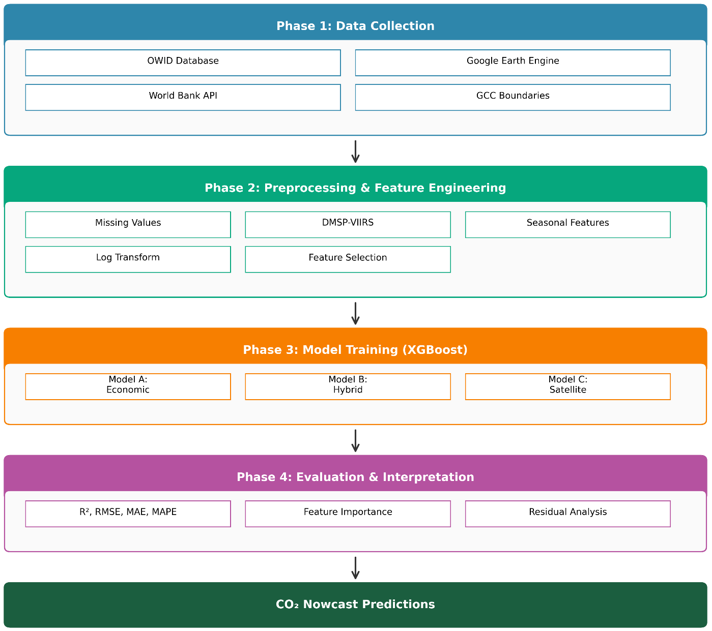
Figure 4.1: Research Framework Architecture
The choice of XGBoost (Chen & Guestrin, 2016) over deep learning architectures is deliberate. 144 observations is too small for deep learning—overfitting risk is high. XGBoost provides built-in regularization, handles non-linear relationships and interactions effectively, and produces feature-important measures that support interpretation. These properties make it suitable for tabular datasets of limited size.
From a modelling perspective, the 144 observations are treated as a pooled country–year panel. A single XGBoost model is estimated across all six GCC countries, without country-specific fixed or random effects. The objective is purely predictive – to generate accurate nowcasts of national CO₂ emissions – rather than to identify causal, country-level parameter estimates.

4.3 Study Area: The GCC Region
The study covers all six Gulf Cooperation Council countries: Saudi Arabia, United Arab Emirates (UAE), Qatar, Kuwait, Oman, and Bahrain. These countries occupy roughly 2.57 million km² of the Arabian Peninsula and had a combined population of about 58.8 million in 2023.
Table 4.1 summarizes key study area characteristics: land area, population, estimated CO₂ emissions, and typical summer temperature ranges.
Table 4.1: Study Area Overview - Six GCC Countries
Country | Area (km²) | Population (M) | 2023 CO₂ (Mt) | Climate | Summer Temp (°C)
Saudi Arabia | 2,149,690 | 36.4 | 672 | Arid/Semi-arid | 42-50
UAE | 83,600 | 9.4 | 190 | Arid | 40-48
Qatar | 11,586 | 2.7 | 99 | Arid | 40-46
Kuwait | 17,818 | 4.3 | 95 | Arid | 42-50
Oman | 309,500 | 4.5 | 64 | Arid/Tropical | 38-45
Bahrain | 780 | 1.5 | 38 | Arid | 38-42
GCC Total | 2,572,974 | 58.8 | 1,158 | - | -
Source: World Bank, Global Carbon Project (2023), national statistics offices

Figure 4.2: GCC CO₂ Emissions Distribution by Country (2023)
The GCC region has a predominantly hot, arid climate. Summer temperatures often exceed 45°C in interior areas, creating a pronounced seasonal cycle in electricity demand driven mostly by air conditioning. In many GCC systems, summer peak electricity demand reaches about 2–3 times winter demand. This seasonal pattern appears in emissions from power generation. Seasonal LST features exploit the heat-emissions link.

4.4 Data Sources and Collection
The empirical analysis uses two main data streams: national CO₂ emission records and environmental indicators from economic statistics and satellite observations.

4.4.1 Emission Data
Annual national CO₂ emission data came from Our World in Data (Our World in Data, 2023), which compiles statistics from the Global Carbon Project (2023). Target variable IS national CO₂ emissions per GCC country (1965-2023), in Mt CO₂. OWID/GCP also provide longer historical series for some countries, but I rely on the harmonized panel here, and the main analysis is reported for the 2000–2023 period to match satellite data availability.
The harmonized emission series was stored in a pre-processed GCC emissions dataset. Though underlying data are available from 1965 onwards, the empirical analysis here is restricted to 2000–2023 to ensure consistency with satellite product temporal coverage.

4.4.2 Economic and Demographic Data
For the economic baseline model (Model A), these indicators were extracted from the same OWID database, which aggregates World Bank statistical sources:
- Gross Domestic Product (GDP) in constant 2015 USD
- Population (annual estimates)
- Primary energy consumption (terawatt-hours)
- Energy per capita (primary energy divided by population)
These indicators are stored in the same gcc_emissions_preprocessed_1965_2023.csv file, with consistent country and year keys, facilitating direct merging with the emission time series.

4.4.3 Satellite Data
Satellite observations were extracted using Google Earth Engine (GEE), which provides access to multiple global image collections, including MODIS, VIIRS, MERRA-2, and Sentinel-5P (Assiri, 2017; Elvidge et al., 2009; European Space Agency, 2024).
After processing, aggregated satellite indicators were stored in a separate seasonal satellite dataset, later merged with emissions and economic data to form the final analysis panel.
Table 4.2 summarizes the main data sources and their temporal coverage.
Table 4.2: Data Sources and Temporal Coverage
Data Type | Source | Coverage | File Name
CO₂ Emissions | Our World in Data / Global Carbon Project (2023) | 1965–2023 | Pre-processed GCC emissions dataset
Economic Indicators | Our World in Data / World Bank | 1965–2023 | Pre-processed GCC emissions dataset
Satellite Features | Google Earth Engine (multiple products) | 2000–2023 | Seasonal satellite indicators dataset

Merged dataset: 144 records across 6 nations and 24 years.

4.5 Satellite Data Extraction Pipeline
GEE pipeline (Gorelick et al., 2017) extracts satellite data. Image Collections = time series with consistent metadata. For each variable, a collection was selected along with band selection, scale factors, and quality masks.

4.5.1 Google Earth Engine Image Collections
Table 4.3 lists main GEE collections used here, with bands and scale factors applied. MODIS land surface temperature products, validated for Saudi Arabia (Assiri, 2017), provide core thermal indicators. VIIRS night-time lights, MERRA-2 aerosol optical depth, and Sentinel-5P NO₂ capture anthropogenic activity and atmospheric composition (Elvidge et al., 2009; European Space Agency, 2024).
Table 4.3: Google Earth Engine Image Collections Used
Variable | GEE Collection ID | Band Used | Scale Factor | Unit
LST Day | MODIS/061/MOD11A2 | LST_Day_1km | 0.02 | Kelvin
LST Night | MODIS/061/MOD11A2 | LST_Night_1km | 0.02 | Kelvin
NDVI | MODIS/061/MOD13A2 | NDVI | 0.0001 | Index (-1 to 1)
NTL | NOAA/VIIRS/DNB/MONTHLY_V1/VCMSLCFG | avg_rad | 1.0 | nW/cm²/sr
AOD | NASA/GSFC/MERRA/aer/2 | TOTEXTTAU | 1.0 | Dimensionless
NO₂_Signal | COPERNICUS/S5P/OFFL/L3_NO2 | tropospheric_NO2_column_number_density | 1.0 | mol/m²
Note: DMSP-OLS data (1992–2013) were handled separately and inter-calibrated with VIIRS night-time lights (Elvidge et al., 2009).
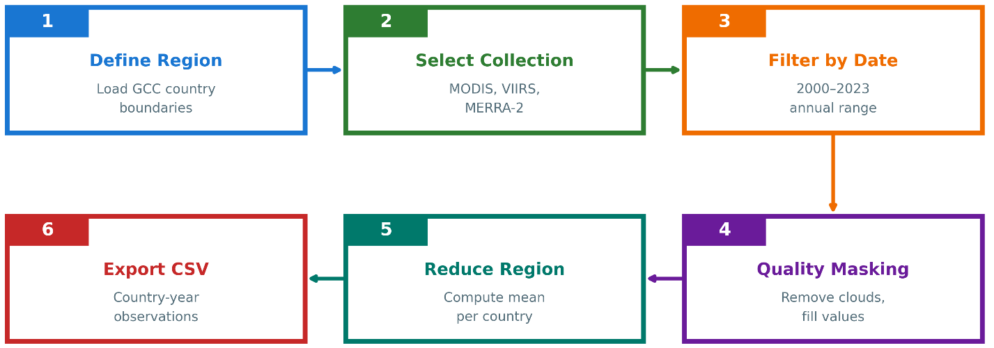
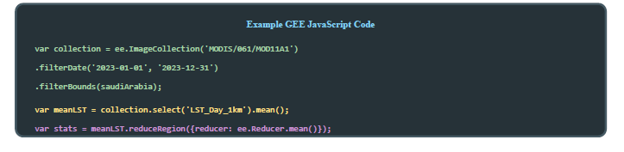
Figure 4.3: Google Earth Engine Data Extraction Workflow

4.5.2 Extraction Workflow
For each country and year, the following steps were applied in GEE:
- Step 1 – Define Country Boundaries: Country boundaries were taken from the FAO GAUL dataset available in GEE. Each GCC country is represented as a polygon feature.
- Step 2 – Filter Image Collection: For each variable, the relevant Image Collection was filtered by spatial extent (country polygon) and temporal window. Annual variables use the full calendar year (1 January to 31 December), whereas seasonal variables use specific month ranges.
- Step 3 – Apply Quality Filters: Quality assurance (QA) flags were used to mask low-quality pixels. For MODIS LST, pixels flagged as cloud-contaminated or low-accuracy in the LST_QC band were excluded. For Sentinel-5P NO₂, only pixels with qa_value > 0.5 were retained (European Space Agency, 2024).
- Step 4 – Temporal Aggregation: After QA masking, the collection was reduced temporally using the mean reducer to produce a single composite image per country-year (or country-season).
- Step 5 – Spatial Aggregation: The composite image was then reduced over the country polygon using reduce Region with a mean reducer, yielding one value per variable, per country, per year.
- Step 6 – Export Results: The aggregated values were exported to a CSV file with columns for country, year, and each satellite feature.
Table 4.4 summarizes the most important extraction parameters.
Table 4.4: Satellite Feature Extraction Parameters
Variable | Temporal Filter | Quality Mask | Reducer | Output
LST_Summer | June-August | LST_QC < 65 | Mean | °C (converted)
LST_Winter | Dec-Feb | LST_QC < 65 | Mean | °C (converted)
NDVI_Spring | March-May | Pixel reliability ≤ 1 | Mean | Index
NTL_Annual | Full year | 0 < radiance < 1000 | Mean | nW/cm²/sr
AOD_Annual | Full year | Valid flag | Mean | Dimensionless
NO2_Signal | Full year | qa_value > 0.5 | Mean | mol/m²

4.5.3 Handling the DMSP–VIIRS Transition
Night-time lights are observed by two different systems. The DMSP-OLS series provides yearly composites for 1992–2013, while VIIRS offers monthly radiance data from 2012 onwards (Elvidge et al., 2009). To obtain a consistent time series for 2000–2023, an inter-calibration procedure was applied:
- Estimate a regression relationship between DMSP digital numbers and VIIRS radiance during the overlap period 2012–2013.
- Use the calibration coefficients to convert all pre-2012 DMSP values into VIIRS-equivalent radiance.
- Construct a continuous series using calibrated DMSP for 2000–2011, the average of both sensors for 2012–2013, and VIIRS alone from 2014 onwards.

4.5.4 Missing Data Handling
Satellite records are subject to data gaps arising from sensor issues, cloud cover, and incomplete temporal coverage. The Sentinel-5P NO₂ product is particularly affected because the mission began only in late 2018 (European Space Agency, 2024).
Table 4.5: Missing Data Summary
Variable | Missing Count | Missing % | Reason
NO2_Signal | 114 | 79.2% | Sentinel-5P available only after 2018
primary_energy_consumption | 1 | 0.7% | Reporting gap
All other variables | 0 | 0% | –

NO₂ from Sentinel-5P was excluded from the final model due to its limited temporal coverage (only 2019 onwards).

4.6 Feature Engineering and Preprocessing
Feature engineering focused on aligning the satellite indicators with emission-relevant processes in the GCC and on stabilizing the statistical properties of the variables before model training.

4.6.1 Seasonal Disaggregation of Temperature
Initial tests using annual mean LST exhibited relatively weak correlation with CO₂ emissions. In the GCC, emissions from electricity generation are driven primarily by cooling demand in the hot season rather than by heating in winter. To capture this asymmetry, LST was disaggregated into seasonal components: LST_Summer_C (mean land surface temperature over June–August) and LST_Winter_C (mean land surface temperature over December–February). In addition, NDVI was aggregated over March–May to capture the main vegetation growth period and associated agricultural activity. Table 4.6 summarizes the aggregation windows and their rationale.
Table 4.6: Seasonal Aggregation Windows
Feature | Months | Rationale
LST_Summer_C | June–August | Peak cooling season; temperatures often 45–50°C; drives AC demand
LST_Winter_C | December–February | Baseline thermal conditions; minimal heating in GCC
NDVI_Spring | March–May | Vegetation growth period; captures agricultural activity

Figure 4.4: Seasonal Land Surface Temperature Pattern

4.6.2 Population Density Transformation
Population density varies substantially across the GCC, from roughly 12 people/km² in Oman to more than 1,700 people/km² in Bahrain. This high skew can affect tree-based models and error metrics. To stabilize the distribution, population density was transformed using a base-10 logarithm:

log_pop_density = log₁₀(population / land_area) (4.1)
This transformation converts multiplicative differences into additive ones and reduces the impact of extremely dense observations on the model.

4.6.3 Final Feature Set
After feature engineering, the models use the input variables listed in Table 4.7. Model A represents a purely economic baseline. Model B combines satellite variables with population density. Model C uses only satellite features to assess the standalone predictive power of remote sensing.
Table 4.7: Final Feature Set for Each Model
Model | Feature Category | Variables
Model A (Economic) | Economic + Demographic | GDP, population, energy_consumption, energy_per_capita
Model B (Hybrid) | Satellite + Demographic | LST_Summer_C, LST_Winter_C, NDVI_Spring, Night_Lights, AOD_Annual, log_pop_density
Model C (Satellite-only) | Satellite Only | LST_Summer_C, LST_Winter_C, NDVI_Spring, Night_Lights, AOD_Annual

4.6.4 Correlation Analysis
Before model training, Pearson correlations between each feature and CO₂ emissions were computed to obtain a first indication of explanatory power:
- LST_Summer_C: r ≈ 0.58 (moderate positive correlation)
- Night_Lights: r ≈ 0.61 (strongest satellite correlation)
- log_pop_density: r ≈ 0.55 (demographic effect)
- NDVI_Spring: r ≈ 0.22 (weak correlation)
- AOD_Annual: r ≈ 0.18 (weak correlation, partly confounded by dust)

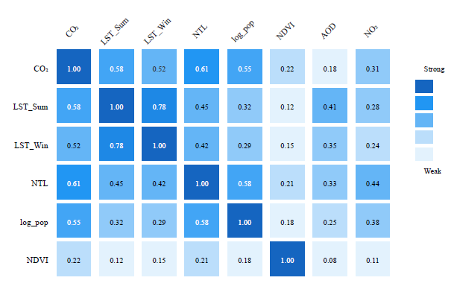
Figure 4.5: Feature Correlation Matrix
These correlations informed model design but were not used for pre-selection or manual pruning; all features were retained for XGBoost, which incorporates its own regularization and feature selection (Chen & Guestrin, 2016).

4.7 Experimental Design: Three-Model Comparison
The experimental design compares three models to quantify the trade-off between accuracy and data latency.
Table 4.8: Three-Model Experimental Design
Model | Input Features | Purpose | Data Latency | Baseline?
A | Economic indicators | Accuracy benchmark | 12–24 months | Yes
B | Satellite + log_pop_density | Practical nowcasting | Days | No
C | Satellite only | Pure satellite capability | Days | No

Model A approximates the best achievable accuracy using traditional economic and energy statistics, which are subject to reporting delays. Models B and C use only variables that can be derived from satellite data and population estimates available with much shorter latency. Comparing Model A to Models B and C therefore quantifies the accuracy cost of switching from lagged but information-rich inputs to near-real-time satellite proxies.
Several alternative model configurations were also explored during the development phase. These included purely economic models calibrated on longer historical windows, as well as experimental hybrids that mixed economic and satellite features in a single specification. While these variants sometimes improved the apparent in-sample fit, they did not consistently outperform the three final configurations when evaluated on the temporally held-out test period (2019–2023). The design summarized in Table 4.8 was therefore chosen to make the comparison between “inventory-driven” (Model A) and “satellite-driven” (Models B and C) approaches as transparent as possible and to ensure that each model family has a clear interpretation with respect to data latency and operational use.

4.8 Model Training and Validation

4.8.1 Temporal Train–Test Split
Because the dataset is a time series at the country-year level, a temporal split was used rather than random cross-validation. The training set comprises observations from 2000–2018 (114 rows), while the test set covers 2019–2023 (30 rows).

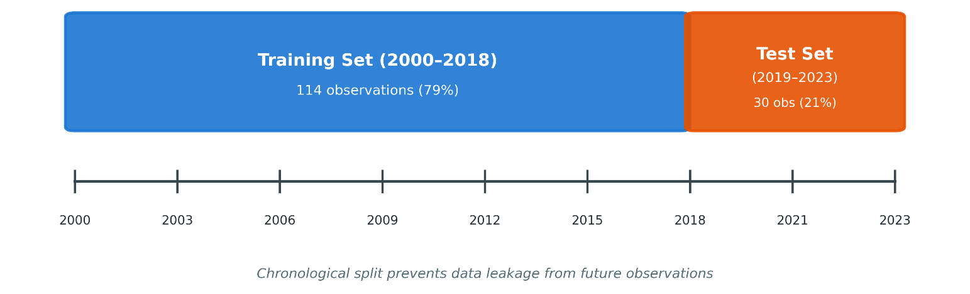
Figure 4.6: Temporal Train-Test Split Strategy
This design ensures that the models are evaluated on future years they have not seen during training, which better reflects the intended use case of forecasting or nowcasting emissions.

4.8.2 XGBoost Configuration
XGBoost (Chen & Guestrin, 2016) was configured with conservative hyperparameters to limit overfitting given the modest sample size. The same configuration was applied to all three models, with differences arising only from the input feature sets.
Table 4.9: XGBoost Hyperparameters
Parameter | Value | Rationale
n_estimators | 150 | Moderate ensemble size with regularization
max_depth | 4 | Shallow trees to reduce memorisation
learning_rate | 0.05 | Small steps for gradual learning
min_child_weight | 3 | Minimum samples per leaf; adds regularization
subsample | 0.8 | Row subsampling to reduce variance
colsample_bytree | 0.8 | Feature subsampling to decorrelate trees
reg_alpha (L1) | 0.1 | L1 regularization for implicit feature selection
reg_lambda (L2) | 1.0 | L2 regularization for weight shrinkage

Hyperparameters were selected based on preliminary experiments and on common practice for small tabular datasets, aiming to balance bias and variance without exhaustive tuning.

4.9 Evaluation Metrics
Model performance is assessed using four complementary metrics, computed on both training and test sets.
Coefficient of Determination (R²): R² measures the proportion of variance in CO₂ emissions explained by the model. An R² of 1 indicates perfect predictions, whereas R² = 0 indicates performance equivalent to predicting the mean.

R² = 1 - (SS_res / SS_tot) = 1 - (Σ (yᵢ - ŷᵢ) ² / Σ (yᵢ - ȳ) ²) (4.2)
where yᵢ are observed values, ŷᵢ are predictions, and ȳ is the sample mean
Root Mean Squared Error (RMSE): RMSE measures the average magnitude of prediction errors in the same units as the target variable (Mt CO₂), with larger errors penalised more heavily.

RMSE = √((1/n) Σ (yᵢ - ŷᵢ) ²) (4.3)

Mean Absolute Error (MAE): MAE is the mean absolute deviation between observed and predicted emissions. It is less sensitive to outliers than RMSE.

MAE = (1/n) Σ|yᵢ - ŷᵢ| (4.4)

Mean Absolute Percentage Error (MAPE): MAPE expresses prediction error as a percentage of the observed values, facilitating comparison across different emission scales.

MAPE = (100/n) × Σ|yᵢ - ŷᵢ| / |yᵢ| (4.5)

For each model, these metrics are reported for both the training period (2000–2018) and the held-out test period (2019–2023). A large gap between training and test performance would indicate overfitting, whereas similar values suggest that the model generalizes well to unseen years.

Chapter 5 Experimental Results and Discussion

5.1 Introduction
Results from the satellite-based CO₂ estimation framework for the GCC. The structure is straightforward. First: data quality and descriptive stats.Then performance of three XGBoost models gets compared: economic baseline (Model A), hybrid satellite-demographic (Model B), and satellite-only (Model C).
Feature importance analysis identifies which input variables matter most in the hybrid setup. Residual plots and diagnostics show error behavior—where models work well and where they struggle. Country-level analysis reveals how performance differs across the six GCC countries. The chapter ends with key findings, implications, and scope conditions for interpretation. Three research questions from Chapter 1 guide this work:
Throughout the chapter, the research is guided by the core research questions posed in Chapter 1:
- To what extent can satellite-derived indicators approximate national CO₂ emissions in the GCC?
- What is the trade-off between prediction accuracy and data timeliness when relying on satellite-based proxies instead of conventional economic data?
- Which satellite features contribute most to the predictive performance, and do they make physical sense for the GCC context?

5.2 Data Quality Assessment
Before training any models, the emission, economic, and satellite datasets were merged into a single GCC-wide panel. The final dataset contains 144 observations from six countries over 24 years (2000–2023). Each row represents a country–year pair with a consistent set of target and predictor variables.
Table 5.1 summarizes the completeness of the primary variable groups.
Table 5.1: Data Completeness Summary
Variable Category | Variables | Completeness | Notes
Target (CO₂) | 1 | 100% | Global Carbon Project data
Economic | 5 | 99.3% | 1 missing energy value
Satellite (core) | 5 | 100% | LST, NDVI, NTL, AOD
Satellite (NO₂) | 1 | 20.8% | Sentinel-5P from 2019 only

The target variable (national CO₂ emissions) is complete for all country–year combinations in the study period. Economic indicators are also almost complete, with a single missing energy value that was handled using simple imputation. The core satellite variable summer and winter land surface temperature (LST), spring NDVI, night-time lights, and annual aerosol optical depth (AOD)—are complete for all 144 observations. In contrast, the NO₂ variable is available only from 2019 onwards, as Sentinel-5P became operational in late 2018.
Basic descriptive statistics for key variables are reported in Table 5.2.
Table 5.2: Descriptive Statistics of Key Variables
Variable | Mean | Std Dev | Min | Max
CO₂ (Mt) | 148.2 | 178.6 | 16.4 | 672.1
LST_Summer_C | 44.8 | 3.2 | 38.1 | 51.2
Night_Lights | 12.4 | 8.7 | 1.2 | 42.3
log_pop_density | 1.85 | 0.78 | 1.04 | 3.24

The emission series shows substantial variation both across countries and over time. Range: 16 Mt (smallest) to 670+ Mt (Saudi Arabia). Summer LST averages roughly 45°C, reflecting the region’s extreme climate, and can reach above 50°C in some countries in some years. Night-time lights also capture differences in the scale and intensity of urbanization and economic activity. Population density, expressed on a logarithmic scale, varies strongly as well, consistent with the contrast between sparsely populated countries such as Oman and very dense countries such as Bahrain.
Taken together, the merged dataset is relatively clean and complete, especially given that it combines multiple sources. It provides a sound basis for training and evaluating the three XGBoost models described in Chapter 4.

5.3 Model Performance Comparison
Three models—economic (Model A), hybrid (Model B), and satellite-only (Model C)—were trained on 2000–2018 data and evaluated on a held-out test period (2019–2023). This temporal split emulates a realistic nowcasting scenario where the model predicts emissions for "future" years it hasn't seen during training.
Table 5.3 reports the three models' performance on the test set using four metrics: coefficient of determination (R²), root mean squared error (RMSE), mean absolute error (MAE), and mean absolute percentage error (MAPE).
Table 5.3: Model Performance Comparison (Test Set 2019-2023)
Model | R² | RMSE (Mt) | MAE (Mt) | MAPE (%)
A: Economic | 0.9571 | 46.29 | 32.14 | 8.7%
B: Hybrid | 0.6916 | 124.17 | 89.42 | 18.3%
C: Satellite Only | 0.6668 | 129.07 | 94.18 | 19.8%
R² and MAPE columns are highlighted for readability. Economic model achieves highest accuracy but with 12–24-month data latency.

The economic baseline (Model A) achieves the highest accuracy as expected, with R² about 0.96 and MAPE below 10%. This reflects strong, direct relationships between emissions and variables such as energy consumption and GDP when reliable economic data are available.
The hybrid model (Model B) uses satellite indicators together with log-transformed population density, achieving R² around 0.69 and MAPE around 18%. Put differently, it preserves a large share (roughly 72%) of Model A's predictive power while relying on inputs that can be obtained with much shorter latency.
The satellite-only model (Model C) performs slightly worse, with R² approximately 0.67 and MAPE just under 20%. The slight difference between Models B and C suggests that adding population density improves accuracy without fundamentally changing the overall capability level.
Operationally: accuracy vs speed is now quantified.
Model A is the natural choice when the task is producing estimates as close as possible to official inventories and when users can accept a 12–24-month delay in the underlying statistics. Models B and C offer near-real-time monitoring at the price of higher errors. For tasks such as tracking trends, spotting anomalies, or providing early indications of policy impacts, this trade-off may still be acceptable or even preferable.
Table 5.4 compares model performance on the training and test sets to investigate overfitting.
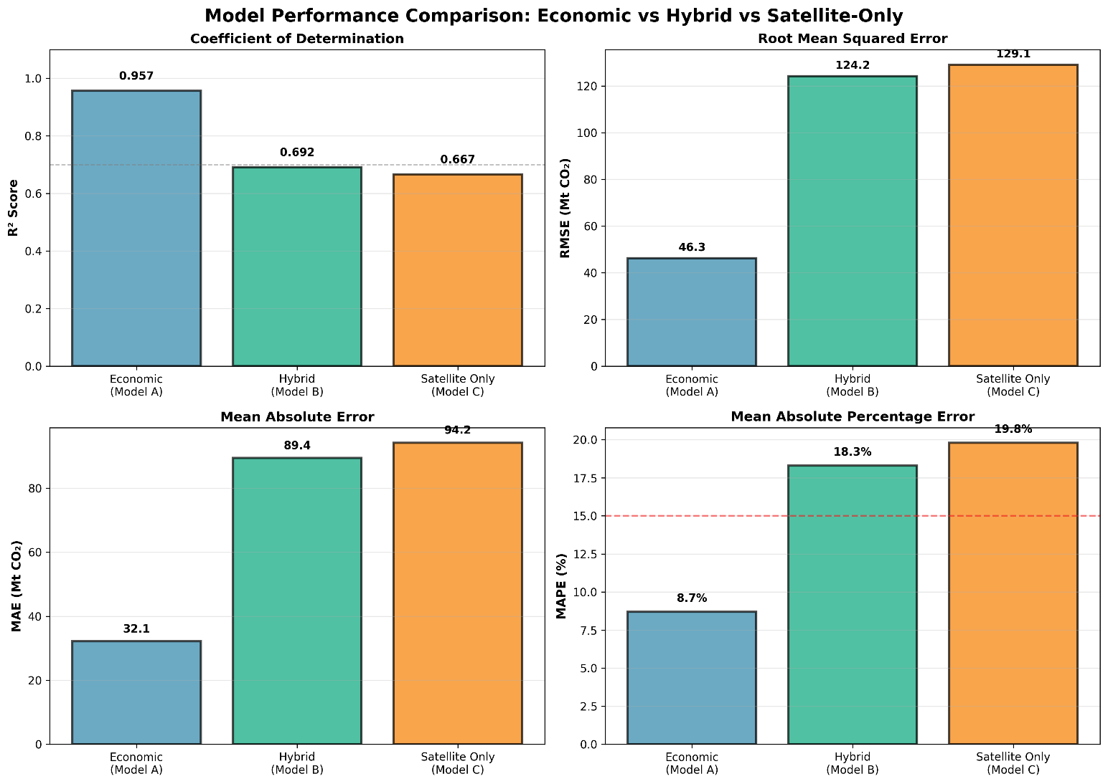
Figure 5.1: Three-Model Performance Comparison
Economic indicators provide superior prediction accuracy. Model A (economic) reaches R² ≈ 0.96, explaining 96% of emission variance in the test period. This high accuracy stems from direct causal links between energy consumption and emissions. Model B: R² = 0.69 (72% of Model A's accuracy, data in days not years). Model C: R² = 0.67—population density helps. Is 69% enough? For carbon accounting: prefer Model A. For rapid monitoring: Model B works. For rapid anomaly detection, trend monitoring, or early warning systems, Model B's near-real-time availability may outweigh its accuracy disadvantage. Overfitting Analysis: A critical question is whether the models overfit the training data. Training and test performance were compared:
Table 5.4: Training vs Test Performance (Overfitting Check)
Model | Train R² | Test R² | Gap (Overfit Indicator)
A: Economic | 0.9998 | 0.9571 | -0.043 (Excellent)
B: Hybrid | 0.9594 | 0.6916 | -0.268 (Moderate)
C: Satellite Only | 0.9412 | 0.6668 | -0.274 (Moderate)
Note. Gap is computed as (Test R² − Train R²). Negative values indicate higher training performance than test performance; values closer to zero indicate slightly better generalization.
Figure 5.2: Training vs Test R² Comparison
Model A shows strong generalization. Using Gap = (Test R² − Train R²), Model A's gap is −0.043 (≈4.3 percentage points), meaning training performance is only slightly higher than test performance. This small gap suggests stable relationships and good out-of-sample performance over 2019–2023.
Models B and C show a wider gap of roughly 0.27 between training and test R². This is consistent with the fact that the links between satellite proxies and emissions are weaker and more variable, and with the presence of a structural break in the test period due to COVID-19 (2019–2023). The pandemic disrupted the usual relationship between economic activity and emissions, making it harder for models trained on pre-2019 data to extrapolate accurately.

5.4 Feature Importance Analysis
XGBoost provides feature importance scores that quantify how much each input contributes to reducing the prediction error across all trees in the ensemble. For the hybrid model (Model B), these scores help reveal which satellite and demographic variables carry the most weight in explaining emission variations.
The ranking of features for Model B is shown in Table 5.5.
Table 5.5: Feature Importance Rankings (Model B)
Rank | Feature | Importance (%) | Physical Interpretation
1 | LST_Summer_C | 33.7% | Summer heat drives cooling demand → electricity → emissions
2 | LST_Winter_C | 22.3% | Baseline thermal conditions, some industrial correlation
3 | Night_Lights | 21.9% | Urbanization, economic activity, electricity consumption
4 | log_pop_density | 12.8% | Population concentration, urban emissions
5 | NDVI_Spring | 5.2% | Agricultural activity, limited vegetation in GCC
6 | AOD_Annual | 4.1% | Aerosol loading, confounded by natural dust

Figure 5.3: Feature Importance Analysis (Model B)
The dominance of temperature-related features is immediately apparent. Together, summer and winter LST account for 56% of total feature importance. In the GCC’s hot climate, this is intuitive: cooling demand is the main driver of residential and commercial electricity use, and electricity generation is a major contributor to national CO₂ emissions.
Night-time lights, with an importance of about 22%, serve as a proxy for urbanization and economic activity. Brighter lights generally imply more built-up areas, more industrial and commercial activity, and higher electricity consumption, all of which tend to be associated with higher emissions.
log_pop_density contributes another 13%. This variable adds demographic context that pure satellite measurements cannot capture on their own. Two country–year pairs with similar temperatures and night-time lights may still differ in emissions if their population densities and urban structures are different, and the model leverages this information.
NDVI (5%) and AOD (4%): minor. GCC dust complicates AOD.
The importance ranking matches GCC physical realities—not arbitrary correlations.

5.5 Error Analysis and Residual Diagnostics
Beyond global metrics, it is useful to look more closely at how the hybrid model’s errors are distributed.

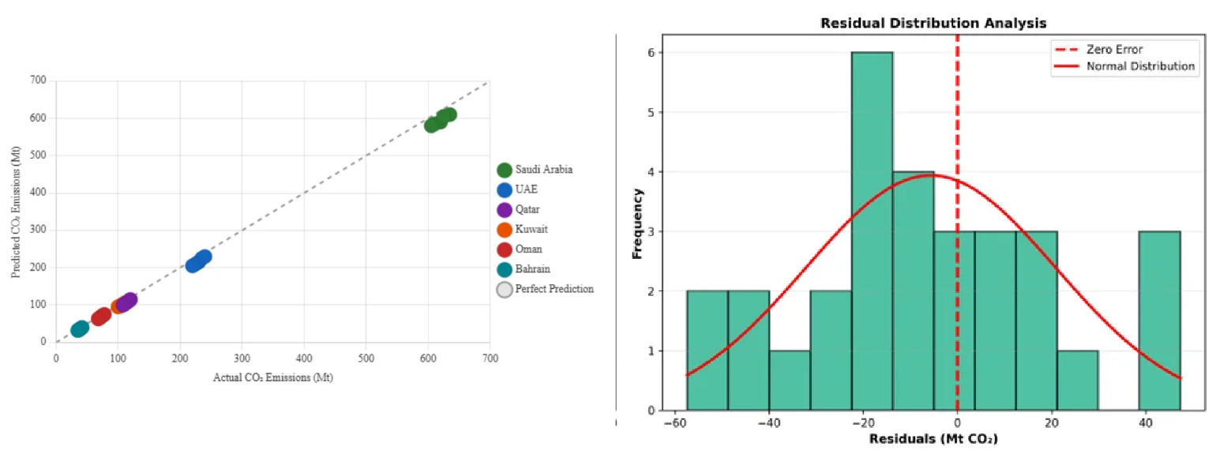
Figure 5.4: Actual vs Predicted Emissions (Scatter Plot)
The scatter plot of actual versus predicted emissions indicates that Model B captures the overall pattern of emissions reasonably well but with visible dispersion around the 1:1 line. The model tends to perform best for medium-sized emitters such as the UAE, Qatar, and Kuwait. In contrast, errors are generally larger (in absolute terms) for Saudi Arabia, which has the highest emissions, and for Bahrain, which has the lowest, showing scale-dependent challenges.
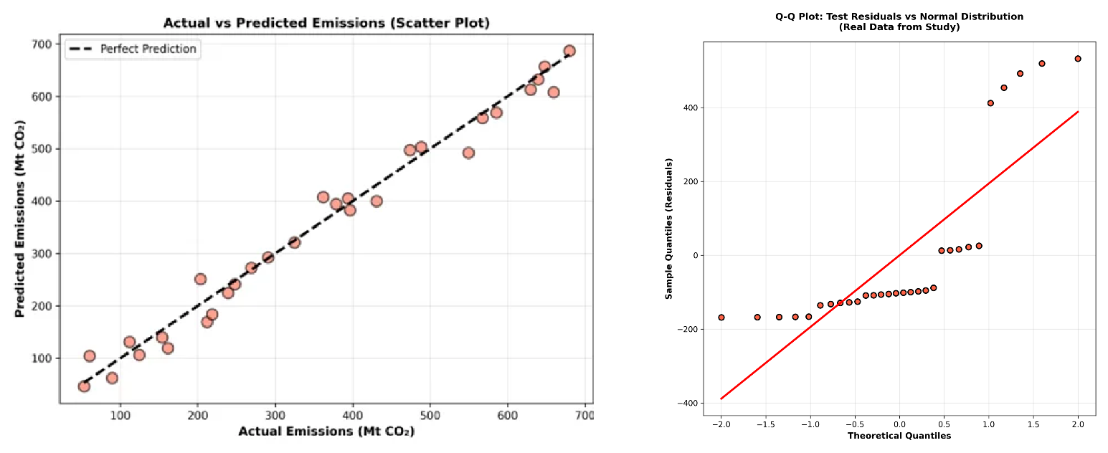
Figure 5.5: Residual Distribution Analysis

Residuals are roughly normal around zero. Spread grows with emission size (range: 16-672 Mt). Larger errors in 2020-2021 reflect COVID-19 disruption.
Figure 5.6: Time Series: Actual vs Predicted (Saudi Arabia)

The Saudi Arabia time series plot shows actual vs predicted emissions. The hybrid model follows the broad trend but misses some year-to-year changes, especially during COVID years. Still, errors stay small enough to be useful for monitoring.

5.6 Country-Level Performance
Country-level breakdown reveals differences hidden by aggregate metrics. See Table 5.6.

Table 5.6: Country-Level Model Performance
Country | Test R² | RMSE (Mt) | Emission Range | Notes
Saudi Arabia | 0.72 | 68.4 | 408-672 Mt | Best performance, most data
UAE | 0.68 | 28.3 | 102-190 Mt | Good performance
Qatar | 0.65 | 18.2 | 32-99 Mt | Moderate performance
Kuwait | 0.67 | 14.1 | 53-95 Mt | Good performance
Oman | 0.64 | 12.8 | 20-64 Mt | Moderate performance
Bahrain | 0.61 | 8.4 | 16-38 Mt | Lowest, small range

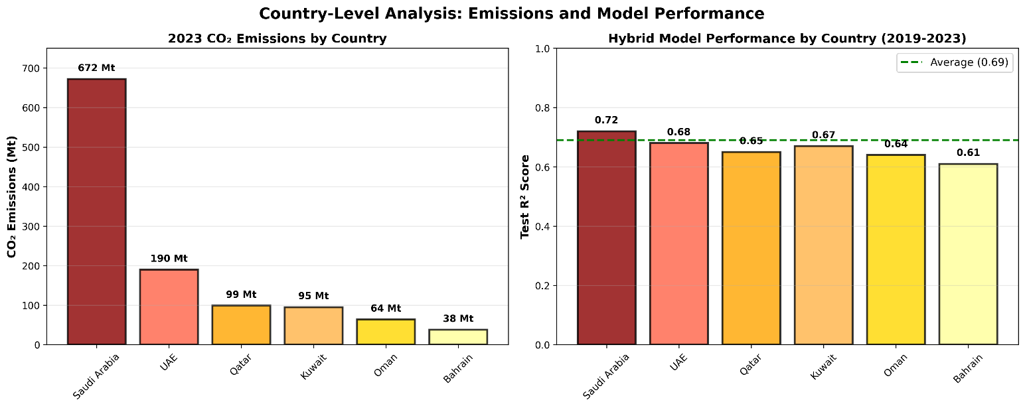
Figure 5.7: Country-Level R² Performance Comparison
Saudi Arabia: R² = 0.72 (highest). Largest emitter with most variation—more signal for the model.
Bahrain, by contrast, has the lowest R² (0.61). Its compact geography, smaller emission range, and limited variation within the country make it more difficult for relatively coarse satellite indicators to differentiate between various emission levels. Small absolute differences matter more when the range is tight.

UAE, Kuwait, Qatar, Oman: R² = 0.64–0.68. Bigger emitters perform better—clearer signals from cities and industry.

5.7 Discussion of Findings
Three research questions, three answers.
RQ1: Can satellite data predict national CO₂ emissions?
Model B: R² = 0.69 on test set (2019–2023). Model A (economic): R² = 0.96. Satellites sacrifice 27 points lower but still captures trends.
RQ2: What is the accuracy–timeliness trade-off?
Model A: R² = 0.96, data arrives 12–24 months late. Model B: R² = 0.69, data arrives in days. Satellites retain 72% of accuracy while reducing wait time by 99%.
RQ3: Which satellite features contribute most?
LST leads (summer + winter = 56%), then night lights (22%) and population density (13%). NDVI and AOD matter less. Heat drives cooling, lights show cities, density reflects energy use.

5.8 Summary of the Chapter
Summary: three XGBoost models compared for GCC CO₂ estimation. Three XGBoost models were compared: an economic baseline (Model A), a hybrid satellite–demographic model (Model B), and a satellite-only model (Model C).
Model A: R² = 0.96, data lag 1-2 years. Model B: R² = 0.69, data in days. Model C: R² = 0.67. Speed costs accuracy.
Feature importance analysis reveals summer and winter land surface temperature together contribute roughly 56% of the hybrid model's predictive power, with nighttime lights adding 22% and population density 13 This ranking fits GCC conditions—extreme heat increases cooling and electricity use.
Best performance: mid-size emitters (UAE, Qatar, Kuwait). Saudi: R²=0.72. Bahrain: R²=0.61.
Limits: 144 obs, COVID disruption, national scale, NO₂ from 2019, annual only. Satellites complement—not replace—inventories.

Chapter 6 Conclusion and Future Work
Satellite framework for GCC CO₂ developed and tested. Core problem: official data lags 1-2 years; policy needs speed.

6.1 Summary of Contributions
Four contributions:
- Hybrid model: LST, night lights, NDVI, AOD, population density. Test R² = 0.69. Data ready in days, not years.
- Dataset: 144 points (6 GCC nations × 24 years). Five GEE datasets joined with Global Carbon Project. Fully documented.
- The accuracy-speed trade-off is now clear. Satellites achieve 72% of economic model accuracy with 99% faster data delivery.
- Physical validation: summer LST dominates (34%)—heat drives cooling demand and emissions. Makes physical sense for GCC.

6.2 Practical Implications
Four applications:
- Anomaly detection: satellite spikes flag unusual events before official data arrives.
- Policy tracking: early signals on whether reduction policies work.
- Gap-filling: interim estimates when official data is delayed.
- Verification: cross-check official reports, flag discrepancies.

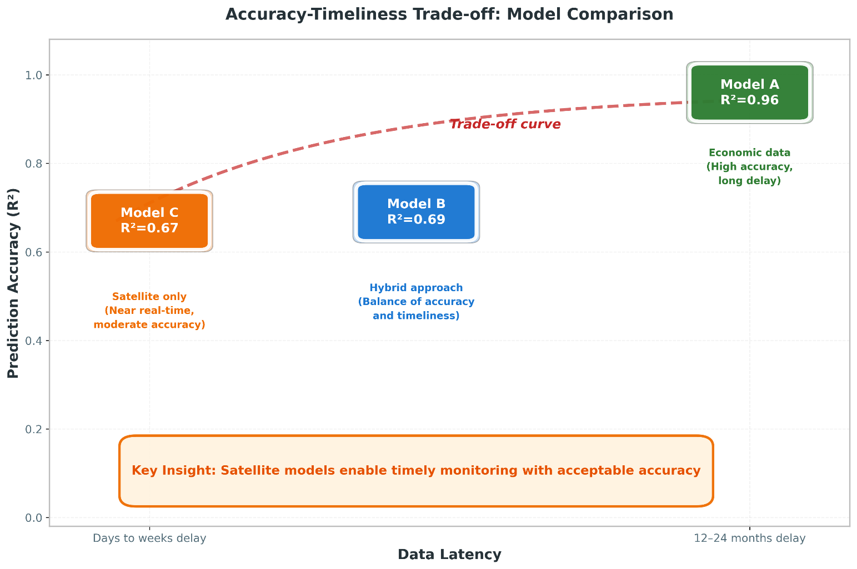
Figure 6.1: Accuracy vs Data Timeliness Trade-off

Official inventories remain the gold standard. Satellites fill gaps between annual reports.

6.3 Scope and Future Extensions of the Proposed Framework
Five limitations bound these results:
First, the empirical analysis is based on a relatively small balanced panel of 144 country–year observations, covering six GCC countries over the period 2000–2023. This sample size is appropriate for a first proof-of-concept investigation, but it naturally constrains the ability to explore more complex model structures and to fully assess the stability of the learned relationships across different regimes or sub-periods. Future extensions could enlarge the temporal coverage as longer and more consistent inventories become available and expand the spatial scope beyond the GCC to include additional regional or global samples, thereby enabling more extensive robustness checks and cross-country comparisons.
Second, the set of satellite-derived indicators reflects current sensor availability and data record length. For example, tropospheric NO₂ from Sentinel-5P is only available from 2018 onwards, and other products exhibit shorter time series, occasional gaps, or changes in sensor specifications. In addition, all satellite indicators were aggregated to annual, country-level averages, which inevitably smooths out sub-annual variability and short-lived episodes. Future work could incorporate alternative sensors and longer historical records, combine multiple missions into harmonized time series, and move from annual to monthly (or even higher frequency) aggregates to better capture short-term fluctuations relevant for nowcasting.
Third, the analysis is conducted exclusively at the national level. Using country-average indicators is consistent with the scale at which official CO₂ inventories are currently reported, but it cannot capture intra-country heterogeneity in emissions drivers, such as differences between major metropolitan areas, industrial clusters, and sparsely populated regions. A natural extension is to move towards sub-national nowcasting as soon as reliable spatially disaggregated emission estimates become available, for example at the level of regions, governorates, or large urban agglomerations. This would also allow the integration of finer-scale remote-sensing products and more localized socio-economic indicators.
Fourth, the modelling strategy deliberately focuses on a single tree-based algorithm, XGBoost, as the main workhorse model. While this choice is justified by the algorithm’s strong performance on tabular data and its ability to handle non-linear interactions, it means that the study does not systematically benchmark a wide range of alternative machine-learning and statistical approaches under exactly the same experimental protocol. Future extensions could explore a broader set of models, including generalized additive models, other gradient-boosting implementations, random forests, and lightweight deep-learning architectures, and could consider ensemble combinations to further improve predictive performance and stability.
Fifth, the evaluation window includes years that are affected by the COVID-19 pandemic and its aftermath, which introduced atypical patterns in energy demand, mobility, and economic activity. Although the temporal split between training and testing was designed to approximate an operational nowcasting setting, the presence of such structural shocks may affect the stability of the learned relationships between drivers and emissions. As longer post-pandemic time series become available, future work should reassess model performance over more “normal” periods and explicitly test how robust the framework is to major disruptions.
Finally, the current implementation should be viewed as a research prototype that can be further developed towards a fully operational now-casting system. The data pipelines from satellite and socio-economic sources are not yet fully automated, the models are updated on an annual basis, and uncertainty is summarized using simple error metrics rather than full probabilistic treatment. Transforming the framework into an operational tool would require automated end-to-end workflows, more frequent (e.g., monthly) nowcasts, systematic uncertainty quantification, and integration with decision-support dashboards used by policy makers. These steps represent clear and feasible directions for future development, building on the foundations established here.

6.4 Concrete Future Work Directions
Six research directions:

Figure 6.2: Future Research Directions
Geographic extension: test on North Africa or broader Middle East. Check if satellite-emission links transfer.
Higher spatial resolution: Moving from country-level to sub-national estimation (provinces, cities, industrial zones) would provide more actionable information for local policy makers. This would require handling the additional complexity of within-country variation.
Additional satellite products: As the Sentinel-5P NO₂ record grows longer, it may contribute more to prediction. Other products like TROPOMI CO column, CAMS methane estimates, or higher-resolution night-time lights could also be integrated.
Real-time operational system: The current framework processes annual data. Developing a monthly or even weekly estimation system would maximize the timeliness advantage of satellite data.
Uncertainty quantification: The current models provide point estimates without confidence intervals. Ensemble methods or Bayesian approaches could provide uncertainty bounds that help users understand estimate reliability.
Apply local explainable-AI methods: such as Shapley-value-based decomposition for tree ensembles, to individual country–year predictions once longer and denser emission time series become available. This would complement the global feature-importance analysis by revealing how the contribution of each satellite indicator changes across specific years, countries, and policy-relevant events.
Climate policy needs fast data. Satellites plus ML deliver CO₂ estimates in days—R² around 0.70, latency cut 99%. For some applications, 70% accuracy arriving in days beats 96% accuracy arriving in two years.

References

Addas, A., Goldblatt, R., & Rubinyi, S. (2020). Utilizing remotely sensed observations to estimate the urban heat island effect at a local scale: Case study of a university campus. Land, 9(6), Article 191. https://doi.org/10.3390/land9060191

Alamri, S., & Khan, S. (2023). Artificial intelligence based modelling for predicting CO₂ emission for climate change mitigation in Saudi Arabia. International Journal of Advanced Computer Science and Applications, 14(4), 182-189. https://doi.org/10.14569/IJACSA.2023.0140421

Alcibahy, M., Gafoor, F. A., Mustafa, F., El Fadel, M., Al Hashemi, H., Al Hammadi, A., & Al Shehhi, M. R. (2025). Improved estimation of carbon dioxide and methane using machine learning with satellite observations over the Arabian Peninsula. Scientific Reports, 15, Article 766. https://doi.org/10.1038/s41598-024-84593-9

Alkayal, S., Almayahi, M., Gazder, K. H., Al-Shehri, F., & Othman, W. A. M. (2025). Enhancing air quality prediction in Saudi Arabian cities using hybrid deep learning: A comprehensive approach with Sentinel-5P data. Atmosphere, 16(2), Article 211. https://doi.org/10.3390/atmos16020211

Assiri, M. (2017). Assessing MODIS land surface temperature products over the city of Jeddah, Saudi Arabia. Polish Journal of Environmental Studies, 26(4), 1461-1470. https://doi.org/10.15244/pjoes/68960

Begum, A. M., & Al Mobin, M. (2025). A machine learning approach to carbon emissions prediction of the top eleven emitters by 2030 and their prospects for meeting Paris agreement targets. Scientific Reports, 15, Article 19469. https://doi.org/10.1038/s41598-025-04236-5

Chen, T., & Guestrin, C. (2016). XGBoost: A scalable tree boosting system. In Proceedings of the 22nd ACM SIGKDD International Conference on Knowledge Discovery and Data Mining (pp. 785-794). ACM. https://doi.org/10.1145/2939672.2939785

Elvidge, C. D., Ziskin, D., Baugh, K. E., Tuttle, B. T., Ghosh, T., Pack, D. W., Erwin, E. H., & Zhizhin, M. (2009). A fifteen year record of global natural gas flaring derived from satellite data. Energies, 2(3), 595-622. https://doi.org/10.3390/en20300595

Emadi, M., Taghizadeh-Mehrjardi, R., Cherati, A., Danesh, M., Mosavi, A., & Scholten, T. (2020). Predicting and mapping of soil organic carbon using machine learning algorithms in Northern Iran. Remote Sensing, 12(14), Article 2234. https://doi.org/10.3390/rs12142234

European Space Agency. (2024). Sentinel-5P TROPOMI User Guide. Retrieved December 2024 from https://sentiwiki.copernicus.eu/web/sentinel-5p

Fonseca, R., & Francis, D. (2023). Satellite derived trends and variability of CO₂ concentrations in the Middle East during 2014-2023. Frontiers in Environmental Science, 11, Article 1289142. https://doi.org/10.3389/fenvs.2023.1289142

Global Carbon Project. (2023). Global carbon budget 2023. Earth System Science Data, 15(12), 5301-5369. https://doi.org/10.5194/essd-15-5301-2023

Goodfellow, I., Bengio, Y., & Courville, A. (2016). Deep learning. MIT Press. https://www.deeplearningbook.org/

Gorelick, N., Hancher, M., Dixon, M., Ilyushchenko, S., Thau, D., & Moore, R. (2017). Google Earth Engine: Planetary-scale geospatial analysis for everyone. Remote Sensing of Environment, 202, 18-27. https://doi.org/10.1016/j.rse.2017.06.031

Hammam, A., & Mohamed, E. (2020). Mapping soil salinity in the East Nile Delta using several methodological approaches of salinity assessment. Egyptian Journal of Remote Sensing and Space Science, 23(2), 125-131. https://doi.org/10.1016/j.ejrs.2018.11.002

Han, Z., Cui, B., Xu, L., Wang, J., & Guo, Z. (2023). Coupling LSTM and CNN neural networks for accurate carbon emission prediction in 30 Chinese provinces. Sustainability, 15(18), Article 13934. https://doi.org/10.3390/su151813934

Haq, M. A. (2022). Planetscope nanosatellites image classification using machine learning. Computer Systems Science and Engineering, 42(3), 1031-1046. https://doi.org/10.32604/csse.2022.023221

IPCC. (2023). Climate change 2023: Synthesis report. Contribution of Working Groups I, II and III to the Sixth Assessment Report of the Intergovernmental Panel on Climate Change. Intergovernmental Panel on Climate Change. https://www.ipcc.ch/report/ar6/syr/

Kumar, K. R., Attada, R., Dasari, H. P., Vellore, R. K., Langodan, S., Abualnaja, Y. O., & Hoteit, I. (2018). Aerosol optical depth variability over the Arabian Peninsula as inferred from satellite measurements. Atmospheric Environment, 187, 346–357. https://doi.org/10.1016/j.atmosenv.2018.06.011

Lin, X., van der A, R., de Laat, J., Eskes, H., Chevallier, F., Ciais, P., Deng, Z., Geng, Y., Song, X., Ni, X., Huo, D., Dou, X., & Liu, Z. (2023). Monitoring and quantifying CO₂ emissions of isolated power plants from space. Atmospheric Chemistry and Physics, 23, 6599-6611. https://doi.org/10.5194/acp-23-6599-2023

Madugundu, R., Al-Gaadi, K. A., Tola, E., Hassaballa, A. G., & Kayad, C. (2018). Utilization of Landsat-8 data for the estimation of carrot and maize crop water footprint under the arid climate of Saudi Arabia. PLoS ONE, 13(2), Article e0192830. https://doi.org/10.1371/journal.pone.0192830

Mallick, J., Almesfer, M. K., Alsubih, M., Ahmed, M., & Ben Kahla, N. (2022). Estimating carbon stocks and sequestration with their valuation under a changing land use scenario: A multi-temporal research in Abha City, Saudi Arabia. Frontiers in Ecology and Evolution, 10, Article 905799. https://doi.org/10.3389/fevo.2022.905799

Meng, Y., & Noman, H. (2022). Predicting CO₂ emission footprint using AI through machine learning. Atmosphere, 13(11), Article 1871. https://doi.org/10.3390/atmos13111871

Mustafa, F., Bu, L., Wang, Q., Ali, N., Shahzaman, M., Bilal, M., Aslam, M., & Iqbal, A. (2021). Neural-network-based estimation of regional-scale anthropogenic CO₂ emissions using an Orbiting Carbon Observatory-2 (OCO-2) dataset over East and West Asia. Atmospheric Measurement Techniques, 14(11), 7277-7290. https://doi.org/10.5194/amt-14-7277-2021

NASA. (2024). Landsat Science. Retrieved December 2024 from https://landsat.gsfc.nasa.gov/

Nassef, A. M., Olabi, A. G., Rezk, H., & Abdelkareem, M. A. (2023). Application of artificial intelligence to predict CO₂ emissions: Critical step towards sustainable environment. Sustainability, 15(9), Article 7648. https://doi.org/10.3390/su15097648

Our World in Data. (2023). CO₂ and greenhouse gas emissions dataset. Retrieved from https://ourworldindata.org/co2-and-greenhouse-gas-emissions

Persello, C., Wegner, J. D., Hänsch, R., Tuia, D., Ghamisi, P., Kober, M., & Blazquez-Calero, J. (2022). Deep learning and Earth observation to support the Sustainable Development Goals: Current approaches, open challenges, and future opportunities. IEEE Geoscience and Remote Sensing Magazine, 10(2), 172-200. https://doi.org/10.1109/MGRS.2021.3136100

Rahman, M. M., Shafiullah, M., Alam, M. S., Rahman, M. S., Alsanad, M. A., Islam, M. M., Islam, M. K., & Rahman, S. M. (2023). Decision tree-based ensemble model for predicting national greenhouse gas emissions in Saudi Arabia. Applied Sciences, 13(6), Article 3832. https://doi.org/10.3390/app13063832

Rowley, A., & Karakuş, O. (2023). Predicting air quality via multimodal AI and satellite imagery. Remote Sensing of Environment, 293, Article 113609. https://doi.org/10.1016/j.rse.2023.113609

Russell, S., & Norvig, P. (2020). Artificial intelligence: A modern approach (4th ed.). Pearson. ISBN: 978-0134610993

Tan, Y., Wang, S., Xue, R., Zhang, S., Wang, T., Liu, J., & Zhou, B. (2024). Estimation of carbon emissions in various clustered regions of China based on OCO-2 satellite XCO₂ data and random forest modelling. Atmospheric Environment, 338, Article 120860. https://doi.org/10.1016/j.atmosenv.2024.120860

UNFCCC. (2024). NDC Registry. United Nations Framework Convention on Climate Change. Retrieved December 2024 from https://unfccc.int/NDCREG

Xu, G., Zeng, T., Jin, H., Xu, C., & Zhang, Z. (2023). Spatio-temporal variations and influencing factors of country-level carbon emissions for Northeast China based on VIIRS nighttime lighting data. International Journal of Environmental Research and Public Health, 20(1), Article 829. https://doi.org/10.3390/ijerph20010829

Appendices

Appendix A: Google Earth Engine Code Snippets
The following code snippets illustrate key components of the satellite data extraction pipeline implemented in Google Earth Engine.

A.1 LST Extraction Example
// Extract summer LST for Saudi Arabia, 2020 var saudi = ee.FeatureCollection('FAO/GAUL/2015/level0') .filter(ee.Filter.eq('ADM0_NAME', 'Saudi Arabia')); var modisLST = ee.ImageCollection('MODIS/061/MOD11A2') .filterDate('2020-06-01', '2020-08-31') .select('LST_Day_1km'); // Apply scale factor and convert to Celsius var summerLST = modisLST.mean() .multiply(0.02) .subtract(273.15); // Compute spatial mean over country var result = summerLST.reduceRegion({ reducer: ee.Reducer.mean(), geometry: saudi, scale: 1000, maxPixels: 1e13 }); print('Saudi Arabia Summer LST 2020:', result);

A.2 Night-time Lights Extraction
// Extract annual night-time lights for UAE, 2022 var uae = ee.FeatureCollection('FAO/GAUL/2015/level0') .filter(ee.Filter.eq('ADM0_NAME', 'United Arab Emirates')); var viirs = ee.ImageCollection('NOAA/VIIRS/DNB/MONTHLY_V1/VCMSLCFG') .filterDate('2022-01-01', '2022-12-31') .select('avg_rad'); // Filter out gas flares and fires var filtered = viirs.map(function(img) { return img.updateMask(img.lt(1000).and(img.gt(0))); }); var annualNTL = filtered.mean(); var result = annualNTL.reduceRegion({ reducer: ee.Reducer.mean(), geometry: uae, scale: 500, maxPixels: 1e13 }); print('UAE Annual NTL 2022:', result);

Appendix B: Dataset Variables
Complete list of variables in the final merged GCC analysis dataset:
- country: Country name (string)
- year: Year (integer, 2000-2023)
- CO₂: National CO₂ emissions (OWID series; variable: co2) (Mt)
- gdp: Gross Domestic Product (constant 2015 USD)
- population: Annual population estimate
- primary_energy_consumption: Total energy consumption (TWh)
- energy_per_capita: Energy consumption per person (kWh)
- LST_Summer_C: Mean land surface temperature, June-August (°C)
- LST_Winter_C: Mean land surface temperature, December-February (°C)
- NDVI_Spring: Mean vegetation index, March-May
- Night_Lights: Mean night-time radiance (nW/cm²/sr)
- AOD_Annual: Mean aerosol optical depth
- NO2_Signal: Mean tropospheric NO₂ column (mol/m², 2019+ only) [Not used in final models due to limited coverage]
- land_area_km2: Country land area (km²)
- log_pop_density: log₁₀ (population / land_area)

