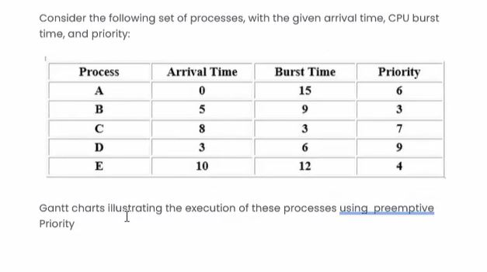
A B E C D

0 15 24 36 39 45
PRIORITY NON PREEMPTIVE

PRIORITY PREEMPTIVE
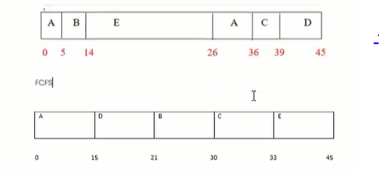
SJF NONPREEMPTIVE
A C D B E

0 15 18 24 33 45

SJF PREEMPTIVE
A D C B A E

0 3 5 8 9 12 21 33 45

RR QUANTUM = 4 NONPREEMPTIVE
A D A B D C E A B E A B E

0 4 8 12 16 18 21 25 29 33 37 40 41 45

