

AI-powered solution for energy consumption optimization in wastewater management

Student Name: Zaher Baali
Course: Thesis AI900 Dr. Hager Saleh Third Trimester 2024, Final project
Keyword: energy consumption, machine learning, wastewater treatment plants, regression

Abstract
Energy consumption (EC) optimization is, the biggest opportunity to reduce wastewater treatment operating costs while maintaining water quality and complying with environmental regulations. An energy optimization system is a system that enables wastewater treatment plant managers and operators to manage their energy and make decisions to improve energy efficiency, productivity and business sustainability while maintaining water quality. They can take advantage of optimize their energy use and sources, reduce energy-related operating costs and manage carbon emissions.
This paper study the potential to apply AI-powered solution using machine learning (ML) and deep learning (DL) methodologies in energy consumption optimization, then we will comparing the models performance with applying feature selection (FS) and without feature selection technique, to evaluate that impact on results to predict WWTP energy consumption using actual data from the Melbourne WWTP.
Furthermore, we using deferent models and compere between ML models (Linear Regression (LR), Decision Tree Regression (DTR), Random Forest Regression (RFR), Support Vector Regression (SVR), Gradient Boosting Regression (GBR), and K-Neighbors Regression (KNNR)) and DL models including Long Short-Term Memory (LSTMs) networks and Convolutional Neural Networks (CNNs) to evaluate results. We presented results by using commonly metrics: Mean Absolute Error (MAE), Mean Absolute Percentage Error (MAPE), Root Mean Squared Error (RMSE) and R-Squared.

Introduction
Management of wastewater is an important things to optimization energy in wastewater treatment processes. In recent years, the rapid development of society and economy have led to a proportional increase in wastewater production, bringing growing business pressure WWTPs [1]. At the same time, the pollutant discharge standards of WWTPs have been raised for sustainable development [2] [3]. In this context, excessive chemicals are used during the treatment processes by many WWTPs, leading to meaningless waste of energy and materials [4]. In fact, such high consumption of energy and materials go against the thought of sustainability to some extent. Therefore, it is of great significance to reasonably schedule energy consumption amount under the condition of meeting the discharge standard [5].
However, WWTPs are energy-intensive processes; therefore, improving their energy efficiency is needed from environmental and economic viewpoints [6]. It has been reported in [7] [8], that WWTPs energy usage accounts for 4% of the national electricity in the United States and around 7% of the electrical energy worldwide [9]. One of technique for enhancing WWTPs is energy management in the facility based on operator’s predictions. In order to accomplish this, the operators forecast the energy demand based on operational scenario, time schedules and equipment.
The development of modern water treatment and distribution systems has been recognized by the U.S. National Academy of Engineering as one of the great engineering achievements of the 20th century systems [10], which provide water for agriculture, domestic needs, and sanitation, rely on complex infrastructure that requires significant amounts of energy for processes such as pumping and purification. In addition, the various ways we use water (heating, washing, dishwashing, bathing, and food preparation) consume significant amounts of energy.
In term of EC optimization, most reviewed works use ML technique. Some studies achieved good outcomes using ML models such as KNN and RF. This review concludes that no one applied Feature selection techniques as a Principal Component Analysis (PCA), Recursive Feature Elimination (RFE), or others. Overall, NNS and hybrid models exhibited satisfactory prediction performance [11].
The approach taken in this study is to first explore the EC of Melbourne water treatment plant data before explaining the demand between energy and another variables (Hydraulic information, Wastewater information, Climate and Time Information) influence the cost at WWTP. Then applied Feature selection techniques and hyper parameter method.
It concludes by emphasizing the available prediction models that can reduce energy consumption optimization in wastewater management.

Related Work
Recently, several studies have investigated the use of ML and DL to improve the operation of WWTPs, especially in predicting their energy consumption. These models provide flexibility and rely only on historical data from the monitored processes. For instance, in [12], used East Melbourne WWTP dataset, and the dataset is a combination of open data produced by Melbourne water and Melbourne airport weather station. The dataset content this elements (Power consumption, Hydraulic, biological, and climate data are merged by the record date. Then applied ML techniques: Artificial Neural Networks (ANN), Gradient Boosting Machine (GBM) and Random Forest (RF) to predict EC records. FS algorithms used to selecting elements that impacted on WWTP energy consumption by selecting the most relevant features from the data for training the ML models. The results shown that GBM was recorded the best performance with reasonable prediction error band.
In [13], applied different deep learning models: the Long Short-Term Memory (LSTM) and Bidirectional Gated Recurrent Unit (BiGRU) to predict energy consumption in WWTP. Spline Cubic interpolation was used to data augmentation to increase dataset size. BiGRU with FS was recorded the best performance with lowest errors. This study used East Melbourne WWTP dataset, and the dataset is a combination of open data produced by Melbourne water and Melbourne airport weather station. The dataset content this elements (Power consumption, Hydraulic, biological, and climate data are merged by the record date).
Furthermore in [14], applied different machine learning models: Random Forest and XGBoost (eXtreme Gradient Boosting) were used to evaluate the impact of the included features on predicting energy consumption. Bayesian optimization used to assess machine-learning models to develop efficient EC predictions. (RF) and XGBoost were used to identify key variables impacting the models' predictive performance. (KNN) model recorded the best methods for energy consumption predictions. This study used the open data produced by Melbourne water and Melbourne airport weather station. In [15], the authors proposed hybrid model based on principal component analysis-convolutional neural network-long-short-term memory neural network (PCA-CNN-LSTM) (PCA-CNN-LSTM) to predict energy and materials-saving management using private wastewater treatment plant dataset that collected from China from 2018 to 2019. Genetic algorithm is used to select the best architecture of DL model. This study takes the WWTP in Chongqing as the study object, and the study data content is the daily data of the WWTP, including influent conditions, flow, effluent value, energy consumption, materials consumption, etc. In [16], presented machine learning models: Four models are developed: CDT, FitcKnn, LRM and Stepwise-LRM to forecast the future energy requirements. The authors validated accuracy, were compared with four another models (BRNN, LMA, TB, and GPR) showing that the proposed ML models effectively capture the impact of climatic variables on energy usage. In [17], focused on the four machine learning models: support vector machines (SVM), artificial neural network (ANN), long-short term memory (LSTM), and gated recurrent network (GRU) to predict EC. Rolling window approach used to segmented data into a window size of 15 with three input features to conclude the best predict algorithm. GRU was showed the best fit for future analysis. This study takes the set of historical data adapted from Li et al, and the study data content influencing factors (inflow rate, COD removal, and TN removal), including subsequent energy consumption.
Finally, [18], used machine learning: Bayesian semi-parametric regression model with the Partial Linear Single-Index Model (PLSIM) to address energy consumption in biochemical wastewater treatment. It estimates quantiles across low, median, and high energy levels using the Asymmetric Laplace Distribution (ALD) in a Bayesian framework and uses the Indicator Model Selection (IMS) technique to find pertinent factors. In [19], the authors used ML techniques: neural network (NN) models, in the Fast Artificial Neural Network Tool (FANN) to produce forecast EC. The relevant predictive factors were found using correlation analysis after the data were initially statistically examined in accordance with the context of EC and features. Waikato Environment for Knowledge Analysis (WEKA) used as feature selection after statistically analyzed of data. This study takes the WWTP in Greece as the study object, and the study data encompasses data from municipals worked in Greece, including Flow rate, Treatment capacity, Served population, Influent load, Sludge treatment line, etc.
Reference | Methods | Advantages | Dataset | Results
[12] | The authors applied machine learning techniques: Artificial Neural Networks (ANN), Gradient Boosting Machine (GBM) and Random Forest (RF) to predict EC records. | FS algorithms used to selecting elements that impacted on WWTP energy consumption by selecting the most relevant features from the data for training the ML models. (ANN) and two decision tree algorithms of (GBM) with (RF) were studied to predict EC. | East Melbourne WWTP dataset | GBM was recorded the best performance with reasonable prediction error band.
[13] | The authors applied different deep learning models | The Long Short-Term Memory (LSTM) and Bidirectional Gated Recurrent Unit (BiGRU) to predict energy consumption in WWTP. Spline Cubic interpolation was used to data augmentation to increase of row of data. Random Forests (RF) was used to feature selection. | East Melbourne WWTP dataset | BiGRU with FS was recorded the best performance with lowest errors.
[14] | The authors applied different machine learning models | Random Forest and XGBoost (eXtreme Gradient Boosting) were used to evaluate the impact of the included features on predicting energy consumption.  Bayesian optimization used to assess machine-learning models to develop efficient EC predictions. RF and XGBoost were used to identify key variables impacting the models' predictive performance. | Melbourne water and Melbourne airport weather station | (KNN) model recorded the best methods for energy consumption predictions.
[15] | The authors proposed to use deep learning and genetic algorithm (GA) for WWTPs: | Neural networks algorithm (NNA) used to treatment processes and estimate the cost.  Genetic Algorithm (GA) selected as optimization technique used to choosing the fittest cost. | WWTP in Chongqing | With the proposed computational techniques, total energy and material costs can be reduced by 10%-15%
[16] | The authors presented machine learning models | Four models are developed: CDT, FitcKnn, LRM and Stepwise-LRM to forecast the future energy requirements. | Melbourne dataset | The authors validated accuracy, were compared with four another models (BRNN, LMA, TB, and GPR) showing that the proposed ML models effectively capture the impact of climatic variables on energy usage.
[17] | The authors used four machine learning models | Support vector machines (SVM), artificial neural network (ANN), long-short term memory (LSTM), and gated recurrent network (GRU) to predict EC.  Rolling window approach used to segmented data into a window size of 15 with three input features to conclude the best predict algorithm. | This study takes the set of historical data adapted from Li et al, and the study data content influencing factors (inflow rate, COD removal, and TN removal), including subsequent energy consumption. | GRU was showed the best fit for future analysis.
[18] | The authors used machine learning | Bayesian semi-parametric regression model with the Partial Linear Single-Index Model (PLSIM) to address energy consumption in biochemical wastewater treatment. | Melbourne dataset | It estimates quantiles across low, median, and high energy levels using the Asymmetric Laplace Distribution (ALD) in a Bayesian framework and uses the Indicator Model Selection (IMS) technique to find pertinent factors.
[19] | The authors used Machine learning techniques | Neural network (NN) models, in the Fast Artificial Neural Network Tool (FANN) to produce forecast EC.  (WEKA) used as feature selection after statistically analyzed of data. | This study takes the WWTP in Greece as the study object, and the study data encompasses data from municipals worked in Greece, including Flow rate, Treatment capacity, Served population, Influent load, Sludge treatment line, etc. | The relevant predictive factors were found using correlation analysis after the data were initially statistically examined in accordance with the context of EC and features.
Table 1. Summary of some studies on the WWTPs power consumption prediction

Methodology and Implementation
This section describe the implementation methodology for machine learning and deep learning models in energy consumption prediction. As presented in Figure 1, we applied six machine learning models (LR, DTR, RFR, SVR, GBR, KNNR) and two deep learning (LSTMs, CNNs). Below in Table 2 presented strengths and weaknesses for each models.
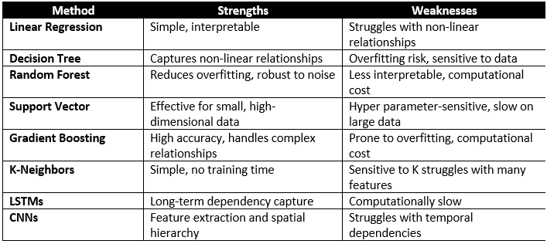
Table 2. The investigated methods in this paper
Wastewater management is a crucial task for preserving the environment's integrity and public health. However, because it consumes a lot of energy, it is still expensive and has negative effects on the environment. Therefore, optimizing energy use in wastewater treatment systems and processes is essential to advancing sustainable development in WWTPs.
The ML and DL methods offer an attractive way to predicate the EC in WWTPs. In order to predicate the energy consumption of the WWTP, we tested the prediction performance of popular ML and DL techniques in this paper. As presented in Figure 1, six machine learning models and two deep learning are considered, including (LR, DTR, RFR, SVR, GBR, KNNR) and (LSTMs, CNNs).
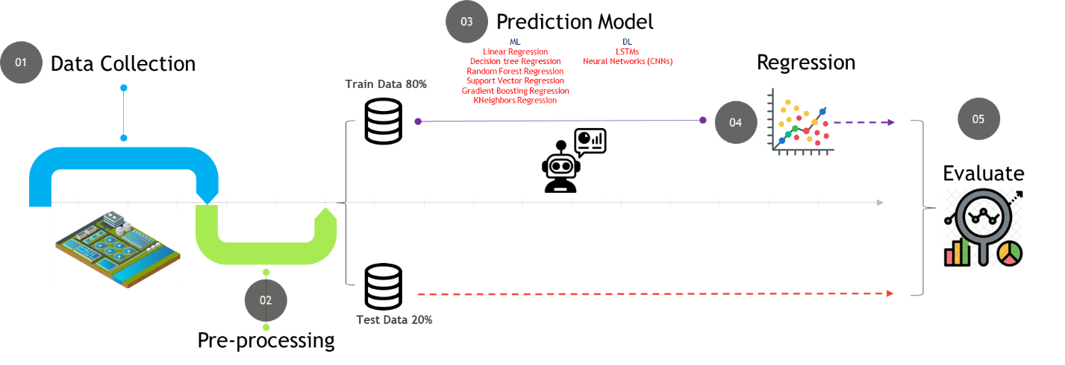
Figure 1. Illustration of the general framework of machine learning-based prediction procedure
Energy consumption is one of the largest operational expenditures in WWTPs and takes a big share of total costs. These facilities are under increasing stress to improve their efficiency in energy use owing to ever-increasing energy prices, global milestones, and the desire to lower their ecological impact. However, the energy requirements for WWTPs are quite volatile and depend on the nature of the inflow, climatic conditions, and operational plans making it difficult to come up with effective energy management measures.
In this study we presented the Artificial Intelligence application to support WWTPs in energy optimization as following:
  - 4.1 Data collected Describe and Analysis:
The dataset used in this study was obtained from the Melbourne water treatment plant and airport weather stations: https://data.mendeley.com/datasets/pprkvz3vbd/1. 1382 records from 19 variables were collected over a five-year period, from 2014 to 2019 listed in the below:
Hydraulic information (Average Outflow, Average Inflow) and Wastewater information (Ammonia, Biological Oxygen Demand, Chemical Oxygen Demand, Total Nitrogen) and Climate information (Average Temperature, Maximum temperature, Minimum temperature, Atmospheric pressure, Average humidity, Total rainfall, Average visibility, Average wind speed, Maximum wind speed) and Time Information (Year, Month, Day)
The dataset comprises climate, hydraulic, and biological variables in addition to power consumption data. Sensors are used to gather biological and water quality data, and the Melbourne airport weather station, which is close to the water treatment facility, is used to gather weather data.
This dataset gives a solid basis for the study of dependencies between energy consumption, climate change effects, and wastewater characteristics. It is suitable to using for machine learning and deep learning solutions in energy consumption optimization in wastewater management.
  - 4.2 Data pre-processing:
Before work on predictive models, we worked to exploratory data and analysis. In beginning, we applied the energy consumption over time Figure 2,3, to get a visual idea of the variation and correlation in the data. Data visualization is important for exploratory data, and helps identify patterns and trends that can be useful for building predictive models. Data visualization can also help identify any outliers or missing data, which may be necessary to preprocess the data before building predictive models.
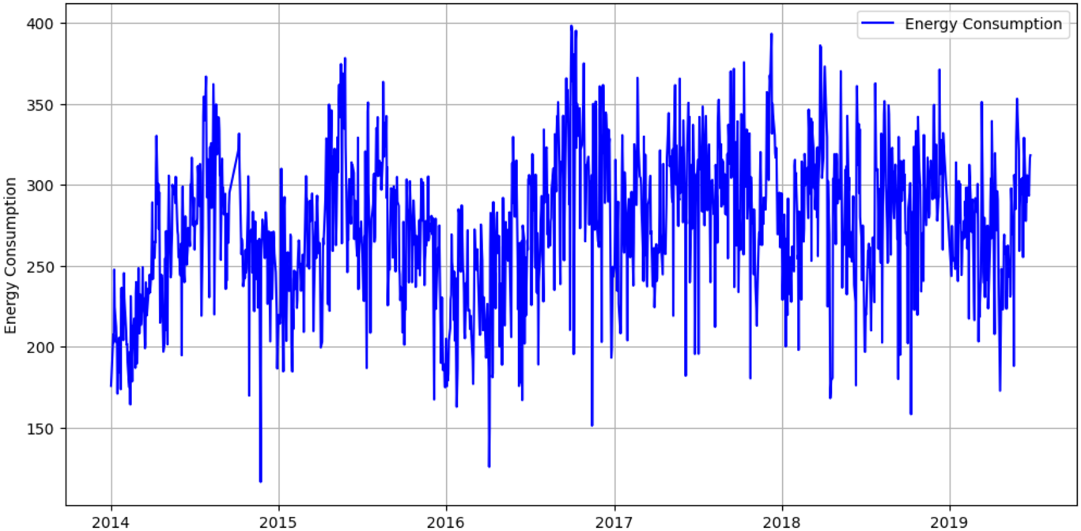
Figure 2. Energy Consumption Over time
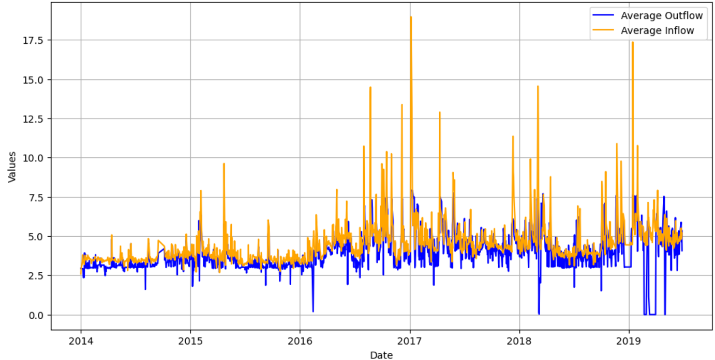Figure 3. Average Outflow and Average Inflow
In Figure 4, we analyzing time energy usage trends. This chart presented a rolling mean is the average of data points within a specific window that "rolls" over time. In a 7-day rolling mean, each point in the resulting data series represents the average of the current day and the previous 6 days.
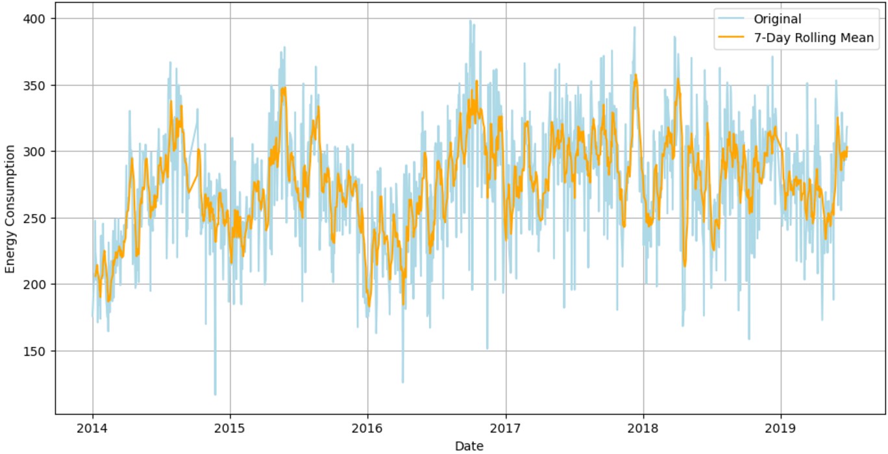Figure 4. Highlight Variations with a Rolling Mean
To understand the relationships between these variables in the dataset, we analyzed the important variables related to climate characteristics, as these variables often interact and influence each other, In Figure 5 and Figure 6.
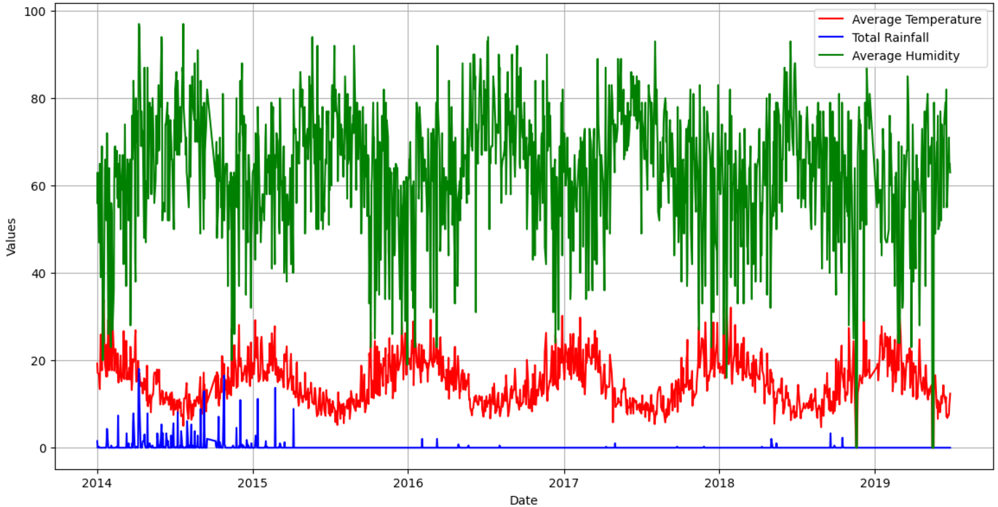Figure 5. Analyze Correlations between Variables (Temperature, Rainfall, and Humidity)
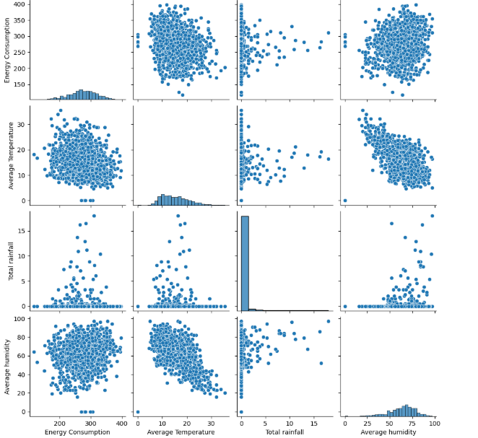
Figure 6. Visualize relationships between some variable
  - 4.3 Data prediction:
The dataset was divided into two subsets using an 80-20 split:
- Training Set (80%): Used to train machine learning and deep learning models by learning patterns, relationships, and underlying structures in the data.
- Testing Set (20%): Reserved for evaluating the performance and generalization ability of the trained models on unseen data.
The result shown by using commonly metrics are Mean Absolute Error (MAE), Mean Absolute Percentage Error (MAPE), Root Mean Squared Error (RMSE), and Coefficient of Determination (R²):
- MAE: Measures the average absolute difference between predicted and true values
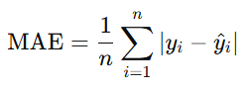
- MAPE: Measures the average percentage difference between predicted and true values
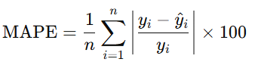
- RMSE: Measures the differences between predicted and true values.
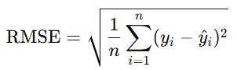
- R2: Measures how well the regression model explains the variance in the actual data
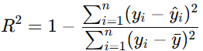
  - 4.4 Evaluation:
We applied ML and DL models with three scenario to predict EC at WWTPs as the below:
- EC prediction Baseline: in this approach we were using all features to train ML and DL models without any FS technique, hyper parameter methods and optimize functions.
- EC Prediction Using Tuning Models: in this approach categorized the data to three groups (Hydraulic, Wastewater and Climate) then, applied hyperparameter (GridSearchCV), this technique identified the optimal set of hyperparameters for each models. Also applied feature selection techniques.
- EC Prediction Using FS Technique: the last approach applied Recursive Feature Elimination to identify and retain the most relevant features while removing less significant ones, this technique enhanced model efficiency and improved results.

Results
  - 5.1 Experiment Setup:
5.1.1 Dataset Features:
- Hydraulic Information:
  - Average Outflow: The daily average effluent flow rate from the plant.
  - Average Inflow: The daily average influent flow rate into the plant.
- Wastewater Characteristics:
  - Ammonia (NH₃): Concentration levels reflecting nitrogenous pollutants.
  - Biological Oxygen Demand (BOD): A measure of the biodegradable organic matter in the water.
  - Chemical Oxygen Demand (COD): Total oxygen required to chemically oxidize pollutants.
  - Total Nitrogen (TN): Combined nitrogen content indicating overall pollutant load.
- Climate Information:
  - Temperature: Includes daily average, maximum, and minimum temperatures (°C).
  - Atmospheric Pressure: Average atmospheric pressure recorded daily (hPa).
  - Humidity: Daily average relative humidity (%).
  - Rainfall: Total daily rainfall (mm).
  - Visibility: Average daily visibility (km).
  - Wind Speed: Daily average and maximum wind speeds (km/h).
- Time Information:
  - Year, Month, and Day: for tracking seasonal and annual.
5.1.2 Algorithm used and Experimental Setup:
- Machine Learning models used: LR, DTR, RFR, SVR, GBR, KNNR
- Deep learning models used: LSTMs, CNNs
- Training and testing splits: (80-20 split)
- Code used: (Python)
- Computational resources used: (11th Gen Intel(R) Core(TM) i5-1135G7 @ 2.40GHz, 2419 Mhz, 4 Core(s), 8 Logical Processor(s))
- Feature selection techniques applied: (Recursive Feature Elimination (RFE))
- Hyperparameters used: (GridSearchCV)
5.1.3 Performance Metrics:
- Metrics used for evaluation: (MAE, MAPE, RMSE and R2)
Choosing the best model is an important step in prediction models. The best model can be chosen by comparing the performance of different models using these metrics. Here, we used four commonly used metrics: MAE, MAPE, RMSE and R2. The model that performs best based on these metrics can be selected as the best model.
  - 5.2 EC prediction Baseline:
We used all features to train ML and DL models without any FS technique, hyper parameter methods and optimize functions, the results as following:
 | MAE(MWh) | RMSE(MWh) | R2(MWh) | MAPE%
Linear Regression | 30.86 | 40.27 | 0.15 | 12.04
Decision Tree | 34.27 | 45.45 | -0.08 | 13.18
Random Forest | 27.19 | 35.74 | 0.33 | 10.60
Support Vector Regression | 34.83 | 43.59 | 0.00 | 13.59
Gradient Boosting | 28.20 | 37.36 | 0.27 | 10.92
KNeighbors Regression | 37.16 | 46.52 | -0.14 | 14.21
LSTM | 38.35 | 47.61 | 0.18 | 13.88
CNN | 34.98 | 44.22 | -0.03 | 13.14
Table 3. EC prediction Using Full Models
  - 5.3 EC Prediction Using Tuning Models:
We split the dataset for 3 categories as following and applied hyperparameter (GridSearchCV) and feature selection techniques:
- Hydraulic (Average Outflow, Average Inflow)
- Wastewater (Energy Consumption “Target variable”, Ammonia, Biological Oxygen Demand, Chemical Oxygen Demand, Total Nitrogen)
- Climate (Average Temperature, Maximum temperature, Minimum temperature, Atmospheric pressure, Average humidity, Total rainfall, Average visibility, Average wind speed, Maximum wind speed)
The results as following:
Hydraulic Category | MAE(MWh) | RMSE(MWh) | R2(MWh) | MAPE%
Linear Regression | 34.11 | 42.95 | 0.03 | 13.28
Decision Tree | 35.75 | 44.54 | -1.38 | 13.94
Random Forest | 34.23 | 43.30 | 0.02 | 13.32
Support Vector Regression | 33.65 | 42.37 | 0.06 | 13.21
Gradient Boosting | 34.05 | 42.86 | 0.04 | 13.28
KNeighbors Regression | 36.23 | 46.16 | -0.12 | 14.04
LSTM | 34.16 | 43.04 | 0.01 | 13.42
CNN | 34.62 | 43.58 | 0.00 | 13.12
Wastewater Category | MAE(MWh) | RMSE(MWh) | R2(MWh) | MAPE%
Linear Regression | 33.02 | 41.61 | 0.09 | 13.30
Decision Tree | 31.01 | 40.23 | 0.15 | 14.04
Random Forest | 29.18 | 37.81 | 0.25 | 13.33
Support Vector Regression | 33.08 | 41.72 | 0.09 | 13.26
Gradient Boosting | 30.37 | 39.76 | 0.17 | 13.32
KNeighbors Regression | 36.16 | 46.16 | -0.12 | 14.34
LSTM | 34.36 | 43.46 | 0.01 | 13.19
CNN | 34.98 | 44.22 | -0.03 | 13.14
Climate Category | MAE(MWh) | RMSE(MWh) | R2(MWh) | MAPE%
Linear Regression | 34.13 | 43.68 | 0.00 | 13.30
Decision Tree | 36.38 | 48.10 | -0.21 | 14.04
Random Forest | 34.31 | 44.10 | -0.02 | 13.33
Support Vector Regression | 33.94 | 43.53 | 0.01 | 13.26
Gradient Boosting | 34.27 | 44.11 | -0.02 | 13.32
KNeighbors Regression | 36.92 | 46.75 | -0.15 | 14.34
LSTM | 33.82 | 43.23 | -0.02 | 13.04
CNN | 34.24 | 43.14 | 0.02 | 13.71
Table 4. EC prediction Using Tuning Models
  - 5.4 EC Prediction Using FS Technique:
We applied Recursive Feature Elimination to identify and retain the most relevant features while removing less significant ones, the results as following:
 | MAE(MWh) | RMSE(MWh) | R2(MWh) | MAPE%
Linear Regression | 31.09 | 40.59 | 0.13 | 12.13
Decision Tree | 38.46 | 50.37 | -0.33 | 14.54
Random Forest | 26.64 | 35.50 | 0.34 | 10.38
Support Vector Regression | 34.88 | 43.64 | 0.00 | 13.61
Gradient Boosting | 28.37 | 37.76 | 0.25 | 11.03
KNeighbors Regression | 35.50 | 45.77 | -0.10 | 13.73
LSTM | 33.97 | 43.29 | 0.02 | 13.36
CNN | 35.21 | 44.12 | -0.02 | 13.19
Table 5. EC prediction Using FS Technique
In Figure 7, shown the results compare between actual and predicted values with after applied FS technique for predicting energy consumption. The function plot_predictions_scatter_and_line generates a combined scatter and line plot to analyze the quality of predictions. This purposed to helps evaluate model performance visually by observing the overlap between actual and predicted values and highlights discrepancies and trends in prediction errors.
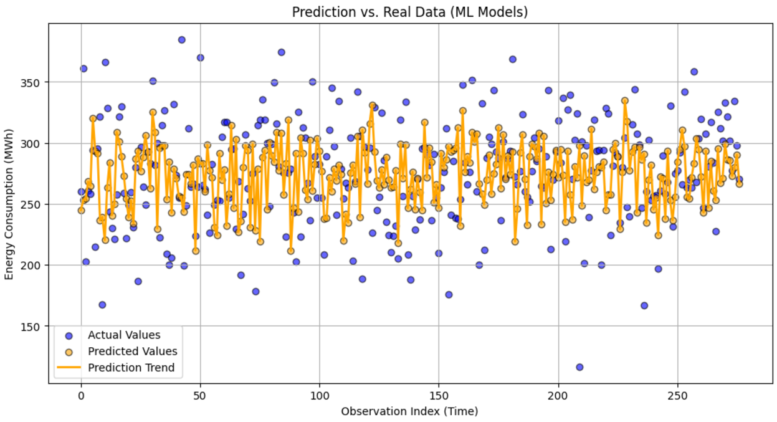Figure 7. Visualizes Prediction vs. Real data for ML models with FS

Conclusions
This study presents an approach for reducing energy usage in WWTPs through using machine and deep learning models with apply FS technique and another, to come up with the most relevant factors affecting energy consumption patterns, and explore the exercise of ML and DL techniques to predict energy consumption in WWTPs on real data collected from a Melbourne WWTP are used. The models were evaluated by used (LR, DTR, RFR, SVR, GBR, KNNR, LSTM and CNN) with applied FS technique.
However, it is important to highlight that while using ML models such as Random Forest and Gradient Boosting that gives much more reliable results than another machine learning models. Other models like Support Vector Regression exhibit strong performance in different evaluation metrics. The findings shown that using the feature selection techniques through models, specifically ML models that improves the accuracy of energy consumption predictions. The Random Forest model appear the good performing model. It is important to highlight that while using tuning models.
Furthermore, analysis of the Melbourne WWTP data shown that multiple variables effect on EC (Average Outflow, Average Inflow, Ammonia, Total Nitrogen, Average Temperature, Average humidity, Total rainfall, Maximum wind speed, Time), so to optimize energy consumption prediction in WWTPs, it is recommended to consider these variables in future energy consumption prediction models.
The proposed approach presented in this study can be customized and implemented in other WWTPs. While the conclusions points in our study may not directly applied to another WWTPs due to differences operation and data criteria. Our approach and methodologies applied in this study can be a valuable references for other WWTPs to enhance their energy in their own systems, there is still potential for improvement in energy consumption prediction for WWTPs using ML.

References

Works Cited

[1] | J. L. X. H. a. H. S. Y. Qiu, "A Feasible Data-Driven Mining System to Optimize Wastewater Treatment Process Design and Operation," https://www.mdpi.com/2073-4441/10/10/1342.
[2] | S. L. Kate Smith, "Energy for Conventional Water Supply and Wastewater Treatment in Urban China: A Review," https://onlinelibrary.wiley.com/doi/10.1002/gch2.201600016.
[3] | H.-c. S. M. H. Yong Qiu, "Nitrogen and Phosphorous Removal in Municipal Wastewater Treatment Plants in China: A Review," https://onlinelibrary.wiley.com/doi/10.1155/2010/914159.
[4] | P. E. a. P. V. Otto Nowak, "Ways to optimize the energy balance of municipal wastewater systems: lessons learned from Austrian applications," https://doi.org/10.1016/j.jclepro.2014.08.068.
[5] | M. S. Kentaro Mizuta, "Benchmarking energy consumption in municipal wastewater treatment plants in Japan," https://doi.org/10.2166/wst.2010.510.
[6] | A. M. Maria Molinos Senante, "Evaluation of energy efficiency of wastewater treatment plants: The influence of the technology and aging factors," https://www.sciencedirect.com/science/article/abs/pii/S030626192200023X?via%3Dihub.
[7] | R. a. W. E. P. R. I. S. Goldstein, "Water & sustainability (volume 4): US electricity consumption for water supply & treatment-the next half century," Electric Power Research Institute.
[8] | A. K. Y. Z. X. W. Zijun Zhang, "Modeling and optimization of a wastewater pumping system with data-mining methods," https://doi.org/10.1016/j.apenergy.2015.11.061.
[9] | A. L. V. J. Plappally, "Energy requirements for water production, treatment, end use, reclamation, and disposal," https://doi.org/10.1016/j.rser.2012.05.022.
[10] | K. E. S. Benjamin K. Sovacool, "Identifying future electricity–water tradeoffs in the United States," https://doi.org/10.1016/j.enpol.2009.03.012.
[11] | K. J. J. L. J. J. Y. M. K. J.-p. P. J. H. K. K. H. C. Hong Guo, "Prediction of effluent concentration in a wastewater treatment plant using machine learning models," https://doi.org/10.1016/j.jes.2015.01.007.
[12] | A. S. N. M.-J. M. S. T. Faramarz Bagherzadeh, "Prediction of energy consumption and evaluation of affecting factors in a full-scale WWTP using a machine learning approach," https://www.sciencedirect.com/science/article/abs/pii/S0957582021004663.
[13] | A. D. A. D. Y. S. Fouzi Harrou, "Energy consumption prediction in water treatment plants using deep learning with data augmentation," https://www.sciencedirect.com/science/article/pii/S2590123023005558.
[14] | F. H. Y. S. Yasminah Alali, "Unlocking the Potential of Wastewater Treatment: Machine Learning Based Energy Consumption Prediction," https://www.mdpi.com/2073-4441/15/13/2349.
[15] | J. Wang, K. Wan, X. Gao, X. Cheng, Y. Shen and Z. Wen, "Energy and Materials-Saving Management via Deep Learning for Wastewater Treatment Plants," https://ieeexplore.ieee.org/abstract/document/9233427.
[16] | H. C. Tanveer Ahmad, "Utility companies strategy for short-term energy demand forecasting using machine learning based models," https://www.sciencedirect.com/science/article/abs/pii/S221067071731096X.
[17] | P. K. K. N. D. C. Akash Das, "A Study to Target Energy Consumption in Wastewater Treatment Plant using Machine Learning Algorithms," https://www.sciencedirect.com/science/article/abs/pii/B9780323885065502333.
[18] | Z. Z. S. W. Yang Yu, "Statistical regression modeling for energy consumption in wastewater treatment," https://www.sciencedirect.com/science/article/abs/pii/S100107421732795X.
[19] | P. K. a. L. Anthopoulos, "Machine Learning-Based Energy Consumption Estimation of Wastewater Treatment Plants in Greece," https://www.mdpi.com/1996-1073/16/21/7408.

