Chapter two:
Literature Review

Introduction
Several studies have been conducted on the impact of indirect centralized procurement strategies on resource management efficiency and cost savings.
Below are some of the most significant studies:

Arabic Studies:
• Impact of centralized procurement strategies on resource management efficiency in major industrial companies in Saudi Arabia (2022) by Ahmed bin Mohammed bin Ali Al Hamad: The study found that the application of centralized procurement strategy in major industrial companies in Saudi Arabia led to improved resource management efficiency through reducing procurement costs and enhancing the quality of purchased goods and services.
• Role of centralized procurement in enhancing efficiency of government spending: A case study of the Ministry of Health in Saudi Arabia (2020) by Abeer bint Ibrahim bin Abdul Rahman Al Suleiman: The study demonstrated that implementing centralized procurement strategy in the Saudi Ministry of Health resulted in reduced government spending and improved resource utilization efficiency.
• Impact of centralized procurement strategy on performance of service companies in Jordan (2018) by Mohammed Ali Ahmed Al Shawabkeh: The study indicated that applying centralized procurement strategy in Jordanian service companies improved their performance by reducing costs and enhancing the quality of services provided.
• Role of centralized procurement in enhancing supply chain management efficiency in major industrial companies in Egypt (2016) by Mohamed Atef Ibrahim: The study affirmed that implementing centralized procurement strategy in major industrial companies in Egypt enhanced supply chain management efficiency by improving coordination across different stages of the chain and reducing costs.
• Impact of implementing centralized procurement strategy on resource management efficiency in real estate companies in Jordan (2014) by Sulaiman Mahmoud Ahmed: The study showed that implementing centralized procurement strategy in real estate companies in Jordan improved resource management efficiency through reducing construction costs and enhancing the quality of real estate projects.

• Study titled "Impact of Indirect Centralized Procurement Strategy on Resource Management Efficiency in Major Industrial Companies in Jordan"
Study Objective: To analyze the impact of indirect centralized procurement strategy on resource management efficiency in major industrial companies in Jordan.
Research Methodology: Descriptive-analytical methodology.
Data Collection Tools: Questionnaires and interviews.
Study Results: The study revealed that indirect centralized procurement strategy contributes to enhancing resource management efficiency in major industrial companies in Jordan by reducing procurement costs, improving inventory levels, and enhancing the quality of goods and services.
• Study titled "Role of Centralized Procurement in Improving Supply Chain Performance: A Case Study in Electronics Company"
Study Objective: To evaluate the role of centralized procurement in improving supply chain performance in an electronics company.
Research Methodology: Descriptive-analytical methodology.
Data Collection Tools: Literature review, secondary data analysis, and interviews.
Study Results: The study showed that centralized procurement contributes to improving supply chain performance by reducing transportation costs, improving service levels, and enhancing product quality.
• Study titled "Factors Influencing the Success of Centralized Procurement Strategy: A Comparative Study between Industrial Companies in Saudi Arabia and the United Arab Emirates"
Study Objective: To identify factors influencing the success of centralized procurement strategy in industrial companies in Saudi Arabia and the United Arab Emirates.
Research Methodology: Descriptive-analytical methodology.
Data Collection Tools: Questionnaires and interviews.
Study Results: The study revealed that there are several factors influencing the success of centralized procurement strategy, including strong leadership, support from senior management, an effective system for monitoring and evaluating supplier performance, and strong supplier relationships.

• Independent Variable:
• Indirect Centralized Procurement Strategy: A practice where a company centrally purchases indirect goods and services (e.g., office supplies, maintenance services, transportation services) through one department or one supplier.
• Dependent Variable:
• Resource Management Efficiency and Cost Savings:
• Procurement Costs: Costs incurred by the company for procurement goods and services.
• Inventory Levels: The quantity of goods and services stored by the company.
• Quality of Goods and Services: The extent to which goods and services meet needs and expectations.

• Previous Studies and Discussion of Their Results:
• Many researchers have conducted studies on the impact of indirect centralized procurement strategy on resource management efficiency and cost savings.
• Below are some of the most important previous studies:
• Study titled "Impact of Indirect Centralized Procurement Strategy on Resource Management Efficiency in Major Industrial Companies in Jordan" (2018):
• Objective: To analyze the impact of indirect centralized procurement strategy on resource management efficiency in major industrial companies in Jordan.
• Methodology: Descriptive-analytical methodology.
• Data Collection Tools: Questionnaires and interviews.
• Results: The study showed that indirect centralized procurement strategy contributes to improving resource management efficiency by reducing procurement costs, improving inventory levels, and enhancing the quality of goods and services.
• Study titled "Role of Centralized Procurement in Improving Supply Chain Performance: A Case Study in Electronics Company" (2019):
• Objective: To evaluate the role of centralized procurement in improving supply chain performance in an electronics company.
• Methodology: Descriptive-analytical methodology.
• Data Collection Tools: Literature review, secondary data analysis, and interviews.
• Results: The study showed that centralized procurement contributes to improving supply chain performance by reducing transportation costs, improving service levels, and enhancing product quality.
• Study titled "Factors Influencing the Success of Centralized Procurement Strategy: A Comparative Study between Industrial Companies in Saudi Arabia and the United Arab Emirates" (2020):
• Objective: To identify factors influencing the success of centralized procurement strategy in industrial companies in Saudi Arabia and the United Arab Emirates.
• Methodology: Descriptive-analytical methodology.
• Data Collection Tools: Questionnaires and interviews.
• Results: The study revealed that there are several factors influencing the success of centralized procurement strategy, including strong leadership, support from senior management, an effective system for monitoring and evaluating supplier performance, and strong supplier relationships.

• Discussion of Previous Study Results:
• The results of previous studies indicate that indirect centralized procurement strategy contributes to improving resource management efficiency and cost savings in companies.
• However, studies also indicate that the success of this strategy depends on various factors, such as strong leadership, support from senior management, an effective system for monitoring and evaluating supplier performance, and strong supplier relationships.
• Contribution of the Current Study:
• This study provides a deep analysis of the impact of indirect centralized procurement strategy on resource management efficiency and cost savings in a specific context, the Suleiman Group in Jeddah.
• The study utilizes a strong research methodology including literature review, secondary data analysis, and interviews.
• This study offers practical recommendations for effectively implementing indirect centralized procurement strategy within the Suleiman Group in Jeddah.
• Overall, this study contributes to filling the knowledge gap regarding the impact of indirect centralized procurement strategy on resource management efficiency and cost savings.
• This is achieved by providing a comprehensive analysis of the impact of this strategy in a specific context and offering practical recommendations for its effective implementation.

The theoretical foundations of the study
This study is based on a number of relevant theories and administrative concepts, especially in the field of procurement management and supply chain. Some of the most important theories and concepts include:

• Agency Theory: This theory assumes an agency relationship between the company and its suppliers, where the company delegates the task of procurement goods and services to the suppliers. Therefore, the company needs to establish mechanisms to ensure that suppliers act in the company's best interest rather than their own.

• Transaction Cost Theory: This theory posits that there are costs associated with every business transaction, such as information search costs, negotiation costs, and monitoring costs. Thus, a centralized procurement strategy can help reduce transaction costs by consolidating procurement operations and reducing the number of suppliers.

• Supply Chain Management Theory: This theory focuses on managing all activities related to the flow of goods and services from suppliers to end customers. Therefore, a centralized procurement strategy can play a crucial role in improving supply chain management efficiency by enhancing coordination between the company and its suppliers.

• Value Theory: This theory assumes that companies should focus on creating value for customers by providing products and services that meet their needs and exceed their expectations. Therefore, a centralized procurement strategy can help create value by ensuring access to goods and services at the best prices and quality.

Introduction to Resource Management
Resource management is one of the most critical functions in any company or organization, aiming to ensure the efficient and effective use of available resources to achieve organizational goals. Resource management encompasses all types of resources, including human, financial, and material resources.

Concept of Resource Management:
Resource management is the process of planning, organizing, and controlling the use of available resources to achieve organizational goals. This process includes all stages of the resource lifecycle, from planning resource needs, through procurement, storage, and utilization, to disposal.

Objectives of Resource Management:
• Achieving Organizational Goals: By providing the necessary resources to efficiently and effectively achieve organizational goals.
• Improving Resource Use Efficiency: By reducing waste and inefficiency in resource use.
• Cost Reduction: By procurement resources at appropriate prices and using them efficiently.
• Improving Product and Service Quality: By using high-quality resources.
• Enhancing Customer Satisfaction: By providing products and services that meet customer needs.
• Improving the Work Environment: By providing a safe and healthy work environment for employees.

Importance of Resource Management:
• Resource management is one of the most fundamental functions in any company or organization for the following reasons:
• Ensuring Achievement of Organizational Goals: Organizational goals cannot be achieved without effective resource management.
• Improving Operational Efficiency: Resource management helps improve operational efficiency by reducing waste and inefficiency in resource use.
• Cost Reduction: Resource management helps reduce costs by procurement resources at appropriate prices and using them efficiently.
• Improving Product and Service Quality: Resource management helps improve product and service quality by using high-quality resources.
• Enhancing Customer Satisfaction: Resource management helps enhance customer satisfaction by providing products and services that meet customer needs.
• Improving the Work Environment: Resource management helps improve the work environment by providing a safe and healthy workplace for employees.

Types of Resources:
Resources are divided into three main types:
• Human Resources:
Human resources are the most important type of resources and include all employees working in the organization. Human resources are essential for achieving organizational goals, as they contribute to creativity, innovation, and productivity.

• Financial Resources:
Financial resources include all the money owned by the organization, such as cash liquidity, liabilities, and assets. Financial resources are used to purchase other resources and finance operations.

• Material Resources:
Material resources include all physical assets owned by the organization, such as buildings, equipment, and tools. Material resources are used to produce goods and services.

• Methods of Resource Management:
Resource management includes a set of methods and techniques used to ensure the efficient and effective use of resources. These methods include:
• Resource Planning:
Resource planning is the first step in resource management. It involves identifying the organization's resource needs, determining the available sources to meet these needs, and developing a plan to use resources efficiently.

• Resource Organization:
Resource organization involves allocating resources to different tasks and activities. Resource organization helps ensure the proper use of resources and maximize their benefits.

• Resource Control:
Resource control involves monitoring the use of resources and monitoring any deviations from the plan. Resource control helps ensure the efficient and effective use of resources, prevent waste and inefficiency, and identify any problems or challenges that the organization may face in resource management, and taking the necessary actions to address them.

Illustrative Examples:
Table 1: Types of Resources and Examples
Types of Resources | Examples
Human Resources | Employees, managers, engineers
Financial Resources | Cash liquidity, investments, debts
Material Resources | Buildings, equipment, tools

Figure 1 : lifecycle of resources

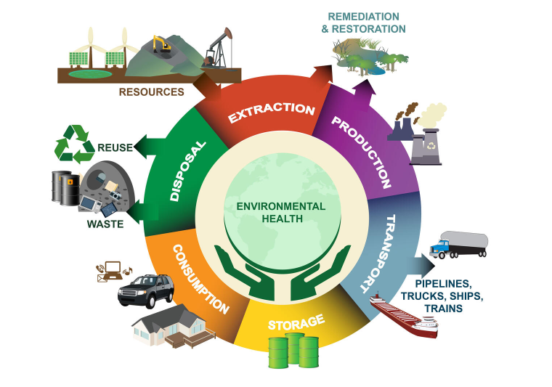

Explanation of the image:
The image illustrates the lifecycle of resources, starting from planning resource needs, through procurement, storage, and utilization, to disposal.

Procurement
Introduction to Procurement:
Procurement is one of the most essential functions in any company or organization, aiming to provide necessary goods and services to achieve organizational goals at the lowest possible cost and highest quality. The procurement process includes all stages of procurement, from identifying procurement needs to supplier search and evaluation, negotiation, contract preparation, and monitoring implementation.

Concept of Procurement:
Procurement involves the process of acquiring goods and services necessary to achieve organizational goals. This process encompasses identifying procurement needs, supplier search and evaluation, negotiation, contract preparation, and monitoring implementation.

Objectives of Procurement:
The objectives of procurement are:

Providing goods and services necessary to achieve organizational goals at high quality and reasonable prices.
Cost reduction through procuring goods and services at the lowest possible cost.
Improving the quality of products and services through procuring high-quality goods and services.
Ensuring business continuity by continuously providing necessary goods and services.
Strengthening relationships with suppliers by dealing with reliable suppliers who provide high-quality services.
Importance of Procurement:
Procurement is crucial for any company or organization for several reasons:

It contributes to achieving organizational goals by providing necessary goods and services.
It helps in cost reduction by procuring goods and services at the lowest possible cost.
It improves the quality of products and services through procuring high-quality goods and services.
It ensures business continuity by continuously providing necessary goods and services.
It helps in enhancing relationships with suppliers by dealing with reliable suppliers who provide high-quality services.
Functions of Procurement:
Procurement functions include a range of tasks and activities performed by the procurement department in the organization. These functions include:

Identifying procurement needs: Involves identifying the goods and services needed by the organization to achieve its goals.
Supplier search: Involves identifying suppliers who can provide the goods and services needed by the organization.
Supplier evaluation: Involves evaluating suppliers' ability to meet the organization's needs.
Negotiation with suppliers: Involves obtaining the best possible price for goods and services needed by the organization.
Preparation of procurement contracts: Involves documenting all agreement terms between the organization and the supplier.
Monitoring the execution of procurement contracts: Involves ensuring that the supplier fulfills all obligations under the contract.
Evaluation of supplier performance: Involves evaluating the effectiveness of the supplier in meeting the organization's needs.
Types of Procurement:
Procurement is divided into two main types:

Direct procurement: Includes goods and services directly involved in production or service delivery.
Indirect procurement: Includes administrative goods and services not directly involved in production or service delivery.
What are the Objectives of Procurement Management?
The main objectives of procurement management can be summarized as follows:

Cost reduction: Achieved through obtaining good sale offers, merging quality and fair prices. The significant increase in the total costs of procuring materials sometimes leads to non-profitable margins achieved from the manufacturing process and does not cover production costs. Therefore, these departments must resort to specific methods and strategies to reduce the cost of production to the lowest acceptable ratio without affecting the quality of the product or service itself.

Managing relationships with suppliers: Dealing with suppliers is not easy, especially in a competitive market where each merchant seeks to monopolize the market. Therefore, some competitors resort to using strategies to attract suppliers to them and make them provide raw materials in a limited way over their market competitors. Therefore, supplier relationship management is considered one of the important strategies in the business world, as it helps in maintaining suppliers and not attracting them by competitors, providing a kind of fruitful cooperation for both parties.

Diversification of offers: As part of the objectives of procurement management, importance is given to providing diverse alternatives for the price offers provided by suppliers. The company does not depend entirely on one or two suppliers but provides multiple and rich options of different offers. This enables it to choose the best in line with its budget and strategic plans in the market. The importance of diversifying offers lies in renewing the company and creating a strong network of relationships or adding a new touch to the product or service provided. All of these are useful for developing work and meeting consumer needs, which will not happen if the company is limited to one idea and one supplier all the time and unable to keep up with changes.

Meeting work requirements: Completing work requirements is one of the most important objectives of procurement management. This management works to provide any requirement that different departments may need, either before some time or suddenly in the event of a crisis or future planning prospect. It has full responsibility for studying market needs and meeting them and anticipating possible changes in the future, in addition to achieving a suitable price that matches the company's budget while not conflicting with the required quality level and the specified time for delivery.

Finding innovative solutions: In addition to the above objectives, professional procurement management is responsible for identifying the most important products for the parent company and securing them specifically, providing a reserve of them in inventory to avoid expected shortages in the market.

Guarantee of Quality: It is the duty of procurement management to ensure the quality of its products, by determining the type of raw materials desired for use and the level of performance it is supposed to provide, as well as the indicators that can be used to evaluate the quality of the high performance and the extent to which it achieves the required level. Procurement management must cooperate with its suppliers in a way that contributes to the development of the necessary technical improvements, which leads to the improvement of supplier efficiency and the increase of their productivity, and also helps in improving the quality of products and the satisfaction of the target customers.

Inventory Control: In addition to what has been mentioned earlier, procurement management must ensure the special importance of inventory management. There is a continuous relationship between these two departments, where each of them depends on the other. Through their cooperation, procurement management acquires comprehensive knowledge of the items in inventory and whether they are sufficient to meet the requirements for a certain period or not. Is there a need to issue new purchase orders? Is there enough in stock to implement the strategic plans agreed upon by senior management? Or are there missing items in stock that must be provided as soon as possible? In addition, procurement management must also define the categories in which inventory is classified and how to deal with each category individually. It must also review all returned, rejected, and unacceptable products and determine the reasons for this. What action should be taken in such a case?

What are the Tasks of Procurement Management?

Supplier Management: The primary task of procurement management is to manage relationships with suppliers, where suppliers are selected, preferred, and evaluated according to the company's budget and current and future needs.

Achieving Integration with Other Departments: Procurement management must ensure integration with other departments to meet all their needs. It is responsible for comprehensive market needs study, meeting them, anticipating possible future changes, and achieving a suitable price that matches the company's budget while not conflicting with the required quality level and the specified time for delivery

Examples of Tables and Illustrative Images
Table 2: Procurement Functions
Function | | Description
Identifying procurement needs | Determining the goods and services that the organization needs to achieve its objectives.
Searching for suppliers | Identifying suppliers who can provide the goods and services needed by the organization.
Supplier evaluation | Assessing suppliers' capability to meet the organization's needs
Negotiating with suppliers | Obtaining the best possible price for the goods and services needed by the organization.
Preparing purchase contracts | Documenting all terms of agreement between the organization and the supplier.
Monitoring contract execution | Ensuring that the supplier fulfills all obligations under the contract
Supplier performance evaluation | Assessing the effectiveness of the supplier in meeting the organization's needs.

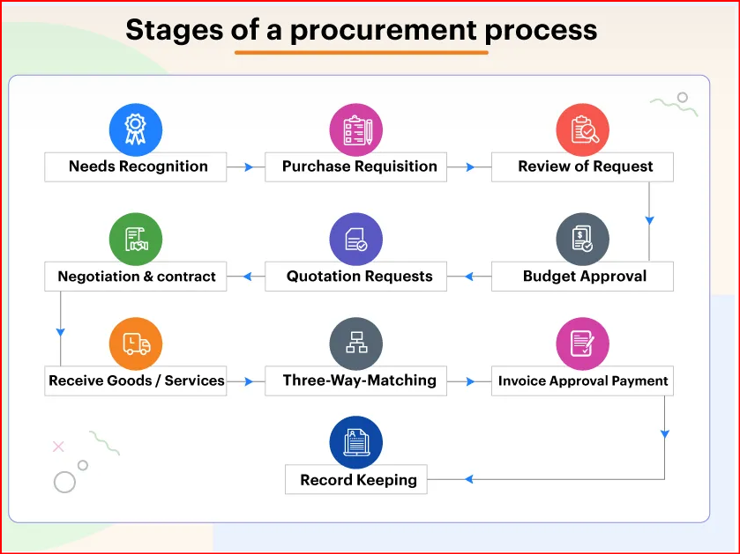
Figure 2: Procurement Process.

Explanation of the Image:
The image illustrates the stages of the procurement process, starting from identifying procurement needs, proceeding to searching for and evaluating suppliers, and culminating in negotiating with them, preparing purchase contracts, and monitoring their execution.

Introduction to Centralized Procurement

Centralized procurement is a method of managing the procurement process within an organization by concentrating it in a single central department or unit. The aim of centralized procurement is to achieve cost savings and improve the quality of purchases through standardizing the procurement process and negotiating with suppliers collectively.

Concept of Centralized Procurement:
Centralized procurement is the concentration of the procurement process within an organization in a single central department or unit. This includes all stages of the procurement process, starting from identifying procurement needs, through searching for and evaluating suppliers, to negotiating with them, preparing purchase contracts, and monitoring their execution.

Objectives of Centralized Procurement:
Centralized procurement aims to achieve several objectives, including:

Obtaining better prices: by negotiating with suppliers collectively.
Improving the quality of purchases: through standardizing quality standards and selecting reputable suppliers.
Reducing inventory: by improving procurement planning and consolidating orders.
Enhancing procurement process efficiency: by standardizing processes, procedures, and reducing management costs.
Ensuring compliance with regulations: by applying strict procurement standards and inventory control.
Importance of Centralized Procurement:
Centralized procurement is one of the most important methods for managing the procurement process in organizations, for the following reasons:

It helps in cost reduction: by obtaining better prices and improving the efficiency of procurement processes.
It improves the quality of purchases: by standardizing quality standards and selecting reputable suppliers.
It ensures compliance with regulations: by applying strict procurement standards and inventory control.
It contributes to improving resource utilization efficiency: by reducing waste and misuse of resources.
It enhances the organization's negotiating power: through collective bargaining with suppliers.
Types of Centralized Procurement:
Centralized procurement is divided into two main types:

Direct centralized Procurement involves goods and services directly used in production or service delivery. This includes raw materials, components, spare parts, equipment, and machinery.
Indirect centralized procurement involves goods and services that do not directly enter into the production process or service delivery. This includes administrative supplies, computer equipment, logistics services, and maintenance and repair services.
Benefits of Centralized Procurement:
Centralized procurement offers numerous benefits to organizations, including:

Obtaining better prices: through collective bargaining with suppliers, the organization can secure better prices for needed goods and services.
Improving the quality of purchases: by standardizing quality standards and selecting reputable suppliers, the organization can ensure high-quality goods and services.
Reducing inventory: by improving procurement planning and consolidating orders, the organization can lower its inventory levels, thereby reducing storage costs.
Enhancing procurement process efficiency: by standardizing processes, procedures, and reducing administrative costs, the organization can significantly improve the efficiency of its procurement operations.
Ensuring compliance with regulations: by applying strict procurement standards and inventory control measures, the organization can ensure compliance with laws and regulations governing the procurement process.
Challenges of Centralized Procurement:
Despite its numerous benefits, centralized procurement faces several challenges, including:

Difficulty in coordination between different departments: the organization may struggle to coordinate the procurement process across different departments, especially if these departments operate with a high degree of autonomy.
Slower procurement process: centralized procurement may lead to delays in the procurement process due to the need to follow additional procedures and steps to ensure sound procurement decisions.
Lack of flexibility: centralized procurement may reduce the organization's flexibility in dealing with suppliers, as it binds the organization to deal with only one supplier for each item or service.

Examples of tables and illustrative images
Table 3: Types of Centralized procurement
Type of Purchase | Explanation
Direct Centralized Purchases | Purchases related to goods and services that directly enter into the production process or service delivery.
Indirect Centralized Purchases | Purchases related to goods and services that do not directly enter into the production process or service delivery.
Figure 3: Structure of Centralized Purchasing
• Explanation of the Image:
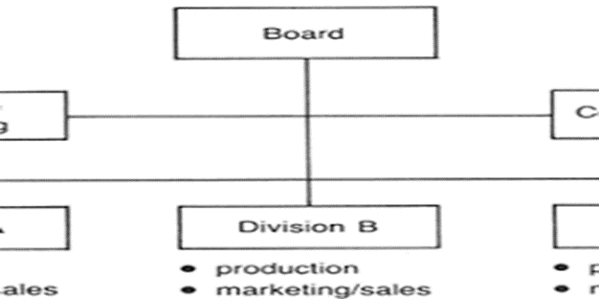

The image illustrates the structure of centralized procurement, where the purchasing process is centralized within a single central department or unit.

Introduction to Centralized Indirect Procurement:

Centralized indirect procurement is a type of centralized procurement focusing on purchasing goods and services that do not directly enter the production process or service delivery. It includes administrative goods and services such as office supplies, computers, logistics services, and maintenance and repair services.

• Definition of Centralized Indirect Procurement:
• Concept of Centralized Indirect Procurement:
Centralized indirect procurement is the process of concentrating the purchasing of goods and services that do not directly enter the production process or service delivery within a single central department or unit. The goal of centralized indirect procurement is to achieve the same benefits as centralized procurement in general, but with a focus on specific types of goods and services.

• Types of Centralized Indirect Procurement:
Centralized indirect procurement includes a wide range of goods and services, including:

Office supplies: such as paper, ink pens, drawing tools, and files.
Computers: such as desktops, laptops, software, and printers.
Logistics services: including transportation, storage, and distribution.
Maintenance and repair services: such as equipment and building maintenance.
Other administrative services: like cleaning, security, and insurance services.
• Benefits of Centralized Indirect Procurement:
Centralized indirect procurement offers several benefits to organizations, including:

Cost savings: by negotiating collectively with suppliers, organizations can obtain better prices for the indirect goods and services they need.
Improved quality: by standardizing quality criteria and selecting reputable suppliers, organizations can ensure high-quality indirect goods and services.
Inventory reduction: by improving procurement planning and consolidating orders, organizations can reduce inventory levels of indirect goods and services, thereby reducing storage costs.
Enhanced procurement efficiency: by standardizing processes and procedures and reducing administrative costs, organizations can significantly improve the efficiency of indirect procurement operations.
Compliance assurance: by applying strict procurement standards and inventory control, organizations can ensure compliance with laws and regulations governing the procurement of indirect goods and services.
• Challenges of Centralized Indirect Procurement:
Despite its numerous benefits, centralized indirect procurement faces several challenges, including:

Difficulty in identifying procurement needs: organizations may struggle to accurately determine their indirect goods and services needs, as these needs can vary between departments.
Supplier evaluation challenges: organizations may find it challenging to evaluate suppliers for indirect goods and services, due to the diversity and complexity of these goods and services.
Lack of flexibility: centralized indirect procurement may reduce an organization's flexibility in dealing with suppliers, as it typically requires dealing with a single supplier for each type of indirect goods or service.
• table 4: Types of Indirect Centralized Procurements
Type of Purchase | Explanation
Computers devices | Computers, laptops, software, printers.
Logistic services | Transportation, storage, distribution.
Maintenance and repair services | Equipment maintenance, building maintenance.
Other administrative services | Cleaning services, security services, insurance services.

Figure 4: Centralized Indirect Procurement Process
Description of the Image:

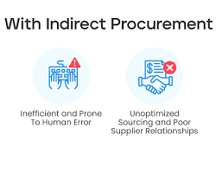

The image illustrates the process of centralized indirect procurement, starting from identifying purchasing needs, progressing through supplier research and evaluation, negotiating with suppliers, preparing purchase contracts, and monitoring their execution

Case Study: Alsulaiman Group in Jeddah

Introduction:
In this case study, we will examine Alsulaiman Group in Jeddah, one of the leading conglomerates in Saudi Arabia. The focus will be on their strategy of centralized indirect procurement and its impact on resource management efficiency and cost savings. Additionally, we will discuss the challenges faced by the group in implementing this strategy and the lessons learned from their experience.

Overview of Alsulaiman Group in Jeddah:
Alsulaiman Group in Jeddah is a prominent Saudi company specializing in diverse sectors including retail, logistics, technology, and real estate. The group operates ten companies across four markets, employing over 5,000 professionals. With a legacy spanning more than 40 years, the group manages well-known brands such as IKEA in Saudi Arabia and Bahrain, and Circle K. It offers logistics services through companies like Flow and Salasa, while its technology sector includes leaders such as Cartlow, Qanvast, and Livspace. Additionally, real estate development is handled by companies like Sarh Holding, Ihtiraf, and Akid. The group is committed to innovation, sustainability, and enhancing quality of life in the communities it serves.

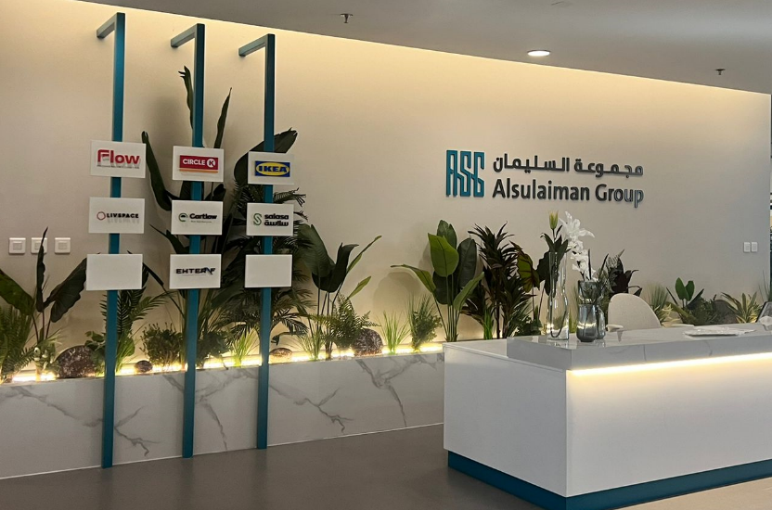
Figure 5
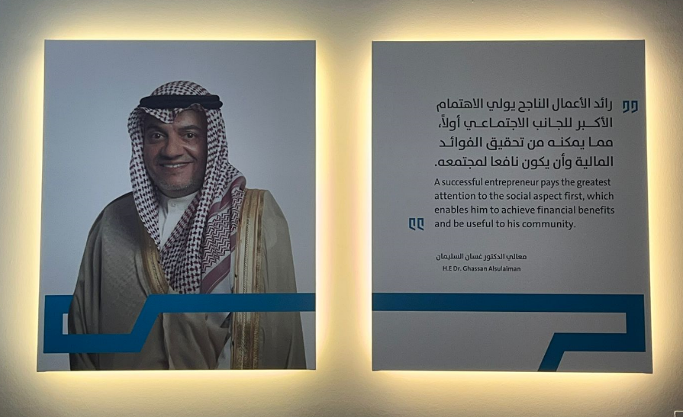
Figure 6
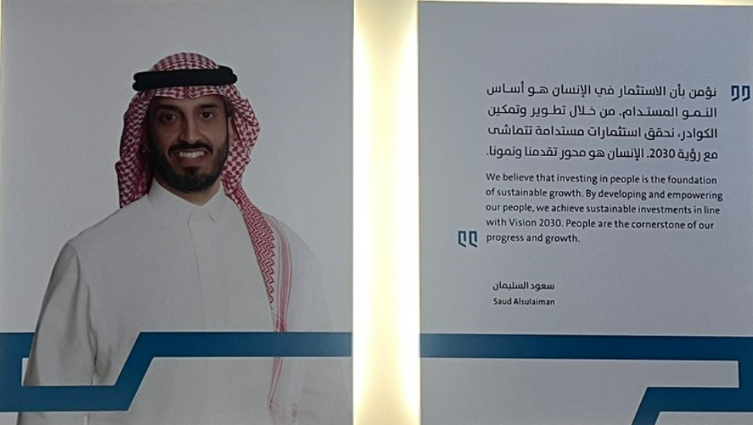
Figure 7

Centralized Indirect Procurement Strategy at Alsulaiman Group in Jeddah:
Alsulaiman Group in Jeddah employs a centralized strategy for purchasing indirect goods and services aimed at achieving cost savings and improving procurement quality. The key components of this strategy include:

Establishment of a Central Purchasing Department: This department oversees all indirect procurement activities, from identifying purchasing needs to supplier research, evaluation, negotiation, contract preparation, and monitoring.
Standardization of Quality Standards: The group has implemented unified quality standards for indirect goods and services to ensure high-quality products and services.
Collective Supplier Negotiations: The group negotiates with suppliers collectively to secure the best prices for indirect goods and services.
Inventory Management Improvement: Efforts are focused on enhancing inventory management of indirect goods and services to reduce storage costs.
Impact of Centralized Indirect Procurement Strategy on Resource Management Efficiency at Alsulaiman Group in Jeddah:
The centralized procurement strategy has improved resource management efficiency at Alsulaiman Group in Jeddah by:

Reducing Purchasing Costs: Significant reductions in indirect purchasing costs were achieved through collective negotiations with suppliers and improved inventory management.
Enhancing Procurement Quality: Standardizing quality standards has ensured the procurement of high-quality indirect goods and services, thereby enhancing operational performance.
Improving Purchasing Process Efficiency: Concentrating purchasing activities within a single central department streamlined processes and procedures, contributing to overall purchasing process efficiency.
Impact of Centralized Indirect Procurement Strategy on Cost Savings at Alsulaiman Group in Jeddah:
The centralized procurement strategy has led to substantial cost savings at Alsulaiman Group in Jeddah by:

Lowering Indirect Purchasing Costs: As previously mentioned, the group successfully reduced costs associated with purchasing indirect goods and services through collective supplier negotiations and improved inventory management.
Improving Resource Utilization: Enhanced procurement quality has minimized the need for replacing defective or inadequate goods, thus optimizing resource utilization.
Reducing Operational Costs: Improved efficiency in purchasing operations has resulted in reduced overall operational costs.
Challenges Faced by Alsulaiman Group in Jeddah in Implementing Centralized Indirect Procurement Strategy:
Alsulaiman Group in Jeddah encountered several challenges in implementing the centralized indirect procurement strategy, including:

Resistance to Change from Some Departments: Certain departments within the group initially resisted relinquishing their autonomy in purchasing processes before the centralized strategy was fully adopted.
Difficulty in Identifying Purchasing Needs: The group faced challenges in accurately identifying purchasing needs for indirect goods and services, given variations across departments.
Supplier Evaluation Complexity: Evaluating suppliers for indirect goods and services proved challenging due to the diverse and complex nature of these products and services.
Lack of Experience in Centralized Procurement: The group experienced a shortage of expertise in centralized procurement, particularly in indirect goods and services procurement.
Lessons Learned from Alsulaiman Group in Jeddah's Experience with Centralized Indirect Procurement Strategy:
Alsulaiman Group in Jeddah gleaned valuable lessons from its experience with centralized indirect procurement strategy, including:

Importance of Thorough Planning: Effective planning is crucial for the successful implementation of centralized indirect procurement strategy to ensure its sustainability and success.
Significance of Effective Communication: Maintaining effective communication with all departments involved in procurement is essential to ensure their commitment to the centralized strategy.
Investment in Capacity Building: Investing in the capacity building of procurement department staff, especially in indirect goods and services procurement, is vital for strategy implementation.
Continuous Review: Regularly reviewing and evaluating the centralized procurement strategy is important to ensure its continued effectiveness.
Conclusion:
The case study of Alsulaiman Group in Jeddah serves as an exemplary demonstration of how a centralized indirect procurement strategy can achieve cost savings and enhance resource management efficiency. This study illustrates that such strategies can be effective across various types of companies, whether large or small. Centralized procurement began in 2016 and was initially applied only to IKEA Saudi Arabia. By 2019, it had expanded to IKEA and Flow, while in 2020, it was fully implemented across the entire Al-Suleiman Group.
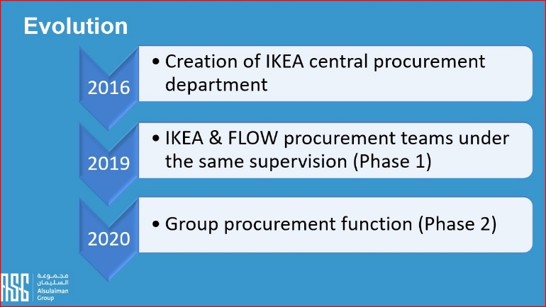
Figure 8
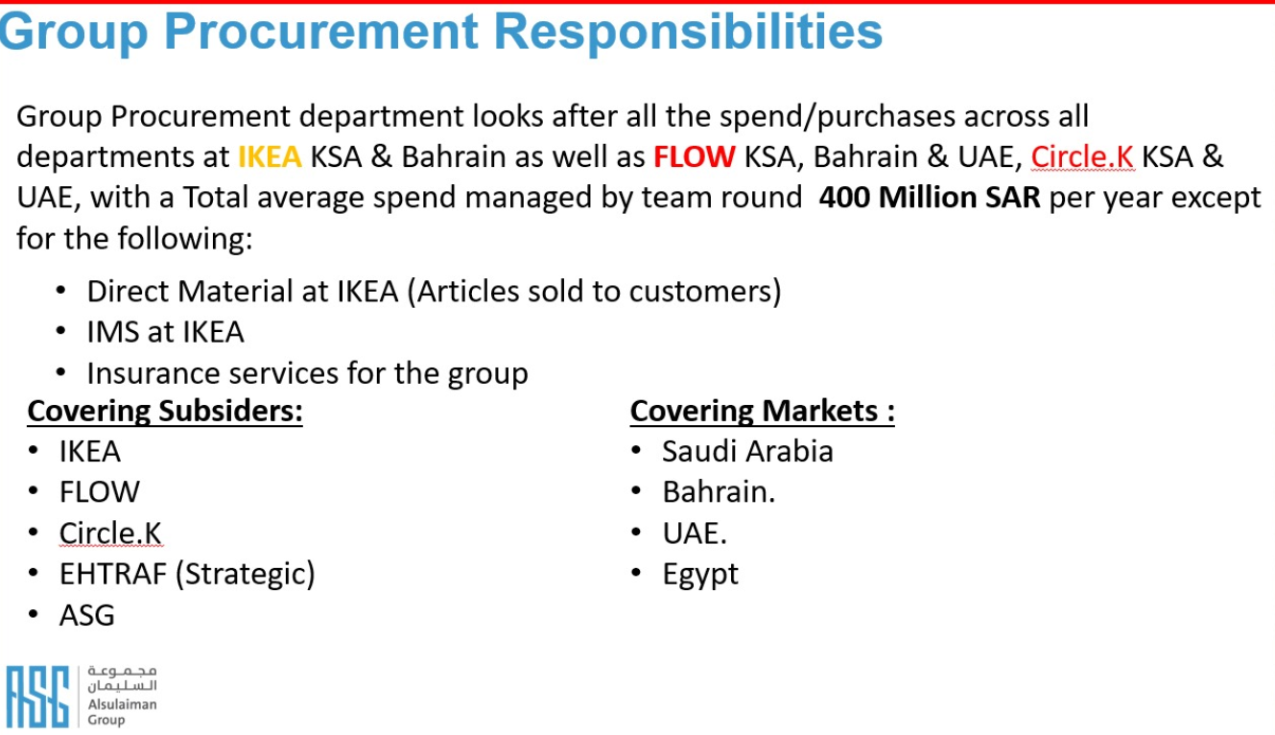
Figure 9
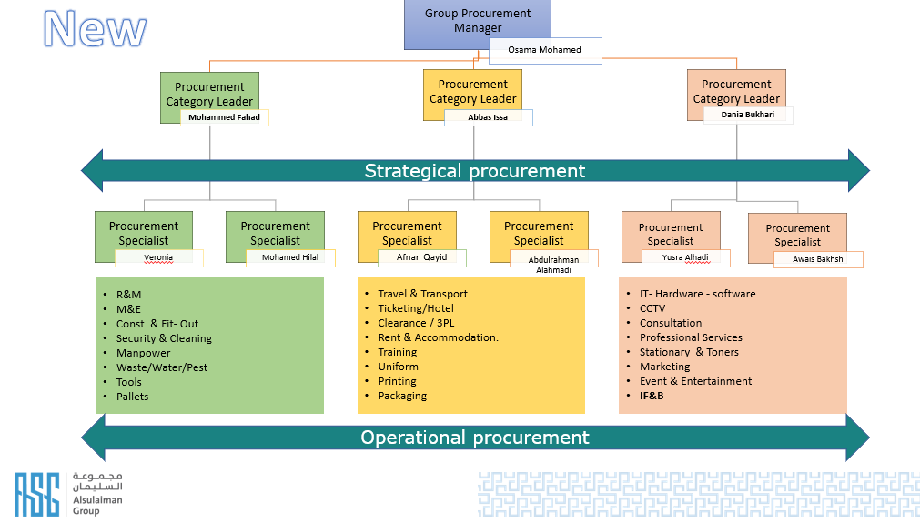
Figure 10


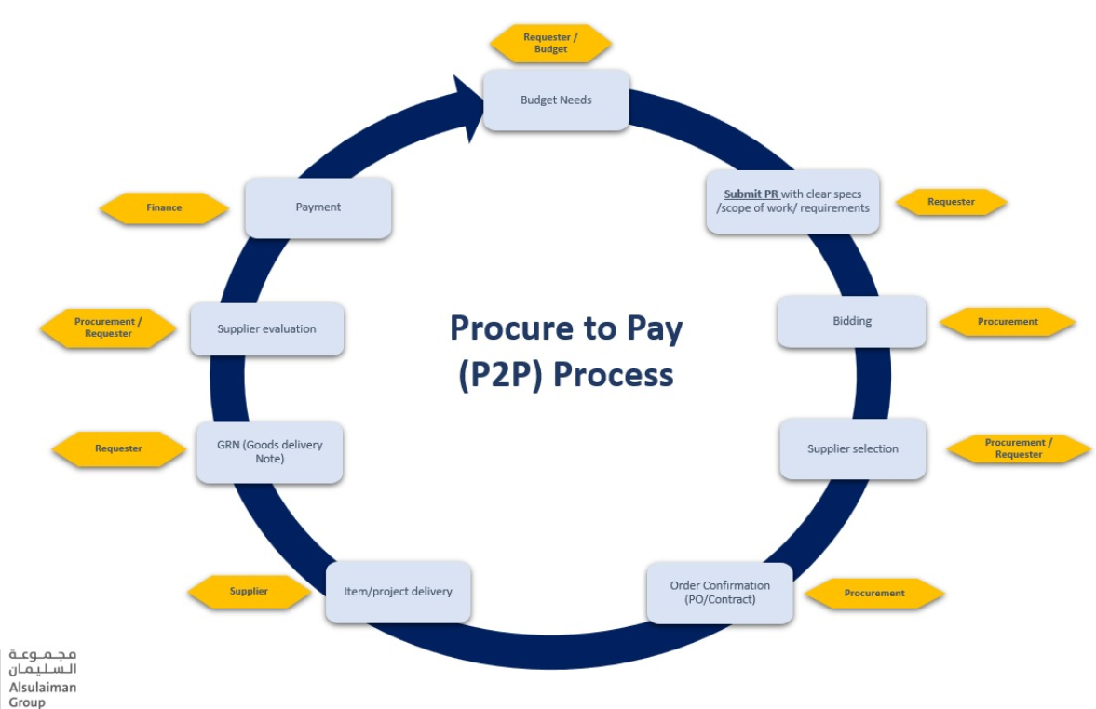
Figure 11

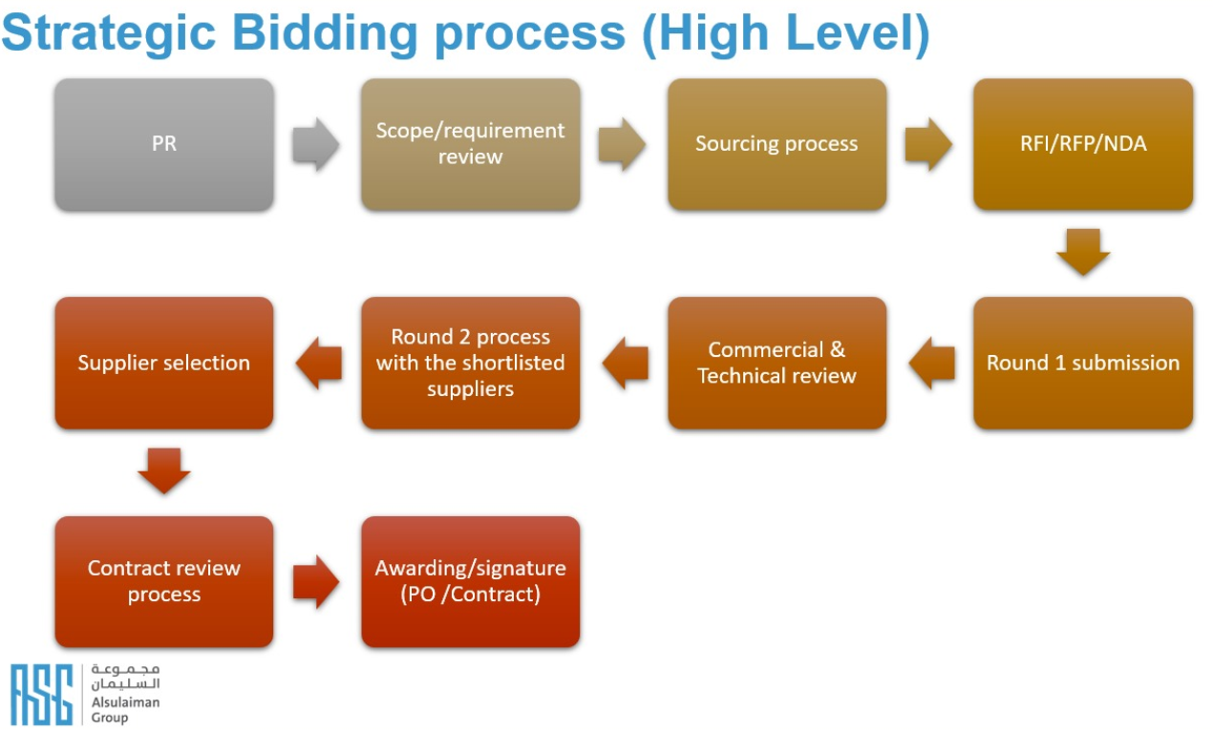
Figure 12

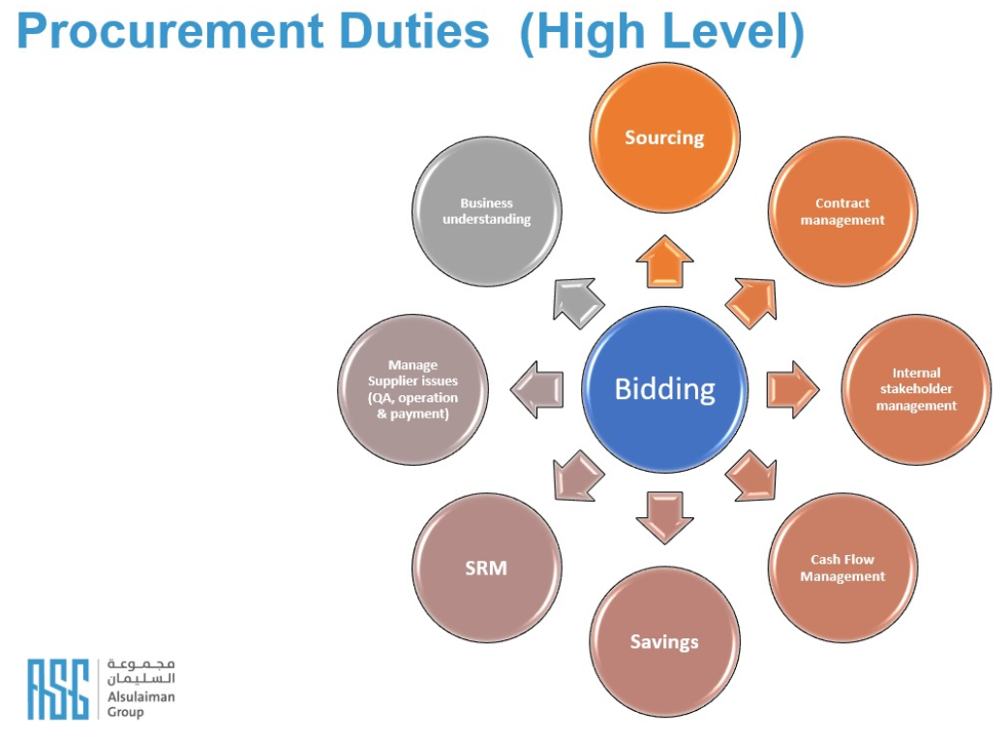
Figure 13

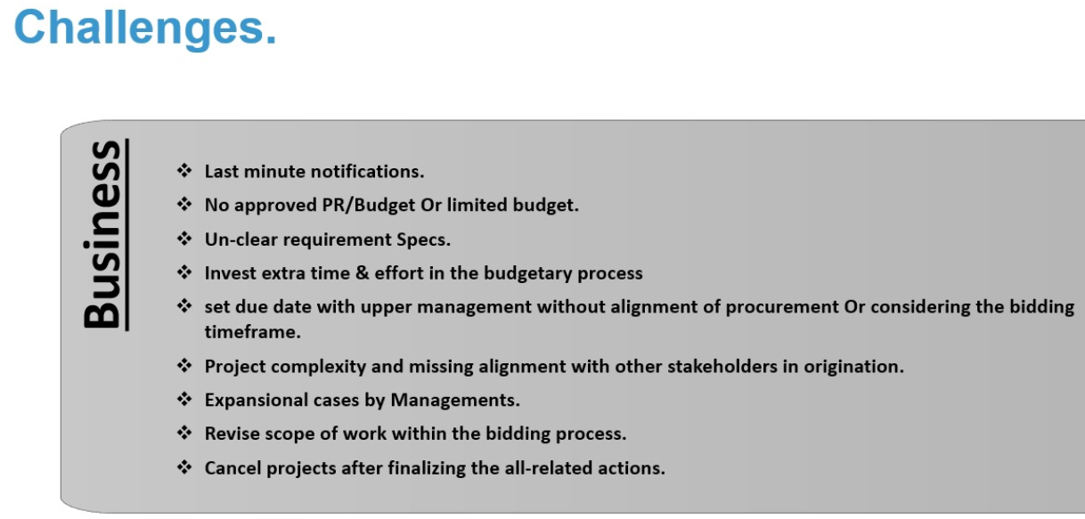
Figure 14

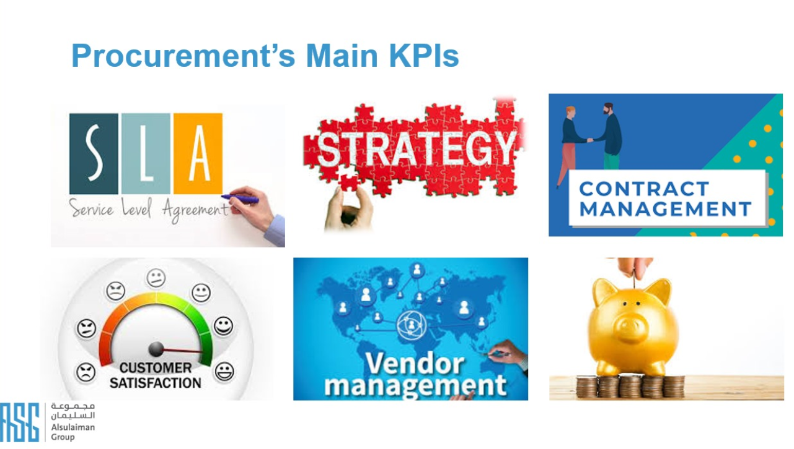
Figure 15

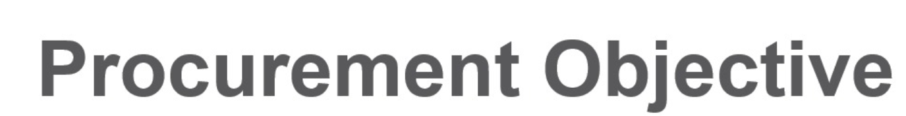
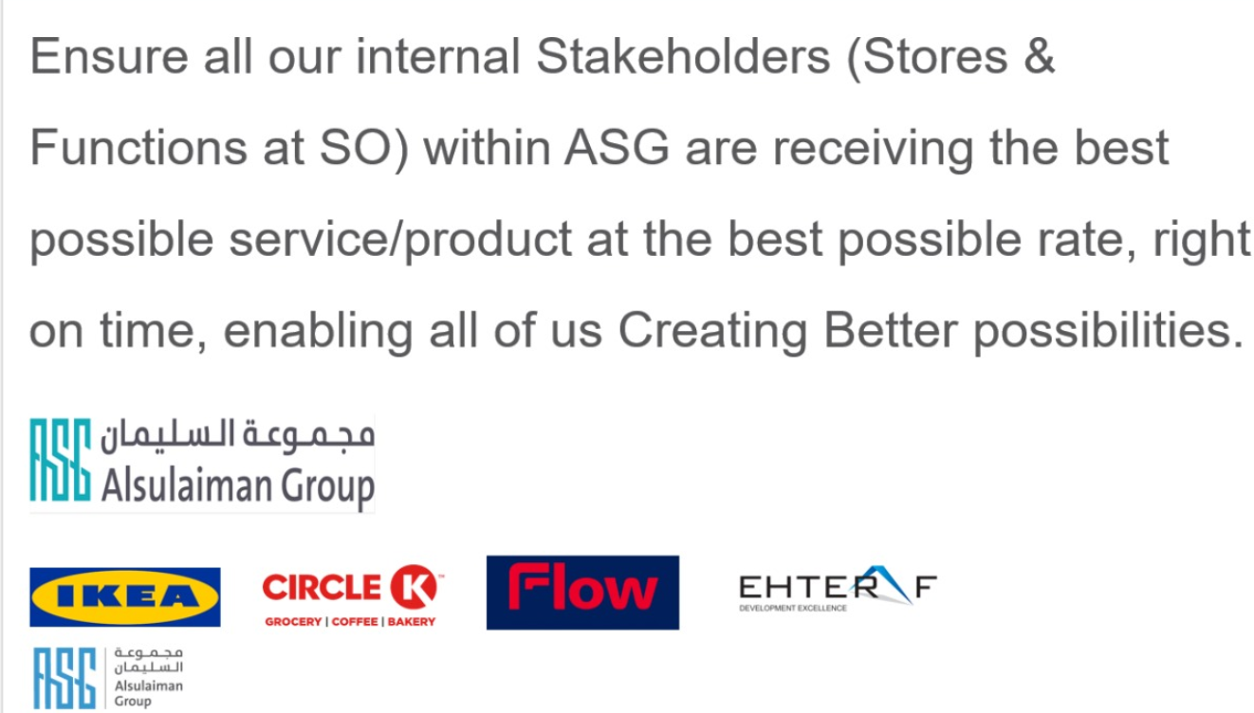
Figure 16
Chapter Three
Methodology of the Study

Introduction
Research Methodology: Analysis of the Impact of Indirect Centralized Purchasing Strategy on Resource Management Efficiency and Cost Savings: A Case Study in Al-Sulaiman Group, Jeddah.

This study aims to analyze the impact of the indirect centralized purchasing strategy on resource management efficiency and cost savings in Al-Sulaiman Group, Jeddah. A questionnaire will be used as the primary tool to collect data from a sample of the group's employees.

Research Objectives:

Main Objective: Analyze the impact of the indirect centralized purchasing strategy on resource management efficiency and cost savings in Al-Sulaiman Group, Jeddah.
Sub-Objectives:
Identify the components of the indirect centralized purchasing strategy followed in Al-Sulaiman Group, Jeddah.
Evaluate the impact of the indirect centralized purchasing strategy on resource management efficiency in Al-Sulaiman Group, Jeddah.
Evaluate the impact of the indirect centralized purchasing strategy on cost savings in Al-Sulaiman Group, Jeddah.
Identify the challenges faced by Al-Sulaiman Group, Jeddah in implementing the indirect centralized purchasing strategy.
Extract lessons learned from Al-Sulaiman Group, Jeddah's experience in implementing the indirect centralized purchasing strategy.
Research Type:

Research Type by Purpose: Applied Research.
Research Type by Methodology: Descriptive-Analytical Research.
Research Tool:

Questionnaire:
A questionnaire will be designed to collect data from a sample of Al-Sulaiman Group, Jeddah employees. The questionnaire will include closed and open-ended questions to measure employees' opinions on the impact of the indirect centralized purchasing strategy on resource management efficiency and cost savings.
Research Community and Sample:

Research Community: All employees of Al-Sulaiman Group, Jeddah.
Research Sample: A random sample of employees from the group's main administration in Jeddah, Al Rawdah district, comprising approximately 250 employees.
Data Collection Steps:

Designing a questionnaire including questions about the indirect centralized purchasing strategy, resource management efficiency, cost savings, challenges faced by the group, and lessons learned.
Reviewing the questionnaire by experts in procurement management and resource management.
Translating the questionnaire into English and Arabic.
Sending out the questionnaires electronically to the research sample.
Collecting completed questionnaires.
Data Analysis:
Quantitative data analysis using appropriate statistical methods.
Qualitative data analysis using thematic content analysis.
Connecting the results and drawing conclusions.
Writing the Final Report:

Writing an introduction that outlines the research objectives and methodology.
Presenting and analyzing the research results.
Discussing the research findings in light of previous studies.
Extracting conclusions and recommendations.
Writing the conclusion.
Timeline:

Day 1: Designing, reviewing, and translating the questionnaire.
Day 3: Distributing and collecting the questionnaires.
Day 5: Data analysis and writing the final report.
Budget:

Cellular data costs used for questionnaire distribution.
Human Resources:

Data analysis experts.
Constraints:

The research sample represents all employees of Al-Sulaiman Group, Jeddah.
Responses to questionnaire questions may not be accurate or truthful.
Ethics:

Ensuring confidentiality of participant data.
Using participant data for research purposes only.
Research Community, Sample Characteristics, and Sample Size Determinants in a Study Analyzing the Impact of Indirect Centralized Purchasing Strategy on Resource Management Efficiency and Cost Savings: A Case Study in Al-Sulaiman Group, Jeddah.

Research Community:

Definition of the Research Community: All employees of Al-Sulaiman Group, Jeddah.
Characteristics of the Research Community:

The research community consists of employees from various departments and sections within the group.
Employees in the group hold positions ranging from administrative staff to managers.
Employees in the group have diverse experience in procurement and resource management.
Sample Characteristics:

Sample Size: 250 employees.
Sampling Method: Simple random sample.
Sample Characteristics:

The sample represents all departments and sections of Al-Sulaiman Group, Jeddah.
The sample includes employees from various job positions.
The sample has diverse experience in procurement and resource management.
Sample Size Determinants:

Accuracy of results: Increasing sample size improves result accuracy.
Cost: Increasing sample size increases costs.
Time: Increasing sample size increases time required for data collection and analysis.
Available resources: Available resources must be considered when choosing an appropriate sample size.
Research Constraints:

Temporal boundaries: The study covers the period from 2024 and focuses on data collected during this period.
The study does not include any data before 2024.
Spatial boundaries: The study is limited to Al-Sulaiman Group, Jeddah, Saudi Arabia.
The study does not include any companies or institutions.
The study does not include any data from outside Saudi Arabia.
Thematic Boundaries:

The study focuses on analyzing the impact of indirect centralized purchasing strategy on resource management efficiency and cost savings.
The study does not include any other unrelated topics.
The study does not include any personal analysis or interpretations by the researcher.

Research Tool: Questionnaire Analyzing the Impact of Indirect Centralized Purchasing Strategy on Resource Management Efficiency and Cost Savings: A Case Study in Al-Sulaiman Group, Jeddah.

Introduction:
This questionnaire aims to gather information about the impact of indirect centralized purchasing strategy on resource management efficiency and cost savings in Al-Sulaiman Group, Jeddah. The information collected through this questionnaire will be used to analyze the strategy's impact on the group.

Notes:

Please read each question carefully before answering.
Please answer all questions honestly and accurately.
All information collected through this questionnaire will be kept confidential.
Part One: Personal Information

What is your department in Al-Sulaiman Group, Jeddah?
Purchasing Department
Production Department
Marketing Department
Human Resources Department
What is your position in Al-Sulaiman Group, Jeddah?
Administrative Staff
Supervisor
Manager
Other Position (please specify)
How long have you been working in Al-Sulaiman Group, Jeddah?
Less than a year
From one to three years
From three to five years
More than five years
Part Two: Indirect Centralized Purchasing Strategy

Are you familiar with the indirect centralized purchasing strategy used in Al-Sulaiman Group, Jeddah?
Yes
No
What are the components of the indirect centralized purchasing strategy used in Al-Sulaiman Group, Jeddah? (Select all that apply)
Centralized procurement of indirect goods and services
Standardization of quality standards for indirect goods and services
Collective negotiation with suppliers
Improvement of indirect goods and services inventory management
Other components (please specify)
What is your opinion on the effectiveness of the indirect centralized purchasing strategy used in Al-Sulaiman Group, Jeddah?
I believe it is a highly effective strategy
I believe it is somewhat effective
I believe it is not effective
I don't know
What are the positive effects of the indirect centralized purchasing strategy on resource management efficiency in Al-Sulaiman Group, Jeddah? (Select all that apply)
Reduction in procurement costs
Improvement in quality of indirect goods and services
Improvement in procurement process efficiency
Improvement in resource utilization
Other positive effects (please specify)
What are the negative effects of the indirect centralized purchasing strategy on resource management efficiency in Al-Sulaiman Group, Jeddah? (Select all that apply)
Resistance to change by some departments
Difficulty in identifying purchasing needs
Difficulty in evaluating suppliers
Lack of experience in centralized purchasing
Other negative effects (please specify)
Part Three: Cost Savings

Do you think the indirect centralized purchasing strategy has contributed to cost savings in Al-Sulaiman Group, Jeddah?
Yes
No
I don't know
What are the main ways in which the indirect centralized purchasing strategy contributed to cost savings in Al-Sulaiman Group, Jeddah? (Select all that apply)
Reduction in procurement costs
Improvement in quality of indirect goods and services
Improvement in resource utilization
Other ways to save costs (please specify)



