

An Efficient Hybrid Framework Combining Transformer Feature Encoding and Machine Learning for Diabetic Retinopathy Classification
Prepared By
Name: Asraa Alwattar ID No.: 253001066
Name: Rahaf Barakat ID No.: 253002370

Submitted in fulfilment of the requirements for the degree Master of Science in Artificial Intelligence
At
College of Informatics
Midocean University
UAE
Supervisor Name: Wessam Ahmad
College of Informatics, Midocean University, Comoros
Email:…………………….

Acknowledgements

Special thanks to Dr. .

Abstract
Diabetic retinopathy is a major cause of preventable visual impairment, and accurate severity grading from retinal fundus images remains challenging because of substantial variations in image quality, class imbalance, and the subtle visual differences between neighboring disease stages. This thesis proposes an efficient hybrid deep-learning and machine-learning framework for automated five-class diabetic retinopathy grading using retinal fundus images. The proposed framework combines complementary visual representations learned from ConvNeXt-Tiny and Swin-V2-Tiny, integrating convolutional modeling of local retinal structures with transformer-based contextual representation of broader spatial relationships. Experiments were conducted on the APTOS 2019 Blindness Detection dataset, comprising 3,662 retinal fundus images categorized into No Diabetic Retinopathy, Mild, Moderate, Severe, and Proliferative Diabetic Retinopathy. A regularized Random Forest classifier was subsequently employed for five-class prediction. The proposed framework achieved 84.91% accuracy, 73.93% macro precision, 68.99% macro recall, and 70.98% macro F1-score, with a 96.11% macro specificity and 94.80% macro-ROC-AUC. The results demonstrate that feature-level fusion of convolutional and transformer representations provides a broader discriminative representation for diabetic retinopathy grading. The findings demonstrate the potential of combining complementary deep visual representations with a regularized machine-learning classifier while highlighting the importance of class-sensitive evaluation, external validation, and improved handling of minority severity classes.

Keywords: Diabetic Retinopathy; Deep Learning; ConvNeXt-Tiny; Swin-V2-Tiny; Random Forest; Multiclass Classification; Medical Image Analysis.

List of Publications
Alwattar, A., & Barakat, R. A Comprehensive Review of Artificial Intelligence Approaches for Diabetic Retinopathy Classification. Manuscript in preparation, College of Informatics, Midocean University.

Table of Contents
Acknowledgements 2
Abstract 3
List of Publications 4
Table of Contents 5
List of Abbreviations 7
List of Figures 8
List of Tables 9
Chapter 1 Introduction 10
1.1 Thesis Overview 10
1.2 Problem Definition 11
1.3 Thesis Objectives 11
1.4 Thesis Contribution 12
1.5 Thesis Organization 13
Chapter 2: Background and Related Work 14
2.1 Introduction 14
2.2 Background 14
2.2.1 Diabetic Retinopathy Overview 14
2.2.2 Artificial Intelligence in Medical Image Analysis: 15
2.2.3 Diabetic Retinopathy Detection Using Machine Learning 16
2.2.4 Diabetic Retinopathy Detection Using Deep Learning 19
2.2.5 Diabetic Retinopathy Detection Using Transformer Models 20
2.2.6 Deep Feature Fusion and Hybrid Classification 23
2.2.7 Performance Metrics 24
2.3 Literature Review 28
2.4 Comparative Analysis of Related Work 32
2.5 Chapter Summary 34
Chapter 3: Proposed Approach (Methodology) 35
3.1 Introduction 35
3.2 Proposed Framework 35
3.3 Dataset Description 36
3.4 Data Preprocessing 37
3.5 Dataset Splitting and Training-Only Augmentation 39
3.5.1 Stratified Dataset Partitioning 39
3.5.2 Training-Only Data Augmentation 39
3.6 Deep Feature Extraction 39
3.6.1 ConvNeXt-Tiny 40
3.6.2 Swin-V2-Tiny 40
3.7 Feature Fusion 41
3.8 Random Forest Classification 41
3.9 Chapter Summary 42
Chapter 4: Experimental Results and Discussion 43
4.1 Introduction 43
4.2 Experimental Setup 43
4.3 Results of the Final Hybrid Model 44
4.4 Discussion of Findings 47
4.4.1 Contribution of Feature Fusion and Random Forest 47
4.4.2 Interpretation in Relation to Related Work 49
4.5 Limitations 49
4.6 Chapter Summary 50
Chapter 5 Conclusion and Future Work 51
References 52

List of Abbreviations
- Diabetic Retinopathy (DR)
- Machine Learning (ML)
- Deep Learning (DL)
- Convolutional Neural Networks (CNNs)
- Support Vector Machines (SVM)
- True Positives (TP)
- True Negatives (TN)
- False Positives (FP)
- False Negatives (FN)
- Random Forest (RF)
- Vision Transformer (ViT)
- Asia Pacific Tele-Ophthalmology Society (APTOS)
- Contrast Limited Adaptive Histogram Equalization (CLAHE)
- Receiver Operating Characteristic (ROC)
- Area Under the Curve (AUC)
- Graphics Processing Unit (GPU)
- Quadratic Weighted Kappa (QWK)

List of Figures:

Figure 1: AI Techniques for Retinal Image Analysis 16
Figure 2: Support Vector Machine Classification of Retinal Features 17
Figure 3: Random Forest Classification for Diabetic Retinopathy Grading 18
Figure 4: K-Nearest Neighbors for Diabetic Retinopathy Grading 19
Figure 5: ConvNeXt-Tiny Feature Extraction for Diabetic Retinopathy Grading 20
Figure 6: Transformer-Based Retinal Image Encoding 21
Figure 7: Vision Transformer Encoding for Diabetic Retinopathy Analysis 22
Figure 8: Swin Transformer Encoding for Diabetic Retinopathy Grading 23
Figure 9: ConvNeXt-Swin Feature Fusion and Random Forest Classification 24
Figure 10: Proposed Hybrid Framework for Diabetic Retinopathy Classification 36
Figure 11: Original Class Distribution in the APTOS 2019 Dataset 37
Figure 12: Representative Retinal Images Before Preprocessing 37
Figure 13: Representative Retinal Images After Preprocessing 38
Figure 14: Confusion Matrix of the Final Hybrid Model 45
Figure 15: One-vs-Rest ROC Curves of the Final Hybrid Model 46
Figure 16: Bar Chart of the Comprehensive Performance Metrics of the Final Hybrid Framework 47
Figure 17: Bar Chart Comparison of the Proposed Framework with Selected Related Studies 48

List of Tables:

Table 1: Comparative study of diabetic retinopathy detection methods 33
Table 2: Deterministic Retinal-Image Preprocessing Parameters 38
Table 3: ConvNeXt-Tiny Final Parameters 40
Table 4: Swin-V2-Tiny Final Parameters 41
Table 5: Selected Random Forest Parameters 42
Table 6: Experimental Dataset Split 44
Table 7: Comprehensive Performance of the Final Hybrid Framework 44
Table 8: Comparison of the Proposed Framework with Selected Related Studies 47

Chapter 1 Introduction

1.1 Thesis Overview
Diabetic retinopathy (DR) is a progressive microvascular complication of diabetes and an important cause of preventable visual impairment. Prolonged hyperglycemia damages the retinal vasculature and may produce microaneurysms, hemorrhages, exudates, ischemic changes, and neovascularization as the disease progresses [1]. Clinical grading is commonly performed by specialists through visual examination of retinal fundus images; however, manual assessment is time-consuming, depends on reader expertise, and is difficult to scale for population-level screening [2]. Advances in artificial intelligence have therefore encouraged the development of automated systems capable of learning disease-related patterns directly from retinal images [3]. This thesis proposes a five-class diabetic retinopathy grading framework that combines deterministic image preprocessing, training-only data augmentation, transfer learning with ConvNeXt-Tiny and Swin-V2-Tiny, feature-level fusion, and Random Forest classification. The framework is designed to integrate complementary convolutional and transformer-based representations for classifying retinal images into no DR, mild, moderate, severe, and proliferative DR.

1.2 Problem Definition
Automated diabetic retinopathy grading remains challenging because retinal fundus images vary considerably in resolution, illumination, contrast, field of view, and acquisition conditions. The problem is further complicated by substantial class imbalance and by the subtle visual differences between adjacent severity grades, particularly among the underrepresented severe and proliferative classes. Although convolutional neural networks are effective at learning localized textures and lesion patterns, a single convolutional backbone may provide limited representation of broader spatial relationships. Conversely, transformer-based models can capture contextual dependencies across retinal regions but may require careful regularization and sufficient data. This thesis therefore investigates whether complementary deep embeddings extracted by ConvNeXt-Tiny and Swin-V2-Tiny can be fused and classified using a regularized Random Forest. The proposed methodology also incorporates dataset-integrity validation, stratified partitioning, class-weighted optimization, controlled augmentation, held-out validation, and final testing to reduce data leakage and support reproducible five-class evaluation.

1.3 Thesis Objectives
The principal objective of this thesis is to develop and evaluate an automated hybrid framework for five-class diabetic retinopathy grading from retinal fundus images. The study aims to preprocess and standardize the APTOS 2019 images; address class imbalance through stratified partitioning and class-weighted training; apply training-only data augmentation to improve generalization; fine-tune ConvNeXt-Tiny and Swin-V2-Tiny as complementary feature extractors; obtain a 768-dimensional embedding from each backbone and concatenate them into a 1,536-dimensional hybrid representation; select a regularized Random Forest classifier by comparing predefined candidate configurations on the held-out validation subset; and evaluate the final framework using accuracy, precision, recall, F1-score, specificity, confusion matrices, and one-vs-rest AUC measures. The performance of the hybrid classifier is subsequently interpreted in relation to the reviewed literature.

1.4 Thesis Contribution
This thesis contributes a reproducibility-oriented hybrid methodology for diabetic retinopathy severity grading through the following elements:
- It proposes a novel hybrid visual representation that fuses convolutional and transformer-based feature extraction by fine-tuning ConvNeXt-Tiny and Swin-V2-Tiny in parallel capturing both fine-grained local lesion patterns and global contextual spatial relationships within retinal images.
- Implements a regularized Random Forest as the final multiclass classifier and selects its configuration through held-out validation comparison without using the testing subset for model selection.
- Evaluates the proposed hybrid classifier using class-sensitive measures, including per-class and aggregate precision, recall, F1-score, and specificity; confusion-matrix analysis; and macro and weighted one-vs-rest ROC-AUC, with particular attention to imbalanced severity grades.

1.5 Thesis Organization
The rest of this dissertation will be organized as follows:
- Chapter 2 presents the medical and technical background of diabetic retinopathy grading. It reviews image preprocessing, data augmentation, machine learning, convolutional networks, vision transformers, hybrid feature representations, evaluation measures, and fourteen related studies that motivate the proposed methodology.
- Chapter 3 describes the proposed methodology in detail, including APTOS 2019 dataset validation, deterministic preprocessing, stratified splitting, training-only augmentation, ConvNeXt-Tiny and Swin-V2-Tiny fine-tuning, deep-embedding extraction, feature fusion, Random Forest model selection, and the evaluation protocol.
- Chapter 4 reports and discusses the experimental results of the proposed hybrid classifier using the defined evaluation measures and class-level analyses.
Chapter 5 concludes the thesis by summarizing the principal findings, identifying methodological and practical limitations, and outlining directions for future explainability research and clinical validation.

Chapter 2: Background and Related Work

2.1 Introduction
This chapter establishes the medical, computational, and empirical foundations of the proposed diabetic retinopathy classification framework. It first describes the disease and its five severity grades, then reviews the role of artificial intelligence in retinal-image analysis. The discussion covers image preprocessing, data augmentation, transfer learning, machine-learning classifiers, convolutional neural networks, vision transformers, deep embeddings, and feature-level fusion. The chapter also defines the performance measures required for imbalanced multiclass evaluation. Finally, fourteen related studies are critically reviewed and compared to identify the methodological gap addressed by the proposed ConvNeXt-Tiny, Swin-V2-Tiny, and Random Forest framework.

2.2 Background

2.2.1 Diabetic Retinopathy Overview
Diabetic retinopathy (DR) is a progressive microvascular complication of diabetes mellitus in which prolonged hyperglycemia damages retinal blood vessels. Clinical manifestations include microaneurysms, hemorrhages, hard exudates, cotton-wool spots, venous abnormalities, intraretinal microvascular abnormalities, and neovascularization. The disease is commonly graded from no DR through mild, moderate, and severe non-proliferative DR to proliferative DR. Accurate severity grading is clinically important because treatment urgency and the risk of irreversible visual loss increase as the disease advances. Since early stages may remain asymptomatic, regular screening and dependable interpretation of retinal fundus images are essential for timely intervention [4].

2.2.2 Artificial Intelligence in Medical Image Analysis:
Artificial intelligence has become increasingly important in medical-image analysis because computational models can learn complex visual patterns associated with disease detection, grading, and clinical decision support. In retinal analysis, a complete automated pipeline normally includes image-quality control, preprocessing, data augmentation, feature learning, classification, and performance evaluation. Preprocessing operations such as background removal, contrast enhancement, resizing, and normalization reduce acquisition variability, while augmentation increases training diversity and can reduce bias toward majority classes. Traditional machine-learning methods separate feature extraction from classification, whereas deep-learning models learn hierarchical representations directly from the images. Transfer learning is particularly valuable when annotated medical datasets are limited because pretrained networks can be adapted to retinal images. Hybrid frameworks extend this principle by extracting deep embeddings from more than one architecture and combining them before classification. Convolutional networks emphasize local textures and lesion structures, while transformer architectures provide broader contextual modeling; their complementary properties motivate the feature-fusion strategy adopted in this thesis [4], [5]. Figure 1 summarizes the principal artificial-intelligence techniques used in retinal-image analysis.

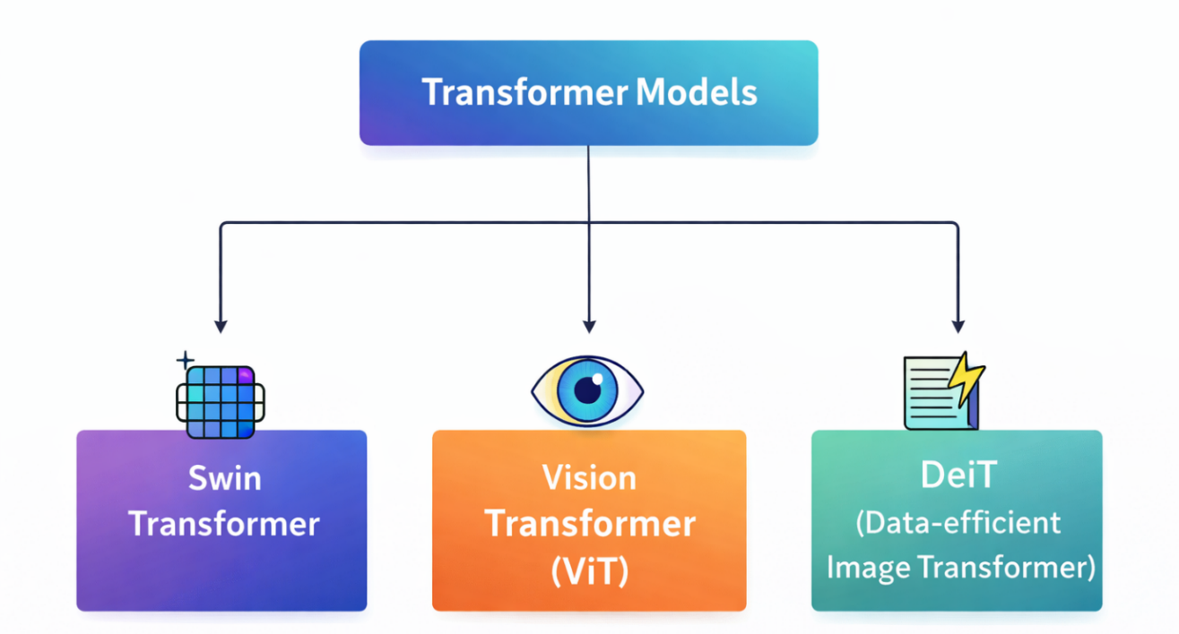
Figure 1: AI Techniques for Retinal Image Analysis [4] [5]

2.2.3 Diabetic Retinopathy Detection Using Machine Learning
Machine-learning approaches commonly represent diabetic retinopathy analysis as two sequential stages: informative features are first extracted from retinal images, after which a classifier maps the feature vectors to diagnostic labels. The features may be manually engineered from texture, intensity, shape, and vascular characteristics or obtained automatically from pretrained deep networks. This separation can reduce the computational cost of repeatedly training an end-to-end network and allows several classifiers to be evaluated on the same fixed representation. In the proposed framework, Random Forest is applied to fused ConvNeXt-Tiny and Swin-V2-Tiny embeddings, making the machine-learning stage directly relevant to the final classification design.

1. Support Vector Machine (SVM)
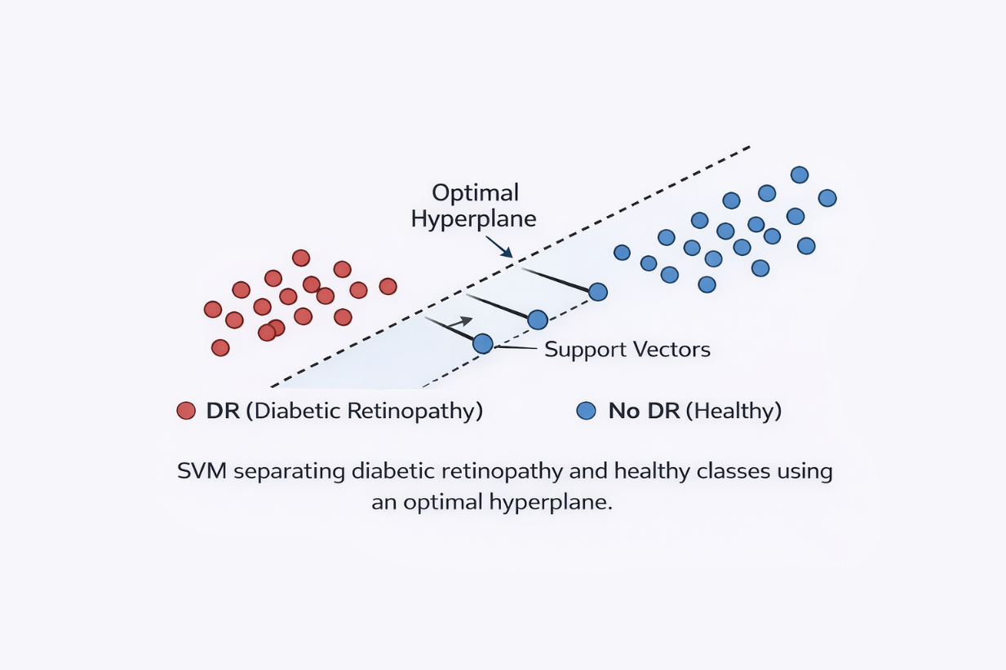
Support Vector Machine constructs a maximum-margin decision boundary and can use kernel functions to represent nonlinear class separation. In retinal-image analysis, SVM is commonly applied to engineered or deep feature vectors, although its performance remains sensitive to scaling, kernel selection, and hyperparameter tuning [6]. The principle is illustrated in Figure 2.

Figure 2: Support Vector Machine Classification of Retinal Features [6]

2. Random Forest
Random Forest is an ensemble classifier that trains multiple decision trees on bootstrapped samples and randomized feature subsets. The final multiclass prediction is obtained by aggregating the decisions of the trees. Its nonlinear decision structure, robustness to correlated predictors, and support for class weighting make it suitable for imbalanced retinal-image classification and fused deep embeddings [7]. Figure 3 presents its majority-voting mechanism for diabetic retinopathy grading.
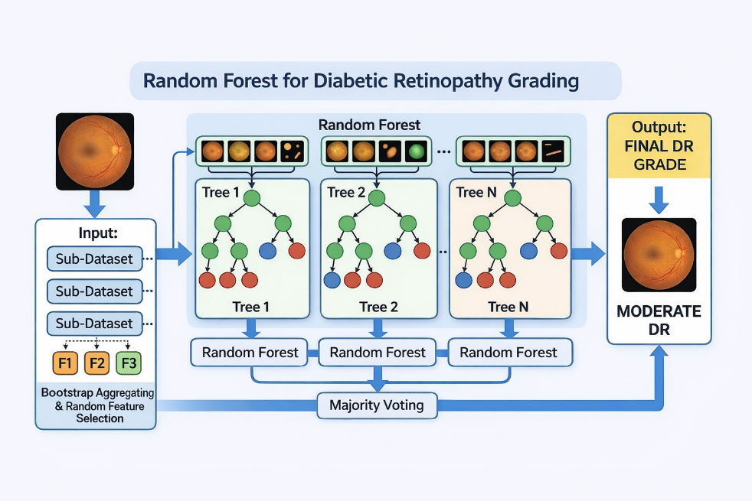
Figure 3: Random Forest Classification for Diabetic Retinopathy Grading [7]

3. K-Nearest Neighbors (KNN)
K-Nearest Neighbors assigns a class according to the labels of the closest samples in the feature space. Although its transparent neighborhood-voting mechanism makes it useful as a baseline, performance is sensitive to distance measurement, feature scaling, neighborhood size, and high dimensionality [8]. Figure 4 illustrates the use of nearest-neighbor voting for retinal-image grading.
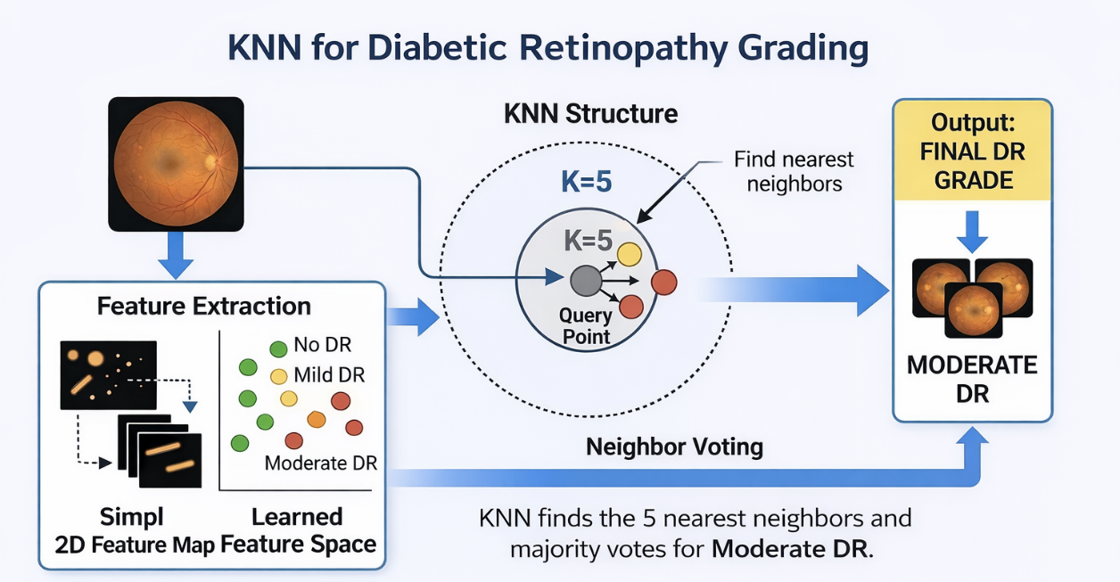

Figure 4: K-Nearest Neighbors for Diabetic Retinopathy Grading [8]

2.2.4 Diabetic Retinopathy Detection Using Deep Learning
Deep learning has transformed diabetic retinopathy analysis by learning hierarchical visual representations directly from retinal fundus images. Early layers capture edges, color transitions, and fine texture, while deeper layers encode vessels, lesions, and broader disease-related structures. Performance nevertheless depends on image quality, class imbalance, augmentation, model capacity, and dataset diversity [9]. This study focuses on ConvNeXt-Tiny as the convolutional feature extractor because it provides modernized convolutional representations while retaining strong spatial inductive biases.

1. ConvNeXt-Tiny (Pre-trained)
ConvNeXt-Tiny modernizes conventional convolutional design through larger kernels, stage-wise feature hierarchies, and updated normalization and optimization choices. For retinal images, these properties support the encoding of local lesion texture, vascular structure, and progressively abstract disease patterns. In the proposed framework, the fine-tuned network produces a 768-dimensional embedding after global average pooling; the classification head is then removed and the embedding is retained for feature fusion [10]. Figure 5 provides an original conceptual illustration of this extraction process.
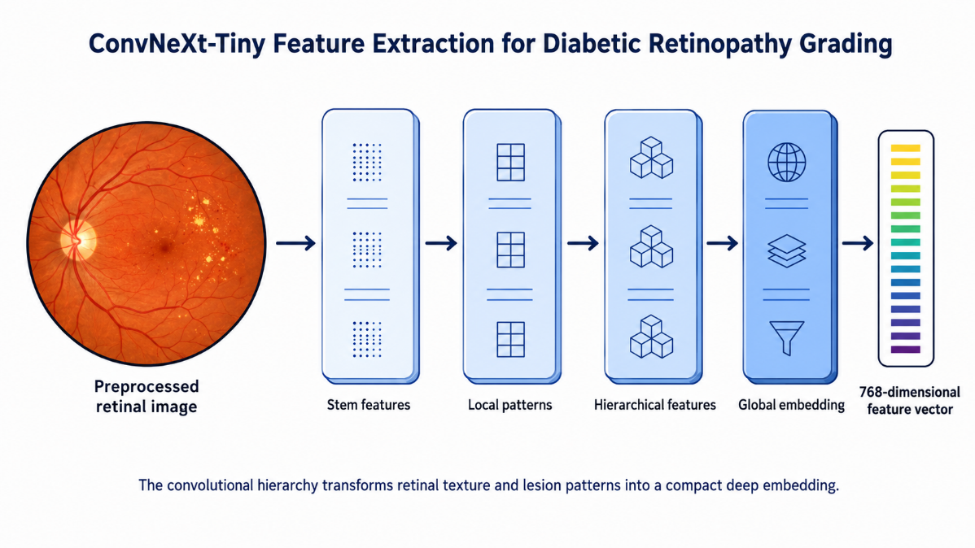
Figure 5: ConvNeXt-Tiny Feature Extraction for Diabetic Retinopathy Grading [10]

2.2.5 Diabetic Retinopathy Detection Using Transformer Models
Vision transformers represent an image as a sequence of patches and learn relationships through self-attention. This mechanism can capture dependencies between spatially separated retinal regions and complements convolutional models that emphasize local patterns. Transformer-based models may nevertheless require careful regularization, sufficient data, and considerable computational resources [11], [12]. Figure 6 summarizes the principal transformer-based retinal-image encoders considered in the background review.
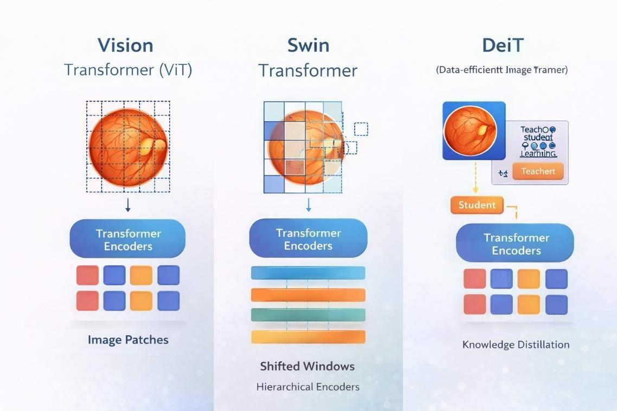

Figure 6: Transformer-Based Retinal Image Encoding [11] [12]

Vision Transformer (ViT)
Vision Transformer (ViT) is one of the earliest transformer architectures for classification of images. While CNN networks use convolutional filters for image analysis, Vision Transformer splits an image into different patches and encodes each patch as a vector referred to as patch embedding with positional encoding that encodes the spatial relations within patches. Such embeddings go through the layers of transformers' encoder where the relationships between various regions within the image are established through the attention mechanism. One of the key features of Vision Transformer is the possibility of capturing dependencies between all pixels of an entire image. Thus, Vision Transformers could be used effectively for medical imaging tasks when some important pathological alterations in organs spread throughout different locations of an image. For instance, such alterations are relevant for the detection of diabetic retinopathy because one should analyze several regions of the retina. However, in order for ViT to function properly, one should provide more data for training and consume more computational power [13]. Figure 7 illustrates patch-based transformer encoding applied to retinal image analysis.
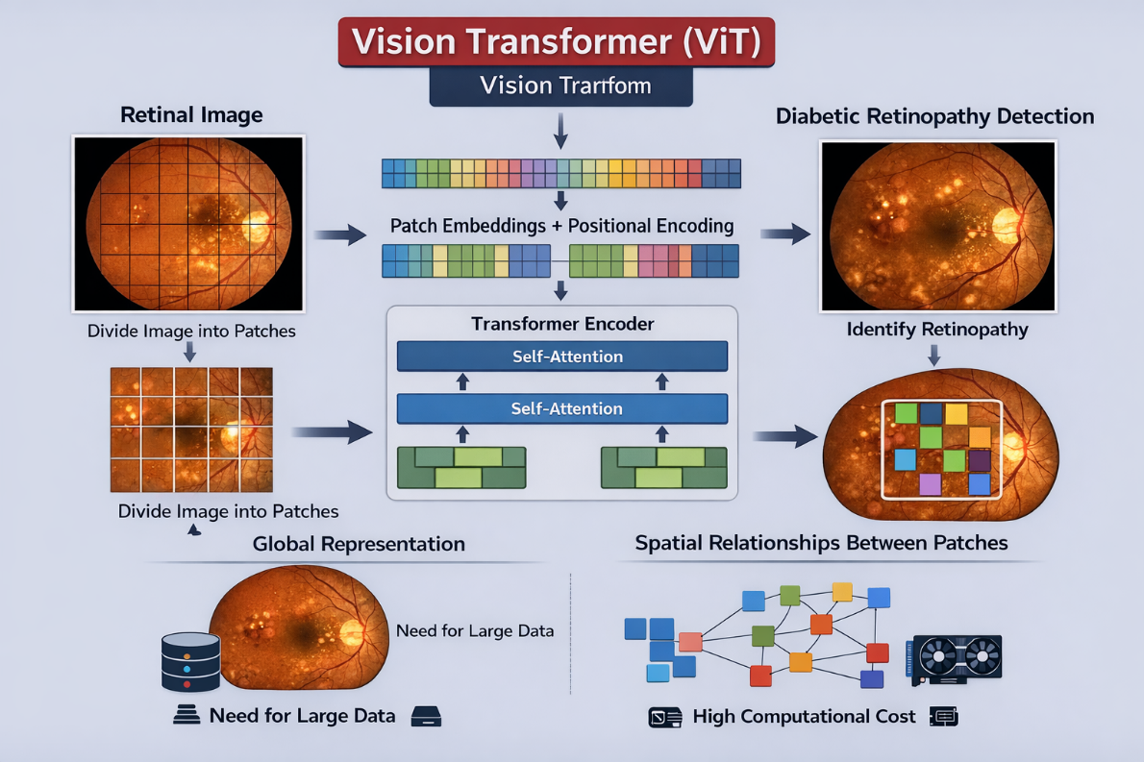
Figure 7: Vision Transformer Encoding for Diabetic Retinopathy Analysis [11]

Swin Transformer
Swin Transformer applies self-attention within local windows and shifts the window partition between successive blocks. This hierarchical strategy reduces computational cost while enabling information exchange across neighboring regions and multiple spatial scales. It is therefore suitable for retinal analysis, where fine lesions and broader contextual patterns must both be represented [12]. Figure 8 illustrates shifted-window feature encoding for diabetic retinopathy grading.

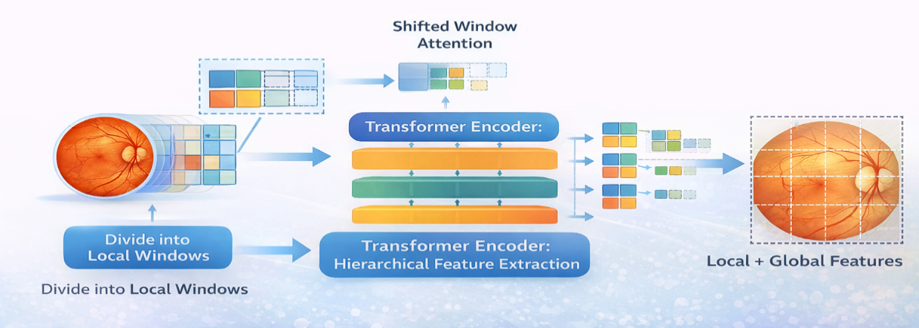
Figure 8: Swin Transformer Encoding for Diabetic Retinopathy Grading [12]

2.2.6 Deep Feature Fusion and Hybrid Classification
Feature-level fusion combines representations extracted by different architectures before classification. In retinal-image analysis, ConvNeXt-Tiny can emphasize local textures, vessels, and lesion morphology, whereas Swin-V2-Tiny can encode broader contextual relationships through shifted-window attention. Direct concatenation preserves both 768-dimensional embeddings and forms a 1,536-dimensional vector for the downstream Random Forest classifier. Regularization is required because fusion increases dimensionality and may introduce redundant variables [7], [10], [14], [15]. The adopted process is summarized in Figure 9.
Direct concatenation is used instead of averaging because the ConvNeXt-Tiny and Swin-V2-Tiny embeddings are not assumed to occupy identical feature spaces. Concatenation retains all architecture-specific variables, while the regularized Random Forest can select informative nonlinear interactions from the fused representation [7].

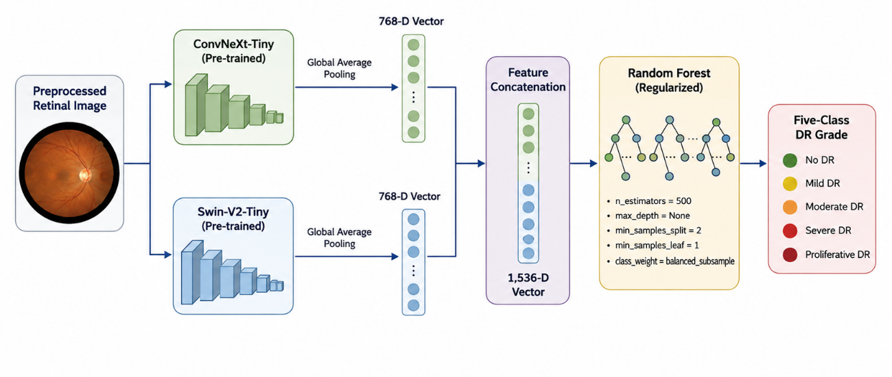
Figure 9: ConvNeXt-Swin Feature Fusion and Random Forest Classification [7] [10] [14] [15]

2.2.7 Performance Metrics
Evaluation of diabetic retinopathy classifiers requires more than overall accuracy because the clinical classes are commonly imbalanced and errors have different implications across severity grades. A model can achieve a high accuracy while performing poorly on rare severe cases. Accordingly, this thesis considers accuracy together with per-class precision, recall, F1-score, specificity, confusion matrices, and one-vs-rest ROC-AUC values. Macro averages are used to give equal importance to each class, whereas weighted averages reflect the observed class distribution.

Accuracy
Accuracy refers to the ratio of correct classifications to total samples.
Where:
- TP = True Positives
- TN = True Negatives
- FP = False Positives
- FN = False Negatives
$Accuracy=\frac{TP+TN}{TP+TN+FP+FN}$ (1)

Precision
Precision measures the proportion of correctly predicted positive cases out of all predicted positive cases.
$Precision=\frac{TP}{TP+FP}$ (2)

Recall (Sensitivity)
Recall measures the proportion of actual positive cases that are correctly identified by the model.
$Recall=\frac{TP}{TP+FN}$ (3)

F1-Score
The F1-score is the harmonic mean of precision and recall.
$F1=2×\frac{Precision×Recall}{Precision+Recall}$ (4)

Specificity
Specificity measures the ability of the model to correctly identify negative cases.
$Specificity=\frac{TN}{TN+FP}$ (5)

Confusion Matrix
The confusion matrix is a table that summarizes classification results in terms of TP, TN, FP, and FN. It helps identify the types of errors made by the model.

ROC Curve and AUC
The Receiver Operating Characteristic (ROC) curve represents the trade-off between sensitivity and specificity at different threshold values. The Area Under the Curve (AUC) reflects the model’s ability to distinguish between classes.
- AUC = 1 indicates perfect classification
- AUC = 0.5 indicates random performance
These measures are particularly important in five-class diabetic retinopathy grading because they reveal whether performance is balanced across no DR, mild, moderate, severe, and proliferative DR rather than being dominated by the majority class.

2.3 Literature Review
Grzybowski and Jin [13] conducted a targeted scoping review of 13 CE-certified artificial-intelligence systems for autonomous or semi-autonomous diabetic retinopathy screening in the European Union. The review found that most systems relied on deep-learning analysis of fundus images, but validation designs, reporting practices, imaging devices, and population characteristics were highly heterogeneous. The authors therefore did not pool diagnostic performance or rank the systems directly. Evidence for sight-threatening diabetic retinopathy was less consistently reported, with mean performance around 80% in the available controlled evaluations. The study is valuable for demonstrating regulatory and real-world implementation challenges, although it is a review of commercial systems rather than an experimental multiclass grading model.
Akhtar et al. [16] proposed RSG-Net for four-stage and binary diabetic retinopathy classification using the Messidor-1 dataset. The method combined bounding-box cropping, denoising, histogram equalization, resizing, data augmentation, and an optimized convolutional architecture. RSG-Net achieved a test accuracy of 99.36% for four-stage grading and 99.37% for binary classification. Despite these strong results, near-perfect training performance indicated a potential overfitting risk, and evaluation was limited to a single dataset, leaving cross-dataset generalization unresolved.
Guefrachi et al. [17] investigated a multistage training strategy using several pretrained convolutional architectures, including InceptionResNetV2, VGG16, VGG19, DenseNet121, MobileNetV2, and EfficientNetV2L. Data augmentation was used to strengthen model robustness and reduce overfitting. The best configuration achieved an accuracy of approximately 96.61% for diabetic retinopathy detection and grading. The study confirmed the effectiveness of transfer learning, although the relatively limited dataset size and the absence of broad external validation constrain the generalizability of the reported performance.
Youldash et al. [18] evaluated six pretrained CNN families on APTOS and on retinal images collected from a Saudi clinical center. On APTOS, RegNetX080 achieved 98.6% accuracy for binary classification, while EfficientNetB3 achieved 85.1% for multiclass grading. In the external clinical experiment, the best binary and multiclass accuracies were 98.2% and 84.4%, respectively. The study provides useful evidence that binary detection is substantially easier than five-class grading and highlights the continuing effects of class imbalance and domain variation.
Shamrat et al. [19] introduced DRNet13, a custom convolutional network for five-class diabetic retinopathy grading, and compared it with fifteen pretrained CNN architectures. The APTOS images were enhanced using median filtering and gamma correction, and augmentation increased the dataset from 3,662 to 7,500 images. DRNet13 achieved 97% accuracy and was reported to be computationally efficient relative to the evaluated backbones. However, the results were obtained from a single public dataset, and the absence of independent clinical validation limits conclusions regarding deployment robustness.
Jabbar et al. [14] proposed a lesion-oriented hybrid framework in which GoogleNet and ResNet representations were optimized using adaptive particle swarm optimization and subsequently classified using Random Forest, SVM, Decision Tree, and Linear Regression. The framework achieved 94% accuracy on the benchmark fundus dataset. This work supports the value of combining deep feature extraction with machine-learning classification; however, the reported study provides limited evidence regarding cross-dataset validation and the reproducibility of the complete model-selection procedure.
Fayyaz et al. [20] extracted deep features from AlexNet and ResNet101, fused the representations, selected informative variables using an ant-colony system, and evaluated several SVM kernels. Using 750 selected features, the cubic SVM achieved 93.0% accuracy, 93.0% precision, 93.5% recall, and a 93.2% F1-score. The study demonstrates the potential of deep-feature fusion followed by conventional classification, although the feature-selection pipeline and restricted evaluation setting may limit reproducibility and generalization.
Alwakid et al. [21] evaluated DenseNet121 on the APTOS 2019 dataset under multiple image-enhancement scenarios involving histogram equalization, CLAHE, and ESRGAN. The CLAHE and ESRGAN configuration achieved a five-class test accuracy of 98.36%, with top-2 and top-3 accuracies of 100%. The study provides evidence that contrast enhancement can improve retinal-image classification; nevertheless, the approach depends on computationally intensive enhancement and was evaluated on a single public dataset without external clinical validation.
Lin and Wu [22] developed a revised ResNet50 architecture together with a standardized preprocessing procedure and adaptive learning-rate control. The revised model achieved a training accuracy of 83.95% and a test accuracy of 74.32%, outperforming the conventional CNN configurations evaluated in the same study while reducing training instability. The remaining train-test difference illustrates the difficulty of controlling overfitting and achieving reliable multiclass generalization on heterogeneous retinal images.
Mohanty et al. [23] compared a hybrid VGG16-XGBoost architecture with DenseNet121 on the APTOS 2019 dataset after preprocessing and class balancing. The hybrid network achieved 79.50% accuracy, whereas DenseNet121 achieved 97.30%, demonstrating that a hybrid design does not automatically outperform a strong end-to-end CNN. The study emphasizes the importance of the selected feature extractor and fusion strategy, but it did not include independent external validation.
Patil et al. [24] trained a ResNet50 model on APTOS and evaluated it using EyePACS, applying image preprocessing, augmentation, and test-time augmentation to improve multiclass generalization. The approach achieved 97.87% accuracy and a quadratic weighted kappa of 0.985. The cross-dataset design is a strength because it assesses robustness beyond the training source; however, the method still depends heavily on extensive augmentation and the characteristics of the selected external subset.
Ali and Dawood [25] fine-tuned ResNet50 for diabetic retinopathy grading using APTOS 2019 fundus images. Their pipeline included preprocessing, transfer learning, checkpoint selection, and final multiclass evaluation. The reported accuracy was 98.3%, with precision of 98.4%, recall of 98.4%, and an F1-score of 98.5%. Although the results indicate strong within-dataset performance, the absence of external validation makes it difficult to determine whether the model generalizes to images acquired under different clinical conditions.
Das et al. [26] developed the DRFEC benchmark and evaluated 26 pretrained CNN architectures on the EyePACS dataset for feature extraction and classification. EfficientNetB4 produced the highest validation accuracy of 79.11% with a training accuracy of 99.37%, while several larger networks exhibited substantial overfitting. The broad architecture comparison is informative, but the large training-validation gaps demonstrate that model capacity and high training accuracy do not necessarily translate into reliable generalization.
Jiwani et al. [27] applied a convolutional neural network to diabetic retinopathy classification using the IDRiD dataset. Subsequent comparative reporting indicates an accuracy of approximately 77.6%, demonstrating moderate performance on a relatively small retinal dataset. The study offers a useful baseline for CNN-based grading, although limited explanation of architecture selection, hyperparameter choices, and validation design reduces reproducibility and restricts direct comparison with more extensively evaluated methods.

2.4 Comparative Analysis of Related Work
The fourteen reviewed studies reveal several consistent patterns. First, preprocessing and augmentation are central to retinal-image classification because acquisition variability and class imbalance strongly influence performance. Second, pretrained CNNs can achieve high within-dataset accuracy, but cross-dataset evaluation frequently produces lower multiclass performance, indicating unresolved generalization challenges. Third, hybrid approaches that combine deep representations with machine-learning classifiers are promising, yet their effectiveness depends on the complementarity of the extracted features, the rigor of model selection, and the prevention of data leakage. The literature also shows that binary detection is generally easier than five-class severity grading and that high aggregate accuracy may conceal poor recognition of minority classes. Comparatively limited work has investigated feature-level fusion between a modern convolutional architecture and a hierarchical vision transformer followed by a regularized ensemble classifier. This gap supports combining ConvNeXt-Tiny and Swin-V2-Tiny embeddings and classifying the fused representation using Random Forest under a stratified training, validation, and testing protocol.

Table 1: Comparative study of diabetic retinopathy detection methods
Authors | Year | Method / Model | Dataset | Results | Limitations
Grzybowski and Jin [13] | 2026 | Review of 13 CE-certified AI systems | EU validation studies | No pooled estimate; STDR ~80% | Heterogeneous validation and reporting
Akhtar et al. [16] | 2025 | RSG-Net | Messidor-1 | 99.36% four-stage; 99.37% binary | Single dataset; overfitting risk
Guefrachi et al. [17] | 2025 | Multistage transfer learning | Kaggle fundus images | 96.61% accuracy | Limited data; no broad external validation
Youldash et al. [18] | 2024 | EfficientNet and RegNet transfer learning | APTOS and Saudi clinical images | 98.6% binary; 85.1% multiclass | Lower multiclass performance
Shamrat et al. [19] | 2024 | DRNet13 vs. 15 pretrained CNNs | APTOS 2019 | 97% accuracy | Single public dataset
Jabbar et al. [14] | 2024 | GoogleNet-ResNet + APSO + ML | Fundus dataset | 94% accuracy | Limited external validation
Fayyaz et al. [20] | 2023 | AlexNet-ResNet101 fusion + SVM | EyePACS | 93.0% accuracy; 93.2% F1-score | Complex feature-selection pipeline
Alwakid et al. [21] | 2023 | DenseNet121 + CLAHE/ESRGAN | APTOS 2019 | 98.36% five-class accuracy | Heavy enhancement; single dataset
Lin and Wu [22] | 2023 | Revised ResNet50 | Kaggle DR images | 83.95% train; 74.32% test | Remaining train-test gap
Mohanty et al. [23] | 2023 | VGG16-XGBoost vs. DenseNet121 | APTOS 2019 | 79.50% vs. 97.30% | No external validation
Patil et al. [24] | 2023 | ResNet50 + augmentation/TTA | APTOS to EyePACS | 97.87%; QWK 0.985 | Extensive augmentation
Ali and Dawood [25] | 2023 | Fine-tuned ResNet50 | APTOS 2019 | 98.3% accuracy; 98.5% F1-score | No external validation
Das et al. [26] | 2023 | DRFEC: 26 pretrained CNNs | EyePACS | Best validation: 79.11% | Overfitting and high train-validation gap
Jiwani et al. [27] | 2022 | CNN classifier | IDRiD | ~77.6% accuracy | Limited design detail

2.5 Chapter Summary
This chapter presented the medical and computational foundations required for automated diabetic retinopathy grading. It described the five clinical severity classes and reviewed the roles of preprocessing, augmentation, transfer learning, machine-learning classifiers, convolutional networks, and vision transformers in retinal-image analysis. It also explained the evaluation measures needed for imbalanced multiclass classification. Fourteen related studies were examined to compare their datasets, methods, reported results, and limitations. The review indicates that strong within-dataset performance does not consistently translate into cross-dataset generalization and that comparatively little work has combined complementary CNN and transformer embeddings with a regularized machine-learning classifier.

Chapter 3: Proposed Approach (Methodology)

3.1 Introduction
This chapter presents the methodology used to construct the five-class diabetic retinopathy framework. It describes the APTOS 2019 dataset, deterministic preprocessing, stratified partitioning, training-only augmentation, deep-feature extraction, feature fusion, and Random Forest model selection.

3.2 Proposed Framework
The proposed architecture integrates convolutional and transformer-based visual representations. ConvNeXt-Tiny supplies a strong local inductive bias for retinal texture, vessel structure, exudates, hemorrhages, and other lesion-related patterns. Swin-V2-Tiny complements these features through hierarchical shifted-window self-attention, which captures broader spatial relationships and contextual dependencies across the fundus image. The penultimate 768-dimensional output of each backbone is retained, producing two complementary embeddings for every image.
Direct concatenation forms a 1,536-dimensional hybrid feature vector without averaging or discarding architecture-specific information. A Random Forest then performs the final five-class prediction. Separating deep feature learning from the final machine-learning classifier allows the optimized embeddings to be stored and reused, while validation-based model selection limits direct dependence on the held-out testing subset. The complete architecture of the proposed framework is summarized in Figure 10.
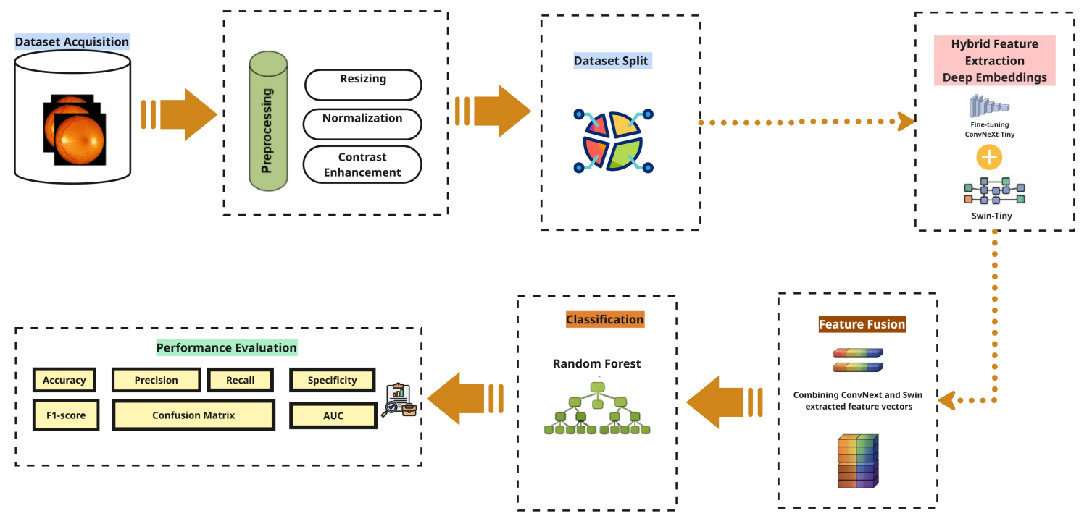
Figure 10: Proposed Hybrid Framework for Diabetic Retinopathy Classification

3.3 Dataset Description
The experiments use the APTOS 2019 Blindness Detection dataset, which contains 3,662 color retinal fundus images labeled according to five diabetic retinopathy severity grades: No DR, Mild, Moderate, Severe, and Proliferative DR. Before training, the image directory and label file were checked for missing files, duplicate identifiers, invalid class labels, and inconsistencies between file names and metadata. No missing images were detected in the final organized dataset.
The class distribution is imbalanced. No DR accounts for the largest proportion of samples, whereas Severe and Proliferative DR contain substantially fewer observations. This imbalance motivates stratified partitioning, class-sensitive training, and the use of macro as well as weighted evaluation measures. The original class counts are illustrated in Figure 11.
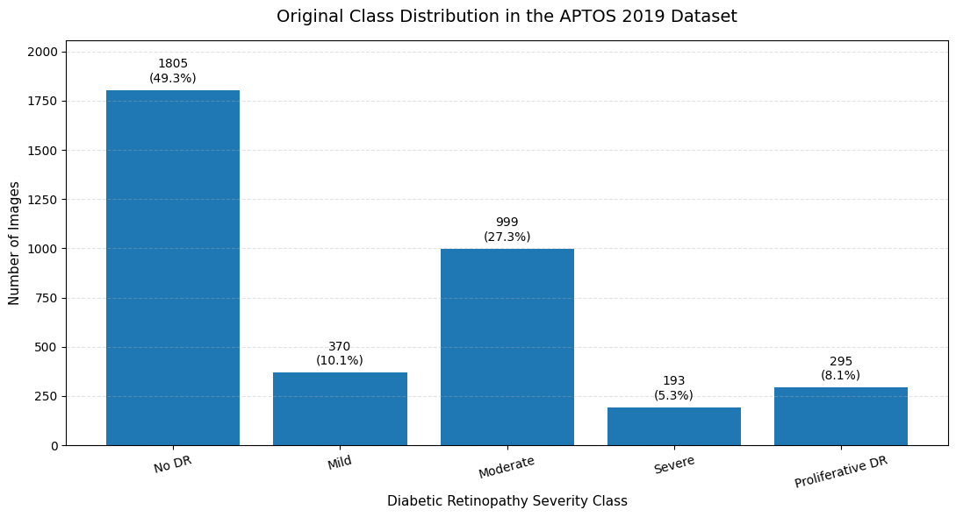
Figure 11: Original Class Distribution in the APTOS 2019 Dataset
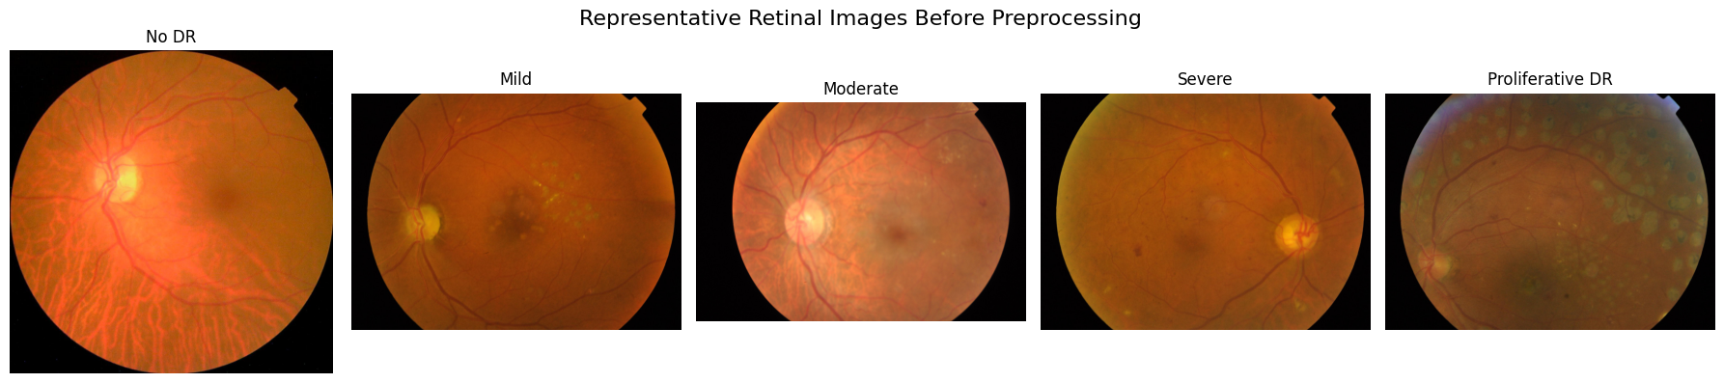
Figure 12 presents one deterministically selected original image from each severity grade. These samples are shown before preprocessing to document the variability in image dimensions, illumination, dark borders, field-of-view coverage, and retinal appearance within the raw dataset.

Figure 12: Representative Retinal Images Before Preprocessing

3.4 Data Preprocessing
A deterministic preprocessing sequence was applied to training, validation, and testing images before model-specific augmentation. The purpose of this stage was to reduce irrelevant variation while preserving clinically meaningful retinal structures. First, dark external borders were removed by identifying the foreground retinal region from a grayscale threshold. The cropped image was then converted to the LAB color space, and contrast-limited adaptive histogram equalization (CLAHE) was applied to the lightness channel to enhance local retinal contrast without strongly amplifying noise.
Each processed image was resized to 300 x 300 pixels using area interpolation, converted from RGB format to a float32 PyTorch tensor, and normalized using the ImageNet channel means and standard deviations required by the pretrained backbones. The final deterministic settings are listed in Table 2. Explanatory descriptions are kept in the text, while the table reports only implemented parameter values.
Table 2: Deterministic Retinal-Image Preprocessing Parameters
Parameter | Value
Foreground threshold | 10
Minimum crop size | 50 pixels
CLAHE clip limit | 1.5
CLAHE tile grid | 8 x 8
Image size | 300 x 300 pixels
Interpolation | INTER_AREA
Tensor type | float32 PyTorch tensor
Normalization mean | [0.485, 0.456, 0.406]
Normalization standard deviation | [0.229, 0.224, 0.225]

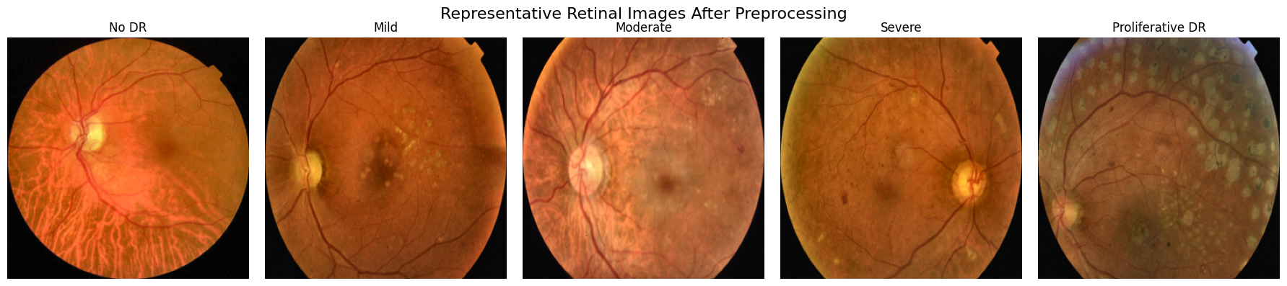
Figure 13 shows representative images after deterministic preprocessing. Compared with the original examples, the processed images have standardized dimensions, reduced border regions, and enhanced local contrast while retaining the principal retinal anatomy used by the feature extractors.

Figure 13: Representative Retinal Images After Preprocessing

3.5 Dataset Splitting and Training-Only Augmentation

3.5.1 Stratified Dataset Partitioning
The complete dataset was divided using a fixed stratified 70:15:15 partition. This produced 2,563 training images, 549 validation images, and 550 testing images. Stratification preserved the relative frequency of each diagnostic grade in every subset. The validation subset supported checkpoint and hyperparameter decisions, whereas the testing subset remained isolated until final model selection had been completed. The numerical split and its class-level implications are reported in the experimental-results chapter.

3.5.2 Training-Only Data Augmentation
Stochastic augmentation was applied only to training images to increase input diversity and reduce sensitivity to acquisition-specific variation. The ConvNeXt pipeline used horizontal flipping, limited random rotation, mild affine translation and scaling, brightness and contrast jitter, saturation variation, and random erasing. The refined Swin pipeline used lighter augmentation because the initial stronger configuration constrained learning. Validation and testing images received only deterministic preprocessing and normalization, ensuring that reported performance reflects unaltered held-out images.

3.6 Deep Feature Extraction
Transfer learning was used because the available medical dataset is considerably smaller than the datasets normally required to train modern visual backbones from random initialization. Both networks were initialized with ImageNet-1K pretrained weights and fine-tuned for five-class retinal-image classification. The saved best checkpoints were subsequently reloaded, their classification heads were bypassed, and the penultimate representations were extracted for the training, validation, and testing subsets.

3.6.1 ConvNeXt-Tiny
ConvNeXt-Tiny was fine-tuned on the training subset and used as the convolutional feature extractor. The selected checkpoint was determined from validation performance. After fine-tuning, the classification head was removed and a 768-dimensional embedding was extracted for each image. Table 3 lists the final implemented parameters.

Table 3: ConvNeXt-Tiny Final Parameters
Parameter | Value
Pretrained weights | ImageNet-1K V1
Input size | 300 x 300 pixels
Batch size | 32
Output classes | 5
Embedding dimension | 768
Classifier head | Dropout (0.45) + Linear (768 to 5)
Loss function | Class-weighted cross-entropy
Label smoothing | 0.06
Optimizer | AdamW
Best checkpoint epoch | 15

3.6.2 Swin-V2-Tiny
Swin-V2-Tiny was fine-tuned as the complementary transformer feature extractor. Its shifted-window hierarchy captured contextual retinal information that differs from convolutional representations. The classification head was removed after checkpoint selection, producing a 768-dimensional embedding per image. Table 4 summarizes the final settings.

Table 4: Swin-V2-Tiny Final Parameters
Parameter | Value
Pretrained weights | ImageNet-1K V1
Input size | 300 x 300 pixels
Batch size | 32
Output classes | 5
Embedding dimension | 768
Classifier head | Dropout (0.20) + Linear (768 to 5)
Loss function | Class-weighted cross-entropy
Label smoothing | 0.02
Backbone learning rate | 1 x 10^-5
Head learning rate | 2 x 10^-4
Optimizer | AdamW
Best checkpoint epoch | 10 (refinement stage)

3.7 Feature Fusion
Feature-level fusion was performed through direct concatenation along the feature dimension. For each image, the 768 ConvNeXt values and 768 Swin values were joined to produce a 1,536-dimensional hybrid vector. No averaging or dimensionality reduction was applied before classification. This preserves the complete architecture-specific output and allows the downstream Random Forest to identify informative variables and nonlinear interactions from either feature family.
The fused training, validation, and testing matrices were saved together with their labels in compressed NumPy files. Saving the fixed embeddings separates the computationally expensive deep-feature extraction stage from repeated machine-learning experiments and enables the final classifier to be rebuilt after a session reset without repeating backbone inference.

3.8 Random Forest Classification
The fused 1,536-dimensional vectors were classified using Random Forest. Hyperparameters were selected through stratified cross-validated randomized search on the training data, with validation performance used to confirm the selected regularized configuration. The testing subset was not used during model selection. Table 5 reports the final parameters applied to the held-out evaluation.

Table 5: Selected Random Forest Parameters
Parameter | Value
Number of trees | 700
Bootstrap | True
Class weighting | balanced_subsample
Criterion | entropy
Maximum depth | 3
Minimum samples split | 80
Minimum samples leaf | 20
Maximum features | sqrt
Maximum samples | 0.25
Random seed | 42
Cross-validation | Stratified 5-fold

3.9 Chapter Summary
This chapter described the complete methodology for the proposed framework. The APTOS 2019 images were preprocessed and divided using a stratified 70:15:15 split. ConvNeXt-Tiny and Swin-V2-Tiny produced complementary 768-dimensional embeddings that were concatenated into a 1,536-dimensional vector. A regularized Random Forest configuration was then selected without using the testing subset.

Chapter 4: Experimental Results and Discussion

4.1 Introduction
This chapter presents the experimental results of the proposed hybrid framework. The evaluation focuses on the Random Forest classifier trained on the fused ConvNeXt-Tiny and Swin-V2-Tiny features. Results are reported using aggregate metrics, confusion-matrix analysis, ROC-AUC, and comparison with related studies, followed by an interpretation of the principal findings.

4.2 Experimental Setup
Experiments were executed in Google Colab using Python, PyTorch, Torchvision, OpenCV, and scikit-learn. GPU acceleration supported fine-tuning and deep-feature extraction, while Random Forest search and final evaluation were executed through scikit-learn. A fixed random seed was used where supported to improve reproducibility. The saved best backbone checkpoints and the stored fused feature matrices were used to ensure that the final evaluation was based on a consistent implementation.
The 3,662 images were separated into training, validation, and testing subsets using the stratified allocation shown in Table 6. Stochastic transformations were restricted to training. Validation accuracy guided deep-learning checkpoint selection, and cross-validated macro F1-score together with accuracy and the training-validation gap guided Random Forest selection. Final reporting includes accuracy, macro precision, macro recall, macro F1-score, weighted F1-score, specificity, confusion-matrix counts, and one-vs-rest ROC-AUC.

Table 6: Experimental Dataset Split
Subset | Number of Images | Percentage
Training | 2,563 | 70%
Validation | 549 | 15%
Testing | 550 | 15%

4.3 Results of the Final Hybrid Model
The final Random Forest classifier was trained on the fused 1,536-dimensional training features after cross-validated model selection. It achieved 98.95% training accuracy, 86.16% validation accuracy, and 84.91% testing accuracy. On the held-out testing subset, macro precision was 73.93%, macro recall was 68.99%, macro F1-score was 70.98%, weighted F1-score was 84.45%, macro specificity was 96.11%, macro ROC-AUC was 94.80%, and weighted ROC-AUC was 96.84%. The 14.04-percentage-point training-testing gap indicates remaining overfitting, while the close validation and testing accuracies support stable held-out generalization. Table 7 summarizes the complete set of performance measures.

Table 7: Comprehensive Performance of the Final Hybrid Framework
Metric | Value
Testing accuracy | 0.8491
Macro precision | 0.7393
Macro recall | 0.6899
Macro F1-score | 0.7098
Weighted F1-score | 0.8445
Macro specificity | 0.9611
Macro ROC-AUC | 0.9480
Weighted ROC-AUC | 0.9684

Figure 14 presents the confusion matrix of the final hybrid model. The diagonal contains 467 correct predictions out of 550 test images. The classifier correctly identified 266 of 271 No DR images, 33 of 56 Mild images, 131 of 150 Moderate images, 14 of 29 Severe images, and 23 of 44 Proliferative DR images. Most mistakes occurred between neighboring severity grades rather than between clinically distant endpoints.
The dominant error pattern involved Mild being predicted as Moderate (18 images) and Proliferative DR being predicted as Moderate (16 images). Severe images were also confused with Moderate and Proliferative DR. These errors are consistent with class imbalance and the visual continuity of diabetic retinopathy progression: lesion burden and appearance can overlap near class boundaries, while a global image-level label does not indicate the exact lesion region that should drive the prediction.
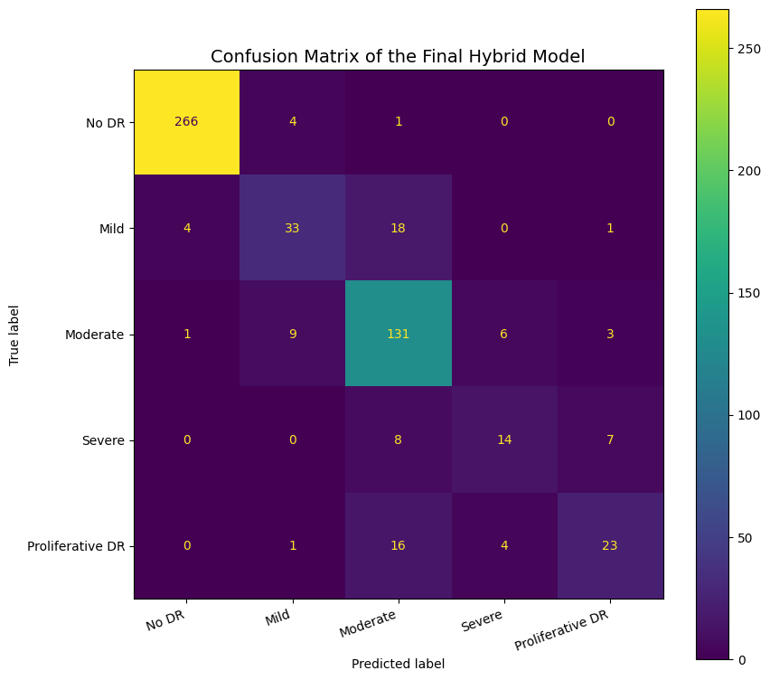
Figure 14: Confusion Matrix of the Final Hybrid Model
Figure 15 shows one-vs-rest ROC curves derived from the Random Forest class-probability outputs. The AUC values were 0.9963 for No DR, 0.9271 for Mild, 0.9506 for Moderate, 0.9340 for Severe, and 0.9321 for Proliferative DR. Every curve remained well above the random-classifier diagonal, confirming that the model retained useful ranking ability even for classes with lower threshold-based recall.
The macro ROC-AUC of 0.9480 gives equal importance to all five classes, while the weighted ROC-AUC of 0.9684 reflects their frequency in the testing subset. The higher weighted value is expected because No DR and Moderate, the most strongly ranked and more frequently represented classes, contribute more heavily. ROC-AUC should therefore be interpreted together with the class-level F1-scores and confusion matrix rather than as a substitute for them.

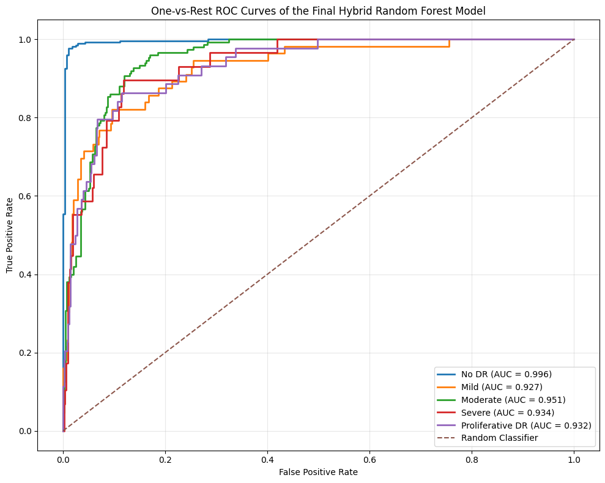
Figure 15: One-vs-Rest ROC Curves of the Final Hybrid Model
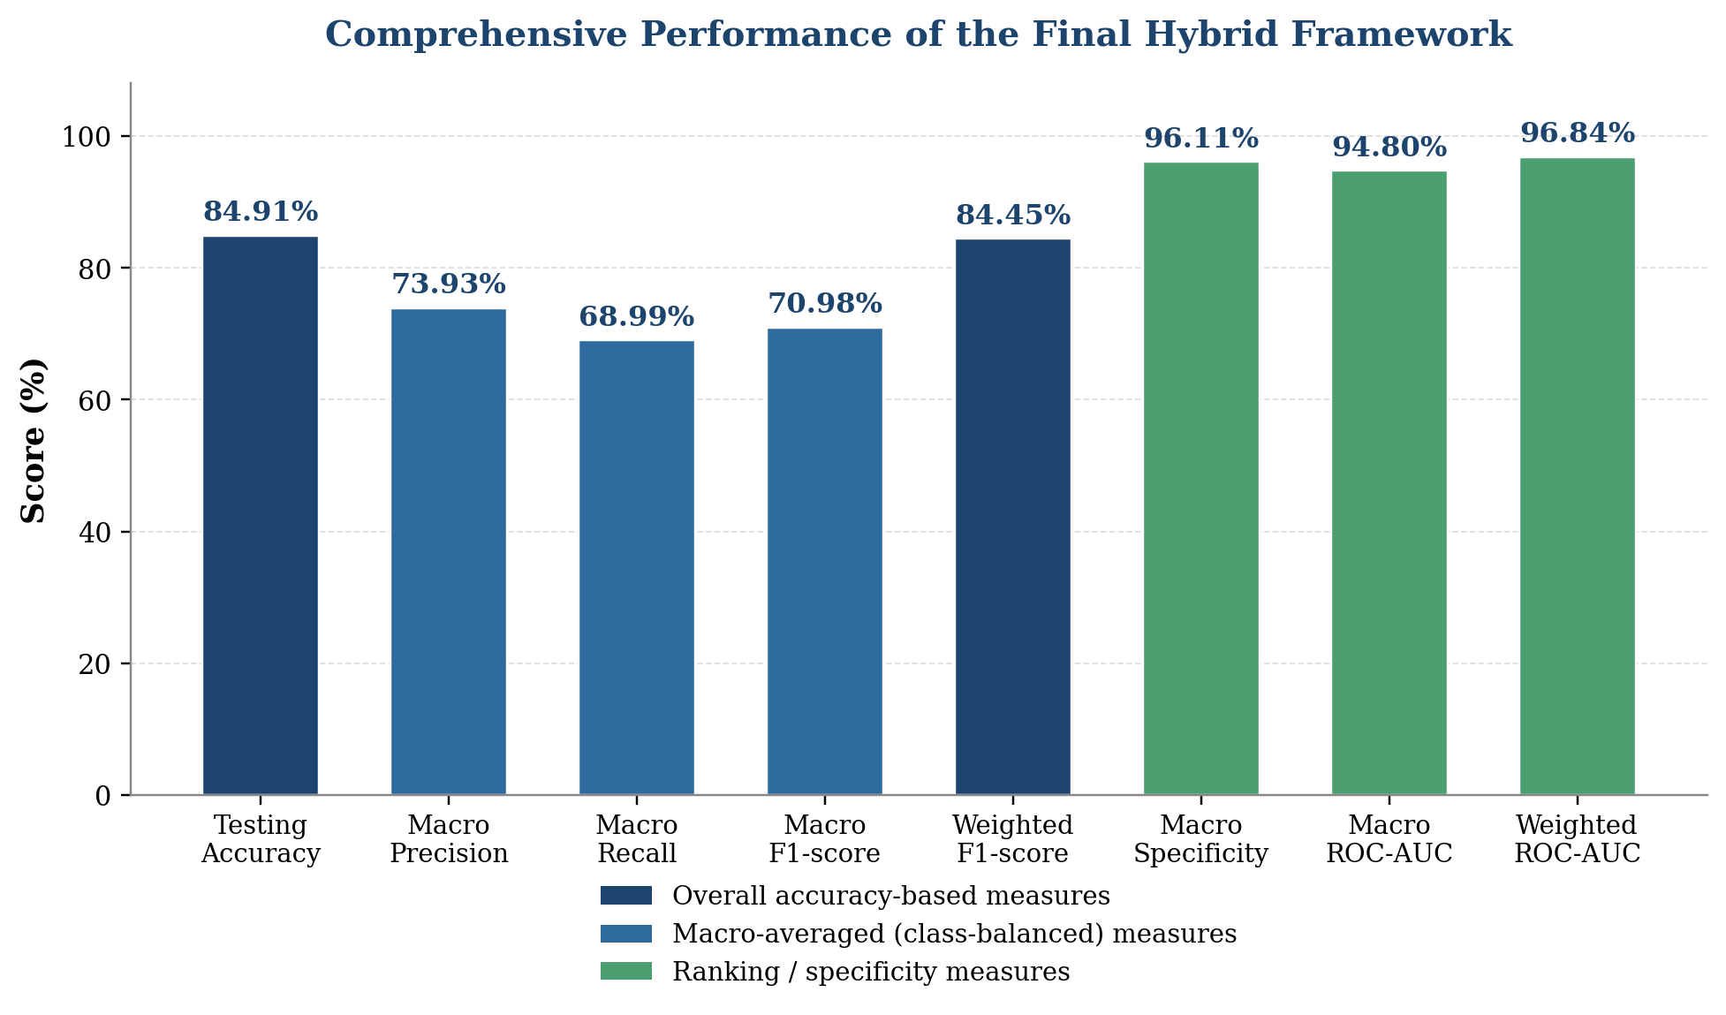
Figure 16: Bar Chart of the Comprehensive Performance Metrics of the Final Hybrid Framework
Table 8 compares the proposed framework with selected studies that used the APTOS 2019 dataset for five-class diabetic retinopathy grading and reported lower accuracy than the present study. Restricting the comparison to the same dataset and classification task provides a more relevant assessment than comparing the framework with binary-classification studies or methods evaluated on different retinal datasets. Nevertheless, the studies differ in preprocessing, data partitioning, augmentation, feature-learning strategies, and validation procedures. Therefore, the comparison should be interpreted as a descriptive contextual analysis rather than a strictly controlled benchmark.

Table 8: Comparison of the Proposed Framework with Selected Related Studies

Study | Method | Dataset / Task | Reported Accuracy
Kumar et al. [28] | DRISTI: VGG16 + Capsule Network | APTOS 2019; five-class grading | 75.81% test accuracy
Mohanty et al. [23] | VGG16 feature extraction + XGBoost | APTOS 2019; five-class grading | 79.50%
Islam et al. [29] | Xception + supervised contrastive learning | APTOS 2019; five-class grading | 84.36%
Proposed framework | ConvNeXt-Tiny + Swin-V2-Tiny + Random Forest | APTOS 2019; five-class grading | 84.91%

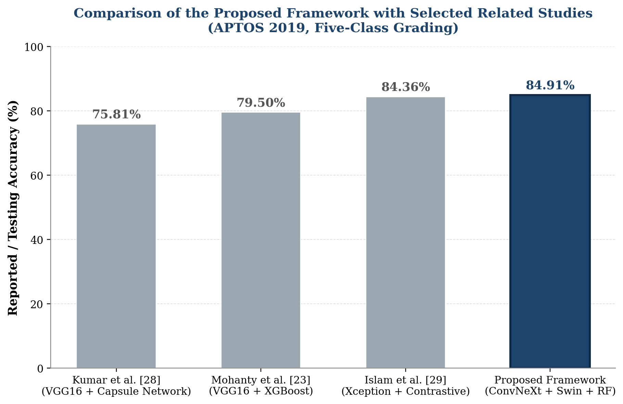
Figure 17: Bar Chart Comparison of the Proposed Framework with Selected Related Studies

4.4 Discussion of Findings

4.4.1 Contribution of Feature Fusion and Random Forest
The fused representation combined two complementary feature families. ConvNeXt-Tiny contributed strong local and hierarchical convolutional patterns, while Swin-V2-Tiny added contextual information derived from shifted-window attention. The improvement over a single representation was moderate rather than dramatic, which suggests partial redundancy between the embeddings; nevertheless, the fused vector provided Random Forest with a broader set of discriminative variables. The ensemble classifier then modeled nonlinear interactions between these variables without requiring additional end-to-end deep-network training.
The high training accuracy reflects the capacity of the tree ensemble to fit the fused training representation, whereas the lower held-out values show that this capacity did not transfer completely to unseen images. Regularization through shallow trees, large minimum split and leaf sizes, restricted feature sampling, bootstrap sampling, and balanced-subsample weighting reduced model complexity. The remaining 14.04-point gap therefore indicates residual overfitting rather than unstable validation, because validation and testing accuracies differed by only 1.25 percentage points.

4.4.2 Interpretation in Relation to Related Work
The proposed accuracy of 84.91% is close to the 85.10% multiclass result reported by Youldash et al. [18] and exceeds some results obtained on IDRiD or other Kaggle diabetic retinopathy settings [22], [27]. Several reviewed studies report substantially higher accuracies, but many use different datasets, binary tasks, extensive enhancement, external images, or non-identical partitions. Their values cannot therefore be treated as direct evidence that one model is superior under the present protocol.
The main strength of the present experiment is its controlled evaluation procedure: preprocessing and splitting were fixed, augmentation was restricted to training, deep checkpoints were selected using validation data, Random Forest parameters were chosen without consulting the final test subset, and performance was reported through both aggregate and class-sensitive measures. This design makes the observed strengths and weaknesses traceable and supports reproducibility, even though further improvement is required in minority-class recall.

4.5 Limitations
The proposed framework still shows a noticeable gap between training and held-out performance, particularly in macro recall and macro F1-score, indicating that the results require further improvement, especially for the underrepresented severity classes such as Mild, Severe, and Proliferative DR. The computational time was also relatively long, since the framework required fine-tuning two deep-learning backbones, extracting two sets of embeddings, and evaluating multiple Random Forest configurations, which increased the overall time needed to reach the final trained model.

4.6 Chapter Summary
This chapter presented the held-out evaluation of the fused Random Forest classifier. The model achieved 84.91% testing accuracy, 70.98% macro F1-score, 84.45% weighted F1-score, 96.11% macro specificity, and 94.80% macro ROC-AUC. Confusion-matrix analysis showed that most errors occurred among adjacent and underrepresented severity grades. The discussion related these outcomes to feature fusion, class imbalance, regularization, and the reviewed literature.

Chapter 5 Conclusion and Future Work
This thesis investigated the development of an automated five-class diabetic retinopathy grading framework using retinal fundus images. The study addressed the major challenges associated with automated diabetic retinopathy classification, including variations in image acquisition conditions, substantial class imbalance, and the difficulty of distinguishing visually similar neighboring disease stages. To address these challenges, a hybrid framework was developed by integrating complementary convolutional and transformer-based visual representations with a regularized machine-learning classifier. The proposed framework was evaluated using the APTOS 2019 Blindness Detection dataset, which contains 3,662 retinal fundus images distributed across five severity categories. A deterministic preprocessing pipeline was employed to reduce irrelevant image variability while preserving clinically meaningful retinal structures. Training-only augmentation and class-sensitive optimization were applied to reduce the influence of class imbalance and improve the robustness of the feature-learning stage. The central contribution of the proposed framework is the integration of two complementary deep feature representations. ConvNeXt-Tiny was used to capture local and hierarchical visual patterns associated with retinal texture, vessels, exudates, hemorrhages, and other lesion-related structures. In contrast, Swin-V2-Tiny provided contextual representations through hierarchical shifted-window self-attention, enabling the model to capture broader spatial relationships within retinal images. A regularized Random Forest was then used to perform the final five-class classification.

Overall, this thesis demonstrates that combining complementary convolutional and transformer-based representations provides a promising strategy for five-class diabetic retinopathy grading. ConvNeXt-Tiny contributes strong local and hierarchical visual representations, while Swin-V2-Tiny contributes contextual information from broader spatial relationships. Their feature-level fusion provides the downstream Random Forest with a richer representation than architecture alone. Future research should first evaluate the proposed framework on multiple independent retinal datasets to assess cross-dataset and cross-device generalization. Second, future studies should investigate more advanced strategies for addressing class imbalance. Third, explainable artificial intelligence (XAI) should be incorporated to improve the clinical interpretability of the proposed framework. Techniques such as Grad-CAM and related attribution methods could be used to identify the retinal regions influencing predictions . This would help bridge the gap between predictive performance and clinical trust.

References
[1] Sebastian, A., Elharrouss, O., Al-Maadeed, S., & Almaadeed, N. (2023). A survey on deep-learning-based diabetic retinopathy classification. Diagnostics, 13(3), 345.
[2] Haq, N. U., Waheed, T., Ishaq, K., Hassan, M. A., Safie, N., Elias, N. F., & Shoaib, M. (2024). Computationally efficient deep learning models for diabetic retinopathy detection: A systematic literature review. Artificial Intelligence Review, 57, 309.
[3] Senapati, A., Tripathy, H. K., Sharma, V., & Gandomi, A. H. (2024). Artificial intelligence for diabetic retinopathy detection: A systematic review. Informatics in Medicine Unlocked, 45, 101445.
[4] Prathibha, S., & Siddappaji. (2024). Advancing diabetic retinopathy diagnosis with fundus imaging: A comprehensive survey of computer-aided detection, grading and classification methods. Global Transitions, 6, 93-112.
[5] Ikram, A., Imran, A., Li, J., Alzubaidi, A., Ahim, S. F., Yasin, A. Y., & Fathi, H. F. (2024). A systematic review on fundus image-based diabetic retinopathy detection and grading: Current status and future directions. IEEE Access, 12, 96273-96303.
[6] Cortes, C., & Vapnik, V. (1995). Support-vector networks. Machine Learning, 20, 273-297.
[7] Breiman, L. (2001). Random forests. Machine Learning, 45, 5-32.
[8] Cover, T., & Hart, P. (1967). Nearest neighbor pattern classification. IEEE Transactions on Information Theory, 13(1), 21-27.
[9] Bappi, M. I., Juthy, J. A., & Kim, K. (2025). Deep learning-based diabetic retinopathy recognition and grading: Challenges, gaps, and an improved approach - A survey. ICT Express, 11(5), 993-1013.
[10] Liu, Z., Mao, H., Wu, C.-Y., Feichtenhofer, C., Darrell, T., & Xie, S. (2022). A ConvNet for the 2020s. Proceedings of the IEEE/CVF Conference on Computer Vision and Pattern Recognition, 11976-11986.
[11] Dosovitskiy, A., Beyer, L., Kolesnikov, A., Weissenborn, D., Zhai, X., Unterthiner, T., Dehghani, M., Minderer, M., Heigold, G., Gelly, S., Uszkoreit, J., & Houlsby, N. (2021). An image is worth 16 × 16 words: Transformers for image recognition at scale. In International Conference on Learning Representations.
[12] Liu, Z., Lin, Y., Cao, Y., Hu, H., Wei, Y., Zhang, Z., Lin, S., & Guo, B. (2021). Swin Transformer: Hierarchical Vision Transformer using shifted windows. Proceedings of the IEEE/CVF International Conference on Computer Vision, 10012-10022.
[13] Grzybowski, A., & Jin, K. (2026). Artificial intelligence-based medical devices for diabetic retinopathy screening in the European Union. Ophthalmology and Therapy, 15(2), 569-589.
[14] Jabbar, A., Liaqat, H. B., Akram, A., Sana, M. U., Azpiroz, I. D., de la Torre Diez, I., & Ashraf, I. (2024). A lesion-based diabetic retinopathy detection through hybrid deep learning model. IEEE Access, 12, 40019-40036.
[15] Liu, Z., Hu, H., Lin, Y., Yao, Z., Xie, Z., Wei, Y., Ning, J., Cao, Y., Zhang, Z., Dong, L., Wei, F., & Guo, B. (2022). Swin Transformer V2: Scaling Up Capacity and Resolution. Proceedings of the IEEE/CVF Conference on Computer Vision and Pattern Recognition, 12009-12019.
[16] Akhtar, S., Aftab, S., Ali, O., Ahmad, M., Khan, M. A., Abbas, S., & Ghazal, T. M. (2025). A deep learning based model for diabetic retinopathy grading. Scientific Reports, 15, 3763.
[17] Guefrachi, S., Echtioui, A., & Hamam, H. (2025). Diabetic retinopathy detection using deep learning multistage training method. Arabian Journal for Science and Engineering, 50, 1079-1096.
[18] Youldash, M., Rahman, A., Alsayed, M., Sebiany, A., Alzayat, J., Aljishi, N., Alshammari, G., & Alqahtani, M. (2024). Early detection and classification of diabetic retinopathy: A deep learning approach. AI, 5(4), 2586-2617.
[19] Shamrat, F. M. J. M., Shakil, R., Sharmin, S., Ovy, N. H., Akter, B., Ahmed, M. S., Ahmed, M. Z., Ahmed, K., Bui, F. M., & Moni, M. A. (2024). An advanced deep neural network for fundus image analysis and enhancing diabetic retinopathy detection. Healthcare Analytics, 5, 100303.
[20] Fayyaz, A. M., Sharif, M. I., Azam, S., Karim, A., & El-Den, J. (2023). Analysis of diabetic retinopathy (DR) based on deep learning. Information, 14(1), 30.
[21] Alwakid, G., Gouda, W., & Humayun, M. (2023). Enhancement of diabetic retinopathy prognostication using deep learning, CLAHE, and ESRGAN. Diagnostics, 13(14), 2375.
[22] Lin, C.-L., & Wu, K.-C. (2023). Development of revised ResNet-50 for diabetic retinopathy detection. BMC Bioinformatics, 24, 157.
[23] Mohanty, C., Mahapatra, S., Acharya, B., Kokkoras, F., Gerogiannis, V. C., Karamitsos, I., & Kanavos, A. (2023). Using deep learning architectures for detection and classification of diabetic retinopathy. Sensors, 23(12), 5726.
[24] Patil, M. S., Chickerur, S., Abhimalya, C., Naik, A., Kumari, N., & Maurya, S. (2023). Effective deep learning data augmentation techniques for diabetic retinopathy classification. Procedia Computer Science, 218, 1156-1165.
[25] Ali, A. A., & Dawood, F. A. A. (2023). Deep learning of diabetic retinopathy classification in fundus images. Journal of Engineering, 29(12), 139-152.
[26] Das, D., Biswas, S. K., & Bandyopadhyay, S. (2023). Detection of diabetic retinopathy using convolutional neural networks for feature extraction and classification (DRFEC). Multimedia Tools and Applications, 82(19), 29943-30001.
[27] Jiwani, N., Gupta, K., & Afreen, N. (2022). A convolutional neural network approach for diabetic retinopathy classification. In 2022 IEEE 11th International Conference on Communication Systems and Network Technologies (CSNT) (pp. 357-361). IEEE.
[28] Kumar, G., Chatterjee, S. K., & Chattopadhyay, C. (2021). DRISTI: a hybrid deep neural network for diabetic retinopathy diagnosis. Signal, Image and Video Processing, 15(8), 1679-1686.
[29] Islam, M. R., Abdulrazak, L. F., Nahiduzzaman, M., Goni, M. O. F., Anower, M. S., Ahsan, M., Haider, J., & Kowalski, M. (2022). Applying supervised contrastive learning for the detection of diabetic retinopathy and its severity levels from fundus images. Computers in Biology and Medicine, 146, 105602.

