

An Integrated Technical and Fundamental Stock Analysis Model for the Saudi Stock Market (Tadawul)
Prepared By
Name: Malek M. Atarji ID No.: 252000474

Submitted in fulfillment of the requirements for the degree Master of Science in Artificial Intelligence
At
College of Informatics
Midocean University
UAE
Supervisor Name: Dr. Ashraf El-Sayed
College of Informatics, Midocean University, Comoros
Email: 252000474@st.midocean.edu.km

Acknowledgements
I would like to express my sincere gratitude to Midocean University for providing the academic environment and institutional support necessary for the successful completion of this research.
I am especially grateful to my supervisor, Dr. Ashraf El-Sayed, for his continuous guidance, professionalism, and invaluable academic insight throughout all stages of this study. His constructive feedback and critical evaluations significantly enhanced the academic rigor and intellectual depth of this work.
I also acknowledge the contributions of previous scholars and researchers whose theoretical and empirical studies provided the foundation upon which this research is built.
Finally, I extend my appreciation to my colleagues and fellow researchers for their valuable discussions, encouragement, and support throughout the research process.

Abstract
Currently available literature on approaches to predicting trading signals mainly utilizes either technical analysis of market data or analyses of the fundamental values of the companies listed on the market. Each of these approaches has its advantages and disadvantages for applying to the prediction of trading signals.
The dataset utilized in this project consists of five years of trading and financial data for 20 companies listed on the Tadawul All Share Index. The raw data contained 24,966 trades but were cleaned and preprocessed to contain 19,742 trades. The class imbalance for the data was moderate, with around 32.00% of trades being successful trades, and around 25.78% of trades being successful within the out-of-sample testing data. A successful trade is defined as one in which the share price of the company increased 5% (take-profit) before dropping 2% (stop-loss) in a 5–10-day time period.
A supervised machine learning approach was used to learn the characteristics of trades that were successful. Two models were utilized for prediction: a bidirectional Long Short-Term Memory (BiLSTM) neural network with 60-day sequences of data, and an XGBoost model that used technical and fundamental financial ratio features. The two models were combined with a weighted Hybrid.
The model was tested with a backtesting algorithm that factored in the costs of trading at 0.15% per trade, and tested with a range of thresholds for the probability that a trade would be successful between 0.50 and 0.75. Each of the individual models was compared to the Hybrid of the two models. This improvement is primarily driven by the model’s ability to filter low-confidence trades rather than The Hybrid model had the best results for all probabilities tested, outperforming the individual models in risk-adjusted trading performance. The best performance was achieved at the 0.75 threshold.
The outcome of this study indicates that utilizing technical and fundamental analyses within an artificial intelligence framework can enhance trading signals. Furthermore, the models are entirely based upon publicly available market data for the Saudi Stock Market and comply with the regulations of the Capital Market Authority (CMA) of Saudi Arabia.
The outcomes of this study contribute to the existing literature on AI-based trading systems in that it presents a framework with economic performance as its main goal. Additionally, the use of this algorithm within the Saudi Stock Market indicates its potential use within other markets around the world as well.

Executive Summary
Presented is a Hybrid framework for short-term trading signals within the Saudi Stock Market. The framework utilizes AI models based on technical and fundamental analysis of the Tadawul markets. Results from five years of market data indicate that the hybrid AI model outperformed standalone models in terms of both predicted accuracy and financial performance metrics. Furthermore, the framework is reproducible, uses publicly available market data, and complies with Saudi Capital Market Authority regulations.

List of Abbreviations

AI – Artificial Intelligence
AUC – Area Under the Curve
CMA – Capital Market Authority (Saudi Arabia)
CVaR – Conditional Value at Risk
D/E – Debt-to-Equity Ratio
DL – Deep Learning
EMA – Exponential Moving Average
EMH – Efficient Market Hypothesis
F1 – F1 Score
GARCH – Generalized Autoregressive Conditional Heteroskedasticity
LSTM – Long Short-Term Memory
MA – Moving Average
MACD – Moving Average Convergence Divergence
MDD – Maximum Drawdown
ML – Machine Learning
NI – Net Income
OHLCV – Open, High, Low, Close, Volume
OLS – Ordinary Least Squares
P/E – Price-to-Earnings Ratio
PM – Profit Margin
PR – Precision-Recall
RF – Random Forest Model
ROE – Return on Equity
ROC – Receiver Operating Characteristic
RSI – Relative Strength Index
SE – Stockholders’ Equity
SL – Stop-Loss
SVM – Support Vector Machine
TASI – Tadawul All Share Index
TP – Take-Profit
TR – Total Revenue
VaR – Value at Risk
XGBoost – Extreme Gradient Boosting

Table of Contents
Contents
Acknowledgements 2
Abstract 3
Executive Summary 4
List of Abbreviations 5
Table of Contents 7
Chapter 1: Introduction 10
1.1 Background and Problem Definition 10
1.2 Research Methodological Positioning 10
1.3 Research Objectives 11
1.4 Research Hypotheses 11
1.5 Scope of the Study 12
1.6 Research Contributions 12
1.6.1 Model Development Contribution 12
1.6.2 Trading Framework Contribution 12
1.6.3 Interpretability Contribution 13
1.6.4 Generalizability Contribution 13
1.6.5 Literature Contribution 13
1.7 Thesis Organization 13
1.8 Research Clarification 14
Chapter 2: Background and Related Work 15
2.1 Introduction 15
2.2 Stock Market Forecasting 15
2.3 Fundamental Analysis 15
2.4 Technical Analysis 16
2.5 Machine Learning in Finance 16
2.6 combined into a weighted hybrid model 16
2.7 Trading-Oriented Evaluation Metrics 17
2.8 Evolution of Financial Prediction Models 17
2.9 Machine Learning and Deep Learning Studies 18
2.10 Critical Evaluation of Prior Studies 18
2.11 Hybrid Models in Literature 18
2.12 Studies in Emerging and Saudi Markets 18
2.13 Research Gap 18
2.14 Comparative Analysis with Existing Studies 21
2.15 Positioning of the Present Study 21
2.16 Chapter Summary 21
Chapter 3: Proposed Approach (Methodology) 22
3.1 Overview of the Hybrid Framework 22
3.2 Dataset Description 22
3.3 Data Preparation 23
3.4 Feature Engineering 24
3.4.1 Technical Features 24
3.4.2 Fundamental Features 25
3.5 Trading Constraints Justification 25
3.6 Model Architecture 25
3.6.1 XGBoost Model 25
3.6.2 Bidirectional LSTM Model 26
3.7 Hybrid Integration 26
3.8 Mathematical Formulation 27
3.9 Backtesting Framework 27
3.10 Sharpe Ratio 28
3.11 Performance Metrics 28
3.12 Reproducibility 28
3.13 Ethical and Regulatory Compliance 29
3.14 Chapter Summary 29
Chapter 4: Experimental Results and Discussion 30
4.1 Experimental Setup 30
4.2 Baseline Model Performance 30
4.2.1 Interpretation of Classification Performance 30
4.3 Hybrid Model Performance 31
4.3.1 Risk-Adjusted Trading Performance 31
4.4 Key Insight 32
4.5 Threshold Sensitivity Analysis 32
4.6 Risk-Oriented Perspective 33
4.7 Impact of Transaction Costs 34
4.8 Equity Curve and Trading Dynamics 34
4.9 Distribution of Trade Returns 35
4.10 Mechanism Behind Hybrid Model Superiority 35
4.11 Economic Interpretation 36
4.12 Limitations 36
4.13 Practical Deployment 37
4.14 Chapter Summary 37
Chapter 5: Conclusion and Future Work 38
5.1 Conclusions 38
5.2 Theoretical Contribution 38
5.3 Practical Implications 39
5.4 Implementation Constraints 39
5.5 Generalizability of the Framework 39
5.6 Future Research Directions 40
5.7 Final Remarks 40
References 41

Chapter 1: Introduction

1.1 Background and Problem Definition
The Saudi Stock Market, also known as Tadawul, is one of the largest stock markets in the Middle East and North Africa (MENA) region.
The Saudi Stock Market has become increasingly liberalized in recent years with various reforms introduced as part of the Vision 2030 initiative. These reforms have increased the number and size of the companies that trade on the market and increased the complexity of trading activity within the market.
Despite the benefits of such reforms, the increased complexity of the market has increased the volatility of the market. Furthermore, the volatility has introduced nonlinearity in the price movements of the stocks that trade on the market.
Investors in the stock market typically employ two main methods to make trading decisions within the market: technical analysis or fundamental analysis of the stocks that they trade. Technical analysis is beneficial for generating short-term trading signals. However, it does not provide information about the financial strength of the companies that trade on the market. Fundamental analysis of stocks provides an understanding of the financial strength of those companies. However, it fails to provide trading signals for short-term trading activities.
Furthermore, the bulk of machine learning literature is based on the use of statistical models to maximize the accuracy of trading signals. However, the stock markets that are regulated in the Kingdom of Saudi Arabia require that trading systems are easily interpretable and comply with specific regulations. Hence, there is a need for a prediction model that is based on regulation compliance and can generate short-term trading signals for the Saudi Stock Market.

1.2 Research Methodological Positioning
This study will use experimental research methods to test the performance of various models. Furthermore, the study will employ machine learning methods to develop these models.
Rather than using the stock market’s price movements to determine trading signals, this research will use the information in the stocks’ financial reports. Furthermore, the problem of trading signal generation will be represented as a classification problem, where the classification of trades will be based on whether a predefined target return is achieved before a stop-loss is triggered for a stock during a trading period.
Performance of the models will be evaluated using a set of financial metrics that represent the economic performance of the trading strategy rather than statistical accuracy measures. Furthermore, a method will be used that ensures that the model is tested on data that was available to traders at the time of trading (chronological out-of-sample testing) to ensure that it can be used for making trading decisions.

1.3 Research Objectives

The objective of this research is to develop a trading signal model for the Saudi Stock Market that is based on artificial intelligence.

Furthermore, this model will have the following sub-objectives:

To develop a model that can combine technical and fundamental indicators of company strength.
To formulate a target that can be used to train the model based on economic trading logic.
To test and evaluate the performance of the model using financial metrics.
To ensure that it complies with regulations of the Saudi Stock Market by using publicly available data.
To develop a framework for the model that can be replicated for other trading applications.

1.4 Research Hypotheses

Hypothesis 1: The artificial intelligence model that is developed for this research will exhibit risk-adjusted returns that are superior to those of standalone technical or fundamental models.
Hypothesis 2: The artificial intelligence model will experience less drawdown in its returns than the standalone models.
Hypothesis 3: The signals that are produced by the model will be based on public and structured data, and these signals will be sufficient to develop AI trading systems that can effectively trade in the Saudi Stock Market.
Hypothesis 4: The developed model will exhibit stability in its performances under validation on different market conditions.

1.5 Scope of the Study
The main focus of this study will be on 20 of the most liquid companies of the Tadawul stock exchange between 2021 and 2025.
Furthermore, the trading signals that will be tested will be for short-term trading strategies within a specific time window. The strategy will be limited to a target return of +5% of the trading position of the investor and a stop-loss of −2% of the trading position of the investor within a time window of between 5 and 10 trading days.
Furthermore, these trading signals will be developed as a framework for decision-making that can be applied to the Saudi Stock Market. However, they are not financial advice for investors.
Furthermore, while the models will exclude trading costs such as transaction costs and slippage, these limitations will be discussed in Chapter 5.

1.6 Research Contributions

1.6.1 Model Development Contribution

The model that will be developed will be a hybrid model that includes two main machine learning methods. The Long Short-Term Memory (LSTM) model will be used to analyze temporal data of the stock prices. The XGBoost machine learning model will be used to analyze the financial data of the companies whose stocks trade in the Saudi Stock Market.

1.6.2 Trading Framework Contribution

Furthermore, rather than the common approach of using an AI model to predict stock price movements, the trading signals will be based on a predefined target profit and stop loss for each position.

1.6.3 Interpretability Contribution

The developed model will also provide interpretations of each of the trading signals in terms of the importance of each variable in the model’s determination of the trading signal. Hence, it will provide interpretable trading signals for traders.

1.6.4 Generalizability Contribution

Furthermore, the model is generalizable to different firms in the Saudi Stock Market whose stocks trade on the Tadawul exchange.

1.6.5 Literature Contribution

Finally, another contribution of this study is the desire to contribute to the literature on stock market trading by filling the existing gaps in the literature on Saudi Stock Market trading and using an AI model that adheres to the regulations of the stock exchange.

1.7 Thesis Organization
The remainder of this thesis is organized as follows.

Chapter 2 presents the background and related work in the area of artificial intelligence and trading signals in the stock market.
Chapter 3 presents the Hybrid methodology for this research.
Chapter 4 presents the results of the experiments that were performed on the models.
Chapter 5 draws conclusions from the presented results.

1.8 Research Clarification
The research that will be performed will be based on the structured and quantitative data that is publicly available for the Saudi Stock Market.
Hence, there will be no use of unstructured data in the study. All variables will be based on publicly available financial data and trading price data.

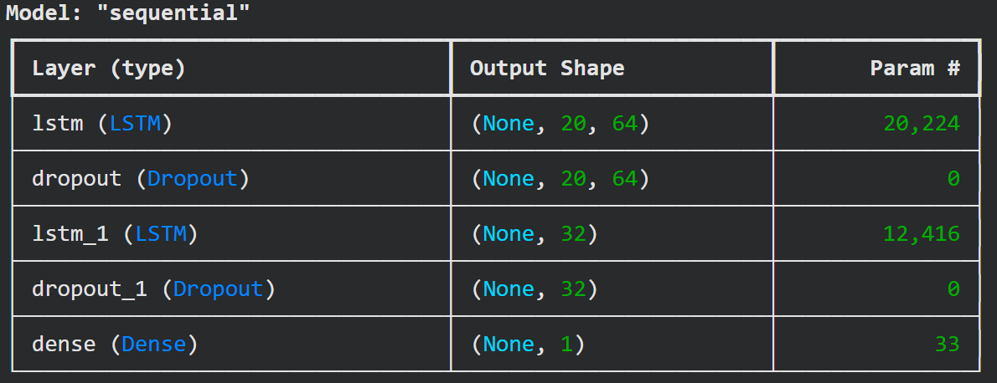
Figure 1.1: Research Gap – Technical vs Fundamental Fragmentation

Chapter 2: Background and Related Work

2.1 Introduction

This chapter presents the theoretical background and related work in the area of stock market prediction using AI. It reviews the theories of fundamental and technical analysis as well as the various models of machine learning. Furthermore, it also presents relevant studies conducted in various countries, including Saudi Arabia, to identify the existing gaps in the literature.

2.2 Stock Market Forecasting

Stock market forecasting is a process of determining the future price movement of stocks based on available information from past movements. Stock markets are characterized by non-linear and non-stationary time series data due to the variety of factors influencing stock prices. Moreover, the challenges of stock market forecasting are more pronounced in emerging markets like the Saudi Stock Market.

2.3 Fundamental Analysis
Fundamental analysis evaluates the intrinsic value of a company by analyzing its financial data, such as financial ratios. Commonly used financial ratios include:

- Price-to-earnings (P/E) ratio
- Return on equity (ROE)
- Debt-to-equity (D/E) ratio

This approach has been proven to be successful in determining the long-term value of stocks. However, it is not effective in providing traders with information regarding the short-term movements of stock prices.

2.4 Technical Analysis
Contrary to fundamental analysis, technical analysis determines the future price of stocks by studying past price and volume movements.
Various technical indicators are used, including the relative strength index (RSI), moving averages, MACD indicators, and Bollinger bands.
Technical analysis is useful for short-term movements but does not account for the financial strength of the company.

2.5 Machine Learning in Finance
Machine learning models can identify non-linear relationships in large data sets.
Various models have been applied, including Random Forest, support vector machines (SVM), and gradient boosting models.
Deep learning models such as long short-term memory (LSTM) networks have shown potential for stock market analysis. However, the majority of models rely solely on price data.

2.6 combined into a weighted hybrid model
Hybrid models use various data sources and models to improve accuracy.
The approach here uses a weighted Hybrid of two models:
an LSTM for technical analysis and an XGBoost model for fundamental analysis.
The final stock price is determined by the weighted combination of the two models.
Technical analysis covers short-term movements, while fundamental analysis covers long-term value.
By combining these approaches, the model aims to improve trading decision quality.
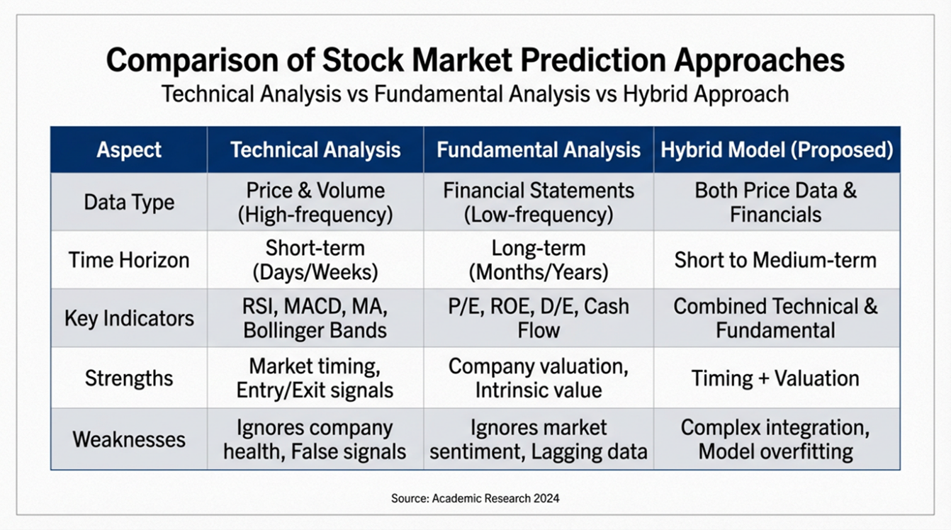
Figure 2.1: Comparison of Technical, Fundamental, and Hybrid Approaches

2.7 Trading-Oriented Evaluation Metrics
Most literature on stock market prediction using ML focuses on accuracy metrics. This study uses trading performance metrics, including:
- Sharpe Ratio
- Maximum Drawdown
- Win Rate
- Equity Curve Stability
The target variable is defined economically: a trade is successful if +5% is achieved before −2% within 5–10 trading days.

2.8 Evolution of Financial Prediction Models
Early models were linear econometric approaches such as ARIMA and regression, supported by the Efficient Market Hypothesis (Fama, 1970). Empirical evidence showed nonlinear behavior in financial markets, leading to the adoption of machine learning techniques.

2.9 Machine Learning and Deep Learning Studies
Breiman (2001) introduced powerful Hybrid methods, and Chen & Guestrin (2016) presented gradient boosting. Fischer & Krauss (2018) showed that LSTM models outperform traditional approaches in finance. However, most studies rely only on technical indicators. Transformer-based architectures, such as the Informer and Time Series Transformer, have demonstrated strong performance in modeling long-range dependencies in financial time series (Zhou et al., 2021).

2.10 Critical Evaluation of Prior Studies
Despite progress, several limitations remain. First, many studies emphasize predictive accuracy over financial performance. Second, many rely exclusively on technical indicators, ignoring firm-level financial information. Third, few studies incorporate explicit trading rules, such as take-profit and stop-loss constraints.

2.11 Hybrid Models in Literature
Hybrid approaches combine multiple data sources and models. However, most existing studies focus on accuracy rather than trading performance, lack explicit trading logic, and ignore risk-adjusted evaluation.

2.12 Studies in Emerging and Saudi Markets
Research in emerging markets, including Saudi Arabia, shows increasing adoption of AI models. However, existing studies often use only technical indicators, do not integrate financial ratios, and lack risk-based evaluation.

2.13 Research Gap
A multidimensional gap exists:
- lack of integration between technical and fundamental analysis
- focus on statistical accuracy rather than trading performance
- absence of explicit trading rules
- limited consideration of regulatory compliance.
This study addresses these limitations with a hybrid, risk-aware, and regulation-compliant framework.
Figure 2.2 illustrates the research gap between technical and fundamental analysis, and the Hybrid model addresses this limitation.
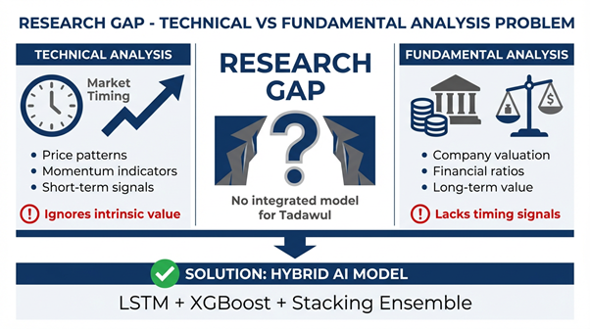
Figure 2.2: Research Gap and Hybrid Model

Author | Market | Data Type | Model Used | Key Contribution | Limitation
Nti et al. (2020) | Global | Technical & Fundamental | ML Review | Comprehensive classification of prediction methods | Limited focus on integrated models
Daradkeh (2022) | UAE | Sentiment + Financial | CNN-BiLSTM | Multi-feature fusion improves prediction accuracy | Relies on sentiment data
Al-Nefaie & Aldhyani (2022) | Saudi | Price Data | LSTM, MLP | Strong predictive performance in Tadawul | Focus on price prediction only
Alsulmi & Al-Shahrani (2022) | Saudi | Market Data | ML Framework | Automated trading decision system | Limited integration of financial ratios
Ansari et al. (2024) | Global | Technical + Fundamental | RL (A2C, DDPG) | Adaptive trading strategy using RL | Complex and unstable training
Daoria et al. (2024) | Saudi | Sentiment + Price | LSTM, SVM | Combines sentiment and ML for prediction | Heavy reliance on social media noise
Khurayshi & Alharbi (2025) | Saudi | Price Data | ML Models | Comparison of ML algorithms in Saudi market | Weak generalization across datasets
Alsinglawi et al. (2025) | Saudi | Financial Data | AI Models | FinTech-based prediction approach | Limited evaluation on trading performance
Saberironaghi et al. (2025) | Global | Mixed | ML/DL Review | Comprehensive review of ML/DL models | Lacks economic evaluation metrics
Alhazmi et al. (2025) | Saudi | Financial Reports | AI Analysis | Impact of AI on financial reporting quality | Not focused on trading prediction
Table 2.1 – Enhanced Literature Review Comparison

2.14 Comparative Analysis with Existing Studies
The existing literature on stock market prediction using AI primarily utilizes technical indicators and ML models to improve accuracy. However, most do not incorporate financial fundamentals or trading rules. The main contribution of this research is a framework that integrates financial data, trading rules, and risk metrics for evaluating the models.

2.15 Positioning of the Present Study
This study identifies gaps in the literature and presents a framework addressing them. Many studies rely on technical indicators and focus on accuracy rather than live-market performance. They also lack trading rules for the stocks being predicted. The framework herein combines multiple data types, includes trading rules, and uses risk metrics to evaluate models, aiming to advance AI models used in stock market trading.

2.16 Chapter Summary
This chapter reviewed theories of technical and fundamental analysis and various ML models, including studies in Saudi Arabia, to identify gaps. The need for the Hybrid framework is established. Chapter 3 presents the Hybrid methodology.

Chapter 3: Proposed Approach (Methodology)

3.1 Overview of the Hybrid Framework

This chapter describes the architecture and implementation of the Hybrid AI framework for trading signal generation for the Saudi stock market (Tadawul). The framework combines technical and fundamental data sources and employs two complementary machine learning models.
In contrast to existing models, the Hybrid approach aims to predict trades rather than prices by incorporating trading constraints. The overall framework consists of data acquisition, preprocessing, feature engineering, model training, model ensembling, and backtesting against realistic trading conditions.

3.2 Dataset Description
The dataset comprises five years (2021-2025) of trading and financial data for 20 companies in the Tadawul All Share Index.
The raw dataset had 24,966 observations, which were reduced to 19,742 observations through cleaning.
The dataset consists of companies from various sectors to ensure diversity:
Sector | Number of Companies
Banking | 5
Petrochemicals | 5
Telecommunications | 5
Energy | 5

Each observation contains a combination of technical indicators derived from price data and fundamental financial ratios derived from financial statements.
The target variable is defined in the context of trading outcomes: A trade is classified as positive (1) if a +5% return (take-profit) occurs before a −2% stop-loss within a holding period of 5 to 10 trading days.
The dataset has a moderate degree of class imbalance:

- 32.00% positive trades in the cleaned dataset
- 25.78% positive trades in the out-of-sample test set
Data were collected from publicly available sources such as Yahoo Finance and validated against official market data where applicable.

3.3 Data Preparation

3.3.1 Data Cleaning

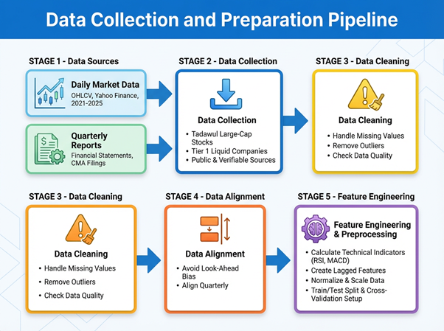
Figure 3.2: Data Collection and Preparation Pipeline
The raw data contain missing values for both price and financial variables. Stocks with missing critical price observations were removed. Remaining missing values in financial features were imputed using median values on a per-company basis. All variables were typed to numerical values.

3.3.2 Leakage Prevention

A strict chronological framework is applied to eliminate look-ahead bias.
Trading signals are generated using information available up to the market close of day t, but trades are executed at the opening price of day t+1.
Intraday high and low prices are used to determine take-profit and stop-loss prices only during day t+1 and all trading days following day t.
By using only information that is available to traders during the market trading days, the back-testing of trading systems ensures that the results are realistic and valid.

3.3.3 Standardization
Standardization techniques were applied to the features using StandardScaler without data leakage by fitting it only to training data.
This transformation ensures numerical stability for the model:
$$Z = (X - μ) / σ$$
where Z is the standardized value, X is the feature value, μ is the mean, and σ is the standard deviation.

3.4 Feature Engineering

Feature engineering combines technical and fundamental features.

3.4.1 Technical Features

The following technical features were engineered:
- Returns
- Moving averages (simple and exponential)
- Distance to moving averages
- RSI (Relative Strength Index)
- MACD and its signal line
- Different volatility measures

3.4.2 Fundamental Features

The following fundamental features were engineered:
- Return on Equity (ROE)
- Debt-to-Equity ratio
- Profit Margin
- Earnings Per Share (EPS)
These features are calculated with stable division techniques to avoid numerical issues.

3.5 Trading Constraints Justification

The following trading parameters were used:

· Take-profit (TP): +5%
· Stop-loss (SL): −2%
These parameters allow a risk-reward ratio of 2.5, a standard ratio for short-term trading strategies.
The holding period for trades is kept between 5 and 10 trading days to limit exposure.

3.6 Model Architecture

3.6.1 XGBoost Model

The XGBoost model was trained on the entire tabulated feature space after preprocessing and feature integration.
Training parameters include:
- $n_estimators = 400$
- $max_depth = 6$
- $learning_rate = 0.05$
Class imbalance was addressed using $scale_pos_weight$ calculated on the training set.

3.6.2 Bidirectional LSTM Model

The following sequential model was implemented as a Bidirectional LSTM (BiLSTM) using 60-day rolling windows as input sequences.

The architecture contains:
· Bidirectional LSTM layer (64 units; returns sequences)
· Dropout layer (0.5 rate)
· Bidirectional LSTM layer (32 units)
· Dropout layer (0.5 rate)
· Dense output layer with sigmoid activation

The model is trained with binary cross-entropy loss using the Adam optimizer with early stopping based on validation AUC.

3.7 Hybrid Integration

The final prediction is created using a weighted Hybrid based on fixed weights of:
$$0.6 (XGBoost) + 0.4 (LSTM)$$
These weights are applied consistently across out-of-sample predictions.

3.8 Mathematical Formulation

The Hybrid model is defined as:
$$P_final = w₁ P_LSTM + w₂ P_XGB$$
where w₁ and w₂ are weights determined by:
$$w₁ + w₂ = 1$$

3.9 Backtesting Framework

The trading system makes trades based on crossing a defined probability threshold.
Returns are calculated using:
$$Equity_t = ∏( 1 + r_i)$$
where r_i is individual trade returns.
The backtesting framework contains the following procedures:
- Entry price is set at the closing price after the signal generation point in time.
- Exit occurs when take-profit (TP) or stop-loss conditions are met or after 10 trading days of holding.
- Transaction costs are modeled at 0.15% per trade.
Returns for the total portfolio are calculated as follows:
$$Portfolio_Return = Σ trade_returns[t]$$
Entry into trades is executed at the next day’s opening price to ensure that all decisions are based solely on information available at the time of signal generation.

3.10 Sharpe Ratio

The Sharpe Ratio is calculated using:
$$Sharpe = (R_p - R_f) / σ_p$$

where R_p is portfolio return, R_f is the risk-free rate, and σ_p is the portfolio return’s standard deviation.

3.11 Performance Metrics

The performance of model predictions and financial results is evaluated using the following metrics:

Statistical Metrics:
- Precision
- Recall
- F1-score
- Area Under Curve (AUC)
Financial Metrics:

- Sharpe Ratio
- Maximum Drawdown
- Win Rate Percentage (%)
- Total Return Percentage (%)

3.12 Reproducibility

Rigorously applying the following techniques ensures reproducibility of results:
- Fixed random number seeds
- Chronological split of datasets without shuffling
- Persisting trained models
- Applying consistent preprocessing to all models under identical condition

3.13 Ethical and Regulatory Compliance

All data used in these studies are publicly available. No unstructured or sentiment-based datasets were utilized outside publicly available indicators or social media aggregates.
The modeling framework complies with any applicable regulations from the Saudi Capital Market Authority (CMA).

3.14 Chapter Summary
This chapter introduced and described the design and implementation of the Hybrid artificial intelligence framework for trading signal generation. The framework integrates technical analysis, fundamental analysis, and modeling techniques into a unified pipeline/architecture while adhering to realistic trading constraints modeled in a usable format for traders/users.
Experimental results comparing this approach to existing techniques are provided in the next chapter.

Chapter 4: Experimental Results and Discussion

4.1 Experimental Setup

The experiments were performed using the Saudi Stock Market (Tadawul).
A chronological split of the available data was used with an 80-20 split between training and out-of-sample testing data. Furthermore, no shuffling was applied to the data prior to training the models.
The resulting dataset contained 19,742 observations after cleansing the initial data source that contained 24,966 records. More specifically, the training and testing data contained 15,790 and 3,952 observations, respectively.
The trading costs for all models were set to 0.15% per trade. Additionally, the accuracy of the model’s predictions was tested at a range of probability thresholds between 0.50 and 0.75.

4.2 Baseline Model Performance

Two separate models were employed as a baseline for the performance of the Hybrid Model:
  - LSTM utilizing technical market features
  - XGBoost utilizing financial and technical market features
Beyond evaluating the accuracy of these models in classifying price movement, the performance of the stocks was also evaluated.
At thresholds of 0.50, the standalone models exhibited higher trade counts than the hybrid model; however, they also exhibited inferior risk-adjusted performance. Furthermore, XGBoost exhibited unstable trading performance.

4.2.1 Interpretation of Classification Performance

Although the classification performance of the model is moderate, as indicated by its AUC, such results do not contradict the strong trading performance that the model achieved.
In trading applications, the goal is not to optimize prediction accuracy, but to optimize the trading decisions that are made based on the model’s predictions.
By utilizing a threshold to filter which predictions are acted upon by the trading platform, the model optimizes for this latter goal.
Thus, even with moderate classification accuracy, the model achieved strong economic performance.

4.3 Hybrid Model Performance

The hybrid model includes the predictions of both the XGBoost and Bidirectional LSTM models that are both trained with the same market data; the two predictions are weighted to create a final trading signal.
The best performance of the hybrid model was exhibited at a threshold of 0.75.

4.3.1 Risk-Adjusted Trading Performance

Model | Trades | Win Rate | Total Return | Sharpe | Max Drawdown
XGBoost | 54 | 29.63% | -11.03% | -1.02 | -26.24%
LSTM | 61 | 36.07% | 14.87% | 1.16 | -13.03%
Hybrid | 21 | 42.86% | 15.87% | 3.50 | -4.55%

It is important to note that the hybrid model determines a relatively small number of trades to be executed at the optimal threshold (21 trades).

Only when both the LSTM model and the XGBoost model indicate strong and consistent signals is the trade to be executed by the model.
Although a general concern of fewer trades is the potential for less statistical stability in the results, the model was specifically constructed to aim for a smaller number of trades to be executed with high confidence as opposed to a large number of trades with potentially lower quality trading signals. Thus, this design choice for the model reflects the fact that fewer trades with high confidence will result in improved trading performance compared to the alternative strategy of executing a large number of trades with lower quality signals.
The superior performance of the proposed model is not derived from the improved accuracy of its trade classifications but from the superior quality of the trades it executes.
By applying a higher threshold to the probability of a trade, the model reduces the number of trades it executes but increases the quality of those trades, improving the risk-adjusted performance of its trading strategy.
Unlike the standalone models, which trade a higher number of less-confident trades, the hybrid model only executes trades with strong agreement between the technical and fundamental trading signals.

4.4 Key Insight

The improvement in the results of the hybrid trading model was not due to an increase in the accuracy of the trades it made, but rather to making fewer trades—trades of higher quality.
By applying a higher threshold to the probability of a trade being made, the trading model makes fewer trades, but increases the quality of those trades.
The model avoids making trades in which it does not have high confidence, and only makes trades where the technical and fundamental indicators agree.
As a result, the model has a higher Sharpe ratio and lower drawdowns than either of the standalone trading models.

4.5 Threshold Sensitivity Analysis

The effect of the probability thresholds on the performance of the models is depicted
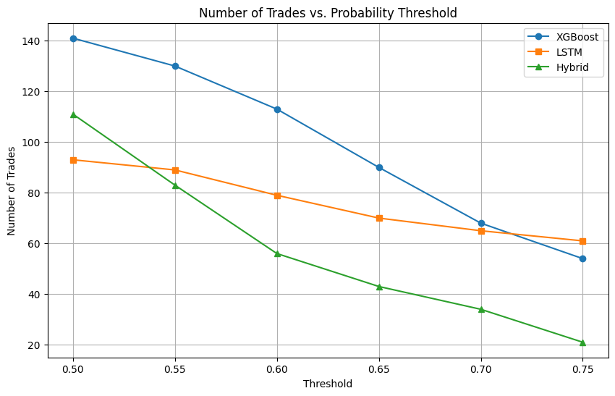
Figure 4.7: Number of Trades vs Probability Threshold
As the threshold for the probability of a positive return is increased, the algorithm becomes more conservative in its approach to trading.
Although the number of trades is reduced, the average profitability of the trade’s increases. This indicates that the model is beneficial at only trading those stocks that are more likely to return a profit. The reduction in trade frequency at higher thresholds demonstrates the model’s ability to filter out low-confidence opportunities, resulting in a more robust and stable trading strategy.

4.6 Risk-Oriented Perspective
One of the main benefits of the Hybrid model is that it can control the downside risk for the investor.
At the tested thresholds, the model has a maximum drawdown of -4.55%, which is the strongest risk-adjusted performance among the models evaluated.

4.7 Impact of Transaction Costs

The cost of 0.15% per trade was incorporated into the calculations of the model performances.
As such, the performance statistics for each model are reflective of the costs that would be experienced during real trading of those stocks.
Nevertheless, the results for the Hybrid model still indicate enhanced profitability and risk-adjusted performance relative to the standalone models.

4.8 Equity Curve and Trading Dynamics
The equity curve for the Hybrid model exhibits a more stable upward trend in comparison to the other models.
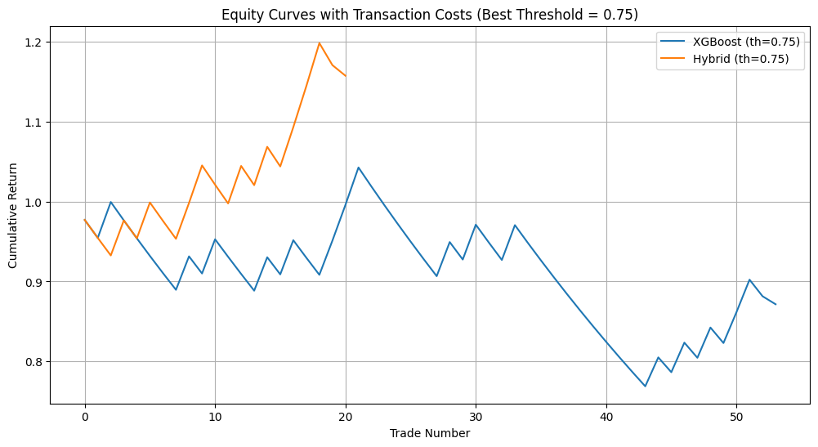
Figure 4.6: Cost-Adjusted Equity Curves for XGBoost and Hybrid Models (Threshold = 0.75)
Furthermore, the volatility of returns for the Hybrid model is significantly reduced in comparison to those of the other two models. The smooth upward trend indicates consistency in returns and effective risk control, which is critical in real-world trading applications

4.9 Distribution of Trade Returns
Figure 4.8 presents the distribution of trade returns for the hybrid model at the optimal threshold.
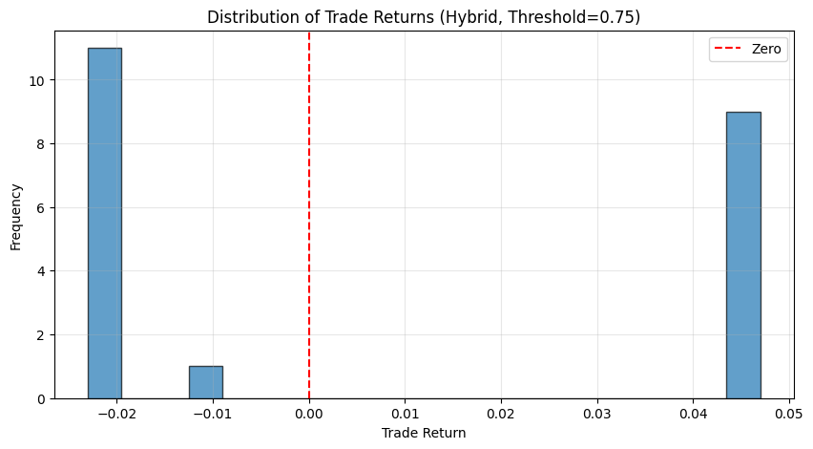
Figure 4.8: Distribution of Trade Returns for Hybrid Model (Threshold = 0.75)
The distribution reflects the rule-based structure of the strategy:
- Losses are concentrated near the stop-loss region
- Gains cluster near the take-profit level
This confirms that the trading logic is effectively enforced.

4.10 Mechanism Behind Hybrid Model Superiority
The superior performance of the hybrid model is due to the fact that each of its components possesses different strengths within the trading process.
Specifically, the Bidirectional LSTM model is found to have strengths in recognizing short-term price movement, while the XGBoost model is found to be strong in recognizing financial and technical market relationships.
Thus, the model’s ability to filter trading opportunities based on the strength of both signals ensures that only trades with high confidence are executed.
The effectiveness of the hybrid model can also be explained by the models themselves.
The LSTM model can identify short-term patterns in the prices of the cryptocurrencies, while the XGBoost model indicates the relationship between the features of the cryptocurrencies. By using both of these models, the hybrid model can validate signals from the LSTM model with the XGBoost model to reject false-positive trades.

4.11 Economic Interpretation

By simultaneously utilizing technical and fundamental trading information within the decision-making process, the Hybrid model avoids entering into trades that have strong signals for only one of the model’s components; such decisions by the model lead to improved consistency in the model’s trades and a reduction in the downside risk of the strategy.

4.12 Limitations

The framework and results of this study are limited in the following aspects
  - The model was tested on only the stocks that trade on the Saudi Stock Market (Tadawul).
  - The historical data used by the model was contained to a five-year span of market data.
  - The model has not been tested for performance under changing market conditions.

4.13 Practical Deployment

In the real world, additional considerations would have to be made for the deployment of the Hybrid model:
  - The model would have to be tested for its performance in markets of differing levels of liquidity.
  - The model would have to account for slippage in real markets.
  - The model would have to account for latency of market orders.
  - In addition, the model would have to be continually retrained to account for changes in the market.

4.14 Chapter Summary
The results of this study indicate that the Hybrid model outperformed the two existing models in terms of risk-adjusted trading performance.
The main finding of this study is that enhancing the trading decisions of the model—rather than the accuracy of its price prediction—is what provides the model with the greatest value to investors. Thus, this aspect is crucial in the development and implementation of trading algorithms based upon AI systems.

Chapter 5: Conclusion and Future Work

5.1 Conclusions
The main results of this study indicate that the Hybrid model is effective in generating trading signals for the Saudi Stock Market (Tadawul). Furthermore, the results reveal that the Hybrid model is able to significantly outperform both of the standalone models in terms of risk-adjusted trading performance.
Specifically, at a threshold of 0.75, the Hybrid model indicates trading performance results of 3.50 for its Sharpe ratio, a win rate of 42.86%, and a maximum drawdown of -4.55%, while trading fewer trades than the other two models. These enhanced risk-adjusted performance results are due to the enhanced selectivity of the trades that are executed by the model relative to those of the other two models.
These findings confirm that focusing upon trading decisions and the accuracy of risk-adjusted performance is more valuable than enhancing the accuracy with which the model can predict the movement of stock prices. Furthermore, by incorporating both technical and fundamental trading information into the model, weak trading signals are automatically filtered by the model prior to being entered into the market.
Although tested under realistic conditions that include transaction costs of 0.15% per trade, these results are still significantly enhanced relative to the standalone models.

5.2 Theoretical Contribution

The theoretical literature on trading signals and financial models could benefit from the findings of this study. More specifically, the integration of technical and fundamental analyses into a single model framework is a novel contribution of the study.

By utilizing both valuation-based indicators as well as technical indicators of the strength of each stock, the model ensures that both analyses contribute to each trading decision. Consequently, this leads to the enhancement of the trading system and model relative to those that utilize only one type of analysis.

5.3 Practical Implications

The findings of this study have a variety of implications for the trading system.
First, it indicates that models can be created that utilize only publicly available information about each trade to make predictions of the direction of the stocks’ prices.
Second, the fact that the model considers the cost of trading helps to indicate that the results of the trading system are realistic relative to the actual trading that would occur in the stock market.
Third, the findings of the study help to suggest that traders should focus upon risk-adjusted performance rather than accuracy of price movement predictions.
Furthermore, because the model is compatible with the regulations of the Saudi Capital Market Authority (CMA), it may be directly applied to the Saudi Stock Market (Tadawul) for trading purposes.

5.4 Implementation Constraints

The findings of the study are positive, but there are some challenges for the implementation of the Hybrid model.
For instance, issues like liquidity and slippage were not considered in the creation of the model. Additionally, while the impact of slippage was incorporated into the backtesting process, other considerations regarding implementation would have to be made prior to its implementation into the market.

5.5 Generalizability of the Framework

While the framework was applied to the Saudi Stock Market (Tadawul), it is not market-specific.
It can be applied to any market that exposes stocks to the same types of financial and price data.

5.6 Future Research Directions

There are a variety of different ways in which the research that was performed can be extended.
Some potential research directions that could be undertaken in the future may include:
- testing the model on different markets around the world
- incorporating additional economic indicators into the model
- applying reinforcement learning to determine trading strategies
- enhancing the model to account for slippage

finding dynamic thresholds for the models to increase their performance.
These are only a few of the ways in which the study can be extended.

5.7 Final Remarks
Overall, this study indicates the importance of focusing upon trading decisions rather than the accuracy of the AI system’s predictions of the prices of the stocks.
By integrating technical and fundamental analyses of the companies and their stocks, and by applying thresholds to filter trades with high probabilities of success, the model indicates that it can significantly outperform existing models for trading decisions.
Thus, the implications of this study suggest that the value of AI algorithms in the stock market is not in their ability to accurately predict the movements of stock prices, but in their potential to automate trading decisions for investors.

References
Abu-Mostafa, Y. S., Magdon-Ismail, M., & Lin, H. T. (2012). Learning from data. AMLBook.
Adebiyi, A. A., Adewumi, A. O., & Ayo, C. K. (2014). Stock price prediction using the ARIMA model. In Proceedings of the UKSim-AMSS 16th International Conference on Computer Modelling and Simulation (pp. 106–112). IEEE.
Ahmed, N. K., Atiya, A. F., Gayar, N. E., & El-Shishiny, H. (2010). An empirical comparison of machine learning models for time series forecasting. Econometric Reviews, 29(5–6), 594–621. https://doi.org/10.1080/07474938.2010.481556
Bao, W., Yue, J., & Rao, Y. (2017). A deep learning framework for financial time series using stacked autoencoders and LSTM. PLOS ONE, 12(7), e0180944. https://doi.org/10.1371/journal.pone.0180944
Breiman, L. (2001). Random forests. Machine Learning, 45(1), 5–32. https://doi.org/10.1023/A:1010933404324
Chen, T., & Guestrin, C. (2016). XGBoost: A scalable tree boosting system. In Proceedings of the 22nd ACM SIGKDD International Conference on Knowledge Discovery and Data Mining (pp. 785–794). https://doi.org/10.1145/2939672.2939785
Fama, E. F. (1970). Efficient capital markets: A review of theory and empirical work. The Journal of Finance, 25(2), 383–417. https://doi.org/10.2307/2325486
Fischer, T., & Krauss, C. (2018). Deep learning with long short-term memory networks for financial market predictions. European Journal of Operational Research, 270(2), 654–669. https://doi.org/10.1016/j.ejor.2017.11.054
Goodfellow, I., Bengio, Y., & Courville, A. (2016). Deep learning. MIT Press.
Hochreiter, S., & Schmidhuber, J. (1997). Long short-term memory. Neural Computation, 9(8), 1735–1780. https://doi.org/10.1162/neco.1997.9.8.1735
Krauss, C., Do, X. A., & Huck, N. (2017). Deep neural networks, gradient-boosted trees, random forests: Statistical arbitrage on the S&P 500. European Journal of Operational Research, 259(2), 689–702. https://doi.org/10.1016/j.ejor.2016.10.031
Tsai, C. F., & Wang, S. P. (2009). Stock price forecasting by hybrid machine learning techniques. Expert Systems with Applications, 36(4), 7551–7559. https://doi.org/10.1016/j.eswa.2008.09.029
Zhou, H., Zhang, S., Peng, J., Zhang, S., Li, J., Xiong, H., & Zhang, W. (2021). Informer: Beyond efficient transformer for long sequence time-series forecasting. Proceedings of the AAAI Conference on Artificial Intelligence, 35(12), 11106–11115.
Yahoo Finance. (2024). Historical market data from https://finance.yahoo.com
Tadawul (Saudi Exchange). (2025). Historical market data. Retrieved from https://www.saudiexchange.sa
Saudi Capital Market Authority (CMA). (2024). Market regulations and guidelines. Retrieved from https://www.cma.org.sa

