

Early Prediction of Alzheimer’s Disease Progression using Deep Learning and Data Fusion
Prepared By
Name: Mohamed Amin Miqdad ID No.: 252001179
Name: Ahmed Naji Lutf. ID No.: 253000445

Submitted in fulfillment of the requirements for the degree Master of Science in Artificial Intelligence
At
Collage of Informatics
Midocean University
UAE
Supervisor Name: Dr. Mohamed Essa
Collage of Informatics, Midocean University, Comoros
Email: 252001179@st.midocean.edu.km / 253000445@st.midocean.edu.km

Acknowledgements
I would like to thank my supervisor for his guidance and support throughout this research. His feedback helped me stay focused and improve my work.
I also appreciate the academic environment provided by the College of Informatics, which encouraged research and continuous learning.
Special thanks to the Alzheimer’s Disease Neuroimaging Initiative (ADNI) for providing the data used in this study.
Finally, I am grateful to my family for their constant support and patience during this journey.

Abstract
Predicting the progression of Alzheimer’s disease (AD) stands as a critical challenge in modern neurology, as early diagnosis is often the deciding factor in the effectiveness of clinical treatment.
Despite its importance, many current diagnostic models rely heavily on single-source data—such as neuroimaging alone—which fails to account for the biological complexity of the disease. This reliance on unimodal data often leads to missed opportunities for early intervention, particularly during the subtle transition from Normal Control (NC) to Mild Cognitive Impairment (MCI) and end with AD.
To bridge this gap, this thesis introduces an integrated Deep Learning and Data Fusion framework designed to process 3D MRI scans alongside longitudinal clinical and genetic biomarkers from the ADNI dataset. By employing a dual-pathway architecture—leveraging 3D-ResNet for automated imaging feature extraction and Deep Neural Networks (DNN) for clinical data processing—the model constructs a more holistic representation of the patient’s health.
Keywords: Alzheimer’s Disease, Deep Learning, Data Fusion, CNN, 3D-ResNet, Early Prediction, Medical Imaging, Explainable AI.

Table of Contents

Acknowledgements 2
Abstract 3
Table of Contents 4
Chapter 1: Introduction 5
Introduction 5
1.1 Problem Definition 6
1.3 Thesis Objectives 6
1.4 Thesis Contribution 7
1.5 Thesis Organization 8
Chapter 2: Related Work 9
2.1 Introduction 9
2.2: Background 9
2.2 Related Work 12
2.3 Related Work Summary 17
References 19

Chapter 1: Introduction

Introduction
Alzheimer’s disease is one of the most difficult brain conditions. While it is more common in older people, it can affect individuals at different stages of life, including those in their younger years. It slowly destroys memory and thinking skills, and in many cases, it is only discovered after the person shows clear symptoms. However, research has shown that changes in the brain start many years before these symptoms appear. This is why finding the disease early is the main goal of medical research today. For example, [1] showed that we can catch these early signs by identifying brain changes over time.
With the fast growth of artificial intelligence (AI), there is a lot of interest in using these smart computer models to help doctors. Brain scans, like MRI, give us detailed pictures of the brain's structure. Studies by [2] and [3] have used these images to build very accurate systems for detecting the disease. At the same time, looking at a patient's medical history and their scores on memory tests can tell us a lot about their condition. Each type of information tells a different part of the story.
Many previous studies rely on only one type of information, like just using brain images. While these methods work well, they might miss the bigger picture because this disease is complex and changes over time. Recent research proves that combining different sources—such as merging brain scans with a patient’s clinical records and physical symptoms [4] leads to a much more precise and reliable diagnosis.
In this thesis, we propose an AI system for early diagnosis that looks at both brain changes and medical records over time. We use data from the ADNI, which is a famous collection of medical information used by many top researchers, including [5] and [6].
The main goal of this work is to see if combining brain images and clinical memory tests can help us find the disease in earlier stages which aims to give a clear and easy-to-understand tool to help patients as early as possible.
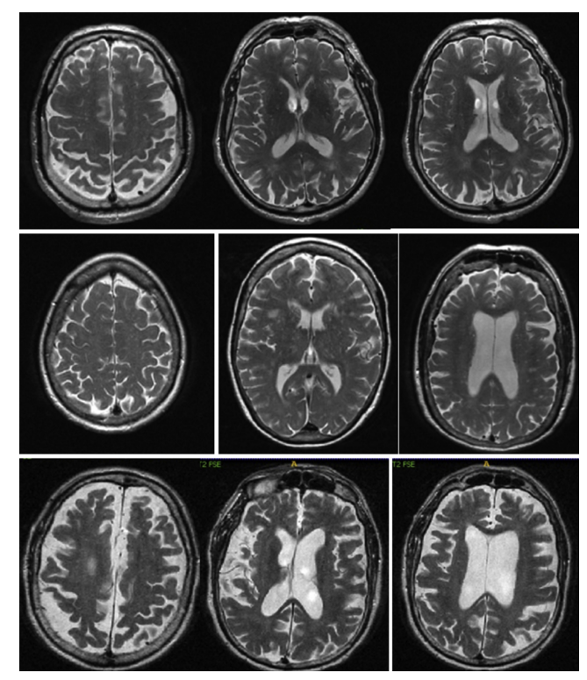
Figure 1: MRI images of Normal Cognitive (Row 1), Mild Cognitive Impairment (row 2) and last is Alzheimer’s Disease

.

1.1 Problem Definition
Despite the large number of studies applying deep learning to Alzheimer’s diagnosis, several important limitations remain.
First, many approaches focus exclusively on imaging data, particularly structural MRI. While MRI can reveal brain atrophy and structural abnormalities, it does not incorporate molecular or genetic information that may indicate susceptibility before structural damage becomes severe.
Second, both neuroimaging and genomic datasets are high-dimensional. Imaging volumes contain millions of voxels, and genomic profiles may include thousands of features. Directly training deep learning models on such data can lead to overfitting if not handled properly. Effective feature extraction and dimensionality reduction strategies are therefore necessary.
Third, Alzheimer’s disease progresses gradually over time. However, several existing models treat patient samples as independent observations and ignore longitudinal progression. This may limit the model’s ability to detect subtle early-stage changes.
Finally, multimodal fusion itself is a challenging research problem. There is no universally optimal way to combine heterogeneous data sources such as imaging and genomics. The architecture design must carefully balance representation of learning and generalization capability.

1.3 Thesis Objectives
The primary objective of this research is to design and evaluate a spatiotemporal multimodal artificial intelligence framework for early Alzheimer’s disease diagnosis.
More specifically, this study aims to:
- Develop a deep learning model capable of extracting meaningful spatial features from high-dimensional neuroimaging data such as MRI scans.
- Incorporate temporal modeling techniques to capture longitudinal disease progression patterns.
- Integrate genomic biomarkers with imaging representations using an effective multimodal fusion strategy.
- Compare the proposed multimodal approach with unimodal baseline models.
- Evaluate the diagnostic performance using standard classification metrics such as accuracy, sensitivity, specificity, and AUC.
Through these objectives, the study seeks to explore whether combining heterogeneous data sources can enhance early detection performance in a clinically meaningful way.

1.4 Thesis Contribution
This thesis contributes to the field of AI-based medical diagnosis in several aspects.
First, it proposes a unified framework that jointly models spatial imaging patterns and temporal progression dynamics rather than treating patient data as independent static samples.
Second, it investigates multimodal fusion between neuroimaging and genomic data within a single deep learning architecture. Instead of relying on a single modality, the proposed approach attempts to capture complementary disease-related information from different biological levels.
Third, the study provides an empirical evaluation using longitudinal data from the Alzheimer’s Disease Neuroimaging Initiative (ADNI), allowing performance comparison between multimodal and unimodal strategies.
Overall, this work aims to provide insights into how multimodal and temporal modeling can be leveraged to improve early Alzheimer’s diagnosis while maintaining methodological transparency and reproducibility.

1.5 Thesis Organization
The remainder of this thesis is organized as follows.
Chapter 2 Provides an in-depth analysis of the historical evolution of Alzheimer’s disease detection. It traces the transition from classical statistical methods and manual feature engineering to modern 3D deep learning architecture and multimodal fusion strategies.
Chapter 3 presents the proposed spatiotemporal multimodal framework, including data preprocessing, model architecture, and fusion strategy.
Chapter 4 describes the experimental setup, evaluation of metrics, and results, followed by a detailed discussion of findings.
Chapter 5 concludes the thesis and outlines potential directions for future research.

Chapter 2: Related Work

2.1 Introduction
The shift from traditional diagnostic tools to advanced AI frameworks is truly changing the landscape of medical research. In this chapter, we take a close look at the current academic research on detecting Alzheimer’s Disease (AD). These methods have evolved over time, starting from basic statistical models all the way up to today's complex "End-to-End" Deep Learning systems [6,7]. Our main goal here is to point out a major blind spot in previous studies: the habit of relying on just one type of data. By highlighting this gap, it becomes much clearer why the multi-source "Data Fusion" strategy proposed in this thesis is a clinical necessity, not just a technical upgrade. Looking at the history of how these methodologies grew helps us see the bigger picture. When we mix 3D MRI scans with standard clinical patient data, our predictions get noticeably sharper. It specifically helps us accurately track whether a patient will progress from Healthy Normal Controle (NC) to Mild Cognitive Impairment (MCI) to full-blown Alzheimer’s [8]. Before the integration of Artificial Intelligence into healthcare, diagnosing Alzheimer's Disease relied entirely on manual clinical assessments and human interpretation. Traditionally, a patient suspected of cognitive decline goes to a standard cognitive test, such as the Mini-Mintal State Examination MMSE. While MRI scans were available, analyzing them was a strictly manual and not easy to process. Radiologists had to visually inspect dozens of image slices to detect subtle structural changes like loss of brain size [9,10]. This manual interpretation was highly subjective, time-consuming, and heavily dependent on the physician's individual experience, often leading to human error. More importantly, the human eye is limited in detecting microscopic or very early structural changes. Consequently, by the time visible brain damage was confirmed, the disease had usually progressed to an irreversible stage. This critical delay created an urgent need for the automated, high-precision tools. To understand the recent advancements in computer-aided diagnosis, it is essential to define the underlying technologies that have revolutionized this field. With rising of Artificial Intelligence (AI) that simulates human intelligence in machines. Within AI, Machine Learning (ML) allows computers to learn patterns from data without explicit programming. Traditional ML models are effective for structured data but struggle with high-resolution medical images because they require "manual feature extraction," where human experts must pre-identify relevant biomarkers [11], this where Deep Learning comes to life which inspired by the human brain's neural networks, DL utilizes multiple "hidden layers" to automatically extract high-level features from raw data. In medical imaging, the first layers might detect simple edges, while the deeper layers identify complex structures like brain diseases. This is reducing the need for human intervention, making DL exceptionally powerful for MRI analysis [12].

2.2: Background
Looking back over the last twenty years, the ways we try to detect Alzheimer’s Disease automatically have changed quite a bit. Catching the very early, tiny signs of the disease is still a massive challenge for computers. If we want to understand why today's advanced models look the way they do, we need to trace this history. Every time a new technology came along, it fixed old problems but brought its own unique flaws to the table.
At first, researchers mostly leaned on traditional Machine Learning. You still see these models a lot in recent papers because they are relatively easy to interpret and don't need supercomputers to run. Take some of the latest studies by [13,16] as examples. They all used standard algorithms like Artificial Neural Networks, Random Forests, SVM, or XGBoost to guess how the disease might progress using patient records or genetic data.
To see where these methods fall short, you have to look at how they work. Normally, you take your data and split it up, maybe keeping 80% for training and 20% for testing, or using a k-fold cross-validation setup. This stops the model from just memorizing the answers. When learning, something like a Random Forest or XGBoost builds lots of decision trees. It basically tries to find the right cut-off numbers. For example, it might decide someone has AD if their memory score and brain volume drop below a certain point. XGBoost just does this a bit smarter by fixing the mistakes of the trees before it. SVMs do something different; they plot all those numbers on a complex graph and try to draw a hard boundary line (a hyperplane) between the sick and healthy patients. Despite the effectiveness of these traditional machine learning techniques, they exhibit significant limitations, particularly in handling high-dimensional and unstructured data such as medical images.
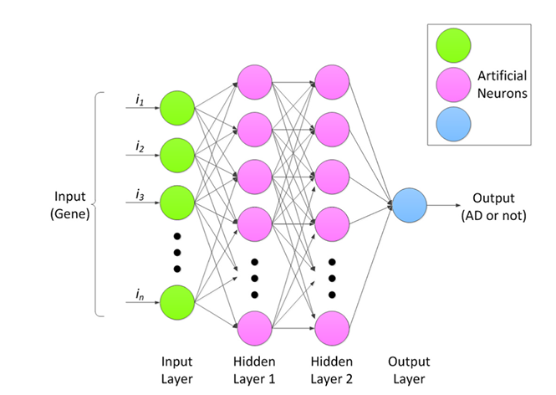
Figure 2: ANN machine learning model to detect brain dementia [14]

The real problem here isn't math. It's the fact that these older models cannot read a raw 3D brain scan on their own. They need humans to feed them the features. The studies had to use separate software to measure brain regions or cut the images into pieces before the algorithm could even start. This process is time-consuming and heavily dependent on human expertise. Furthermore, this approach oversimplifies complex three-dimensional brain structures by converting them into tabular data. When you do that, you lose a lot of hidden, spatial clues about the disease. And if a model only looks at numbers it is completely blind to the actual physical damage visible in an MRI.
This heavy reliance on manual work is exactly why the field moved on to Deep Learning. Early on, researchers tried standard 2D CNNs like VGG-16 or AlexNet. These were a massive deal because they could look at raw pixels and figure out the features by themselves. No human measurements needed. But applying a 2D network to a 3D MRI scan forces a bad compromise [17]. You have to slice the brain volume into thin, flat images. Doing this destroys the 3D context, but if you look at the whole 3D structure, the damage is obvious.
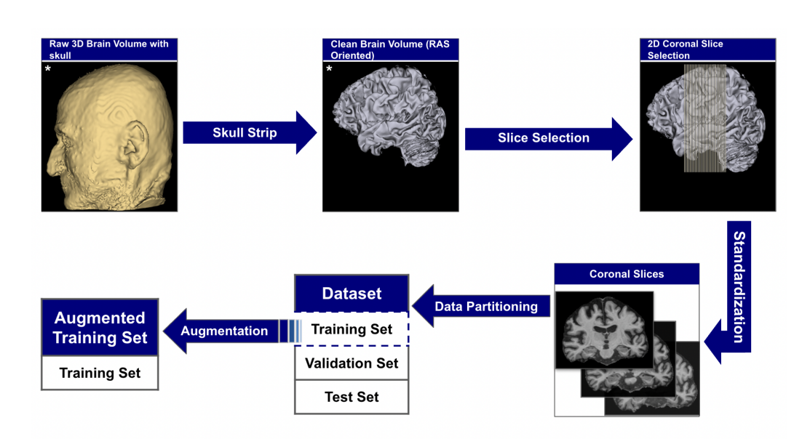
Figure 3: Slicing 3d image into 2D [18]
Because slicing images didn't work well, the next logical step was building 3D-CNNs. These models handle volume pixels (voxels) instead of flat pixels, meaning they can ingest the entire MRI scan at once and keep the brain's real shape intact [18].
Even with great improvement in the scan methods, old ML and early DL models shared one massive clinical flaw. They were almost all unimodal. They only looked at one thing at a time. A deep learning model might stare at an MRI scan but know nothing about the patient. A machine learning model might process memory scores but never see the physical brain. That is just not how medicine works in the real world. A doctor doesn't diagnose dementia by staring at a scan in a dark room. They look at the MRI, sure, but they also check the patient's age, ask about their education, and look at their MMSE test scores [19,21].
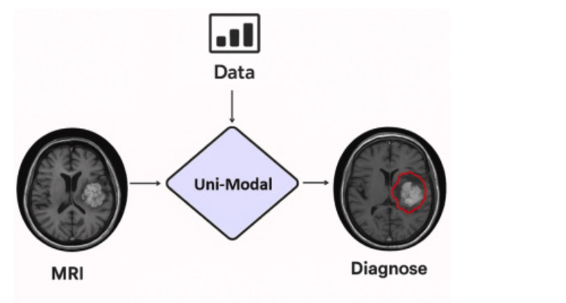
Figure [4] Unimodal 3D images into 3D CNN
When you piece all this history together—the painful manual work of ML, the chopped-up images in 2D networks, the unimodal of 3D models, and the blindness of looking at only one type of data, the gap in the research becomes obvious. There is a huge need for a system that actually mimics clinical practice. We need an architecture that can process deep 3D images without the learning signal dying out, while at the exact same time reading the patient's clinical file. Combining these two streams of information end-to-end has the potential to improve diagnostic accuracy to the next level.

2.3 Related Work
Muksimova et al (2025) proposed a multi-modal deep learning framework called FusionNet for the early detection and classification of Alzheimer’s disease. The model integrates deep learning techniques: a 3D CNN with an LSTM network to track brain changes over time. Using the ADNI dataset, the study combined MRI, PET, and CT scans to train the system effectively. The proposed framework achieved a high diagnostic accuracy of 94%. However, its main limitations are the high computational power required for processing 3D multi-modal scans, and the practical difficulty and high cost of obtaining all three types of brain scans for a single patient in standard clinical settings.
Li et al (2025). presented a multi-modal deep learning framework to improve the early detection of Alzheimer’s disease. The researchers focus on integration on two main deep learning techniques: a Convolutional Neural Network (CNN) to analyze brain images, and a Transformer model to process genetic data, combined via a cross-transformer fusion. The study used the ADNI dataset, including MRI scans and genetic records from 1,541 patients across different stages: healthy (NC), stable memory loss (sMCI), progressive memory loss (pMCI), and Alzheimer’s disease (AD). This system achieved a high accuracy of 93.04%. However, its main limitations are the use of a basic CNN model that restricts performance and the difficulty of mixing different genetic records.
Bricaud and Masala (2026) Presented a comprehensive framework to evaluate various deep learning models for detecting early Alzheimer's disease. Instead of relying on a single network, the researchers compared several different methods, including traditional CNNs and modern Vision Transformers. The study used ADNI data set to utilize MRI scans to classify patients into groups such as cognitively normal and those with Alzheimer's disease. They evaluated the images from two perspectives: looking at individual 2D slices and analyzing the entire 3D scan. The best-performing hybrid model (ConvNeXtV2-L) achieved a realistic and robust accuracy of 91.07% when analyzing the full scans. However, its main limitations are that it relies entirely on brain images without integrating the patients' clinical medical records.
Bekhet et al (2026) proposed a dual-pathway deep learning framework named DeepALZNET for the early prediction and diagnosis of Alzheimer’s disease. The researchers highlighted two main independent techniques: the first uses a 1D Convolutional Neural Network (CNN) combined with a Random Forest model to analyze patient clinical records, while the second uses a VGG19 network to detect changes in brain MRI scans. The study utilized large public datasets, specifically ADNI and OASIS, categorizing patients into different stages: healthy normal control (NC), mild cognitive impairment (MCI), and Alzheimer's disease (AD). The DeepALZNET framework achieved a diagnostic accuracy of over 90%. However, its main limitations are that it does not yet combine both images and clinical data into a single decision, and it relies on 2D images which might miss some 3D details of the brain.
Zhang et al. (2023) introduced a multi-modal Graph Neural Network (GNN) framework to improve the early detection of Alzheimer’s disease. Instead of just analyzing flat images, the researchers highlighted advanced GNN deep learning techniques to understand the complex network connections and relationships between different brain regions. The study utilized the ADNI dataset, combining two types of brain scans (MRI and PET) for a more comprehensive analysis. Patients were carefully categorized into four main developmental stages: healthy (NC), early memory loss (EMCI), late memory loss (LMCI), and Alzheimer's disease (AD). By merging these two imaging modalities, the proposed framework achieved a highly impressive performance, reaching a 92% accuracy score in detecting the disease. However, the main limitations of this approach are the high clinical cost and practical difficulty of requiring patients to undergo both MRI and PET scans simultaneously, alongside the heavy computational power needed to build complex brain network graphs for each individual patient.
Helaly et al. Presented a deep learning framework called E2AD2C for the early detection and classification of Alzheimer’s disease. The researchers used two methods: one using simple computer networks (CNN) and another using a more advanced, pre-trained system called VGG19. The study used brain scans from the ADNI dataset, covering four different stages: healthy (NC), early memory loss (EMCI), late memory loss (LMCI), and Alzheimer’s disease (AD). The simple computer networks achieved an accuracy of 95.17%, while the advanced VGG19 model reached an even higher accuracy of 97% in identifying the correct stage of the disease. This study also proposed a web application that could help doctors check patients' brain scans remotely, which is very useful during times when visiting hospitals is difficult. However, its main limitations are the high computer power needed for the 3D brain scans and the fact that the model only uses images, without considering other patient data like memory tests or age.
Warren and Moustafa. Presented a multimodal diagnostic system that combines functional brain imaging (fMRI) with clinical tests to identify Alzheimer’s disease. The proposed method uses a 3D Convolutional Neural Network (3D CNN) that analyzes the "default mode network" of the brain—a region known to be affected early in the disease. To make the model more reliable, the researchers supplemented the fMRI scans with five clinical memory tests and used a strict "leave-one-out" validation technique to prevent any data errors. A key part of their method is the use of "explainable AI" (XAI) through a technique called perturbation ranking, which helps show exactly which clinical test was most important for the diagnosis. The study involved a small group of 52 participants from the ADNI database. This multimodal approach achieved a high accuracy of 90%, which was much better than the 58% accuracy reached when using brain scans alone. The study proves that combining functional brain data with doctor’s tests is highly effective for accurate diagnosis. However, its main limitations are the very small sample size and the need for more testing on larger, different groups of patients.
Wang et al. (2024) proposed a deep joint learning framework based on multimodal for the early diagnosis of Alzheimer’s disease. To fully capture complex brain changes, the researchers highlighted advanced deep learning techniques, using a Residual Network (ResNet) to extract features from local brain regions, alongside an attention convolution module to focus on critical disease locations. The study utilized the ADNI dataset, combining structural MRI brain scans with patient genetic data to construct unique 3D fusion images. Patients were categorized into three main stages: healthy controls (HC/NC), mild cognitive impairment (MCI), and Alzheimer's disease (AD). This combined imaging and genetic approach achieved a high diagnostic accuracy of 93.44% in distinguishing AD from healthy patients. However, its main limitations are the high computational complexity of creating these 3D image-gene fusions, and the practical difficulty of requiring both advanced MRI scans and detailed genetic profiles for every single patient in standard clinical settings.
Alsubaie et al. Presented a new deep learning framework called BiFPN3DViT to identify Alzheimer’s disease using brain images. The proposed method combines three advanced tools: a 3D computer network (3D CNN) to capture basic brain structures, a special network (BiFPN) to connect details of different sizes, and "Vision Transformers" to understand the overall picture of the brain. The study used a large dataset of 4,706 MRI scans from the ADNI project, covering healthy individuals, those with mild memory loss, and Alzheimer’s patients. By combining these tools, the model achieved a high accuracy of 92.1% in classifying the three stages of the disease. The study shows that looking at both tiny details and the whole brain improves diagnosis without needing massive computer power. However, its main limitation is that it relies entirely on brain scans (MRI) and does not use other important patient information like medical records or memory tests.
Ahmed et al. Presented a smart computer system to diagnose Alzheimer’s disease using brain images. The proposed method uses a deep computer network (Deep CNN) designed to classify patients into three groups: healthy individuals, those with mild memory loss, and Alzheimer’s patients. The study used MRI scans from the popular ADNI dataset. By using this system, the model achieved a high accuracy of 93.86% in telling the three stages apart. The study shows that advanced computer networks can provide very accurate diagnoses. However, its main limitations are that it relies only on brain scans—without using patient medical records—and it lacks "Explainable AI" tools, making it hard for doctors to understand exactly how the computer made its final decision.
Lu et al. Presented a highly practical deep learning system to diagnose Alzheimer’s disease using brain images. To make the model reliable, the researchers used a massive dataset of over 85,000 MRI scans from different hospitals, including the ADNI project. The proposed method uses a technique called "transfer learning." First, they trained an advanced computer network (Inception-ResNet-V2) on a basic task, and then they fine-tuned it specifically to detect Alzheimer's disease. By using this huge and diverse set of images, the model achieved a high accuracy ranging from 90.9% to 94.5% across different testing groups. The study proves that training computer models on massive amounts of data from different sources makes the diagnosis much more robust. However, its main limitations are that it relies only on brain scans without including patients' medical records, and the data primarily came from Western populations, which might affect how well it works for people in other parts of the world.
Khalid et al. Presented a practical "dual-modal" system to detect and classify the stages of Alzheimer’s disease. Instead of relying solely on brain images, the researchers utilized a multimodal dataset sourced from the OASIS-3 database, comprising routinely observed clinical symptoms combined with MRI scans to get a fuller picture of the patient's health. They tested various deep learning and machine learning models for this task. For the MRI scans, an advanced computer network (CNN) achieved a realistic overall accuracy of 94% in staging the disease. Meanwhile, a traditional algorithm (Random Forest) analyzed the clinical data. The study emphasizes that using both clinical records and imaging data provides a much more reliable diagnostic route than using images alone. Furthermore, researchers used "Explainable AI" tools to visually highlight the affected brain regions, such as the hippocampus. However, its main limitation is that the framework processes the MRI images and clinical data using two separate models, rather than smoothly fusing them into one single automated network.
Sheikh et al. Presented a practical and fast computer system to detect early signs of Alzheimer’s disease using brain images. Because many advanced deep learning models are too heavy and require massive computer power, the researchers focused on "lightweight" networks (specifically EfficientNetV2B0 and MobileNetV2) that can run smoothly in standard clinics. Using 2D slices from standard MRI scans sourced from the ADNI dataset, the system aimed to classify patients into three difficult stages: cognitively normal, early mild cognitive impairment, and late mild cognitive impairment. The best model achieved a realistic mean accuracy of 88.0%. To build trust with doctors, the researchers also included "Explainable AI" tools to visually highlight the brain areas the computer focused on. The study proves that fast, lightweight models can be highly useful. However, its main limitations are that it relies only on 2D image slices instead of full 3D brain shapes, and it strictly uses MRI scans without looking at the patients' medical records or clinical history.

Ghosh et al. (2023) introduced a secure and collaborative AI system to diagnose Alzheimer’s disease using brain images. Because medical data is often private and scattered across different hospitals, the researchers used a technique called "Federated Learning." This allows multiple hospitals to collaboratively train a shared, lightweight computer network (MobileNet) without ever moving or sharing the patients' private images. The study utilized 2D MRI scans sourced from two major databases: the ADNI and OASIS datasets. By training the model in this collaborative way, it achieved a realistic and robust accuracy of 95.24% on the OASIS data, and around 84% when both datasets were combined. The study proves that hospitals can work together to build accurate diagnostic tools without compromising patient privacy. However, its main limitations are that it relies only on 2D image slices rather than full 3D brain volumes, and it strictly uses MRI scans without incorporating the patients' clinical medical records.

Abbasian and Hammond. Presented a 3D deep learning framework specifically designed to detect the very early stages of Alzheimer's disease using structural brain images. Because distinguishing between a completely healthy brain and one with "Early Mild Cognitive Impairment" (EMCI) is extremely difficult, the researchers built a 3D Convolutional Neural Network (3D-CNN) that analyzes the entire brain volume at once, rather than looking at flat 2D slices. Using 3D MRI scans sourced from the ADNI dataset (specifically the ADNI3 collection), the model was put to the test. It achieved a highly realistic accuracy of 81.80% in telling early-stage patients apart from healthy individuals. The study proves that analyzing the brain in 3D captures important spatial details that 2D methods miss. However, its main limitations are its strictly binary focus (only evaluating early impairment versus normal) and its complete reliance on MRI scans without incorporating any supporting clinical data, which could otherwise help boost the accuracy for these difficult early cases.

2.3 Related Work Summary
Study (Year) | Proposed Method | Key Accuracy | Main Limitations
Muksimova et al. (2025) | CNN + LTMS | 94.00% | Fuses images only; completely lacks integration of clinical medical records.
Li et al. (2025) | CNN + Transformer | 93.04% | Struggles with MCI-to-AD prediction.
Bricaud & Masala (2026) | Hybrid CNN (ConvNeXtV2-L) | 91.07% | MRI-only; lacks integration of clinical medical records.
Bekhet et al. (2025) | 1D CNN + Random Forest | > 90.0% | No simultaneous fusion; relies on 2D images.
Zhang, Y., et al. (2023) | GNN framework | 92% | Highly computational cost with required of both MRI + PET scans
Helaly et al. (2021) | E2AD2C (CNN & VGG19) | 97.0% | High power for 3D scans; images-only.
Warren & Moustafa (2026) | 3D CNN with XAI | 90.0% | Very small sample size; lacks validation.
Wang, J., et al. (2024) | ResNet + Attentation convolution | 93.44% | Highly computational cost with required of both MRI + PET scans
Alsubaie et al. (2026) | BiFPN3DViT (3D CNN + BiFPN + ViT) | 92.10% | MRI-only; lacks integration of clinical medical records.
Ahmed et al. (2023) | Deep CNN | 93.86% | MRI-only; lacks Explainable AI tools.
Lu et al. (2022) | Transfer Learning (Inception-ResNet-V2) | 94.50% | MRI-only; data mostly from Western populations.
Khalid et al. (2026) | CNN & Random Forest | 94.00% | Processes images and clinical data separately; lacks a fully unified fusion network.
Sheikh et al. (2025) | Lightweight CNN (EfficientNetV2B0) & Explainable AI | 88.00% | 2D images only; lacks integration of clinical medical records.
Ghosh et al. (2023) | Federated Learning & MobileNet | 95.24% | 2D images only; lacks integration of clinical medical records.
Abbasian & Hammond (2024) | 3D CNN | 81.80% | MRI-only; strictly binary classification; lacks clinical data integration.

References
[1] Muksimova, S., Umirzakova, S., Baltayev, J., & Cho, Y. I. (2025). Multi-modal fusion and longitudinal analysis for Alzheimer's disease classification using deep learning. Diagnostics, 15(6), 717
[2] Li, Y., et al. (2025). An imaging and genetic-based deep learning network for Alzheimer's disease diagnosis. Frontiers in Aging Neuroscience, 17, 1532470.
[3] Bricaud, I., & Masala, G. L. (2026). Multi-architecture deep learning for early Alzheimer's detection in MRI: Slice- and scan-level analysis. International Journal of Environmental Research and Public Health, 23(3), 322.
[4] Bekhet, S., et al. (2025). Alzheimer disease predicting from clinical and MRI data using DeepALZNET dual pathway framework. Scientific Reports, 15, 43250
[5] Zhang, Y., He, X., Chan, Y. H., Teng, Q., & Rajapakse, J. C. (2023). Multi-modal graph neural network for early diagnosis of Alzheimer’s disease from sMRI and PET scans. Computers in Biology and Medicine, 164, 107328.
[6] Helaly, H. A., et al. (2022). Deep learning approach for early detection of Alzheimer’s disease. Cognitive Computation, 14(5), 1711–1727.
[7] Shen, D. et al., "Deep learning in medical image analysis," Annual Review of Biomedical Engineering, 2017.
[8] Shojaei, S., Abadeh, M. S., & Momeni, Z. (2023). An evolutionary explainable deep learning approach for Alzheimer’s MRI classification. Expert Systems with Applications, 220, 119709.
[9] Alsubaie, A., Alqarni, M., Alshamrani, S., & Alruwaili, M. (2026). A novel Alzheimer’s disease classification framework integrating 3D CNN with bidirectional feature pyramid network and vision transformers. IEEE Access, 11, 11364136.
[10] Ahmed, H. M., Elsharkawy, Z. F., & Elkorany, A. S. (2023). Alzheimer disease diagnosis for magnetic resonance brain images using deep learning neural networks. Multimedia Tools and Applications, 82(12), 17963–17977.
[11] Lu, B., Li, H. X., Chang, Z. K., Li, L., Chen, N. X., Zhu, Z. C., ... & Yan, C. G. (2022). A practical Alzheimer's disease classifier via brain imaging-based deep learning on 85,721 samples. Journal of Big Data, 9(1), 101.
[12] Khalid, M. Z., et al. (2026). Detection and classification of Alzheimer's disease using deep and machine learning. Tomography, 12(1), 4.
[13] Gelir, F., Akan, T., Alp, S., et al. (2024). Machine Learning Approaches for Predicting Progression to Alzheimer's Disease in Patients with Mild Cognitive Impairment. Biomedical Signal Processing and Control.
[14] Hsiao, C. C., et al. (2023). Classifying Alzheimer's disease and normal subjects using machine learning techniques and genetic-environmental features. Journal of the Formosan Medical Association, 123(5), 600-608.
[15] Jahan, S., et al. (2023). Explainable AI-based Alzheimer's prediction and management using multimodal data. PLoS One, 18(11), e0294253.
[16] Jiang, S. F., et al. (2024). Machine learning models for diagnosing Alzheimer's disease using brain cortical complexity. Frontiers in Aging Neuroscience, 16, 1434589.
[17] Sheikh et al. (2025). Lightweight deep learning models with explainable AI for early Alzheimer's detection from standard MRI scans. Diagnostics, 15(21), 2709.
[18] Ghosh et al. (2023). A robust distributed deep learning approach to detect Alzheimer's disease from MRI images. Mathematics, 11(12), 2633.
[19] Abbasian, P., & Hammond, T. A. (2024). A comprehensive analysis of early Alzheimer disease detection from 3D sMRI images using deep learning frameworks. Information, 15(12), 746.
[20] Warren and Moustafa. (2026). Functional and clinical: An explainable deep learning model for multimodal Alzheimer’s disease classification. Brain and Behavior, 16, e71240.
[21] Payan, A., Montana, G., "Predicting Alzheimer’s disease using 3D CNN," NeuroImage, 2015.

