
كلية الإدارة
قسم / تخصص إدارة الأعمال

دراسة استكشافية حول بناء الوعي بالعلامة التجارية لشركات الطلاء الواقية متعددة الجنسيات في سوق المشاريع الكبرى في المملكة العربية السعودية

إعداد الطالب/
أنس أحمد الشحاتيت

إشراف/
د.الفيصل عبد الحميد
د.فايز جراد

العام الدراسي:
2024


Midocean University
College of Management
Department of Business administration

An Exploratory Study on Building Brand Awareness for Multinational Protective Coatings Companies in Saudi Arabia's Giga Projects Market

Prepared by:
Anas Ahmad Al Shahatit
241001572

Supervised by:
Dr. Faisal Abdulhameed
Dr. Fayez Jarad

Year:2024

Copyright
The copyright is owned by MidOcean University. All materials and contents included in this research are the property of the university and may not be used, republished, or distributed without prior permission from MidOcean University.
The researcher

Abstract
The research explores marketing methods which multinational protective coatings organizations can use to increase their brand recognition in Saudi Arabia's fast-growing giga infrastructure market. Large-scale infrastructure developments that Saudi Arabia has initiated under Vision 2030 particularly NEOM and the Red Sea Project along with Qiddiya have created an escalating need for high-quality protective coatings throughout the construction sector and industry. The analysis explores Saudi Arabia's brand awareness trends by revealing crucial market obstacles alongside possibilities that impact multinational companies while trying to position their brands in Saudi Arabia's competitive market environment. Strategic marketing measures receive analysis through market research and expert interviews to identify brand perception factors and enhance visibility levels and reputation status. The research intends to supply crucial findings and practical recommendations that support international companies in building robust brand visibility and lasting relationships in Saudi Arabia’s giga projects sector.

الملخص :
تهدف هذه الدراسة إلى استكشاف كيفية بناء الوعي بالعلامات التجارية بشكل فعال لشركات الطلاء متعددة الجنسيات في قطاع البناء السعودي المتنامي، خاصة في إطار مشاريع رؤية 2030. يستخدم البحث منهجية مدمجة تشمل كلًا من الأساليب النوعية (المقابلات مع خبراء الصناعة ومديري المشاريع وضباط المشتريات) والأساليب الكمية (استطلاعات تستهدف المهنيين من مختلف قطاعات صناعة البناء). يركز البحث على المهنيين المشاركين في المشاريع الكبيرة مثل نيوم، القدية، وملاعب كأس العالم 2034. تكشف النتائج أن أداء المنتج، المتانة، والدعم الفني هي العوامل الرئيسية التي تؤثر في اختيار علامات الطلاء الواقية. كما تبين أن استراتيجيات التسويق مثل الزيارات المباشرة من قبل المبيعات ورعاية الفعاليات الصناعية كانت الأكثر فعالية في زيادة الوعي بالعلامة التجارية. تسلط الدراسة الضوء على التحديات التي تواجهها الشركات متعددة الجنسيات عند دخول السوق السعودي، بما في ذلك المنافسة، الحواجز الثقافية، وضرورة تبني استراتيجيات تسويق محلية. يسهم هذا البحث في تقديم رؤى قيمة حول ديناميكيات بناء العلامات التجارية في سياق صناعة البناء السعودية المزدهرة ويوفر توصيات عملية لشركات الطلاء متعددة الجنسيات التي تسعى لتوسيع وجودها في هذا السوق.

Acknowledgments:
I genuinely appreciate all who provided their support during my investigation work of this research project. The foundation of my appreciation goes first to supervisors Dr. Al Faisal Abdulhamid and Dr. Fayez Jaradeh because of their essential direction and expert mentoring. This research has achieved its direction and quality due to their continuous support and informative feedback.
The resources and inspiring academic environment supplied by Midocean University faculty members together with staff members has allowed me to complete this project.
I express sincere appreciation to all my student colleagues who helped throughout the research period.
I express my gratitude to all industrial professionals and experts for giving their time to share comprehensive knowledge about the sector. These experts jointly expanded the knowledge about multinational protective coatings companies operating in Saudi Arabia’s giga infrastructure market.
I am profoundly grateful for the valuable support provided by these individuals as my research would have reached its completion without their help.

List of Contents:
- Chapter one: Introduction
- Introduction مقدمة
- Problem Statement مشكلة الدراسة
- Analysis of Saudi Arabia’s Giga Projects Investment
- Study Purposes أهداف الدراسة
- Study Importance أهمية علمية و أهمية عملية
- Study Questions تساؤلات الدراسة
- Research Hypotheses فرضيات الدراسة
- Theoretical Model النظرية العلمية المتبعة لإعداد البحث
- Chapter two: Literature review الدراسات السابقة
- Introduction: المقدمة
- Dependent Variableالمتغير التابع
- Independent Variableالمتغير المستقل
- Summary of Past studies الدراسات السابقة ومناقشة نتائج الدراسات السابقة وتوضيح ما ستقدمه الدراسة الحالية مقارنة بما سبق من دراسات

- Chapter three: Research Methodology (منهجية الدراسة)
- Introduction: المقدمة
- Research Design تصميم البحث
- Population of the studyمجتمع البحث
- Sample Characteristicخصائص العينة
- Sample Size Determinationمحددات حجم العينة
- Data Collections proceduresخطوات جمع البيانات / أداة جمع البيانات
- Study Determinants حدود زمانية، مكانية وحدود موضوعية
- Method of Analysis الأداة المستخدمة للتحليل الإحصائي
- Chapter four: Practical Study (الدراسة الميدانية)
- Data Analysis تحليل البيانات
- Research Findingsنتائج الدراسة ومناقشتها مع نتائج الدراسات السابقة
- Research Recommendationsالتوصيات
- References المراجع
Appendixes(الملاحق)
- Appendixes for example
- Arabic abstractالملخص العربي
- English abstractالملخص الأانجليزي

Chapter 1 : Introduction

- Introduction:
Giga construction projects now find their primary destination in Saudi Arabia because of the HH Mohammad Bin Salman 2030 Vision. Twenty projects worth more than $900bn ⁽¹⁾ constitute Giga initiatives throughout infrastructure and Industrial development and educational arenas as well as healthcare initiatives, urban development and tourism components intended to establish Saudi Arabia as a world economic leader.
The Vision 2030⁽¹⁴⁾ initiative has received substantial funding from Saudi Arabia for its giga projects till March 2025.
These projects serve to enhance Saudi Arabia's economic stability by establishing a worldwide tourism center and innovative entertainment center. Notable investments include:
- NEOM represents a $500 billion development of The Line alongside Trojena to establish an advanced high-tech urban center. ⁽²⁾
- Qiddiya represents a $9.8 billion dollar investment in building an entertainment center outside Riyadh to blend cultural attractions with recreation amenities. ⁽²⁾
- Red Sea Global: An investment of $23.6 billion in tourism and luxury developments along the Red Sea coast. ⁽²⁾
- The Diriyah Gate project worth $63.2 billion seeks to establish Diriyah as both a historical and cultural center. ⁽²⁾
- King Salman Park receives $23 billion dollars to establish a massive urban park across Riyadh while developing its green and recreational areas. ⁽²⁾
- The construction of Expo 2030 Site requires $7.8 billion to make Riyadh ready for World Expo 2030. ⁽²⁾
The Kingdom runs these investments as part of a nationwide initiative to both update infrastructure and put monetary firepower behind economic fueling and oil revenue diversification. ⁽¹⁵⁾
The actual payment schedule for these projects likely will experience changes throughout their development phase with several projects possibly needing modifications or experiencing time delays.
To achieve these initiatives the project requires advanced materials and technology with various coating and paint types that both protect its properties and establish the exceptional visual theme between Heritage and Modernity elements. Therefore, protective coatings guarantee extended durability and sustainable operation of these Iconic Projects.
Leading protective coating companies worldwide face amazing business prospects within Saudi Arabia's construction sector although they encounter numerous market difficulties in this market.
Brand awareness development in this demanding market becomes essential because it helps companies win market share positions while also gaining trust as Saudi Arabia's major development partners.
Research investigates the branding strategies and tactics protective coatings industries use to expand their awareness within the Saudi Arab Construction sector. The research investigates factors that shape brand perception and positioning through current branding strategy analysis to generate new optimization recommendations which enhance brand recognition for targeted market segments.
The examination of Saudi Arabian construction market dynamics together with cultural factors and themes and regulations alongside technological developments will offer guidance for multinational companies to succeed within this market.
The research seeks to broaden understanding regarding international marketing tactics as well as brand administration and market access techniques for evolving international markets. Such sections detail the specific obstacles multinational corporations encounter along with explaining why this research matters before showing its goals and survey questions.
Subsequently, theoretical perspectives receive attention followed by an explanation of research methods and final recommendations for action.

- Problems of the study:
The protective coatings industry operates with multiple barriers when it comes to expanding brand familiarity throughout Saudi Arabian construction sites.
Several major difficulties prevent multinational firms from successfully exploiting the substantial number and size of opportunities created through Vision 2030's⁽¹⁴⁾ Giga projects despite such abundant opportunities.
Branding and marketing strategies need tailored adaptation in line with Saudi Arabian cultural elements. Multinational companies require knowledge about cultural restrictions as well as preferences that enable them to focus their resources with maximum effectiveness.
Saudi Arabian regulatory standards appear distinct to international companies because their business ethics contrast from common international standards.
The need to follow local rules and legislations increases the operational challenges of market entry and implementing business strategy.
The Saudi Arabian building materials sector attracts heavy competition since domestic firms together with international operators aggressively pursue market control.
Some obstacles arise when companies must compete for market dominance which requires both strategic branding methods alongside successful communication approaches.
The development of branding recognition means establishing mutual trust relationships with essential stakeholders starting from developers through contractors to consultants and Clients.
The development of favorable brand recognition that matches Saudi Arabian standards demands accurate execution along with careful strategic planning.
Understandings of the mentioned challenges demand thorough research about regional market dynamics together with customer behavior patterns and main companies and important parties and cultural customs and competitive postures as well as Saudi Arabia national objectives.
Understandable problems have been evaluated to provide guidelines and recommendations that allow multinational protective coating companies to build strong brand awareness in Saudi Arabia building materials sector.

- importance of the study:

The study possesses value because it offers important recommendations along with strategic guidelines for multinationals which seek to develop brand presence in Saudi Arabia's protective coatings market. Significant importances such as:
Market and business development has surged from Vision 2030's implementation of broad Giga projects which seek to transform both infrastructure and economic development. Constructing strong brand awareness throughout the Saudi market becomes essential for worldwide protective coatings companies who aim to seize these expansion opportunities.

The Saudi Arabian market presents distinct cultural aspects and regulatory requirements which create obstacles for new companies entering the market. The research investigates these market factors to produce solutions that transform challenges into opportunities through an analysis of both factors and their transformation paths.

Construction materials market in Saudi Arabia faces intense competition from multiple local and international companies that compete for both contracts and partnerships.
Companies that effectively implement brand awareness strategies distinguish themselves from competitors because they become favored partners in large projects and secure more clients which gives them a better competitive market position.
Beyond immediate commercial needs this research delivers substantial economic value and intellectual findings for global business operations. This research explores brand awareness development complexities in the Saudi and middle eastern markets which enables multinational companies to better grasp their challenges so they can capitalize on growth opportunities to assist with Saudi economic development.

- Analysis of Saudi Arabia’s Giga Projects Investment:

Saudi Arabia has launched its Vision 2030 program as an extensive strategy to develop different economic branches beyond oil production. Multiple "giga projects" serve as foundational elements of this vision to establish Saudi Arabia as an international hub for tourism along with technology and business and cultural activities. These projects demand hundreds of billions of dollars from investors who focus their investments between infrastructure development and tourism and sustainable growth.
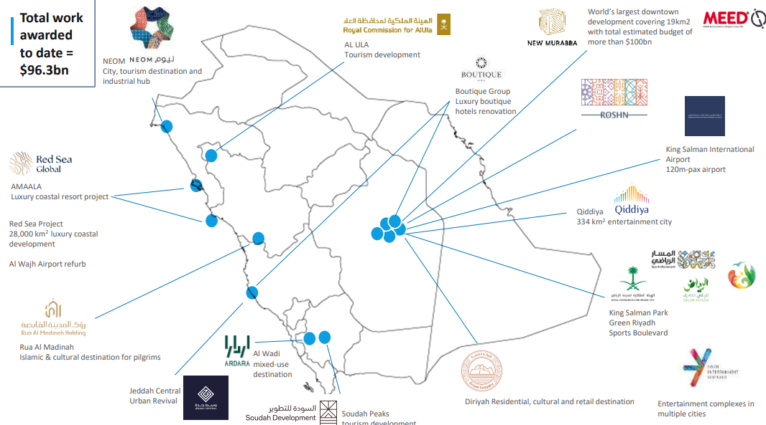

Figure 1-4-0 : MEED website

- NEOM: A Futuristic City ⁽³⁾
The $500 billion NEOM project features The Line which has designs for a car-free city and Trojena which consists of a desert ski resort. The project strives to establish itself as the initial city which runs exclusively from renewable power while implementing modern technologies across different fields including biotechnology and entertainment.
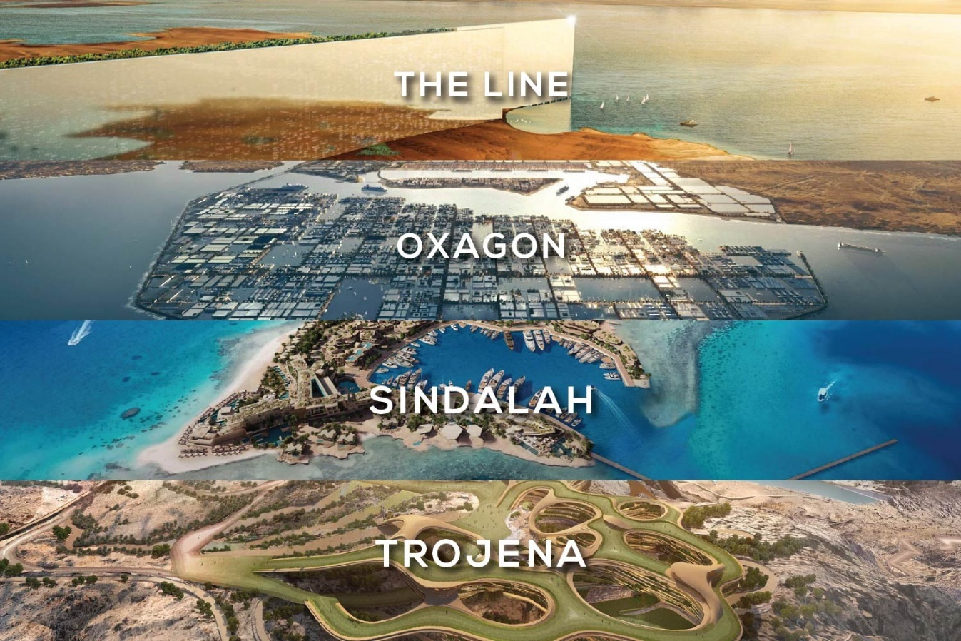
NEOM functions as an important driver for innovation by concentrating on tech and renewable energy development which establishes Saudi Arabia as a global industry leader while expanding tourism activity.

Figure 1-4-1 : PIF website

- Qiddiya: Entertainment and Culture ⁽⁴⁾
The Qiddiya project represents a $9.8 billion investment that has shaped a $9.8 billion investment to establish an entertainment and cultural hub through theme parks and sports facilities and cultural centers. The enhanced entertainment sector in the area will support diverse tourism traffic thereby decreasing international visit dependence.

Through its development Qiddiya will establish employment opportunities and strengthen domestic entertainment businesses and it plans to welcome both Saudi nationals and international visitors.


Figure 1-4-2 : PIF website

- Red Sea Global: Sustainable Tourism⁽⁵⁾
Red Sea Global, with an investment of $23.6 billion, focuses on luxury eco-tourism along the Red Sea coastline. The development includes sustainable marinas and resorts among its various facilities.

The Saudi Arabian tourism market will establish itself as a premier luxury destination because of this project which has established modern standards in sustainable travel development.

- Diriyah Gate: Preserving Heritage⁽⁵⁾
The Diriyah Gate project worth $63.2 billion aims to protect Saudi Arabian cultural heritage while boosting its cultural visibility in the world. Diriyah will host multiple museums alongside cultural venues and top-class hotels located within the historical Diriyah city.

Through Diriyah Gate Saudi Arabia advances its cultural tourism segment while building recognition of its cultural influence worldwide.

- King Salman Park: Urban Green Spaces ⁽⁵⁾
The $23 billion King Salman Park functions as a project to develop 13 square kilometers of green space in Riyadh for improving sustainability and urban life quality.
- World Cup Stadiums Project in Saudi Arabia
Saudi Arabia operates an active construction program for advanced stadiums that supports its Vision 2030 sports infrastructure development agenda. The Kingdom works toward constructing high-tech sustainable stadiums that will serve as event venues for major sports competitions such as potential FIFA World Cup tournaments.
Stadiums under construction will contain advanced technology elements which include retractable roofing systems along with energy-efficient cooling mechanisms and environmentally friendly construction features. The development combines environmental sustainability goals with spectator comfort principles. Saudi Arabia implements this development as part of its economic diversification strategy to build its position as a worldwide sports hub and create stadiums that will host international sporting events in the future. Through this development Saudi Arabia shows its dedication to upgrading its infrastructure while establishing permanent sports heritage across the area.
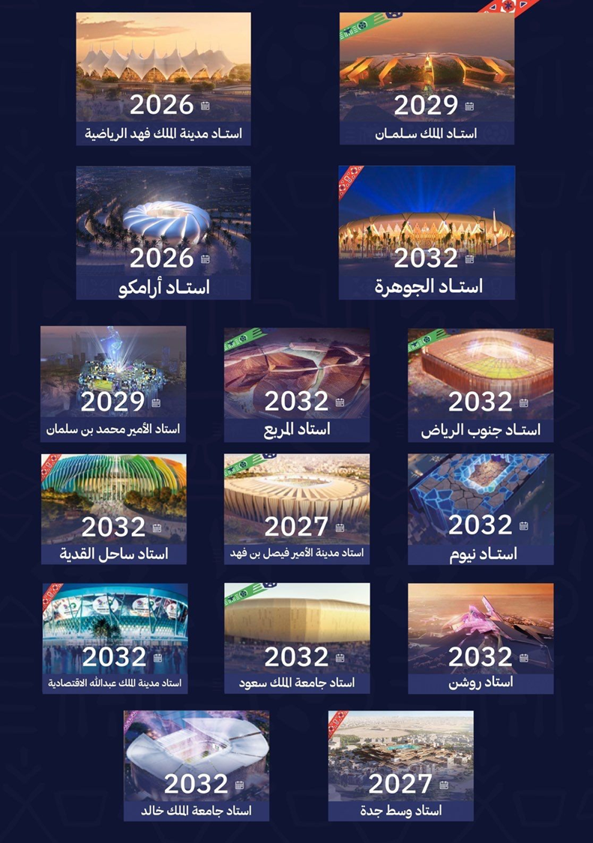
Over 15 stadiums are under process, either design, Bidding, or execution, with Value over than 7 Billion USD.

Figure 1-4-6 : Ministry of Sports announcement
The recreation area will create a more appealing Riyadh environment by drawing people who want a sustainable lifestyle along with visitors for leisure.
Expected impact for the giga projects in Saudi Arabia will produce major economic along with societal and international influence changes by 2025. The projects will advance economic diversification through their job creation and their support of non-oil industries and their ability to draw foreign investments. Tourism will experience major expansion because NEOM and Qiddiya along with Red Sea Global attract international tourists to their locations. Through its smart city model at NEOM Saudi Arabia will demonstrate its innovation and sustainability capabilities to the world. The cultural project Diriyah Gate will improve Saudi Arabia's cultural reputation while its eco-tourism and green initiatives will establish new environmental benchmarks. Through these developments Saudi Arabia will establish itself as a worldwide leader in tourism and technology as well as culture by 2025 which will support the economic transformation and diversification of Vision 2030. ⁽⁶⁾
Conclusion
The giga projects in Saudi Arabia serve as critical elements for reaching the objectives set in Vision 2030 regarding economic growth, environmental consciousness and global marketplace dominance. These developments will lead to innovation which generates employment opportunities while making Saudi Arabia an international power in tourism and technology and cultural domains.

- Goals of the study
The main goal of this research examines the essential brand awareness building objectives for Multinational Paints company across Giga Projects Saudi market.
Our main goal is to identify and study the essential elements that influence brand awareness within the Saudi building materials market through evaluation of cultural regulatory and competitive market factors which determine audience recognition patterns for such companies.

The evaluation of present branding strategies used by these companies in Saudi Arabia makes up part of this assessment. The researcher will evaluate cases and conduct expert interviews and analyze market information to assess the effectiveness and barriers of present strategies.

The study presents recommendations that aim to enhance market visibility together with strategic understandings designed to boost brand recognition within Saudi Arabia. These recommendations will target the challenges while utilizing available opportunities to enhance brand observation and increase market penetration.

Strategic Decision-Making needs better market insight and effective strategies: This research delivers practical recommendations and data-based strategies which support decision-making processes for these companies’ leadership. The study of Saudi Arabian market conditions enables companies to transform their strategies for local market success and sustainable competitive advantage.

- Questions of the study:
The specific questions developed for the study guide researcher activities toward specific Questions which enable the study to provide responses to its main questions.
- These companies need to understand the main cultural barriers preventing them from entering the Saudi building materials market while building brand awareness remains a significant challenge.

- The study examines which main regulations need attention during brand awareness planning and how these companies handle them in the Saudi construction market.

- How do Clients, contractors, and other parties in this chain understands and act on quality, reliability, and trustworthiness which can be added by such companies, and would it be possible to influence buying decisions as key factors beating other factors like price, and stock availability?

- Which are the main obstacles companies need to overcome to maintain long-term competitive superiority in this market sector and what core advantages do leading market participants currently hold?

- Giga projects employ specific technological advances which determine the selection process for coating products operating in this sector.

- Such companies employed specific strategies in comparable markets to create brand awareness historically but must adapt their Saudi market approach through necessary changes to be effective in this market.

- Assumptions
The research on brand awareness development for multinational protective coatings companies operating in Saudi Arabia's giga projects market relies on the following assumptions:

- The giga projects in Saudi Arabia will pursue their planned expansion according to Vision 2030 through major investment in infrastructure and development. The market expansion creates new opportunities for multinational organizations to develop their presence in this area.

- A well-designed brand awareness strategy coupled with market-specific advertising will enhance the Saudi market's recognition and brand loyalty towards multinational protective coatings companies.

- The protective coatings market of Saudi Arabia exists as a competitive field where multinational companies fight for market share together with local and regional competitors. The research explores the methods multinational brands should use to create unique positioning and deliver their essential value propositions.

- The research depends on continued Saudi government backing for international investments particularly within Vision 2030 relevant sectors including infrastructure and construction. The market entry of multinational protective coatings companies will become easier through these measures.

- The study relies on the assumption that Saudi Arabia's economic conditions will sustain business expansion through the ongoing large-scale Vision 2030 investments and projects.

- High-quality protective coatings demand in Saudi Arabia will increase because of expanding construction and infrastructure development throughout real estate and transportation and energy sectors.

- Multinational companies understand the necessity to adjust their marketing approaches, so they match Saudi market cultural and geographical tastes which requires localization of their brand awareness initiatives.

- Theoretical Model:

This research uses multiple marketing frameworks to develop a theoretical model which examines how multinational protective coatings businesses should establish brand awareness in Saudi Arabia's giga projects marketplace⁽¹⁶⁾.

AIDA Model ⁽¹⁷⁾ works by getting customer attention followed by interest creation before developing desire and finally driving them to select the brand.
Brand Awareness Pyramid demonstrates the different stages through which awareness develops from being non-existent to becoming the leading brand option.
SWOT Analysis⁽¹⁸⁾ serves as an assessment method to determine both organizational strengths and weaknesses as well as market opportunities and threats in competitive marketplaces.
These models will direct multinational companies toward establishing their brand recognition throughout the expanding Saudi Arabian construction and infrastructure market.

