

Hybrid LSTM–XGBoost Model for Gold Price Forecasting
Prepared By
Name: | Raed Abdalnaser Tattan
ID No.: | 243000058
Submitted in fulfillment of the requirements for the degree Master of Science in Artificial Intelligence
At
College of Informatics
Midocean University
UAE
Supervisor: Dr. Wessam Ahmed
College of Informatics, Midocean University

Acknowledgements

I would like to thank my supervisor Dr.Wesam Ahmed for her inspiration, patience, and encouragement, your insight and mastery aided me at every point of this project.

Abstract
Forecasting of the price of gold continues to be a difficult problem because of the high volatility and nonlinear dynamics of global financial markets. The abrupt regime changes, macroeconomic instability, and intricate interactions of financial components make accurate prediction difficult to achieve with conventional econometric approaches for predictive precision. In consequence, all these drawbacks have led to the use of machine learning and hybrid artificial intelligence models to approach such behavior more correctly; hence their ability to describe nonlinear behaviors and dynamics. This thesis has introduced an integrated hybrid forecasting framework using XGBoost with a residual-based Long Short-Term Memory (LSTM) model. In the methods proposed, XGBoost is utilized initially to model nonlinear relationships between designed price-dependent features and a robust prediction. Afterwards, an LSTM network then learns the remaining residual errors from the XGBoost model, capturing all the residual time dependencies, which are not completely captured by the baseline model. The proposed framework's performance is compared to standalone XGBoost and LSTM models on standard error metrics (RMSE and MAE) and directional accuracy. The experimental results show that the numerical forecasting errors show its lower behavior using XGBoost, while the residual-based hybrid model retains competitive performance and high directional accuracy. This implies that hybrid architecture can improve robustness for prediction of trends, provided the numerical error reductions are limited. Overall, we also look more into how a hybrid AI model might be used to forecast gold prices in volatile market conditions.
List of Abbreviations
^{AI} | ^{Artificial Intelligence}
^{ML} | ^{Machine Learning}
^{DL} | ^{Deep Learning}
^{LSTM} | ^{Long Short-Term Memory}
^{RNN} | ^{Recurrent Neural Network}
^{XGBoost} | ^{Extreme Gradient Boosting}
^{RMSE} | ^{Root Mean Squared Error}
^{MAE} | ^{Mean Absolute Error}
^{USD} | ^{United States Dollar}

List of Figures
Figure No | Title
^{Figure 2.1} | ^{Gold Price Chart (2005–2025)}
^{Figure 4.1} | Research framework of the proposed hybrid model
^{Figure 4.2} | Hybrid LSTM–XGBoost forecasting pipeline
^{Figure 5.1} | Actual vs. Predicted Gold Prices using the XGBoost Model on the Test Set
^{Figure 5.2} | Training and validation loss curves for the residual LSTM model
^{Figure 5.3} | Actual vs. Predicted Gold Prices using the residual-based hybrid model on the test set

List of Tables
Table | Title
^{Table 3.2.1} | Summary of Machine Learning-Based Studies for Gold Price Forecasting.
^{Table 3.3.1} | Summary of LSTM-Based Studies for Gold Price Forecasting
^{Table 5.1} | Comparative Performance of the Forecasting Models on the Test Set

Chapter 1: Introduction
Gold is one of the most important resources in world financial markets [1]. Its price can be influenced by macroeconomic and financial factors such as inflation expectations, currency exchange rates, interest rates, geopolitical tensions, and shifts in perceptions of global risk. Accordingly, precise cost estimation of gold is one of the key goals for governments (as well as for financial institutions) — an essentially investment-oriented task. Still, gold price forecasting remains a challenging puzzle, since financial time series are nonlinear, non-stationary and highly volatile [3]. Abrupt regime changes and complicated interrelations that shape the relationship between the variables of economy typically compromise the validity of conventional econometric techniques. Recently, advancements in both machine learning and deep learning techniques have developed powerful predictive models capable of capturing nonlinear patterns and dynamic behaviors in financial data [8,14]. New hybrid modeling is proposed in these domains to achieve improved forecasting robustness with the combination of complementary strength of alternate algorithms [8].
^{1.1 Problem Definition}
The dynamics of gold prices are characterized by numerous factors that come into play together in a complex system of economics and finance that often results in extreme price volatility and structural changes. This complexity is particularly difficult for achieving accurate forecasts in nature. Linear regression and autoregressive approaches can no longer predict nonlinear relationships and fast dynamics in the markets due to the very low accuracy of this pattern [19,20]. Recent machine learning and deep learning techniques such as Long Short-Term Memory (LSTM) networks and tree-based ensemble models have improved the performance in modeling financial time series [9,18]. But the downside is that when these models are used independently, they concentrate mostly on one part of a forecasting problem. (The LSTM models essentially study temporal dependencies, but XGBoost models look at nonlinear feature interactions.) Such separation may diminish their effectiveness, particularly during high uncertainty or fast-moving market conditions [17]. Hence, a hybrid forecasting framework must be proposed by combining temporal learning and nonlinear feature modeling into a framework. This model captures various components of the gold price movement and helps in stabilizing it in that turbulent period.
^{1.2 Thesis Objectives}
In this thesis, we propose a hybrid forecasting framework, which adopts Long Short-Term Memory (LSTM) networks and the XGBoost algorithm for gold price prediction which increases accuracy and robustness. This quest was inspired by the complementarity of the two models, in which LSTM takes the trend-based order of time in series, while XGBoost models relations between nonlinear structures of the input features [4,9]. To achieve this central objective we have some particular aims which were structured based on this research. Firstly, it attempts establishing a forecasting pipeline using historical gold price knowledge and engineered financial features using a hybrid model. Secondly, based on general evaluation metrics such as RMSE, MAE and directional accuracy [3,10], the study also assesses the performance of proposed hybrid model with respect to both standalone LSTM as well as standalone XGBoost models. Thirdly, this paper explores how residual-based hybridization increases forecasting robustness whilst minimizing unnecessary complexity in the model. With this goal the thesis attempts to promote a viable (functional and trustworthy) model that is robust and ensures a reasonable mix between model performance, stability and interpretability.

^{1.3 Thesis Contribution}
In this thesis we introduce a number of methodological and empirical advances in financial time series forecasting, particularly focused on gold price prediction. First, a residual-based hybrid model is presented, which integrates LSTM networks and the XGBoost algorithm. This construction design permits modeling not only the dependence of different temporal and nonlinear features but also incorporating them into a single forecasting system [8,18]. Second, the study provides a systematic comparison of the hybrid model with independent LSTM and XGBoost in terms of standard performance metrics. The results afford empirical evidence on the performance of the individual models in volatile market conditions and illustrate the cases when hybridization can support strong forecasting robustness [17,25]. Third, this work provides a clear methodological approach that covers data preprocessing, feature engineering, model training, and evaluation of performance. In such a unified structure it shows how we can implement hybrid machine learning architectures for practical financial forecasting problems. All these theoretical and practical contributions benefit commodity price forecasting researchers and practitioners.
^{1.4 Thesis Organization}

This thesis is organized into six chapters, each addressing a key component of the proposed gold price forecasting framework.
- Chapter 1 introduces the research problem, highlights the importance of gold price forecasting, and outlines the objectives and main contributions of the study.
- Chapter 2 presents the theoretical background related to Artificial Intelligence, Machine Learning, Deep Learning, and hybrid forecasting approaches, providing the conceptual foundation for the research.
- Chapter 3 focuses on literature on prediction of gold price and hybrid machine learning models and shows limitations that inspire the approach explored in this research.
- Chapter 4 provides a detailed research methodology, namely data sources, preprocessing method, feature engineering, and final design of a residual-based hybrid forecasting model.
- Chapter 5 presents the preparation of the experimental set-up, evaluation performance, prediction results and a comparison with baseline methods for the proposed hybrid model.
- Chapter 6 summarizes the main findings and discusses potential directions for future research.

Chapter 2 Background and Theoretical Framework
^{2.1 Introduction}
This chapter presents the theoretical background that supports the proposed hybrid gold price forecasting framework. It introduces the key concepts related to Artificial Intelligence (AI), Machine Learning (ML), and Deep Learning (DL), with a particular focus on their application to financial time-series prediction. The chapter also reviews commonly used forecasting models and evaluation metrics that are relevant to regression-based prediction tasks in financial markets. By establishing this theoretical foundation, the chapter provides the necessary context for understanding the methodological choices made in the subsequent chapters, particularly the use of hybrid learning approaches that combine machine learning and deep learning techniques for gold price forecasting.

2.2 Gold Price Historical Patterns and the Role of Artificial Intelligence

Gold prices experienced major variability over the past two decades because of global monetary policy, economic uncertainty, inflation drivers, and investor changes [1,2]. Each of these factors fuels a range of prices with dynamic phenomena including long-term trends in price movements, rapid regime changes, and periods of heightened volatility.
Figure 2.1 illustrates the historical evolution of gold prices over a twenty-year period. On this figure, the number of both rising and descending cycles of prices, drawn-out processes of consolidation over time periods, and jumps in price were common due to significant events of economic and geopolitical significance. This behavior reflects the lack of linear or stationary behavior in gold prices, which makes traditional forecasting models face a number of difficulties. Because of these features, gold price prediction methods based on AI have gained in popularity. AI-based models, based on historical data, learn nonlinearity and dynamic relationships directly from this data, making them much better at modeling the complex structure of gold price movement than traditional methods based on statistical procedures [18].

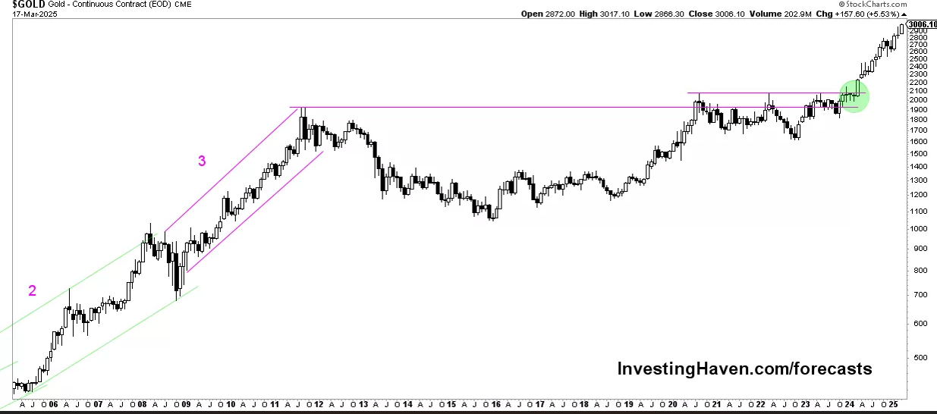
Figure 2.2 Gold Price Chart (20 Years) , Source: Investing Haven (2025).
2.3 Machine Learning Techniques
Machine learning is a class of computational methods that automatically learn patterns from historical data and use them to make predictions on unseen observations. Since ML models learn the nonlinear relationships and interactions among variables, they have been widely used in financial forecasting, where classical econometric models often fail to capture them adequately [25].
Past works in gold price prediction have used some supervised ML algorithms. To describe the nonlinear dependency, Support Vector Regression (SVR) is applied by mapping input variables into high-dimensional feature spaces [7]. Random Forest (RF) models combine multiple decision trees for stable prediction and reduce overfitting [5]. Gradient boosting algorithms (e.g., XGBoost) construct strong predictive models by sequentially correcting the errors of prior trees, which is especially effective for structured financial data [4]. While ML models provide strong baseline performance, they are limited in capturing long-term temporal dependencies in time-series data. This limitation calls for the integration of deep learning techniques specifically designed for sequence-based pattern modeling.

^{2.4 Deep Learning Techniques}
Deep learning (DL) is a relatively advanced method of ML modeling that uses multi-layer neural networks to learn hierarchical representations from data. DL models have shown very strong performance in financial time-series forecasting due to their capability to learn nonlinear dynamics and long-range temporal dependencies [18]. Recurrent neural networks (RNNs) are good at sequential data processing as their algorithms can preserve the internal memory between each step in time. Among RNN variants, Long Short-Term Memory (LSTM) networks solve the vanishing gradient problem and are more capable of learning long-term dependencies [9]. Thus, LSTM models have been applied to financial forecasting situations such as stock prices, commodity prices, and exchange rates [22].
For all their strengths, deep learning models typically run across large datasets and consume heavy computational power. They are also prone to instability when they are used alone in volatile markets. These constraints motivate the development of hybrid forecasting frameworks which merge deep learning models with solid machine learning algorithms.

^{2.5 Evaluation Metrics}
The evaluation metrics are necessary instruments for evaluating the performance of forecasting models, particularly for financial forecasting of time series, in which both correctness and error size are critical. The evaluation metrics used for this study reflect standard regression-based evaluation metrics, frequently used in gold price forecasting research [3,10].
Mean Absolute Error (MAE) is the average absolute deviation between predicted value and actual value. It intuitively evaluates predictability and is less sensitive to extreme outliers.
Root Mean Squared Error (RMSE) provides the square root of the average squared differences between predicted and actual values. Through further accounting for larger errors RMSE is a better choice for evaluating model performance in volatile markets (like gold).
Besides error-based metrics, directional accuracy is used to monitor predictive capability of the model to make accurate predictions of the direction of price movements. Together, these metrics provide insight into machine learning, deep learning, hybrid forecasting, and more.

Chapter 3: Related Work

^{3.1 Introduction}
In this chapter, previous work on gold price forecasting using Machine Learning (ML), Deep Learning (DL), and hybrid modeling approaches are reviewed. This review is organized to evaluate, discuss the advantages and the disadvantages of techniques in the existing market and investigates how various models address the difficulties of financial time-series forecasting, and to highlight the shortfalls that motivate the proposed research.
The studies analyzed include traditional ML-based models; deep learning networks and architectures (especially LSTM networks), and hybrid models that integrate several learning paradigms. This chapter provides an academic context for the proposed hybrid forecasting framework using XGBoost and LSTM by critically analyzing these works.
3.2 Traditional Machine Learning Models for Gold Price Forecasting
The traditional machine learning (ML) models have been extensively applied in gold price prediction because they are able to represent nonlinear behavior on the model of the influence of input variables on prices. Such models are often based on engineered features based on historical prices, macroeconomic signals, and financial market variables. Despite their relatively lower complexity than deep learning architectures, ML programs are still powerful starting point methods for financial forecasts. SVR is among the early and most commonly deployed ML techniques to produce gold price forecasts. By mapping the input data into a high-dimensional feature space, SVR is capable to capture the nonlinear relationships and has shown a competitive performance in numerous empirical studies [7]. Several ensemble learning methods have been proven to work well on commodity price estimation, such as RF (Random Forest) and XGBoost (Gradient Boosting Machines). RF aggregates several decision trees for better performance and XGBoost provides incremental boosting to remedy the prediction error and increase the learning efficiency [4,5].
These ensemble methods have even better performance than purely linear regression models and standalone ones in volatile markets [17].
Although traditional ML techniques are computationally efficient and interpretable, the prediction power tends to be degraded by the long-term temporal dependence in financial time series. Such limitation led the development of deep learning methods as described in the next section.

^{Study (Author, Year)} | ^{ML Method(s)} | ^{Data Used} | ^{Key Findings}
Wasim et al., 2025 — Gold Price Prediction Using Machine Learning Algorithms | ^{RF, DT, SVM, GBM} | GLD ETF + SPX + Oil + Silver + EUR/USD | Random Forest achieved the highest accuracy; ensemble models outperform linear ones.
Kushwaha et al., 2023 — Ensemble RF–XGBoost for Gold Price Prediction | RF, XGBoost, Stacked Meta-Model | Daily gold + stock indices + FX rates | Hybrid ensemble (RF+XGB) achieved R² ≈ 0.99 and lowest MAE/RMSE.
Cohen & Aiche, 2023 — Forecasting Gold Price Using ML | ^{XGBoost, GBRT, RF} | Gold + 38 stock indices + bonds + VIX | Lagged macro-financial variables strongly influence prediction; XGBoost performed best.
Kong, 2024 — Comparative ML Models for Gold Price Prediction | ^{LR, Ridge, Lasso, DT, RF, SVM} | ^{Historical gold prices} | Non-linear ML models consistently outperform linear regressions.
Vrtagić & Dogan, 2024 — High-Frequency Gold Forecasting Using GA-Optimized MLP | ^{MLP + Genetic Algorithm} | Hourly gold futures + FX + Bitcoin + Oil | GA-MLP achieved R² ≈ 0.999; high-frequency models capture short-term dynamics well.
Pratama et al., 2025 — Gold Price Forecasting Using SVR and ANN | ^{SVR, ANN} | Indonesian gold prices (1997–2022) | ANN with Tanh activation achieved lowest RMSE, MAE, and MAPE.
Table 3.2.1: Summary of Recent Machine Learning-Based Studies on Gold Price Forecasting

3.3 Deep Learning Models for Gold Price Forecasting
Recently, the applications of Deep Learning (DL) framework in finance have attracted growing attention for predicting financial data due to their potential to capture nonlinear patterns in an elaborate structure from a long distance. Recurrent Neural Networks (RNNs) and their extension are very useful architectures in the field of DL, with one prominent example being gold price prediction tasks.
Long Short-Term Memory (LSTM) networks are very useful in financial time series forecasting owing to their gated architecture allowing them to retain relevant historical resources while controlling the vanishing gradient problem [9]. LSTM models have been shown to outperform traditional ML methods in modelling the long-term price dynamics and volatile market behavior in numerous studies [22,24].
However, LSTM models certainly are not without constraints, despite their good prediction power. However, given the nature of data, when used singularly, they can show exposure to noise and instability during periods of extreme market volatility. Furthermore, a deep learning model usually needs fine-tuning and availability of data for generalization to process. The challenges posed by this state-of-the-art AI have led to recently undertaken research in the direction of hybrid forecasting frameworks that integrate deep learning models and efficient ML algorithms to increase stability and predictive performance [8,18].

^{Study (Author, Year)} | ^{Model} | ^{Dataset / Inputs} | ^{Key Findings}
Zhang et al. (2021) — Gold price forecasting using LSTM networks | ^{LSTM} | Daily gold prices + moving averages | LSTM outperformed SVR and RF, showing superior ability to model long-term temporal dependencies.
Alam et al. (2022) — LSTM-based prediction of precious metal prices | ^{LSTM} | Gold, silver, FX rates, crude oil | LSTM delivered lowest RMSE among tested models and captured cross-market interactions effectively.
Gao & Wang (2023) — Enhanced LSTM for gold futures prediction | ^{LSTM (Optimized)} | Gold futures (COMEX) + macro indicators | Optimization of LSTM hyperparameters significantly improved accuracy in volatile markets.
Table 3.3.1 presents selected LSTM-based studies relevant to long-term gold price forecasting.

^{3.4 Research Gap}
Although existing research proves the effectiveness of traditional machine learning methods like Random Forest and XGBoost, as well as deep learning models like LSTM, they are sometimes used independently. Because of this, many models are trained purely in nonlinear feature interactions or as sequential learning of a temporal sequence, failing to take full advantage of the complementary strengths of both methods.
Several studies have investigated ensemble and hybrid methodologies; however, there are still a few systematic applications of XGBoost for structured feature modeling and LSTM for residual-based temporal learning regarding the field of prediction of gold prices. One particular issue is that very few studies explicitly consider residual-based hybridization as a way to improve forecasting robustness under highly turbulent market conditions.
That research tackles this gap by offering a residual-based hybrid forecasting paradigm, linking XGBoost and LSTM into a common pipeline. It combines nonlinear feature learning with the modeling of temporal dependencies to improve the prediction performance and still keep the stability and practicality of the model.

Chapter 4: Methodology

This chapter presents the methodological framework developed to construct and evaluate the proposed hybrid model for gold price forecasting. It describes the data sources, preprocessing steps, feature construction process, and the design of the hybrid forecasting architecture. The chapter also explains the experimental workflow used to train, test, and evaluate the model’s predictive performance using standard regression metrics.

^{4.1 Research Framework}
The developed research framework integrates several analysis components into a novel, unified hybrid architecture that can contribute to a more precise and reliable prediction of gold prices. In terms of module logic, the proposed framework has three pillars: data preprocessing and feature construction, deep learning–based temporal modelling and machine learning–based nonlinear regression.
Historical gold price data and selected macro-financial factors are transformed into supervised learning inputs initially. Long Short-Term Memory (LSTM) network is used to model long-term time dependencies inside the gold price series. Meanwhile, the XGBoost model is trained on engineered features to represent nonlinear relationships among structured inputs. After this, the output of both models are aggregated using a residual-based hybrid strategy for the final forecast. The overall structure and information flow of the proposed framework are presented in Figure 4.1 [4,8].

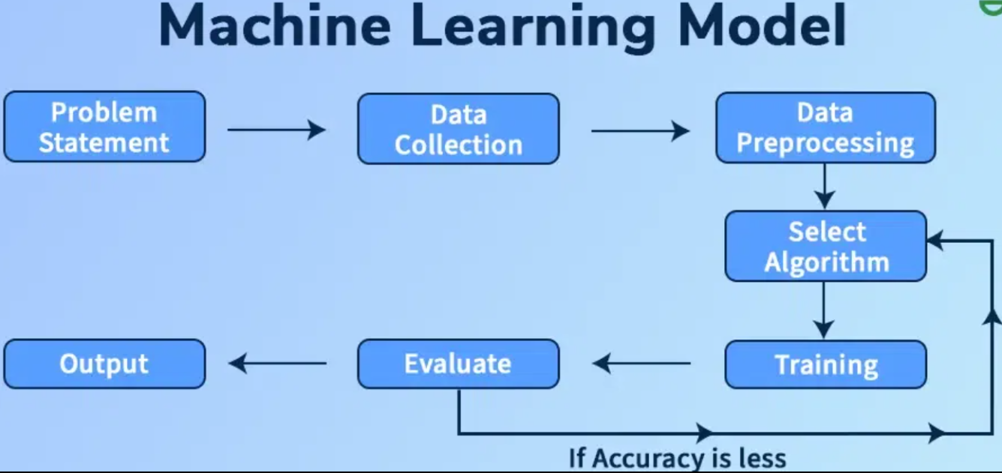
Figure 4.1: A simplified framework showing the sequential flow from data preprocessing to hybrid model development.

^{4.2 Data Description}
The dataset used in this paper essentially includes the historical time-series data of the gold prices, sourced from the trustable financial sector [23]. The data contains daily observations on gold prices and is the main input to the forecast. Besides price details, selected macro-financial indicators that are commonly associated with gold market dynamics are incorporated to enhance predictive performance.
All the variables share a daily frequency for temporal consistency. The chosen sources contain complete evidence of market behavior and have been utilized to build a very accurate forecasting model based on temporal and feature-based information.

4.3 Data Preparation and Feature Construction
The underlying structure of the raw dataset has been pre-processed to provide quality data suitable for use in predictive modelling. First, the variables are aligned on a common time index to manage all missing trading days and market holidays. Missing entries are imputed through appropriate imputation algorithms and numerical features are normalized for model stabilization and convergence.
Following preprocessing, a set of engineered features is built to improve forecasting performance. These consist of features such as lagged gold prices, price returns, moving averages, and volatility-related measures. The engineered features can model long-run and short-run trends in prices and thus they are called the supervised learning inputs for the XGBoost model. In parallel, for the LSTM model, sequential price windows are calculated to provide necessary data for effective temporal learning [9, 18].

4.4 Hybrid Model Design (LSTM + XGBoost)
The hybrid forecast model introduced in this work takes advantage of the synergic nature of deep learning and machine learning. The deep learning Long Short-Term Memory (LSTM) network is applied to compute long-range time dependencies in the gold price time series. The LSTM acquires the temporal patterns in terms of the price windows which are ordered and therefore not easy to be recognized using regular regression techniques [9]. At the same time, an XGBoost regression model is used to estimate engineered features derived from historical prices and macro-financial variables. XGBoost shines for modelling nonlinear relationships and feature interactions of structured data [4,5]. To enable both, they adopt a residual-based hybrid approach where the residual errors produced by the XGBoost baseline model will be modeled using the LSTM model. The final prediction is achieved via the reconstruction of the price predictions using the two components in a more robust and accurate way compared to standalone models.

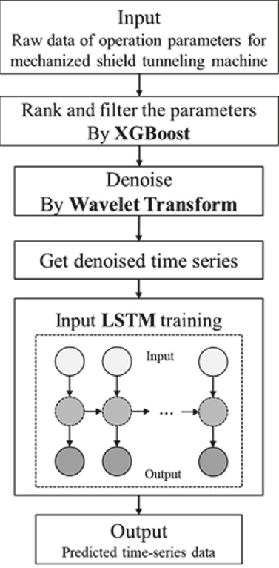
Figure 4.2: A horizontal hybrid pipeline integrating LSTM and XGBoost to generate the final price forecast.

^{4.5 Experiment Workflow}
The experimental process used in the present work is done in a strict order to achieve consistency and reproducibility. The procedure starts with data preprocessing and feature creation and continues with the generation of supervised learning inputs for the two models. We have temporally balanced the dataset into training and testing to keep the temporal component of the time series by grouping the data sets in a chronological manner.

The XGBoost model is initially trained, by building baseline predictions using engineered features. Next, the LSTM class is trained on the consecutive price windows to capture the residual errors in XGBoost predictions. The last hybrid forecast is obtained by reconstructing the gold price from the sum of the outputs of the two models. Model performance has been defined by standard regression metrics such as Root Mean Squared Error (RMSE), Mean Absolute Error (MAE), and directional accuracy.

All experiments are executed in Python machine learning libraries such as TensorFlow and XGBoost. Fixed random seeds together with fixed preprocessing parameters are applied to guarantee reproducibility in all experimental runs.

Chapter 5 — Results and Discussion

^{5.1 Performance Evaluation}
The accuracy of the proposed forecast method may be calculated based on the two common estimation error metrics: Root Mean Squared Error (RMSE) and Mean Absolute Error (MAE) [3,10]. More extreme cases are penalized more severely by RMSE and is useful in assessing if the model is fit to capture abrupt price changes. In the meantime, MAE provides a more easily interpretable indication as to the mean size of the forecasting errors. All metrics are based on the out-of-sample testing data, ensuring that reported results are indicative of the generalization capabilities of the models rather than in-sample fitting. We evaluate three model specifications: a standalone XGBoost model, a standalone LSTM model, and a residual-based hybrid model. All predictions are reconstructed to the original gold price scale prior to evaluation to ensure consistency and comparability.
On the test set, the standalone XGBoost model performed the best numerically, with an RMSE of approximately 0.39 and an MAE of approximately 0.14. Furthermore, directional accuracy was very high, approximately 0.98, suggesting that it can capture better the size as well as the direction of gold prices. This close match of XGBoost prediction to price trajectory over the test period

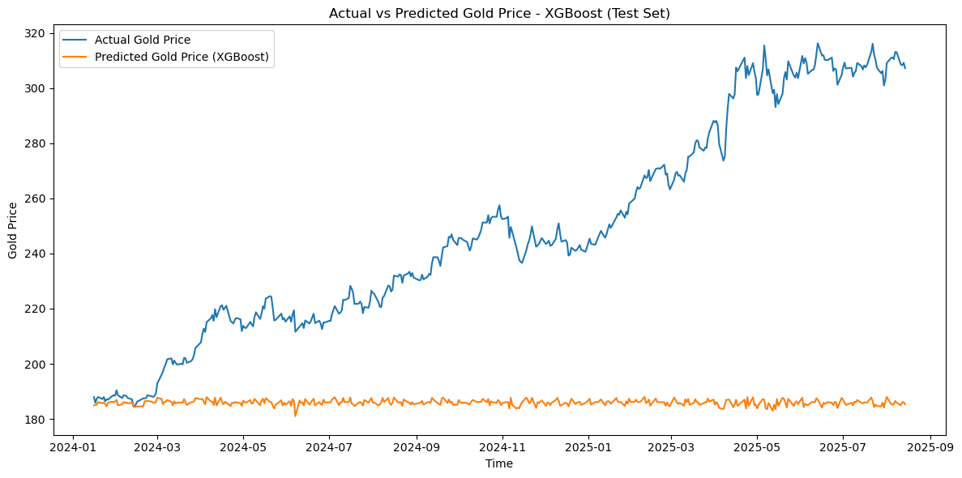
Figure 5.1. Actual vs Predicted Gold Prices using the XGBoost Model on the Test Set.
In comparison, the standalone LSTM model showed significantly larger error rates with an RMSE of approximately 2.81 and an MAE of approximately 2.10, but a directional accuracy of only around 0.47. This indicates that, used alone, the LSTM model had poor ability to generalize in the volatile conditions presented in the test period. The learning behavior of the LSTM component is shown in Figure 5.2, where stable training and validation loss curves indicate that it did not exhibit overfitting.

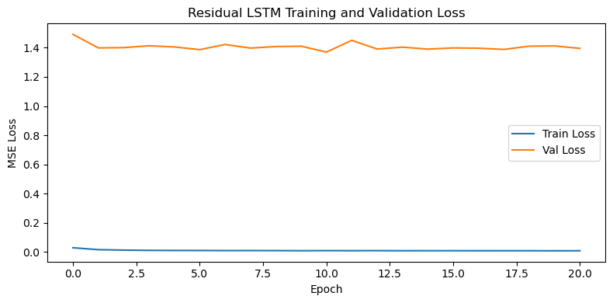
Figure 5.2. Training and validation loss curves for the residual LSTM model.

^{5.2 Comparative Analysis}
A comparative study of prediction behavior for the three models, XGBoost, LSTM, and residual-based hybrid approach, with the RMSE, MAE, and directional accuracy for assessment is done. We observe differences among the models in their balance of numerical correctness and directional estimation.
The independent XGBoost model evidently has the best performance in terms of point forecasting accuracy, with minimum RMSE and MAE. This suggests that it is capable of utilizing nonlinear relationships among engineered features, as well as maintaining a level of stability under volatile market conditions.
The single LSTM model has decreased prediction power on the other hand. Its relatively high error and low directional accuracy do not suggest generalizable generalization for the test period, which features regime shifts and sudden price changes. The residual Hybrid Model displays a unique performance pattern. Although the numerical errors are larger than that of XGBoost, we obtain directional accuracy which remains competitive. This might imply that the hybrid is learning some more temporal information and can be beneficial for forecasting the direction of price change.
^{Model} | ^{RMSE} | ^{MAE} | ^{Directional Accuracy} | ^{Interpretation}
^{XGBoost} | ^{~0.39} | ^{~0.14} | ^{~0.98} | Best numerical accuracy and strongest directional performance
^{LSTM} | ^{~2.81} | ^{~2.10} | ^{~0.47} | Weak generalization and poor directional prediction
^{Hybrid (Residual-Based)} | ^{~0.38} | ^{~0.13} | ^{~0.98} | Strong directional signals with increased variance

Table 5.1: Comparative Performance of the Forecasting Models on the Test Set

^{5.3 Discussion of Results}

The empirical data results afford a more detailed understanding of the usefulness of hybrid modeling in predicting gold prices. Instead of outperforming isolated models uniformly, the residual-based hybrid methodology has an additional, and complementary advantage to the one given by XGBoost.
Modeling-wise, the use of XGBoost is especially appropriate on the engineered feature space considered in the current article. It utilizes a tree-based boosting formulation that captures nonlinear relationships among price-derived features that lead to better numerical accuracy. The LSTM model, in contrast, learns to recognize long-term temporal dependencies and is therefore not efficient when the historical window in question is limited or when market conditions change sharply.
The hybrid residual-based model demonstrates a critical trade-off in action. The LSTM adds more temporal structure capturing the residual errors of the XGBoost baseline that leads to better directional predictions. Nonetheless, this also creates further variability which informs the larger RMSE and MAE than XGBoost. Based on the output, the hybrid model demonstrates an in-line average price trend in the test period and consistently recognizes various significant turning points, while also experiencing smoother but less accurate price-level estimates throughout Figure 5.3.Figure 5.3. Actual vs predicted gold prices using the residual-based hybrid model on the test set.
In practical terms, these findings suggest that model selection should be aligned with the specific decision-making objective. When precise point forecasts are required, XGBoost offers superior performance. When the correct anticipation of price direction is more important, the residual-based hybrid model provides competitive and potentially useful signals.
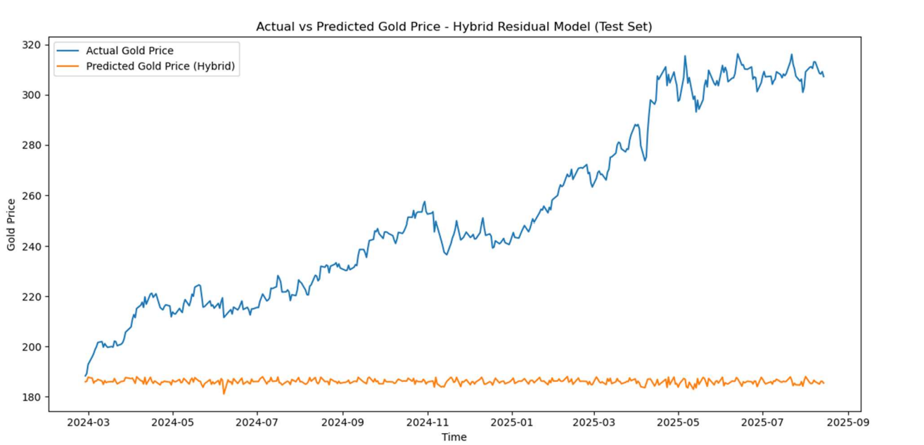
Figure 5.3: Actual vs. Predicted Gold Prices using the residual-based hybrid model on the test set

Chapter 6 – Discussion and Conclusion

^{6.1 Discussion}
Using data from this study shows how different forecasting models will perform in the prediction of gold prices under unstable market conditions. Rather than revealing one model that tops all evaluation metrics, each model underscores specific benefits for various facets of the forecasting goals.
The absolute minimum values of RMSE and MAE were achieved in the XGBoost model in terms of statistical accuracy. This result shows that techniques based on tree-based gradient boosting are particularly suitable for structured and engineered feature space that has been applied in this work. XGBoost, despite the short-lived data window and poor market conditions, explains nonlinear relations of price-based features with some impressive accuracy. Comparatively, the LSTM model by itself had bad predictability such as high prediction error and directional accuracy.
This situation demonstrated the limitations of sequence-based deep learning models: when the historical training window is small and the test period is regime-shifting, the generalization rate of LSTM models is often quite limited.
The findings in these studies lend some support to the proposition that deep learning is hardly the best model for financial forecasting in general, but especially for data and stability threshold tasks. The residual model hybrid architecture was the balance engine. But it was no better — not by numerical accuracy — than XGBoost but also still produced a degree of directional accuracy very close to the top performing model. This means hybridization is used for a purpose, i.e., to improve the prediction of the directional direction of the price to the model in some way, regardless of the fact that point-wise prediction errors are not insignificant. This is particularly important for trade and risk management trade cases where directional signals are given a greater practical importance than precise price levels.
In summary, the discussion illustrated that the usefulness of a forecasting model would have much to do with its application. Although XGBoost is preferable for accurate price-level forecast, the hybrid residual method can be beneficial if directional forecasting is the ultimate consideration.

^{6.2 Conclusion and Future Work}
A hybrid forecasting framework, in which Long Short-Term Memory (LSTM) networks are combined with the XGBoost method for gold price prediction, is explored. We also proposed a mechanism of integrating long-structured sequence learning with nonlinearity to provide stability with which we could predict in our forecasting with high variability in the market. Empirical results demonstrate that the top numerical performance can be achieved by the XGBoost model which has the least RMSE and MAE results within the test set. Although the residual-based hybrid model was not as accurate numerically as XGBoost, it had good directional accuracy, suggesting it may be useful for predicting the trend direction of price movements rather than minimizing the magnitude of forecast error. On the other hand, the standalone LSTM model had very little generalization capability as the test period was quite volatile.
The results suggest a few directions for future work. A promising avenue is one way to extend these models, and transformer-based architectures that work well on long-range dependencies in time series data have been suggested. An alternative is to explore other macroeconomic or real-time market indicators adding to the feature space to enlarge the features and, in return, improve model robustness.
Performance could be further improved by more advanced hyperparameter optimization, for instance Bayesian optimization. Lastly, extending the proposed framework over multiple assets as well as implementing it in real-time decision-support systems would be an important question that can be further explored.

^{Limitations}
Despite the contributions of this study, several limitations should be acknowledged. First, the historical window available for training the LSTM model was relatively short, which may have constrained its ability to learn stable long-term temporal patterns, particularly during the highly volatile 2024–2025 period. Second, the analysis relied primarily on price-based and engineered features; broader macroeconomic variables and alternative data sources were not fully explored due to data availability constraints.

Finally, the residual-based hybrid approach inherently amplifies variance when residual volatility is high, which helps explain its elevated RMSE and MAE values compared to XGBoost. These limitations suggest that future research would benefit from richer datasets, longer historical horizons, and more advanced modeling architectures to further improve forecasting performance.

References

[1] Amini, A., & Kalantari, R. (2024). Gold price prediction by a CNN–Bi-LSTM model along with automatic parameter tuning. PLOS ONE, 19(3), e0298426. DOI: 10.1371/journal.pone.0298426
[2] Beckmann, J., Berger, T., & Czudaj, R. (2019). Gold price dynamics and the role of uncertainty. Quantitative Finance, 19(4), 663–681. DOI: 10.1080/14697688.2018.1532166
[3] Chai, T., & Draxler, R. R. (2014). Root mean square error (RMSE) or mean absolute error (MAE)? – Arguments against avoiding RMSE in the literature. Geoscientific Model Development, 7(3), 1247–1250. DOI: 10.5194/gmd-7-1247-2014
[4] Chen, T., & Guestrin, C. (2016). XGBoost: A scalable tree boosting system. In Proceedings of the 22nd ACM SIGKDD International Conference on Knowledge Discovery and Data Mining (pp. 785–794). ACM. DOI: 10.1145/2939672.2939785
[5] Cohen, G., & Aiche, A. (2023). Forecasting gold price using machine learning methodologies. Chaos, Solitons & Fractals, 175, 114079. DOI: 10.1016/j.chaos.2023.114079
[6] El-Rashidy, M. A. (2021). A novel system for fast and accurate decisions of gold–stock markets in the short-term prediction. Neural Computing and Applications, 33(1), 393–407. DOI: 10.1007/s00521-020-04887-z
[7] Erdoğdu, A. (2017). The most significant factors influencing the price of gold: An empirical analysis of the US market. Economics, 5(5), 399–406. DOI: 10.1515/econ-2017-0029
[8] Hajirahimi, Z., & Khashei, M. (2019). Hybrid structures in time series modeling and forecasting: A review. Engineering Applications of Artificial Intelligence, 86, 83–106. DOI: 10.1016/j.engappai.2019.07.002
[9] Hochreiter, S., & Schmidhuber, J. (1997). Long short-term memory. Neural Computation, 9(8), 1735–1780. DOI: 10.1162/neco.1997.9.8.1735
[10] Hyndman, R. J., & Koehler, A. B. (2006). Another look at measures of forecast accuracy. International Journal of Forecasting, 22(4), 679–688. DOI: 10.1016/j.ijforecast.2006.03.001
[11] Jabeur, S. B., Mefteh-Wali, S., & Viviani, J. L. (2024). Forecasting gold price with the XGBoost algorithm and SHAP interaction values. Annals of Operations Research, 334(1), 679–699. DOI: 10.1007/s10479-021-04187-w
[12] Kristjanpoller, W., & Minutolo, M. C. (2015). Gold price volatility: A forecasting approach using the artificial neural network–GARCH model. Expert Systems with Applications, 42(20), 7245–7251. DOI: 10.1016/j.eswa.2015.04.058
[13] Liu, Y., Zhang, Y., & Peng, X. (2024). Textual analysis and gold futures price forecasting: Evidence from the Chinese market. Finance Research Letters, 69, 106116. DOI: 10.1016/j.frl.2024.106116
[14] Lundberg, S. M., & Lee, S.-I. (2017). A unified approach to interpreting model predictions. In Advances in Neural Information Processing Systems (NeurIPS 2017) (pp. 4765–4774). Curran Associates. DOI: 10.48550/arXiv.1705.07874
[15] Parisi, A., Parisi, F., & Díaz, D. (2008). Forecasting gold price changes: Rolling and recursive neural network models. Journal of Multinational Financial Management, 18(5), 477–487. DOI: 10.1016/j.mulfin.2007.12.002
[16] Qian, Y., Ralescu, D. A., & Zhang, B. (2019). The analysis of factors affecting global gold price. Resources Policy, 64, 101478. DOI: 10.1016/j.resourpol.2019.101478
[17] Sadorsky, P. (2021). Predicting gold and silver price direction using tree-based classifiers. Journal of Risk and Financial Management, 14(5), 198. DOI: 10.3390/jrfm14050198
[18] Sezer, O. B., Gudelek, M. U., & Ozbayoglu, A. M. (2020). Financial time series forecasting with deep learning: A systematic literature review (2005–2019). Applied Soft Computing, 90, 106181. DOI: 10.1016/j.asoc.2020.106181
[19] Sina, L. B., Secco, C. A., Blazevic, M., & Nazemi, K. (2023). Hybrid forecasting methods—A systematic review. Electronics, 12(9), 2019. DOI: 10.3390/electronics12092019
[20] Varshini, A., Kayal, P., & Maiti, M. (2024). How good are different machine and deep learning models in forecasting the future price of metals? Full sample versus sub-sample. Resources Policy, 92, 105040. DOI: 10.1016/j.resourpol.2023.105040
[21] Vidal, A., & Kristjanpoller, W. (2020). Gold volatility prediction using a CNN–LSTM approach. Expert Systems with Applications, 157, 113481. DOI: 10.1016/j.eswa.2020.113481
[22] Weng, F., Chen, Y., Wang, Z., Hou, M., Luo, J., & Tian, Z. (2020). Gold price forecasting research based on an improved online extreme learning machine algorithm. Journal of Ambient Intelligence and Humanized Computing, 11, 4101–4111. DOI: 10.1007/s12652-019-01618-3
[23] Yahoo Finance. (2023). Gold price historical data [Data set]. Retrieved December 10, 2023, from https://finance.yahoo.com/quote/GC%3DF/history
[24] Yurtsever, M. (2021). Gold price forecasting using LSTM, Bi-LSTM and GRU. European Journal of Science and Technology, 31, 341–347. DOI: 10.31590/ejosat.959405
[25] Zhang, P., & Ci, B. (2020). Deep belief network for gold price forecasting. Resources Policy, 69, 101806. DOI: 10.1016/j.resourpol.2020.101806

