MIDOCEAN university

college of management

business administration


Digitalization of Services and Its Impact on Customer Loyalty, Satisfaction, and Retention in Saudi Arabia

Research PROJECT Supervised By:

DR. FAYEZ JArd DR.ALFAISAL HASAN

MGM697
Prepared by: KAMAL IBRAHEEM ALKHIBARY

ID: 243001681

2025

جامعة ميدأوشن
كلية الإدارة
إدارة اعمال

رقمنة الخدمات وأثرها على ولاء العملاء ورضاهم والاحتفاظ بهم في المملكة العربية السعودية

إشراف/
د. فايز جراد د. الفيصل حسن

عمل الطالب/
كمال إبراهيم الخيبري

2025

Contents

Abstract 4
1 Introduction 5
1.1 Introduction 6
1.2 Problem Statement 7
1.3 Research Questions 8
1.4 Research Objectives 8
1.5 Research Hypotheses 9
1.6 Research Variables 9
2 Literature review 10
2.1 Introduction 11
2.2 Digitalization of Services 11
2.3 The Trend of Digitalization of Services in Saudi Arabia 12
2.4 Customer Loyalty and the Factors that affecting it 13
2.4.1 Customer loyalty concept 13
2.4.2 Factors affecting Customer Loyalty 13
2.5 Customer Satisfaction Factors 14
2.5.1 Customer Satisfaction 14
2.5.2 Factors affecting Customer Satisfaction 15
2.6 Ways of achieving Customer satisfaction and loyalty 15
2.7 Customer Retention 16
3 Methodology 17
3.1 Research community and sample 18
3.2 Research Tool 18
3.3 Research Scale 18
3.4 Tool Scale 19
3.5 Statistical methods 20
4 Data Analysis 21
4.1 Descriptive Data Analysis 22
4.2 Questionnaire’s Items Analysis ( Mean & Standard Deviation) 23
4.3 Reliability Analysis 24
4.4 Correlations Analysis 25
5 Findings 26
5.1 Validity Analysis 27
5.2 First Hypothesis Test 27
5.2.1 Hypothesis Content 27
5.2.2 Regression Analysis 27
5.3 Second Hypothesis Test 29
5.3.1 Hypothesis Content 29
5.3.2 Regression Analysis 29
5.4 Third Hypothesis Test 31
5.4.1 Hypothesis Content 31
5.4.2 Regression Analysis 31
5.5 Findings 33
6 Discussion & Conclusion 34
6.1 Discussion 35
6.2 Conclusion 39
7 References 40
8 Appendices 44
8.1 Questionnaire 44

Abstract

Since the COVID-19 Pandemic, the importance of the digital world has become evident to Saudi Arabia's Society even though the concept was not old, as the government announced the same in its 2030 Vision and the National Transformation Strategy (2020) 2016. On the other hand, customer satisfaction, loyalty, and retention are the main goals for any firm to increase its market share and profitability. However, these variables are significant even for non-profit and government organizations. Accordingly, this inductive research aims to evaluate the Saudi public opinion about the digitalization of services and its impact on customer satisfaction, loyalty, and retention. Drawing from the literature reviews, three hypotheses were formulated to indicate the relationships between the Digitalization of Services, Customer Satisfaction, Loyalty, and Retention in Saudi Arabia. The three hypotheses were tested by conducting an online survey distributed among Saudi Society across different regions of Saudi Arabia. By applying statistical analysis (Multiple Regression Analysis) to 329 respondents, we found evidence of the effects of the digitalization of services on customer satisfaction, loyalty, and retention. At the end of the research, a discussion of how and why digitalization of services affects customer satisfaction, loyalty, and retention and what other factors affect the same are explained.

Key Words: Digitalization of Services (Dig_Ser) , Customer Satisfaction (Cus_sat)Customer Loyalty (Cus_Loy) ,Customer Retention (Cus_Ret) , Saudi Vision 2030 , and COVID-19 Pandemic.

Digitalization of Services and Its Impact on Customer Loyalty, Satisfaction, and Retention in Saudi Arabia
Chapter One

Introduction
  - Introduction
  - Problem Statement
  - ResearchQuestions
  - Research Objectives
  - Research Hypotheses
  - Research Variables

Introduction

The importance of Vision 2030 is that it seeks to develop infrastructure and create an enabling environment for the public, private and non-profit sectors by focusing on achieving excellence in government performance, contributing to the private sectordevelopment, supporting digital transformation, promoting community development, ensuring sustainability, and developing economic partnerships. One of the factors that help achieve Vision 2030 is the trend towards using electronic commerce and digitalization of services because it contributes a lot to saving time, effort and reducing costs at the best possible quality.
Given the radical developments in the international business environment, represented in the phenomenon of trade liberalization, the significant expansion of information and communications, the intensity of competition, and technological globalization (Evans, James R (2019,5). The quality of services has become the most decisive field in achieving the goals of organizations, and achieving competitive advantage can only be achieved by providing a high level of performance in line with the requirements and desires of the beneficiaries, which shows the growing interest in the quality of products and services on an ongoing basis (Chia-Ming Chang, 2012, 34).
Digital transformation is the lifeline for entrepreneurs in an age of speed and constant change (Trofino, A.J, 2000, 47). Digital transformation represents a significant change in the provision of services and not a cumulative change. It helps to achieve sustainability and competitiveness and build influential societies because it helps provide services in a better and faster manner (Bello, V, 2018, 65).
Digital transformation involves the process of changing the product or service delivery entirely, which may be strategic by interfering with the functions of the entire organization, as well as changing the main components of the business in terms of infrastructure, methods of operation, and how services are obtained. The digital future is the only practical alternative, as the future of human beings is linked to this new pattern.However, the traditional services is characterized by the intense intervention of the human element and many errors (Zeithaml, 2003, 14).
Thus, digital transformation contributes to the development of business and the provision of services through the use of the Internet in a very high manner to achieve customer satisfaction and loyalty (Kuo Y-F, 2019, 65). However, there is little known about the quality of online services of the existing online stores' services, mainly how e-service quality provides satisfaction to consumers and contributes to loyalty (Kuo Y-F,2019,65). However, E-commerce seeks to achieve corporate goals, achieve more sales, and thus increase the number of customers. Because increased sales mean increased customer satisfaction with the company's products and services, this is why companies are moving towards digitalization and electronic commerce. Many companies that have incorporated digitalization and e-commerce into their activities are reaping great success (Slack, 2004, 73).
Reliance on modern technology, electronic commerce, and digitalization of services contribute to the development of the economy of countries. Thus, it achieves a decent life for the citizens. The importance of modern technologies and technology is that they contribute to the development of our scientific and practical life in all fields, hence the importance of the trend towards digitalization of services make the extra push you need to stay ahead of your rivals along with the increase of your sales and profits (Sharma, 2020, 64).

Problem Statement

Some companies suffer from customer complaints due to difficulties in obtaining services and products using traditional methods. This prompted companies to switch to the digitalization of their services to standardize their services and eliminate human errors.
Saudi companies, institutions, and private and public organizations are interested in achieving customer satisfaction and gaining loyalty as customer satisfaction indicates their success and boosts their development process. So companies are keen to provide all the necessary capabilities for them, and this is what prompted Saudi companies to use modern technology and benefit from the Internet and social networks to offer their services electronically. Therefore, the current research aims to identify/evaluate the impact/relationship of digitalization of services and customer satisfaction, loyalty, and retention in Saudi Arabia.
This inductive study used a survey strategy with quantitative data collection and analysis to test the hypotheses. The data collected from (329) Saudi residents with different ages, background, regions, and qualification. By using the data collected from various Saudi communities, the proposed model will be tested using several statistical methods. The results from data samples will be expected to support the proposed hypothesized relationships, supporting the idea that digitalization of services helps improve customer satisfaction, loyalty , and retention.
The report has six main chapters, including Literature Reviews, Methodology, Data Analysis, Findings, and Discussion& Conclusion. The Literature Review section will show some critical reviews of previous studies along with the explanation of some related theories. In Methodology Section, the research setting, sampling procedures, data collection, and research instrument will be discussed. In Data Analysis & Findings Sections, some descriptive& inferential analyses will be applied to the data collected to test the proposed hypotheses and determine the relationships between the variables. After that, an interpretation of the results and discussion of why and how these variables are related will be included in the Discussion section with indicating the implication of the research. In the end, the study will be summarized in the Conclusion Section.

ResearchQuestions

The present study aims to answer the following questions:
- Does the digitalization of services has a relationship with Customer Satisfaction in Saudi Arabia?
- Does the digitalization of services has a relationship with Customer Loyalty in Saudi Arabia?
- Does the digitalization of services has a relationship with Customer Retention in Saudi Arabia?

ResearchObjectives

Main objective of the research:
- To identify the relationship between digitalization of Services and Customer Satisfactions.
- To identify the relationship between digitalization of Services and Customer Loyalty.
- To identify the relationship between digitalization of Services and Customer Retention.

Research Hypotheses

H1: The Digitalization of Services in Saudi Arabia Companies, Institutions, and Private & Public Organizations have a positive relationship with Customer Satisfaction.
H2: The Digitalization of Services in Saudi Arabia Companies, Institutions, and Private & Public Organizations have a positive relationship with Customer Loyalty.
H3: The Digitalization of Services in Saudi Arabia Companies, Institutions, and Private &
Public Organizations have a positive relationship with Customer Retention.

Research Variables

Independent Variable: Digitalization of Services.
Dependent variable: Customer satisfaction, loyalty, and retention.
H1 Research’s Variables1
Digitalization of services

Customer Satisfaction

Customer Loyalty

Customer Retention

H2 Research’s Variables 1
H3Research’s Variables 1

Digitalization of Services and Its Impact on Customer Loyalty, Satisfaction, and Retention in Saudi Arabia

Chapter Two

Literature review
2.1 Introduction.
2.2 Digitalization of Services.
2.3 The Trend of Digitalization of Services in Saudi Arabia.
2.4 Customer Loyalty.
2.5 Customer Satisfaction.
2.6 Ways to achieve Customer loyalty and Satisfaction.
2.7 Customer Retention.

Introduction

In this chapter, we address terms, concepts, and previous studies related to the current study, where identify the concept of customer loyalty and the factors affecting it, as well as identifying the concept of customer satisfaction and the factors affecting it, then explain the ways to achieve customer loyalty and satisfaction, and ways to maintain them. Then identify the concept of the Digitalization of Services and their importance. Finally, place the trend of Digitalization of Services in Saudi Arabia.

Digitalization of Services

The digitalization of services is one of the most critical modern means that companies use to provide their services efficiently and conveniently (Grant, 2019). Digitalization is one of the crucial ongoing transformations of modern society (Hagberg et al., 2016). According to Gartner IT Glossary (2019), digitalization is “the use of digital technologies to change a business model and provide new revenue and value-producing opportunities”. Digitalization is also described as moving to a digital business based on digitization, meaning the process of changing from an analog form to a digital one (Garner IT Glossary, 2019).
According to Hagberg et al. (2016), the transformation from analog to digital is crucial for the retail sector since this development both affects and is being affected. The drive to digitize services helps governments meet public expectations and demonstrate flexibility and efficiency. Undoubtedly, it is a complex task, but it ensures that we move at a faster pace and with limited resources if we adhere to the application of a correct and tried method (Grant, 2019).
The availability of digital public services has become an urgent necessity after the private sector contributed to improving customer experience, and governments are expected to keep pace with this development (Hajdukiewicz, 2016). However, this issue is often related to the confidence of individuals in their governments, and it has been shown that citizens who are satisfied with public services are nine times more likely to trust the overall performance of governments than others (Emma Silvennoinen 2020).
Digitalization of government services means facilitating digital technology and transforming the government's services in a practical way based on digital technology. The digitalization of government services is replacing and exchanging information from paper writing to electronic systems through the use of the Internet. It is saved electronically after that, with the spread of diseases and epidemics and the ease of infection (Garner IT Glossary, 2019).

The Trend of Digitalization of Services in Saudi Arabia

Saudi Arabia has been keen to adopt the concept of digital government transformation by replacing digital processes with traditional ones and has developed five-year plans and strategies to ensure the achievement of its goals with quality and efficiency, as it aims to reach an integrated digital government that facilitates all services to the beneficiaries (Saudi vision,2030).
The Kingdom has a strong digital infrastructure that has accelerated its digital transformation process. This structure enabled the Kingdom to face crises that disrupted all public and private services and contributed to the continuity of business and educational processes and all the requirements of daily life for residents and citizen in light of the Corona Covid-19 pandemic.
Saudi Arabia has been among the top ten developed countries due to its robust digital infrastructure. KSA has improved the digital services’ quality that are provided to beneficiaries through a partnership with the private sector to provide fiber-optic network coverage for more than 3.5 million homes throughout the Kingdom, and Internet traffic during the pandemic has increased by 30%, and Internet traffic has doubled through the national Internet exchange, as well as advanced Internet speed from 9 Mbps in 2017 to 109 Mbps in 2020, and the completion of the expansion of the internal coverage system in the third Saudi expansion in the Great Mosque of Mecca (https://www.my.gov.sa/).
The Kingdom's achievement of the title of "most advanced country" among the 20 countries in digital competitiveness due to the comprehensive government support for digital transformation in the Kingdom as part of Vision 2030 (Saudi vision,2030).
The Kingdom worked on developing a five-year strategy within three action plans: The first action plan: 2006-2010: It sought to enable everyone by the end of 2010, from anywhere and at any time, to obtain government services at a distinguished level, in an integrated and easy way, through many secure electronic means (://www.my.gov.sa/). Second Action Plan: 2012-2016: It sought to enable everyone to use effective government services safely, in an integrated and accessible manner through multiple electronic channels. The third work plan: 2020-2024: It is the current work plan, which seeks to reach the concept of "smart government" " (Saudi vision,2030).

Customer Loyalty and the Factors that affecting it

All companies and service institutions seek to achieve customer loyalty because gaining customer loyalty is an essential and vital matter for the success of companies, their development, and their ability to survive and compete (Jefry Romdonny,2021). Based on the importance of customer loyalty, we will identify the concept of customer loyalty and know the factors affecting it. The business organizations development can be realized if supported by two significant factors, namely customer satisfaction and loyalty for the products they produce. The greater the pleasure received by consumers and the higher the value of customer loyalty, the greater the company's profits (Qualtrics, 2019) (Mohamad Dimyati,2016).

Customer loyalty concept

Customer loyalty is the customer’s willingness to deal with a brand again and again or buy from it, which results from a positive customer experience, customer satisfaction, and the value of the products or services that the customer gets from the transaction (Albert Caruana,2017). Customer loyalty measures how likely customers are to continuously repurchase a product or service from the same company or institution (Acar& Puntoni,2016). Customer loyalty could be considered as a positive ongoing relationship between a business and a customer. It is what drives new customers to repeat purchases and prompts existing customers to choose your company over a competitor offering similar benefits (Farai & Promise,2015).

Factors affecting Customer Loyalty

Customer satisfaction and loyalty measurement is an important segment of marketing control to gather information on what is necessary for customers to repeat their purchase and decide whether that is sufficient for essential loyalty (Woon& Cheng,2015). Measuring customer loyalty in the business market is complex and often linked with the subjectivity of researchers (Anderson & Mittal,2016).
Many factors affect customer loyalty, and the most important of these factors are: Customer satisfaction is an essential indicator of customer loyalty, but it is not sufficient. Customers may be happy, but they do not have to re-shopping from the same firm. According to that, satisfaction involves information exchange with the company and cooperation. The primary requirement is the existence of mutual trust with sharing sensitive information to create value for customers and develop a long-term relationship with them (Kumar& Shah,2018).
Trust creates customer loyalty which explicitly and implicitly means that open, frequent, and honest communication will develop. Such communication increases credibility, reliability, and intimacy and reduces doubt, uncertainty, one-sided orientation, and preoccupation (Kundu& Datta,2015). Trust improves customer responsiveness, incredibly emotional, which increases customer readiness to cooperate and engage more in relationships (Trasorras& Abratt,2017).

Customer Satisfaction Factors

Customer Satisfaction

Customer satisfaction is a measurement that indicates how happy customers are with a company's capabilities, products, and services (Anderson & Mittal., 2016). Customer satisfaction is defined as the positive result of measuring the degree of customer satisfaction with a product, service, or experience, choosing answers such as (satisfied - not satisfied) (Bansal, S. & Gupta, G. 2019). Customer satisfaction is a concept inherent in the field of marketing that means, as is already expected, the satisfaction that a customer feels in relation to a product or service obtained or consumed, precisely because it has fully covered the expectations set at the time of purchase (Zairi, M., 2016).
The customer's satisfaction about A product or service that he consumes because it meets his demands and expectations (Evangels & Yannis 2018). Customer satisfaction is vital because it provides a system for measuring the extent of the relationship between the company and the customer and is helpful in improving services and products and thus doubling the success rate because it analyzes the strengths and weaknesses in performance and thus leads to the development of performance in general (McIlroy& Barnett,2017).

Factors affecting Customer Satisfaction

Companies and institutions are interested in achieving customer satisfaction. For that, companies seek to identify the factors that affect customer satisfaction, because identifying the factors influencing customers contributes a lot to achieving customer satisfaction, and this contributes to gaining their confidence in the company and makes them deal with the company many times (Cronin, J.J., Brady& Hult,2019). Therefore, we will try to identify the most critical factors contributing to customer satisfaction.
The first step in improving your customer satisfaction is by understanding the factors that impact it, followed by learning how to act on those factors (Al-Hawari&Ward,2016). The three significant factors that affect modern customer satisfaction are customer perceived quality, value, and service (Anderson & Lehmann,2014).

Ways of achieving Customer satisfaction and loyalty

Companies use many ways and means to achieve customer loyalty and satisfaction with the products and services offered by those companies or institutions, whether they are profit or service. It can be explained as follows:
Good listening to customers: Good listening to customers and understanding their needs is one of the most important ways to achieve customer satisfaction (Kundu& Datta,2015). This is done by collecting customer feedback, measuring their satisfaction through questionnaires and suggestion boxes, and converting customer feedback and suggestions into actions dealt with by the work team.
Product and service development: Various companies and institutions seek to develop the level of services and products they provide to their customers; Because of this of great importance in raising the levels of customer satisfaction, especially those improvements that come based on customer feedback and suggestions, which would solve their problems (Bowen& Chen,2015).
Hiring the best: Customer service is the primary interface for companies and businesses, so it is significant for the customer service team to leave a good impression on the company through optimal dealing with customers and ensuring that dealings are professional and highly professional, so it is necessary to employ the best in this critical section of companies and provide appropriate incentives to them.
Take care of credibility: Companies are also keen to maintain high credibility as one of the most critical factors attracting customers as successful companies are keen not to promise anything that cannot be done as one of the most significant sources of customer dissatisfaction is when the service or product does not match the customer’s expectations (Anderson & Mittal,2016).

Customer Retention

The concept of customer retention refers to companies' activities and actions to reduce the number of customers who stop dealing with the company or using its products (Palmatier,2018). The goal of the customer retention program that many companies follow, especially international companies, is to enable the company to retain the most significant possible number of customers, often by providing customer loyalty initiatives and their association with the brand (Ennew., & Chiplin,2015).
The customer retention strategy starts from the first communication between the company and the customer and continues throughout the transaction period (Campbell,2017). While most companies spend more money to attract customers because they see this as an effective and quick way to increase revenue, customer retention is more beneficial. On average, customer retention costs less than the process of attracting new customers. The players often play with existing customers, more effective in increasing revenue than selling to a potential customer (Srivastava,2016).

Digitalization of Services and Its Impact on Customer Loyalty, Satisfaction, and Retention in Saudi Arabia

Chapter Three

Methodology
3.1 Research community and sample
3.2 Research Tool
3.3 Research Scale
3.4 Tool Scale
3.6 Statistical methods

The main objective of this research is to test the relationship between the digitalization of the services and customer satisfaction, loyalty, and retention in the Kingdom of Saudi Arabia. Therefore, the researcher deals with the methodology applied in this study, describing the methods and procedures used to carry out this study to answer the questions that represent the problem and objective of the study.

Research community and sample

The study community is represented by Saudi society members, who did the questionnaire via Google Form that was distributed through a link to a group of people who use modern technologies and practice dealing with digital services in their daily lives in Saudi society. About (329) respondents have been collected, and the data collection process started on April 2022 and took about one month.

Research Tool

To achieve the research goals and test the hypotheses, preparation was completed by reviewing previous literature and studies and creating a questionnaire. The questionnaire was designed to use closed questions as much as possible in order to facilitate the process of coding and analyzing the data. The questionnaire has Thirty-One items that reflect the following variables, Digitalization of Services (Six items), Customer Satisfaction (Eight items), Customer Loyalty (Eleven items), and Customer Retention (Six items). The questionnaire has been distributed here in Saudi Arabia through What's App, e-mail, LinkedIn, and Twitter.

Research Scale

The following variables, which are related to the research subject, were divided into four axes:
First Scale:Digitalization of Services.
Second Scale:Customer Satisfaction.
Third Scale: Customer Loyalty.
Fourth Scale: Customer Retention.

Tool Scale

The seven- point Likert scale was used to measure the respondents' responses to the questionnaire items according to the following table.

Table No. ( 1 ): It shows the Likert scale
Response | Strongly Agree | Agree | somewhat ok | Neutral | Somewhat disagree | Not agree | Strongly Disagree
Degree | 7 | 6 | 5 | 4 | 3 | 2 | 1

The response categories labels were divided into seven primary responses, Strongly Disagree (1), Not Agree (2), Somewhat Disagree (3), Neutral (4), Somewhat Ok (5), Ok (6), and Strongly Agree (7). When the researchers choose a score of ( 7 ) for the response “ strongly agree”, the relative weight, in this case, is 100 %. According to the relative weight table No. ( 2 ), gives positive results for the item. Table (2) shows the rest of the response categories along with their relative weight.
Table ( 2 ) shows the relative weight
A series | Verbal Estimate | Relative weight from - to | the percentage is 100 %
7 | Strongly Agree | 6.20 - 7.00 | 100%
6 | OK | 5.60 - 6.20 | 89.8%
5 | somewhat ok | 4.40 - 5.60 | 77.5%
4 | neutral | 3.20 – 4.40 | 68.8%
3 | Somewhat disagree | 2.60 – 3.40 | 56.5%
2 | not agree | 1.80 – 2.60 | 36.5%
1 | Strongly Disagree | 1.80 -1 | less than 30%

Statistical methods

Two types of analysis were used to analyze the collected questionnaires’ data and responses: Descriptive and Inferential (Empirical) analyses. In the Descriptive Analysis, the demographic information of the samples has been summarized and described. Moreover, Mean and Standard Deviation have been calculated to check the homogeneity of the samples’ responses. The mean helps to find the average or the most common value in our data collection, where the standard deviation helps to indicate the average amount of variability in our data collection. In the Inferential Analysis, some statistical methods were used to test the relationships between Digitalization of Services and Customer Satisfaction, Customer Loyalty, and Customer retention. The three main statistical methods used are Reliability Analysis, Multiple Regression Analysis (Validity) , and Correlation Analysis. In Reliability Analysis, the responses’ consistency has been measured through the value of Cronbach’s Alpha. In Multiple Regression Analysis, a relationship between our research’s dependent and independent variables has been observed. Besides, the direction, significance, strength, and magnitude of these relationships have been tested. In Correlation Analysis, the strength of the relationships between our variables has been evaluated.

Digitalization of Services and Its Impact on Customer Loyalty, Satisfaction, and Retention in Saudi Arabia

Chapter Four

Data Analysis
  - Descriptive Analysis
  - Questionnaire’s Items Analysis (Mean & Standard Deviation)
  - Reliability Analysis
  - Correlations Analysis

Descriptive Data Analysis

The research aims to see the general public opinion about the digitalization of services and if it currently leads to customer satisfaction, loyalty, and retention. Therefore, the sample was people from the Saudi Arabia society with different ages, backgrounds, qualifications, and regions. About (329) respondents have been collected by distributing a link through the questionnaire that has been broadcast here in Saudi Arabia through What's App, e-mail, LinkedIn, and Twitter. However, the questionnaire was created by Google Forum, including Thirty-one Items divided as follows, Digitalization of Services (Six items), Customer Satisfaction (Eight items), Customer Loyalty (Eleven items), and Customer Retention (Six items).

The questionnaire has been distributed in three main phases. In the first phase, the questionnaire was broadcasted through What's App and e-mail to about Eighty students and Twenty doctors/professors who are part of the Executive Master of Business Administration Program community at King Abdul-Aziz University. In the second phase, the questionnaire was distributed through LinkedIn to a network of (354) professional employees working in different firms in various industries in public and private sectors of Saudi Arabia. In the third phase, the questionnaire was broadcast through Twitter and What's App to a network of (86) close family members and friends.

The received (329) respondents were all from Saudi Arabia, professional employees working in private and public sectors. The sample was an average of aged Twenty to Forty years, and the qualification of the sample was a bachelor's or master's degree. It is worth mentioning that the targeted sample mainly was male rather than female.

Questionnaire’s Items Analysis ( Mean & Standard Deviation)

Table No. (4) Descriptive Analysis of Research Scales
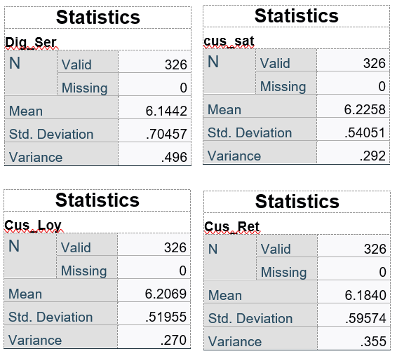
Table No. (4) shows the descriptive analysis of the four scales in the research. From the table, the average mean of the six items located under the Digitalization of Service Scale is 6.1442, which means the average responses for this scale were in an Agree degree. The Customer Satisfaction Scale has an average mean value of 6.2258, which reflect the Strongly Agree degree for its eight items. Moreover, Customer Loyalty has 6.2069, reflecting the same degree of Customer Satisfaction Scale. However, Customer Loyalty has the same degree as the Digitalization of Services, Agree. The Variance values of the four scales are accepted as they are in Low degrees as they are less than 0.5.

Reliability Analysis

In this analysis, the IBM SPSS Statistics tool was used to test the responses’ reliability by measuring Cronbach’s Alpha’s value. The analysis was applied on the four main scales or categories in the questionnaire: Digitalization of services, Customer Satisfaction, Customer Loyalty, and Customer Retention. As shown in Table-5, all Cronbach’s Alpha values for the four scales are above 0.7, indicating an acceptable range of consistency. Furthermore, the minimum and maximum values of Cronbach’s Alpha were 0.733 and 0.834, which reflect a very good level of reliability. Note that the number of items indicates the number of questions under each scale of the questionnaire.
Table No. (5) consequences a test Cronbach ( alpha ) for Tool search
Scale | number of items | Alpha . Stability Coefficient
Digitalization of services | 6 | 0.834
Customer Satisfaction | 8 | 0.799
Customer Loyalty | 11 | 0.823
Customer Retention | 6 | 0.733
Average of Scales | 31 | 0.929

Correlations Analysis

Table No. (6)Correlations Analysis of the Research Variables
Correlations
 |  | Dig_Ser | cus_sat | Cus_Loy | Cus_Ret
Dig_Ser | Pearson Correlation | 1 | .614** | .646** | .491**
Dig_Ser | Sig. (2-tailed) |  | <.001 | <.001 | <.001
Dig_Ser | N | 326 | 326 | 326 | 326
cus_sat | Pearson Correlation | .614** | 1 | .853** | .677**
cus_sat | Sig. (2-tailed) | <.001 |  | <.001 | <.001
cus_sat | N | 326 | 326 | 326 | 326
Cus_Loy | Pearson Correlation | .646** | .853** | 1 | .677**
Cus_Loy | Sig. (2-tailed) | <.001 | <.001 |  | <.001
Cus_Loy | N | 326 | 326 | 326 | 326
Cus_Ret | Pearson Correlation | .491** | .677** | .677** | 1
Cus_Ret | Sig. (2-tailed) | <.001 | <.001 | <.001
Cus_Ret | N | 326 | 326 | 326 | 326
**. Correlation is significant at the 0.01 level (2-tailed).

Table-6 shows the correlations between the variables of the models. From the table, the Digitalization of Services has a significant correlation with both Customer Satisfaction and Customer Loyalty at a 99% Confidence Interval under a 2-tailed test. However, the Digitalization of Services has less significant correlations with Customer Retention at a 99% Confidence Interval under a 2-tailed test than the other two dependent variables.

Digitalization of Services and Its Impact on Customer Loyalty, Satisfaction, and Retention in Saudi Arabia

Chapter Five

Findings
5.1 Validity Analysis
5.2 First Hypothesis Test
5.2.1 Hypothesis Content
5.2.2 Regression Analysis
5.3 Second Hypothesis Test
5.3.1 Hypothesis Content
5.3.2 Regression Analysis
5.4 Third Hypothesis Test
5.4.1 Hypothesis Content
5.4.2 Regression Analysis
5.5 Findings

Validity Analysis

In Validity analysis, we make sure that our survey questions measure what we intend to measure. In this analysis, Multiple Regression Analysis tested the relationships between the independent variables, Digitalization of Services, and the dependent variables Customer Satisfaction, Loyalty, and Retention. The IBM SPSS Statistics tool was used to test the Strength, Significance, Direction, and Magnitude of the relationships through applying the Multiple Regression Analysis. Moreover, the validity of the model's relationships has been measured by calculating the correlation between the predicted and observed values R and the coefficient's square and indicates the variation percentage$R^{2}$. Furthermore, the Confidence Level in the analysis was 95%, reflecting 5 % of acceptable error.

First Hypothesis Test

Hypothesis Content

The Digitalization of Services ,in Saudi Arabia Companies, Institutions, Private & Public Organizations, have a positive relationship with Customer Satisfaction

Regression Analysis

Table No. (7)Regression Analysis of First Hypothesis
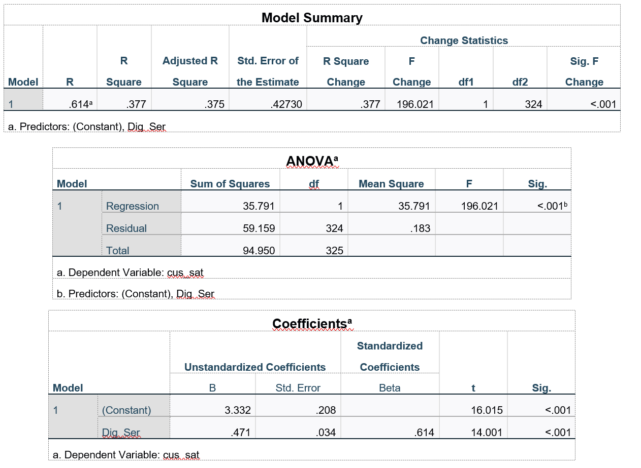
Table-7 shows the Model summary, this table indicate the correlation between the independent variables (Digitalization of Services) and dependent variable (Customer Satisfaction). The values of both $R^{}$&$R^{2}$ were 0.614 and 0.377, respectively. The $R$ value reflects that independent variables explain 61.4 % variance into the dependent variable , where 38.6% variance is left unexplained. These results reflect an acceptable range of the model's strength and a medium acceptable range of variation percentage. However, the table shows the estimated error of the whole model which equal to 0.42730.
The variance analysis (ANOVA)reports the overall model significance with the independent variable (Digitalization of Service) and the dependent variable (Customer Satisfaction). This table shows that the whole model is significant, with an accuracy equal to 99.%.
The coefficients of the Multiple Regression Analysis shows the Strength, Significance, Direction, and Magnitude of the relationships could be observed. From Table-7, we can observe a significant and strong relationship between the Digitalization of Services and Customer Satisfaction with almost 99.0 % accuracy since the Sig. Value of the Digitalization of Services is less than 0.001 with t value equal to 14.001. Moreover, The Digitalization of Services has an impact on the dependent variable (Customer Satisfaction), with a magnitude equal to 0.614. Besides, the relationship's direction is positive, as observed from the Unstandardized Coefficient Beta value of the Digitalization of Services.
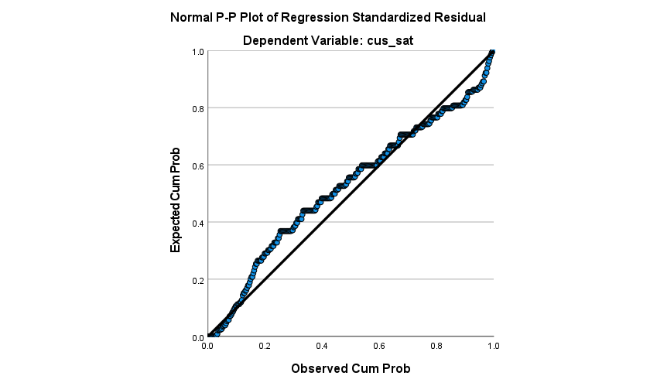
Figure (1) First Hypothesis Graph

Second Hypothesis Test

Hypothesis Content

The Digitalization of Services ,in Saudi Arabia Companies, Institutions, Private & Public Organizations, have a positive relationship with Customer Loyalty

Regression Analysis

Table No. (8)Regression Analysis of Second Hypothesis
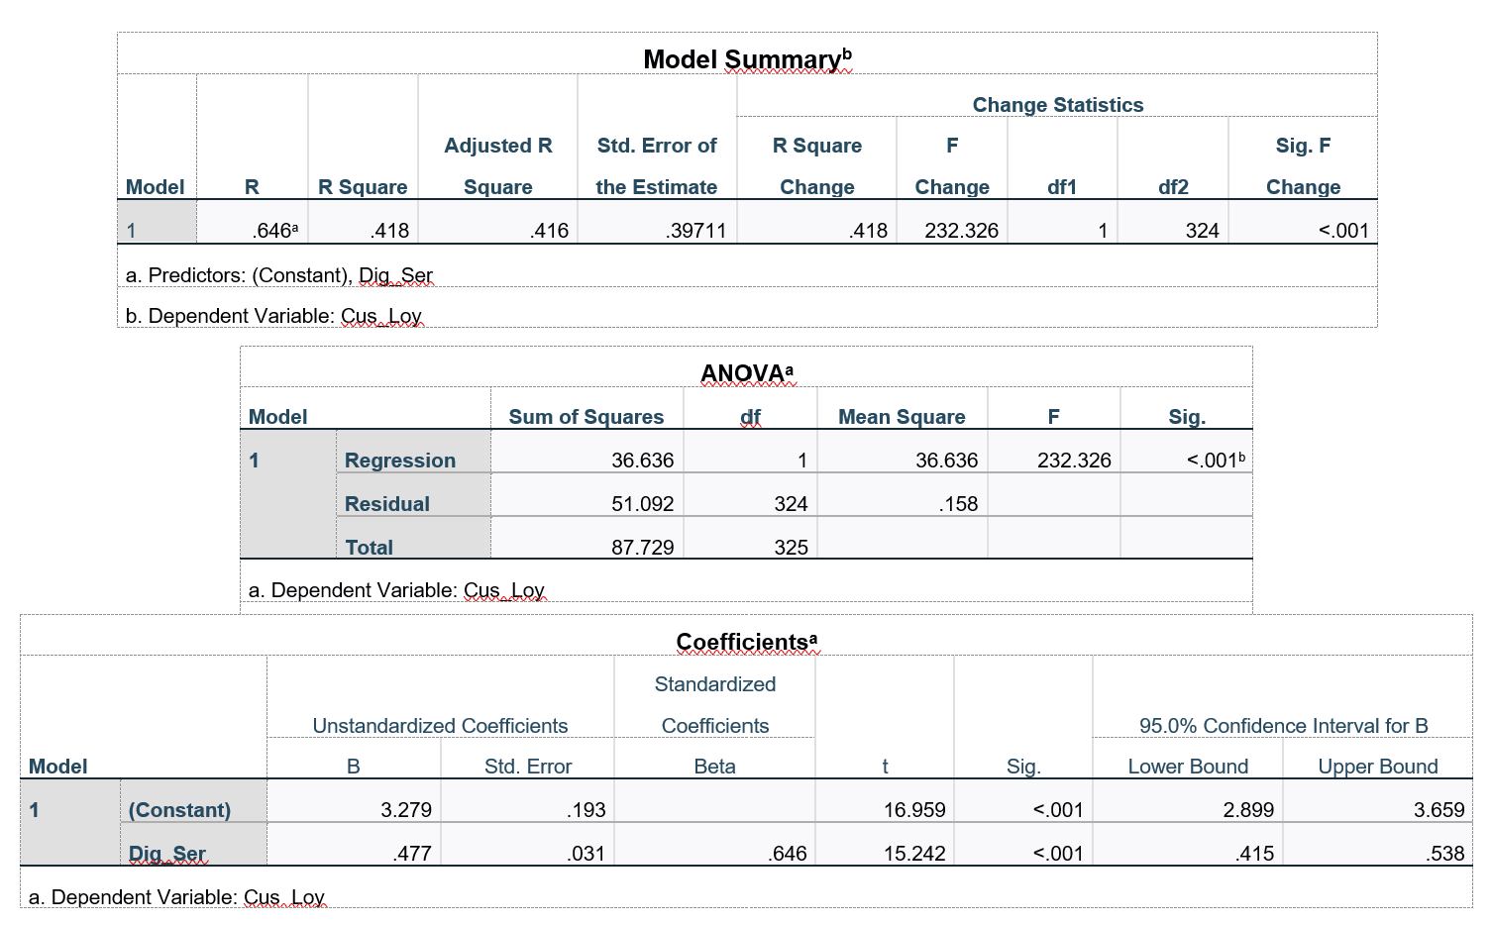
Table-8 shows the Model summary, this table indicates the correlation between the independent variables (Digitalization of Services) and dependent variable (Customer Loyalty). The values of both $R^{}$&$R^{2}$ were 0.646 and 0.418, respectively. The $R$ value reflects that independent variables explain 64.6 % variance into the dependent variable, where 35.4% variance is left unexplained. These results reflect an acceptable range of the model's strength and a medium acceptable range of variation percentage. However, the table shows the estimated error of the whole model which equal to 0.39711.
The variance analysis (ANOVA)reports the overall model significance with the independent variable (Digitalization of Service) and the dependent variable (Customer Loyalty). This table shows that the whole model is significant, with an accuracy equal to 99.%.
The coefficients of the Multiple Regression Analysis shows the Strength, Significance, Direction, and Magnitude of the relationships could be observed. From Table-8, we can observe a significant and strong relationship between the Digitalization of Services and Customer Loyalty with almost 99.0 % accuracy since the Sig. Value of the Digitalization of Services is less than 0.001 with t value equal to 15.242. Moreover, The Digitalization of Services has an impact on the dependent variable (Customer Loyalty), with a magnitude equal to 0.646. Besides, the relationship's direction is positive, as observed from the Unstandardized Coefficient Beta value of the Digitalization of Services.
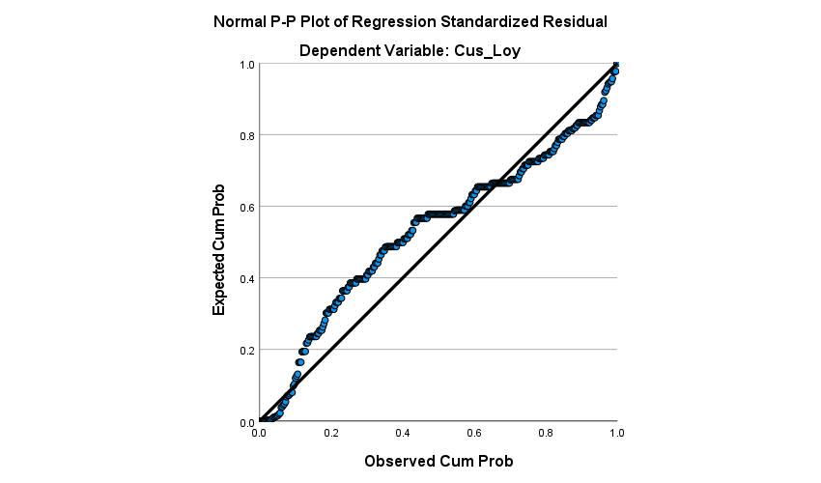
Figure (2) Second Hypothesis Graph

Third Hypothesis Test

Hypothesis Content

The Digitalization of Services, in Saudi Arabia Companies, Institutions, Private & Public Organizations, have a positive relationship with Customer Retention

Regression Analysis

Table No. (9)Regression Analysis of Third Hypothesis
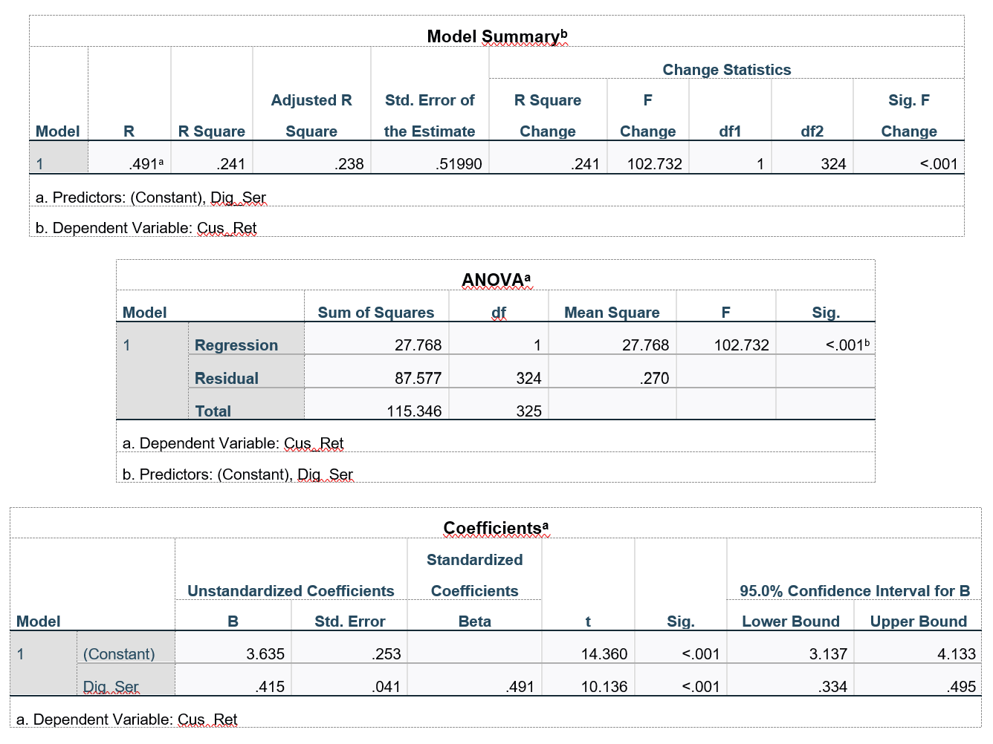

Table-9 shows the Model summary, this table indicates the correlation between the independent variables (Digitalization of Services) and dependent variable (Customer Retention). The values of both $R^{}$&$R^{2}$ were 0.491 and 0.241, respectively. The $R$ value reflects that independent variables explain 49.1 % variance into the dependent variable , where 50.9% variance is left unexplained. These results reflect an acceptable range of the model's strength and a medium acceptable range of variation percentage. However, the table shows the estimated error of the whole model which equal to 0.51990.
The variance analysis (ANOVA)reports the overall model significance with the independent variable (Digitalization of Service) and the dependent variable (Customer Retention). This table shows that the whole model is significant, with an accuracy equal to 99.%.
The coefficients of the Multiple Regression Analysis shows the Strength, Significance, Direction, and Magnitude of the relationships could be observed. From Table-9, we can observe a significant and strong relationship between the Digitalization of Services and Customer Retention with almost 99.0 % accuracy since the Sig. Value of the Digitalization of Services is less than 0.001 with t value equal to 10.136. Moreover, The Digitalization of Services has an impact on the dependent variable (Customer Retention), with a magnitude equal to 0.491. Besides, the relationship's direction is positive, as observed from the Unstandardized Coefficient Beta value of the Digitalization of Services.
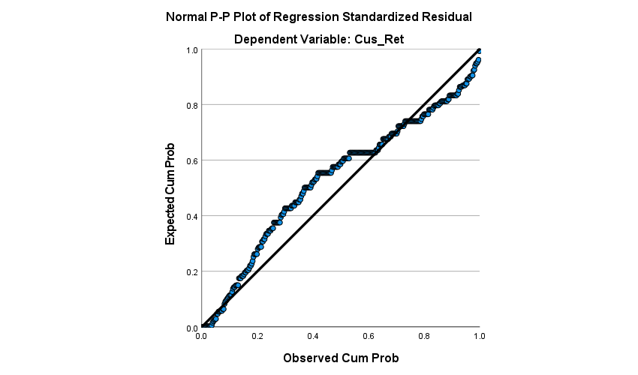
Figure (3) Third Hypothesis Graph

Findings

- There are positive relationships between the Digitalization of service in Saudi Arabia Companies, Institutions, Private & Public organizations, and customer satisfaction, customer loyalty, and customer retention.
- The most significant dependent variable relationships are as follows, Customer Loyalty (0.646), Customer Satisfaction (0.614), and Customer Retention (0.491).
- From the study, it seems evident that there are other variables affecting the dependent variables along with the Digitalization of services. Therefore, digitalization of services is not the only factor that affecting the customer satisfaction, loyalty, and retention.
- There are strong correlations between the dependent variables of the study. This suggests that there are internal positive relationships between Customer Satisfaction, Loyalty, and Retention.
- Nowadays, the digitalization of services gives an institution/company/organization a competitive advantage against its competitors. However, the digitalization of services will be mandatory to survive in the business in the near future (as it happened in the bank industry).
- Digitalization of services alone is not enough to get customer satisfaction. Other factors such as quality, value, development of the services, and understanding customer needs are crucial to customer satisfaction.
- Digitalization of services alone is not enough to gain customer loyalty. Other factors such as quality, value, and speed of the services are significant to customer Loyalty.
- Digitalization of services alone is not enough to maintain customers. Other factors such as adopting transparency and credibility with the customers throughout the transaction period are critical to retaining customers.

Digitalization of Services and Its Impact on Customer Loyalty, Satisfaction, and Retention in Saudi Arabia

Chapter Six

Discussion & Conclusion

6.1 Discussion
6.2 Conclusion

Discussion

This inductive research aims to test the relationship between the digitalization of the services in Saudi Arabia Companies, Institutions, Private & Public organizations, and customer satisfaction, loyalty, and retention. The research has three main hypotheses, which are,
H1: The Digitalization of Services in Saudi Arabia Companies, Institutions, and Private & Public Organizations have a positive relationship with Customer Satisfaction.
H2: The Digitalization of Services in Saudi Arabia Companies, Institutions, and Private & Public Organizations have a positive relationship with Customer Loyalty.
H3: The Digitalization of Services in Saudi Arabia Companies, Institutions, and Private &
Public Organizations have a positive relationship with Customer Retention.
The importance of this research appears from the current situation of the Saudi Arabia environment, especially after the COVID-19 Pandemic. In fact, Saudi Arabia has witnessed exponential growth in the E-services since the announcement of the 2030 Vision and the strategic National Transformation (2020) in 2016. Looking at statistical KPIs, 64% of Saudi residents use online apps and websites to buy monthly products or services. The mobile phone usage rate is continuously growing, and it is expected to reach 36.17 million users in 2025.
On another side, the Saudi government is particularly concerned about digital transformation through Digital Transformation Program and 2030 Vision. To date, Saudi Arabia is considered the most advanced country among the Twenty Countries (G20) in the digital world and ranked second in allocation frequency bands. Besides, Saudi Arabia is the first in the Service Download (5G) Speed rate. Moreover, Saudi Arabia is continuously improving the quality of its digital services; for instance, Saudi Arabia covered more than 3.5 million homes with a Fiber-optic network, increased internet traffic during the Pandemic by 30%, doubled the internet traffic through the National Internet Exchange, and increased the internet speed from 9 Mbit/s in 2017 to 109 Mbit/s in 2020. Furthermore, Saudi Arabia started some initiatives in this field, such as launching the MASDAR Platform to support open-source solutions, establishing the largest advanced Goole Cloud Center in the Kingdom, opening the first Cloud Computing Center in the middle east and north Africa, and launching the Digital Knowledge Platform (ThinkTech).
Obviously, there is no doubt about the role that the digitalization of services plays nowadays, especially with the great movement and effort toward a digital world. However, does the digitalization of services in Saudi Arabia Companies, Institutions, and Private & Public Organizations have a relationship with customer satisfaction, loyalty, and retention nowadays? The research's primary objectives were generated to evaluate and test the previous hypotheses from this question.
This Inductive research used a questionnaire strategy with quantitative data collection and analysis to test the generated and suggested hypotheses. The data was collected from members of the Saudi community, who were doing a survey via Google Forms and distributing the link to a group of people who use modern technologies and practice dealing with digital services in their daily lives in Saudi society as a sample an actress to search, done receiving (329) answers via the Google Forms platform.
The study found that there are positive relationships between the digitalization of services and customer satisfaction, loyalty, and retention. The most significant relationship is customer loyalty, customer satisfaction, and customer retention. In addition, this study goes deep to observe correlations among the dependent variables: customer satisfaction, loyalty, and retention. Therefore, the study suggested internal relationships between these dependent variables and indicated that the relationship looks like this: Customer Satisfaction leads to customer loyalty and retention—moreover, other factors affect these dependent variables regardless of the digitalization of services. Accordingly, the digitalization of services is one factor affecting these dependent variables, but not the only factor.
Furthermore, the digitalization of services alone is not enough to get customer satisfaction. Firms/organizations/ institutions shall be concerned about the value of the services, quality and development, and understanding the customer needs to achieve customer satisfaction. Similarly, the digitalization of services is not enough to maintain customers and get their loyalty. Factors such as the value of service, quality, and service speed are significant to getting customer loyalty. Additionally, adopting transparency and credibility with customers throughout the transaction period is crucial to retaining the customer.
Firms/organizations/institutions seek to achieve customer satisfaction and loyalty as they are essential and vital matters for their success, development, and ability to survive and compete. However, customer loyalty is an ongoing relationship that never ends between the firms and the customers, and it is considered along with customer satisfaction as an important segment of marketing. Besides, customer retention costs are less than the process of attracting new customers, which makes Many organizations prefer retaining customers over attracting new ones.
Apart from this, the digitalization of services gives firms/organizations/institutions a competitive advantage against their competitors. It contributes to the provision of services efficiently and conveniently. In addition, it helps to provide high-quality services at lower costs, save time, and reduce expenses if utilized and control well. Thus, digitalization is one of the crucial ongoing transformations of modern society. Altogether, the digitalization of services will be mandatory to survive in the business in the near future (as happened in the bank industry).
Consequently, the research recommends that firms/organizations/institutions should spread the culture of digital technology at the level of the entity and individuals. They should look to seize new digital and electronic commerce opportunities by promoting policies and procedures to drive digital business opportunities and gain a competitive advantage against their competitors. They are highly recommended to develop a digital platform to serve internal and external stakeholders transactions, create innovative internal operationtools to spread the digital infrastructure in the entity, develop and adopt policies to achieve electronic security to protect data privacy, and establish regulatory and legislative measures to disseminate the content that threatens the right and dignity of the customer. On the other side, the government should continue its support for firms/organizations/institutions by providing policies and strategies that lead to large-scale electronic applications and services, making the digital revolution the basis for providing services and supporting the transformation into the digital world. However, the support should not be exclusive to large organizations but should include small and medium enterprises.
The research evaluated the relationships between the digitalization of services and customer satisfaction, loyalty, and retention in Saudi Arabia. The sample was the common Saudi residents of different ages, backgrounds, regions, and qualifications. Therefore, it is highly recommended to do profound research related to a specific industry with a particular population to evaluate the main factors of the digitalization of services such as the management, controlling, operations, tools, and technology with customer satisfaction, loyalty, and retention. In addition, it is recommended to conduct a study that evaluates how the digitalization of services in a specific industry affects the overall performance of a firm/organization/institute and the main obstacles preventing entities from adopting the digital transformation. Finally, and as it is predicted that the digitalization of services will be mandatory to survive in Saudi Arabia businesses, it is suggested to do research that evaluates to which degree the digitalization of services will be crucial to surviving in the near future for different industries in Saudi Arabia.

Conclusion

The research showed positive relationships between service digitalization and customer satisfaction, customer loyalty, and customer retention. Besides, the digitalization of services is not the only factor affecting these dependent variables. In fact, it is observed that there are others factors affecting these variables along with the internal relationships between them, where customer satisfaction leads to customer loyalty and customer retention. Understanding customer needs, the value of services, quality, speed, and development of service along with transparences and credibility are crucial factors that should be considered in order to get customers satisfaction, gain customers loyalty, and maintain them.
Apart from this, there is a great step toward a digital world in Saudi Arabia, supported by the government, which clearly announced in the 2030 Vision and the 2020 National Transformation strategy in 2016. Furthermore, the COVID-19 Pandemic has accelerated the digital transformation across the globe and has shown that the current step in the world is the digitalization of services. With this in mind, the digitalization of services was a factor that helped to get a competitive advantage against firms' competitors before and during the Pandemic. Nowadays, it is one factor that assists in gaining customer satisfaction and loyalty and maintaining customers. Nevertheless, the digitalization of services will be a mandatory factor to survive in all sorts of businesses soon.
Firm/organization/ institution should consider the digitalization of services as the current challenge as it is not affecting only the customers' feelings and behavior. Still, it has a direct effect on internal business processes and performance. It boosts the firms' effectiveness and efficiency, automates their system, saves time and money, accelerates innovation, and grows business. Therefore, it is highly recommended for firms/organizations/institutions that are not interesting in digital transformation to evaluate and update their business model, adopt a digital culture in the firm, and select the proper tools that fit both the business model and culture. However, others, who have already started the digital transformation journey, should keep evaluating and improving their digital businesses and customer experience as the digitalization of services and customer satisfaction & loyalty is an ongoing relationship that never ends.

References

- Bello, V, &Andronikidis, A: (2018)«The Impact of Internal Service Quality on Customer Service Behavior », International Journal of Quality and Reliability Management, Vol 25,
- Chia-Ming Chang, Chin-Tsuchen,andCin-Hsien (2012) A Review of Service Quality in Corporate and Recreational Sport: Fitness Programs, The sport Journal, 5(3).
- Evans, James R (2019) Applied production and operation management, West publishing Co.
- Gupta, B., S. Dasgupta, and A. Gupta. 2018. Adoption Of ICT In A Government Organization In A Developing Country: An Empirical Study. Journal Of Strategic Information Systems 17: 140–154.
- Parasuraman A.,Zeithaml, Valarie A., & Berry Leonard (1988) SERVQUAL: A multiple-Item Scale Measuring –Customer Perceptions of Service Quality , Journal of Retaili , 64(1) p 12-14.
- Sharma, Yukti, (2020) Analysis of Service Quality for Customer Satisfaction and Loyalty in E-Commerce Pertaining to TheFMCG Sector. Available at SSRN: https://ssrn.com/abstract=3669575 or http://dx.doi.org/10.2139/ssrn.3669575
- Slack, Nigel & Chambers, Stuart & Johnston, Robent, (2004) Operations Management, Prentice –Hill, New York.
- Trofino, A.J., (2000), “Transformational Leadership: Moving Total Quality Management to World-Class Organizations”, International Nur sing Review, 47: 232-242.
- Zeithaml, V. A., Berry, L. L., & Parasuraman, A. (2019). Communication and control
- Zeithaml, Valarie A. and Britner M., (2003) Services Marketing Integrating Customer, Focus across the Firm, McGraw-Hill, New York.
- Amorim M and BashashiSaghezchi F 2014 An investigation of service quality assessments across retail formats Int. J. of Quality and Service Sciences 6 221-36 [
- Clegg B, Kersten W and Koch J 2020 The effect of quality management on the service quality and business success of logistics service providers Int. J. of Quality & Reliability Management 27 185- 200.
- Kuo Y-F, Wu C-M and Deng W-J 2019 The relationships among service quality, perceived value, customer satisfaction, and p97.
- Acar, O.A. &Puntoni, S. (2016) Customer Empowerment in the Digital Age. Journal of Advertising Research. [online] Available at:https://www.researchgate.net/publication/298333682_
- Albert Caruana, "Service loyalty: The effects of service quality and the mediating role of customer satisfaction," European Journal of Marketing, vol. 36, no. 7/8, pp. 811-828, 2017.
- Al-Hawari, M. and Ward, T. (2016), “The effect of automated service quality on Australian banks’ financial performance and the mediating role of customer satisfaction”, Marketing Intelligence & Planning, Vol. 24 No. 2, pp. 27-47.
- Anderson W. E. & Mittal, V. (2016). Strengthening the Satisfaction-Profit Chain. Journal of Service Research 3 (2), 107-120.
- Anderson, E.W., Fornell, C., & Lehmann, D. R. (2014). Customer satisfaction, market share, and profitability: Findings from Sweden. Journal of Marketing, 58(3), 53-66
- Bansal, S. & Gupta, G. 2019. Building Customer Loyalty Business-to-Business Commerce. New Delhi: Tata McGraw-Hill.
- Bowen, J. T. & Chen, S. L. M. (2019). Transitioning loyalty programs: A commentary on “The relationship between customer loyalty and customer satisfaction”. International Journal of Contemporary Hospitality Management, 27 (3), 415-430.
- Campbell, C. L., (2017)The Customer is NOT Always Right? Marketing Orientations in a Dynamic Business World: Proceedings of the 2011 World Marketing Congress, Springer International Publishing AG, Switzerland, 2017
- Cronin, J.J., Brady, M.K. and Hult, G.T. (2019), “Assessing the effects of quality, value, and customer satisfaction on consumer behavioral intentions in service environments”, Journal of Retailing, Vol. 76, pp. 193-218
- Emma Silvennoinen (2020),How digitalization has affected the importance of customer loyalty and the nature of customer loyalty programs Case Study: Developing Case Company X’s customer loyalty program Degree Thesis International Business 2020
- Ennew, C.T., Binks, M.R., &Chiplin, B. (2015). Customer satisfaction and customer retention: An examination of small businesses and their banks in the UK. In Proceedings of the 1994 Academy of Marketing Science (AMS) Annual Conference (pp. 188-192). Springer, Cham.
- Evangels, G & Yannis, S. (2018)Customer Satisfaction Evaluation: Methods for Measuring and Implementing Service Quality. London: Springer.
- Farai Chigora and Promise Zvavahera, "Awareness completes brand loyalty: Reality of Zimbabwe Tourism Destination," Business and Management Horizons, vol. 3, no. 2, pp. 60-69, November 2015.
- Gartner IT Glossary. (2019) Digitalization. [online] Available at: https://www.gartner.com/it-glossary/digitalization/ Accessed the 23rd of May 2019.
- Grant, M. (2019) Strength, Weakness, Opportunity, and Threat (SWOT) Analysis. [online] Available at: https://www.investopedia.com/terms/s/swot.asp Accessed the 23rd of January 2020.
- Hagberg, J., Egels-Zandén, N. &Sundström, M. (2016) The digitalization of retailing: an exploratory framework [online] Available at:https://www.researchgate.net/publication/305922138 Accessed the 24th of May 2019.
- Hajdukiewicz, A. (2016) A new approach to customer loyalty programs in the era of digitalization: The example of the Freebee loyalty technology platform. [online] Available at: https://bib.irb.hr/datoteka/846065.Trade_Perspectives_2016_proceedings.pdf#page=159 Accessed the 17th of October 2019.
- https://www.my.gov.sa/wps/portal/snp/aboutksa/digitaltransformation
- Jefry Romdonny1 , Maskarto Lucky Nara Rosmadi" Factors Affecting Customer Loyalty in Products “, Institute of Economic Science STMy, Majalengka, Indonesia 2 Institute of Economic Science Kridatama Bandung, Indonesia. vol. 7, no. 4, pp. 5-19 May ,2021.
- Kumar, V., & Shah, D. (2018). Building and sustaining profitable customer loyalty for the 21st century,Journal of Retailing, 80 (4), 317-330.
- Kundu, S. & Datta, S.K. (2015). Impact of trust on the relationship of e-service quality and customer satisfaction, EuroMed Journal of Business, 10 (1), 21–46.
- McIlroy, A. and Barnett, S., (2017), Building Customer Relationships: Do Discount Cards Work?, Managing Service Quality, 10 (6), pp. 347-355.
- Mohamad Dimyati and N. Ari Subagio, "Impact of Service Quality, Price, and Brand on Loyalty with the mediation of Customer Satisfaction on Pos Ekspres in East Java," Mediterranean Journal of Social Sciences, vol. 7, no. 4, pp. 74-86, 2016.
- Palmatier, R. W. (2018). Interfirm relational drivers of customer value. Journal of Marketing Research, 72 (4), 76–8
- Qualtrics. (2019) Customer Satisfaction (CSAT) Theory. [online] Available at: https://www.qualtrics.com.
- Srivastava, M.(2016), Customer Relationship Management, Vikas Publishing House Pvt. Ltd., New Delhi, 2016
- Trasorras, R., Weinstein, A. &Abratt, R. (2017). Value, satisfaction, loyalty and retention in professional services. Marketing Intelligence & Planning, 27 (5), 615-632.
- Woon, C.L., Kee, L.K., Hwee, T. G., Lee, T. L. & Cheng, T.S. (2015). Factors Influencing Customer Loyalty in Airline Industry in Malaysia, Retrieved from: http://eprints.utar.edu.my/1802/1/BAC-2015-1206820- 1.pdf, Accessed on: 20 March 2018.
- Zairi, M., 2016, Managing Customer Dissatisfaction through effective, complaint Management Systems. The TQM Magazine: 12 (5), pp. 331-335.

Appendices

Questionnaire
Dear Sir/Madam,
Vision 2030 contributed to the transition to digital services or the digitalization of services, especially in institutions and the governmental sector in the Kingdom of Saudi Arabia.However, Digitalization of services means shifting from providing services in the traditional way to providing services electronically or it could be defined as replacing and exchanging information from paper writing to electronic systems through the use of the Internet .This development may contribute to achieve customer satisfaction, loyalty , and increasing their numbers. We are conducting a field study to identify the impact of digitalization of services on customer satisfaction, loyalty , and retention in Saudi Arabia, and here we want to ascertain the importance and impact of digitalization of services in the Kingdom through your interaction, participation and answers to questions. We sincerely appreciate your valuable time for participating in this survey.
Please be assured that your responses will remain anonymous and will only be use the aggregate response for our analysis .
Thank you in advance for your kind participation
Sincerely,
عزيزي السيد/ السيدة
ساهمت رؤية 2030 في التحول إلى الخدمات الرقيمة أو رقمنة الخدمات وخاصة في المؤسسات والقطاعات الحكومية في المملكة العربية السعودية ورقمنة الخدمات تعني التحول من تقديم الخدمات بالطريقة التقليدية إلى تقديم الخدمات إلكترونيا أو يقصد بها استبدال وتبادل المعلومات من الكتابة الورقية إلى الأنظمة الإلكترونية من خلال استخدام الإنترنت.وهذا التطور قد يساهم في تحقيق رضاء العملاء وولاءهم وازياد عددهم، نحن بصدد اجراء دراسة ميدانية للتعرف على تأثير رقمنة الخدمات على رضاء العملاء وولاءهم والمحافظة عليهم ، وهنا نريد التأكد من أهمية وتأثير رقمنة الخدمات في المملكة من خلال تفاعلك ومشاركتك واجاباتك على الاسئلة.
نحن نقدر بصدق وقتك الثمين للمشاركة في هذا الاستبيان ، يرجى التأكد من أن ردودك ستبقى مجهولة الهوية ولن تستخدم إلا لغرض الدراسة
شكرا لك مقدما على مشاركتك الكريمة
مع تحياتي

Alltheitemsaremeasuredon  LikertScale: | StronglyDisagree  (1) | Not Agree  (2) | Somewhat disagree  (3) | Neutral  (4) | Somewhat disagree  (5) | Ok  (6) | StronglyAgree  (7)

Digitalization of service, Customer Satisfaction, Loyalty, and Retention
Digitalization of Services
Digitalization of services contributes to the provision of services easily and conveniently.
The digitalization of services contributes to providing high quality services at lower costs.
Digitalization of services helps save time and reduce costs.
Saudi Arabia’s Vision 2030 contributed to the transformation of the digitalization of services.
Saudi Arabia is at the forefront of countries interested in applying the digitalization of services in all fields
Digitalization is one of the crucial ongoing transformations of modern society
Customer Satisfaction
Digitalization of services affects customer satisfaction for Saudi institutions
Customer satisfaction and loyalty measurement is an important segment of marketing.
The factors that affect customer satisfaction are customer perceived quality, value, and service
Customer satisfaction with services is an indicator of the company's success and distinction.
Customer satisfaction is a measurement that indicates how happy customers are with a company's capabilities, products, and services.
Customer satisfaction is defined as the positive result of measuring the degree of customer satisfaction with a product, service, or experience.
Understanding customers’ needs is one of the most important ways to achieve customer satisfaction.
Development of services is of great importance in raising the levels of customer satisfaction.
Customer Loyalty
Digitalization of services increases customer loyalty to Saudi institutions
Digitalization of services contributes to gaining customers’ trust in Saudi institutions.
All companies and service institutions seek to achieve customer loyalty.
Gaining customer loyalty is an essential and vital matter for the success of companies, their development, and their ability to survive and compete.
Customer loyalty is the customer’s willingness to deal with a brand again and again or buy from it.
Customer loyalty measures how likely customers are to continuously repurchase a product or service from the same company or institution.
Customer loyalty could be considered as a positive ongoing relationship between a business and a customer.
One of the factors affecting customer loyalty is the quality of service.
One of the factors that affect customer loyalty is the speed of service provision
One of the factors that influence customer loyalty is the value of service provision.
One of the factors affecting customer loyalty is the quality of service.
Customer Retention
Digitalization of services helps Saudi institutions retain customers.
The concept of customer retention refers to companies' activities to reduce the number of customers who stop dealing with the company.
Adopting transparency and credibility contributes to attracting and retaining customers.
The Customer Retention strategy starts from the first communication between the company and the customer and continues throughout the transaction period.
Customer Retention costs less than the process of attracting new customers.
Many organizations prefer retaining customers over attracting new ones, because customer retention is less expensive.

