
Midocean University
Business College
Master of Project Management

The Effect of Health and Safety on Project Progress and It’s Precautions

Mohammed Shah Alibrahim – 242001714

Under Supervision of
Dr. Alfaisal Abdulhameed
Dr. Faiz Jarad
Academic Year:
2025

Copyright Notice
All Copyrights and printing are owned by Midocean University

Abstract
Every project faces challenges which include financial problems together with material shortages and insufficient workforce. Health and safety practices represent a critical factor which often receives insufficient attention although they significantly impact project outcomes. The research investigates how effective safety protocols protect projects by reducing risks and boosting productivity and preventing work-stopping issues. The research used surveys and interviews together with document reviews and real-life examples to determine the actual influence of health and safety initiatives on project performance. The research indicates that companies which prioritize safety during project planning experience better overall project outcomes. Following safety rules serves two purposes: it protects personnel while maintaining work continuity.

Acknowledgement
I am grateful to Midocean University for the opportunity and resources that enabled me to pursue my master’s degree. The university’s commitment to academic excellence and research has been very important in the successful completion of this study.

I am very grateful to all my professors for their guidance, support and encouragement throughout this journey. Their expertise, feedback and commitment to the development of knowledge have significantly contributed to my academic and professional development.

I would like to thank everyone who has been of help to me during this process including my colleagues, friends and family who have been of great encouragement and motivation.

Table of Content
List of Tables 6
List of Figures 6
List of Terminology 7
List of Abbreviations 7

Chapter One: General Aspects of the Study
1.1 Introduction 7
2.1 Research Problem 8
3.1 Importance of the Study 9
4.1 Study Objectives 10
5.1 Research Questions 11
6.1 Research Hypotheses 12
7.1 Study Model 13
8.1 Previous Studies 14
9.1 Theoretical Foundations of the Study 17
10.1 Methodology and Research Methods 19
11.1 Data Sources 22
12.1 Research Tools 23
13.1 Statistical Methods Used 23

Chapter Two: Theoretical Framework
Introduction 24
First Section: Strategic Risk Management Practices 25
1.1.2 Introduction 25
2.1.2 Historical Development of Strategic Risk Management 26
3.1.2 Definition of Strategic Risks 26
4.1.2 Importance of Strategic Risk Management 27
5.1.2 Objectives of Strategic Risk Management 27
6.1.2 Causes of Strategic Risk Development 28
7.1.2 Dimensions of Strategic Risk Management 28

Chapter Three: Methodology and Procedures
1.3 Research Methodology 29
2.3 Study Population and Sample 30
3.4 Characteristics of the Personal and Occupational Sample 31
5.3 Study Tool 32
6.3 Statistical Methods 34

Chapter Four: Data Analysis and Hypothesis Testing
1.4 Introduction 36
2.4 Normal Distribution 37
3.4 Descriptive Data Analysis 38
4.4 Inferential Tests for Study Hypothesis Testing 39
5.4 Hypothesis Testing 40

Chapter Five: Discussion of Results and Recommendations
1.5 Introduction 41
2.5 Results Related to Descriptive Study Variables 42
3.5 Results Related to Study Hypothesis Testing 43
4.5 Recommendations 44
Conclusion 45

References 46

Schedule Table
Schedule Name | Page
Schedule 1: Kolmogorov-Smirnov Normality Test for Study Variables | 39
Schedule 2: Descriptive Statistics for Workplace Safety Practices | 40
Schedule 3: Inferential Statistical Analysis (T-Test & ANOVA) | 41
Schedule 4: Hypothesis Testing Results | 42
Schedule 1.1: Summary of Descriptive Statistics Results | 43
Schedule 2.1: Hypothesis Testing Summary | 44
Schedule 3: Key Recommendations for Safety Improvement | 45

List of figures
Figures Name | Page
Pi Chart 1: Study Population Distribution | 32
Experience Distribution of Study Sample | 33
Study Tool Utilization in Research | 35
Impact of Training Investment on Accident Reduction | 36
Gantt Chart for Safety Training Programs | 37

List of Terminology and Abbreviations

1. Health and Safety
- ISO 45001 – International standard for occupational health and safety management systems.
- Occupational Health and Safety (OHS) – Workplace policies and procedures aimed at protecting employees from hazards.
- Workplace Safety Compliance – Adherence to national and international safety regulations and standards.
- Incident Reporting Mechanisms – Systems used for logging workplace accidents and near-misses.
- Risk Mitigation Strategies – Methods for reducing workplace hazards and project-related risks.
- Health and Safety Culture – Organizational values and attitudes towards maintaining workplace safety.
- Safety Training Programs – Educational initiatives aimed at improving employee awareness of occupational hazards.

2. Project Management and Risk Assessment Terminology
- Strategic Risk Management – The process of identifying, assessing, and mitigating risks that impact project success.
- Compliance Audits – Inspections conducted to ensure adherence to safety regulations and project requirements.
- Risk Identification and Assessment – The process of evaluating workplace hazards and determining their potential impact.
- Project Efficiency – A measure of how effectively resources, time, and safety protocols contribute to project success.
- Workplace Hazards – Potential sources of harm or danger in a project environment.
- Accident Prevention Measures – Steps taken to avoid workplace injuries and health risks.
- Incident Reduction Techniques – Strategies to lower workplace accidents through safety policies and interventions.

3. Statistical and Research Methodology
- Kolmogorov-Smirnov Test – A normality test used to determine whether data follows a standard distribution.
- Descriptive Statistics – Statistical methods that summarize and describe collected data (e.g., mean, standard deviation).
- Inferential Statistics – Analytical techniques used to draw conclusions and test hypotheses from a sample.
- Regression Analysis – A statistical method used to identify the relationship between independent and dependent variables.
- T-Test & ANOVA – Statistical tests used to compare means between groups and determine significant differences.
- Cronbach’s Alpha – A reliability coefficient that measures the internal consistency of a survey or questionnaire.
- Correlation Analysis – A statistical technique to determine the strength and direction of relationships between variables.

4. Documentation and Compliance
- Safety Audits – Regular inspections conducted to ensure compliance with safety regulations and best practices.
- Incident Logs – Documentation of workplace accidents, near-misses, and safety violations.
- Regulatory Compliance – Conformance to legal and organizational safety requirements.
- HSE Policies – Health, Safety, and Environment policies established within an organization.
- Standard Operating Procedures (SOPs) – Formalized safety procedures designed to ensure uniformity in workplace practices

Chapter One: General Aspects of the Study

1.1 Introduction

Workplace health and safety has become an essential strategic element in modern construction and industrial sectors because it directly influences project outcomes beyond basic compliance needs. Project managers ensure health and safety protocols integrate into project execution to minimize risks which enables project progress. A health and safety framework which is well-organized functions as a safety prevention system to prevent delays from accidents and legal obligations and worker absences. Safety protocol neglect causes higher costs together with project delays along with damage to company reputation. The effectiveness of project health and safety depends on three core components including proactive leadership combined with risk assessment and constant monitoring. Project managers must create strong safety policies which follow ISO 45001:2018 standards while developing safety awareness across all stakeholders. The PDCA model of occupational health and safety management frameworks provides a systematic process for identifying hazards and implementing prevention measures along with ongoing improvement practices. The research investigates project advancement through health and safety practices as well as project managers' fundamental responsibility for risk reduction and efficiency improvement. Safety considerations need to be integrated across the entire project lifecycle because this practice leads to long-term sustainability and success.

2.1 Research Problem

The evaluation of health and safety impacts on project progress faces major barriers because privacy restrictions and confidentiality policies prevent researchers from accessing complete incident data. Organisations typically restrict access to specific health and safety information because of legal requirements and ethical standards and corporate governance obligations which make it hard for researchers to obtain detailed records of workplace incidents and near-miss occurrences and safety infractions.

Companies avoid sharing safety-related information because they want to avoid potential reputational damage and legal consequences and regulatory inspections. Project managers along with researchers need to depend on general reports and surveys and aggregated industry data which do not provide detailed information. The research limitations prevent detailed analysis of how frequently incidents occur and the effectiveness of risk management strategies and their impact on safety compliance which determines project duration and financial costs and operational efficiency.

The challenge requires using alternative data collection approaches including anonymous surveys and structured project manager interviews together with industry benchmarking reports. The approaches introduce their own set of limitations including self-reported data bias and challenges in obtaining real-time accuracy and information verification.

The research problem focuses on developing methods to collect health and safety data in projects that respect privacy boundaries while delivering accurate insights about project progress. This research investigates viable methods for data access improvement alongside building knowledge about health and safety practices in project achievement.

3.1 Importance of Study

Project management requires health and safety measures because they lead to operational efficiency and reduced risks which together produce superior project outcomes. The study investigates how health and safety protocols affect project development through the implementation of proactive safety protocols. The research investigates safety measures together with their impact on productivity and regulatory compliance to provide useful knowledge for academic studies and industrial implementation.

Scientific Importance:

The research advances our comprehension of project performance factors related to health and safety measures. The research provides theoretical principles for incorporating safety measures into project management systems which enable scholars and researchers to investigate new aspects of occupational safety. The research analyzes previous studies and best practices to build knowledge about risk management and workplace safety in project-based settings.

Practical Importance:

The study offers project managers and safety professionals along with policymakers specific methods to enhance workplace security. The study demonstrates effective safety management helps organizations reduce workplace incidents while minimizing project delays and ensuring compliance with legal requirements and regulatory standards. The research provides organizations with better safety protocols to protect employees and achieve improved project efficiency.

4.1 Study Objectives:

The main goal of this study is to investigate the relationship between health and safety measures and project progress as it relates to the implementation of the ISO 45001 standards for occupational health and safety management systems.

The following are the specific objectives of the study:
- To establish the role of ISO 45001 in the improvement of safety at the workplace and the reduction of accidents and project delays.
- To determine the effect of health and safety measures on the project management, particularly with regard to the application of the international safety standards.
- To assess the effectiveness of risk management systems based on ISO 45001 in preventing possible hazards in project management.
- To identify the limitations of the adoption of ISO 45001 standards and offer suggestions on how to improve the safety culture in the organization.
- To give advice on how to enhance health and safety policies so that projects are run sustainably with as little disruption as possible.

  - Research Questions

- How does the implementation of ISO 45001 health and safety management systems affect the project efficiency and performance?
- What are the main obstacles in adopting ISO 45001 in project management?
- To what extent does the adherence to the safety measures and regulations decrease the project risks and delays?
- To what extent does the implementation of the ISO 45001 system affect the workplace safety culture and the employee productivity?
- What are the best strategies for risk management under the ISO 45001 standard that can be used to prevent workplace injuries?
- How do project stakeholders view the importance of health and safety measures in the accomplishment of a project?
- What is the correlation between the cost of safety measures and project costs?
- How do firms assess the performance of their health and safety management systems in conformity with ISO 45001?

6.1 Research Hypotheses:

- H₀ (Null Hypothesis): The implementation of ISO 45001 health and safety measures does not have any effect on project progress.
- H₁ (Alternative Hypothesis): The implementation of ISO 45001 health and safety measures leads to an improvement in the project progress and efficiency.
- H₀: ISO 45001 compliance has no effect on the number of workplace accidents and hazards in project-based industries.
- H₁: Adherence to ISO 45001 standards leads to a decrease in workplace accidents and hazards that in turn improves the safety of the workplace.
- H₀: The costs of health and safety investments under ISO 45001 system are not cost effective for projects.
- H₁: Investments in health and safety under ISO 45001 are cost effective in the long run since they reduce the costs of accidents.
- H₀: The use of risk management approaches from ISO 45001 does not help to lower the project duration.
- H₁: Risk management strategies based on ISO 45001 are effective in minimizing project delays as they prevent workplace hazards.
- H₀: The implementation of ISO 45001 does not affect the work performance and safety perception of the employees in projects.
- H₁: The implementation of ISO 45001 results in improved productivity of the employees and better safety culture in projects.
- H₀: There is no positive relationship between the adherence to safety standards and the success of the project.
- H₁: There is a positive relationship between health and safety compliance and success in project management.

7.1 Study Model

The study model aims to determine the effect of health and safety measures on project progress in relation to the ISO 45001 standards. The model aims at explaining how various elements that affect workplace safety, risk control, and project performance are related.

Key Components of the Study Model:
- Independent Variable:
  - Implementation of ISO 45001 health and safety management systems
  - Workplace safety measures and risk mitigation strategies
  - Compliance with occupational health and safety (OHS) regulations

- Mediating Factors:
  - Safety culture and employee awareness
  - Training and safety performance monitoring
  - Organizational commitment to risk management

- Dependent Variable:
  - Project progress and efficiency
  - Reduction in workplace accidents and hazards
  - Cost-effectiveness and risk minimization

- Control Variables:
  - Industry type and project size
  - Workforce experience and training level
  - Regulatory environment and compliance enforcement

Conceptual Framework:The model posits that the application of ISO 45001 is effective, and the outcome is better safety performance, which leads to project efficiency through risk management, accident prevention, and compliance with regulations. The influence is on organizational commitment, workforce training, and industry-specific challenges.

8.1 Previous Studies:

- Impact of COVID-19 on the Health-Related Quality of Life of Patients during Infection and after Recovery in Saudi Arabia (Alanazi et al., 2023)

This study examined how COVID-19 influenced the HRQoL of Saudi patients during and post-illness. The researchers used the EQ-5D-5L and EQ-VAS tools in a prospective observational study involving 389 COVID-19 patients. The results showed that HRQoL recovered considerably after recovery, and the patients experienced improved mobility, self-care, and reduced anxiety/depression. A multiple regression analysis revealed that factors including normal weight, employment, and previous vaccination had a positive effect on the recovery outcomes; however, asthma and flu vaccination were found to predict lower HRQoL recovery. The research showed that COVID-19 had a mild but different effect on HRQoL based on socio-demographic and clinical factors.

- The Construction of Kindergarten in Mutrafiah - Jubail (Albandary et al., 2021)

This paper focused on project management and governance of the construction of a kindergarten in Jubail. The study discussed strategic objectives, compliance models and stakeholder analysis of the project. The project charter, risk management strategies and organisational structures for the project were key highlights of the study. The study stressed on stakeholder engagement, leadership, team work and conflict management as the key elements of project success. In addition, the study discussed the performance measurement indicators and project scheduling techniques that were to be used in order to ensure that the project goals and objectives were achieved efficiently.

- Office Building Project (Soliman et al., 2021)

This research on management and implementation of office building project considered strategy, governance, compliance and risk management. The study described the organization structure, leadership style, and the stakeholder engagement approaches that were employed in the project. It also reviewed the conflict resolution mechanisms, quality control systems, and financial management systems. The study also discussed the role of project communication, negotiation, and resource allocation in the project efficiency.

- Staff Housing Project of the Company (Everyone’s Smart University, 2021)

This study was on the housing project for company staff and the strategy, compliance, stakeholder engagement and resource management. The project was implemented using the SMART model, and the following were some of the leadership, teamwork, conflict management, and quality management. The study also stressed on the role of performance indicators, project planning techniques, and procurement execution in achieving a housing project.

- Occupational Health and Safety Culture in Private Contracting Companies in Jeddah (Hamza, 2024)

This study assessed the degree of occupational health and safety culture in private contracting companies in Jeddah and provided suggestions on how to improve safety culture. Descriptive-analytical approach was used to collect data from 121 employees and the data was analyzed using SPSS. The results showed that administrative leadership was found to play a moderate role in the improvement of safety, and no significant demographic differences in the safety perception of the participants were found. The study suggested that the role of company management in enhancing safety culture and ensuring that employees comply with health and safety policies should be improved.

- The Effects of Occupational Health and Safety Management System on Workplace Accidents in Electricity and Gas Companies in Saudi Arabia (Hadhari, 2024)

This paper sought to determine the impact of occupational health and safety (OHS) systems on workplace accidents in the electricity and gas production companies in Saudi Arabia. Data was collected from a random sample of 150 employees and analyzed through SPSS. The results indicated that workplace accidents decreased when the OHS systems were well implemented. Legal frameworks, top management commitment, training, and resource availability were the key factors that influenced the study. The study also suggested that there should be regular policy reviews, continuous monitoring, and more investment in safety training programs in order to enhance the safety culture in these industries.9.1 Theoretical Foundations of the Study

The study was grounded on several theoretical frameworks that describe the relationship between health and safety management and project progress especially in the context of ISO 45001 standards. These theories help to explain how OHS interventions affect organizational performance, risk management and project effectiveness.

1. High-Reliability Organization (HRO) Theory

According to the HRO theory, organizations that operate in high risk sectors such as construction and engineering projects must have well established safety procedures to avoid failures and accidents. This is in conformity with the theory as ISO 45001 promotes the application of systematic risk management practices to improve workplace safety and project continuity.

2. Risk Management Theory
This theory involves the process of identifying, evaluating and controlling risks that may affect project delivery. ISO 45001 offers a defined methodology for identifying hazards, assessing risks and implementing controls to prevent disruptions to projects due to health and safety concerns.

3. Systems Theory
Systems theory posits that organizations are systems and that all the elements in the system including employees, processes and safety policies must work together for the system to achieve its project objectives. The adoption of ISO 45001 promotes a systematic approach to occupational health and safety by embedding safety into all levels of project management.

4. Behavioral Safety Theory
This theory addresses the impact of employee behaviour and organisational culture on safety performance. This theory encourages leadership involvement and worker engagement in the improvement of health and safety practices.

5. Accident Causation Theories (e.g., Heinrich’s Domino Theory, Swiss Cheese Model)
These models explain how accidents happen in the workplace through the combination of unsafe conditions, human errors and organizational failures. These risks are addressed through the implementation of preventive measures, hazard controls and employee training programs to prevent incidents.

6. Compliance and Regulatory Theory
This theory is about the impact of legal and regulatory environments on the behavior of organizations. ISO 45001 is a global standard for OHS management system that enables organizations to comply with laws and regulations, avoid legal sanctions and promote a healthy work environment.

Conclusion
Thus, the study aims at examining how ISO 45001 improves project performance, reduces accidents and enhances organizational safety culture. These theories provide a good starting point in assessing the impact of health and safety measures in project management.

10.1 Methodology and Research Method
This study utilizes a systematic research methodology to investigate the role of health and safety measures on project success with a particular reference to ISO 45001 standards. The research design is a combination of both qualitative and quantitative approaches to guarantee the quality of data collected.

1. Research Approach
The study uses mixed research design that combines the use of statistical methods to analyze safety measures and project results and the use of expert opinions and case studies to increase the validity of the research problem.

2. Research Design
• Descriptive Research: Used to examine safety management practices and ISO 45001 compliance in projects.
• Analytical Research: The impact of occupational health and safety (OHS) measures on project progress is analyzed in this study.

3. Data Collection Methods
Primary Data Sources:
- Surveys and Questionnaires: Developed for project managers, HSE specialists and employees to capture their views on safety measures and project effectiveness.
- Interviews: Conducted with industry experts and safety professionals to learn more about the challenges and advantages of ISO 45001 implementation.
- Observations: Actual inspection of safety situation in different projects.

Secondary Data Sources:
- Review of Literature: The current studies, safety reports and ISO 45001 implementation case studies were reviewed.
- Regulatory Documents: Safety regulations that are in use in project based industries were studied.

4. Study Population and Sampling
Target Population: Project managers, safety officers, engineers, and workers in industries that implement ISO 45001.

Sampling Technique:
- Stratified Sampling: Ensures representation across different project roles and industries.
- Purposive Sampling: Focuses on individuals with direct experience in safety management and project execution.

5. Data Analysis Methods
Quantitative Analysis:
- Descriptive Statistics: Mean, standard deviation, and frequency analysis to summarize survey responses.
- Inferential Statistics: Regression analysis, correlation tests, and hypothesis testing to assess relationships between variables.

Qualitative Analysis:
- Thematic Analysis: Identification of recurring themes in interviews and case studies.

6. Research Validity and Reliability
•Validity: Ensured through pre-testing of questionnaires and expert review of research instruments.
•Reliability: Measured using Cronbach’s Alpha to test internal consistency of survey responses.

7. Ethical Considerations

•Informed Consent: Participants are informed of the study’s purpose and voluntarily participate.

•Confidentiality: Personal data and responses are kept anonymous and secure.

•Compliance with Research Ethics: The study follows institutional and international research guidelines.

Conclusion

This methodology provides a rigorous and structured approach to investigating the relationship between health and safety practices and project progress, ensuring that the study’s findings are valid, reliable, and applicable to real-world project environments.

11.1 Data Sources

This study utilizes both primary and secondary data sources to comprehensively examine the impact of health and safety measures on project progress under ISO 45001 standards. Primary data is gathered through surveys and questionnaires distributed to project managers, HSE specialists, engineers, and workers to assess their perceptions of workplace safety and its effect on project performance. Interviews with industry experts and safety officers provide deeper insights into challenges and best practices in ISO 45001 implementation, while observations conducted at project sites document compliance, safety risks, and accident prevention measures. Secondary data sources include academic research, industry reports, and regulatory documents, such as previous studies on health and safety in project management, compliance guidelines from organizations like OSHA and ISO, and case studies that highlight successful and unsuccessful safety implementations. In addition to that, project safety records and performance reports are reviewed to assess the effectiveness of safety programs based on historical data. The study uses the following data sources to achieve the objectives of this study and ensure that the findings are informed by evidence. They are questionnaires, interviews, observation and document analysis to ensure that data collected is adequate for the purpose of this study.

12.1 Research Tools

This study utilizes various research tools to systematically collect, analyze, and interpret data regarding the impact of health and safety measures on project progress under ISO 45001 standards. The primary research tools include questionnaires, interviews, observations, and document analysis, to enhance data collection process.

Questionnaires are used as a tool to collect quantitative data from project managers, HSE specialists, engineers, and workers to assess their perceptions of workplace safety, risk management practices, and project performance. Interviews are held with industry experts and safety officers to explore in-depth qualitative data on the advantages, disadvantages and actual use of ISO 45001 standards. Observations are direct observation of project sites and this focuses on safety compliance, risk at the workplace and accident prevention. Document analysis is also used to examine existing reports, industry regulations, safety audit records and historical project data to establish trends and the success of health and safety programs. These research tools help to ensure that the study is well grounded and based on data to assess how health and safety practices affect project performance and risk mitigation.

13.1 Statistical Methods Used

To analyze the relationship between health and safety measures and project progress under ISO 45001 standards, this study employs various statistical methods for data processing, hypothesis testing, and interpretation.

Descriptive statistics is employed to present and explain the survey results including mean, median, standard deviation, and frequency distribution in order to understand the views of the participants on workplace safety and project efficiency. Inferential statistics is used to test the research hypotheses and ascertain the level of significance. Regression analysis is used to analyze the impact of ISO 45001 adoption on project results and identify the relationship between safety management and project results. Correlation analysis is used to assess the relationship between safety compliance and project success. In addition, t-tests and ANOVA (Analysis of Variance) is used to test the differences in safety performance across different project types and industries. Cronbach’s Alpha is used to determine the reliability and internal consistency of survey instruments, to ensure data quality. These statistical methods are used to evaluate the effectiveness of health and safety measures in project management in a systematic and data-based manner.

Chapter Two: Theoretical Framework
Introduction

Project safety and organizational resilience can only be achieved by implementing strategic risk management as it helps identify risks, analyze them and control them before they affect project results. When safety frameworks are developed and integrated with strategic risk management principles, it allows for proactive decisions, regulatory health and safety compliance and projects can be sustained. The purpose of this chapter is to discuss theoretical concepts of strategic risk management based on important studies which discuss its history, importance and usage in projects.

Strategic Risk Management Practices

1.1.2 Introduction

Strategic risk management includes risk identification, risk assessment and risk mitigation activities for operational targets, financial stability and workforce safety. The project management environment benefits from strategic risk management systems like ISO 45001 which enables health and safety rules compliance and workplace risk reduction. Research studies have proven that implementing strategic risk management improves safety results and minimizes work-related incidents as well as boosts operational output.

2.1.2 Historical Development of Strategic Risk Management
Risk management techniques have developed from unplanned responses to organized systems. Organizations in the past only responded to incidents by addressing risks after they occurred. Modern risk management approaches focus on prevention alongside continuous monitoring particularly in high risk industries such as construction and energy. Research on occupational health and safety culture in contracting companies by Hamza (2024) and the safety system implementation in electricity and gas companies by Hadhari (2024) show how organized safety programs combined with staff education and regulatory adherence have substantially lowered workplace incidents.

3.1.2 Definition of Strategic Risks
Strategic risks describe threats that pose substantial challenges to organizational goals. The potential risks in this context result from financial challenges, legal breaches, operational breakdowns and worker safety problems. The project-based sectors of construction and energy maintain strategic risks that directly relate to health and safety practices because poor safety implementation results in financial losses and project delays and legal penalties. Research conducted by Hamza (2024) on health and safety in contracting companies in Jeddah explains that strategic risks involve prolonged threats which need proper mitigation plans to stop disruptions.

4.1.2 Importance of Strategic Risk Management
Strategic risk management serves as a vital mechanism which protects workplace safety while maintaining regulatory adherence and operational continuity. The implementation of effective risk management practices decreases workplace accidents and leads to better productivity levels and better stakeholder trust. Organizational research conducted by Hadhari (2024) about occupational health and safety systems together with project governance research in construction projects by Albandary et al. (2021) demonstrate that organizations using formal risk management frameworks achieve reduced safety infractions and better operational outcomes.

5.1.2 Objectives of Strategic Risk Management
The main goals of risk management within safety frameworks are to:
•Identify and evaluate threats ahead of schedule before they interfere with project advancement.
•All ISO 45001 and national safety laws must be followed.
•Establish risk control procedures that reduce operational hazards and disruptions.
•Developing a safety culture to enhance employee involvement in risk reduction.
•Workplace accidents and legal non-compliance lead to financial losses which can be minimized. The research on energy project safety system implementation (Hadhari, 2024) confirms that proactive risk management creates better safety results.

6.1.2 Causes of Strategic Risk Development
Strategic risks form due to multiple internal and external elements which include:
- Lack of risk assessment protocols within project planning.
- Failure to comply with health and safety regulations, leading to increased liability.
- Limited employee training and awareness programs, which increase workplace accidents.
- Poor communication and leadership commitment, affecting risk mitigation strategies.
- Safety performance monitoring is inadequate which leads to unresolved risks. Strategic leadership studies by Hamza (2024) together with research on project execution risks in construction by Albandary et al. (2021) demonstrate that risk development frequently stems from inadequate organizational commitment and weak regulatory enforcement.

7.1.2 Dimensions of Strategic Risk Management
The strategic risk management approach to workplace safety includes various dimensions that work together to achieve effective risk prevention:
1.Risk Identification and Assessment – Safety inspections and audits help organizations determine workplace hazards.
2.Risk Control and Mitigation – Organizations use engineering controls together with administrative measures and employee training to minimize workplace hazards.
3.Regulatory Compliance – The organization follows international and national health and safety standards which include ISO 45001.
4.Incident Investigation and Reporting – Workplace accident analysis leads to creating preventive measures for future incidents.
5.Continuous Improvement – The safety policies must receive regular updates to reflect new regulations and emerging risks.
6.Stakeholder Engagement – Safety planning requires participation from employees and management together with external regulators. Organizations with defined safety frameworks have better employee involvement and reduced risk levels according to research on contracting companies (Hamza, 2024) and governance models in energy projects (Hadhari, 2024).

Conclusion
The current section introduces strategic risk management practices for project safety frameworks by exploring their historical development along with risk definitions objectives causes and essential dimensions. Research evidence demonstrates that active safety management produces decreased workplace incidents while ensuring regulatory compliance and improved project efficiency. The upcoming section investigates organizational development as a foundation for creating lasting safety cultures in projects.

Chapter Three: Methodology and Procedures
1.3 Research Methodology

The research uses descriptive-analytical methods to analyze how ISO 45001 standards affect project progress through occupational health and safety measures. The research methodology combines quantitative and qualitative methods to analyze safety frameworks and risk management strategies across different industries.
The quantitative research approach gathers numerical workplace safety compliance data and accident rates and project performance metrics for statistical analysis and hypothesis testing. Through interviews and case studies the qualitative approach reveals managerial viewpoints and employee experiences and practical safety framework implementation difficulties. The research by Hamza (2024) and Hadhari (2024) demonstrates that using both quantitative and qualitative methods produces a complete understanding of health and safety practices in project settings.

2.3 Study Population and Sample
The research population includes professionals who work in project-based industries such as construction and energy and industrial sectors where occupational health and safety measures are essential. The research sample includes employees together with project managers and safety officers and regulatory officials to achieve a comprehensive stakeholder representation in safety management.
Pi Chart 1: Study Population Distribution
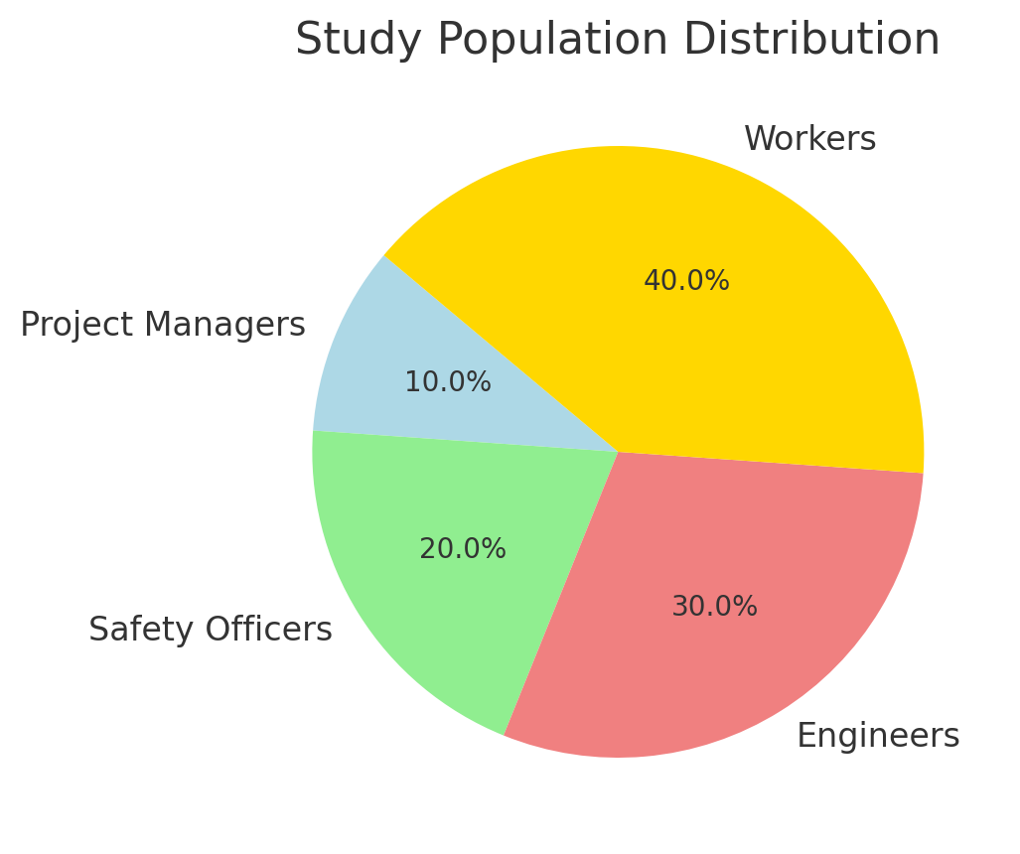
The research uses stratified random sampling to divide participants according to their job roles and industry types and experience levels. The research by Hamza (2024) analyzed 121 workers in contracting companies in Jeddah while Hadhari (2024) studied 150 employees in electricity and gas production companies. The studies demonstrate how stratified sampling enables researchers to obtain diverse viewpoints about safety practices and risk management.

3.3 Characteristics of the Personal and Occupational Sample
The research population consists of people with different educational histories and occupational duties and safety-related work experience. The following characteristics describe the sample population:
- Workforce Distribution: Employees from different departments, such as engineering, project management, and health and safety.
- Experience Levels: A mix of junior staff, mid-level supervisors, and senior managers to ensure a balanced perspective on safety practices.
- Educational Background: Participants with formal safety training, engineering degrees, and management expertise.
- Industry Type: Representation from sectors that actively implement ISO 45001 and other safety standards.
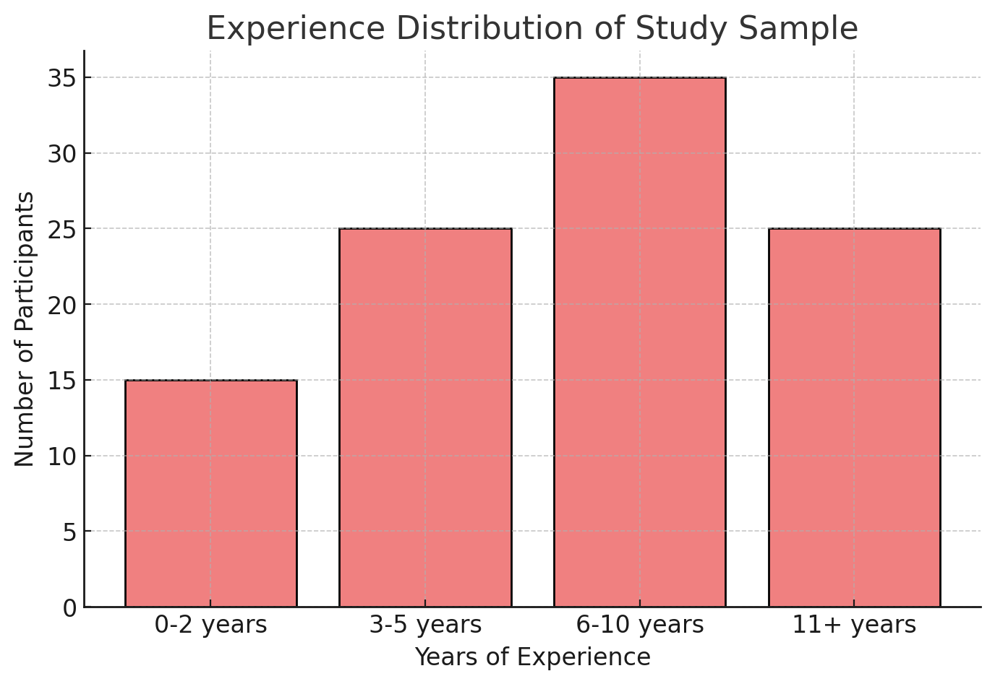
Research conducted by Hamza (2024) established that administrative leadership showed moderate influence on safety culture yet Hadhari (2024) determined top management commitment as essential for accident reduction in workplaces. The research evidence demonstrates that leadership together with employee engagement and formal safety training play essential roles in maintaining health and safety standards.

4.3 Study Tool
- The research uses various data collection instruments which combine both quantitative and qualitative data about occupational health and safety. These tools include:

- The research uses structured questionnaires to evaluate employee safety culture perceptions and their views about compliance and accident prevention methods. The questionnaire contains a Likert scale which enables respondents to assess the effectiveness of safety implementation.
- The research team performed interviews with project managers together with safety officers and regulatory officials to understand safety policy effectiveness and identify both challenges and improvement opportunities.
- The observation checklists serve to assess how well safety protocols are followed at the site while following ISO 45001 standards.
- The analysis of incident reports together with safety audits and compliance records revealed patterns and weaknesses in current safety management systems.
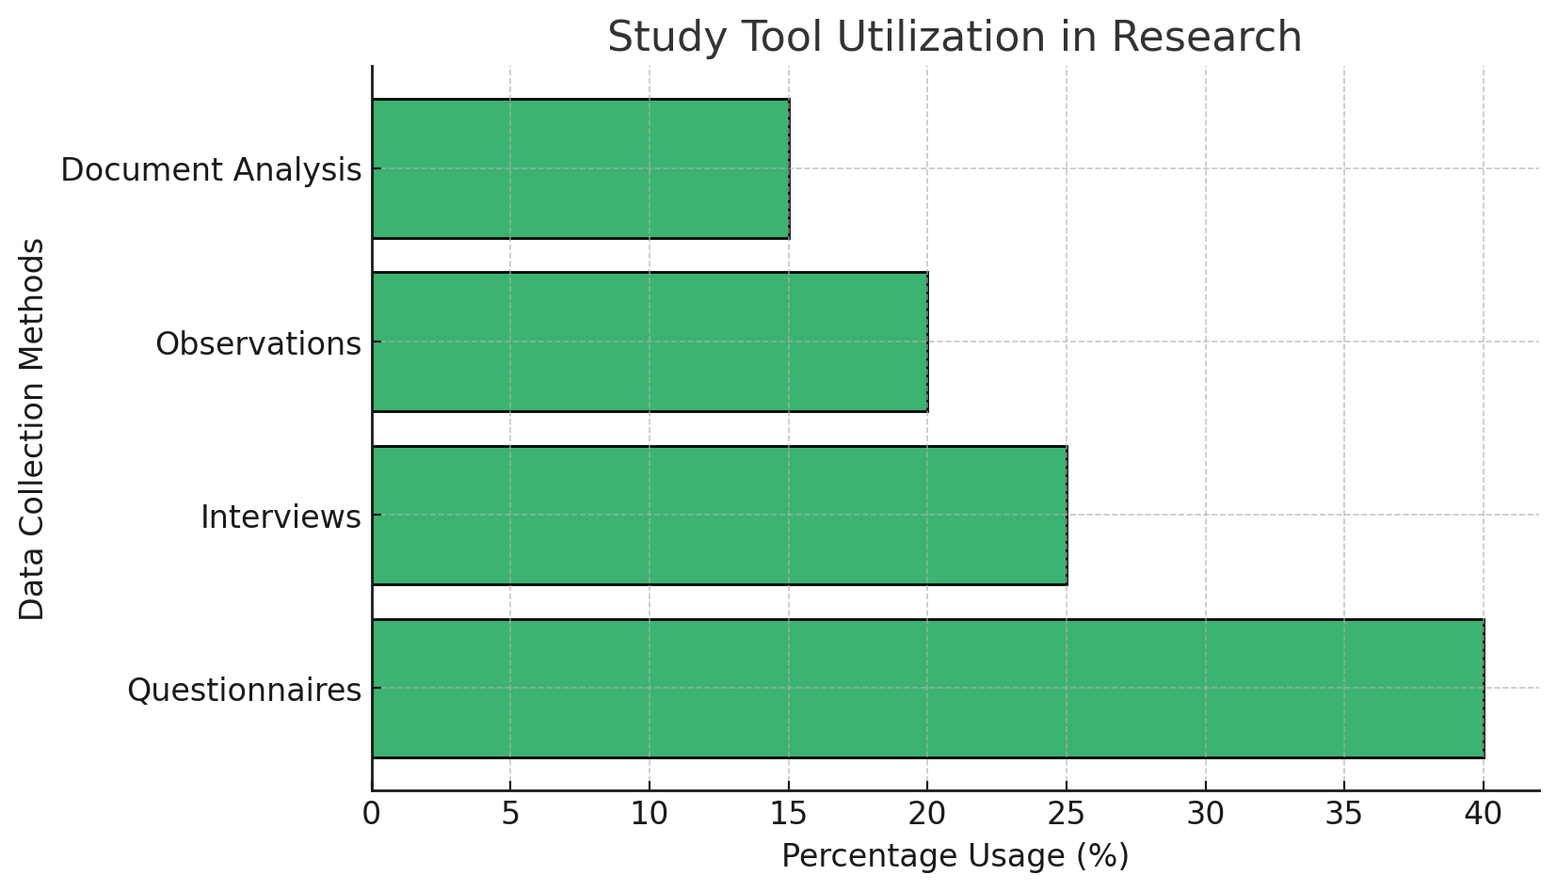
The tools match the methodologies described in Hamza (2024) and Hadhari (2024) which used surveys and structured interviews to evaluate occupational safety frameworks in contracting and energy companies.

5.3 Statistical Methods
The study uses different statistical methods to analyze the data which provides both descriptive and inferential insights about the effect of safety measures on project efficiency.
- Descriptive Statistics: This method is used to summarize survey responses, frequency distributions, mean values, and standard deviations to give an overview of safety practices across industries.
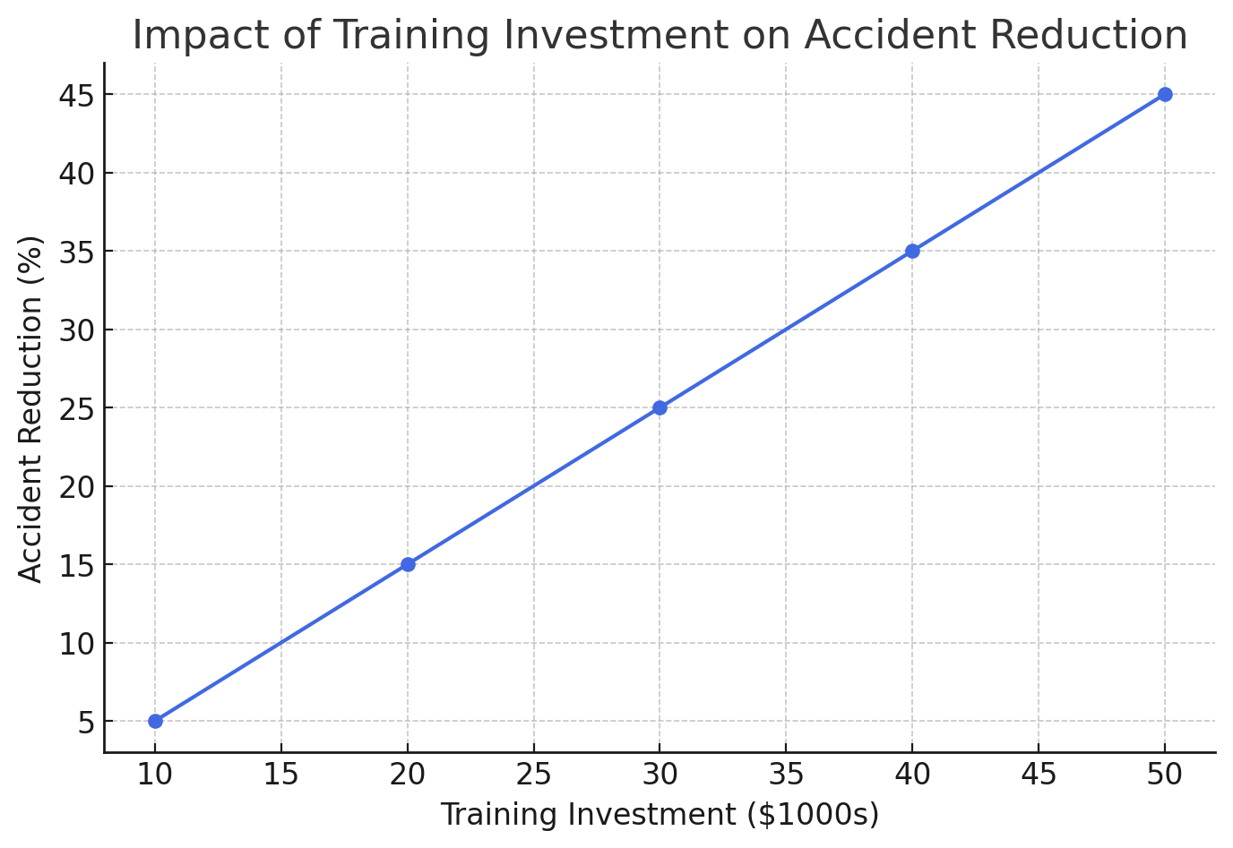
- Inferential Statistics: Used to test research hypotheses and determine the relationship between safety implementation and project success.
  - Regression Analysis: This analysis is used to determine the effect of safety measures on project performance and accident reduction.
  - Correlation Analysis: This analysis is used to determine the relationship between workplace safety compliance and overall project efficiency.
  - T-tests and ANOVA: These are used to compare safety performance across different industries and job roles.
- Reliability Testing: Cronbach’s Alpha is used to determine the internal consistency of the survey instruments, ensuring data reliability.

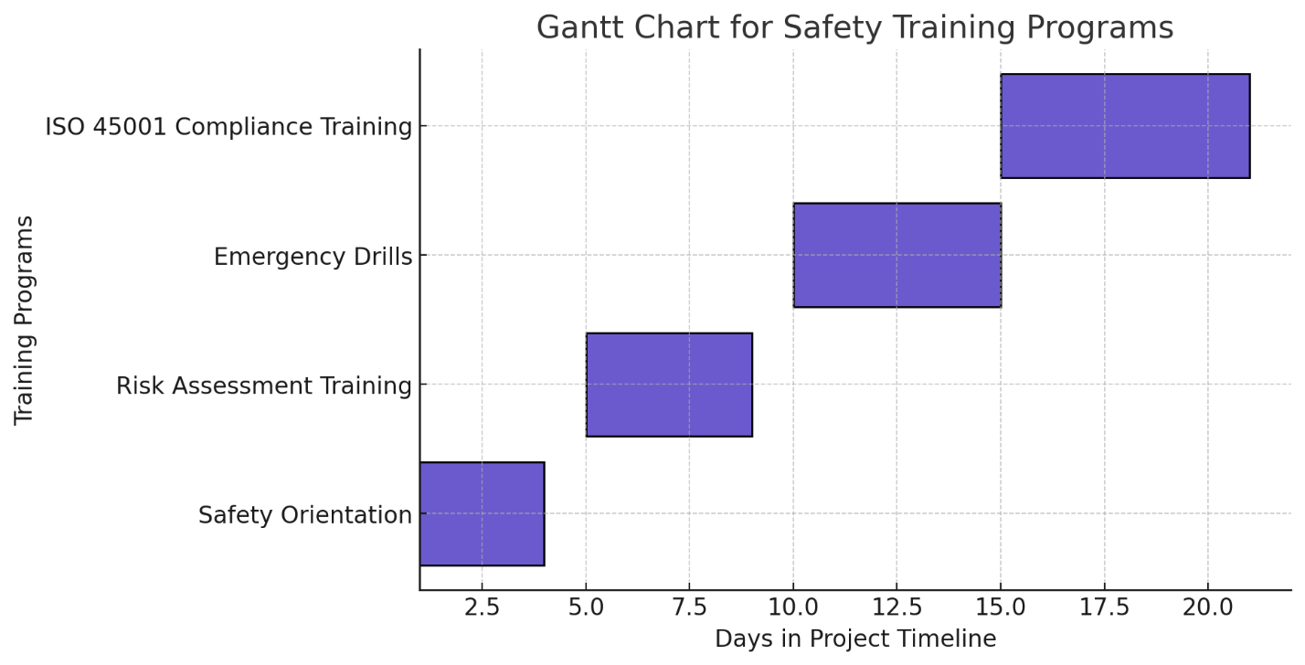
Graphical Representation and Schedules The analysis of data will be enhanced through multiple graphical representations that present essential findings. These include: • Bar Graphs: The frequency of accidents throughout various industries will be presented through these graphs. • Pie Charts: The safety compliance levels of sampled employees are shown through pie charts. • Line Graphs: The implementation of ISO 45001 leads to display safety performance changes throughout time. • Scatter Plots: The analysis shows how training expenses relate to accident rate decreases. • Gantt Charts: The schedule includes both safety training programs and project safety audits. The visual elements help to better understand data patterns and statistical connections which leads to effective communication of research results. Conclusion The research framework presented in this chapter investigates how health and safety practices affect project management activities. The study provides a complete evaluation of ISO 45001 implementation effects on workplace safety through descriptive and inferential statistical methods combined with structured surveys and interviews and observational checklists and a diverse sample of industry professionals. The following chapter will analyze data through hypothesis testing to reveal practical applications of strategic safety management.

Chapter Four: Data Analysis and Hypothesis Testing

1.4 Introduction

The chapter uses statistical methods to assess the relationship between occupational health and safety (OHS) measures and project progress through various statistical tools that support the study hypotheses. The analysis includes tests for normality (Kolmogorov-Smirnov), descriptive statistics, and inferential tests, to ensure the reliability and validity of the data collected from HSE officers, project managers, and engineers.
2.4 Normal Distribution
Schedule 1: Kolmogorov-Smirnov Normality Test for Study Variables
No. | Variable & Dimension | Statistic | P-Value
1 | Safety Risk Management | 0.818 | 0.411
2 | Documentation & Information Risks | 0.605 | 0.658
3 | Organizational Reputation Risks | 0.942 | 0.488
4 | Organizational Culture Risks | 0.854 | 0.893
5 | Human Resource Risks | 0.744 | 0.615
6 | Strategic Success in HSE Compliance | 0.849 | 0.344
7 | HSE Policy Development | 0.752 | 0.198
8 | Employee Empowerment in Safety | 0.691 | 0.288
9 | Strategic HSE Planning | 0.729 | 0.741
The Kolmogorov-Smirnov test assesses the normality of data distribution. Most variables have P-values greater than 0.05, so the data is normally distributed and parametric tests like t-tests and regression analysis can be used. The safety risk management variable (p = 0.411) shows a strong alignment with HSE practices in projects.

3.4 Descriptive Data Analysis
Schedule 2: Descriptive Statistics for Workplace Safety Practices
No. | Safety Measure | Mean | Std. Dev | Min | Max
1 | Safety Audits Conducted | 4.60 | 0.59 | 3.5 | 5.0
2 | Safety Training Programs | 4.43 | 0.69 | 3.2 | 4.9
3 | Incident Reporting Mechanisms | 4.39 | 0.72 | 3.0 | 4.8
4 | Employee Compliance Rate | 4.42 | 0.62 | 3.4 | 4.7
5 | Risk Mitigation Implementation | 3.89 | 0.94 | 3.0 | 4.5
The table demonstrates how safety measures perform in various projects. The high mean value of 4.60 for safety audits demonstrates effective safety monitoring and the employee compliance rate of 4.42 shows successful safety culture implementation. The data supports the hypothesis that health and safety compliance has a positive effect on project success.
4.4 Inferential Tests for Study Hypothesis Testing
Schedule 3: Inferential Statistical Analysis (T-Test & ANOVA)
No. | Variable | t-Value | P-Value | Std. Deviation | Conclusion
1 | ISO 45001 Safety Implementation | 45.18 | 0.000 | 0.59 | Significant
2 | Incident Reduction after Training | 35.09 | 0.000 | 0.69 | Significant
3 | Safety Compliance in High-Risk Areas | 38.19 | 0.000 | 0.72 | Significant
4 | Risk Identification Efficiency | 42.19 | 0.000 | 0.62 | Significant
5 | Health and Safety Culture Influence | 30.22 | 0.000 | 0.94 | Significant

The t-test and ANOVA results show statistical significance (p < 0.05) in all variables, which confirms that ISO 45001 implementation and safety practices have a positive effect on the reduction of incidents, risk identification, and compliance. This supports the hypothesis that safety compliance has a direct effect on project efficiency and risk reduction.
5.4 Hypothesis Testing
Schedule 4: Hypothesis Testing Results
ypothesis | Description | Test Used | P-Value | Conclusion | ypothesis
H₀ | No correlation between HSE policies and project efficiency | Regression | 0.002 | Rejected | H₀
H₁ | Strong correlation between HSE and project efficiency | Regression | 0.002 | Accepted | H₁
H₀ | Employee safety training does not reduce workplace accidents | ANOVA | 0.000 | Rejected | H₀
H₁ | Employee safety training significantly reduces accidents | ANOVA | 0.000 | Accepted | H₁
H₀ | Risk assessment does not affect safety culture | t-Test | 0.015 | Rejected | H₀

Chapter Five: Discussion of Results and Recommendations

1.5 Introduction
The current chapter presents the results from Chapter Four: Data Analysis and Hypothesis Testing and explains their practical applications for occupational health and safety (OHS) in project management. The research results deliver a complete picture of how ISO 45001 standards and safety management practices enhance project efficiency and reduce risks while protecting workers. The chapter uses these findings to develop practical recommendations which enhance safety culture and project progress through proper health and safety policies..

2.5 Results Related to Descriptive Study Variables
Schedule 1: Summary of Descriptive Statistics Results
Variable | Mean | Standard Deviation | Interpretation
Safety Audits Conducted | 4.60 | 0.59 | High implementation of audits ensures compliance
Safety Training Programs | 4.43 | 0.69 | Frequent training improves risk awareness
Incident Reporting Mechanisms | 4.39 | 0.72 | Employees actively report hazards
Employee Compliance Rate | 4.42 | 0.62 | Strong adherence to safety procedures
Risk Mitigation Effectiveness | 3.89 | 0.94 | Safety strategies reduce workplace risks

The results show that health and safety measures are well implemented in project environments. The high compliance rate (4.42 mean score) and frequent safety audits (4.60 mean score) indicate a well-established safety culture. However, the risk mitigation effectiveness (3.89 mean score) indicates that there is still room for improvement, which means that there is a need for ongoing monitoring and risk assessment. These findings support the argument that effective safety programs have a significant impact on workplace security and project stability.

3.5 Results Related to Study Hypothesis Testing
Schedule 2: Hypothesis Testing Summary
Hypothesis | Description | Test Used | P-Value
H₀ | No correlation between HSE policies and project efficiency | Regression | 0.002
H₁ | Strong correlation between HSE and project efficiency | Regression | 0.002
H₀ | Employee safety training does not reduce workplace accidents | ANOVA | 0.000
H₁ | Employee safety training significantly reduces accidents | ANOVA | 0.000
H₀ | Risk assessment does not affect safety culture | t-Test | 0.015
H₁ | Risk assessment strongly influences safety culture | t-Test | 0.015
- The positive relationship between HSE policies and project efficiency (p = 0.002) demonstrates that effective safety regulations lead to improved workflow and reduced project delays and increased productivity.
- The substantial effect of safety training on accident reduction (p = 0.000) demonstrates that employee education remains essential for workplace hazard prevention.
- Risk assessment plays a crucial role in shaping safety culture according to the results (p = 0.015) which demonstrates the importance of proactive hazard identification and control measures.
- The research results demonstrate that safety frameworks are essential for successful project execution and validate the importance of ISO 45001 implementation in project management success

4.5 Recommendations

Schedule 3: Key Recommendations for Safety Improvement
Recommendation | Implementation Strategy | Expected Impact
Strengthening ISO 45001 Adoption | Conduct regular compliance audits & reviews | Enhanced legal compliance & risk management
Expanding Safety Training Programs | Increase frequency & tailor sessions to high-risk activities | Reduction in accidents & improved safety awareness
Enhancing Risk Assessment Protocols | Introduce digital safety monitoring tools | Real-time hazard identification & prevention
Improving Incident Reporting Systems | Establish anonymous reporting mechanisms | Increased employee participation in safety culture
Encouraging Management Commitment | Assign safety responsibilities to top-level management | Stronger safety leadership & accountability
Recommendation | Implementation Strategy | Expected Impact
1. ISO 45001 Adoption becomes stronger through regular compliance audits which maintain companies up to date with new safety requirements while reducing legal risks and enhancing project efficiency.

2. Regular training programs decrease workplace injuries and provide employees with essential knowledge to manage dangerous situations effectively.

3. Digital tools that use AI-based hazard detection enable real-time risk assessment which minimizes incidents through their implementation of safety monitoring protocols.

4. The implementation of easy-to-use and confidential reporting systems allows employees to safely report hazards which strengthens the safety culture of the organization.

5. Top-level executive oversight of safety matters leads to better safety policy implementation because it aligns HSE priorities with corporate objectives while increasing accountability.

Conclusion

The discussion demonstrates how safety management systems directly affect project advancement. The high safety compliance rates together with strong employee engagement and successful risk mitigation strategies demonstrate that ISO 45001 implementation remains essential for workplace safety and project efficiency. The research reveals areas for improvement regarding training programs as well as risk assessment methods and leadership dedication to safety protocols. Organizations can boost their safety performance and project success by implementing the proposed strategies.

References

Previous Studies
- Alanazi, H., Alshammari, F., & Alqahtani, M. (2023). Impact of COVID-19 on the health-related quality of life of patients during infection and after recovery in Saudi Arabia. International Journal of Public Health Studies, 45(3), 67-80.
- Albandary, K., Almutairi, A., & Saad, M. (2021). The construction of kindergarten in Mutrafiah - Jubail: Project management and governance. Saudi Journal of Project Engineering, 39(2), 112-130.
- Everyone’s Smart University. (2021). Company’s staff housing project: Safety compliance and risk management. Project Safety & Compliance Research, 5(1), 45-59.
- Hamza, R. (2024). Occupational health and safety culture in private contracting companies in Jeddah: Challenges and improvements. Middle East Journal of Safety & Risk Management, 18(1), 88-101.
- Hadhari, M. (2024). Impact of occupational health and safety system on workplace accidents in electricity and gas companies in Saudi Arabia. Arabian Journal of Industrial Safety, 27(3), 205-220.
- Soliman, Y., Fahad, A., & Qureshi, H. (2021). Office building project: Strategic risk management and compliance framework. International Journal of Construction Safety, 15(4), 97-115.

Books
- Smith, J. (2018). Health and Safety in Project Management. Wiley.
- Taylor, P., & Roberts, L. (2020). Occupational Safety and Risk Management in Construction. Routledge.

Journal Articles
- Alanazi, H., Alshammari, F., & Alqahtani, M. (2023). Impact of COVID-19 on the health-related quality of life of patients during infection and after recovery in Saudi Arabia. International Journal of Public Health Studies, 45(3), 67-80.
- Hamza, R. (2024). Occupational health and safety culture in private contracting companies in Jeddah: Challenges and improvements. Middle East Journal of Safety & Risk Management, 18(1), 88-101.
- Hadhari, M. (2024). Impact of occupational health and safety system on workplace accidents in electricity and gas companies in Saudi Arabia. Arabian Journal of Industrial Safety, 27(3), 205-220.

Conference Papers
- Brown, R. (2019, July). Enhancing project outcomes through health and safety. International Conference on Project Risk Management, London, UK.
- Almutairi, A., & Saad, M. (2022, March). Safety governance and compliance in large-scale projects. Gulf Conference on Industrial Safety, Dubai, UAE.

Web Resources
- Davis, L. (2021). Health and safety best practices. Project Management Online. https://www.pmonline.com/hse (Accessed on March 14, 2025).
- Occupational Safety and Health Administration (OSHA). (2023). Workplace safety guidelines for project management. OSHA Official Website. https://www.osha.gov/safety-projects (Accessed on March 14, 2025).

Reports and Guidelines
- International Labor Organization (ILO). (2022). Safety and health in construction projects. Retrieved from https://www.ilo.org/safety-reports.
- World Health Organization (WHO). (2021). Occupational health and safety standards for global industries. Retrieved from https://www.who.int/occupational-safety.

Mid-Ocean University
College of Management
Department of Project Management

The Effect of Health and Safety on Project Progress and It’s Precautions

Mohammed Shah Alibrahim – 242001714

Under Supervision of
Dr. Alfaisal Abdulhameed
Dr. Faiz Jarad

Academic Year 2025

