

Title
"Machine Learning-Based Traffic Congestion Classification
for Urban Road Networks"

Prepared By
Name: Rabab Alghamdi ID No.: 243000952

Submitted in fulfillment of the requirements for the degree Master of Science in Artificial Intelligence
At
Collage of Informatics
Midocean University
UAE
Supervisor Name: Prof. Dr. Yasser Abdelhamid

Collage of Informatics, Midocean University, Comoros
Email: 243000952@st.midocean.edu.km

Acknowledgements
All praise is due to Allah, by whose grace good deeds are completed and through whose guidance long-awaited dreams come true, and stories of perseverance are written with patience and faith.
I dedicate this thesis to those who were my very first joy, whose prayers have always preceded me, and who have been my true support in life…
To my father, whose kindness carried the burdens of life on my behalf, and to my beloved mother, who planted in my heart the love of knowledge — you are the roots from which my ambitions have grown, and without you I would never have reached this point.
To the soul that embraced me with love throughout my childhood and adulthood, and instilled peace within me during my hardest times — my dearest grandmother.
To the man who saw nothing in me but success, and who never settled for less than excellence — my beloved husband, Professor Ali. You believed in me before I believed in myself, and once told me: “I will be satisfied only when you become Dr. Rabab.” Your words were not just motivation, but a living heartbeat that accompanied me through every step. Thank you for your patience, your unwavering support, and the love that gave me strength in every moment of weakness.
To my only daughter, the heartbeat of my life and the flower that illuminated my days despite my busyness — may you always be proud of me, just as I am forever proud of having you in my life.
To my ever-inspiring and supportive siblings, who celebrated my achievements as if they were their own.
To Prof. Dr. Yasser Abdelhamid, who was a guiding light when my vision grew dim, a source of support when I faltered, and the one who corrected my path, believed in my potential, and insisted that I continue despite all obstacles.
And to everyone who stood by me with a word, a prayer, or a smile — I dedicate this achievement to you all, with love and deep gratitude.

Abstract
Urban traffic congestion undermines mobility, energy efficiency, and safety. This thesis develops a machine-learning framework to classify traffic states—Normal, Heavy Traffic, and Very Heavy Traffic—using historical vehicle-count and temporal features from urban road networks. The pipeline includes data cleaning, exploratory data analysis, and feature engineering to derive time-period indicators and day-level attributes. Two representative classifiers are built and compared: Random Forest and L2-regularized Logistic Regression. Models are evaluated using accuracy, precision, recall, and F1-score, and their behavior is interpreted through feature-importance analyses. Results show that Random Forest attains very high training performance but exhibits overfitting, whereas the L2-regularized logistic model generalizes more reliably to unseen data. The analysis identifies time-of-day context and vehicle-type counts as the most discriminative predictors of congestion level. The study contributes a reproducible, low-cost, data-driven approach for augmenting Intelligent Transportation Systems (ITS) in settings where extensive sensing infrastructure is impractical, and offers practical guidance on model choice, feature design, and evaluation for deployment-oriented congestion classification.

Table of Contents

List of Abbreviations xiv
List of Figures xvi
List of Tables xviii

Chapter 1: Introcudion ............................................................................... 8
1.1 Problem Definition ................................................................................... 8
1.2 Thesis Objectives ..................................................................................... 8
1.3 Thesis Contribution .................................................................................. 9
1.4 Thesis Organization................................................................................... 9

Chapter 2: Overview..................................... 10
2.1 Introduction .............................................................................................. 11
2.2 Educational Data Mining ......................................................................... 12
2.3 Applications of Educational Data Mining ................................................ 17
Chapter 3: Related Work …………………………………………... 18
3.1 Introduction ............................................................................................19
3.2 History .................................................................................................. 21
Chapter 4: Proposed Approach ............................................................... 22
4.1 Introduction ............................................................................................ 23

Chapter 5: Experimental Results and Discussion ................................... 24
Chapter 6: Conclusion and Future Work .............................................. 29
7.1 Important Features ................................................................................. 29
7.3 Future Work ..........................................................................................29

References .................................................................................................. 31

List of Abbreviations
ML: Machine Learning
RF: Random Forest
LR: Logistic Regression
L2: L2 Regularization
EDA: Exploratory Data Analysis
ITS: Intelligent Transportation Systems
CNN: Convolutional Neural Networks
LSTM: Long Short-Term Memory
DBN: Deep Belief Network
GNN: Graph Neural Networks

List of Figures
Figure1:descriptive statistics of dataset
Figure2: chart of car count vs hour.
Figure3: chart of bus count vs hour.
Figure4: chart of bike count vs hour.
Figure5: chart of truck count vs hour.
Figure6: chart of total vehicles vs hour.
Figure7: Average Vehicle Count by Day of the Week.
Figure8: Boxplot of Vehicle Count Distributions by Type.
Figure9: distribution of classes vs total.
Figure10: Confusion matrix of RF.
Figure11: feature importance of model1.
Figure12: Confusion matrix of l2 of logistic regression.
Figure13:feature importance of model2.

List of Tables
Table1: Data Set Description
Table2: Performance of models

Chapter 1 Introduction

Problem Definition
The rapid increase in the number of vehicles has led to frequent traffic jam in urban areas. Managing traffic efficiently is critical to reducing delays, reducing fuel consumption, and improving safety. Traditional traffic monitoring systems rely on manual monitoring or expensive sensor infrastructure, which can be less scalable. This project aims to develop a machine learning-based traffic classification system that predicts whether traffic conditions are normal, heavy, or extremely heavy, based on historical traffic data.

Thesis Objectives
- Conduct data preprocessing and electronic data analysis to understand traffic patterns.
2. Implement and compare Random Forest and Logistic Regression with L2 Regularization models.
3. Using matrix to evaluate models: accuracy, precision, recall, and F1 score.
4. Recognize the most important features that influence traffic forecasting.

Thesis Contribution
-Developing the pipeline for traffic classification using machine learning.
- Comparative study of RF and LR-L2 models for traffic prediction.
- Feature importance analysis to identify the key factors that influence traffic flow.
- Recommendations for integrating the model into real-time traffic management systems.

1.4 Thesis Organization
Chapter1: introduces the research problem, objectives, and contributions.
Chapter2: presents an overview of traffic prediction concepts and related work.
Chapter3: discusses previous studies on traffic status prediction.
Chapter4: describes the proposed machine learning approach.
Chapter5: presents experimental results and performance analysis.
Chapter6: concludes the thesis and suggests future work.

Chapter 2 Overview
2.1 introduction
Traffic status prediction is an essential element in Intelligent Transportation Systems (ITS), enabling proactive measures to alleviate congestion.
From Kaggle using the dataset in file .csv contain 14 features(day of week,time,date, Bike count, Bus Count, Car count,Truck Count, Total, Hour, Minute,, time_period, day_of_ week, Time _of _month)and label column contain four classes(heavy,high,low,normal).
This dataset constitutes an integral part of transportation planning, traffic congestion management, and traffic flow studies this system provides insights into vehicle demand, highlights zones characterized by elevated traffic density, and informs infrastructure enhancement initiatives. By enabling specific actions such as improved traffic signals and lane redesign, the system enhances the efficiency of roadway usage. Researchers can analyze traffic trends by hour, day, or specific dates and analyze the relationships with external factors. It also facilitates studies on vehicle interactions and overall traffic behavior. Urban planners may employ it to evaluate traffic conditions impact of zoning and infrastructure projects. Ultimately, the dataset provides decision-makers with the tools to make informed, data-driven choices that improve mobility, enhance efficiency, and promote sustainable urban development. [1]

2.2 Traffic Data Mining

Data mining is the process mining patterns and constructing relevant knowledge. In our project, we apply data mining techniques to the traffic domain to classify, analyze, and predict traffic conditions (heavy, high, and normal, low). Comprehending traffic flow dynamics (an important feature for which we employed the numerical value and timing of vehicles) and analyzing their data enables us to generate reliable predictions that support transportation planning.
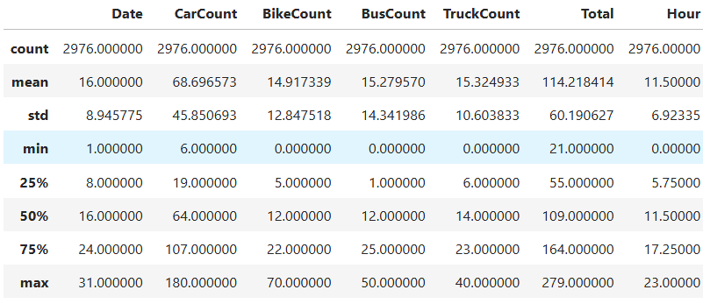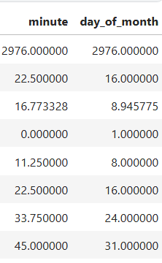
figure1: descriptive statistics of dataset in kaggle notebook [2]

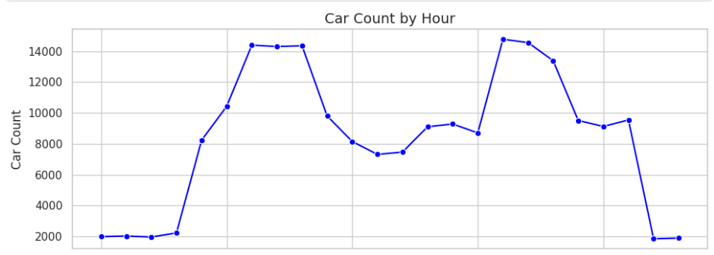

Figure2:chart of car count vs hour [2]

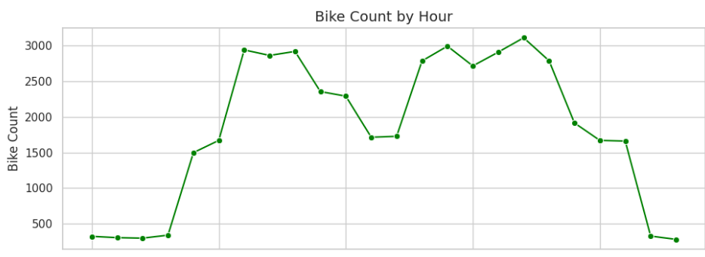
Figure3: chart of Bike count vs hour[2]

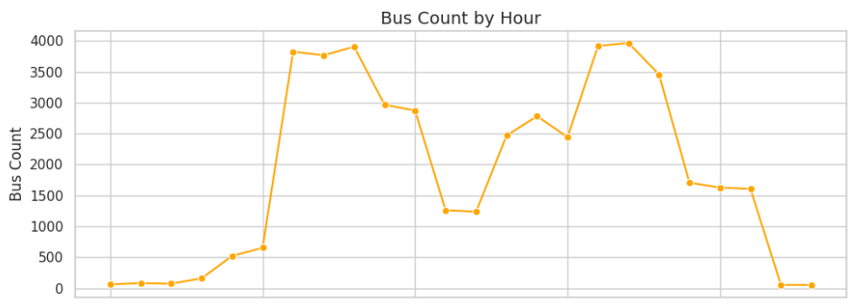
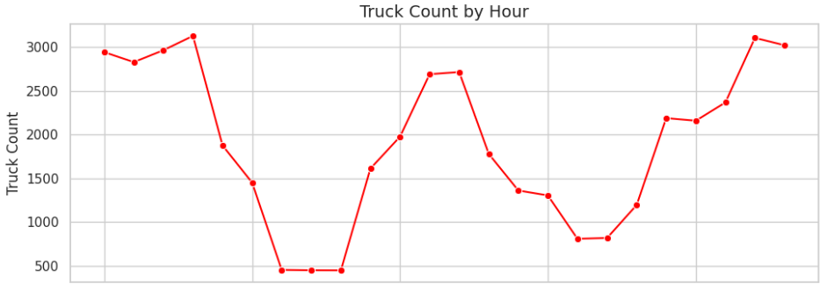
Figure4: chart of Bus vs Hour

Figure 6: chart of total vehical vs hour[2]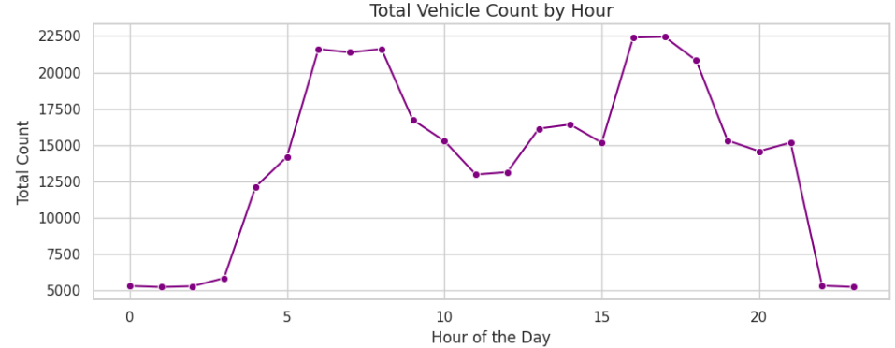
Figure5: chart of truck count vs hour [2]

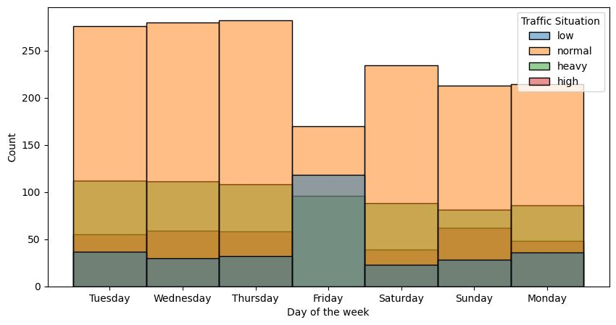
Figure7:chart of traffic situation during week days[2]

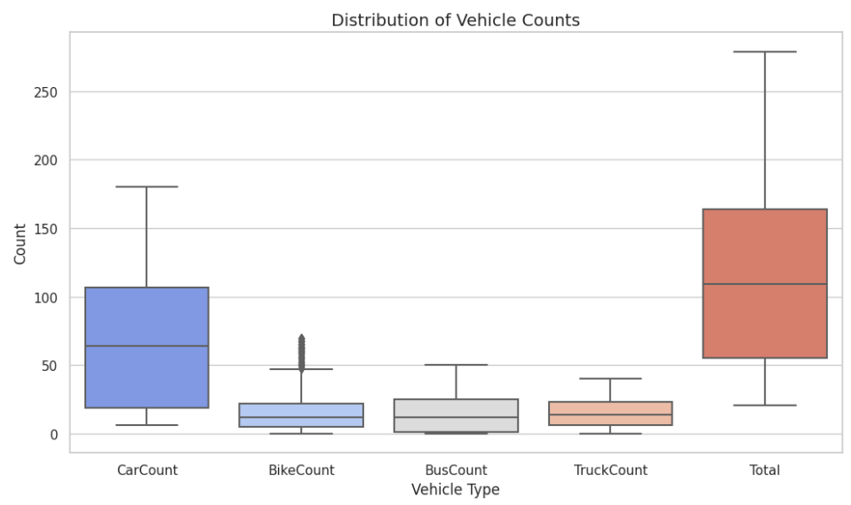

Figure8:check outlier of vehical types counts[2]
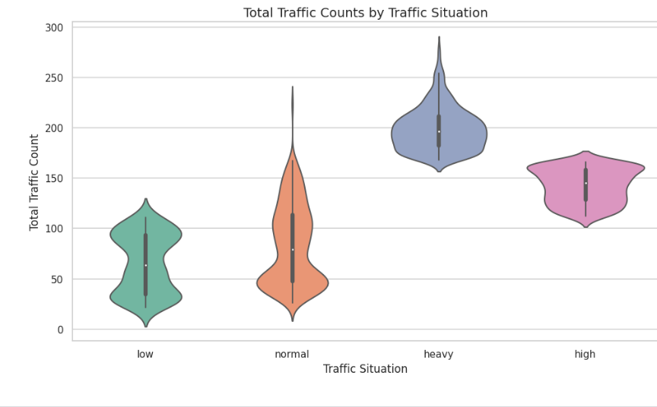
figure9: number of each class (heavy,high,normal,low)[2]

Chapter 3 Related Work

3.1 Introduction:
Research on traffic congestion classification has gained momentum as part of the growing field of Intelligent Transportation Systems (ITS). Earlier monitoring approaches depended mainly on manual checks and costly infrastructure, which made them difficult to scale. With the development of machine learning, however, sensor-based methods have started to play a central role in congestion analysis and anomaly detection. In this section, I review several key studies, highlighting their contributions and limitations, and point out the gaps that inform the direction of this thesis.

Traffic Flow State Classification via Smartphone Sensors (Tu et al., 2017)
Tu and colleagues explored the use of data from smartphone sensors—accelerometers, gyroscopes, and GPS—to identify traffic states through a Deep Belief Network (DBN). Their approach performed better than traditional techniques in terms of accuracy and efficiency. Even so, the dataset was limited both in time span and location, which makes it uncertain whether the findings can be generalized to other contexts.
Detecting and Predicting Traffic Congestion Anomalies (Mihaita et al., 2020)
In a different setting, Mihaita et al. proposed a CNN–LSTM model trained on more than 36 million sensor readings from Sydney’s motorway loops. By applying anomaly adjustment, their system was able to capture spatial and temporal congestion patterns more effectively than baseline models. The results were strong, but the focus on only one metropolitan area limits how far the findings can be extended.
A New Approach to Congestion and Anomaly Detection (Ben Slimane & Ben Ammar, 2024)
Ben Slimane and Ben Ammar introduced a deep learning framework for real-time congestion and anomaly detection in urban networks. Their architecture, combining CNN and LSTM, showed notable gains in accuracy, precision, recall, and efficiency compared to established methods. Still, the study offered little detail about how the dataset was collected or what areas it covered, which poses challenges for reproducibility.
Adaptive Traffic Prediction with Edge-Impulse TinyML (Tolani et al., 2025)
More recently, Tolani and colleagues used proximity sensors installed at signalized intersections together with a TinyML model on the Edge-Impulse platform. The system forecasted traffic density and vehicle arrival times, then adjusted signal timings dynamically. Compared with fixed-time systems, it reduced congestion effectively. That said, the approach was tested only at selected intersections, leaving questions about whether it could scale to larger and more complex road networks.

Study | Authors | Year | Research Design | Key Findings / Results | Methodology | Limitations
Traffic Flow State Classification via Smartphone Sensors | Tu et al. | 2017 | Experimental study using DBN | Outperformed traditional classification methods in accuracy and efficiency | Deep Belief Network on smartphone sensor data (accelerometer, gyroscope, GPS; 747,856 samples / 5 days) | Short-term dataset; limited generalizability
Traffic Congestion Anomaly Detection and Prediction | Mihaita et al. | 2020 | Hybrid CNN–LSTM framework | Consistently outperformed traditional models; anomaly adjustment improved predictions | Hybrid CNN–LSTM applied to 36.34 million motorway loop readings from Sydney | Single-city dataset; focused on highways only
A Novel Approach for Congestion and Anomaly Detection | Ben Slimane & Ben Ammar | 2024 | Hybrid deep learning framework | Higher accuracy, precision, recall, and efficiency than benchmarks | CNN–LSTM with real-time feature extraction and urban dataset | Limited dataset transparency; reproducibility concerns
Edge‑Impulse TinyML Adaptive Traffic Prediction | Tolani et al. | 2025 | Applied Edge ML with proximity sensors to predict traffic density and vehicle arrival times. | Congestion is reduced by dynamically adjusting signal timings in real time. | Proximity sensors + Edge‑Impulse ML model for adaptive traffic signal control. | Limited to specific junctions; scalability across larger road networks not yet demonstrated.

3.2 History:
Early research on traffic analysis leaned on statistical and regression models to describe flow patterns. Those tools were useful to a point, but they struggled with the inherently dynamic and nonlinear behavior of urban traffic. As larger sensor datasets became available and machine learning matured, the field moved toward models that can capture richer structure—most notably CNNs, LSTMs, and hybrid designs. In practice, these approaches improved congestion-level prediction, anomaly detection, and decisions that must be taken in real time. A concise summary of representative studies appears in the table that follows.

Chapter 4 Proposed Approach

4.1 Introduction:

The approach uses the traffic prediction dataset from Kaggle, applying two classification models: random forest (ensemble learning) and logistic regression with L2 regularization.

Pipeline steps:
1-import libraries (numpy: mathematical library, pandas: read file of csv data and preprocess, matplotlib: visualization dataset and seaborn correlations of columns)
2-read dataset: use function of read_csv () in library of pandas
3-Discover the dataset (use the shape method to display rows numbers and columns, use the unique () accessor method for date columns to make all dates unique, use the info () method to inform the data types) null values in dataset and use finally duplicated () to check duplicate values.

4- Exploratory data analysis (EDA):
Use various charts:
The first graph (line graph) shows the relationship between the number of vehicles per hour, the breakdown by type, and the total, indicating that the number of cars is the highest.
Second chart :(barplot) show relationship between Average Vehicle Count by Day of the Week indicate the most days heavy traffic Tuesday, Wednesday.
Third chart :(boxplot) check outlier in vehicle type(car, bus, truck, bike, total vehicle) indicate no outlier.
Fourth chart :(pie) Average Contribution of Vehicle Types to Total Traffic indicate car count most vehicles in total.
Fifth chart :( Violin Plot ) show relationship between Total Traffic Counts by Traffic Situation indicate normal traffic states most.

5-feature engineering:
Convert date to details day,month and time_period.
6-build first model Random Forest:
Frist converting columns by label encoder to numeric datatypes ['hour', 'minute', 'CarCount', 'BikeCount', 'BusCount', 'TruckCount', 'day_of_week', 'day_of_month', 'time_period']] then build model RF with hyperparameter n_estimators=100, random_state=42 and train model with fit() function and test with function predict() found accuracy about 100% this indicate overfitting we solve it in second model. finally visualize most important feature model depend on it is car count.

7-build second model Logistic Regression:
Start with convert this columns by label encoder to numeric datatypes ['hour', 'minute', 'Car Count', 'Bike Count', 'Bus Count', 'Truck Count', 'day_of_week', 'day_of_month', 'time_period']
then build model LR with hyperparameter penalty='l2', # Use L2 regularization
C=1.0, # Inverse of regularization strength
solver='lbfgs', # Optimization algorithm
max_iter=1000, # Maximum number of iterations for convergence
random_state=42
And train model with fit() function and test with function predict() found accuracy about 89% this indicate we solve problem of overfitting . finally visualize most important feature model depend on it is time_period.

Chapter 5

Experimental Results and Discussion
Below are the models performance results including confusion matrices and feature importance chart of two models (random forest, l2 of logistic regression)

First model: random forest
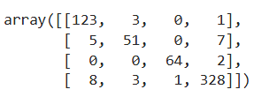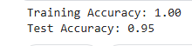

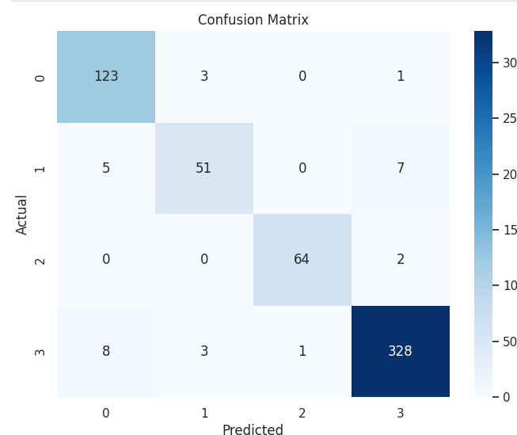
Figure12: Confusion matrix of RF.[2]

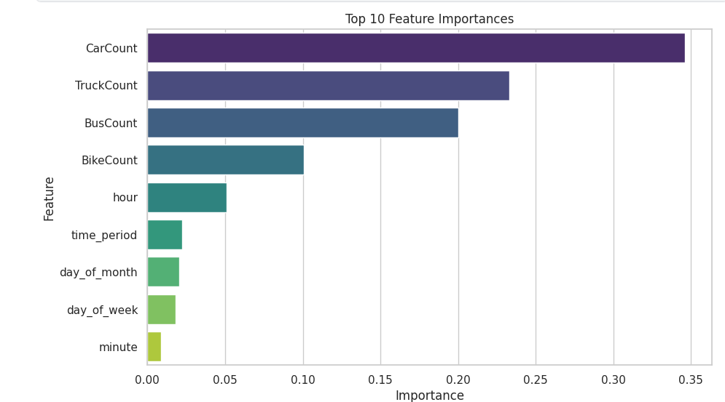
Figure13: feature importance of model1 [2]

The model shows the accuracy training of 1.00 and the accuracy testing of 0.95, indicating potential overfitting. This occurs when the model memorizes the training data, including noise, resulting in high training accuracy but lower generalization to unseen data. To mitigate overfitting, regularization techniques are essential, as they penalize large parameters and encourage the construction of simpler models, which improves generalization and enhances model robustness.

Second model: l2 of logistic regression

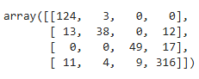
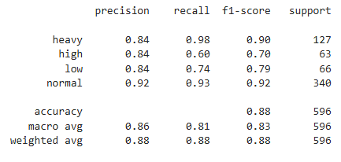
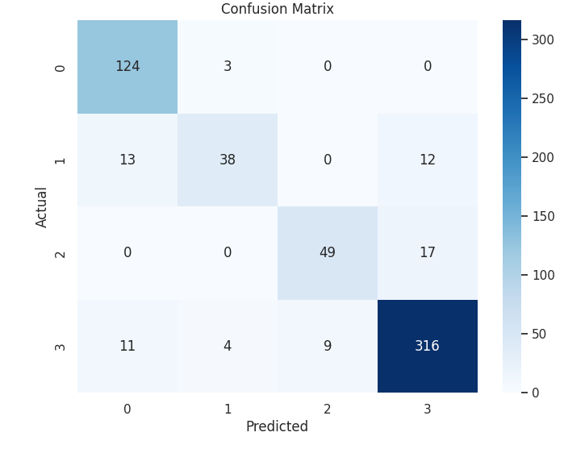
Figure14: Confusion matrix of l2 of logistic regression.[2]

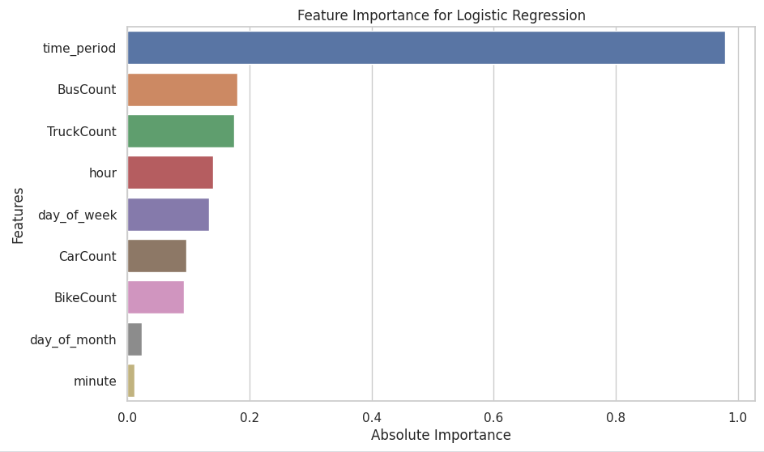
Figure14: feature importance of model2 [2]
In the logistic regression model, time period is the most important feature, highlighting its crucial role in traffic prediction. BusCount and TruckCount also appear to be of significant importance, while the hour and day_of_week contribute moderately. The number of vehicles, such as CarCount and BikeCount, has a smaller impact, emphasizing the model's focus on temporal factors for effective traffic management.

Time Series Forecasting Model (LSTM)
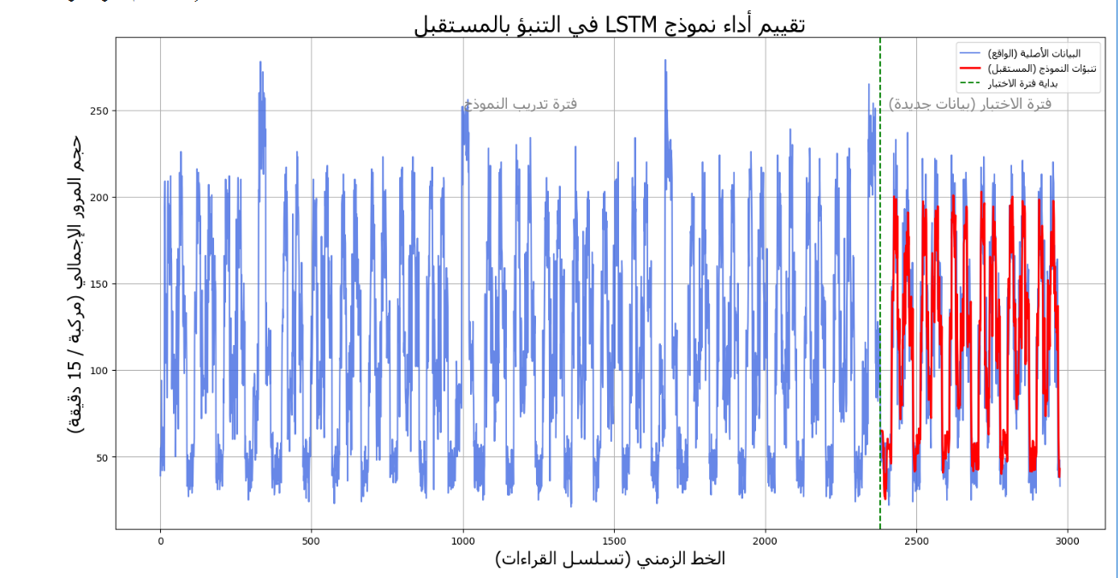

Chapter 6 Conclusion and Future Work

6.1 Conclusion
The random forest model is overfitted, and I solve it in a logistic regression model with L2-norm regularization. in terms of accuracy and generalization for traffic status prediction.

6.2 Important Features
The most influential features were CarCount, TruckCount, BusCount, and BikeCount especially, in first model RF.

The most influential features were time period, in second model logistic regression with l2 norm regulazation.

6.3 Future Work
- Integrating weather data
- Using hybrid models
- Expanding the application

References

Kaggle dataset:https://www.kaggle.com/datasets/hasibullahaman/traffic-prediction-dataset
- Kaggle notebook: https://www.kaggle.com/code/angilazmy/random-forest-and-logistic-regression-l2-regulariz

[Abu Saa, Amjed, et al., 2019]
Abu Saa, Amjed, Mostafa Al-Emran, and Khaled Shaalan. “Factors Affecting Students’ Performance in Higher Education: A Systematic Review of Predictive Data Mining Techniques”. Tech Know Learn 24, 567–598., 2019.

[Adewale, Amoo M., et al., 2018]
Adewale, Amoo M., Alaba O. Bamidele, and Usman O. Lateef. “Predictive modelling and analysis of academic performance of secondary school students: Artificial Neural Network approach”. International Journal of Science and Technology Educational Research 9(1), 1-8, 2018.

[Ali S, Rasheed Mansoor, and S Perumal, 2022]
Ali S, Rasheed Mansoor, and S. Perumal. “Multi-class LDA classifier and CNN feature extraction for student performance analysis during Covid-19 pandemic”. International Journal of Nonlinear Analysis and Applications, 13(1), pp. 13291339., 2022.

[Alpaydin, Ethem, 2010]
Alpaydin, Ethem (2010). Introduction to Machine Learning. London: The MIT Press. ISBN 978-0-262-01243-0

[Ben Slimane, 2024]
Ben Slimane, J., & Ben Ammar, M. (2024). A novel approach of traffic congestion and anomaly detection with prediction using deep learning. Journal of Engineering Studies, Article 1814. https://doi.org/10.52783/jes.1814

[Simona Mihaita, 2017]
Mihaita, A.-S., Li, H., & Rizoiu, M.-A. (2020). Traffic congestion anomaly detection and prediction using deep learning [Preprint]. arXiv. https://arxiv.org/abs/2006.13215

[Tu, W., Xiao, F., Fu, L., & Pan, G. , 2017 ]
Tu, W., Xiao, F., Fu, L., & Pan, G. (2017). A deep learning model for traffic flow state classification based on smartphone sensor data [Preprint]. arXiv. https://arxiv.org/abs/1709.08802

[Tolani, M., Saathwik, G. E., Roy, A., Ameeth, L. A., Rao, D. B., Bajpai, A., & Balodi, A. ,2025]
Tolani, M., Saathwik, G. E., Roy, A., Ameeth, L. A., Rao, D. B., Bajpai, A., & Balodi, A. (2025). Machine learning based adaptive traffic prediction and control using Edge‑Impulse platform. Scientific Reports, 15, Article 17161.
https://doi.org/10.1038/s41598-025-00762-4

