

Deep Learning-Based Monkeypox Detection: A
Hybrid Approach Using DenseNet121 and
MobileNetV2
Prepared By
Name: Omar AbuAmra ID No.: 242001458
Name: Ali AbuAmra ID No.: 242001474
Name: Mahmoud AbuAmra ID No.: 242001469

Submitted in fulfillment of the requirements for the degree Master of Science in Artificial Intelligence
At
Collage of Informatics
Midocean University
UAE
Supervisor Name: Dr. Hager Saleh
Collage of Informatics, Midocean University, Comoros
Email:…………………….

Acknowledgements
I would like to extend my profound appreciation and sincere gratitude to Dr. Hager Saleh for her exemplary supervision, unwavering support, and insightful guidance throughout the course of this research. Her deep expertise in Artificial Intelligence, coupled with her meticulous attention to detail and academic rigor, have significantly enriched the quality and depth of this work. Dr. Saleh’s commitment to excellence and her continuous encouragement have not only shaped this thesis but also contributed greatly to my academic and personal development. It has been a distinct privilege to work under her supervision, and I am truly grateful for her invaluable contributions.

Abstract
Due to recent outbreaks outside of endemic areas, Monkeypox is a newly developing zoonotic disease that has drawn international attention. As a result, early and precise lesion detection is crucial for effective containment and treatment. To overcome this difficulty, we suggest a hybrid deep-learning method that combines DenseNet121 and MobileNetV2 for reliable monkeypox identification from skin lesion photos using the Monkeypox Skin Lesion Dataset (MSLD) and the Monkeypox Skin Lesion Dataset V2.0 (MSLDV2.0). The accuracy of the proposed model was 98% on the MSLD2.0 dataset and 99.18% on the MSLD dataset. The confusion matrix further validated the model's robustness, which outperformed current techniques and demonstrated exceptional precision for both the Monkeypox and non-monkeypox classes. The hybrid model makes it clinically feasible for environments with restricted resources by carefully balancing the computational efficiency of MobileNetV2 with the hierarchical feature extraction of DenseNet121. This work advances AI-driven diagnostics by providing a high-accuracy, deployable solution that supports international efforts to stop the spread of Monkeypox through dependable early identification.

List of Publications

Table of Contents

List of Abbreviations vii
List of Figures viii
List of Tables viii

Chapter 1: Introcudion ............................................................................... 1
1.1 Problem Definition ................................................................................... 1
1.2 Thesis Objectives ..................................................................................... 1
1.3 Thesis Contribution .................................................................................. 1
1.4 Thesis Organization................................................................................... 2

Chapter 2: Overview..................................... 2
2.1 Introduction ............................................................................................... 2
2.2 Hybrid Model for Monkey Pox Detection ............................................... 3
2.3 Applications of Hybrid Model for Monkey Pox Detection........................ 3
Chapter 3: Related Work …………………………………………... 4
3.1 Introduction ............................................................................................4
3.2 History .....................................................................................................4
Chapter 4: Proposed Approach ............................................................... 7
4.1 Introduction ............................................................................................ 7

Chapter 5: Experimental Results and Discussion ................................... 10

Chapter 6: Conclusion and Future Work .............................................. 17
7.1 Important Features ............................................................................... 17
7.3 Future Work ....................................................................................... 18

References .................................................................................................. 19

List of Abbreviations
- AI: Artificial Intelligence
- CNN: Convolutional Neural Network
- DL: Deep Learning
- MSLD: Monkeypox Skin Lesion Dataset
- MSLDV2.0: Monkeypox Skin Lesion Dataset Version 2.0
- WHO: World Health Organization
- PCR: Polymerase Chain Reaction
- ReLU: Rectified Linear Unit (activation function)
- LIME: Local Interpretable Model-Agnostic Explanations
- TFLite: TensorFlow Lite
- MAE: Masked Autoencoder
- DINO: Self-Distillation with No Labels
- HFMD: Hand, Foot, and Mouth Disease
- SHAP: SHapley Additive exPlanations
- MSMPNet: Multi-Scale Monkeypox Prediction Network
- GPU: Graphics Processing Unit
- RAM: Random Access Memory
- SSD: Solid-State Drive
- OTCON: OPJU International Technology Conference on Smart Computing
- ICECSP: International Conference on Electronics, Communication and Signal Processing
- NMITCON: Networks, Multimedia and Information Technology Conference

List of Figures
2.1 Illustration of the Steps of the Method ……………………………… | 7
2.2 Sample images from the dataset …………………………………… | 7
2.3 Sample Images from the Dataset after Augmentation ………….… | 9
2.4 Illustration of the Hybrid Model ………...……………….….……… | 9
2.5 Confusion Matrices of Models for the MSLD Dataset ……………  2.6 Confusion Matrices of Models for the MSLDV2.0 Dataset……… 16 | 13

List of Tables
3.1 List of Models Utilized by Researchers in the Related Work and Accuracies Obtained……………………………………………………………………… 6
3.2 Number of Images in Each Class for MSLD and MSLDV2.0…………… 11
3.3 Parameters of the Hybrid Model………………………………………… 12
3.4 Performance of the Hybrid Model in Each Class for the MSLD Dataset…13
3.5 Performance of the Hybrid Model in Each Class for the MSLDV2.0
Dataset……………………………………………………………………… 15
3.6 Comparison with Existing Work and the Proposed Models Based on Models and Performance for the MSLD and MSLDV2.0 Datasets………………… 17

Chapter 1 Introduction

Problem Definition
Monkeypox, a remerging zoonotic disease of the Orthopoxvirus genus, garnered unprecedented global attention following its multi-country outbreak in 2022. Traditional diagnostic approaches like PCR and clinical examination, while reliable, are time-intensive and require access to well-equipped laboratories and trained personnel. This presents a significant barrier in low-resource or outbreak heavy settings. Moreover, Monkeypox's symptomatic similarity to other pox-like diseases such as Chickenpox and Measles makes early and accurate diagnosis challenging. These limitations highlight the urgent need for fast, accurate, and scalable diagnostic tools, particularly those that can perform well in resource-limited environments.

Thesis Objectives
This thesis aims to develop a hybrid deep learning model that integrates DenseNet121 and MobileNetV2 architectures for the accurate classification of Monkeypox skin lesions. By leveraging transfer learning techniques on limited medical datasets (MSLD and MSLDV2.0), the proposed approach seeks to achieve high diagnostic accuracy with reduced training time. Additionally, the study addresses the limitations of single-model frameworks by combining DenseNet121’s global feature extraction capabilities with the lightweight efficiency of MobileNetV2. Ultimately, the objective is to evaluate the hybrid model’s performance across multiple disease classes and validate its robustness and generalizability in real-world clinical scenarios.

1.3 Thesis Contribution
The main contribution of this thesis lies in proposing a novel hybrid deep learning architecture that combines DenseNet121 and MobileNetV2 for the detection of Monkeypox and other similar skin diseases. Unlike traditional single-network approaches, this dual-architecture model leverages the complementary strengths of both networks DenseNet121's dense feature propagation and MobileNetV2's computational efficiency to deliver high classification accuracy while remaining lightweight and suitable for deployment in low-resource environments. The model also demonstrates superior performance compared to existing state-of-the-art methods on both MSLD and MSLDV2.0 datasets, setting a new benchmark for AI-driven diagnostics in the context of emerging infectious diseases.

1.4 Thesis Organization
This thesis is structured into five main sections. The first section introduces the background of Monkeypox, highlights the challenges of traditional diagnostic methods, and defines the problem and research objectives. The second section provides a comprehensive literature review, discussing existing deep learning approaches for Monkeypox detection and their limitations. The third section details the proposed methodology, including dataset description, data augmentation techniques, and the architecture of the hybrid model. The fourth section presents the experimental setup and evaluation results across different datasets, followed by comparisons with previous models. Finally, the fifth section summarizes the key findings, discusses their implications, and outlines potential future research directions.

Chapter 2 Overview
2.1 Introduction
This section provides a critical overview of existing deep learning approaches for Monkeypox detection from skin lesion images. It begins by examining Convolutional Neural Network (CNN)–based methods, highlighting models such as MpoxSLDNet, InceptionV3, and MobileNetV2, which have demonstrated strong performance in binary classification tasks. The chapter then explores transfer learning strategies, emphasizing their significance in medical image classification when annotated data is limited. Multiple ensemble and hybrid techniques are also reviewed, illustrating how the combination of diverse architectures—such as VGG, DenseNet, and EfficientNet—can improve model robustness and accuracy. In addition, transformer-based architectures like SwinTransformer and ViT are evaluated, showcasing their capabilities in capturing complex spatial dependencies for multi-class lesion classification. Finally, the chapter discusses the major limitations in the current literature, including the lack of dataset diversity, generalization issues, and computational inefficiencies. This comprehensive review forms the foundation for proposing a hybrid model in the following chapter.
2.2 Hybrid Model for Monkey Pox Detection
To address the limitations of single-model systems in image-based disease classification, this research proposes a hybrid deep learning model that integrates DenseNet121 and MobileNetV2. DenseNet121 offers superior feature propagation and reuse, while MobileNetV2 is computationally efficient and optimized for deployment in low-resource environments. The hybrid model extracts both global and local features from lesion images, enabling high diagnostic accuracy with minimal computational cost. Transfer learning is utilized to fine-tune the model using Monkeypox-specific datasets (MSLD and MSLDV2.0), resulting in state-of-the-art performance across multiple classes.
2.3 Applications of Hybrid Model for Monkey Pox Detection

The hybrid model's high accuracy and lightweight architecture make it suitable for a variety of real-world applications. Clinically, it can be embedded into diagnostic platforms for use in hospitals and rural health centers. In public health, the model can support large-scale screening during outbreaks, providing decision-makers with timely insights. Additionally, the model’s efficiency allows it to be integrated into mobile apps for telemedicine and remote diagnostics. These applications highlight the model’s potential to enhance disease surveillance, early intervention, and overall healthcare delivery in both developed and under-resourced regions.

Chapter 3 Related Work

3.1 Introduction
The monkeypox virus spreads quickly. Therefore, prompt and precise diagnosis is essential. Although the primary diagnostic technique is polymerase chain reaction (PCR) testing, the accuracy of this test is dependent on the pathologist's experience. Differences between and among observers may impact it. To overcome these constraints, researchers have created several AI-based methods to distinguish between skin lesions brought on by Monkeypox and other illnesses. Essential advancements in AI-based monkeypox detection are reviewed in this section.

History

3.2.1 CNN-Based Approaches
Convolutional Neural Networks (CNNs) have emerged as the dominant architecture for medical image analysis, including monkeypox detection. (Dihan et al., 2024) Proposed MpoxSLDNet, a lightweight CNN evaluated against VGG16, ResNet50, and DenseNet121 for Monkeypox versus non monkeypox skin-lesion classification; the results showed that MpoxSLDNet attained a validation accuracy of 94.56 %. (Pal et al., 2023a) proposed a monkeypox image-classification framework that fine-tunes VGG19, DenseNet121, DenseNet201, Inception V3, Xception, and MobileNet CNNs; the results showed that Inception V3 attained the best accuracy of 94.99 %. (AKIN et al., 2022) Proposed an explainable-AI-assisted decision support system that evaluates 12 transfer-learning CNNs—ResNet-18, ResNet-50, VGG-16, Densenet-161, EfficientNet B7, EfficientNet V2, GoogLeNet, MobileNet V2, MobileNet V3, ResNeXt-50, ShuffleNet V2, and ConvNeXt—for Monkeypox versus Normal skin-lesion classification; the results showed that MobileNet V2 achieved the highest accuracy of 98.25 %.
    - Transfer Learning Approaches
Transfer learning has proven particularly effective for medical image classification tasks where large annotated datasets are scarce. (Pal et al., 2023a) proposed a monkeypox image classification framework using data augmentation and pre-trained CNN models, VGG-16, ResNet50, and Inception V3. The results showed that Inception V3 achieved an accuracy of 94.99%. (Shashikala et al., 2024a) In this study, EfficientNet-B7 has demonstrated superior performance in Monkeypox detection, achieving up to 97.4% accuracy, which highlights the potential of transfer learning in medical image classification.
(Islam et al., 2022) proposed a deep-learning framework that fine-tunes seven CNNs—ResNet50, DenseNet121, Inception-V3, SqueezeNet, MnasNet-A1, MobileNet-V2, and ShuffleNet-V2—combined via majority-voting ensemble for multi-pox lesion classification; the results showed that the ensemble attained an accuracy of 83 %. (Ahsan et al., 2022) Proposed a modified VGG16 network augmented with Local Interpretable Model-Agnostic Explanations (LIME) for classifying Monkeypox 2022 skin-lesion images; the results showed that the model achieved 97 % accuracy. (Vuran et al., 2025) Proposed a multi-class, fast, and reliable autonomous disease diagnosis model using transformer-based deep learning architectures (ViT, MAE, DINO, and SwinTransformer) with self-supervised learning, self-distillation, and shifted window techniques on the Mpox Skin Lesion Dataset Version 2.0. The results showed that the SwinTransformer achieved the highest classification success with 93.71% accuracy.

    - Ensemble and Hybrid Approaches
Ensemble and hybrid approaches combine multiple models or techniques to improve classification performance. (Pal et al., 2023b) proposed an AI-based framework that fine-tunes VGG19, DenseNet121, DenseNet201, Inception V3, Xception, and MobileNet CNNs with custom ReLU and Softmax layers for monkeypox image classification. The results showed that Inception V3 achieved 94.99 % testing accuracy. (Shashikala et al., 2024b) Proposed deep-learning skin-lesion classification using pre-trained VGG-16, ResNet50, and InceptionV3 models combined in an ensemble with data augmentation. The results showed that the approach achieved an average accuracy of 97 %. (C. Sitaula & Shahi, 2022) proposed a Monkeypox virus detection approach that fine-tunes 13 pre-trained models—including Xception, DenseNet-169, InceptionResNetV2, EfficientNet-B1, and ResNet-101—with common custom layers and ensembles of the top performers via majority voting. The results showed that the ensemble achieved 87.13 % accuracy. (Almutairi, 2022) proposed DL-MDF-OH2, an optimized diagnostic framework that fine-tunes pre-trained CNNs—VGG19, VGG16, Xception, MobileNet, and MobileNetV2—using the Harris Hawks Optimizer and ensembles their features with machine-learning classifiers via majority voting. The results showed that the framework achieved 97.67 % accuracy on the Monkeypox Skin Images Dataset. (Huan & Dun, 2024) proposed MSMP-Net, a multi-scale neural network using ConvNeXt backbone with inverse bottleneck layers, large convolution kernels, and a multi-scale feature fusion structure for end-to-end monkeypox virus skin lesion classification. The results showed that it achieved an accuracy of 87.03 %.
(Sahin et al., 2022) developed a mobile Android system that applies a low-modified MobileNetV2 deep-learning model converted to TensorFlow Lite for on-device classification of monkeypox skin-lesion images; the results showed that it achieved 91.11 % accuracy.

    - Limitations of Existing Approaches
Various AI-based approaches for monkeypox detection have shown promising findings; however, the existing literature still has several drawbacks. Moreover, the datasets that were utilized have a significant constraint. The majority of research uses artificial data augmentation or comparatively tiny datasets. These datasets may not adequately represent the variety of real-world monkeypox representations. There is frequently insufficient representation of variations across different skin types, lesion stages, and lighting conditions. One of the significant drawbacks is efficiency and model complexity. A lot of high-performing models require a lot of computing power. Single-architecture models often struggle to represent both local and global aspects simultaneously. Robust feature type extraction is necessary to differentiate monkeypox lesions from comparable skin diseases. Due to generalization difficulties, models trained on particular datasets may not effectively generalize to new, unknown data, especially when there are differences in image quality, patient demographics, or clinical presentations.

By fusing the complementary advantages of the DenseNet121 and MobileNetV2 architectures, our proposed hybrid approach overcomes these drawbacks and permits effective global and local feature extraction while preserving computational efficiency appropriate for various deployment scenarios. The models used in related work, and their reported accuracy are compiled in Table This comparison demonstrates the variety of methods and the disparities in performance attained by various architectures.

Table (1): List of Models Utilized by Researchers in Related Work and Accuracies Obtained
Ref. | Methods | Accuracy | Dataset
(Dihan et al., 2024) | MpoxSLDNet | 94.56% | MSLD
(Pal et al., 2023a) | Inception V3 | 94.99% | MSLD and MSID
(AKIN et al., 2022) | MobileNet V2 | 98.25% | MSID
(Islam et al., 2022) | Ensemble of 7 CNNs | 83% | MSLDV2.0
(Ahsan et al., 2022) | Modified VGG16 + LIME | 97% | MSLDV2.0
(Almutairi, 2022) | DL-MDF-OH2 | 94.99% | MSLD
(Shashikala et al., 2024b) | VGG16, ResNet50, InceptionV3 | 97% | Image Lesion Dataset
(C. Sitaula & Shahi, 2022) | 13 CNNs incl. Xception, DenseNet169, InceptionResNetV2, EfficientNetB1, ResNet101 | 87.13% | MSID
(Sahin et al., 2022) | MobileNetV2 (TFLite) | 91.11% | MSLD
(Huan & Dun, 2024) | ConvNeXt | 87.03 % | MSLDV2.0
(Vuran et al., 2025) | ViT, MAE, DINO, and SwinTransformer | 93.71% | MSLDV2.0

Chapter 4 Proposed Approach
The procedure has six primary steps, as shown in Figure 1, including collecting image datasets, data augmentation, model training, and model evaluation.
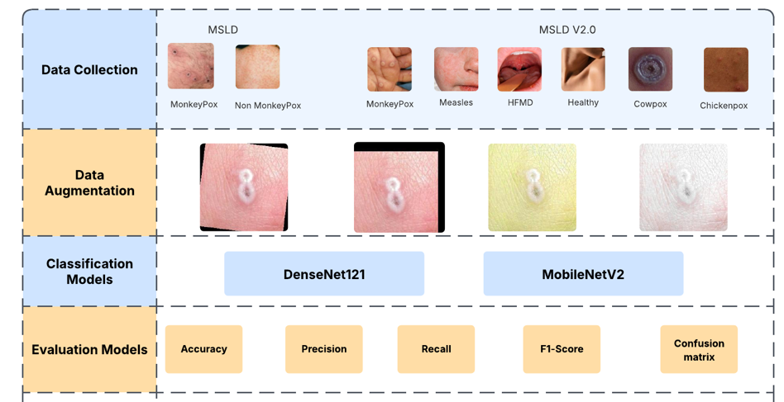
Figure (1): Illustration of the Steps of the Method

4.1 Dataset Description

The Mpox Skin Lesion Dataset v2.0 (MSLD v2.0) (Joydip Paul, 2023) and MSLD (Ali, 2022) are used in our research. 10570 skin lesion images from 541 people make up the MSLD v2.0 dataset. These images include 3976 Mpox, 1050 Chickenpox, 770 Measles, 924 Cowpox, 2254 Hand, Foot, and Mouth Disease, and 1596 Healthy images. The Monkeypox and non-Monkeypox classes are included in the second dataset, the Monkeypox Skin Lesion Dataset (MSLD). There are 2630 images in this dataset, including 1165 photos of skin disorders other than Monkeypox and 1465 photos of Monkeypox lesions. The images were meticulously curated to represent diverse manifestations of Monkeypox across various body regions, infection stages, and skin types. Figure 2 shows sample images from the datasets that highlight the specific visual characteristics of monkeypox lesions compared to non-monkeypox lesions.
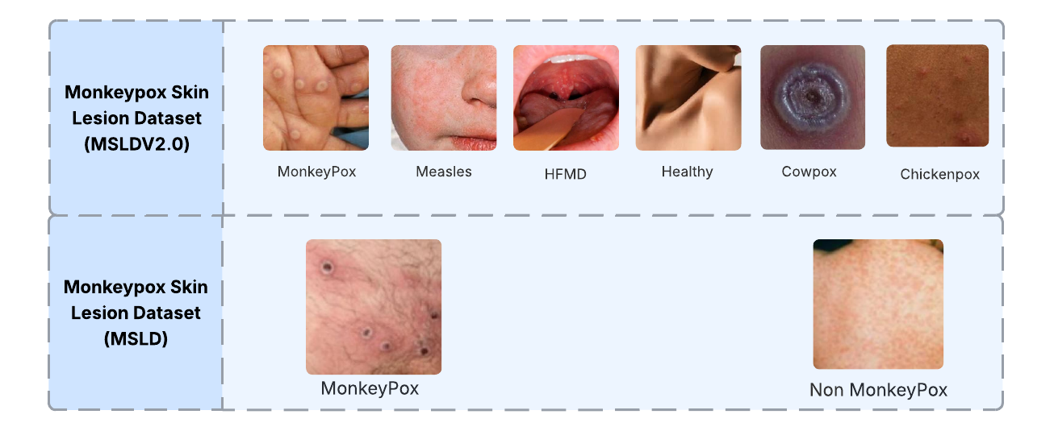
Figure )2(: Sample images from the dataset

4.2 Image Augmentation
A thorough image augmentation technique was used on the training data to improve the model's capacity for generalization and reduce the possibility of overfitting. The model was made more resilient to orientation changes by adding horizontal flipping and mirroring the images along the vertical axis. These augmentation approaches were used on the training dataset to maintain the consistency and integrity of the commonly normalized validation and test sets. (Garcea, 2023). Figure 3 illustrates Sample images from the dataset after augmentation.

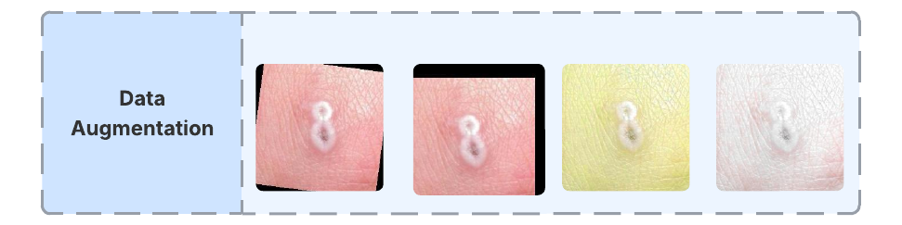
Figure (3): Sample Images from the Dataset after Augmentation

4.3 Proposed Model
The proposed system employs a hybrid deep learning architecture that integrates DenseNet121 and MobileNetV2 for image classification, implemented using TensorFlow and Keras. The model leverages transfer learning by utilizing pre-trained weights from ImageNet, followed by feature fusion and dense layers for final classification. Figure 4 illustrates the hybrid model.

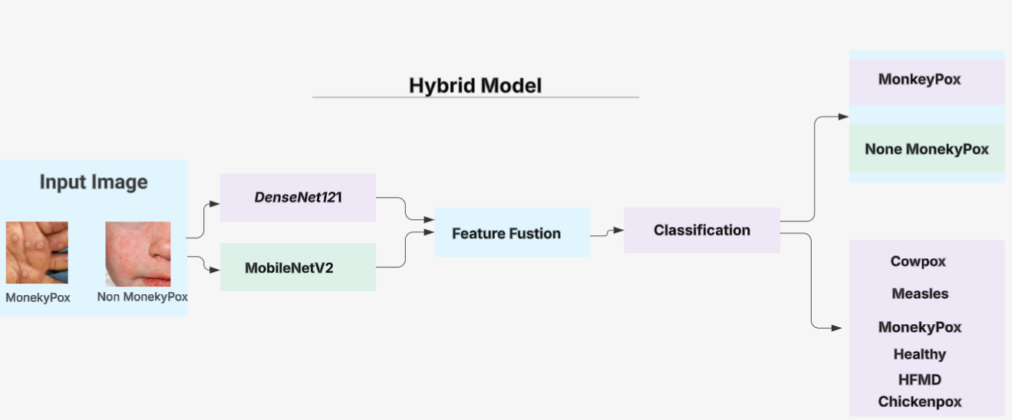
Figure (4): Illustration of the Hybrid Model

4.4 DenseNet121
A densely linked convolutional neural network (CNN) architecture is used by DenseNet 121 to improve feature propagation and significantly reduce parameter redundancy. To facilitate substantial feature reuse and allow the network to learn richer, more complicated representations, each layer within each dense block receives the concatenated outputs of all previous levels. This allows DenseNet 121 to achieve accuracy on par with other top CNN models using fewer parameters. In this study, we use DenseNet 121 in our methodology to take advantage of its strong feature propagation and reuse processes, which will increase model robustness and classification accuracy in identifying Monkeypox lesions. (Arumugam et al., 2024).

4.5 MobileNetV2
MobileNet is one kind of computationally efficient convolutional neural network that lowers inference costs by using depthwise separable convolutions (Howard et al., 2017). Our model used the MobileNetV2 variant (Sandler et al., 2018), which consists of an average pooling layer, thirteen depthwise separable convolution blocks at the end, a standard convolution layer at the beginning, and a standard convolution layer at the end. Complex feature representations can be learned in a lightweight model thanks to the architecture's inverted residual blocks with linear bottlenecks, which also ease information flow. Additionally, MobileNetV2 pairs each depthwise convolution with a 1×1 pointwise convolution to rectify channel dimensionality. MobileNetV2 drastically lowers processing overhead without sacrificing predictive performance using these inverted bottleneck structures for conventional 2D convolutions(Jaradat et al., 2023) (Sehgal & Saini, 2024).

4.6 Feature Concatenation
The suggested fusion network builds two concurrent feature-extraction models to process the same input image. This concatenation enhances the representation and produces a more discriminative feature embedding for further classification by integrating complementary global and local descriptors.
4.7 Classification Layer
The fused feature vector is passed to a compact classification head consisting of Dense(256, ReLU), Dropout, and Dense(NNN, Softmax). The complete model is compiled with the Adam optimizer and trained using the categorical cross-entropy loss, with classification accuracy monitored as the primary metric.

Chapter 5

Experimental Results and Discussion
5.1 Evaluation Metrics
The results for the MSLD and MSLDV2.0 datasets are presented in two dedicated subsections, each reporting the confusion matrix alongside per-class recall, precision, and F1-score. In addition, the overall precision, recall, accuracy, and F1-score for each dataset are summarized in Section V. Here, TP, TN, FP, and FN denote the numbers of true positives, true negatives, false positives, and false negatives, respectively.
Accuracy = (TP + TN) / (TP + TN + FP + FN)
Recall = TP / (TP + FN)
Precision = TP / (TP + FP)
F1-score = 2 * (Precision * Recall) / (Precision + Recall)

5.2 Experimental Setup
The experiments were performed on a high-performance computing workstation powered by an Intel Xeon E5-2680 v4 processor (14 cores at 2.40 GHz) and an NVIDIA Tesla V100 GPU with 16 GB of VRAM, supported by 64 GB of DDR4 main memory and a 1 TB solid-state drive. Details the number of images per class employed during training, validation, and testing. All networks were trained and evaluated exclusively on the augmented dataset, with 70 % of the images allocated for training, 15 % for validation, and 15 % for testing. A summary of the hybrid model's parameter settings for optimal feature selection is presented in Tables 2 & 3.

Table (2): Number of Images in Each Class for MSLD and MSLDV2.0
Dataset | Class label | Training | Testing | Validation | Total
MSDL | MonkeyPox | 818 | 175 | 175 | 1168
MSDL | None MonkeyPox | 1007 | 216 | 216 | 1439
MSDL | Total | 1825 | 391 | 391 | 2607
MSDLV2.0 | MonkeyPox | 2783 | 596 | 596 | 3976
MSDLV2.0 | Chickenpox | 735 | 156 | 156 | 1051
MSDLV2.0 | Measles | 539 | 116 | 116 | 771
MSDLV2.0 | Cowpox | 647 | 139 | 139 | 924
MSDLV2.0 | HFMD | 1578 | 338 | 338 | 2254
MSDLV2.0 | Healthy | 1117 | 239 | 239 | 1596
MSDLV2.0 | Total | 7399 | 1584 | 1584 | 10572

Table (3): Parameters of the Hybrid Model
Parameter | Value
Input shape | (224, 224, 3)
Fusion-dense layer units | 256
 | relu
  Fusion Dense activation
Dropout rate | 0.5
Output activation | SoftMax
Optimizer | Adam
  Learning rate
  1e-4
Epochs | 30
Model Checkpoint | True

5.3 Performance Hybrid Model in MSLD Dataset:
The proposed hybrid model, which integrates DenseNet-121 and MobileNetV2, was applied to the MSLD dataset and demonstrated outstanding performance in classifying Monkeypox and Non-Monkeypox cases. This dual-architecture approach capitalizes on the dense connectivity of DenseNet and the lightweight efficiency of MobileNetV2, enabling the model to extract rich and diverse features with minimal redundancy. The hybrid model achieved precision, recall, and F1-score values of 98.6%, 99.5%, and 99.1%, respectively, for the Monkeypox class and 99.6%, 98.8%, and 99.3% for the Non-Monkeypox class—surpassing all other benchmarked models in every metric. Compared to individual models such as ResNet50, VGG-19, DenseNet-121, and MobileNetV2, which showed notable variations and limitations, particularly in recall and F1-score for the Non-Monkeypox class, the hybrid approach consistently outperformed them across both categories. As shown in Table 4, these results demonstrate the efficacy and resilience of integrating DenseNet121 and MobileNetV2, underscoring the importance of architectural fusion in attaining higher classification accuracy in medical image analysis tasks.

Table (4): Performance of the Hybrid Model in Each Class for the MSLD Dataset
Approach | Model | Class Name | Precision | Recall | F1-score
Pre-trained CNN | ResNet50 | Monkeypox | 40.33 | 80.43 | 54.47
Pre-trained CNN | ResNet50 | Non-Monkeypox | 61.81 | 46.22 | 52.11
Pre-trained CNN | MobileNetV2 | Monkeypox | 92.17 | 86.30 | 89.42
Pre-trained CNN | MobileNetV2 | Non-Monkeypox | 76.07 | 68.05 | 72.03
Pre-trained CNN | DenseNet-121 | Monkeypox | 82.08 | 91.46 | 86.16
Pre-trained CNN | DenseNet-121 | Non-Monkeypox | 93.22 | 68.00 | 79.42
Pre-trained CNN | VGG-19 | Monkeypox | 61.07 | 91.00 | 73.29
Pre-trained CNN | VGG-19 | Non-Monkeypox | 53.89 | 21.00 | 35.03
Pre-trained CNN | VGG-19 | Non-Monkeypox | 88.00 | 86.02 | 86.07
The Proposed Hybrid Model | DenseNet-121, MobileNetV2 | Monkeypox | 98.60 | 99.52 | 99.10
The Proposed Hybrid Model | DenseNet-121, MobileNetV2 | Non-Monkeypox | 99.64 | 98.83 | 99.35

Figure 5 displays six confusion matrices that illustrate the performance of different models when asked to classify data into two groups: Monkeypox and others. In each confusion matrix, the color intensity indicates the number of samples classified into each class; darker colors indicate bigger counts.

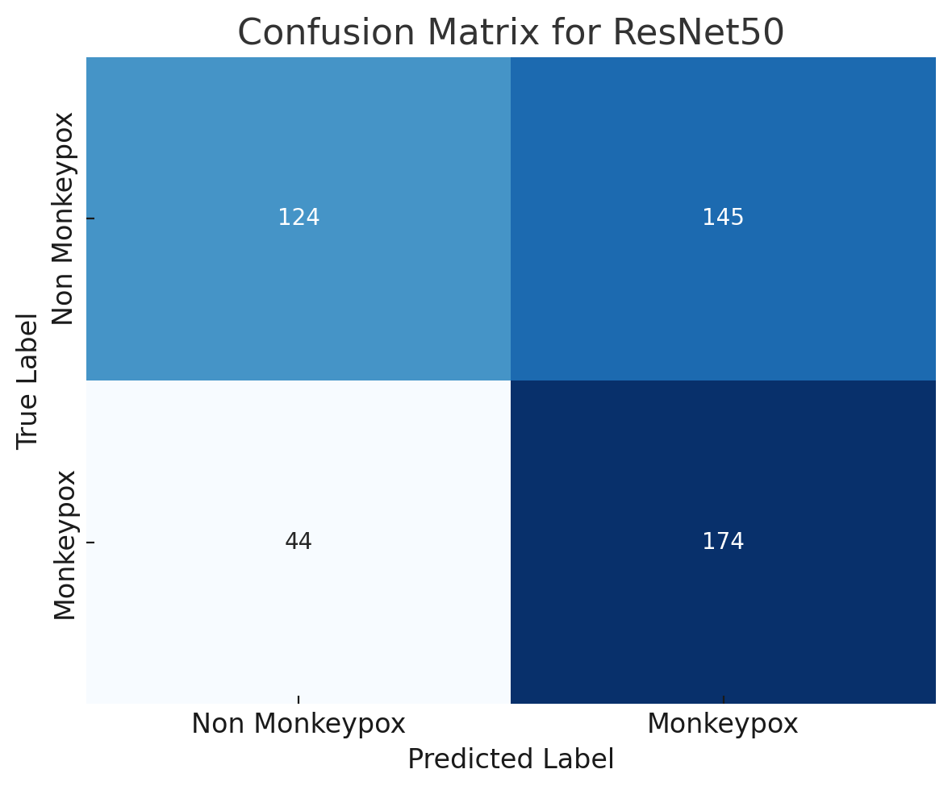 | 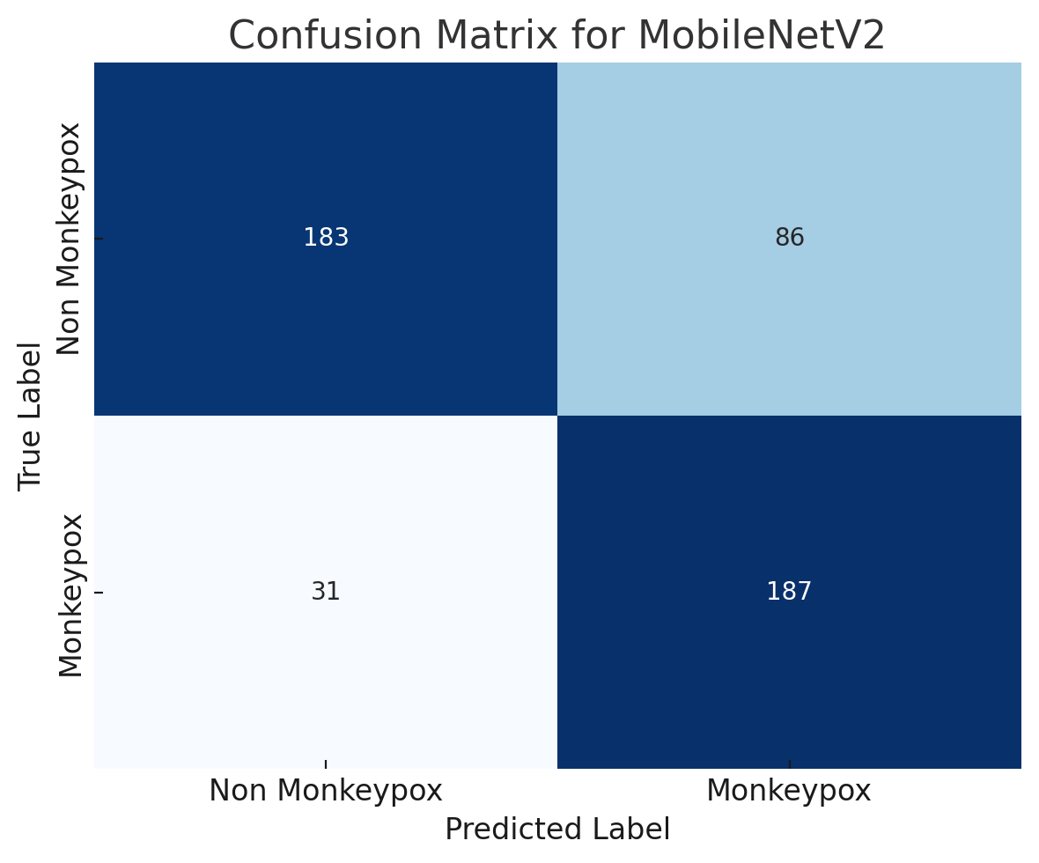

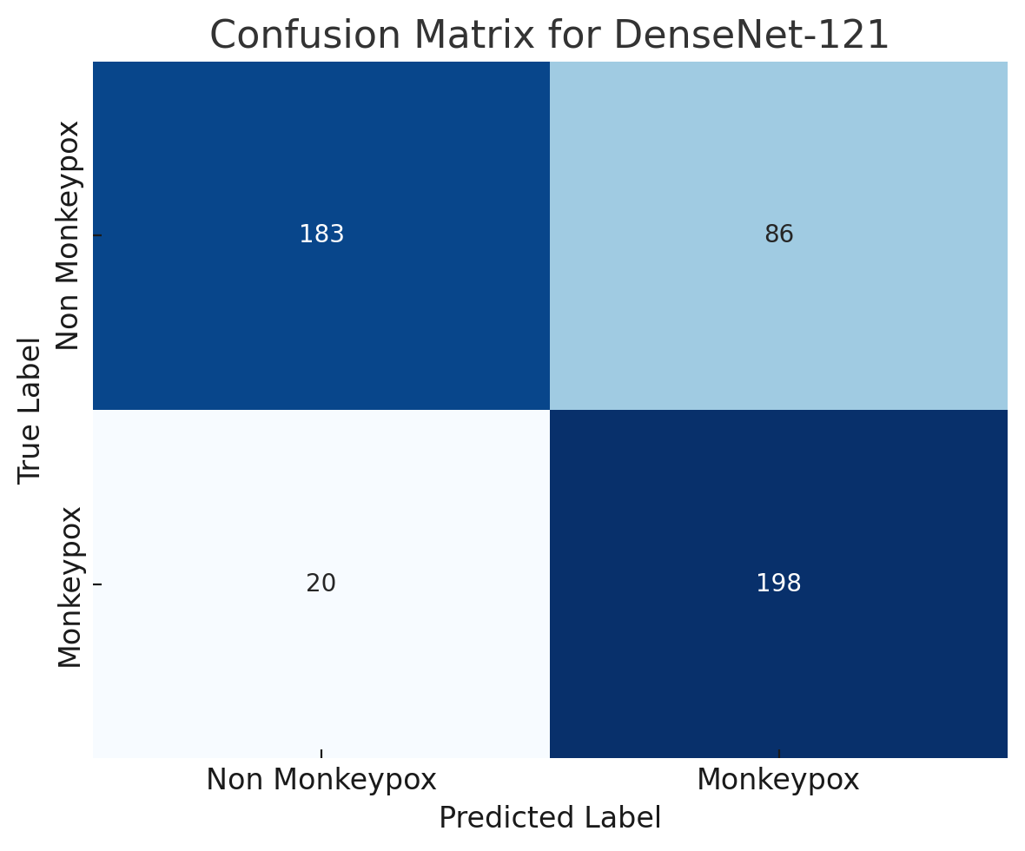 | 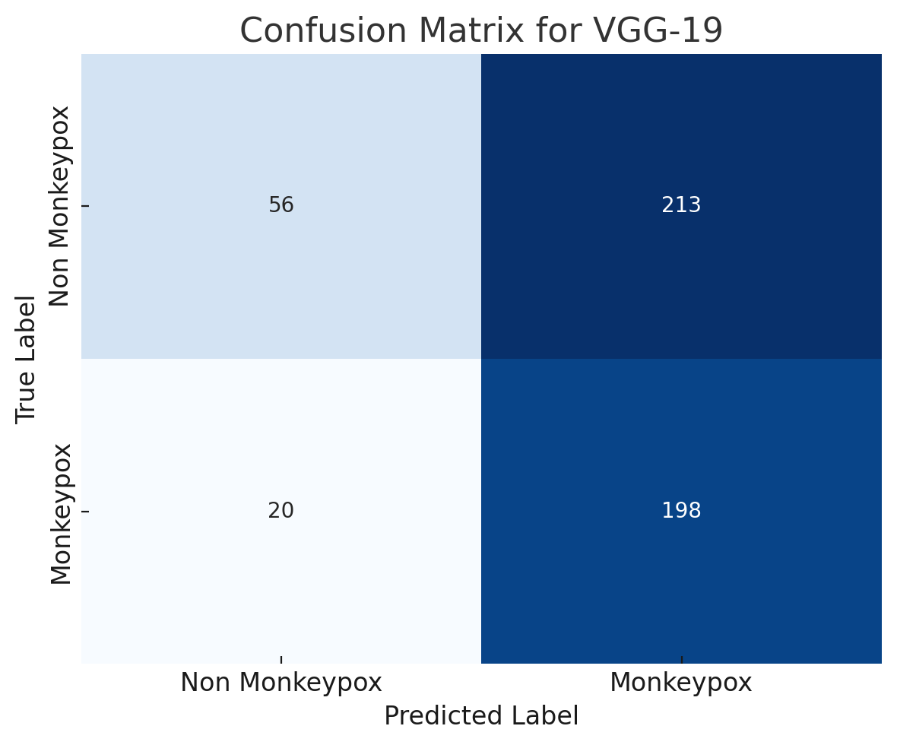

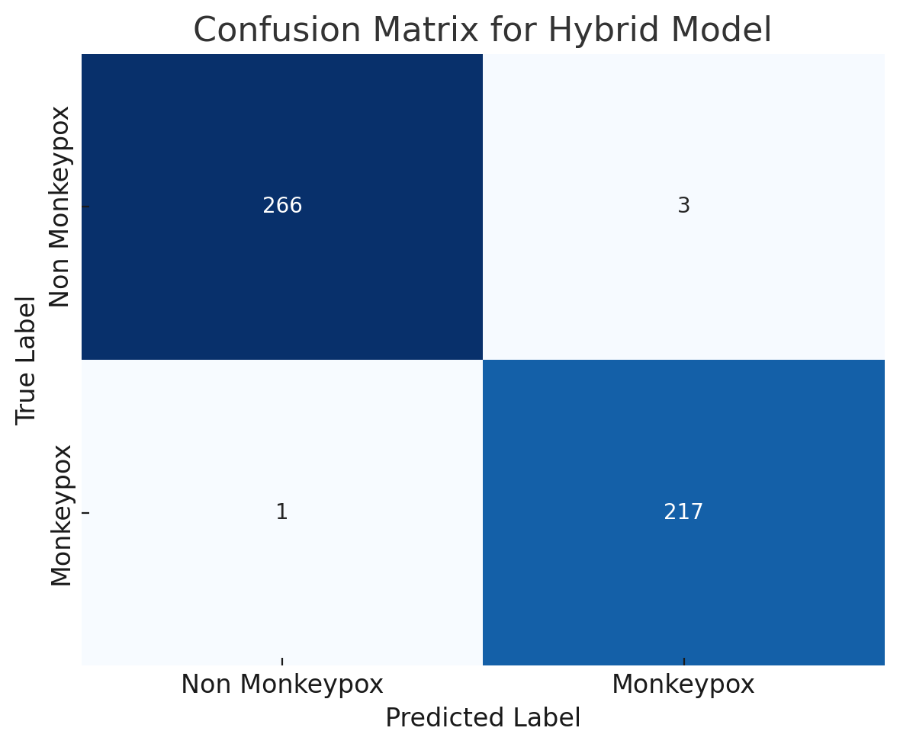
Figure (5): Confusion Matrices of Models for the MSLD Dataset

5.4 Performance Hybrid Model in MSLDV2.0 Dataset:
The proposed hybrid model, which combines DenseNet-121 and MobileNetV2, showed excellent classification performance across several illness classes, according to the study done using the MSLDV2.0 dataset. For the Monkeypox class in particular, this model outperformed all other pre-trained convolutional neural networks (CNNs) and transformer-based models with exceptional precision, recall, and F1-scores (99%, 98%, and 99%, respectively). As presented in Table 5, traditional CNN models such as ResNet50, MobileNetV2, and VGG-19 exhibited significantly lower performance, with ResNet50 yielding only a 48% F1-score for Monkeypox. While DenseNet-121 performed better (91% and 93% F1-score for Monkeypox, respectively), the results were still inferior to those of the hybrid approach. Moreover, the hybrid model also recorded high performance for other critical classes, such as Chickenpox (F1-score: 97%) and Measles (F1-score: 95%), indicating its robust generalization ability. These findings highlight the advantage of combining DenseNet's feature reuse with MobileNet's lightweight structure, resulting in a more expressive and efficient architecture for fine-grained classification tasks. The hybrid model's superior metrics highlight how important architectural fusion is to improving model accuracy and dependability for multi-class illness diagnosis in medical imaging.

Table (5): Performance of the Hybrid Model in Each Class for the MSLDV2.0 Dataset
Approach | Model | Class Name | Precision | Recall | F1-score
Pre-trained CNN | ResNet50 | Monkeypox | 65.01 | 51.46 | 48.39
Pre-trained CNN | ResNet50 | Chickenpox | 61.08 | 73.07 | 79.02
Pre-trained CNN | ResNet50 | Measles | 70.01 | 81.19 | 86.01
Pre-trained CNN | ResNet50 | Cowpox | 72.40 | 77.45 | 79.01
Pre-trained CNN | ResNet50 | HFMD | 70.01 | 69.10 | 71.01
Pre-trained CNN | ResNet50 | Healthy | 80.28 | 81.40 | 79.01
Pre-trained CNN | MobileNetV2 | Monkeypox | 81.16 | 83.25 | 85.01
Pre-trained CNN | MobileNetV2 | Chickenpox | 70.50 | 74.28 | 78.15
Pre-trained CNN | MobileNetV2 | Measles | 78.41 | 74.16 | 77.47
Pre-trained CNN | MobileNetV2 | Cowpox | 89.01 | 88.01 | 87.01
Pre-trained CNN | MobileNetV2 | HFMD | 69.14 | 75.42 | 71.24
Pre-trained CNN | MobileNetV2 | Healthy | 77.01 | 75.01 | 71.01
Pre-trained CNN | DenseNet-121 | Monkeypox | 88.22 | 90.12 | 91.36
Pre-trained CNN | DenseNet-121 | Chickenpox | 96.01 | 97.34 | 95.36
Pre-trained CNN | DenseNet-121 | Measles | 91.01 | 89.01 | 94.01
Pre-trained CNN | DenseNet-121 | Cowpox | 91.01 | 88.01 | 86.01
Pre-trained CNN | DenseNet-121 | HFMD | 74.04 | 70.06 | 73.28
Pre-trained CNN | DenseNet-121 | Healthy | 90.16 | 88.01 | 85.01
Pre-trained CNN | VGG-19 | Monkeypox | 62.01 | 60.19 | 66.39
Pre-trained CNN | VGG-19 | Chickenpox | 76.14 | 72.01 | 77.29
Pre-trained CNN | VGG-19 | Measles | 69.39 | 65.01 | 65.32
Pre-trained CNN | VGG-19 | Cowpox | 81.41 | 77.37 | 72.01
Pre-trained CNN | VGG-19 | HFMD | 61.01 | 60.01 | 60.24
Pre-trained CNN | VGG-19 | Healthy | 66.33 | 62.30 | 64.05
The Proposed Hybrid Model | DenseNet-121 and MobileNetV2 | Monkeypox | 99.41 | 98.43 | 99.42
The Proposed Hybrid Model | DenseNet-121 and MobileNetV2 | Chickenpox | 99.05 | 95.04 | 97.36
The Proposed Hybrid Model | DenseNet-121 and MobileNetV2 | Measles | 91.03 | 99.07 | 95.08
The Proposed Hybrid Model | DenseNet-121 and MobileNetV2 | Cowpox | 100 | 98.22 | 99.33
The Proposed Hybrid Model | DenseNet-121 and MobileNetV2 | HFMD | 99.01 | 100 | 99.35
The Proposed Hybrid Model | DenseNet-121 and MobileNetV2 | Healthy | 99.11 | 100 | 99.01

Figure 6 displays six confusion matrices that illustrate the performance of different models when asked to classify data into two groups: Monkeypox and others. In each confusion matrix, the color intensity indicates the number of samples classified into each class; darker colors indicate bigger counts.

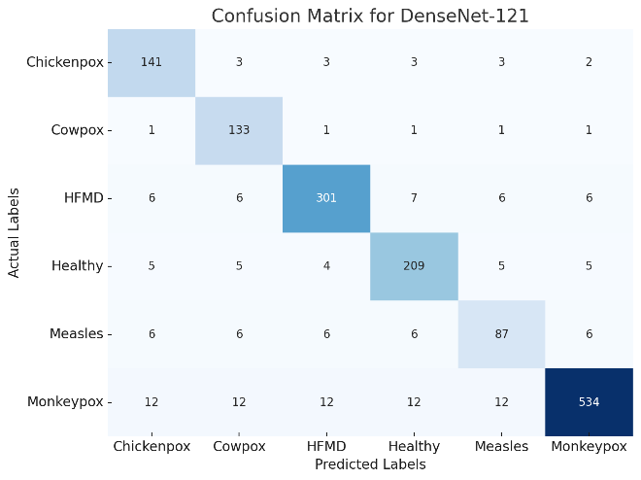 | 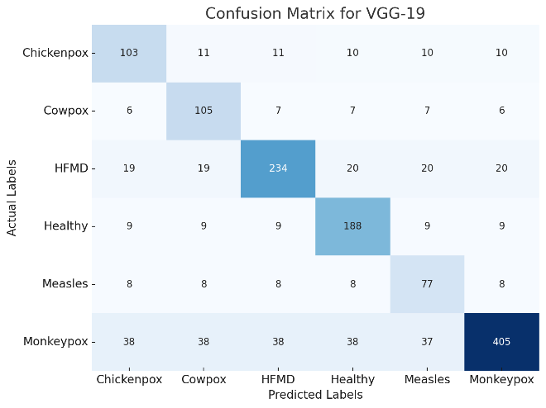

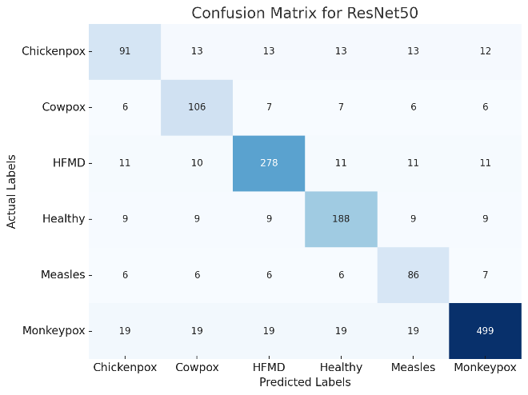 | 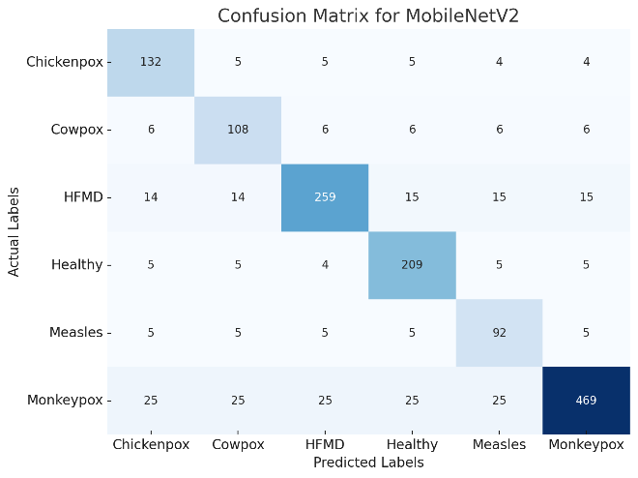

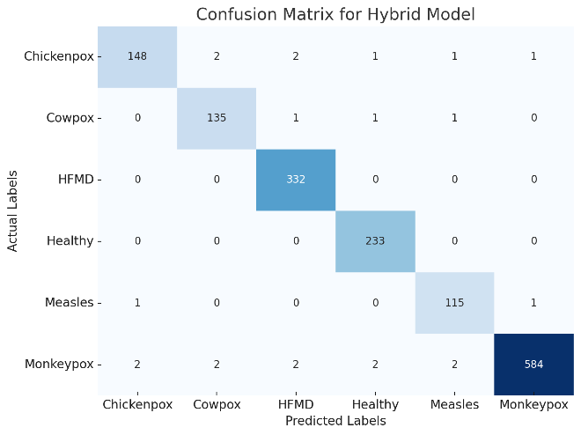

Figure (6): Confusion Matrices of Models for the MSLDV2.0 Dataset

The proposed hybrid model, which blends DenseNet-121 and MobileNetV2, performs significantly better than earlier studies on the MSLD and MSLDV2.0 datasets. The hybrid model outperformed all other models described in similar publications, achieving an overall accuracy of 99.18% on the MSLD dataset and 98% on the MSLDV2.0 dataset, as indicated in Table 6. On the MSLD dataset, existing methods such as MpoxSLDNet (Dihan et al., 2024), Inception V3 (Pal et al., 2023a), and MobileNetV2 (Sahin et al., 2022) Reported accuracy values ranging from 91.11% to 94.99%. Moreover, none surpassed the proposed model's 99.18%, indicating the effectiveness of integrating DenseNet's dense feature propagation with MobileNetV2's lightweight efficiency.
Additionally, the results of the MSLDV2.0 dataset support the hybrid model's resilience. Competing approaches, such as an ensemble of 7CNNs (Islam et al., 2022) and (Huan & Dun, 2024), produced significantly lower accuracies of 83% and 87.03%, respectively. Advanced transformer-based techniques, including ViT, MAE, DINO, and SwinTransformer (Vuran et al., 2025), reached only 93.71%. The closest performance came from a Modified VGG16 with LIME (Ahsan et al., 2022), achieving 97%, still falling short of the hybrid model's 98%.
Particularly for complicated, fine-grained classification tasks in medical imaging, the proposed model's outstanding accuracy margins across two dataset versions demonstrate its powerful feature extraction and outstanding generalization capabilities. The model utilizes deep hierarchical representations and computational performance thanks to integrating two complementary architectures. In addition to confirming the efficacy of architectural fusion, these results offer a viable path forward for future deep learning-based disease detection and diagnosis solutions.

Table (6): Comparison with Existing Work and the Proposed Models Based on Models and Performance for the MSLD and MSLDV2.0 Datasets
Ref. | Methods | Accuracy | Dataset
(Dihan et al., 2024) | MpoxSLDNet | 94.56% | MSLD
(Pal et al., 2023a) | Inception V3 | 94.99% | MSLD
(Almutairi, 2022) | DL-MDF-OH2 | 94.99% | MSLD
(Sahin et al., 2022) | MobileNetV2 (TFLite) | 91.11% | MSLD
Proposed Model | Hybrid Model Densenet121 and MobilenetV2 | 99.18% | MSLD
(Islam et al., 2022) | Ensemble of 7 CNNs | 83% | MSLDV2.0
(Ahsan et al., 2022) | Modified VGG16 + LIME | 97% | MSLDV2.0
(Huan & Dun, 2024) | ConvNeXt | 87.03 % | MSLDV2.0
(Vuran et al., 2025) | ViT, MAE, DINO, and SwinTransformer | 93.71% | MSLDV2.0
Proposed Model | Hybrid Model Densenet121 and MobilenetV2 | 98% | MSLDV2.0

Chapter 6 Conclusion and Future Work

7.1 Important Features
The proposed hybrid deep learning model incorporates several key features that contribute to its superior performance in detecting Monkeypox and related skin diseases. First, the integration of DenseNet121 and MobileNetV2 enables a balance between feature richness and computational efficiency. DenseNet121 provides deep, hierarchical feature propagation, capturing complex lesion patterns, while MobileNetV2 contributes a lightweight, fast-processing structure ideal for real-time deployment.
Second, the use of transfer learning from pre-trained ImageNet weights enhances model generalizability, particularly when trained on relatively small medical datasets like MSLD and MSLDV2.0. Third, the feature fusion mechanism allows the model to combine global and local descriptors, increasing its sensitivity to subtle inter-class differences such as between Monkeypox and Chickenpox.
Additionally, the model demonstrates robust classification performance across multiple classes, achieving F1-scores above 99% for both Monkeypox and non-Monkeypox classes, which highlights its clinical reliability. These features collectively ensure that the model is not only accurate and reliable but also scalable and feasible for deployment in both hospital settings and remote or resource-constrained
the hybrid model's scalability, resilience, and diagnostic capacity, which makes it a promising option for practical use in telemedicine and automated illness screening systems.
Given the model's high performance and generalizability, it is recommended that future research focus on deploying this hybrid architecture in clinical environments through user-friendly mobile or web-based platforms. Furthermore, using explainability methods like Grad-CAM or SHAP would improve the interpretability of the model and help doctors validate diagnoses made using AI. The model's dependability and preparedness for widespread implementation in public health systems would be further enhanced by testing it across various demographic groups and growing the dataset with various real-world samples.

7.3 Future Work
While the hybrid model achieved remarkable accuracy and robustness, several future enhancements are proposed to extend its applicability and improve its clinical integration. One key direction is the development of a mobile or web-based diagnostic platform powered by the trained model, enabling real-time skin lesion analysis in telemedicine scenarios. This would facilitate wide-scale adoption in remote or under-resourced areas lacking access to expert dermatologists or laboratory equipment.
Another promising area is the incorporation of explainability methods, such as Grad-CAM and SHAP, to visualize decision-making processes and build trust among clinicians. These tools would allow users to understand which parts of the lesion image influenced the model’s classification outcome.
Furthermore, expanding the dataset with more diverse real-world samples—including different skin tones, lighting conditions, and lesion stages—would enhance the model’s generalization capability. Testing across demographically varied populations and in live clinical environments is also crucial to assess the model’s robustness under practical conditions.
Lastly, integrating additional clinical metadata (e.g., patient history, symptoms) with image inputs could further improve diagnostic performance, paving the way for a multi-modal AI diagnostic system tailored to infectious skin diseases.

References
[Ahsan, Md Mostafa Monowar, et al., 2022]
Ahsan, Md Mostafa Monowar, Md Rashedul Islam Uddin, Mst Farjana, A. N. Sakib, Khaled Al Momin, and Sohana Afroz Luna. “Image Data Collection and Implementation of a Deep Learning-Based Model in Detecting Monkeypox Disease Using Modified VGG16”. arXiv preprint arXiv:2206.01862. 2022.
[AKIN, Kadir Doğan, et al., 2022]
AKIN, Kadir Doğan, Ceylan GÜRKAN, A. BUDAK, and Hüseyin KARATAŞ. “Classification of Monkeypox Skin Lesion Using the Explainable Artificial Intelligence Assisted Convolutional Neural Networks”. European Journal of Science and Technology. 2022. https://doi.org/10.31590/ejosat.1171816
[Ali, Syed Nafin, et al., 2022]
Ali, Syed Nafin, et al. “Monkeypox Skin Lesion Dataset - Kaggle”. Kaggle Dataset. April 2022. https://www.kaggle.com/datasets/nafin59/monkeypox-skin-lesion-dataset
[Almutairi, Sulaiman A., 2022]
Almutairi, Sulaiman A. “DL-MDF-OH2: Optimized Deep Learning-Based Monkeypox Diagnostic Framework Using the Metaheuristic Harris Hawks Optimizer Algorithm”. Electronics (Switzerland), 11(24). 2022. https://doi.org/10.3390/electronics11244077
[Arumugam, M., et al., 2024]
Arumugam, M., G. Arun, and S. S. Tharun Vikas. “Detection of Monkeypox Disease Using Deep Learning Techniques”. OTCON 2024 – OPJU International Technology Conference on Smart Computing for Innovation and Advancement in Industry 4.0. 2024. https://doi.org/10.1109/OTCON60325.2024.10688010
[Dihan, Farzana Jahan, et al., 2024]
Dihan, Farzana Jahan, Sheikh Asif Murad, Md. Al Muzahid, Kazi Md. Arif Uddin, Mohammad Jafar F. Alenazi, A. K. M. Bairagi, and Sajal Biswas. “MpoxSLDNet: A Novel CNN Model for Detecting Monkeypox Lesions and Performance Comparison with Pre-trained Models”. arXiv preprint arXiv:2405.21016. 2024.
[Fleck, Fiona, 2022]
Fleck, Fiona. “Where Has Monkeypox Spread To?”. Statista. April 4, 2022. https://www.statista.com/chart/27537/countries-with-monkeypox-cases
[Garcea, Francesco, et al., 2023]
Garcea, Francesco, et al. “Data Augmentation for Medical Imaging: A Systematic Literature Review”. Computers in Biology and Medicine, 152, 106391. 2023.
[Howard, Andrew G., et al., 2017]
Howard, Andrew G., Menglong Zhu, Bo Chen, Dmitry Kalenichenko, Weijun Wang, Tobias Weyand, Marco Andreetto, and Hartwig Adam. “MobileNets: Efficient Convolutional Neural Networks for Mobile Vision Applications”. arXiv preprint arXiv:1704.04861. 2017.
[Huan, Enliang, and Han Dun, 2024]
Huan, Enliang, and Han Dun. “MSMP-Net: A Multi-Scale Neural Network for End-to-End Monkeypox Virus Skin Lesion Classification”. Applied Sciences (Switzerland), 14(20). 2024. https://doi.org/10.3390/app14209390
[Islam, Tanvirul, et al., 2022]
Islam, Tanvirul, Md. Abdullah Hussain, F. U. H. Chowdhury, and B. M. R. Islam. “Can Artificial Intelligence Detect Monkeypox from Digital Skin Images?”. bioRxiv. 2022. https://doi.org/10.1101/2022.08.08.503193
[Jaradat, Ahmad Sameer, et al., 2023]
Jaradat, Ahmad Sameer, Rasha E. Al Mamlook, Noura Almakayeel, Nawaf Alharbe, Abdulaziz S. Almuflih, Ahmad Nasayreh, Hazem Gharaibeh, Mohammad Gharaibeh, Ahmad Gharaibeh, and Hamzeh Bzizi. “Automated Monkeypox Skin Lesion Detection Using Deep Learning and Transfer Learning Techniques”. International Journal of Environmental Research and Public Health, 20(5). 2023. https://doi.org/10.3390/ijerph20054422
[Joydip Paul, 2023]
Joydip Paul. “Mpox Skin Lesion Dataset Version 2.0 (MSLD v2.0)”. Kaggle. April 2023. https://www.kaggle.com/datasets/joydippaul/mpox-skin-lesion-dataset-version-20-msld-v20
[Kumar, B. N., et al., 2023]
Kumar, B. N., T. R. Mahesh, G. Geetha, and S. Guluwadi. “Redefining Retinal Lesion Segmentation: A Quantum Leap with DL-UNet Enhanced Auto Encoder-Decoder for Fundus Image Analysis”. IEEE Access, 11, 70853–70864. 2023. https://doi.org/10.1109/ACCESS.2023.3294443
[Pal, Shubham, et al., 2023a]
Pal, Shubham, A. K. Mishra, and Kriti. “Artificial Intelligence-Based Framework for Predicting Monkeypox Disease”. 2023 International Conference on Computer Science and Emerging Technologies (CSET). 2023. https://doi.org/10.1109/CSET58993.2023.10346841
[Pal, Shubham, et al., 2023b]
Pal, Shubham, A. K. Mishra, and Kriti. “Artificial Intelligence-Based Framework for Predicting Monkeypox Disease”. 2023 International Conference on Computer Science and Emerging Technologies (CSET). 2023. https://doi.org/10.1109/CSET58993.2023.10346841
[Sahin, Veysel H., et al., 2022]
Sahin, Veysel H., I. Oztel, and G. Yolcu Oztel. “Human Monkeypox Classification from Skin Lesion Images with Deep Pre-trained Network Using Mobile Application”. Journal of Medical Systems, 46(11). 2022. https://doi.org/10.1007/s10916-022-01863-7
[Sandler, Mark, et al., 2018]
Sandler, Mark, Andrew Howard, Menglong Zhu, Andrey Zhmoginov, and Liang-Chieh Chen. “MobileNetV2: Inverted Residuals and Linear Bottlenecks”. arXiv preprint arXiv:1801.04381. 2018.
[Sehgal, Deepak, and Inderpreet Saini, 2024]
Sehgal, Deepak, and Inderpreet Saini. “GAN-Based Image Augmentation and Comparative Analysis of Various CNN Models for Monkeypox Detection”. Proceedings of the 1st International Conference on Electronics, Communication and Signal Processing (ICECSP). 2024. https://doi.org/10.1109/ICECSP61809.2024.10697992
[Shashikala, S. V., et al., 2024a]
Shashikala, S. V., K. T. Anil Kumar, and K. N. Chaithra. “Deep Learning Solutions for Enhanced Detection of Skin Lesions”. 2nd IEEE International Conference on Networks, Multimedia and Information Technology (NMITCON). 2024. https://doi.org/10.1109/NMITCON62075.2024.10699030
[Shashikala, S. V., et al., 2024b]
Shashikala, S. V., K. T. Anil Kumar, and K. N. Chaithra. “Deep Learning Solutions for Enhanced Detection of Skin Lesions”. 2nd IEEE International Conference on Networks, Multimedia and Information Technology (NMITCON). 2024. https://doi.org/10.1109/NMITCON62075.2024.10699030

