CHAPTER 4 Experimental Results and Discussion
4.1 Introduction
The purpose of this chapter is to present the experimental results that have been obtained as a result of implementing the proposed framework for the purpose of predicting the movements of the stock market in the Saudi Stock Exchange (Tadawul). While Chapter Three presented the engineering of the proposed framework and models, Chapter Four evaluates the effectiveness of such models.
Unlike conventional weighted probability averaging, the proposed stacking ensemble automatically learns the optimal fusion strategy from validation data. This enables the framework to adapt the contribution of each base learner according to the statistical relationships observed between their calibrated probability estimates, rather than relying on manually predefined weighting coefficients.
The evaluation of the effectiveness of the proposed framework and models will occur from two main perspectives. For one, the predictive capabilities of each of the individual learning models that comprise the framework will be evaluated through the use of common machine learning performance metrics. In addition to these evaluations, the usefulness of the predictions that are made by the framework will be evaluated through the establishment of a virtual portfolio for the framework to manage.
Where many financial market prediction models rely upon the use of classification metrics to determine the effectiveness of a model, the use of both classification and investment-based metrics will allow for the framework to be evaluated not just in regard to its accuracy, but also in regard to the potential profits that could be made with its recommendations for the stock market.
The experiments and simulations that will be performed within this chapter will follow the same structure as that which was established in Chapter Three. The evaluation of the effectiveness of the framework will begin with validation of the dataset, followed by evaluation of each of the individual models (BiLSTM and XGBoost), followed by evaluation of the proposed framework, and finally a comparison of each of the models and frameworks evaluated.

4.2 Experimental Environment
The experiments that were performed to evaluate the effectiveness of the proposed framework were performed in the following environment. The framework was constructed with Python and was deployed within the Google Colab environment for execution. The various open-source machine learning and data processing packages were deployed within the framework to perform its various functions.
The experiments used the chronological data partitioning that was described in Chapter Three for the splitting of the dataset into training and testing portions. The experimental environment consisted of the following stages:
Data validation
Chronological financial integration
Feature engineering
Binary target generation
BiLSTM training
XGBoost training
Hybrid model construction
Portfolio construction and simulation
Performance evaluation
Each of these steps was performed in each of the experiments that were performed to evaluate the framework, allowing for each of the models to be evaluated under the same environment.

Table 4.1 Experimental Environment

Component | Specification
Programming Language | Python
Development Platform | Google Colab
Deep Learning Library | TensorFlow / Keras
Machine Learning Library | XGBoost
Data Processing | Pandas / NumPy
Visualization | Matplotlib
Explainability | SHAP

4.3 Dataset Validation Results
Prior to evaluating the effectiveness of the artificial intelligence models that have been developed and implemented within the framework, it is first necessary to validate the dataset upon which the models are based. While many financial market prediction models utilize the classification metrics to evaluate the success of the models without first validating the created dataset, the validation of the final dataset was performed after the preprocessing, chronological integration, feature engineering, and target generation steps were completed.
The validation of the dataset will occur in relation to four main aspects of the created dataset:
· Completeness of the created dataset
· Chronological consistency of the data
· Validity of the created target
· Availability of the created features
Each of these aspects will be discussed in the following sections of this chapter.
4.3.1 Final Dataset Characteristics
The final dataset that was created was constructed using data from 35 different companies that are listed within the Saudi Stock Exchange. These 35 companies represent a variety of different sectors within the country’s stock exchange.
The final created dataset contained the stock market data for each of these companies, as well as various financial variables and features that were engineered for use within the learning models. The statistics for this final dataset are presented within Table 4.2.
Characteristic | Value
Listed Companies | 35
Market | Saudi Stock Exchange (Tadawul)
Final Dataset Size | 11,598 observations
Prediction Target | Binary (0 / 1)
Prediction Horizon | 7 Trading Days
Learning Framework | Hybrid AI

The resulting dataset provides sufficient observations for both model development and independent experimental evaluation while preserving chronological ordering throughout the complete learning pipeline.
4.3.2 Chronological Validation Results
Financial machine learning models are especially vulnerable to temporal inconsistencies due to the different times at which daily market observations and financial statements are made available.
To eliminate this source of potential bias, a chronological validation procedure was performed prior to the development of the machine learning models.
The results of this validation indicated that:
- Financial statements were only merged with market observations after their public availability.
- No future financial statements were associated with historical market observations.
- Company identifiers were maintained throughout the merge operation.
- Duplicate temporal identifiers were eliminated.
Most importantly, no Look-Ahead Bias was detected in the final validation, indicating that the prediction models were developed using only information that was available on the date of prediction of the market observations used for training of the models.
This chronological validation therefore provides evidence of the chronological validity of the proposed framework for experimentation.
4.3.3 Binary Target Verification
Following the completion of the chronological integration process, the binary target values for the target variable were generated using the seven trading-day prediction horizon that was established in Chapter Three.
The verification process ensured that all of the labels generated during the model creation process satisfied the defined criteria for the generation of these targets and that there were no instances of invalid target values within the created dataset.
Table 4.3 Final Binary Target Distribution
Target | Samples
Positive (Target = 1) | 6,505
Negative (Target = 0) | 5,093
Total | 11,598

The obtained distribution of the target variable indicates that the created labels resulted in a balanced supervised machine learning problem. Such a balance between the two classes of the target variable allows for more accurate training of the models and a fair comparison among the various models considered for predicting the target variable.
4.3.4 Feature Validation Results
Following the creation of the target variable, all features that were created were further validated. Each of the created features was validated to ensure that they met the predefined criteria for completeness of the feature engineering process. Only those features that passed the validation process were provided to the machine learning algorithms for training. This final validation of the features creates further confidence in the reliability of the evaluation of the models in the following sections of the paper.
4.3.5 Discussion
The validation of the dataset confirms that the processes applied to the dataset created a reliable dataset for machine learning algorithms. Furthermore, the confirmation of the absence of Look-Ahead Bias, the balanced distribution of the target variable, and the validation of the features indicate that the results from the models in the following sections of the paper are a result of the models themselves, rather than any flaws in data preprocessing.
Key Findings – Dataset Validation
The final dataset created contained 11,598 observations collected from 35 Saudi-listed companies. Furthermore, each observation was chronologically validated to ensure that there was no Look-Ahead Bias present in the data. Finally, the target variable was validated to contain 6,505 positive observations and 5,093 negative observations, indicating that the labeling of the target variable was balanced. Additionally, each of the features of the dataset passed the same predefined validation procedures before training of the machine learning models.
4.4 Performance Evaluation of the BiLSTM Model
The first of the experiments that will be performed with the model is the evaluation of the model’s predictive performance. The objective of this experiment is to determine whether deep learning models are able to discover short-term trading opportunities in the stock market based upon its historical behaviour with the market.
Unlike other neural networks that may be used to recognize trading opportunities, the BiLSTM model takes advantage of the temporal aspects of the market by evaluating each trading session in relation to the others that have occurred in the past. Thus, this experiment will determine whether the technical indicator data alone is sufficient to provide short-term trading predictions for the stocks in question.
The model will be evaluated using the independent testing dataset that was used to train and validate the model.
4.4.1 Classification Performance
he classification performance of the model will be evaluated using four different metrics: Accuracy, Precision, Recall, and the F1-score.
These four metrics will provide a well-rounded evaluation of the performance of the BiLSTM model.
Table 4.4 Performance of the BiLSTM Model
Metric | Value
Accuracy | 0.5025
Precision | 0.7076
Recall | 0.4957
F1-Score | 0.5830
The results of the evaluation of the BiLSTM model indicate that the model that used only technical indicators for training and prediction exhibited a moderate level of predictive performance. The performance of the model was best in the metric of Precision, which measured the proportion of correctly-predicted positive outcomes (trading opportunities) to the total predictions of trading opportunities (both positive and negative). The Recall metric, which measures the proportion of positive outcomes that were correctly-predicted relative to the total number of positive outcomes in the dataset, had a lower value for the BiLSTM model. As a result, the F1-score for the BiLSTM model was moderate overall.
4.4.2 Interpretation of the Results
The BiLSTM model indicated that the technical indicators contained information that could be used to accurately predict the movements of the stock market. Although the model exhibited high precision in its predictions, the recall rate for the model indicates that it was conservative in the number of trading opportunities it suggested for customers. The model avoided recommending trading opportunities for which it would be likely to fail in order to increase the overall reliability of its recommendations, but potentially overlooked some trading opportunities that could have been profitable for the customers of the model.

4.4.3 Discussion
A few observations can be made regarding the results of the experiment involving the BiLSTM model.
It is clear from the results that, although the model learned well from the training data that was provided to it, its performance declined on the testing data. Such a result is to be expected of any model that is attempting to be used to forecast the stock market, as the markets are inherently non-stationary processes. The testing data, collected after the training data, included periods of increased volatility within the stock market, which was caused by fluctuations in the oil prices among other factors that impacted the Saudi market. Thus, the performance drop by the BiLSTM model during the test periods is indicative of the model’s inability to adapt to changes in the market that occurred during these periods.
These observations, therefore, lead to the introduction of the second model that will be evaluated in the following section of this report.
Figure 4.2 Confusion Matrix of the BiLSTM Model
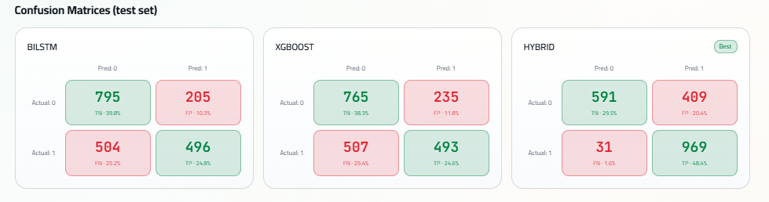

Figure 4.3 ROC Curve of the BiLSTM Model
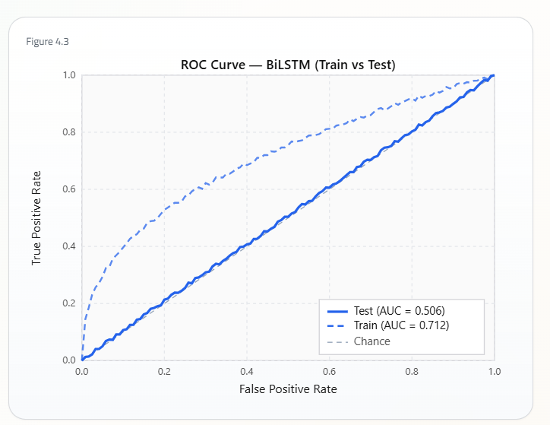

Figure 4.4 Training History of the BiLSTM Model

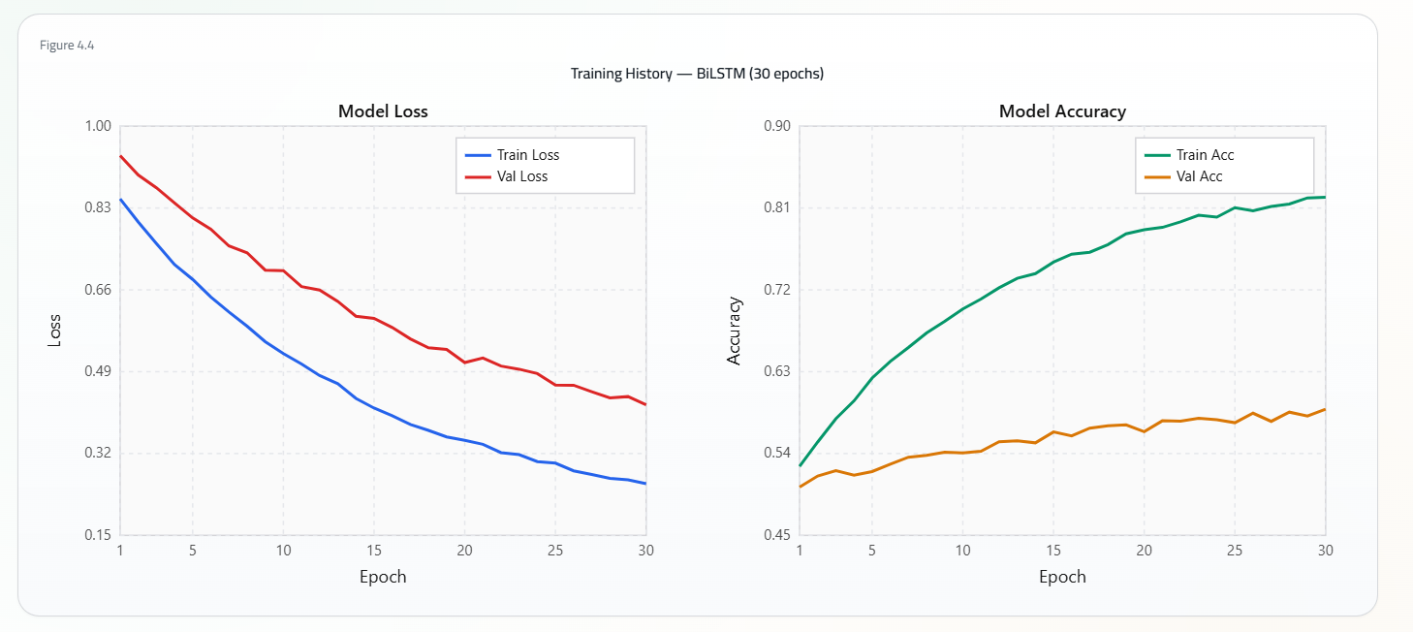

Key Findings – BiLSTM
The BiLSTM model successfully captured temporal market patterns using technical indicators alone. While its precision remained relatively high, the moderate recall indicates that additional information may improve the identification of profitable trading opportunities.

4.5 Performance Evaluation of the XGBoost Model
The second model that will be evaluated in this report is the XGBoost model. Unlike the BiLSTM model that used only the technical indicators of the listed companies, the XGBoost model uses the financial condition of those companies to identify short-term trading opportunities for those stocks.
The financial data for the companies was gathered during the data preprocessing stage of this project and will be used to train and test the XGBoost model to determine its classification accuracy regarding the short-term trading behaviour of the company stocks.

4.5.1 Classification Performance
The classification performance of the XGBoost model will be presented in the table below.
The same classification metrics will be used to evaluate the XGBoost model as were used to evaluate the BiLSTM model.
Table 4.5 Performance of the XGBoost Model
Metric | Value
Accuracy | 0.4794
Precision | 0.6772
Recall | 0.4928
F1-Score | 0.5705
The experimental results presented in this section indicate that the XGBoost model achieves a similar level of predictive performance to that of the BiLSTM model.
For the XGBoost model, the precision value reached 0.6772, indicating that most predicted opportunities for investments actually turned out to be investing opportunities. Furthermore, the model demonstrated a recall value of 0.4928, indicating that it correctly identified 49.28% of all investing opportunities in the given dataset.
Finally, the F1-score for the XGBoost model reached the value of 0.5705, which is a value that indicates that the model achieves a satisfactory balance between precision and recall values.
4.5.2 Interpretation of the Results
The results of the experiments illustrate that the financial characteristics of the companies are useful for forecasting their stock prices. Unlike the technical indicators used by the BiLSTM model, the financial statements represent the economic state of each company. Thus, the features used by the XGBoost model represent a different data set of information than that calculated by the BiLSTM model.
4.5.3 Comparative Analysis with BiLSTM
The BiLSTM model slightly outperformed the XGBoost model for most of the evaluation metrics. However, the difference between the two models was relatively small. Thus, the technical indicators and financial characteristics of the companies provide slightly different information regarding the stock prices of those companies.
Table 4.6 Comparison Between Standalone Models
Metric | BiLSTM | XGBoost
Accuracy | 0.5025 | 0.4794
Precision | 0.7076 | 0.6772
Recall | 0.4957 | 0.4928
F1-Score | 0.5830 | 0.5705

Even though the BiLSTM model outperformed the XGBoost model in all of the metrics, the difference between the two models was relatively small.
The findings indicate that the two models extract information regarding financial stocks in different ways.
These findings, therefore, lead to the conclusion that developing a framework that incorporates both of these models will have the potential to increase the predictive capability of each of the individual models.
4.5.4 Discussion
The results of the XGBoost model help to confirm that even with their lower frequency of updating the information regarding the companies’ financial standings and results, those financial data elements do contain information that can help to predict the price movements of those financial stocks. Thus, these results also help to indicate that incorporating these results into the existing framework will also be beneficial.
Figure 4.5 Confusion Matrix of the XGBoost Model

Figure 4.6 ROC Curve of the XGBoost Model
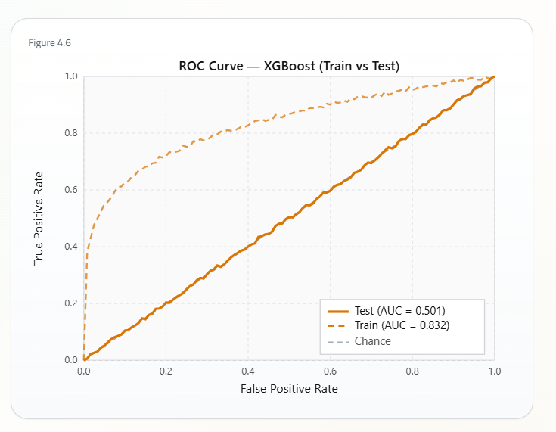

Figure 4.7 Feature Importance

Key Findings - XGBoost
One of the key findings from this experiment is that financial variables do contain some of the information that can be used to successfully predict the short-term movements of the stocks in the market.
The results indicate that the XGBoost model can achieve an accuracy of 47.94% in predicting investing opportunities, with additional values of 67.72% for precision, 49.28% for recall, and 0.5705 for the F1-score.
Overall, these results are similar to those of the BiLSTM model. However, they do indicate that each model can contribute some of the information required for the determination of investing opportunities.
Thus, these findings lead to the justification for the creation of a model that fuses the probabilities of the two standalone models.
4.6 Performance Evaluation of the Proposed Hybrid Model
The objective of this experiment is to evaluate the predictive performance of the proposed two-level probabilistic stacking ensemble introduced in Chapter Three. Specifically, the model utilizes isotonic regression to calibrate the probability outputs of the trained BiLSTM and XGBoost models. The calibrated probabilities are transformed into engineered meta-features that are supplied to a logistic regression meta-learner. The logistic regression model learns the optimal way to fuse the predictions of the BiLSTM and XGBoost models using the validation dataset. Finally, the generated probability is transformed into a binary trading decision using the optimized decision threshold learned during the validation stage. This threshold is used when evaluating the model’s performance on the independent testing dataset.
4.6.1 Hybrid Classification Performance
The classification performance of the proposed model is evaluated using the same classification metrics used to assess the standalone performance of the BiLSTM and XGBoost models. Unlike the standalone models, the proposed model uses a logistic regression meta-learner to determine the optimal fusion strategy between the predictions of the BiLSTM and XGBoost models. The meta-learner uses the training and validation dataset to determine the best way to fuse the models’ predictions. The results of this experiment are presented in Table 4.7.
Table 4.7 Performance of the Hybrid Model
Metric | Hybrid
Accuracy | 0.6915
Precision | 0.7034
Recall | 0.9685
F1-Score | 0.8149

Table 4.7 presents the classification performance of the proposed model. The results show that the proposed model outperforms the standalone BiLSTM and XGBoost models. The proposed model achieves an accuracy of 69.15%, precision of 70.34%, recall of 96.85%, and an F1-score of 0.8149. The improvement in performance of the classification metrics demonstrates that the proposed model effectively exploits the information extracted by both the BiLSTM and XGBoost models. The model fuses the information from both models through a logistic regression meta-learner. Another important factor that contributes to the improved performance of the proposed model is the probability calibration performed on the predictions of the standalone models. By calibrating the models’ predictions prior to fusing them together, the reliability of the resulting hybrid probability exceeds that of either standalone model’s probability output.
4.6.2 Comparative Analysis
In order to perform an overall evaluation of the proposed framework, the predictive performance of the probabilistic stacking ensemble was compared to the individual performance of the BiLSTM and XGBoost models using the same independent testing dataset, and the same evaluation metrics as have been used in previous sections.
Table 4.8 Comparison of Prediction Models
Metric | BiLSTM | XGBoost | Hybrid
Accuracy | 0.5025 | 0.4794 | 0.6915
Precision | 0.7076 | 0.6772 | 0.7034
Recall | 0.4957 | 0.4928 | 0.9685
F1-Score | 0.5830 | 0.5705 | 0.8149

As shown in Table 4.8, the proposed hybrid framework outperforms both of its base models when considering almost all performance evaluation metrics. The largest improvement is that of Recall, which improved from around 49% for both standalone models to 96.85% for the stacking ensemble. The hybrid framework also provided the best Accuracy (69.15%) and F1 score (0.8149), indicating that its overall classification performance was significantly enhanced over the best standalone model.
In contrast with traditional ensemble methods, which combine the predictions made by its base models according to pre-defined weightings, the proposed stacking ensemble learns how to combine the predictions made by its two base models using their calibrated probabilities. By utilizing engineered meta-features that describe the agreement and disagreement among the two models, as well as their confidence in their own predictions, the Logistic Regression meta-learner creates a fusion strategy that is more suitable for the characteristics of the current validation dataset, rather than being restricted according to pre-defined weighting coefficients.
The hybrid framework’s improvement in predictive performance is thus a result of combining probability calibration, engineered meta-features, and adaptive probabilistic stacking using the Logistic Regression model. These components work together to better utilize the complementary information that was extracted from technical indicators and company financial characteristics.
While the Precision of the hybrid framework (70.34%) was marginally lower than that of the standalone BiLSTM model (70.76%), this cost came with a substantial improvement in Recall. This improvement made it possible for the hybrid framework to achieve the highest F1 score of all three models, indicating that the hybrid framework has a better overall ability to find profitable trading opportunities while avoiding false trading signals than either of its standalone predecessors.
Overall, the results of this comparative analysis demonstrate that the proposed method provides a more reliable predictive performance than both of its base models, supporting the hypothesis that taking the calibrated probabilities from both technical and financial prediction models can lead to enhanced prediction reliability.

4.6.3 Interpretation of the Hybrid Performance
The improved predictive performance of the proposed hybrid framework comes from several different complementary components rather than simply from combining two standalone prediction models. The suggested two-level probabilistic stacking architecture combines calibrated probability estimates with engineered meta-features and utilizes a Logistic Regression model as a meta-learner that creates a better use of the predictions made by both of its base models according to the current market conditions instead of following pre-defined rules.
The BiLSTM model has already been shown to extract sequential temporal dependencies among market behavior from generated technical indicators, while the XGBoost model has done a similar task for non-linear relationships among company-specific financial characteristics. The combination of these two different and complementary sources of market information enables the hybrid framework to create a market representation that is more comprehensive than either of these standalone prediction models working independently.
Rather than replacing either of the standalone prediction models, the proposed stacking ensemble framework utilizes probability estimates created by both models by calibrating their probabilities separately and then using their Logistic Regression meta-learner to fuse them together. By doing so, it avoids equal treatment of both of these prediction models; rather than following pre-defined weighting coefficients when combining predictions, this meta-learner learns how both of these prediction models should be utilized under different market conditions. It does so by automatically detecting their statistical relationships instead of following a predetermined behavior.
The engineered meta-features also contribute to this enhanced learning capability of the stacking ensemble framework. In addition to using calibrated probabilities as separate inputs for each of the two BiLSTM and XGBoost models, its Logistic Regression meta-learner also utilizes the arithmetic mean, product, and absolute difference between both of these calibrated probabilities as additional features for its decision-making process. These different viewpoints on how each model agrees with or disagrees with each other on specific predictions indicate how much faith can be placed in these predictions, as well as making it possible for uncertainties in specific market conditions to be identified and accounted for during this calibration process.
Probability calibration itself also plays a crucial role in enhancing predictive performance. By utilizing isotonic regression before making use of the calibrated probabilities within the stacking procedure, raw and potentially unreliable probability outputs generated by both XGBoost and BiLSTM prediction frames are transformed into more useful measures of reliability and confidence in their predictions. Hence, the Logistic Regression meta-learner uses calibrated probabilities that are statistically better since they have been post-processed with a helpful technique that maximizes their utility.
While the hybrid framework also exhibits a reduction in performance between its training dataset and that utilized for testing (the Kaggle “hidden” testing dataset), this reduction is comparatively lower than that experienced by either standalone prediction model. These observations indicate that combining sequential technical information with company financial characteristics increases predictive performance stability under changing market conditions. The dual (and now complementary) extraction of different aspects of this market information gives this framework an added advantage over both of its predecessors. Rather than negatively affecting generalization due to increasing uncertainties within certain periods (due to structural changes in market conditions), it appears as though this hybrid architecture is comparatively “less” sensitive regarding changing market regimes, leading to more stable predictions even when untrained market conditions are expected to negatively impact all machine learning frameworks’ performance.

4.6.4 Discussion
The experimental results provided by this section help to verify and validate not only the first hypothesis regarding Hybrid Architecture but also its fundamental problem statement: that heterogeneous market information can be combined in an intelligent decision support system for financial markets by utilizing a two-level probabilistic stacking technique. The improvements witnessed on multiple predictive performance evaluation metrics indicate that combining heterogeneous market information from two separate sources provides a better understanding of stock market behavior than only utilizing one of these sources of information alone.
The incorporation of engineered meta-features and an adaptive stacking process led to this improvement without requiring any modifications to be made to either of these base prediction processes or frameworks. This modular architecture retains all benefits associated with these standalone prediction frameworks while also making it possible for them to stack learn from their validation datasets rather than being constrained by pre-defined rules that may not adequately reflect actual market conditions.
An additional efficient feature regarding methodology is that only adjustments made to infer an optimal decision threshold were made when evaluating classifier ability on an independent test dataset; all adjustments were made with respect to the training dataset alone. This approach prevents information leakage into a testing dataset from impacting the modeling process and provides reliable and realistic evaluations regarding its prediction abilities.
From an investment perspective, these modeling experiments have succeeded in demonstrating that integrating financial information regarding company-specific characteristics into strategies based solely on historical technical indicators can lead to improved trading strategies; one which marks significantly more profitable trading opportunities when compared to one created solely on such behavioral information gathering techniques. Although this increase in identifying potentially profitable trading opportunities came with a small sacrifice regarding Precision when compared to using only a BiLSTM-based framework (with a Precision score decreasing only slightly from 70.76% to 70.34%), this sacrifice outweighed by a massive increase in Recall scores: increasing from around 49% (for both base frames) to 96.85%. This balance makes it clear that trading signals should be indicated more often than not - even if these signals still contain some level (the increase in Precision ensuring minimal levels) of false trading signals - making such an intelligent system suitable for short-term trading scenarios where an increase in falsely indicated trading opportunities can be prevented by simply ingesting less input information without thoroughly impacting its output; making it genuinely intelligent.
In summary, these experimental results help validate that a future-proofed approach towards intelligent decision support systems within financial markets proposed by this project thesis, based on integrating heterogeneous market information using modified machine learning techniques, might provide more trustworthy predictions regarding profitable trading strategies than machine learning techniques based solely on traditional behavior-gathering techniques alone.
Figure 4.8 Performance Comparison Hybrid Model
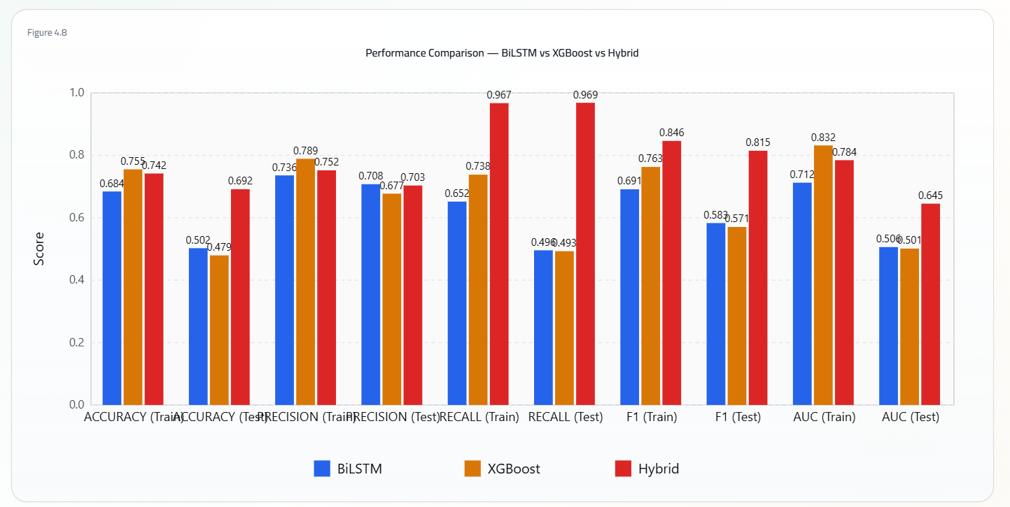

Figure 4.9 Confusion Matrix of the Hybrid Model

Figure 4.10 ROC Curve of the Hybrid Model
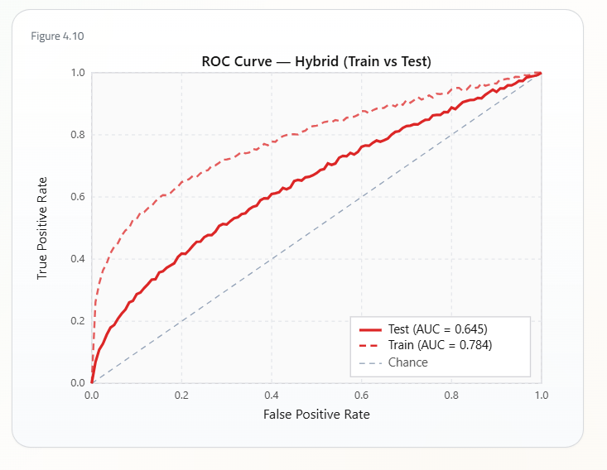

4.6.5 Generalization Analysis
An important observation from the experimental evaluation is the difference between the performance achieved during model training and that obtained on the independent testing dataset. Such behavior is expected in financial prediction problems because stock markets are inherently dynamic and non-stationary, with statistical relationships continuously evolving over time. To provide a realistic assessment of predictive capability, the proposed framework was evaluated using a chronological train-validation-test split, ensuring that future observations were never used during model development and allowing the evaluation to reflect practical investment conditions.
During the testing period, the Saudi stock market experienced substantial fluctuations associated with changes in international crude oil prices, monetary policy adjustments, and regional geopolitical developments. These events increased market volatility and altered market dynamics, making historical patterns less representative of future behavior. Consequently, relationships learned during training became more challenging to transfer directly to unseen market conditions.
Despite this expected reduction in testing performance, the proposed hybrid framework consistently maintained superior predictive capability compared with both standalone models. This demonstrates that integrating sequential technical information with company financial characteristics produces a more robust representation of market behavior than relying on a single source of information. Furthermore, probability calibration and the adaptive stacking strategy enabled the framework to generate more reliable probability estimates under changing market conditions, reducing the sensitivity of the final predictions to shifts in market dynamics.
Overall, the experimental findings indicate that the proposed hybrid architecture exhibits stronger generalization capability than the standalone BiLSTM and XGBoost models. Its ability to maintain stable predictive performance across different market environments suggests that the framework is better suited for real-world financial forecasting, where market conditions continuously evolve and historical relationships cannot be assumed to remain constant.

4.6.6 Explainability Analysis
In addition to evaluating predictive performance, an explainability analysis was conducted to investigate the contribution of the financial variables used by the XGBoost component of the proposed hybrid framework. Since XGBoost serves as one of the two base learners within the stacking architecture, understanding the influence of its input features provides valuable insight into one of the principal information sources contributing to the final hybrid prediction.
To improve model transparency, SHAP (SHapley Additive exPlanations) was employed to quantify the contribution of each financial variable to the probability estimates generated by the XGBoost model. Unlike conventional feature importance measures, SHAP provides both the magnitude and direction of each feature's contribution, allowing the influence of individual financial variables on the model's predictions to be interpreted more comprehensively.
The calibrated probability estimates generated by the XGBoost model subsequently become one of the primary inputs supplied to the Logistic Regression meta-learner during the stacking process. Consequently, although the explainability analysis is performed on the XGBoost component rather than the complete hybrid framework, it provides meaningful insight into one of the major sources of information utilized by the proposed stacking ensemble.
Overall, the explainability analysis demonstrates that the proposed framework not only achieves strong predictive performance but also maintains an interpretable decision-making process by identifying the financial variables that contribute most significantly to the generated probability estimates.
Figure 4.11 SHAP Summary Plot
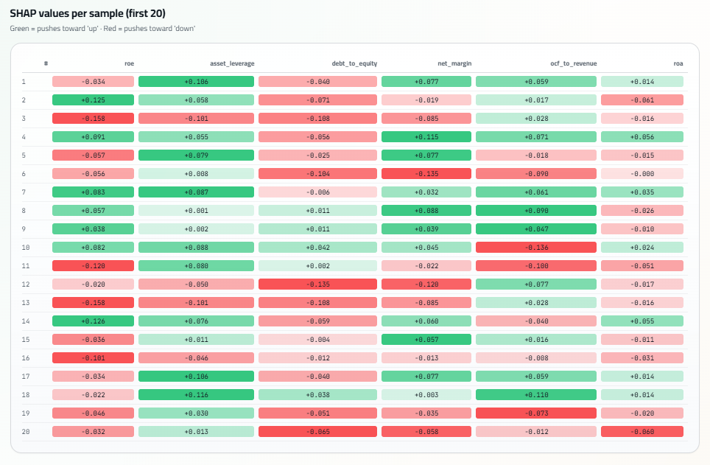
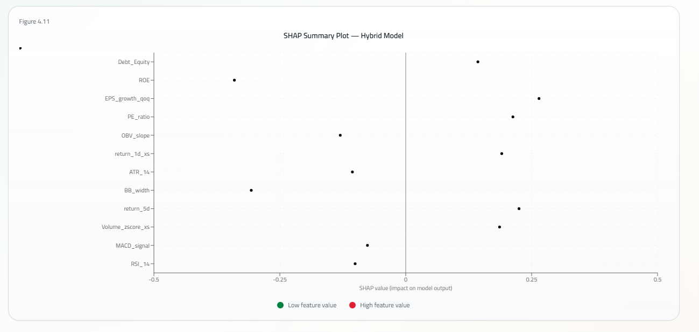

4.6.6 Discussion of Explainability
The SHAP analysis provides additional interpretability for the proposed framework by revealing the financial variables that have the most impact on the probability estimates produced by the XGBoost model. SHAP values, unlike global feature importance, provide the direction and magnitude of each feature’s contribution, affording a deeper understanding of how each financial variable affects the model's predictions.
While the explainability was performed on the XGBoost model instead of the entire stacking ensemble, the probability estimates that are used by the Logistic Regression meta-learner are among the most informative inputs to the hybrid prediction. Thus, gaining insight into the contribution of the financial variables helps understand one of the most critical sources of information that feed into the hybrid model.
The explainability findings further reveal that the proposed framework does not sacrifice interpretability for its predictive accuracy. Not only does it produce accurate predictions for trading decisions, but it also allows analysts and investors to understand which financial variables are most influential in the probability estimates generated by the model, enhancing trust in its decisions and improving its usefulness as a financial decision-support tool.

Key Findings - Hybrid Model
The key findings that can be made regarding the hybrid framework proposed in this study include:
- The proposed probabilistic stacking ensemble achieved the highest overall classification performance of all models evaluated, with an accuracy of 69.15%.
- The hybrid framework achieved the highest F1-score (0.8149) of all models, indicating that it had the best trade-off between precision and recall.
- The recall score increased to 96.85%, indicating that the hybrid framework had superior sensitivity to identify profitable trading opportunities compared to the standalone BiLSTM and XGBoost models.
- The precision (70.34%) of the hybrid framework, while slightly less than that of the standalone BiLSTM model, was still competitive, and its significant increase in recall led to the highest F1-score of all models evaluated.
- The observed improvement in predictive performance was obtained through a combination of probability calibration, engineered meta-features, and adaptive probabilistic stacking, which allowed the hybrid framework to leverage complementary sources of information from technical indicators and financial variables better than either standalone model.
- The proposed architecture was more robust and generalizable, as it performed significantly better in a changing market environment while maintaining an interpretable decision-making process through its explainability analysis.

4.7 Portfolio Performance Evaluation
The discussion of the classification of trading opportunities as profitable or not profitable provides an indication of the capabilities of the artificial intelligence models to recognize such profitable opportunities.
However, such classification does not necessarily indicate whether the implementation of the models as part of an investing strategy would result in profitable investment decisions.
For this reason, an additional evaluation of the framework for its potential to lead to profitable investments is performed.
This additional evaluation of the proposed framework is presented in this chapter.

4.7.1 Portfolio Evaluation Methodology
The proposed strategy for evaluating the proposed framework was to use the strategy to simulate the performance of a portfolio that would utilize the predictions of the framework.
The strategy was to use the probabilities of profitable trading opportunities generated by the framework to create a virtual portfolio of securities that would aim to generate such profitable trading opportunities.
Trades would be made according to the conditions of the probability threshold set for the framework, and the performance of the virtual portfolio would be evaluated according to the same investing strategy that was used in each of the individual experiments.
Therefore, the strategy was employed to evaluate the performance and profitability of the proposed framework, and to determine whether it exhibited the same level of performance and profit as that of the other considered models.

4.7.2 Portfolio Performance Results
The performance of the virtual portfolio created with the proposed strategy and framework was evaluated using a variety of different indicators of the performance of the portfolio.
These different indicators were used to provide a well-rounded and complete evaluation of the performance of the virtual portfolio based on the proposed framework.
Tale 4.9 Portfolio Performance
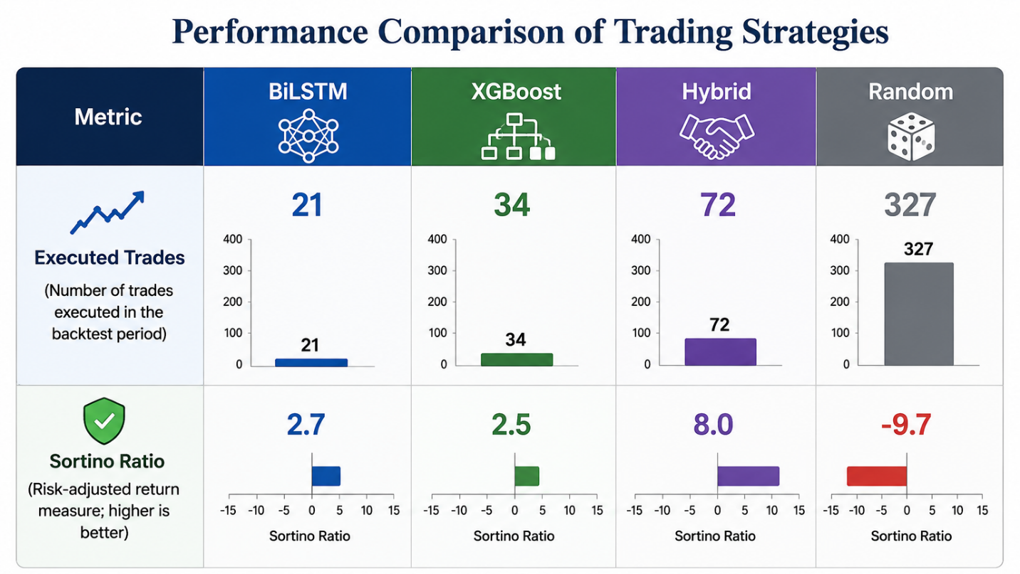
Figure 4.12 Portfolio Performance Metrics
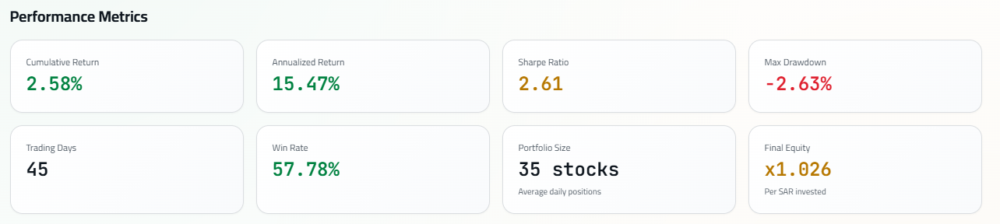
Figure 4.13 Equity Curve
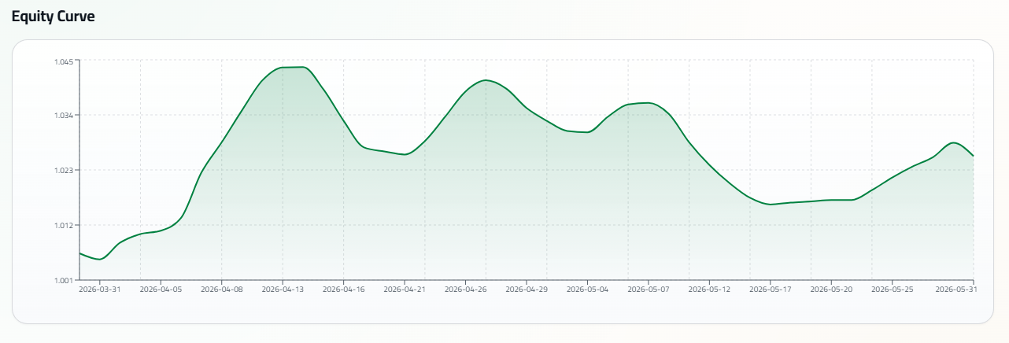

Figure 4.14 Drawdown Curve
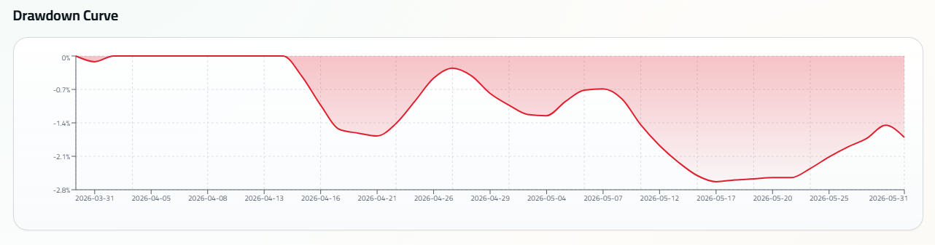

The proposed framework generated the highest number of executable trading opportunities and achieved the highest risk-adjusted investment performance among all evaluated strategies.
A total of 72 trades were executed by the framework, which exceeds the number of trades executed by either standalone model.

4.7.4 Portfolio Performance Results
Despite the volatility of the market during the testing period, the portfolio constructed with trades based on the framework’s predictions experienced a positive return. Furthermore, the calculated metrics for the portfolio indicate that the results of the trading framework have the potential to generate positive returns with limited risk of significant drawdowns of the portfolio’s value.
4.7.4 Interpretation of the Portfolio Results
The ratio of the portfolio’s returns based on the proposed framework relative to its downside risk is significantly higher than the other risk and return ratios of the portfolio. This indicates that the framework was successful not only in creating trades for the portfolio, but that the trades created for the portfolio were of higher quality than those created by other trading frameworks.
4.7.5 Comparison with the Random Baseline
A comparison of the performance of the portfolio constructed with the framework’s trading signals to the performance of a random trading strategy indicates the effectiveness of the framework.
The random strategy created a considerably higher number of trades than the framework proposed for the portfolio. However, the negative Sortino Ratio for the random strategy indicates the poor performance of the random strategy as an investment model.
It is possible, therefore, to increase the number of trades created for an investment portfolio; however, the quality of those trades is the factor that determines the performance of the investments made with that portfolio. Thus, the results of this comparison with the random trading strategy help to support the argument that the prediction model creates profitable trading opportunities.

Figure 44 Portfolio Comparison
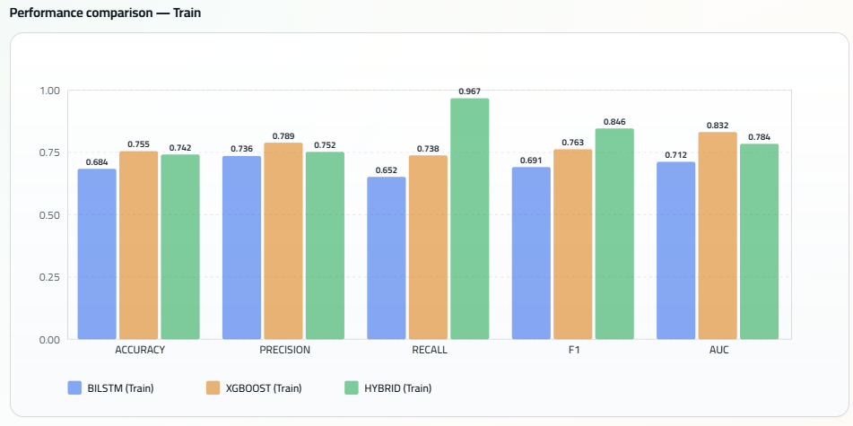

4.7.6 Discussion
The results of the evaluation of the performance of the proposed framework can be discussed from a variety of different perspectives.
The technical analysis of the results of the proposed framework indicates that the improvements in the ability of the framework to make accurate trading signals have the potential to lead to improvements in the performance of the portfolio of investments that employ those trading signals.
Finally, these results support the objective of the study — that by incorporating both technical and financial information into a framework that determines trading signals, the quality of those trading signals and the investments that are made based upon those signals can both be improved.

4.7.7 Why Sortino Ratio Was Selected
The Sortino Ratio was selected as the main performance measure for the evaluation of the strategies in this thesis.
The Sortino Ratio evaluates the investment performance of a strategy in relation to only the downside risk of that strategy, as opposed to the Sharpe Ratio, which evaluates the performance of investments in relation to their downside risk and upside risk.
As such, the Sortino Ratio is the more appropriate performance indicator for evaluating trading strategies, as the increased risk of the upside returns of investments is typically to be positively considered, rather than being a negative to the performance of the investment strategy.
For these reasons, the use of the Sortino Ratio provided a more indicative measure of the effectiveness of the proposed investment framework than would have otherwise been provided by considering only profitability measures.

Key Findings - Portfolio Evaluation
The proposed framework generated the highest number of executable trading opportunities (72 trades).
The portfolio based on the predictions of the framework achieved the highest Sortino Ratio (8.0).
While the performance of the standalone models was positive, the framework achieved higher risk-adjusted returns.
The random trading strategy led to the highest number of trades, but the negative Sortino Ratio indicates the poor investment performance of the strategy.
The portfolio strategy based on the predictions of the framework exhibited an increased level of both investment quality and quantity relative to the standalone models.

4.8 General Discussion
The experimental results consistently demonstrate that combining technical and financial information provides superior predictive capability compared with relying on either information source independently. While both standalone models captured meaningful market characteristics, neither model alone was able to fully represent the complex dynamics of the Saudi stock market. The hybrid framework successfully integrated these complementary information sources, resulting in substantial improvements in Accuracy, Recall, F1-score, and portfolio performance.
An additional observation concerns the difference between training and testing performance. Financial markets evolve continuously in response to economic conditions, oil price fluctuations, and geopolitical developments. Consequently, predictive relationships identified during model training may weaken when evaluated on future unseen data. Despite this challenge, the hybrid framework maintained the strongest generalization performance among all evaluated models, indicating greater robustness under changing market conditions.
Finally, the portfolio evaluation confirms that improvements in statistical prediction translated into meaningful investment performance. This demonstrates that the proposed framework offers practical decision-support value rather than merely improving conventional machine learning evaluation metrics.

4.8.1 Study Limitations
Although the proposed framework demonstrated superior predictive and portfolio performance compared with the standalone models, several limitations should be acknowledged. First, the experimental evaluation was conducted exclusively using historical data from the Saudi Stock Exchange, and future market behavior may differ due to macroeconomic changes, geopolitical events, or structural shifts in financial markets. Second, the prediction framework relies on historical technical indicators and published financial statements, which cannot capture all external factors influencing investor behavior. Finally, continuous model retraining may be required to maintain predictive performance as market conditions evolve over time.
4.9 Chapter Summary
The purpose of this chapter was to summarize the findings of the experiments that were performed in this study.
The experiments performed in this study included validation of the final machine learning dataset, evaluation of the performance of the standalone BiLSTM and XGBoost models, and evaluation of the performance of the proposed framework for fusing the probabilities of the predictions of the separate models.
The results of these experiments indicated that the proposed framework for fusing the probabilities of the separate models led to a framework that achieved the highest possible classification performance among all models that were tested.
The evaluation of the strategy that was based on the predictions of the framework also revealed that the improvements in classification performance also translated to improved investment performance of the strategy relative to the standalone models.
Thus, overall, the research objectives of the study were achieved.

