

AI-Based Recommendation System for Selecting Suitable Training Courses for Students (AIRSS)
Prepared By
Name: Bushra Ali Alharby ID No.: 252000279
Submitted in fulfillment of the requirements for the degree Master of Science in Artificial Intelligence
At
College of Informatics
Midocean University
UAE
Supervisor Name: Dr. Khaled Eskaf
College of Informatics, Midocean University, Comoros

Acknowledgements
I expand my true much obliged and appreciation to everybody who contributed to my back and bolster amid the planning of this Study.
I would too like to thank my expensive guardians for their nonstop bolster, persistence and support all through my scholastic career, as their confidence in me has had an incredible affect on my inspiration and progress.
I amplify my true much obliged and appreciation to my administrator, Dr. Khaled Eskaf, for his nonstop back, important direction, and valuable logical perceptions, which played a essential part in the advancement and enhancement of this Study.
I would too like to amplify my earnest much appreciated to Dr. Hajar Saleh for her productive perticipation, profitable perceptions, and direction, which contributed altogether to raising the quality of this work.
I would like to express my appreciation to Midocean College – College of Informatics, for giving a invigorating and steady scholastic environment that contributed to the completion of this Study.
In conclusion, I would like to express my much appreciated and appreciation to all those who have contributed, specifically or by implication, to this work, trusting that this inquire about will be valuable and contribute emphatically to the field of Artificial Intelligence in instruction.

Abstract

This study aims to develop an intelligent recommendation system predicated on advanced artificial intelligence ways to support Saudi university graduates in concluding training courses that align with their academic backgrounds and career aspirations. The significance of the system lies in its capability to help graduates in navigating the vast range of online knowledge platforms and making informed opinions that meet the demands of the original labor request.

The proposed .system analyzes druggies’ textual inputs, analogous as their educational interests and chops, and matches them with course descriptions using Natural Language Processing (NLP) ways. To enhance recommendation performance, the system employs multiple text representation styles, including TF- IDF and BERT, combined with similarity dimension approaches analogous as cosine similarity and Euclidean distance to .induce substantiated and applicable course recommendations.

Experimental. .results deemonstrate that the BERT model combined with cosine similarity provides more accurate and meaningful recommendations compared to other approaches, as it effectively captures semantic connections between handbooks.

The system is anticipated to meliorate educational decision- timber, reduce the time and trouble demanded for career drug, and promote invention in digital knowledge surroundings. likewise, it contributes to the development of intelligent educational systems aligned with modern trends in AI- driven knowledge.

Keywords:
Artificial Intelligence, Natural Language Processing, Recommendation Systems, Course Recommendation, BERT, TF- IDF, Cosine Similarity, Personalized Learning

Table of Contents
ii
Acknowledgements iii
Abstract iv
Keywords: iv
List of Abbreviations xxiv
List of Figures xxv
List of Tables xxvi
Table 4- 3: Comparison of Recommendation Models Performance xxvi
Chapter 01 1
Introduction 1
1.1 Background of the Study 2
1.2 Problem Definition 3
1.3 Study Objectives 4
1.4 Study Contribution 5
1.6 Scope of the Research 7
1.7 Research Gap 8
1.8 Operational Definitions 9
1.9 Study Organization 10
Chapter 02 11
Background and Related Work 11
2.1 Introduction 12
2.2 Artificial Insights (AI) 12
2.3 Recommendation Systems 13
2.4 Natural Language Processing Preparing (NLP) 14
2.5 Related Work 16
2.6 Summary of Previous Studies 17
2.7 Comparative Analysis: 20
2.8 Study Gap 23
2.9 Summary 24
Chapter 03 25
Proposed Approach (Methodology) 25
3.1 Introduction 26
3.2 System Overview 26
3.3 Dataset Description 28
3.4 Data Preprocessing 28
3.5 Feature Extraction Using TF-IDF 29
3.6 Feature Extraction Using BERT 30
3.7 Similarity Computation 32
3.8 Recommendation Mechanism 33
3.9 System Implementation 33
3.10 Summary 34
Chapter 04 35
Experimental Results and Discussion 35
4.1 Introduction 36
4.2 Experimental Setup 36
4.3 Evaluation Metrics 37
4.4 System Interface 37
Figure 9 TF- IDF Euclidean Recommendation Results 41
Figure 10: BERT + Euclidean Recommendation Results 42
4.5 Results and Discussion 43
4.6 Model Comparison 44
Table 4-3: Comparison of Recommendation Models Performance 45
4.7 Summary 45
Chapter 05 46
Conclusion and Future Work 46
5.1 Conclusion 47
5.2 Future Work 48
References 49

List of Abbreviations
AI — Artificial Intelligence
NLP — Natural Language Processing
AIRSS — AI-Based Recommendation System for Selecting Suitable Training Courses for Students and Graduates
TF-IDF — Term Frequency–Inverse Document Frequency
BERT — Bidirectional Encoder Representations from Transformers
ML — Machine Learning
DL — Deep Learning
RS — Recommendation Systems
CBR — Content-Based Recommendation
CS — Cosine Similarity
ED — Euclidean Distance
LMS — Learning Management System
IR — Information Retrieval

List of Figures
Figure 1: Types of Recommendation Systems
Figure 2: Intelligent Training Course Selection Process
Figure 3: AIRSS System Workflow
Figure 4: Text Representation Using TF-IDF
Figure 5: Text Representation Using BERT
Figure 6: Model Selection Interface
Figure 7: TF-IDF + Cosine Recommendation Results
Figure 8: BERT + Cosine Recommendation Results
Figure 9: TF-IDF + Euclidean Recommendation Results
Figure 10: BERT + Euclidean Recommendation Results

List of Tables
Table 2-1: Comparative Analysis of Previous Studies and Proposed AIRSS System
Table 2-2: Summary of Previous Studies Related to Educational Recommendation Systems

Table 4- 3: Comparison of Recommendation Models Performance

Chapter 01

Introduction

  - Background of the Study
The education and training sector has witnessed rapid-fire- fire development in recent times due to the adding reliance on digital technologies and the wide vacuity ofe- learning platforms. This changeover has led to a significant expansion in the number and diversity of training courses across various fields and specializations. As a result, scholars and graduates are now presented with precious openings to enhance their chops and align themselves with the evolving demands of the labor request.
This growth also reflects a shift toward lifelong knowledge, where individualities continuously seek to meliorate their knowledge and professional capabilities. Still, despite these advantages, the quick- fire expansion of available courses has created a major problem in relating the most applicable training options. With the cornucopia of choices, course quality variations and learning object differences make it extremely sensitive for addicts looking to discover courses which fit their interest, chops and career pretensions.
The difficulty manifests itself indeed more in the surroundings where there's little structure available to guide them through their academic/ career path. Thousands of scholars still calculate on approaches similar as homemade searching or general recommendations while deciding training courses in Saudi Arabia. These are constantly in need of personalisation opposed to universal choice or capabilities based maybe on an opaque factor which fails to serve meaningful knowledge challenges and guiding timber.
Within this geography, Aritifical Intelligence( AI) technologies have surfaced as promising results to grease educational decision- makers. This idea of recommendation system has shown important pledge over time in assaying stoner data and furnishing substantiated suggestions. These systems can exercise textual content the use of Natural Language Processing( NLP) approaches and degree how similar a stoner's enter is to every path description and discover the fine aligned training choices.
THE result To overcome these challenges, the present study introduces AIRSS system( one AI- recommendation system aimed at aiding scholars and graduates in arriving at ideal training courses. The system combines several means of textbook representation, similar as TF- IDF and BERT at the same using similarity measures similar as cosine similarity and Euclidean distance to achieve precise, individualized recommendations.
The unified., model-specific interfaces( for comparison evaluation)
It proposes a system that can ameliorate the quality of educational decision- timber, accelerate( and ease) the course selection process, and help scholars to more fit their crafts with labor request conditions.

1.2 Problem Definition

College graduates in Saudi Arabia face a significant challenge in concluding applicable training courses due to the vast vacuity of educational platforms and the diversity of course content and specializations. While this variety provides precious openings, it also creates confusion and query, constantly leading to deficiently informed opinions that do not align with graduates’ academic interests or the evolving demands of the original labor request.

In addition, utmost being quest tools warrant effective personalization capabilities, as they do n't sufficiently dissect addicts’ preferences, chops, and background information. As a result, these systems give generalized recommendations that may not directly reflect individual conditions.

This limitation reduces the effectiveness of academic and career guidance and increases the time and trouble demanded to identify suitable training openings. Likewise, the absence of intelligent recommendation systems contributes to a gap between available training options and factual stoner conditions, which may negatively impact skill development and career readiness among graduates.

• thus, the problem addressed in this study can be epitomized in the following question.

How can Artificial Intelligence( AI) ways be used to give personalized course recommendations that help Saudi university graduates in concluding training courses aligned with their career pretensions and professional conditions?

1.2.1 Study Questions
This study aims to answer the following main exploration question. Grounded on this main question, the study seeks to address the following sub-questions.
- To what extent can gladden-grounded recommendation systems support graduates in making effective and informed training opinions?
- How can Natural Language Processing(NLP) ways be applied to dissect stoner interests and match them with descriptions of available online training courses?
- How do substantiated and interpretable recommendations contribute to enhancing stoner experience and adding satisfaction with the proposed AIRSS system?
- What's the impact of the proposed AIRSS system on reducing the time and trouble needed for graduates to identify suitable training courses?

1.2.2 Study Hypothesis

This study hypothesizes that the proposed intelligent recommendation system(AIRSS) will significantly ameliorate the applicability and felicity of training course recommendations for Saudi university graduates compared to traditional or homemade course selection styles.

Likewise, it's hypothecated that the integration of advanced textbook representation ways, similar as BERT, combined with similarity dimension styles( e.g., Cosine Similarity and Euclidean Distance), will enhance the delicacy and effectiveness of the recommendation process.
  - Study Objectives

This study aims to develop an intelligent recommendation system that supports Saudi university graduates in making accurate and effective training opinions. This ideal can be achieved through the following.
- To help graduates in opting for training courses that align with their interests, chops, and career paths.
- To reduce the time and trouble I needed to manually search for suitable training courses.
- To enhance the quality of academic and career guidance using Artificial Intelligence (AI) ways.
- To dissect druggies’ textual data using Natural Language Processing (NLP) styles in order to induce accurate and individualized recommendations.
- To apply advanced textbook representation ways, similar as TF- IDF and BERT, combined with similarity measures (e.g., Cosine Similarity and Euclidean Distance) to ameliorate recommendation delicacy.
- To design and develop multiple system interfaces, including model-specific and unified interfaces, to enable effective comparison between different recommendation approaches.
- To support universities and training institutions in developing intelligent advising systems for scholars and graduates.
- To contribute to the advancement of smart education and substantiated learning systems.

Study Contribution

Former studies have made significant benefactions to the development of AI- grounded recommendation systems in educational surroundings. Several crucial benefactions can be epitomized as follows
- Oubalahcen et al.( 2023) handed a comprehensive review of artificial intelligence ways used ine-learning recommendation systems, pressing their capability to deliver substantiated literacy pathways grounded on stoner geste
- and preferences.
- Salim et al.( 2025) emphasized the part of substantiated course recommendation systems in Massive Open Online Courses (MOOCs), particularly in enhancing availability, inclusivity, and learner engagement through gusto.
- driven data analysis.
- Tolety and Prasad(2022) proposed a cold-blooded recommendation approach that combines cooperative filtering and content- grounded filtering, achieving bettered performance compared to traditional styles ine-learning surroundings.
- Mentec(2023) introduced resolvable recommendation systems, emphasizing the significance of translucency and stoner commerce in perfecting trust, effectiveness, and decision- making processes.
- Pazzani and Billsus(2007) handed foundational perceptivity into content- grounded recommendation systems, explaining how stoner biographies and point features are employed to induce individualized recommendations.

Overall, these studies inclusively demonstrate the significance of personalization, delicacy, explainability, and rigidity in recommendation systems. still, there remains a need for systems that integrate advanced textbook representation ways, similar as BERT, with effective similarity measures to give more accurate and environment- apprehensive recommendations.

1.5 Significance of the Study

The significance ofthis study can be examined from academic, practical, and societal perspectives, as outlined below

1.5.1 Academic Significance

This study contributes to the being literature on educational recommendation systems by fastening content- rested approaches and integrating Natural Language Processing( NLP) ways for textual data analysis. It incorporates advanced textbook representation styles, similar as TF- IDF and BERT, to enhance the understanding of stoner inputs and course descriptions.
Likewise, the study integrates multiple similarity measures, including Cosine Similarity and Euclidean Distance, to estimate and compare different recommendation approaches. This integration improves the delicacy and connection of recommendations by landing both syntactic and semantic connections within textual data.
Consequently, the study provides a comprehensive frame for developing further effective and individualized recommendation systems in educational surroundings.

1.5.2 Practical Significance
The practical significance of this study. falsehoods in the development of the proposed intelligent recommendation system( AIRSS), which is designed to help graduates in concluding suitable training courses predicated on their interests, chops, and career pretensions.
The system reduces reliance on traditional manual quest styles and general recommendations by furnishing substantiated suggestions using AI ways. By exercising TF- IDF, BERT, Cosine Similarity, and Euclidean Distance, the AIRSS system enhances decision- making effectiveness and improves user experience by delivering accurate and applicable recommendations.
In addition, the system offers multiple model-specific interfaces as well as a unified interface, allowing stoners to compare different recommendation models and better understand their performance.

1.5.3 Societal Importance

From a societal perspective, this study supports the advancement of substantiated knowledge and professional development through the operation of intelligent technologies. It contributes to preparing graduates to meet the dynamic conditions of the labor request, particularly in the terrain of rapid-fire- fire digital transformation.

also, the study aligns with the objects of Saudi Vision 2030 by promoting the integration of Artificial Intelligence in education and training systems. By enhancing graduates’ readiness and supporting skill development, the proposed system contributes to erecting a knowledge- predicated economy and fostering sustainable societal growth.

1.6 Scope of Research

This study is limited to a defined compass that outlines its boundaries and focus, icing clarity, thickness, and validity of the exploration issues. The compass of the study can be epitomized as follows.

1. Target Group

The study focuses on university graduates in the Kingdom of Saudi Arabia, as it aims to support them in concluding applicable training courses aligned with their career paths. This group represents a vital member that can significantly profit from intelligent recommendation systems.

2. Thematic compass

The study is concerned with recommendation systems in the educational sphere, specifically fastening on course recommendation processes. It aims to support the selection of suitable training courses and programs that match addicts’ interests, chops, and career pretensions.

3. Specialized compass

The study adopts a content- rested recommendation approach, exercising Natural Language Processing( NLP) ways to dissect textual data. It integrates advanced textbook representation styles similar as TF- IDF and BERT, along with similarity measures including Cosine Similarity and Euclidean Distance, to induce individualized recommendations.

In addition, the system supports multiple recommendation models and provides both model-specific interfaces and a unified interface, enabling comparison between different approaches.

4. Data Scope

The study relies on textual data that includes addicts’ interests, chops, and course descriptions. This data are used to develop and estimate the proposed AIRSS system, furnishing a meaningful base for understanding stoner conditions and perfecting recommendation quality.

1.7 Research Gap

A review of former studies in the field of educational recommendation systems reveals several important gaps that have n't been adequately addressed.

First, utmost being studies primarily concentrate on general pupil populations within formal educational surroundings. Limited attention has been given to university graduates and their specific conditions in concluding applicable training courses aligned with their career paths. This limitation reduces the connection of being systems to real- worldpost- scale challenges.

Alternate, multitudinous recommendation systems have been developed without sufficient consideration of original educational and socio-profitable surrounds. In particular, there is a lack of systems adapted to the Saudi labor request and its evolving conditions. Ignoring analogous contextual factors may lead to lower applicable and ineffective recommendations.

Third, there is a conspicuous gap in the operation of Natural Language Processing( NLP) ways, especially in assaying textual user inputs to induce personalized recommendations. This highlights the need for systems that can effectively exercise and understand user- generated handbooks.

likewise, multitudinous being systems fail to adequately separate between user lives, analogous as academic backgrounds, specializations, and particular interests. This limitation reduces the system’s capability to give precise and meaningful recommendations.

In addition, limited exploration has explored the integration of advanced textbook representation models, similar as BERT, with multiple similarity measures( e.g., Cosine Similarity and Euclidean Distance) to meliorate recommendation delicacy and semantic understanding.

Research Contribution Motivation
These gaps punctuate the need for an intelligent, environmentally apprehensive recommendation system that focuses on graduates, leverages advanced NLP ways, and aligns with original labor request conditions.
Consequently, this study proposes the AIRSS system, which integrates TF-IDF and BERT with similarity dimension styles to give substantiated, accurate, and environment-apprehensive training course recommendations.

1.8 Operational Definitions

To this study, the following terms are defined operationally.

• Intelligent Recommendation System( AIRSS)

An AI- grounded system designed to give individualized training course recommendations for graduates by assaying their textual inputs, including interests, chops, and preferences, using advanced Natural Language Processing (NLP) ways.

• Content- Grounded Recommendation

A recommendation approach that suggests particulars grounded on the similarity between point features and stoner preferences, without counting on data from other druggies.

• TF- IDF (Term frequence – Inverse Document frequence)

A statistical system used to transfigure textual data into numerical vectors by measuring the significance of words within a document relative to a collection of documents.

• BERT (Bidirectional Encoder Representations from Mills)

A deep literacy model used for advanced textbook representation, able of understanding the contextual meaning of words within a judgment, which enhances semantic analysis in recommendation systems.

• Cosine Similarity

A fine measure used to determine the similarity between two vectors by calculating the cosine of the angle between them, where advanced values indicate lesser similarity.

• Euclidean Distance

A fine measure used to calculate the distance between two vectors in a multidimensional space, where lower values indicate advanced similarity.
1.9 Study Organization
The remainder of this thesis is organized as follows.
Chapter 1 introduces the exploration background, problem description, exploration questions, objects, thesis, significance of the study, compass, and crucial delineations. It also provides an overview of the overall structure of the thesis.
Chapter 2 presents the theoretical background and affiliated work, covering crucial generalities similar as Artificial Intelligence (AI), Natural Language Processing (NLP), and recommendation systems. It also reviews former studies and identifies the exploration gap.
Chapter 3 describes the proposed methodology of the AIRSS system. It explains the dataset, data preprocessing way, and textbook representation ways, including TF-IDF and BERT. It also presents similarity dimension styles similar as cosine similarity and Euclidean distance used for generating recommendations.
Chapter 4 presents experimental results and discussion. It evaluates the performance of the system and compares different approaches to demonstrate the effectiveness of the proposed recommendation system.
Chapter 5 concludes the thesis by recapitulating the crucial findings and benefactions. It also provides recommendations for unborn work and implicit advancements to the system.

*************

Chapter 02

Background and Related Work

2.1 Introduction
This chapter presents the abecedarian generalities related to Artificial Intelligence (AI), recommendation systems, and Natural Language Processing (NLP). Understanding these generalities is essential for establishing a solid theoretical foundation for the proposed study.
In addition, this chapter reviews former studies in the field of AI-grounded recommendation systems, particularly those applied in educational surrounds and course selection. This review helps in relating the strengths and limitations of being approaches, as well as pressing current exploration gaps.
The chapter aims to make a comprehensive theoretical background that supports the design and development of the proposed AIRSS system. It also provides a clear link between being exploration and the proposed result by relating the gaps addressed in this study.
From this perspective, establishing a strong theoretical foundation is pivotal for icing the effectiveness, delicacy, and applicability of the proposed recommendation system.

2.2 Artificial Insights (AI)

Artificial Intelligence (AI) refers to the capability of machines to pretend to be mortal intelligence processes, similar as literacy, logic, and decision- timber. It has become one of the most transformative technologies in ultramodern education due to its capability to replicate intelligent mortal gusto and automate complex tasks.

In educational surrounds, AI is extensively used to enhance literacy guests and support intelligent decision-making systems. It enables the analysis of large volumes of data and the birth of meaningful perceptivity, which can be employed to ameliorate the quality and effectiveness of educational processes (Russell & Norvig, 2021).

Likewise, AI plays a critical part in the development of recommendation systems by assaying stoner data and generating substantiated suggestions. These systems influence AI ways to understand stoner preferences, prognosticate requirements, and give applicable recommendations.

In this study, AI serves as the foundational technology for the proposed AIRSS system, enabling the generation of accurate and individualized training course recommendations grounded on druggies’ textual inputs and behavioral patterns.

2.3 Recommendation Systems

Recommendation systems are intelligent systems designed to suggest applicable particulars to druggies grounded on their preferences, gusto.

, and commerce history. These systems play a pivotal part in simplifying decision-making processes, especially in surroundings characterized by a large number of available options.

In educational surrounds, recommendation systems are extensively used to suggest courses, training programs, and literacy coffers. Their operation enhances substantiated literacy by helping druggies identify suitable openings aligned with their interests and career pretensions.

Figure 1: Types of Recommendation Systems
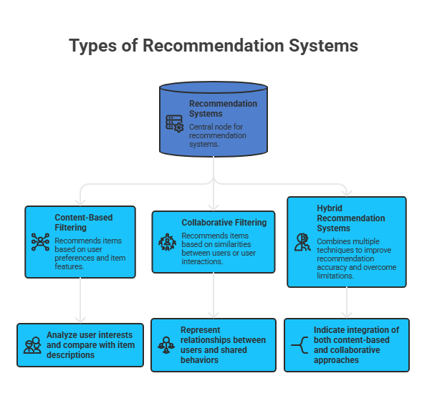

This figure illustrates the main types of recommendation systems, including content- rested, cooperative filtering, and cold- pedigreed approaches.

Among the colorful approaches, content- rested recommendation systems calculate on assaying stoner preferences and matching them with point descriptions. This approach is particularly suitable for educational surroundings where stoner data may be limited( Pazzani & Billsus, 2007). It enables the system to capture individual interests and give applicable recommendations.

In distinction, cold- pedigreed recommendation systems combine multiple ways, similar as content- rested and cooperative filtering, to ameliorate delicacy and overcome the limitations of individual approaches( Tolety & Prasad, 2022). Integrating multiple styles can lead to further robust and dependable recommendation issues.

In this study, the proposed AIRSS system adopts a content- rested approach enhanced with advanced Natural Language Processing( NLP) ways, including TF- IDF and BERT, along with similarity dimension styles to induce accurate and individualized course recommendations. In this study, the proposed AIRSS system adopts a content- rested approach enhanced with advanced Natural Language Processing( NLP) ways, including TF- IDF and BERT, along with similarity dimension styles to induce accurate and individualized course recommendations.

2.4 Natural Language Processing (NLP)

Natural Language Processing( NLP) is a abecedarian branch of Artificial Intelligence that focuses on assaying and understanding textual data. It enables machines to interpret mortal language in a meaningful way, allowing systems to prize perceptivity and support intelligent decision- timber.

In the terrain of recommendation systems, NLP plays a critical part in processing stoner inputs and course descriptions. By applying NLP ways, the system can more understand stoner preferences and directly match them with applicable traening content. This enhances the system’s capability to deliver substantiated and meaningful recommendations.

Among the used ways, TF- IDF is employed to transfigure textual data into numerical representations rested on the significance of words within a document. This approach helps in relating significant terms and lodging useful features from textbook data.

In addition, similarity measures, particularly cosine similarity, are used to estimate the degree of similarity between stoner input and course descriptions. This enables the system to rank courses according to their connection and alignment with stoner interests. The integration of textbook representation ways similar as TF- IDF and advanced models like BERT, combined with similarity computations, significantly improves the delicacy and quality of recommendations.

Figure 2: Intelligent Training Course Selection Process
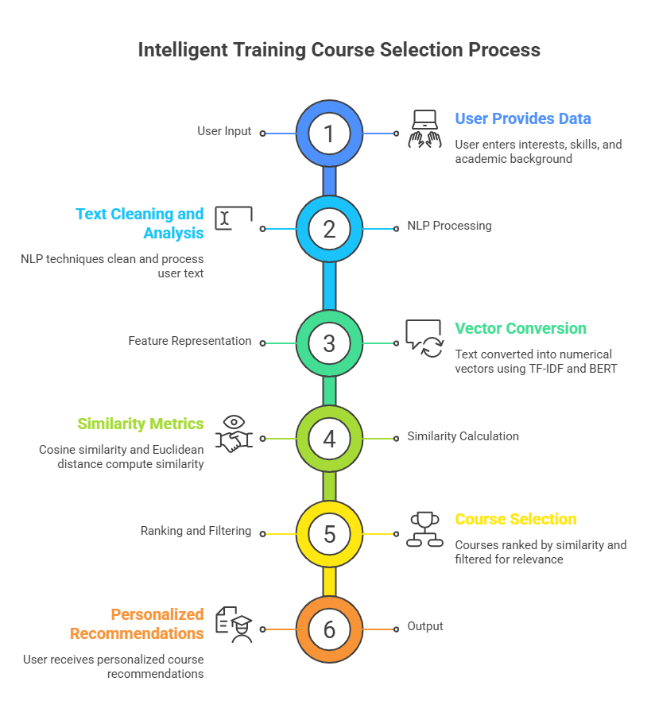

Figure 2 illustrates the overall workflow of the intelligent training course selection process. It shows how stoner input is collected and reused using NLP ways, followed by converting textbook into numerical vectors through point representation styles similar as TF- IDF and BERT. The system also computes similarity using distance criteria, ranks the courses, and generates individualized recommendations.
This process demonstrates a structured and effective channel that transforms stoner textual data into practicable recommendations, enhancing stoner experience and supporting informed decision- timber.
This figure outlines in the general medication of brilliantly preparing course determination. It illustrates how the client gives input in the frame of erudite interface, how the system analyzes this input exercising NLP strategies, and how it produces a positioned list of recommended courses predicated on connection.

The critic accepts that this medication reflects a orderly and productive approach to changing client input into important proposals, in this manner upgrading decision- timber and client involvement. The critic accepts that this medication reflects a orderly and productive approach to changing client input into important proposals, in this manner upgrading decision- timber and client involvement.

2.5 Related Work

Several studies have explored the operation of artificial intelligence- predicated recommendation systems in educational surroundings, reflecting the growing significance of intelligent results in modern knowledge systems.

Akbar et al.( 2023) demonstrated that recommendation systems can enhance decision- making processes and meliorate stoner satisfaction by effectively assaying stoner preferences. This highlights the critical part of understanding stoner interests in perfecting system performance. also, Cha et al.( 2024) showed that AI- rested systems support multiple stages of course selection, including searching, assessing, and final decision- timber, indicating the comprehensive part of AI in guiding addicts throughout the entire process.

In addition, Tani et al.( 2021) emphasized the significance of recommendation systems in supporting lifelong knowledge and aligning educational choices with labor demands. This alignment is essential for perfecting graduates’ readiness for employment. Likewise, Mentec( 2023) stressed the significance of answerable recommendation systems in enhancing stoner trust and limpidity, which are vital factors for adding stoner acceptance of AI- driven results.

Outbalance et al.( 2023) handed a comprehensive review of artificial intelligence ways used ine- learning recommendation systems, offering precious perceptivity into the diversity of being approaches. Likewise, Salim et al.( 2025) mooted recent advancements in substantiated knowledge and linked several exploration gaps in recommendation systems for MOOCs, which supports the need for farther development in this area.

also, Tolety and Prasad( 2022) proposed an cold- pedigreed recommendation system that combines content- rested and cooperative filtering ways, achieving significant advancements in performance and delicacy. This suggests that integrating multiple approaches can enhance system effectiveness. Lops et al.( 2019) also talked over recent trends in content- rested recommendation systems, specifically in homemade representation and explainability, which are directly applicable to this study.

the foundational work of Pazzani and Billsus( 2007) provides the theoretical base for content- rested recommendation systems, supporting the abstract frame of the proposed AIRSS system.

2.6 Summary of Previous Studies
Table 2- 1 presents an structured summary of the most applicable former studies in the field of educational recommendation systems. It highlights the artificial intelligence ways used in each study, along with their vital benefactions and connection to the proposed AIRSS system.
Organizing former studies in a irregular format facilitates clearer comparison and deeper understanding of being approaches. As shown in Table 2- 1, former exploration has employed a wide range of ways, including content- rested filtering, cooperative filtering, crossbred styles, and Natural Language Processing( NLP). These approaches have demonstrated strong effectiveness in perfecting decision- timber, enhancing stoner satisfaction, and supporting individualized knowledge surroundings.
The diversity of these styles reflects the rapid-fire- fire- fire elaboration of recommendation systems and their adding significance in the educational sphere. Several studies emphasize the benefits of combining multiple ways to ameliorate recommendation delicacy, while others concentrate on explainability and limpidity to enhance stoner trust and system acceptance.
Despite these advancements, certain limitations remain. numerous being systems do n't adequately address the specific conditions of university graduates, particularly in aligning recommendations with original labor request conditions. In addition, limited attention has been given to using textual data for generating individualized recommendations.

To address these gaps, the proposed AIRSS system adopts a content- rested recommendation approach supported by NLP ways. It utilizes TF- IDF and BERT for textbook representation, along with analogous measures similar as cosine similarity and Euclidean distance, to give accurate and individualized course recommendations acclimated to stoner interests To address these gaps, the proposed AIRSS system adopts a content- rested recommendation approach supported by NLP ways. It utilizes TF- IDF and BERT for textbook representation, along with analogous measures similar as cosine similarity and Euclidean distance, to give accurate and individualized course recommendations acclimated to stoner interests .

Table (2-1): Summary of Previous Studies Related to Educational Recommendation Systems
# | Reference | Title | Authors | Study Summary | Methodologies / Techniques | Contribution to AIRSS
1 | Akbar et al. (2023) | The Role of Artificial Intelligence-Based Recommendation Systems in Selection of Courses for Students | Akbar, Z.; Sopandi, E.; Badruzzaman, B.; Khalik, M. F. | Examines the role of AI-based recommender systems in supporting course selection, focusing on user satisfaction and decision-making effectiveness. | Quantitative Survey, Descriptive Analysis | Confirms the effectiveness of recommender systems in improving educational decision-making, aligning with AIRSS objectives.
2 | Cha et al. (2024) | The Impact of AI-Based Course-Recommender System on Students’ Course-Selection Decision-Making Process | Cha, S.; Loeser, M.; Seo, K. | Explores how AI-based systems support different stages of decision-making (search, evaluation, selection). | Qualitative Method, Thematic Analysis | Supports AIRSS as an intelligent assistant during evaluation and selection stages.
3 | Tani et al. (2021) | Recommendation Systems and AI Solutions Guiding Open (Life-Long) Learning | Tani, P. et al. | Links recommender systems with lifelong learning and labor market needs. | AI-based Matching, Recommender Systems | Supports AIRSS focus on lifelong learning and career-oriented recommendations.
4 | Mentec (2023) | Explainable Job Recommender Systems for Recruiters and Consulting Companies | Mentec, F. | Focuses on explainable systems and improving user trust and transparency. | NLP, Semantic Similarity, Explainable AI, Advanced Text Representation | Supports explainability and transparency in AIRSS.
5 | Oubalahcen et al. (2023) | The Use of AI in E-Learning Recommender Systems: A Comprehensive Survey | Oubalahcen, H.; Tamym, L.; El Ouadghiri, M. D. | Provides a comprehensive survey of AI techniques in e-learning systems. | AI Techniques, NLP, Deep Learning Models (e.g., BERT) | Supports integration of advanced NLP and BERT in AIRSS.
6 | Tolety & Prasad (2022) | Hybrid Content and Collaborative Filtering Based Recommendation System for E-Learning Platforms | Tolety, V. B. P.; Prasad, E. V. | Proposes a hybrid recommender combining content-based and collaborative filtering. | TF-IDF, Content-Based Filtering, Collaborative Filtering, Text Representation | Supports hybrid and content-based design used in AIRSS.
7 | Salim et al. (2025) | Advancements in Personalized Learnieng: A Systematic Review of Recommendation Systems in MOOCs | Salim, A. I. M. et al. | Reviews personalized recommender systems and identifies research gaps. | PRISMA, Content-Based, Hybrid Approaches | Supports personalization and highlights gaps addressed by AIRSS.
8 | Mallik & Gangopadhyay (2023) | Proactive and Reactive Engagement of Artificial Intelligence Methods for Education | Mallik, S.; Gangopadhyay, A. | Reviews AI applications in education across different learning stages. | Literature Review | Provides theoretical support for integrating AI in AIRSS.
9 | Lops et al. (2019) | Trends in Content-Based Recommendation | Lops, P.; Jannach, D.; Musto, C.; Bogers, T.; Koolen, M. | Discusses trends in content-based systems including text representation. | Text Representation, NLP, Explainable Recommendation Systems | Supports use of NLP and BERT in AIRSS.
10 | Pazzani & Billsus (2007) | Content-Based Recommendation Systems | Pazzani, M. J.; Billsus, D. | Provides foundational concepts of content-based recommendation systems. | Conceptual Models | Provides theoretical foundation for AIRSS design.
11 | Stewart (2023) | Evaluating Organizational Success of an AI-Based Recommender System at a Higher Education Institution | Stewart, C. P. | Eevaluates recommender systems using organizational success metrics. | Mixed Methods, Delone & McLean IS Success Model | Supporrts evaluation and user satisfaction in AIRSS.

Table 2- 1 presents a relative summary of former studies in the field of educational recommendation systems. It highlights the methodologies used, including content- predicated filtering, cold- thoroughbred approaches, and Natural Language Processing ways analogous as TF- IDF and BERT. The table also demonstrates how these studies contribute to the development of the proposed AIRSS system, particularly in perfecting personalization, delicacy, and decision- timber.
  - Comparative Analysis:

This section presents a relative analysis of the most applicable studies in the field of AI- rested recommendation systems, particularly those applied in educational surroundings. The comparison focuses on vital aspects similar as the type of study, datasets used, methodologies and algorithms applied, and the main benefactions of each work.

Conducting such a comparison is essential for furnishing a structured understanding of being exploration sweats. It offers a clear overview of different approaches and highlights the diversity of ways used in developing recommendation systems.

The purpose of this analysis is to identify the strengths and limitations of former studies and to clarify how they differ from the proposed AIRSS system. By examining these aspects, the study highlights gaps in the literature, particularly in terms of personalization, contextual adaption, and the use of advanced textbook representation ways similar as BERT.

likewise, this comparison emphasizes the significance of integrating multiple ways, including Natural Language Processing( NLP), TF- IDF, BERT, and similarity measures similar as cosine similarity and Euclidean distance, to meliorate recommendation delicacy and conclusiveness.

Table 2-2: Comparative Analysis of Previous Studies and Proposed AIRSS System
Study | Type | Dataset | Method / Algorithm | Key Contribution
Study 1 | Survey Study | Questionnaire (20 students) | General AI-based Recommendation System | Demonstrated student satisfaction and trust in recommendation systems
Study 2 | Survey + Interview | 24 students | AI-based Recommendation System (Conceptual) | Highlighted the importance of user interaction in course selection
Study 3 | Applied System | ESCO + Course Data | NLP + Decision Tree | Matched user skills with suitable courses for career development
Study 4 | Applied System | Resume + Job Dataset | Embedding + Cosine Similarity | Improved job candidate matching using similarity techniques
Study 5 | Review Study | Multiple datasets | Machine Learning (ML) & Deep Learning (DL) | Reviewed AI techniques used in e-learning recommendation systems
Study 6 | Hybrid System | Student Activity Data | Collaborative Filtering + Content-Based + TF-IDF | Improved recommendation accuracy by combining multiple approaches
Study 7 | Systematic Review | MOOC Platforms | Hybrid Methods + Behavioral Analysis | Enhanced learner engagement and course completion rates
Study 8 | Review Study | Educational Data | Machine Learning Models | Applied AI techniques to support decision-making in education
Study 9 | Review Study | Multimedia datasets | Content-Based + Deep Learning | Introduced advanced recommendation techniques using rich data
Study 10 | Theoretical Study | Item datasets | TF-IDF + Vector Space Models | Provided foundational understanding of content-based recommendation
Study 11 | Evaluation Study | Student Survey | AI + Statistical Models | Evaluated system performance and user satisfaction
AIRSS (Proposed) | Applied System | Course Dataset (Kaggle) | TF-IDF + BERT + Cosine Similarity + Euclidean Distance | Provides accurate and personalized course recommendations based on user interests and semantic understanding

Table 2- 2 presents a relative analysis of former studies and the proposed AIRSS system grounded on pivotal aspects analogous as study type, dataset, methodologies, and contributions.

As shown in the table, utmost former studies have concentrated on traditional approaches similar as content- rested filtering, cooperative filtering, or crossbred styles. These approaches have demonstrated effectiveness in perfecting recommendation delicacy and supporting decision- making processes. still, numerous of these systems calculate on limited stoner data or leave deep semantic understanding of textual information.

In addition, several studies emphasize the significance of personalization, stoner commerce, and explainability in recommendation systems. Despite these advancements, there's still a gap in integrating advanced textbook representation models with similarity- rested ways to achieve advanced delicacy and contextual understanding.

The proposed AIRSS system addresses these limitations by combining TF- IDF and BERT for textbook representation with similarity measures similar as cosine similarity and Euclidean distance. This integration enables the system to capture both keyword- rested and semantic connections, performing in more accurate and individualized course recommendations.

thus, AIRSS provides a more comprehensive and effective approach compared to former systems, particularly in handling textual data and aligning recommendations with stoner interests and career pretensions.

2.8 Study Gap

Despite the rapid-fire- fire- fire development of recommendation systems, several limitations still live in current approaches.

First, the systems primarily concentrate on scholars within academic surroundings, with limited attention given to university graduates and their specific conditions in concluding suitable training courses aligned with their career paths.

Alternate, there's a lack of recommendation systems specifically acclimated to the Saudi terrain, particularly in relation to original labor request conditions and artistic considerations.

Third, the use of Natural Language Processing( NLP) for assaying user interests and textual data remains limited in multitudinous being systems, which reduces the capability to induce accurate and meaningful recommendations.

ultimately, multitudinous systems warrant explainability and advanced personalization capabilities, making it delicate for stoners to understand and trust the recommendations handed.

To address these gaps, this study proposes an intelligent recommendation system( AIRSS) that leverages NLP ways, including TF- IDF and BERT, along with similarity measures analogous as cosine similarity and Euclidean distance. The system aims to give accurate, substantiated, and soluble course recommendations predicated on stoners’ textual inputs.

2.9 Summary
This chapter presented the theoretical foundation of Artificial Intelligence( AI), recommendation systems, and Natural Language Processing( NLP). It also reviewed applicable former studies and linked the disquisition gaps addressed by this study.
The analysis of former work stressed the need for further substantiated, terrain-alive recommendation systems that concentrate on university graduates and effectively use textual data. In addition, it emphasized the significance of integrating advanced ways similar as deep knowledge models and similarity- rested approaches to meliorate recommendation quality.
rested on these findings, the proposed AIRSS system was introduced as a result that combines textbook representation styles, including TF- IDF and BERT, with similarity measures similar as cosine similarity and Euclidean distance to induce accurate and individualized recommendations.
The coming chapter presents the proposed methodology, including data preprocessing, point birth, and similarity calculation, along with the performance details of the recommendation process.
******************

Chapter 03

Proposed Approach (Methodology)

3.1 Introduction

This chapter presents the methodology used to develop the proposed AI- predicated recommendation system( AIRSS) for concluding suitable training courses.

A structured and regular approach is espoused to ensure the effectiveness and responsibility of the system. The chapter outlines the pivotal stages involved in erecting the recommendation system, including data preprocessing, point birth, similarity computation, and the recommendation generation process.

In particular, the system leverages Natural Language Processing( NLP) ways to exercise textual data and convert it into meaningful representations. Point birth is performed using styles analogous as TF- IDF and BERT, while similarity is reckoned using measures analogous as cosine similarity and Euclidean distance.

fluently defining these way contributes to perfecting system performance and achieving accurate and personalized recommendations. Integrating these factors within a unified frame enhances the system’s capability to anatomize user inputs and induce applicable recommendations aligned with user interests and career pretensions.

3.2 System Overview

The proposed AIRSS system is designed to recommend suitable training courses by assaying stoner input and comparing it with course data stored in the dataset.

The recommendation process consists of the following main stages
- The stoner provides input in the form of interests, chops, or preferences.
- The input textbook is preprocessed and converted into a suitable format.
- point birth is performed using textbook representation ways similar as TF- IDF and BERT.
- The similarity between the stoner input and course descriptions is reckoned using cosine similarity and Euclidean distance.
- The system generates and displays the top recommended courses( Top- N).

Figure 3 illustrates the overall workflow of the proposed AIRSS system. The process begins with stoner input, followed by textbook preprocessing. The system also applies TF- IDF and BERT for point birth and computes similarity using cosine similarity and Euclidean distance to measure the applicability between stoner input and course descriptions. Eventually, the system generates substantiated course recommendations grounded on similarity scores.

Figure 3: AIRSS System Workflow
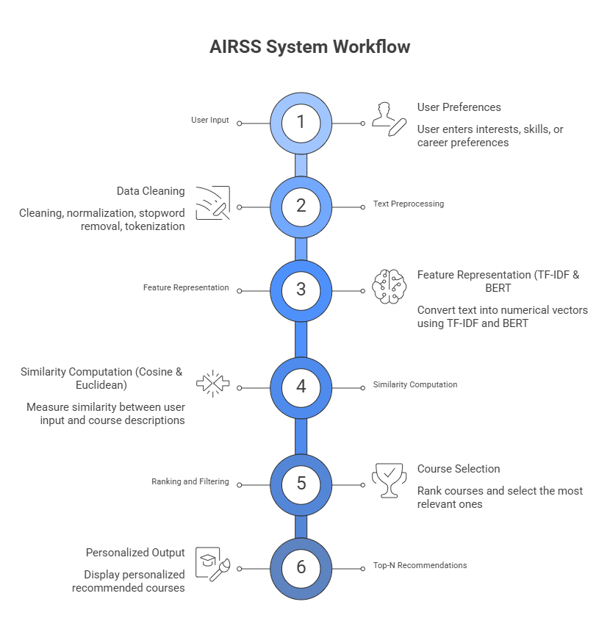

Figure 3 illustrates the workflow of the proposed AIRSS system. The process begins with stoner input, followed by textbook preprocessing and point representation using TF- IDF and BERT. The system also computes similarity using cosine similarity and Euclidean distance, ranks the courses, and eventually generates substantiated Top- N recommendations.

3.3 Dataset Description

The proposed AIRSS system is erected using a dataset that contains information about training courses. The dataset was precisely preprocessed to insure its felicity for analysis and recommendation tasks.

The dataset includes the following crucial attributes
- Course ID A unique identifier for each course
- Description Detailed textual description of the course content
- Category The main order or field of the course
- Tags: Keywords associated with each course
- Cleaned Text Fields Preprocessed performances of the description, order, and markers( e.g., description_clean, category_clean, tags_clean)
- Combined Text A unified textbook representation created by incorporating applicable fields, used for point birth
- Similarity Scores reckoned values used to measure the applicability between stoner input and course descriptions for ranking recommendations

This dataset forms the foundation of the AIRSS system, where textual data is anatomized using Natural Language Processing( NLP) ways to match stoner interests with applicable training courses. The use of combined textual features enhances the system’s capability to induce accurate and individualized recommendations.

3.4 Data Preprocessing

To ameliorate the quality of the textual data and insure its felicity for analysis, several preprocessing way were applied before point birth.

The main preprocessing way include
- Removing punctuation and special characters barring gratuitous symbols that do n't contribute to the meaning of the textbook
- Converting textbook to lowercase homogenizing textbook to insure thickness during processing
- Removing stopwords barring common words( e.g., “ the ”, “ and ”) that do n't add significant value
- drawing inapplicable or noisy data Removing gratuitous or indistinguishable information to ameliorate data quality
- Tokenization Splitting textbook into individual words or commemoratives for farther processing

These preprocessing way help in transubstantiating raw textual data into a clean and structured format, which enhances the effectiveness of point birth ways similar as TF- IDF and BERT. As a result, the system becomes further able of generating accurate and meaningful recommendations.

3.5 Feature Extraction Using TF-IDF
The TF- IDF( Term frequence – Inverse Document frequence) fashion was used to convert textual data into numerical representations grounded on the significance of words within a document relative to the entire dataset.
TF\text{-}IDF(t,d) = TF(t,d) \times IDF(t)
Where
TF( Term frequence) Measures how constantly a term appears in a document
IDF( Inverse Document frequence) Measures the significance of a term across the dataset
This fashion assigns advanced weights to important words that appear constantly in a specific document but are less common across other documents. As a result, TF- IDF helps in relating the most applicable terms for representing course descriptions.
In this study, TF- IDF is applied to the combined textual data( e.g., description, order, and markers) to induce point vectors that represent each course. These vectors are latterly used in similarity calculations to match stoner input with applicable courses.

Figure 4: Text Representation Using TF-IDF
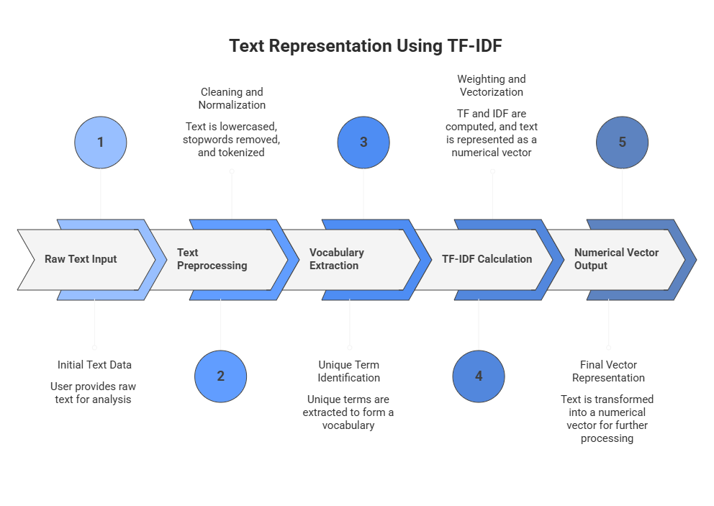

Figure 4 illustrates the process of converting textual data into numerical vectors using TF- IDF. The process begins with raw text input, followed by preprocessing way analogous as drawing and tokenization. also, a vocabulary of unique terms is pulled, and TF- IDF weights are calculated. ultimately, the text is represented as a numerical vector, which is used for similarity computation in the recommendation system.

3.6 Feature Extraction Using BERT

In addition to TF- IDF, the proposed AIRSS system utilizes BERT( Bidirectional Encoder Representations from Mills) as an advanced fashion for textbook representation.

BERT is a deep literacy model developed for Natural Language Processing( NLP) tasks, which is able of understanding the contextual meaning of words within a judgment . Unlike traditional styles similar as TF- IDF, which calculate on word frequence, BERT captures semantic connections by considering the environment in which words appear.

In this study, BERT is applied to the combined textual data( including course descriptions, orders, and markers) to induce thick vector representations, appertained to as embeddings. These embeddings render the semantic meaning of the textbook, allowing the system to more understand stoner input and course content.

The metamorphosis performed by BERT can be conceptually represented as

E=BERT(T)

Where

T represents the input textbook

E represents the performing embedding vector

The use of BERT enhances the system’s capability to identify meaningful parallels between stoner preferences and course descriptions, indeed when different words with analogous meanings are used. This significantly improves the delicacy and applicability of the recommendations generated.

By integrating both TF- IDF and BERT, the AIRSS system benefits from combining keyword- grounded representation with deep semantic understanding, performing in a more robust and effective recommendation process.

Figure 5: Text Representation Using BERT

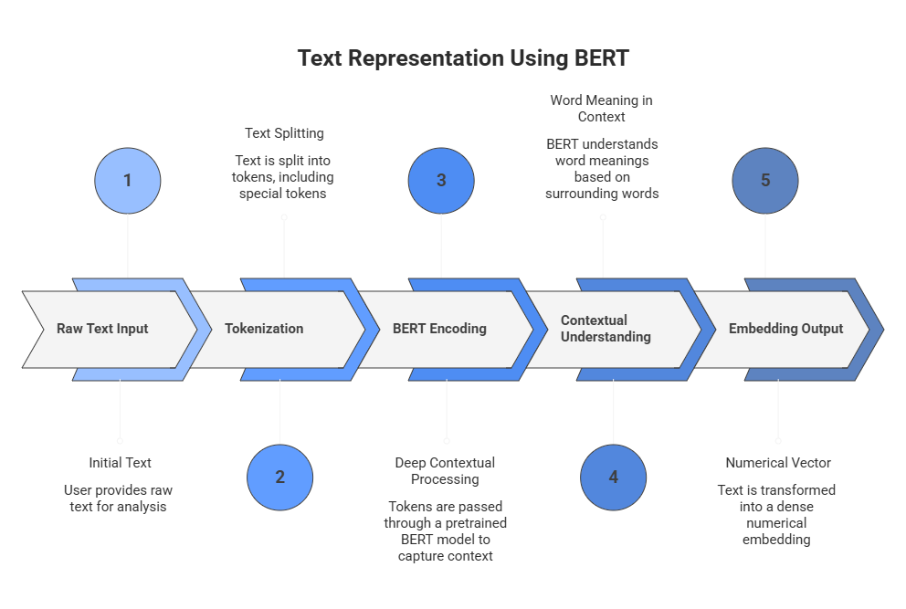

Figure 5 illustrates the process of transubstantiating textual data into contextual embeddings using BERT. The process begins with tokenizing the input textbook, followed by passing the commemoratives through a pretrained BERT model. BERT captures the contextual meaning of words using multiple layers, generating thick vector representations that render semantic information. These embeddings are also used for similarity calculation in the recommendation system.

3.7 Similarity Computation
Similarity Computation is a fundamental step in the AIRSS system, as it measures the degree of similarity between user input and course representations. This process enables the system to identify the most applicable training courses predicated on user interests.
In this study, two similarity dimension ways are used cosine similarity and Euclidean distance.
Cosine similarity measures the similarity between two vectors by calculating the cosine of the angle between them. It's particularly effective for textual data, as it focuses on the direction of the vectors rather than their magnitude.
Cosine Similarity
$$\text{Cosine Similarity}=\frac{A⋅B}{∥A∥×∥B∥}$$
Where
$A$and $B$represent vector representations of user input and course data
On the other hand, Euclidean distance measures the distance between two vectors in a multidimensional space. Smaller distances indicate higher similarity between the compared texts.
$$d(A,B)=\sqrt{\sum_{i=1}^{n}{(}A_{i}-B_{i})^{2}}$$
By combining both cosine similarity and Euclidean distance, the system enhances its capability to directly measure similarity and induce further dependable recommendations.

3.8 Recommendation Mechanism

The recommendation medium in the proposed AIRSS system follows a structured and methodical process to induce substantiated course recommendations grounded on stoner input.

The medium integrates multiple factors, including textbook preprocessing, point representation, similarity calculation, and ranking, to insure accurate and applicable recommendations.

The process can be epitomized as follows
- The stoner provides input in the form of interests, chops, or career preferences.
- The input textbook is preprocessed to remove noise and regularize the data.
- The reused textbook is converted into numerical representations using both TF- IDF and BERT, landing both keyword- grounded and semantic features.
- Similarity scores are reckoned between the stoner input and course descriptions using cosine similarity and Euclidean distance.
- The courses are ranked in descending order grounded on their similarity scores.
- The system generates and displays the Top- N most applicable course recommendations to the stoner.
- The final stage of the recommendation mechanism involves opting the Top- N courses with the loftiest similarity scores, icing that the recommendations are largely applicable, substantiated, and aligned with the stoner’s interests and career pretensions.

By combining traditional statistical styles with advanced deep literacy ways, the AIRSS system achieves a more robust and effective recommendation process compared to conventional approaches.

3.9 System Implementation

The proposed AIRSS system was enforced using a set of extensively used programming tools and libraries to insure effectiveness, scalability, and ease of development.

The perpetration terrain includes the following factors
- Python programming language for developing the system sense and integrating all factors
- Scikit- learn library for enforcing TF- IDF vectorization and similarity calculations
- Mills( BERT) for generating contextual textbook embeddings and enhancing semantic understanding
- Pandas library for data manipulation and preprocessing
- NumPy library for numerical calculations
- Streamlit frame for erecting an interactive stoner interface

These tools were integrated to develop an effective and interactive system able of recycling stoner input, performing advanced textbook analysis, and generating accurate and individualized course recommendations.

3.10 Summary
This chapter presented the methodology used to develop the proposed AIRSS system. It described the main stages of the system, starting from data preprocessing, followed by point birth using TF-IDF and BERT, and the operation of similarity measures analogous as cosine similarity and Euclidean distance to estimate the relationship between user input and course descriptions.
The chapter also explained the recommendation medium and system performance. The system relies on preprocessed textual data, which improves effectiveness and reduces response time when generating personalized recommendations.
Overall, the integration of traditional text representation ways with advanced deep knowledge models enhances the system’s capability to deliver accurate, applicable, and terrain-alive course recommendations.
************

Chapter 04

Experimental Results and Discussion

4.1 Introduction
This chapter presents the experimental results of the proposed AI- grounded recommendation system (AIRSS). It evaluates the system’s performance in generating applicable and individualized course recommendations grounded on stoner input.
The chapter also examines the effectiveness of the applied ways, including TF- IDF and BERT for textbook representation, as well as cosine similarity and Euclidean distance for measuring similarity. These styles are anatomized to determine their impact on perfecting recommendation delicacy and applicability.
likewise, this chapter provides perceptivity into the system’s geste.
, compares the performance of different models, and discusses the overall effectiveness of the proposed approach.

4.2 Experimental Setup

The AIRSS system was enforced using Python and estimated within a Jupyter Tablet terrain. The system was also stationed using Streamlit to give an interactive stoner interface for testing and demonstration.

The dataset used in this study consists of preprocessed course descriptions along with their corresponding textual representations, including gutted textbook and combined features.

The following tools and libraries were used
- Python programming language
- Scikit- learn for TF- IDF vectorization and similarity calculations
- Mills( BERT) for generating contextual embeddings
- Pandas for data manipulation and preprocessing
- NumPy for numerical calculations
- Matplotlib for visualization
- Streamlit for erecting the stoner interface

The trials were conducted by furnishing different stoner inputs and assessing the generated course recommendations using both TF- IDF and BERT- grounded models.

4.3 Evaluation Metrics

To estimate the performance of the recommendation system, multiple evaluation criteria were used to measure the delicacy and effectiveness of the generated recommendations.

In this study, similarity measures similar as cosine similarity and Euclidean distance are used to cipher the applicability between stoner input and course descriptions.

In addition, the system performance is estimated using standard criteria , including
- Precision Measures the proportion of applicable recommended courses out of all recommended courses .
- Recall Measures the proportion of applicable courses that were successfully recommended
- F1- Score Represents the harmonious mean of perfection and recall
- Cosine similarity plays a crucial part in ranking the courses by measuring the similarity between stoner input vectors and course vectors. Advanced similarity values indicate stronger applicability.

The final recommendations are ranked grounded on similarity scores, where the loftiest- ranked courses are considered the most applicable.

4.4 System Interface
The AIRSS system provides an interactive and stoner-friendly interface developed using Streamlit, allowing druggies to input their academic background, interests, and chops in order to admit substantiated course recommendations.
The system enables druggies to elect from multiple recommendation models through a unified interface. These models include combinations of textbook representation ways and similarity measures, videlicet TF- IDF Cosine, TF- IDF Euclidean, BERT Cosine, and BERT Euclidean. This inflexibility allows druggies to compare the performance of different approaches within the same terrain.

Figure 6 Model Selection Interface
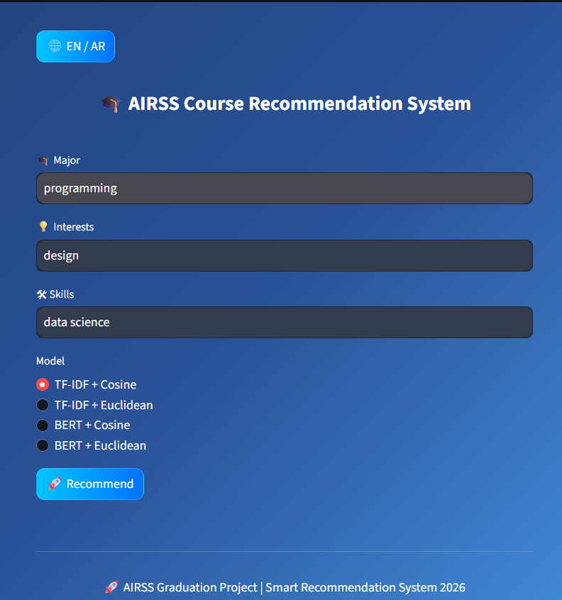
Figure 6 shows the main interface of the AIRSS system, where druggies can enter their major, interests, and chops, and elect one of the four available recommendation models before generating recommendations.

After submitting the input, the system processes the data and generates a ranked list of recommended courses grounded on similarity scores, where the most applicable courses appear at the top. Figure 6 shows the main interface of the AIRSS system, where druggies can enter their major, interests, and chops, and elect the recommendation model( TF- IDF or BERT) before generating recommendations.

After submitting the input, the system processes the data and generates a ranked list of recommended courses grounded on similarity scores.

Figure 7 TF-IDF + Cosine Recommendation Results

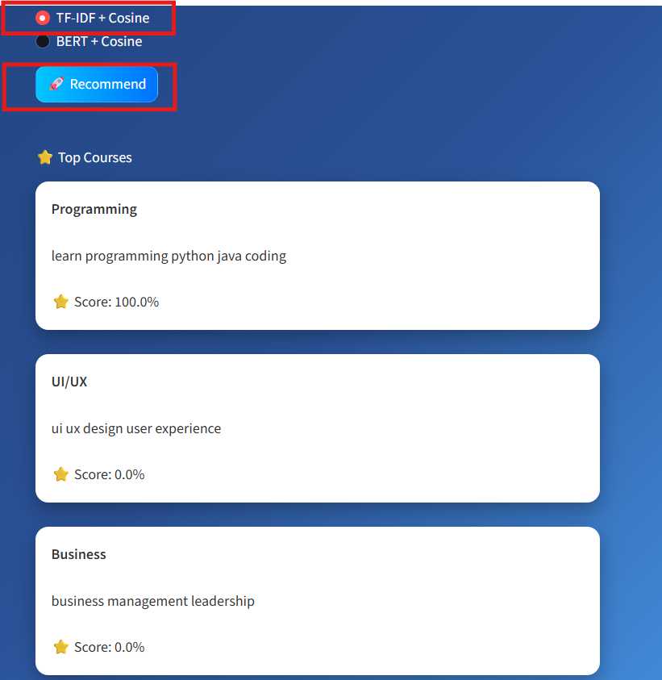

Figure 7 illustrates the recommendation results using the TF- IDF model, where the system provides a list of courses ranked according to similarity scores.

Figure 8 BERT + Cosine Recommendation Results

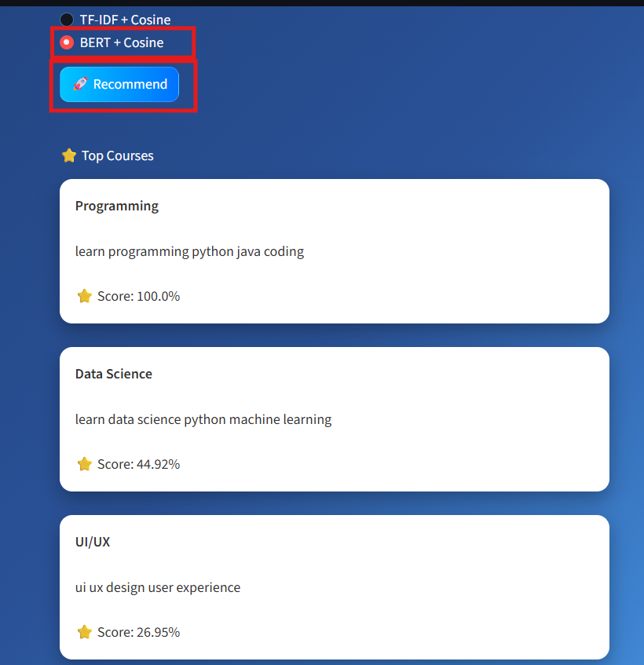 Figure 8 presents the recommendation results using the BERT model, which captures deeper semantic connections and provides farther terrain-alive recommendations.

The interface displays the recommended courses along with their corresponding similarity scores, enabling stoners to easily understand and estimate the connection of each recommendation. Figure 9 TF- IDF Euclidean Recommendation Results



Figure 9 illustrates the recommendation results generated using the TF- IDF Euclidean Distance model. The system computes the distance between the user input vector and course description vectors, also converts these distances into similarity scores to rank the courses.

The results show that the system is suitable to identify applicable courses predicated on keyword matching, where courses sharing similar terms with the user input achieve higher ranking positions.

still, compared to semantic- predicated models, this approach mainly relies on the frequency and circumstance of words rather than contextual meaning. Despite this limitation, the model provides clear and interpretable recommendations, making it suitable for birth comparison.

Figure 10: BERT + Euclidean Recommendation Results

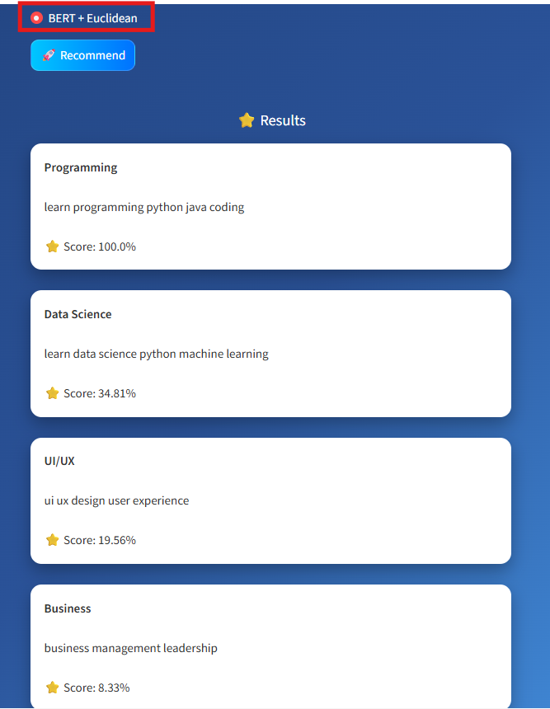

Figure 10 presents the recommendation results generated using the BERT Euclidean Distance model. In this approach, BERT is used to produce contextual embeddings that capture the semantic meaning of both user input and course descriptions.

The system also computes the Euclidean distance between these embeddings and converts the distances into similarity scores in order to rank the courses. As shown in the figure, the most applicable course( “ Programming ”) achieves the topmost score, followed by other related courses analogous as “ Data Science ” and “ UI/ UX ”.

These results demonstrate the effectiveness of combining deep semantic representation with distance- predicated similarity, enabling the system to give farther meaningful and terrain-alive recommendations compared to traditional styles.

4.5 Results and Discussion

• The experimental results demonstrate that the proposed AIRSS system effectively generates ranked course recommendations rested on stoner input.

• The system was estimated using different inputs representing addicts’ interests, chops, and academic background. rested on these inputs, the system successfully produced a list of recommended courses ranked according to similarity scores.

• As shown in numbers 7, 8, 9, and 10, the system is suitable of relating applicable courses that align with stoner preferences. For illustration, when the stoner input includes terms similar as programming, design, and data wisdom, the system recommends courses related to these areas with advanced similarity scores.

• The TF- IDF- rested models induce recommendations rested on keyword matching, furnishing results that reflect term frequence within the textbook. still, these models may be limited in landing deeper semantic connections.

• In distinction, the BERT- rested models demonstrate bettered performance by landing contextual and semantic meanings of words. This enables the system to recommend further applicable courses, indeed when exact keywords are n't explicitly present.

• Regarding similarity measures, Cosine Similarity evaluates the angle between vectors, making it effective for high- dimensional textbook data, while Euclidean Distance measures the distance between vectors and is converted into similarity scores for ranking purposes.

• The results indicate that combining different textbook representation ways( TF- IDF and BERT) with multiple similarity measures( Cosine and Euclidean) enhances the system’s harshness and evaluation capability. In particular, the BERT- rested models, especially when combined with Euclidean Distance, give further terrain-alive and meaningful recommendations.

still, several limitations were observed

• The system primarily relies on textual similarity

• It does n't incorporate stoner history or behavioral data

• It does n't consider stoner feedback or former relations

• The system may perform less effectively when the input textbook is truly short

Despite these limitations, the AIRSS system provides an effective and practical result for course recommendation. The integration of traditional styles and deep knowledge models contributes to perfecting recommendation delicacy and overall system performance.

4.6 Model Comparison

The performance of different recommendation models was anatomized to estimate their effectiveness in generating applicable course recommendations.

Four models were compared, including TF- IDF Cosine, TF- IDF Euclidean, BERT Cosine, and BERT Euclidean.

The results show that TF- IDF- rested models calculate on keyword matching, which limits their capability to capture semantic connections. As a result, these models produce lower different recommendations.

In distinction, BERT- rested models demonstrate better performance by landing contextual and semantic meanings, leading to more accurate and meaningful recommendations.

Likewise, Euclidean distance provides a wider distribution of similarity scores compared to cosine similarity, which improves the diversity of recommended courses.

Among all models, BERT Euclidean achieved the voguish overall performance due to its capability to combine semantic understanding with effective similarity dimension.

Table 4-3: Comparison of Recommendation Models Performance
Model | Performance | Interpretation
TF-IDF + Cosine | Moderate | Keyword-based
TF-IDF + Euclidean | Moderate | Limited understanding
BERT + Cosine | High | Good semantic understanding
BERT + Euclidean | Very High | Best overall performance

4.7 Summary
This chapter presented the experimental results and estimated the performance of the proposed AIRSS system. The results demonstrated the effectiveness of the system in generating applicable and individualized course recommendations rested on stoner input.
The chapter also anatomized the performance of different ways, including TF- IDF and BERT for textbook representation, as well as Cosine Similarity and Euclidean Distance for similarity dimension. In addition, a relative analysis of different models was conducted to assess their effectiveness in recommendation tasks.
The comparison results showed that BERT- rested models outperform TF- IDF- rested models due to their capability to capture semantic and contextual connections. Among all estimated approaches, BERT combined with Euclidean Distance achieved the voguish overall performance, furnishing more accurate, different, and meaningful recommendations.
Overall, the results confirm that the proposed AIRSS system provides an effective and effective result for course recommendation. The coming chapter concludes with the study and presents recommendations for unborn work.

Chapter 05

Conclusion and Future Work

5.1 Conclusion

• This study presented the design and performance of an AI- rested recommendation system( AIRSS) for concluding suitable training courses rested on stoner interests, chops, and career preferences.

• The proposed system utilizes Natural Language Processing( NLP) ways to dissect textual data and induce individualized recommendations. The methodology includes preprocessing textual data, converting it into numerical representations using TF- IDF and BERT, and calculating similarity scores using Cosine Similarity and Euclidean Distance.

• The experimental results demonstrated the effectiveness of the proposed system in generating applicable and meaningful course recommendations. The system was suitable to successfully match stoner input with applicable training courses and rank them rested on similarity scores.

• A relative analysis between different models showed that while TF- IDF provides effective keyword- rested recommendations, BERT significantly improves the system’s capability to capture semantic connections and deliver further terrain-alive suggestions.

• likewise, the integration of multiple similarity measures revealed that combining BERT with Euclidean Distance achieved the voguish overall performance in terms of recommendation connection and diversity.

• Overall, the AIRSS system achieves its ideal of perfecting the course selection process by furnishing substantiated, accurate, and data- driven recommendations. The integration of traditional textbook representation ways with advanced deep knowledge models enhances both the performance and usability of the system.

5.2 Future Work

Although the proposed AIRSS system has achieved promising results, several advancements can be considered for future development.

First, the system can be enhanced by incorporating user commerce data, where user inputs, feedback, and ginger

are stored and used to meliorate future recommendations. This would enable the system to learn from formerly user relations and give farther adaptive and accurate suggestions.

Alternate, further advancements can be achieved by optimizing and fine- tuning advanced models analogous as BERT, or integrating more recent motor- predicated architectures to enhance semantic understanding and recommendation delicacy.

Third, incorporating user lives, preferences, and nonfictional commerce data would allow the system to deliver further personalized and terrain-alive recommendations adapted to individual stoners.

Also, expanding the dataset to include a further different and real- world collection of training courses( e.g., from platforms analogous as Kaggle or real educational providers) would meliorate the robustness and conception capability of the system.

Likewise, espousing cold- thoroughbred recommendation approaches that combine content- predicated filtering and collaborative filtering could further enhance recommendation performance.

Also, future work may explore advanced evaluation strategies and fresh similarity measures to further anatomize and meliorate system performance.

ultimately, planting the system as a fully functional web or mobile operation would enable real- time user commerce and meliorate vacuity and usability.

************

References
Akbar, Z., Sopandi, E., Badruzzaman, B., & Khalik, M. F. (2023).
The role of artificial intelligence-based recommendation systems in selection of courses for students. Journal of Social Science Utilizing Technology, 1(4), 249–260.
https://doi.org/10.70177/jssut.v1i4.671
Cha, S., Loeser, M., & Seo, K. (2024).
The impact of AI-based course-recommender system on students’ course-selection decision-making process. Applied Sciences, 14(9), 3672.
https://doi.org/10.3390/app14093672
Lops, P., Jannach, D., Musto, C., Bogers, T., & Koolen, M. (2019).
Trends in content-based recommendation. User Modeling and User-Adapted Interaction, 29(2), 239–273.
https://doi.org/10.1007/s11257-019-09231-w
Mallik, S., & Gangopadhyay, A. (2023).
Proactive and reactive engagement of artificial intelligence methods for education: A review. Frontiers in Artificial Intelligence, 6, 1151391.
https://doi.org/10.3389/frai.2023.1151391
Mentec, F. (2023).
Explainable job recommender systems for recruiters and consulting companies (Doctoral dissertation, Université de Rennes).
https://theses.hal.science/tel-04108901
Oubalahcen, H., Tamym, L., & El Ouadghiri, M. D. (2023).
The use of AI in e-learning recommender systems: A comprehensive survey. Applied Sciences, 14(8), 3672.
https://doi.org/10.3390/app14083672
Pazzani, M. J., & Billsus, D. (2007).
Content-based recommendation systems. In P. Brusilovsky, A. Kobsa, & W. Nejdl (Eds.), The adaptive web (pp. 325–341). Springer.
https://doi.org/10.1007/978-3-540-72079-9_10
Salim, A. I. M., et al. (2025).
Advancements in personalized learning: A systematic review of recommendation systems in MOOCs. Education and Data Technologies.
https://doi.org/10.1007/s10639-025
Stewart, C. P. (2023).
Evaluating organizational success of an AI-based recommender system at a higher education institution. Journal of Applied Research in Higher Education, 15(1), 143–164.
Tani, P., Huttunen, S., Ahokallio-Leppälä, H., Moisio, A., Ruotsalainen, T., & Toukkari, P. (2021).
Recommendation systems and AI solutions guiding open (life-long) learning. In ICERI2021 Proceedings (pp. 2397–2402).
https://doi.org/10.21125/iceri.2021.0598
Tolety, V. B. P., & Prasad, E. V. (2022).
Hybrid content and collaborative filtering-based recommendation system for e-learning platforms. Procedia Computer Science, 171, 1765–1774.
https://doi.org/10.1016/j.procs.2020.04.189
*****************

