

An AI-Based Early Warning System for Academic Risk Prediction Using Machine Learning and Learning Management System Data
Marya Mohammed Bawazir
ORCID: 253000692
Master of Science in Artificial Intelligence
College of Informatics, Midocean University, UAE
Email: 253000692@st.midocean.edu.km
Hala Haytham Hajjar
ORCID: 253001456
Master of Science in Artificial Intelligence
College of Informatics, Midocean University, UAE
Email: 253001456@st.midocean.edu.km
Supervisor
Dr. Hager Saleh
College of Informatics
Midocean University, Comoros

Abstract
Early identification of students at academic risk has become a critical challenge for institutions to improve learning outcomes, provide timely academic intervention, and increase student retention. This study proposes an Artificial Intelligence (AI)-Based Early Warning System for predicting students' academic performance using the educational data extracted from a Private Learning Management System (LMS). The proposed framework consists of 1,395 student records described by 17 educational attributes, where students were classified into four academic performance categories: Excellent, Good, Pass, and Fail. The proposed methodology integrates data preprocessing, Random Forest (RF)-based feature selection, class balancing using the Synthetic Minority Oversampling Technique (SMOTE), supervised machine learning algorithms, and Grid Search for hyperparameter optimization. Four experimental configurations were designed to investigate the individual and combined effects of feature selection and class balancing on prediction performance. Eight supervised machine learning algorithms, including traditional and ensemble learning models, were comparatively evaluated using Accuracy, Precision, Recall, F1-score, and Confusion Matrix analysis. The experimental results demonstrated that Extreme Gradient Boosting (XGBoost) achieved the highest predictive performance among all evaluated models, reaching an accuracy of 82.80%, with corresponding precision, recall, and F1-score values of 82.63%, 82.80%, and 82.42%. Furthermore, RF based on feature selection effectively reduced data dimensionality while maintaining competitive predictive performance, whereas SMOTE improved minority-class recognition and enhanced the robustness of several classifiers. The proposed AI-Based Early Warning System provides an effective decision-support tool for identifying academically at-risk students at an early stage, enabling timely intervention and evidence-based educational decision-making. Future research should investigate explainable artificial intelligence techniques, deep learning models, and real-time learning analytics to further enhance prediction accuracy and personalized educational support.
Keywords: Academic Risk Prediction, Early Warning System, Machine Learning (ML), Learning Management System, XGBoost.

1.Introduction
Artificial Intelligence (AI) transformed modern education by enabling data-driven approaches that improve learning outcomes and support educational decision-making. The widespread adoption of Learning Management Systems (LMSs) has generated a large volume of educational data describing students’ academic performance, assessment results, learning behavior, and engagement activities. These data provide valuable opportunities for developing intelligent systems capable of supporting early academic intervention.
Predicting students’ academic performance has become an important research topic in higher education. Traditional evaluation methods often identify academically at-risk students only after poor performance has occurred, limiting the effectiveness of intervention strategies. Consequently, machine learning techniques have been increasingly employed to analyze educational data and provide early predictions that assist instructors and academic advisors in supporting students before academic failure occurs.
Although previous studies have reported promising results, several challenges remain. Many existing approaches evaluate a limited number of machine learning algorithms or investigate only a single preprocessing technique without considering the combined impact of feature selection, class balancing, and hyperparameter optimization. In addition, comprehensive comparisons between traditional and ensemble learning models using real-world LMS data are still limited.
To address these challenges, this study proposes an AI-Based Early Warning System for predicting students’ academic risk using educational data extracted from a Learning Management System. The proposed framework integrates data preprocessing, Random Forest-based feature selection, class balancing using the Synthetic Minority Oversampling Technique (SMOTE), supervised machine learning algorithms, and Grid Search-based hyperparameter optimization. Four experimental configurations were designed to investigate the impact of preprocessing techniques on prediction performance, while eight supervised machine learning algorithms were comparatively evaluated to identify the most reliable model for early academic risk prediction. Narratively evaluated to identify the most reliable model for early academic risk prediction.
2. Research Problem
Despite the widespread adoption of (LMSs), many education sectors still face challenges in identifying academically at-risk students before their performance decreases. Traditional evaluation methods rely on midterm, short quizzes, and final examination results that limit the ability to provide timely academic support and early intervention.
Although LMS platforms continuously collect educational data describing students' learning behavior, assessments, participation, and engagement, these data are not fully utilized to support proactive academic decision-making. The existing machine learning (ML) studies often evaluate a limited number of algorithms or focus on individual preprocessing techniques without investigating the combined effects of feature selection, class balancing, and hyperparameter optimization using real-world educational datasets.
Addressing this problem is essential for improving student retention, enhancing learning outcomes, and supporting evidence-based educational decision-making. Therefore, this study proposes an AI-Based Early Warning System that integrates advanced preprocessing techniques with multiple supervised machine learning models to accurately predict students' academic risk and enable timely educational intervention.

3. Importance of the Study
The importance of this study lies in the growing need for intelligent educational systems that can identify academically at-risk students at an early stage using Learning Management System (LMS) data. By integrating advanced machine learning techniques into an AI-Based Early Warning System, this study contributes to both scientific research and educational practice.

3.1 Scientific Importance
We propose an integrated machine learning framework that combines data preprocessing, Random Forest-based feature selection, SMOTE, and Grid Search optimization to improve academic risk prediction. In addition, it provides a comprehensive comparison of eight supervised machine learning algorithms under four experimental configurations to identify the most effective model for predicting students' academic performance.

3.2 Practical Importance
The proposed framework enables educational institutions to identify academically at-risk students at an early stage, allowing timely intervention and personalized academic support. It also supports evidence-based educational decision-making and can be integrated into Learning Management Systems to improve student retention and overall learning outcomes.

4. Study Objectives
The primary objective of this study is to develop an early warning system that can be applied to classify students' risk levels in terms of their academic performance by using AI and ML methods. The project will rely on LMS data, including students' academic performance indicators, engagement, and demographics, to identify those who have risks of poor performance as early as possible. For this purpose, the target (Final Mark) is transformed into a classification problem ( Excellent, Good, Pass, and Fail). We use the technique of data pre-processing and feature engineering to increase the quality of the data used for predictions.
5. Theoretical Literature of the Study
Learning Management Systems (LMSs) have become an essential component of modern education by generating educational data related to students' academic performance, assessments, attendance, participation, and learning engagement. These data provide educational institutions with valuable information that can be utilized to support academic decision-making and improve learning outcomes.
Artificial Intelligence (AI), particularly Machine Learning (ML), has become an effective approach for analyzing educational data and predicting students' academic performance. Supervised machine learning algorithms can identify hidden patterns within historical educational records and classify students according to their academic performance. The effectiveness of these models depends on several factors, including data quality, feature selection, class balancing, and hyperparameter optimization.
Based on these concepts, this study develops an AI-Based Early Warning System that applies supervised machine learning techniques to predict students' academic risk using Learning Management System data. The proposed framework aims to support the early identification of academically at-risk students and facilitate timely educational intervention.
6. Review of Previous Studies

6.1 Traditional Machine Learning Approaches
Several studies have investigated the use of traditional machine learning algorithms for predicting students' academic performance using educational data extracted from Learning Management Systems (LMSs). (Macfadyen & Dawson, 2010) Analyzed students' learning activities, including discussion participation, login frequency, assessment performance, and communication patterns, and demonstrated that LMS data could effectively identify academically at-risk students before final assessments. Similarly, (Khan et al., 2021). Evaluated several machine learning algorithms, including Decision Tree (DT), K-Nearest Neighbors (KNN), Naïve Bayes (NB), and Artificial Neural Networks (ANN), and reported that early prediction models can assist instructors in providing timely academic support. Furthermore,(Queiroga et al., 2022). compared several classification algorithms, including Random Forest (RF), Decision Tree (DT), AdaBoost (AB), Logistic Regression (LR), Naïve Bayes (NB), and Multilayer Perceptron (MLP), demonstrating that machine learning models can achieve high prediction accuracy when educational and behavioral features are effectively utilized.

6.2 Ensemble Learning Approaches
Recent studies have increasingly focused on ensemble learning techniques because of their ability to improve prediction accuracy and model robustness.(Johora et al., 2025). proposed an ensemble-based prediction framework that combined Random Forest, Gradient Boosting, XGBoost, Support Vector Machine, K-Nearest Neighbors, Decision Tree, and Logistic Regression. Their findings indicated that ensemble learning models outperform traditional machine learning algorithms while providing more reliable predictions. Likewise, (Bettahi et al., 2025). Demonstrated that advanced ensemble learning techniques significantly improve the identification of academically at-risk students by effectively modeling complex relationships within educational datasets. These findings confirm the advantages of ensemble learning for educational prediction tasks.

6.3 AI-Based Early Warning Systems
Artificial Intelligence-based Early Warning Systems have become an effective solution for supporting educational decision-making through the early identification of academically at-risk students. Previous studies have utilized students' assessments, attendance records, learning engagement, and participation indicators to generate early predictions that assist instructors and academic advisors in implementing timely intervention strategies. These systems have demonstrated their ability to improve student retention and enhance academic performance through data-driven educational support.

Limitations of Existing Studies
Although previous studies have demonstrated promising results in predicting students' academic performance, several limitations remain. Most existing studies evaluate a limited number of machine learning algorithms or investigate only a single preprocessing technique. In addition, the combined effects of feature selection, class balancing, and hyperparameter optimization have not been comprehensively examined. Furthermore, comprehensive comparisons between traditional and ensemble learning algorithms under multiple experimental configurations using real-world Learning Management System data remain limited. These limitations make it difficult to identify the most reliable predictive model for practical deployment in educational environments.

Table 1. Summary of Previous Studies
Study | Dataset | Machine Learning Models | Main Findings
(Macfadyen & Dawson, 2010) | LMS Data | Logistic Regression | LMS activity data can effectively identify academically at-risk students.
(Khan et al., 2021) | Educational Dataset | DT, KNN, NB, ANN | Early prediction supports timely academic intervention.
(Queiroga et al., 2022) | Educational Dataset | RF, DT, AB, LR, NB, MLP | Random Forest and ensemble models achieved strong predictive performance.
(Bettahi et al., 2025) | LMS Data | Ensemble Learning | Ensemble learning improved prediction reliability.
(Johora et al., 2025) | Educational Dataset | RF, XGB, GB, DT, LR, SVM, KNN | XGBoost-based ensemble models outperformed traditional machine learning models.

Research Gap
Despite the considerable progress achieved in previous studies, important research gaps remain. Most existing studies focus on evaluating a limited number of machine learning algorithms or apply individual preprocessing techniques without examining their combined impact on prediction performance. In addition, few studies compare both traditional and ensemble learning algorithms under multiple experimental configurations using real-world Learning Management System data. To address these limitations, this study proposes an AI-Based Early Warning System that integrates data preprocessing, Random Forest-based feature selection, SMOTE, and Grid Search optimization within a unified machine learning framework. The proposed framework evaluates eight supervised machine learning algorithms under four experimental configurations to identify the most accurate and reliable model for predicting students' academic risk.
7. Methodology
This section presents the methodology adopted to design, implement, and evaluate the proposed AI-Based Early Warning System for Academic Risk Detection in the Education sector. Figure 3.1 describes the basic framework and identifies students who are at risk of poor academic achievement using educational data collected from (LMS)
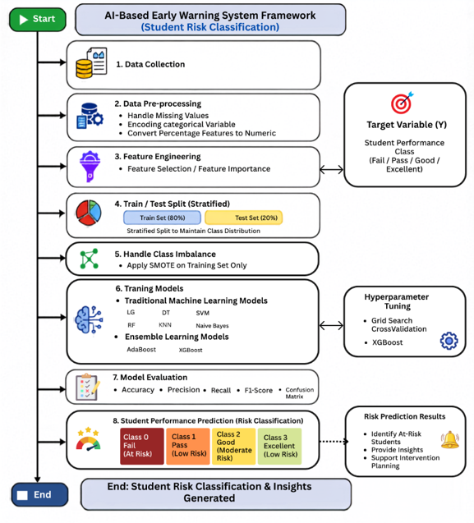
Figure 1. Proposed AI-Based Early Warning Framework

7.1 Dataset Description
We used a private educational dataset collected from a Learning Management System (LMS). The dataset contains 1,395 student records represented by 17 educational attributes describing students' academic performance, participation, assessments, virtual classroom activities, homework completion, discussion participation, attendance, and other engagement indicators. The target variable represents students' academic performance and classifies each student into one of the following four categories: Excellent, Good, Pass and Fail.

7.2 Data Preprocessing
Data preprocessing was performed to improve data quality before model development. The preprocessing stage included handling missing values, converting percentage-based features into numerical values, encoding categorical variables, and splitting the dataset into 80% training and 20% testing subsets using the Stratified Train-Test Split technique to preserve the original class distribution. To address class imbalance, the Synthetic Minority Oversampling Technique (SMOTE) was applied only to the training dataset.

7.3 Feature Selection and Experimental Configurations
Random Forest feature importance was employed to identify the most influential educational features affecting students' academic performance. Features with low importance were excluded from the selected feature set. To investigate the impact of feature selection and class balancing, four experimental configurations were evaluated:
- Experiment 1: Full feature set without SMOTE.
- Experiment 2: Selected feature set without SMOTE.
- Experiment 3: Full feature set with SMOTE.
- Experiment 4: Selected feature set with SMOTE.

7.4 Machine Learning Models
Eight supervised machine learning algorithms were evaluated under identical experimental conditions. The evaluated models included six traditional machine learning algorithms: Decision Tree (DT), Random Forest (RF), Logistic Regression (LR), Support Vector Machine (SVM), K-Nearest Neighbors (KNN), and Naïve Bayes (NB), in addition to two ensemble learning algorithms: AdaBoost (AB) and Extreme Gradient Boosting (XGBoost).

7.5 Hyperparameter Optimization and Model Evaluation
After evaluating the baseline models, the best-performing algorithms were optimized using Grid Search with cross-validation. Model performance was assessed using Accuracy, Precision, Recall, F1-score, and Confusion Matrix to identify the most reliable model for predicting students' academic risk.
8.Results
8.1 Experimental Setup
Experiments were carried out via Google Collab using Python 3 as an implementation environment. The performance of the suggested framework was estimated on a private dataset that consists of 1,395 student instances and includes 17 academic and behavioral features, such as participation, assessments, attendance, and engagement measures. For data preprocessing, Pandas and NumPy libraries were used, while the ML models were built using the Scikit-learn framework and the XGB library. To conduct a fair experiment, we split the dataset into 80% train and 20% test using stratified sampling. A feature selection technique was utilized in two experimental settings to examine the influence of shrinking the number of input features. Because of the imbalanced nature of our dataset, the SMOTE algorithm was applied exclusively to the train set during the corresponding experiments.

8.2 Class Distribution and Feature Importance
The understanding of the distribution of the classes under study is a necessary condition prior to the use of the model since class imbalance can affect the learning process and the biases of classifiers towards the majority classes. From the information provided in Table 2, it is clear that the distribution of data in four academic performance classes was not even. In particular, the percentage of the Good class constituted 51.97% while the Pass class constituted only 7.67%. The rest of the data was related to Excellent and Fail classes (23.08% and 17.28%, correspondingly).
Table 2. Distribution of Student Performance Classes.
Class | Number of Students | Percentage
Good | 725 | 51.97
Excellent | 322 | 23.08
Fail | 241 | 17.28
Pass | 107 | 7.67

As illustrated in Figure 2 below, it is clear that the problem of imbalance was solved using SMOTE. The Good class had more observations compared to other classes prior to oversampling. In the SMOTE-oversampled training dataset, there were equal numbers of observations in each class, meaning that the dataset was balanced. The balance dataset was then utilized for the SMOTE-based experiments.

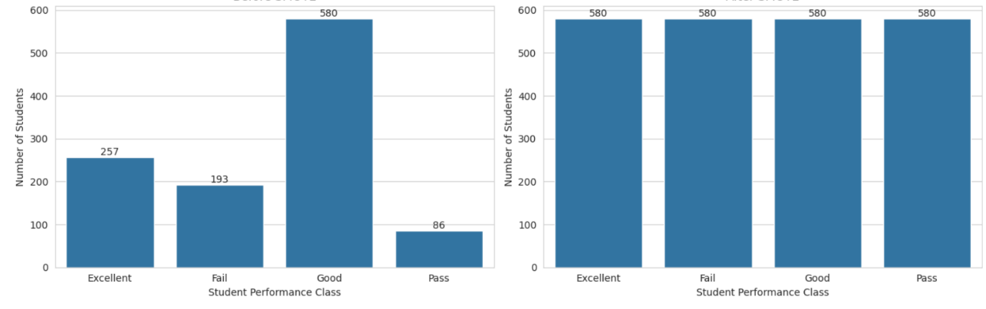
Figure 2. Class Distribution with and without Applying SMOTE.
The analysis of feature importance was done in order to understand which factors are more important in the prediction of student academic performance. An RF classifier was used for the estimation of the relative importance of each input variable. From the feature importance results shown in Figure 3, it is evident that the variables that have the highest importance in the prediction of student academic performance include Homework, Absence, and Interactive Contents. Other participation variables, such as Average Participation Percentage, Contents Participation Percentage, and Homework Participation Percentage, are also relatively highly important, showing the great role played by participation and continuous assessment activities of students in accurate prediction. However, Teacher Messages and Student Login Percentage have extremely low importance, implying that these variables contribute little to the prediction process.
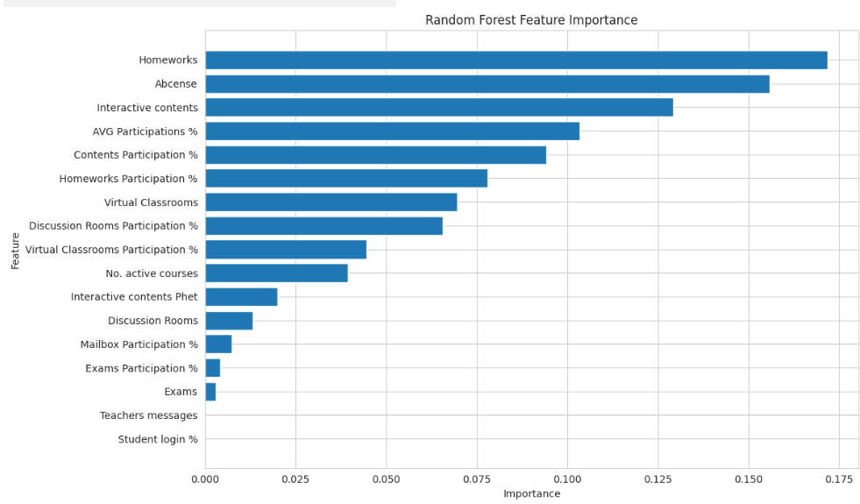
Figure 3. Random Forest Feature Importance Ranking.
8.3 Results of Model Performance
As shown in Table 3, the ensemble learning models have always shown better results compared to the traditional ML algorithms in all experimental conditions. As far as the analyzed models are concerned, XGB provided the highest accuracy of 82.80% in both EXP1 and EXP2, but remained the same (82.08%) in EXP3 and EXP4 due to their stable predictive ability regardless of different preprocessing techniques. However, RF showed the best performance of all the traditional ML algorithms prior to SMOTE implementation, while DT was able to become the best-performing traditional model after balancing the dataset, achieving 79.93% in EXP4. It is also evident from Table 2 that AB showed the lowest performance in all experiments, with accuracy rates ranging from 70.97% to 74.19%. Such superior results of XGB can be explained by their gradient boosting approach, which helps to identify complicated nonlinear relationships between the features of students' behavior. The mentioned results correspond to those obtained by (Johora et al., 2025)who found that XGB-based models outperformed traditional ML methods, as well as (Bettahi et al., 2025)
Table 3. Performance of the Evaluated Models under the Four Experimental Configurations.
NUM | Configuration | Approach | Model | Accuracy | Precision | Recall | F1-Score
1 | Full Features +  Without SMOTE. | Traditional ML | RF | 79.57 | 79.64 | 79.57 | 78.77
1 | Full Features +  Without SMOTE. | Traditional ML | DT | 79.21 | 79.42 | 79.21 | 79.21
1 | Full Features +  Without SMOTE. | EL | XGB | 82.80 | 82.63 | 82.80 | 82.42
1 | Full Features +  Without SMOTE. | EL | AdaBoost | 74.19 | 73.91 | 74.19 | 72.70
2 | Selected Features + without SMOTE. | Traditional ML | RF | 79.57 | 79.69 | 79.57 | 78.77
2 | Selected Features + without SMOTE. | Traditional ML | DT | 78.14 | 78.27 | 78.14 | 78.14
2 | Selected Features + without SMOTE. | EL | XGB | 82.80 | 82.63 | 82.80 | 82.42
2 | Selected Features + without SMOTE. | EL | AdaBoost | 74.19 | 73.91 | 74.19 | 72.70
3 | Full Features + SMOTE. | Traditional ML | DT | 79.57 | 79.82 | 79.57 | 79.51
3 | Full Features + SMOTE. | Traditional ML | RF | 79.21 | 79.28 | 79.21 | 78.25
3 | Full Features + SMOTE. | EL | XGB | 82.08 | 82.24 | 82.08 | 81.89
3 | Full Features + SMOTE. | EL | AdaBoost | 71.33 | 73.89 | 71.33 | 70.92
4 | Selected Features + SMOTE. | Traditional ML | DT | 79.93 | 80.56 | 79.93 | 79.84
4 | Selected Features + SMOTE. | Traditional ML | RF | 79.21 | 79.52 | 79.21 | 78.27
4 | Selected Features + SMOTE. | EL | XGB | 82.08 | 82.31 | 82.08 | 81.82
4 | Selected Features + SMOTE. | EL | AdaBoost | 70.97 | 73.94 | 70.97 | 70.71

The confusion matrices shown in Figure 4 represent a complete description of the classification results of the models used in our study for all four experimental designs. The prevalence of the diagonal elements in the XGB matrix suggests that most of the records have been correctly classified, while the few misclassifications occur among adjacent academic performance classes. It indicates that the XGB model is capable of differentiating among the four performance categories well. The results show that despite applying the selected data preprocessing methods such as feature selection and SMOTE, there is very little variation in the classification patterns, implying that none of the preprocessing methods change the predictive capabilities of XGB. Rather, they preserve the classification performance of the algorithm while enhancing the representation of minority classes. The observations from the confusion matrices are in line with the results quantitatively shown in Table 3, which indicate that XGB has performed best in terms of Accuracy, Precision, Recall, and F1-score among all the models considered. Similar conclusions can be drawn from (Bettahi et al., 2025) and (Johora et al., 2025).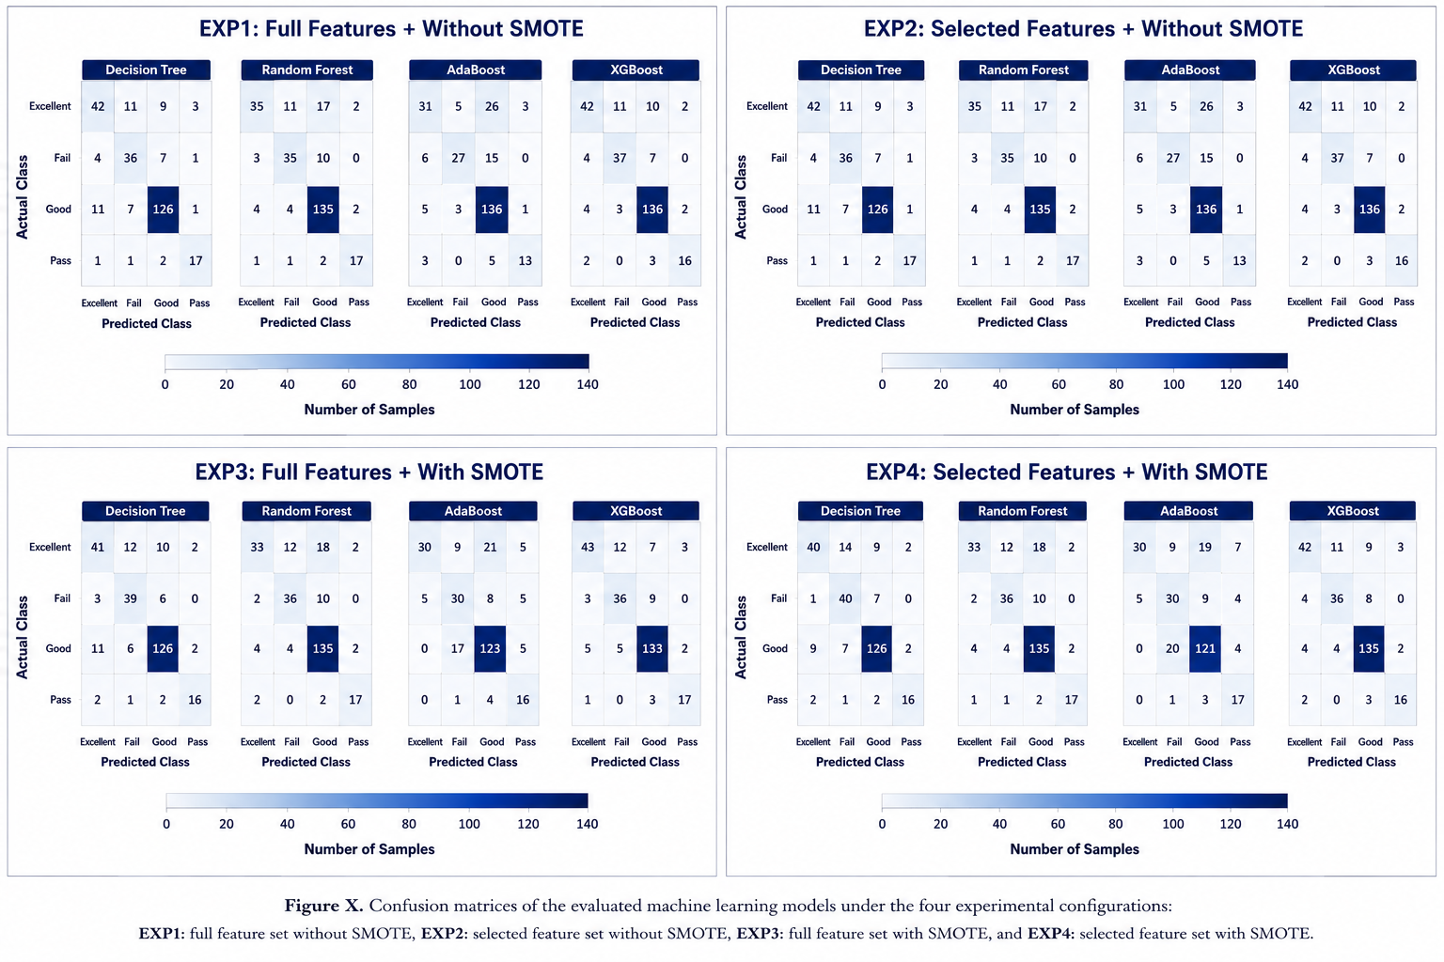
Figure 4. Confusion Matrices of the Evaluated Models.

8.4 Hyperparameter Optimization
Based on Table 4, the effect of the Grid Search optimization was different for the tested models. The model RF consistently improved in the experiments without SMOTE, with its accuracy changing from 79.57% to 80.29%. DT obtained the best result in EXP4, and its accuracy increased from 79.93% to 82.80%. This shows that hyperparameter tuning significantly increased the classification quality of DT in the selected features setting with SMOTE. However, XGB showed minor changes after optimization. As can be seen from Table 3, the classification accuracy of the model XGB stayed above 81.70% for all experiment configurations, which means that the initial settings of the model parameters were close to the optimal ones for the current data set. It can be concluded that Grid Search optimization affected the traditional machine learning models more compared to XGB, which had a high generalization ability.
Table 4. Performance of the Best Selected Models under Default and Optimized Hyperparameter Settings.
EXP NUM | Grid Search | Model | Accuracy | Precision | Recall | F1-Score
1 | Without | XGB | 82.80 | 82.63 | 82.80 | 82.42
1 | Without | RF | 79.57 | 79.64 | 79.57 | 78.77
1 | With | XGB | 81.72 | 81.66 | 81.72 | 81.10
1 | With | RF | 80.29 | 80.21 | 80.29 | 79.35
2 | Without | RF | 79.57 | 79.69 | 79.57 | 78.77
2 | Without | XGB | 82.80 | 82.63 | 82.80 | 82.42
2 | With | RF | 80.29 | 80.62 | 80.29 | 79.18
2 | With | XGB | 81.72 | 81.66 | 81.72 | 81.10
3 | Without | DT | 79.57 | 79.82 | 79.57 | 79.51
3 | Without | XGB | 82.08 | 82.24 | 82.08 | 81.89
3 | With | DT | 77.78 | 78.49 | 77.78 | 78.05
3 | With | XGB | 82.08 | 82.33 | 82.08 | 81.48
4 | Without | DT | 79.93 | 80.56 | 79.93 | 79.84
4 | Without | XGB | 82.08 | 82.31 | 82.08 | 81.82
4 | With | DT | 82.80 | 82.56 | 82.80 | 82.37
4 | With | XGB | 81.72 | 81.66 | 81.72 | 81.10

8.5 Final Model Selection
Performance of the optimized XGB algorithm in all the experiments is presented in Table 4, and Figure 5 displays confusion matrices for all four configurations. As can be seen from Figure 5, the optimized XGB model correctly classified the majority of students' cases with the minimal number of misclassified data cases between neighboring classes of academic performance. High consistency of the classification results in all the experiments shows that the feature selection procedure and application of SMOTE to data have had little impact on the prediction behavior of the XGB algorithm, demonstrating its reliability when used with different data preprocessing techniques. Considering the quantitative results obtained and qualitative analysis performed, the XGB algorithm was chosen as the prediction model. The obtained results are similar to the results obtained by (Johora et al., 2025) and (Bettahi et al., 2025).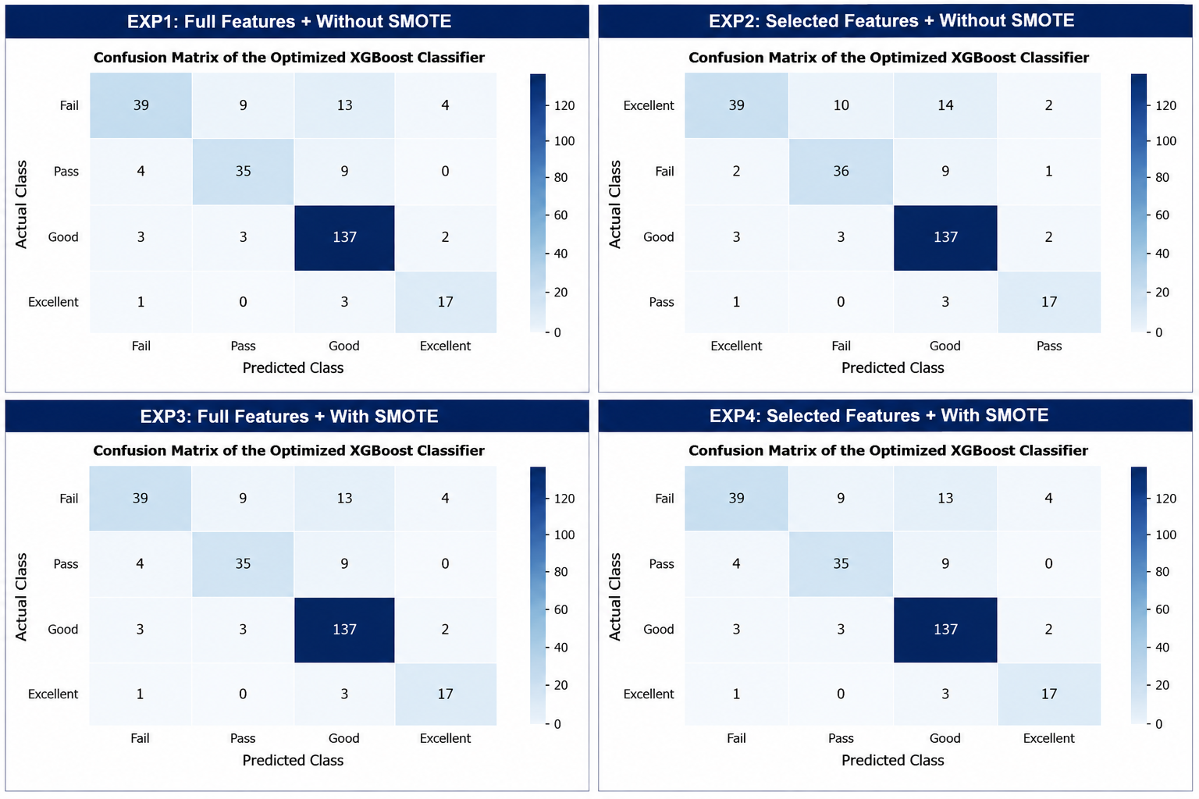
Figure 5. Confusion Matrix of the Final XGB Model.

9. Conclusion and Discussion of Results
This study proposed an Artificial Intelligence (AI)-Based Early Warning System for predicting students' academic risk using Learning Management System (LMS) data. The proposed framework integrated data preprocessing, Random Forest-based feature selection, SMOTE, supervised machine learning algorithms, and Grid Search-based hyperparameter optimization.
The experimental results showed that XGBoost achieved the highest predictive performance, obtaining an accuracy of 82.80%, while Random Forest feature selection effectively reduced the number of input features without significantly affecting prediction performance. In addition, SMOTE improved class balance, and Grid Search enhanced the performance of the best-performing models.
These findings are consistent with previous studies, confirming that ensemble learning algorithms provide reliable prediction performance for educational data. The proposed framework can support the early identification of academically at-risk students and assist educational institutions in implementing timely interventions and evidence-based academic decision-making.

10. Recommendations
Based on the findings of this study, the following recommendations are proposed:
- Integrate the proposed AI-Based Early Warning System into Learning Management Systems to support early academic intervention.
- Apply machine learning models to assist educational institutions in improving student retention and academic performance.
- Investigate Explainable Artificial Intelligence (XAI) and deep learning techniques to enhance prediction performance and model interpretability.
- Validate the proposed framework using larger and more diverse educational datasets from different institutions.
References
Bettahi, A., Harroud, H., & Belouadha, F.-Z. (2025). Early Student Risk Detection Using CR-NODE: A Completion-Focused Temporal Approach with Explainable AI. Algorithms, 18(12), 781.
Johora, F. T., Hasan, M. N., Rajbongshi, A., Ashrafuzzaman, M., & Akter, F. (2025). An explainable AI-based approach for predicting undergraduate students academic performance. Array, 26, 100384.
Khan, I., Ahmad, A. R., Jabeur, N., & Mahdi, M. N. (2021). An artificial intelligence approach to monitor student performance and devise preventive measures. Smart Learning Environments, 8(1), 17.
Macfadyen, L. P., & Dawson, S. (2010). Mining LMS data to develop an “early warning system” for educators: A proof of concept. Computers & education, 54(2), 588–599.
Queiroga, E. M., Batista Machado, M. F., Paragarino, V. R., Primo, T. T., & Cechinel, C. (2022). Early prediction of at-risk students in secondary education: A countrywide k-12 learning analytics initiative in uruguay. Information, 13(9), 401.
Y. Li, "Artificial Intelligence Technologies for Education," ed: MDPI-Multidisciplinary Digital Publishing Institute, 2025.
A. Taghvaie, T. Warnakulasuriya, D. Kumar, F. Zare, R. Sharma, and D. M. Vilathgamuwa, "A comprehensive review of harmonic issues and estimation techniques in power system networks based on traditional and artificial intelligence/machine learning," Ieee Access, vol. 11, pp. 31417–31442, 2023.
[C. M. Bishop and N. M. Nasrabadi, Pattern recognition and machine learning (no. 4). Springer, 2006.
S. U. S. o. I. Studies. "Data Science vs. Machine Learning." Syracuse University. https://ischool.syracuse.edu/data-science-vs-machine-learning/ (accessed july 4, 2026).
K. P. Murphy, Machine learning: a probabilistic perspective. MIT press, 2012.
T. Hastie, "The elements of statistical learning: data mining, inference, and prediction," ed: springer, 2009.
T. Hastie, R. Tibshirani, and J. Friedman, "The elements of statistical learning," ed: Springer series in statistics New-York, 2009.
J. R. Quinlan, C4. 5: programs for machine learning. Elsevier, 2014.
D. Bañeres, M. E. Rodríguez, A. E. Guerrero-Roldán, and A. Karadeniz, "An early warning system to detect at-risk students in online higher education," Applied Sciences, vol. 10, no. 13, p. 4427, 2020.
B. Ujkani, D. Minkovska, and N. Hinov, "Course success prediction and early identification of at-risk students using explainable artificial intelligence," Electronics, vol. 13, no. 21, p. 4157, 2024.
O. H. Embarak and S. Hawarna, "Automated AI-driven system for early detection of at-risk students," Procedia Computer Science, vol. 231, pp. 151–160, 2024.
W. Bagunaid, N. Chilamkurti, A. S. Shahraki, and S. Bamashmos, "Visual data and pattern analysis for smart education: a robust DRL-based early warning system for student performance prediction," Future Internet, vol. 16, no. 6, p. 206, 2024.
V. Christou et al., "Performance and early drop prediction for higher education students using machine learning," Expert Systems with Applications, vol. 225, p. 120079, 2023.
V. Realinho, J. Machado, L. Baptista, and M. V. Martins, "Predicting student dropout and academic success," Data, vol. 7, no. 11, p. 146, 2022.
N. N. Hamadneh, S. Atawneh, W. A. Khan, K. A. Almejalli, and A. Alhomoud, "Using artificial intelligence to predict students’ academic performance in blended learning," Sustainability, vol. 14, no. 18, p. 11642, 2022.
M. Skittou, M. Merrouchi, and T. Gadi, "Development of an early warning system to support educational planning process by identifying at-risk students," IEEE access, vol. 12, pp. 2260–2271, 2023.
G. Akçapınar, A. Altun, and P. Aşkar, "Using learning analytics to develop early-warning system for at-risk students," International Journal of Educational Technology in Higher Education, vol. 16, no. 1, p. 40, 2019.
B. Albreiki, T. Habuza, Z. Shuqfa, M. A. Serhani, N. Zaki, and S. Harous, "Customized rule-based model to identify at-risk students and propose rational remedial actions," Big Data and Cognitive Computing, vol. 5, no. 4, p. 71, 2021.

