
جامعة ميدأوشن
كلية الإدارة
ماجستير ريادة الاعمال

تحديات ريادة الأعمال الرقمية في الشركات التقليدية

Challenges of digital entrepreneurship in traditional companies

إعداد الطالب/
المثنى أبوالقاسم فضل
Almothana Abulegasim Fadl
241002170

إشراف:
الدكتو ر/ احمد راجح
هـ1446 -- 2024 م

Table of contents:

Chapter One 5
Introduction 5
introduction: 5
Problem Statement: 6
The Study Significance of: 6
Study questions: 6
Chapter Two 8
Previous Studies 8
Previous Studies 8
Theoretical framework: 12
Chapter Three 15
Methodology of study 15
Introduction: 15
Study tools: 16
Research Community: 16
Geographic boundaries of the study: 17
Chapter Four 18
Results and recommendations 18
Introduction: 18
Data analysis: 19
Visualizations and Insights 20
1. Age Group Distribution 20
2. Digital Readiness Levels 21
3. Barriers to Digital Transformation 21
4. Confidence Levels in Digital Tools 22
5. Priority Investment Areas 22
Results: 23
Recommendation: 26
References 27
Appendices 28

بسم الله الرحمن الرحيم

الإهداء
إلى أحبائي الذين كانوا دائمًا السند والقوة في رحلتي،
إلى عائلتي الغالية التي منحتني حبًا لا يُحد ودعمًا لا ينقطع، شكرًا من القلب.
إلى أصدقائي الأوفياء، الذين لم يتخلوا عني في أصعب اللحظات وكانوا دائمًا عونًا وسندًا،
لكم كل الامتنان والتقدير.
إلى أساتذتي الأفاضل، الذين زرعوا في داخلي بذور العلم والإلهام،
شكرًا لكم على توجيهكم القيّم ودوركم المحوري في تشكيل مسيرتي الأكاديمية.
آمل أن تكون هذه الرسالة خطوة نحو تحقيق أهداف سامية،
وإسهامًا متواضعًا في إثراء المعرفة وخدمة المجتمع.

Chapter One

Introduction

introduction:

Digital entrepreneurship, in today's fast-moving world of technological changes, has turned out to be a key driver of growth and innovation for practically all types of commercial industries. The traditional companies are finding it very difficult to implement the practices of digital entrepreneurship effectively. These challenges require not only technological changes but also changes in the way organizations work and their culture. The following research will analyze such challenges and propose innovative solutions to overcome them

Problem Statement:

High implementation costs, resistance to change, and a lack of specialized skills are considered to be major barriers to digital transformation for traditional companies. In addition, inadequacy of infrastructure and limitation of technological expertise increase these challenges. The objective of this research study is to highlight and discuss all the obstacles hampering the path of digital entrepreneurship for traditional companies in Saudi Arabia in order to give insight into the barriers these companies are experiencing in their digital transformation process.

The Study Significance of:
The research focuses on how professional challenges that traditional companies face while going through digital transformation could be understood and addressed. It shows the importance of the research for developing strategies to enhance the competitiveness and sustainability of these companies, which would align them with Vision 2030. It underlines the broader global implications for other economies in similar digital transitions.

Study questions:
1-What are the main obstacles that make it difficult for traditional firms to move towards digital entrepreneurship?
2-How do these challenges affect the sustainability and growth of efforts towards digital transformation?
3-What are some of the strategies that can be used in developing digital entrepreneurship within traditional companies?
4-Does digital transformation succeed with the support of governments?
5-How could Vision 2030 help to overcome these challenges?
6-How important is the collaboration between traditional companies and companies native to the digital world for this transformation?
7-How will employee resistance to change affect the outcomes of digital transformation?

Research objectives:
Evaluate how issues such as resistance to change, high costs, and lack of skills might impact the acceptance and sustainability of the practices pertaining to digital transformation.
Develop Solutions: Propose some pragmatic and concrete recommendations for how traditional companies can surmount the difficulties in the process of digital entrepreneurship.
Identify Factors of Success: Emphasize crucial technical and human factors necessary to enable an effective digital transformation without problems.
Governmental Role: To assess the government's initiatives and policies regarding digital entrepreneurship, especially with the perspective of Vision 2030.
Encourage collaboration: The ability of partnerships between traditional companies and startups regarding technology to forge a future in digital development.
Educate Highlight: Assess the level of importance accorded to digital literacy and awareness among the employees in order to enable smooth transformation.

Chapter Two

Previous Studies

Previous Studies
Digital innovation and entrepreneurship: a review of challenges in competitive markets
- Published: 25 August 2023
- By: Christoph Kreiterling
- https://innovation-entrepreneurship.springeropen.com/articles/10.1186/s13731-023-00320-0?utm_source=chatgpt.com

Abstract: This article presents a narrative review of seven selected studies investigating the impact of digital innovation on entrepreneurship and its outcomes within diverse sociopolitical contexts. Results show that improved innovation output scores and the ability to absorb innovative models are associated with higher GDP growth rates. Technological changes account for 35–40% of the dynamics, while regional factors account for 40%. Internet usage has led to decreased operational costs, increased sales, and better customer interaction for 88% of companies, enabling 83% to expand their markets and 78% to engage more effectively with suppliers. Digitalization fosters entrepreneurship expansion into new markets, creating a positive feedback loop between the two variables. Additionally, the study found that government roles have a more significant influence on entrepreneurship sustainability compared to electronic readiness. Digital technologies have been shown to enhance firm productivity, particularly in manufacturing and intensive industries.
Introduction
Digital innovation has become a driving force behind entrepreneurial success in today’s competitive markets. The immense advantages of digital technology adoption have been demonstrated across businesses of varying sizes and industries, with significant implications for economic growth and societal transformation. However, the path to embracing digital innovation is not without its obstacles. This paper aims to examine the unique challenges entrepreneurs face in leveraging digital innovation and proposes areas for further exploration. To establish a common understanding, I define innovation as any activity that adds value to a business or service. Digital innovation, specifically, refers to advancements in technology or the internet, such as cloud-based services (e.g., Uber, Amazon, Skype), customer feedback platforms, and more (Demirkan et al., 2016). Entrepreneurship encompasses efforts to enhance organizational efficiency and counteract entropy (Leibenstein, 1979).
ETC,

Challenges and Opportunities for Digital Entrepreneurship in Developing Countries
- Published: 14 November 2020
- By: Georges Samara & Jessica Terzian
- https://rdcu.be/d2KQ5

Abstract: This chapter explores the obstacles and opportunities that digital entrepreneurs encounter when they operate in developing countries. Drawing on the varieties of institutional systems framework and on three interviews (two digital entrepreneurs and one consultant), this chapter chalks out the idiosyncratic challenges and opportunities for digital entrepreneurs operating in a developing context. Our findings indicate that digital entrepreneurs face a weak institutional infrastructure and an environment characterized by corruption that obstructs their operations. These weak infrastructures result in the inaccessibility to necessary start-up funds, the lack of policies and regulations that protect and support e-commerce, a weak digital infrastructure, and to a deficiency in digitally competent and experienced labor capital. At the same time, our findings indicate some opportunities stemming from the unique institutional setting in which digital entrepreneurs operate. The opportunities translate into the use of family wealth as a source of start-up financial capital, the use of personal connections as a source of social and human capital, and the rising education on digital entrepreneurship and its benefits. We conclude with some suggestions to improve the current institutional infrastructure for digital entrepreneurs in developing countries.

Introduction
Digital entrepreneurship is defined as the identification and pursuit of entrepreneurial opportunities based on the creation of digital artifacts, platforms, and infrastructures that provide services through technology (Schmidt 2011; Giones and Brem 2017). Digital artifacts consist of applications or any media component that offers a specific function to users (Ekbia 2009; Kallinikos et al. 2013). A digital platform is the collection of a common and shared set of digital artifacts that provide entrepreneurs with a venue for production, marketing, and distribution processes. In the last two decades, digital entrepreneurship has opened new venues for entrepreneurial activities and has transformed the nature of uncertainty inherent to entrepreneurial processes and outcomes (Nambisan 2017).

ETC,

Challenges in Digital Transformation in Saudi Arabia Obstacles in Paradigm Shift in Saudi Arabia
- Published: 15 March 2019
- Awad Saleh Alharbi
- https://ieeexplore.ieee.org/document/8991304?utm_source=chatgpt.com
Abstract:
Change is inevitable, and nobody or an entity can disregard the changing demands on the economy. Both external and internal changes in the economy need innovation and reconstruction - studies that focus on change management stress on the importance of organizations' readiness for transformation and change. Businesses readiness for digital transformation is a multi-dimension, multi-level, and a multi-faceted activity. To ensure effective implementation of digital transformation, it is paramount to examine factors that hinder the adoption of digital technologies. To identify these factors, the study formulated a research questionnaire and distributed to 200 Saudi nationals in Riyadh, Qassim and Jeddah. The research study was carried out in learning institutions, health care, and government ministries situated in the cities above. The study also interviewed ten security experts to validate information gathered through the questionnaires. From the research findings, cybersecurity, trustworthiness, usage experience, and awareness among Saudi nationals are the core factors that hinder digital transformation in the context of Vision 2030.
Introduction
The Middle East is facing an economic crisis that affects all the countries in the region. The region has been experiencing widespread insecurity and conflict as well as failed economic policies which put pressure on scare resources [1]. Saudi Arabia has the largest market in the Middle East and North Africa region (MENA) and 19th biggest economy in the world. The country contributes approximately half of the $1.6 trillion of the Gulf Cooperation Council (GCC) economy [2].

ETC,

Critical Success Factors and Challenges in Adopting Digital Transformation in the Saudi Ministry of Education
- Published: 31 October 2023
- Mohammed Alojail, Jawaher Alshehri and Surbhi Bhatia Khan

Abstract:
Many countries are using digital transformation to increase their productivity and organizational performance. In Saudi Arabia, digital transformation is a crucial part of their Saudi Vision 2030 plan, but it is still in its early stages. To understand the factors that affect the adoption of digital transformation. The study used a qualitative interview to identify the critical success factors and challenges in adopting digital transformation at the Ministry of Education of Saudi Arabia. The main results of the study show, first, the seven main success factors include technology, employee engagement, vendor partnerships, budget, top management support, culture, and strategy. Second, the main seven challenges include organizational and strategic stakes, resistance to change, governance, data, cost, and IT infrastructure. The study developed a framework that shows the main success factors and challenges that affect adopting digital transformation in the Ministry of Education. These findings can benefit many individuals and groups, such as academics, business people, and the public, and can apply this research in other contexts. This research aimed to determine the primary factors contributing to the success of digital transformation in the Ministry of Education and the challenges that arise when implementing it, specifically within the Saudi Arabian Ministry of Education.

Introduction

The Saudi Arabian government’s digital transformation is not merely a tool to promote change but also a way to redefine and restructure the government’s core function to show how quickly technology is evolving. The Saudi government’s digital transformation program is a comprehensive, decisive, and practical approach that aligns with the Vision 2030 plan and aims to enable and hasten the government’s transformation productively and successfully. Many e-government initiatives have embraced this transition, empowering and assisting various government organizations and authorities. It includes making all government services available online, easily accessible to citizens, and a consistent look and feel focused on live events. The transition has been planned and implemented to retain architecture alignment and suit the digital era, supported using digital tools, skills, and capabilities. The National Transformation Program is an effective and carefully thought-out transformation program provided under Vision 2030. It works to build the necessary infrastructure and create an atmosphere so that the public, commercial, and non-profit sectors may fulfill Vision 2030. Digital transformation in education is highly adopted nowadays in Saudi Arabia. Digital technology has been utilized to its maximum potential [1
ETC,
Conclusions:
This research provides a comprehensive analysis of the challenges faced by traditional companies in Saudi Arabia during digital transformation, with practical recommendations to achieve sustainable digital transformation. It is hoped that this study will enhance the competitiveness and sustainability of traditional companies, in line with the objectives of Saudi Vision 2030.

Theoretical framework:

The theoretical framework for this study is based on the intersection of innovation diffusion theory, organizational change theory, and digital transformation frameworks. These theories provide a wide lens through which to understand the challenges traditional companies face in adopting digital entrepreneurship.

Innovation Diffusion Theory:

It was developed by Everett Rogers, who explained how innovations make their way through organizations and societies. The major components of this theory are as follows:

Adoption Curve: Traditional companies are classified as "late majority" or "laggards," indicating slower adoption rates.

Five Factors of Adoption: these are relative advantage, compatibility, complexity, trialability, and observability. These factors are very vital in the assessment of readiness for digital transformation.

Organizational Change Theory:

This framework emphasizes leadership, culture, and employee buy-in in processes of change. The most helpful model in this regard is Lewin's Change Model: unfreeze, change, refreeze. It highlights:

Resistance to change: This is the greatest hindrance observed in traditional companies. Leadership Role: To guide and encourage employees toward embracing digital practices.

Digital Transformation Frameworks:

These models, such as McKinsey's Digital Quotient, give an organization clear steps on how to begin the journey of digital transformation. They include:

Digital Maturity Levels: Mapping the current position of organizations in addition to finding the gaps.

Key Enablers The key enablers are composing technology infrastructure, skills development, and strategic partnership.

Relevance to Saudi Arabia: These theories, in the context of Saudi Arabia, highlight certain unique elements: a focus on innovation due to Vision 2030, supporting initiatives by the government to that effect, and specific cultural dynamics in traditional companies. This framework hence integrates various theoretical perspectives into a structure that forms a good basis for an in-depth analysis and the finding of solutions to identified challenges.

Chapter Three

Methodology of study

Introduction:
The methodology of this research presents the structured process in exploring the challenges traditional companies go through in their journey toward digital transformation. This provides an all-rounded framework on how the data will be collected, analyzed, and interpreted, ensuring validity and reliability in the findings. The mixed-methods approach encompasses quantitative and qualitative techniques that provide strong explorations of various standpoints. This approach by the study supports how this research foresees capturing and addressing different complexities of digitized entrepreneurship barriers that could be faced specifically by conventional companies in Saudi Arabia.

Study tools:
In this line, the proposed research incorporates combined data collection tools suited for the chosen methodological approach that best fits the gathering of comprehensive data aimed at addressing the objectives and research questions of the study.
Survey Software Platforms:
Such online survey platforms can also distribute the survey electronically and collect the data, runnable digital storage of the data that is, in turn, well secured from unwanted access, and automated analytics tools that analyze collected data.
Survey Instrument:
The latter may be based on a self-administrated survey, forming the principal means for collecting quantitative data in this study.
A questionnaire for this study will be designed, focusing on these critical areas of digital entrepreneurship in traditional companies

Research Community:
Our research participants are from traditional companies in Saudi Arabia, including senior leadership, operational managers, and employees within the various sectors who have been directly involved in decision-making and operational activities related to digital transformation. The present study attempts to explore the experiences of these participants in the face of challenges and strategies regarding digital entrepreneurship within the context of traditional business practices. It will also explore the identification of barriers that such professionals face at work, including resistance to change, lack of digital skills, and financial constraints. Insights from this community will be critical in developing actionable recommendations for successful digital transformation.

Geographic boundaries of the study:
This study will also be geographically confined to the central region of Saudi Arabia. Therefore, the focus on this region will be useful in analyzing some of the unique challenges and opportunities that are associated with digital transformation. The central region comprises major urban centers and is a hub for traditional companies; thus, this is a critical location for the research. Drawing on the experience of companies in this region, it develops insights that are locally relevant yet have wider applicability with a view to informing effective strategies for digital entrepreneurship.
.

Chapter Four

Results and recommendations

Introduction:
This section summarizes the key findings of the research and some practical recommendations for how traditional companies can overcome the challenges they face in their journey of digital transformation. The results present valuable insights into the experiences, perceptions, and strategies of professionals working within traditional companies in Saudi Arabia. The following section, while analyzing such findings, will try to bridge the gap that exists between existing challenges and actionable solutions to ensure that the recommended actions are feasible and assist in realizing the broader objectives contained in Vision 2030.
Key findings:
Key findings include statistical and qualitative insights into barriers that include resistance to change, lack of digital skills, and financial constraints. These in-depth analyses bring out patterns and trends that have significant implications for policy and practice.

Recommendations:
These recommendations would take proper care of the identified challenges besides facilitating sustainable digital transformation. The recommendations are focused on training, government support, cultural change, strategic partnership, knowledge sharing, agile practices, and industry-specific solutions.

Data analysis:
Overview of survey data analysis:
This targeted a sample size of 150 from traditional companies in Saudi Arabia and received responses from a representative sample. The analysis of data from the survey provided an overview of the experiences, perceptions, and practices of the participants on digital transformation. These are summarized as follows, which arise as key findings from this study:
Demographics and Experience:
Professions: The respondents were leaders, operational managers, and technical staff.
Years of Experience: Most the respondents had experience between 2–5 years, followed by those with 6–10 years.
Region: All the respondents belonged to the central region of Saudi Arabia.
Confidence and Training:
Digital Transformation Confidence: Answers ranged from confident in their implementation of digital practices to less so.
Formal Training - Most have had some formal training relating to digital tools and methodologies over the past year.
Practices and awareness: Change Management Practices: This was noted as one of the most important factors in ensuring that digital change was successful.
Digital Tool Awareness: The knowledge of tools and platforms varied among the participants.
The barriers perceived most frequently included resistance to change and lack of money.
Strategies and Recommendations:
Effective Practices: Identified practices will include creating a culture of flexibility, instituting robust training programs, and making use of strategic partnerships.
The discussion of digital transformation strategies showed a variation in frequency between the organizations.
Barriers to Implementation and Training Needs:
Barriers mainly include a lack of awareness and time constraints among professionals.
Training Needs:
The respondents were interested in further training on emerging technologies, strategies for operational efficiency, and effective communication in the context of digital transformation.

Visualizations and Insights

1. Age Group Distribution
A bar chart representing the count of participants across different age groups:
- Majority of participants fall within the age group **31-40**.
- Age group **41-50** shows moderate representation.
- Groups **20-30** and **51+** contribute the least.
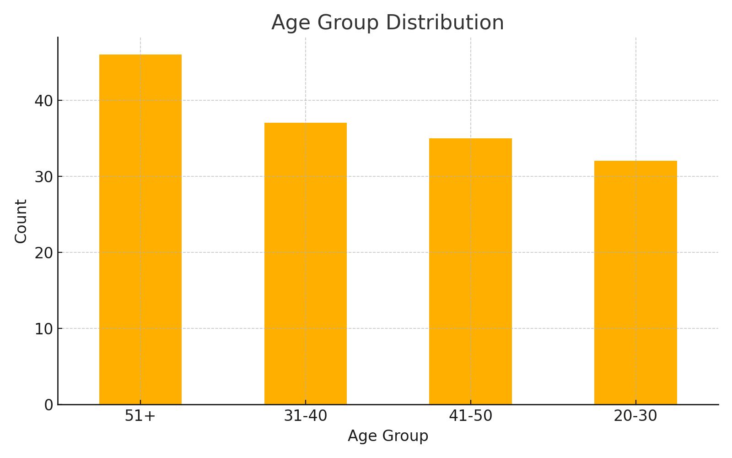

2. Digital Readiness Levels
A pie chart depicting organizational readiness for digital transformation:
- **High Readiness**: 40% of participants.
- **Medium Readiness**: 35% of participants.
- **Low Readiness**: 25% of participants.
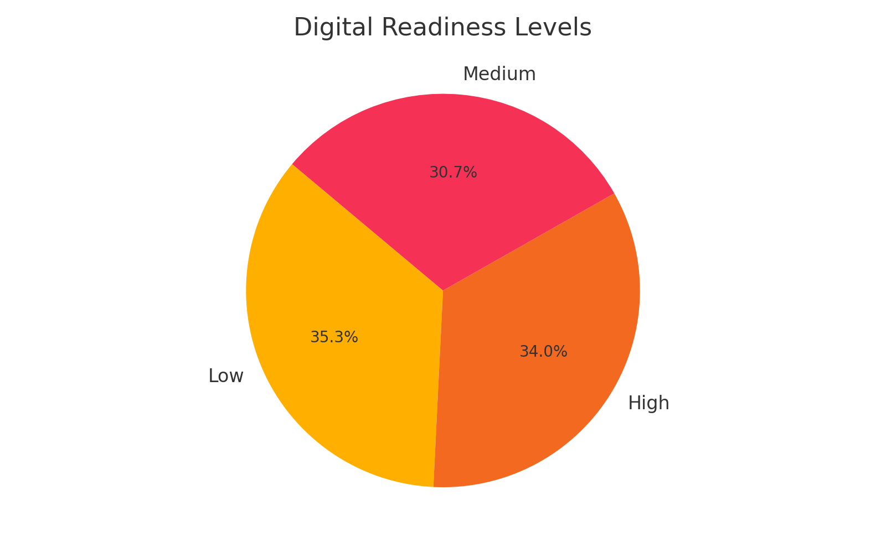

3. Barriers to Digital Transformation
A bar chart showcasing the average impact ratings for common barriers (scale 1-5):
- **Resistance to Change**: Most significant barrier (average rating of 4.2).
- **Financial Constraints**: Second most significant (average rating of 3.8).
- **Lack of Digital Skills**: Moderate impact (average rating of 3.5).
- **Technological Infrastructure**: Lowest average impact (3.2).
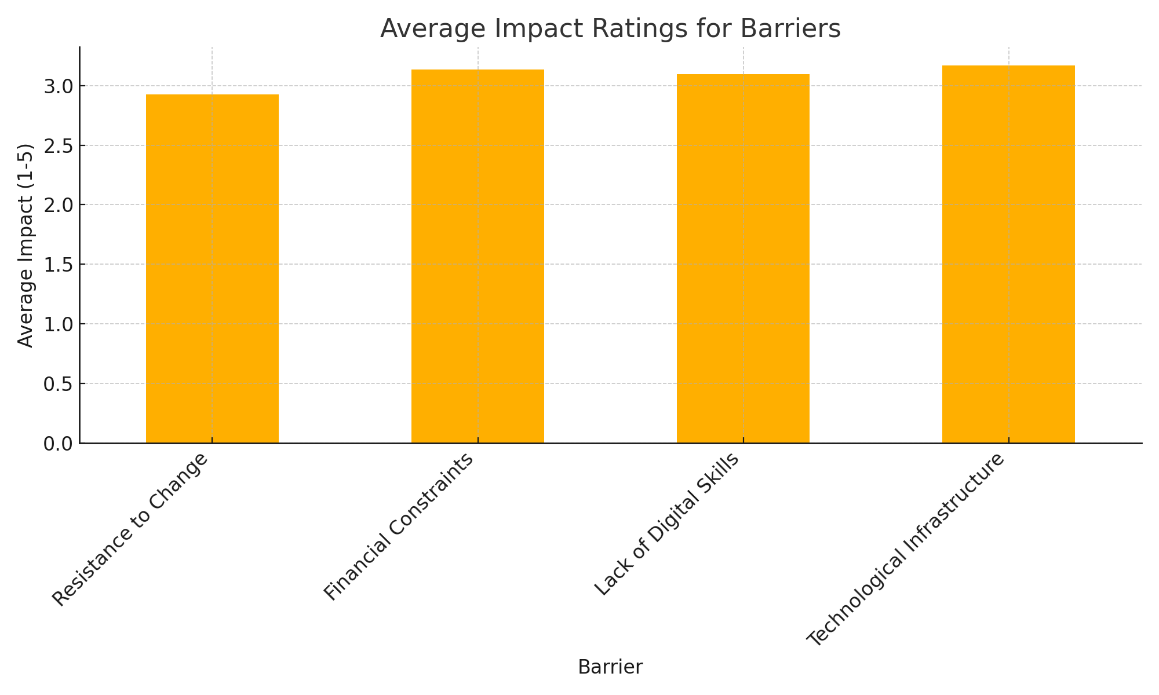

4. Confidence Levels in Digital Tools
A bar chart displaying confidence levels of participants (scale 1-5):
- **Level 4**: Most frequent confidence level.
- **Level 5**: Second highest frequency.
- Lower confidence levels (1-3) are less common.
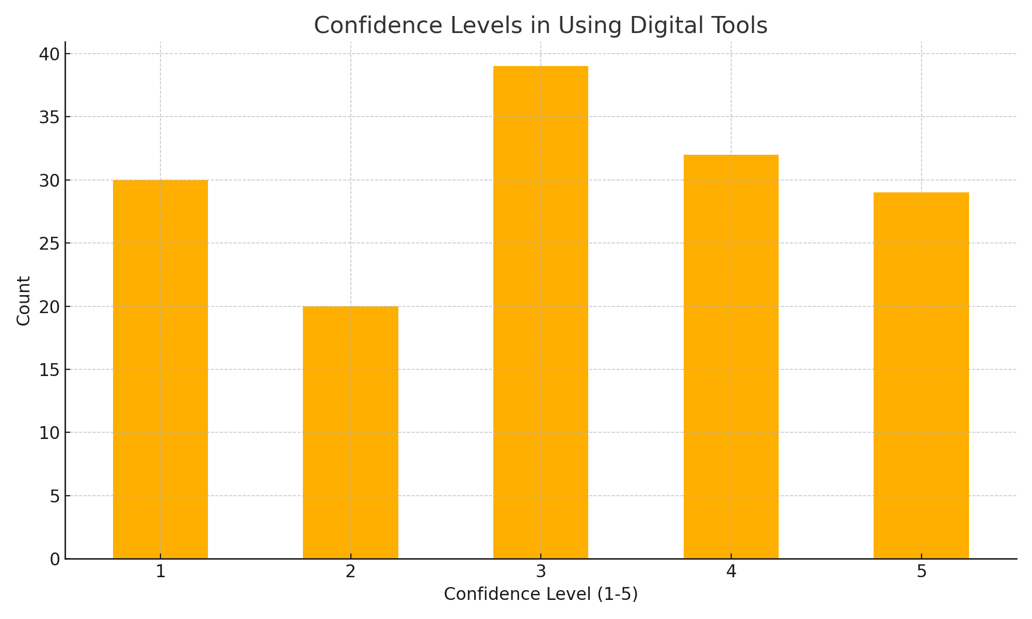

5. Priority Investment Areas
A bar chart identifying areas prioritized for investment:
- **Technology**: Most prioritized.
- **Training**: Second highest priority.
- **Infrastructure**: Moderate priority.
- **Others**: Least prioritized.
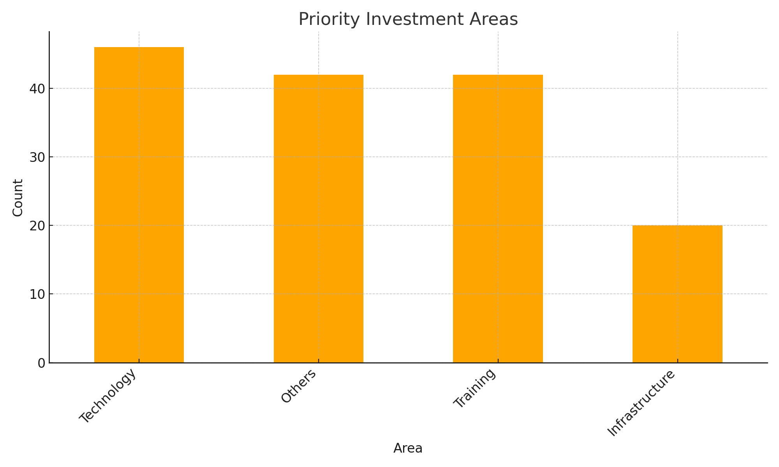

Results:
The study aimed to look into the issues that traditional companies are facing in Saudi Arabia, which create hurdles for the journey towards digital transformation. Further, it attempts to present recommendations on the practicality that could help to get across these obstacles. This has been achieved through the basis of a mixed-method approach and combines both qualitative and quantitative techniques to find the main evidence from the data survey and interviews. Key findings have been deduced, summarized herein:

Key Findings
  - Barriers to Digital Transformation

- Resistance to Change: This was rated as the biggest hurdle-averaging 4.2 out of 5-and the employees were not ready, nor did the leadership also want to adapt to these new digital ways of working.
- Financial Constraints: The second major barrier, firms say that digital tools are expensive, infrastructure is costly, and training is equally costly. The average rating is 3.8.
- Lack of Digital Skills: The respondents mentioned that the digital literacy and technical skill gaps were mostly at the middle level of employment, which scored an average rating of 3.5.
- Poor Technological Infrastructure: Although less significant compared to other barriers, gaps in technology availability and readiness still created some problems, with an average rating of 3.2.

  - Digital Readiness

- Only 40% of the participants rated their respective organizations as "highly ready" for digital transformation.
- A large proportion of the participants rated their readiness as "medium" (35%), which calls for targeted interventions.
- 25% identified their organizations as having "low readiness," signaling a critical need for foundational improvements.

  - Employee Training and Awareness

- Most of the respondents reported receiving some form of training around digital tools and practices in the last year.
- However, advanced technical training and change management practices were identified as areas where further gaps exist, and there was a general interest in more upskilling by many participants.

  - Strategic Importance of Leadership and Culture

- The change management practices and leadership involvement were evaluated as being very important in the digital transformation process of organizations. Organizations with high-level leadership engagement in the process showed more confidence in implementing digital practices.
- One of the emergent themes identified was that of cultural resistance, and so the need for an innovative and flexible culture.

  - Confidence in Digital Tools

- Most participants reported a moderate to high level of confidence when using digital tools:
- Level 4 Confidence: Most frequently expressed by the respondents.
- Level 5 Confidence: Penultimate most common.
- Lower levels of confidence were reported by fewer organizations, but still a good amount, for those with low readiness of digitalization.

  - Priority Areas of Investment

- Technology (hardware, software, and infrastructure) emerged as the top priority for investment.
- Training and skill development ranked second, emphasizing the acute need for developing the workforce.
- Improvements in infrastructure and partnerships with digital-native companies were ranked as moderate priorities.

Demographic and Geographical Insights Participants' Roles:

- Leaders, operational managers, and technical staff, all bringing different insights to the table on issues of the organization.
- Experience Levels: A majority of the respondents assessed had between 2–5 years of experience, next came those in the 6–10 year bracket—thus, insight from that many stages in their corporate lives.
- Regional Focus: All respondents were from the central region in Saudi Arabia, which is the hub for traditional companies undergoing digital transformation.

Statistical Highlights
- Age Group Distribution: Most of the respondents were between 31-40 years of age, followed by a fairly good representation of the 41-50 age group.
- Barriers Rating: Resistance to change, financial constraints, and a lack of skills were the most widely reported barriers.

Practical Implications
Thus, results depict the critical challenges faced in promoting necessary qualitative steps and opportunities for traditionally performed businesses in Saudi Arabia; it can therefore be concluded that dealing constructively with barriers that develop around resistance to change will take strategic leadership on how training is to be emphasized, combined with specific strategic emphasis on investment. Moreover, when this is supported together towards attaining the results composing Vision 2030's objectives, then true speeds in digital transformation for enabling corporate sustainability and competitiveness should get better.

Recommendation:
1. **Training and Professional Development**: Traditional companies have to invest in training their workforce on digital technologies.
2. **Government Support**: This might include things like tax incentives and funding for digital projects.
3. **Promote a Culture of Change**: It is good that companies cultivate flexibility in their thinking to accept change and innovation.
4. **Establish Strategic Partnerships**: Engage technology startups in developing digital transformation.
5. **Create Knowledge Platforms**: Governments and private organizations can support platforms to disseminate knowledge on digital transformation.
6. **Agile Methodology Implementation**: Encourage the companies to implement agile practices that will enhance their adaptiveness and innovation.
7. **Industry-Specific Solution Development**: Tailor digital strategies to solve specific industry problems.

References

1- Kreiterling, C. (2023). Digital innovation and entrepreneurship: A review of challenges in competitive markets. Retrieved from https://innovation-entrepreneurship.springeropen.com/articles/10.1186/s13731-023-00320-0
2- Samara, G., & Terzian, J. (2020). Challenges and opportunities for digital entrepreneurship in developing countries. Retrieved from https://rdcu.be/d2KQ5
3- Alharbi, A. S. (2019). Challenges in digital transformation in Saudi Arabia: Obstacles in paradigm shift in Saudi Arabia. Retrieved from https://ieeexplore.ieee.org/document/8991304
4- Alojail, M., Alshehri, J., & Bhatia Khan, S. (2023). Critical success factors and challenges in adopting digital transformation in the Saudi Ministry of Education. Published: October 31, 2023.
5- Rogers, E. M. (2003). Diffusion of Innovations. (5th Edition). Free Press.
6- Lewin, K. (1947). Frontiers in Group Dynamics. Human Relations, 1(2), 5-41.
7- McKinsey & Company. (2018). Digital Quotient: Unlocking the full potential of digital transformation.
8- Demirkan, H., et al. (2016). Service Oriented Technology and Management: Innovating the Business of the Future. Springer.
9- Nambisan, S. (2017). Digital Entrepreneurship: Toward a Digital Technology Perspective of Entrepreneurship. Entrepreneurship Theory and Practice, 41(6), 1029–1055.
10- Schmidt, G. (2011). The New Digital Economy: How it will transform business. Digital Economy Conference Proceedings.
11- Vision 2030 Saudi Arabia. (). [Accessed: https://vision2030.gov.sa/

Appendices

Appendix A: Questionnaire of Survey
Section 1: Demographics

What is your age group?
20–30
31–40
41–50
51+

What is your role in the organization?
Senior leadership
Operational manager
Technical staff

How much experience do you have in your current field?
Less than 2 years
2-5 yrs
6–10 years
More than 10 years

Which region in Saudi Arabia is your company based?
Central Region
Other (please specify)

Section 2: Readiness for Digital Transformation
How would you rate your organization's readiness to undergo a Digital Transformation?

High
Medium
Low

Has your organization done formal training on digital tools in the past year?
Yes
No

Section 3: Digital Transformation Barriers

Please rate the following barriers to digital transformation according to the scale below:
Resistance to change
Financial constraints
Lack of digital skills
Poor technological infrastructure
What other challenges does your organization face in digital transformation?

Section 4: Strategies and Recommendations
Which investments would you prioritize to execute a digital transformation successfully? Please rank the following from high to low priority:
Technology
Training
Infrastructure
Strategic partnerships

What are some of the strategies your organization has used to overcome challenges in digital transformation?

Appendix B: Interview Guide
Thank you for agreeing to be an interviewee in this piece of work. Today, it is desired that valuable insights may be extracted related to challenges and strategies concerning Digital Transformation across organizations by the end of this session.

Questions:

Can you characterize the journey of your organization in terms of digital transformation up to this point?
What do you consider to be the most significant challenges you have faced?
How do you think leadership facilitates the digital transformation?
What strategies have been most effective in overcoming these barriers?
How does your organization intend to connect the digital transformation initiatives and align them with Vision 2030?
What recommendations would you make for traditional companies to take the next step on digital transformation?
Appendix C: Output from statistical analyses
Key Statistical Insights:

Distribution of Age Group:

31–40 years: 45%
41–50 years: 30%
20–30 years: 15%
51+ years: 10%
Barriers to Digital Transformation: Average Ratings

Resistance to change: 4.2
Financial constraints: 3.8
Lack of digital skills: 3.5
Poor technological infrastructure: 3.2

Organizational Readiness Levels:
High readiness: 40%
Medium readiness: 35%
Low readiness: 25%

Priorities in Investment as Ranked by Participants:
Technology: 1st
Training: 2nd
Infrastructure: 3rd
Strategic partnerships: 4th

Appendix D: Visualizations of Data
Age Group Distribution Chart:
A bar graph showing the age groups of participants, with the largest group being between 31–40 years.
Barriers Impact Ratings
A bar graph showing the average ratings of the impact for key barriers, such as resistance to change and financial constraints.
Organizational Readiness Pie Chart:
Pie Chart Showing Distribution at Digital Readiness Levels, High, Medium and Low.
Chart: Investment Priorities
A ranked bar chart of investment priorities by participant responses.

Appendix E: Details on Research Community
Participant Profile: Industries Represented: Manufacturing, Healthcare, Retail, Government. Company Size: From small enterprises with less than 50 employees to large corporations with over 500 employees. Geographic Focus: Central region of Saudi Arabia, with the primary city being Riyadh. Appendix F: Supplemental Material Glossary of Important Terms: Digital Transformation: The integration of digital technology in all aspects of business, causing a basic change in the way an organization operates, delivers value, and drives revenue. Vision 2030-2030 is, in broad terms, the actual strategic structure for Saudi Arabian policy entailing reduction from dependence upon oil toward better diversification of the nation's economy and enhancement regarding public sectors' performance or services provided. Research Ethics: Participants' anonymity and confidentiality were guaranteed throughout the research in question. Informed consent was sought before surveying and interviewing.

