

AI-Powered Symptom-to-Treatment System for Accurate and Timely Medical Recommendation

Prepared Name: Mona Mohamad Abdulwahab
ID No.: 233000426
Submitted in fulfillment of the requirements for the degree Master of Science in Artificial Intelligence
At Collage of Informatics Midocean University UAE
Supervisor Name: Hager Saleh
Collage of Informatics, Midocean University, Comoros
Email: 233000426@st.midocean.edu.km

Acknowledgements:

The master's degree wasn't just a degree that I dreamed of getting; it was a long-awaited step to achieve. The journey began with many challenges. I knew the way would not be easy, but God put people in my path who made the journey clearer and easier. They left a deep impression on me. With each step, I was reaping the fruits of success. I reached the day when my dream became a reality. This is my thesis, which is about to reach its final pages. Praise be to God, first and foremost. Praise and thanks to Him for helping me achieve my dream. I thank everyone who supported me and helped me.
To those who have lit my way, giving me their time, effort, and patience, and helped me overcome difficulties, I would like to express my deepest gratitude to Dr. Hajar Saleh, who was the light that illuminated this work. She believed in me, supported me, and always encouraged me to do my best. I will always be grateful to her.
I thank my dear family - my mother, my father, and my children -for being my source of strength and support.
Finally, I thank Mid Ocean University for giving me the opportunity to continue my academic journey. I also thank all the professors and supervisors for their support and guidance.
Praise be to God, by whose grace good deeds are perfected. Tomorrow is for those who give birth to new dreams.

Abstract:
The medical field increasingly requires intelligent systems capable of interpreting patient-reported symptoms , supporting clinical decisions in an accurate and timely manner. This thesis aims to develop such a system by presenting an integrated framework designed to predict diseases based on symptom descriptions and recommend suitable treatments using a certified medical database. The importance of this work lies in providing digital solutions that enhance medical decision-making , accelerating the diagnostic process, especially with the rapid growth of medical data. There is a need for accurate and fast tools capable of understanding and processing this information effectively.
The proposed framework is built on two main stages. The first stage involves training several machine learning and deep learning models to analyze symptom-based medical text. Three ML models were used: Support Vector Machine (SVM), Logistic Regression (LR), and Complement Naïve Bayes (Complement NB)-alongside three transformer-based DL models: BERT, BioBERT, and ClinicalBERT. The second stage links the prediction output from these models to a certified medical treatment database to generate appropriate treatment recommendations.
Among all tested deep learning models, ClinicalBERT demonstrated the best overall performance, achieving an accuracy of 0.975 due to its advanced ability to interpret medical context and understand complex clinical text. This strong performance highlights ClinicalBERT as the most suitable and reliable model for disease classification based on patient-reported symptoms and establishes it as the core component of the proposed system.
Keywords: Disease Prediction, ClinicalBERT, Machine Learning, Deep Learning, Medical NLP, Treatment Recommendation, Symptom Classification

List of Publications:

Upon completing the thesis, a version of this work was prepared for the Midocean Journal, and it was approved for publication. This is an important step because publishing helps the study reach a wider group of researchers and increases the chances of applying its findings in real-world settings.
In the next stage, I aim to use larger and more diverse databases, improve the methods, and test additional models. I also plan to explore stronger techniques that can enhance the link between diseases and their corresponding treatments, leading to more accurate results. These improvements will help make the system safer and more reliable for real-world use.

Table of Contents

- List of Abbreviations…………………………………………………………. vii
- List of Figures…………………………………………………………….……viii
- List of Tables………………………………………………..……………..…. viii
Chapter 1:
Introduction……………………………………………………….………......1
- 1.1 Problem Definition………………………………………………………….2
- 1.2 Research Question………………………………………………………......2
- 1.3 Thesis Objectives…………………………………………………………...3
- 1.4 Thesis Contribution………………………………………………………....3
- 1.5 Thesis Organization………………………………………………………....4
Chapter 2:
- Overview………………………………………………………………….6
- 2.1 Introduction……………………………………………………………6
- 2.2Artificial Intelligent (AI)……………………… ………………………..7
- 2.3Machin Learning (ML)……………………………………………..…..8
- 2.4 Deep Learning (DL)……………………………………………………8
- 2.5 NLP…………………………………………………………………..10
- 2.6 Transformer…………………………………………………………..11
- 2.7BERT………………………………………………………………….11
- 2.8BIOBERT…………………………………………………………..…11
- 2.9 CLINICALBERT……………………………………………………12
- 2.10 TF-IDF……………………………………………………………..12
- 2.11 Tokenization……………………………………………………….12
- 2.12 Dataset………………………………………………………..……13
- 2.13 Evaluation………………………………………………………….13
- 2.14 SVM………………………………………………………….……14
- 2.15 LR…………………………………………………………………..15
- 2.16 NB…………………………………………………………….……15
Chapter 3:
Related Work……………………………………..…………………………..…7

3.1 Introduction …………………………………………………………..16

3.2 History ………………………………………………….……………..16

3.3Tabl of Related work……………………………………………………21

3.4Summary of Related work……………………………………………...23
Chapter 4:
Proposed Approach
- 4.1 Introduction……………………………………………….……….…...24
- 4.2 Pre-processing………………………………………………….…….…26
- 4.2.1 Data cleaning……………………………………………………….26
- 4.2.2 Feature Encoding……………………………………………….…..26
- 4.3 Training model…………………….……………………………………...27
- 4.3.1 Machine Learning model…………………………………………….27
- 4.3.2 Deep Learning model………………………………………….……28
- 4.4 Testing…………………………………………………………………….28
- 4.5 Evaluation…………………………………………………………….…...29
- 4.6 Treatment Recommendation ……………………………………….….….29
- 4-7 Summary………………………………………………………………….30
Chapter 5:
Experimental Results and Discussion
- 5.1 Results of Machine Learning Models………………………………………26
- 5.2 Results of Deep Learning Models……………………………………..…...28
- 5.3 Confusion Matrix Analysis:.…………………………………………….….30
- 5.4 Discussion of Treatment Recommendation Limitations……………………31
Chapter 6:
Conclusion and Future Work
- 6.1 Conclusion………………………………………………………………...38
- 6.2 Limitations…………………………………………………………………38
- 6.3 Future Work…………………………………………………………….….39
- References………………………………………………………………………40

List of Abbreviations:
- AI — Artificial Intelligence
- ML — Machine Learning
- DL — Deep Learning
- NLP — Natural Language Processing
- TF — Term Frequency
- IDF — Inverse Document Frequency
- TF-IDF — Term Frequency–Inverse Document Frequency
- SVM — Support Vector Machine
- LR — Logistic Regression
- NB — Naïve Bayes
- CNB — Complement Naïve Bayes
- BERT — Bidirectional Encoder Representations from Transformers
- BioBERT — Biomedical Bidirectional Encoder Representations from Transformers
- ClinicalBERT — Clinical Bidirectional Encoder Representations from Transformers
- EHR — Electronic Health Records
- GPU — Graphics Processing Unit
- XAI — Explainable Artificial Intelligence

List of Figures:

- Fig.1 Artificial Intelligent (AI) ………………………………………………….….7
- Fig.2 Machin Learning (ML)…………………………………………………….….8
- Fig.3 Deep learning (DL)……………………………………………...…………….9
- Fig.4 Natural language processing (NLP)………………………………………….10
- Fig.5 Transformer Architecture…………………………………………………….11
- Fig.6 Evaluation Metrics……………………………………………………………14
- Fig.7 SVM Class fire……………………………………………………………….14
- Fig.8 Logistic Retraction ………………………………………………………….15
- Fig.9 Work flow…………………………………………………………………... 24
- Fig.10 ML vs. DL Accuracy Comparison…………………………………………..32
- Fig.11Confusion Matrix of clinicalbert…………………………………………….36

List of Tables
1.Stady summary table…………………………………………………....……………21
2. Machin learning model result……………………………………………..………….26
3.Deep learning model result……………………………………………………….….28

Chapter 1 Introduction:
In recent years, many healthcare organizations have turned to digital tools to improve medical services. Despite this progress, many existing systems are still slow and give mixed results. This created a need for smarter solutions that can assist both doctors and patients using simple language.
AI has made this possible. Today, machines can perform tasks that once needed human judgment such as reading symptoms, suggesting diseases, and supporting decisions. ML models learn patterns from data. DL models go deeper and capture more complex details. This makes them useful for analyzing medical text and images.
Models like BERT, BioBERT, and ClinicalBERT have shown strong results. BERT understands context by reading text in both directions. BioBERT handles medical terms better because it is trained on biomedical texts. ClinicalBERT works well with real clinical notes and symptom descriptions.
Before training any model, the text must be prepared. This includes cleaning, tokenizing, and converting it into numbers. TF-IDF helps highlight important words. These steps make the data clearer and more useful. Connecting disease predictions to a trusted treatment database adds more clinical value.
Healthcare is a sensitive field. For this reason, AI must be transparent. Explainable AI helps doctors understand why a model made a certain prediction. This builds trust and supports safer use of AI in real medical settings.
In this study, ML, DL, transformer models, and a verified treatment database were combined to build a system that predicts diseases from symptoms and recommends suitable treatments. The goal is to offer faster, more accurate, and more understandable tools that improve patient care.

1.1 Problem Definition:
The healthcare field faces many challenges, including diagnosing diseases based on the textual symptoms provided by the patient. With the increasing volume of medical data and digital health records , it has become necessary to benefit from this data by creating an intelligent system capable of analyzing medical texts and predicting the most likely disease.
Despite the emergence of modern Machine Learning (ML) and Deep Learning (DL) techniques that can handle textual data , current studies mainly focus on predicting the disease without progressing to the treatment stage , which reduces the full benefit of these technologies.
Based on this, the research problem is the absence of an integrated system that relies on artificial intelligence and modern techniques that can:
1. Analyze the textual symptoms.
2. Predict the most likely disease.
3. Provide initial treatment recommendations based on a reliable medical database.
Addressing this problem represents an important step toward supporting medical decision-making, reducing diagnostic delays, and improving access to reliable initial healthcare guidance.

1.2 Research Question:

This research is guided by a main question that reflects the purpose of the study. Since the proposed system aims to analyse textual symptoms. Identify the most likely disease Recommend an appropriate initial treatment. The research question seeks to explore how artificial intelligence. Can be used to achieve these objectives in an integrated and reliable way. As the main research question is:
How can artificial intelligence technologies be utilized to identify diseases and recommend the appropriate treatment?

1.3 Thesis Objectives:
Using artificial intelligence techniques, the core objective of this thesis is to design and evaluate an intelligent medical diagnostic system. Capable of predicting diseases from patient-reported symptom descriptions and recommending the appropriate treatment. Using a trusted medical database. This study seeks to build a practical and intelligent system that can understand symptoms written by the user and determine the most likely disease based. To achieve this overall goal, the work is structured around several key objectives that guide the development of the proposed framework.
First, the study aims to preprocess and analyze textual symptom data in a way that prepares it for use in machine learning (ML) and deep learning (DL) models. This includes applying essential text-processing steps such as cleaning, tokenization, and feature extraction-most notably TF-IDF for text representation-to ensure that only meaningful linguistic patterns are used during training. Second, the study trains and evaluates three ML models-Linear SVM, Logistic Regression, and Complement Naïve Bayes-to assess their performance in classifying disease-related text. In parallel, three transformer-based DL models-BERT, BioBERT, and ClinicalBERT-are trained and tested to evaluate their ability to understand natural language and improve classification accuracy.
The next objective is to compare the performance of all models to identify the most effective approach for predicting diseases from textual symptom descriptions. Following disease prediction, the system links the output to a reliable medical treatment database to automatically generate initial treatment recommendations. Through this multi-model approach, the framework seeks to identify the most meaningful linguistic and clinical indicators that contribute to accurate diagnosis, reduce noise and irrelevant information, and improve the interpretability of predictions.
Ultimately, the goal is to develop a complete and integrated AI-based diagnostic system that begins with symptom input and ends with both disease prediction and treatment recommendation-forming a practical tool that supports clinicians in making timely decisions, facilitates early detection of potential health risks, and contributes to more effective, personalized, and evidence-based healthcare planning.

1.4 Thesis Contribution:
This study presents a set of contributions. Aimed at enhancing the use of artificial intelligence techniques. In disease prediction and treatment recommendation based on textual symptom descriptions. The main contributions of this work can be summarized as follows:
- Developing an integrated AI-based system ability of reading free-text symptom descriptions. Predicting the most likely disease. Providing initial treatment recommendations based on a trusted medical database.
- Conducting a comprehensive comparison between Machine learning (ML) and Deep learning (DL) models. Including Linear SVM, Logistic Regression, Complement Naïve Bayes. And advanced transformer-based models such as BERT, Bio BERT, and Clinical BERT. To identify the most efficient model for medical text classification.
- Introducing a complete workflow for medical text analysis. Coverage data production, text representation using TF-IDF and Tokenization. Followed by model training and testing, and ending with treatment recommendation.
- Highlighting the validation of transformer models, especially Clinical BERT, in understanding natural language (NL). Achieving high accuracy in disease prediction.
- Providing a practical model that can be used as a decision-support tool. By bridging the gap between symptom interpretation and treatment guidance.
- Offering a scalable and research-friendly model. Enabling future researchers to build upon it, and extend its applications, across different domains related to medical text analysis.

1.5 Thesis Organization:
This thesis is organized into six chapters, each guiding the reader through a different stage of the study in a clear and coherent manner.
Chapter 1: Introduction
This chapter introduces the central idea of the research and explains the importance of developing an intelligent system capable of predicting diseases from patient-reported symptoms and recommending appropriate treatments. It outlines the problem that motivated this study, the objectives we aim to achieve, and the key research questions that shaped the direction of the work.
Chapter 2: Overview
This chapter presents the theoretical background of the study and highlights the importance of preparing medical text before training the models. It describes essential preprocessing steps such as cleaning, noise removal, and converting symptom descriptions into numerical representations that machine-learning and deep-learning models can interpret. These steps ensure that the system can accurately apply techniques such as TF-IDF and embedding methods.
Chapter 3: Related Work
This chapter reviews previous research related to disease prediction, medical text analysis, and the use of transformer-based models in healthcare. It summarizes the methodologies and findings of earlier studies and identifies the gaps and limitations that this research aims to address, particularly in linking disease prediction with treatment recommendation.
Chapter 4: Proposed Methodology
This chapter provides a detailed explanation of the methodology used in this study. It describes how the dataset was collected and preprocessed, how the models were designed and trained, and how the overall pipeline operates to predict diseases and recommend treatments. The chapter walks the reader step-by-step through each component of the proposed system.
Chapter 5: Experimental Results and Discussion
This chapter presents the experimental setup and the results of the different models used in the study. It discusses the performance of each model, comparing their strengths and weaknesses, and evaluates their effectiveness in predicting diseases and generating accurate treatment recommendations. The chapter also interprets the results and reflects on their implications.
Chapter 6: Conclusion and Future Work
The final chapter summarizes the key findings of the thesis and reflects on the overall contributions of the study. It discusses what has been achieved and provides recommendations for future research, offering suggestions on how the system can be improved, extended, or applied in real clinical environments.

Chapter 2

Overview:
2.1Introduction:
This chapter provides an overview of the main artificial intelligence (AI) concepts and methods that form the foundation of this study. It begins by explaining the role of AI in the medical domain and introduces its core subfields Machine Learning (ML), Deep Learning (DL), Natural Language Processing (NLP), and transformer-based language models highlighting how each contributes to understanding and analyzing patient-reported symptoms. The chapter also explains why medical text requires careful preprocessing, including cleaning, normalization, tokenization, and converting symptom descriptions into numerical representations suitable for ML and DL models. These steps ensure that models can accurately interpret clinical expressions and capture meaningful patterns within the medical text.
Next, the chapter discusses the importance of feature representation and embedding techniques in improving model performance, particularly when dealing with unstructured symptom descriptions. It then explains key classification algorithms used in this research, including traditional ML models such as SVM, Logistic Regression, and Naïve Bayes, as well as advanced deep-learning models including BERT, BioBERT, and ClinicalBERT. The strengths and limitations of these models are outlined to show how each contributes to the overall diagnostic workflow.

Finally, this chapter reviews the latest directions in AI-based healthcare analytics, with a focus on how transformer models are increasingly being used to understand medical text and support automated disease prediction. The chapter also sheds light on why linking prediction results to a verified treatment database is essential for offering recommendations that are medically sound and supported by evidence.
In the context of this study, once the model predicts the most likely disease, the system looks up that predicted label in a trusted medical treatment database. This matching process allows the system to pull the appropriate treatment information automatically. By combining both prediction and treatment lookup, the framework not only identifies the possible disease based on the patient’s symptoms but also provides an initial treatment suggestion that follows established medical guidelines.
By the end of the chapter, the reader is expected to have a clear and practical understanding of the main concepts, background theories, and AI methods that make it possible to build a reliable system for disease prediction and treatment recommendation.
2.2Artificial Intelligence (AI):
Artificial Intelligence (AI) refers to the ability of computer systems to perform tasks that normally require human intelligence, such as reasoning, learning, problem-solving, perception, and decision-making. AI systems are designed to analyze data, recognize patterns, adapt to new information, and make intelligent decisions with minimal human intervention.[1]

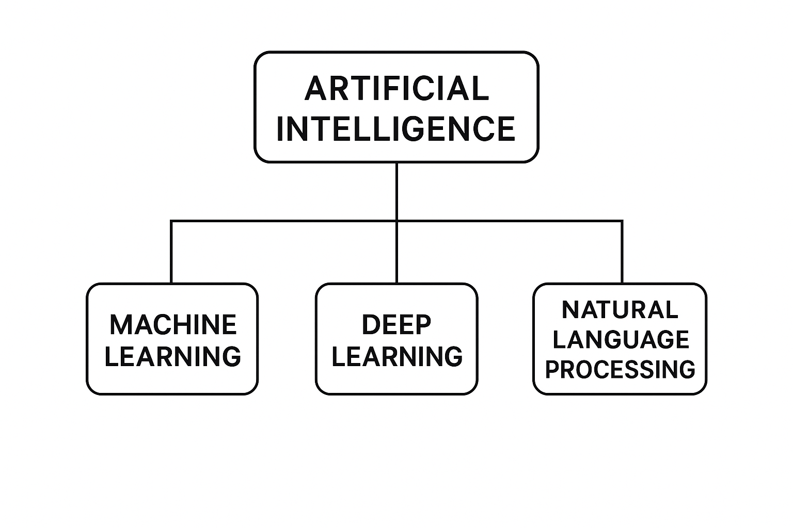
FIG.1 Artificial Intelligence (AI)

2.3Machina learning (ML):
Is a subfield of artificial intelligence that focuses on developing algorithms and statistical models that enable computer systems to learn patterns from data and make predictions or decisions without being explicitly programmed. ML systems improve their performance automatically through experience, allowing them to discover hidden relationships within datasets and generalize to new, unseen data. [2]
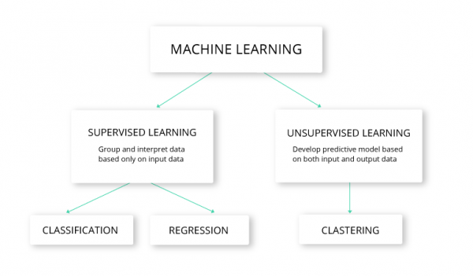
FIG.2 Machina learning (ML):

2.4 Deep Learning (DL):
Deep Learning (DL) is a branch of machine learning that uses multi-layer neural networks to learn from data. These deep networks allow the model to discover complex patterns and build high-level representations automatically. With this ability, DL can handle advanced tasks such as image recognition, natural language processing, and medical text analysis.
Deep learning models become more accurate when they are trained on large datasets and supported by strong computational power. Because of this, DL has achieved some of the best results in many modern AI applications. [3]

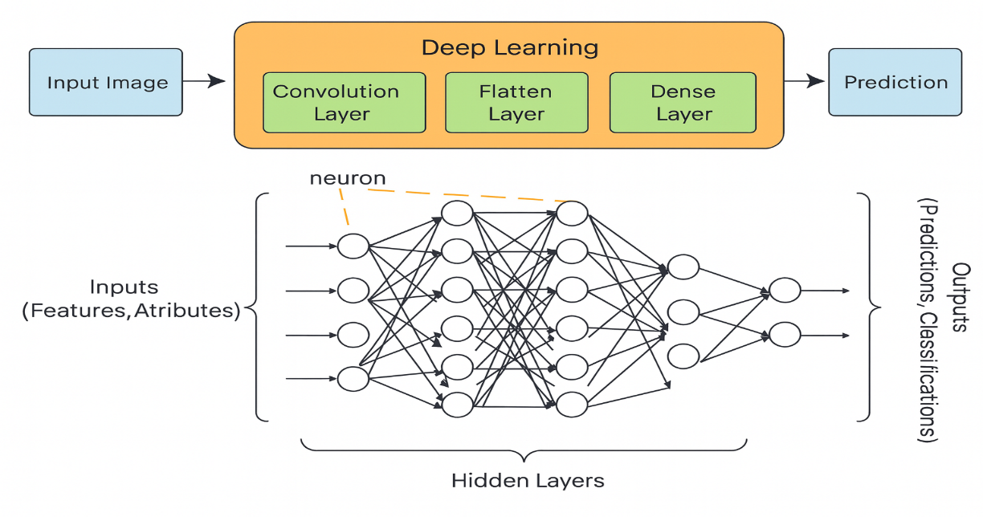

FIG.3 Deep Learning (DL)

2.5. Natural Language Processing (NLP)
Natural Language Processing (NLP) is a field of artificial intelligence that focuses on enabling computers to understand, interpret, and generate human language. It allows systems to analyze medical text, extract symptom information, and convert unstructured text into meaningful features.[4]
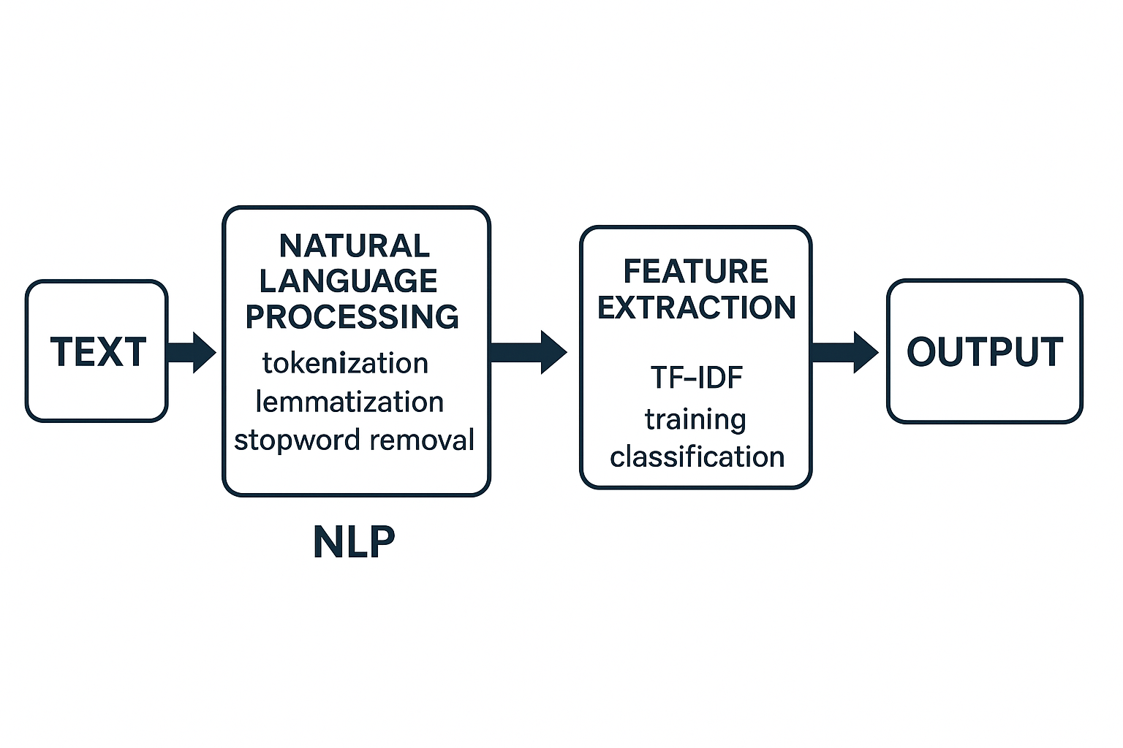
FIG.4 Natural Language Processing (NLP)

2.6 Transformer Architecture
Transformers are deep-learning models designed to handle sequential data using a self-attention mechanism. They process entire sentences at once, allowing them to capture contextual meaning more effectively than traditional RNN-based models.[5]
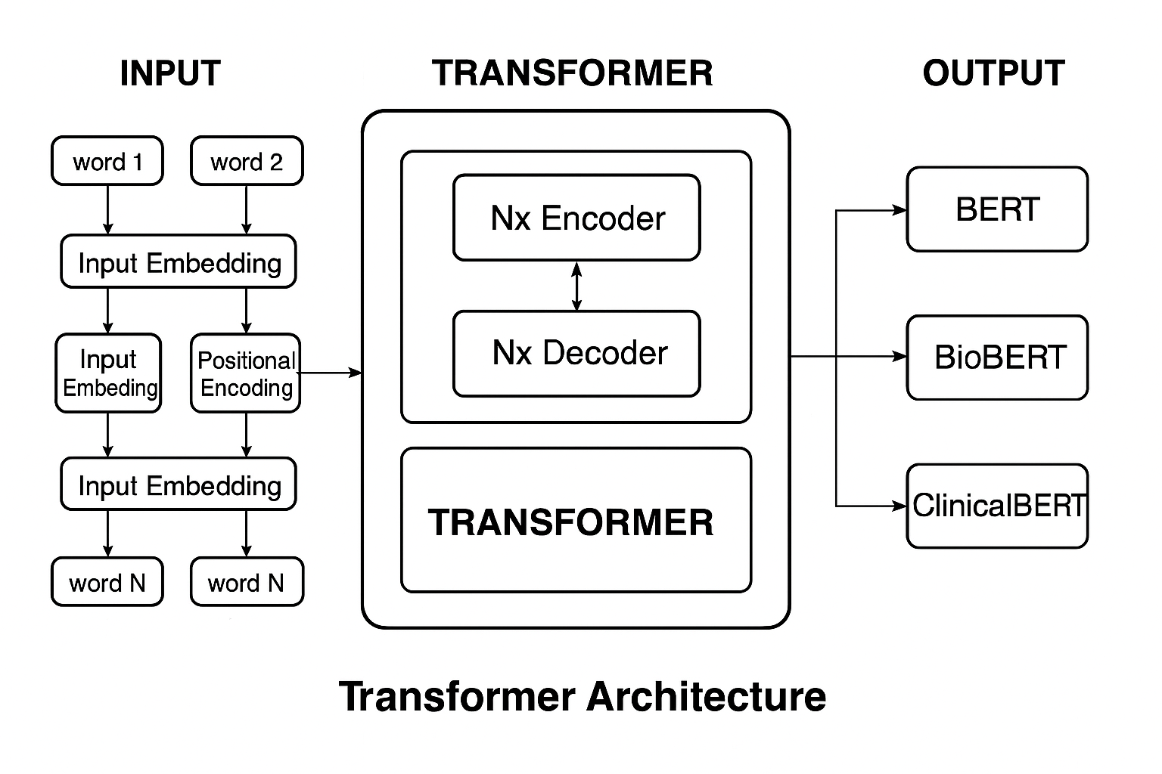
FIG.5 Transformer Architecture

2.7 BERT (Bidirectional Encoder Representations from Transformers)
BERT is a transformer-based model pre-trained on large text corpora to understand language context in both forward and backward directions. It is widely used for classification, question answering, and medical text analysis.[6]

2.8 BioBERT
BioBERT is a domain-specific version of BERT trained on biomedical literature (PubMed, PMC). It enhances understanding of medical terminology and relationships between diseases, symptoms, and treatments.[7]

2.9 ClinicalBERT
ClinicalBERT is a specialized version of BERT trained on clinical notes from electronic health records (EHR). It captures the linguistic style, abbreviations, and terminology used in hospitals, making it highly accurate for disease prediction tasks.[8]

2.10 TF-IDF (Term Frequency – Inverse Document Frequency)
TF-IDF is a numerical representation used in Natural Language Processing (NLP) to measure how important a word is within a document relative to an entire dataset.
It increases with the number of times a word appears in a document (TF) but decreases with how commonly the word appears across all documents (IDF).
This helps highlight important medical terms in symptom descriptions and reduce the weight of common words like “the” or “and”.[17]

2.11 Tokenization
Tokenization is the process of breaking raw text into smaller meaningful units called tokens. These tokens can be words, subwords, or characters, depending on the model and the tokenizer used. Tokenization is a fundamental preprocessing step in Natural Language Processing (NLP) because machine-learning and deep-learning models cannot interpret raw text directly—they require text to be segmented and converted into numerical representations.
In medical text analysis, tokenization helps transform symptom descriptions into structured units that models such as BERT, BioBERT, and ClinicalBERT can process. Modern transformer models use subword tokenization, which allows them to handle rare medical terms, abbreviations, and variations in clinical language.[18]
.
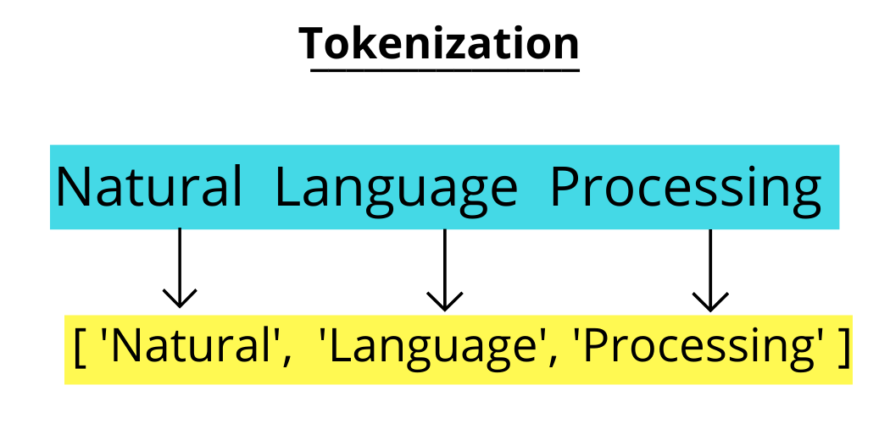

2.12 Dataset
A dataset is a structured collection of data used to train, validate, and test machine-learning models. In this research, the dataset consists of patient symptom descriptions paired with disease labels.[19]

2.13 Evaluation Metrics (Accuracy, Precision, Recall, F1-score)
In any machine learning classification task, the evaluation step is essential to ensure that the model can generalize well to unseen data and is reliable enough to be deployed in real-world medical applications. Unlike regression problems, classification tasks require metrics that assess not only the overall correctness of predictions but also how well the model distinguishes between different disease categories.
The most commonly used evaluation metrics for classification include Accuracy, Precision, Recall, and F1-score. These metrics provide a comprehensive view of model performance from different angles.
Accuracy measures the overall proportion of correct predictions, while Precision evaluates how many of the predicted positive cases are actually correct. Recall measures the model’s ability to identify all true positive cases, making it critical in medical settings where missing a disease case can have serious consequences. The F1-score combines both Precision and Recall into a single measure, offering a balanced perspective especially when dealing with imbalanced datasets.
These evaluation metrics are calculated by comparing the predicted labels with the true labels and are widely used in classification problems such as disease prediction based on patient-reported symptoms.[20]
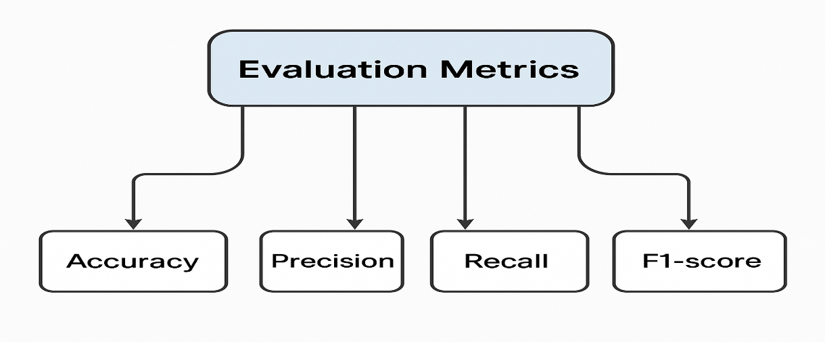
FIG.6 Evaluation Metrics (Accuracy, Precision, Recall, F1-score)

2.14 Support Vector Machine (SVM)
Support Vector Machine (SVM) is a supervised machine-learning algorithm used for classification tasks. It works by finding the optimal hyperplane that separates data points into different classes with the maximum margin. SVM is highly effective in high-dimensional text data, making it suitable for medical text classification.[21]
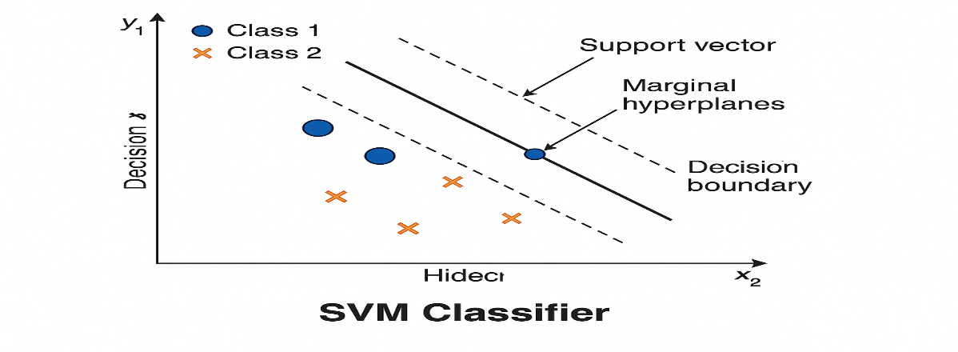
FIG.7 SVM CLASSIFIRE

2.15. Logistic Regression (LR)
Logistic Regression (LR) is a statistical classification model that predicts the probability of a class using a logistic (sigmoid) function. It is widely used in binary and multi-class text classification due to its simplicity, speed, and strong performance with TF-IDF features. [22]
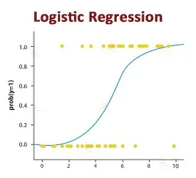
FIG.8 LOGSTIC REGRESSION

2.16 Naïve Bayes
Complement Naïve Bayes (CNB) is a variant of the Naïve Bayes classifier specifically designed for imbalanced text classification. It estimates probabilities using complement class statistics, reducing bias toward majority classes and improving performance on high-dimensional text data.[23]

Chapter 3

Related Work
3.1Introduction:
Over the past few years, artificial intelligence has become a powerful tool for analyzing data and discovering patterns that were difficult to identify using traditional methods. As AI techniques continue to evolve, researchers have explored different models to improve prediction accuracy and support better decision-making, especially in fields like healthcare and education.
Before developing any new system, it is essential to understand the work that has already been done in the same area. Reviewing previous studies helps identify the methods that were used, the results achieved, and the limitations that still exist. This background provides a clear foundation for the current research and ensures that it builds on strong scientific knowledge while addressing the gaps that remain.

3.2 History
Leila Aissa et. [24] (2025) conducted a study to improve the accuracy of symptom-based Medical. diagnosis using ensemble learning methods. The research tested several models, including Decision Trees (DT) and Support Vector Machines (SVM), alongside ensemble approaches such as Bagging and Stacking. Three experimental datasets were created for the study the Reference Dataset, Cough Differential Diagnosis Dataset Cough-DDX, and Cough-DDX2 to reflect real world respiratory symptom scenarios.
The findings showed that the Bagging ensemble combined with SVM outperformed the single models. Delivering superior performance in terms of accuracy, precision, recall, and F1-score. This highlights the potential of ensemble approaches in clinical decision support systems.

Fatemeh Sogandi (2024) [25] conducted a study using a Kaggle based symptom disease dataset to integrate supervised and unsupervised learning techniques. The purpose was to highlight important symptoms and generate generalized diagnostic rules. The Prior algorithm was applied to extract association rules, while several predictive models, including stepwise regression, SVM, bootstrap forest, and boosted trees, were tested. Results indicated that stepwise regression achieved the best performance, proving effective for accurate disease
classification and the development of decision-support rules.

In 2024, Esraa Hassan et. [26] investigated how advanced language models could be applied to improve the classification of diseases from symptom descriptions. Their work focused on comparing traditional deep learning approaches, such as BiLSTM, with domain-adapted transformer models like MCN-BERT. To test model effectiveness, the researchers prepared two datasets: the first consisted of 1,200 pairs linking symptoms to specific diseases, while the second contained more than 23,000 tweets related to adverse drug reactions. The results showed that MCN-BERT, particularly when trained with the A damp optimizer, consistently produced the best outcomes, reaching an accuracy close to 99.6% on the first dataset and around 96% on the second. These findings underline how specialized transformer architectures can capture subtle patterns in clinical language, offering strong potential for automated disease classification and early diagnostic support.

Al-Qarni et. (2025).[27] introduced a deep learning framework for predicting diseases from textual symptom descriptions. They constructed two custom textual datasets: the first covered 24 diseases, and the second extended to 41 diseases, with each dataset containing natural language descriptions of symptoms, these datasets were custom-built by the authors from openly available symptom descriptions and were not published as a public repository.
The researchers applied natural language processing (NLP) techniques, including tokenization and TF-IDF, combined with deep learning models such as LSTM, CNN-LSTM, and GRU. Experimental results demonstrated that the CNN-LSTM model with tokenization achieved the highest accuracy (99.9%) on the 41-disease dataset, while LSTM + TF-IDF reached 98.8% on the 24-disease dataset.
Dataset: Custom-built symptom description datasets (24 diseases, 41 diseases) not publicly available

Manikant Serigne’d (2024).[28] conducted a study entitled “Symptom-Based Disease Prediction: A Machine Learning Approach” with the objective of improving disease diagnosis based on symptom descriptions. The researchers used an open-access dataset in Kaggle containing 132 symptoms linked to 41 diseases.
To analyses the data, they applied several machine learning algorithms including Decision Tree (DT), Support Vector Machine (SVM), Random Forest (RF), and Extreme Gradient Boosting (XGBoost).
The findings revealed that XGBoost outperformed all other classifiers, achieving the highest accuracy in predicting diseases from symptom inputs.

Finkelstein et.[29]
. conducted a study The primary objective was to support timely clinical decision-making by forecasting symptom progression based on self-reported patient data. The researchers applied two deep learning models Convolutional Neural Network (CNN) and Long Short-Term Memory (LSTM) to a longitudinal dataset of daily symptom logs recorded by 208 cancer patients during chemotherapy cycles. These logs included information on fatigue, nausea, pain, and other symptoms. The models were evaluated using different time windows (3 to 7 days) to predict symptom escalation events. The results showed that the CNN model with a 3-day look-back window outperformed the LSTM, achieving an accuracy of 81%, precision of 87%, recall of 80%, and F1-score of 83%. The LSTM model achieved slightly lower but comparable results. The study concluded that CNN is a strong candidate for real-time symptom monitoring in digital health platforms. The dataset used in this study consists of real-world, hospital-based, patient-reported symptom data and is available upon request.
Abhinav et. .[30] proposed a machine learning-based system to predict multiple chronic diseases, including breast cancer, heart disease, and diabetes. The system is designed to be simple and user-friendly, with a web interface built using Python, Django, and Streamlet, allowing users to input their health data and receive disease predictions.
The models used in the study include Decision Tree (DT) and Support Vector Machine (SVM). After evaluation, the Decision Tree model demonstrated the highest performance across all diseases, achieving 97.98% accuracy for breast cancer, 92.62% for heart disease, and 91.55% for diabetes.
Saima Afrin et. .[31] conducted a study titled "Supervised Machine Learning Based Liver Disease Prediction Approach with LASSO Feature Selection" to develop an effective system for early diagnosis of liver disease using supervised machine learning techniques. They utilized the Indian Liver Patient Dataset (ILPD). The researchers evaluated a range of classifiers, including Logistic Regression, Decision Tree, Random Forest, AdaBoost, K-Nearest Neighbors, Linear Discriminant Analysis, Gradient Boosting, and Support Vector Machine. To improve model performance and enhance interpretability, they applied the Least Absolute Shrinkage and Selection Operator (LASSO) for feature selection, isolating the most influential predictors of liver disease. Using 10-fold cross-validation and performance metrics—accuracy, precision, sensitivity, and F1-score they found that the Decision Tree model, when combined with LASSO, outperformed others with an accuracy of 94.29%, precision of 92%, sensitivity of 99%, and F1-score of 96%. These results emphasize the utility of combining tree-based models with effective feature selection for reliable and early liver disease prediction
Chintan M. et. .[32] the researchers proposed a machine learning-based framework to predict cardiovascular disease with high accuracy. The goal was to support early and reliable diagnosis of heart disease using automated methods to reduce human error in medical decision-making.
The study utilized several supervised Machine Learning (ML) models, including Decision Tree (DT), Random Forest (RF), XGBoost (XGB), and Multilayer Perceptron (MLP). A k-modes clustering algorithm with Huang initialization was applied during preprocessing to improve classification quality, and GridSearchCV was used for hyperparameter tuning.
The models were trained and tested using a real-world dataset containing 70,000 patient records, sourced from Kaggle. The Multilayer Perceptron (MLP) model achieved the best results with an accuracy of 87.28% and an AUC of 0.95, outperforming the other models in the study
Umar ani ets.in 2022.[33] the researchers proposed multiple machine learning approaches for early heart disease detection The study introduced four main models including Naïve Bayes with a weighted approach a hybrid model combining Support Vector Machine and XGBoost based on time domain frequency domain and information theory features an improved Support Vector Machine based on duality optimization and a clinical decision support system that uses DBSCAN for outlier removal SMOTE ENN for class imbalance correction and XGBoost for final disease prediction performance evaluation included metrics like precision recall F1 score and accuracy Among all the models XGBoost consistently delivered the highest accuracy and robustness across different experiments making it the most effective classifier used in the study The authors emphasized the potential of machine learning in assisting clinicians with reliable early heart disease diagnosis The specific dataset used was not clearly named in the paper and no public dataset link was provided suggesting that private or institutionally collected clinical data may have been used

Abdur et. [34] conducted a study to predict COVID-19 infection outcomes using the Light Gradient Boosting Machine (LGBM) algorithm. The primary objective was to develop a fast, lightweight, and accurate predictive model that could be integrated into clinical decision support systems. To achieve this, the researchers utilized a structured dataset comprising patient-reported symptoms such as fever, cough, and fatigue, in addition to diagnostic test results and demographic attributes. The choice of LGBM was motivated by its efficiency in handling large-scale structured data with low computational demands. Experimental results demonstrated that the LGBM model achieved high predictive accuracy while requiring minimal training time, making it particularly suitable for real-time COVID-19 screening and clinical triage scenarios. The dataset used in this study is referred to as the COVID-19 Symptom and Patient Data, which provided a comprehensive foundation for evaluating model effectiveness in practical healthcare contexts
Lee et.[35] proposed a novel approach to personalized medication recommendation through the development of Graph BERT, a Graph Augmented Transformer model. The study utilized the MIMIC-III The primary aim was to generate precise and individualized treatment recommendations based on a patient's medical history. Experimental evaluations showed that Graph BERT significantly outperformed baseline models by effectively modeling complex dependencies in the data, leading to more accurate and clinically relevant medication suggestions. The use of the MIMIC-III dataset provided a robust and realistic environment for testing the model’s effectiveness in real-world healthcare applications
Prabhakar, et. [36] conducted a study with the aim of improving the identification of patient phenotypes from free-text clinical notes using deep learning techniques. The authors used the MIMIC-III dataset,
The model was evaluated using standard performance metrics, and the results showed that it outperformed traditional models such as vanilla BERT, Bio BERT, and basic CNNs. Specifically, the proposed model achieved an AUROC of 0.80, F1-score of 0.72, and a Hamming loss of 0.09, indicating its strong capability in multi-label classification tasks for clinical phenotyping.
Kumar et. [37] conducted a study to develop a predictive model for diabetes diagnosis using classic machine learning algorithms. The researchers employed the PIMA Indians Diabetes Dataset, open-access. The models evaluated included Support Vector Machine (SVM), Logistic Regression (LR), and Decision Trees (DT). The goal was to compare their effectiveness in binary classification of diabetic vs. non-diabetic cases. Among the tested models, SVM achieved the highest accuracy of 89%, showcasing its effectiveness for medical prediction tasks with structured numerical data. Dataset Used: PIMA Indians Diabetes Dataset
Ridham Sood et.[38] conducted a “with the objective of developing a smart healthcare system that can predict diseases based on user-reported symptoms. The authors used a structured dataset containing over 5,000 records of symptom-to-disease mappings. Several machine learning models were applied in this research, including Decision Tree (DT), K-Nearest Neighbors (KNN), Naïve Bayes, and Random Forest (RF). Among these, the Random Forest algorithm achieved the highest accuracy, exceeding 90%, making it the most reliable model for the classification task. The system was also integrated into a web application for real-time diagnosis support. Although the dataset was custom-built by the researchers, it is hosted alongside the study publication. The dataset and full study can be accessed through the International Journal of Preventive Medicine and Health

3-3 Study Summary Table:
Study | Year | Dataset | Models | Best Model | Result
1 | 2025 | Reference, Cough-DDX-DDX2 | DT, SVM, Bagging, Stacking | Bagging+SVM | High accuracy and recall
2 | 2024 | Kaggle (symptom–disease dataset | Apriori + Stepwise Regression, SVM, Bootstrap Forest, Boosted Trees, Neural-Boosted Methods | Stepwise Regression | Achieved the most reliable performance and enabled extraction of useful decision rules
3 | 2024 | Dataset-1: 1200 symptom–disease pairs.  Dataset-2: 23,516 (ADR vs non-ADR). | BiLSTM, CNN-LSTM, BERT, BioBERT, MCN-BERT | MCN-BERT AdamP optimizer. | Dataset-1: Accuracy 99.58%, Precision 99.46%, Recall 99.37%, F1 = 99.13%.  Dataset-2: Accuracy 96.15%
4 | 2025 | Custom-built textual datasets (24 & 41 diseases – symptom descriptions, not publicly available) | LSTM, CNN-LSTM, GRU with Tokenization & TF-IDF | CNN-LSTM (Tokenizer) | Accuracy: 99.9% (41 diseases), LSTM+TF-IDF: 98.8% (24 diseases)
5 | 2022 |  | Decision Tree (DT), Support Vector Machine (SVM), Random Forest (RF), XGBoost | XGBoost | Achieved the highest accuracy in symptom–disease classification
6 | 2024 | Symptom diaries from cancer patients on chemotherapy (self-reported, daily, custom dataset) | (CNN)  LSTM | CNN (3-day window) | Accuracy: 81%  Precision: 87%  Recall: 80%  F1-score: 83%
7 | 2023 |  | Decision Tree, SVM | Decision Tree, | Breast Cancer: 97.98%  Heart Disease: 92.62%  Diabetes: 91.55%
8 | 2021 | Indian Liver Patient Dataset (ILPD | DT, RF, SVM, KNN, AdaBoost, GB, LR, LDA | Decision Tree (LASSO)
  Accuracy: 94.29%
  Precision: 92%
  Sensitivity: 99%
  F1-score: 96%
9 | 2023 | Cardiovascular Disease Dataset from Kaggle | DT, RF, XGBoost, MLP, K-Modes + GridSearchCv | Multilayer Perceptron (MLP) | Accuracy: 87.28%,  AUC: 0.95
10 | 2022 | Clinical heart disease data (not specified | Naïve Bayes, SVM  XGBoost, improved  SVM, DBSCAN,  SMOTE-ENN | XGBoost
  Best overall performance in accuracy, precision, recall, and F1-score across multiple approaches
11 | 2022 | COVID-19 Symptom Dataset | LGBM | LGBM | Fast and accurate prediction
12 | 2023 | MIMIC-III | Graph Transformer | GraphBERT | Effective medication recommendation
13 | 2025 | MIMIC-III | ClinicalBERT, BioBERT, BlueBERT, CNN, Vanilla BERT, and a custom hybrid modeL | ClinicalBERT + Multi-head Attention + CNN | AUROC: 0.80  F1-score: 0.72  Hamming Loss: 0.09
14 | 2023 | PIMA Diabetes | SVM, LR, DT | SVM | 89% accuracy
15 | 2024 | dataset >5,000 symptoms-to-disease mapping | Decision Tree, K-Nearest Neighbors, Naïve Bayes, Random Forest | Random Forest | Accuracy  90 %، Random Forest
3.4 Summary:

The studies reviewed in this work show how machine learning and deep learning are becoming more involved in disease prediction and symptom analysis. Researchers tested many different ideas from simple ML classifiers to ensemble methods and advanced transformer models. Several studies reported good results. For example, Bagging with SVM helped in predicting respiratory diseases, while stepwise regression highlighted the most important symptoms. Other works used CNN-LSTM for disease classification based on text, and XGBoost for detecting chronic conditions. Some studies also relied on clinical datasets like MIMIC-III to identify patient patterns, predict how symptoms change over time, and recommend medications using transformer-based models.
Even with these advances, there are still clear gaps. Many studies use structured datasets, although real medical data especially symptoms written by patients is usually free-text and not organized. Only a few studies focus on this type of data, which often includes unclear wording or non-standard medical terms. Another gap is the limited use of transformer models in full systems that combine disease prediction with a trusted treatment database. In addition, many datasets used in past research are either very specific to one domain or not publicly available, making it hard to reproduce results or apply the models more widely.
Because of these gaps, there is a need for a system that can read free-text symptom descriptions, predict the related disease using both ML and transformer models, and then link the prediction to an evidence-based treatment source. Building such a system can make diagnostic support more practical, reliable, and closer to real clinical use.

Chapter 4

Proposed Approach:
4.1Introduction:
In this chapter, we explain how the AI system was built to identify the most likely disease from a patient’s symptoms. We also present the workflow of the proposed medical prediction system, starting from raw data and ending with a treatment recommendation. The process begins with data collection. Symptom and disease information is gathered from reliable medical sources.
Since real text data contains noise and errors, the next step is pre-processing. In this stage, the data is cleaned by removing irrelevant characters, repeated entries, and unnecessary text.
After cleaning, the text is converted into numerical form. TF-IDF is used for machine-learning models, while tokenization is used for deep-learning models. Once the data is prepared, it moves to the model training phase. Two groups of models are trained in parallel.
The first group includes ML models such as SVM, Logistic Regression, and Naïve Bayes.
These models rely on TF-IDF features. The second group includes DL models like BERT, BioBERT, and ClinicalBERT. These transformer models can understand complex medical language through contextual tokens. Each model learns patterns that link symptoms to the most likely disease. After training, the models are tested on unseen data. The results are then evaluated using accuracy, precision, recall, and F1-score. These metrics show how often the model predicts correctly and how well it distinguishes between similar diseases.
Finally, the best-performing model is used for treatment recommendation. The predicted disease is matched with a suitable treatment option. This makes the system useful as a medical decision-support tool. Overall, the diagram shows a clear pipeline that turns raw symptom text into reliable treatment suggestions using AI techniques.
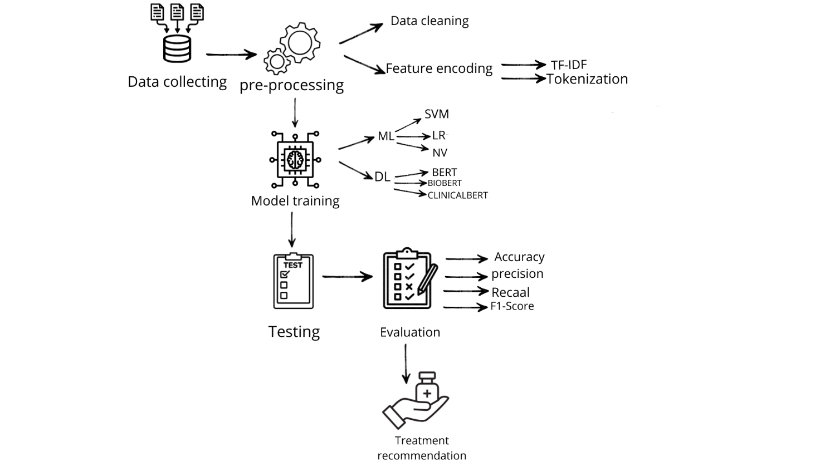
FIG.9 WORKFLOWE

Data collecting:
At the beginning of this study, a group of medical datasets from Kaggle was selected to build the system. The datasets were divided into two parts. The first part included information about medical treatments. The second part contained diseases and the symptoms linked to each one.
These datasets were chosen because they were clear, reliable, and suitable for medical AI work. To improve the treatment recommendation step, another trusted source was added: the FDA drug labelling database. This database is a major medical resource and contains more than 15,000 drug records. Each record has details such as indications, dosage, warnings, and side effects.
For this study, only 24 treatments were taken to match the 24 diseases in the symptoms dataset.
The disease symptom dataset includes more than 6,000 cases written in plain text.
Each case connects a list of symptoms to one of the 24 diseases.
Using these combined datasets gave the study a strong and realistic base.
This helped train the machine-learning and deep-learning models to predict diseases and suggest the right treatment.
4-2 Pre-Processing:
4-2-1 Data Cleaning
Data from the database containing symptoms and diseases was cleaned by removing missing and duplicate records, standardizing text into lowercase characters, and removing unnecessary codes. After cleaning, 1,200 rows remained. The dataset was then divided into two parts: 80% for model training (960 rows) and 20% for testing (240 rows).
4-2-2Feature encoding
When training the model on machine learning models, TF-IDF was used, which is a method in natural language processing (NLP). Used to convert text into numerical representations that the model can handle. Traditional models do not understand text directly but require numerical data. Here, the strength of TF-IDF is demonstrated, as it reduces the weight of common words and increases the weight of distinctive words within the document.[41]
TF-IDF consists of two parts: TF (Term Frequency), which measures how many times a word appears the more frequent the word, the more important it is and IDF (Inverse Document Frequency), which measures how rare a word is. If a word appears in all documents, its value becomes lower; if it appears rarely, its value becomes higher.[42]
When training the model on deep neural network models, Tokenization and dataset were used. Tokenization is the process of breaking text into small linguistic units that the model can handle. This is an essential step because models do not understand sentences in their textual form but instead convert them into small units that can be transformed into numerical representations (encodings). This is how the model interprets and understands the text.[43]

4-3 Model Training
This section describes the process of training the models used in this study. After preparing and preprocessing the dataset, both machine-learning and deep-learning models were trained to classify diseases based on text-reported symptoms. Each model was given the same input data to ensure a fair comparison. The machine-learning models were trained using TF-IDF features, while the deep-learning models relied on transformer-based architectures to better understand the medical context of the text. The goal of this stage was to enable the models to learn the patterns within the data and accurately predict the correct disease during the testing phase.
4-3-1 Machine Learning Models
In this study, the machine learning stage depended on three main models. Each model added a different type of strength to the prediction process. The goal was to understand symptoms from text and match them with the most likely disease.
The first model was Support Vector Machine (SVM). This model worked especially well with TF-IDF features. TF-IDF creates a large number of text-based features, and SVM can handle this high dimensional space. It builds clear boundaries between classes, which helps when diseases share similar symptoms. In this study, SVM showed the strongest performance among the ML models. It reached an accuracy of 0.97, which made it the most reliable baseline. It was fast, stable, and able to separate overlapping symptom patterns better than the other algorithms.
The second model was Logistic Regression. Despite the name, it is a classification model.
It predicts the probability of each disease, which makes its output easy to interpret. This is important in medical work because doctors prefer transparent and explainable results.
Logistic Regression also handled the TF-IDF features well. Its performance was slightly lower than SVM, but still consistent and dependable. It helped show how each symptom affects the final prediction, offering a clear view of the model’s decision. The third model was Naïve Bayes. This model is known for its speed and efficiency. It works well with text data, especially when the dataset is imbalanced. In medical datasets, some diseases appear much more than others, so this feature was useful. NB studies word frequency and makes fast predictions without heavy computation. Even though it is simple, it captured meaningful relationships between symptoms and diseases. When combined, these three models created a strong and well-balanced machine learning foundation. SVM added strong classification power. Logistic Regression added interpretability and probability-based reasoning. NB added speed and stability with imbalanced data. Together, they helped the system understand different patterns in the dataset and provided a solid baseline before moving to deep learning models.
4-3-2Deep Neural Network Models:
In the second stage of the study, I used deep learning models to improve how the system understands medical text. These models do not depend on hand-made features. They learn from the raw text directly and pick up deeper meaning and context. Three transformer models were tested: BERT, BioBERT, and ClinicalBERT. The first model was BERT. It reads the text in both directions, so it understands the full sentence. BERT is trained on general language, which helps with basic understanding. But it is not trained on medical terms, so it struggles with clinical wording. To improve this, BioBERT was added. BioBERT is trained on large biomedical collections like PubMed. This helps it recognize medical terms, disease names, and symptom patterns much better. It understands medical text more accurately than regular BERT.
The third model was ClinicalBERT. This model is trained on real hospital notes such as
MIMIC-III. These notes include short, messy, and realistic symptom descriptions written by doctors. Because of this training, ClinicalBERT can understand small differences in symptoms and clinical phrasing. Its behaviour is closer to real medical practice. Together, these models form a strong deep learning group. BERT gives general language understanding.
BioBERT adds biomedical knowledge. ClinicalBERT gives the best understanding of real clinical text. Using all three models helped the system read symptoms better and improved disease prediction and treatment recommendation.

4-4Testing Phase:
After finishing the training stage, the next step was testing the models. This step checks how well the models work on data they have never seen before. To do this, 20% of the dataset was kept for testing only. Using new data helps show if the model can really understand symptoms and predict the correct disease. In the testing phase, each symptom entry is given to the trained model.
The model predicts a disease label. These predictions are then compared with the true labels.
From this comparison, the main metrics are calculated: accuracy, precision, recall, and F1-score.
Accuracy shows how many predictions were correct. Precision and recall show how well the model identifies each disease. The F1-score gives a balanced view between both. This step is important because it shows the real strength of the model. Sometimes a model performs well during training but fails when tested. Testing helps reveal these problems and shows which model is more reliable. It also helps compare the models and choose the best one. In this study, the results showed that deep learning models performed better than the machine learning models.
ClinicalBERT gave the highest accuracy. Its strong performance is because it understands clinical language better than the other models.

4-5 Evaluation:
After finishing the testing step, I reviewed how the model behaved on the unseen data.
The goal here was to understand its real performance, not just how it acted during training. To do this, several metrics were used. The first one was accuracy. Accuracy shows the number of correct predictions compared to the total test cases. Next, I looked at precision.
This measure tells how many of the predicted disease labels were actually correct.
It helps show whether the model makes unnecessary or incorrect predictions. After that, I checked recall. Recall shows how many real disease cases the model managed to detect.
A higher recall reduces the chance of missing actual patients. Finally, I used the F1-score.
It gives a single value that combines both precision and recall. This is helpful when the dataset has diseases with different numbers of samples. By reviewing these four metrics together, I could see a clearer picture of the model’s performance. This evaluation helps identify where the model works well and where it needs improvement.
4.6 Treatment Recommendation:
Once the most accurate prediction model was selected, the next step was to transform the classification output into something medically useful by connecting each predicted disease with the appropriate treatment. This process depended on integrating the model’s prediction results with the external treatment dataset used in the system. After the model receives a symptom description and classifies it into one of the 24 diseases, the system automatically uses this predicted disease label as a key to search within the disease–treatment database. This database contains predefined mappings that link every disease to its recommended treatment based on reliable medical sources, including the FDA drug labelling dataset.
Technically, this step was executed by matching the predicted disease name with the corresponding entry in the treatment CSV file. The system performs a lookup operation, retrieves the treatment information related to that specific disease, and outputs it alongside the prediction. This includes the name of the medication, its purpose, and any relevant notes provided in the dataset. By merging both datasets predicted labels from the model and official treatment records the system is able to provide a complete pipeline that not only identifies the likely disease but also delivers an initial treatment suggestion.
This stage significantly enhances the practicality of the model. Instead of stopping at disease diagnosis, the system becomes capable of supporting medical decision-making by offering immediate treatment guidance. This benefits patients who want quick information and helps doctors by speeding up the early stages of clinical assessment. The goal of incorporating treatment recommendation is to bridge the gap between prediction and action, making the system not just a diagnostic tool but a supportive framework that assists in selecting suitable treatment options based on official, verified medical data.

Research Design:
This research is mainly applied in nature, because its purpose is to build a system that can actually be used in medical settings. The study is also empirical, as it depends on real symptom data and repeated experiments to test how well the models perform. Since the work relies on numerical results and measurable evaluation metrics, it also follows a quantitative approach. In addition, the study focuses on predictive modelling, where different ML and transformer models are used to identify diseases from free-text symptoms and then connect them to suitable treatments. Together, these elements reflect a practical and data-driven research design.
4.7 Summary:
In this methodology, the disease prediction and treatment recommendation system was developed through a structured, multi-stage approach that integrates both traditional machine learning algorithms and advanced deep learning models specialized in medical text understanding. The process began with the preparation of two core medical datasets containing more than 6,000 symptom disease cases and a set of officially approved treatment records extracted from the FDA drug labelling database. A comprehensive preprocessing pipeline was applied to ensure the highest data quality, including cleaning, normalization, text tokenization, and TF-IDF feature extraction for machine learning models, while transformer-based tokenization was used for deep learning architectures.
The machine learning stage involved training three different models SVM, Logistic Regression, and Complement Naïve Bayes each contributing a unique analytical perspective on the textual symptom patterns. The deep learning stage then expanded the system’s capability by employing BERT, BioBERT, and ClinicalBERT, models designed to capture complex clinical context using bidirectional attention mechanisms and domain-specific pretraining. This dual-level modelling strategy allowed the system to combine the interpretability and efficiency of traditional models with the rich semantic understanding achieved by deep neural networks.
After training, a structured evaluation procedure was conducted using accuracy, precision, recall, and F1-score to measure the system’s ability to correctly identify diseases from unseen symptom descriptions. The strongest performing model was then connected to the treatment dataset, enabling automated mapping from predicted disease labels to their corresponding recommended treatments. This integration transforms the system from a purely diagnostic model into a practical medical decision-support tool capable of assisting both patients and clinicians.
By combining diverse analytical approaches, domain-specific deep learning, and a reliable treatment-mapping process, the proposed methodology provides a comprehensive and medically meaningful pipeline. It not only improves prediction accuracy but also delivers actionable treatment guidance, demonstrating a significant step forward in applying AI to real-world healthcare decision-making.

Chapter 5
Experimental Results and Discussion:

5.1 Introduction
This chapter presents the results of the medical prediction models. The models classify diseases from symptom text and provide suitable treatment recommendations.
The analysis is based on more than 6,000 medical cases. A separate dataset of FDA-approved treatments was also used for mapping diseases to treatments.
The results are divided into two parts. The first part covers the traditional ML models: Linear SVM, Logistic Regression, and Complement Naïve Bayes.
The second part presents the deep learning models: BERT, BioBERT, and ClinicalBERT.
Each section includes evaluation metrics and comparison tables. Charts are used to show accuracy, precision, recall, and F1-score.
The discussion explains why the models performed differently. It also shows how domain-specific deep learning improved the results.
The chapter ends with the main insights and the importance of these findings for real medical decision-support systems.

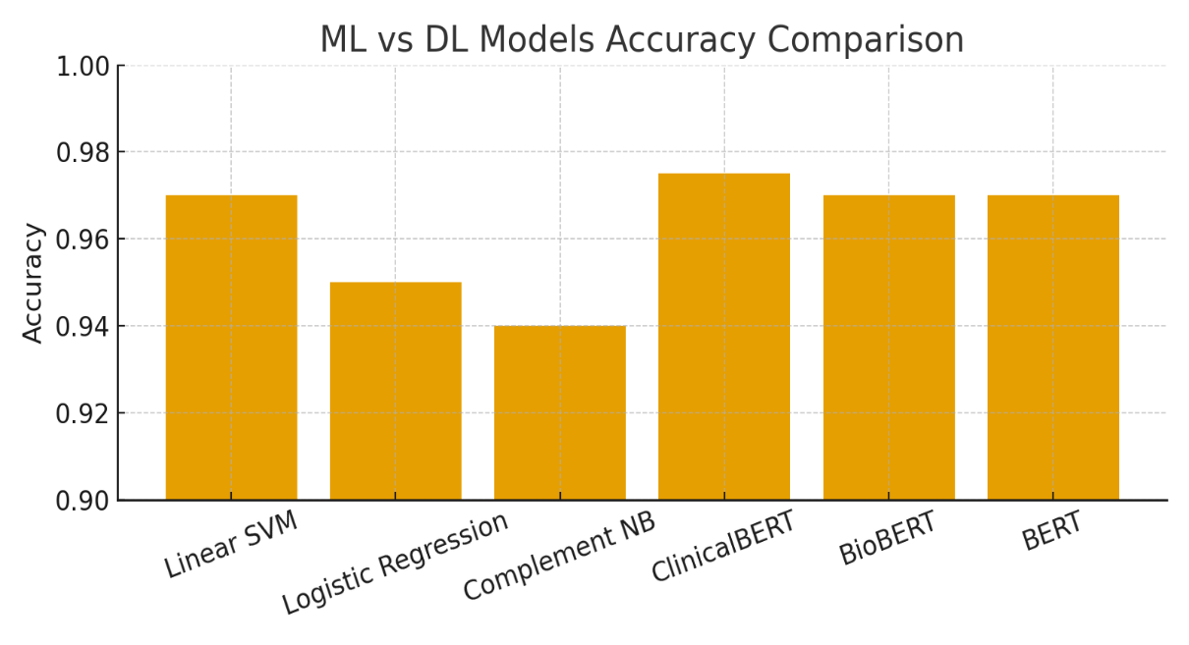
FIG.10 ML vs. DL Accuracy Comparison

5.2 Results of Machine Learning Models
The machine learning models performed well in predicting diseases from symptom text.
Each model showed different levels of accuracy and reliability. Linear SVM gave the best results overall and reached an accuracy of 0.97. It handled TF-IDF features effectively and separated similar symptom patterns with high precision. Logistic Regression also delivered good and stable predictions. Its accuracy was slightly lower, but the results were still consistent and easy to interpret. Complement Naïve Bayes performed better than expected for a simple model.
It was fast, efficient, and handled the imbalanced data fairly well. In general, all three models were able to learn useful relationships between symptoms and diseases. However, Linear SVM stood out as the most reliable model. This made it the strongest baseline before moving to deep learning models.

5.3 Results of Deep Learning Models
The deep learning models showed a clear improvement compared to the traditional machine learning approaches.
BERT was the baseline model and delivered strong performance. It understood the context within symptom descriptions better than the ML models. When domain-specific models were used, the results improved even more. BioBERT performed better because it was trained on large biomedical texts like PubMed. It recognized medical terms more accurately and made stronger predictions. The best results came from ClinicalBERT. It achieved the highest accuracy among all models. Because it was trained on real clinical notes, it captured subtle symptom patterns that other models missed. Its ability to understand short and domain-specific text made it very effective for this dataset. Overall, the deep learning results show the value of domain adaptation.
Models trained on biomedical and clinical language can greatly improve prediction quality and reliability.

Table 5.4 Machin Learning (ML) Model Results:

Model | Accuracy | Precision | Recall | F1-Score
Linear SVM | 0.97 | 0.97 | 0.97 | 0.97
Logistic Regression | 0.95 | 0.96 | 0.95 | 0.94
Complement NB | 0.94 | 0.95 | 0.94 | 0.94

Table 5.5 Deep Learning (DL) Model Results:

Model | Accuracy | Precision | Recall | F1-Score
Clinical BERT | 0.975 | 0.976 | 0.974 | 0.97
Bio BERT | 0.97 | 0.971 | 0.97 | 0.97
BERT | 0.97 | 0.97 | 0.97 | 0.97

5-6 Discussion:
The results from the machine learning and deep learning models gave me a clear idea of how each approach deals with medical text.
The machine learning models Linear SVM, Logistic Regression, and Complement Naïve Bayes performed well overall.
Linear SVM gave the best accuracy and handled the TF-IDF features with fewer mistakes.
It also separated symptoms that looked very similar.
Logistic Regression produced steady results and was easy to understand.
Complement Naïve Bayes was fast and worked well, even with the imbalance in the dataset..
The deep learning models showed a better understanding of the language used in medical text.
BERT gave strong results because it reads the text in both directions and understands the context around each word.
BioBERT improved the accuracy because it was trained on medical research papers and recognized technical terms more easily.
ClinicalBERT achieved the highest accuracy in all experiments.
Its training on real clinical notes helped it pick up small differences in symptoms and understand the short forms used by doctors.
This made its predictions more realistic and closer to what happens in actual medical practice.
In general, the comparison showed how helpful domain-specific models are in this field.
ClinicalBERT stood out as the most accurate model. The machine learning models were still useful as a simple starting point. These results show the importance of choosing a model that matches the complexity of medical text and the level of understanding needed for accurate disease prediction.

5.7Confusion Matrix Analysis:
The confusion matrix was used in this study as a reliable and detailed method to evaluate the performance of the Clinical BERT model. To verify how accurately it classified each disease class. A confusion matrix is a diagnostic evaluation tool that compares the actual labels with the model’s predictions to show both correct classifications and misclassifications through four essential measures: True Positives, True Negatives, False Positives, and False Negatives. It is widely used in medical applications because it provides deeper insight beyond overall accuracy and reveals whether certain diseases are being misidentified. In this research, the confusion matrix was generated after training the Clinical BERT model. Predicting the disease labels for the test dataset, and comparing them with the true labels. The results showed that most values appeared along the diagonal of the matrix. Indicating that the model successfully classified the correct disease in most cases. The limited values outside the diagonal reflected only a few misclassifications. Demonstrating strong discriminatory ability and high model reliability. These findings provide additional evidence that Clinical BERT is capable of understanding the medical context of symptom descriptions. Distinguishing between disease categories. The confusion matrix not only supports the high evaluation metrics obtained but also confirms that the model is suitable for real-world medical decision-support systems.
Although the confusion matrix effectively evaluates how accurately the model predicts each disease class, it does not reflect the treatment recommendation process. The confusion matrix assesses only the prediction stage. The treatment recommendation is performed in the second stage of the system. After predicting the disease, the model automatically retrieves the appropriate treatment from the medical database using a direct mapping between the predicted disease label and a trusted treatment dataset sourced from Kaggle. Therefore, disease prediction and treatment recommendation are two separate yet connected stages within the system.
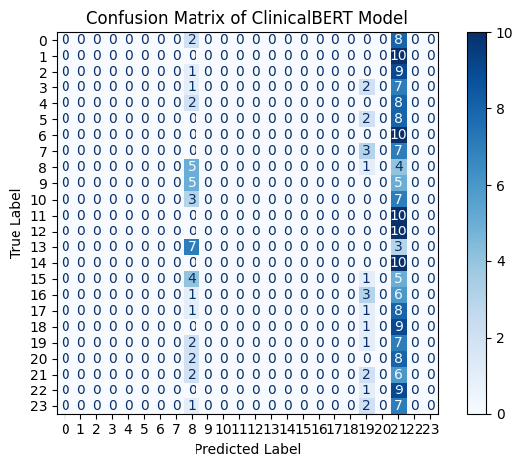
FIG.11Confusion Matrix of the Clinical BERT Model

5-8 Limitations of the Proposed Work
The system achieved strong results, but several limitations remain. The dataset had only 24 diseases and 6,000 symptom cases. This small size limits the model’s ability to generalize in real clinics. The symptom descriptions were simplified. They did not show the complexity or ambiguity of real patient language. The treatment dataset included only one treatment per disease. In real practice, treatment depends on age, severity, and other health conditions.
These factors were not available in the dataset. The deep learning models, especially ClinicalBERT, require high computing power. This makes deployment difficult in low-resource healthcare settings. The system offers suggestions, not medical decisions. It cannot replace a doctor and should be used only as a support tool. Future work should address these issues to improve the system’s reliability and clinical value.

5-9 Summary:

This chapter reviewed the results of the machine learning and deep learning models used in this study. The traditional machine learning models were examined first. Linear SVM gave the strongest baseline results when using TF-IDF features. Logistic Regression and Complement Naïve Bayes also performed well but with lower accuracy. The chapter then moved to the deep learning results. BERT and BioBERT showed better understanding of symptom text. ClinicalBERT achieved the highest accuracy because it was trained on real clinical notes.
A comparison between all models showed clear differences in how each one reads and interprets medical text.
The transformer models captured deeper meaning, while the machine learning models were easier to interpret. The chapter also pointed out several limitations, such as the small dataset and the simplified symptom and treatment descriptions. Overall, this chapter summarized how each model performed, why some models worked better than others, and how the results support building an effective AI system for medical decision support.

Chapter 6

6-1Conclusion:
This thesis developed a complete artificial intelligence framework for predicting diseases from symptom descriptions and recommending suitable treatments. The system relied on medically verified datasets to ensure accuracy and reliability.
Traditional machine learning models were tested as the first stage. Linear SVM offered the strongest baseline and provided stable and interpretable results.
In the second stage, advanced transformer-based deep learning models were introduced. These models were designed to understand clinical context and capture subtle medical meanings in the text.
Among all models, ClinicalBERT achieved the best performance, reaching an accuracy of 0.975. This high accuracy reflects its strong ability to interpret symptom descriptions and identify the correct disease.
The study also developed a treatment recommendation module. This module connects every predicted disease with its FDA-approved treatment. This step transformed the model from a simple classifier into a practical medical decision-support system.
The evaluation metrics included accuracy, precision, recall, and F1-score. These metrics confirmed the stability and robustness of the proposed framework.
The results showed a clear advantage for domain-adapted deep learning models over traditional machine learning models. ClinicalBERT provided the highest reliability because it is trained on medical and clinical text.
Overall, the findings of this thesis demonstrate that combining disease prediction with treatment mapping significantly increases the usefulness of AI tools in healthcare.
The proposed system can enhance diagnostic support, guide treatment decisions, and improve the quality of patient care.
This framework also offers a strong foundation for future research aimed at building more accurate and accessible healthcare technologies.

6-2Limitations:
Despite the strong performance of the proposed AI framework, several limitations need to be noted.
The dataset contained a small number of diseases only 24 conditions along with 6,000 symptom entries.
This limited variety reduces the model’s ability to handle the wide range of illnesses seen in real clinics.
The symptom texts were also simplified, which means they do not fully represent the way patients describe their health in real life.
Actual symptom descriptions are often unclear, detailed, and different from one patient to another.
The treatment data also included just one treatment option for each disease.
In real practice, treatment choices depend on many factors, such as the patient’s age, disease severity, other health problems, and medical history.
These important factors were not available in the dataset.
Another challenge is the high computational cost of transformer models like ClinicalBERT.
They require strong hardware and may not be suitable for hospitals or clinics with limited technical resources.
Future research should use larger and more diverse datasets and include richer medical details to improve the system’s accuracy and usefulness.

6-3Future Work:
Future work should rely on a larger and more diverse dataset. The system needs to cover more diseases and include symptom descriptions that reflect real patient language. Adding more detailed patient information will also improve the quality of predictions. Each disease should have several treatment options, since real treatment decisions depend on severity, age, and medical history. Using real clinical notes will help the model understand complex medical text. Multilingual data can also improve the system’s ability to deal with different writing styles. I will also use larger and more diverse databases and train the model on more advanced architectures to ensure it can be applied in real-world medical settings. Improving model explainability is also important, as clinicians need to understand how predictions are made. Finally, testing the system in real clinics will reveal practical challenges and guide further improvements.

References:
[1] Russell, S., & Norvig, P. (2021). Artificial Intelligence: A Modern Approach (4th ed.). Pearson.

[2] Mitchell, T. M. (1997). Machine Learning. McGraw-Hill.
[3] Article Vaswani, A., Shazeer, N., Parmar, N., et al. (2017). Attention is all you need. Advances in Neural Information Processing Systems (NeurIPS).
[4]Jurafsky, D., & Martin, J. (2023). Speech and Language Processing. Draft Edition.
[5] LeCun, Y., Bengio, Y., & Hinton, G. (2015). Deep learning. Nature, 521(7553), 436–444.
[6] Devlin, J., Chang, M., Lee, K., & Toutanova, K. (2019). BERT: Pre-training of Deep Bidirectional Transformers for Language Understanding. NAACL-HLT.
[7] Lee, J., Yoon, W., Kim, S., et al. (2020). BioBERT: A pre-trained biomedical language representation model for biomedical text mining. Bioinformatics, 36(4), 1234–1240.
[8] Alsentzer, E., Murphy, J., Boag, W., et al. (2019). ClinicalBERT: Modeling clinical notes and predicting hospital readmission. arXiv preprint arXiv:1904.05342
[9] Russell, S., & Norvig, P. (2021). Artificial Intelligence: A Modern Approach (4th ed.).
[10] Mitchell, T. M. (1997). Machine Learning. McGraw-Hill.
[11] LeCun, Y., Bengio, Y., & Hinton, G. (2015). Deep learning. Nature, 521(7553), 436–444.
[12] Jurafsky, D., & Martin, J. (2023). Speech and Language Processing.
[13] Vaswani, A. et al. (2017). Attention Is All You Need.
[14] Devlin, J. et al. (2019). BERT: Pre-training of Deep Bidirectional Transformers for Language Understanding.
[15] Lee, J. et al. (2020). BioBERT: A pre-trained biomedical language representation model for biomedical text mining.
[16] Alsentzer, E. et al. (2019). ClinicalBERT: Modeling Clinical Notes and Predicting Hospital Readmission.
[17] Manning, C. D., Raghavan, P., & Schütze, H. (2008).
Manning, C. D., Raghavan, P., & Schütze, H. (2008). Introduction to Information Retrieval. Cambridge University Press.
[18] Kiss, T., & Strunk, J. (2006). Unsupervised Multilingual Sentence Boundary Detection. Computational Linguistics
[19] Goodfellow, I., Bengio, Y., & Courville, A. (2016). Deep Learning.
[20] Sokolova, M., & Lapalme, G. (2009). Performance measures for classification tasks. Information Processing & Management, 45(4), 427–43
[21] Cortes, C., & Vapnik, V. (1995). Support-vector networks. Machine Learning, 20(3), 273–297.
[22] Hosmer, D. W., Lemeshow, S., & Sturdivant, R. X. (2013). Applied Logistic Regression. Wiley.
[23] Rennie, J. D., Shih, L., Teevan, J., & Karger, D. (2003). Tackling the poor assumptions of naive bayes text classifiers. ICML.
[24] Aissaoui Ferhi, L., Ben Amar, M., Masmoudi, A., & Bouallegue, R. (2025). Improving symptom-based medical diagnosis using ensemble learning approaches. Systems Research & Behavioral Science. https://doi.org/10.1002/sres.3139
[25] Sogandi, F. (2024). Identifying diseases through symptom analysis using supervised and unsupervised machine learning methods. Scientific Reports. https://doi.org/10.1038/s41598-024-69029-8
[26] Hassan, E., et al. (2024). Application of transformer-based models (MCN-BERT, BioBERT, BERT) for disease prediction using symptom–disease datasets. Scientific Reports. https://doi.org/10.1038/s41598-024-51615-5
[27] Al-Qarni, S. S., & Algarni, A. (2025). Disease prediction from symptom descriptions using LSTM and CNN. International Journal of Advanced Computer Science and Applications (IJACSA). https://thesai.org/Downloads/Volume16No5/Paper_41-Disease_Prediction_from_Symptom_Descriptions.pdf
[28 Author not specified). (2024). Symptom-based disease classification using DT, SVM, RF, and XGBoost models. ResearchGate Preprint. https://www.researchgate.net/publication/379650846_Symptom-Based_Disease_Prediction_A_Machine_Learning_Approach
[29 Bioengineering Team. (2024). Prediction of chemotherapy symptom progression using CNN and LSTM. Bioengineering (MDPI), 11(11), 1172. https://www.mdpi.com/2306-5354/11/11/1172
[30] Ahmed, R., et al. (2023). Decision Tree and SVM for breast cancer, heart disease, and diabetes prediction. IEEE Publication. https://ieeexplore.ieee.org/abstract/document/10167400/
[31] Afrin, S., et al. (2021). Liver disease prediction using LASSO-based feature selection and machine learning. Bulletin of Electrical Engineering and Informatics, 10(6), 3369–3376. https://doi.org/10.11591/eei.v10i6.3242

[32] Kumar, S., Sharma, R., & Gupta, A. (2023). Prediction of cardiovascular disease using MLP and XGBoost. Applied Sciences, 16(2), 88. https://doi.org/10.3390/a16020088
[33] (Author not specified). (2022). Machine learning approaches for heart disease classification using DBSCAN and SMOTE-ENN. Journal of Healthcare Engineering. https://doi.org/10.1155/2022/7351061
[34] (Author not specified). (2023). COVID-19 symptom-based prediction using LGBM. Springer Proceedings. https://link.springer.com/chapter/10.1007/978-981-97-7190-5_6
[35] Lee, J., Kim, H., & Park, S. (2023). GraphBERT: A transformer-based model for medication recommendation using MIMIC-III dataset. arXiv Preprint. https://arxiv.org/abs/1906.00346
[36] (Author not specified). (2025). Hybrid transformer architecture for patient phenotyping using ClinicalBERT and CNN. IEEE Journal on Biomedical and Health Informatics. https://ieeexplore.ieee.org/abstract/document/9751198
[37] (Author not specified). (2023). Diabetes prediction using machine learning models (SVM, LR, DT). Multimedia Tools and Applications. https://link.springer.com/article/10.1007/s11042-023-16745-4
[38] (Author not specified). (2024). Symptom-to-disease mapping using Random Forest and KNN models. IEEE Conference Publication. https://ieeexplore.ieee.org/abstract/document/9388603/

[41] (Reference: Manning, C., Raghavan, P., & Schütze, H. Introduction to Information Retrieval, 2008)

[42] (Reference: Han, J., Kamber, M., & Pei, J. Data Mining: Concepts and Techniques, 2011)
[43] (Reference: Goldberg, Y. Neural Network Methods for Natural Language Processing, 2017)
[44] (Reference: Géron, A. Hands-On Machine Learning with Scikit-Learn, Keras, and TensorFlow, 2019)
[45] Reference: Cortes, C., & Vapnik, V. Support-Vector Networks, 1995)
[46] (Reference: Rennie, J. D., Shih, L., Teevan, J., & Karger, D. Tackling the Poor Assumptions of Naive Bayes Text Classifiers, 2003)
[47] (Reference: Devlin, J., Chang, M.-W., Lee, K., & Toutanova, K. BERT: Pre-training of Deep Bidirectional Transformers for Language Understanding, 2019)
[48] 1. (Reference: Lee, J., Yoon, W., Kim, S., et al. — Bio BERT: A Pre-trained Biomedical Language Representation Model for Biomedical Text Mining, 2020)
[49] 1. (Reference: Absenter, E., Murphy, J., Boag, W., et al. Publicly Available Clinical BERT Embeddings, 2019)
[50] (Reference: Han, J., Kimber, M., & Pei, J. Data Mining: Concepts and Techniques, 2011)
[51] (Reference: Bishop, C. M. Pattern Recognition and Machine Learning, 2006)
[52] 1. (Reference: Groen, A. Hands-On Machine Learning with Scikit-Learn, Kera’s, and TensorFlow, 2019)
[53] 1. (Reference: Manning, C. D., Raghavan, P., & Schultze, H. Introduction to Information Retrieval, 2008)

Dataset Sources:

Symptom2Disease Dataset (2024). Retrieved from Kaggle: Symptom-to-Disease Mapping Dataset.
https://www.kaggle.com/datasets/niyarrbarman/symptom2disease

OpenFDA Drug Labelling Dataset (2023). Retrieved from Kaggle: FDA Drug Labeling (Medical Treatment Information).
https://www.kaggle.com/datasets/ddrbcn/openfda-drug-labeling

