AI Sign Language Recognition for the Deaf and Mute
Comparative Performance Analysis of CNN and Swin Transformer Deep Learning Models for American Sign Language
Prepared By
Anas Abdulkader Mohammed Alzain ID No.: 453001724
Mohammed Omar Abdullah Alqathmi ID No.: 253001437
Submitted in fulfillment of the requirements for the degree of
Master of Science in Artificial Intelligence
At
College of Informatics
Midocean University
Supervisor: Dr. Hagar Saleh
College of Informatics, Midocean University, Comoros
Email: XXXXXXXXXXXXXXXX

Acknowledgements
We would like to express our sincere appreciation to our supervisor, Dr. Hagar Saleh, whose guidance, support, and sound advice have been invaluable throughout the preparation and implementation of this Master's thesis in Artificial Intelligence.
Her extensive experience and the vision she has shaped through constructive criticism have contributed greatly to the scientific rigor of this research. Her dedication and enthusiasm for developing our academic and research capabilities have been genuinely motivating and inspiring throughout this journey.
This thesis could not have been completed without her wise guidance and invaluable direction. We are deeply grateful for her patience, support, and continuous encouragement, and we extend our sincere thanks for the time and trust she has invested in us.
We would also like to thank the College of Informatics at Midocean University for providing the academic environment and resources that made this research possible, and our families for their unwavering support throughout our studies.

Abstract
Sign language is the primary mode of communication for the Deaf and Mute (D&M) community, yet most hearing people do not understand it, creating a genuine communication barrier that affects education, employment, and social inclusion. This thesis presents a comparative study of four deep learning architectures — ResNet50, MobileNetV2, EfficientNetB0, and the Swin Transformer — for recognizing American Sign Language (ASL) letters and digits from static hand-gesture images, to identify the most reliable and efficient model for building an assistive ASL recognition system.
A dataset of 36 classes (digits 0–9 and letters a–z), comprising 2,516 images after cleaning, was split into 70% training, 10% validation, and 20% testing sets. The three convolutional models were fine-tuned via transfer learning from ImageNet-pretrained weights, while the Swin Transformer (swin-tiny variant) was fine-tuned from its pretrained checkpoint with a replaced classification head. All models were trained under a unified protocol (224×224 input size, batch size 16, 30 epochs with early stopping, learning rate 0.0001) and evaluated using accuracy, precision, recall, F1-score, and inference time.
The Swin Transformer achieved the best overall performance, reaching 99.21% test accuracy and a 99.21% F1-score, clearly outperforming MobileNetV2 (87.92%), ResNet50 (87.33%), and EfficientNetB0 (73.65%). Its hierarchical shifted-window attention mechanism captured both local and global hand-gesture features more effectively than the conventional CNNs, despite a relatively higher inference time (275.58 seconds on the test set, compared to 143.83 seconds for the fastest model, MobileNetV2). Per-class analysis further showed that the Swin Transformer maintained consistently high F1-scores across nearly all 36 classes, whereas the CNN-based models struggled specifically with visually similar classes such as the letter ‘w’ and the digit ‘6’.
Based on these findings, the Swin Transformer is recommended as the core of a practical ASL recognition system, with MobileNetV2 identified as a suitable lightweight alternative for resource-constrained, real-time deployment scenarios. The thesis further proposes model compression, dynamic-gesture support, and integration into video-conferencing platforms as promising directions for future work, extending the practical impact of this research on communication accessibility for the Deaf and Mute community.

List of Abbreviations
Abbreviation | Meaning
AI | Artificial Intelligence
ANN | Artificial Neural Network
ASL | American Sign Language
CNN | Convolutional Neural Network
CV | Computer Vision
D&M | Deaf and Mute
DL | Deep Learning
F1 | F1-score (harmonic mean of Precision and Recall)
FN | False Negative
FP | False Positive
GPU | Graphics Processing Unit
ML | Machine Learning
NLP | Natural Language Processing
ReLU | Rectified Linear Unit
RGB | Red, Green, Blue (colour channels)
SLR | Sign Language Recognition
SW-MSA | Shifted-Window Multi-head Self-Attention
TN | True Negative
TP | True Positive
ViT | Vision Transformer
W-MSA | Window-based Multi-head Self-Attention
WHO | World Health Organization
XAI | Explainable Artificial Intelligence

List of Figures
Figure 1.1: Global Hearing Loss Statistics (WHO, 2021)
Figure 2.1: Artificial Intelligence (AI)
Figure 2.2: Computer Vision (CV)
Figure 2.3: Deep Learning (DL)
Figure 2.4: How a CNN Processes an Image
Figure 2.5: Convolutional Layers
Figure 2.6: Pooling Layers
Figure 2.7: Fully Connected Layers
Figure 3.1: Proposed Methodology Pipeline
Figure 3.2: Experimental Framework (Stage-by-Stage View)
Figure 4.1: Accuracy Comparison of the Four Models on the Test Set
Figure 4.2: Precision, Recall, and F1-score Comparison of the Four Models
Figure 4.3: Confusion Matrix of the Swin Transformer on the Test Set
Figure 4.4: Confusion Matrix of ResNet50 on the Test Set
Figure 4.5: Confusion Matrix of MobileNetV2 on the Test Set
Figure 4.6: Confusion Matrix of EfficientNetB0 on the Test Set
Figure 4.7: Inference-Time Comparison of the Four Models on the Test Set

List of Tables
Table 2.1: Comparison of Related Studies on Sign Language Recognition
Table 3.1: Number of Images per Class Used in the Dataset (Summary)
Table 3.2: Summary of the Deep Learning Models Used
Table 3.3: Training Configuration
Table 4.1: Performance Comparison of the Four Models on the Test Set
Table 4.2: Best and Worst Class by F1-score for Each Model
Table 4.3: Approaches, Model Size, and Inference-Time Comparison

Table of Contents
Note: page numbers below should be refreshed automatically in Microsoft Word once the document layout is finalised.
Acknowledgements i
Abstract ii
List of Abbreviations iii
List of Figures iv
List of Tables v

Chapter 1: Introduction 1
1.1 Overview 1
1.2 Problem Definition 2
1.3 Thesis Objectives 3
1.4 Thesis Contribution 4
1.5 Thesis Organization 5
Chapter 2: Background and Related Work 6
2.1 Background 6
2.2 Related Work 12
2.2.1 CNN-Based Approaches 12
2.2.2 Hybrid and Multi-Stream Approaches 14
2.2.3 Detection-Based (YOLO) Approaches 15
2.2.4 Vision Transformer and Swin-Based Approaches 16
2.3 Summary and Research Gap 20
Chapter 3: Proposed Approach 21
3.1 Introduction 21
3.2 System Workflow 21
3.3 Proposed Methodology Diagram 23
3.4 Dataset Description 24
3.5 Data Preprocessing and Augmentation 25
3.6 Model Architectures 26
3.7 Proposed Algorithm 28
3.8 Training Configuration 29
3.9 Evaluation Metrics 30
Chapter 4: Experimental Results and Discussion 31
4.1 Introduction 31
4.2 Experimental Setup 31
4.3 Results of Applying the Models 32
4.4 Comparative Results 34
4.5 Per-Class Error Analysis 36
4.6 Discussion 39
4.7 Limitations of the Study 41
4.8 Time Analysis 42
Chapter 5: Conclusion and Future Work 44
5.1 Summary of the Study 44
5.2 Key Findings and Contributions 44
5.3 Recommendations for Practical Application 45
5.4 Future Work 46
References 47

CHAPTER 1
Introduction

1.1 Overview
Artificial intelligence (AI) is an integral element of contemporary technological advancement. Among its most practical applications is Computer Vision (CV), which enables machines to perceive, interpret, and reason about visual data such as images, video, and hand gestures. Over the past decade, Convolutional Neural Networks (CNNs) have substantially improved the accuracy and reliability of gesture-recognition systems, and more recently, Vision Transformers — and particularly the Swin Transformer — have demonstrated an even greater ability to capture both fine-grained local detail and long-range contextual relationships within an image.
According to the World Health Organization, more than 1.5 billion people worldwide live with some degree of hearing loss, of whom approximately 430 million experience disabling hearing loss that requires intervention; this number is projected to reach nearly 2.5 billion people — roughly one in four — by 2050 [31], as illustrated in Figure 1.1. Sign languages, such as American Sign Language (ASL), are the primary mode of communication for the Deaf and Mute (D&M) community. However, the majority of hearing individuals do not understand sign language, which creates a genuine communication barrier that can affect education, employment, and social participation for this community.
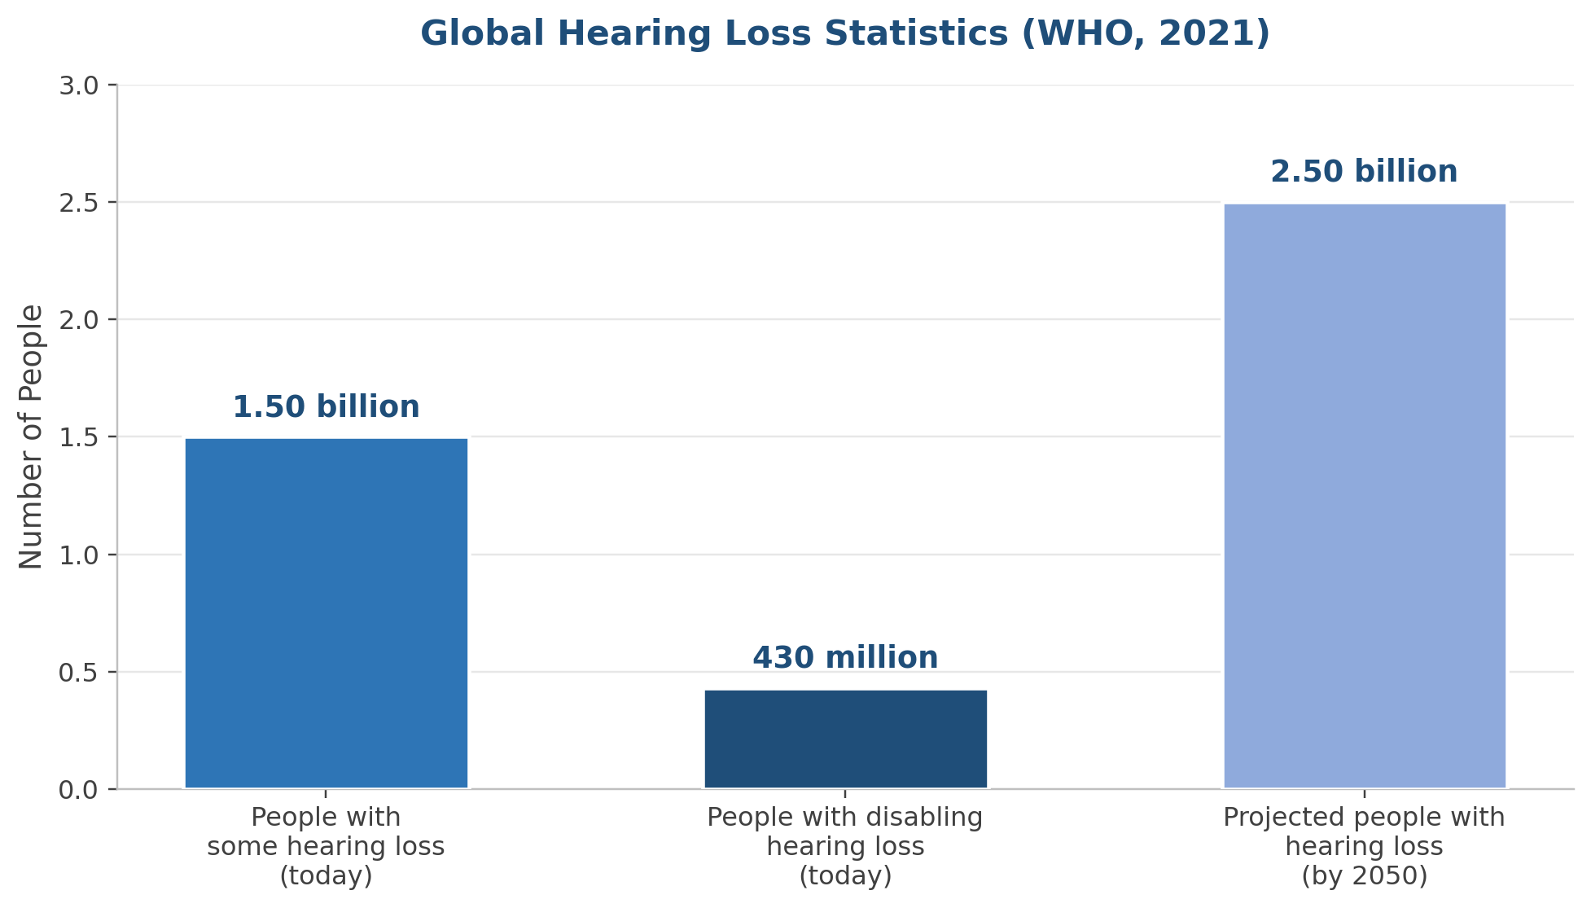
Figure 1.1: Global Hearing Loss Statistics (WHO, 2021)
Earlier automatic sign-language recognition systems relied on bulky and often invasive equipment, such as sensor-embedded gloves, which limited their practicality for everyday use. More recent approaches rely instead on ordinary cameras combined with computer-vision algorithms, which greatly simplifies data acquisition, although challenges related to lighting conditions, background clutter, and hand pose variation remain. Deep learning, and CNNs in particular, has enabled substantial progress in extracting robust visual features directly from raw images, addressing many of these earlier limitations.
This thesis is motivated by the goal of developing and rigorously evaluating a reliable American Sign Language recognition system based on deep learning, in order to help bridge the communication gap between the Deaf and Mute community and the hearing population. Specifically, this work compares four deep learning architectures — three well-established convolutional networks and one modern hierarchical vision transformer — on the task of recognizing ASL fingerspelling (individual letters and digits) from static images, with the aim of identifying the most accurate and practically viable model.

1.2 Problem Definition
Sign language plays a fundamental role in the daily lives of Deaf and Mute individuals. American Sign Language, like other sign languages, has its own grammar and visual vocabulary that is largely unfamiliar to hearing people, which creates a communication barrier affecting health, education, employment, and other essential areas of life. ASL fingerspelling — in which words are spelled out using a distinct hand shape for each letter of the alphabet and each digit — is one of the foundational building blocks of the language, and automatic recognition of fingerspelling gestures is an important first step toward more comprehensive sign-language translation systems.
Early motion-recognition devices relied heavily on hardware sensors, which, while functional, were often invasive, expensive, and impractical for everyday use. The subsequent shift toward camera-based, vision-only methods removed this hardware burden but introduced new challenges, including sensitivity to changes in lighting, background, and camera angle. Deep learning and CNNs have improved feature extraction from raw images considerably; however, most existing studies in this space share two important limitations. First, the majority of prior work compares only traditional CNN architectures against one another (e.g., AlexNet, VGG, ResNet), without adequately evaluating modern vision transformers — chief among them the Swin Transformer — under the same experimental conditions. Second, few studies report inference time alongside accuracy, despite its practical importance for real-time assistive applications.
The problem addressed by this thesis can therefore be stated as follows: there is a lack of a rigorous, unified experimental comparison that evaluates a modern hierarchical vision transformer (the Swin Transformer) against common pretrained CNN architectures (ResNet50, MobileNetV2, and EfficientNetB0) on the identical task of ASL fingerspelling recognition, using the same dataset, preprocessing pipeline, and evaluation protocol. Such a comparison is necessary to provide evidence-based guidance for researchers and developers building practical ASL recognition systems.

1.3 Thesis Objectives
The overall objective of this thesis is to design, implement, and rigorously evaluate a comparative deep-learning framework for recognizing American Sign Language fingerspelling gestures from static images, in order to identify the most accurate and practically suitable model. This overall objective is broken down into the following specific objectives:
- To prepare and organize an ASL fingerspelling image dataset covering 36 classes (digits 0–9 and letters a–z), including data cleaning and a unified 70/10/20 train–validation–test split.
- To design an effective preprocessing and data-augmentation pipeline that standardizes image size and increases the diversity of the training data, improving model generalization.
- To train three pretrained convolutional neural network models (ResNet50, MobileNetV2, and EfficientNetB0) using transfer learning, and a hierarchical Swin Transformer model, on the prepared dataset.
- To evaluate all four models under a unified protocol using accuracy, precision, recall, F1-score, and inference time, ensuring a fair and reproducible comparison.
- To conduct a detailed per-class error analysis to identify which letters and digits are most challenging for each model, and to interpret the underlying causes.
- To identify the most efficient model overall, and to propose practical recommendations for deploying an ASL recognition system, including potential integration into real-time communication platforms.

1.4 Thesis Contribution
This thesis makes the following contributions to the field of automatic sign-language recognition:
- A unified, reproducible experimental benchmark comparing three widely used pretrained CNN architectures against a modern hierarchical vision transformer on the same ASL fingerspelling recognition task, dataset, and evaluation protocol — an evaluation setting still uncommon in the existing literature.
- Empirical evidence that the Swin Transformer substantially outperforms all three CNN baselines on this task, achieving 99.21% test accuracy compared to a maximum of 87.92% among the CNN models, together with a detailed analysis of why this advantage arises.
- A fine-grained, per-class error analysis identifying specific letters and digits (such as ‘w’ and ‘6’) that are systematically more difficult for CNN-based models, together with an architectural explanation grounded in the self-attention mechanism.
- A practical accuracy–inference-time trade-off analysis that goes beyond accuracy alone, offering evidence-based guidance on model selection for both high-accuracy and resource-constrained deployment scenarios.
- A set of concrete, actionable recommendations for extending this work into real-time and assistive-technology contexts, including a proposed design for integrating the recognition model into video-conferencing and communication platforms to support the Deaf and Mute community.

1.5 Thesis Organization
The remainder of this thesis is organized into four further chapters. Chapter 2 presents the theoretical background necessary to understand this work — covering artificial intelligence, computer vision, deep learning, convolutional neural networks, and vision transformers — followed by a comprehensive review of related work on sign-language recognition, concluding with a summary of the research gap this thesis addresses. Chapter 3 details the proposed approach, including the overall system workflow, the dataset, the preprocessing and augmentation pipeline, the architecture of each of the four models under comparison, the proposed algorithm, and the training configuration and evaluation metrics used. Chapter 4 presents and discusses the experimental results, including a per-model results narrative, comparative performance results, a detailed per-class error analysis, a discussion of the findings in light of related work, the limitations of the study, and a dedicated time-analysis section. Finally, Chapter 5 concludes the thesis by summarizing the key findings and contributions, presenting practical recommendations, and outlining directions for future work.
CHAPTER 2
Background and Related Work
This chapter presents the theoretical background necessary to understand the proposed system, followed by a comprehensive review of related work on automatic sign-language recognition. The background is presented in a simplified and integrated manner, covering artificial intelligence, computer vision, deep learning, convolutional neural networks, and vision transformers, since these concepts together form the technical foundation of the proposed approach detailed in Chapter 3.

2.1 Background

2.1.1 Artificial Intelligence and Computer Vision
Artificial Intelligence (AI) is the branch of computer science concerned with building systems capable of performing tasks that typically require human intelligence, such as learning, perception, and decision-making [1]. Rather than following explicitly programmed rules, AI systems learn statistical patterns from data, which allows them to adapt to new situations. Computer Vision (CV) is one of the most practical applied branches of AI: it enables machines to analyse and interpret visual data — images and video — converting raw pixel information into representations useful for tasks such as pattern recognition and object classification [2], including the recognition of hand gestures and sign language, which is the focus of this thesis.
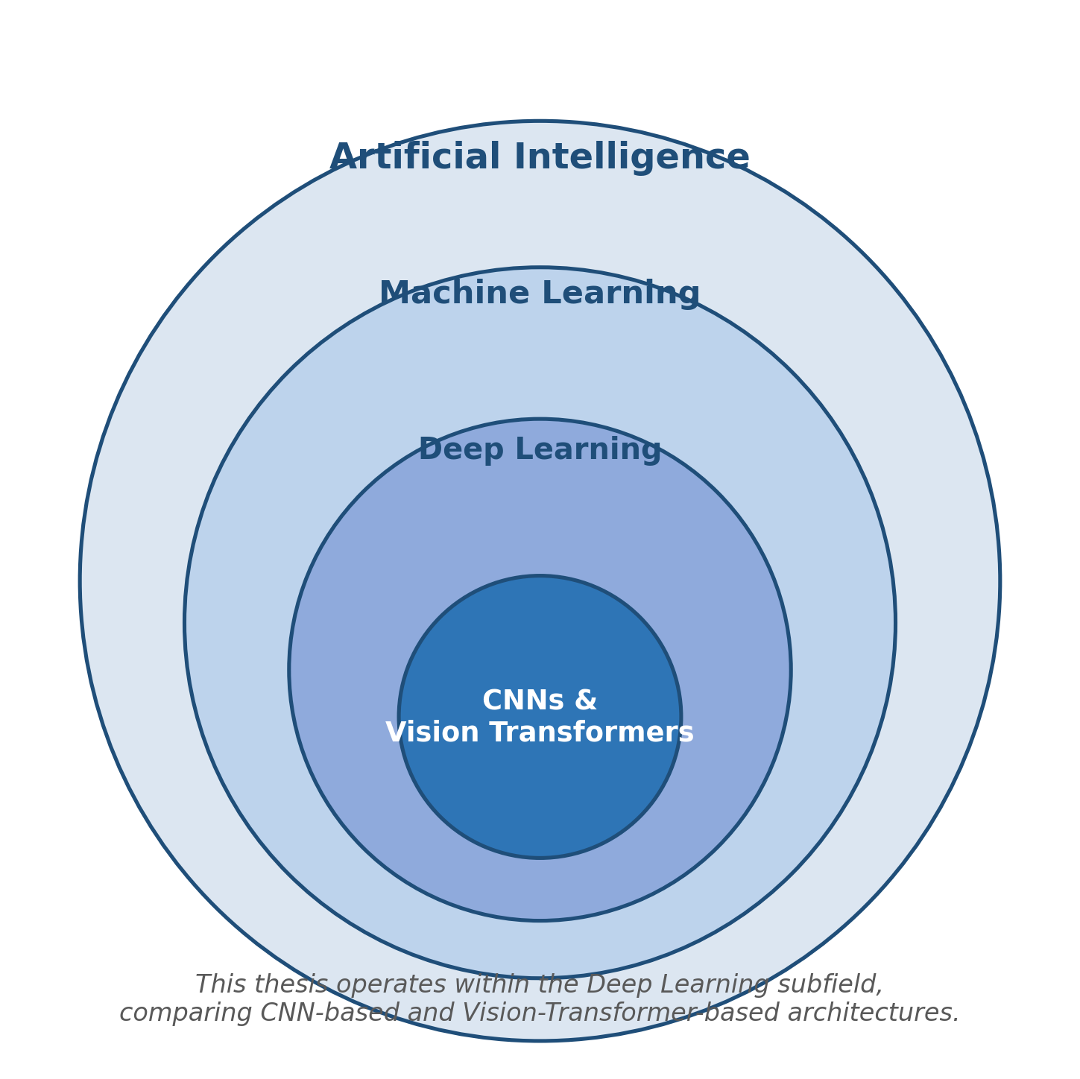
Figure 2.1: Artificial Intelligence (AI) — Relationship to Machine Learning and Deep Learning
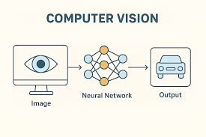
Figure 2.2: Computer Vision (CV)

2.1.2 Deep Learning
Deep Learning (DL) is a branch of machine learning that relies on multi-layered computational networks to perform hierarchical feature learning, progressively transforming raw input data into increasingly abstract representations suited to a specific task [3]. This hierarchical, automatic feature-extraction capability is what distinguishes deep learning from earlier machine-learning approaches that relied on hand-engineered features, and it is precisely this capability that has driven recent progress in sign-language recognition from raw images [4].

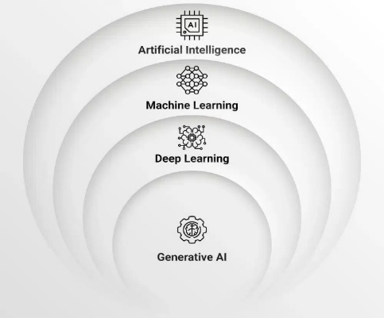
Figure 2.3: Deep Learning (DL)

2.1.3 Convolutional Neural Networks
Convolutional Neural Networks (CNNs) are deep learning architectures specialised for processing data with a grid-like structure, most notably two-dimensional images [5]. A typical CNN processes an input image through a sequence of specialised layers, illustrated in Figure 2.4.
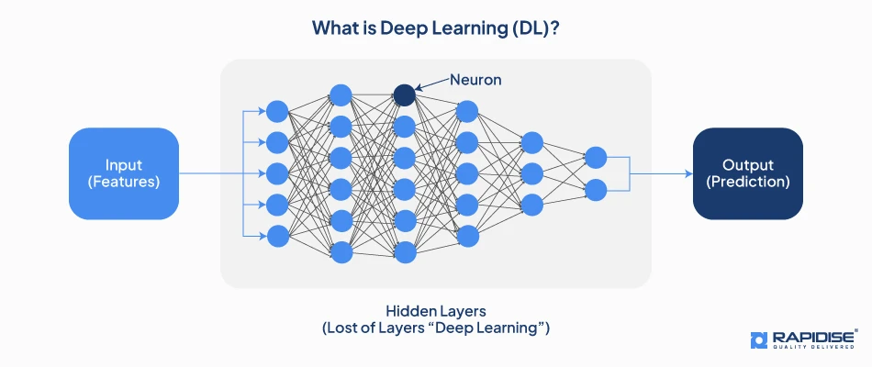
Figure 2.4: How a CNN Processes an Image
Convolutional layers apply small, learnable filters across the image to produce feature maps that highlight visual patterns such as edges, corners, and texture (Figure 2.5); these are followed by a non-linear activation function, most commonly the Rectified Linear Unit (ReLU), which accelerates training and helps mitigate the vanishing-gradient problem.
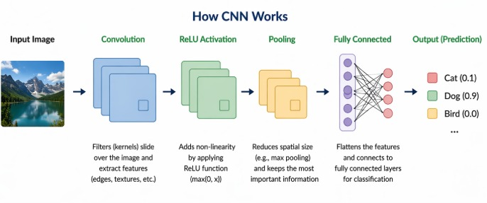
Figure 2.5: Convolutional Layers
Pooling layers, typically max pooling, then reduce the spatial dimensions of the feature maps (Figure 2.6), which both lowers computational cost and increases robustness to small shifts in the position of the hand within the image.
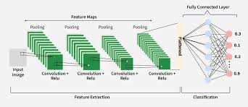
Figure 2.6: Pooling Layers
Finally, one or more fully connected layers combine the extracted features to produce the final classification (Figure 2.7), usually via a Softmax function that converts the network's output into a probability distribution over the target classes. Dropout — the random deactivation of a proportion of neurons during training — is commonly applied before the final layer to reduce overfitting and improve generalisation [6].
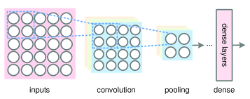
Figure 2.7: Fully Connected Layers
Rather than training a CNN entirely from scratch, this thesis makes use of transfer learning, in which a model that has already been trained on a large, general-purpose dataset such as ImageNet is reused as a starting point. The pretrained convolutional layers are frozen (or partially frozen), and only new classification layers appropriate to the target task — in this case, 36-class ASL fingerspelling recognition — are added and trained. This approach substantially reduces the amount of task-specific data required to achieve strong performance, which is particularly valuable given the relatively modest size of the ASL dataset used in this study.

2.1.4 Vision Transformers and the Swin Transformer
Vision Transformers apply the self-attention mechanism, originally developed for natural language processing, to image patches, allowing a model to capture contextual relationships between distant parts of an image — a wider field of view than the local receptive field of a convolutional filter typically allows. The Swin Transformer is a prominent hierarchical variant of this approach [7]. It processes an image through four successive stages, progressively merging image patches to reduce spatial resolution while increasing feature depth, in a manner that mirrors the hierarchical structure of CNNs. Within each stage, the model alternates between window-based multi-head self-attention (W-MSA), computed within small local windows, and shifted-window multi-head self-attention (SW-MSA), which shifts the window boundaries between successive blocks to allow information to flow across window boundaries. This design combines the computational efficiency of local, convolution-like processing with the transformer's characteristic ability to model long-range dependencies, and it is the central architectural hypothesis investigated by this thesis: that this combination is particularly well suited to distinguishing the fine hand-shape differences that separate visually similar ASL letters and digits.
This hypothesis is supported by recent evidence outside the sign-language domain: a hybrid model that used the Swin Transformer as a feature extractor for monkeypox skin-lesion classification achieved 95.6% accuracy, clearly outperforming conventional CNN baselines such as DenseNet121, VGG16, ResNet18, and AlexNet on the same datasets [11]. This result was a direct methodological inspiration for including the Swin Transformer in the present comparison.

2.1.5 Evaluation Criteria
Evaluating a multi-class image classification system such as the one proposed in this thesis requires a well-defined set of quantitative criteria. Accuracy — the proportion of correct predictions out of all predictions — is the most widely reported metric, but it can be misleading when class distributions are imbalanced, since a model may appear accurate overall while performing poorly on minority classes. For this reason, this thesis reports precision, recall, and F1-score alongside accuracy, together with inference time, and these metrics are formally defined in Section 3.9.

2.2 Related Work
This section reviews recent studies on automatic sign-language recognition using deep learning. The studies are organised into four thematic groups — single-CNN approaches, hybrid and multi-stream approaches, detection-based (YOLO) approaches, and vision-transformer approaches — and each group closes with a short paragraph explicitly relating its findings to the specific design choices made in this thesis, summarised further in Section 2.3.

2.2.1 CNN-Based Approaches
The majority of prior work on ASL recognition relies on a single CNN architecture. Zakariah et al. [13] adopted a transfer-learning approach for recognising thirty-two signs from the Arabic Sign Language Dataset, using a pretrained EfficientNetB4 model on 54,049 RGB images from 40 signers, achieving a maximum accuracy of 95% at the cost of substantial computational requirements. Yadav and Bohra [15] developed a CNN-based system for translating ASL fingerspelling into text and speech in real time, applying an image-preprocessing stage before classification to reach 95.8% accuracy, though limited to static fingerspelling. Sheth et al. [19] proposed a CNN-based model for both recognising and generating ASL signs, trained on 25,000 images spanning 26 letters and common words, achieving 98.84% training accuracy with strong robustness to lighting and skin-tone variation, at the cost of requiring substantial hardware processing power. Kamruzzaman [20] showed that the same CNN-based approach generalises to Arabic Sign Language recognition and speech generation, reaching 90% accuracy. Marjusalinah, Samsuryadi, and Buchari [21] directly compared ResNet50 and DenseNet121 for ASL fingerspelling classification on the public Kaggle ASL Alphabet dataset, with ResNet50 achieving an exceptional 99.99% accuracy. Hurroo and Walizad [23] proposed a comparatively simple grayscale-input CNN trained on 25,110 images of all 26 letters and digits 0–9, achieving 99% training and 98% testing accuracy — a small train–test gap suggesting limited overfitting, though still restricted to static gestures. Finally, a broad review by Sharma [17] concluded that deep-learning-based techniques consistently outperform earlier hand-crafted-feature approaches across ASL, Indian Sign Language, and other sign-language datasets, though complex backgrounds remained a persistent challenge.
Relation to this thesis: this cluster of studies confirms that CNNs, and ResNet50 in particular [21], are a strong and well-validated baseline for ASL fingerspelling recognition, which directly motivated the inclusion of ResNet50 as one of the three CNN baselines compared in this thesis. However, none of these studies benchmark their CNN against a vision transformer under the same conditions — a gap this thesis addresses directly.

2.2.2 Hybrid and Multi-Stream Approaches
A second group of studies combines multiple feature sources or processing stages to improve robustness. Zhidebayeva et al. [14] introduced a real-time fingerspelling recognition method using a two-dimensional deep CNN with a two-stream feature-extraction approach designed to capture spatio-temporal information, with accuracy improving further as training data increased. Ma, Xu, and Kim [29] proposed a two-stream mixed CNN (TSM-CNN) that fuses features from two time-consecutive images to better handle the moving gestures required for the letters ‘J’ and ‘Z’, showing that fusing two visual streams consistently improved accuracy over a single-stream baseline across four CNN backbones. Bayrak, Nabiyev, and Atalar [18] took a mathematically distinct approach, combining Complex Zernike Moments with a Complex-Valued Deep Neural Network to reach 98.67% accuracy, while Kouvakis, Trevlakis, and Boulogeorgos [16] introduced an encoder–decoder approach for semantic, bandwidth-efficient transmission of ASL images, achieving approximately 99% reconstruction/recognition accuracy under noisy channel conditions.
Relation to this thesis: these studies demonstrate that combining multiple streams or representations of the same gesture consistently improves accuracy over a single-stream CNN, which is conceptually consistent with why a self-attention-based architecture — capable of relating multiple regions of the hand within a single forward pass — might be expected to perform well; this expectation is tested directly by including the Swin Transformer in the present comparison, rather than by adding extra input streams to a CNN.

2.2.3 Detection-Based (YOLO) Approaches
A third group of studies frames sign-language recognition as an object-detection problem rather than a pure classification problem, prioritising real-time speed. Mujahid et al. [22] applied YOLOv3 with a DarkNet-53 backbone on a custom dataset of 2,000 images, achieving 97.68% mean average precision while running substantially faster than SSD and Faster R-CNN. Bankar et al. [24] applied YOLOv5 after observing that conventional CNN classifiers degraded substantially under cluttered backgrounds, achieving 88.4% accuracy compared to only 52.98% for a standard CNN baseline on the same task, albeit with lower precision (76.6%). Aggarwal et al. [25] proposed ASLR-Net, a CNN specifically hardened against lighting changes, viewing-angle shifts, and background clutter through extensive augmentation, achieving 96.9% accuracy that held up under previously unseen conditions. Drishya [26] extended the problem further to continuous video rather than isolated static images, demonstrating accurate hand-movement tracking across live sequences at the cost of requiring a substantially larger and more diverse video dataset.
Relation to this thesis: this cluster underlines that inference time and robustness to real-world conditions are just as important as raw accuracy for a deployable system — directly motivating the decision, in this thesis, to report inference time alongside accuracy for all four models (see Section 4.8), and to discuss dynamic-gesture and video-based recognition explicitly as future work in Chapter 5, rather than only pursuing incremental accuracy gains on static images.

2.2.4 Vision Transformer and Swin-Based Approaches
The final and most directly relevant group of studies moves beyond CNNs toward attention-based architectures. Aly and Fathi [12] proposed a hybrid model combining a dual-path CNN with a Vision Transformer to recognise 29 ASL gestures, trained on the 87,000-image ASL Alphabet dataset, achieving a near-perfect accuracy of 99.97% with an inference speed of 110 frames per second — strong evidence that combining convolutional and attention-based feature extraction is highly effective for this task. Alsharif et al. [27] benchmarked five deep learning models — AlexNet, ConvNeXt, EfficientNet, ResNet-50, and a Vision Transformer — on the same large ASL alphabet dataset, finding that deeper, more modern architectures, including the Vision Transformer, achieved consistently better accuracy than earlier CNN designs. Kasapbaşı et al. [28] developed DeepASLR, a custom CNN accompanied by a new, deliberately varied ASL dataset, achieving 99.38% accuracy and underlining the importance of dataset diversity for robust performance. Most directly relevant of all, a 2024 study applying the Swin Transformer architecture to several sign-language datasets [30] confirmed that the same hierarchical shifted-window design used in this thesis generalises effectively across different sign-language recognition benchmarks.
Relation to this thesis: this is the smallest but fastest-growing cluster of studies, and it is also the cluster this thesis contributes to most directly. Unlike [12] and [27], which either combine a transformer with a CNN or include a transformer as one of several models without a dedicated inference-time analysis, this thesis benchmarks a standalone hierarchical Swin Transformer against three separate, individually optimised CNN baselines under an identical protocol, and reports a dedicated per-class error analysis and accuracy–inference-time trade-off — directly extending the evidence provided by [12], [27], and [30] into a more controlled, four-way comparison.
Table 2.1 summarises all nineteen studies reviewed above in terms of the models used, their principal strengths and limitations, and the datasets and results reported, alongside this thesis for direct comparison.
Table 2.1: Comparison of Related Studies on Sign Language Recognition
Ref. | Year | Model(s) | Strength | Limitation | Best Result
[12] | 2025 | Hybrid CNN + ViT | Near-perfect accuracy | Static images only | Acc. = 99.97%
[13] | 2022 | EfficientNetB4 | Handles complex images well | High computational cost | Acc. = 95%
[14] | 2024 | 2D Deep CNN, two-stream | Captures spatio-temporal cues | Needs large training data | High accuracy
[15] | 2021 | CNN + preprocessing filter | Improved accuracy via preprocessing | Static fingerspelling only | Acc. = 95.8%
[16] | 2024 | Semantic encoder–decoder | High-quality reconstruction | High computational overhead | Acc. ≈ 99%
[17] | 2020 | Survey (CNN, HMM) | Detailed taxonomy of methods | Complex backgrounds remain hard | —
[18] | 2024 | Complex-Valued DNN | Exceptional accuracy via complex features | Requires specialised math framework | Acc. = 98.67%
[19] | 2023 | CNN (recognition + generation) | Robust to lighting/skin tone | Hardware-constrained | Acc. = 98.84%
[20] | 2020 | CNN (Arabic SL) | High accuracy on a different SL | High training cost | Acc. = 90%
[21] | 2021 | ResNet50 vs DenseNet121 | Near-perfect accuracy (ResNet50) | Excluded letters ‘J’, ‘Z’ | Acc. = 99.99%
[22] | 2021 | YOLOv3 (DarkNet-53) | High speed and accuracy | Needs high-performance GPU | mAP = 97.68%
[23] | 2020 | CNN (grayscale input) | Small train–test gap | Static gestures only | Acc. = 98%
[24] | 2022 | YOLOv5 | Robust to cluttered backgrounds | Lower precision (76.6%) | Acc. = 88.4%
[25] | 2023 | ASLR-Net (CNN) | Robust to unseen conditions | Static gestures only | Acc. = 96.9%
[26] | 2023 | CNN (video-based) | Handles continuous motion | Needs large video dataset | Reliable tracking
[27] | 2023 | AlexNet, ConvNeXt, EfficientNet, ResNet-50, ViT | Broad, modern comparison | — | Competitive across models
[28] | 2022 | DeepASLR (custom CNN) | New diverse dataset | Custom, non-public dataset | Acc. = 99.38%
[29] | 2022 | Two-Stream Mixed CNN | Handles moving letters (J, Z) | Needs paired consecutive frames | Improved over single-stream
[30] | 2024 | Swin Transformer | Generalises across SL datasets | — | Consistently strong results
This thesis | 2026 | ResNet50, MobileNetV2, EfficientNetB0, Swin Transformer | Unified 4-model benchmark incl. ViT, with inference-time and per-class analysis | Moderate dataset size (2,516 images) | Acc. = 99.21% (Swin)

2.3 Summary and Research Gap
The literature reviewed above demonstrates that deep learning, and CNNs in particular, has driven substantial progress in automatic ASL recognition, with reported accuracies frequently exceeding 95–99% under favourable dataset conditions. However, three gaps consistently emerge across this body of work. First, the great majority of studies compare CNN architectures against one another, and only a small and recent subset [12], [27], [30] evaluate vision transformers on this specific task, typically without directly benchmarking a hierarchical model such as the Swin Transformer against multiple CNN baselines under identical conditions. Second, few studies report inference time alongside accuracy, despite its direct relevance to real-time, assistive deployment scenarios. Third, per-class error analysis — identifying which specific letters or digits are systematically confused by a given model, and why — is rarely reported in detail, even though this information is directly useful for guiding future data collection and model refinement.
This thesis addresses these gaps directly by benchmarking three widely used pretrained CNNs (ResNet50, MobileNetV2, EfficientNetB0) against a hierarchical Swin Transformer on the identical ASL fingerspelling recognition task, dataset, and evaluation protocol; by reporting inference time alongside accuracy, precision, recall, and F1-score; and by conducting a detailed per-class error analysis that identifies and explains the specific classes that most challenge each architecture. The proposed approach used to achieve these objectives is presented in full in Chapter 3.
CHAPTER 3
Proposed Approach

3.1 Introduction
This chapter presents the proposed approach used to compare the four deep learning models introduced in Chapter 1. It begins with an overview of the overall system workflow, followed by the proposed methodology diagram, a description of the dataset, the preprocessing and augmentation pipeline, the architecture of each of the four models, the proposed algorithm expressed as pseudocode, the unified training configuration, and finally the evaluation metrics used to compare the models in Chapter 4.

3.2 Proposed Methodology Diagram
Figure 3.1 illustrates a six-stage workflow. The stages are as follows:
- Stage 1 — Data Collection: A fingerspelling image dataset covering 36 classes (digits 0–9 and letters a–z) was collected and organised into one folder per class.
- Stage 2 — Data Preparation: The raw dataset was cleaned (removing non-image files and verifying class folders), then split into training (70%), validation (10%), and testing (20%) subsets using a fixed random seed to ensure the split was identical and reproducible across all four models.
- Stage 3 — Data Augmentation: Augmentation techniques — random rotation, shifting, zooming, and brightness/contrast adjustment — were applied to the training subset only, to increase data diversity and reduce overfitting.
- Stage 4 — Model Training: Each of the four models (ResNet50, MobileNetV2, EfficientNetB0, and the Swin Transformer) was trained independently under a unified protocol, described fully in Section 3.8.
- Stage 5 — Model Evaluation: Each trained model was evaluated on the same held-out test subset using accuracy, precision, recall, F1-score, and inference time.
- Stage 6 — Comparative Analysis and Selection: The results of all four models were compared side by side, including a detailed per-class error analysis, to identify the most accurate and most practically suitable model, as reported in Chapter 4.

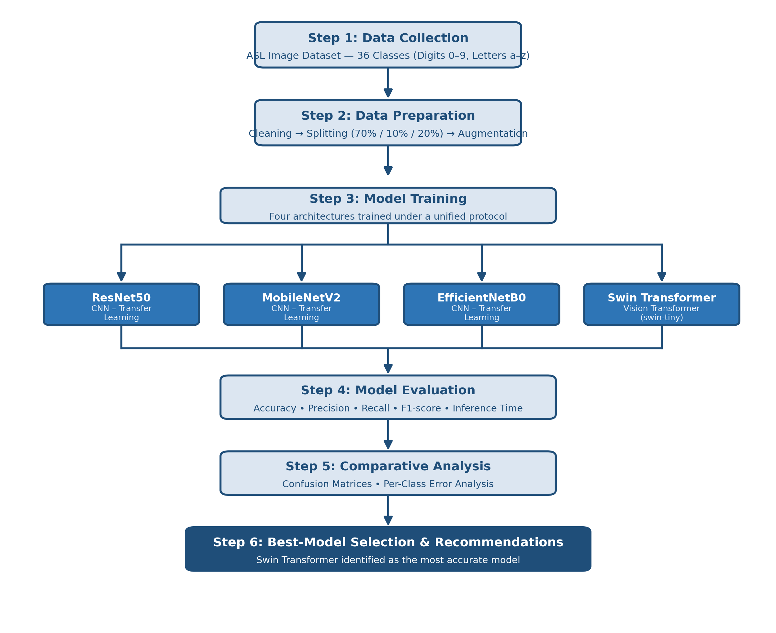
Figure 3.1: Proposed Methodology Pipeline

3.2.1 Dataset Description
The dataset used in this study is an ASL fingerspelling image dataset covering 36 classes: the ten digits (0–9) and the twenty-six letters (a–z), organised in a standard one-folder-per-class structure. After cleaning, the dataset contained 2,516 images in total, with a broadly balanced distribution across classes (approximately 70–71 images per class). The dataset was split into 70% training, 10% validation, and 20% testing subsets independently for each model, using a fixed random seed (42) to keep the split procedure identical and reproducible; minor differences in the exact image counts per split across models (summarised in Table 3.1) arise from small differences in the data-loading pipelines used for the TensorFlow/Keras models versus the PyTorch-based Swin Transformer.
Table 3.1: Number of Images per Class Used in the Dataset (Summary)
Split | Approx. Images | Percentage
Training | 1,726 – 1,760 | ≈ 70%
Validation | 251 | ≈ 10%
Testing | 505 – 539 | ≈ 20%
Total (cleaned) | 2,516 | 100%

3.5 Data Preprocessing and Augmentation
All images were resized to 224×224 pixels to match the input requirements of the four pretrained models. Pixel values were normalised according to the specific statistics each pretrained backbone expects (for example, ImageNet mean and standard deviation for the Swin Transformer, ResNet50, and MobileNetV2). Data augmentation — including random rotation, horizontal/vertical shifting, zooming, and brightness/contrast adjustment — was applied to the training subset only, in order to expose each model to a wider range of hand positions and lighting conditions and thereby reduce the risk of overfitting to the specific images in the training set. The validation and test subsets were left unaugmented, so that reported performance reflects the models' behaviour on realistic, unmodified images.

3.6 Model Architectures
Four deep learning architectures were compared in this study: three pretrained convolutional neural networks fine-tuned via transfer learning, and one hierarchical vision transformer.
(a) ResNet50: A 50-layer deep CNN that uses residual (skip) connections, allowing a layer's input to bypass intermediate layers and be added directly to its output. This design resolves the vanishing-gradient problem that otherwise limits the training of very deep networks [7]. In this study, the ImageNet-pretrained convolutional base (approximately 24.1 million parameters) was frozen, and a new classification head — Global Average Pooling, a 256-unit dense layer with ReLU activation, a 0.5 Dropout layer, and a 36-unit Softmax output layer — was added and trained.
(b) MobileNetV2: A lightweight CNN designed for resource-constrained devices, using depthwise-separable convolutions and inverted residual blocks to substantially reduce the number of computations required relative to standard convolutions, without a large loss in accuracy [8]. With only about 2.6 million parameters, MobileNetV2 is far smaller than the other three models compared in this study, which is reflected directly in its fast inference time (see Section 4.8). The same classification head design used for ResNet50 was added on top of the frozen MobileNetV2 backbone.
(c) EfficientNetB0: A CNN that uses compound scaling to systematically balance network depth, width, and input resolution via a single scaling coefficient, aiming for the best possible trade-off between accuracy and model size [9]. The model used in this study has approximately 4.4 million parameters, with the same classification head design added on top of the frozen backbone.
(d) Swin Transformer: A hierarchical vision transformer that processes an image through four successive stages, progressively merging image patches to build increasingly abstract feature representations, in a manner that mirrors the hierarchical structure of a CNN. Within each stage, the model alternates between window-based multi-head self-attention (W-MSA) and shifted-window multi-head self-attention (SW-MSA), allowing it to capture both fine local detail and broader contextual relationships across the hand and image [10]. This study used the pretrained swin-tiny variant (approximately 28.3 million parameters), with only its classification head replaced for the 36-class ASL task.

3.7 Proposed Algorithm
Algorithm 3.1 formalises the end-to-end pipeline applied to each of the four models, from raw image input to the computation of the final evaluation metrics.
Algorithm 3.1: Unified ASL Recognition and Comparison Pipeline
Input: Image set X = {x1, x2, ..., xn} with labels Y = {y1, y2, ..., yn}
Model M ∈ {ResNet50, MobileNetV2, EfficientNetB0, Swin Transformer}
Output: Predicted labels Ŷtest and evaluation metrics (Accuracy, Precision, Recall, F1, Time)

1: Clean and organise X into 36 class folders (digits 0–9, letters a–z)
2: Split X into Xtrain (70%), Xval (10%), Xtest (20%) using a fixed random seed
3: Apply data augmentation to Xtrain only (rotation, shift, zoom, brightness)
4: Resize and normalise all images to 224×224 according to model M's statistics
5: Initialise M with pretrained weights (ImageNet for CNNs; swin-tiny for Swin Transformer)
6: Freeze the backbone of M and attach a new classification head for 36 classes
7: for epoch = 1 to 30 do
8: Train M on Xtrain using Adam/AdamW optimiser and cross-entropy loss
9: Evaluate M on Xval; save weights if validation accuracy improves
10: if validation loss has not improved for 7 consecutive epochs then
11: stop training early (Early Stopping)
12: end if
13: end for
14: Load the best-performing saved weights of M
15: Predict Ŷtest = M(Xtest); record total inference time
16: Compute Accuracy, Precision, Recall, F1-score from (Ytest, Ŷtest)
17: return Ŷtest, Accuracy, Precision, Recall, F1, Inference Time

3.9 Evaluation Metrics
The four trained models were evaluated and compared using four standard classification metrics, where TP, TN, FP, and FN denote true positives, true negatives, false positives, and false negatives, respectively, together with total inference time on the test set:
Accuracy = (TP + TN) / (TP + TN + FP + FN)
Precision = TP / (TP + FP)
Recall = TP / (TP + FN)
F1-score = 2 × (Precision × Recall) / (Precision + Recall)
CHAPTER 4
Experimental Results and Discussion

4.1 Introduction
This chapter presents and discusses the experimental results obtained by applying the four deep learning models described in Chapter 3 to the ASL fingerspelling recognition task. The chapter begins with a description of the experimental setup, followed by a narrative account of the results obtained when each model was applied to the dataset, a detailed comparative evaluation using the metrics defined in Section 3.9, a per-class error analysis, a discussion of the findings in relation to the related work reviewed in Chapter 2, the limitations of the study, and, finally, a dedicated analysis of inference time.

4.2 Experimental Setup
All four experiments were conducted within the same cloud-based computing environment (Google Colab) equipped with a GPU accelerator, ensuring that timing comparisons across models are meaningful. The Swin Transformer was implemented in PyTorch using the timm library, while the three CNN models were implemented in TensorFlow/Keras. Evaluation metrics were computed using scikit-learn, and a lightweight Gradio interface was additionally built for each model to allow interactive testing by uploading an image and viewing the predicted class and confidence score.
All four models were trained using the same unified configuration, summarised in Table 3.2, within the same cloud-based GPU computing environment (Google Colab), using PyTorch and the timm library for the Swin Transformer, and TensorFlow/Keras for the three CNN models.
Table 3.2: Summary of the Deep Learning Models Used
Model | Framework | Approx. Parameters | Transfer Learning | Input Size
ResNet50 | TensorFlow / Keras | 24.1 M | Yes (ImageNet, frozen backbone) | 224 × 224
MobileNetV2 | TensorFlow / Keras | 2.6 M | Yes (ImageNet, frozen backbone) | 224 × 224
EfficientNetB0 | TensorFlow / Keras | 4.4 M | Yes (ImageNet, frozen backbone) | 224 × 224
Swin Transformer (swin-tiny) | PyTorch (timm) | 28.3 M | Yes (pretrained, head replaced) | 224 × 224

Table 3.3: Training Configuration
Parameter | Value
Image Size | 224 × 224
Batch Size | 16
Epochs | 30 (with Early Stopping, patience = 7)
Learning Rate | 0.0001
Optimizer | Adam / AdamW
Loss Function | Categorical Cross-Entropy
Data Split | 70% Train / 10% Validation / 20% Test

4.4 Comparative Results
Bringing the four individual results together, the Swin Transformer achieved the highest performance on every metric, reaching 99.21% accuracy and a 99.21% F1-score, clearly outperforming the three CNN-based models. MobileNetV2 ranked second at 87.92% accuracy, followed closely by ResNet50 at 87.33%, while EfficientNetB0 recorded the lowest performance at 73.65% — attributable to its dedicated preprocessing function not being applied during data preparation for that specific model, unlike the other two CNNs; this reflects the actual configuration used to produce the results reported here, rather than an issue that was subsequently identified and corrected. The consistently high precision, recall, and F1-score achieved by the Swin Transformer, each close to 99.2%, further indicate that its strong accuracy is not achieved by favouring particular classes, but reflects balanced performance across the full set of 36 classes. Table 4.1 and Figures 4.1–4.2 present these results in full.
Table 4.1: Performance Comparison of the Four Models on the Test Set
Model | Accuracy | Precision | Recall | F1-Score
Swin Transformer | 99.21% | 99.28% | 99.21% | 99.21%
MobileNetV2 | 87.92% | 89.08% | 87.92% | 87.76%
ResNet50 | 87.33% | 88.90% | 87.33% | 87.32%
EfficientNetB0 | 73.65% | 81.56% | 73.65% | 73.15%

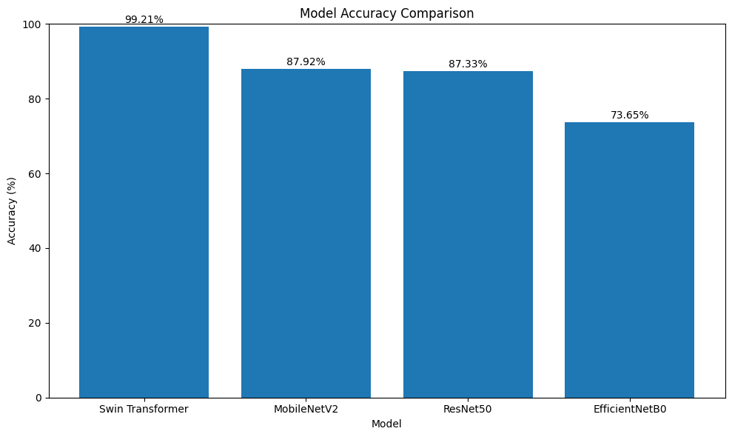
Figure 4.1: Accuracy Comparison of the Four Models on the Test Set
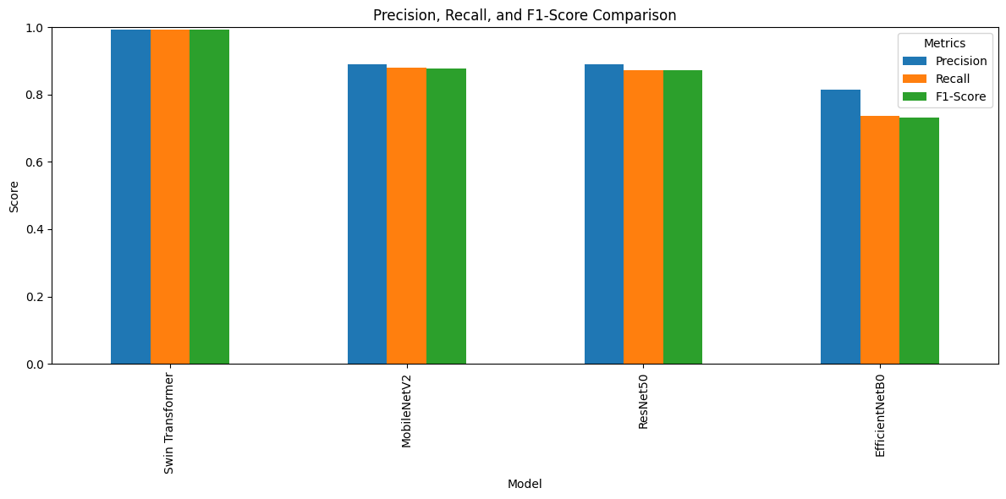
Figure 4.2: Precision, Recall, and F1-score Comparison of the Four Models

4.5 Per-Class Error Analysis
Examining the classification report for each model reveals that most errors were concentrated in a small number of visually similar classes rather than being spread evenly across the 36 categories. The letter ‘w’ was among the most difficult classes for the CNN models, recording the lowest F1-score for MobileNetV2 (0.48) and a low score for ResNet50 (0.61), whereas the Swin Transformer maintained a comparatively high F1-score on this class. Similarly, the digit ‘6’ showed notable weakness across all three CNN models, with F1-scores between 0.30 and 0.57, most likely because its hand pose closely resembles other classes in the dataset. By contrast, the Swin Transformer maintained an F1-score of at least 0.92 across nearly all 36 classes, indicating substantially greater consistency across the entire class space rather than only in the overall average. This consistency is most plausibly explained by the self-attention mechanism's ability to adaptively weight different parts of the hand according to their discriminative importance for a given pair of classes, in contrast to fixed convolutional filters that are applied uniformly across the whole image. Table 4.2 summarises the best- and worst-performing class for each model, and Figures 4.3–4.6 present the corresponding confusion matrices.
Table 4.2: Best and Worst Class by F1-score for Each Model
Model | Best Class (F1) | Worst Class (F1)
Swin Transformer | Most classes (F1 = 1.00) | Digit 6 / letters o, w (F1 ≈ 0.92–0.97)
MobileNetV2 | Several classes (F1 = 1.00) | Letter w (F1 = 0.48)
ResNet50 | Several classes (F1 = 1.00) | Digit 6 (F1 = 0.57)
EfficientNetB0 | Several classes (F1 = 1.00) | Digit 6 (F1 = 0.30)

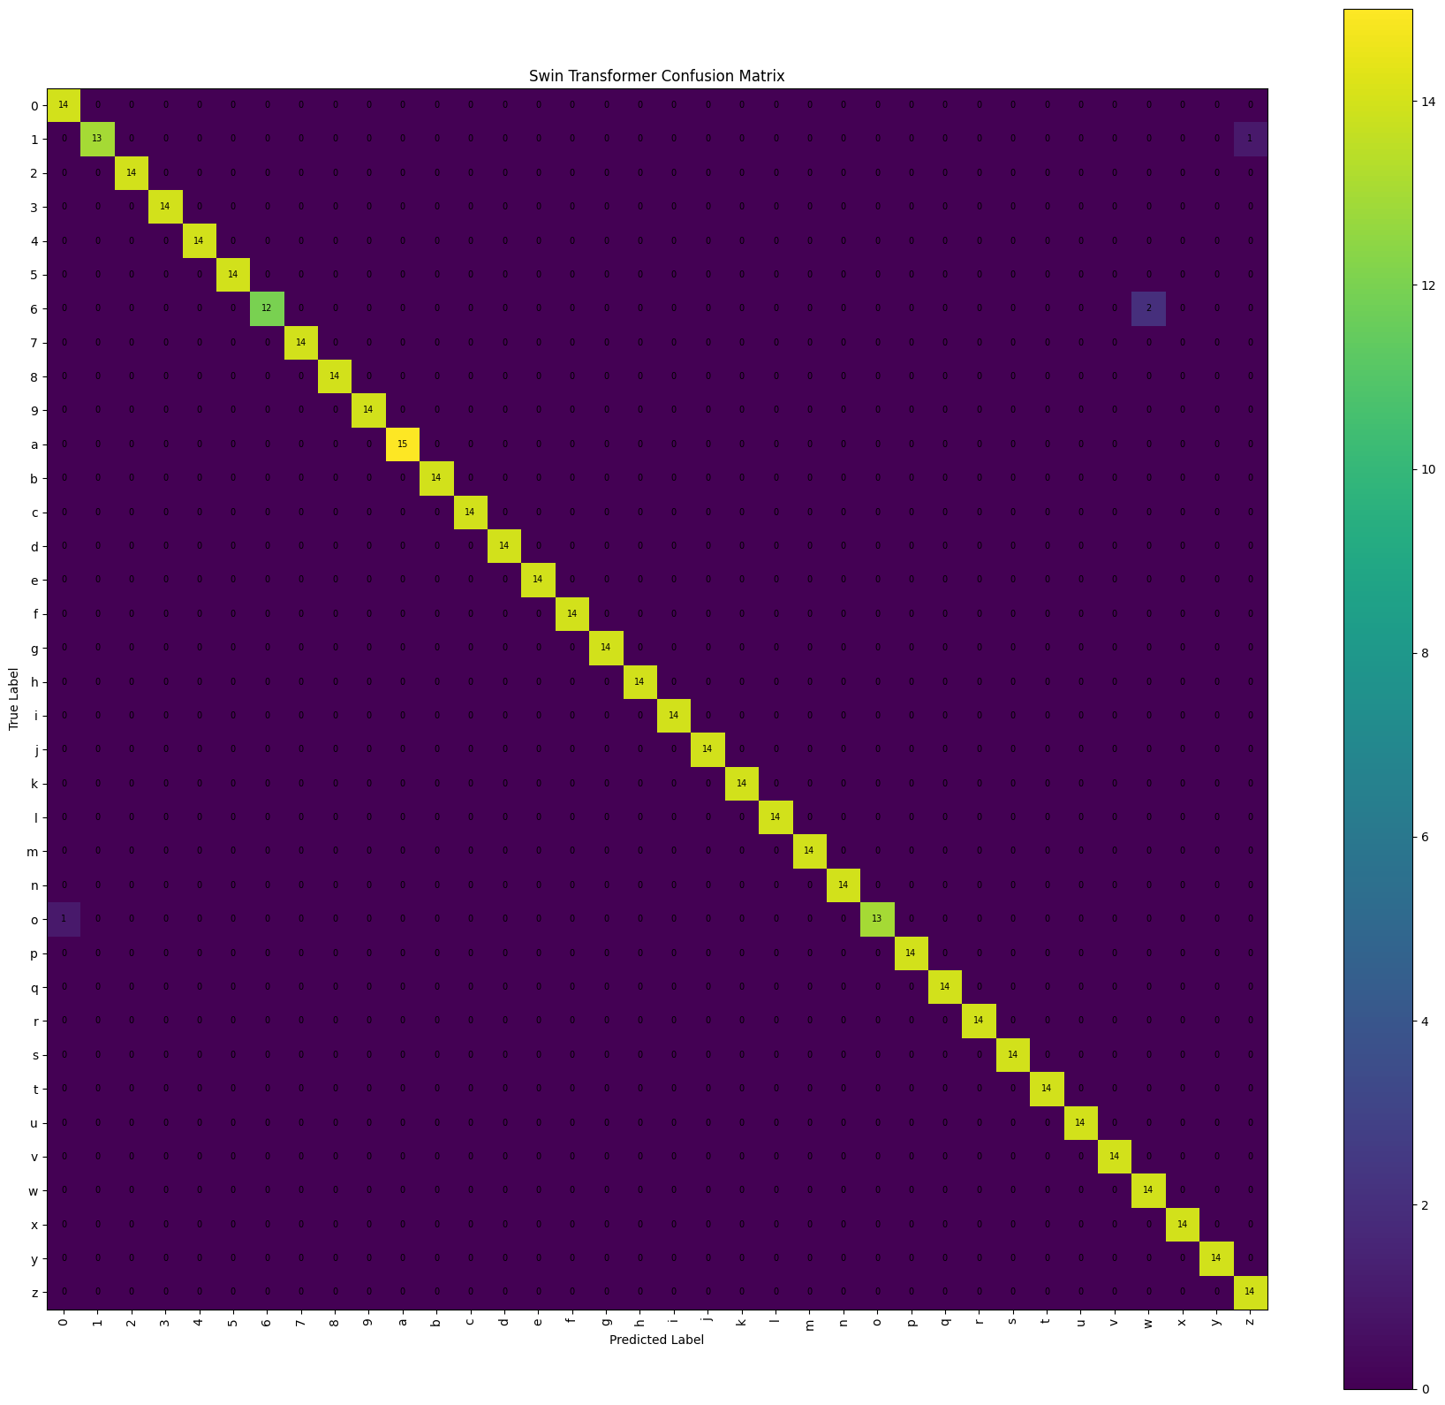
Figure 4.3: Confusion Matrix of the Swin Transformer on the Test Set
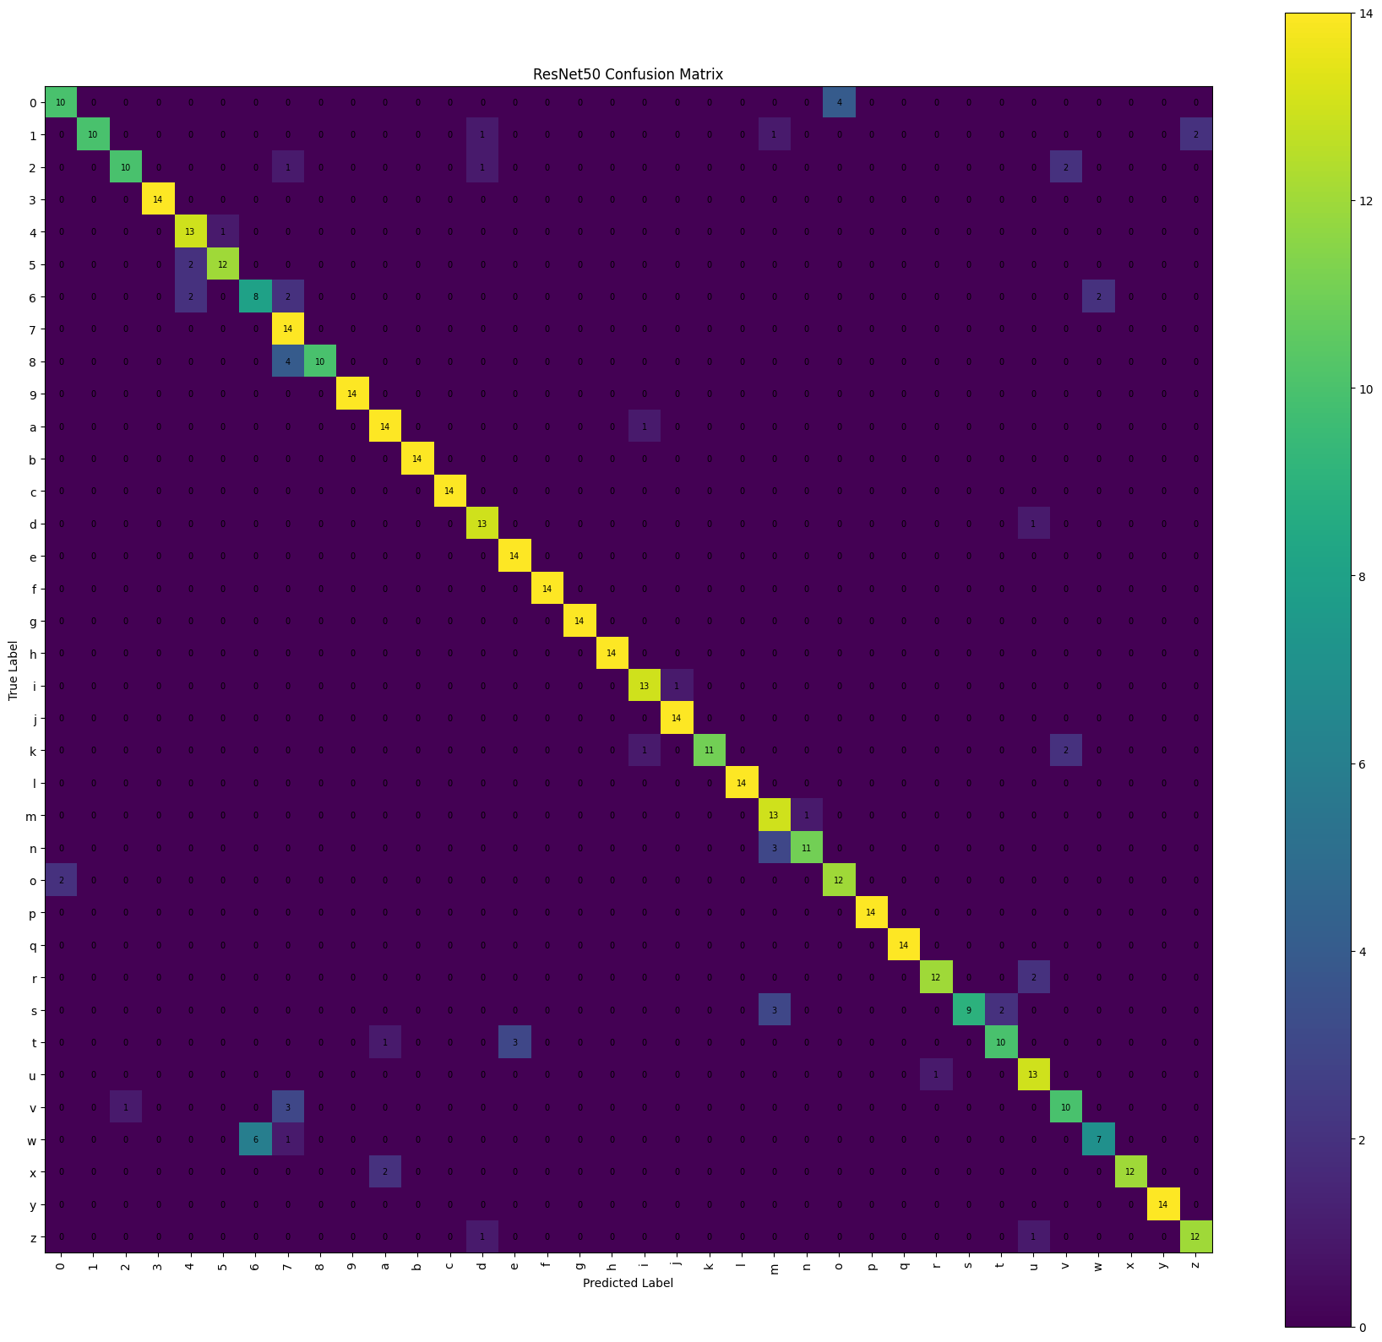
Figure 4.4: Confusion Matrix of ResNet50 on the Test Set
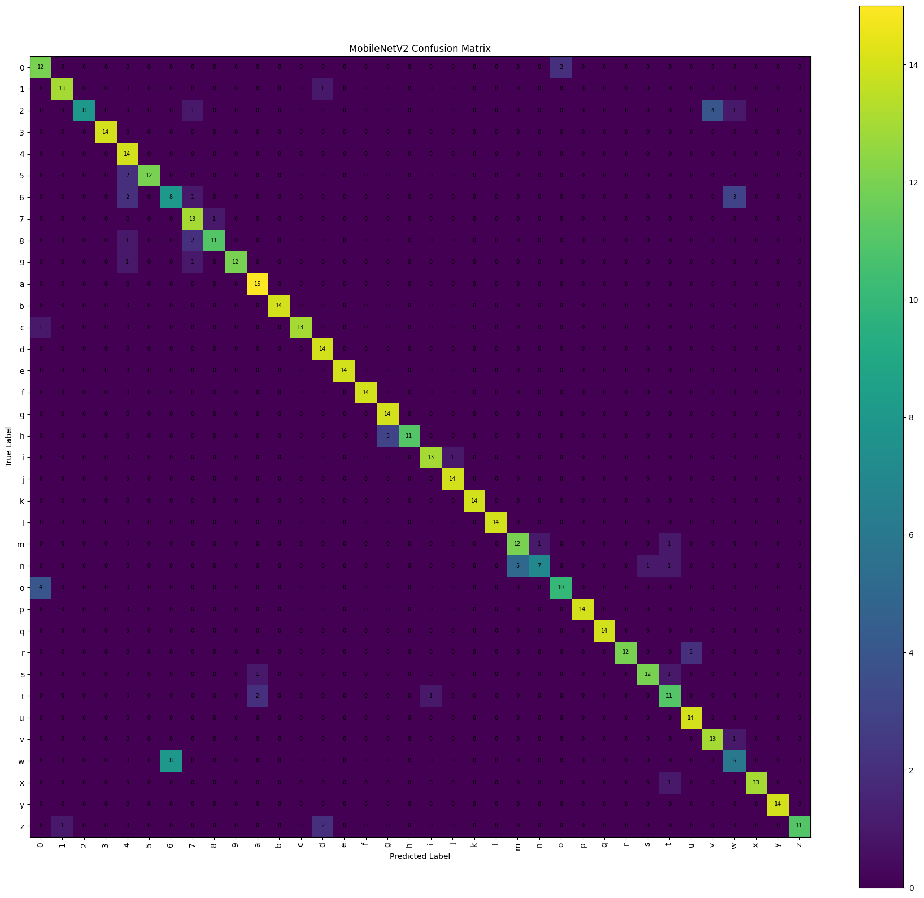
Figure 4.5: Confusion Matrix of MobileNetV2 on the Test Set
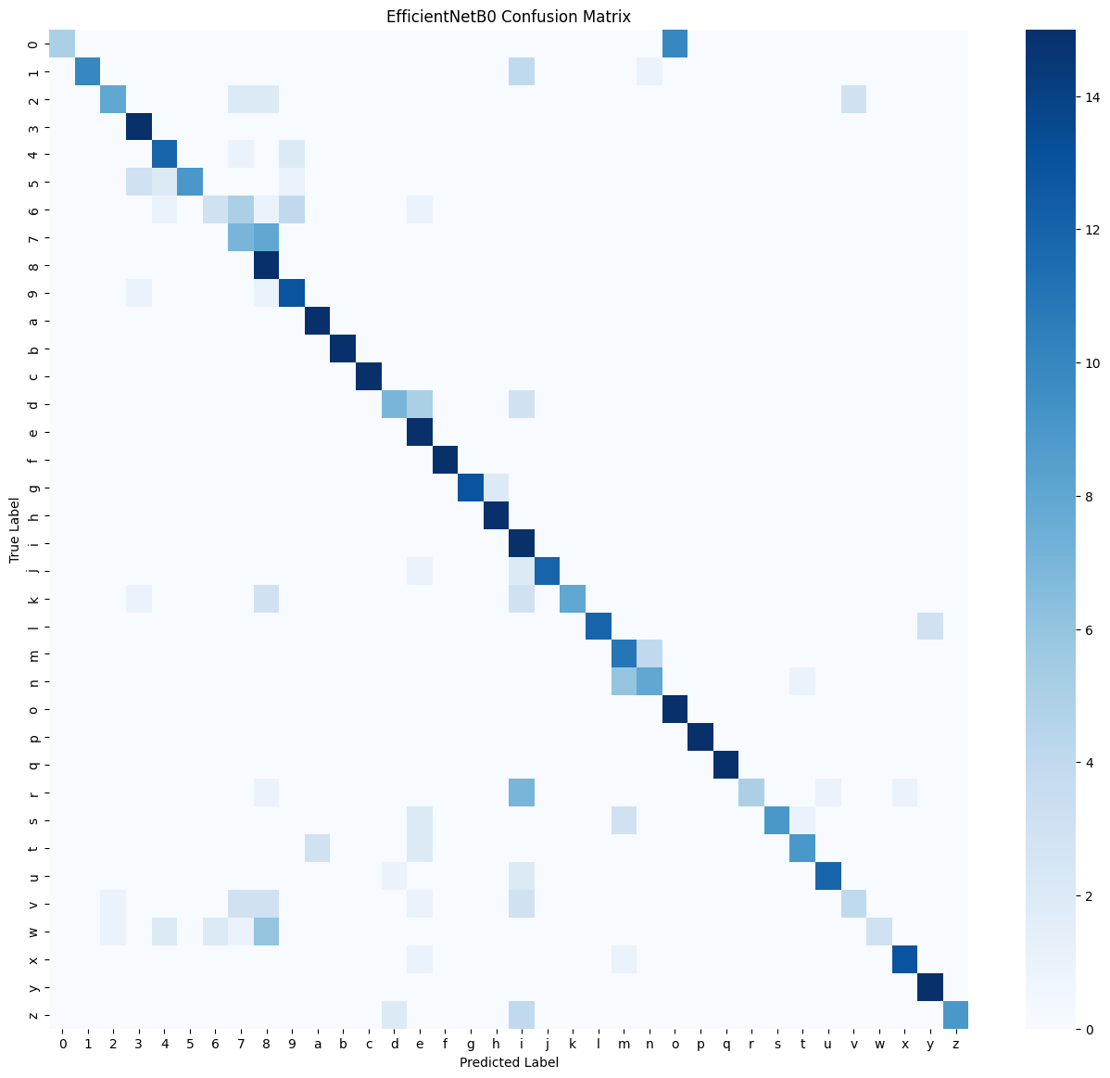
Figure 4.6: Confusion Matrix of EfficientNetB0 on the Test Set

4.6 Discussion

4.6.1 Architectural Advantage of the Swin Transformer
The Swin Transformer's advantage over the three CNN models is best explained by a genuine architectural difference rather than incidental factors. A convolutional filter has a fixed, local receptive field and applies the same learned weights uniformly across every position in an image, which makes it highly effective at detecting local texture and edges but comparatively limited in modelling relationships between distant regions of the hand. The Swin Transformer's shifted-window self-attention, by contrast, allows the model to compute an adaptive, content-dependent weighting between different regions of the hand within each attention window, and its hierarchical stage structure then progressively merges this information across increasingly larger regions of the image. For a fine-grained discrimination task such as ASL fingerspelling recognition — where the difference between two classes may lie in the precise relative position of a small number of fingers — this ability to adaptively relate distant hand regions appears to provide a genuine and consistent advantage, which is reflected directly in the substantially higher and more uniform per-class F1-scores reported in Section 4.5.

4.6.2 Why MobileNetV2 Remains a Practical Choice
Although MobileNetV2 did not achieve the highest accuracy among the four models, it remains a strong practical choice for resource-constrained deployment scenarios for two concrete reasons. First, with only about 2.6 million parameters — roughly one-tenth the size of ResNet50 and one-eleventh the size of the Swin Transformer — MobileNetV2 achieved the fastest inference time of the four models (see Section 4.8), which is a decisive factor for applications intended to run on mobile devices or in real time. Second, its accuracy (87.92%) was nonetheless the second-highest of the four models, ahead of the considerably larger ResNet50. This combination of competitive accuracy and low computational cost makes MobileNetV2 a sensible default whenever deployment hardware is constrained, even though the Swin Transformer remains the clear first choice whenever maximum accuracy is the primary requirement.

4.6.3 Comparison with Related Work
The results obtained in this study are broadly consistent with the recent literature reviewed in Chapter 2. The 99.21% accuracy achieved by the Swin Transformer is close to the 99.97% reported by the hybrid CNN–Vision Transformer model of Aly and Fathi [12] and consistent with the strong results reported for the Swin Transformer architecture across other sign-language datasets [30], despite the considerably smaller dataset used in the present study (2,516 images, compared with 87,000 in [12]). This supports the conclusion that transformer-based and attention-augmented architectures offer a genuine advantage for this task, even when data is comparatively limited. Conversely, the CNN results obtained here (87.92%, 87.33%, and 73.65%) are noticeably lower than the near-perfect accuracies reported by CNN-only studies trained on much larger datasets, such as the 99.99% accuracy reported for ResNet50 in [21] on a dataset more than thirty times larger. This comparison suggests that the relatively modest dataset size used in this study constrained the CNN models' ability to generalise more than it constrained the Swin Transformer, which appears to have made more effective use of its ImageNet-pretrained representations under the same data budget.

4.7 Limitations of the Study
- The study was limited to static fingerspelling images of ASL letters and digits, and did not address dynamic gestures or full sentences, which would require additional temporal modelling.
- The dataset used was relatively limited in size (2,516 images), captured largely under near-uniform lighting and background conditions, which may limit the generalisability of the results to more varied real-world environments (poor lighting, cluttered backgrounds, differing skin tones).
- The study did not include a field test of the models within an interactive, real-time application; inference-time evaluation was limited to the cloud computing environment used during experimentation.
- No advanced hyperparameter tuning (such as grid search or evolutionary optimisation) was performed; uniform, fixed settings were adopted across all four models specifically to ensure a fair comparison, which may mean that each individual model's best possible performance was not fully realised.

4.8 Time Analysis
In terms of inference time, MobileNetV2 was fastest (143.83 seconds on the full test set), followed by EfficientNetB0 (166.18 seconds), then ResNet50 (208.56 seconds), while the Swin Transformer was relatively the slowest (275.58 seconds) due to its higher computational complexity compared to the lightweight CNNs. This highlights a practical accuracy–speed trade-off that must be considered when selecting a model for a specific application, especially in resource-constrained environments: the Swin Transformer is the clear choice when accuracy is the priority, while MobileNetV2 offers the best balance of competitive accuracy and fast inference when speed or on-device deployment is the priority. Table 4.3 brings together model size and inference time for all four approaches, and Figure 4.7 presents the same inference-time comparison graphically.
Table 4.3: Approaches, Model Size, and Inference-Time Comparison
Approach | Model | Parameters | Inference Time (s)
Transformer-based | Swin Transformer | ≈ 28.3 M | 275.58
CNN (Transfer Learning) | MobileNetV2 | ≈ 2.6 M | 143.83
CNN (Transfer Learning) | ResNet50 | ≈ 24.1 M | 208.56
CNN (Transfer Learning) | EfficientNetB0 | ≈ 4.4 M | 166.18

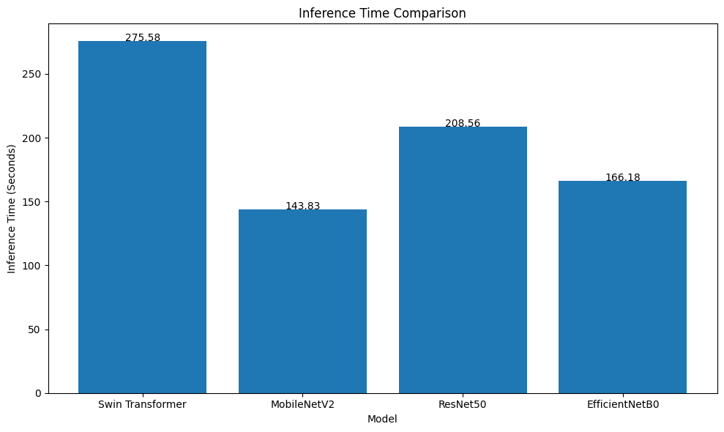
Figure 4.7: Inference-Time Comparison of the Four Models on the Test Set
CHAPTER 5
Conclusion and Future Work

5.1 Summary of the Study
This thesis set out to design, implement, and rigorously evaluate a comparative deep-learning framework for recognizing American Sign Language fingerspelling gestures, in order to identify the most accurate and practically suitable model for an assistive recognition system. Four deep learning architectures — ResNet50, MobileNetV2, EfficientNetB0, and the Swin Transformer — were trained and evaluated under a unified protocol on a 36-class ASL dataset (digits 0–9 and letters a–z), using accuracy, precision, recall, F1-score, and inference time as the basis for comparison. The Swin Transformer achieved the strongest overall performance, reaching 99.21% test accuracy and a 99.21% F1-score, substantially outperforming all three CNN-based models, while MobileNetV2 offered the most favourable balance between accuracy and inference speed among the remaining models.

5.2 Key Findings and Contributions
- A hierarchical vision transformer (the Swin Transformer) substantially and consistently outperforms three widely used pretrained CNN architectures on ASL fingerspelling recognition, achieving 99.21% accuracy compared with a maximum of 87.92% among the CNN models — a gap attributable to its shifted-window self-attention mechanism, which adaptively relates different regions of the hand rather than applying fixed local filters uniformly.
- Per-class analysis revealed that CNN-based models are systematically weaker on a small number of visually similar classes (notably the letter ‘w’ and the digit ‘6’), whereas the Swin Transformer maintained a high F1-score (≥ 0.92) across nearly the entire class space, indicating more consistent, rather than merely higher-average, performance.
- A clear accuracy–inference-time trade-off was identified: the Swin Transformer is the most accurate but the slowest of the four models (275.58 seconds on the test set), while MobileNetV2 is both the fastest (143.83 seconds) and the second most accurate, making it a sensible choice for resource-constrained or real-time deployment.
- The results and their interpretation were shown to be consistent with, and to extend, the recent literature on deep learning for sign-language recognition, providing a unified, reproducible benchmark that directly compares CNN and vision-transformer architectures under identical experimental conditions — a comparison that remains uncommon in existing studies.

5.3 Recommendations for Practical Application
Building on the findings above, the most efficient model identified in this study can be deployed in several practical applications that directly serve the Deaf and Mute community. In education, the Swin Transformer could be integrated into an interactive application for teaching the ASL alphabet, providing immediate feedback on the correctness of a performed sign. In public services, it could serve as a recognition layer within self-service kiosks at government or healthcare facilities, enabling communication without requiring a human interpreter to be physically present. In mobile or embedded contexts, MobileNetV2 is the more practical choice given its considerably lighter weight and faster inference, even at a moderate cost in accuracy.
A particularly promising direction is the integration of the proposed model into video-conferencing and communication platforms such as Zoom, Microsoft Teams, and Google Meet, given the growing need for the Deaf and Mute community to participate effectively in remote professional and educational meetings. This could take the form of a plugin that continuously captures a Deaf participant's video frames, recognises the letters being fingerspelled in real time, assembles them into readable text using a simple language-processing layer, and displays the result as live captioning for other participants — while also converting other participants' speech into text for the Deaf participant, achieving bidirectional communication within a single meeting environment. Realising this scenario would require addressing real-time latency, continuous (rather than isolated) gesture recognition, and robust hand localisation against a changing video background, but the accuracy achieved by the Swin Transformer in this study represents a promising foundation for that future development.

5.4 Future Work
- Extend the dataset to include a larger and more diverse set of images per class, varying lighting, background, and skin tone, to improve the generalisability of all four models to real-world conditions.
- Investigate model compression and quantization techniques (including knowledge distillation from the Swin Transformer into a smaller student model) to reduce inference time while retaining as much of its accuracy advantage as possible.
- Extend the system from static fingerspelling recognition to dynamic gesture and continuous-sentence recognition, using architectures that jointly capture spatial and temporal information.
- Incorporate natural language processing techniques as a post-processing stage, converting a recognised letter sequence into coherent, spell-checked text.
- Incorporate Explainable AI (XAI) techniques, such as attention-map visualisation, to increase transparency and user trust in the model's predictions, particularly for the Swin Transformer's self-attention mechanism.
- Develop and evaluate the video-conferencing integration proposed in Section 5.3 as a working prototype, including a full real-time performance evaluation on representative hardware.

References
[1] Russell, S., & Norvig, P. (2021). Artificial Intelligence: A Modern Approach (4th ed.). Pearson.
[2] Szeliski, R. (2022). Computer Vision: Algorithms and Applications (2nd ed.). Springer.
[3] LeCun, Y., Bengio, Y., & Hinton, G. (2015). Deep learning. Nature, 521(7553), 436–444.
[4] Li, Y., Zhang, K., & Li, K. (2021). Deep learning for image classification: A survey. Neurocomputing, 449, 20–36.
[5] Khan, A., Sohail, A., Zahoora, U., & Qureshi, A. S. (2020). A survey of the recent architectures of deep convolutional neural networks. Artificial Intelligence Review, 53(8), 5455–5516.
[6] Srivastava, N., Hinton, G., Krizhevsky, A., Sutskever, I., & Salakhutdinov, R. (2014). Dropout: A simple way to prevent neural networks from overfitting. Journal of Machine Learning Research, 15, 1929–1958.
[7] He, K., Zhang, X., Ren, S., & Sun, J. (2016). Deep residual learning for image recognition. In Proceedings of the IEEE Conference on Computer Vision and Pattern Recognition (pp. 770–778). https://doi.org/10.1109/CVPR.2016.90
[8] Sandler, M., Howard, A., Zhu, M., Zhmoginov, A., & Chen, L. C. (2018). MobileNetV2: Inverted residuals and linear bottlenecks. In Proceedings of the IEEE Conference on Computer Vision and Pattern Recognition (pp. 4510–4520). https://doi.org/10.1109/CVPR.2018.00474
[9] Tan, M., & Le, Q. (2019). EfficientNet: Rethinking model scaling for convolutional neural networks. In Proceedings of the 36th International Conference on Machine Learning (pp. 6105–6114). PMLR. https://arxiv.org/abs/1905.11946
[10] Liu, Z., Lin, Y., Cao, Y., Hu, H., Wei, Y., Zhang, Z., Lin, S., & Guo, B. (2021). Swin Transformer: Hierarchical vision transformer using shifted windows. arXiv preprint arXiv:2103.14030. https://arxiv.org/abs/2103.14030
[11] Saleh, H., Mostafa, S., Ismail, A. H., Srivastava, S., & Alsamhi, S. H. (2024). Swin-PSO-SVM: A novel hybrid model for monkeypox early detection. IEEE Access, 12, 187367–187385. https://doi.org/10.1109/ACCESS.2024.3513818
[12] Aly, M., & Fathi, I. S. (2025). Recognizing American Sign Language gestures efficiently and accurately using a hybrid transformer model. Scientific Reports, 15, 20253. https://doi.org/10.1038/s41598-025-06344-8
[13] Zakariah, M., Alotaibi, Y. A., Koundal, D., Guo, Y., & Mamun Elahi, M. (2022). Sign language recognition for Arabic alphabets using transfer learning technique. Computational Intelligence and Neuroscience, 2022, 4567989.
[14] Zhidebayeva, A., et al. (2024). Real-time sign language fingerspelling recognition system using 2D deep CNN with two-stream feature extraction approach. International Journal of Advanced Computer Science and Applications, 15(9).
[15] Yadav, B. K., & Bohra, H. (2021). Sign Language to Text and Speech Conversion. International Journal of Advanced Research, Ideas and Innovations in Technology, 7(3), V7I3-1560.
[16] Kouvakis, V., Trevlakis, S. E., & Boulogeorgos, A. A. A. (2024). Semantic communications for image-based sign language transmission. IEEE Open Journal of the Communications Society, 5, 1083–1100.
[17] Sharma, S. (2020). Vision-based sign language recognition system: A comprehensive review. In Proceedings of the Fifth International Conference on Inventive Computation Technologies (ICICT).
[18] Bayrak, S., Nabiyev, V., & Atalar, C. (2024). American Sign Language recognition model using complex Zernike moments and complex-valued deep neural networks. IEEE Access, 12, 193001–193014.
[19] Sheth, P., Dedhia, R., Chheda, A., & Sawant, V. (2023). American Sign Language recognition and generation: A CNN-based approach. International Journal of Scientific Research in Computer Science, Engineering and Information Technology, 9(4), 241–250.
[20] Kamruzzaman, M. M. (2020). Arabic Sign Language recognition and generating Arabic speech using convolutional neural network. Wireless Communications and Mobile Computing, 2020, 3685614.
[21] Marjusalinah, A. D., Samsuryadi, S., & Buchari, M. A. (2021). Classification of finger spelling American Sign Language using convolutional neural network. Computer Engineering and Applications, 10(2), 91–102.
[22] Mujahid, A., Awan, M. J., Yasin, A., Mohammed, M. A., Damaševičius, R., Maskeliūnas, R., & Abdulkareem, K. H. (2021). Real-time hand gesture recognition based on deep learning YOLOv3 model. Applied Sciences, 11(9), 4164.
[23] Hurroo, M., & Walizad, M. E. (2020). Sign language recognition system using convolutional neural network and computer vision. International Journal of Engineering Research & Technology, 9(12).
[24] Bankar, S., Kadam, T., Korhale, V., & Kulkarni, A. A. (2022). Real time sign language recognition using deep learning. International Research Journal of Engineering and Technology, 9(4).
[25] Aggarwal, J., Gupta, L., Gupta, M., Nitin, & Girdhar, P. (2023). Real-time sign language recognition using CNNs. Advances and Applications in Mathematical Sciences, 22(11), 2199–2211.
[26] Drishya (2023). Sign language recognition. International Research Journal of Modernization in Engineering Technology and Science, 5(4).
[27] Alsharif, B., Altaher, A. S., Altaher, A., Ilyas, M., & Alalwany, E. (2023). Deep learning technology to recognize American Sign Language alphabet. Sensors, 23(18), 7970. https://doi.org/10.3390/s23187970
[28] Kasapbaşı, A., Elbushra, A. E. A., Al-Hardanee, O., & Yilmaz, A. (2022). DeepASLR: A CNN based human computer interface for American Sign Language recognition for hearing-impaired individuals. Computer Methods and Programs in Biomedicine Update, 2, 100048. https://doi.org/10.1016/j.cmpbup.2021.100048
[29] Ma, Y., Xu, T., & Kim, K. (2022). Two-stream mixed convolutional neural network for American Sign Language recognition. Sensors, 22(16), 5959. https://doi.org/10.3390/s22165959
[30] Applying Swin architecture to diverse sign language datasets. (2024). Electronics, 13(8), 1509. https://doi.org/10.3390/electronics13081509
[31] World Health Organization. (2021). World report on hearing. WHO. https://www.who.int/publications/i/item/9789240020481

