AI-powered solution for energy consumption optimization in wastewater management

Student Name: Zaher Baali
Course: Thesis AI900 Dr. Hager Saleh Third Trimester 2024, Final project
Keyword: energy consumption, machine learning, wastewater treatment plants, regression
  - Abstract
Energy consumption prediction in WWTPs is crucial for cost savings, process optimization, compliance with regulations, making optimization an objective for consumption wastewater management. This paper evaluates an AI-powered solution using machine learning (ML) and deep learning (DL) methodologies, then we will comparing the models performance with feature selection (FS) applied and without feature selection, to evaluate its impact on the results to predict WWTP energy consumption using actual data from the Melbourne WWTP.
In terms of evaluation this paper focused on hybrid model and compere between ML techniques as Linear Regression (LR), Decision Tree Regression (DTR), Random Forest Regression (RFR), Support Vector Regression (SVR), Gradient Boosting Regression (GBR), and K-Neighbors Regression (KNNR). And DL models, including Long Short-Term Memory (LSTMs) networks and Convolutional Neural Networks (CNNs).
Results showed that using commonly metrics: Mean Absolute Error (MAE), Mean Absolute Percentage Error (MAPE), Mean Squared Error (MSE), Root Mean Squared Error (RMSE) and R-Squared.
The result showing that the ML and DL models recorded the best methods for energy consumption predictions.
  - Introduction
Management of wastewater is an important activity in relation to maintaining the integrity of the environment and health of the masses. However, it’s remains costly and poses environmental adverse impacts since it uses a lot of energy. Hence, optimization of energy use in wastewater treatment processes and systems is very crucial in the quest of promoting sustainable development while EC.
Machine Learning (ML) and Deep Learning (DL), especially, are vital in solving this problem. AI uses its assets to make it possible to reduce energy use while maintaining treatment effectiveness by patterns in existent operational data. Such models could be improved further by employing Feature Selection (FS) techniques which aim at capturing the pertinent factors of interest, increasing efficiency while minimizing computational burden.
In this paper, I analyze ML and DL methods to optimize energy cost in wastewater management, with models that use FS being contrasted with those that don’t. The research aims to assess the role of FS in the accuracy and effectiveness of AI-based solutions, with the aim of enhancing the desire for adoption of sustainable treatment solutions.
  - Related Work
Recently, many studies have explored the concept of machine learning to control WWTP by predicting how much energy they consume as below:
For instance, ref. [1], the authors applied machine learning (ML) techniques: Artificial Neural Networks (ANN), Gradient Boosting Machine (GBM) and Random Forest (RF) to predict energy consumption (EC) records.
FS algorithms used to selecting elements that impacted on WWTP energy consumption by selecting the most relevant features from the data for training the (ML) models. (ANN) and two decision tree algorithms of (GBM) with (RF) were studied to predict (EC).
GBM was recorded the best performance with reasonable prediction error band.
This research takes the East Melbourne WWTP dataset, and the dataset is a combination of open data produced by Melbourne water and Melbourne airport weather station. The dataset content this elements (Power consumption, Hydraulic, biological, and climate data are merged by the record date). Ref. [2], the authors applied different deep learning models (DL): the Long Short-Term Memory (LSTM) and Bidirectional Gated Recurrent Unit (BiGRU) to predict energy consumption in WWTP. Spline Cubic interpolation was used to data augmentation to increase of row of data. Random Forests (RF) was used to feature selection. BiGRU with FS was recorded the best performance with lowest errors.
This research takes the East Melbourne WWTP dataset, and the dataset is a combination of open data produced by Melbourne water and Melbourne airport weather station. The dataset content this elements (Power consumption, Hydraulic, biological, and climate data are merged by the record date). Ref. [3], the authors applied different machine learning models (ML): Random Forest and XGBoost (eXtreme Gradient Boosting) were used to evaluate the impact of the included features on predicting energy consumption.
Bayesian optimization used to assess machine-learning models to develop efficient (EC) predictions. (RF) and XGBoost were used to identify key variables impacting the models' predictive performance.
(KNN) model recorded the best methods for energy consumption predictions. This research used the open data produced by Melbourne water and Melbourne airport weather station.
Furthermore, ref. [4], the authors proposed hybrid model based on principal component analysis-convolutional neural network-long-short-term memory neural network (PCA-CNN-LSTM) (PCA-CNN-LSTM) to predict energy and materials-saving management using private wastewater treatment plant dataset that collected from China from 2018 to 2019. Genetic algorithm is used to select the best architecture of DL model. This research takes the WWTP in Chongqing as the research object, and the research data content is the daily data of the WWTP, including influent conditions, flow, effluent value, energy consumption, materials consumption, etc. Ref. [5], the authors presented machine learning models: Four models are developed: CDT, FitcKnn, LRM and Stepwise-LRM to forecast the future energy requirements. The authors validated accuracy, were compared with four another models (BRNN, LMA, TB, and GPR) showing that the proposed ML models effectively capture the impact of climatic variables on energy usage. In [6], focused on the four machine learning models: support vector machines (SVM), artificial neural network (ANN), long-short term memory (LSTM), and gated recurrent network (GRU) to predict energy consumption (EC). Rolling window approach used to segmented data into a window size of 15 with three input features to conclude the best predict algorithm. GRU was showed the best fit for future analysis. This research takes the set of historical data adapted from Li et al, and the research data content influencing factors (inflow rate, COD removal, and TN removal), including subsequent energy consumption.
Finally, ref. [7], the authors used machine learning: Bayesian semi-parametric regression model with the Partial Linear Single-Index Model (PLSIM) to address energy consumption in biochemical wastewater treatment. It estimates quantiles across low, median, and high energy levels using the Asymmetric Laplace Distribution (ALD) in a Bayesian framework and uses the Indicator Model Selection (IMS) technique to find pertinent factors. In [8], the authors used Machine learning (ML) techniques: neural network (NN) models, in the Fast Artificial Neural Network Tool (FANN) to produce forecast EC.
The relevant predictive factors were found using correlation analysis after the data were initially statistically examined in accordance with the context of EC and features. Waikato Environment for Knowledge Analysis (WEKA) used as feature selection after statistically analyzed of data.
This research takes the WWTP in Greece as the research object, and the research data encompasses data from municipals worked in Greece, including Flow rate, Treatment capacity, Served population, Influent load, Sludge treatment line, etc.
Reference | Methods | Advantages | Dataset | Results
[1] | The authors applied machine learning (ML) techniques: Artificial Neural Networks (ANN), Gradient Boosting Machine (GBM) and Random Forest (RF) to predict energy consumption (EC) records. | FS algorithms used to selecting elements that impacted on WWTP energy consumption by selecting the most relevant features from the data for training the (ML) models. (ANN) and two decision tree algorithms of (GBM) with (RF) were studied to predict (EC). | East Melbourne WWTP dataset | GBM was recorded the best performance with reasonable prediction error band.
[2] | The authors applied different deep learning models (DL) | The Long Short-Term Memory (LSTM) and Bidirectional Gated Recurrent Unit (BiGRU) to predict energy consumption in WWTP. Spline Cubic interpolation was used to data augmentation to increase of row of data. Random Forests (RF) was used to feature selection. | East Melbourne WWTP dataset | BiGRU with FS was recorded the best performance with lowest errors.
[3] | The authors applied different machine learning models (ML) | Random Forest and XGBoost (eXtreme Gradient Boosting) were used to evaluate the impact of the included features on predicting energy consumption.  Bayesian optimization used to assess machine-learning models to develop efficient (EC) predictions. (RF) and XGBoost were used to identify key variables impacting the models' predictive performance. | Melbourne water and Melbourne airport weather station | (KNN) model recorded the best methods for energy consumption predictions.
[4] | The authors proposed to use deep learning and genetic algorithm (GA) for WWTPs: | Neural networks algorithm (NNA) used to treatment processes and estimate the cost.  Genetic Algorithm (GA) selected as optimization technique used to choosing the fittest cost. | WWTP in Chongqing | With the proposed computational techniques, total energy and material costs can be reduced by 10%-15%
[5] | The authors presented machine learning models | Four models are developed: CDT, FitcKnn, LRM and Stepwise-LRM to forecast the future energy requirements. | Melbourne dataset | The authors validated accuracy, were compared with four another models (BRNN, LMA, TB, and GPR) showing that the proposed ML models effectively capture the impact of climatic variables on energy usage.
[6] | The authors used four machine learning models | Support vector machines (SVM), artificial neural network (ANN), long-short term memory (LSTM), and gated recurrent network (GRU) to predict energy consumption (EC).  Rolling window approach used to segmented data into a window size of 15 with three input features to conclude the best predict algorithm. | This research takes the set of historical data adapted from Li et al, and the research data content influencing factors (inflow rate, COD removal, and TN removal), including subsequent energy consumption. | GRU was showed the best fit for future analysis.
[7] | The authors used machine learning | Bayesian semi-parametric regression model with the Partial Linear Single-Index Model (PLSIM) to address energy consumption in biochemical wastewater treatment. | Melbourne dataset | It estimates quantiles across low, median, and high energy levels using the Asymmetric Laplace Distribution (ALD) in a Bayesian framework and uses the Indicator Model Selection (IMS) technique to find pertinent factors.
[8] | The authors used Machine learning (ML) techniques | Neural network (NN) models, in the Fast Artificial Neural Network Tool (FANN) to produce forecast EC.  (WEKA) used as feature selection after statistically analyzed of data. | This research takes the WWTP in Greece as the research object, and the research data encompasses data from municipals worked in Greece, including Flow rate, Treatment capacity, Served population, Influent load, Sludge treatment line, etc. | The relevant predictive factors were found using correlation analysis after the data were initially statistically examined in accordance with the context of EC and features.
Table 1. Summary of some studies on the WWTPs power consumption prediction
  - Methodology
This section briefly describes the considered machine learning and deep learning models for energy consumption prediction in this paper. As presented in Figure 2, 6 machine learning models and 2 deep learning are considered, including (LR, DTR, RFR, SVR, GBR, KNNR) and (LSTMs, CNNs). Each model has its own strengths and weaknesses.
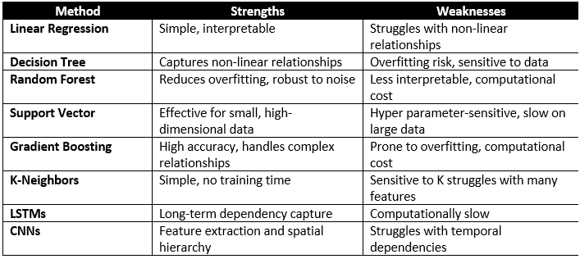
Figure 1. The investigated methods in this paper
Wastewater management is a crucial task for preserving the environment's integrity and public health. However, because it consumes a lot of energy, it is still expensive and has negative effects on the environment. Therefore, optimizing energy use in wastewater treatment systems and processes is essential to advancing sustainable development in WWTPs.
The ML and DL methods offer an attractive way to predicate the EC in WWTPs. In order to predicate the energy consumption of the WWTP, we examined the prediction performance of popular ML and DL techniques in this paper. As presented in Figure 2, 6 machine learning models and 2 deep learning are considered, including (LR, DTR, RFR, SVR, GBR, KNNR) and (LSTMs, CNNs).
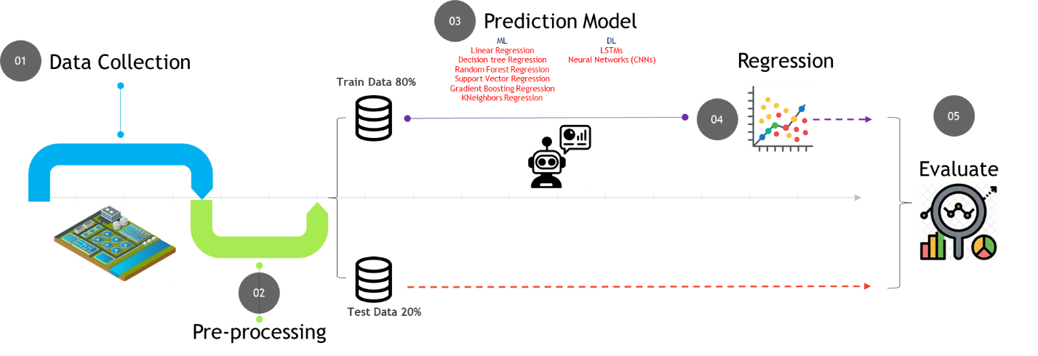
Figure 2. Illustration of the general framework of machine learning-based prediction procedure
Implementation
Energy consumption is one of the largest operational expenditures in wastewater treatment plants (WWTPs) and takes a big share of total costs. These facilities are under increasing stress to improve their efficiency in energy use owing to ever-increasing energy prices, global milestones, and the desire to lower their ecological impact. However, the energy requirements for WWTPs are quite volatile and depend on the nature of the inflow, climatic conditions, and operational plans making it difficult to come up with effective energy management measures.
Static rules or heuristics used in traditional energy optimization methods have significant power since they do not take into account the dynamic and nonlinear energy consumption relations. Because of this problem, WWTPs have not been provided with any proper prediction-based modeling optimization tools fitted for energy consumption which is responsive to operational requirements and policy regulation.
I seeks to fill those gaps by creating a machine learning (ML) and deep learning (DL) based AI energy optimization technique. The proposed model will be able to predict energy requirements, highlight where energy is used excessively, and offer alternatives for energy savings while still achieving effective waste water treatment.
Data Description and Analysis:
The role of water and wastewater management for the metropolitan area of Melbourne is of great importance for the Melbourne Water Treatment Plant. This facility treats high quantities of water on a daily basis. And conducting such activities often encompasses energy now and in the future. The dataset utilized in this study incorporates variables that have an effect on energy usage innovations such as water volumes that have entered the facility or that have left on the average water quality indicators such as ammonia, biological’ oxygen demand, chemical oxygen demand, and static nitrogen and climatic factors precipitation temperature humidity wind speed. These factors, for instance, are useful for estimating the energy necessary for treatment processes such as pumping, filtration, time and chemical treatments.
I applied some of the techniques before training the model as (Handling missing values, Handling outliers, data analysis and split the data to 80% for train data and 20% as a test data)
The below charts show variations in individual or multiple variables over time as part of analyzed results over dataset
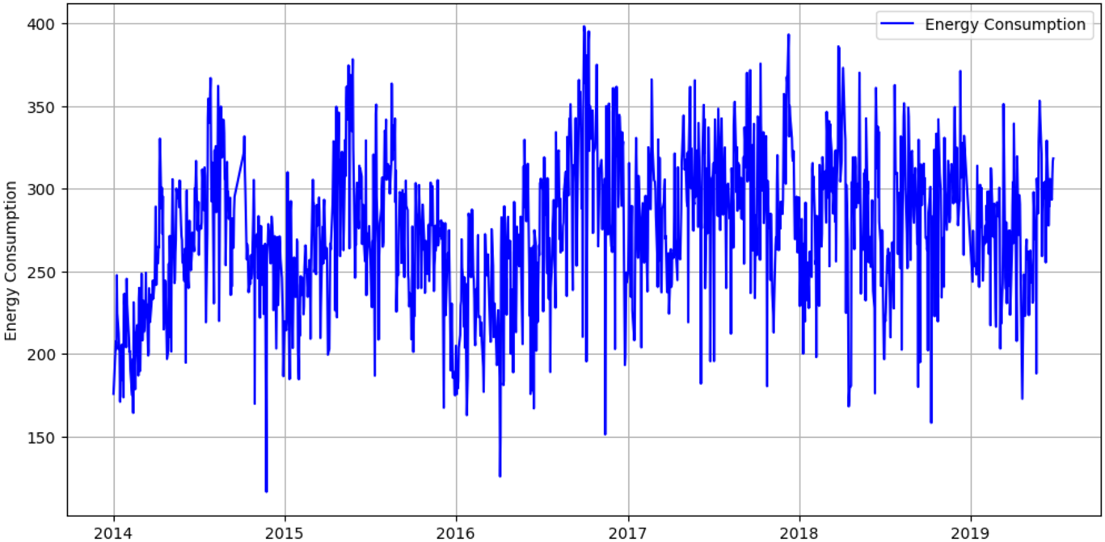
Figure 3. Energy Consumption Over time
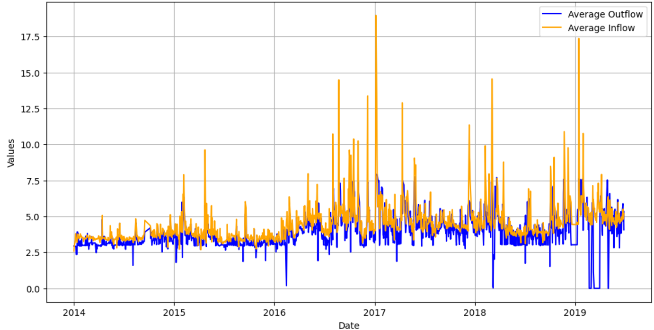 Figure 4. Average Outflow and Average Inflow
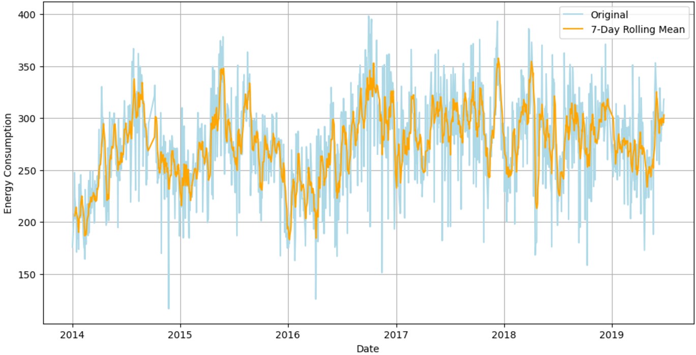 Figure 5. Highlight Variations with a Rolling Mean
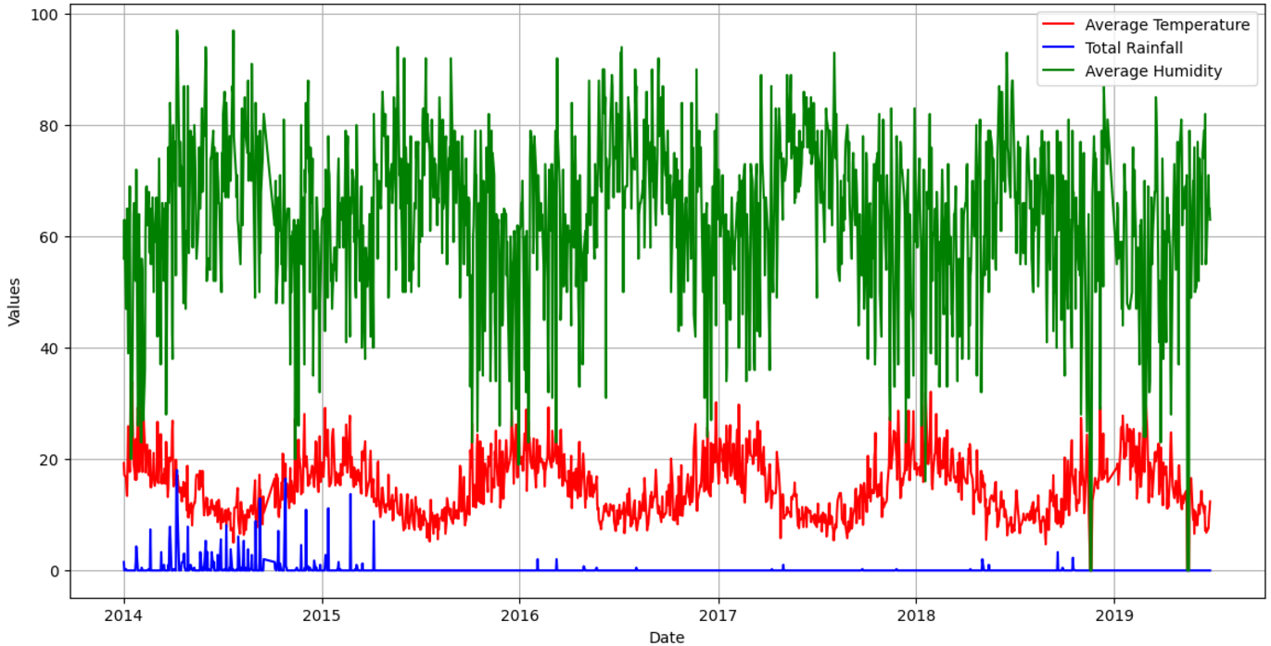 Figure 6. Analyze Correlations between Variables (Temperature, Rainfall, and Humidity)
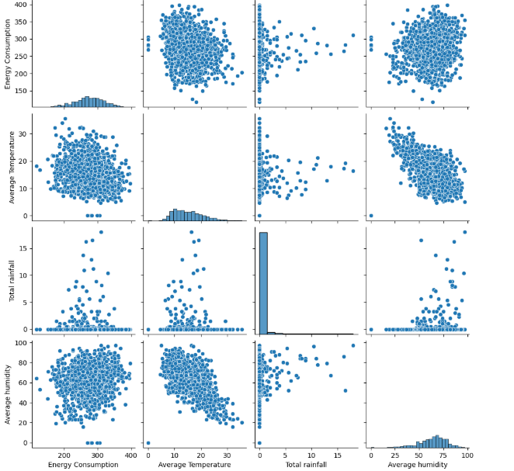
Figure 7. Visualizes pairwise relationships between some variable
The result showing that the ML and DL models recorded the best methods for energy consumption predictions. Results showed that using commonly metrics are (MAE, MAPE, MSE, RMSE and R2):
- MAE: Measures the average absolute difference between predicted and true values
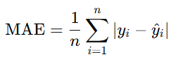
- MAPE: Measures the average percentage difference between predicted and true values
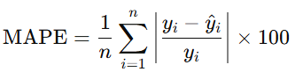
- MSE: Calculates the average squared difference between predicted and actual values
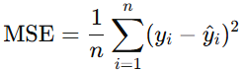
- RMSE: Measures the differences between predicted and true values.
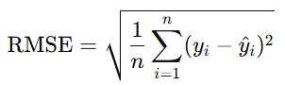
- R2: Measures how well the regression model explains the variance in the actual data
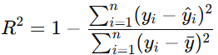
  - Results
This study presents an algorithmic approach for reducing energy usage in wastewater treatment plants (WWTPs) that involves the integration of substantial ML and DL techniques with feature selection engineering. This incorporates a stack of techniques for data treatment and pre-processing, outlier treatment and also selection of features which employs the ML and DL approaches to come up with the most relevant factors affecting energy consumption patterns.
EC prediction Using Full Models:
 | MAE(MWh) | MSE(MWh) | RMSE(MWh) | R2(MWh) | MAPE%
Linear Regression | 31.510318 | 1628.740553 | 40.357658 | 0.145026 | 0.15
Decision Tree | 38.942960 | 2550.571191 | 50.503180 | -0.338870 | -0.34
Random Forest | 26.976978 | 1221.586945 | 34.951208 | 0.358753 | 0.36
Support Vector Regression | 31.703361 | 1649.776059 | 40.617435 | 0.133984 | 0.13
Gradient Boosting | 27.854088 | 1335.981933 | 36.551087 | 0.298703 | 0.30
KNeighbors Regression | 32.717762 | 1794.093564 | 42.356742 | 0.058227 | 0.06
LSTM | 0.1058 | 0.0191 | 0.1381 | -0.0213 | 0.2250
CNN | 0.1430 | 0.0326 | 0.1806 | -0.7480 | 0.2255
Table 2. EC prediction Using Full Models

EC Prediction Using FS:
I split the dataset for 3 categories as following:
- Hydraulic (Average Outflow, Average Inflow)
- Wastewater (Energy Consumption “Target variable”, Ammonia, Biological Oxygen Demand, Chemical Oxygen Demand, Total Nitrogen)
- Climate (Average Temperature, Maximum temperature, Minimum temperature, Atmospheric pressure, Average humidity, Total rainfall, Average visibility, Average wind speed, Maximum wind speed)
The prediction results as following:
Hydraulic Category | MAE(MWh) | MSE(MWh) | RMSE(MWh) | R2(MWh) | MAPE%
Linear Regression | 34.11 | 1844.86 | 42.95 | 0.03 | 0.13
Decision Tree | 52.66 | 4535.2 | 67.34 | -1.38 | 0.2
Random Forest | 37.88 | 2360.38 | 48.58 | -0.24 | 0.15
Support Vector Regression | 33.63 | 1793.64 | 42.35 | 0.06 | 0.13
Gradient Boosting | 35.97 | 2073.68 | 45.54 | -0.09 | 0.14
KNeighbors Regression | 37.18 | 2267.84 | 47.62 | -0.19 | 0.14
LSTM | 0.18 | 34.28 | 0.19 | -0.017 | 0.06
CNN | 34.62 | 1899.16 | 43.58 | 0.00 | 13.12
Table 3. EC prediction Using Hydraulic Category
Wastewater Category | MAE(MWh) | MSE(MWh) | RMSE(MWh) | R2(MWh) | MAPE%
Linear Regression | 0 | 0 | 0 | 1 | 0
Decision Tree | 0.23 | 0.47 | 0.68 | 1 | 0
Random Forest | 0.22 | 2.25 | 1.5 | 1 | 0
Support Vector Regression | 29.3 | 1348.47 | 36.72 | 0.29 | 0.11
Gradient Boosting | 0.42 | 0.58 | 0.76 | 1 | 0
KNeighbors Regression | 6.4 | 98.62 | 9.93 | 0.95 | 0.03
LSTM | 0.18 | 34.64 | 0.19 | -0.02 | 0.07
CNN | 34.98 | 1955.77 | 44.22 | -0.03 | 13.14
Table 4. EC prediction Using Wastewater Category
Climate Category | MAE(MWh) | MSE(MWh) | RMSE(MWh) | R2(MWh) | MAPE%
Linear Regression | 34.13 | 1908.13 | 43.68 | 0 | 0.13
Decision Tree | 50.39 | 4071.62 | 63.81 | -1.14 | 0.19
Random Forest | 36.5 | 2164.45 | 46.52 | -0.14 | 0.14
Support Vector Regression | 34.21 | 1875.77 | 43.31 | 0.02 | 0.13
Gradient Boosting | 34.56 | 1980.19 | 44.5 | -0.04 | 0.13
KNeighbors Regression | 37.3 | 2239.85 | 47.33 | -0.18 | 0.14
LSTM | 0.18 | 35.05 | 0.19 | -0.02 | 0.07
CNN | 34.24 | 1860.74 | 43.14 | 0.023 | 13.71
Table 5. EC prediction Using Climate Category

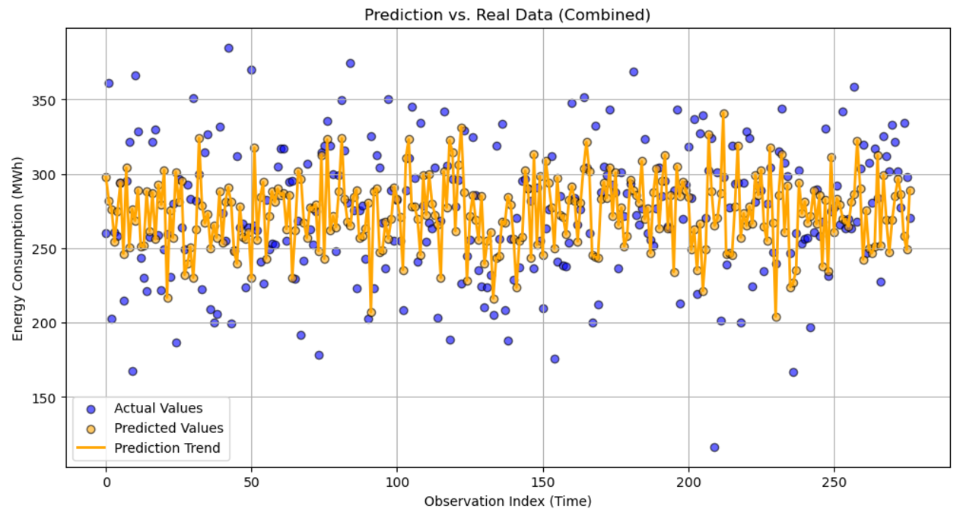 Figure 8. Visualizes Prediction vs. Real data
  - Conclusions
This study presents an algorithmic approach for reducing energy usage in wastewater treatment plants (WWTPs) that involves the integration of substantial machine and deep learning techniques with competent feature engineering and temporal modeling. This incorporates a stack of techniques for data treatment and pre-processing, outlier treatment and also selection of features which employs the Random Forest (RF) and Gradient Boosting (GBR) approaches to come up with the most relevant factors affecting energy consumption patterns.
In additional, investigates the potential of using deep learning models such as Long Short-Term Memory (LSTMs) networks and Content Neural Networks (CNN) that is able to locate and depict time and space relationships in the running of WWTP which gives much more reliable results than conventional machine learning models. The models also promote the use of lagged energy consumption data for use in the models to assist emphasize the lag patterns of temporal variables to enhance forecasting accuracy in the face of changing operational settings. In addition, the use of ML models such as Support Vector Regression (SVR), Gradient Boosting and K-Neighbors Regression (KNR) also gives valid low-order comparisons which are useful in confirming the effectiveness of the deep learning models.
The methodology empowers WWTP operators to implement proactive energy management, leading to enhanced resource distribution, reduced operational costs, and real-time process adjustments that ensure regulatory compliance while minimizing energy waste.

  - References
[1] Faramarz Bagherzadeh, Amirreza Shojaei Nouri, Mohamad-Javad Mehrani, Suresh Thennadil, “Prediction of energy consumption and evaluation of affecting factors in a full-scale WWTP using a machine learning approach”
[2] Fouzi Harrou, Abdelkader Dairi, Abdelhakim Dorbane, Ying Sun, “Energy consumption prediction in water treatment plants using deep learning with data augmentation”
[3] Yasminah Alali, Fouzi Harrou, Ying Sun, “Unlocking the Potential of Wastewater Treatment: Machine Learning Based Energy Consumption Prediction”
[4] Jianhui Wang; Keyi Wan; Xu Gao; Xuhong Cheng; Yu Shen; Zheng Wen, “Energy and Materials-Saving Management via Deep Learning for Wastewater Treatment Plants”
[5] Tanveer Ahmad, Huanxin Chen, “Utility companies strategy for short-term energy demand forecasting using machine learning based models”
[6] Akash Das, Piyush Kumar Kumawat, Nitin Dutt Chaturvedi, ”A Study to Target Energy Consumption in Wastewater Treatment Plant using Machine Learning Algorithms”
[7] Yang Yu, Zhihong Zou, Shanshan Wang, “Statistical regression modeling for energy consumption in wastewater treatment”
[8] Panagiotis Karadimos and Leonidas Anthopoulos, “Machine Learning-Based Energy Consumption Estimation of Wastewater Treatment Plants in Greece”

