
Midocean University
College of Management
Department of Project Management

Title in English: Applied Study on The Impact of the Project Manager’s Interpersonal Skills on Projects Success

Prepared by: Hamed Eltayeb Hammad

Supervised by: Dr. Ahmed Hussein

Year: 2024

Chapter One
Introduction

Introduction:
Project management is regarded as one of the crucial domains that necessitates a broad range of abilities to guarantee project success and the accomplishment of its primary objectives. Having the necessary Effective project delivery, improved communication, problem-solving, and well-informed decision-making all depend on interpersonal skills. Building interpersonal skills has become crucial for anyone aiming for project management excellence in light of the modern workplace's quick changes and growing problems.
How does one acquire these qualities, then? Courses, self-study, and workshops can improve a person's ability to think systemsically and their overall business viewpoint. Training courses help enhance communication and emotional intelligence. Additionally, people can learn time and stress management skills.
The purpose of this study is to investigate how interpersonal skills affect project management and how they might be improved to improve team output and project success. Identifying the fundamental interpersonal skills that project managers ought to have and going over various approaches and tactics for honing these abilities will be the main goals.
Being a successful project manager does not require a single management approach or set of rules. The field of project management is too complex to be dominated by a single management style or methodology.
Effective project managers are adept at changing their approaches depending on the context. In addition to helping people improve their abilities to accomplish their projects to the highest standard, we believe that our research will contribute to the advancement of both academic and practical knowledge in the field of project management.
The performance of the project team is not the only factor that determines the success of the project. Project stakeholders, including senior management, department managers, clients, suppliers, contractors, and others, frequently determine whether a project succeeds or fails.
We discuss the distinction between project management and project leadership in our research, emphasizing the value of communicating and interacting with the project's stakeholders. To be successful in this sector, project managers require a wide range of influence.
We'll talk about a number of publications that explore influence and explain how project managers develop social capital. Project managers rely on this management approach, which necessitates constant communication with various groups of individuals. The significance of setting a good example and maintaining the vital relationship with upper management are given particular consideration. The significance of obtaining collaboration in ways that establish and preserve trust with others is also emphasized as a critical component of project success.
Research Problem:
The problem addressed in this research is articulated around the current lack of focus on interpersonal skills in project management, in which its neglect will have an impact on the success of projects.
The nature of the issue, the surrounding circumstances, and the resources at hand all play a role in determining the soft skills required for success. In the construction industry, project management can present a number of unforeseen difficulties. These initiatives demand soft talents to manage. Effective project managers adapt well to changing requirements. A project manager's team can be inspired to finish a project by experience. The issue is that project managers in the construction industry lack soft skills, which results in lower success rates for high-quality projects. This study demonstrates the efficacy of soft skills in modern contexts and surroundings.
The purpose of this study was to provide a framework for comprehending the relationship between project managers' successful completion rates and soft skills in the construction sector. The study framework consists of a number of ideas, hypotheses, and players. The project team, construction management, customers, and organizational leadership are all involved in these ideas. An knowledge of the relationships between soft skills and project outcomes was developed through the use of research-relevant theories.

Importance of the Research:
Traditionally, the project would be finished if the project manager just carried out the project plan. The project manager would collaborate with others to create a timeline, assemble a team, monitor progress, and make announcements about the next steps, after which everyone would rush forward. However, these days. Participants in the project become irritable; they don't get along with one another; other departments can't deliver on their promises; there are technological issues; and the project takes longer than anticipated. Restoring the project's momentum is the project manager's responsibility. A manager finds solutions to technical issues, expedites some tasks, mediates conflicts when they arise, and makes the right trade-offs between project scope, budget, and time.
Since there is an underlying logic to the process, project management appears to be a deceptive discipline. From defining a project scope statement to establishing a work breakdown structure (WBS), building a network, adding resources, completing a plan, and hitting milestones, there is a logical progression. However, this reasoning can soon fall apart when it comes to actually carrying out and finishing initiatives. Project managers frequently deal with a messier, more contradictory, and paradoxical world. The paradoxical character of their work is something that effective project managers must be able to handle.
The impact of interpersonal skills on project success is examined in this study, along with its connection to team member and project performance enhancement and useful strategies for adopting and investing in interpersonal competences by individuals and organizations.

Research Objectives:
The managers of the projects Any successful project manager needs interpersonal skills; they are not only "nice-to-haves." These abilities enhance the technical facets of project management, transforming you into a leader as well as a manager. Investing in these abilities can not only increase your effectiveness in your position but also help create a more prosperous and peaceful workplace. The following elements of the study demonstrate how intrapersonal skills contribute to project success:
First, determining which interpersonal skills are crucial for improving both individual and team performance.
Second, examining how interpersonal skills relate to project outcomes including cost, time, and quality.
Interpersonal: The success of a project depends on the relationships between the members of the project team. You must be team players and coworkers, but you are not required to be buddies. There will be issues if the stakeholders and project team do not have good working relationships. Senior management should be made aware of these interpersonal issues.
Third, the study aims to offer helpful suggestions for enhancing people's interpersonal abilities, which will boost productivity at work.
The overall goal of the study is to comprehend how interpersonal skills affect the development of solid bonds with clients and other stakeholders.
By accomplishing these goals, the study intends to provide insightful information to businesses and project managers regarding the significance of funding the growth of interpersonal skills as a strategy for long-term project success.

Research Questions:
This research is shading the light on important aspects to understand the impact of interpersonal skills on project success.
1. What are the project manager’s soft skills affecting the team performance?
2. How do these skills improve the collaboration among the team members?
3. What is the relationship between development of the interpersonal skills and the outcome of the project?
4.How can interpersonal skills influence the relationship and engagement of different stakeholders of a project?
5. What type of strategies can be adopted to improve the soft skills among the project team individuals?
By answering these questions, this research aiming to provide overall understanding of the effect of those qualities and skills in success of the project.

Hypotheses of the research:
First Hypothesis:
Although it is generally preferred, strong leadership is not always required to finish a project successfully. As might be the case while building a typical apartment complex, when the project manager merely administers the project plan, well-defined projects that don't face any major surprises require little leadership. On the other hand, more leadership is needed when a project has a greater level of uncertainty.
The ability to lead and manage a project is one of the qualities that makes excellent project managers so beneficial to a company. In doing so, they acknowledge the necessity of establishing a social network that enables them to learn about what has to be done and secure the collaboration required to accomplish it.
Second Hypothesis:
How well a project manager works with one group will have an impact on how well he engages other groups. In order to protect the project's integrity and the interests of its participants, project managers must be able to allay customer worries, maintain support for the project at higher organizational levels, and promptly spot issues that could jeopardize project activity.
The project manager must determine what must be done within this network of relationships in order to accomplish the project's objectives and create a collaborative network to do so.
Third Hypothesis:
Establishing Trust: The Secret to Using Influence The concept of trust is elusive. The reasons why certain project managers are trusted while others are not are difficult to pinpoint in detail. The idea that trust is a function of competence and character is a common one. While competence focuses on the abilities required to actualize motives (e.g., does he or she know the proper things to do?), character focuses on personal motives (e.g., does he or she desire to do the right thing?).
Stephen Covey's best-selling book, Seven Habits of Highly Effective People, revived the importance of character in the leadership literature. Covey attacked popular management literature for emphasizing deceptive tactics and superficial interpersonal abilities, which he dubbed the personality ethic. He contends that a strong sense of personal values and principles, such as respect, justice, service, dignity, and the quest of truth, form the foundation of highly productive people.

Fourth Hypothesis:
Qualities of an Effective Project Manager, Since there is an underlying logic to the process, project management appears to be a deceptive discipline. From defining a project scope statement to establishing a work breakdown structure (WBS), building a network, adding resources, completing a plan, and hitting milestones, there is a logical progression. However, this reasoning can soon fall apart when it comes to actually carrying out and finishing initiatives. Project managers frequently deal with a messier, more contradictory, and paradoxical world. The paradoxical character of their work is something that effective project managers must be able to handle.

8- Scientific Theory Model Applied in the Research:
A scientific theory is a well-substantiated explanation of some aspect of the natural world, based on a body of facts that have been repeatedly confirmed through observation and experiment.
1- Transformational Leadership Theory: Since the 1980s, transformational leadership theory has been the most widely accepted leadership idea. It has consistently demonstrated a significant impact on a variety of organizational standards and outcomes, including commitment, job satisfaction, performance, and job performance. The majority of leadership research over the past three decades has concentrated more on transformational leadership, which provides robust support for project teams, organizational environment, culture, employee wellbeing, and organizational performance. The project's future is fully explained by transformational leaders, who also encourage stakeholder meetings that ultimately result in project success.
2- Emotional Intelligence (EQ) Theory: The ability to recognize, evaluate, and control one's own and other people's emotions is known as emotional intelligence (EQ). Even though the idea of emotional intelligence (EQ) first surfaced in the 1920s, it wasn't until Daniel Goleman's book Emotional Intelligence that the public and corporate community began to take notice of it.
3- Conflict Management Theory: On a project, conflict is unavoidable, and when disputes are managed well, performance can improve. However, dysfunctional conflict—a kind of conflict that deteriorates employee relations and impedes organizational advancement—can flare up and seriously jeopardize the success of a project. Conflicts might arise in outsourced projects since individuals are not used to collaborating and have different viewpoints and values.
Successful businesses put a lot of time and effort into creating the "rules of engagement" in advance to ensure that conflicts are resolved amicably.
4- Contemporary Project Management Model: Contemporary project management utilizes the tried-and-true project management techniques along with modern improvements such as the most current versions of Microsoft® Project Professional 2013 and the fifth edition of the Guide to the Project Management Body of Knowledge (PMBOK® Guide).
Contemporary project management also utilizes a wide range of tools and insights from a variety of sources, including extended role definitions, leadership principles, human strengths, agile planning and execution, and contemporary approaches to quality and communications. Modern project management is scalable, employing more complicated versions of key approaches for larger projects and simpler equivalents for smaller ones.

These theories collectively give a detailed understanding of how interpersonal skills contribute to project success and provide a basis for developing strategies to improve these skills in project management.

8.1 Definitions:
As the project management skills greatly affect the projects performance and success, we will highlight the main definitions of the qualities that make an effective project manager:
8.1.1 Managing versus Leading a Project
In an ideal scenario, the project would be finished if the project manager just carried out the project plan. The project manager would collaborate with others to create a timeline, assemble a team, monitor progress, and make announcements about the next steps, after which everyone would rush forward. Naturally, nobody lives in a perfect world, and things rarely go as planned. Participants in the project become irritable; they don't get along with one another; other departments can't deliver on their promises; there are technological issues; and the project takes longer than anticipated. Restoring the project's momentum is the project manager's responsibility. A manager speeds up specific tasks; finds solutions to technical issues, mediates conflicts when they arise, and strikes the right balance between project scope, budget, and schedule.
Project managers, however, frequently do more than simply keep the project on schedule and put out fires. Additionally, they innovate and adjust to constantly shifting conditions. In order to respond to unforeseen dangers or opportunities, they occasionally have to depart from the original plan and implement considerable changes in the project scope and timetable.
For instance, halfway through the project, the needs of the clients can change and necessitate major design adjustments. New items from rival companies could force collapsing project deadlines. Project participants' working relationships may deteriorate, necessitating a reorganization of the project team.
In the end, what was achieved by the project's conclusion may differ greatly from what was first anticipated or intended. In order to finish the project on schedule, project managers must integrate the resources they have been allotted. Simultaneously, they must start making adjustments to timetables and plans since ongoing issues render them impractical. To put it another way, managers want to continue the project while making the required modifications as it progresses.
Kotter (1990) asserts that these two unique tasks serve as a representation of the differences between management and leadership.
Leadership is about adapting to change, whereas management is about managing complexity. By creating plans and goals, creating structures and processes, keeping an eye on performance against plans, and taking corrective action when needed, good management creates stability and order. Leadership entails identifying and communicating the need to drastically modify the project's operation and direction, bringing everyone on board with the new course, and inspiring them to collaborate in order to overcome obstacles brought on by the shift and achieve new goals.
Although it is generally preferred, strong leadership is not always required to finish a project successfully.
As might be the case while building a typical apartment complex, when the project manager merely administers the project plan, well-defined projects that don't face any major surprises require little leadership. On the other hand, more leadership is needed the more uncertainty a project faces, whether it be from shifting project scope, technical dead ends, or poor interpersonal coordination. For instance, a software development project with constantly shifting specifications to accommodate industry advancements would require excellent leadership.
It requires a unique individual to be good at both roles. Some people are excellent visionaries who can motivate others to embrace change.
As might be the case while building a typical apartment complex, when the project manager merely administers the project plan, well-defined projects that don't face any major surprises require little leadership. On the other hand, more leadership is needed the more uncertainty a project faces, whether it be from shifting project scope, technical dead ends, or poor interpersonal coordination. For instance, a software development project with constantly shifting specifications to accommodate industry advancements would require excellent leadership.
It requires a unique individual to be good at both roles. Some people are excellent visionaries who can motivate others to embrace change. By doing this, they realize they need to build a social network that helps them figure out what they need to do and get everyone to work together to get it done.
8.1.2 Engaging Project Stakeholders
In order to successfully finish their project, new project managers are keen to put their own ideas into practice and oversee their team. They quickly discover that the collaboration of numerous people, many of whom do not directly report to them, is essential to the success of the project. For instance, a project manager was taken aback by the amount of time she spent negotiating and collaborating with vendors, consultants, technical experts, and other functional managers during a system integration project.
All too frequently, inexperienced project managers take a hands-on approach to project management when they do find time to work directly on the project. They use this approach because they are motivated to produce results rather than because they are egotistical power-hungry individuals. How slowly things move along, how many people need to be brought on board, and how hard it is to get collaboration swiftly irritate them. Regretfully, the temptation to increase pressure and become more involved in the project naturally arises as this irritation increases. These project managers rapidly acquire the reputation of "micro managing" and start to lose focus on their actual responsibility for project direction.
This vicious circle is something that some new managers never escape. Others quickly come to the realization that power does not equate to influence and that managing a far more complicated group of stakeholders is a necessary part of being a successful project manager. They come upon a network of connections that call for a far wider range of influence than they believed was required or even feasible.
A major project, for instance, will probably entail collaborating with several groups of stakeholders in one way or another, whether it is repairing a bridge, developing a new product, or setting up a new information system. The core team of experts tasked with finishing the project comes first. Professionals who work on particular project segments are likely to join this group at various points in time. Second, there are groups of people who are either directly or indirectly connected with the project within the performing company. Top management, to whom the project manager reports, is the most significant.
Additionally, there are other managers who supply resources and/or may be in charge of particular project components, as well as administrative support services like finance, human resources, and so forth. The customer for whom the project is intended is the most significant external group that affects the project's success, albeit this depends on the type of project (see figure 2).
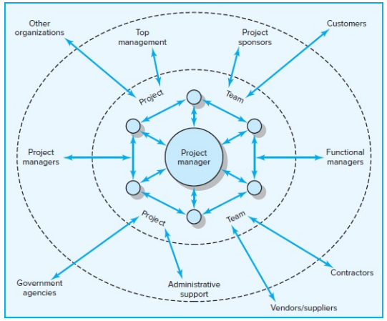
Figure. 2 (Network of Stakeholders)
Every one of these stakeholder groups contributes unique standards, goals, priorities, and areas of expertise to the project. According to the Project Management Institute (2017), stakeholders are individuals and groups that actively participate in the project or whose interests may be impacted by it in either a favorable or negative way.
Project management is distinct from ordinary management due to the extensive and intricate nature of stakeholder connections. A project manager needs to create strategies for managing dependencies and comprehend how stakeholders can impact the project in order to be successful. Here is a description of these dependencies' nature:
The project team oversees and finishes the task. Although the majority of participants desire to perform well, they are also focused on their other responsibilities and how their participation in the project would advance their own objectives. It is only normal for project managers to vie for resources and upper management support. They frequently have to communicate information and pool resources at the same time.
Important support services are offered by administrative support groups, including buying agents, maintenance, information systems, and human resources. At the same time, they place restrictions and demands on the project, like the need to accurately and promptly supply information and to document expenses.
Depending on the structure of the project, functional managers may have a little or significant impact on its success. They might be in charge of allocating project staff, addressing technical issues, and supervising the execution of important project work segments in matrix setups. Functional managers' technical advice can be helpful even in specialized project teams, and internal initiatives may depend on their acceptance of finished work. There is a limit to how much functional managers desire to work together. Along with limiting any delays the project may cause to their own business; they are also focused on maintaining their standing within the company.

The organization's top management sets priorities and authorizes the project's funding. They decide how to reward achievements and define success. Usually, their agreement is required for significant changes to the budget, scope, and timeline. They naturally have a stake in the project's success, but they also need to consider what's best for the organization as a whole.

Project sponsors: advocate for the project and use their power to get it approved. Since their reputation is dependent on the project's success, they must be updated on all significant advancements. They are an important project ally and stand up for the project when it is attacked.

In certain situations, contractors may handle all of the actual work, with the project team only coordinating their input. In other situations, they are in charge of supporting areas of the project's scope. The main project team's work may be impacted by subpar work and timetable errors. Although delivering quality work is what builds contractors' reputations, they also have to balance their contributions with their own profit margins and their obligations to other clients.

Governmental organizations impose restrictions on project work. Permits must be obtained. Code-compliant construction is required. The U.S. Food and Drug Administration requires new medications to pass a stringent battery of tests. Other items must adhere to safety regulations, such as those set forth by the Occupational Safety and Health Administration.

Suppliers and vendors supply the resources required to finish the project. Poor quality, shortages, and delays can cause a project to stall.

Depending on the project's nature, other organizations may have a direct or indirect impact. Environmental organizations, for instance, might contest or even halt project work. Governmental organizations may come under pressure from public interest groups. In order to safeguard their interests during a project, clients frequently employ consultants and auditors.

Customers determine the project's scope, and their pleasure is ultimately what determines the project's success. Project managers must be able to meet the expectations of their clients and adapt to their changing demands and requirements. Getting a fair bargain is the main concern of customers, which inevitably leads to conflict with the project team.
A project manager's capacity to collaborate with one group will influence his capacity to involve other groups, demonstrating the interdependence of these partnerships. For instance, if functional managers believe that upper management is becoming less committed to the project, they are likely to be less cooperative. On the other hand, the project manager's reputation among the team is likely to improve if he can protect them from a client's overbearing meddling.
The quantity and level of external dependencies that must be involved will depend on the project management structure being employed. Because the majority of the resources are allocated to the project, one benefit of forming a specialized project team is that it decreases dependencies, particularly inside the organization. On the other hand, a functional matrix organization creates more dependencies, making the project manager more dependent on functional peers for staff and work.

Snapshot from Practic.01 (Gray C. Project Management. The Managerial Process 8ed 2021)
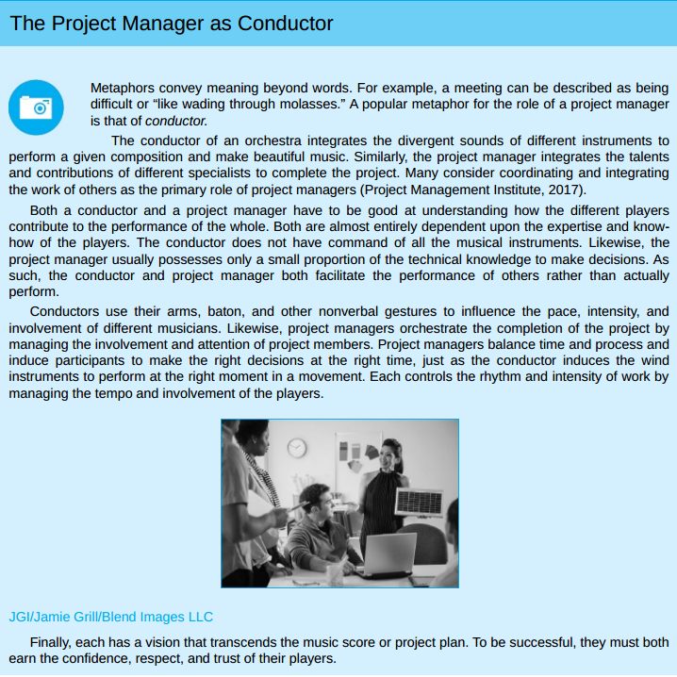

8.1.3 Influence as Exchange
A manager must skillfully create a cooperative network among disparate allies in order to oversee a project successfully. The law of reciprocity typically governs networks, which are advantageous partnerships (Grant, 2013; Kaplan, 1984).
"One good deed deserves another, and likewise one bad deed deserves another" is the fundamental tenet. Giving others resources and services in return for future resources and services is the main strategy for gaining cooperation.
The exchange view of influence was referred to as "currencies" by Cohen and Bradford (1990). You must be ready to utilize the right currency if you wish to conduct business in a certain nation, and exchange rates are subject to change as circumstances evolve. Similarly, the values of a marketing manager and a seasoned project engineer may differ, and you will probably need to utilize different influence currencies to win each person's cooperation. The main idea is that cooperative partnerships require a balance between "debit" and "credit" accounts over time, even though this analogy is a little oversimplified. (Refer to table 3.)
Table. – 3 Commonly Traded Organizational Currencies
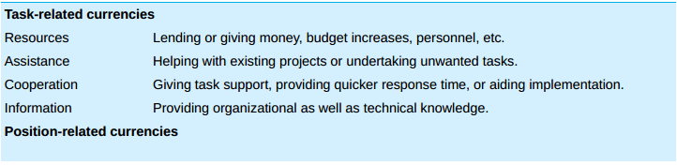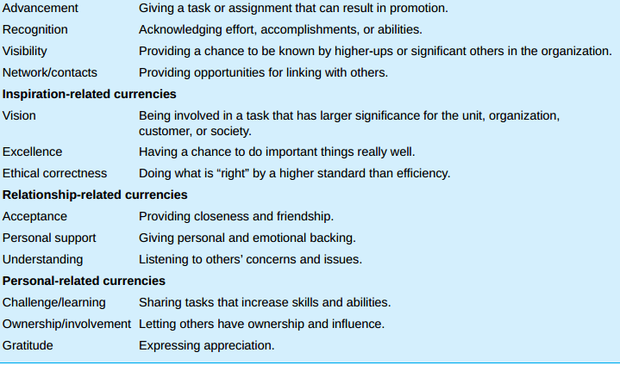
The following sections provide a more thorough discussion of the same Commonly Traded Organizational Currencies:
Task-Related Currencies
The ability of the project manager to help others complete their tasks is the basis for task-related currencies, which can take many various forms. The ability to respond to demands from subordinates for more time, money, or labor to finish a project segment is likely the most important form of this currency. Sharing resources with another project manager who is in need is another example of this type of currency. On a more intimate level, it can only entail giving a coworker hands-on help with a technical issue.
Another use of this currency is to lend support to a colleague's suggestion or idea. Having a "friend in court" can be very helpful to the individual attempting to get clearance for a plan or proposal, as most significant activity is likely to encounter some sort of opposition.
This money can also be expressed as remarkable effort. For instance, responding to an urgent request to finish a design document in two days as opposed to the customary four days is likely to inspire appreciation. Lastly, another way this currency is used is by exchanging important information that other managers could find helpful.
Position-Related Currencies
The manager's capacity to elevate others' standing inside their company is the source of position-related currencies. A project manager can accomplish this by assigning a difficult task that will help the individual grow by enhancing her abilities and skills. Strong feelings of thankfulness are naturally produced when you are given the opportunity to prove yourself. Goodwill is created by sharing the praise and drawing attention to the successes and efforts of others from superiors.
Project managers reveal that figuring out how to make these individuals appear good to their superiors is a helpful tactic for winning over professionals in other departments or organizations. A project manager, for instance, collaborated with a subcontractor whose company had a strong commitment to total quality management (TQM). During high-level briefings, the project manager made it a point to highlight how the contractor's quality improvement initiatives helped with cost containment and issue avoidance.
Improving the standing of other employees inside the company is an additional form of acknowledgment. While "bad press" can rapidly cut someone off and make performance tough, "good press" can open up a lot of chances. This currency is also demonstrated by defending someone who has been wrongfully held responsible for project failures, therefore protecting their reputation.
Lastly, exchanging contacts with others is one of the most powerful ways to use this cash. Introducing people to important people and assisting them in growing their own networks inherently fosters gratitude.

Inspiration-Related Currencies
The most potent kind of impact is probably that which is associated with inspiration. The majority of inspiration comes from people's intense desire to change the world and give their life purpose. A project can inspire incredible dedication if an interesting, audacious concept is developed. For instance, the belief that project participants had an opportunity to alter the way people viewed computers was responsible for many of the technological innovations connected to the launch of the first Macintosh computer. An opportunity to achieve something truly well is presented by a different kind of vision. Many people are motivated by the ability to take pride in their work.
Frequently, inspiration comes from the project's very nature. People can feel good about what they are doing and that they are making a difference when they find a cure for a terrible disease, launch a new social program that will help those in need, or just build a bridge that will ease a significant traffic bottleneck. Rather than pressuring individuals to take action, inspiration works like a magnet, drawing them in.
Relationship-Related Currencies
More than completing project tasks, relationship-related currencies focus on improving the relationship with the other person. Building a relationship that goes beyond typical professional limits and into the realm of friendship is the essence of this type of influence. Personal and emotional support is necessary for the development of such relationships. Encouragement, confidence-boosting, and picking others up when they're feeling low all naturally foster goodwill. Another way to use this currency is to make tough circumstances enjoyable and to share a sense of humor. Relationships are also organically strengthened by participating in non-work-related activities like sports and family vacations.
Listening to others is arguably the simplest way to use this currency. According to psychologists, relationships end when people stop listening to one another, and most people have a strong need to be understood. A unique link is also formed between people when they are wise confidants and share personal secrets and goals.
Personal-Related Currencies
Individual needs and a strong sense of self-worth are addressed by personal currencies. Some think that helping people feel important and valuable will inevitably lead to goodwill, and that self-esteem is a fundamental psychological need. By asking for assistance and comments, giving people authority over their work, and letting them feel free to push themselves, a project manager can help a colleague feel more valuable. Sincere thanks for other people's contributions are another example of this type of cash. However, since appreciation is readily diminished when overused, care must be taken while expressing it. In other words, the first thank you is probably more important than the fifty.
In the end, a project manager will only have influence if she can provide something that other people find valuable. Additionally, a project manager needs to be able to acquire and use a variety of influence currencies since she depends on a wide range of people. This will be limited, in part, by the structure and character of the project. A project manager overseeing a committed team, for instance, has a lot more to offer team members than a manager tasked with coordinating the efforts of many specialists from various departments and organizations.
8.1.4 Social Network Building
Mapping Stakeholder Dependencies: Determining which stakeholders are essential to the project's success is the first stage in creating a social network. The following inquiries must be made by the project manager and his principal assistants:
Whose assistance will we require?
Whose consent or endorsement will we require?
Whose resistance would prevent us from completing the project successfully?
Making a map of these dependencies is useful for many project managers. For instance, a project manager in charge of implementing a new financial software system in her organization recognized the relationships shown in Figure 3.
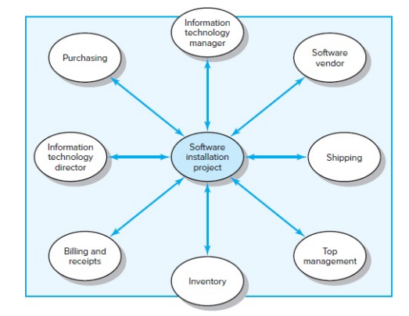
Figure. 3 (Stakeholder Map for Financial Software Installation Project)
Dependencies should always be overestimated rather than underestimated. Project managers who were otherwise gifted and successful have far too frequently been sidetracked by someone whose position or influence they did not expect. Once the stakeholders involved in your project have been identified, it is critical to evaluate their importance. The most important stakeholders are those who have the most influence on and interest in the project; they should receive the most attention. You must specifically "step into their shoes" and consider the project from their point of view by posing the following queries:
What aspects—goals, values, demands, working styles, and risks—differ between myself and the people I rely on?
How do these various individuals—supporters, apathetic, and adversaries—feel about the project?
How do my relationships with the folks I rely on stand right now?
In comparison to the people I rely on, what are my sources of influence?
Starting this examination will help you understand what other people value and what currency you might be able to offer as a foundation for a collaborative connection. You start to identify relationships where you have a present debit or no convertible cash as possible trouble spots. You may also predict how other people will feel and react to your choices and actions by assessing their viewpoints and the reasons behind them. In order to choose the best influence strategy and tactics and create win-win solutions, this information is essential.
Management by Wandering Around (MBWA):
After determining who the important actors are, you reach out to them and start establishing a rapport with them. Since managers at Hewlett Packard spend much of their time outside of their offices, establishing this relationship involves an interactive management style known as management by wandering around (MBWA).
Since there is a pattern or goal behind the "wandering," MBWA is a bit misleading. Project managers can stay informed about the true status of the project and foster the collaboration necessary for its success through in-person contacts.
Proficient project managers reach out to important stakeholders to stay updated on progress, foresee possible issues, offer support, and reaffirm the project's goals and vision. They have the ability to step in and settle disputes and avoid deadlocks. To put it simply, they "manage" the project. By remaining informed about several facets of the project, they become the information hub. Their primary function as project manager is further reinforced by the fact that participants look to them for the most up-to-date and thorough information about the project.
Successful project managers also make time to communicate with stakeholders farther away on a regular basis. They maintain communication with top management, vendors, suppliers, and other functional managers. By doing this, they stay acquainted with many parties, establish connections, find opportunities to provide a helping hand, and get insight into the needs and motivations of others. They promote their project's cause and remind others of their commitments. According to Snapshot from Practice 10.2: Managing Expectations, they also influence people's expectations.
By communicating often, they allay people's fears about the initiative, debunk rumors, alert individuals to possible issues, and provide the framework for handling setbacks more skillfully. Unless project managers are proactive in creating a network of support beforehand.
Snapshot from Practic.02 (Gray C. Project Management. The Managerial Process 8ed 2021)
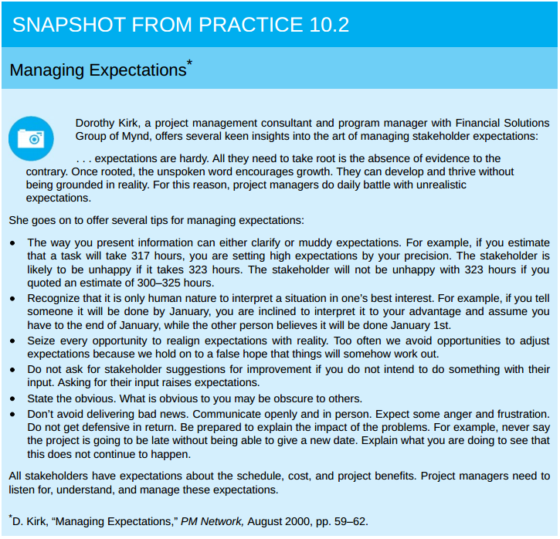
Building relationships before they are needed is something that seasoned project managers understand. They reach out to the important parties when there are no unresolved concerns or difficulties, and hence no misgivings or suspicions. They inherently participate in response banter and small conversation during these social events. They exchange information, offer consoling advice, and reply to others' appeals for assistance. By doing this, kids build positive relationships that will help them handle more difficult issues in the future.
Managing Upward Relations:
Studies repeatedly demonstrate that the level of top management support for a project has a significant impact on its success.3. An enough budget, flexibility in responding to unforeseen demands, and a clear communication to other members of the organization about the significance of the project and the necessity of collaboration are all examples of this kind of support.
In addition to being essential for gaining the support of other managers in an organization, visible top management support is also crucial for the project manager's capacity to inspire the project team. A manager's capacity to defend is what most clearly establishes his authority to lead.
Project managers must effectively advocate for their projects in order to gain the support of their team members. They must be able to persuade upper management to drop irrational demands, supply more resources, and acknowledge team members' achievements. Saying this is easier said than done.
Although it would seem illogical for a subordinate to "manage" a superior, smart project managers invest a great deal of time and energy on swaying and winning over upper management. Project managers must learn to be adept at influencing superiors and embrace significant variations in viewpoint.
Perspective differences are a major source of conflict between project managers and senior management. Naturally, project managers focus on what will work best for their project. Their project is the most important thing in the world to them. The priorities of top management ought to be distinct. They care about what's best for the organization as a whole. These two interests will naturally clash from time to time. A project manager might, for instance, vigorously advocate for more workers, only to have their request denied because upper management feels that the other departments cannot afford to cut back. The project manager must acknowledge that senior management will unavoidably have a different perspective on the world, even though regular contact might reduce discrepancies.
It's all about timing. It will be far more difficult to request more funding the day after the third quarter's dismal earnings are announced than it will be to do so four weeks later. Effective project managers choose the best time to win over upper management. To advocate for their cause, they recruit sponsors for their projects. They also understand that the allowances made by upper management are limited. The Lone Ranger analogy is relevant here: make good use of your limited supply of silver bullets.
Lastly, some project managers acknowledge that they overlook the line of command. They act without requesting permission if they are certain that a significant request would be denied by upper management and that their actions will advance the project. They assert that supervisors usually don't argue with success, despite the fact that this is quite dangerous.
Leading by Example
Project managers can use their most effective leadership tool—their own behavior—by adopting a highly visible, interactive management style, which is also crucial for establishing and maintaining cooperative relationships (Kouzes & Posner, 2012; Peters, 1988).
People frequently show a tendency to imitate the actions of those they respect and turn to others for guidance when faced with uncertainty. The actions of a project manager serve as a model for how other team members should approach the project. A project manager can affect how others behave and react to a range of project-related difficulties by modeling certain behaviors.
(For a striking illustration of this, see Snapshot from Practice 10.3: Leading at the Edge.)
Six aspects of leading by example are discussed as following (also refer to figure – 4):

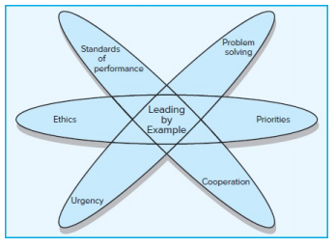
Figure. 4 (Leading by Example)

Snapshot from Practic.03 (Leading at the Edge) Gray C. Project Management. The Managerial Process 8ed 2021)
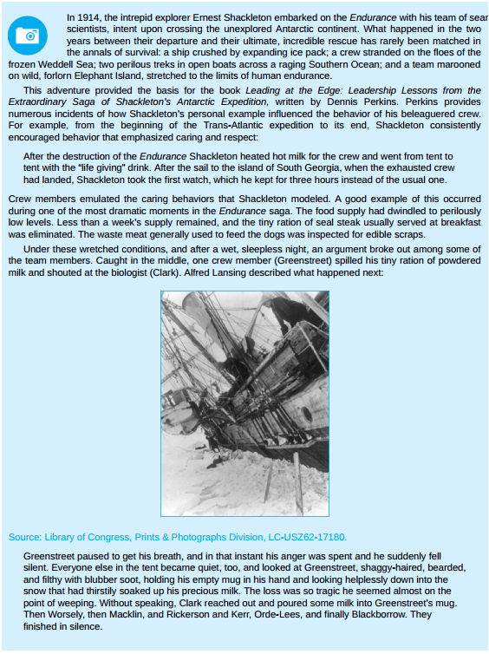
Priorities: Deeds are more powerful than words. The way that project managers use their time reveals their priorities to subordinates and others. All of a project manager's verbal pledges are likely to be ignored if she asserts that this project is crucial but is later seen as spending more time on other projects. On the other hand, a project manager who spends time observing a
The relevance of the testers and their work is confirmed by doing critical tests rather than only waiting for a report. Similarly, the questions that project managers ask convey priorities. A project manager might emphasize the significance of customer satisfaction by continually questioning how particular challenges relate to meeting the needs of the client.
Urgency: Project managers can communicate a sense of urgency by their behaviors, and this sense can permeate all aspects of project activities. Strict deadlines, regular status report meetings, and aggressive project-speeding solutions are some ways to communicate this urgency. To keep track of the project's rhythm, the project manager employs these tools as a metronome.
At the same time, if the project manager's conduct does not change in tandem, these tools will be useless. Project managers must work more quickly themselves if they expect people to work and solve issues more quickly. Their own behavior needs to pick up speed. Their interactions should be more frequent, they should walk and chat faster, they should arrive at work earlier, and they should depart later. Project managers can instill a sense of urgency in others by merely quickening the speed of their regular interactions.
Problem Solving: The way that project managers handle issues sets the standard for how others handle them. Others will be reluctant to share negative news if it is met with verbal abuse.4. Others will try to hide their tracks and shift the blame elsewhere if the project manager is more focused on identifying the guilty party than on how to stop issues from occurring in the future. Others are more likely to take a more proactive approach to problem solving, however, if project managers concentrate more on how they may use a problem as an opportunity or what can be learnt from a mistake.
Cooperation: Team members' interactions with external parties are influenced by the way project managers behave. When a project manager makes negative comments about the "idiots" in the marketing department, the team as a whole frequently adopts this viewpoint. It is more probable that others will follow suit if project managers establish the standard of showing respect and being attentive to the demands of outsiders.
Standards of Performance: Experienced project managers understand that they must surpass others' expectations of a competent project manager if they wish to see participants surpass project expectations. The caliber of their everyday interactions sets a high bar for project performance. They attend to others' needs promptly, plan and conduct meetings with precision, keep abreast of all the relevant issues, assist in addressing problems effectively, and maintain their position on crucial subjects.
Ethics: The way a project manager handles ethical quandaries during a project will impact how others handle similar situations afterwards. Team members frequently base their decisions on how they believe the project manager would react.
Project managers send a message to others that this type of behavior is acceptable if they purposefully misrepresent or omit important information from clients or upper management. Project management inevitably leads to a number of ethical conundrums; now would be a good time to get deeper into this subject.
8.1.5 Ethics and Project Management
Due to the complexity of project management, ethics always entail ambiguous regions of interpretation and judgment. For instance, it is challenging to discern intentional exaggeration of project payoffs from sincere optimism or malicious fabrication of projections from honest errors. Determining whether unmet promises were intentional deception or a suitable reaction to evolving circumstances becomes hard.
Many businesses and professional associations release a code of conduct to help clarify corporate ethics. Advocates contend that these documents are significant, if constrained, initial steps, while cynics view them as merely window dressing. Personal ethics are found at the intersection of one's work, family, education, profession, religious views, and everyday interactions rather than in formal statutes. According to the majority of project managers, they depend on their own personal moral compass, or what one project manager referred to as his "internal compass."
According to a lot of project managers, acting morally is rewarding in and of itself. Your behavior reflects your personal ideals when you act in accordance with your internal compass. According to some, acting morally has two benefits. In addition to being able to sleep at night, you also build a solid and respectable reputation. Such a reputation is crucial to building the trust required to successfully use influence, as will be discussed in the following section.

Snapshot from Practic.04 (The Collapse of Arthur Andersen) Gray C. Project Management. The Managerial Process 8ed 2021)

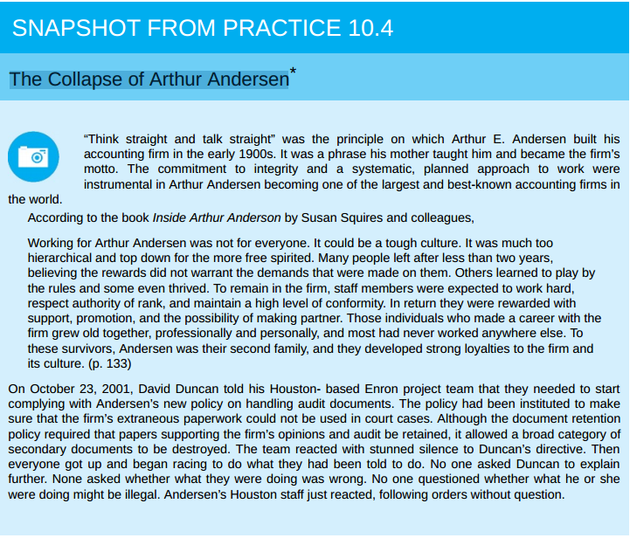

8.1.6 Building Trust: The Key to Exercising Influence
The absence of trust is a sign of its importance. Consider the difference in a working relationship between mistrusting and trusting the other person.
The concept of trust is elusive. The reasons why certain project managers are trusted while others are not are difficult to pinpoint in detail. The idea that trust is a function of competence and character is a common one. While competence focuses on the abilities required to actualize motives (e.g., does he or she know the proper things to do?), character focuses on personal motives (e.g., does he or she desire to do the right thing?).
Stephen Covey's best-selling book, Seven Habits of Highly Effective People, revived the importance of character in the leadership literature. Covey attacked popular management literature for emphasizing deceptive tactics and superficial human relations skills, which he called the personality ethic. He contends that a strong sense of personal values and principles, such as respect, justice, service, dignity, and the quest of truth, form the foundation of highly productive people.
Consistency is one of the qualities that set character apart. People are inherently more predictable when they follow a core set of principles since their behavior is in line with these values. Openness is another aspect of character. People are more open to others when they know exactly who they are and what they value. This characteristic gives them the ability to sympathize and the skill to bring disparate individuals together. Lastly, having a feeling of purpose is another trait of character. Characteristic managers are motivated by the greater good in addition to their own goals. What is best for the project and their organization, not for themselves, is their top priority. The respect, loyalty, and trust of others are earned by this readiness to put a greater good ahead of one's own interests.
Trust cannot be built on character alone. Before we can truly trust someone, we must first have faith in their competence (Kanter, 1979). We have all encountered well-meaning bosses that we like but do not trust due to their track record of breaking commitments. We may become friends with these managers, but we don't want to work for or with them.
Competence manifests itself on several levels. The first is task-related knowledge and abilities, which are demonstrated by the capacity to respond to inquiries, resolve technical issues, and perform exceptionally well in particular types of work. Secondly, interpersonal competence is proven through the ability to listen well, speak clearly, settle disputes, offer support, and so on. Organizational competence comes last.
This entails having the ability to organize productive meetings, establish worthwhile goals, cut down on inefficiencies, and create a social network. Young engineers and other professionals all too frequently have a tendency to overvalue technical or task proficiency. They undervalue the importance of being well-organized. Conversely, veteran professionals appreciate interpersonal and organizational abilities more and understand the significance of management.
One issue that new project managers face is that developing a feeling of competence and character takes time. When put to the test, such as when faced with a difficult decision or a challenging challenge to address, character and competency are frequently displayed. Experienced project managers benefit from a solid reputation and proven track record of accomplishment. Even though a rookie project manager can make a good first impression with the support of reputable sponsors, her actions will eventually determine whether or not she can be trusted.
8.1.7 Qualities of an Effective Project Manager
Since there is an underlying logic to the process, project management appears to be a deceptive discipline. From defining a project scope statement to establishing a work breakdown structure (WBS), building a network, adding resources, completing a plan, and hitting milestones, there is a logical progression. However, this reasoning can soon fall apart when it comes to actually carrying out and finishing initiatives. Project managers frequently deal with a messier, more contradictory, and paradoxical world. The paradoxical character of their work is something that effective project managers must be able to handle. The following is a list of some of those contradictions:
Maintain stability while innovating: Project managers must put out fires, reestablish order, and bring the project back on course. They must simultaneously be creative and create fresh, more effective methods of accomplishing tasks. Innovations disrupt routines and can lead to other disruptions that require attention.
See the big picture while getting their hands dirty: Project managers must have a broad perspective and understand how their project fits into their company's overall strategy. They occasionally have to become quite active with technology and project work. Who will care about the specifics if they don't?
Encourage individuals but stress the team: While preserving teamwork, project managers must inspire, persuade, and lure individual performers. They must take care to treat each team member as a unique individual while still being regarded as fair and consistent in their treatment of them.
Be hands-off/hands-on: Project managers must step in, break deadlocks, fix technical issues, and insist on alternative strategies. They must simultaneously know when it's acceptable to take a backseat and let others do the fighting.
Be flexible but firm: Project managers must be flexible and sensitive to the happenings and results of the project. However, there are moments when they must persevere and hold the line when everyone else wants to give up.
Manage team versus organizational loyalties: It is the responsibility of project managers to create a cohesive team whose members inspire each other to achieve exceptional results. However, they must simultaneously combat the team's intolerance to outside ideas and the excesses of cohesiveness. They must develop allegiances to the parent company as well as the team.
Being a successful project manager does not require a single management approach or set of rules. Project management is too complex a field to be governed by formulas. Effective project managers are adept at changing their approaches depending on the context.
Sometimes it seems like someone with superhuman abilities is needed to be a good project manager. There are certain fundamental qualities and abilities that can be cultivated to effectively manage a project, even though not everyone possesses these abilities. Eight of these characteristics are as follows:
Effective communication skills: For a project to be successful, communication is essential. Project managers must be sympathetic listeners and speak the language of many stakeholders.
Systems thinking: Instead of approaching projects in a reductionist manner, project managers need to be able to adopt a holistic approach. A systems approach concentrates on attempting to comprehend how pertinent project components interact collectively to produce project outcomes, as opposed to dissecting a project into discrete parts (budget, planning) and controlling it by comprehending each component. After then, controlling how various components interact rather than the components themselves becomes crucial to success.
Personal integrity: You must be able to lead and manage yourself before you can lead and manage others (Bennis, 1989). Establishing a clear understanding of your identity, values, and appropriate conduct should be your first step. This inner strength gives you the credibility you need to keep other people's trust and the buoyancy to weather the ups and downs of the project life cycle.
Proactivity: Effective project managers act before it's necessary to stop minor issues from becoming bigger ones. Instead of focusing on matters over which they have little control, they try to solve problems within their sphere of influence for the majority of the day. Project managers are not allowed to complain.
High emotional intelligence (EQ): Not everyone is cut out for project management. When things get a little out of control, project managers need to be able to regulate their emotions and react to people in a positive way. To learn more about this trait, see Research Highlight 10.2: Emotional Intelligence.
General business perspective: It is crucial for a manager to have a comprehensive understanding of business principles and how the many functional disciplines interact to contribute to a successful business, as the main responsibility of a project manager is to combine the contributions of various technical and business disciplines.
Effective time management: The most valuable resource for a manager is time. Time management skills and the ability to swiftly rearrange priorities are essential for project managers. To ensure that nobody feels overlooked, they must strike a balance in their interactions.
Optimism: Project managers must have a positive outlook. On a gloomy day, they must be able to discover rays of sunshine and have an optimistic attitude. A project manager's greatest assets are frequently a lighthearted disposition and a decent sense of humor.
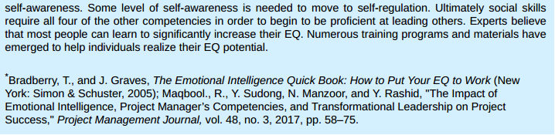
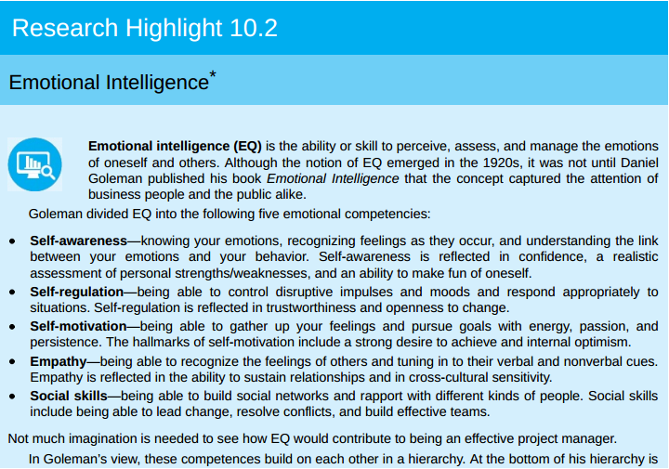
Research Highlight 10.2

How does one acquire these qualities, then? One can improve their ability to think in systems and their overall business viewpoint through workshops, self-study, and classes. Communication and emotional intelligence can be enhanced through training programs.
Techniques for managing time and stress can also be taught to people. However, we are not aware of any workshop or magic elixir that can give someone a sense of purpose when they lack one or turn a pessimist into an optimist. These characteristics strike at a person's core essence. Without an innate tendency to exhibit these, it is difficult to cultivate optimism, honesty, and even proactivity.

Chapter Two
Literature Review

Introduction:

In today's fast-paced and constantly evolving business world, interpersonal skills are crucial for project success, as demonstrated by earlier studies that emphasized and clarified their importance in project management.
The subjects covered in the list below include the impact of interpersonal skills in project management, the effect of leadership abilities on project success, and a number of driving competencies that break down the ways in which these attributes impact project success.
Recommendation, evidences and conclusions of these studies form a solid foundation leading to a better and enhanced training and development in the field of the Interpersonal skills.
Previous Studies:
1- Impact of Project Manager’s Interpersonal Leadership Skills on Project Success
Mr. Manazar Hussain Awan, Mr. Kashif Ahmed, Wajid Zulqarnain
https://iiste.org/Journals/index.php/JPID/article/view/19288
2- Importance of Soft Skills in Project Management
https://ijsrm.net/index.php/ijsrm/article/view/850/746
3- Do the Project Manager’s Interpersonal Skills Matter? Impacts of the Project Manager’s Emotional Intelligence, Trustworthiness, and Job Satisfaction on Project Success
https://www.mdpi.com/2076-3387/12/4/141
4- How do project managers’ competencies impact project success? A systematic literature review
https://journals.plos.org/plosone/article?id=10.1371/journal.pone.0295417
5- Analysis of The Success of Construction Projects Based on Labor Productivity
Malia Urrahmi1 0F*, Cut Zukhrina Oktaviani1, and Mubarak
https://www.e3s-conferences.org/articles/e3sconf/pdf/2024/06/e3sconf_aisce2023_01002.pdf

Dependent Variables:
Project success defined in the classic criterion from practice as a measure of the immediate performance of a project against its main design parameters—schedule (time), budget (cost), scope, and/or quality.
According to the traditional method, a post-project review evaluates performance by determining whether the project was finished "on time, within budget, and to specification." If all of them fell inside a small tolerance range, the project is considered successful. [10]
Punctuality, or the percentage of tasks you manage to do by the work unit's deadline, is frequently used to describe completing all scope activities on time. A 100% punctuality rate indicates that every assignment you are thinking about has been finished by the work unit's respective deadline.

Indicator |  | Variable
Competitive Cost | Y1 | Project Success (Y)
Quality Sustainability | Y2 | Project Success (Y)
Punctuality | Y3 | Project Success (Y)
Table 1. Dependent Variable

Independent Variables:
Project team performance is not the only factor that determines a project's success. The contributions of senior management, functional managers, clients, vendors, contractors, and others frequently determine whether a project succeeds or fails.
The paradoxical character of their work is something that effective project managers must be able to handle. The performance and success of the project will be impacted or improved by their interpersonal skills.

Indicator |  | Variable
Solving technical problems | X1.1 | Leadership (X1)
Serves as peacemaker when tensions rise | X1.2 | Leadership (X1)
Makes appropriate tradeoffs of time, cost, and scope | X1.3 | Leadership (X1)
build a cooperative network among divergent allies. | X1.4 | Leadership (X1)
Negotiating and working with different stakeholders | X2.1 | Engaging Project Stakeholders (X2)
Broader spectrum of influence | X2.2 | Engaging Project Stakeholders (X2)
Develop methods for managing the dependency | X2.3 | Engaging Project Stakeholders (X2)
Buffer the team from excessive interference from a client | X2.4 | Engaging Project Stakeholders (X2)
Sound communication skills | X2.5 | Engaging Project Stakeholders (X2)
Political savvy | X2.6 | Engaging Project Stakeholders (X2)
Provide services for others in exchange for future services | X3.1 | Influence as Exchange (X3)
Ability to contribute to others’ accomplishing their work. | X3.2 | Influence as Exchange (X3)
ability to respond to subordinates’ requests for additional resources | X3.3 | Influence as Exchange (X3)
Ability to enhance others’ positions within their organization | X3.4 | Influence as Exchange (X3)
Identifying the stakeholders on whom the project depends for success. | X4.1 | Social Network Building (X4)
Diagnosing others’ points of view | X4.2 | Social Network Building (X4)
Initiate contact and begin to build a relationship | X4.3 | Social Network Building (X4)
Working relationships with upper management | X4.4 | Social Network Building (X4)
Character ethic | X5.1 | Building Trust (X5)
Task related, Interpersonal and organizational Competency | X5.2 | Building Trust (X5)
Connecting, exhibiting warmth and concern | X5.3 | Building Trust (X5)
Innovate and maintain stability | X6.1 | Interpersonal Qualities (X6)
See the big picture while getting their hands dirty | X6.2 | Interpersonal Qualities (X6)
Encourage individuals but stress the team | X6.3 | Interpersonal Qualities (X6)
Be hands-off/hands-on | X6.4 | Interpersonal Qualities (X6)
Be flexible but firm | X6.5 | Interpersonal Qualities (X6)
Effective communication skills | X6.6 | Interpersonal Qualities (X6)
Self-awareness | X7.1 | Emotional Intelligence (X7)
Self-regulation | X7.2 | Emotional Intelligence (X7)
Self-motivation | X7.3 | Emotional Intelligence (X7)
Empathy | X7.4 | Emotional Intelligence (X7)
Social skills | X7.5 | Emotional Intelligence (X7)
Encouraging Functional Conflict | X8.1 | Conflict Management (X8)
Managing Dysfunctional Conflict | X8.2
Reading body language to identify unspoken disagreement | X8.3
Table 2. Independent Variables

Leadership (X1)

Engaging Project Stakeholders (X2)
Influence as Exchange (X3)
Social Network Building (X4)
Project Success (Y)
Building Trust (X5)
Interpersonal Qualities (X6)

Emotional Intelligence (X7)
Conflict Management (X8)

Figure -1. Schematic of variable X and variable Y

Summary of Previous Studies:
In their study of - Impact of Project Manager’s Interpersonal Leadership Skills on Project Success -Manazar Hussain, Mr. Kashif Ahmed and Wajid Zulqarnain where they test hypotheses were tested and all were accepted. The study amply highlights the importance of project mangers’ coordination skills and problem finding, analyzing and solving skills, refer to study no. 1 in the previous studies list.
Dr. Anupama Jena, Swasti Suvasweta Satpathy highlighted in his study titled: Importance of Soft Skills in Project Management Website: www.ijsrm.in ISSN (e): 2321-3418, that hard skills and soft skills
cross over each other in all the stages of project management. All the soft skills that a project manager needs are not one time endeavors but threads applied throughout the project. Since soft skills spread widely through personal and interpersonal attributes, it must be recognized from the simple gesture of day-to-day activities to the complex management activities at workplace. So, to fit the right soft skill at the proper place is the need of the hour.
Another study titled: Do the Project Manager ’s Soft Skills Matter? (by Marcela Castro, André Barcaui and Ronnie Figueiredo) concluded that there is a growing trend toward soft skills and reinforce the need to fill the gap between ‘hardcore’ measures of project success and its antecedents. Therefore, the findings contribute to the project management literature in terms of the integration of soft skills as impacting factors on project success.
Project managers’ competencies impact project success was studied by Paola Ochoa Pacheco , David Coello-Montecel, Michelle Tello, Virginia Lasio, Alfredo Armijos, December 7, 2023 and they concluded that firstly, project success is a multidimensional construct that comprises three main dimensions: impact on stakeholders, impact on the organization, and general project management. Secondly, the available data suggested that greater levels of project managers’ competencies are associated with improved project success rate.
Finally, in their study titled: Analysis of The Success of Construction Projects Based on Labor Productivity, Malia Urrahmi1 0F*, Cut Zukhrina Oktaviani1, and Mubarak, concluded that a successful project should have a valuable asset, namely a good workforce that can produce high productivity under the auspices of the project manager. Productivity is the dominant aspect that drives the effective use of resources in the construction industry. [refer to the list of previous studies in the next page]

Research Gap:
According to the previous studies discussed above, they highlight the importance soft/ interpersonal skills and the impact they have to the project success and performance. But their interdependencies, on the other hand, have been largely disregarded.
For this reason, it is important to shade the light at the different interpersonal skills taking into account their enhance factors for possessing them, and the impact of lack of those skills on the project success measuring their influence and interdependencies.
In practice, there are countless cases where the team members, project success affected directly by the project managers personal qualities or lack of exercising the good ones. Therefor, we will be studying those areas in addition to the individual qualities among the targeted population.
The Theoretical Framework:
A theoretical framework consists of concepts and, together with their definitions and reference to relevant scholarly literature, existing theory that is used for a particular study. The theoretical framework demonstrates an understanding of theories and concepts that are relevant to the topic of the research paper and that relate to the broader areas of knowledge being considered. [9]
The theoretical framework strengthens the study in the following ways:
- An explicit statement of theoretical assumptions permits the reader to evaluate them critically
- The theoretical framework connects the researcher to existing knowledge. Guided by a relevant theory, you are given a basis for your hypotheses and choice of research methods
- Articulating the theoretical assumptions of a research study forces you to address questions of why and how. It permits you to intellectually transition from simply describing a phenomenon you have observed to generalizing about various aspects of that phenomenon
- Having a theory helps you identify the limits to those generalizations. A theoretical framework specifies which key variables influence a phenomenon of interest and highlights the need to examine how those key variables might differ and under what circumstances
- The theoretical framework adds context around the theory itself based on how scholars had previously tested the theory in relation their overall research design (i.e., purpose of the study, methods of collecting data or information, methods of analysis, the time frame in which information is collected, study setting, and the methodological strategy used to conduct the research). [9]
The theoretical framework is not just a part of the research, it is the backbone that supports all aspects of the study, from defining the problem to analyzing the results.

