 | Midocean University  Faculty of Computers and Information Technology

AI-Driven Resource Optimization and Document Intelligence
BY

Eng. Amjad Homedan & Eng. Anas Alhabashi
A Thesis Submitted to
Faculty of Computers and Information Technology
Fulfillment of the Requirements for the Master Degree of Computer Science
Under the Supervision of

Prof. Dr. Yasser Abdelhamid
Associate Professor, Faculty of Computers and Information Technology (EELU)

Abstract

List of Publications

Table of Contents

List of Abbreviations xiv
List of Figures xvi
List of Tables xviii

Chapter 1: Introcudion .................................................................................. 1
1.1 Problem Definition ...................................................................................... 2
1.2 Thesis Objectives ........................................................................................ 3
1.3 Thesis Contribution ..................................................................................... 4
1.4 Thesis Organization..................................................................................... 5

Chapter 2: Overview on Educational Data Mining ..................................... 6
2.1 Introduction ................................................................................................. 6
2.2 Educational Data Mining ............................................................................ 6
2.3 Applications of Educational Data Mining .................................................. 7
2.3.1 Prediction ............................................................................................ 8
2.3.2 Clustering ........................................................................................... 9
2.3.3 Relationship Mining ......................................................................... 10
2.3.4 Discovery with Model ...................................................................... 11
2.3.5 Distillation of Data for Human Judgment ........................................ 12
2.4 Goals of Educational Data Mining ............................................................ 12
2.5 Predicting Student Performance ................................................................ 13
2.5.1 Students Previous Grades and Class Performance ........................... 14
2.5.2 Students e-Learning Activity ............................................................ 14
2.5.3 Students Demographics .................................................................... 15
2.5.4 Students Social Information ............................................................. 16
2.5.5 Students Environment ...................................................................... 16
2.5.6 Instructor Attributes.......................................................................... 17
2.5.7 Course Attributes .............................................................................. 18
2.5.8 Course Evaluations ........................................................................... 18
2.5.9 Students Experience Information ..................................................... 18
2.6 Dataset of Educational Data Mining ......................................................... 20
2.6.1 Student Performance Dataset ........................................................... 20
2.6.2 Educational Process Mining (EPM): A Learning Analytics Dataset ....
................................................................................................................... 22
2.6.3 Students' Academic Performance Dataset ........................................ 23
2.6.4 Student Performance: Standardized Testing Results ....................... 24
2.6.5 The Open University Learning Analytics Dataset (OULAD) .......... 25
2.7 Performance Measures in Educational Data Mining ................................ 26
2.7.1 Accuracy ........................................................................................... 26
2.7.2 Kappa Statistic .................................................................................. 26
2.7.3 Receiver Operating Characteristic ................................................... 27
2.7.4 Precision and Recall ......................................................................... 28
2.7.5 Mean Absolute Error ........................................................................ 28
2.7.6 Root Mean Square Error ................................................................... 29
2.8 Summary ................................................................................................... 29
Chapter 3: Related Work ………………………………………………... 31
3.1 Introduction ................................................................................................31
3.2 History ...................................................................................................... 31
3.3 Predicting Student Performance Using Statistical Analysis .................... 33
3.4 Predicting Student Performance Using Machine Learning ..................... 35
3.4.1 Predicting Student Performance Using Artificial Neural Networks 36
3.4.2 Predicting Student Performance Using Decision Trees .................. 38
3.4.3 Predicting Student Performance Using Support Vector Machines . 39
3.4.4 Predicting Student Performance Using Logistic Regression ........... 40
3.4.5 Predicting Student Performance Using Naïve Bayes ....................... 40
3.4.6 Predicting Student Performance Using k-Nearest Neighbor ........... 41
3.5 Predicting Student Performance Using Both Statistical Analysis and
Machine Learning ........................................................................................ 42
3.6 Predicting Student Performance Using Deep Learning ........................... 44
3.7 The-State-of-Art ....................................................................................... 45
3.8 Summary .................................................................................................. 47

Chapter 4: Background on Mahcine Learning .......................................... 48
4.1 Introduction ............................................................................................... 48
4.2 Conventional Programming vs. Machine Learning .................................. 48
4.3 Supervised Learning .................................................................................. 51
4.3.1 Bias-variance tradeoff ...................................................................... 53
4.3.2 Bias and Variance Test ..................................................................... 54
4.3.3 Hypothesis Space.............................................................................. 55
4.4 Unsupervised Learning ............................................................................. 56
4.5 Semi-supervised Learning ......................................................................... 57
4.6 Active Learning ......................................................................................... 59
4.7 Reinforcement Learning ............................................................................ 59
4.7.1 Difference between Reinforcement Learning and Supervised
Learning ..................................................................................................... 60
4.7.2 Relation between Reinforcement Learning and Dynamic
Programming ............................................................................................. 61
4.7.3 Component of Reinforcement Learning ........................................... 61
4.7.4 Deep Reinforcement Learning ......................................................... 62
4.8 Artificial Neural Network ......................................................................... 63
4.8.1 Common Structure of Artificial Neural Network ............................ 65
4.8.2 Backpropagation .............................................................................. 67
4.8.3 Types of Artificial Neural Networks ............................................... 67
4.9 Decision Trees and Random Forests ......................................................... 69
4.10 k-Nearest Neighbor ................................................................................. 71
4.11 Logistic Regression ................................................................................. 72
4.12 Support Vector Machine ......................................................................... 73
4.13 Naïve Bayes ............................................................................................ 74
4.14 Deep Learning ........................................................................................ 75
4.15 Summary ................................................................................................ 76

Chapter 5: Proposed Approach .................................................................. 78
5.1 Introduction ............................................................................................... 78
5.2 Approach Stages ....................................................................................... 78
5.2.1 Data Acquisition ............................................................................. 79
5.2.2 Data Cleaning .................................................................................. 80
5.2.3 Feature Extraction and Selection .................................................... 81
5.2.3.1 Filter Methods ........................................................................ 82
5.2.3.2 Wrapper Methods ................................................................... 83
5.2.3.3 Hybrid Methods ..................................................................... 83
5.2.3.4 Embedded Methods ............................................................... 83
5.2.3.5 The Chosen Feature Selection Methods ................................. 84
5.2.4 Data Encoding and Standariztion ................................................... 84
5.2.5 Training and Evaluation of Machine Learning Based Methods ..... 85
5.3 Summary ................................................................................................... 85

Chapter 6: Experimental Results and Discussion ..................................... 86
6.1 Introduction ............................................................................................... 86
6.2 Dataset Description ................................................................................... 87
6.2.1 Demographic Information .............................................................. 89
6.2.2 Activities Informaion ...................................................................... 89
6.2.3 Modules and Presentaions Information .......................................... 90
6.3 Preparing Combinations of Data ............................................................... 90
6.4 Dealing with Imbalanced Data ................................................................. 91
6.5 Parameters of ML models ......................................................................... 92
6.6 Performance Measures ............................................................................. 94
6.6.1 Confusion Matrix ............................................................................. 94
6.6.2 Accuracy ........................................................................................ 105
6.6.3 Precision ......................................................................................... 107
6.6.4 Recall or Sensitivity (True Positive Rate) ..................................... 107
6.6.5 F₁ Score .......................................................................................... 109
6.6.6 Area Under the Curve and Receiver Opearting Characteristic .... 110
6.7 Most Important Features for Predicting Student Performance ............... 120
6.7.1 Feature Selection Using Embedded Methods ................................ 120
6.7.2 Feature Selcction Using Filter Methods ....................................... 125
6.8 Summary ................................................................................................ 125

Chapter 7: Conclusion and Future Work ................................................. 127
7.1 Important Features .................................................................................. 127
7.2 Most Efficient Models in Educational Data Mining .............................. 129
7.3 Future Work ......................................................................................... 129

References ................................................................................................... 130

List of Abbreviations
- Acc.: Accuracy
- ANN: Artificial Neural Network
- API: Application Programming Interface
- DL: Deep Learning
- DM: Data Mining
- DT: Decision Tree
- KNN: K-Nearest Neighbor
- LR: Logistic Regression
- ML: Machine Learning
- SVM: Support Vector Machine

List of Figures
2.1 Educational Data Mining Process ……………………………………… | 7
2.2 Applications of Educational Data Mining ……………………………… | 8
2.3 Distribution of Papers that used different attributes for PSP problem …. | 19
2.4 Student Performance Data Set …………………………………………... | 21
2.5 Educational Process Mining (EPM): A Learning Analytics Data Set … | 23
3.1 Most Commonly Used ML Algorithms in EDM ……………………… | 35
4.1 Machine Learning Subfields …………………………………………… | 50
4.2 Supervised Learning ……………………………………………………. | 51
4.3 Unsupervised Learning …………………………………………………. | 56
4.4 Reinforcement Learning ………………………………………………... | 59
4.5 Simple ANN ……………………………………………………………. | 66
4.6 The relation between performances of deep learning algorithm compared to other traditional machine learning algorithms and the amount of data … | 76
5.1 The Proposed Approach …………………………….…………………... | 78
6.1 OULAD Database Schema ……………………………………………... | 88
6.2 A Bar Chart Shows Imbalanced Data …………………………………… | 91
6.3 Comparing Precisions …………………………………………………... 107
6.4 Comparing Recalls ……………………………………………………… 108
6.5 Comparing F₁-Scores …………………………………………………… 109
6.6 ROC curve of the ANN model on demographics without using SMOTE 110
6.7 ROC curve of the ANN model on demographics using SMOTE ……… 111
6.8 ROC curve of the ANN model on demographics and scores ………….. 111
6.9 ROC curve of the ANN model on demographics, scores, and VLE …… 112
6.10 ROC curve of the RF model on demographics ……………………….. 112
6.11 ROC curve of the RF model on demographics and scores …………… 113 6.12 ROC curve of the RF model on demographics, scores, and VLE ……… 113 6.13 ROC curve of the k-NN model on demographics ……………………… 114
6.14 ROC curve of the k-NN model on demographics and scores ………… 114
6.15 ROC curve of the k-NN model on demographics, scores, and VLE …… 115
6.16 ROC curve of the LR model on demographics ………………………… 115
6.17 ROC curve of the LR model on demographics and scores …………… 116
6.18 ROC curve of the LR model on demographics, scores, and VLE ……… 116
6.19 ROC curve of the NB model on demographics ………………………… 117
6.20 ROC curve of the NB model on demographics and scores …………… 117
6.21 ROC curve of the NB model on demographics, scores, and VLE ……… 118 6.22 ROC curve of the SVM model on demographics ………………………. 118
6.23 ROC curve of the SVM model on demographics and scores ………… 119
6.24 ROC curve of the SVM model on demographics, scores, and VLE ……. 119
6.25 Comparing AUCs ……………………………………………………. 120 6.26 MDI of Demographics ………………………………………………… 121
6.27 MAD of Demographics ……………………………………………….. 121
6.28 MDI of Demographics and Scores ……………………………………. 122
6.29 MAD of Demographics and Scores …………………………………… 123
6.30 MDI of Demographics, Scores, and VLE ……………………………… 124
6.31 MAD of Demographics, Scores, and VLE …………………………… 124

List of Tables
2.1 Student Performance Data Set Description ………………………… 21
2.2 Students' Academic Performance Dataset Description ……………… 23
2.3 School_data file fields Description ………………………………… 25

3.1 Summary of researches that used Machine Learning Based models … 43

6.1 Positions of True Positives, False Positives, True Negatives, and False
Negatives in the Confusion Matrix …………………………………… 94

6.2 CM of the ANN Model on Demographics without Using SMOTE … 96
6.3 CM of the ANN Model on Demographics Using SMOTE …………. 96 6.4 CM of the ANN on Demographics and Scores ……………………… 97
6.5 CM of the ANN on Demographics, Scores. And VLE ……………… 97 6.6 CM of the RF on Demographics only ……………………………….. 98
6.7 CM of the RF on Demographics and Scores ………………………… 98
6.8 CM of the RF on Demographics, Scores and VLE ………………….. 99 6.9 CM of the k-NN on Demographics ………………………………….. 99
6.10 CM of the k-NN on Demographics and Scores ……………………… 100
6.11 CM of the k-NN on Demographics, Scores, and VLE ……………… 100
6.12 CM of the LR on Demographics …………………………………….. 101 6.13 CM of the LR on Demographics and Scores ………………………… 101 6.14 CM of the LR on Demographics, Scores, and VLE …………………. 102
6.15 CM of the NB on Demographics ……………………………………. 102
6.16 CM of the NB on Demographics and Scores ………………………... 103
6.17 CM of the NB on Demographics, Scores, and VLE ………………… 103 6.18 CM of the SVM on Demographics ………………………………….. 104
6.19 CM of the SVM on Demographics and Scores ……………………… 104 6.20 CM of the SVM on Demographics Scores, and VLE ……………….. 105
6.21 Comparing Accuracies of Models on Different Data Combinations ... 106
6.22 Important Features Using Filter Methods …………………………… 125

Chapter 1 Introduction
Learning (ML) in EDM for solving the PSP problem were in early 2000s
[Jayaprakash et al. 2014].

1.1 Problem Definition

1.2 Thesis Objectives

1.3 Thesis Contribution

1.4 Thesis Organization

Chapter 2 Overview on Educational Data Mining

2.1 Introduction

2.2 Educational Data Mining

2.3 Applications of Educational Data Mining

2.3.1 Prediction

2.3.2 Clustering

2.3.3 Relationship Mining

2.3.4 Discovery with Model

2.3.5 Distillation of Data for Human Judgment

2.4 Goals of Educational Data Mining

2.5 Predicting Student Performance

2.5.1 Students Previous Grades and Class Performance

2.5.2 Students e-Learning Activity

2.5.3 Students Demographics

2.5.4 Students Social Information

Chapter 3 Related Work

3.1 Introduction

3.2 History
The integration of artificial intelligence (AI) into human resource management (HRM) represents a major evolution in the field, reflecting broader historical shifts in economic organization and technological advancements. Traditionally, HRM relied on manual processes for recruitment, performance management, and employee relations, but the advent of AI has introduced automation and data-driven decision-making, enhanced efficiency and reducing biases in recruitment (Jia et al., 2018; Vivek & Yawalkar, 2019). AI technologies like machine learning and data mining now enable organizations to analyze large amounts of data for strategic planning and performance evaluation, fundamentally transforming HR functions(Jia et al., 2018). This transition not only streamlines HR activities but also requires HR professionals to develop new skills to effectively interact with AI systems (Jia et al., 2018);(Sangeeta, 2019a). Similarly, the history of question answering (QA) in AI, which began with early systems like ELIZA, has evolved from simple rule-based approaches to advanced models leveraging machine learning and neural networks, such as BERT and DistilBERT (Pearce et al., 2023). These advancements, including the integration of external knowledge bases and representation learning, have improved the accuracy of responses and reflect the growing complexity of processing natural language and generating human-like answers(Goel et al., 2022). Both HRM and QA illustrate how AI's historical and technological progress is shaping the future of workforce management and natural language processing.

3.3 Predicting Document Reading and Resource Optimization Using Statistical Analysis
Resource optimization in organizations can be significantly enhanced through various statistical analysis methods, particularly in the context of human resource management. For instance, the use of process mining techniques allows for the analysis of event logs to understand resource behavior and improve allocation strategies, as demonstrated in studies that apply statistical models to optimize resource distribution based on performance metrics and constraints (Yeon et al., 2022). Additionally, the integration of data analytics in business processes supports the identification of patterns in employee performance, which can inform better decision-making regarding resource allocation (Votto et al., 2021). By leveraging accurate data, organizations can align their resources more effectively with operational needs, ultimately driving productivity and efficiency(Sangeeta, 2019a). Thus, statistical analysis serves as a critical tool in the ongoing effort to optimize resources within organizations. In addition, some authors highlighted the relationship between the workload and Performance of the workers.(Yeon et al., 2022). Figure 3.1, and
Statistical analysis plays a crucial role in the development and evaluation of question answering (QA) systems. Various QA methodologies utilize statistical measures such as exact match (EM), F1 score, in context also Author referred to the relationship between process performance and resource allocation.
(Yeon et al., 2022)
mean reciprocal rank (MRR) to assess the accuracy and effectiveness of their responses, particularly in datasets like SQuAD(Nuamah, 2021). Additionally, modern QA systems have evolved from simple rule-based approaches to more sophisticated models that incorporate statistical reasoning and machine learning techniques, allowing for improved performance in retrieving and generating answers (Nuamah, 2021). The integration of statistical methods enhances the interpretability and efficiency of QA systems, enabling them to handle complex queries across diverse modalities, including text and multimedia(Nuamah, 2021). Overall, statistical analysis is integral to refining QA systems and ensuring their reliability in providing accurate information.

Resource optimization in organizations can be significantly enhanced through various statistical analysis methods, particularly in the context of human resource management. For instance, the use of process mining techniques allows for the analysis of event logs to understand resource behavior and improve allocation strategies, as demonstrated in studies that apply statistical models to optimize resource distribution based on performance metrics and constraints (Yeon et al., 2022). Additionally, the integration of data analytics in business processes supports the identification of patterns in employee performance, which can inform better decision-making regarding resource allocation (Votto et al., 2021). By leveraging accurate data, organizations can align their resources more effectively with operational needs, ultimately driving productivity and efficiency(Sangeeta, 2019a). Thus, statistical analysis serves as a critical tool in the ongoing effort to optimize resources within organizations. In addition, some authors highlighted the relationship between the workload and Performance of the workers.(Yeon et al., 2022). Figure 3.1, and
Statistical analysis plays a crucial role in the development and evaluation of question answering (QA) systems. Various QA methodologies utilize statistical measures such as exact match (EM), F1 score, in context also Author referred to the relationship between process performance and resource allocation.
(Yeon et al., 2022)
mean reciprocal rank (MRR) to assess the accuracy and effectiveness of their responses, particularly in datasets like SQuAD(Nuamah, 2021). Additionally, modern QA systems have evolved from simple rule-based approaches to more sophisticated models that incorporate statistical reasoning and machine learning techniques, allowing for improved performance in retrieving and generating answers (Nuamah, 2021). The integration of statistical methods enhances the interpretability and efficiency of QA systems, enabling them to handle complex queries across diverse modalities, including text and multimedia(Nuamah, 2021). Overall, statistical analysis is integral to refining QA systems and ensuring their reliability in providing accurate information.

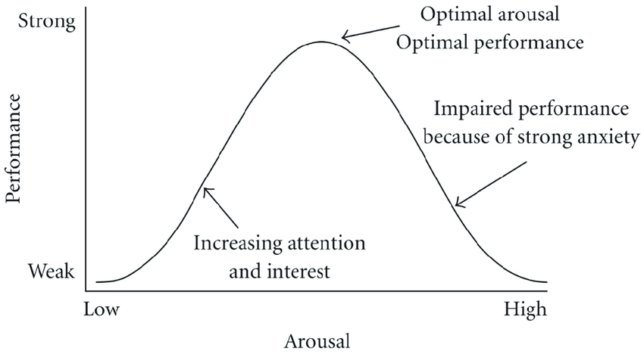
Figure 3.1 Hebbian version of the Yerkes-Dodson law

3.4 Predicting Document Reading and Resource Optimization Using TensorFlow and Kubernetes
This study presents significant contributions, including an artificial intelligence-based resource scheduling method that utilizes TensorFlow and CooperNet, tested and validated through experiments on an open controller. By establishing a resource scheduling model and optimization algorithm, the study achieves intelligent resource allocation and scheduling, evidenced by experimental results showing an improved scheduling efficiency of 10.2% and a response time reduced to 202 milliseconds—a marked improvement over traditional methods. As AI technology continues to evolve, more applications increasingly rely on AI-powered systems. For instance, in OpenEuler, TensorFlow configuration requires several key parameters, including model selection, input data from OpenStackDataFrame (which may be segmented for large datasets), and additional parameters to optimize training and testing, such as training set sizes and activation functions. Additionally, a TensorFlow model repository is maintained for efficient model management and monitoring, deployed through Kubernetes. Resource scheduling on Kubernetes is managed by implementing YARN (Yet Another Resource Negotiator) standards, where a YARN node is established with yarn.fit_layer_selection_data selected as the resource scheduler. This scheduler does not run as a traditional Kubernetes container; instead, it handles resource scheduling through Kubernetes functions. The article also delves into resource scheduler optimization formulas, primarily focusing on hardware resource management, which may also find applications in HRD systems. With OpenEuler built on OpenStack, this approach ensures seamless accessibility to required computing resources, facilitating reliable resource allocation for applications running on this platform.(Li & Zhang, 2024).

In the first experiment, as below Figure 3.2, the resource utilization rate of the rule-based resource scheduling method was 33.2%, peaking at 35.9% in the fifth experiment and recording 34.1% in the tenth experiment, with the lowest value of 30.1% observed in the third experiment. For the heuristic-based resource scheduling method, the utilization rate started at 28.2% in the first experiment, dropped to a minimum of 20.4% in the fifth, and reached 28.5% in the tenth, with the highest rate of 29.9% occurring in the eighth experiment. The resource scheduling method introduced in this study showed a utilization rate of 17.4% in the first experiment, increased to 19.4% in the fifth, reached a minimum of 10.2% in the tenth, and a maximum of 19.7% in the fourth experiment. These results indicate that the proposed resource scheduling method achieves a lower resource utilization rate, effectively minimizing system burden while maintaining smooth task execution.(Li & Zhang, 2024).
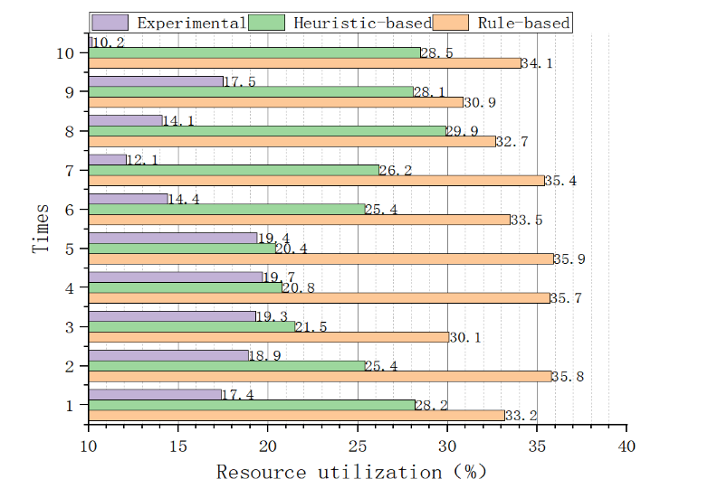
Figure 3.2 Resource Utilization Rate

3.5 Predicting Document Reading and Resource Optimization Using Machine Learning
Resource optimization in organizations can be significantly enhanced through the application of machine learning techniques, particularly in the context of human resource allocation. Various studies highlight the use of process mining and reinforcement learning to analyze operational data and improve decision-making regarding resource distribution. For instance, one approach involves mining event logs to uncover patterns that inform resource allocation strategies, thereby optimizing workflow efficiency and reducing execution time under specific constraints (Yeon et al., 2022). Additionally, the integration of human-centric networks allows for a more nuanced understanding of employee roles and their centrality within processes, which can further refine resource allocation decisions (Yeon et al., 2022). By leveraging these advanced methodologies, organizations can streamline their human resource management processes and enhance overall operational effectiveness (Votto et al., 2021; Yeon et al., 2022) .

Machine learning plays a crucial role in enhancing question and answering (QA) systems by enabling them to process natural language queries and extract relevant information effectively. For instance, a hybrid classification system, as described in one study, utilizes both machine learning and semantic rules to interpret user questions and generate structured queries for knowledge bases, thereby improving response accuracy (Goel et al., 2022). Additionally, the integration of deep learning techniques is emphasized for their ability to automate reasoning processes in QA, although they are often complemented by symbolic methods to achieve better interpretability and robustness(Nuamah, 2021). Furthermore, AI systems can automate repetitive tasks in QA, such as candidate screening in recruitment, showcasing the practical applications of machine learning in real-world scenarios(Sangeeta, 2019b). Overall, the combination of machine learning with traditional methods enhances the efficiency and effectiveness of QA systems across various domains.

3.6 Predicting Document Reading and Resource Optimization Using Deep Learning:
The integration of deep learning techniques into resource optimization is highlighted through various approaches, particularly in human resource management. One method involves using reinforcement learning to develop policies that optimize resource allocation during business process execution, as discussed in the context of human-centric networks. This approach emphasizes the importance of analyzing operational event logs to understand the relationships and centrality metrics of employees, which can inform more effective resource distribution. Additionally, the evolution of information technology and business process management systems supports the implementation of these deep learning strategies, enhancing overall organizational efficiency. Thus, leveraging deep learning in resource optimization can lead to improved decision-making and operational effectiveness in organizations.(Yeon et al., 2022).
Deep learning has significantly advanced question answering (QA) systems, leveraging models like BERT and GPT-3, which utilize powerful computing resources to enhance natural language processing capabilities(Research et al., n.d.). These models can be categorized into extractive and generative approaches, as seen with DistilBERT and T5, where the former retrieves answers directly from the context while the latter generates responses based on the input(Pearce et al., 2023b) . Additionally, hybrid systems that combine deep learning with traditional methods, such as symbolic reasoning, are proposed to improve interpretability and robustness in QA tasks(Nuamah, 2021). The integration of deep learning techniques allows for more effective handling of complex queries, making QA systems more efficient and user-friendly (#1 et al., n.d.; Goel et al., 2022).

3.8 Summary
In this chapter an AI application framework for human resource management (HRM), combining AI technology with six key HRM dimensions. By leveraging AI, the framework enhances the efficiency of HR management practices. The study analyzes case studies on recruitment and training, providing practical insights. Its ultimate goal is to guide enterprises in integrating AI into their HR processes effectively. (Jia et al., 2018). The role of artificial intelligence in human resource management, emphasizing the importance of effective workforce management. It highlights how new technologies aim to simplify HR tasks and improve efficiency. AI has the potential to enhance HR functions and support decision-making processes. Additionally, the paper addresses the challenges associated with implementing AI in HR practices. (Sangeeta, 2019a).
The paper explores the impact of AI on human resource management (HRM), focusing on how AI-assisted decision-making is transforming HR functions. It highlights the shift of HR departments into strategic decision-making centers within organizations. Additionally, the paper addresses the financial and legal implications of AI adoption, emphasizing the need for reskilling HR staff to effectively navigate these changes. (Sakka & El Hadi El Maknouzi, n.d.).
In this chapter, we have explores algorithmic reasoning in question answering (QA) and advocates for a hybrid AI approach that combines symbolic and sub-symbolic methods. It argues that neural networks alone are insufficient for effective algorithmic reasoning. The proposed method, known as Deep Algorithmic Question Answering (DAQA), focuses on enhancing interpretability, generalizability, and robustness in AI systems. (Nuamah, 2021). developing an intelligent learning system designed for processing text input and extracting knowledge to answer user questions. This system aims to advance research in the field of Question Answering (QA) and has practical applications in areas such as online assessments and lectures.(#1 et al., n.d.).
In deep learning in question-answering systems, with a particular focus on applications in hepatocellular carcinoma research. It discusses how advances in natural language processing (NLP) are enhancing human-computer language interaction. The study also analyzes practical AI-driven question-answering systems and highlights future prospects for NLP based on large-scale models.(Research et al., n.d.).

Chapter 4 A Background on Machine Learning

4.2 Conventional Programming vs. Machine Learning
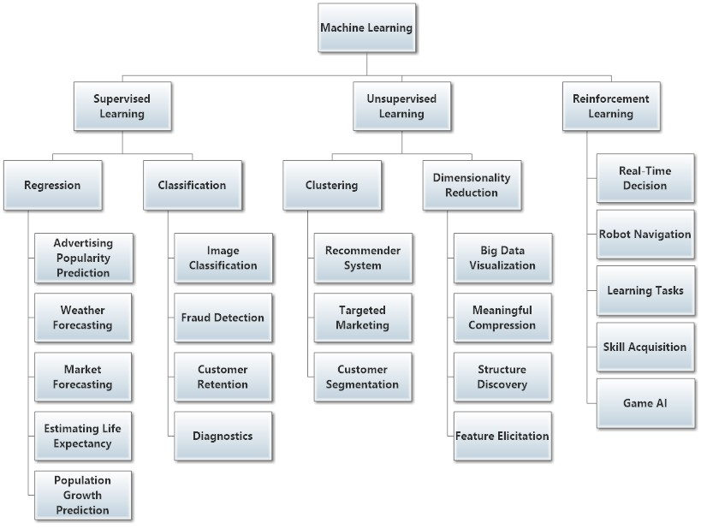
Figure 4.1 Machine Learning Subfields

4.3 Supervised Learning

Figure 4.2 Supervised Learning
statistical significance to be used with such sparse data [Konstantinos and Sergios 2008]. Supervised learning depends on conditional probability distribution. Assume that X and Y are two random variables that are jointly distributed, the conditional probability distribution of Y given X means the probability distribution of Y when value of X is known.
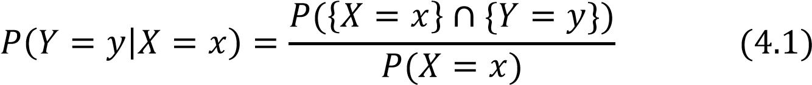
This function is for discrete random variables, the probability of occurrence of X must be positive (non-zero).
Classification algorithms and regression algorithms are among types of supervised learning. Classification algorithms are used when the output values are discrete (specified categories) or has limited set of values. If there are only two output classes, it is called binary classification problem, For example, classifying tumors to be benign or malignant, or classifying transactions to fraud or not.
In the case of presence of more than two classes for the algorithm to select from, it is called multi-classification problem. For instance, classifying various objects in pictures into different groups, classifying animals into different species, or classifying articles based on their topics. On the other hand, regression algorithms are used when the output values are continuous or in other words, they have any value in a certain range of values. For example, predicting the salaries, or estimating the prices of certain goods or services.
There are many supervised learning algorithms. For example, linear regression, logistic regression, neural networks (multilayer perceptron), DTs, naïve Bayes, linear discriminant analysis, and k-nearest neighbor. There are some qualities in certain algorithms that are not found in others. For example, neural networks can handle numerical data only while DTs work on categorical data with no need for encoding them. If categorical data has to be fed into neural networks, they should be encoded first and changed into numerical values. So, in ML or statistical learning, there is no one algorithm that can perform very well in all problems [Wolpert 1996].

4.3.1 Bias-variance tradeoff
Any model is built based on a finite and limited number of training examples no matter how big this amount of data, the future cases are always uncertain, so the model should rely on probabilistic measures and should generalize its experience after being trained on the available training set, so it can perform well on test data. The hypothesis formed by the model should not be much simpler than the function that represents the data, or the model is said to be underfitted or highly biased as it does not consider relevant features in the training set. Also, the hypothesis formed by the model should not be too complex, or the model is said to be overfitted or prone to the noise in the training set. Prediction error is the addition of bias to variance. [James 2003]. Model generalization should be balanced in order to decrease the generalization error which is the sum of bias, variance and a value called irreducible error that comes from the noise in the data. The objective is to generalize the model and to minimize both bias and variance. In other words, the model should have low bias and low variance, so it performs well on the training data and on the test data. The bias-variance decomposition is a method to measure generalization error [Sammut et al. 2011].

4.3.2 Bias and Variance Test

4.3.3 Hypothesis Space

4.4 Unsupervised Learning

4.5 Semi-supervised Learning
time which sometimes lasts for up to few days or even a week [Shi et al. 2016].

4.15 Summary
In this chapter, we have presented a brief background about machine learning and its types, namely: supervised, unsupervised, semi-supervised, active learning, and reinforcement learning. We have explained the main differences between reinforcement learning and both supervised and dynamic programming. The remaining sections of this chapter have introduced different machine learning models that were used in this research. These ML model were ANN, DT or RF, kNN, LR, SVM, and NB. The common structure, Backpropagation method, and types of ANN have been explained. The final section introduced DL and its characteristics.

Chapter 5 Proposed Approach

5.1 Introduction

5.2.1 Data Acquisition

5.2.2 Data Cleaning

5.2.3.1 Filter Methods

Chapter 6

Experimental Results and Discussion

6.4 Dealing with Imbalanced Data
The following bar plot shows that the “Pass” class is more than 4 times greater than the “Fail” class and more than 10 times greater than the “Distinction” class!
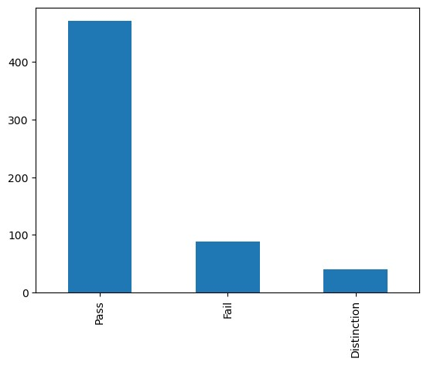
Table 6.21 Comparing Accuracies of Models on Different Data Combinations
Model | Demo. | Demo. & Scores | Demo., Scores, % VLE
RF | 79.86% | 90.78% | 94.68%
ANN | 78.80% | 85.82% | 90.43%
SVM | 74.56% | 87.94% | 86.52%
k-NN | 75.62% | 82.62% | 84.04%
LR | 66.78% | 89.01% | 87.94%
NB | 44.88% | 78.37% | 78.01%

6.6.3 Precision
Precision, also called positive predictive value, is a measure of accuracy of prediction of a specific class. For instance, it measures how much the model is accurate in predicting the “Distinction” class correctly. Precision can be calculated using equation (6.2):
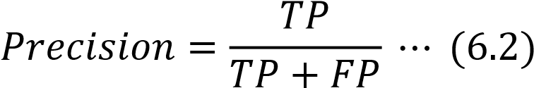
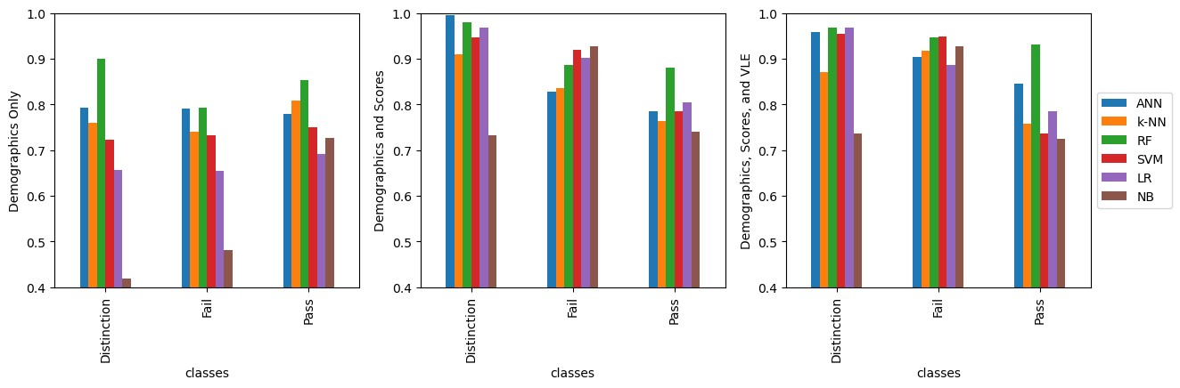
Figure 6.3 Comparing Precisions
Precision of all models on demographics in the left, on demographics and scores in the middle, and on demographics, scores, and VLE on the right. In most cases, RF and ANN has the highest precision than other ML models.

6.6.4 Recall or Sensitivity (True Positive Rate)
Recall, also called sensitivity or true positive rate, is the ratio of true positive predictions to the total number of actual members of that class. Its value ranges from zero to one. It determines ability of the model to detect relevant cases of certain class in a dataset. For example, the model is able to detect “Fail” class from all actual
“Fail” instances, including those who are classified as not “Fail,” but actually, they belong to that class. Recall can be calculated using equation (6.3):
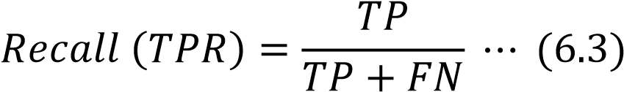
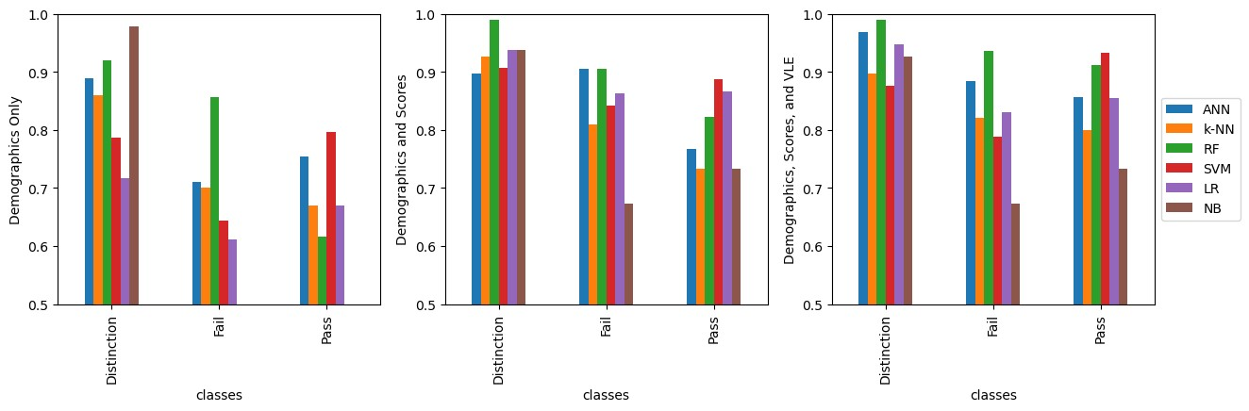
Figure 6.4 Comparing Recalls
Recall of all models on demographics in the left, on demographics and scores in the middle, and on demographics, scores, and VLE on the right. In most cases, RF and ANN has the highest recall than other ML models especially after introducing scores and VLE data.

6.6.5 F1 Score
The general formula to measure F score for positive real 𝛽 is called F-beta score which can be calculated from formula (6.4), and it is the harmonic mean of precision and recall:
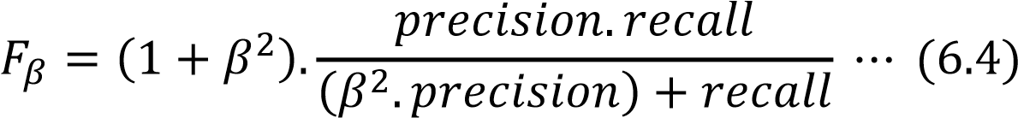
The default value of 𝛽 is 1.0, so in this case it is called 𝐹₁ score. 𝐹₁ reaches its best value at 1, which means perfect, and its worst value is 0.
The equation of 𝐹₁ score can be written as in formula (6.5):
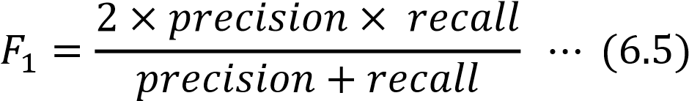
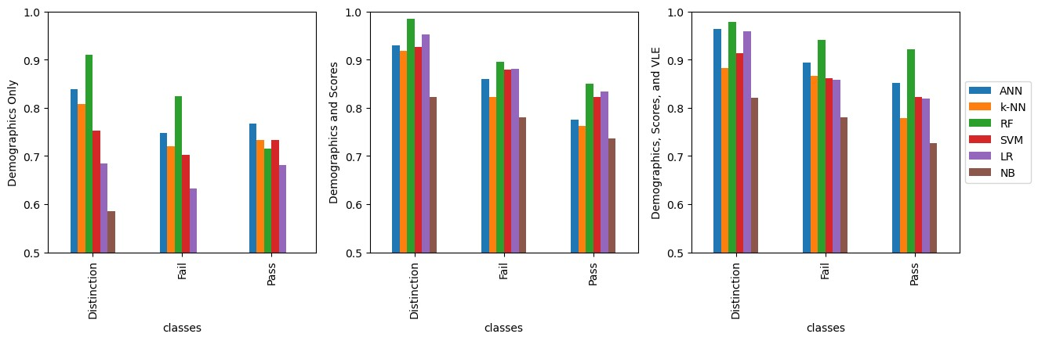
Figure 6.5 Comparing F₁-Scores
F₁-Score of all models on demographics in the left, on demographics and scores in the middle, and on demographics, scores, and VLE on the right. In most cases, RF and ANN has the highest F₁-Score than other ML models.

6.6.6 Area under the Curve and Receiver Operating Characteristic
Both true positive rate and false positive rates are used for plotting the Receiver Operating Characteristic (ROC). It is a metric used for evaluating the quality of a classifier. It is usually used with binary classifiers, but its functionality can be extended to include multiclass classifiers. From the receiver operating characteristics, area under the curve (AUC) can be calculated. The following figures show the receiver operating characteristic for each class using the ML models that were used during this research.
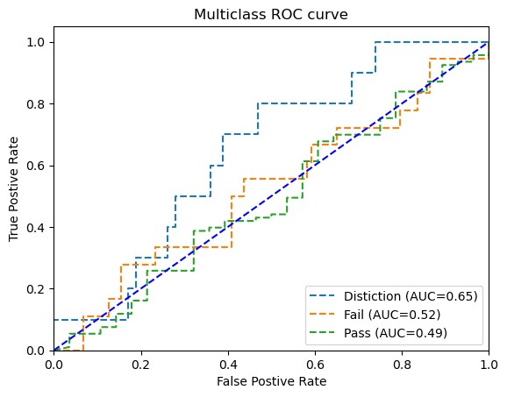
Figure 6.6 ROC curve of the ANN model on demographics without using SMOTE
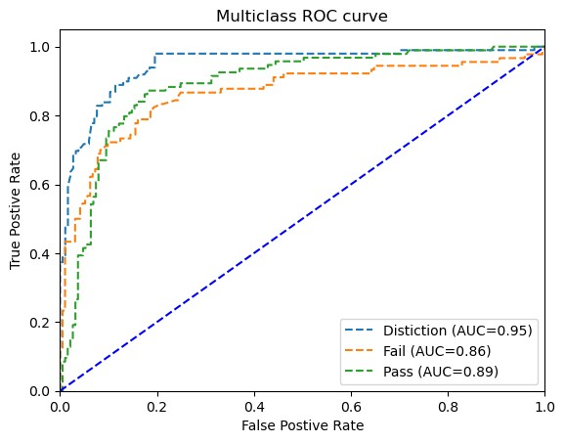
Figure 6.7 ROC curve of the ANN model on demographics using SMOTE
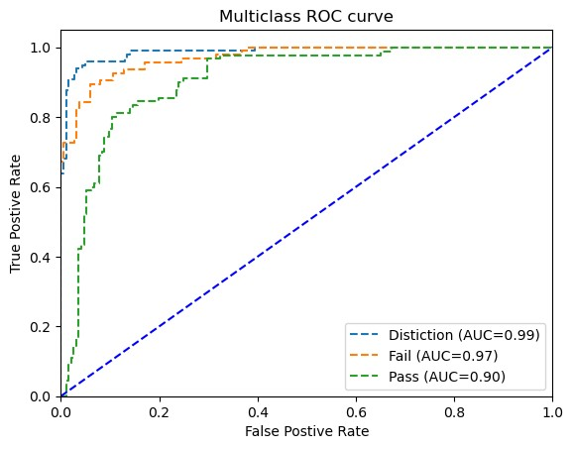

Figure 6.8 ROC curve of the ANN model on demographics and scores
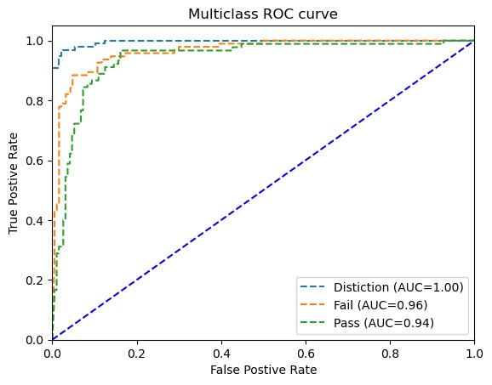

Figure 6.9 ROC curve of the ANN model on demographics, scores, and VLE
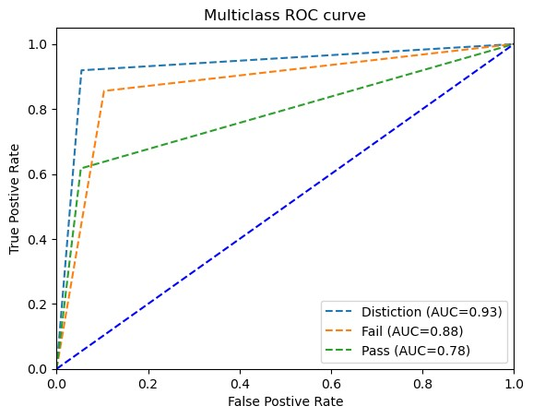
Figure 6.10 ROC curve of the RF model on demographics
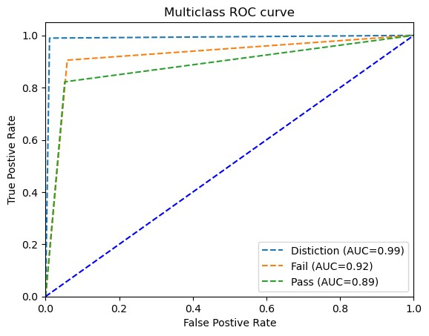
Figure 6.11 ROC curve of the RF model on demographics and scores
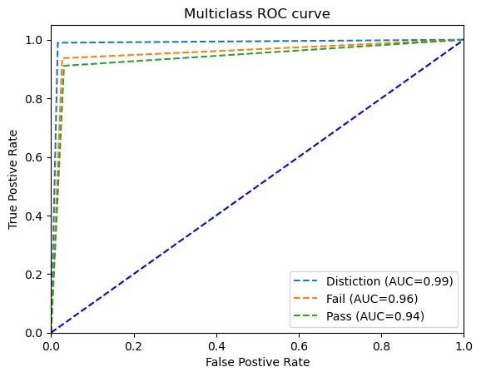
Figure 6.12 ROC curve of the RF model on demographics, scores, and VLE
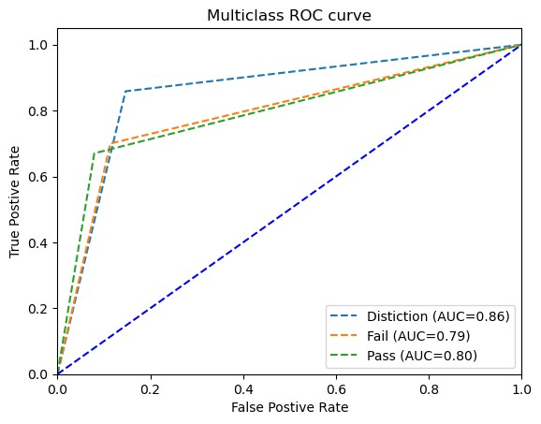
Figure 6.13 ROC curve of the k-NN model on demographics
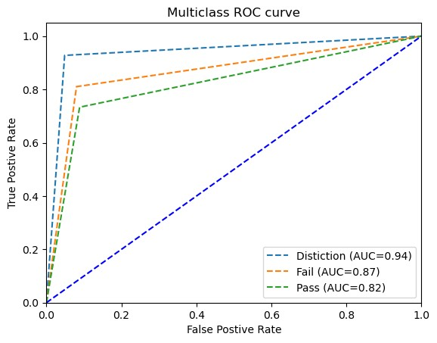
Figure 6.14 ROC curve of the k-NN model on demographics and scores
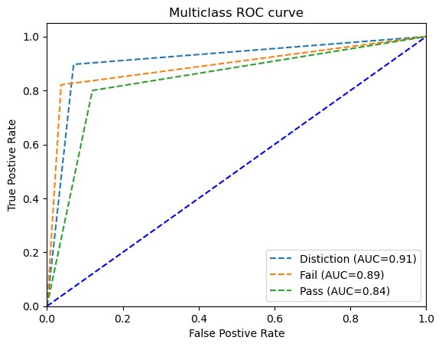
Figure 6.15 ROC curve of the k-NN model on demographics, scores, and VLE
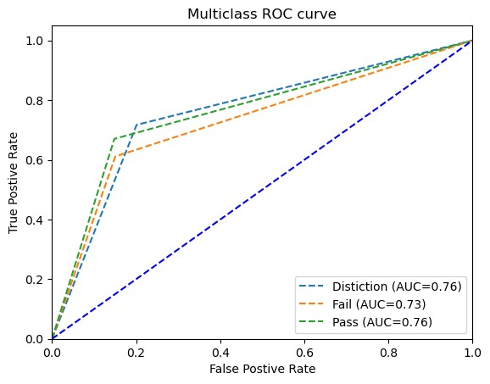
Figure 6.16 ROC curve of the LR model on demographics
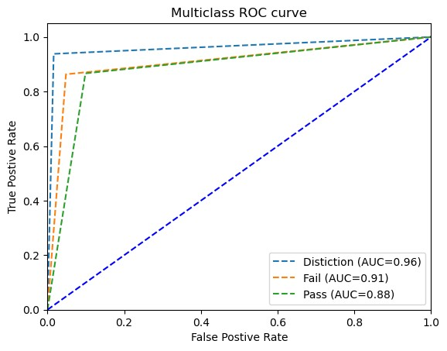
Figure 6.17 ROC curve of the LR model on demographics and scores
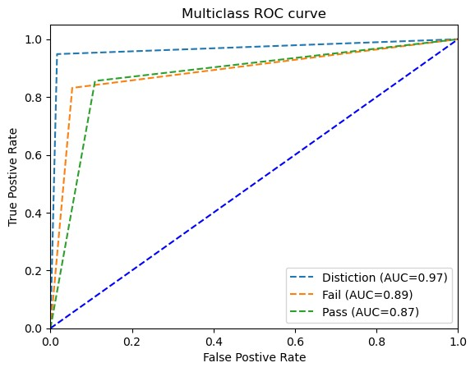
Figure 6.18 ROC curve of the LR model on demographics, scores, and VLE
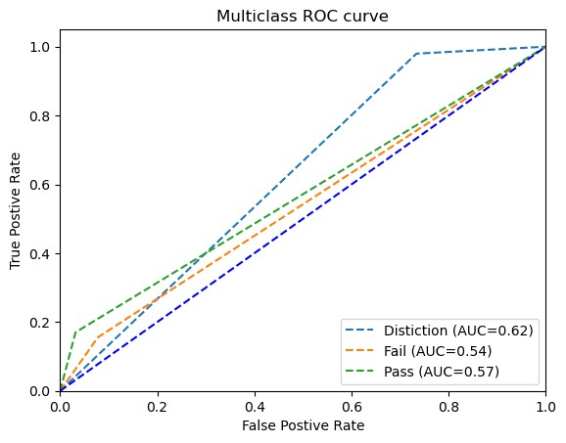
Figure 6.19 ROC curve of the NB model on demographics
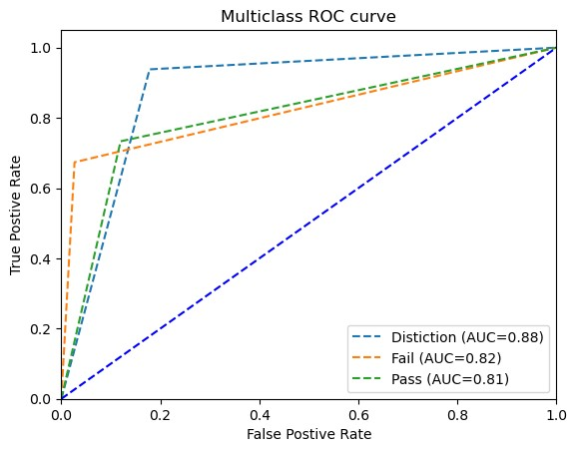
Figure 6.20 ROC curve of the NB model on demographics and scores
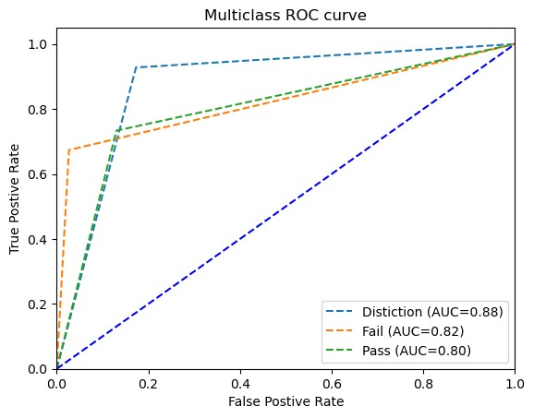
Figure 6.21 ROC curve of the NB model on demographics, scores, and VLE
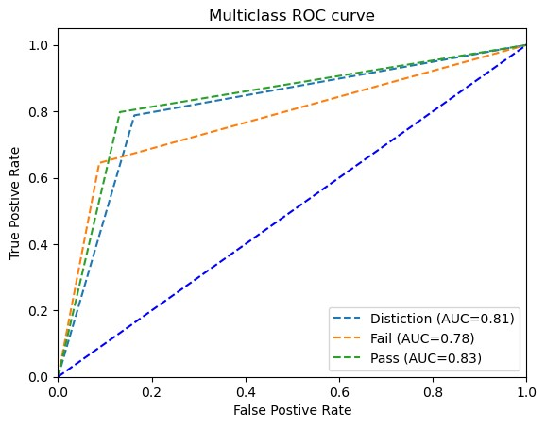
Figure 6.22 ROC curve of the SVM model on demographics
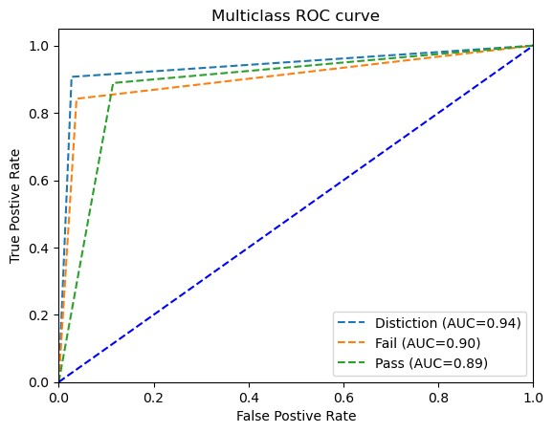
Figure 6.23 ROC curve of the SVM model on demographics and scores
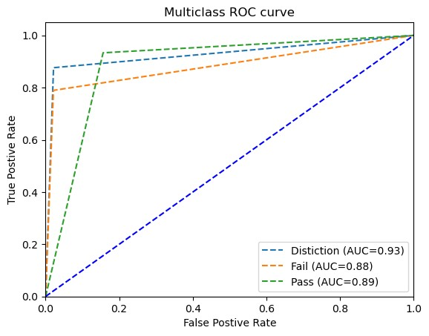
Figure 6.24 ROC curve of the SVM model on demographics, scores, and VLE AUCs of all models on demographics in the left, on demographics and scores in the middle, and on demographics, scores, and VLE on the right. In most cases, RF and ANN has the highest AUCs than other ML models.
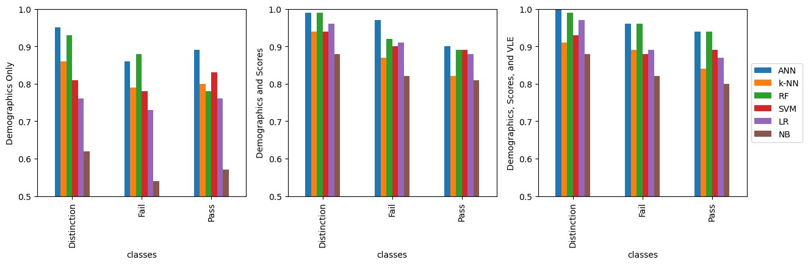
Figure 6.25 Comparing AUCs

6.7 Most Important Features for Predicting Student Performance

6.7.1 Feature Selection Using Embedded Methods
Some models have embedded features importance functionality. RF is one of these ML models. There are two ways to assess the importance of a feature in RF. The first one is called Mean Decrease in Impurity (MDI) and the second one is called Mean Accuracy Decrease (MAD). Sometimes the first one favors numerical values, so it is better to use both methods to confirm the results.
The following figures shows bar chart of features importance using the two aforementioned methods.

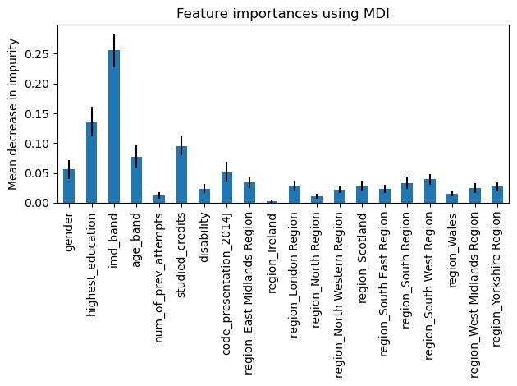
Figure 6.26 MDI of demographics
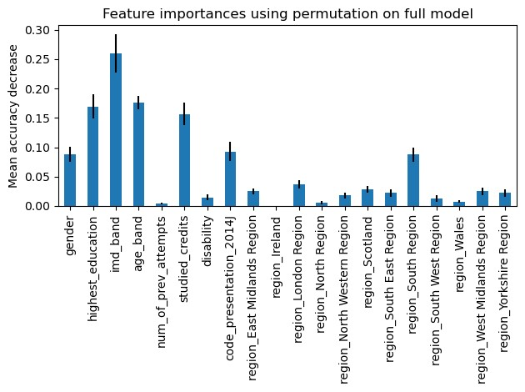
Figure 6.27 MAD of demographics
It is clear from the above bar charts that IMD band has the highest importance in the two methods, followed by level of highest education, age band, and studied credits.
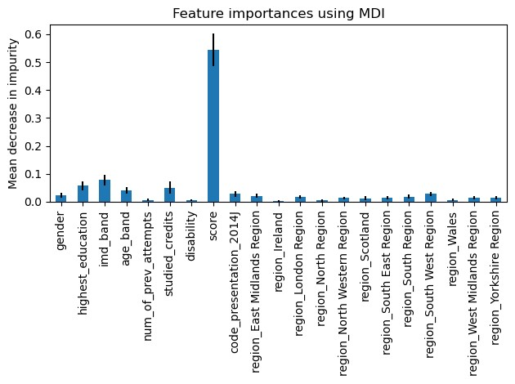
Figure 6.28 MDI of Demographics and Scores
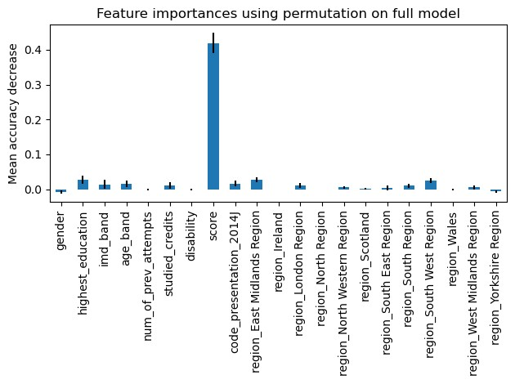
Figure 6.29 MAD of Demographics and Scores
When scores were introduced to the model, it undisputedly got the highest importance as shown the above bar charts. This gives an insight how much the assessments scores feature is important in predicting student academic performance. Actually, it is consistent with logical thinking because scores directly determine whether a student will pass, fail, or show a distinct performance.
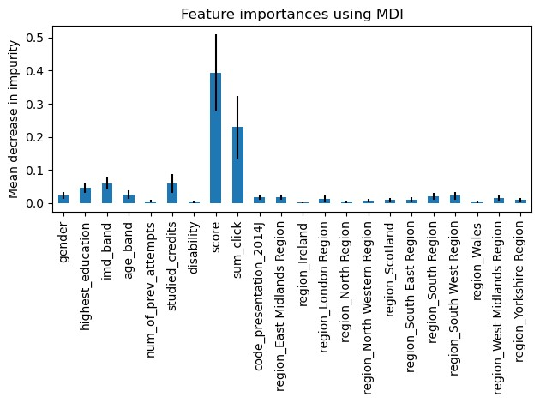
Figure 6.30 MDI of Demographics, Scores, and VLE
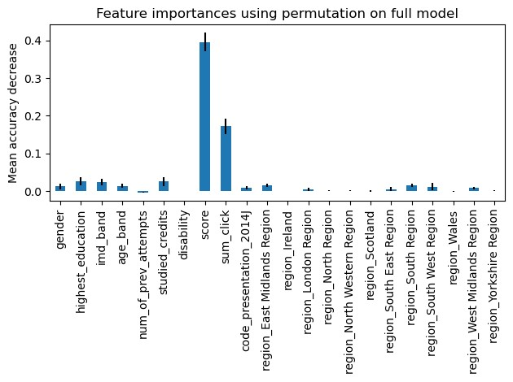
Figure 6.31 MAD of Demographics, Scores, and VLE
When VLE data which contain the sum of clicks done the student during the course is introduced, it competed with scores feature.

6.7.2 Feature Selection Using Filter Methods
The table below shows the most important features selected by filter methods such as ReliefF, Chi-Square, and ANOVA.
Table 6.22 Important Features Using Filter Methods
Data | Chi-Square | ANOVA | ReliefF
Demographics | age_band, studied_credits, and disability | age_band, studied_credits, and disability | age_band,  studied_credits, imd_band
Demographics and average assessment scores | studied_credits, disability, and score. | imd_band, age_band, and score | imd_band, studied_credits, and score
demographics, average scores, and VLE | disability, score, and sum_click | age_band, score, and sum_click | imd_band, score, and sum_click

6.8 Summary
This chapter has introduced the experimental results and evaluation metrics that were used in this research. The Accuracies of six models have been evaluated on three different combinations of data to realize the overall quality of each model. RF and ANN have shown their superiority above all other four ML models. Because the classes of the predicted vector is not equally distributed among the three classes, accuracy cannot be the only reliant evaluation metric, so we used SMOTE to deal with imbalanced data and used other evaluation metrics such precision, recall, F₁score, ROC and AUC have been used to insure the validity of the model. All evaluation metrics support our conclusion.

Chapter 7 Conclusion and Future Work
In most of the previous researches, performance of ML models on educational data was questionable and most results were near average and do not reach the state-ofthe-art performance. In this study, ANN, logistic regression, k-nearest neighbor, Naïve Bayes, support vector machine, and random forest ML models were used for predicting academic performance of students of the Open University in the United Kingdom.
The highest accuracies reached when the models were used on demographics, assessment scores, and VLE data. RF accuracy was 94.68%, ANN accuracy of prediction reached 90.43%, accuracy of the logistic regression model was 87.94%, accuracy of support vector machine was 86.52%, k-nearest neighbor was 84.04%, and accuracy of the accuracy of Naïve Bayes was 78.01%. The RF and ANN models outperformed all other models’ accuracies and also other evaluation metrics such as precision, recall, and F₁ score.

7.1 Important Features
Machine Learning models can reach the-state-of-the-art performance in predicting student academic performance using their demographic, assessment data, and their online learning environment activity, but using demographic data only will give – in most cases – a near average performance.
The following conditions must be met to get the-state-of-the-art prediction accuracy using ML-based models on educational data:
- The input features must be relevant to student academic performance such as assessments scores, their activity on the VLE, highest level of education, their age, and deprivation level of regions where they live.
- Relatively large dataset with a large number of observations must be used to allow the model to “learn” from various training examples, and hence improving its performance on test set.
- Data should be balanced to avoid because imbalanced data cause the model to favor the most represented class in the dataset Important features using different data combinations:
  - Demographics only: o Age band o Studied credits o Disability o IMD band
  - Demographics and assessments scores: the previous features plus the scores
  - Demographics, assessments scores, and VLE: the previous features plus the sum of clicks

7.2 Most Efficient Model in Educational Data Mining
The results show that RF and ANN can perform very well on educational data as they do on data that come from other field because they can scale with complex datasets. It is important though to give relevant features such as scores and VLE activity. This study support other studies that suggest using RF and ANN on educational data to predict student academic performance.

7.3 Future Work
Further investigations can be made to predict student performance using their VLE data using same ML or DL models. Conducting more researches that study other factors affecting student performance such as course attributes and instructors attributes. Also, statistical analysis can be made to find correlations between factors such age, gender, presence of disability, living in deprived areas, and so forth, and their influences on the performance of students. Moreover, recurrent neural networks
(RNNs) can be used for detecting students who are about to withdraw or dropout. Finally, building a dataset that contain more features that are related to VLE and assessments to investigate their role in predicting student performance.

References
- The Role of AI in Human Resource Management Practices.(Rastogi & Pandya, 2023b)
- Influence of Artificial Intelligence in Human Resource Management: A Comprehensive Review(Nikita Saklani & Ashli Khurana, 2023).
- Artificial Intelligence in Tactical Human Resource Management: A Systematic Literature Review.(Votto et al., 2021a).
- Deep Algorithmic Question Answering: Towards a Compositionally Hybrid AI for Algorithmic Reasoning. (Nuamah, 2021a)
- Explanation as Question Answering based on a Task Model of the Agent’s Design. (Goel et al., 2022a)
- SPIE Proceedings Publications Deep Learning Approaches for Improving Question Answering Systems in.(Research et al., n.d.-a)
- Implementing AI-Driven Resource Scheduling on OpenEuler using TensorFlow and Kubernetes(Li & Zhang, 2024)
- AI and Business Planning: Revolutionizing Forecasting and Resource Allocation (Subrahmanyam et al., 2024a)
- AI and Business Planning: Revolutionizing Forecasting and Resource Allocation(Subrahmanyam et al., 2024b).
- Intelligent Question Answering System Based on Knowledge Graph(Feng et al., n.d.).
- Build-a-Bot: Teaching Conversational AI Using a Transformer-Based Intent Recognition and Question Answering Architecture(Pearce et al., 2023).
- Explanation as Question Answering based on a Task Model of the Agent's Design(Goel et al., 2022b).
- Review of artificial intelligence-based question-answering systems in healthcare(Budler et al., 2023).
- SPIE Proceedings Publications Deep Learning Approaches for Improving Question Answering Systems in(Research et al., n.d.-b).
- Question Answering System Based on Artificial Intelligence for Restricted Domain(#1 et al., n.d.).
- Association for Information Systems AIS Electronic Library (AISeL) A Conceptual Artificial Intelligence Application Framework in Human Resource Management Recommended Citation "A Conceptual Artificial Intelligence Application Framework in Human Resource Management"(Jia et al., 2018).
- Experimental Verification on Human-Centric Network-Based Resource Allocation Approaches for Process-Aware Information Systems.
(Yeon et al., 2022).

- Increased Productivity and Reduced Waste with Robotic Process Automation and Generative AI-powered IoE Services(Lo et al., 2024).
- A Study of Artificial Intelligence and its role in Human Resource Management(Vivek & Yawalkar, 2019).
- Human Resource Management and Artificial Intelligence(Sangeeta, 2019).

