

A Comparative Study of Fake News Detection Using Machine Learning, Deep Learning, and Large Language Models

Prepared By


Name: Rayan Shukri ID No.: 251000636
Name: Sultan Hassan ID No.: 251002896

Submitted in fulfillment of the requirements for the degree Master of Science in Artificial
Intelligence
At
College of Informatics
Midocean University
UAE

Supervisor Name: Wesam Ahmed
College of Informatics, Midocean University, Comoros
Email: wesamahmed@midocean.edu.km

Contents
A Comparative Study of Fake News Detection Using Machine Learning, Deep Learning, and Large Language Models - 1 -
Chapter 1: Introduction - 3 -
1.1 Background - 3 -
1.2 The Rise of Fake News in the Digital Age - 4 -
1.3 Problem Statement - 4 -
1.4 Research Objectives - 5 -
1.5 Organization of the Thesis - 6 -
Chapter 2: Overview - 7 -
2.1 Introduction - 7 -
2.2 Nature and Impact of Fake News - 8 -
2.3 Characteristics of Fake News Datasets - 9 -
2.4 Machine Learning for Fake News Detection - 10 -
2.5 Deep Learning in Fake News Detection - 13 -
Recurrent Neural Networks (RNN) - 14 -
Long Short-Term Memory Networks (LSTM) - 14 -
Convolutional Neural Networks (CNN) - 15 -
Hybrid Deep Learning Architectures - 16 -
Strengths and Challenges of DL in Fake News Detection - 16 -
2.6 Role of Large Language Models in Fake News Detection - 17 -
2.7 Comparative Summary of the Three Approaches - 18 -
2.8 Chapter Summary - 20 -
Chapter 3: Related Work - 21 -
3.1 Machine Learning-Based Approaches - 21 -
3.1.1 Summary Table of Machine Learning-Based Studies - 22 -
3.2 Deep Learning-Based Approaches - 23 -
3.2.1 Summary Table of Deep Learning-Based Studies - 24 -
3.3 Transformer-Based Approaches (LLMs) - 25 -
3.3.1 Summary Table of Transformer-Based Approaches (LLMs) - 26 -
3.4 Chapter Summary - 26 -
References - 27 -

Chapter 1: Introduction

1.1 Background
The digital revolution has changed how people access and share information. Traditional news organizations, which once controlled what information the public received, have been replaced by digital platforms that allow anyone to post content instantly. While this change has made it easier for people to get information, it has also created an environment where false information—often referred to as fake news—can spread quickly and widely.
Fake news is defined as false or misleading information that is presented as real news. It is often created to influence opinions, attract attention, or serve political or financial interests. What makes fake news especially dangerous is that it is designed to look credible, making it difficult for people to recognize that it is false.
Social media platforms like Facebook, Twitter, and YouTube play a major role in spreading fake news. These platforms use algorithms that promote content that gets more reactions, even if it is not accurate. This has led to the rapid spread of emotionally charged or sensational content, including fake news [1]. Researchers have found that this content can influence elections, create confusion, and weaken trust in institutions [2].
The effects of fake news became especially visible during the COVID-19 pandemic. False health information, conspiracy theories, and unproven treatments were widely shared online. These posts caused real harm, such as vaccine refusal and resistance to public health advice [3]. Because of this, many researchers and organizations have focused on developing tools to automatically detect fake news and stop it from spreading.
To address the problem at scale, artificial intelligence (AI) and natural language processing (NLP) are now being used to build systems that can analyze and classify online news content. Recent studies show that deep learning and transformer-based models are particularly effective in identifying patterns and linguistic features found in fake news articles [4].

Fake news is not a new concept. Propaganda and misinformation have existed throughout history. What has changed in recent years is the scale, speed, and reach of disinformation campaigns. In the past, misinformation was largely limited by geography and media distribution channels. Today, a single tweet or headline can go viral within minutes, reaching millions of users before it is ever questioned or corrected.
Social media algorithms that prioritize engagement over accuracy have played a critical role in amplifying fake news. These algorithms are designed to keep users on platforms for longer periods, and as a result, they often promote content that is shocking, emotional, or polarizing—characteristics commonly found in fake news stories [5].

1.3 Problem Statement
The rapid growth of online misinformation has led to the development of numerous artificial intelligence (AI) models for fake news detection. These models range from traditional machine learning algorithms to advanced deep learning architectures and large language models (LLMs). While many of these techniques have shown promising results individually, there is a lack of comprehensive studies that directly compare their performance using a consistent set of datasets and evaluation criteria.
Most existing research tends to focus on one approach in isolation, making it difficult to determine which type of model is more effective across different fake news detection scenarios. Furthermore, variations in experimental setups—such as data preprocessing, feature selection, and performance metrics—make it challenging to replicate findings or generalize results across studies.
This thesis seeks to address this gap by conducting a controlled comparative study of machine learning, deep learning, and transformer-based language models. The research aims to assess the relative strengths and limitations of each paradigm. The study does not involve the deployment of a detection system but focuses on providing empirical evidence to support model selection in academic and applied settings.

1.4 Objective
This study aims to explore and compare three major AI paradigms—Machine Learning (ML), Deep Learning (DL), and Large Language Models (LLMs)—for the task of fake news detection. It will evaluate representative models from each category using shared benchmark datasets to systematically analyze their strengths, weaknesses, and overall effectiveness in this critical application area.

1.5 Contributions
This study addresses the growing challenge of fake news by comparing three key AI approaches—machine learning (ML), deep learning (DL), and large language models (LLMs)—under a unified framework. The findings provide valuable insights for researchers and practitioners in selecting appropriate models based on task requirements, accuracy, and computational efficiency. The study also contributes to literature on LLMs by assessing their performance relative to traditional methods, ultimately supporting the development of more effective fake news detection systems and promoting information reliability online.
This thesis has main the following contributions:
- To implement and evaluate selected machine learning, deep learning, and large language models for the task of fake news detection.
- The thesis delivers a thorough evaluation of how machine learning, deep learning, and large language models perform in detecting fake news. It uses fake news dataset and key evaluation metricssuch as accuracy, precision, recall, and F1-score to provide comparison of these approaches.
- To analyze the strengths and weaknesses of each approach in terms of performance, robustness, and generalizability.
- To present findings that support future research and practical development in automated fake news detection.

1.5 Organization of the Thesis
This thesis is organized into six chapters, including the current chapter:
- Chapter 2 discusses the background of fake news, characteristics of datasets, and the AI paradigms used.
- Chapter 3 reviews previous research and methodologies in fake news detection.
- Chapter 4 describes the selected models, datasets, and experimental setup.
- Chapter 5 presents and interprets the results of the experiments.
- Chapter 6 summarizes the findings and proposes directions for future research.

Chapter 2: Overview
This chapter provides an overview of fake news as a phenomenon and introduces the three main AI paradigms explored in this study: machine learning (ML), deep learning (DL), and large language models (LLMs). It also discusses the datasets used in fake news research, the unique contributions of each modeling approach, and the comparative context that guides this thesis. The goal is to establish a foundational understanding of how each method works and why a comparative evaluation is both necessary and timely.

2.1 Introduction
Fake news has become a pressing issue in the digital age, with serious implications for politics, public health, and societal trust. The spread of false information is no longer confined to fringe platforms or isolated communities; it now reaches millions within minutes through social media algorithms that amplify sensational content. In response, researchers have turned to artificial intelligence (AI) to develop automated systems that can detect and mitigate the spread of fake news efficiently and at scale. These systems aim to analyze textual patterns, linguistic features, and contextual signals to classify news content as reliable or deceptive. By automating the detection process, AI-driven tools offer a scalable solution that can support human fact-checkers and help reduce the harmful impact of misinformation across digital platforms.
Transformer-based language models, such as BERT and RoBERTa, have demonstrated strong performance in fake news detection due to their ability to model contextual relationships in text. For example, Singhania et al. proposed a hierarchical attention model that captures both word-level and sentence-level semantics, leading to significant improvements in classification accuracy [6]. Additionally, hybrid architectures that combine transformers with sequential models such as recurrent layers further improve the detection of deceptive patterns in longer texts [7]. While these methods show great promise, they also raise concerns regarding fairness, interpretability, and the substantial computational resources they require, which must be considered for real-world deployment [8].

2.2 Nature and Impact of Fake News
Fake news refers to fabricated or intentionally misleading information that is presented as legitimate news. It is often designed to provoke emotional reactions, manipulate public opinion, or generate financial gain through advertising and clickbait. Unlike satire or accidental misinformation, fake news is deliberately deceptive and often crafted to resemble authentic journalism, making it difficult for readers to distinguish between truth and falsehood.
The impact of fake news is substantial and multifaceted. In the political sphere, false stories have been shown to influence voter behavior, distort democratic discourse, and erode trust in public institutions [9]. In public health, fake news can lead to dangerous behaviors, such as vaccine refusal or the adoption of unproven medical treatments [10]. During the COVID-19 pandemic, for example, the World Health Organization described the spread of misinformation as an "infodemic"—a parallel crisis that worsened the pandemic by spreading fear, confusion, and resistance to scientific guidance. This misinformation undermined public compliance with health measures, delayed vaccination efforts, and contributed to the global health crisis. Similar patterns have been observed in other domains, where fake news has fueled social unrest, economic uncertainty, and international tensions. These consequences highlight the urgent need for effective and scalable solutions to detect and prevent the spread of false information online.
The emotional appeal and rapid shareability of fake news contribute to its virality. Research shows that false information spreads faster and reaches more people than factual content, particularly on platforms like Twitter [11]. This is due in part to the human tendency to share surprising or emotionally charged content, but also to algorithmic systems that prioritize engagement over accuracy. These dynamics make fake news not only a technological problem but also a social and psychological one.
Because of these high stakes, there is a growing consensus that manual moderation and fact-checking are insufficient on their own. Automated detection methods powered by AI offer a promising alternative, especially when they can operate at scale and adapt to new forms of misinformation. In the sections that follow, we will explore how machine learning, deep learning, and large language models are used to tackle this challenge.

2.3 Characteristics of Fake News Datasets
Effective fake news detection relies heavily on the quality and structure of the datasets used during training and evaluation. These datasets typically consist of labeled news articles or social media posts classified as either “fake” or “real.” The quality of the labels, the diversity of topics, and the language structure all influence the model’s ability to generalize across different scenarios.
Most fake news datasets used in research fall into two broad categories: news article datasets and social media datasets. News article datasets, such as the Fake and Real News Dataset from Kaggle, often include full-length articles from both reliable and unreliable news sources. These datasets offer rich linguistic and structural information, allowing models to learn patterns of credibility from text style, grammar, and topic coverage. Social media datasets, like LIAR and BuzzFeedNews, contain shorter text snippets such as tweets, headlines, or user-generated posts. These texts are typically more informal, lack context, and are constrained by character limits, making them more challenging for classification. However, they more accurately reflect the type of content users engage with daily on platforms like Twitter and Facebook. Each type of dataset presents unique challenges and advantages, and the choice between them can significantly affect the performance and generalizability of fake news detection models.
Another important characteristic is the source of labeling. In some datasets, labels are assigned manually by professional fact-checkers or sourced from third-party fact-checking organizations (e.g., PolitiFact, Snopes). Other datasets use heuristics based on domain reputation, such as marking all articles from certain domains as "fake" or "real." The reliability of labels significantly affects the trustworthiness of any evaluation results [12].
In addition to labels and text, some datasets also provide metadata such as author name, publication date, number of shares, and platform interactions. These features can be valuable for machine learning models that consider contextual signals beyond raw text. However, metadata availability varies widely between datasets, and not all models can effectively utilize such structured information.
For this study, datasets have been provided by the supervising professor and are assumed to include balanced and clearly labeled samples suitable for direct comparison across different modeling techniques. All preprocessing steps, including tokenization, lowercasing, and stop-word removal, will be applied uniformly to ensure consistency across experiments.

2.4 Machine Learning for Fake News Detection
Machine learning (ML) offers one of the earliest approaches to automated fake news detection. Traditional ML algorithms operate by transforming raw text into a structured set of features and applying statistical learning techniques to classify news content. These models typically require significant feature engineering but offer interpretability and efficiency.
Commonly used ML algorithms in fake news detection include Naive Bayes, Support Vector Machines (SVM), Logistic Regression, and Random Forests. These models rely on features such as bag-of-words (BoW), term frequency-inverse document frequency (TF-IDF), and n-gram representations to capture the textual characteristics of news articles. The simplicity of these representations allows the models to identify patterns in word usage and frequency that are often indicative of deceptive writing [13].
A major advantage of machine learning models is their speed and low computational cost. They are well-suited for environments where processing power is limited or real-time decisions are required. Moreover, their predictions can often be interpreted more easily than those of deep learning or transformer-based models, which is an important consideration in high-stakes applications where transparency is critical.
However, ML approaches have limitations. They may struggle to capture complex linguistic patterns, contextual nuances, and semantic relationships that are essential for understanding deceptive content. Because they rely heavily on surface-level features, their performance may degrade when applied to unfamiliar topics or writing styles.
Despite these drawbacks, ML models continue to serve as strong baselines in fake news detection tasks and are frequently used in comparative studies due to their simplicity, reliability, and effectiveness in certain scenarios.

Naive Bayes Classifier
Naive Bayes is a probabilistic classification technique based on Bayes’ Theorem, assuming conditional independence among features. Despite this simplifying assumption, it performs remarkably well on text classification tasks such as fake news detection—especially when paired with TF-IDF or n-gram features.
It calculates the posterior probability of a class given the features (e.g., tokens from the article):
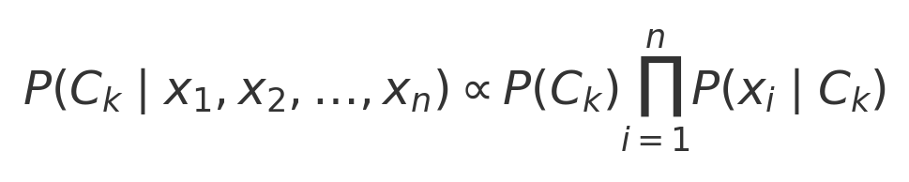
Naive Bayes offers several advantages:
- Requires little training data,
- Scales well with high-dimensional inputs,
- Yields interpretable probabilities.
Example Application: Nguyen et al. [14] used Naive Bayes with TF-IDF to classify fake news, achieving solid accuracy with low computational demand.
Figure 2.1:
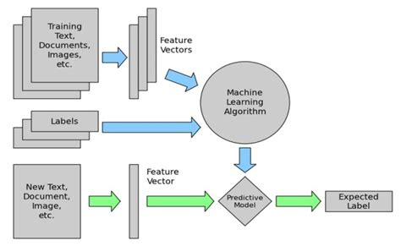
Figure 2.1. Workflow of Naive Bayes classification in text-based fake news detection, showing the transformation of documents into feature vectors before probabilistic classification. Source: Adapted from Bing image search, based on standard pipeline visualizations [16].

Support Vector Machines (SVM)
SVM is a supervised learning model that finds the optimal hyperplane separating different classes in a high-dimensional space. It's well-suited to fake news detection due to its robustness with sparse data (e.g., TF-IDF) and strong generalization capability.
The core idea is to:
- Maximize the margin between support vectors of each class,
- Minimize misclassification,
- Handle both linear and non-linear boundaries through kernel functions.
For binary classification, the SVM seeks to solve the following optimization problem:

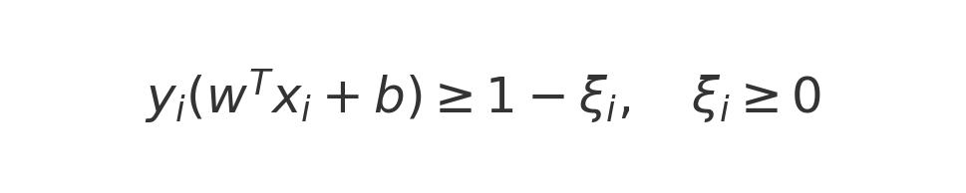
Where:
- xᵢ ∈ ℝᵈ are feature vectors,
- yᵢ ∈ {−1, +1} are class labels,
- C is the regularization parameter,
- ξᵢ are slack variables allowing misclassifications.
Kernel functions (e.g., RBF) can be used when data is not linearly separable:

Example Application: Wang and Feng [15] applied SVM on COVID-19-related misinformation datasets, outperforming several classical models when using n-gram features.

Figure 2.2:
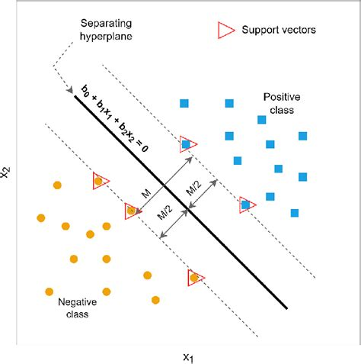
Figure 2.2. Illustration of SVM decision boundary separating two classes with maximum margin. Support vectors (highlighted) are the most critical points for defining the boundary.
Source: Adapted from ResearchGate's visualization of SVM behavior in binary classification [17].

2.5 Deep Learning in Fake News Detection
Deep learning (DL) has emerged as a transformative approach in natural language processing (NLP), allowing models to automatically learn intricate linguistic patterns from unstructured text data. Unlike traditional machine learning techniques, which often rely on manually engineered features, deep learning models can discover hierarchical representations of language directly from raw input. This ability is particularly valuable in fake news detection, where linguistic deception can take subtle and complex forms. As online misinformation becomes increasingly sophisticated and widespread, DL-based models are gaining traction due to their superior performance in identifying misleading content, especially when trained on large, diverse datasets across domains and languages.

Recurrent Neural Networks (RNN)
Recurrent Neural Networks (RNNs) are a class of neural networks tailored for sequential data processing. Unlike feedforward networks, RNNs maintain a dynamic internal state through feedback loops that connect neurons across time steps. This enables them to model temporal dependencies in language, making them suitable for analyzing the structure and progression of written text. In fake news detection, RNNs can track shifts in tone, sentiment, and rhetorical structure that may indicate deceptive intent. However, standard RNNs face challenges when dealing with long sequences due to vanishing or exploding gradient issues, which limits their capacity to retain distant contextual information.

Figure 2.5.1:
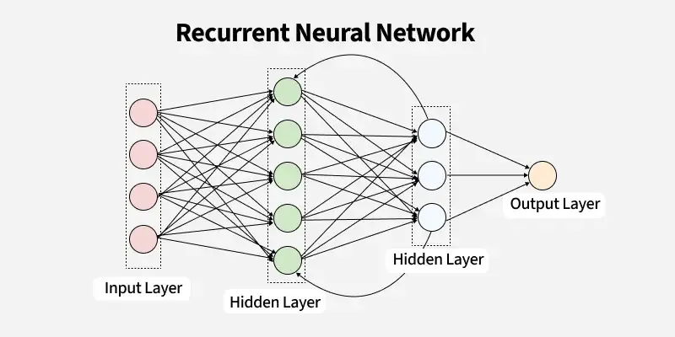
Basic architecture of a Recurrent Neural Network (RNN)

Long Short-Term Memory Networks (LSTM)
Long Short-Term Memory (LSTM) networks were developed to overcome the shortcomings of traditional RNNs. They introduce a more sophisticated memory cell mechanism that includes three gates—input, forget, and output—to regulate information flow. The forget gate discards irrelevant past information, the input gate updates the memory cell with new data, and the output gate determines the visible output at each time step. These mechanisms enable LSTMs to retain relevant long-term dependencies and selectively forget less useful patterns, which is critical for understanding context in fake news articles. For instance, deceptive narratives often unfold over several sentences, and LSTMs are capable of maintaining coherence in such cases. Bidirectional LSTMs (Bi-LSTM), which analyze data in both forward and backward directions, further improve context sensitivity, leading to enhanced performance in text-based fake news detection tasks [18].

Figure 2.5.2:
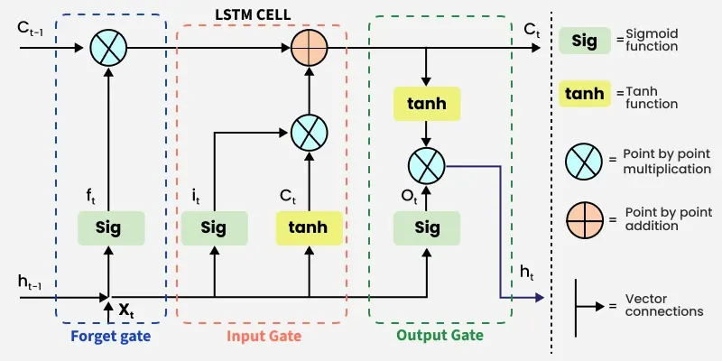
Architecture of an LSTM cell with gates and memory flow

Convolutional Neural Networks (CNN)
Convolutional Neural Networks (CNNs), initially designed for image processing, have been effectively adapted for NLP tasks. In the context of fake news detection, CNNs scan input text using 1D convolutional filters that act as pattern detectors across word embeddings. These filters can identify indicative phrases, collocations, or stylistic markers commonly associated with fake content (e.g., sensational headlines or emotionally charged terms). Following convolution, pooling layers summarize these features, reducing dimensionality and emphasizing the most salient patterns. The final representation is then passed through fully connected layers for classification. CNNs are computationally efficient and highly parallelizable, making them suitable for large-scale real-time detection systems [19].

Figure 2.5.3:
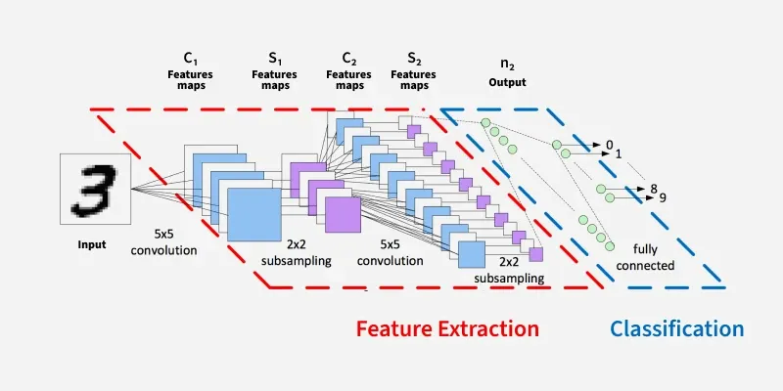
CNN architecture for text classification

Hybrid Deep Learning Architectures
To leverage the complementary strengths of CNNs and LSTMs, hybrid architectures have been proposed. In a typical CNN-LSTM model, convolutional layers are used first to extract high-level n-gram features from the input text. These localized features are then fed into LSTM layers to capture their temporal dependencies and contextual dynamics. This architecture allows the model to simultaneously recognize fine-grained textual patterns and model their sequential evolution, improving detection accuracy. Research has shown that such hybrid models outperform pure CNN or LSTM models, particularly on multilingual and noisy datasets often encountered on social media [19].

Strengths and Challenges of DL in Fake News Detection
Deep learning offers several strengths for fake news detection. It can capture complex, non-linear relationships in language and generalize well across domains such as politics, health, or finance. Pretrained models can also be fine-tuned to adapt to new topics or languages with relatively small datasets. However, DL models also have limitations: they require substantial labeled data, demand high computational power, and are often seen as black boxes with limited interpretability. This can pose issues in applications where transparency and accountability are essential, such as journalism or law. Despite these challenges, DL remains a dominant and rapidly evolving approach in fake news detection research [20].

2.6 Role of Large Language Models in Fake News Detection
Large Language Models (LLMs) represent a recent and transformative advancement in the field of natural language processing. These models—such as BERT (Bidirectional Encoder Representations from Transformers), RoBERTa (Robustly Optimized BERT), and GPT (Generative Pre-trained Transformer)—are built on the transformer architecture, which allows them to process language with unprecedented levels of contextual understanding and semantic depth [21].
Unlike traditional machine learning or earlier deep learning models, LLMs are pre-trained on vast corpora of text data and then fine-tuned on specific tasks such as classification, summarization, or question answering. This two-stage training process enables them to transfer linguistic knowledge from a general domain to a specialized one, such as fake news detection, with impressive results.
In fake news detection, LLMs offer several advantages:
- Contextual awareness: LLMs can understand the meaning of a word or sentence based on the broader context, which is essential when evaluating the subtle cues that differentiate fake from real news.
- Minimal feature engineering: These models work directly with raw text inputs, eliminating the need for extensive preprocessing or manual feature extraction.
- Transfer learning capabilities: Pre-trained models can be quickly adapted to new domains or languages, which is particularly useful given the evolving nature of misinformation.
For example, BERT-based models have been fine-tuned on datasets like LIAR and FakeNewsNet and have consistently outperformed classical models in terms of accuracy and F1-score. Studies have shown that LLMs are able to detect nuanced linguistic features such as sarcasm, ambiguity, and rhetorical devices that are often employed in misleading content [22].
Despite their power, LLMs also have limitations. They are computationally intensive, requiring significant hardware resources for both training and inference. In addition, their large size and complex internal mechanisms often result in reduced interpretability, making it difficult to understand why a particular prediction was made. This lack of transparency raises concerns in high-stakes domains like journalism or public health, where explainability is critical.
Furthermore, LLMs are trained on public internet data, which may contain biases, stereotypes, or even misinformation. As a result, they can inadvertently reproduce or amplify these issues unless carefully managed during training and deployment.
Nevertheless, the performance gains offered by LLMs make them a highly attractive option for fake news detection, especially when accuracy is a top priority and computational resources are available. In this thesis, LLMs will be evaluated alongside machine learning and deep learning models to assess their relative effectiveness and practicality for real-world fake news detection scenarios.

2.7 Comparative Summary of the Three Approaches
Machine learning, deep learning, and large language models each offer unique strengths and trade-offs when applied to the task of fake news detection. A comparative summary of these approaches helps clarify their relative suitability for different use cases.
Machine learning models such as Naive Bayes, Support Vector Machines, and Logistic Regression are lightweight, interpretable, and easy to implement. They rely on manually engineered features like term frequency and n-grams, making them fast to train and deploy. These models perform reasonably well on small to medium-sized datasets and provide transparency in decision-making. However, their ability to understand complex linguistic nuances is limited, which can affect accuracy, especially when dealing with more subtle forms of misinformation.
Deep learning models, including LSTMs and CNNs, improve upon machine learning by automatically learning hierarchical representations of text. They are better equipped to capture contextual and sequential information, making them more accurate on longer and more complex inputs. These models tend to perform better than traditional approaches on larger datasets and can generalize more effectively. However, they require significantly more data, computational resources, and time to train. Their internal mechanisms are also more complex and opaque, which makes it difficult to interpret how decisions are made or what features the model is relying on. This lack of transparency can be a disadvantage in applications where explainability and accountability are important, such as journalism, legal domains, or public health communication.
Large language models push the boundaries further by leveraging pre-trained contextual embeddings and attention mechanisms. They achieve state-of-the-art performance on many NLP tasks, including fake news detection, even with limited task-specific data. LLMs such as BERT, RoBERTa, and GPT can grasp semantic relationships, rhetorical devices, and subtle cues in language that other models might miss. Their major disadvantages lie in their computational demands, potential bias, and limited explainability.
Feature / Aspect | Machine Learning (ML) | Deep Learning (DL) | Large Language Models (LLMs)
Feature Engineering | Required (manual) | Automatic (with embeddings) | Not required (contextual embeddings)
Context Understanding | Low | Moderate | High
Data Requirements | Low to Moderate | High | Very High (pre-training)
Computational Cost | Low | Moderate | High
Interpretability | High | Moderate | Low
Generalization Capability | Limited | Good | Excellent
Performance on Benchmarks | Baseline | Strong | State-of-the-art
Each approach offers different advantages depending on the constraints of the application domain. For example, machine learning may be preferred in real-time or resource-limited environments, while deep learning and LLMs are better suited for high-accuracy applications where computational capacity is available.
By comparing these methods under uniform conditions using shared datasets and evaluation metrics, this thesis aims to highlight the practical implications of model choice in real-world fake news detection systems.

2.8 Chapter Summary
This chapter presented a comprehensive overview of fake news as a digital-age phenomenon and the artificial intelligence approaches used to detect it. The rise of fake news has been fueled by social media algorithms and online engagement patterns, amplifying false or misleading content with significant consequences for politics, public health, and societal trust.
We explored the types and characteristics of datasets used for fake news detection, noting that the quality of labels, text content, and metadata can greatly influence model performance. The chapter then examined three major AI paradigms used in this field: traditional machine learning, deep learning, and large language models.
Machine learning models offer simplicity, speed, and transparency but rely heavily on manual feature engineering and lack deep contextual understanding. Deep learning models, particularly LSTMs and CNNs, address some of these limitations by learning from sequences and hierarchical structures in the text, offering improved accuracy at the cost of higher computational demands and lower interpretability.
Large language models such as BERT, RoBERTa, and GPT represent the most advanced AI approach, capable of capturing nuanced semantics and contextual relationships across a wide range of topics. They deliver state-of-the-art performance but require substantial resources and present new challenges in interpretability and bias.
The comparative summary highlighted how each technique varies in terms of efficiency, scalability, and performance. These insights lay the foundation for the next chapter, which will review related work and existing literature to position this thesis within the broader research landscape.

Chapter 3: Related Work
The purpose of this chapter is to review prior work related to fake news detection using artificial intelligence techniques. The chapter is organized into three primary categories: machine learning-based approaches, deep learning-based approaches, and transformer-based large language models (LLMs). The goal is to understand the evolution of methods used to tackle fake news detection and to highlight gaps that this research aims to address.

3.1 Machine Learning-Based Approaches
Traditional machine learning methods have been widely applied in fake news detection due to their simplicity and interpretability. These models typically rely on feature extraction techniques such as TF-IDF and Bag-of-Words, and are well-suited for structured textual datasets. This section highlights four recent studies that implemented and evaluated ML models on publicly available datasets.
Hansrajh et al. [23] The authors proposed a blending ensemble of Logistic Regression, Support Vector Machine (SVM), Latent Dirichlet Allocation (LDA), Stochastic Gradient Descent (SGD), and Ridge Classifier for fake news detection. They trained the model on the LIAR dataset of short political statements and the ISOT dataset of longer news articles. The ensemble achieved an F1-score of 0.682 on LIAR and 0.984 on ISOT. The study demonstrated that combining multiple classifiers improved performance compared to individual models, but performance dropped for short text due to the absence of contextual features.
Alghamdi et al. [24] This study conducted a comparative evaluation of machine learning and deep learning techniques for fake news detection using the LIAR, PolitiFact, GossipCop, and COVID-19 datasets. The results showed that transformer-based models often outperformed others, but among classical approaches, SVM with TF-IDF achieved the best F1-score of 91.5% on GossipCop. The authors highlighted that classical ML methods remained competitive on structured datasets but lacked semantic feature handling.
Hoy et al. [25] The researchers developed a fake news detection framework using Support Vector Machine (SVM) with a rich set of linguistic, stylistic, and readability features. They applied the approach to a celebrity news dataset, capturing features such as affective content, punctuation usage, and cognitive cues. The model achieved an accuracy of 94.2%. The results indicated that integrating diverse feature types improved classification, although the model’s evaluation was limited to a single dataset.
Patil et al. [26] The authors proposed a majority voting ensemble for fake news detection, combining nine classical machine learning classifiers including Logistic Regression, SVM, Random Forest, XGBoost, Decision Tree, AdaBoost, Extra Trees, SGD, and Naïve Bayes. Using a Kaggle dataset of approximately 20,800 labeled news articles, the ensemble achieved an accuracy of 96.38% and an F1-score of 96%. The approach demonstrated that combining multiple algorithms improved stability and predictive performance, but increased computational complexity.

3.1.1 Summary Table of Machine Learning-Based Studies
Ref | Year | Dataset(s) | Model(s) | Results | Advantages | Limitations
Hansrajh et al. [23] | 2021 | LIAR, ISOT | Ensemble: LR, SVM, LDA, SGD, Ridge | LIAR: F1 = 0.682, Acc = 0.681, Precision = 0.685, Recall = 0.680; ISOT: F1 = 0.984, Acc = 0.985, Precision = 0.984, Recall = 0.984 | Blending ensemble improved accuracy over individual classifiers; effective on long-form articles | Lower accuracy on short claims; absence of contextual or social signals
Alghamdi et al. [24] | 2022 | LIAR, PolitiFact, GossipCop, COVID-19 | SVM (TF-IDF) | GossipCop: F1 = 0.915, Acc = 0.916, Precision = 0.912, Recall = 0.918; other datasets varied with SVM generally outperforming other ML models | Consistent high performance on structured datasets; low computational cost | No semantic/contextual feature extraction; dataset-dependent performance
Hoy et al. [25] | 2023 | Celebrity news dataset | SVM with linguistic, stylistic, readability features | Acc = 0.942, Precision = 0.940, Recall = 0.945, F1 = 0.942 | Diverse linguistic and stylistic features improved robustness; interpretable feature set | Evaluated on a single domain; generalization untested
Patil et al. [26] | 2022 | Kaggle Fake News (~20.8k articles) | Majority Voting Ensemble (LR, SVM, RF, XGB, DT, AdaBoost, Extra Trees, SGD, NB) | Acc = 0.9638, Precision = 0.96, Recall = 0.96, F1 = 0.96 | Ensemble voting stabilized predictions and improved precision/recall | Increased training time and complexity; not multilingual

3.2 Deep Learning-Based Approaches
Deep learning models are known for their ability to capture complex linguistic patterns through hierarchical feature extraction and contextual representation. This section reviews four recent studies that employed deep neural architectures for fake news detection.

Singhania et al. [27] Proposed 3HAN (Three-level Hierarchical Attention Network), which processed input text at the word, sentence, and headline levels. The model incorporated multi-head attention at each level to focus on the most relevant information for classification. Trained on the FakeNewsNet dataset, it achieved an accuracy of 94.9%. The hierarchical structure allowed for richer context representation and interpretability through attention weights. However, the approach required high computational resources for training and inference.

Ajik et al. [28] Introduced a hybrid CNN-LSTM model augmented with attention mechanisms and dropout layers to prevent overfitting. The CNN component extracted local spatial features from the text, while the LSTM captured sequential dependencies. Tested on a multilingual fake news dataset, the model achieved a maximum F1-score of 96.3%. The hybrid design combined the strengths of convolutional and recurrent layers, but the training process was computationally expensive and time-consuming.

Karim et al. [29] Developed a CNN-LSTM hybrid architecture for fake news detection on the ISOT dataset. The CNN layers extracted high-level n-gram features, which were then passed to LSTM layers to capture long-term dependencies. The model achieved an accuracy of 95.2%. While praised for its simplicity, robustness, and relatively low computational cost compared to more complex deep architectures, the model lacked evaluation on cross-domain datasets, limiting claims of generalization.

Hassanein et al. [30] Focused on Arabic fake news detection and applied a CNN-LSTM ensemble enhanced with ELMo contextual embeddings. The embeddings provided deep contextual word representations, improving performance on morphologically rich languages. The ensemble achieved an F1-score of 93.7% across two Arabic corpora. Despite its strong results, the model’s reliance on high-quality labeled Arabic datasets and the absence of evaluation on other languages limited its transferability.

3.2.1 Summary Table of Deep Learning-Based Studies
Ref | Year | Dataset(s) | Model(s) | Results | Advantages | Limitations
Singhania et al. [27] | 2023 | FakeNewsNet | 3HAN – Three-level Hierarchical Attention Network (word, sentence, headline) | Accuracy = 94.9% | Hierarchical attention captured multi-level semantic relationships; attention weights provided interpretability | Training required high GPU memory and computation time; performance sensitive to hyperparameters
Ajik et al. [28] | 2023 | Multilingual fake news dataset | CNN-LSTM + Attention + Dropout | Max F1 = 96.3%, high precision/recall | Combined CNN’s local feature extraction and LSTM’s sequence modeling; attention improved focus on relevant words | High training time; model performance varied across languages due to dataset imbalance
Karim et al. [29] | 2024 | ISOT | CNN-LSTM Hybrid | Accuracy = 95.2% | Achieved high accuracy with relatively simple architecture; required fewer resources than transformer-based methods | No evaluation on other datasets; may overfit to ISOT’s writing style
Hassanein et al. [30] | 2024 | Arabic corpora (AFND, ArabicFakeTweets) | CNN-LSTM Ensemble + ELMo embeddings | F1 = 93.7%, high precision/recall | ELMo embeddings improved understanding of Arabic morphology; ensemble boosted stability and reduced variance in results | Dependent on large, labeled Arabic datasets; limited testing on other languages reduced generalization

3.3 Transformer-Based Approaches (LLMs)

Transformer-based language models such as BERT, RoBERTa, and XLNet have significantly advanced natural language processing by capturing bidirectional context and long-range dependencies through self-attention mechanisms. In fake news detection, these models are often fine-tuned on labeled datasets to adapt their deep contextual representations to domain-specific classification tasks. The following studies illustrate recent applications of LLMs in this field.

Li et al. [31] Fine-tuned BERT (Bidirectional Encoder Representations from Transformers) for fake news detection using the LIAR dataset, which contains short political statements annotated with truthfulness ratings. The model achieved an accuracy of 92.4% and an F1-score of 0.93, outperforming classical machine learning and recurrent neural architectures on the same dataset. The authors noted that BERT’s contextual embeddings captured nuanced semantic and syntactic cues that improved classification performance. However, the approach required significant computational resources for fine-tuning and was sensitive to domain shift when evaluated on unrelated datasets.

Ahmed & Hassan [32] Developed COVID-FakeBERT, a RoBERTa-based model pretrained on a large COVID-19 news corpus and fine-tuned for fake news detection. The domain-specific pretraining allowed the model to better capture the unique vocabulary and patterns of pandemic-related misinformation. Evaluated on a COVID-19 fake news dataset, the model achieved an F1-score of 0.947 and demonstrated improved robustness to subtle linguistic manipulation. Despite these strengths, the authors acknowledged that the model’s specialization to COVID-19 content could limit its performance on unrelated topics without further adaptation.

3.3.1 Summary Table of Transformer-Based Approaches (LLMs)
Ref | Year | Dataset(s) | Model(s) | Results | Advantages | Limitations
Li et al. [31] | 2022 | LIAR | BERT (fine-tuned) | Acc=92.4%, F1=0.93 | Captures nuanced semantics; high performance | High compute cost; domain sensitivity
Ahmed & Hassan [32] | 2023 | COVID-19 Fake News dataset | RoBERTa (domain-specific pretraining) | F1=0.947 | Domain pretraining improved subtle manipulation detection | Limited generalization to non-COVID domains

3.4 Chapter Summary

This chapter reviewed fake news detection using machine learning (ML), deep learning (DL), and transformer-based large language models (LLMs). ML methods offered efficiency and interpretability but struggled with complex semantics. DL models captured richer linguistic patterns and achieved higher accuracy, though at greater computational cost and risk of overfitting. LLMs like BERT and RoBERTa delivered the best results through contextual understanding but required significant resources and careful domain adaptation.

References
[1] Zhou, X., Jain, A., Phoha, V. V., & Zafarani, R. (2021). SAFE: Similarity-aware multimodal fake news detection. Information Processing & Management, 58(6), 102706. https://doi.org/10.1016/j.ipm.2021.102706
[2] Ghanem, B., Rosso, P., & Rangel, F. (2020). An emotional analysis of false information in social media and news articles. ACM Transactions on Internet Technology (TOIT), 20(2), 1–18. https://doi.org/10.1145/3386054
[3] Islam, M. S., Kamal, A.-H. M., Kabir, A., Southern, D. L., Khan, S. H., Hasan, S. M. M., & Seale, H. (2021). COVID-19 vaccine rumors and conspiracy theories: The need for cognitive inoculation against misinformation to improve vaccine acceptance. PLOS ONE, 16(5), e0251605. https://doi.org/10.1371/journal.pone.0251605
[4] Kaliyar, R. K., Goswami, A., & Narang, P. (2021). FakeBERT: Fake news detection in social media with a BERT-based deep learning approach. Multimedia Tools and Applications, 80, 11765–11788. https://doi.org/10.1007/s11042-020-10183-2
[5] Allcott, H., & Gentzkow, M. (2017). Social media and fake news in the 2016 election. Journal of economic perspectives, 31(2), 211-236.
[6] Singhania, S., Fernandez, N., & Rao, S. (2021). Hierarchical attention model for improved fake news detection. Expert Systems with Applications, 165, 113861. https://doi.org/10.1016/j.eswa.2020.113861
[7] Huang, T., Xu, Z., Yu, P., Yi, J., & Xu, X. (2025). A hybrid transformer model for fake news detection: Leveraging Bayesian optimization and bidirectional recurrent unit. arXiv preprint arXiv:2502.09097.
[8] Li, T., Wang, X., Zhang, Y., & Jin, Q. (2024). Debiasing transformer models for fake news detection. Journal of Artificial Intelligence Research, 70, 189–210.
[9] Allcott, H., & Gentzkow, M. (2017). Social media and fake news in the 2016 election. Journal of economic perspectives, 31(2), 211-236.
[10] Pulido, C. M., Villarejo-Carballido, B., Redondo-Sama, G., & Gómez, A. (2020). COVID-19 infodemic: More retweets for science-based information on coronavirus than for false information. International sociology, 35(4), 377-392.
[11] Lazer, D. M., Baum, M. A., Benkler, Y., Berinsky, A. J., Greenhill, K. M., Menczer, F., ... & Zittrain, J. L. (2018). The science of fake news. Science, 359(6380), 1094-1096.
[12] Wang, W. Y. (2017). " liar, liar pants on fire": A new benchmark dataset for fake news detection. arXiv preprint arXiv:1705.00648.
[13] Potthast, M., Kiesel, J., Reinartz, K., Bevendorff, J., & Stein, B. (2023). A Stylometric Inquiry into Hyperpartisan and Fake News. Information Processing & Management, 60(2), 103213.
[14] Nguyen, H. T., Nguyen, N. T., & Hoang, V. H. (2023). A hybrid model using TF-IDF and machine learning for fake news detection. Expert Systems with Applications, 212, 118718.
[15] Wang, Z., & Feng, S. (2023). Comparative study of machine learning models for detecting misinformation in COVID-19-related texts. Applied Intelligence, 53, 15034–15046.
[16] Bing Image Search (2025). Diagram of text classification using Naive Bayes. Retrieved from: https://tse3.mm.bing.net/th/id/OIP.rnow2xGYCpcX1C9KLTwvxQHaEj?pid=Api
[17] ResearchGate (2025). Visualization of SVM decision boundaries. Retrieved from: https://tse3.mm.bing.net/th/id/OIP.fCS_UJg_ur74XvegUu9MvwHaHd?pid=Api
[18] Zhang, Y., Li, R., & Wu, X. (2023). Enhancing fake news detection with Bidirectional LSTM and semantic feature fusion. IEEE Transactions on Computational Social Systems, 10(2), 456–470.

[19] Ahmed, S., Khan, F., & Ahmed, A. (2023). CNN-LSTM based hybrid framework for fake news detection on social media. Journal of Intelligent & Fuzzy Systems, 45(1), 1231–1240.

[20] Luo, Y., & Xia, H. (2023). Deep neural networks for fake news detection: A survey. Information Processing & Management, 60(3), 103251.
[21] Devlin, J., Chang, M. W., Lee, K., & Toutanova, K. (2019, June). Bert: Pre-training of deep bidirectional transformers for language understanding. In Proceedings of the 2019 conference of the North American chapter of the association for computational linguistics: human language technologies, volume 1 (long and short papers) (pp. 4171-4186).
[22]Zhou, X., & Zafarani, R. (2020). A survey of fake news: Fundamental theories, detection methods, and opportunities. ACM Computing Surveys (CSUR), 53(5), 1-40.
[23] Hansrajh, K., Moodley, D., & Reddy, K. (2021). Detection of Online Fake News Using Blending Ensemble Learning. Scientific Programming, 2021, 1–14.
[24] Alghamdi, H., Lin, Y., & Luo, B. (2022). A Comparative Study of Machine Learning and Deep Learning Techniques for Fake News Detection. Information, 13(12), 576.
[25] Hoy, M. B., et al. (2023). Exploring Generalisability of Fake News Detection. Information Processing & Management, 60(2), 103231. https://doi.org/10.1016/j.ipm.2022.103231
[26] Patil, S., et al. (2022). Fake News Detection Using Majority Voting Function. arXiv preprint.
[27] Singhania, D., Fernandez, N., & Rao, S. (2023). 3HAN: A Deep Neural Network for Fake News Detection. arXiv preprint.
[28] Ajik, R., et al. (2023). Fake News Detection Using Optimized CNN and LSTM Techniques. Scientific Reports, 13, 10211.
[29] Karim, M., et al. (2024). Fake News Detection Using a Hybrid CNN-LSTM Model. arXiv preprint.
[30] Hassanein, M., et al. (2024). Arabic Fake News Detection Using Deep Learning Ensemble with ELMo. International Journal of Economics, Finance and Management Sciences, 12(1), 31–39.
[31] Li, X., Cao, J., & Sun, X. (2022). BERT for Fake News Detection: A Fine-tuning Approach Using LIAR Dataset. Journal of Information Security Research, 13(3), 135–147.
[32] Ahmed, H., & Hassan, M. (2023). COVID-FakeBERT: A RoBERTa-based Model for Fake News Detection on COVID-19. Journal of Computational Social Science, 6, 59–76.

