

Prepared By
Name Mahmoud Al Ra’e ID No.: 253001641
Name Hussein Mudeheg ID No.: 253001186

Submitted in fulfillment of the requirements for the Master degree of Science in Artificial Intelligence
At
College of Informatics Midocean University
Supervisor Name: Dr. Hager Saleh

Table of Contents

Chapter 1: Introduction 3
1.1 Problem Definition 3
1.2 Thesis Objectives 4
1.3 Thesis Contribution 4
1.4 Thesis Organization 4
Chapter 2 Background and Related Work 5
2.1 Background 5
2.2 Artificial Intelligence (AI) 5
2.3 Deep Learning (DL) 5
2.4 Convolutional Neural Networks (CNN) 5
2.5 Transform Model 6
2.6 Vision Transformer (ViT) 6
2.7 Internet of Things (IoT) 6
2.8 Related Work 7
Chapter 3 Methodology 10
3.1 Data Collection 11
3.2 Data Splitting 11
3.3 Data Augmentation and Preprocessing 11
3.4 Training and Configuration 13
Chapter 4 Results and Discussion 13
4.1 Experimental setup 13
4.2 Overall performance Comparison 13
4.3 Overall performance Comparison 14
4.4 Discussion 15
4.5 Conclusion 15
References 17

Chapter 1: Introduction

1.1 Problem Definition
Plant diseases are a major challenge due to the fact that they can reduce quality and productivity and cause economic losses. Detecting plant diseases at an early stage is important to reducing their impact on crops. In farming environments the disease diagnosis depends on visual inspection and the experience of farmers or specialists. This process can be time consuming and subjective when large numbers of plants need to be inspected. Diagnosis becomes more difficult when different diseases produce similar visual symptoms on plant leaves. Recent developments in artificial intelligent (AI) have provided new opportunities for automating plant disease detection from leaf images. Deep learning (DL) techniques demonstrated strong capabilities in image classification because they can learn relevant visual features directly from images. Convolutional neural networks (CNNs) are widely used for this purpose because they can learn different levels of image information which ranges from basic characteristics such as edges and colors to more complex patterns associated with disease symptoms. CNN based approaches have become important for identifying healthy and diseased plant leaves. Developing deep learning models from scratch requires substantial amounts of labeled data and computational resources. Transfer learning provides a practical alternative by adapting models that have learned useful visual representations from large scale image datasets to a specific classification task. This approach has been utilized in plant disease recognition where CNN architectures can be tuned using plant leaf images. Earlier studies reported promising results using architectures such as ResNet, EfficientNet and MobileNet for plant disease classification. DL architectures differ in their number of parameters as well as computational requirements, training time and ability to distinguish visually similar disease classes. A larger model may provide higher predictive performance that requires greater computational resources while a lightweight model may reduce the accuracy to produce faster execution and smaller memory consumption. This is particularly relevant when plant disease recognition systems are intended for mobile phones or computing devices with limited resources. Several studies evaluated pre trained DL architectures for plant disease classification. However, direct comparisons can be difficult when the models trained using different datasets, preprocessing procedures, augmentation techniques, data splits and optimization settings. A controlled comparison trained and evaluated under the same experimental conditions can provide a clear understanding of the relative strengths and limitations. This thesis compares ResNet50, EfficientNetB0 and MobileNetV2 under a unified transfer learning framework using 20,638 PlantVillage images across 15 plant health and disease classes. In addition, it makes three contributions. First, it provides a controlled comparison of three widely used architectures. Second, it evaluates predictive performance together with model size and training time. Third, it analyzes class-level errors to identify disease categories that remain difficult to separate visually.

1.2 Thesis Objectives
The objective of this thesis is to develop an intelligent system of plant disease detection based on leaf images using deep learning models and techniques. The study aims to improve the accuracy and speed of disease diagnosis which would support early detection and better crop management. The specific objectives are to apply and evaluate three convolutional neural network (CNN) architectures, ResNet50, EfficientNetB0, and MobileNetV2, for plant disease classification under a unified transfer-learning protocol. In addition, this thesis compares these models in terms of classification accuracy, computational efficiency, and suitability for real-world agricultural deployment. Another specific objective is to analyze class-level errors across the three models to identify disease categories that remain visually difficult to separate.

1.3 Thesis Contribution
This thesis makes the following contributions: First, we provide a controlled comparison of three widely used transfer-learning architectures, ResNet50, EfficientNetB0, and MobileNetV2, trained and evaluated under an identical experimental protocol on the same dataset split, preprocessing pipeline, classification head, optimizer, and evaluation measures. Second, we evaluate the three models not only on classification accuracy but also on model size and training time, and we report an accuracy-per-parameter efficiency measure. This allows the results to inform practical deployment decisions rather than accuracy alone. Finally, we perform a class-level error analysis using confusion matrices to identify which disease categories remain difficult to separate visually, and we show that the same cluster of tomato diseases accounts for most misclassifications across all three models, regardless of architecture.

1.4 Thesis Organization
The thesis is organized as follows: Chapter 2 reviews the background of convolutional neural networks and transfer learning, and previous studies and related works of plant disease classification using CNNs, Vision Transformers, and IoT based approaches. Chapter 3 presents the methodology including the proposed framework, dataset description, data preparation and splitting, data augmentation and preprocessing,. Chapter 4 presents the results, including the overall performance comparison, per-class performance, confusion matrix analysis, and model efficiency comparison of ResNet50, EfficientNetB0, and MobileNetV2.Chapter 5 concludes the thesis and discusses limitations and directions for future work.

Chapter 2 Background and Related Work

2.1 Background
Technology has started to play a major role in many areas including the agriculture and plants, especially in the health of Crop and productivity. One of the most challenges faced by the farmers is the early detection of the plant diseases. This process earlier has a large dependency on the expertise of the human which is time consuming, could have a biased and sometimes are inaccurate. With the advancement of the technology and Ai, newly automated approaches have emerged to automate the process disease detection that making it faster and more reliable

2.2 Artificial Intelligence (AI)
Artificial intelligence (AI) is the ability of a machine or computer system to simulate and perform tasks that would normally require human intelligence, such as logical reasoning, learning, and problem solving. Artificial intelligence is based on the use of machine learning algorithms and technologies to give machines the ability to apply certain cognitive abilities and perform tasks on their own autonomously or semi-autonomously [1]. In agriculture, AI is being increasingly used to analyze the plant conditions, detect the diseases based on the image and ultimately support in taking the right decision in by processing large amount of data and identifying patterns which enable early diagnostic for better crop management.

2.3 Deep Learning (DL)
Deep learning (DL) is a subset of the Artificial Intelligence (AI) that focuses on learning from large scale datasets using multi-layered neural network, enabling systems to automatically extract, meaningful and hierarchical features without the need for manual feature engineering or extensive intervention of Human [2]. In plant disease detection, DL has demonstrated high efficiency due to its ability to analyze complex visual patterns in leaf images and identifying plant diseases under controlled conditions [3].

2.4 Convolutional Neural Networks (CNN)
A Convolutional Neural Network (CNN) is one of the most popular deep learning models for image analysis due to its ability to learn spatial hierarchies of features from input data [2]. Many different types of CNN architecture exist like LeNet, AlexNet and their more recent versions VGG, GoogLeNet, ResNet, DenseNet and MobileNet. CNN works perfectly in processing visual data and identifying patterns of images including edges, textures and shapes. Within the agricultural sector CNN is commonly used for disease diagnosis of plants through analysis of leaf images, with architectures such as VGG, ResNet, and DenseNet achieving accuracy above 95% [3].

2.5 Transform Model
The transformer architecture is an approach to deep learning based on the concept of attention rather than convolution. Unlike CNNs which build understanding through a hierarchy of local and overlapping regions, the Transformer divide the image into patches and models the relationships between all patches directly allowing to capture dependencies across the image. Due to these properties, and architectures using transformers such as Vision Transformers (ViTs) have become popular for image analysis compared to CNNs and other methods [4].

2.6 Vision Transformer (ViT)
ViT is a model applies transformer architecture to image data and instead of analyzing the complete image, it divides it into smaller patches and then processes them in a similar way to words in a sentence. This approach allows the model to understand both local and global features [4]. Many recent studies show that ViT models could outperform traditional CNNs in plant disease classification tasks. Some studies compared ViT with models like ResNet and DenseNet which have reported accuracy levels approximately close to 99% that demonstrate strong performance and capabilities [5]. However, the side effect of the ViT models often is that they require large datasets and higher computational resources which could limit the accessibility, especially for smaller research teams or applications with limited data availability.

2.7 Internet of Things (IoT)
The term Internet of Things generally refers to scenarios where network connectivity and computing capability extends to objects, sensors and everyday items not normally considered computers, allowing these devices to generate exchange and consume data with minimal human intervention [6]. IoT makes it possible to have real-time plant disease detection systems when used with AI and deep learning. For instance, cameras with IoT can take pictures of leaves in the field, and deep learning models can quickly look at these pictures to find diseases.

2.8 Related Work
Too et al. applied multiple types of pertained models such as VGG16, InceptionV4, ResNet50, and DenseNet121 which classify 38 different classes of plant diseases. The public dataset so called PlantVillage was used from KAGGLE, which has 54,306 images with 38 classes. The preprocessing steps included image resizing in order to match the required input size of the CNN architecture, and rotation, flipping, and scaling were applied to increase dataset variability and reduce overfitting. The result has shown that DenseNet121 achieved the highest classification accuracy among the evaluated models. Transfer learning significantly improved performance compared to training from scratch. The models demonstrated very high accuracy under laboratory conditions. [7]
The study examines the use of Vision Transformers (ViT) for plant disease classification to determine whether attention-based architectures can perform better than the traditional convolutional neural networks (CNNs) or not. A pre-trained VIT model on ImageNet was improved for plant disease detection and compared with CNN models such as ResNet50 and DenseNet121. The model utilizes five public plant datasets that include the famous PlantVillage dataset, which contains 54,306 images from 38 classes that were collected under controlled conditions. The preprocessing involved resizing the images to 244X244 pixels, patch embedding preparation, pixel normalization, and data augmentation such as rotation and flipping. The final results demonstrate that VIT achieved approximately 99% accuracy, which outperforms several models. [8]
The research proposed a lightweight deep learning model, so called Dise-Efficient which is built on EfficientNetV2 to identify plant diseases and pest identification. The objective of the study is to improve the model efficiency as well as ensuring strong recognition performance. The model was trained and evaluated using plant image datasets applying steps such as image resizing, normalization and data augmentation for preprocessing which enhanced the performance and generalization. The results show that the proposed model has achieved high accuracy of classification as well as reduced the computational complexity. [9]

The authors proposed an integrated Internet of Things (IoT) solution that combined deep learning techniques to detect plant diseases. Leaf images were captured through cameras along with environmental data collected from IoT sensors such as temperature and humidity. The purpose of the preprocessing techniques is to improve image quality prior to applying deep learning models for disease classification. The system includes training and evaluation stages that measure the performance of the model which resulted into high accuracy. In addition, the framework supports real time monitoring and feedback allowing continuous tracking of crop conditions and early detection of diseases. [10]
Aldakheel et al. proposed a real time plant leaf disease detection system based on the YOLOv4 object detection framework. In contrast to the traditional classification models that only predict disease categories, YOLOv4 enables simultaneous detection of diseased regions within leaf images. The methodology involved training the YOLOv4 model to identify and classify multiple plant diseases directly from leaf images by bounding box coordinates and class probabilities in a single detection process. The model was trained on annotated plant leaf disease datasets that contain multiple disease categories in several environments. The preprocessing steps included image resizing to match the YOLOv4 input dimensions, image normalization, and data augmentation such as rotation, scaling, and flipping to improve robustness and at the same time to reduce the overfitting. The result of the experimentation demonstrated that YOLOv4 achieved higher accuracy with fast inference speed which making it suitable for real time agricultural applications. [11]
Duhan et al. have designed a real-time plant disease diagnosis based on mobile and edge devices. The authors have combined the RTR_Lite framework with MobileNetV2, a compact convolutional neural network known for its use of separable convolutions, which significantly reduce computational cost and still maintain strong performance. The goal was to develop a model that balances between accuracy and speed, which makes it very practical for field deployment where the computational resources are always limited. The model was trained on available public plant disease datasets that include various crops and disease categories which were captured under different environmental conditions. Prior to commencing the training the images were resized to match the input size required by MobileNetV2, and pixel values were normalized. Data augmentation techniques such as rotation, flipping, and scaling were applied to improve the ability of the models to generalize. The results showed that RTR_Lite_MobileNetV2 achieved high classification accuracy and at the same time has maintained a small model size and fast inference speed. [12]
Bhola and Kumar have designed a CNN model that automatically learns the important visual features from leaf images which eliminates the need for manual feature extraction. The main objective was to support farmers in detecting diseases at an early stage so that timely treatment can reduce crop damage and yield loss. Pre-trained CNN models such as VGG16, ResNet-50, and Inception-v3 were used. The model was trained and tested on a dataset of vegetable leaf images that included several disease categories, collected under both controlled and natural environmental conditions. Before starting the training, the images were resized to fit the input requirements of the network and normalized to standardize pixel values. Data augmentation techniques such as rotation, flipping, and brightness adjustment were also applied to increase dataset diversity and accordingly improve the ability of the models to generalize. The results showed that the proposed model achieved high accuracy and performed well in recognizing early symptoms of the disease. [13]
Kheir et al. have proposed a hybrid model combined of Vision Transformer (ViT) and MobilePlantViT, the lightweight design generalized plant disease image classification and balance both accuracy and efficiency for mobile and edge deployment. Traditional deep learning models for plant disease recognition often struggle on resource limited devices caused by high computational costs. MobilePlantViT combines efficient convolutional operations with a Vision Transformer backbone to capture local and global features while maintain the architecture compact. The model was evaluated across multiple diverse plant disease datasets that has shown a strong generalization and test accuracies ranging from around 80% to over 99% depending on the dataset. Preprocessing consisted of the usual image resizing and normalization, along with data augmentation to improve its reliability and prevent overfitting. The outcomes from the experiments highlight the potential that MobilePlantViT holds for practical disease detection in plants. [14]
Thanjaivadivel developed EnConv which is an improved CNN, meant to accurately classify plant leaves and their diseases using more efficient feature extraction techniques. The objective is to use ML and DL to detect diseases in plants which does not need extensive knowledge in the field . EnConv uses deep convolutional layers, which optimize calculations and retain crucial properties such as leaf colors and shapes. Instead of having a flattening layer as in most CNNs, EnConv has global pooling layers that can reduce overfitting and improve performance. After testing EnConv on data from a total of 39 diseases from different crops, it had a maximum accuracy rate of 99.87%. This clearly indicates that EnConv is more accurate than other machine learning and deep learning models. [15]
The authors developed a deep learning- and IoT-based framework for real-time plant-leaf disease detection. The framework uses a CNN to analyze leaf images and determine whether a plant is healthy or diseased. Transfer learning was applied to improve the performance of pretrained models, including MobileNetV2, ResNet50, and VGG16, using datasets such as PlantVillage. An IoT camera captures leaf images, which undergo preprocessing operations such as noise removal, resizing, and data augmentation to improve reliability under varying weather conditions. Furthermore, the model can run on edge-computing devices, including Raspberry Pi and Jetson Nano, and achieves an accuracy of more than 90%. [16]
The authors introduced a deep learning framework for identifying and classifying plant leaf diseases. They build a custom model called CropLeafNet using reliable backbone architectures including ResNet50, MobileNetV2 and VGG16 that improve feature extraction and classification. The proposed framework identifies local features such as leaf textures and global features including leaf colors and patterns. This enables the diagnosis of multiple diseases using a single model. PlantVillage and field captured images used for training to represent diverse leaf environments. The images were resized and normalized while augmentation techniques such as rotation, flipping and contrast adjustment were applied. Experimental results showed that CropLeafNet classified plant diseases with high accuracy and outperformed standard CNN models. [17]
Rajput and Doddamani proposed a machine learning approach for detecting diseases in pigeon pea leaves to support farmers with early diagnosis. Their approach combines classical computer vision techniques with several classification algorithms. Dense SIFT and Bag of Visual Words were used to extract features because of their robustness to noise and rotation. The authors evaluated several classifiers includes SVM, KNN, Random Forest, Decision Tree, Gradient Boosting, LightGBM and CNN using the extracted descriptors. The dataset contained 900 field images of healthy and diseased pigeon pea leaves. Image preprocessing included resizing and quality enhancement. The results showed that CNN and LightGBM effectively classified pigeon pea leaves into the corresponding disease categories. [18]
Singh et al developed PlantDoc as a real world dataset to improve the ability of AI models to recognize plant diseases under non laboratory conditions. PlantDoc contains images with complex backgrounds inconsistent illumination and different angles. The authors evaluated several deep learning models to determine their ability to recognize plant diseases. Before training the images were resized and cropped using bounding boxes for disease localization, normalized and augmented through operations such as flipping and brightness adjustment. The results showed that models trained on PlantDoc were more robust under real agricultural conditions than models trained on laboratory images. However, their overall accuracy was lower because of the complexity of real world images. [19]
Atila et al. examined the performance of EfficientNet in plantleaf disease classification. EfficientNet uses compound scaling to balance network depth, width and input resolution. The authors evaluated several EfficientNet variants ranging from B0 to B7 and applied transfer learning using the PlantVillage dataset. Before training, the images resized according to each model input requirements, normalized and augmented using techniques such as rotation, flipping and zooming. EfficientNet outperformed established CNN architectures including ResNet and Inception while requiring fewer parameters. The best models achieved classification accuracies exceeding 99%. However, these experiments were conducted using relatively clean and controlled images. [20]
The Authers introduced ResNet a deep convolutional neural network that employs residual learning to address the degradation problem encountered when training extremely deep models. Although originally designed for general image recognition where ResNet demonstrated strong performance in plant disease classification because of its effective feature extraction capabilities. Its central innovation is the skip connection which supports gradient flow during training and enables the construction of extremely deep networks including ResNet50, ResNet101 and ResNet152. In plant disease studies, ResNet is commonly fine tuned through transfer learning using datasets such as PlantVillage. Images are typically resized, normalized and augmented before training. ResNet based models have achieved high classification accuracy in plant disease recognition tasks. [21]

Chapter 3 Methodology
Figure 1 presents the framework used for plant leaf disease classification starting from image collection, preprocessing and data augmentation, training of the three models (ResNet50, EfficientNetB0, and MobileNetV2), Evaluation of each model on the test set and Final disease classification output across the 15 classes.
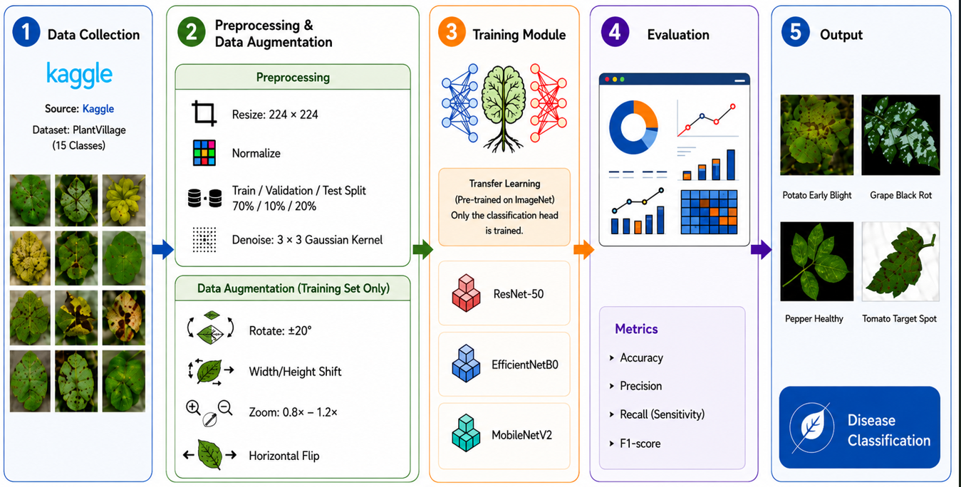
Figure 1 . The Steps of Method

3.1 Data Collection
The PlantVillage dataset is being used as the main folder which includes both healthy and diseased leaves across three crops as follows pepper, potato, and tomato. It contains the following 15 subfolder classes: Pepper contributes two classes, bacterial spot and healthy. Potatoes contribute three classes that include early blight, late blight, and healthy ones. Tomatoes contribute to ten classes: bacterial spot, early blight, late blight, leaf mold, Septoria leaf spot, two-spotted spider mites, target spot, yellow leaf curl virus, mosaic virus, and health.
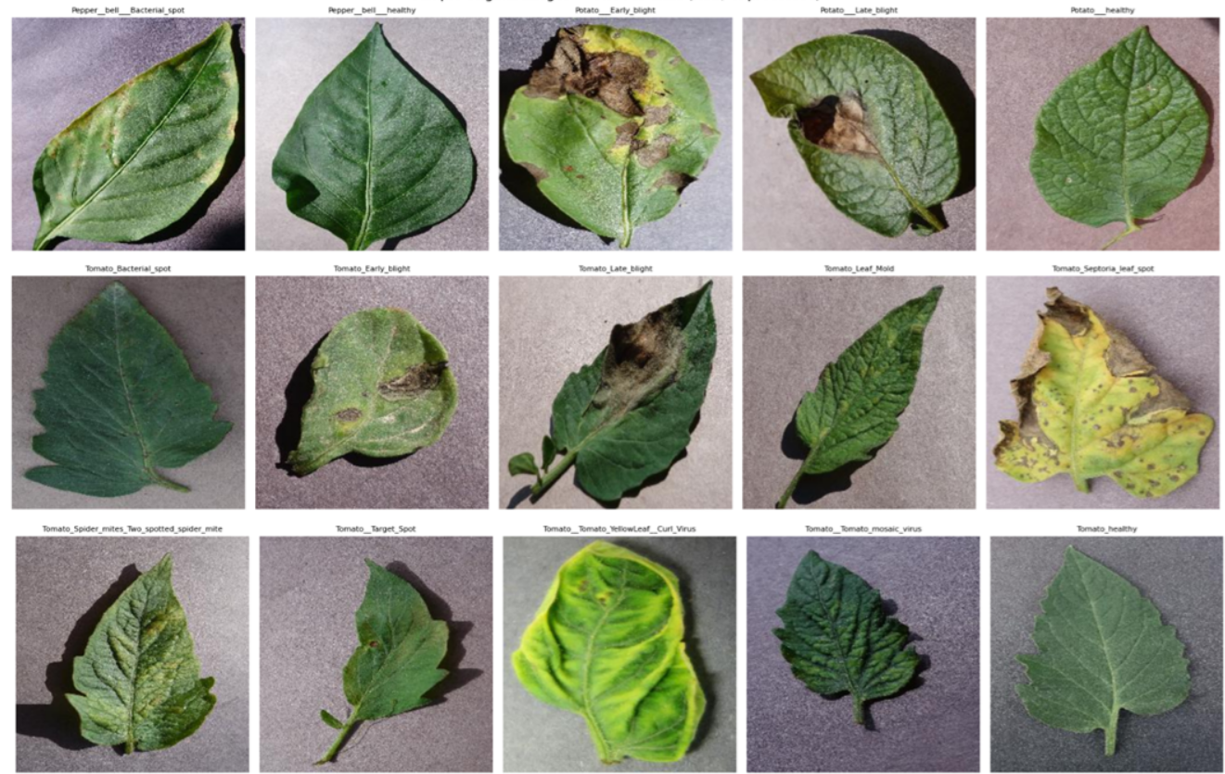
Figure 2 . Sample of Plantvilige dataset images

3.2 Data Splitting
We split the images into training, validation, and test sets using a fixed ratio of 70% for training, 10% for validation, and 20% for testing. This split was applied separately within each of the 15 classes. Also, the random seed was fixed at 42. Therefore the same images fall into the same set every time the notebook is run, and all three models are trained and evaluated on identical data.

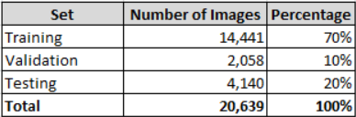
Table 1, Number of image per split

3.3 Data Augmentation and Preprocessing
We build two separate image generators, one for training and one for validation and testing. The training generator applies each model's own preprocessing function together with data augmentation, randomly rotating, shifting, zooming, and flipping images to increase variability in the training data. The validation and test generator applies preprocessing only with no augmentation since these sets are used to measure the model's real performance rather than to help it learn. All three generators resize every image to the fixed input size required by the model and load images in fixed-size batches. Figures 4 and 5 display the applied augmentation and preprocessing.

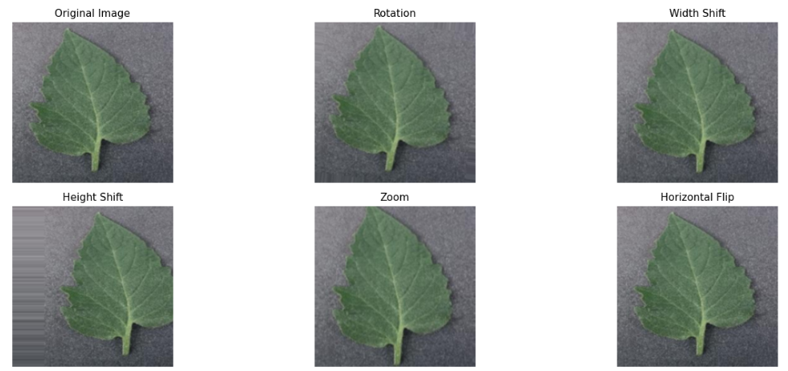
Figure 3, Augmentation Techniques Applied

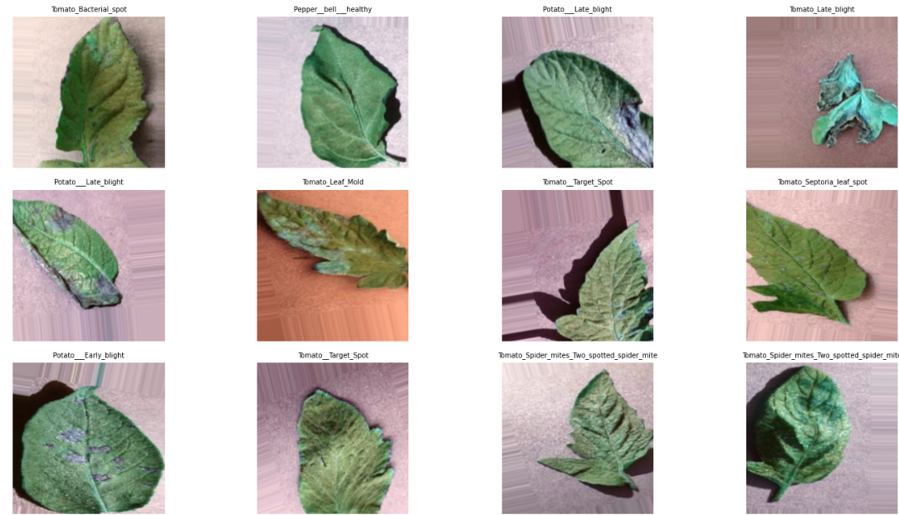
Figure 4, Sample Training of image (Preprocessed)

3.4 Training and Configuration
All the three models were trained on the same way to be fair for comparison. The Adam method was used with each and trained in batches of 32 images for up to 20 epochs. Two safety checks were used, one that stops training early if it stops improving and keeps the best version while the other saves the best-performing model to Google Drive. All three models have applied identical settings. Therefore, any reported difference in the results would be generated from the models themselves. Every model tested on unseen images, matching predictions correctly to the real answers and then measure the accuracy, precision, recall and F1-score.

Chapter 4 Results and Discussion

4.1 Experimental setup
This section presents the results obtained by applying the methodology to the three transfer learning models ResNet50, EfficientNetB0, and MobileNetV2. The experiments were implemented using Python and Google Colab with GPU acceleration for the PlantVillage dataset which contains 20,638 leaf images across 15 healthy and diseased classes from pepper, potato, and tomato plants. All three models, ResNet50, EfficientNetB0, and MobileNetV2 were compiled with the Adam optimizer for training with a learning rate equal to 0.001 and trained with a batch size of 32 up to 20 epochs. An EarlyStopping callback monitored validation loss with a patience of 5 epochs and restored the best weights.

4.2 Overall performance Comparison
Table 2 displays the overall performance comparison, where ResNet50 records the highest accuracy of the three models at 96.47% followed by EfficientNetB0 at 95.97% and finally MobileNetV2 at 92.13%. EfficientNetB0 achieves accuracy 0.5% less than ResNet50 (95.97% vs. 96.47%). This makes EfficientNetB0 the best tradeoff between accuracy and size among the three models. MobileNetV2 is the smallest model with fewer than 2.6 million parameters but records the lowest accuracy and more than four points behind ResNet50. Training time is similar for all three models, between 63 and 66 minutes.
Model | Accuracy | Precision (Macro) | Recall | F1-score | Parameters | Training time
ResNet50 | 96.47% | 96.55% | 96.20% | 96.33% | 24,116,111 | 63.5 min
EfficientNetB0 | 95.97% | 95.80% | 95.74% | 95.67% | 4,381,362 | 66.0 min
MobileNetV2 | 92.13% | 92.08% | 91.75% | 91.69% | 2,589,775 | 63.2 min
Table 2, Overall performance comparison

4.3 Overall performance Comparison

The confusion matrices of ResNet50, EfficientNetB0, and MobileNetV2 are presented in Figure 7, where all three models record high overall accuracy, but the confusion matrices show consistent misclassification patterns among visually similar tomato diseases.

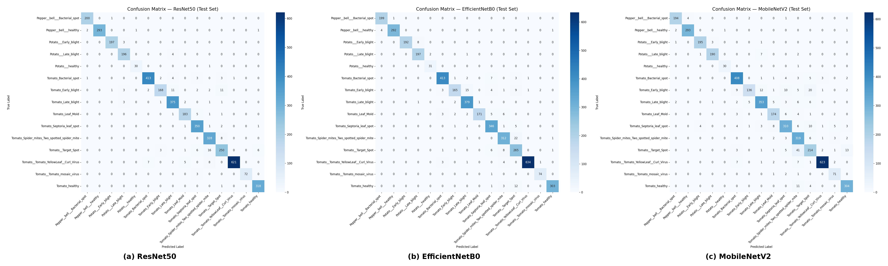
Figure 5, Comparison Matrix Analysis
ResNet50 produces the fewest misclassifications across nearly all disease pairs, EfficientNetB0 shows slightly more confusion between spider mites and target spot, and MobileNetV2 produces considerably more errors, particularly among the tomato diseases. The largest confusion is MobileNetV2 classifying 41 target spot samples as spider mites compared with only 16 for ResNet50 and 22 for EfficientNetB0. This suggests that the higher capacity architectures may capture more discriminative features for these visually similar diseases.

Disease Pair | ResNet50 | EfficientNetB0 | MobileNetV2
Target Spot → Spider Mites | 16 | 22 | 41
Early Blight → Late Blight | 11 | 15 | 12
Early Blight → Target Spot | 11 | 8 | 20
Table3, Number of test-set misclassifications for the three most frequent confusion pairs, compared across models.

4.4 Discussion
Net50 provides the highest classification performance across all evaluation metrics and produces the lowest number of misclassifications in the confusion matrix. EfficientNetB0 provides comparable performance while needing about one fifth of the parameters which makes it a practical choice for deployment in resource-constrained environments. MobileNetV2 demonstrates lower classification accuracy and more confusion among visually similar tomato diseases. Its small size remains attractive for edge computing applications where computing resources are limited. A consistent pattern appears across all three confusion matrices. The same group of tomato diseases, target spot, spider mites, early blight, and late blight, accounts for most of the misclassifications in every model, and tomato target spot and tomato early blight are among the two lowest F1-score classes for all three models. This matches the underlying plant pathology rather than a weakness of one architecture: Target spot, early blight, Late blight, and Septoria leaf spot are all necrotic-lesion diseases that produce similar brown to dark, roughly circular spotting on the leaf surface, and Spider mite damage can produce similar leaf discoloration and stippling at the resolution of the PlantVillage images. Since even the highest-capacity model in this comparison (ResNet50) could not fully resolve this confusion, the difficulty appears to come from the visual similarity between these disease categories rather than from model capacity.

4.5 Conclusion
In this paper, a comparative analysis of transfer learning models for classifying plant leaf diseases was performed using the PlantVillage dataset. Three popular deep learning models, ResNet50, EfficientNetB0, and MobileNetV2, were studied using the same experimental setup to ensure the comparability of the experiments. All models were trained and tested with the same transfer learning approach, optimization method, and evaluation criteria, with each backbone using its own required preprocessing function. In addition to predictive accuracy, the performance of each model was estimated using precision, recall, F1-score, training duration, and model size. Experimental results show that all three architectures can provide good performance in classifying plant diseases. ResNet50 showed the best results and may be considered when maximal predictive accuracy is required. EfficientNetB0 showed an acceptable compromise between predictive accuracy and computational cost, while MobileNetV2 had the lowest model size and shortest training time among the three compared architectures. Therefore, it can be concluded that the choice of model should depend not only on accuracy but also on the hardware limitations of the target platform. The main contribution of this work is a comparative study of transfer learning models under identical experimental conditions, isolating architectural characteristics from the training process itself. Such an analysis can support the development of intelligent agricultural monitoring systems.

Ref | Best Model | Dataset Source & Link | Result
Too et al., 2019  [7] | DenseNet (Fine-tuned) | PlantVillage Dataset – Kaggle: https://www.kaggle.com/datasets/emmarex/plantdisease | ~99.7% accuracy
Chen et al., 2022  [8] | Vision Transformer (ViT-B/16) | PlantDoc: https://www.kaggle.com/datasets/abdulhasibuddin/plant-doc-dataset | ~99% accuracy, strong generalization in the wild
Xie et al., 2023 [9] | Dise-Efficient (EfficientNetV2-based) | PlantVillage , IP102 and mixed plant disease & pest datasets  https://www.frontiersin.org/journals/plant-science/articles/10.3389/fpls.2023.1227011/full?utm_source=chatgpt.com | 98–99% accuracy, lightweight & efficient performance
Talaat et al., 2026 [10] | CNN-based IoT-integrated system | Field-collected dataset (custom) + PlantVillage | ~97–99% accuracy, real-time detection with IoT integration
Aldakheel, E. A., Zakariah, M., & Alabdalall, A. H. (2024)  [11] | YOLOv4 | PlantVillage (Detection version) | mAP ≈ 95%, real-time multi-disease detection
Duhan et al., 2025  [12] | RTR_Lite + MobileNetV2 | Multiple datasets: PlantVillage + Mendeley Data (Soybean, Coffee, Wheat, Sugarcane) https://data.mendeley.com/ | ~98% accuracy, low latency mobile deployment
Bhola & Kumar, 2025  [13] | Lightweight CNN-based model | Vegetable Leaf Dataset (Custom Field Dataset) | ~92–93% accuracy, efficient lightweight model for early-stage disease detection
Tonmoy et al., 2025  [14] | MobilePlantViT (Hybrid CNN + ViT) | Multi-crop dataset (PlantVillage + Field images) | ~80–99% accuracy, lightweight
Castillo Ossa & Corchado, 2025  [15] | EnConv (Enhanced Convolutional Neural Network) | https://link.springer.com/article/10.1007/s41348-024-01033-6  DataSet: PlantVillage | ~98–99% accuracy, improved interpretability
Real-Time Monitoring System  [16] | CNN + Deep Learning models (VGG16,VGG19,InceptionV3,MobileNet,DenseNet121,Xception) | https://www.sciencedirect.com/science/article/pii/S2772899424000417  PlantVillage + Real-time camera dataset | ~95–97% real-time detection accuracy
Conditional Mutual Information DL  [17] | CNN + CMI Regularization | PlantVillage  (PDF) Conditional Mutual Information Constrained Deep Learning: Framework and Preliminary Results | 2–4% improvement over baseline CNN
Rajput & Doddamani, 2024  [18] | BoVW + DSIFT + SVM | Pigeon Pea Leaf Dataset (Custom) | ~92–95% accuracy
Singh et al., 2020 [19] | Faster R-CNN / SSD | PlantDoc Dataset – https://github.com/pratikkayal/PlantDoc-Dataset | Better real-world performance
Tan & Le, 2019 [20] | EfficientNet | PlantVillage – https://www.kaggle.com/datasets/emmarex/plantdisease | >99% accuracy
He et al., 2016 [21] | ResNet | ImageNet – https://www.image-net.org/ | High accuracy baseline
Table4, Summary of related studies on plant leaf disease detection using deep learning

References
[1] F. Morandín-Ahuerma, "What is Artificial Intelligence?" International Journal of Research Publication and Reviews, vol. 3, no. 12, pp. 1947–1951, Dec. 2022.
[2] Y. LeCun, Y. Bengio, and G. Hinton, “Deep learning,” Nature, vol. 521, no. 7553, pp. 436–444, 2015.
[3] S. Mohanty, D. Hughes, and M. Salathé, “Using deep learning for image-based plant disease detection,” Frontiers in Plant Science, vol. 7, p. 1419, 2016
[4] A. Dosovitskiy et al., “An Image is Worth 16x16 Words: Transformers for Image Recognition at Scale,” International Conference on Learning Representations (ICLR), 2021.
[5] X. Zhang et al., “A Multitask Learning-Based Vision Transformer for Plant Disease Classification,” Springer, 2024.
[6] K. Rose, S. Eldridge, and L. Chapin, “The Internet of Things: An Overview – Understanding the Issues and Challenges of a More Connected World,” Internet Society, 2015.
[7] S. Too, L. Yujian, S. Njuki, and L. Yingchun, “A comparative study of fine-tuning deep learning models for plant disease identification,” 2019.
[8] X. Chen et al., “Vision Transformer for Plant Disease Classification in the Wild: A Multimodal Approach,” 2022.
[9] X. Xie et al., “A lightweight model for efficient identification of plant diseases and pests based on deep learning,” 2023.
[10] F. M. Talaat and M. Ibrahim, “IoT-Integrated Robotic System for Automated Plant Disease Detection and Environmental Monitoring,” 2023.
[11] M. Rahman et al., “Detection and Identification of Plant Leaf Diseases Using YOLOv4,” 2024.
[12] A. Duhan et al., “RTR_Lite_MobileNetV2 for Plant Disease Detection,” 2025.
[13] R. Bhola and A. Kumar, “Deep Learning Model for Early Vegetable Disease Detection,” 2025.
[14] M. Kheir et al., “MobilePlantViT: A Mobile-Friendly Hybrid Vision Transformer for Generalized Plant Disease Image Classification,” 2025.
[15] M. Thanjaivadivel, “Enhanced CNN for Leaf Disease Classification,” 2025.
[16] “A Real-Time Monitoring System for Accurate Plant Leaves Disease Detection Using Deep Learning,” 2024.
[17] “Conditional Mutual Information Constrained Deep Learning for Classification,” 2023.
[18] S. Rajput and S. Doddamani, “Pigeon Pea Leaf Disease Classification Using BoVW and DSIFT,” 2024.
[19] D. Singh et al., “PlantDoc: A Dataset for Visual Plant Disease Detection,” 2020.
[20] M. Tan and Q. Le, “EfficientNet: Rethinking Model Scaling for Convolutional Neural Networks,” 2019.
[21] K. He et al., “Deep Residual Learning for Image Recognition,” 2016.

