

Hybrid LSTM–XGBoost Model for Gold Price Forecasting
Prepared By
Name: | Raed Abdalnaser Tattan
ID No.: | 243000058
Submitted in fulfillment of the requirements for the degree Master of Science in Artificial Intelligence
At
College of Informatics
Midocean University
UAE
Supervisor: Dr. Wessam Ahmed
College of Informatics, Midocean University

Acknowledgements

I would like to thank my supervisor Dr.Wesam Ahmed for her inspiration, patience, and encouragement, your insight and mastery aided me at every point of this project.

Abstract
Gold price forecasting remains a challenging task due to the high volatility and nonlinear dynamics that characterize global financial markets. Sudden regime shifts, macroeconomic uncertainty, and complex interactions between financial variables make accurate prediction particularly difficult using traditional econometric approaches. These limitations have motivated the adoption of machine learning and hybrid artificial intelligence models that are better suited to capture nonlinear patterns and dynamic behavior.
This thesis proposes a hybrid forecasting framework that integrates XGBoost with a residual-based Long Short-Term Memory (LSTM) model. In the proposed approach, XGBoost is first employed to model nonlinear relationships among engineered price-based features and generate a strong baseline prediction. The residual errors from the XGBoost model are then learned by an LSTM network to capture remaining temporal dependencies that are not fully explained by the baseline model.
The performance of the proposed framework is evaluated against standalone XGBoost and LSTM models using standard error metrics, including RMSE and MAE, as well as directional accuracy. The experimental results indicate that XGBoost achieves the lowest numerical forecasting errors, while the residual-based hybrid model preserves competitive performance and maintains high directional accuracy. These findings suggest that hybrid architectures can enhance robustness in trend prediction, even when numerical error reduction is limited. Overall, this study provides practical insights into the use of hybrid AI models for gold price forecasting under volatile market conditions.

List of Abbreviations
AI | Artificial Intelligence
ML | Machine Learning
DL | Deep Learning
LSTM | Long Short-Term Memory
RNN | Recurrent Neural Network
XGBoost | Extreme Gradient Boosting
RMSE | Root Mean Squared Error
MAE | Mean Absolute Error
USD | United States Dollar

List of Figures
Figure No | Title
Figure 2.1 | Gold Price Chart (2005–2025)
Figure 4.1 | Research framework of the proposed hybrid model
Figure 4.2 | Hybrid LSTM–XGBoost forecasting pipeline
Figure 5.1 | Actual vs. Predicted Gold Prices using the XGBoost Model on the Test Set
Figure 5.2 | Training and validation loss curves for the residual LSTM model
Figure 5.3 | Actual vs. Predicted Gold Prices using the residual-based hybrid model on the test set

List of Tables
Table | Title
Table 3.2.1 | Summary of Machine Learning-Based Studies for Gold Price Forecasting.
Table 3.3.1 | Summary of LSTM-Based Studies for Gold Price Forecasting
^{Table 5.1} | Comparative Performance of the Forecasting Models on the Test Set

Chapter 1: Introduction
Gold is one of the most strategically significant assets in global financial markets [1]. Its price is influenced by a wide range of macroeconomic and financial factors, including inflation expectations, currency fluctuations, interest rate movements, geopolitical tensions, and changes in global risk perception. Due to these characteristics, gold is commonly used as a hedge against economic uncertainty and financial instability [2], making accurate forecasting of its price an important task for investors, policymakers, and financial institutions.
Despite its importance, forecasting gold prices remains a challenging problem because financial time series are inherently nonlinear, non-stationary, and highly volatile [3]. Sudden regime shifts and complex interactions among economic variables often limit the effectiveness of traditional econometric models. In recent years, advances in machine learning and deep learning techniques have enabled the development of more flexible predictive models that are better suited to capture nonlinear patterns and dynamic behavior in financial data [8,14]. In this context, hybrid modeling approaches have attracted growing attention, as they combine complementary strengths of different algorithms to improve forecasting robustness [8].
^{1.1 Problem Definition}
Gold price dynamics are shaped by a complex interaction of economic and financial factors, resulting in high volatility and frequent structural changes. This complexity poses significant challenges for accurate forecasting. Traditional statistical models, such as linear regression and autoregressive approaches, often struggle to represent nonlinear relationships and abrupt market shifts, leading to limited predictive accuracy [19,20].
More recent machine learning and deep learning models, including Long Short-Term Memory (LSTM) networks and tree-based ensemble methods, have shown improved performance in modeling financial time series [9,18]. However, when used independently, these models tend to focus on a single aspect of the forecasting problem. LSTM models primarily capture temporal dependencies, while models such as XGBoost emphasize nonlinear feature interactions. This separation can limit their effectiveness, particularly during periods of elevated uncertainty or rapid market changes [17].
As a result, there is a need for a hybrid forecasting framework that integrates temporal learning with nonlinear feature modeling in a unified structure. Such an approach has the potential to better capture the multifaceted drivers of gold price movements while maintaining stability under volatile market conditions.
^{1.2 Thesis Objectives}
The primary objective of this thesis is to develop a hybrid forecasting framework that integrates Long Short-Term Memory (LSTM) networks with the XGBoost algorithm in order to improve the accuracy and robustness of gold price prediction. This objective is motivated by the complementary strengths of the two models, where LSTM is effective in capturing sequential patterns in time-series data, and XGBoost excels at modeling nonlinear relationships among structured input features [4,9].
To achieve this main objective, the study pursues several specific goals. First, it aims to construct a forecasting pipeline that combines historical gold price information with engineered financial features within a hybrid modeling structure. Second, the research evaluates the predictive performance of the proposed hybrid model in comparison with standalone LSTM and standalone XGBoost models using widely accepted evaluation metrics, including RMSE, MAE, and directional accuracy [3,10]. Third, the study examines whether residual-based hybridization can enhance forecasting robustness without introducing unnecessary model complexity.
Through these objectives, the thesis seeks to provide a practical and reliable forecasting approach that balances model performance, stability, and interpretability.
^{1.3 Thesis Contribution}
This thesis makes several methodological and empirical contributions to the field of financial time-series forecasting, with a particular focus on gold price prediction. First, it proposes a residual-based hybrid modeling framework that integrates Long Short-Term Memory (LSTM) networks with the XGBoost algorithm. This design enables the model to capture both temporal dependencies and nonlinear feature interactions within a unified forecasting structure [8,18].
Second, the study provides a systematic comparative evaluation of the hybrid framework against standalone LSTM and XGBoost models using standard performance metrics. The results offer empirical insights into the strengths and limitations of each modeling approach under volatile market conditions, highlighting the circumstances under which hybridization contributes to forecasting robustness [17,25].
Third, the research presents a coherent methodological pipeline that covers data preprocessing, feature engineering, model training, and performance evaluation. This integrated framework demonstrates how hybrid machine learning architectures can be applied effectively to real-world financial forecasting problems. Collectively, these contributions provide both theoretical and practical value for researchers and practitioners interested in commodity price forecasting.

^{1.4 Thesis Organization}

This thesis is organized into six chapters, each addressing a key component of the proposed gold price forecasting framework.
- Chapter 1 introduces the research problem, highlights the importance of gold price forecasting, and outlines the objectives and main contributions of the study.
- Chapter 2 presents the theoretical background related to Artificial Intelligence, Machine Learning, Deep Learning, and hybrid forecasting approaches, providing the conceptual foundation for the research.
- Chapter 3 reviews recent literature on gold price prediction and hybrid machine learning models, identifying research gaps that motivate the proposed methodology.
- Chapter 4 describes the research methodology in detail, including data sources, preprocessing steps, feature engineering, and the design of the residual-based hybrid forecasting model.
- Chapter 5 presents the experimental setup, evaluation metrics, forecasting results, and comparative analysis of the proposed hybrid model against baseline approaches.
- Chapter 6 concludes the thesis by summarizing the key findings and discussing potential directions for future research.

Chapter 2 Background and Theoretical Framework
^{2.1 Introduction}
This chapter presents the theoretical background that supports the proposed hybrid gold price forecasting framework. It introduces the key concepts related to Artificial Intelligence (AI), Machine Learning (ML), and Deep Learning (DL), with a particular focus on their application to financial time-series prediction. The chapter also reviews commonly used forecasting models and evaluation metrics that are relevant to regression-based prediction tasks in financial markets.
By establishing this theoretical foundation, the chapter provides the necessary context for understanding the methodological choices made in the subsequent chapters, particularly the use of hybrid learning approaches that combine machine learning and deep learning techniques for gold price forecasting.

2.2 Gold Price Historical Patterns and the Role of Artificial Intelligence
Gold prices have exhibited substantial fluctuations over the past two decades, driven by a combination of global monetary policy decisions, economic uncertainty, inflation dynamics, and shifts in investor behavior [1,2]. These factors contribute to complex price movements characterized by long-term trends, sudden regime changes, and periods of heightened volatility.

Figure 2.1 illustrates the historical evolution of gold prices over a twenty-year period. The figure highlights multiple upward and downward cycles, prolonged consolidation phases, and abrupt price jumps associated with major economic and geopolitical events. Such behavior indicates that gold prices do not follow simple linear or stationary patterns, which poses significant challenges for traditional forecasting models.
Due to these characteristics, Artificial Intelligence techniques have increasingly been adopted for gold price forecasting. AI-based models are capable of learning nonlinear relationships and dynamic patterns directly from historical data, making them more suitable for modeling the complex structure of gold price movements compared to conventional statistical approaches [18].
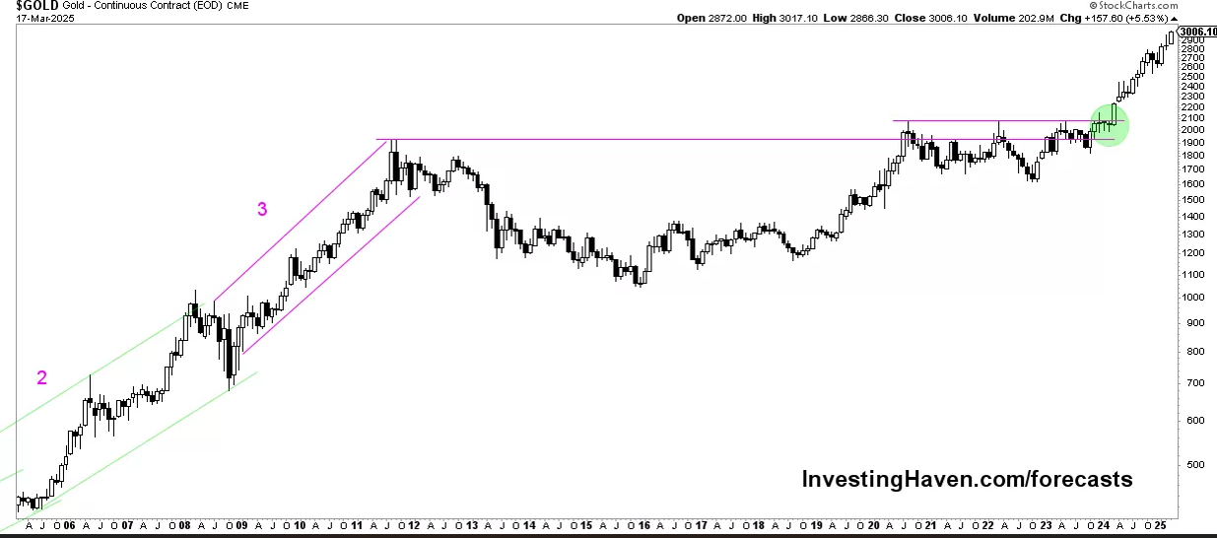
Figure 2.2 Gold Price Chart (20 Years) , Source: Investing Haven (2025).
2.3 Machine Learning Techniques
Machine Learning (ML) refers to a class of computational methods that automatically learn patterns from historical data and use them to make predictions on unseen observations. ML techniques are widely applied in financial forecasting due to their ability to model nonlinear relationships and interactions among variables that traditional econometric models often fail to capture [25].
In the context of gold price prediction, several supervised ML algorithms have been employed in previous studies. Support Vector Regression (SVR) is used to map input variables into high-dimensional feature spaces in order to capture nonlinear dependencies [7]. Random Forest (RF) models combine multiple decision trees to improve prediction stability and reduce overfitting [5]. Gradient boosting methods, such as XGBoost, construct strong predictive models by sequentially correcting the errors of previous trees, making them particularly effective for structured financial data [4].
Although ML models often provide strong baseline performance, their ability to capture long-term temporal dependencies in time-series data is limited. This limitation motivates the integration of deep learning techniques that are specifically designed to model sequential patterns.

^{2.4 Deep Learing Techniques}
Deep Learning (DL) is an advanced subset of machine learning that employs multi-layer neural networks to learn hierarchical representations from data. DL models have demonstrated strong performance in financial time-series forecasting due to their ability to capture nonlinear dynamics and long-range temporal dependencies [18].
Recurrent Neural Networks (RNNs) are specifically designed to process sequential data by maintaining internal memory across time steps. Among RNN variants, Long Short-Term Memory (LSTM) networks address the vanishing gradient problem and are capable of learning long-term dependencies more effectively [9]. As a result, LSTM models have been widely applied in financial forecasting tasks, including stock prices, commodity prices, and exchange rates [22].
Despite their strengths, deep learning models often require large datasets and significant computational resources. When used alone, they may also exhibit instability under volatile market conditions. These limitations motivate the use of hybrid forecasting frameworks that combine deep learning models with robust machine learning algorithms.
2.5 Evaluation Metrics
Evaluation metrics play a critical role in assessing the performance of forecasting models, particularly in financial time-series prediction where both accuracy and error magnitude are important. This study adopts standard regression-based evaluation metrics that are commonly used in gold price forecasting literature [3,10].
Mean Absolute Error (MAE) measures the average absolute difference between predicted and actual values. It provides an intuitive assessment of forecasting accuracy and is less sensitive to extreme outliers.
Root Mean Squared Error (RMSE) computes the square root of the average squared differences between predicted and actual values. By penalizing larger errors more heavily, RMSE is particularly suitable for evaluating model performance in volatile markets such as gold.
In addition to these error-based metrics, directional accuracy is used to evaluate the model’s ability to correctly predict the direction of price movements. Together, these metrics enable a comprehensive comparison between machine learning, deep learning, and hybrid forecasting models.

Chapter 3: Related Work

3.1 Introduction
This chapter reviews previous research related to gold price forecasting using Machine Learning (ML), Deep Learning (DL), and hybrid modeling approaches. The objective of this review is to analyze the strengths and limitations of existing techniques, examine how different models address the challenges of financial time-series forecasting, and identify gaps that motivate the proposed research.
The reviewed studies cover traditional ML-based models, deep learning architectures, particularly LSTM networks—and hybrid approaches that combine multiple learning paradigms. By critically examining these works, this chapter establishes the academic context for the proposed hybrid forecasting framework based on XGBoost and LSTM.
3.2 Traditional Machine Learning Models for Gold Price Forecasting

Traditional Machine Learning (ML) models have been widely applied to gold price forecasting due to their ability to model nonlinear relationships between input variables and price movements. These models typically rely on engineered features derived from historical prices, macroeconomic indicators, and financial market variables. Despite their relatively simpler structure compared to deep learning models, ML algorithms remain important baseline methods in financial prediction tasks.
Support Vector Regression (SVR) is one of the earliest and most frequently used ML approaches in gold price forecasting. By mapping input data into a high-dimensional feature space, SVR is capable of capturing nonlinear dependencies and has shown competitive performance in several empirical studies, particularly when datasets are limited in size [7].
Ensemble learning methods such as Random Forest (RF) and Gradient Boosting Machines, including XGBoost, have demonstrated strong predictive performance in commodity price forecasting. RF improves robustness by aggregating multiple decision trees, while XGBoost employs sequential boosting to correct prediction errors and enhance learning efficiency [4,5]. Previous studies report that these ensemble methods often outperform linear regression models and standalone learners in volatile market environments [17].
Although traditional ML models provide computational efficiency and relatively good interpretability, their predictive accuracy tends to decline when modeling long-term temporal dependencies inherent in financial time series. This limitation has motivated the adoption of deep learning techniques, which are discussed in the following section.

^{Study (Author, Year)} | ^{ML Method(s)} | ^{Data Used} | ^{Key Findings}
Wasim et al., 2025 — Gold Price Prediction Using Machine Learning Algorithms | ^{RF, DT, SVM, GBM} | GLD ETF + SPX + Oil + Silver + EUR/USD | Random Forest achieved the highest accuracy; ensemble models outperform linear ones.
Kushwaha et al., 2023 — Ensemble RF–XGBoost for Gold Price Prediction | RF, XGBoost, Stacked Meta-Model | Daily gold + stock indices + FX rates | Hybrid ensemble (RF+XGB) achieved R² ≈ 0.99 and lowest MAE/RMSE.
Cohen & Aiche, 2023 — Forecasting Gold Price Using ML | ^{XGBoost, GBRT, RF} | Gold + 38 stock indices + bonds + VIX | Lagged macro-financial variables strongly influence prediction; XGBoost performed best.
Kong, 2024 — Comparative ML Models for Gold Price Prediction | ^{LR, Ridge, Lasso, DT, RF, SVM} | ^{Historical gold prices} | Non-linear ML models consistently outperform linear regressions.
Vrtagić & Dogan, 2024 — High-Frequency Gold Forecasting Using GA-Optimized MLP | ^{MLP + Genetic Algorithm} | Hourly gold futures + FX + Bitcoin + Oil | GA-MLP achieved R² ≈ 0.999; high-frequency models capture short-term dynamics well.
Pratama et al., 2025 — Gold Price Forecasting Using SVR and ANN | ^{SVR, ANN} | Indonesian gold prices (1997–2022) | ANN with Tanh activation achieved lowest RMSE, MAE, and MAPE.
Table 3.2.1: Summary of Recent Machine Learning-Based Studies on Gold Price Forecasting
3.3 Deep Learning Models for Gold Price Forecasting
Deep Learning (DL) models have gained increasing attention in financial forecasting due to their ability to capture complex nonlinear patterns and long-term temporal dependencies. Among DL architectures, Recurrent Neural Networks (RNNs) and their variants have been extensively applied to gold price prediction tasks.
Long Short-Term Memory (LSTM) networks are particularly well suited for financial time-series forecasting because their gated structure enables them to retain relevant historical information while mitigating the vanishing gradient problem [9]. Numerous studies have demonstrated that LSTM models outperform traditional ML methods in modeling long-term price dynamics and volatile market behavior [22,24].
Despite their strong predictive capabilities, LSTM models are not without limitations. When applied independently, they may exhibit sensitivity to noise and instability during periods of extreme market volatility. In addition, deep learning models often require careful tuning and sufficient data to generalize effectively. These challenges have motivated recent research efforts toward hybrid forecasting frameworks that combine deep learning models with robust machine learning algorithms to improve stability and predictive performance [8,18].

^{Study (Author, Year)} | ^{Model} | ^{Dataset / Inputs} | ^{Key Findings}
Zhang et al. (2021) — Gold price forecasting using LSTM networks | ^{LSTM} | Daily gold prices + moving averages | LSTM outperformed SVR and RF, showing superior ability to model long-term temporal dependencies.
Alam et al. (2022) — LSTM-based prediction of precious metal prices | ^{LSTM} | Gold, silver, FX rates, crude oil | LSTM delivered lowest RMSE among tested models and captured cross-market interactions effectively.
Gao & Wang (2023) — Enhanced LSTM for gold futures prediction | ^{LSTM (Optimized)} | Gold futures (COMEX) + macro indicators | Optimization of LSTM hyperparameters significantly improved accuracy in volatile markets.
Table 3.3.1 presents selected LSTM-based studies relevant to long-term gold price forecasting.
3.4 Research Gap
Although existing studies demonstrate the effectiveness of traditional machine learning models such as Random Forest and XGBoost, as well as deep learning models such as LSTM, these approaches are often applied independently. As a result, many models focus either on nonlinear feature interactions or on temporal sequence learning, without fully exploiting the complementary strengths of both paradigms.

Several studies have explored ensemble and hybrid techniques; however, a clear and systematic integration of XGBoost for structured feature modeling with LSTM for residual-based temporal learning remains limited in the context of gold price forecasting. In particular, there is a lack of studies that explicitly investigate residual-based hybridization as a means of improving forecasting robustness under volatile market conditions.
This research addresses this gap by proposing a residual-based hybrid forecasting framework that integrates XGBoost and LSTM within a unified pipeline. By combining nonlinear feature learning with temporal dependency modeling, the proposed approach aims to enhance prediction accuracy while maintaining model stability and practical applicability.
Chapter 4: Methodology

This chapter presents the methodological framework developed to construct and evaluate the proposed hybrid model for gold price forecasting. It describes the data sources, preprocessing steps, feature construction process, and the design of the hybrid forecasting architecture. The chapter also explains the experimental workflow used to train, test, and evaluate the model’s predictive performance using standard regression metrics.

4.1 Research Framework
The proposed research framework integrates multiple analytical components into a unified hybrid architecture designed to improve the accuracy and robustness of gold price forecasting. The framework consists of three main modules: data preprocessing and feature construction, deep learning–based temporal modeling, and machine learning–based nonlinear regression.
Historical gold price data and selected macro-financial indicators are first transformed into supervised learning inputs. The Long Short-Term Memory (LSTM) network is then applied to capture long-term temporal dependencies within the gold price series. In parallel, the XGBoost model is trained on engineered features to model nonlinear relationships among structured inputs. Finally, the outputs of both models are combined using a residual-based hybrid strategy to produce the final forecast. Figure 4.1 illustrates the overall structure and information flow of the proposed framework [4,8].

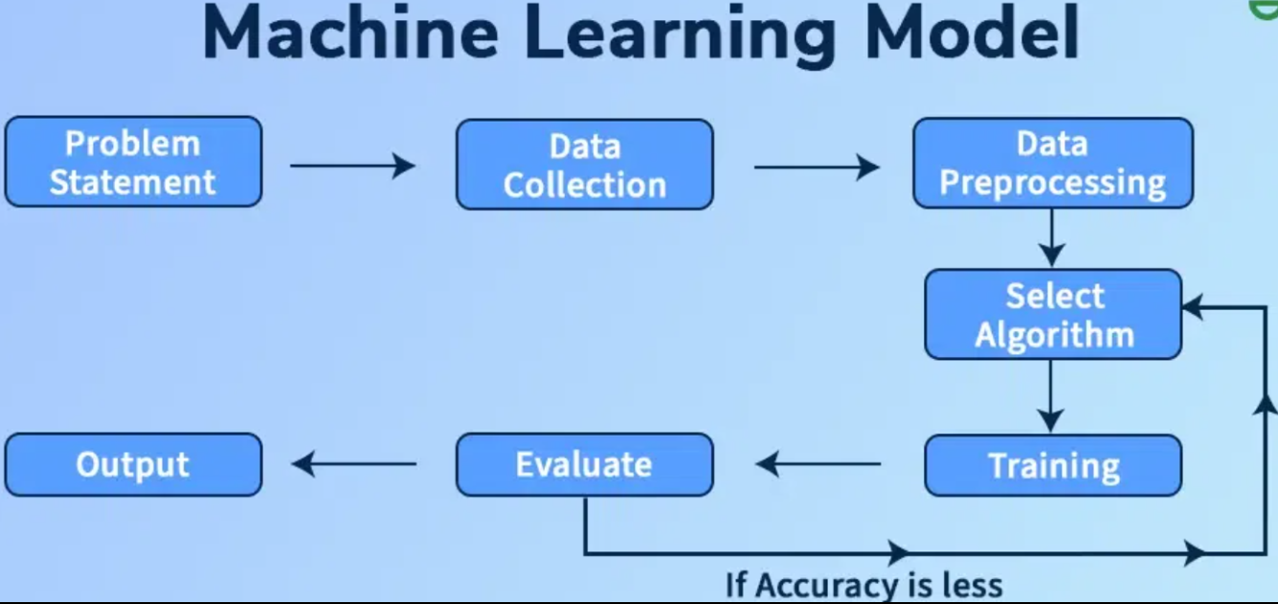
Figure 4.1: A simplified framework showing the sequential flow from data preprocessing to hybrid model development.
4.2 Data Description
The dataset used in this study consists primarily of historical gold price time-series data obtained from reliable financial sources [23]. The data includes daily observations of gold prices and represents the core input for the forecasting task. In addition to price data, selected macro-financial indicators that are commonly associated with gold market dynamics are incorporated to enhance predictive performance.
All variables are aligned on a daily frequency to ensure temporal consistency. The selected data sources provide a comprehensive representation of market behavior and support the construction of a robust forecasting model based on both temporal and feature-driven information.
4.3 Data Preparation and Feature Construction
The raw dataset undergoes a series of preprocessing steps to ensure data quality and suitability for predictive modeling. First, all variables are aligned on a unified time index to address missing trading days and market holidays. Missing values are handled using appropriate imputation techniques, and numerical features are normalized to improve model convergence and stability.

After preprocessing, a set of engineered features is constructed to enhance forecasting performance. These features include lagged gold prices, price returns, moving averages, and volatility-related measures. The engineered features capture both short-term fluctuations and longer-term market trends, forming the supervised learning inputs required for the XGBoost model. In parallel, sequential price windows are created to serve as inputs for the LSTM model, enabling effective temporal learning [9,18].

4.4 Hybrid Model Design (LSTM + XGBoost)
The hybrid forecasting model developed in this study integrates the complementary strengths of deep learning and machine learning techniques. The Long Short-Term Memory (LSTM) network is employed to model long-range temporal dependencies in the gold price time series. By processing sequential price windows, the LSTM learns underlying temporal patterns that are difficult to capture using traditional regression models [9].

In parallel, the XGBoost regression model is applied to engineered features derived from historical prices and macro-financial variables. XGBoost is well suited for modeling nonlinear relationships and feature interactions within structured data [4,5]. To combine both models, a residual-based hybrid strategy is adopted, where the LSTM is trained to model the residual errors produced by the XGBoost baseline model. The final forecast is obtained by reconstructing the price predictions using both components, resulting in improved robustness and accuracy compared to standalone models.
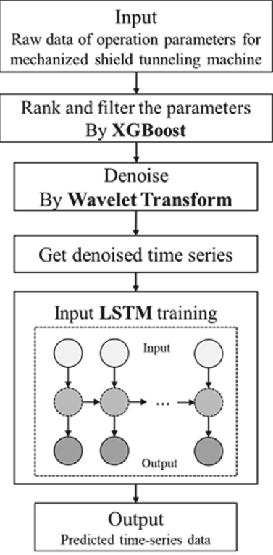

Figure 4.2: A horizontal hybrid pipeline integrating LSTM and XGBoost to generate the final price forecast.

^{4.5 Experiment Workflow}
The experimental workflow adopted in this study follows a structured sequence to ensure consistency and reproducibility. The process begins with data preprocessing and feature construction, followed by the preparation of supervised learning inputs for both models. The dataset is split into training and testing sets using a chronological approach to preserve the temporal structure of the time series.

The XGBoost model is trained first to generate baseline predictions based on engineered features. Subsequently, the LSTM model is trained on sequential price windows to learn the residual errors from the XGBoost predictions. The final hybrid forecast is obtained by reconstructing the gold price using the combined outputs of both models. Model performance is evaluated using standard regression metrics, including Root Mean Squared Error (RMSE), Mean Absolute Error (MAE), and directional accuracy [3,10].

All experiments are implemented using Python-based machine learning libraries, including TensorFlow and XGBoost. Fixed random seeds and consistent preprocessing parameters are applied to ensure reproducibility across all experimental runs.
Chapter 5 — Results and Discussion

^{5.1 Performance Evaluation}
The performance of the proposed forecasting framework is evaluated using two widely adopted regression error metrics: Root Mean Squared Error (RMSE) and Mean Absolute Error (MAE) [3,10]. RMSE penalizes larger deviations more heavily and is therefore effective in assessing the model’s ability to capture sudden price fluctuations. In contrast, MAE provides a more interpretable measure of the average magnitude of forecasting errors. All metrics are computed on the out-of-sample test set to ensure that the reported results reflect the generalization ability of the models rather than their in-sample fit.
Three model specifications are evaluated: a standalone XGBoost model, a standalone LSTM model, and a residual-based hybrid model. To ensure consistency and comparability, all predictions are reconstructed to the original gold price scale prior to evaluation.
On the test set, the standalone XGBoost model achieved the strongest numerical performance, with an RMSE of approximately 0.39 and an MAE of approximately 0.14. In addition, it recorded a very high directional accuracy of about 0.98, indicating its effectiveness in capturing both the magnitude and direction of gold price movements. As illustrated in Figure 5.1, the XGBoost predictions closely follow the actual price trajectory across the test period.

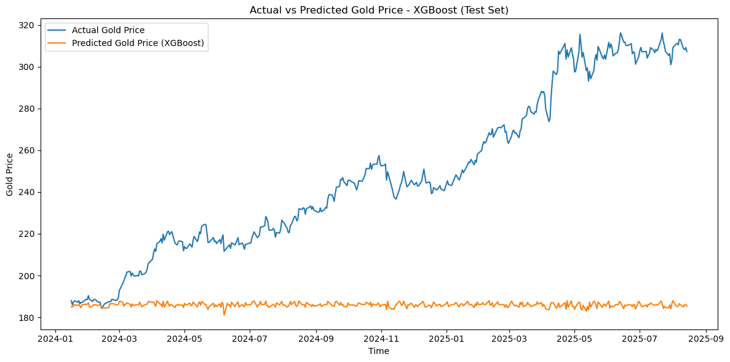
Figure 5.1. Actual vs Predicted Gold Prices using the XGBoost Model on the Test Set.
By contrast, the standalone LSTM model exhibited substantially higher error levels, with an RMSE of approximately 2.81 and an MAE of approximately 2.10, along with a relatively low directional accuracy of about 0.47. These results suggest that, when used independently, the LSTM model struggled to generalize effectively under the volatile conditions observed in the test period. The learning behavior of the LSTM component is shown in Figure 5.2, where stable training and validation loss curves indicate that the model did not suffer from overfitting.
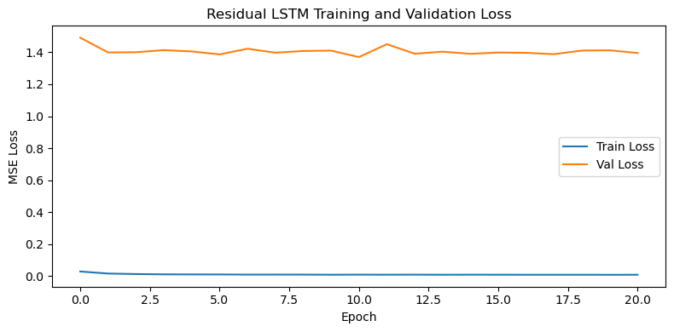
Figure 5.2. Training and validation loss curves for the residual LSTM model.

^{5.2 Comparative Analysis}
A comparative analysis is conducted to examine the forecasting behavior of the three models—XGBoost, LSTM, and the residual-based hybrid approach—using RMSE, MAE, and directional accuracy as the primary evaluation metrics. The results reveal clear differences in how each model balances numerical accuracy and directional prediction.

^{Model} | ^{RMSE} | ^{MAE} | ^{Directional Accuracy} | ^{Interpretation}
^{XGBoost} | ^{~0.39} | ^{~0.14} | ^{~0.98} | Best numerical accuracy and strongest directional performance
^{LSTM} | ^{~2.81} | ^{~2.10} | ^{~0.47} | Weak generalization and poor directional prediction
^{Hybrid (Residual-Based)} | ^{~0.38} | ^{~0.13} | ^{~0.98} | Strong directional signals with increased variance

Table 5.1: Comparative Performance of the Forecasting Models on the Test Set
The standalone XGBoost model clearly demonstrates the strongest overall performance in terms of point forecasting accuracy, achieving the lowest RMSE and MAE values. This reflects its ability to exploit nonlinear interactions among engineered features and to remain stable under volatile market conditions.
In contrast, the standalone LSTM model shows limited predictive capability. Its relatively high error values and low directional accuracy indicate difficulty in generalizing the test period, which is characterized by regime shifts and abrupt price movements.
The residual-based hybrid model presents a distinct performance profile. While its numerical errors are higher than those of XGBoost, it achieves directional accuracy that remains competitive. This suggests that the hybrid approach captures additional temporal information that contributes positively to predicting the direction of price changes.
^{5.3 Discussion of Results}
The empirical results provide a nuanced perspective on the effectiveness of hybrid modeling for gold price forecasting. Rather than uniformly outperforming standalone models, the residual-based hybrid approach demonstrates strengths that are complementary to those of XGBoost.

From a modeling standpoint, XGBoost proves particularly well suited to the engineered feature space used in this study. Its tree-based boosting structure effectively captures nonlinear relationships among price-derived features, resulting in superior numerical accuracy. The LSTM model, by contrast, relies on learning long-term temporal dependencies and therefore struggles when the available historical window is limited and the market environment becomes highly volatile.

The behavior of the residual-based hybrid model highlights an important trade-off. By modeling the residual errors of the XGBoost baseline, the LSTM component captures additional temporal structure that improves directional prediction. However, this also introduces additional variance, which explains the higher RMSE and MAE values compared to XGBoost. As illustrated in Figure 5.3, the hybrid model follows the general price trend and successfully identifies several major turning points in the test period, despite exhibiting smoother but less precise price-level estimates.

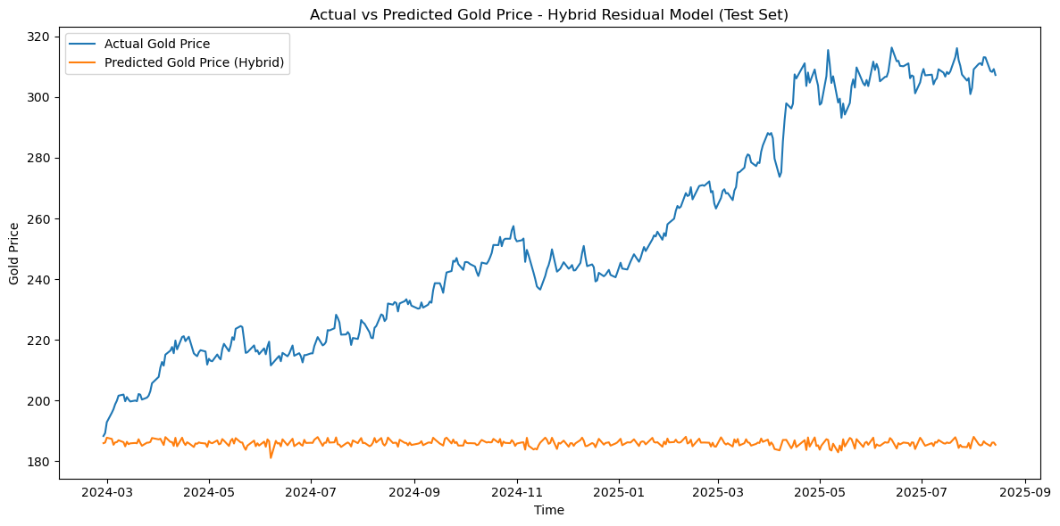
Figure 5.3. Actual vs predicted gold prices using the residual-based hybrid model on the test set.
In practical terms, these findings suggest that model selection should be aligned with the specific decision-making objective. When precise point forecasts are required, XGBoost offers superior performance. When the correct anticipation of price direction is more important, the residual-based hybrid model provides competitive and potentially useful signals.

Chapter 6 – Discussion and Conclusion

^{6.1 Discussion}
The results of this study provide a clear perspective on how different forecasting models behave when applied to gold price prediction under volatile market conditions. Rather than identifying a single model that dominates across all evaluation criteria, the findings demonstrate that each model exhibits distinct strengths depending on the forecasting objective.
The XGBoost model achieved the highest numerical accuracy, as reflected by the lowest RMSE and MAE values. This outcome suggests that tree-based gradient boosting methods are particularly well suited to the structured and engineered feature space used in this study. XGBoost effectively captures nonlinear relationships among price-derived features, even when the available data window is limited and market conditions are unstable.
In contrast, the standalone LSTM model showed weaker performance, characterized by higher prediction errors and lower directional accuracy. This behavior highlights a practical limitation of sequence-based deep learning models: when the historical training window is relatively short and the test period exhibits frequent regime shifts, LSTM models may struggle to generalize reliably. These findings support the view that deep learning is not always the optimal choice in financial forecasting, especially under data and stability constraints.
The residual-based hybrid model demonstrated a balanced performance profile. Although it did not improve numerical accuracy compared to XGBoost, it achieved directional accuracy that was very close to the best-performing model. This indicates that hybridization can add value by enhancing the model’s ability to anticipate price direction, even when point-wise prediction errors remain relatively high. Such behavior is particularly relevant in trading and risk-management contexts, where directional signals often carry greater practical importance than exact price levels.
Overall, the discussion underscores that the effectiveness of a forecasting model depends strongly on the intended application. While XGBoost is preferable for precise price-level prediction, the hybrid residual approach offers meaningful advantages when directional forecasting is the primary objective.

^{6.2 Conclusion and Future Work}
This study investigated a hybrid forecasting framework that integrates Long Short-Term Memory (LSTM) networks with the XGBoost algorithm for gold price prediction. The proposed approach was designed to combine temporal sequence learning with nonlinear feature modeling in order to improve forecasting robustness under volatile market conditions.
The empirical results show that the XGBoost model delivers the strongest numerical performance, achieving the lowest RMSE and MAE values on the test set. While the residual-based hybrid model did not outperform XGBoost in terms of numerical accuracy, it demonstrated strong directional accuracy, highlighting its potential usefulness in applications where anticipating the direction of price movement is more important than minimizing forecast error magnitude. The standalone LSTM model, by comparison, exhibited limited generalization capability during the volatile test period.
Several directions for future research emerge from these findings. One promising avenue is the exploration of transformer-based architectures, which have shown strong potential in modeling long-range dependencies in time-series data. Another direction involves incorporating additional macroeconomic or real-time market indicators to enrich the feature space and potentially enhance model robustness. More advanced hyperparameter optimization techniques, such as Bayesian optimization, may also improve performance. Finally, extending the proposed framework to multiple assets or deploying it within real-time decision-support systems represents a valuable area for further investigation.

^{Limitations}
Despite the contributions of this study, several limitations should be acknowledged. First, the historical window available for training the LSTM model was relatively short, which may have constrained its ability to learn stable long-term temporal patterns, particularly during the highly volatile 2024–2025 period. Second, the analysis relied primarily on price-based and engineered features; broader macroeconomic variables and alternative data sources were not fully explored due to data availability constraints.

Finally, the residual-based hybrid approach inherently amplifies variance when residual volatility is high, which helps explain its elevated RMSE and MAE values compared to XGBoost. These limitations suggest that future research would benefit from richer datasets, longer historical horizons, and more advanced modeling architectures to further improve forecasting performance.

References

[1] Amini, A., & Kalantari, R. (2024). Gold price prediction by a CNN–Bi-LSTM model along with automatic parameter tuning. PLOS ONE, 19(3), e0298426. DOI: 10.1371/journal.pone.0298426
[2] Beckmann, J., Berger, T., & Czudaj, R. (2019). Gold price dynamics and the role of uncertainty. Quantitative Finance, 19(4), 663–681. DOI: 10.1080/14697688.2018.1532166
[3] Chai, T., & Draxler, R. R. (2014). Root mean square error (RMSE) or mean absolute error (MAE)? – Arguments against avoiding RMSE in the literature. Geoscientific Model Development, 7(3), 1247–1250. DOI: 10.5194/gmd-7-1247-2014
[4] Chen, T., & Guestrin, C. (2016). XGBoost: A scalable tree boosting system. In Proceedings of the 22nd ACM SIGKDD International Conference on Knowledge Discovery and Data Mining (pp. 785–794). ACM. DOI: 10.1145/2939672.2939785
[5] Cohen, G., & Aiche, A. (2023). Forecasting gold price using machine learning methodologies. Chaos, Solitons & Fractals, 175, 114079. DOI: 10.1016/j.chaos.2023.114079
[6] El-Rashidy, M. A. (2021). A novel system for fast and accurate decisions of gold–stock markets in the short-term prediction. Neural Computing and Applications, 33(1), 393–407. DOI: 10.1007/s00521-020-04887-z
[7] Erdoğdu, A. (2017). The most significant factors influencing the price of gold: An empirical analysis of the US market. Economics, 5(5), 399–406. DOI: 10.1515/econ-2017-0029
[8] Hajirahimi, Z., & Khashei, M. (2019). Hybrid structures in time series modeling and forecasting: A review. Engineering Applications of Artificial Intelligence, 86, 83–106. DOI: 10.1016/j.engappai.2019.07.002
[9] Hochreiter, S., & Schmidhuber, J. (1997). Long short-term memory. Neural Computation, 9(8), 1735–1780. DOI: 10.1162/neco.1997.9.8.1735
[10] Hyndman, R. J., & Koehler, A. B. (2006). Another look at measures of forecast accuracy. International Journal of Forecasting, 22(4), 679–688. DOI: 10.1016/j.ijforecast.2006.03.001
[11] Jabeur, S. B., Mefteh-Wali, S., & Viviani, J. L. (2024). Forecasting gold price with the XGBoost algorithm and SHAP interaction values. Annals of Operations Research, 334(1), 679–699. DOI: 10.1007/s10479-021-04187-w
[12] Kristjanpoller, W., & Minutolo, M. C. (2015). Gold price volatility: A forecasting approach using the artificial neural network–GARCH model. Expert Systems with Applications, 42(20), 7245–7251. DOI: 10.1016/j.eswa.2015.04.058
[13] Liu, Y., Zhang, Y., & Peng, X. (2024). Textual analysis and gold futures price forecasting: Evidence from the Chinese market. Finance Research Letters, 69, 106116. DOI: 10.1016/j.frl.2024.106116
[14] Lundberg, S. M., & Lee, S.-I. (2017). A unified approach to interpreting model predictions. In Advances in Neural Information Processing Systems (NeurIPS 2017) (pp. 4765–4774). Curran Associates. DOI: 10.48550/arXiv.1705.07874
[15] Parisi, A., Parisi, F., & Díaz, D. (2008). Forecasting gold price changes: Rolling and recursive neural network models. Journal of Multinational Financial Management, 18(5), 477–487. DOI: 10.1016/j.mulfin.2007.12.002
[16] Qian, Y., Ralescu, D. A., & Zhang, B. (2019). The analysis of factors affecting global gold price. Resources Policy, 64, 101478. DOI: 10.1016/j.resourpol.2019.101478
[17] Sadorsky, P. (2021). Predicting gold and silver price direction using tree-based classifiers. Journal of Risk and Financial Management, 14(5), 198. DOI: 10.3390/jrfm14050198
[18] Sezer, O. B., Gudelek, M. U., & Ozbayoglu, A. M. (2020). Financial time series forecasting with deep learning: A systematic literature review (2005–2019). Applied Soft Computing, 90, 106181. DOI: 10.1016/j.asoc.2020.106181
[19] Sina, L. B., Secco, C. A., Blazevic, M., & Nazemi, K. (2023). Hybrid forecasting methods—A systematic review. Electronics, 12(9), 2019. DOI: 10.3390/electronics12092019
[20] Varshini, A., Kayal, P., & Maiti, M. (2024). How good are different machine and deep learning models in forecasting the future price of metals? Full sample versus sub-sample. Resources Policy, 92, 105040. DOI: 10.1016/j.resourpol.2023.105040
[21] Vidal, A., & Kristjanpoller, W. (2020). Gold volatility prediction using a CNN–LSTM approach. Expert Systems with Applications, 157, 113481. DOI: 10.1016/j.eswa.2020.113481
[22] Weng, F., Chen, Y., Wang, Z., Hou, M., Luo, J., & Tian, Z. (2020). Gold price forecasting research based on an improved online extreme learning machine algorithm. Journal of Ambient Intelligence and Humanized Computing, 11, 4101–4111. DOI: 10.1007/s12652-019-01618-3
[23] Yahoo Finance. (2023). Gold price historical data [Data set]. Retrieved December 10, 2023, from https://finance.yahoo.com/quote/GC%3DF/history
[24] Yurtsever, M. (2021). Gold price forecasting using LSTM, Bi-LSTM and GRU. European Journal of Science and Technology, 31, 341–347. DOI: 10.31590/ejosat.959405
[25] Zhang, P., & Ci, B. (2020). Deep belief network for gold price forecasting. Resources Policy, 69, 101806. DOI: 10.1016/j.resourpol.2020.101806

