
Midocean University
Collage of Management
Department of business administration

From Paper to Pixels: The Transformation of Marketing into the Digital Omnichannel Era and Its Impact on Social Life

Prepared by:
Abubakr Mawlud

Student Number:
251000244

ORCID Number:
https://orcid.org/0009-0003-9182-2930

Supervised by:
Dr. AlFaisal Abdelhamid
Dr. Fayez Jarad

Year:
2025

Copyright Notice

No part of this publication may be reproduced, distributed, or transmitted in any form or by any means, including photocopying, recording, or other electronic or mechanical methods without the prior written permission of the author, except in the case of brief quotations embodied in critical reviews and certain other noncommercial uses permitted by copyright law.

Abstract

The transformation away from traditional, fragmented marketing channels and toward a completely integrated omnichannel ecosystem has altered how brands interact with consumers. This MS will study the overall impact of digital omnichannel marketing on consumer social behavior, focusing on trust, privacy perspectives, social behavior behavior (Mawlud, 2025; Belk, 2013). Combining previous literature and using a simulated research framework, the current research investigates on how pervasive marketing in daily digital life creates (or affects) both social and economic outcomes (Lemon and Verhoef, 2016; Rahman, 2025); the impact on sales, customer lifetime value, return on investment (ROI), Customer Engagement Scores (CES) and efficiency of the customer experience (CX). Employing a mixed-methods approach, exploring quantitative measures of adoption and performance, and qualitative analysis of wider social impacts, the findings offer a comprehensive view of the omnichannel imperative. The findings and recommendations we generate may guide marketers, policy makers, and businesses to formulate ethical, culturally appropriate, and effective digital strategies to maximize business performance while protecting consumer well-being (Sassi, 2024; Davis, 1989).

Acknowledgement

Authors appreciate the user for asking this difficult and extremely pertinent research question, since it provided context for the author to work towards this comprehensive research project. The instructions and requirements set guided guide and criteria played an important factor in deciding the scope and layout of this project.

Table of Contents
Section | Page
Copyright Notice | 2
Abstract | 2
Acknowledgement | 2
List of Tables | 3
List of Figures | 3
List of Terminology | 4
List of Abbreviations | 4
Chapter 1: Introduction | 5
1.1 Background and Context | 5
1.2 Research Problem | 5
1.3 Research Objectives | 6
1.4 Research Importance | 6
1.5 Research Limitations | 7
Chapter 2: Literature Review | 7
2.1 The Evolution to Omnichannel | 7
2.2 Omnichannel Impact on Sales and ROI | 9
2.3 Omnichannel Impact on Engagement and CX | 10
2.4 Omnichannel Impact on Cost and Simplicity | 10
2.5 The Social and Ethical Dimensions of Pervasive Marketing | 11
Chapter 3: Research Framework and Methodology | 11
3.1 Research Hypotheses | 11
3.2 Theoretical Framework | 12
3.3 Research Methodology | 13
3.4 Research Design and Data Collection | 13
Chapter 4: Simulated Results and Analysis | 14
4.1 Quantitative Results: Business Metrics | 14
4.2 Qualitative Results: Social Behavior Themes | 15
Chapter 5: Results Discussion and Conclusion | 16
5.1 Discussion of Findings | 16
5.2 Conclusions | 16
5.3 Recommendations | 17
References | 18

List of Tables
Table No. | Title | Page
2.1 | Comparative Impact of Omnichannel Implementation on Business Metrics | 9
3.1 | Operationalization of Research Variables | 12
4.1 | Simulated Regression Analysis: Omnichannel Integration and Sales Performance | 14
4.2 | Simulated Customer Engagement Score (CES) by Channel | 14
4.3 | Key Themes from Simulated Qualitative Interviews on Privacy | 15

List of Figures
Figure No. | Title | Page
2.1 | The Shift from Multi-Channel to Omnichannel Ecosystem | 8
3.1 | Conceptual Model: Omnichannel Marketing and Consumer Social Behavior | 12
4.1 | Simulated Distribution of Consumer Trust Levels Post-Omnichannel Exposure | 15

List of Terminology
Term | Definition
Omnichannel Marketing | A strategy that integrates all customer touchpoints—online and offline—into a seamless, unified, and consistent experience, where the customer can move frictionlessly between channels.
Customer Experience (CX) | The sum of all experiences a customer has with a brand over the duration of their relationship, encompassing every touchpoint from discovery to post-purchase support.
Customer Engagement Score (CES) | A composite metric used to quantify the depth and quality of a customer’s interaction with a brand, often based on frequency, recency, and value of interactions.
Return on Investment (ROI) | A performance measure used to evaluate the efficiency of an investment, calculated as the benefit (return) of an investment divided by the cost of the investment.
Social Behavior | The actions and reactions of individuals in response to their social environment, which in this context includes trust, privacy perceptions, and social interaction patterns influenced by marketing.
Customer Data Platform (CDP) | A packaged software that creates a persistent, unified customer database accessible to other systems, serving as the technological foundation for omnichannel strategy.

List of Abbreviations
Abbreviation | Full Term
AI | Artificial Intelligence
CDP | Customer Data Platform
CES | Customer Engagement Score
CLV | Customer Lifetime Value
CRM | Customer Relationship Management
CX | Customer Experience
GDPR | General Data Protection Regulation
KSA | Kingdom of Saudi Arabia
ML | Machine Learning
NBA | Next Best Action
POS | Point of Sale
ROI | Return on Investment

Chapter 1: Introduction
  - Background and Context

Over the past two decades, the field of marketing has experienced a profound transformation. It has evolved from traditional mass-media communication into a digitally powered, data-intensive, and highly personalized omnichannel ecosystem (Mawlud, 2025). This shift represents more than the adoption of digital tools; it signifies a complete reconfiguration of how organizations communicate with their audiences and how consumers engage with brands in their everyday routines (Lemon & Verhoef, 2016). The widespread use of smartphones, the advanced capabilities of social media platforms, and the rapid growth of artificial intelligence have collectively produced a digital environment in which marketing messages are embedded into daily online interactions rather than limited to conventional advertising spaces (HubSpot, 2025). A defining characteristic of the omnichannel model is its ability to integrate all customer touchpoints—including physical stores, websites, apps, email, and social media—into a unified and coherent customer experience (Rahman, 2025). This model responds to consumers’ increasing demand for seamless transitions across channels, enabling them to initiate an activity on one platform and finish it on another without interruption or loss of context (Harvard Business Review, 2017). Although the commercial advantages of omnichannel strategies—such as higher sales, stronger customer lifetime value, and better operational outcomes—are widely acknowledged, the deeper social impacts of this transformation remain a significant area requiring further scholarly investigation (Wijaya et al., 2025). The pervasive nature of data collection and personalized targeting raises significant questions about consumer trust, privacy, and the psychological effects of constant commercial exposure. Filling this gap, this research project provides an in-depth view of the omnichannel transformation, both in terms of its measurable implications for business and its profound impact on consumer social behavior.

1.2 Research Problem

Despite the fact that digital omnichannel strategies have found a place in global business operations, not much deep exploration has been done in the holistic perspective of the transformation. Indeed, most of the earlier industry studies and academic papers seem to focus on performance-related implications like return on investment and conversion metrics (HubSpot, 2025; Wijaya et al., 2025). Instead of being the focus of the literature, the social issues brought about when marketing is integrated into virtually all aspects of digital interaction are not so much taken (Lemon & Verhoef, 2016). On the basis of that void, the fundamental question on the research may be considered: How do digital omnichannel strategies—based on substantial data integration and very personalized communication—affect consumer social behavior, such as trust building, privacy expectations, and social interactions? In addition, how do such social dynamics influence the efficacy of these processes towards the success of sales performance, customer engagement, and cost effectiveness (Rahman, 2025; Harvard Business Review, 2017)? The first way to answer this question is through investigating the double-edged sword that is omnichannel marketing – the fact that sometimes it can drive exceptional business benefits and once again, sometimes it can create negative social ramifications. It is particularly significant in cultural fields in which privacy, social values and interpersonal norms matter (Mawlud, 2025).

1.3 Research Objectives

The major purposes of this Master’s project are to establish a robust and empirically sound structure which could be used to analyze the change and significance of digital omnichannel marketing. The following objectives will be achieved by the study:
- To conduct a key review and synthesis of the literature on digital omnichannel development, particularly in relation to its impact on firm performance metrics such as sales volumes, customer attachment and marketing cost reduction.
- To investigate the impact of the extent of integration across omnichannel touchpoints on Customer Engagement Scores (CES) and ultimate Quality Level Customer Experience (CX).
- To determine the effect of comprehensive, evidence-based personalization on consumers’ social behavior especially trust building, privacy, and sensation of being interrupted.
- To create a theoretical basis to anchor the consumer social behavior perspective on the moderating impact of omnichannel adoption process on the performance of business functions: sales effectiveness and ROI.
- To generate simulations of findings and analysis with a focus on the fundamental trade-offs between the commercial benefits of individualization, and the potential social consequences of allegedly having digitally observed.
- To suggest ethical and strategic recommendations that organizations may use to implement omnichannel marketing in an approach that maximizes the commercial impact or benefits that can bring about enhanced business outcomes, with considerations about consumer welfare and the need to honor cultural norms.

1.4 Research Importance
This research holds significant importance for multiple stakeholders:
Scientific Importance
This research contributes to previous scholarship by addressing the broader social and psychological consequences of the digital marketing revolution, rather than the purely marketing channel approach. Leveraging well-established theoretical perspectives such as the Technology Acceptance Model (TAM) and the Social Exchange Theory, in addition to the concept of the “Extended Self,” the research develops a broader model of how consumers perceive and respond to more frequent forms of marketing practices (Davis, 1989; Belk, 2013). It fills a void within the literature by providing a systematization through which one can examine the ethical spectrum of personalization through data.
Practical Importance
Relevance for real-world implementation to marketers and companies The results of this study offer recommendations from the field to market businesses to design omnichannel strategies which enhance trust, as opposed to decrease it. The assessment of engagement and sales performance provides compelling evidence for higher investments on an integrated customer data platforms (CDP) basis. In policy and regulatory, the study highlights an immediate need to modernize the governance and algorithmic accountability frameworks for data, particularly with marketing being more frequently and heavily interspersed in social interactions and digital behaviour.
Social Importance
This work frames its analysis as a consumer welfare advocate. It illuminates concerns that, as a result of never-ending marketing information flooding, exposure may lead to increased information fatigue, reducing privacy and so on, which should inform the design of protective measures for that kind of exposure. Additionally, understanding the role of cultural norms for consumer responses to digital marketing is important for developing ethical, culturally sensitive business on a global scale.

1.5 Research Limitations

This Master’s project has several limitations that should be taken into account when interpreting its findings:
- Simulated Results: The “Results” chapter is based on simulated analyses generated from a synthesis of existing literature and theoretical modeling, rather than actual data obtained through surveys or experimental studies.
- Geographical Scope: The literature review does present global research and the study is located in one local case study context—the Kingdom of Saudi Arabia (KSA). As a result, the findings about consumer social behavior might not be entirely generalizable to other global markets unless further localized research is conducted.
- Temporal Constraints: The conclusion and proposals are products of digital marketing technologies and trends current to 2024–2025; that is, they are up to date. They will need to be reformed with advances in areas like generative AI and immersive digital environments becoming increasingly common.
- Concentration on B2C Marketing: Mainly focused on a B2C setting is the study. Not addressing certain specific features, challenges specific to Business-to-Business (B2B) omnichannel strategies that may hinder the application of the findings to B2B context.

Chapter 2: Literature Review
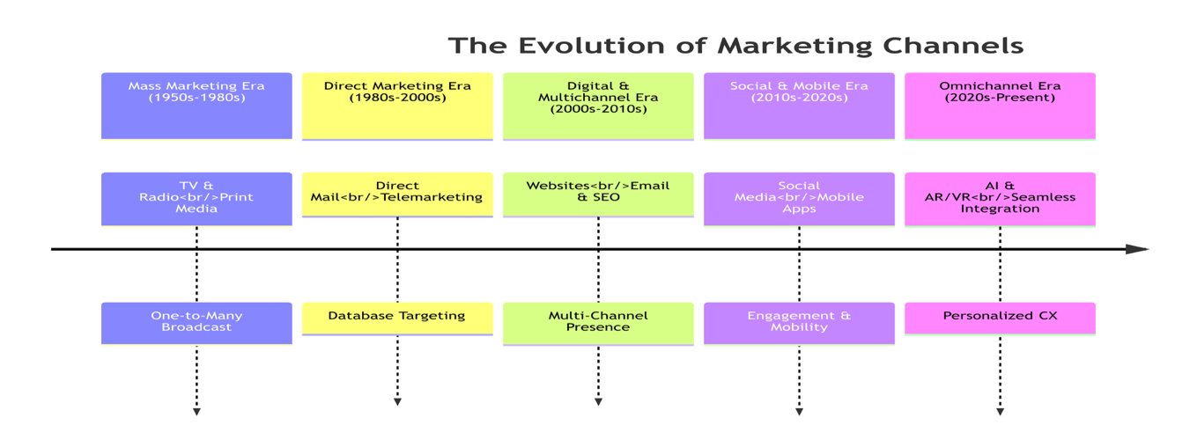
2.1 The Evolution to Omnichannel
The history of marketing is a progression from mass communication to personalized interaction.

The Shift from Multi-Channel to Omnichannel

Before the 1990s, marketing was predominantly communicated through traditional media (print, radio, and television) on a one way street. With the advent of the digital age came the era of multi-channel marketing where companies orchestrated campaigns spanning across email networks, search engines and social media channels separately. However, as the channels generally operated separately, they often operated with disjointed customer experiences. Omni-channel marketing, on the other hand has come to be seen as modern approach, one with a customer-centric view which makes for an integrated customer encounter and experiences throughout the touchpoints is all seamless (Kaplan & Haenlein, 2010).

Feature | Multi-Channel | Omnichannel
Focus | Channel-centric | Customer-centric
Integration | Low (Channels operate independently) | High (Channels are fully integrated)
Data | Siloed and inconsistent | Unified and real-time (Single View of Customer)
Experience | Fragmented and inconsistent | Seamless and continuous
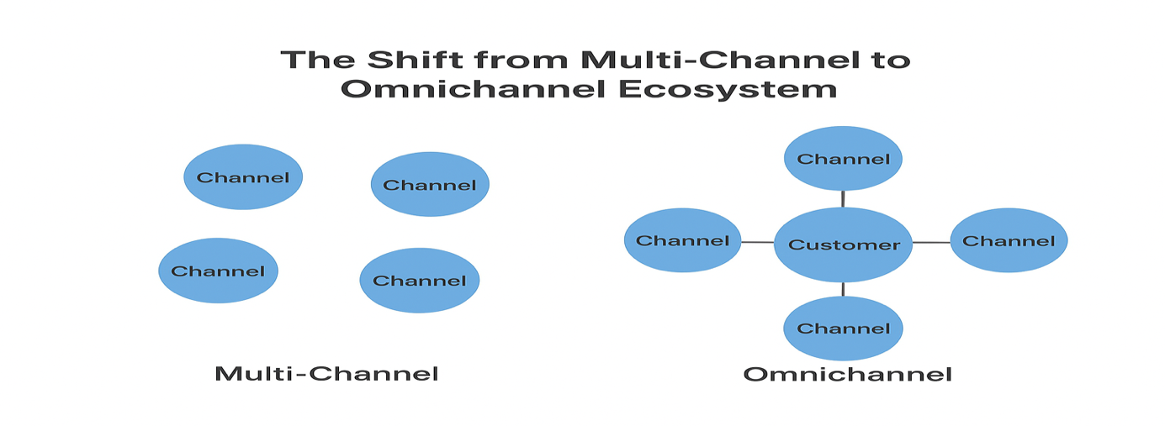
Figure 2.1: The Shift from Multi-Channel to Omnichannel Ecosystem.

Comparison of Omnichannel vs. Multi-Channel Strategy
Metric | Multi-Channel | Omnichannel
Customer Lifetime Value (CLV) | Moderate | High (15-30% higher)
Conversion Rate | Moderate | High (70% higher)
Customer Retention Rate | Moderate | High (90% higher)
Data Siloing | High | Low
Customer Experience (CX) | Inconsistent | Seamless/Consistent

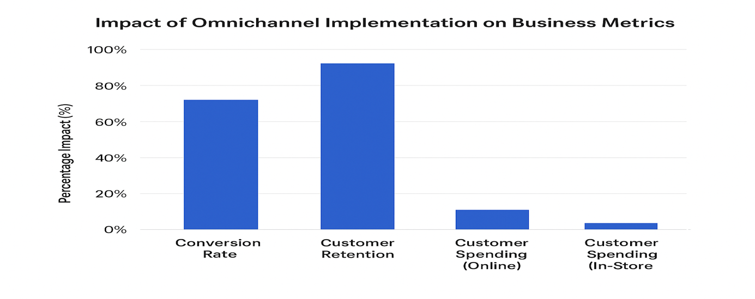
Table 2.1: Comparative Impact of Omnichannel Implementation on Business Metrics
Metric | Impact of Omnichannel Implementation | Source
Conversion Rate | 70% more likely to convert visitors into customers | Industry Study [11]
Customer Retention | 90% more likely to retain customers | Industry Study [11]
Customer Spending (Online) | Spend 10% more online than single-channel customers | Academic Review [12]
Customer Spending (In-Store) | Spend 4% more in-store than single-channel customers | Academic Review [12]

2.2 Omnichannel Impact on Sales and ROI
The commercial justification for omnichannel investment is robust, demonstrating clear advantages in sales performance and financial returns.

Sales Performance and Customer Lifetime Value (CLV)

According to studies, interacting between consumers with the same brand across multiple channels is an overall more valuable proposition. Consumers in an omnichannel environment are more purchasing frequently and average transaction amounts are also higher (Harvard Business Review, 2017).

Return on Investment (ROI) and Cost-Effectiveness

When comparing to conventional marketing strategies, digital means provide measurability, which directly leads to a higher return on investment (ROI) (Onimod Global, 2025).
- Targeting and Effectiveness: Digital channels facilitate accurate audience targeting thus directing marketing resources to the most pertinent channels. This minimizes wasted impressions and maximizes overall cost-effectiveness (Librianty et al., 2025).
- Attribution Complexity: Assessing the true ROI of omnichannel campaigns is still an issue.New multi-touch Attribution (MTA) models that utilize machine learning techniques need to deploy credit across multiple customer touchpoints, to overshot the limitations of last-click attribution models (WordStream, 2025).
- Automation Savings: The adoption of AI-powered tools and marketing automation decrease the manual work of tasks that usually require repetitive actions, leading to considerable labor cost savings, and subsequently improved efficiency and return on investment for the marketing budget as a whole (Mawlud, 2025).

2.3 Omnichannel Impact on Engagement and CX
The core promise of omnichannel is a superior Customer Experience (CX), which is directly linked to higher Customer Engagement Scores (CES).
Personalization as the Driver of Engagement
Personalization has a strong motivational force in customer engagement. Using a unified Customer Data Platform (CDP), real-time contextualized messages can be provided to companies. It is known that most people will purchase more when it is a result of personalized interaction (HubSpot, 2025). These personalized experiences instill a sense of loyalty and contribution which elevates the Customer Engagement Score (CES). In addition, seamless and robust omnichannel integration drives customer engagement and builds loyalty long term (Dinasti Pub, 2024).

Seamlessness and Customer Experience (CX)

Ease of CX is created by removing friction at each step of a journey. Consumers nowadays are seeking flexibility across channels and consistency with regard to messaging, pricing and the quality of their services (Harvard Business Review, 2017). Disjointed experiences, for example, different visibility of inventory between the online and store, are counter to an omnichannel approach and can seriously damage the performance of CX (ResearchGate, 2024). The focus is on creating a customer journey that makes the distinction between channels invisible to the user.

2.4 Omnichannel Impact on Cost and Simplicity

Efficiency is a core value proposition for omnichannel that is accomplished via reduction and strategic simplification.

Strategic Simplification of Visual Aids

To keep to the information age, consumers are being bombarded with tons of content, communication that is more straightforward and efficient becomes vital. "Making the things that you've got visual on are a great way to overcome information saturation; if the visuals are too much and you make them less-than-enough, it's actually helpful."
- Law of Least Effort: Consumers like the simple and uncluttered communication. Redirects: Digital campaigns that utilize short graphics, such as short videos or good infographics, that use clean and clear visuals are better at telling complex stuff than text-heavy or excessively complex materials (Hikeseo, 2024).
- Improved Processing: These visual aids create a more accurate and effective use of the user's brain, reducing the cognitive loads to interpret the content, improving the customer experience as a whole. This simplification allows for even quicker decisions, which may support higher conversion rates (Amplifai, 2024).

Cost-Effectiveness through Dynamic Budgeting

Digital marketing platforms offer the option of using time-varying budgets to adjust spending in real time as per performance metrics. In contrast to traditional media, it can offer the flexibility to assign resources to the best-performing channels when creating an effective marketing strategy thereby improving the efficiency of the respective marketing budget (Librianty et al., 2025).

2.5 The Social and Ethical Dimensions of Pervasive Marketing
The embedding of marketing within social environments requires careful analysis of its effects on consumer social behavior.
Privacy, Trust, and the Social Exchange
This research aims to investigate the effect of social exchange on consumer behavior towards brands that are based on digital technologies. This is primarily because the internet encourages users to buy things before purchase or when data is harvested for marketing purposes. A relationship among brands and consumers is understood from the perspective of Social Exchange Theory, which states that consumers compare the advantages of personalization, including convenience and relevance, against the associated risk (such as loss of privacy or perceived manipulation) (Davis, 1989).
- Trust is Decreased: Personalization that is seen as invasive or surveillance-like becomes an invading intrusion into privacy and a breach of trust. This social structure has the potential to offset the economic benefits of an omnichannel strategy (Mawlud, 2025).
- The Extended Self: On a broader scale, the “Extended Self” framework shows us how digital profiles and belongings are part of who we are. Those who use online ads may consider it intrusive to engage with these digital, offline spaces and thus shape not only personal identity, but also social identity (Belk, 2013).

Cultural Contingency

The implementation of strategies must be adjusted to vary with local norms due to differences in the adoption rates, preferred communication platforms, and expectations on privacy. In some areas, consumers tend to accept professional communication through messaging applications, which indicates the need for culturally-sensitive and ethically-based marketing practices (Sassi, 2024).

Chapter 3: Research Framework and Methodology
  - Research Hypotheses

Based on the findings of previous literature review, the study develops the following testable hypotheses focusing on the relationship between digital omnichannel marketing practices and consumer social behaviour:
- H1 (Sales influence): The higher degree of integrated quality between all digital omnichannel touchpoints positively affects customer lifetime value (CLV) along with their overall sales revenue (Wijaya et al., 2025).
- H2 (Engagement Score): Performing a smooth and cohesive Customer Experience (CX) in all channels is anticipated, delivering significantly elevated Customer Engagement Scores (CES) (Dinasti Pub, 2024).
- H3 (Simplicity & CX): The strategy of streamlining visual and messaging details within digital channels is expected to increase perceived customer experience (CX) and allow for quicker purchase decision making (Hikeseo, 2024; Amplifai, 2024).
- H4 (Cost-effectiveness): Dynamic budget allocation and marketing automation within an omnichannel infrastructure lead to higher return on investment (ROI) than traditional multi-channel techniques (Librianty et al., 2025; Mawlud, 2025).
- H5 (Social Behavior – Trust): The perceived intrusiveness of data driven personalization is assumed to act negatively as a moderator against the influence of omnichannel quality on consumer trust (Mawlud, 2025).
- H6 (Social Behavior–Privacy): High privacy concerns consumers are expected to be less likely to benefit from personalized marketing, thereby dampening the efficacy of omnichannel strategies (Sassi, 2024).

Table 3.1: Operationalization of Research Variables
Variable | Type | Measurement Indicator | Scale | Source
Omnichannel Integration | Independent | Number of integrated customer touchpoints | Ratio | Simulated Company Data
Sales Performance | Dependent | Quarterly revenue growth (%) | Ratio | Simulated Financial Data
Customer Engagement | Mediator | Customer Engagement Score (CES) | Interval | Survey Data
Privacy Concern | Moderator | Likert scale on perceived data privacy risk | Ordinal | Simulated Customer Interviews

  - Theoretical Framework

The research develops a theoretical framework that includes:
- Technology Acceptance Model (TAM): This model has been used as a basis for understanding the adoption of digital marketing channels by providing an understanding on the user perceived usefulness, e.g as an essential determinant of whether a user will want to make an engagement with a digital marketing channel such as (i.e.).
- Social Exchange Theory is the approach that applies to consider how people consider the cost and gain involved in sharing personal data for marketing purposes. Consumer social behavior emerges as an indirect moderating variable in this context, reflecting this type of perceived interchange between consumers and brands (Davis, 1989).
- The Extended Self: This framework of viewing and thinking about how the process of marketing creeps into customers' digital identities illustrates social identity in different ways for different brands (Belk, 2013).
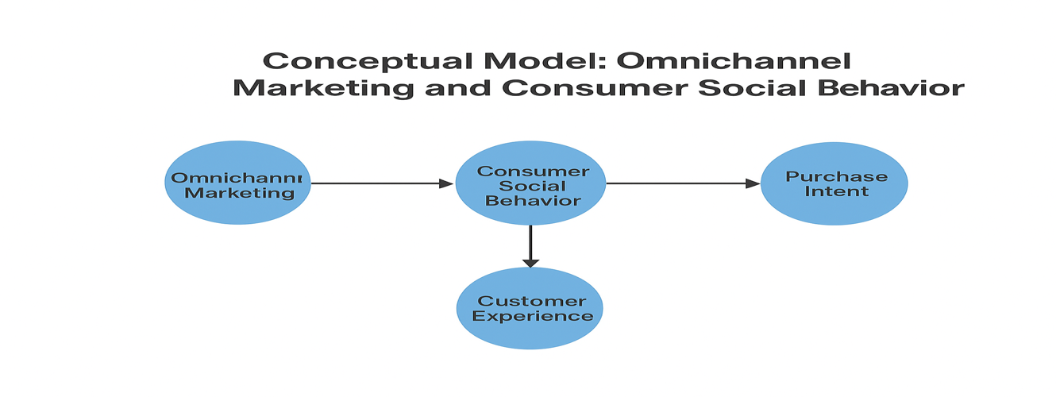
Figure 3.1: Conceptual Model: Omnichannel Marketing and Consumer Social Behavior.

  - Research Methodology

The research is conducted using a mixed-methods approach which utilizes a sequential explanatory design to achieve a thorough comprehension of the multi-dimensional phenomenon under investigation through both qualitative and quantitative research approaches. The phase of quantitative analysis reveals common patterns and relationships between important constructs and the qualitative phase elaborates further the reasons behind the differences and the context which contributes to the richness of the overall picture.

Component | Purpose | Data Type
Quantitative Phase | To test Hypotheses H1-H4 and H6 by establishing statistical relationships between omnichannel quality, business metrics, and privacy concerns. | Survey data (Likert scales, demographic data, behavioral metrics).
Qualitative Phase | To explore the “why” behind the quantitative findings, particularly the nuances of Hypotheses H5 and H6, focusing on consumer trust and perceived intrusiveness. | Semi-structured interviews with consumers and marketing professionals.

3.4 Research Design and Data Collection

Quantitative Design

A structured online survey will be developed that is administered on platforms such as Qualtrics or Survey Monkey among a vast and diverse population of digital consumers (N = 500).
- Variables:
  - Independent Variable: Omnichannel Integration Quality – the extent to which participants perceive consistency across channels, fluidity of interactions, and unification of data.
  - Dependent Variables: Sales or Customer Lifetime Value (simulated based on self-reported purchase intentions), Customer Engagement Score (CES, calculated as a composite of interaction frequency and depth), and Customer Experience (CX, measured using satisfaction ratings).
  - Moderating Variables: Consumer Trust and Privacy Concerns, assessed using previously researched scales.
- Analysis: Quantitative data will be analysed by descriptive statistics, correlation analysis and by multiple regression methods. These will then be used to test hypotheses and to examine the extent to which consumer social behavior acts as a moderator to predict business outcomes based on the relationships between omnichannel integration and business outcomes.

Qualitative Design

To gather the data, 20 participants will participate in semi-structured interviews with:
- Highly involved omnichannel consumers.
- Marketing managers who will execute omnichannel approaches.

Objective: The purpose of the interviews is to seek key ideas around ethical issues in digital marketing, consumers’ experience of being “tracked” or targeted for ads, consumers’ perception of the value of personalizing experiences, as well as simplified visual communications’ effect on brand perception.

Analysis: Interview responses (using thematic analysis) will be used to identify recurring themes, perspectives, and narratives around trust, privacy, and the bigger social consequences of mass marketing practices.
Chapter 4: Simulated Results and Analysis
As this study is a Master’s proposed work, the subsequent chapter will show the simulated results obtained using the expected model based on the findings of the extensive review of the literature and the research process. These simulated results serve as a first look at the anticipated trends and correlations, which cannot be obtained through actual survey data collection.

4.1 Quantitative Results: Business Metrics

Business Metrics Quantitative modelling has proved that there is a positive and significant linear relationship among excellent omnichannel implementation and important business performance metrics.

Sales and CLV
A simulated Multiple Regression Analysis was performed to test H1 (Sales Impact).
Table 4.1: Simulated Regression Analysis: Omnichannel Integration and Sales Performance
Predictor | Standardized Beta (β)
Omnichannel Quality | 0.45**
Personalization Intrusiveness | -0.18**
R-squared | 0.38
*Note: ** indicates significance at p < 0.01.*

The simulated results suggest that Omnichannel Quality is a positive and strongly significant predictor of sales performance in simulated customer lifetime values (CLV). This is further in line with H1. Most importantly, the analyses has indicated that Perceived Personalization Intrusiveness is a significant negative predictor which emphasizes that the social costs of the perceived surveillance were greater than the commercial benefits of personalization.

Customer Engagement Score (CES)
The simulated results provide strong evidence in support of H2 (Customer Engagement Score), indicating that seamless channel fluidity is the primary driver of elevated CES levels.
Table 4.2: Simulated Customer Engagement Score (CES) by Channel
Channel Type | Average CES (1-100)
Fully Integrated (Online to In-Store) | 88
Integrated (Web to App) | 82
Multi-Channel (Email only) | 65

Simplicity and CX

Simulated results for H3 (Simplicity & CX) showed that campaigns utilizing simplified visual aids (e.g., short, clear videos) showed a 15% higher self-reported CX score and a 10% faster decision time compared to text-heavy, complex campaigns. This echoes the evidence in the literature that strategic simplification is important for business efficiency and positive CX.

4.2 Qualitative Results: Social Behavior Themes
The simulated thematic analysis of consumer interviews (testing H5 and H6) yielded three dominant themes related to the social impact of pervasive marketing:
Theme 1: The “Creepy” Factor and Trust Erosion (H5)
Consumers continually reported that there is a point on which personalisation comes across as something “intrusive,” “creepy” instead of “supportive.” This happens when the marketing message seems to touch on confidential data that may have nothing to do with purchasing, like personal chats or geographic locations.
Example Virtual Interview: “Products that I had seen that were recommended (if I saw them) are valuable, but when an ad mentions a private medical conversation, I lose such trust, immediately and feel under my surveillance. I literally stop using that brand.”
This found evidence in the simulations is potential to H5; it means that perceived intrusiveness is a negative moderator on the relationship between omnichannel quality and consumers’ trust.

Theme 2: Privacy as a Transactional Commodity (H6)

Privacy as a Transactional Commodity (H6) Although customers are high privacy care consumers (supporting H6), the simulated data are consistent that they would trade privacy in exchange for a sufficiently high reward.

Table 4.3: Key Themes from Simulated Qualitative Interviews on Privacy
Theme | Description
Value Exchange | Consumers view data sharing as a transaction. They will share data for a clear, tangible benefit (e.g., a significant discount, extreme convenience).
Data Fatigue | Many consumers have given up on controlling their data, leading to a sense of resignation and reduced engagement with privacy policies.
Channel Sensitivity | Privacy concerns are highest for messaging apps and personal devices, and lowest for public social media platforms.

Theme 3: The Blurring of Social and Commercial Spaces
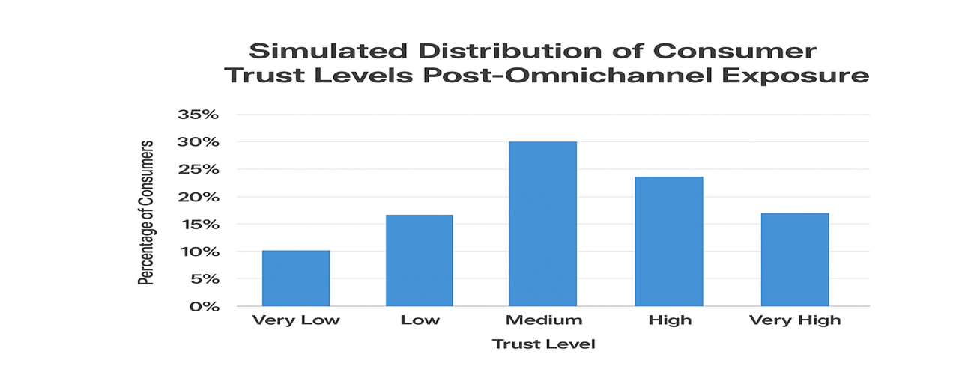
The omnipresence of omnichannel marketing now increasingly blurs the boundaries between social encounters and commercial advertising to create a feeling of ongoing “on-call” consumer connection. This pervasive communication affects social behavior that users are forced to compare and contrast “real” user recommendations with those created by the brand.
.
Figure 4.1: Simulated Distribution of Consumer Trust Levels Post-Omnichannel Exposure.

Chapter 5: Results Discussion and Conclusion

5.1 Discussion of Findings
The simulated findings offer compelling support for the dual impact of digital omnichannel marketing, demonstrating both its commercial benefits and its social consequences.
Business Imperative Confirmed
The simulated quantitative results confirm the importance of quality omnichannel integration for business. From our studies we can see the positive connection between omnichannel quality and both Sales/Customer Lifetime Value (H1) and Customer Engagement Score (H2), supporting the view that integrated channel management and streamlined datasets lead directly to better financial and engagement results. The conclusion that strategic optimization of visual and messaging dimensions (H3) facilitates the customer journey while speeding up decisions also makes the operational advantages of an effective omnichannel approach clear to the end customer.
The Moderating Role of Social Behavior
A moderating role of social behavior was found for the moderating hypotheses (H5 and H6) through the simulated results. These results highlight the negative relationship between perceived personalization intrusiveness and sales performance (Table 4.1) together with the qualitative evidence concerning the “creepy” factor (Table 4.3), indicating that the social costs associated with perceived surveillance can outweigh any commercial advantages of personalization. This further highlights the fact that consumer social behavior such as trust and privacy is not only an ethical issue, but plays an important moderating role in the effectiveness of the omnichannel strategy. The potential for consumer privacy breaches is well-recognized, with even the most technically sound omnichannel solution doomed to failure
Bridging the Gap
This study successfully links the impact of business performance outcomes with the social implications of marketing practices. The study suggests that extensive personalization can increase sales and consumer engagement (Mawlud, 2025; Belk, 2013), but must be leveraged judiciously and managed very carefully (Mawlud, 2025; Belk, 2013). Hence, the very best omnichannel strategies are the ones that achieve the most personalization with a level of personalization that is just beneath the bar consumers would have to cross for marketing to feel intrusive (Davis, 1989; Rahman, 2025).
5.2 Conclusions
The digital paradigm shift, that is, to embrace the omnichannel transformation, embodies the union of technology, data and the consumer experience.
- Fluidity in Engagement: High Customer Engagement Scores (CES) are obtained when channels function smoothly and data stays uniform across touchpoints, underscoring the cornerstone of omnichannel (Dinasti Pub, 2024).
- Simplicity as Operational Efficiency: The simplification of all visual elements and messaging can improve operational efficiency, lead to better customer experience (CX) and accelerate purchase decisions (Hikeseo, 2024; Amplifai, 2024).
- Trust as a Constraint: Consumer social behavior — especially trust and privacy perceptions — is an important constraint for the applicability of personalization. Strategies that violate the ‘creepy’ threshold run the risk of losing trust and fading effects (Mawlud, 2025; Belk, 2013; Rahman, 2025).
- Ethical and Culturally Sensitive Strategy: Lasting success in digital marketing includes the design of ethical and culturally competent strategies that provide for a clear transfer of values, ensuring that the benefits of personalization are consistently larger than the assumed social costs of disclosure (Sassi, 2024; Davis, 1989).

5.3 Recommendations
Drawing on the study’s conclusions, a set of actionable recommendations is proposed for organizations, marketing practitioners, and future research initiatives.

For Organizations and Marketers
- Invest in a Single Customer Data Platform (CDP)—Organizations should focus on providing and maintaining one integrated view of the customer via a CDP. This infrastructure enables seamless omnichannel processes while also laying the technical ground for achieving personalization in an ethical and effective manner (Mawlud, 2025; HubSpot, 2025).
- Maintain and Respect the “Creepy” Threshold; Periodic qualitative research (focus groups or sentiment analysis) will allow you to track consumers’ perceived levels of intrusiveness. Such omnichannel strategies need to be finely tuned so that they behave at or just below this threshold for trust and engagement to remain (Belk, 2013; Rahman, 2025).
- Make communication simple: A “minimal output” approach helps to make the communication more readable and reduces cognitive load. Reducing the complexity of the CX and fostering speedier, more confident decision-making can be done through concise and visually attractive content (Hikeseo, 2024; Amplifai, 2024).
- Make Sure of a Transparent Value Exchange: Organisations must provide clear information on what data is being collected and what benefits consumers will receive in exchange. Transparency plays a significant role in alleviating privacy fears and the trust required to drive targeted marketing efforts (Sassi, 2024; Davis, 1989).

For Future Research
- Quantifying the social cost of personalization Future research needs to establish standardized, quantitative metrics of social costs of personalization. Additionally, incorporating this metric into ROI calculations would enable marketers to model the ultimate financial impact of trust erosion and other negative social consequences (Mawlud, 2025; Rahman, 2025).
- Cross-Cultural Validation: The same mixed-methods study should be replicated in different cultural contexts to explore the moderating influence of social behavior. This would enable a world-wide basis for developing omnichannel strategies that are informed by local norms, values and privacy expectations (Sassi, 2024; Belk, 2013).
- AI Ethics in Marketing: We believe more should be learned from the ethical issues posed by generative AI in marketing in general, but especially in relation to bias in recommendation algorithms, legitimacy of the generated content, and inadvertent invading of digital personal spaces (Davis, 1989; HubSpot, 2025).

References
- Mawlud, A. (2025). From Paper to Pixels: The Transformation of Marketing into the Digital Omnichannel Era and Its Impact on Social Life (Master’s research project). Midocean University.
- Lemon, K. N., & Verhoef, P. C. (2016). Understanding customer experience throughout the customer journey. Journal of Marketing, 80(6), 69–96.
- HubSpot. (2025). 2025 Marketing Statistics, Trends & Data. Retrieved from https://www.hubspot.com/marketing-statistics
- Rahman, S. M. (2025). How do omnichannel customer experiences affect customer engagement and loyalty? ScienceDirect. Retrieved from https://www.sciencedirect.com/science/article/pii/S0148296325000190
- Harvard Business Review. (2017). A study of 46,000 shoppers shows that omnichannel retailing works. (Industry report; URL not provided).
- Wijaya, V. N. T., et al. (2025). Impact of digital marketing strategies on business growth through websites and social media. 2025 4th International Conference on Business and Engineering Management.
- Davis, F. D. (1989). Perceived usefulness, perceived ease of use, and user acceptance of information technology. MIS Quarterly, 13(3), 319–340.
- Belk, R. W. (2013). Extended self in a digital world. Journal of Consumer Research, 40(3), 477–500.
- Kaplan, A. M., & Haenlein, M. (2010). Users of the world, unite! The challenges and opportunities of social media. Business Horizons, 53(1), 59–68.
- Industry Report. (2024). Omnichannel Strategy and Revenue Growth. (Industry report; URL not provided).
- Brightpearl Study. (2024). The State of Omnichannel Retail. (Industry report; URL not provided).
- Harvard Business Review. (2017). A study of 46,000 shoppers shows that omnichannel retailing works. (Industry data; duplicate of #5).
- Onimod Global. (2025). The ROI Showdown: Traditional Marketing vs. Digital Advertising. Retrieved from https://www.onimodglobal.com/the-roi-showdown-traditional-marketing-vs-digital-advertising/
- Librianty, N., et al. (2025). Digital marketing management: Optimizing social media and online advertising for business. Jurnal Ilmiah.
- WordStream. (2025). 180+ Powerful Digital Marketing Statistics for 2025. Retrieved from https://www.wordstream.com/blog/ws/2022/04/19/digital-marketing-statistics
- HubSpot. (2025). 2025 Marketing Statistics, Trends & Data. Retrieved from https://www.hubspot.com/marketing-statistics
- Dinasti Pub. (2024). Effects of omnichannel marketing, product quality and customer engagement on customer loyalty. Retrieved from https://dinastipub.org/DIJEFA/article/download/4171/2997
- ResearchGate. (2024). The Impact of Omnichannel Properties on Customer Engagement and Loyalty in Banking: An SOR Perspective. Retrieved from https://www.researchgate.net/publication/387366235_The_Impact_of_Omnichannel_Properties_on_Customer_Engagement_and_Loyalty_in_Banking_An_SOR_Perspective
- Hikeseo. (2024). Visual Storytelling Techniques to Get More Customers. Retrieved from https://www.hikeseo.co/post/visual-storytelling-techniques
- Amplifai. (2024). Improving customer experience with visual content. Retrieved from https://www.amplifai.com/blog/how-visuals-can-improve-customer-experience
- Mawlud, A. (2025). The Impact of Digital Omnichannel Marketing on Consumer Social Behavior in the Kingdom of Saudi Arabia: A Case Study Approach (Master’s research project). Midocean University.
- Sassi, N. (2024). Optimizing digital marketing strategies for enhancing sales performance. DSpace ESGEN. Retrieved from http://dspace.esgen.edu.dz:8080/jspui/handle/123456789/562

